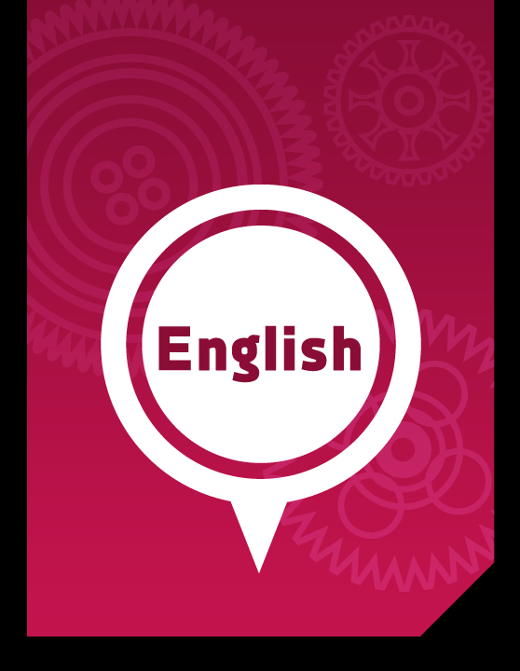

Skills Pack

English Literacy & Language Development, Workshop Series 2010

English Language and Literacy Development: Skills Pack

1. Concord in Texts
Students often make subject-verb relation errors, or concord errors. Most sentences in English contain a subject and a verb. In order for you to understand concord, make sure you know the following:

- A noun is a naming word, such as chair (common noun), love (abstract noun), Bloemfontein (proper noun).
- A verb is a doing word, such as walk, eat, swim, etc.
- Finite verbs show a particular tense, person and number: for example, ‘am’, ‘is’, ‘are’, ‘was’ and ‘were’
- Non-finite verbs do not show a particular tense, person and number, such as ‘be’, ‘being’ and ‘been’.
- The subject is the one that performs the action of the verb. For example; the boy played in the sand pit. Ask yourself what the verb (doing word) is, which would be played. Then ask yourself who is performing the action (verb), which would be the boy. This subject-verb relationship is called concord.
- A pronoun replaces a noun in a sentence. So instead of “John loved John’s book”, we would replace the second John with his, which would be a pronoun. The sentence would then read, “John loved his book”. That and what are also pronouns.
- The subject in a sentence is usually a noun or a pronoun. When a noun is plural, the verb has to be plural as well. Look at the following example:
The boys fetch their bags from the classroom.
You see that the subject, boys, is a plural noun (many boys) and the verb (fetch) is also plural. The pronoun is also plural (their) because it replaces ‘boys’ in the sentence.
For a clearer, deeper understanding of concord, look at the following:
CONCORD IS THE AGREEMENT BETWEEN WORDS IN GENDER, NUMBER,
CASE, OR PERSON.
Gender: The queen has lost her crown.
Number: The shoes are too small.
Person: I am thankful.

Three principles govern the subject-verb concord: Grammatical concord, Notional concord and principle of proximity.

Grammatical concord
- A singular subject requires a singular verb
Example: My son watches television after dinner.

- A plural subject requires a plural verb
Example: My sons watch television after dinner.

If the subject is a noun phrase (a phrase is a group of words forming an abstract unit, but not a sentence, i.e. there is no verb): the number of the verb depends on the number (singular or plural) in the main phrase.

Example: The change in female attitudes is most obvious in industry.
The changes in female attitudes are most obvious in industry.

A clause (a clause is a distinct part of a sentence, including a subject and predicate) in the position of subject counts as singular:

Example: That she was angry really bothers me.
Smoking cigarettes is dangerous to your health.
To err is human.
For students to hand in papers is always a good idea.
That they should all hand in papers and that the papers should all be so
good was a big surprise.
What I like most about the house is that it’s warm.

Notional Concord
- Agreement of verb with subject according to the idea/notion of number
Example:
Collective nouns (A collective noun is a noun indicating a group or collection of similar individuals considered as one complete whole. It is therefore naturally regarded as being singular and as such takes a singular verb):
The committee is having a meeting.
The committee consists of seven members.
The audience is enjoying the show.
The public has to be served.

- But, when the parts or members that make up the thing indicated by the collective noun are thought of individually, a plural verb may be used:
The committee are finding it difficult to reach a decision.
Her family are coming to dinner.
The public are requested not to litter the streets.
When necessary, a collective word must be followed by which when it is singular, but who when it is plural: ‘the board which is meeting…’; ‘the orchestra who are having coffee.’

- The nouns people, police, clergy, cattle are always used with a plural verb, for example:
The people of Norway are called Norwegians.
The police are making enquiries about the murder.
Cattle are found crossing the road.

- People is often used as the plural of person; it also means nation, e.g. The French people, the peoples of Europe.

Principle of Proximity
- Agreement of the verb with the noun closest to the verb.
Example: No one except his own supporters agree with him.
One in ten take drugs.
One or two reasons were suggested.
More than one person has refused.
Nearly one out of three twenty-year-olds are without work.
Can you tell me whether the hat or the gloves are red?
Is the hat or the gloves red?
Either John or the girls have to do it.
Either the girls or John has to do it.

- Measures and partial numbers (fractions, percentages, decimals, etc.)
Example: Three milligrams of calcium nitrate was administered.
A quarter of the vines were destroyed in the fire.
Twenty-five per cent of the crop was lost.
Half of the sand was wet.
Half of the plates were wet.

- Either/ or and neither /nor: principle of proximity
Example: Either the students or the parents are going on the trip.
Either the students or the teacher is going to be there.
Either the teacher or the students are going to be there.
Either John or Mary has to do it.
Either John or the girls have to do it.
Either the girls or John has to do it.
Neither John nor Mary has to do it.
Neither John nor the girls have to do it.
http://www.fs.gov.za/Departments/SAC/Library/depart/language_articles.htm

Concord in two texts
It is important that you are able to identify the subject-verb relations in business texts, and of course, you have to be able use it correctly in your own writing. Before you hand in an essay, you have to check all subjects and their verbs in your essays, assignments or reports (including your informal memos and letters).

Argentina formally defaults on debt
Sapa-AFP In Business Day 06/01/2002

BUENOS AIRES - Argentina has formally defaulted on its $141-billion public debt by failing to make a $28-billion payment on a bond, a local news agency reported on Friday, citing finance ministry sources. Argentina failed on Thursday to make payments on a lira-denominated bond due in 2007, according to the report. The event had been expected: on December 23 interim president Adolfo Rodriguez Saa announced a halt on debt payments soon after he took office. His successor, Eduardo Duhalde, who took office on January 1, said he would continue the policy. The finance ministry was tight lipped about the event late on Thursday, declining comment.

We may list the subjects and their corresponding verbs in the following table:

Subjects | Verbs
Argentina | has defaulted
news agency | reported
Argentina | failed
event | had been expected
Saa | announced
He | took
Successor (who) | took + said
He | would continue
Ministry | was

In the past tenses, the use of was and were with singular or plural subjects may create problems. Otherwise, past tense is relatively easy to manage. It is the past tense sequence that poses problems: Argentina is singular; therefore, the proper noun takes singular has. In the next text, consider the subject-verb relations and the tenses that are used. The head word and the verb (i.e. subject + verb) have been placed in bold. It is important to note that one has to be careful to check on all head words in complex noun phrases and how these are related to the verbs in the text. It is also important to state that subject-verb relations apply only in the case of subjects and their finite verbs. Non-finite verbs do not require you to apply the rules of concord.

It is therefore important that you know what a finite verb is. It was for this reason that the concepts finite verb and subject were considered at the very start of this section. If you are uncertain about the distinction, re-read the entire Appendix.

Chinese economists send mixed signals
AFP In Business Day 06/01/2002
BEIJING - Chinese state-employed analysts disagree on their forecasts for economic growth this year because of conflicting views on the impact of the slowing world economy, official media said Friday. Among the optimists is Chen Dongqi, head of research at the State Development Planning Commission, who expects 7.5% growth in 2002, the highest forecast by any government economist so far. "I don't want to play down China's economic growth potential in the years to come," Chen said, according to the China Daily. China's economy expanded by 7.3% last year, compared with 8% the year before. The decline was mainly due to a steep decline in export growth to about 5% from 27.8% in 2000.
Most Chinese economists share the view that foreign trade will continue to be hurt by the sluggish international economy but the question is how serious the impact will be. Explaining his 7.5% prediction, Chen told the China Daily that the negative impact of the September 11 attacks in the United States would be short-term. "Fortunately, the interruption will not last long," he said.
More serious are the difficulties that many foreign economies are experiencing due to the slump in the technology industry, but the good news was many governments were looking for ways to overcome the problems, Chen said. But even within the State Development Planning Commission, there are dissenting voices, with some adopting a gloomier view, the paper said.
"If the developed economies are still in recession, China's (economic) growth rate will continue to drop this year," said Wang Jian, a macroeconomic expert with the commission, who was not quoted as giving a growth forecast. "Last year's decline in export (growth) was caused by the worsening global economic situation. This year, world economic expectations are even lower and that resulted in my downbeat judgement," Wang said.
AFP

Task: When you read texts, identify the subject-verb relations in them. Keep a list of interesting examples of subject-verb concord.

2. Journaling academic arguments
– Developing your own voice

Introduction
We recommend that you keep a journal and write at least three pages each day of the week. The purpose is to develop the habit of writing, and to become used to putting your thoughts down on paper. You may write about any topic you have come across in the course. Write three pages a day. You can also choose any argument you came across in any of your modules. In this case, we have included an outline of the Read-Think-Write pattern of text production.

Learning outcomes
By the end of Part 2 of the module, students will have written at least 21 pages of spontaneous writing.

Calculation this! If you write three pages per day for 200 days of the year, how many pages will you have written? Easy sum, I would say: a whopping 600 pages will have come from your pen. To be able to reflect critically on your journaling abilities, we suggest that you read the following article (not compulsory):
Advantages and disadvantages of Journaling...\..\Skills_Pack\050908_Journal_Writing_in_Experiential_Education Possibilities, Problems, and Recommendations_ ER.htm

Do not use your journal as a private war zone where you attack others.

Look at the following structure; it can help you with your journal entries:

Start-up activity 2.1:

From reading to thinking to writing
We recommend the following formula:

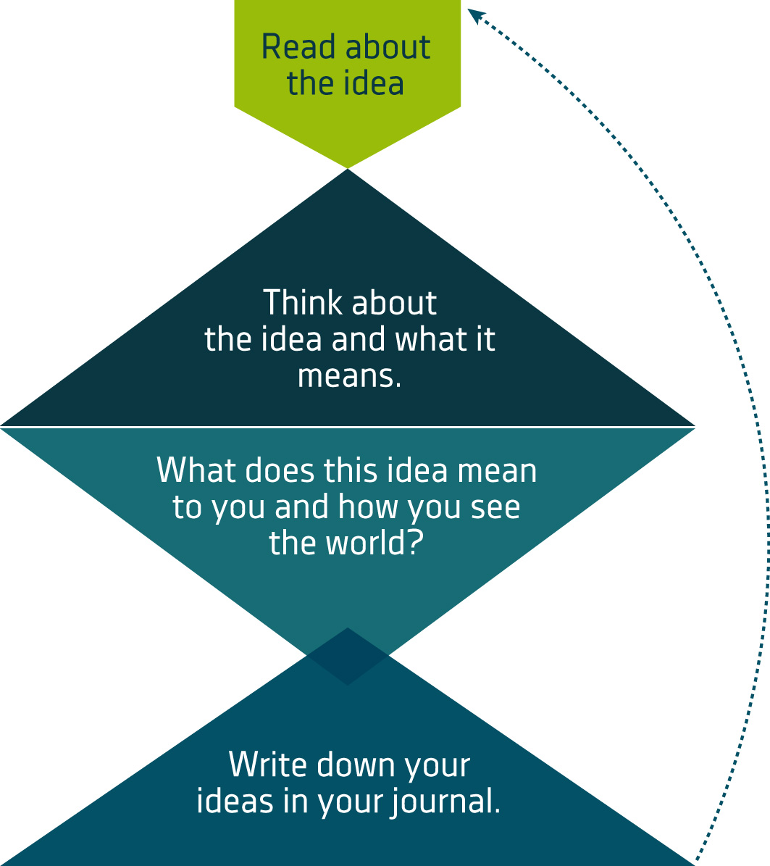

An example:
Outline of the idea:
Okun (2002: 43) says that practitioners in the helping professions have to develop high levels of self-awareness. Once they have developed these levels of awareness, they are better at helping others because they are able to step away from their own needs, perceptions and feelings. They are then better able to deal with others’ thoughts and feelings.

What this means for me:
I also believe that we have to work on our self-awareness. If we don’t have self-awareness, those hidden parts of ourselves may lead to negative experiences, and then, we may not be able to understand why. There are many ways of raising our self-awareness. Firstly, we have to measure our strengths and weaknesses. Second, once we know what we like and what we can do, we will know what to do with our energies. We should not avoid our weaknesses; rather, we should also keep an eye on them, at try develop them too. Through self-awareness we will be able to plan our personal development more effectively.

For more information on critical-reflective, self-directed analysis, click on the following button:
Self awareness and success

3. Cohesion in Texts
Cohesion refers to how words are connected in a text. This means that the words in a text are related in different ways. For example, look at how the word ‘however’ is used in the following sentence:
He thought he had done well in the test. However, when he received his results, he realized that he had not known his work as well as he had thought.
This particular discourse marker (also known as a connecting or linking word) warns you that you are about to read contradicting information.

Look at the following examples of cohesive ties (connecting/linking words).

Cohesion ties
Conjuctions | Prepositions | Pronouns | Adverbs
and | thought | he | nevertheless
but | via | she | nonetheless
while | over | it | however
because | by | they | by contrast
furthermore | with | their | on the contrary
in addition | above | we | still
moreover | below | us | on the other hand
firstly | close | ours
secondly | nearby | which
thirdly | on | this
either...or | of | that
neither...nor | to | these
before |  | those
while |  | herself
since |  | himself
after |  | themselves
until

See if you can identify the cohesive ties in the following passage.

(1) People have argued hotly for centuries about the pros and cons of comics, the most popular and widely-read form of literature in the world. (2) The continuing popularity of comics is indicted, for example, by the fact that comic strips have been made and read since 3500 BC, and that in America today they are enjoyed by over 70, 000,000, both young and old. (3) There it is estimated that, every Sunday morning, some 41,000,000 children pore over comic sections of the newspaper, whereas very few read the Bible with much concentration. (4) Educators, gasping at the proportions of this addiction, say that story-strips provide entertainment only for moronic minds – that is, they suggest that comics lack mental substance, artistic form and educational value. (5) However, less conservative educators and some psychologists argue that because comics evoke an instant and universal emotional response, they can be utilized educationally in the teaching of literacy and morality. (6) Instead of throwing them out of the window, teachers in third world countries (such as Africa, Mexico and India) can use comics for mass literacy projects, since this material is both cheap to produce and visually stimulating. (7) Moral educators suggest that comics can also be used with children to cultivate, visually, a perception of what is right and wrong, good and evil. (8) “Superman”, for instance, can be used as an example to young boys of a person who works hard to right wrongs, to protect the weak, and to help humanity – in short, to see that good overcomes evil (Rodseth, V., Johanson, L. & Rodseth, W. (1992) Think Write. Southern Africa: Hodder & Stoughton Educational.)

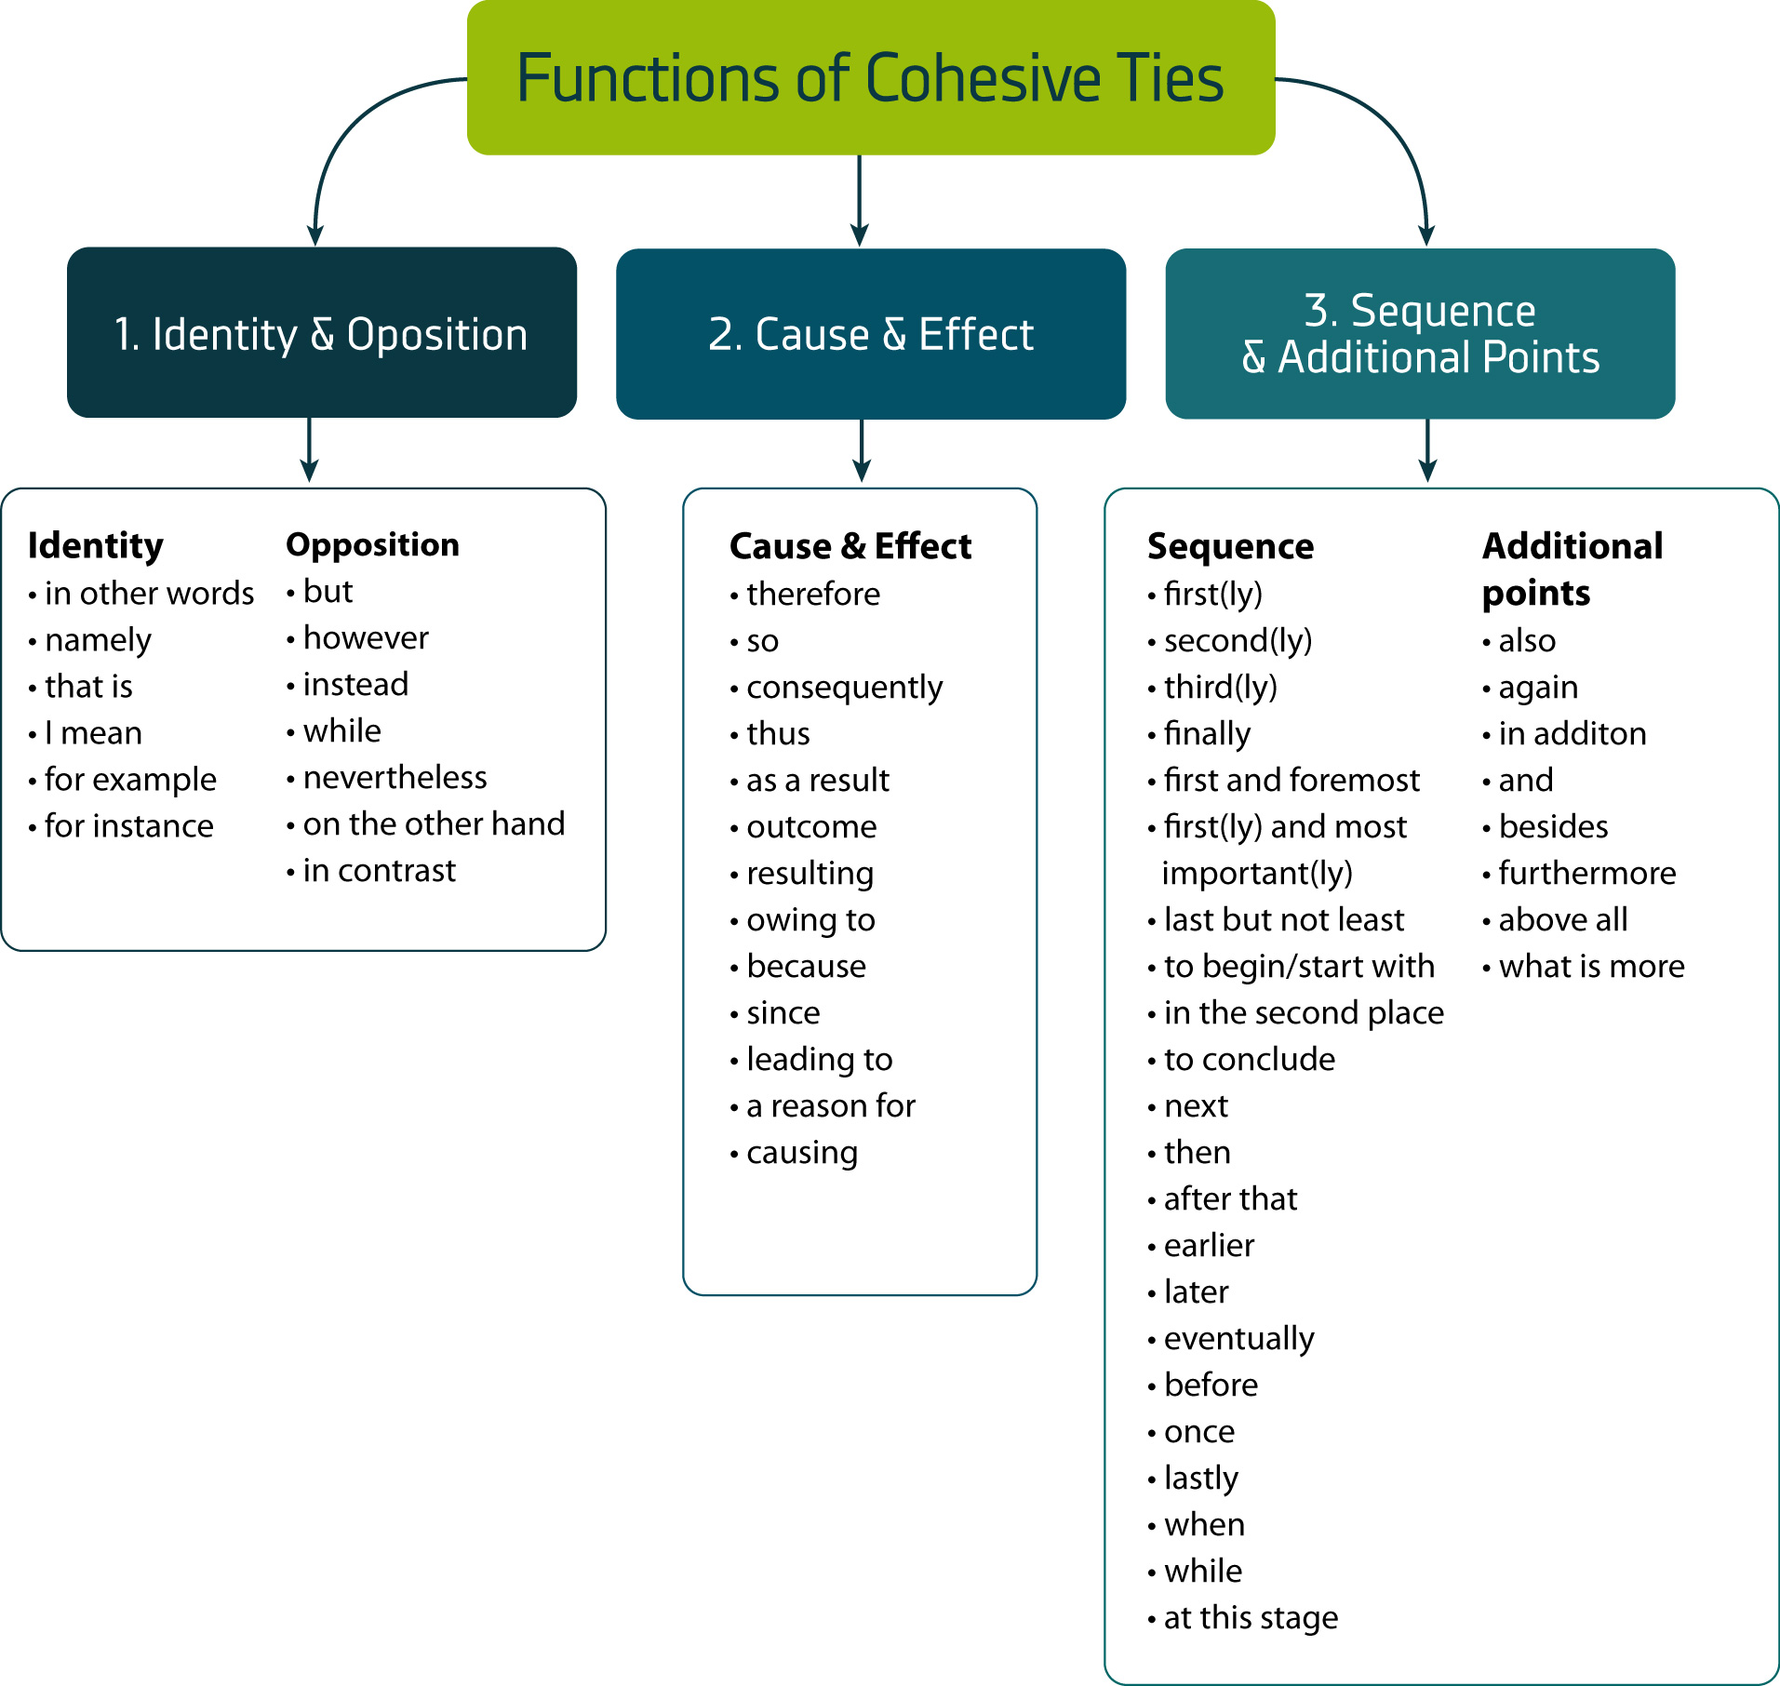
- Identity (sameness) and Opposition
in other words | that is | for example
namely | I mean | for instance

Example:
My grandfather is a difficult old man. It is not easy to get along with him.
My grandfather is a difficult old man. In other words it is not easy to get along with him.

Now, use the words in the box above to complete the following paragraph.

  - Connectives expressing identity (sameness)
There is a certain type of connective word which indicates that the statement following it is saying much the same as the statement preceding it. _________(1)_________, the new statement is re-stating the first statement, ____(2)_____, saying it again, only in different words, or in different terms. ___(3)____, the new statement might give an example demonstrating the same point as the first statement, _(4)_ present the point in more specific or concrete terms.
(Rodseth, V., Johanson, L. & Rodseth, W. (1992) Think Write. Southern Africa: Hodder & Stoughton Educational.)

in contrast | instead | while | but
on the other hand | nevertheless | however

  - Connectives expressing opposition
___(1)____ some connective devices express identity, others express opposition. ___(2)_____ of presenting the same point in another way, they present a completely opposing point. “Identity” connectives sometimes introduce examples, __(3)__ “opposition” connectives never do. The statement introduced by the “opposition” connective looks at another side of the story from the point adjacent to it. ___(4)___, it is still related to the main idea, which itself usually expresses an opposite or a contrast.
(Rodseth, V., Johanson, L. & Rodseth, W. (1992) Think Write. Southern Africa: Hodder & Stoughton Educational.)

- Cause and Effect
Look at how the causes, connectors and effects of the following passage are tabulated below.

therefore | consequently | because | since
outcome | owing to | as a result | thus | causing
leading to | a reason for | resulting | so

- My alarm did not go off this morning.
- I got up late
- I was late for work
- I did not give my boss the report at 8:00.
- He was very angry.
- He had to cancel his appointment with the MD.
Because my alarm did not go off this morning, I got up late, which resulted in my being late for work. Consequently, my boss was very angry because I did not give him the report at 8:00. As a result, he had to cancel his appointment with the MD.
Cause | Connector | Effect
my alarm did not go off | because | I got up late
my alarm did not go off | which resulted in | my being late for work
I did not give him the report at 8:00 | because | my boss was angry
I did not give him the report at 8:00 | as a result | he had to cancel his appointment with the MD

- Sequencing and Additional Points
first(ly) | finally | next | before | while
second(ly) | to begin/start with | then | once | when
third(ly) | in the second place | after that | lastly | at this stage

Use the connectors in the box to connect the following sentences:
- Make sure that the handbrake is on, and the car is in neutral.
- Depress the clutch.
- Turn the key and press the accelerator.
- Put the car into first gear.
- Release the clutch gradually and take off the hand-brake.
- Press the accelerator gently.
- Move forward.
(Rodseth, V., Johanson, L. & Rodseth, W. (1992) Think Write. Southern Africa: Hodder & Stoughton Educational.)

There are many ways in which these sentences can be connected; the following are two examples:

To begin with, make sure that the handbrake is on, and the car is in neutral. Then depress the clutch. Next, turn the key and press the accelerator. After that, put the car into first gear. Once the clutch is released, gradually take off the hand-brake. Finally, press the accelerator gently and move forward.

OR

Firstly, make sure that the handbrake is on, and the car is in neutral. Secondly, depress the clutch. Thirdly, turn the key and press the accelerator. Then put the car into first gear, release the clutch gradually and take off the hand-brake. Finally, press the accelerator gently and move forward.

4. Common Errors

Mind-mapping, topic and supporting sentences

Mind-mapping

- How to create a mind-map:
- Use single words or simple phrases for information: You can fill in the gaps later on, but a mind map consists of single, strong words/phrases that carry the most important information. Too many words will just clutter your mind map.
- Print words: Joined up or indistinct writing can be more difficult to read.
- Use colour to separate different ideas: This will help you to separate ideas where necessary. It also makes your mind map easier to remember. Colour also helps to show the organisation of the subject.
- Use symbols and images: Where a symbol or picture means something to you, use it. Pictures can help you to remember information more effectively than words.
- Using cross-linkages: Information in one part of the mind map may relate to another part. Here you can draw in lines to show the cross-linkages. This helps you to see how one part of the subject connects with another.
http://www.mindtools.com/pages/article/newISS_01.htm

An essay consists of an introduction, a body and a conclusion.
Each of these are made up of paragraphs, which in turn are made up of topic sentences and supporting sentences:

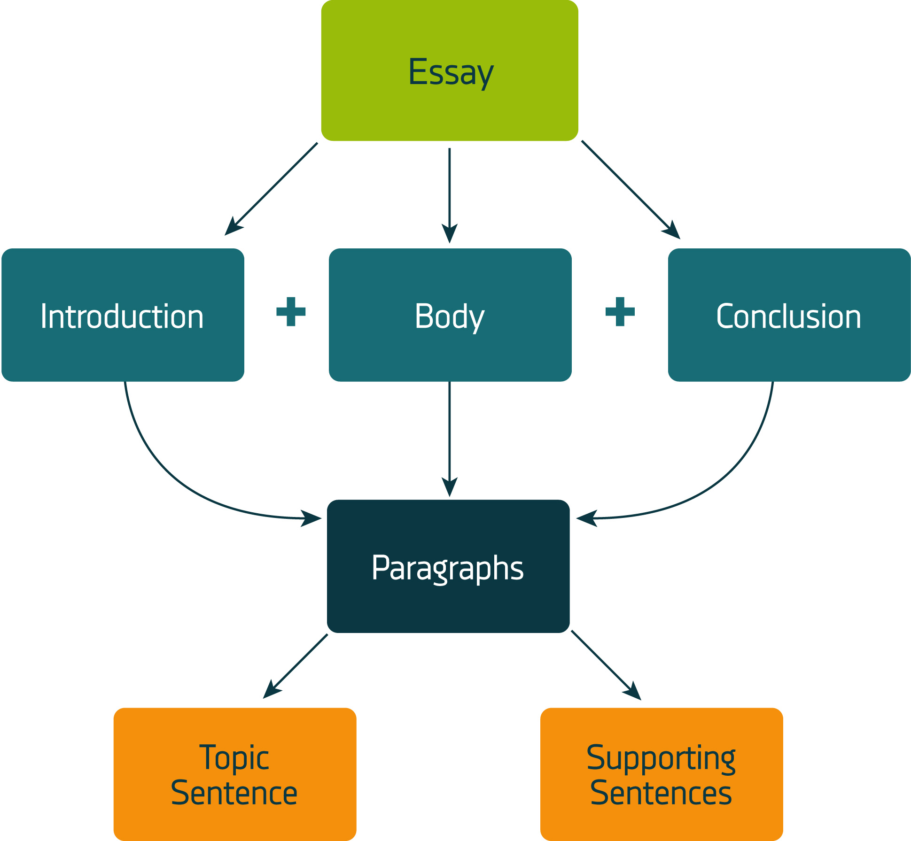

Look at the following paragraph:

Birds of prey often circle in the sky as they search for their victims. Many bird watchers have described their delight in seeing an eagle soaring before it swoops down on a rabbit, or a hawk hovering high above the ground as it searches for a mouse.

The first sentence contains the main idea and is therefore the topic sentence, and the other sentences give specific details and are therefore supporting sentences.

The topic sentence:
- introduces the main idea to the reader
- is a general statement

The topic sentence in this paragraph introduces birds of prey and the fact that they hunt for their prey

The supporting sentences:
- give more information about the main idea,
- and are therefore more specific

The specific, supporting information about the birds of prey and how they hunt (the main idea) includes:
- the birds of prey we are dealing with are an eagle and a hawk
- an eagle soars and swoops and it hunts rabbits
- a hawk hovers in the sky and it hunts mice
Rodseth, R., Johanson, L., Rodseth, W. (1992) Think Write. Hodder and Stoughton Educational, Randburg.

Topic sentences are general statements and supporting sentences are more specific; now look at the following:
Granny Smith green apples / fruit / apples / food green apples / the green Granny Smith apple in my lunch tin
These can be arranged from general to specific, as follows:
- food
- fruit
- apples
- green apples
- Granny Smith green apples
- the green Granny Smith apple in my lunch tin

Now, order the following items from general to specific:
pansies, plants, annual flowers, flowers, the African pansy
1.
2.
3.
4.
5.
6. the black-eyed African pansy
Rodseth, R., Johanson, L., Rodseth, W. (1992) Think Write. Hodder and Stoughton Educational, Randburg.

Look at this opening sentence for a paragraph, and at the main idea which it contains:
“She was not very fond of university.”
Look at the following sentences and decide which are appropriate supporting sentences, and which are not:

- There were problems between the mother and father at home.
- The classes were poorly organised, which resulted in many subjects clashes.
- Her father always blamed her for the problems at home.
- The lecturers were unfriendly, impatient and intolerant.
- They were never willing to listen to students’ explanations for arriving late for class.
- The problems at home were affecting her relationship with her boyfriend.

Sentences 2, 4 and 5 would be appropriate supporting sentences, as they give reasons (specific information) for her not liking university (main idea).

Should you combine these to form a paragraph, it would read as follows:

She was not very fond of university. The classes were poorly organised, which resulted in many subject clashes. The lecturers were unfriendly, impatient and intolerant. They were never willing to listen to students’ explanations for arriving late for class.

Remember:
- Before writing a paragraph, you need to brainstorm, mind-map, select and order your ideas.
- Good writers draft and revise their work before producing their final paragraph
- A good paragraph has a main idea, usually expressed in the first sentence
- This sentence is known as the topic sentence.
- The topic sentence is not a heading, but a full, declarative sentence.
- Connected support sentences develop the main idea, expressed in the topic sentence.
- In good writing, every sentence connects with the previous sentence.
- The main idea in the topic sentence is often a generalisation.
- The support sentences give specific details illustrating the main idea.

Rodseth, R., Johanson, L., Rodseth, W. (1992) Think Write. Hodder and Stoughton Educational, Randburg.

- Use discourse markers to show the reader where you are headed:
Discourse markers are words that are used to connect ideas in writing.
Examples of discourse markers:

- with regard to  - regarding as regards  - as far as………..is concerned  - as for  - on the other hand  - while  - firstly  - secondly  - next  - whereas  - however, nonetheless | - moreover  - furthermore  - although  - when  - in addition  - therefore  - as a result  - consequently  - so that  - more specifically  - nevertheless

Example:
There are many reasons why I don’t like school. Firstly, I dislike getting up so early in the morning and putting on layers of uncomfortable clothes. Secondly, because I take so long to get dressed, my breakfast is always cold by the time I get to the table. As a result, I usually have a stomach ache when I get to school. In addition, we usually have Mathematics first and our teacher is very strict. Finally, there is this boy named Ted Wilkins who always bullies me during break time –this is by far the worst part of my school day.
- Hyphenation of compound adjectives
An adjective is a describing word; they describe nouns.
For example: My dog, Spot, is an enormous animal.
The adjective “enormous” describes the noun “animal.

When two adjectives describe a noun, this is referred to as a compound adjective, and it needs to be hyphenated:
One usually gets paid very well for high-risk work.
The school seems to have many ill-mannered children.

- The use of articles (the, an and a)
‘The’ is used to indicate when you refer to a specific person or thing:
I am looking for the book with the red cover (refers to a particular book that has a red cover, not just any book with a red cover)

‘A’ is use as a more general reference:
They are going to paint a house (there are many houses and they are going paint one of them).

‘An’ is also more general, and is used before a word that starts with a vowel, or before a word that is pronounced in such a way that it sounds as though it starts with a vowel:
The principal had to deal with an incredibly difficult situation.
He is an honest man. (The ‘h’ is not pronounced, so it sounds as though honest begins with ‘o’, which is why ‘an’ is used)

- Belief and believe
Belief is a noun (a naming word): The belief that he is a hero is mistaken.
Believe is a verb (a doing word): I believe that you are a good student.

- The use of ‘a lot’
Try to minimise the use of ‘a lot’;
Rather use ‘many’ in a sentence such as: A lot of cases (many cases)
Rather use ‘much’ in a sentence such as: A lot of work (much work = uncountable)

- The apostrophe (‘)
The apostrophe is used in two ways:
- to show possession (the ownership of something), and
- to show omission (that something has been left out)
Look at the following examples:
- All the princess’s dresses were pink
- That is Sarah’s bag, not yours.
- The child’s lunchbox went missing.
- The children’s clothes were dirty after the soccer match.
- The students’ marks were very good.
- The princesses’ lost their books.
- *The dog bit its tail.

Rules for possession:
- A singular noun ending in an s takes an apostrophe s, as in sentence 1.
- A singular noun that does not end in an s also takes an apostrophe s, as in sentences 2 and 3.
- A plural noun that does not end in an s takes an apostrophe s, as in sentence 4.
- A plural noun that ends in an s takes an apostrophe after the s, as in sentences 5 and 6.

* NOTE that in sentence 7, NO apostrophe is used! The only time ‘its’ has an apostrophe, is when it signals the omission of the ‘i’ in ‘it is’.

- I can’t understand why you don’t want to go with me.
- Let’s see you try it.
- You shouldn’t tease the dog; it’s going to bite you.

The apostrophe is used to show that a letter has been left out.
In sentence 1, the apostrophe replaces the ‘no’ in ‘cannot’, and the ‘o’ in ‘do not’.
In sentence 2, the apostrophe replaces the ‘u’ in ‘let us’.
In sentence 3, the apostrophe replaces the ‘o’ in ‘should not’, and ‘i’ in ‘it is’.

- Pronouns
A pronoun is used in the place of a noun in a sentence to avoid it sounding clumsy.
Look at the following example to see why pronouns are necessary:

Tony took Tony’s cat to the vet because Tony’s cat was ill.
The children hid the children’s books under the children’s seats.
My mother couldn’t find the flour that my mother uses to make my mother’s famous cakes.

The sentences should rather read:
Tony took his cat to the vet because it was ill.
The children hid their books under their seats.
My mother couldn’t find the flour that she uses to make her famous cakes.

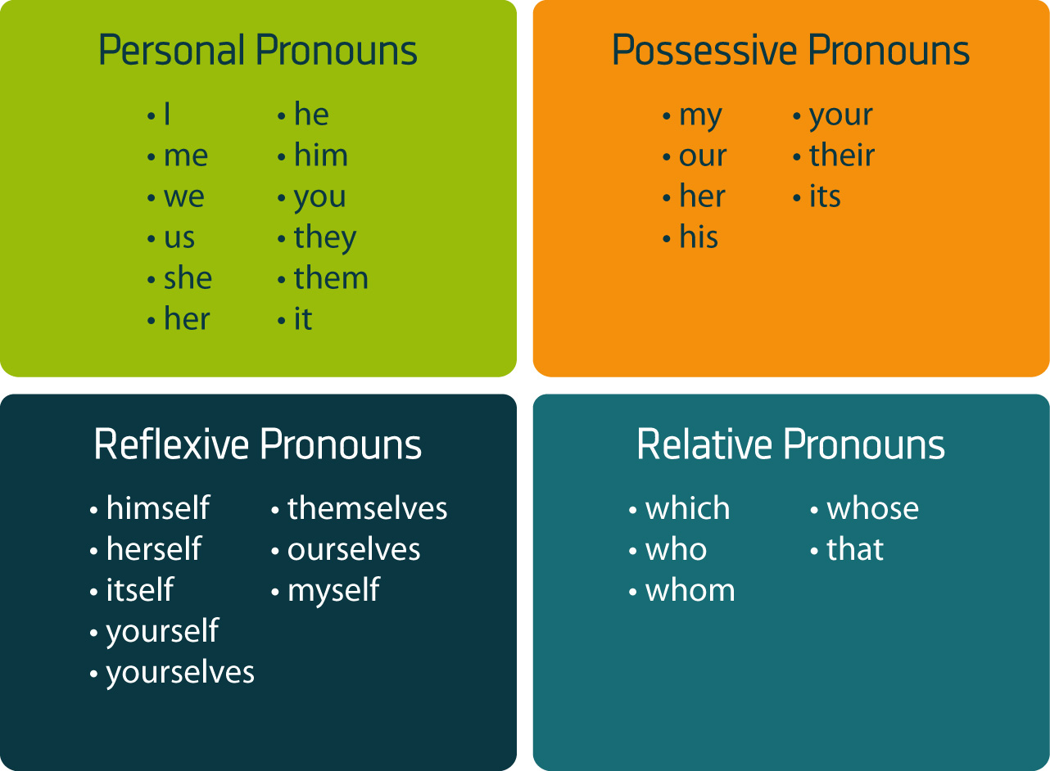

Now try complete the following sentences using the pronoun-type indicators above:

- He told ___________ that _____ could win the race.
- _____ had her hair cut on Monday, but _____ didn’t like the way the hairdresser had cut _____ hair.
- They did not know what to tell ______ parents about ______ bad behaviour at school.
- ______ had a wonderful party on Saturday; all _____ friends were there.
- He is the man _______ stole the car.
- She didn’t know __________ bag it was.
Check below for answers.

- Tenses
Look at the following sentences and time lines to determine the tense of the sentences. The auxiliary verbs together with the verbs are what determine tense.

Past tense
- She was working in the garden when it started raining.
- I had been waiting for hours for my dad to come home.
- They had done research on the property before they bought it.
- My friend moved to New Zealand when she left school.

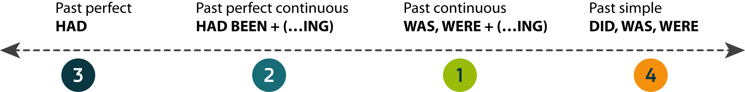

Present tense
- Mary often arrives early for class.
- What are you doing with that bucket of water?
- They have not eaten their food yet.
- We have been swimming for the last 3 hours.

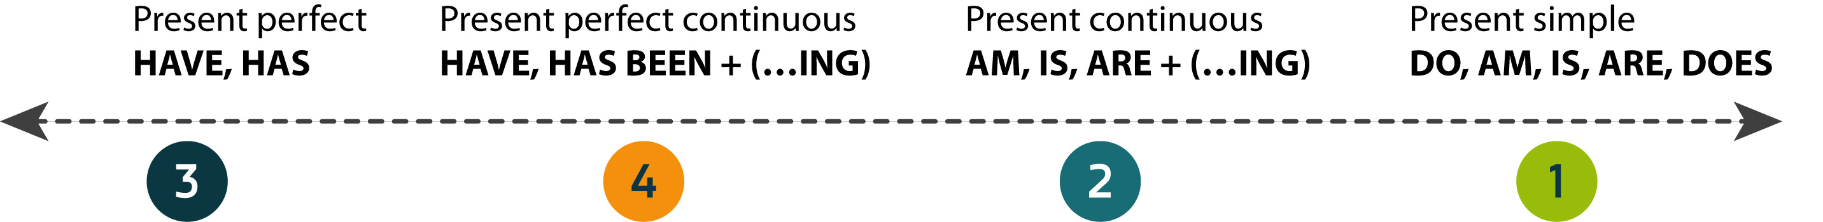

Future tense
- The train will arrive today.
- What will you be doing on Monday?
- She'll have gone by the time you get back.
- Dave will have been my husband for 12 year this coming Saturday.

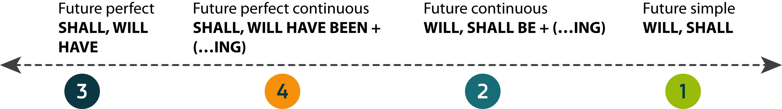

- General errors

The difference between loose and lose | My pants are too loose on me, they are about to fall off.
 | I put it in my bag because I was afraid I would lose it.
The difference between  off and of | Be careful that you do not fall off the wall.
 | I am sick of waiting in the bank for so long every time I need to draw money.
The difference between safe and save | I would love to save all the animals at the SPCA.
 | It is not safe to walk around alone at night.
The difference between were and where | They were on their way to the shop when they saw him.
 | Where did you put my pencil?
The difference between whether and weather | I cannot decide whether I prefer the green dress or the blue pants.
 | The weather was so bad yesterday that I had to stay indoors the entire day.
The difference between practice and practise | Practice is a noun and practise is a verb
I practise writing every day of my life.
The practice that doctors perform community is a solution to health-care system problems.
The difference between no, know and now | I know that you work very hard (to have knowledge of)  Now is the time to act (the present moment)  There is no more sugar in the house (nothing)
Slang | Avoid using slang in your writing, write out the whole word
gonna = going to
wanna = want to
cause = because
SMS language | Avoid using SMS language in your writing
gr8 = great
2nite = tonight
u = you
Contractions | Avoid using contractions; write out the whole word
can’t = cannot
won’t = will not
isn’t = is not
don’t = do not

- Ambiguity
If a sentence is ambiguous, then it can be understood in more than one way. In other words, it has more than one meaning. The double meaning can be quite funny and is often unintended.

For example, look at the following newspaper headings and see if you can identify the ambiguity in each of them:

- KIDS MAKE NUTRITIOUS SNACKS
- STOLEN PAINTING FOUND BY TREE
- MINERS REFUSE TO WORK AFTER DEATH
- MILK DRINKERS ARE TURNING TO POWDER
- INCLUDE YOUR CHILDREN WHEN BAKING COOKIES
- SQUAD HELPS DOG BITE VICTIM
http://www.fun-with-words.com/ambiguous_headlines.html, viewed on 11 June 2009

Different meanings:
- The kids are the nutritious snacks, so it is healthy to eat kids OR nutritious snacks are made by kids.
- The tree found the stolen painting OR the stolen painting was found in the vicinity of the tree.
- The miners refused to work after one of the minders died OR the miners refused to work after they died.
- People who drink milk are resorting to drinking powdered milk OR people who drink milk are themselves turning into powder.
- You should allow your children to help you bake cookies OR when you bake cookies, you should bake your children as well.
- The squad helped the dog bite the victim OR the squad helped the victim who was bitten by the dog.

The double meaning is usually a result of incorrect word order in a sentence. Once you have written something, read it again carefully to make sure there is no double meaning.

- Punctuation
Question mark:
Used to indicate a question. It acts as a full stop at the end of the sentence. The sentence that follows starts with a capital letter.
• Please would you help me carry this bag? It is so heavy.
• Don't you ever listen to anything I say?
Exclamation mark:
Used to indicate an exclamation. It acts as a full stop at the end of the sentence. The sentence that follows starts with a capital letter.
• Go away! I never want to see you again!
• Don't put your dirty feet on the bed!
Colon:
Used to introduce a list, a summary, an explanation, or before reporting what somebody has said.
• Remember the following important points : brush your teeth, eat your vegetables, and don't watch too much television.
• Paul: Larry is a terrific fellow, you should meet him.
Brackets:
Used to indicate parenthesis. This is additional information, without which the sentence will still make sense.
• I had a dog (a black poodle) that got run over.
• The University of the Free State (UFS) is located in Bloemfontein.
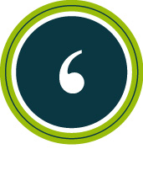 | Apostrophe:  Used to show possession or omission (refer to beginning of Common Errors for further information)  Omission:  • I can't understand this question.  • Don't walk to school alone, it is dangerous.  Possession:  • That is Tony's hat.  • The learners' bags got wet when it rained.
Full stop:
used at the end of a sentence and in abreviations
• So many children in South Africa are homeless.
• Dr. A.M. Goodie will be attending the seminar today.
• etc.
Inverted commas or quotation marks are used to indicate a direct quotation.
• The boy said, "I have never been to Mexico."
• In yesterday's meeting, John spoke of "highly motivated staff" as the key to success in business.
Hyphen:
used between the parts of a compound word or name or between the syllables of a word when divided at the end of a line of text. Don't confuse the hyphen with the dash.
• post-box or happy-go-lucky or long-legged animal
Dash:
used to set off a word or phrase after an independent clause or to set off words, phrases, or clauses that interrupt a sentence. Don't confuse the dash with the hyphen.
• "She was very angry and began screaming - at me, I mean."
Semicolon
(1) Used when two clauses are not joined by connecting words such as but, and, yet, or, nor, for, and so.
(2) Used to separate main clauses joined by a conjunctive adverb (such as however, consequently, otherwise, moreover, nevertheless)
• Students with good reading proficiencies are given standard texts books; students with low reading proficiencies are given additional supporting materials.
• Many people are under the impression they are finished learning; however, they don't realise that learning is a life-long process.
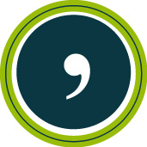 | Comma:  (1) Used to separate clauses in a sentence when they are joined by :but, for, or, or, yet  • The show was finished, yet the audience remained in their seats.  • It was my birthday yesterday, so my mom took me out for supper.  (2) Use a comma after introductory clauses that begin with: after, although, as, because, if, since, when and while.  • While I was washing my hands, my dog ate the food on the table.  • As for the game, it did not go very well.  (3) Use a comma after introductory words such as yes, however, well.  • Well, then you should go on your own.  • Yes, I think those pants look nice.  (4) Use two commas to set off clauses or phrases that are not essential to the meaning of the sentence.  • Last week Wednesay, the day it rained so hard, I went to the supermarket to buy candles.  • My cousin, the boy wearing the blue jacket, is seven years old.  (5) Use a comma to separate 3 or more words, phrases or clauses that are written in a series.  • I went to the store to buy eggs, bread, milk and honey.  • The boy next door is unfriendly, he never plays with other children, he kicks his dog when he is angry and is generally a rather unpleasant fellow.  (6) Use a comma to separate 2 or more adjectives used to describe a noun.  • Betty has a large, hairy, long-legged dog.  • You are dealing with a difficult, stubborn old man.  (7) Use a comma near the end of a sentence to separate contrasting elements or to show a pause or shift.  • He was merely lazy, not stupid.  • You are one of Izabel's friends, aren't you?  • The main in the rain coat looked strange, even creepy.  (8) Use a comma to set off phrases at the end of the sentence that refer back to the beginning or the middle of the sentence.  • Lisa waved at Mark, who was leaving for Johannesburg.  (9) Use a comma to separate geographical names, items in dates, addresses and titles in names.  • She comes from Cape Town, South Africa.  • December 21, 2001, was the year my son was born.  (10) Use a comma to indicate a quotation.  • Ruth said, "I hope I see you again soon."  • "Don't you want to come with," said John.  (11) Use a comma wherever necessary to prevent confusion or misreading.  • To Helga, Michael was just a friend.

5. Self Awareness

Why is this for me?
Self-awareness, or understanding more about ourselves, is at the centre of personal development and career development. This development process should run parallel to your academic studies, and the two processes should complement each other.

As you progress through your course, you should gain knowledge of your subject and yourself. Together, this knowledge helps you prepare for what you want to do next, by helping you to:
- make the right choices (e.g. whether to get a job or take a further course of study)
- make the most of your learning opportunities
- identify what are your key skills and where you can apply these most effectively
- describe fluently the ‘type’ of person you are
- identify things you might find difficult and develop strategies to deal with these
- understand how you relate to others in different situations (e.g. team work, leadership/management, socially).
© Profiling for Success 2005

Becoming self-aware
One way to think about self-awareness and how it relates to development activities is shown below.

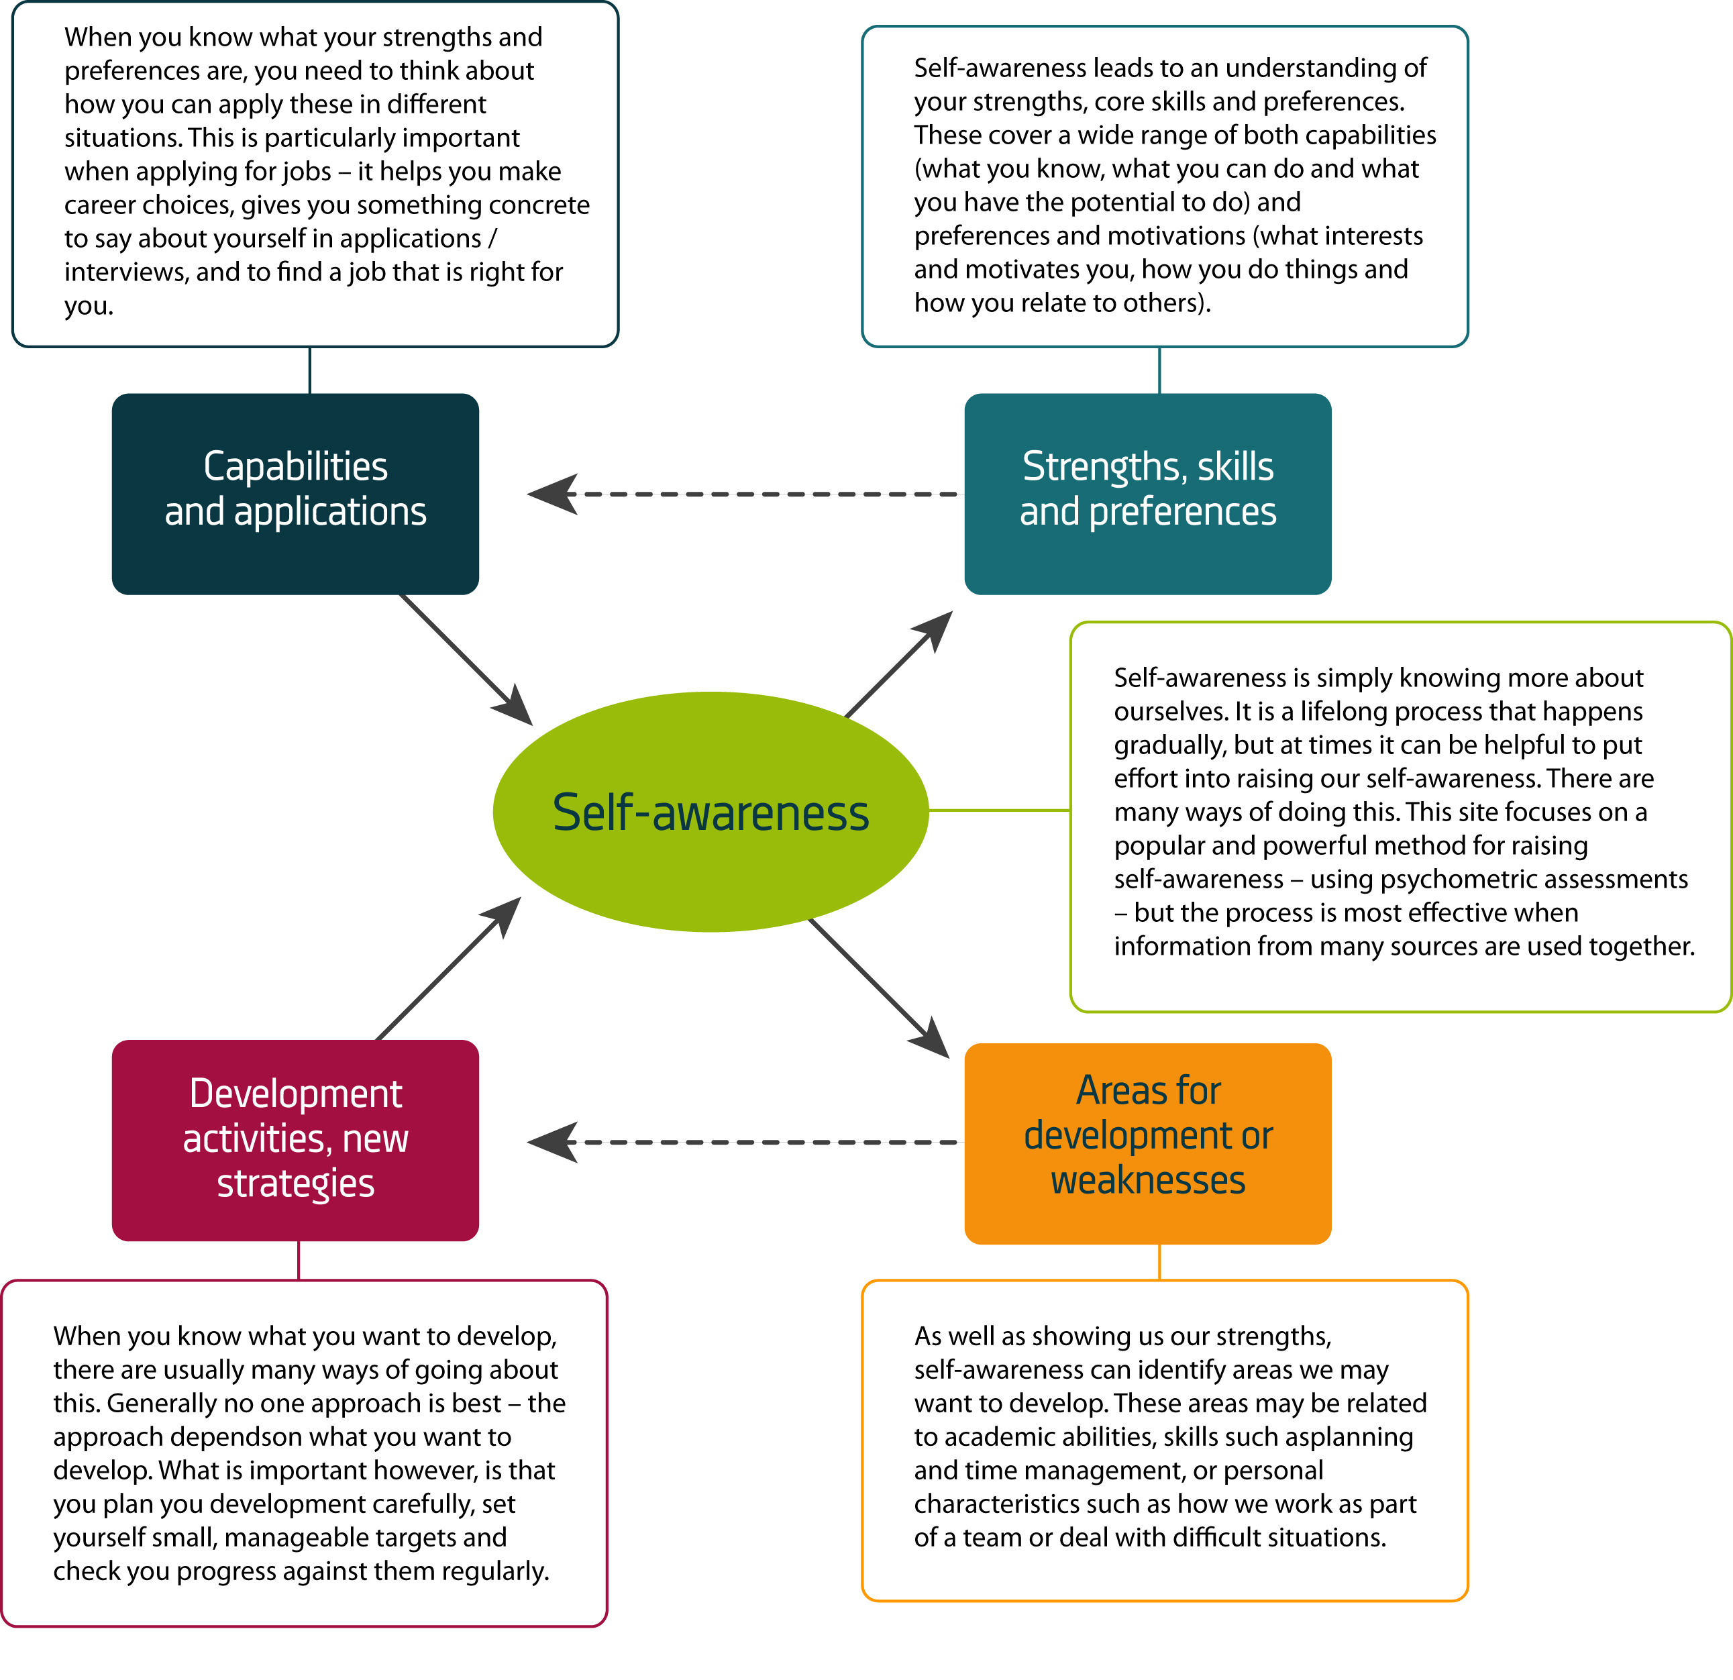

© Profiling for Success 2005

(2) for example; (3) whereas; (4) that is; (5) However; (6) Instead of (8) for instance; (8) in short
Rodseth, V., Johanson, L. & Rodseth, W. 1992. Think Write. Southern Africa: Hodder & Stoughton Educational.
(1) In other words (or that is / I mean); (2) that is (or in other words); (3) For instance (or for example); (4) or.
(1) While (or Although); (2) Instead; (3) but; (4) Nevertheless (However)
plants, flowers, annual flowers, pansies, the African pansy, the black-eyed African pansy
He told himself that he could win the race OR He told her that she could win the race etc. ² She/she/her; ³ their/their; ⁴ They had a wonderful party on Saturday, all their friends were there OR She had a wonderful party on Saturday, all her friends were there, etc. ⁵ who; ⁶ whose

