Part 5:

Communication

ICT Module, Workshop Series 2010

Part 5: Communication

Section 1: e-mailing

1. Introduction
In this Part, we will focus on how to use the computer to improve communication. In the world of work, or as tertiary education students, it will be essential that you can use the latest communication technologies.

E-mail is electronic mail, which has been an unprecedented success. Businesses have seen the advantages offered as being very important to improving their productivity and profitability.

There are many advantages to using e-mail. E-mail provides a way to exchange information between two or more people with no set-up costs and it is generally far less expensive than physical meetings or phone calls. Much of the business world relies upon communications between people who are not physically in the same building, area or even country; setting up and attending an in-person meeting, telephone call, or conference call would not only be inconvenient, but also time-consuming and costly. E-mail allows asynchrony, which allows the recipient to review and respond to the mail at a time that is convenient. The e-mail recipient is able to decide when and how much time they will spend dealing with any associated information.

There are also a number of disadvantages associated with the use of e-mail as a communication tool. Most business workers today spend from one to two hours of their working day on email: reading, ordering, sorting,„re-contextualising‟ fragmented information, as well as writing and replying to emails. The use of email is increasing due to increasing levels of globalization, labour division and outsourcing, amongst other things. Email can lead to some well-known problems such as loss of context, where the context is lost forever; information overload, where the use of mailing lists and „copy all‟ can lead to people receiving unwanted or irrelevant information that is of no use to them.

Learning Outcomes
On completion of this Part, you will:
- Understand the relationship between the Internet, email and communication
- Be aware of the advantages and disadvantages of email communication
- Be able to setup and use a webmail account

2. Communicating via the Internet
The Internet is a communication system that allows computers around the world to communicate and to exchange information with each other. The Internet also facilitates access to resources, such as files, services, or other people.

A group of computers that have been joined together or connected is known as a network.
Computers in a network can communicate with one another.

Many schools, universities, businesses, and government institutions around the world have networks. All of these networks are connected to one another in a huge worldwide network, which is called the Internet.

Networked computers communicate through telephone lines, cables, wireless, and satellite links. Being connected is not enough, though computers must also understand one another. Just like people, they must speak the same language in order to communicate. Computers connected to the Internet exchange instructions that allow them to ‘talk’ to one another.

Computers break information into small chunks, called packets. Each packet travels along the Internet on its own. When the packets reach their destination, they’re put back together. Sometimes, a packet gets lost, but even before you now it’s missing, it’s sent again and joins the other packets.

Packets do not travel directly from one computer to another on the Internet. They travel through machines called routers. A router is like a traffic cop at a busy intersection. It reads the “address” on each packet and decides what path the packets should travel. Packets sent to far off computers may go through many routers.

3. Setting up a webmail account
Setting up a webmail account  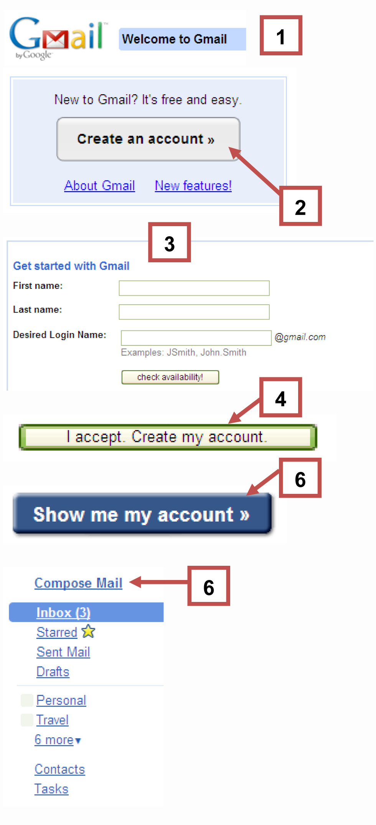 | There are hundreds of services to choose from where you can create a webmail account, but 3 popular services:  · Google Mail: http://www.gmail.com  · Yahoo Mail: http://www.ymail.com  · MS Hotmail: http://www.hotmail.com  Steps:  1. Type in: http://www.gmail.com  2. Click on “Create an account”  3. Fill in all the information asked of you under “Get started with Gmail”  4. Click on “I accept. Create my account.”  5. Congratulations! You‟ve successfully signed up for Gmail!  6. Click on “Show me my account” to start sending e-mails.  7. Click on “Compose Mail” to send someone and e-mail
Netiquette  Examples of emoticons1:  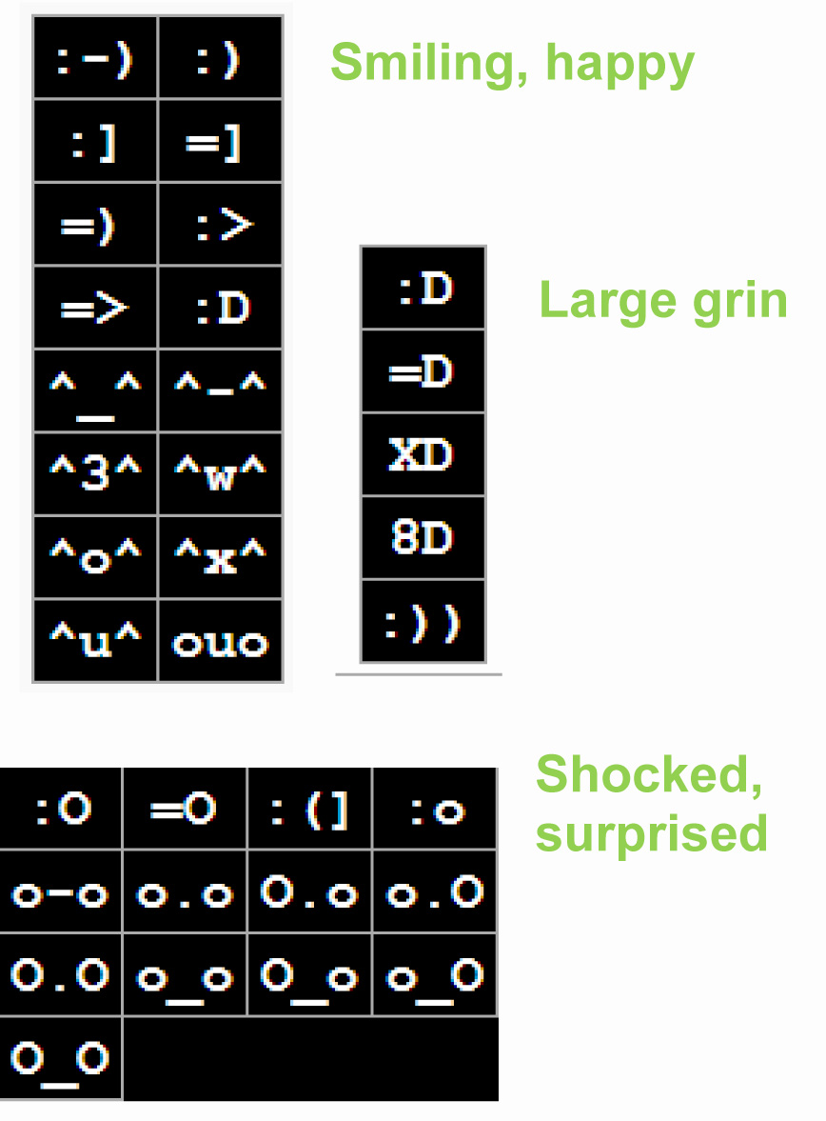  Popular abbreviations and shorthand:  BTW = By The Way  LOL = Laughing Out Loud  ROTFL = Rolling On The Floor Laughing  IMHO = In My Humble Opinion  IYKWIMAITYD = If You Know What I Mean And I Think You Do  JK = Just Kidding  NP = No Problem  WBS = Write Back Soon | Netiquette refers to the conventions of good behaviour when online. There are 4 sacred netiquette rules:  1. Consider email public information. Since messages can be easily leaked, write them professionally because you never know who will see them. Also, don‟t include offensive or misleading phrases in the signature that may go against your company's policy.  2. Don‟t shout. Writing in capital letters means you're screaming in the digital world. That's not nice. So to emphasize a word, place *asterisks* on either side.  3. Smile. Icons, such as 8), invoking a smile are okay to use and add personality. See Wikipedia for more emoticons examples1.  4. Get to the Point. Email is supposed to increase efficiency. Write short paragraphs and edit messages.

Mind your Netiquette
E-mail prudence is becoming more important, as courts recognise e-mail messages as evidence. Keep in mind that for company-owned e-mail accounts, the company owns the e-mail messages, not the employee. Thus, keep the following questions in mind when writing e-mails:
- How would you feel if your boss read this e-mail?
- How would you feel if this e-mail appeared in the newspapers?
- What if the person you are referring to in your e-mail was in the same room?
- How would you feel if you received this e-mail message?

Group Activity 1.1

Your institution possibly also has additional netiquette rules. Find out what they might be. Now have a look at the following scenarios and decide whether they are examples of good or bad netiquette:

Scenario | Good netiquette | Bad netiquette
Joe receives an e-mail message from a colleague. He decides that it is appropriate to mailing list he subscribes to, and decides to pass it along. Before he does this, however, he writes to his colleague to receive permission.
Monge uses a computer in an Internet Cafe where a number of people use the same computer. When she logs on, she discovers that the machine pulls up the previous person‟s e-mail. „I know her , we're working on the same assignment," she thinks, "and I don't have time to change the configurations. I'll just use this account to see if there's any new information on the project‟.
A group or organization has sent out e-mail to large quantities of people whether they have any interest in what is being offered or not. People enjoy receiving lots of mail, right?
Sipho writes the following e-mail memo to his professor:

PROF NCUBE -
I HAVE RECEIVED YOUR LATEST EMAIL ON THE ICT MODULE PROJECT AND WOULD LIKE TO DISCUSS THE DEADLINES YOU HAVE SET FOR SUBMISSION. WOULD YOU HAVE TIME IN YOUR SCHEDULE TO MEET WITH ME THIS THURSDAY AT 11:00?
THANK YOU,
SIPHO

5. Tracking my progress
You have reached the end of this section. Check whether you have achieved the learning outcomes for this section.

Learning outcomes | I feel confident | I still need practice
Be aware of the changes communication inventions have undergone throughout the ages.
Understand the relationship between the Internet, email and communication.
Be aware of the advantages and disadvantages of email communication.
Be aware of the different types of email.
Be able to setup and use a webmail account.

What did you like best about this section?

What did you find most difficult in this section?

What do you need to improve on? How will you do this?

How will you do this?

Part 5: Communication

Section 2: Social networking

1. Introduction
Social networking facilitates communication between individuals or organizations that share common interests, values, visions, ideas, ideals, financial exchange, friendship, or the like. Social networking is very popular online, because the internet is teaming with individuals who are looking to meet other internet users in order to develop friendships or business relationships.

Social networking websites are often referred to as virtual communities, and these can attract members in the hundreds of thousands. Such social networking websites help people who have common interests communicate with one another; members are provided with tools to communicate, discuss issues, make recommendations, as well as upload resources to share with one another.

In the early days of the World Wide Web institutions, used to publish materials for others to read on the web. It was all rather one-way traffic and it was difficult for end users to make queries or to talk to the publishers, let alone with other end users. Social networking sites, however, have overcome these barriers by using online forums, blogs or discussion list facilities. In fact, many of them have developed special applications or “apps“ that offer rather unique facilities. For example, you can send “virtual“ cakes or flowers for friend’s birthdays within FaceBook, add comments to other people’s photos in Flickr, or write book recommendations within Amazon. The best way to appreciate social networking is to get involved. This Section focuses on some of the most popular social networking sites.

Learning Outcomes
On completion of this Section, you will:
- Understand the meaning of online social networking;
- Understand the benefits and risks of participating in social networking sites; and
- Join/subscribe to a number of social networking sites.

2. Characteristics of Social Networking Sites
There is certainly no shortage of social networking sites on the web, with new sites popping up almost every day. Therefore, you are bound to find one that appeals to you. But what is it exactly that differentiates a social networking site from a regular web site? According to the site, http://socialnetworking.lovetoknow.com, there are five basic characteristics of social networking sites:

Online social networks are built and directed by users themselves, who populate the network with conversations and content. Anyone who takes part in the discussion can determine the direction of the content, making social networks exciting and dynamic for Internet users.
The social network websites are often filled with network-based gaming applications, chatrooms and forums. They also serve as entertainment and a way to connect and have fun with friends.
Social networks are founded on the fact that members hold common beliefs, hobbies, interests, etc. You can also discover new friends and reconnect with old friends via these interest-based communities.
Social networks thrive on relationships – the more relationships you have, the more established you are toward the centre of that network.
Social networks provide users with emotional security and a sense that no matter what happens, their friends are within easy reach. Users can go online and communicate directly with a circle of friends, who can provide support.

3. Risks of Social Networking
As with most things in life, there’s are pros and cons associated with social networking. Some people are strong supporters of social networking, while others think it withdraws you from the real world.

The pros:
- Making new friends
- Connecting with old friends
- Finding romance
- Forming new businesses
- Finding property
- Finding work
- Receiving recommendations

The cons:
- Identity theft
- Cyber-stalking
- Internet addiction
- Can waste time
- You face exposure
- Some information is permanent
- Invasion of privacy

Discuss these with your facilitator and your partner in class. It is important to weigh both opinions in order to thoroughly explore the advantages and disadvantages of social networking.

4. How to join a Social Networking Site
 | Facebook is a social networking site that has attracted thousands of people all over the world, and is also a favourite of a large South African contingent. There are quizzes and tests, as well as numerous facilities to share information, such as photos, music, favourite films, books, etc.
Register on facebook  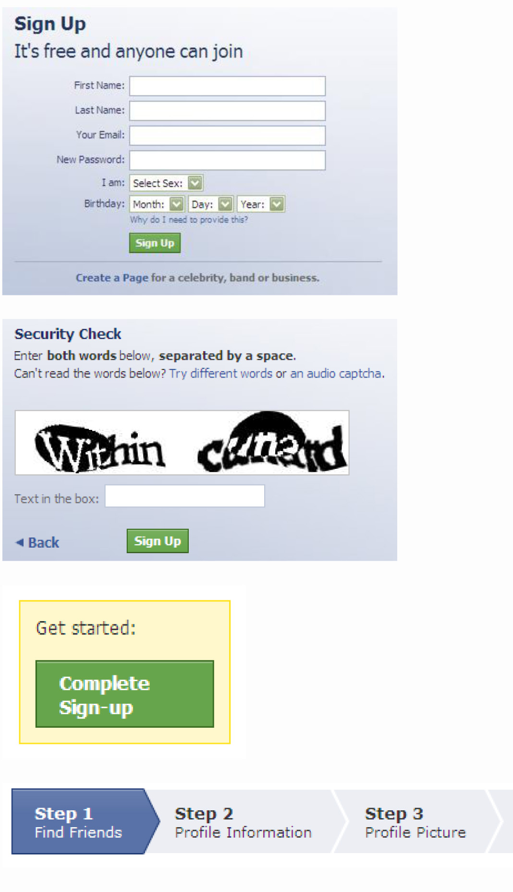 | - Go to www.facebook.com  - Enter your first name, last name, e-mail address, password, gender and birthday and click Sign Up.  - Complete the Security Check by filling in the given text in the text box provided and click Sign Up.  - Go to your e-mail account and look for a confirmation e-mail from Facebook and click on Complete Sign-up.  - Complete the information under Step 1, 2 and 3 and click on Save and Continue.  - On the Welcome page you can then activate your mobile phone (section 4), find people you know (section 5) and control what information you share (section 6).
Signing up Friends | Just use Facebook Search to find the person you know and then click on the "Add as Friend" button to the right of their search listing. A friend request will be sent to that person. Once they confirm that they actually are friends with you, they will show up on your Friends List.
Writing messages on your friends’ walls  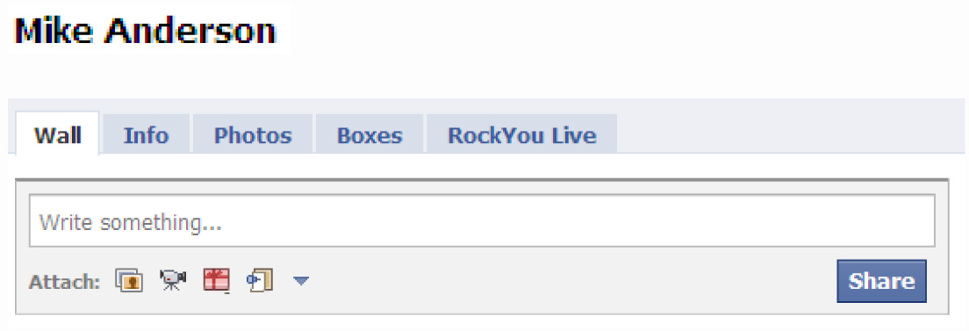 | The Wall is the center of your profile for adding new things, like photos, videos, notes and other application content. The Publisher at the top of your Wall allows you to update your status and share content through many different kinds of Wall posts.  Facebook only lets you write on your friends' Walls and your own Wall. You can also write on the Wall of any Page you become a fan of.  Click on any of your friends‟ profiles and select Wall. Write in the ‘Write something’ block provided and then click on Share. Whatever you wrote in the box will then show on that friend‟s wall.
My Account and Help Center  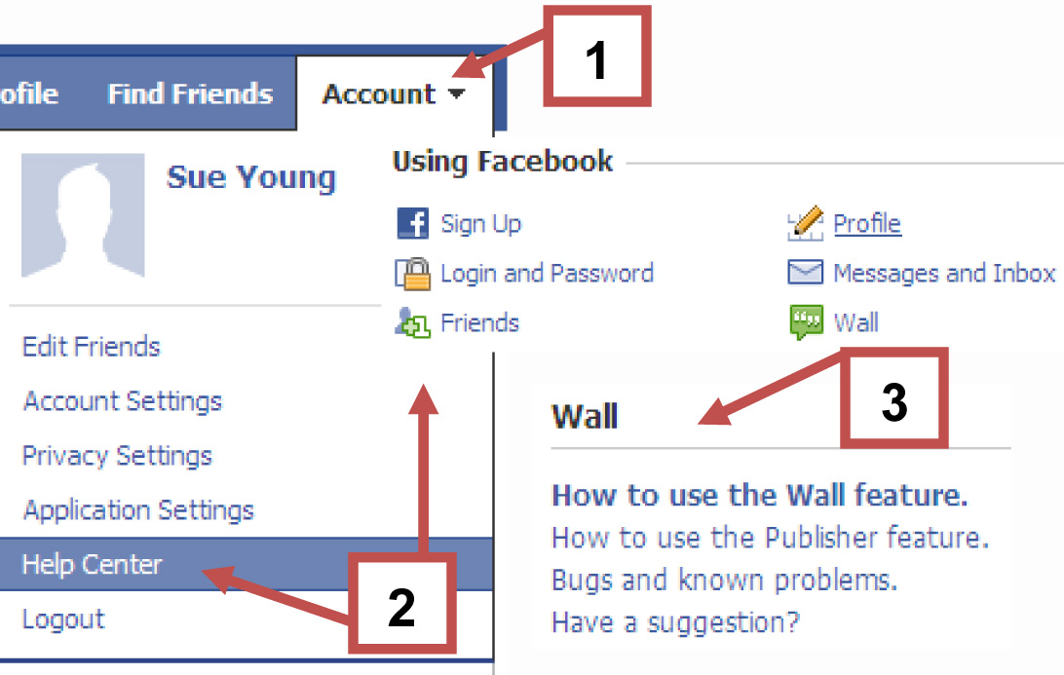 | Should you have any problems with applications, click on Account and select Help Center. A screen will appear with various applications under Using Facebook, Facebook Applications and Features, and Ads and Business Solutions.  Click on any of the items under these headings for assistance.

Group Activity 1.2

- In groups, create your own rating scale (1-5) that you will use to assess a number of websites to determine if they can be classified as social networking sites or not.
- Visit the following sites listed below and rate each site based on the scale you have developed. Provide explanations for each rating you have provided.
- Identify some of the “cool” social networking features (if any) contained within each site.
- Your facilitator will then lead a discussion inviting feedback from each of the groups.

Social Networking Site: Rating Scale
1= | 2= | 3= | 4= | 5=

 | Flickr www.flickr.com | Rating:
 | MySpace www.myspace.com | Rating:
 | News24.com www.news24.com | Rating:
 | Wikipedia www.wikipedia.org | Rating:
 | Kalahari.net www.kalahari.net | Rating:
 | 5FM Radio www.5fm.co.za | Rating:
 | Youtube www.youtube.com | Rating:
 | Iafrica.com www.iafrica.com | Rating:

5. Tracking my progress
You have reached the end of this section. Check whether you have achieved the learning outcomes for this section.

Learning outcomes | I feel confident | I still need practice
Understand the meaning of online social networking;
Understand the benefits and risks of participating in social networking sites;
Join/subscribe to a number of social networking sites.

What did you like best about this section?

What did you find most difficult in this section?

What do you need to improve on? How will you do this?

How will you do this?

