T arou

Section 1b:

Linear Programming

Maths Literacy, Workshop Series 2010

Section 1b: Linear Programming

# 1. Introduction

Solving linear inequalities is pretty much the same as solving linear equations.

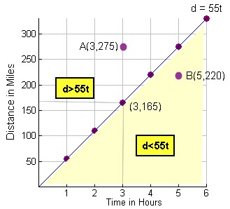  
(graph replicated from CORD Math)

The graph above can be used to locate safe and unsafe speed zones.

The lower shaded region is a safe-speed zone where d < 55t.  (d is less than 55t for any pair (t,d) in this region)

The upper region is an unsafe-speed zone where d > 55t.

1. The point with coordinates (3, 165) lies on the line d = 55t.  What does the number 165 mean?
2. At what speed would a car be traveling to satisfy the coordinates

A(3, 275)?  Is this speed safe according to this graph?

1. At what speed would a car be traveling to satisfy the coordinates

B(5, 220)?  Is this speed safe according to this graph?

1. What is the maximum speed that one can drive to stay in the safe-speed zone?

[*http://regentsprep.org/Regents/Math/Solvin/PracIneqD.htm*](http://regentsprep.org/Regents/Math/Solvin/PracIneqD.htm)

(02-03-2009)  
**Check your answers at the end of the section.**

## Learning outcomes

At the end of this section you should be able to solve linear programming problems in real life situations by making use of graphs and computers.

|  |  |
| --- | --- |
| Maths Literacy icon_2.jpg | Start up activity 1.1:  What is a linear programming problem? |

The Student Council is making coloured armbands for the football team for an upcoming game.  The school's colours are orange and black.  After meeting with students and teachers, the following conditions were established:

* The Council must make at least one black armband but not more than 4 black armbands since the black armbands might be seen as representing defeat.
* The Council must make no more than 8 orange armbands.
* Also, the number of black armbands should not exceed the number of armbands.

Let *x* = the number of black armbands *y* = the number of orange armbands

The **constraints** are as follows:

*x* > 1   and   *x* < 4  
 *y* < 8  
 *x* < *y*

The **feasible set** consists of all those points (*x,y*) that satisfy all the constraints, and is shown in yellow in the graph below.

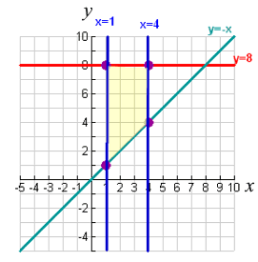

1. Convince yourself that every point in the shaded (yellow) area does indeed satisfy all the constraints.
2. Is it possible to make 3 black and 9 orange armbands? Explain.
3. Is it possible to make 4 black and 5 orange armbands? Explain.
4. Place all possible combinations of black and orange armbands that can be made on a table.
5. Suppose I can earn R50 for a black armband and R75 for an orange armband.
   1. Use the above table to find all possible profits that I can make from selling the armbands.
   2. Which combination on the table will give the maximum profit?
   3. Where is this point situated on the graph?
   4. Can you remember an easy method to find a maximum or minimum value for an objective function under all the constraints?

[*http://regentsprep.org/Regents/math/ALGEBRA/AE9/GrIneqTR.htm*](http://regentsprep.org/Regents/math/ALGEBRA/AE9/GrIneqTR.htm)

(02-03-2009)  
**Check your answers at the end of the section**.

# 2. Linear Inequality

An inequality expresses a relationship between the quantities on both sides of the inequality. This relationship is very similar to the relationship expressed by an equation.

#### Example 1.1

Determine whether or not each of the following points satisfies the inequality .

**1a** (2,4)

**1b** (3,6)

##### Solution:

Substitute the *x*-coordinate of the point for *x* and the *y*-coordinate for *y* and determine if the resulting inequality is satisfied or not.

**1.1** Substitute  and  in the inequality:



 is not correct.

Therefore the point (2,4) does not satisfy the inequality.

**1.2** Substitute  and  in the inequality:



 is correct.

Therefore the point (3,6) satisfies the inequality.

#### Example 1.2

For each of the following statements, write down the appropriate inequality. Use *x* and *y* as variables.

1. Two numbers add up to at least eight.
2. Two numbers add up to less than eight.
3. The sum of two numbers is less than or equal to eight.
4. The maximum value of the sum of two numbers is eight.
5. The difference between two numbers is greater than seven.
6. The difference between two numbers is greater than or equal to seven.
7. The minimum value of the difference between two numbers is seven.
8. A certain number is less than twice another number.

##### Solution

1. 
2. 
3. 
4. 
5. 
6. 
7. 
8. 

## Sketching Linear Inequalities

The **graph** of an inequality is the set of all points whose coordinates satisfy the inequality.

Let us work through the procedure to sketch the region represented by a linear inequality in two variables.

|  |
| --- |
| **To graph  or**  Step 1: Sketch the straight line: .  Step 2: Choose a test point not on the line: (0,0) is a good choice if the line does not pass through the origin, and if the line does pass through the origin you can choose a point on one of the axes).  Step 3: If the test point satisfies the inequality, then the set of solutions (feasible set) is the region on the same side of the line as the test point. Otherwise it is the region on the other side of the line. In either case, shade the side that does not contain the solutions leaving the feasible set unshaded. (The feasible set is sometimes called the feasible area.) |

**To graph  or**

1. Sketch the straight line: **.**
2. Choose a test point not on the line: (0,0) is a good choice if the line does not pass through the origin, and if the line does pass through the origin you can choose a point on one of the axes).
3. If the test point satisfies the inequality, then the set of solutions feasible set) is the region on the same side of the line as the test point. Otherwise it is the region on the other side of the line. In either case, shade the side that does not contain the solutions leaving the set unshaded. (The feasible set is sometimes called the feasible area.)

#### Example 1.3

Sketch the linear inequality.

Solution



*Y*

*X*

1. The inequality must first be put into standard form: ****





The intercepts are (0,10) and (5,0).

1. Next, choose the origin (0, 0) as the test point (since it is not on the line). Substituting,  in the inequality gives:

, which is not correct.

1. Since this is not a true statement, (0, 0) is not in the solution set, so the Feasible set consists of all points on the other side of the line as (0, 0). This region is left unshaded (feasible area), while the (grey) shaded region is blocked out. Since our inequality is strict (>), we use a dashed line and not a solid Line to indicate that the line itself is not part of the feasible set.

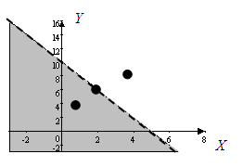

It is convenient to think of each inequality as consisting of three parts:

1. Points on the line between the two regions. This line is included in the feasible set if the inequality is not strict ( or ) not).
2. Points in the feasible set (on one side of the line, which satisfy the inequality)
3. All points not in the feasible area (on the other side of the line.)
4. Points on the line between the two regions, like (2,6), represent combinations of *x* and *y* that will satisfy the equality .

Test the point (2,6): 

1. Points in the unshaded region, like (4,10), represents combinations of *x* and *y* that satisfy the inequality. Test the point (4,10) in :  is true. Therefore (4,10) belongs to the feasible set.
2. Points in the shaded region, like (1,4), represents combinations of *x* and *y* that will not satisfy the inequality. Test the point (1,4) in :  is not true.

#### Example 1.4

Sketch the linear inequality .

##### Solution



1. The inequality must first be put into standard form: 









The intercepts on the axes are (0,5) and .

1. Next, choose the origin (0, 0) as the test point (since it is not on the line). Substituting,  in the inequality gives 
2. Since this is a true statement, (0, 0) is in the solution set, so the feasible set consists of all points on the same side of the line as (0, 0). This region is left unshaded (feasible area), while the (grey) shaded region is blocked out. Since our inequality is not strict (), we use a solid line and not a dashed line, to indicate that the points on the line belong to the feasible set.

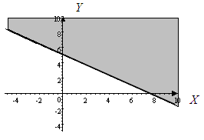

|  |
| --- |
| Draw a broken or dashed line on the boundary for inequalities with < or >.  Draw a solid line on the boundary for inequalities with  or . |

#### Example 1.5

Sketch the linear inequality .

##### Solution



*Y*

*X*

**Step 1** The inequality must first be put into standard form: ****







The intercepts are  and.

**Step 2** Next, choose the origin (0, 0) as the test point (since it is not on the line).

Substituting,  in the inequality gives: , which is not true.

**Step 3** Since this is not a true statement, (0, 0) is not in the solution set, so the feasible set consists of all points on the other side of the line as (0, 0). This region is left unshaded, while the (grey) shaded region is blocked out.

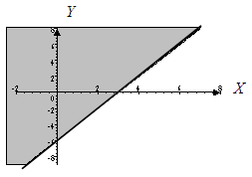

|  |  |
| --- | --- |
| Maths Literacy icon_2.jpg | Learning activity 1.2 |

1. For each of the following statements, write an appropriate inequality. Use *x* and *y* as variables.
   1. The sum of two numbers must not exceed twelve.
   2. The sum of two numbers is at most twelve.
   3. The sum of two numbers exceeds twelve.
   4. Three times a number is greater than ten.
   5. The maximum value of the sum of two numbers is ten.
   6. The minimum value of the sum of two numbers is ten.
   7. Three times a certain number is less than twice another number.
2. Determine whether or not the given point satisfies the given inequality. Then sketch the feasible set. Use separate sets of axes for the different inequalities.
   1. , (3, 15)
   2. , (3,0)
   3. , (4, 6)
   4. , 

## Sketching a System of Linear Inequalities

At first, our convention of shading the region of points not satisfying an inequality (instead of shading the feasible set) may have seemed odd. However, the real advantage of this convention becomes apparent when graphing a system of several inequalities. Can you image trying to find the common feasible set to all inequalities if each feasible set of each inequality had been shaded. It would have been necessary to locate the points that had been shaded, say, for example, three times, which would make it harder to detect them.

### Feasible Region

The feasible region determined by a collection of linear inequalities is the collection of points that satisfy all of the inequalities simultaneously.

#### Example 1.6

Determine whether the points (5,3) and (1,2) are in the feasible set of the following system of inequalities:







##### Solution:

We can just substitute the coordinates of the points into each of the inequalities of the system and see whether or not all of the inequalities are satisfied.

**Check (5,3):**

  true

  true

 true

Hence (5,3) is in the feasible set.

**Check (1,2):**

  not true

  not true

 true

Hence (1,2) is not in the feasible set.

Let us study the procedure to graph the feasible region determined by a collection of linear inequalities in two variables.

|  |
| --- |
| **Graph the feasible region**  **Step 1** Sketch the regions represented by each inequality on the same set of axes  **Step 2** Shade the parts of the plane that you do not want.  **Step 3** What is unshaded when you are done, is the feasible region. |

#### Example 1.7

Graph the feasible set for the system of inequalities:







##### Solution

1. The inequalities must first be put into standard form: ****

|  |  |
| --- | --- |
| The intercepts are  and. | The intercepts are  and. |
| Is a horizontal line that coincides with the *x*-axis |  |



*X*

*Y*

1. Next, choose the origin (0, 0) as the test point for  and .

Substituting,  in : 

Since this is not a true statement, (0, 0) is not in the solution set, so the feasible set (for the inequality ) consists of all points on the other side of the line as (0, 0). Shade the region below the line to indicate that it is blocked out.

Substituting,  in : 

Since this is not a true statement, (0, 0) is not in the solution set, so the feasible set (for the inequality ) consists of all points on the other side of the line  as (0, 0). Shade the region above the line to indicate that it is blocked out for  the region shaded is everything below and on the *x*-axis to indicate that the feasible set consists of all points above the x-axis for this inequality.

1. The feasible region for the system is left unshaded, while the (grey) shaded region is blocked out. The feasible region for the following collection of inequalities is the unshaded region shown below (including its boundary).

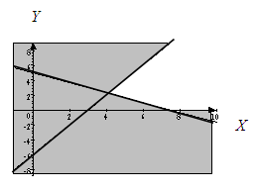

#### Example 1.8

Graph the feasible set for the system of inequalities:









##### Solution:

1. The inequalities must first be put into standard form: ****

|  |  |
| --- | --- |
| The intercepts are  and. | The intercepts are  and. |
| Is a vertical line with intercept (1,0) | Is the horizontal line that coincides with the *x*-axis |

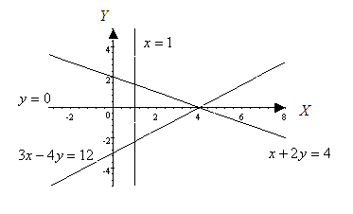

1. Next, choose the origin (0, 0) as the test point for  and  and. Substituting,  in  gives 

Since this is a true statement, (0, 0) is in the solution set, so the feasible set for the inequality  consists of all points on the same side of the line  as (0, 0). Shade the region below the line to indicate that it is blocked out. Substituting,  in : 

Since this is not a true statement, (0, 0) is not in the solution set. So the feasible set for the inequality  consists of all points on the other side of the line  as (0, 0). Shade the region below the line to indicate that it is blocked out. Substituting,  in : 

Since this is not a true statement, (0, 0) is not in the solution set. So the Feasible set for the inequality  consists of all points on the other side of the line  as (0, 0). Shade the region to the left of the line to indicate that it is blocked out.

For  the region shaded is everything below the *x*-axis, as well as on the x-axis, to indicate that the feasible set for the inequality  consists of the region above the x-axis.

1. The feasible region for the system of inequalities is left unshaded, while the (grey) shaded region is blocked out. See figure below.

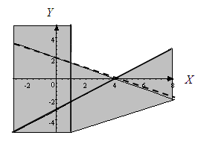

|  |  |
| --- | --- |
| Maths Literacy icon_2.jpg | Learning activity 1.3 |

1. Determine whether the given point is in the feasible set of this system of inequalities:











* 1. (8,7)
  2. (9,10)
  3. (16,0)

1. Graph the feasible set for the system of inequalities





1. Graph the feasible set for the system of inequalities







1. Graph the feasible set for the system of inequalities







1. The lines  and  are drawn below.



1. Write down the inequalities that represent the feasible region for
   1. section 1
   2. section 2
   3. section 3
   4. section 4

## Optimum point

We must select from the feasible set an optimum point. That is a point that corresponds to a maximum or a minimum value for a given function (in terms of x and y) that we want to maximise or minimise, the so-called **objective function.**

#### Example 1.9

Maximise the function  subject to the following inequalities (constraints):









Suppose further that x and y are allowed to be integers only.

##### Solution

1. The inequalities must first be put into standard form: ****

|  |  |
| --- | --- |
| *The intercepts are (0,50) and (50,0)* | *Is the vertical line that coincides with the y-axis* |
| *The intercepts are (0,60) and (40,0)* | *Is the horizontal line that coincides with the x-axis* |



*Y*

*X*

1. Next, choose the origin (0, 0) as the test point for  and .

Substituting,  in: 

Since this is a true statement, (0, 0) is in the solution set, so the feasible set in this case consists of all points on the same side of the line  as (0,0). Shade the region above the line to indicate that it is blocked out.

Substituting,  in: 

Since this is a true statement, (0, 0) is in the solution set, so, in this case the feasible set consists of all points on the same side of the line as (0, 0). Shade the region above the line to indicate that it is blocked out.

For  the region shaded is everything below the *x*-axis.

For  the region shaded is everything to the left of the *y*-axis.

1. The feasible region is left unshaded, while the (grey) shaded region is blocked out. See figure below.

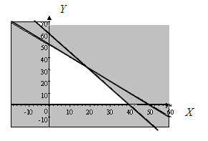

1. Now, let's find the maximum value of the function  where *x* and *y* are allowed to vary in the feasible region, and only assume integral values. The solution set is represented by the dots in our feasible set for some of the points. Points such as (10,1), (10,2)…(10,49) etc. are not shown.



*X*

*Y*

|  |  |  |
| --- | --- | --- |
| **Point** | **Function** | **Value** |
| (0,0) |  | 0 |
| (0,50) |  | 2350 |
| (0,40) |  | 1880 |
| (0,30) |  | 1410 |
| (0,20) |  | 940 |
| (0,10) |  | 470 |
| (0,0) |  | 0 |
| (10,0) |  | 560 |
| (20,0) |  | 1120 |
| (30,0) |  | 1680 |
| (40,0) |  | 2240 |
| (10,10) |  | 1030 |
| (10,20) |  | 1500 |
| (10,30) |  | 1970 |
| (10,40) |  | 2440 |
| (20,10) |  | 1590 |
| (20,20) |  | 2060 |
| (20,30) |  | 2530 |
| (30,10) |  | 2150 |

To find the maximum value we can substitute all possible points in the feasible region into the function,.

The maximum value that occurs in this table is 2530 and it occurs at the point (20, 30). (Note that it is still possible for the objective function to attain even higher values, since we have not checked all points with integral coordinates in the feasible region.)

|  |
| --- |
| **Corner point theorem**  The maximum (or minimum) value of a given objective function is achieved at one of the corner points (vertices) of the feasible set. |

Let us look at the previous problem again. The vertices of the feasible set are (0, 50), (0, 0), (20, 30) and (40, 0). To find the maximum value, we need to substitute only these corner points into , and find the largest value. From the table above we can see that (20, 30) gives, after all, the largest value, namely 2530, for .

The graphical method for finding the maximum or minimum value for a given function in two unknowns is as follows.

|  |
| --- |
| **Finding maximum or minimum value for a given function**   1. Write inequalities in standard form:  and draw graph. 2. Find the feasible region. 3. Graph the feasible region. 4. Compute the coordinates of the vertices of the feasible region. Substitute the coordinates of the vertices into the objective functionThat has to be maximised or minimised, and check which gives the optimal value.     If the feasible region is not bounded, this method can be misleading: optimal solutions always exist when the feasible region is bounded, but may or may not exist when the feasible region is unbounded. |

#### Example 1.10

Minimise the function  subject to the following constraints:











##### Solution:

**Step 1:** The inequalities must first be put into standard form: ****

|  |  |
| --- | --- |
| *The intercepts are  and* | *The intercepts are  and (10,0)* |
| *The intercepts are (0,10) and* | *Is the vertical line that coincides with the y-axis* |
|  | *Is the horizontal line that coincides with the x-axis* |

*X*







*Y*

**Step 2:** Next, choose the origin (0, 0) as the test point for each of 

 and .

Substituting,  in : 

Since this is a true statement, (0, 0) is in the solution set, so the feasible set in this case consists of all points on the same side of the line  as (0, 0). Shade the region above the line to indicate that it is blocked out.

Substituting,  in : 

Since this is a true statement, (0, 0) is in the solution set, so the feasible set in this case consists of all points on the same side of the line as (0, 0). Shade the region above the line to indicate that it is blocked out.

Substituting,  in : 

Since this is not a true statement, (0, 0) is not in the solution set, so the feasible set in this case consists of all points on the other side of the line  as (0, 0). Shaded the region below the line that is blocked out.

For  the region to be blocked out is everything below *x*-axis, hence that region is shaded.

For  the region to be blocked out is everything to the left of the *y*- axis, hence that region is shaded.

**Step 3:** The feasible region is left unshaded, while the (grey) shaded region is blocked out.

The feasible region for the following collection of inequalities is the unshaded region shown below (including its boundary).

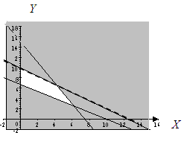

**Step 4:** To find the minimum value of the objective function we can substitute our vertices of the feasible region into the function, . The vertices are , (0;10),  and . (Exactly how to find these points of intersection will be discussed later.)

|  |  |  |
| --- | --- | --- |
| **Point** | **Function** | **Value** |
|  |  | 1,3333 |
| (0;10), |  | 2 |
|  |  | 2,5883 |
|  |  | 2,375 |

From the table above we can see that the objective function attains its smallest value, namely 1,3333, at

#### Example 1.11

Maximise the function  subject to the following constraints:









##### Solution:

**Step 1:** The inequalities must first be put into standard form: 

|  |  |
| --- | --- |
| *The intercepts are (0,10) and (5,0)* | *Is the vertical line that coincides with the y-axis* |
| *The intercepts are (0,7) and (14,0)* | *Is the horizontal line that coincides with the x-axis* |



*X*

*Y*

**Step 2:** Next, choose the origin (0, 0) as the test point for  and .

Substituting,  in: 

Since this is a true statement, (0, 0) is in the solution set, so the feasible set in this case consists of all points on the same side of the line as (0, 0). Shade the region below the line to indicate that it is blocked out.

Substituting,  in: 

Since this is a true statement, (0, 0) is in the solution set, so the feasible set in this case consists of all points on the same side of the line as (0, 0). Shade the region below the line to indicate that it is blocked out.

For  the region to block out is everything below the x-axis, hence this region is shaded.

For  the region to block out is everything to the left of the y-axis, hence this region is shaded

**Step 3:** The feasible region is left unshaded, while the (grey) shaded region is blocked out.

The feasible region for the following collection of inequalities is the unshaded region shown below (including its boundary).

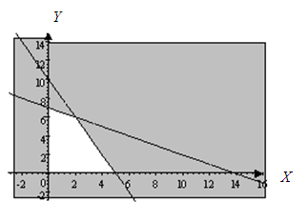

*X*

**Step 4:** To find the maximum value of the objective function, we substitute the vertices of the feasible region into the function. The vertices on the axes are (0,0), (0,7) and (5,0). To find the other vertex we have to find the intersection point of the two lines.

We use substitution to find the intersection point.

…A

…B

Make *y* the subject in A:

…C

Substitute C in B:









Substitute  in B:





The intersection point is (2,6), which is the other vertex of the feasible region.

|  |  |  |
| --- | --- | --- |
| **Point** | **Function** | **Value** |
| (0,0) |  | 0 |
| (0,7) |  | 28 |
| (2,6) |  | 30 |
| (5,0) |  | 15 |

From the table above we can see that the objective function attains its maximum value, namely 30, at the vertex (2,6).

#### Example 1.12

Maximise the function  subject to the constraints:











##### Solution:

**Step 1:** The inequalities must first be put into standard form: 

|  |  |
| --- | --- |
| *The intercepts are  and* | *The intercepts are  and (36,0)* |
| *The intercepts are (0,18) and* | *Is the vertical line through the point (3;0)* |
|  | *Is the horizontal line through the point (0;1)* |

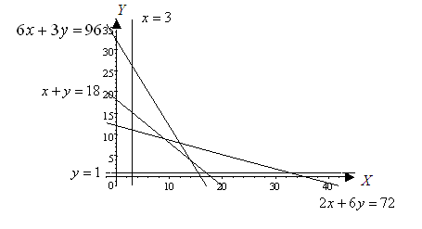

**Step 2:** Next, choose the origin (0, 0) as the test point for ,

,, and.

Substitute,  in : 

Since this is a true statement, (0, 0) is in the solution set, so the feasible set for this constraint is the set consisting of all points on the same side of the line as (0, 0). Shade the region above the line to indicate that it is blocked out.

Substitute,  in: 

Since this is a true statement, (0, 0) is in the solution set, so the feasible set in this case consists of all points on the same side of the line as (0, 0). Shade the region above the line to indicate that it is blocked out.

Substitute,  in : 

Since this is a true statement, (0, 0) is in the solution set, so the feasible set here consists of all points on the same side of the line as (0, 0). Shade the region above the line to indicate that it is blocked out.

For , shade the region below the line to indicate that it is blocked out.

For , shade the region to the left of the line to indicate that it is blocked out.

**Step 3:** The feasible region is left unshaded, while the (grey) shaded region is blocked out.

The feasible region for the following collection of inequalities is the unshaded region shown below (including its boundary).

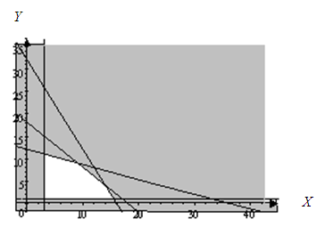

**Step 4:** To find the maximum value of the function , subject to the constraints, we substitute the vertices of the feasible region into the function and compare the corresponding function values.

Let us find these points of intersection.

We use substitution to find the point where the lines  and intersect. Note that can also be written  (see the table above).

…A

…B

Substitute A into B:





The vertex is (3,11).

We use substitution to find the point where the lines  and  intersect.

…A

…B

Substitute A in B:







Put  in A:





The vertex is (9,9)

We use substitution to find the point where the lines  and intersect.

…A

…B

Substitute A in B:





Put  in A:





The vertex is (14,4)

We use substitution to find the point where the lines  and intersect.

…A

…B

Substitute A in B:







Put  in B:





The vertex is .

|  |  |  |
| --- | --- | --- |
| **Point** | **Function** | **Value** |
| (3,1) |  | 310 |
| (3,11) |  | 1010 |
| (9,9) |  | 1350 |
| (14,4) |  | 1400 |
|  |  | 1310 |

From the table above it follows that the objective function , subject to the given constraints, attains its maximum value of 1400 at the point (14,4).

|  |  |
| --- | --- |
| Maths Literacy icon_1.jpg | Assessment activity 1.3 |

1. Maximise the function  subject to the following constraints:









1. Minimise the function  subject to the following constraints:









1. Maximise the function  subject to the following constraints:











1. Minimise the function  subject to the following constraints:













1. Minimise the function  subject to the following constraints:











1. Minimise subject to the constraints:









# 3. Linear Programming in two variables

Many manufacturers produce various kinds of products; the important thing is that they make the best use of their resources such as materials, labour, and machinery.

They also need to decide which products to manufacture that will maximise their profits. The theory of Linear Programming can help them to make these decisions.

Linear programming is a method for solving problems in which a linear function is to be maximised or minimised, subject to certain types of constraints. Such problems are examples of optimization problems.

Let us start with a typical problem that can be solved by linear programming.

1. A financial analyst must select an investment portfolio from a variety of stock and bond investment alternatives. The analyst would like to establish the portfolio that maximises the return on investment.
2. A firm must produce a quality product, less expensive than its competitors. Thus the firm has to minimise its cost.
3. A farmer has to decide on the ratio of ingredients that will minimise the cost of producing a food mix for his cattle.

Even though the applications are diverse, there is one basic property that all of these problems have in common. That is, in each example we were concerned with maximizing or minimizing a given function. We call this the objective function. The objective function is often of the type “a profit to maximise” or “a cost to minimise”.

A second property that is common to all problems is that there are restrictions or constraints that limit the degrees of freedom among which we can pursue our objective. For most planning problems there are real restrictions which limit the kinds of plans which can be considered. These restrictions appear in the form of resources in limited supply, for example, limited production-machinery capacity, limited number of workers, limited amount of time on a given shift, limited labor supply, limited working capital, etc.

By using what we call the corner point theorem, we can find an optimal solution to our problem.  When we graph these constraints, we obtain a feasible region that contains our solutions.  The corner point theorem says that if a maximum or minimum value exists, it will occur at a corner point (vertex) of this feasible region.

## Writing constraints and objective functions

|  |
| --- |
| **Procedure to write constraints and objective functions**   1. Translate the problem into mathematical language. Identify the unknown quantities and define corresponding variables. 2. Organise the data in a table. Translate the restrictions or constraints into linear inequalities. 3. Write the constraints for the problem from the table. 4. Write down the objective function. |

#### Example 1.13

Give the constraints and objective function for the following problem.

A manufacturer makes two types of chairs, type A and type B.  It takes 20 hours to assemble, and 2 hours to finish off chair A. It takes 25 hours to assemble, and 5 hours to finish off chair B. The factory has at most 400 hours per day available for assembly and 60 hours per day available for finishing off chairs.  A profit of R300 is made on a type A chair, and a profit of R500 on a type B chair. Find the number of each type of chair that the factory should produce to maximise his profit.

Solution

**Step 1:** Let *x* = the number of type A chairs produced per day

*y* = the number of type B chairs produced per day

**Step 2:** Organize the information into a table

|  |  |  |  |
| --- | --- | --- | --- |
|  | **Chair A** | **Chair B** | **Total** |
| *Hours for Assembly* |  |  |  |
| *Hours for finishing off* |  |  |  |

**Step 3:** Since we can't use negative amounts of chairs, the first two constraints are the usual ones:









**Step 4:** The objective function is:



#### Example 1.14

Give the constraints and objective function for the following problem.

Two types of crates are used for transporting items, type A and type B. Each crate of type A requires six square meter of floor space, and has a volume of ten cubic meters. Each crate of type B requires eight square meter of floor space, and has a volume of twenty cubic meters. Each type A crate costs R15 000 and a type B crate costs R25 000. The truck cannot carry more than 140 cubic meters of crates and has a floor space of 72 square meters. Determine the number of each type of crate that will minimise the total cost.

##### Solution

**Step 1:** Let *x* = the number of type A crates

*y* = the number of type B crates

**Step 2:** Organize the information into a table

|  |  |  |  |
| --- | --- | --- | --- |
|  | **Crates of cargo A** | **Crates of  cargo B** | **Total** |
| *Floor space in square meter* |  |  |  |
| *Volume in cubic meter* |  |  |  |

**Step 3:** Since we can't use a negative number of crates, the first two Constraints are the usual ones:









**Step 4:** The objective function is:



#### Example 1.15

Give the constraints and objective function for the following problem.

A company manufactures two products (X and Y) using two machines (A and B). Each unit of X that is produced requires 50 minutes processing time on machine A and 30 minutes processing time on machine B. Each unit of Y that is produced requires 24 minutes processing time on machine A and 33 minutes processing time on machine B.

The available processing time on machine A is estimated to be 2 400 minutes and on machine B to be 2 100 minutes in a week.

The demand for X in the current week is estimated to be not more than 35 units and for Y at most 5 units. Company policy is to maximise the total number of units at the end of the week.

##### Solution

**Step 1:** Let *x* = the number of units of type X produced in the current week

Let *y* = the number of units of type Y produced in the current week

**Step 2:** Organise the information into a table

|  |  |  |  |
| --- | --- | --- | --- |
|  | **Units X** | **Unit Y** | **Total** |
| *Minutes on Machine A* |  |  |  |
| *Minutes on Machine B* |  |  |  |

**Step 3:** Since we can't produce a negative number of units, the first two constraints are the usual ones:













**Step 4:** The objective function is:



#### Example 1.16

Give the constraints and objective function for the following problem.

A farmer produces corn and soybeans. The restrictions on producing corn and soybeans are twofold, namely labour hours and machine hours. Corn production requires 13 minutes of labour, and 20 minutes of machine time per unit. Soybeans production requires 40 minutes of labour, and 29 minutes of machine time per unit.

The farmer has 2 400 minutes of labor time available in a working week but only 2 100 minutes of machine time. According to a contract, the farmer has to produce 10 units of corn per week for a certain customer.

The net profit on each unit of corn produced is R200 and for each unit of soybeans R300. Find the number of units of each of the commodities that should be produced to maximise the profit.

Solution

**Step 1:** Let *x* = the number of units of corn produced in a week

Let *y* = the number of units of soybeans produced in a week

**Step 2:** Organize the information into a table

|  |  |  |  |
| --- | --- | --- | --- |
|  | **Corn** | **Soybeans** | **Total** |
| *Labour hours per week* |  |  |  |
| *Machine hours per week* |  |  |  |

**Step 3:** Since the farmer can't produce a negative number units, the first two Constraints are the usual ones:











**Step 4:** The objective function is:



#### Example 1.17

Give the Constraints and objective function for the following problem.

A nutritionist, working for a cycling company, must meet certain nutrition requirements and yet keep the weight of the food at a minimum. She is considering a combination of two foods which are packed in tubes. Each tube of food X contains 8 units of protein, 12 units of carbohydrate, 2 units of fat, and weighs 0,45 kg. Each tube of food Y contains 12 units of protein, 12 units of carbohydrate, 1 units of fat, and weighs 0,65 kg. The requirements call for at least 24 units of protein, 36 units of carbohydrate and 4 units of fat. Also, the total weight of the food cannot exceed 5 kg.

##### Solution

**Step 1:** Let *x* = the number of tubes of food X

Let *y* = the number of tubes of food Y

**Step 2:** Organize the information into a table

|  |  |  |  |
| --- | --- | --- | --- |
|  | **Corn** | **Soybeans** | **Total** |
| *Protein* |  |  |  |
| *Carbohydrate* |  |  |  |
| *Fat* |  |  |  |

**Step 3:** Since no negative number of tubes is possible, the first two Constraints are the usual ones:













**Step 4:** The objective function is:



|  |  |
| --- | --- |
| Maths Literacy icon_2.jpg | Learning activity 1.5 |

Give constraints and objective functions for the following problems.

1. A manufacturer makes two types of golf bags – standard bags and deluxe bags. For simplicity, divide the production process into three distinct operations – cutting and dying, sewing and finishing.

The amount of labor required for each operation varies. To manufacture a standard bag requires 6 hours of cutting and dying, 1 hour of sewing and 2 hours of finishing.

For a deluxe bag, 3 hours of cutting and dying, 1 hour of sewing and 6 hours of finishing are required.

Due to limited availability of skilled labor, tools and equipment, the factory can only deal with 96 labor-hours for cutting and dying, 18 labor-hours for sewing and 72 labor hours for finishing per day.

The profit per standard bag is R900 and R1 500 per deluxe bag. How many standard bags and how many deluxe bags should be produced each day to maximise the profit?

1. A manufacturer of calculators produces a basic model that yields a R25 profit, and a scientific model yielding a profit of R50. To meet the demand, the company needs to produce at least 200 of the basic calculators and at least 80 of the scientific calculators daily. The largest daily output possible is a total of 400 calculators. How many of each model should be produced to maximise the profit?
2. A company makes electronic hockey and soccer games. Long-term projections indicate an expected demand of at least 100 hockey games and 80 soccer games each day. Because of limitations on production capacity, no more than 200 hockey games and a maximum of 170 soccer games can be manufactured daily. To satisfy a contract, a total of at least 200 games must be supplied each day.

If each hockey game sold results in a R200 loss, but each soccer game earns a R500 profit, how many of each type should be made daily to maximise net profits?



1. You can produce two types of candy to sell at the concert. Energy bars sell at a profit of R3,70 each, while nougat bars sell at a profit of R7 each. The manufacturing process consists of three main operations: blending, cooking and packaging. The blending process takes 2 minutes for energy bars and 6 minutes for nougat bars. The cooking process takes 3 minutes for energy bars and 5 minutes for nougat bars. Packaging takes 1 minute for energy bars and 2 minutes for nougat bars. During each production run, the blending equipment is available for a maximum of 25 hours, the cooking equipment for at most 30 hours, and the packaging equipment for at least 5 hours. Determine how many bars of each kind you should make in order to maximise your profit. [Hint: change all hours into minutes.]

## The Graphical Solution Approach

|  |
| --- |
| **Steps to be followed in approaching any linear programming problem.**   1. Translate the problem into mathematical language. Identify the unknown quantities and define corresponding variables. 2. Organize the data in a table. Translate the restrictions or Constraints into linear inequalities. 3. Write down the constraints for the problem from the table. 4. Form the objective function. 5. Graph the feasible set. 6. Determine the vertices of the feasible set. 7. Evaluate the objective function at each vertex. Determine at which vertex the optimum value of the objective function is attained. |

Let us solve the examples from the previous section.

#### Example 1.18

A manufacturer makes two types of chairs, type A and type B.  It takes 20 hours to assemble, and 2 hours to finish off chair A. It takes 25 hours to assemble, and 5 hours to finish off chair B. The factory has at most 400 hours per day available for assembly and 60 hours per day available for finishing off chairs.  A profit of R300 is made on a type A chair, and a profit of R500 on a type B chair. Find the number of each type of chair that the factory should produce to maximise his profit.

Solution

**Step 1:** Let *x* = the number of type A chairs produced per day

*y* = the number of type B chairs produced per day

**Step 2:** Organize the information into a table

|  |  |  |  |
| --- | --- | --- | --- |
|  | **Chair A** | **Chair B** | **Total** |
| *Hours for Assembly* |  |  |  |
| *Hours for finishing off* |  |  |  |

**Step 3:** Since we can't use negative amounts of chairs, the first two constraints are the usual ones:









**Step 4:** The objective function is:



**Step 5:** The inequalities must first be put into standard form: ****

|  |  |
| --- | --- |
| *The intercepts are  and* | *The intercepts are  and* |
| *It is the horizontal line that coincides with the x-axis* | *It is the vertical line that coincides with the y-axis* |

Next, choose the origin (0, 0) as the test point for  and 

Substituting,  in : 

Since this is a true statement, (0, 0) is in the solution set, so the feasible set in this case consists of all points on the same side of the line  as (0, 0). Shade the region above the line to indicate that it is blocked out.

Substituting,  in : 

Since this is a true statement, (0, 0) is in the solution set, so the feasible set here consists of all points on the same side of the line  as (0, 0). Shade the region above the line to indicate that it is blocked out.

For , shade the region below the x-axis to show that it is blocked out.

For , shade the region to the left of the y-axis to indicate that it is blocked out.

The feasible region is left unshaded, while the (grey) shaded region is blocked out.

The feasible region for the following collection of inequalities is the unshaded region shown below (including its boundary).



*X*

*Y*





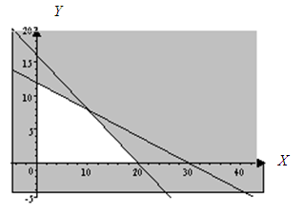

**Step 6:** To find the maximum possible value for the objective function , we substitute the vertices of the feasible region into the function.

Let us first find these vertices:

We use substitution to find the point where the lines  and  intersect. Note that we can rewrite the second relation as .

…A

…B

Substitute A in B:









Put  in B:







The vertex is (10,8)

The complete set of vertices is given by (0, 0), (0, 12), (20, 0) and (10,8).

|  |  |  |
| --- | --- | --- |
| **Point** | **Function** | **Value** |
| (0,0) |  | 0 |
| (0,12) |  | 6000 |
| (20,0) |  | 6000 |
| (10,8) |  | 7000 |

From the table above we can see that reaches its maximum value at the vertex (10,8).

This means that the manufacturer should produce 10 chairs of type A, and 8 chairs of type B to maximise the profit.

In the previous problem a factory produces two types of chairs. Hence both constraints, together with the non-negativity requirements, must be satisfied simultaneously. It is therefore necessary to consider only those combinations of type A chairs and type B chairs that will not exceed the time available in assembly and finishing.

The feasible region ABCD represents all possible combinations of type A and type B chairs satisfying all restrictions simultaneously. Only at the intersection of the constraint lines (point B) are all resources fully utilized.

The (vertical) distance between the line AB and the line EB, when converted into units of resource, represents unused assembly time for production combinations along the AB line. For production plans along the BC line there will be hours in the finishing department that are unused, shown by the (horizontal) distance between lines BC and BF.

Although only one strategy, represented by point B, exactly exhausts all units of the resources available, this point does not necessarily represent the optimal strategy.

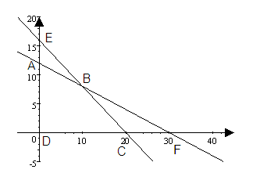

#### Example 1.19

Two types of crates are used for transporting items, type A and type B. Each crate of type A requires six square meter of floor space, and has a volume of ten cubic meters. Each crate of type B requires eight square meter of floor space, and has a volume of twenty cubic meters. Each type A crate costs R15 000 and a type B crate costs R25 000. The truck cannot carry more than 140 cubic meters of crates and has a floor space of 72 square meters. Determine the number of each type of crate that will minimise the total cost.

##### Solution

**Step 1:** Let *x* = the number of type A crates

*y* = the number of type B crates

**Step 2:** Organize the information into a table

|  |  |  |  |
| --- | --- | --- | --- |
|  | **Crates of cargo A** | **Crates of cargo B** | **Total** |
| *Floor space in square meter* |  |  |  |
| *Volume in cubic meter* |  |  |  |

**Step 3:** Since we can't use a negative number of crates, the first two Constraints are the usual ones:









**Step 4:** The objective function is:



**Step 5:** The inequalities must first be put into standard form: 

|  |  |
| --- | --- |
| *The intercepts are  and* | *The intercepts are  and* |
| *This is the horizontal line that coincides with the x-axis* | *This is the vertical line that coincides with the y-axis* |

Next, choose the origin (0, 0) as the test point for  and .

Substituting,  in: 

Since this is a true statement, (0, 0) is in the solution set, so the feasible set here consists of all points on the same side of the line  as (0, 0). Shade the region above the line to indicate that it is blocked out.

Substituting,  in : 

Since this is a true statement, (0, 0) is in the solution set, so the set in this case consists of all points on the same side of the line  as (0, 0). Shade the region above the line to indicate that it is blocked out.

For  the region shaded is everything below the x-axis to show that it is blocked out.

For  the region shaded is everything to the left of the y-axis to indicate that it is blocked out.

The feasible region is left unshaded, while the (grey) shaded region is blocked out.

The feasible region for the following collection of inequalities is the unshaded region shown below (including its boundary).

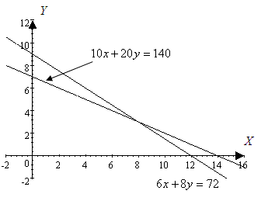

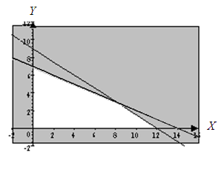

**Step 6:** To find the maximum value for the function (subject to the constraints), we substitute the vertices of the feasible region into the function.

Let us first identify these vertices:

Use substitution to find the point of intersection between the lines  and . The latter relation can also be written as .

…A

…B

Substitute A in B:









Put  in B:







So this vertex is (8,3).

The complete set of vertices is given by (0,0), (0,7), (12,0) and (8,3).

|  |  |  |
| --- | --- | --- |
| **Point** | **Function** | **Value** |
| (0,0) |  | 0 |
| (0,7) |  | 175000 |
| (12,0) |  | 180000 |
| (8,3) |  | 195000 |

From the table we can see that  attains its maximum value, namely 19500, at (8,3).

This means that 8 type A crates and 3 type B crates should be used to maximise the profit.

#### Example 1.20

A company manufactures two products (X and Y) using two machines (A and B). Each unit of X that is produced requires 50 minutes processing time on machine A and 30 minutes processing time on machine B. Each unit of Y that is produced requires 24 minutes processing time on machine A and 33 minutes processing time on machine B.

The available processing time on machine A is estimated to be 2 400 minutes and on machine B to be 2 100 minutes in a week.

The demand for X in the current week is estimated to be not more than 35 units and for Y at most 5 units. Company policy is to maximise the total number of units at the end of the week.

##### Solution

**Step 1:** Let *x* = the number of units of type X produced in the current week

Let *y* = the number of units of type Y produced in the current week

**Step 2:** Organise the information into a table

|  |  |  |  |
| --- | --- | --- | --- |
|  | **Units X** | **Unit Y** | **Total** |
| *Minutes on Machine A* |  |  |  |
| *Minutes on Machine B* |  |  |  |

**Step 3:** Since we can't produce a negative number of units, the first two constraints are the usual ones:













**Step 4:** The objective function is:



**Step 5:** The inequalities must first be put into standard form: 

|  |  |
| --- | --- |
| *The intercepts are  and* | *The intercepts are  and* |
| *Is the vertical line through the point (35;0)* | *Is the horizontal line through the point (0;5)* |
| *Is the horizontal line that coincides with the x-axis* | *Is the vertical line that coincides with the y-axis* |

Next, choose the origin (0, 0) as the test point for  and .

Substituting,  in: 

Since this is a true statement, (0, 0) is in the solution set, so the feasible set for this case consists of all points on the same side of the line as (0, 0). Shade the region above the line to indicate that it is blocked out.

Substituting,  in : 

Since this is a true statement, (0, 0) is in the solution set, so the feasible set here consists of all points on the same of the line  as (0, 0). Shade the region above the line to indicate that it is blocked out.

For  the region shaded is everything below the x-axis to show that it is blocked out.

For  the region shaded is everything to the left of the y-axis to show that it is blocked out.

For  the region shaded is everything below the line  to show that it is blocked out.

For  the region shaded is everything to the right of the line  to show that it is blocked out.

The feasible region is left unshaded, while the (grey) shaded region is blocked out.

The feasible region for the following collection of inequalities is the unshaded region shown below (including its boundary).

*Y*

*X*











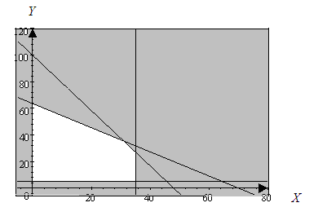

**Step 6:** To find the maximise value for the objective function , substitute the vertices of the feasible region into the function, and compare the values.

Let us first determine the vertices.

We use substitution to find the points of intersection for the lines

 and . The first relation can also be written as .

…A

…B

Substitute A in B:







 *(Remember to work with whole numbers)*

Put  in B:







Use substitution to find the intersection point for the lines

 and .

…A

…B

Substitute A in B:







The complete set of vertices is given by (0,5), (0,63), (32,35), (35,27) and (35,5).

|  |  |  |
| --- | --- | --- |
| **Point** | **Function** | **Value** |
| (0,5) |  | 0 |
| (0,63) |  | 63 |
| (31,35) |  | 66 |
| (35,27) |  | 62 |
| (35,5) |  | 40 |

From the table it is clear that the objective function  attains its largest value, namely 67, at the vertex (31,35).

This implies that 31 units of X and 35 units of Y should be produced to maximise the total number of units produced at the end of the week.

#### Example 1.21

A farmer produces corn and soybeans. The restrictions on producing corn and soybeans are twofold, namely labour hours and machine hours. Corn production requires 13 minutes of labour, and 20 minutes of machine time per unit. Soybeans production requires 40 minutes of labour, and 29 minutes of machine time per unit.

The farmer has 2 400 minutes of labor time available in the next working week but only 2 100 minutes of machine time. The farmer has a specific contract to produce 10 units of corn per week for a particular customer.

The net profit received for each unit of corn produced is R200 and for each unit of soybeans R300. Find the number of units of each of the commodities that should be produced to maximise the net profit. [Round all numbers to the nearest whole number]

##### Solution

**Step 1:** Let *x* = the number of units of corn produced

Let *y* = the number of units of soybeans produced

**Step 2:** Organize the information into a table

|  |  |  |  |
| --- | --- | --- | --- |
|  | **Corn** | **Soybeans** | **Total** |
| *Labour hours* |  |  |  |
| *Machine hours* |  |  |  |

**Step 3:** Since it is not possible to produce a negative number of units, the first two constraints are the usual ones:











**Step 4:** The objective function is:



**Step 5:** The inequalities must first be put into standard form: 

|  |  |
| --- | --- |
| *The intercepts are  and* | *The intercepts are  and* |
| *Is the horizontal line that coincides with the x-axis* | *Is the vertical line that coincides with the y-axis* |
| *Is the vertical line through the point (10,0)* |  |

Next, choose the origin (0, 0) as the test point for  and .

Substituting,  in: 

Since this is a true statement, (0, 0) is in the solution set, so the feasible set in this case consists of all points on the same side of the line as (0, 0). Shade the region above the line to indicate that it is blocked out.

Substituting,  in : 

Since this is a true statement, (0, 0) is in the solution set, so the feasible set in this case consists of all points on the same side of the line  as (0, 0). Shade the region above the line to show that it is blocked out.

For  the shaded region is everything below the x-axis to indicate that it is blocked out.

For  the shaded region is everything to the left of the y-axis to indicate that it is blocked out.

For  the shaded region is everything to the left of the line  to show that it is blocked out.

The feasible region is left unshaded, while the (grey) shaded region is blocked out.

The feasible region for the following collection of inequalities is the unshaded region shown below (including its boundary).

*Y*



*X*







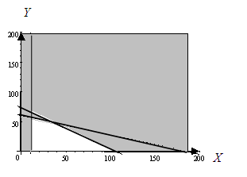

**Step 6:** To find the maximum possible value for the objective function

, we substitute the vertices of the feasible region in the function and compare the values.

Let us first find these vertices.

Use substitution to find the intersection point for  and . The first relation can also be written as .

…A

…B

Substitute A in B:









Set  in B:





The vertex is (34,48)

Use substitution to find the intersection point for

 and 

…A

…B

Substitute A in B:





The vertex is (10, 56)

The complete set of vertices is given by (10,0), (105,0), (34,48) and (10, 56).

|  |  |  |
| --- | --- | --- |
| **Point** | **Function** | **Value** |
| (10,0) |  | 2000 |
| (105,0) |  | 21000 |
| (34,48) |  | 21200 |
| (10, 56) |  | 18800 |

From the table it is clear that the objective function  attains its maximum value, namely 21200, at the vertex (34,48).

This means the farmer should produce 34 units of corn and 48 units of soybeans to maximise the net profit.

#### Example 1.22

A nutritionist, working for a cycling company, must meet certain nutrition requirements and yet keep the weight of the food at a minimum. She is considering a combination of two foods which are packed in tubes. Each tube of food X contains 8 units of protein, 12 units of carbohydrate, 2 units of fat, and weighs 0,45 kg. Each tube of food Y contains 12 units of protein, 12 units of carbohydrate, 1 unit of fat, and weighs 0,65 kg. The requirements call for at least 24 units of protein, 36 units of carbohydrate and 4 units of fat. Also, the total weight of the food cannot exceed 5 kg.

##### Solution:

**Step 1:** Let *x* = the number of tubes of food X

Let *y* = the number of tubes of food Y

**Step 2:** Organize the information into a table

|  |  |  |  |
| --- | --- | --- | --- |
|  | **Food X** | **Food Y** | **Total** |
| *Protein* |  |  |  |
| *Carbohydrate* |  |  |  |
| *Fat* |  |  |  |

**Step 3:** Since no negative number of tubes is possible, the first two constraints are the usual ones:













**Step 4:** The objective function is:



**Step 5:** The inequalities must first be put into standard form: ****

|  |  |
| --- | --- |
| *The intercepts are  and* | *The intercepts are  and* |
| *The intercepts are  and* | *The intercepts are  and* |
| *Is the horizontal line that coincides with the x-axis* | *Is the vertical line that coincides with the y-axis* |

Next, choose the origin (0, 0) as the test point for,  and 

Substituting,  in : 

Since this is a true statement, (0, 0) is in the solution set, so the feasible set in this case consists of all the points on the same side of the line  as (0, 0). Shade the region above the line to indicate that it is blocked out.

Substituting,  in : 

Since this is not a true statement, (0, 0) is not in the solution set, so the feasible set here consists of all points on the other side of the line  as (0, 0). Hence shade the region below the line to indicate that it is blocked out.

Substituting,  in: 

Since this is not a true statement, (0, 0) is not in the solution set. So the feasible set in this case consists of all the points on the other side of the line  as (0, 0). Hence shade the region below the line to show that it is blocked out.

Substituting,  in: 

Since this is not a true statement, (0, 0) is not in the solution set, so the feasible set here consists of all the points on the other side of the line  as (0, 0). Shade the region below the line to indicate that it is blocked out.

For  shade the region below the x-axis to indicate that it is blocked out.

For  shade the region to the left of the y-axis to show that it is blocked out.

The feasible region is left unshaded, while the (grey) shaded region is blocked out.

The feasible region for the following collection of inequalities is the unshaded region shown below (including its boundary).

*Y*

*X*











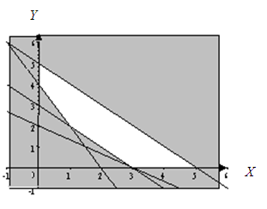

**Step 6:** To find the maximum value of the objective function, , substitute the vertices of the feasible region into the function, and compare the corresponding function values.

Let us first find the vertices.

Use substitution to find the intersection point of  and . The first relation can also be written as .

…A

 …B

Substitute A in B:







Put  in B:





The vertex is (1, 2)

The complete set of vertices is given by: (0,4), (0,5), (5,0), (3,0) and (1,2)

|  |  |  |
| --- | --- | --- |
| **Point** | **Function** | **Value** |
| (0,4) |  | 2,6 |
| (0,5) |  | 3,25 |
| (5,0) |  | 2,25 |
| (3,0) |  | 1,35 |
| (1,2) |  | 1,75 |

From the table it follows that the smallest value, namely 1,35, of the objective function is attained at the vertex (3,0).

This means that we should take 3 tubes of food X and 0 tubes of food Y to minimise the total weight.

|  |  |
| --- | --- |
| Maths Literacy icon_1.jpg | Assessment activity 1.6 |

Solve the following Linear Programming Problems:

1. A manufacturer makes two types of golf bags – standard bags and deluxe bags. For simplicity, divide the production process into three distinct operations: cutting and dying, sewing and finishing.

The amount of labor required for each operation varies. To manufacture a standard bag requires 6 hours of cutting and dying, 1 hour of sewing and 2 hours of finishing.

For a deluxe bag, 3 hours of cutting and dying, 1 hour of sewing and 6 hours of finishing are required.

Due to limited availability of skilled labor, tools and equipment, the factory can only deal with 96 labor-hours for cutting and dying, 18 labor-hours for sewing and 72 labor hours for finishing per day.

The profit per standard bag is R900 and R1 500 per deluxe bag. How many standard bags and how many deluxe bags should be produced each day to maximise the profit?

1. A manufacturer of calculators produces a basic model that yields a R25 profit, and a scientific model yielding a profit of R50. To meet the demand, the company needs to produce at least 200 of the basic calculators and at least 80 of the scientific calculators daily. The largest daily output possible is a total of 400 calculators. How many of each model should be produced to maximise the profit?
2. A company makes electronic hockey and soccer games. Long-term projections indicate an expected demand of at least 100 hockey games and 80 soccer games each day. Because of limitations on production capacity, no more than 200 hockey games and a maximum of 170 soccer games can be manufactured daily. To satisfy a contract, a total of at least 200 games must be supplied each day.

If each hockey game sold results in a R200 loss, but each soccer game a R500 profit, how many of each type should be made daily to maximise net profits?



1. You can produce two types of candy to sell at the concert. Energy bars sell at a profit of R3,70 each, while nougat bars sell at a profit of R7 each. The manufacturing process consists of three main operations: blending, cooking and packaging. The blending process takes 2 minutes for energy bars and 6 minutes for nougat bars. The cooking process takes 3 minutes for energy bars and 5 minutes for nougat bars. Packaging takes 1 minute for energy bars and 2 minutes for nougat bars. During each production run, the blending equipment is available for a maximum of 25 hours, the cooking equipment for at most 30 hours, and the packaging equipment for at least 5 hours. Determine how many bars of each kind you should make in order to maximise your profit. [Hint: change all hours into minutes.]

|  |  |
| --- | --- |
| Maths Literacy icon_1.jpgIcon_7.jpg | Assessment activity 1.7 |

1. Two products are produced using two machines, X and Y. Each unit of product 1 that is produced requires at least 15 minutes processing time on machine X and at most 25 minutes processing time on machine Y. Each unit of product 2 that is produced requires 7 minutes processing time on machine X and 45 minutes processing time on machine Y. Machine X is available for at most 20 hours and machine Y is available for at least 15 hours. Due to economical reasons, at most 36 units of product 1, and at least 10 units of product 1 can be produced.

Each unit of product 1 sold contributes to a profit of R100 and each unit of product 2 sold contributes to a profit of R400. Find the number of each type of product that must be produced in order to maximise the profit. [Remember to change hours to minutes.]

1. A farmer wants to plant oats and/or corn. Each acre of oats requires a R20 capital layout and 2 hours of labour. Each acre of corn requires a R29 capital layout and 2 hours of labour. Labour costs R15 per hour. The farmer has R2 400 available for capital layout and R3 000 available for labour. If the revenue is R75 from each acre of oats and R175 from each acre of corn, which planting combination will produce the largest total profit? What is the maximum profit?
2. An automobile factory manufactures standard automobiles and station wagons. A profit of R200 000 is made on each standard automobile and R300 000 on each station wagon. The company can afford to invest in up to 2500 man-hours per week. It takes three man-hours to manufacture a standard automobile and six man-hours to manufacture a station wagon. Customer demand requires that he should make at least twice as many standard automobiles as station wagons. A station wagon takes up twice as much storage space as a standard automobile, and there is storage room for at most 200 station wagons each week. Determine the number of standard automobiles and station wagons that the company should manufacture to maximise its profit.

****

**Part 4 and activity 1.7 are for enrichment**

# 4. Linear Programming in “three” variables

At first sight, the following problem appears to involve more than two variables. However, the problem can be modelled (using the correct mathematical language) so that only two variables are required.

#### Example 1.23

A pension fund has R30 million to invest. The money is to be divided among low- medium- and high risk stocks. The rules of the fund require that at least R4 million be invested in each type of investment, at least two thirds of the money be invested in low- and medium risk stocks, and the amount invested in medium risk bonds not exceed three times the amount invested in low risk stocks. The annual yields for the various investments are 8% for low risk stocks, 10% for medium risk stocks, and 11% for high risk stocks. How should the money be allocated among the various investment types in order to ensure the largest return?

##### Solution:

Let us agree that all numbers and variables stand for millions of rand. That is, we write 30 to stand for 30 million rand. There appear to be three variables, namely the amounts to be invested in each of the three categories. However, since the three investments must total 30, we need only two variables.

**Step 1:** Let *x* = the amount invested in low risk stocks

Let *y* = the amount invested in medium risk stocks

Then the amount invested in high risk stocks is.

**Step 2:** Organize the information into a table

|  |  |  |  |
| --- | --- | --- | --- |
|  | **Low risk stock** | **Medium risk stock** | **Total** |
| *Amount in millions* |  |  |  |

**Step 3:** Since we do not deal with negative amounts, the first three constraints are the usual ones:











… (two thirds of 30 is 20)





**Step 4:**

Remember that 8% = 

The objective function is: 

**Step 5:** The inequalities must first be put into standard form: 

|  |  |
| --- | --- |
| *The intercepts are  and* | *The intercepts are  and* |
| *The vertical line through the point (4,0)* |  |
| *The intercept is  and another coordinate is* | *The horizontal line through the point (0,4)* |
| *The horizontal line that coincides with the x-axis* | *The vertical line that coincides with the y-axis* |

Next, choose the origin (0, 0) as the test point for , ,  and .

Substituting,  in: 

Since this is not a true statement, (0, 0) is not in the solution set, so the feasible set in this case consists of all the points on the other side of the line  as (0, 0). Hence shade the region below the line to show that it is blocked out.

Substituting,  in: 

Since this is a true statement, (0, 0) is in the solution set, so the feasible set here consists of all points on the same side of the line  as (0, 0). Shade the region above the line to indicate that it is blocked out.

For  shade the region below the line to show that it is blocked out.

For  shade the region to the left of the line  to indicate that it is blocked out.

Next, choose the origin (10,10) as the test point for.

Substituting,  in: 

Since this is a true statement, (0, 0) is in the solution set, so the feasible set here consists of all the points on the same side of the line  as (0, 0). Hence shade the region above the line to indicate that it is blocked out.

The feasible region is left unshaded, while the (grey) shaded region is blocked out.

The feasible region for the total collection of inequalities is the unshaded region shown below (including its boundary).

*Y*

*X*













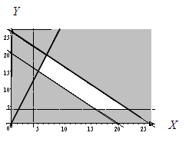

**Step 6:** To find the maximum value of the objective function , substitute the vertices of the feasible region into the function, and compare the corresponding function values.

Let us first find the vertices.

Use substitution to find the intersection point of  and.

…A

…B

Substitute A in B:







Put  in B:





The vertex is (5,15)

Next, use substitution to find the intersection point of  and .

…A

…B

Substitute A in B:







Put  in A:





The vertex is (6,5;19,5)

The complete set of vertices is given by (16,4), (22,4), (6,5;19,5) and (5,15)

|  |  |  |
| --- | --- | --- |
| **Point** | **Function** | **Value** |
| (16,4) |  | 3,08 |
| (22,4) |  | 2,72 |
| (6,5,19,5) |  | 3,03 |
| (5,15) |  | 3,3 |

From the table it is clear that the objective function attains its maximum value, namely 3,3, at the vertex (5,15). This means that the fund should invest 5 million rand in the low risk stocks, 15 million rand in the medium risk stock and 10 (=30 – (15 + 5)) million rand in high risk stock to maximise the return.

|  |  |
| --- | --- |
| Maths Literacy icon_1.jpgIcon_7.jpg | Assessment activity 1.8 |

1. During the spring season a resort operator rents bicycles at R75 per day, roller skates at R30 per day and motorcycles at R120 per day. He has storage space for a combined total of 100 bicycles, roller skates and motorcycles. In order to satisfy certain regular customers, he must rent at least 20 bicycles, 10 roller skates and 30 motorcycles every day. He must also rent at least as many bicycles as roller skates. How many bicycles, roller skates and motorcycles should he rent for a maximum income?

|  |  |
| --- | --- |
| Maths Literacy icon_4.jpg | Group activity 1.9 |

We will now show how software can be used to solve linear programming problems. This is an excellent way of solving problems with more than two variables.

Consult the web site: [*http://www.cob.sjsu.edu/anaya\_j/LinPro.htm*](http://www.cob.sjsu.edu/anaya_j/LinPro.htm)

(02-03-2009)

Use Excel to verify your answers in this unit.

### Solving a Linear Programming Problem Using Excel

**Note:** Before starting this section, you need to install ***Solver*** into Excel. Click **Office button (on top left)**.

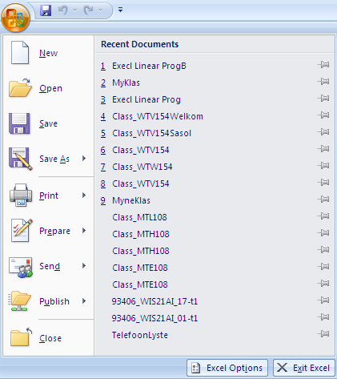

Choose **excel options**, **Add-ins** and **Solver Add-in**.

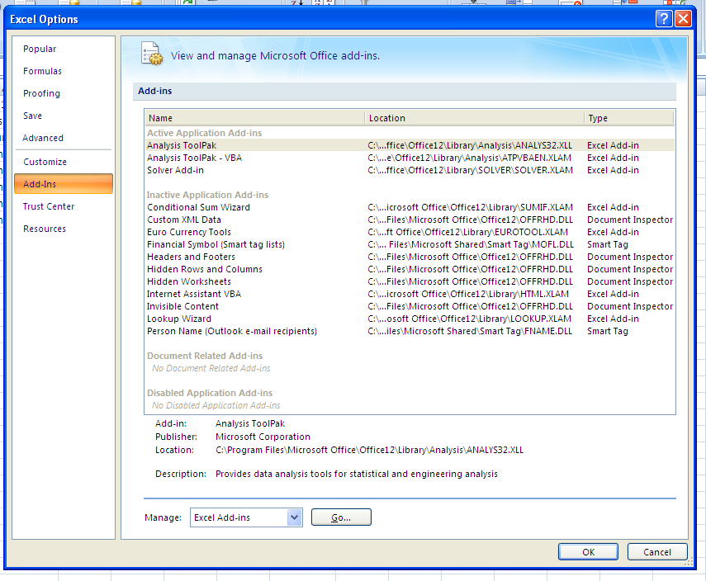

Click **the Go button. Solver** is now installed.

*Solver* has the capability of optimizing a function subject to constraints. Click on **Data** to see the **Solver**.

#### Setting Up the Worksheet

The first step in solving a linear programming problem using *Solver,* is to set up the worksheet to contain the variables, the constraints and the objective function.  The following basic template can be used (with modifications for larger problems) for any linear programming problem.  In a blank Excel worksheet enter labels as follows.

|  |  |  |  |  |  |  |  |  |
| --- | --- | --- | --- | --- | --- | --- | --- | --- |
|  | **A** | **B** | **C** | **D** | **E** | **F** | **G** | **H** |
| **1** | **Problem Name** |  |  |  |  |  |  |  |
| **2** | Variables | X1 | X2 | Sign | RHS |  | LHS | Slack / Surplus |
| **3** | Objective Function |  |  | = | Max P/Min C | **Profit / Cost** |  |  |
| **4** | Constraint 1 |  |  |  |  | Constraint 1 |  |  |
| **5** | Constraint 2 |  |  |  |  | Constraint 2 |  |  |
| **6** | Constraint 3 |  |  |  |  | Constraint 3 |  |  |
| **7** |  |  |  |  |  |  |  |  |
| **8** |  | **Solutions** | |  |  |  |  |  |
| **9** |  | **X1** | **X2** |  |  |  |  |  |
| **10** |  |  |  |  |  |  |  |  |

#### Example 1

Max P = $50x1 + $60x2 subject to:

* 2x1 + 1x2 < 6
* 1x1 + 2x2 < 6
* x1, x2 > 0

**1** In cell A1 enter the label **Example 1**.  In cell E3 enter the label **Max P**.  In cell F3 enter the label **Profit**.

**2** Enter the coefficients of the profit function (50,60) in cells B3 and C3.

**3** For constraint 1, enter the coefficients of the variables (2,1) and the right-hand side value (6) in cells B4, C4, and E4.

**4** For constraint 2, enter the coefficients of the variables (1,2) and the right-hand side value (6) in cells B5, C5, and E5.

**5** Enter < signs in cells D4 and D5.

|  |  |  |  |  |  |  |  |  |
| --- | --- | --- | --- | --- | --- | --- | --- | --- |
|  | **A** | **B** | **C** | **D** | **E** | **F** | **G** | **H** |
| **1** | **Example 1** |  |  |  |  |  |  |  |
| **2** | Variables | X1 | X2 | Sign | RHS |  | LHS | Slack |
| **3** | Objective Function | 50 | 60 | = | Max P | **Profit** |  |  |
| **4** | Constraint 1 | 2 | 1 | < | 6 | Constraint 1 |  |  |
| **5** | Constraint 2 | 1 | 2 | < | 6 | Constraint 2 |  |  |
| **6** | Constraint 3 |  |  |  |  | Constraint 3 |  |  |
| **7** |  |  |  |  |  |  |  |  |
| **8** |  | **Solutions** | |  |  |  |  |  |
| **9** |  | **X1** | **X2** |  |  |  |  |  |
| **10** |  |  |  |  |  |  |  |  |

The worksheet provides Solver with the necessary information and a place where to display the solution to the problem.  Now, enter the following formulas in the right-hand portion of the worksheet by following these steps:

**1** In cell G3 enter the following formula for computing the profit:  **=SUMPRODUCT(B3:C3,B$10:C$10)**.  This formula uses the cells that contain the unit profits and the cells that will contain the solution(s) at which the maximum profit is attained.

**2** Copy this formula into cell G5.

**3** In cell H4 enter the following formula to determine the slack for constraint 1:  **=ABS(E4-G4)**.  Copy this formula down to cell H5.

Your worksheet should now resemble the one shown below.

|  |  |  |  |  |  |  |  |  |
| --- | --- | --- | --- | --- | --- | --- | --- | --- |
|  | **A** | **B** | **C** | **D** | **E** | **F** | **G** | **H** |
| **1** | **Example 1** |  |  |  |  |  |  |  |
| **2** | Variables | X1 | X2 | Sign | RHS |  | LHS | Slack |
| **3** | Objective Function | 50 | 60 | = | Max P | **Profit** | **0** |  |
| **4** | Constraint 1 | 2 | 1 | < | 6 | Constraint 1 | 0 | 6 |
| **5** | Constraint 2 | 1 | 2 | < | 6 | Constraint 2 | 0 | 6 |
| **6** | Constraint 3 |  |  |  |  | Constraint 3 |  |  |
| **7** |  |  |  |  |  |  |  |  |
| **8** |  | **Solutions** | |  |  |  |  |  |
| **9** |  | **X1** | **X2** |  |  |  |  |  |
| **10** |  |  |  |  |  |  |  |  |

Now, *Solver* will be used.  Click **Data** and **Solver**.  The Solver Parameters Window is completed as follows:

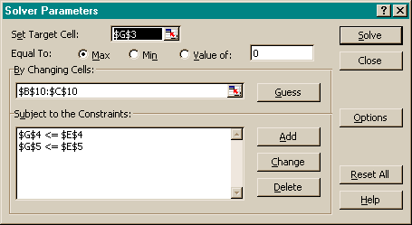

Next, click **Options** and select **Assume Linear Model** and **Assume Non-Negative**. Click **OK**.

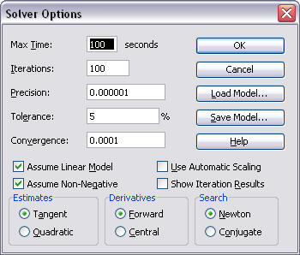

Then click **Solve**. The worksheet now contains the solution to the problem. The cells that contain the solution are highlighted in blue.

|  |  |  |  |  |  |  |  |  |
| --- | --- | --- | --- | --- | --- | --- | --- | --- |
|  | **A** | **B** | **C** | **D** | **E** | **F** | **G** | **H** |
| **1** | **Example 1** |  |  |  |  |  |  |  |
| **2** | Variables | X1 | X2 | Sign | RHS |  | LHS | Slack |
| **3** | Objective Function | 50 | 60 | = | Max P | **Profit** | **220** |  |
| **4** | Constraint 1 | 2 | 1 | < | 6 | Constraint 1 | 6 | 0 |
| **5** | Constraint 2 | 1 | 2 | < | 6 | Constraint 2 | 6 | 0 |
| **6** | Constraint 3 |  |  |  |  | Constraint 3 |  |  |
| **7** |  |  |  |  |  |  |  |  |
| **8** |  | **Solutions** | |  |  |  |  |  |
| **9** |  | **X1** | **X2** |  |  |  |  |  |
| **10** |  | **2** | **2** |  |  |  |  |  |

The solution to Example 1 is: Max profit = $220, when x1 = 2 and x2 = 2, and both constraints are binding (neither one has any slack).

Example 2  
Min C = $100x1 + $150x2 + $120x3 subject to:

* 1x1 + 1x2 + 1x3 = 6
* 1x1 + 2x2 + 1x3 > 8
* 1x1 + 1x2 + 2x3 < 9
* x1, x2, x3 > 0

Enter the problem data into the worksheet - you will need an extra column to contain the coefficients of x3.  In the right-hand side of the worksheet, enter the necessary formulas by following these steps.

**1** In cell H3 enter the following formula for computing the cost:  **=SUMPRODUCT(B3:D3,B$10:D$10)**.

**2** Copy this formula into cells H5:H6.

**3** In cell E4 enter the label **=**.  In cell E5 enter the label **>**.  In cell E6 enter the label **<**.

**4** In cell I4 enter the following formula to determine the slack/surplus for constraint 1:  **=ABS(F4-H4)**.  Copy this formula into cells I5:I6.

Your worksheet should now resemble the one shown below.

|  |  |  |  |  |  |  |  |  |  |
| --- | --- | --- | --- | --- | --- | --- | --- | --- | --- |
|  | **A** | **B** | **C** | **D** | **E** | **F** | **G** | **H** | **I** |
| **1** | **Example 2** |  |  |  |  |  |  |  |  |
| **2** | Variables | X1 | X2 | X3 | Sign | RHS |  | LHS | Slack/Surplus |
| **3** | Objective Function | 100 | 150 | 120 | = | Min C | **Cost** | **0** |  |
| **4** | Constraint 1 | 1 | 1 | 1 | = | 6 | Constraint 1 | 0 | 6 |
| **5** | Constraint 2 | 1 | 2 | 1 | > | 8 | Constraint 2 | 0 | 8 |
| **6** | Constraint 3 | 1 | 1 | 2 | < | 9 | Constraint 3 | 0 | 9 |
| **7** |  |  |  |  |  |  |  |  |  |
| **8** |  | **Solutions** | | |  |  |  |  |  |
| **9** |  | **X1** | **X2** | **X3** |  |  |  |  |  |
| **10** |  |  |  |  |  |  |  |  |  |

Now the Solver comes into play. Click **Data** and **Solver**. The Solver Parameters window is completed as follows:

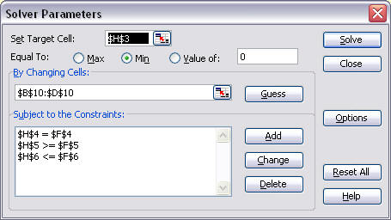

Next, click **Options** and select **Assume Linear Model** and **Assume Non-Negative**. Click **OK**.



Then click **Solve**. The worksheet now contains the solution to the problem. The cells that contain the solution are highlighted in blue.

|  |  |  |  |  |  |  |  |  |  |
| --- | --- | --- | --- | --- | --- | --- | --- | --- | --- |
|  | **A** | **B** | **C** | **D** | **E** | **F** | **G** | **H** | **I** |
| **1** | **Example 2** |  |  |  |  |  |  |  |  |
| **2** | Variables | X1 | X2 | X3 | Sign | RHS |  | LHS | Slack/Surplus |
| **3** | Objective Function | 100 | 150 | 120 | = | Min C | **Cost** | **700** |  |
| **4** | Constraint 1 | 1 | 1 | 1 | = | 6 | Constraint 1 | 6 | 0 |
| **5** | Constraint 2 | 1 | 2 | 1 | > | 8 | Constraint 2 | 8 | 0 |
| **6** | Constraint 3 | 1 | 1 | 2 | < | 9 | Constraint 3 | 6 | 3 |
| **7** |  |  |  |  |  |  |  |  |  |
| **8** |  | **Solutions** | | |  |  |  |  |  |
| **9** |  | **X1** | **X2** | **X3** |  |  |  |  |  |
| **10** |  | **4** | **2** | **0** |  |  |  |  |  |

The solution to Example 2 is determined to be Min cost = $700, x1 = 4, x2 = 2,  x3 = 0 and constraints 1 and 2 are binding.

Use Excel to answer the questions below:

1. Find the maximum profit  subject to the following constraints:







1. Find the maximum profit  subject to the following constraints:







1. Find the maximum profit  subject to the following constraints:





1. Minimise the cost function  subject to the following constraints:





1. Minimise the cost function  subject to the following constraints:





We can now also solve problems in more than two variables.

1. Find the maximum value of  subject to the following constraints:





1. Find the maximum value of  subject to the following constraints:







You can also visit the following website for further information:

[*http://www.economicsnetwork.ac.uk/cheer/ch9\_3/ch9\_3p07.htm*](http://www.economicsnetwork.ac.uk/cheer/ch9_3/ch9_3p07.htm)

(02-02-2009)

# End of section comments

This wraps up the section on linear programming. You will now be able the solve problems in which a linear function (representing cost, profit, weight or the like) is to be maximised or minimised. The content of this section will not be use further on.

# Feedback

##### Answers to check on the speed zones:

Remember: 

1. After 3 hours you have driven 165 miles, and your speed was 55 miles per hour.
2. A(2, 275) represents a distance of 275 miles covered in 2 hours at a speed of 275/2 or 91,7 miles per hour.  Unsafe zone.
3. B(5, 220) represents a distance of 220 miles covered in 5 hours at a speed of 220/5 or 44 miles per hour.  Safe zone.
4. The same speed as coordinate (3, 165), which was on the line, and that was 55 miles per hour.

##### Answers to startup activity 1.1



* The blue part shows all possible combinations.
* No, because it falls outside the blue area.
* Yes, because it falls inside the blue area.

|  |  |  |
| --- | --- | --- |
| **Black** | **Orange** | **Profit**  **Profit** |
| 1 | 1 | 125 |
| 1 | 2 | 200 |
| 1 | 3 | 275 |
| 1 | 4 | 350 |
| 1 | 5 | 425 |
| 1 | 6 | 500 |
| 1 | 7 | 575 |
| 1 | 8 | 650 |
| 2 | 2 | 250 |
| 2 | 3 | 325 |
| 2 | 4 | 400 |
| 2 | 5 | 475 |
| 2 | 6 | 550 |
| 2 | 7 | 625 |
| 2 | 8 | 700 |
| 3 | 3 | 375 |
| 3 | 4 | 450 |
| 3 | 5 | 525 |
| 3 | 6 | 600 |
| 3 | 7 | 675 |
| 3 | 8 | 750 |
| 4 | 4 | 500 |
| 4 | 5 | 575 |
| 4 | 6 | 650 |
| 4 | 7 | 725 |
| 4 | 8 | 800 |

* Check the table above.
* 4 black and 8 orange armbands.
* In the blue area (feasible area).
* The maximum and minimum values of the objective function are attained at the corner points (vertices) of the feasible region.

##### Answers to learning activity 1.2

* 1. 
  2. 
  3. 
  4. 
  5. 
  6. 
  7. 
  8. Yes, it satisfies
     + 1. 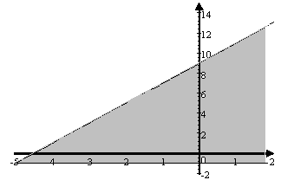
  9. Yes, it satisfies

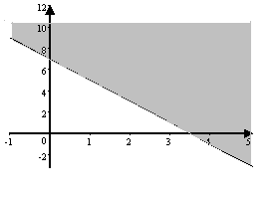

* 1. No, it does not satisfy

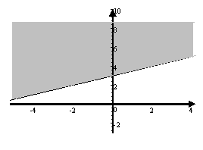

* 1. Yes it satisfies

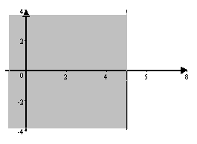

##### Answers to learning activity 1.3

* 1. Yes
  2. No
  3. Yes

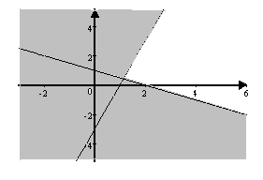

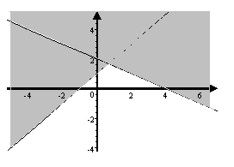

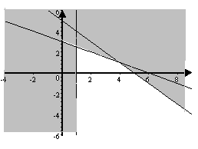

* 1. 



* 1. 



* 1. 



* 1. 



##### Answers to assessment activity 1.4

1.   
2.   
3.   
4.   
5.   
6.   

##### Answers to learning activity 1.5

Put all the information in table form:

|  |  |  |  |
| --- | --- | --- | --- |
|  | **Standard bag** | **Deluxe bag** | **Available time** |
| *Cutting and dying* | 6 hours | 3 hours | 96 labor-hours |
| *Sewing* | 1 hour | 1 hour | 18 labor-hours |
| *Finishing* | 2 hours | 6 hours | 72 labor-hours |
| ***Profit*** | **R900** | **R1 500** |  |

1. **Constraints:**











Objective function:



1. **Constraints:**











Objective function:



1. **Constraints:**















Objective function:



1. **Constraints:**











Objective function:



##### Answers to assessment activity 1.6

1.   
2.   
3.   
4.   

##### Answers to enrichment activity 1.7

**1** **Constraints:**















Objective function:



Solution:









**2 Constraints:**









Objective function:



Solution:









**3** **Constraints:**











Objective function:



Solution:







##### Answers to enrichment activity 1.8

1. **Constraints:**















Objective function:



Solution:









##### Answers to group activity 1.9

1.  
2.  
3.  
4.  
5.  
6.   
7.   

# Tracking my progress

You have reached the end of this section. Check whether you have achieved the learning outcomes for this section.

|  |  |  |
| --- | --- | --- |
| **Learning outcomes** | **✓ I feel confident** | **✓ I don’t feel confident** |
| Determine whether a given point satisfy an inequality |  |  |
| Write an inequality for a given constraint |  |  |
| Sketch an inequality |  |  |
| Determine whether a given point satisfy a system of inequalities |  |  |
| Graph the feasible area for a system of inequalities in two variables |  |  |
| Determine the vertex of a feasible region at which the objective function attains its maximum and minimum values in a system of two variables |  |  |
| Determine the vertex of a feasible region at which the objective function attains its maximum and minimum values in a system of “three” variables which could be transformed into a system of two variables |  |  |
| Use Excel to determine the vertex of a feasible region at which the objective function attains its maximum and minimum values in a system of any number of variables |  |  |

Now answer the following questions honestly:

1. What did you like best about this section?

|  |
| --- |
|  |
|  |
|  |

1. What did you find most difficult in this section?

|  |
| --- |
|  |
|  |
|  |

1. What do you need to improve on?

|  |
| --- |
|  |
|  |
|  |

1. How will you do this?

|  |
| --- |
|  |
|  |
|  |