

Section 2:

Calculator Skills

Maths Literacy, Workshop Series 2010

Section 2: Calculator Skills

# 1. Introduction

In order to study mathematical literacy successfully, you need to be able to use a scientific calculator correctly. This section will provide you with guidance on how to use the **CASIO**  **SCIENTIFIC CALCULATOR**.

## Learning outcomes

At the end of this section you will be able to use your calculator with confidence.

|  |  |
| --- | --- |
| Maths Literacy icon_2.jpg | Start up activity 1.1 |

Let’s first play with the “up-side-down” calculator.

**We can also make up problems to fit the answers**

For example: To make the word 

We need to make up a problem that has **345** as an answer

So a possible problem is **107 + 238 = 345**

**You try these ones**

|  |  |  |
| --- | --- | --- |
| **1.** | **= 3704** | **B35.jpg** |
| **2.** | **= 7735** | **B38.jpg** |
| **3.** | **= 55378** | **B40.jpg** |
| **4.** | **=** | **B41.jpg** |
| **5.** | **=** | **B36.jpg** |
| **6.** | **=** | **B39.jpg** |

<http://www.funmaths.com/worksheets/downloads/view.htm?ws0086_2.gif>

(03-03-2009)

|  |  |
| --- | --- |
| Maths Literacy icon_2.jpg | Learning activity 2.2 |

You probably have a reasonable idea of how to use a scientific calculator, as you must have used it in grades 10 – 12.

* With this background, do calculations1 to 7 listed below on the **CASIO**  **SCIENTIFIC CALCULATOR**.
* When you have completed the exercise, compare your answers to those of the person sitting next to you.
* Now decide on the correct order in which the keys on the calculator have to be pressed to do each calculation and write them down in your book. The first exercise has been done for you as an example.

1. 

The answer to this question is 64. The keypads were pressed in the following order:

|  |  |  |  |  |  |  |  |  |
| --- | --- | --- | --- | --- | --- | --- | --- | --- |
| 4 | ( | 5 | + | 12 | ) | - | 14 | = |

1. 
2. 
3. 
4. 
5. 
6. 

# 2. Getting started

In order to use the **CASIO**  **SCIENTIFIC CALCULATOR** we first need to understand the basic information that the calculator communicates to us. All the keys on the calculator have markings which indicate what information the key will input into the calculator’s processing unit (its “brain”), or what function it will perform.

 This key, for example, indicates that any input value will be squared.

## Changing the input/output format

The calculator gives you the opportunity to decide whether you want to display your input as it is written on paper or in a linear format. In the B5.jpg format, fractions, irrational numbers and other expressions are displayed as they are written on paper. In theB4.jpg format, fractions and other expressions are always displayed as decimal numbers in a single line.

Let’s investigate what the input on the calculator looks like in each of these modes. Your calculator is probably still switched on after the start-up activity and you have certainly performed some calculations out of curiosity. To make sure our calculators all function in the same way, let’s initialise our calculators. This procedure will return you calculator to its original default setting. The default setting refers to the setting that the calculator had when you switched it on for the very first time. Now press the keys in the following order:

|  |  |  |  |  |
| --- | --- | --- | --- | --- |
| SHIFT | 9 | 3 | = | AC |

The calculator is now in its default setting.

It is important to remember that we press the B12.jpg key to clear the display screen.

To turn the calculator off, press B7.jpgB12.jpg

Note that the B5.jpg mark is displayed in the top right-hand corner of the display screen of the calculator. This means the calculator is in Math mode and will display any input as it is written on paper. Press the following keys to see what the input looks like.

|  |  |  |
| --- | --- | --- |
|  | 4 | = |

The calculator displays and shows the answer, 2, in the lower right-hand corner when you press the equal sign (=).



Now change the mode to linear, by pressing the following keys:

|  |  |  |
| --- | --- | --- |
| SHIFT | MODE | 2 |

You will notice that the B5.jpg mark has disappeared. Let’s press

|  |  |  |
| --- | --- | --- |
|  | 4 | = |

again. The calculator now displays it as and the answer, 2, appears in the lower right-hand corner when you press the equal-sign.



It is not difficult to read a simple equation or expression in linear format, but complex expressions can sometimes cause ambiguities which we certainly want to avoid. We therefore prefer to work with our calculators in Math mode. To put the calculator back into Math mode, press the following keys in order:

|  |  |  |
| --- | --- | --- |
| SHIFT | MODE | 1 |

The B5.jpg mark has now reappeared in the top right-hand corner of the display screen.

## Second functions on a key

You will also notice that many of the keys have additional markings in either red or yellow. This means that a single key may be able to perform more than one function. To access these second functions we use theB7.jpg key for functions marked in yellow and the  B9.jpg  key for functions marked in red.

#### Example 2.1

To determine , we need to access the  function which is marked in yellow just above the key. The order in which to press the keys is as follows:



|  |  |  |  |  |  |  |
| --- | --- | --- | --- | --- | --- | --- |
| SHIFT |  | 0 | . | 5 | ) | = |

The answer, , appears in the lower right-hand corner of the display screen. The input is displayed as , just as you would have written it on paper.

How to use the B9.jpg key for variables marked in red, will be explained later in the section.

## Display indicators

It is important to understand the markers (also called indicators) that are displayed on the display screen of the calculator, as it provides you with information of how the calculator will operate and what type of outputs it will give. The following table gives an overview of these indicators.

|  |  |
| --- | --- |
| **Indicator** | **Meaning** |
| S | This marker is displayed when the B7.jpg key is pressed. |
| A | This marker is displayed when the B9.jpg key is pressed. |
| M | There is a value stored in the independent memory. |
| STO | This indicator appears after you have press B7.jpgB2.jpg. The calculator is then waiting for you to input a variable name (A, B, C, D, X or Y, indicated in red on the calculator) so that a value can be assigned to that specific variable. |
| RCL | This indicator appears after the B2.jpg key is pressed. The calculator is then waiting for you to input a variable name so that it can recall its value. |
| STAT | The calculator is in the STAT mode. |
| D | The default angle unit is degrees. |
| R | The default angle unit is radians. |
| G | The default angle unit is gradians (or decimal degrees). |
| FIX | A fixed number of decimal places is used for all numbers. |
| SCI | A fixed number of significant digits is used for all numbers. |
|  | Calculation history and/or memory data is available and can be recalled, or there is more data above/below the current screen. Press the up and down arrows on the REPLAY key to scroll up or down. |
| Disp | The display currently shows an intermediate result of a multi-statement calculation. |

## Calculation modes

The **CASIO**  **SCIENTIFIC CALCULATOR** can be used to do general mathematical and arithmetic calculations, as well as statistical and regression calculations. It can also generate a number table based on an expression. To execute the tasks correctly, it has to be in the correct mode. The following table describes how each mode will be indicated on your calculator.

|  |  |
| --- | --- |
| **Operation** | **Mode** |
| Mathematical and arithmetic calculations | COMP |
| Statistical and regression calculations | STAT |
| Generate a number table | TABLE |

To specify the mode that you want to work in, press B8.jpg to display the mode menu and then press the number key that corresponds to the mode that you want to select. By default your calculator will be in COMP mode. Note that this mode is not indicated on the display screen.

## Specifying the fraction display format

When doing calculations with fractions, the answers can be given in either mixed format, such as , or as improper fractions, such as . The calculator makes it possible to choose which format the fractions should be displayed in.



To display fractions in mixed format, press

|  |  |  |  |
| --- | --- | --- | --- |
| SHIFT | MODE |  | 1 |

To display fractions as improper fractions, press

|  |  |  |  |
| --- | --- | --- | --- |
| SHIFT | MODE |  | 2 |

### Switching between Fractional and Decimal format

When you have made a calculation and the calculator displays the answer as a fraction, be it as an improper fraction or in mixed fraction format, you can change it to decimal format by pressing the B3.jpg key on your calculator.

Pressing B3.jpg again, changes the format back to that of a fraction.

#### Example 2.2

Calculate  and press the equal sign on your calculator. The answer should be displayed as . To change it to decimal format, press B3.jpg on you calculator. It now displays . To change it back to an improper fraction, press B3.jpg once again.



### Switching between Improper Fraction and Mixed Fraction Format

When a fraction has been calculated and is displayed on the calculator screen, it is possible to change the fraction display format from improper fraction format to mixed fraction format in a similar way. To do this you use the B7.jpg key together with the B3.jpg key.

#### Example 2.3

Calculate  and press the equal sign on your calculator. The answer should be displayed as . This is shown as an improper fraction. To change it to mixed fraction format, press B7.jpg and B3.jpg. The answer is now displayed as , which is in mixed fraction format. Pressing the same keys again, changes the fraction back to its improper fraction display format.

# 3. Inputting Expressions and Values

Recall that you can choose whether your calculator operates in linear or in Math mode. For most cases, we prefer our calculators to be in Math mode. Make sure the B5.jpg mark is displayed in the top right-hand corner of your calculator.

## Displaying a long expression

The display can show up to 15 characters at a time. Inputting the 16th character causes the expression to shift to the left. At this instant, the  indicator appears to the left of the expression, indicating that it runs off the left hand side of the screen.

#### Example 2.4

Input the following expression into your calculator:

1111+2222+3333+4444

You will notice that as soon as you enter the first 4, which is the 16th character, the  indicator is displayed and you can scroll to the left to view the hidden part by pressing the left-arrow key on the B1.jpg key. In a similar way you can scroll to the right of the expression.

It is useful to know what the cursor looks like while you are inputting an expression or any other information. The cursor usually appears as a straight vertical or horizontal flashing line on the display screen. When there are 10 or fewer bytes of input remaining in the current expression (approximately 10 input characters), the cursor changes to ( ) to let you know. When this fatter cursor appears, it is wise to terminate (end) the expression at a convenient point and calculate the result.

## Correcting an expression

This section explains how to correct and expression as you are inputting it. The procedure you should use depends on whether you have “insert” or “overwrite” selected as the input mode.

### About Insert and Overwrite input modes

With the Insert mode, the displayed characters shift to the left to make room for any new characters to be inserted. The cursor is a vertical flashing line ( ) in the Insert mode. With the Overwrite mode, any new character replaces the character at the current cursor position. The cursor is a horizontal flashing line ( ) in this case.

The initial default input mode is Insert. You can change to the overwrite mode when you need it. This, however, is only possible when you are working in Linear format. With Math format, you can only use the Insert mode.

### Changing the most recent character or function that you have input (Insert mode in Math format)

#### Example 2.5

Correct the expression  so that it becomes .

##### Solution

Enter the faulty expression by pressing

|  |  |  |  |  |  |
| --- | --- | --- | --- | --- | --- |
| 3 | 5 | 9 |  | 1 | 4 |

The cursor will be flashing after the number 4.

To delete the number 4, press B11.jpg once.

Then input the number 7.

### Deleting previous characters or functions (Insert mode in Math format)

#### Example 2.6

Correct the expression  so that it becomes .

##### Solution

Enter the faulty expression by pressing

|  |  |  |  |  |  |  |
| --- | --- | --- | --- | --- | --- | --- |
| 3 | 5 | 9 |  |  | 1 | 4 |

The cursor will be flashing after the number 4.

Now move backwards to just AFTER the division symbol by pressing

|  |  |
| --- | --- |
|  |  |

To delete the division sign, press B11.jpg once.

### Correcting a calculation (Insert mode in Math format)

#### Example 2.7

Correct  so that it becomes 

##### Solution

Enter the faulty calculation by pressing

|  |  |  |  |
| --- | --- | --- | --- |
|  | 6 | 0 | ) |

The cursor will be flashing after the bracket ).

Now move backwards to just AFTER the first bracket by pressing

|  |  |  |
| --- | --- | --- |
|  |  |  |

To delete the cosine function, press B11.jpg once.

To input the sine function, press B6.jpg on the keypad. The display screen will now display .

### Displaying the location of an error

If an error message like “Math ERROR” or “Syntax ERROR” appears when you press , you should press

|  |  |  |
| --- | --- | --- |
|  | or |  |

This will display the part of the calculation where the error occurred, with the cursor positioned at the error location. You can then make the necessary corrections.

## Inputting mathematics (in Math format)

#### Example 2.8

Calculate 

##### Solution

The  and  keys are used to perform arithmetical calculations. The calculator knows the order of operation, hence no brackets have to be used when doing ordinary arithmetical calculations. Just press the keys in the order as asked in the question and follow it by pressing . The answer, 51, will appear in the lower right-hand corner of the display screen.

#### Example 2.9

Calculate 

##### Solution

Press the following keys in the correct order:

|  |  |  |  |  |
| --- | --- | --- | --- | --- |
| 3 |  | + | 4 | = |

The answer, 13, is displayed in the lower right-hand corner of the screen.

#### Example 2.10

Calculate 

##### Solution

Press the following keys in the correct order:

|  |  |  |  |  |
| --- | --- | --- | --- | --- |
| 4 |  | + | 7 | = |

The answer, 71, is displayed in the lower right-hand corner of the screen.

#### Example 2.11

Calculate 

##### Solution

Press the following keys in the correct order:

|  |  |  |  |  |  |  |
| --- | --- | --- | --- | --- | --- | --- |
| 2 |  | 5 |  | + | 3 | = |

You will notice that after pressing the 5, the cursor is flashing at the base of the exponent, 5. If we immediately input the plus sign  and then press 3, we will be adding 3 to 5 and not to.

#### Example 2.12

Calculate 

##### Solution

Press the following keys in the correct order:

|  |  |  |  |  |  |  |  |
| --- | --- | --- | --- | --- | --- | --- | --- |
| 2 | + |  | 5 |  | + | 8 | = |

Notice that after pressing the root sign, , the cursor is flashing underneath the root sign and you can input the 5. To add 8 to the answer, you need to move out from underneath the root sign by pressing the right-arrow key on the B1.jpg keypad.

#### Example 2.13

Calculate 

##### Solution

Press the following keys in the correct order:

|  |  |  |  |  |  |  |  |  |  |  |  |  |
| --- | --- | --- | --- | --- | --- | --- | --- | --- | --- | --- | --- | --- |
| ( | 2 | + |  | 3 |  | 4 |  | ) |  |  | 5 | = |

Once again you need to use the arrow keys on the B1.jpg keypad to navigate within the expression.

After pressing the equal sign, the answer, expressed as , appears in the lower right-hand corner of the display screen. Notice that part of the expression that you entered into the calculator seems to be cut off the screen.

If you need to view the entire input expression again, press B12.jpg followed by the right-arrow  on the B1.jpg keypad.

## Inserting a value into a function

When using the Math format, you can insert part of an existing input expression, such as a value or an expression within parentheses, into a function.

#### Example 2.14

Consider the expression  and enter it into your calculator.

If we want to replace 2 by the square root of 2 (so that the expression looks like ) without re-entering the whole expression into the calculator, we can do the following:

Move the cursor so that it flashes just in front of the number 2. Then press B7.jpg and B11.jpg.

This instruction tells the calculator that an insertion is going to be made and the shape of the cursor changes to an arrow.

The last step is to tell the calculator which function the value will be inserted to. We want to apply the root function to the value 2, so we press the  key. This gives the desired result.

#### Example 2.15

Enter the expression  into your calculator again.

If we want to insert or incorporate the sum  into the numerator of a fraction, we first need to group the 2 and 3 together by placing parentheses around them as explained in section 3.2.1. The expression then looks like . We then proceed as follows:

Move the cursor so that it flashes just in front of the first parenthesis. Then B7.jpg and B11.jpg. Note that the cursor changes to an arrow.

Now specify the function by pressing . The expression immediately changes to .

#### Example 2.16

Again consider the expression .

If we want to incorporate the sum  into the 5th root function , we need to group the 3 and 4 together by placing them within parentheses. The expression then looks like  and we follow the steps:

Move the cursor so that it flashes just in front of the first parenthesis. Then B7.jpg and B11.jpg. Note that the cursor’s shape changes to an arrow.

Now specify the function. Because  is a second function we need to press

|  |  |  |
| --- | --- | --- |
| SHIFT |  | 5 |

The expression changes to .

In the last example the value  was incorporated into the function, because the flashing cursor was placed in front of the first parenthesis. If there were no parenthesis and the cursor was placed in front of the 3, then only the 3 would have been incorporated into the function.

Values can also be incorporated into the logarithmic function, the natural logarithmic function, the exponential and natural exponential functions, and the absolute value function in a similar way.

|  |  |
| --- | --- |
| Maths Literacy icon_2.jpg | Learning activity 2.3 |

1. Make sure your calculator is in Math mode and specify the fraction display format as “improper fractions”.
2. Perform the following calculations:
   1. 
   2. 
   3. 
   4. 
   5. 
   6. 
3. Use the second function on each key to perform the following calculations:
   1. 
   2. 
   3. 
   4. 
4. Consider the expression . Use this expression to incorporate parts of it into given functions.
   1. Incorporate 5 into the square root function  and determine the value of the expression.
   2. Incorporate the value  into the natural logarithmic function, , and determine the value of the expression.
   3. Incorporate the value  into the numerator of the fraction function, , and use 6 as the denominator of the fraction. Then determine the value of the expression.
   4. Incorporate the whole expression into the square function, , and determine the value of the new expression.

# 4. Displaying results that include irrational number formats

When the Math format is selected as the input/output format, you can specify whether calculation results should be displayed in a form that includes expressions like  and  (irrational number format) or not.

After pressing  to obtain the answer of some calculation, the result is displayed using irrational number format (if applicable). By pressingB7.jpg and  to obtain the answer, the calculator will display the result in decimal number format.

#### Example 2.17

Make sure your calculator is in math mode and then calculate the following:

1.  Press  after inputting the expression.
2.  Press B7.jpg and  after inputting expression .

Make sure your calculator is in math mode and the angle unit is set to ‘degrees’. Then calculate the following:

1.  Press after inputting the expression 
2.  Press B7.jpg and  after inputting the expression .

##### Solution

1. 
2. 
3. 
4. 

There are exceptions as to when a result will be displayed in decimal format, even after you have pressed only the equal sign after inputting the expression to be evaluated. These exceptions have to do with the limitations of the calculator on using irrational forms, and cannot be changed. The result of an expression containing more than two irrational terms, for example, will be displayed as a decimal number.

# 5. Percentage Calculations (%)

Inputting a value and pressing B7.jpg and  causes the input value to become a percentage.

#### Example 2.18

Change the number 56 to a percentage.

##### Solution

Press 56, B7.jpg and . Then  is displayed on you calculator screen.

If you proceed with the  sign, the percentage will be expressed as a fraction, , in the lower right-hand corner of your screen.

If you press B7.jpg and , instead of only , the percentage will be expressed as a decimal number . (Recall the work that was done in section 4.)

#### Example 2.19

Calculate  of 150.

##### Solution

To find the answer, we need to calculate , which is equivalent to .

Press the following keypads in the correct order:

|  |  |  |  |  |  |
| --- | --- | --- | --- | --- | --- |
| 150 |  | 20 | SHIFT | ( | = |

The answer, 30, will appear in the lower right-hand corner of your display screen.

#### Example 2.20

Calculate what percentage 660 is of 880.

##### Solution

To find the answer, we need to calculate , which is equivalent to .

Press the following keypads in the correct order:

|  |  |  |  |  |  |
| --- | --- | --- | --- | --- | --- |
| 660 |  | 880 | SHIFT | ( | = |

The answer, 75, will appear in the lower right-hand corner of your display screen.

#### Example 2.21

Increase 2500 by .

##### Solution

To find the answer, we need to calculate , which is equivalent to .

Press the following keypads in the correct order:

|  |  |  |  |  |  |  |  |
| --- | --- | --- | --- | --- | --- | --- | --- |
| 2500 | + | 2500 |  | 15 | SHIFT | ( | = |

The answer, 2875, will appear in the lower right-hand corner of your display screen.

#### Example 2.22

Decrease 3500 by .

##### Solution

To find the answer, we need to calculate , which is equivalent to .

Press the following keypads in the correct order:

|  |  |  |  |  |  |  |  |
| --- | --- | --- | --- | --- | --- | --- | --- |
| 3500 | - | 3500 |  | 25 | SHIFT | ( | = |

The answer, 2625, will appear in the lower right-hand corner of your display screen.

#### Example 2.23

Discount the sum of 168, 98 and 734 by .

##### Solution

To find the final answer, we need to add 168, 98 and 734, and subtract  of this sum from the result. We therefore need to find . To do this, we use the  key. The sum  will be represented by .

Press the following keys in the correct order:

|  |  |  |  |  |  |  |  |  |  |  |  |  |
| --- | --- | --- | --- | --- | --- | --- | --- | --- | --- | --- | --- | --- |
| 168 | + | 98 | + | 734 | = | - | Ans |  | 20 | SHIFT | ( | = |

After entering the input in the brace into your calculator,  appears in the display screen and the sum is immediately represented by .

The final answer, 800, will appear in the lower right-hand corner of your display screen after pressing the second equal sign.

#### Example 2.24

If 357 grams are added to a test sample originally weighing 512 grams, what is the percentage increase in weight?

##### Solution

To find the answer, we need to calculate  which is equivalent to . Press the following keys in the correct order:

|  |  |  |  |  |  |  |  |  |  |  |
| --- | --- | --- | --- | --- | --- | --- | --- | --- | --- | --- |
| ( | 357 | + | 512 | ) |  | 512 | SHIFT | ( | SHIFT | = |

The answer () will appear in the lower right-hand corner of the display screen. Notice that because the B7.jpg key was pressed before the final equal sign, the answer was given in decimal format. If only the equal sign was pressed, the answer would have been given as the improper fraction .

#### Example 2.25

What is the percentage change that takes place when a value is increased from 41 to 47?

##### Solution

To find the answer, we need to calculate , which is equivalent to . Press the following keys in the correct order:

|  |  |  |  |  |  |  |  |  |  |  |
| --- | --- | --- | --- | --- | --- | --- | --- | --- | --- | --- |
| ( | 47 | - | 41 | ) |  | 41 | SHIFT | ( | SHIFT | = |

The answer  will appear in the lower right-hand corner of the display screen. If the B7.jpg key was not pressed before the equal sign, the answer would have been given as the improper fraction .

|  |  |
| --- | --- |
| Maths Literacy icon_2.jpg | Learning activity 2.4 |

1. Express the value 87 as a percentage on your calculator.
2. Calculate  of 2744.
3. Determine what percentage 56 is of 78.
4. Increase 4890 by .
5. Decrease 987 by .
6. If you gained 7 kilograms over a twenty-month period and your initial weight was 98 kg, what was the percentage increase in your weight.
7. What is the percentage change when a value is decreased from 68 to 51?

# 6. Calculation History Memory

The calculation history memory of the calculator maintains a record of each calculation expression that you have input and executed, as well as its result. It can only be used if the calculator is in B33.jpg mode (Mode 1 – Recall the calculation modes in section 2.4).

To illustrate this concept, press the following keys on your calculator exactly as it is indicated and in the given order (from left to right, row by row):

|  |  |  |  |
| --- | --- | --- | --- |
| 1 | + | 1 | = |
| 2 | + | 2 | = |
| 3 | + | 3 | = |
| 4 | + | 4 | = |

Now use the  arrow on the B21.jpg keypad to scroll up through the calculation history memory contents. In the same way you can scroll back down by using the down-pointing arrow on the B21.jpg keypad.

Note that both the calculation expressions, e.g. 1+1, 2+2, 3+3, etc. as well as the results (2, 4, 6, etc.) are showed.

The calculation history memory contents is cleared whenever

* You turn off the calculator;
* Press the  key;
* Change the calculation mode;
* Change the input/output format, or
* Perform any reset operation.

The calculation history memory is limited. When the most recent calculation causes the calculation history memory to become full, the first calculation is deleted automatically from the memory to make room for the new calculation.

# 7. Using Calculator Memory

The following table provides a description of the three different types of memory that the calculator offers.

|  |  |
| --- | --- |
| **Memory name** | **Description** |
| Answer Memory (Ans) | Stores the last calculation result obtained. |
| Independent Memory (M) | Calculation results can be added to or subtracted from the independent memory. The “M” display indicator on the display screen indicates that there is data in the independent memory. |
| Variables (A, B, C, D, X, Y) | Six variables named A, B, C, D, X and Y can be used to store individual values. |

## Answer Memory (Ans)

The Answer Memory stores the last calculation result that was executed on the calculator. The contents are maintained in this memory even if you press the B12.jpg key, change the calculation mode, or turn off the calculator.

The Answer Memory contents are updated whenever you execute a calculation using any one (or pairs) of the following keys:

|  |  |  |  |  |  |
| --- | --- | --- | --- | --- | --- |
| B15.jpg | B7.jpgB15.jpg | B27.jpg | B7.jpgB27.jpg | B28.jpg | B7.jpgB28.jpg |

### Using the Answer Memory to perform a series of calculations

The Answer Memory is especially useful when you want to make two or more consecutive calculations, using the answer of the first calculation in the second and so on.

#### Example 2.26

Divide the result of  by 68 by using the Answer Memory.

##### Solution

To determine the final answer we need to perform two calculations.

Calculation 1: Answer

Calculation 2: Answer 

|  |  |  |  |  |  |  |
| --- | --- | --- | --- | --- | --- | --- |
| 4 |  | 7 | = |  | 68 | = |

The section in the brace is represented by “Ans” on your calculator the moment you have pressed the division sign. It is therefore essential that you perform the second calculation immediately after the first one to get the correct answer. If you need to recall Answer Memory contents after pressing the B12.jpg key, press the  key.

#### Example 2.27

Determine  by using the Answer Memory

##### Solution

To determine the final answer we need to do three calculations.

Calculation 1:  Answer “a”

Calculation 2: Answer “a”  Answer “b”

Calculation 3: Answer “b” Final answer

|  |  |  |  |  |  |  |  |  |  |  |  |
| --- | --- | --- | --- | --- | --- | --- | --- | --- | --- | --- | --- |
| 9 | + | 12 | + | 134 | = |  | 76 | = | - | 17 | = |

Answer: Answer: Answer:

**155 11780 11763**

The final answer, 11763, appears in the lower right-hand corner of the display screen when the last equal sign is pressed.

### Substituting the Answer Memory contents into an expression

It is possible to calculate an answer and then use it in another expression where it is not the first input value. You may, for instance, calculate  and then subtract this answer from 600.

#### Example 2.28

Calculate  and subtract the answer from 985. Use the Answer Memory.

##### Solution

Press the following keys in the correct order.

|  |  |  |  |  |  |  |  |  |  |
| --- | --- | --- | --- | --- | --- | --- | --- | --- | --- |
| 4 |  | 16 |  | 11 | = | 985 | - | Ans | = |

The answer, 281, appears in the lower right-hand corner or the display screen as soon as you press the second equal sign.

## Independent Memory (M)

You can add calculation results to, or subtract results from, the independent memory. An “M” appears in the upper left-hand corner of the display screen when the independent memory contains a value other than zero. The following table contains a summary of the different operations you can perform using the independent memory.

|  |  |
| --- | --- |
| **To do this:** | **Perform this key operation:** |
| Add the displayed value or result of a calculation to the independent memory | B27.jpg |
| Subtract the displayed value or result of a calculation from the independent memory | B7.jpgB27.jpg |
| Recall current independent memory value | B2.jpgB27.jpg |
| Insert the “M” variable into a calculation, to tell the calculator to use the current independent memory value at a specific location | B9.jpgB27.jpg |

The independent memory value is maintained even if you press the B12.jpg key, change the calculation mode, or turn off the calculator.

Before working with the independent memory, you should make sure that there is nothing already stored in it. To clear the independent memory, press

|  |  |  |  |
| --- | --- | --- | --- |
| 0 | SHIFT | RCL | M+ |

 M will appear on the display screen, indicating that the value 0 has been placed in the independent memory. The “M” indicator will then disappear from the display screen.

#### Example 2.29

Store the results of the following expressions in the calculator’s independent memory. Remember to clear the memory before storing each new value.

1. 
2. 
3. 

##### Solution

|  |  |  |  |
| --- | --- | --- | --- |
| 37 | - | 14 | M+ |

The answer, 23, appears in the lower right-hand corner of the display screen. Note that it was not necessary to press the equal sign.

1. Remember to clear the independent memory before saving this calculation. Then press:

|  |  |  |  |
| --- | --- | --- | --- |
| 12 |  | -16 | M+ |

The answer, 192, appears in the lower right-hand corner of the display screen.

1. Clear the independent memory. Then press:

|  |  |  |  |
| --- | --- | --- | --- |
| 58 |  | 4 | M+ |

The answer  appears in the lower right-hand corner of the display screen.

Consecutive calculations, using the independent memory, can also be made. Remember that pressing B27.jpg will add the result of whatever precedes it on you calculator screen to whatever is already stored in the independent memory. If, for example, you already have the value 20 stored in the independent memory and you type the following,

|  |  |  |  |
| --- | --- | --- | --- |
| 50 | - | 12 | M+ |

then the result of the calculation , which is 38, will be added to the 20 which is already in the independent memory. The new value contained in the independent memory will then be 58. You can verify this by recalling the independent memory, by pressing B2.jpgB27.jpg.

#### Example 2.30

Do the following calculation by using the independent memory.

Determine the sum .

Then add  to the answer.

Then subtract  from the result.

Now add  to the answer.

Recall the final answer on your calculator’s display screen.

##### Solution

First clear the independent memory. Then type the following:

|  |  |  |  |
| --- | --- | --- | --- |
| 23 | + | 9 | M+ |

The value 32 is stored in the independent memory.

|  |  |  |  |
| --- | --- | --- | --- |
| 53 | - | 6 | M+ |

The value 47, which equals 53 – 6, is now **added** to the 32 which is already in the independent memory. The new value of the independent memory is 79.

|  |  |  |  |  |
| --- | --- | --- | --- | --- |
| 45 |  | 2 | SHIFT | M+ |

The value 90, which equals , is now **subtracted** from the 79 which was already in the independent memory. Its new value is .

|  |  |  |  |
| --- | --- | --- | --- |
| 99 |  | 3 | M+ |

Finally, 33 is **added** to the  in the independent memory, so the final answer is 22. Verify this by immediately (and without clearing the screen), pressing B28.jpgB27.jpg.

## Variables (A, B, C, D, X, Y)

You can assign a specific value or calculation result to a variable indicated as a second function (in red) on your calculator.

#### Example 2.31

Assign the result of  to variable A.

##### Solution

|  |  |  |  |  |  |
| --- | --- | --- | --- | --- | --- |
| 17 |  | 5 | SHIFT | RCL | RCL |

Variable A is now equal to 85. To recall the contents of variable A, press B28.jpg and .

You can easily include variables to which values have been assigned, into an expression. Let’s keep the value 85 assigned to the variable A and assign the value 37 to the variable B. Do this by pressing:

|  |  |  |  |
| --- | --- | --- | --- |
| 37 | SHIFT | RCL | ۥ ۥۥ |

#### Example 2.32

Multiply the value of variable A with that of variable B.

##### Solution

Remember that to recall the value of a variable so that it can be used in a calculation, and not just to display it as in the previous example, we use the B9.jpg key.

To perform the required calculation, press the following keys:

|  |  |  |  |  |  |
| --- | --- | --- | --- | --- | --- |
| ALPHA |  |  | ALPHA | ۥ ۥۥ | = |

Recalls A Recalls B

Note that only A  B, and not the actual values, is displayed on your calculator screen. The answer, 3145, is displayed in the lower right-hand corner of the display screen.

The values of the variables are maintained, even if you press the B12.jpg key, change the calculation mode, or switch off the calculator.

To clear the contents of a specific variable, press B29.jpgB7.jpgB2.jpg and the key for the name of the variable whose contents you want to clear. Note that this actually assigns the value 0 to the variable. To clear, for example, the contents of variable A, press:

|  |  |  |  |
| --- | --- | --- | --- |
| 0 | SHIFT | RCL |  |

Now clear the contents of variable B as an exercise.

#### Example 2.33

Calculate  by assigning the numerator and denominator to variables A and B respectively.

##### Solution

First clear the contents of the variables.

Calculate the numerator and assign it to variable A:

|  |  |  |  |  |  |  |  |
| --- | --- | --- | --- | --- | --- | --- | --- |
| 8 |  | 7 | + | 12 | SHIFT | RCL |  |

The value 68 is now assigned to variable A.

To assign the denominator to variable B, press:

|  |  |  |  |  |  |
| --- | --- | --- | --- | --- | --- |
| 12 |  | 15 | SHIFT | RCL | ۥ ۥۥ |

The value 180 is now assigned to variable B.

Complete the calculation by executing the division. Press:

|  |  |  |  |  |  |
| --- | --- | --- | --- | --- | --- |
| ALPHA |  |  | ALPHA | ۥ ۥۥ | = |

The final answer  is displayed in the lower right-hand corner of the display screen. You can change the answer to decimal format by pressing B3.jpg I. The answer is then expressed as .

## Clearing the Contents of All Memories

To clear the contents of the Answer Memory, the independent memory and all of the variables at once, press the following keys:

|  |  |  |  |
| --- | --- | --- | --- |
| SHIFT | 9 | 2 | = |

Clear Yes

Memory

|  |  |
| --- | --- |
| Maths Literacy icon_2.jpg | Learning activity 2.5 |

1. Determine  by using the Answer Memory.
2. Calculate  and subtract the answer from 4136. Use the Answer Memory.
3. Do the following calculation by using the independent memory.
   1. Determine the sum .
   2. Then subtract  from the answer.
   3. Then add  to the result.
   4. Now add  to the answer.
   5. Recall the final answer on your calculator’s display screen.
4. Assign the result of  to variable A.
5. Calculate  by assigning the numerator to variable A and the denominator to variable B. Express the answer in decimal format.

|  |  |
| --- | --- |
| Icon_5.png | Group activity 2.6 |

#### Up-side-Down Crossword

Do the sums and then turn your calculator up-side-down to reveal the word that you can enter into your crossword. For the answer ignore the decimal point.

**Across Down**

**1. 1. **

**4.  2. **

**5.  3. **

**7.  5. **

**8.  6. **

**10.  9. **

**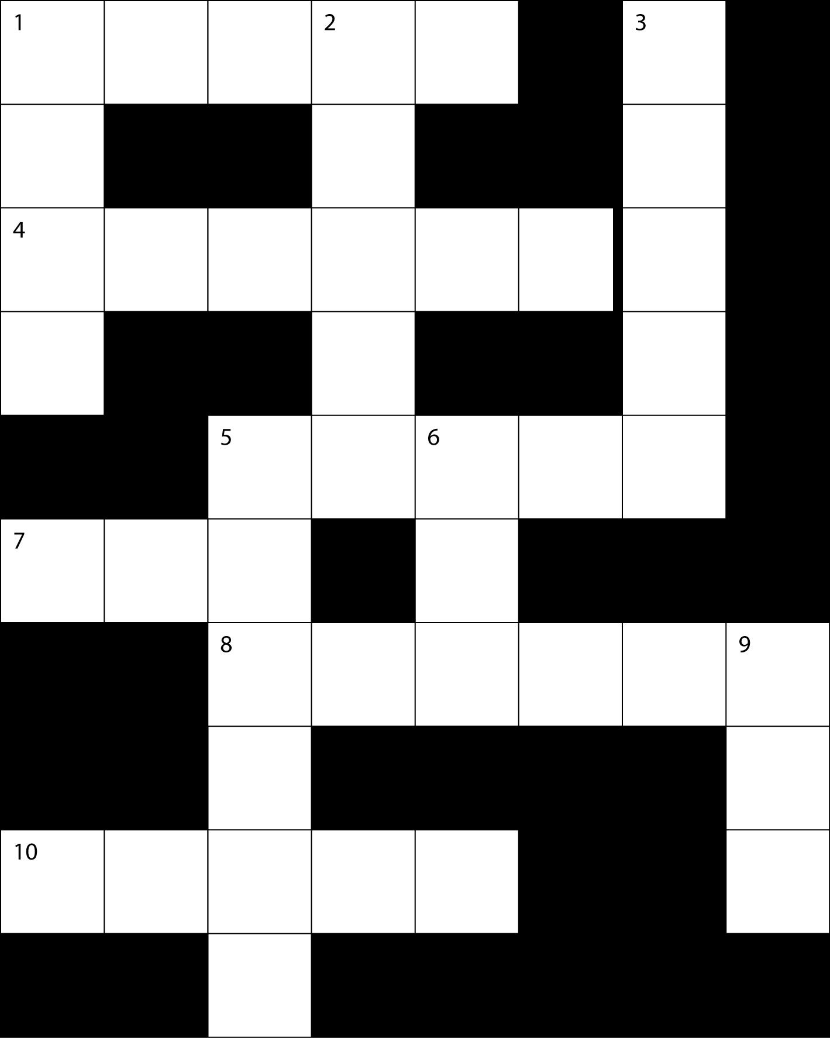**

<http://www.funmaths.com/worksheets/downloads/view.htm?ws0006_1.gif>

(03-03-2009)

# End of section comments

After working through this section you should have a better understanding of how the calculator works and what its possibilities are with respect to several types of calculations. You will use the calculator throughout the rest of the course. It is therefore very important that you have thoroughly grasped the contents of this section.

# Feedback

##### Start up activity 2.2

**1.** 64

|  |  |  |  |  |  |  |  |  |
| --- | --- | --- | --- | --- | --- | --- | --- | --- |
| 4 | ( | 5 | + | 12 | ) | - | 14 | = |

**2.** 49

|  |  |  |  |  |  |  |
| --- | --- | --- | --- | --- | --- | --- |
| ( | 3 | + | 4 | ) |  | = |

**3.** -3

|  |  |  |  |  |
| --- | --- | --- | --- | --- |
| SHIFT |  | (-) | 27 | = |

**4.** 

|  |  |  |
| --- | --- | --- |
| tan | 60 | = |

**5.** 60

|  |  |  |  |  |  |  |
| --- | --- | --- | --- | --- | --- | --- |
| SHIFT | cos |  | 1 |  | 2 | = |

**6.** 1,9828

|  |  |  |  |  |
| --- | --- | --- | --- | --- |
| log | 9 |  | 78 | = |

**7.** 162754,7914

|  |  |  |  |
| --- | --- | --- | --- |
| SHIFT | ln | 12 | = |

##### Answers to learning activity 2.3

* 1. -9
  2. -5184
  3. 
  4. 0,7781512504
  5. 1,543959311
  6. 4
  7. -1579,586841
  8. 1004
  9. 
  10. 10,8322008
  11. 
  12. 
  13. 
  14. 

##### Answers to learning activity 2.4

1. 87% Press 87 then SHIFT then (
2. 932,96 or 
3. 71,79%
4. 5476,8 or 
5. 542,85 or 
6. 107,1428571%
7. 25%

##### Answers to learning activity 2.5

1. 25
2. 896
3. 83
4. Press (189x4) then SHIFT then RCL and then (-).
5. 2,683544304

##### Answers to Group Activity 2.6

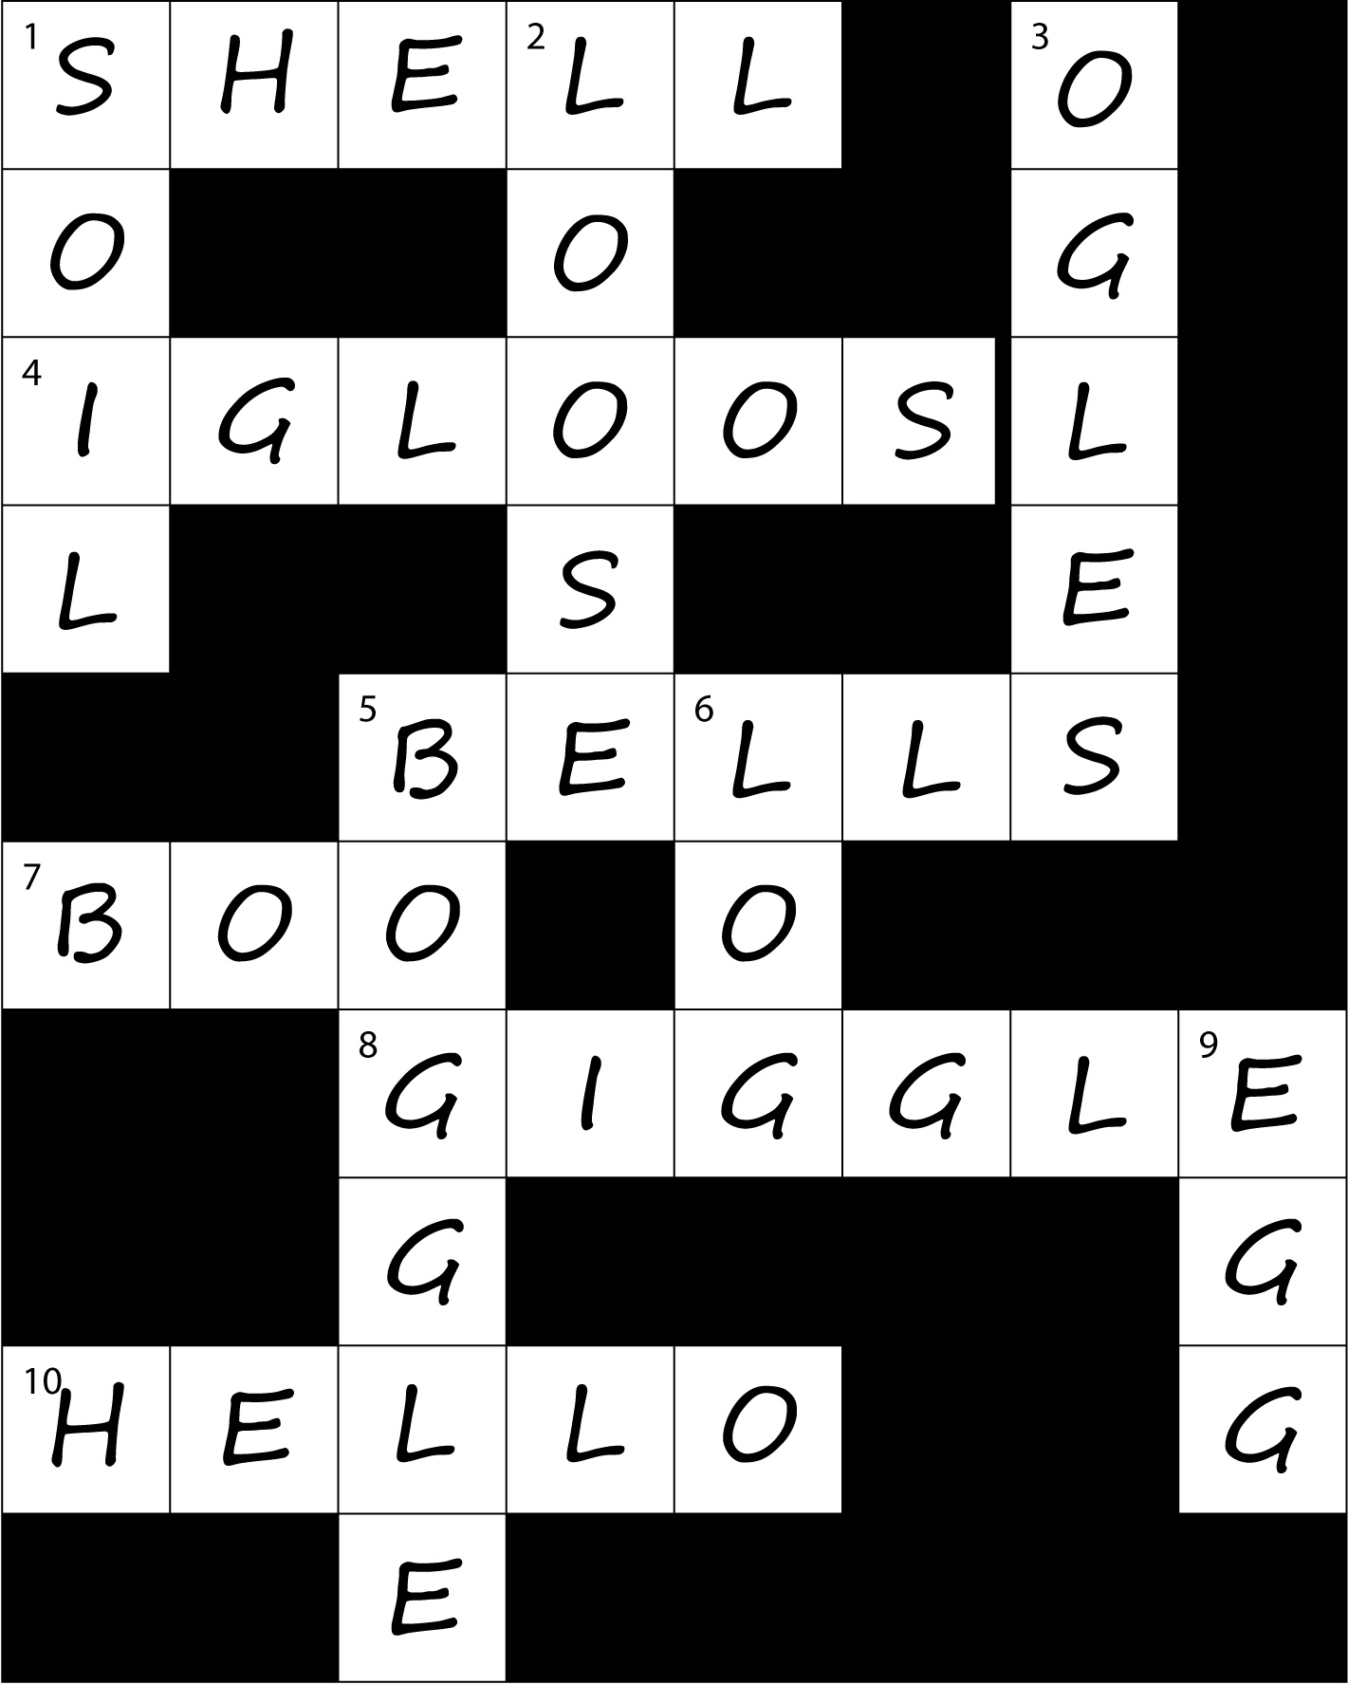

<http://www.funmaths.com/worksheets/downloads/view.htm?ws0006_2.gif>

(03-03-2009)

# Tracking my progress

You have reached the end of this section. Check whether you have achieved the learning outcomes for this section.

|  |  |  |
| --- | --- | --- |
| **Learning outcomes** | **✓ I feel confident** | **✓ I don’t feel confident** |
| Change the input/output format |  |  |
| Do simple calculations using second functions |  |  |
| Change the calculation mode |  |  |
| Switch between fraction and decimal format |  |  |
| Switch between improper fraction and mixed fraction format |  |  |
| Input expressions and values |  |  |
| Display calculation results that include irrational number formats |  |  |
| Do percentage calculations |  |  |
| Work with the calculation history memory |  |  |
| Use the Answer Memory to perform a series of calculations |  |  |
| Use the calculator memory |  |  |

Now answer the following questions honestly:

1. What did you like best about this section?

|  |
| --- |
|  |
|  |
|  |

1. What did you find most difficult in this section?

|  |
| --- |
|  |
|  |
|  |

1. What do you need to improve on?

|  |
| --- |
|  |
|  |
|  |

1. How will you do this?

|  |
| --- |
|  |
|  |
|  |