T arou

Section 3b:

Quadratic Functions

Maths Literacy, Workshop Series 2010

Section 3b:

Quadratic Functions

# 1. Introduction

A ball is thrown vertically upward from ground level with an initial velocity of 32 meters per second. The formula  gives its height, s, in meter, t seconds after it has left your hand. We can use this formula to answer three kinds of questions: (See if you can answer question 1 and 2 straightaway.)

1. “What is the height of the ball, at a given time, say 0,5 seconds, after the ball has left your hand?” This is easy. Just substitute the time into the equation.
2. “How long does it take the ball to reach a given height, say 16 meters?” This is harder and requires solving a quadratic equation.
3. “What is the maximum height of the ball?” Here, both the time and height are unknowns. One way to solve the problem is to sketch the graph of the function.

*Check your answers at the end of the section.*

## Learning outcomes

At the end of this section you should be able to solve quadratic functions in real life situations.

|  |  |
| --- | --- |
| Maths Literacy icon_2.jpg | Start up activity 3.1:  Make use of Excel to plot quadratic functions |

Pair up with a class mate and complete the following activity.

Let’s try to plot the above function, , by making use of Excel.

Type the following *x*-coordinates in cell A1 to A5: -1 0 1 2 3

Type the formula: =(32\*(A1)-16\*(A1^2)) in B1 and copy this formula through to B5.

The cells should look like this:

|  |  |
| --- | --- |
| -1 | -48 |
| 0 | 0 |
| 1 | 16 |
| 2 | 0 |
| 3 | -48 |

Highlight these cells and choose **insert, line, XY Scatter, Scatter with smooth lines and markers** and then press OK. Your graph should look as follows.

Can you read from the graph the maximum height of the ball?

For the activities that follow in this unit, you can use Excel to plot your graphs and confirm your answers.

# 2. Quadratic Equations

In this section, we will solve a specific type of equation called the *quadratic equation*.

A "quadratic" expression involves an unknown raised to the [power](http://www.ucl.ac.uk/Mathematics/geomath/MHglossary/MHglosspower.html) 2, such as the expression . It is called quadratic because the largest power of the unknown is 2.

|  |  |
| --- | --- |
| **The following are examples of quadratic expressions** | **The following are NOT  quadratic expressions** |
|  |  |

If we add one more term, , to the equation of a straight line, we get the equation , which defines a quadratic function.

|  |
| --- |
| **Quadratic equation**  A quadratic equation is an equation that can be written in the form , where *a, b*, and *c* are real numbers, with . |

## Solving Quadratic Equations

### The Quadratic Formula

A quadratic equation of the form  can be solved (that is, find the value(s) of , if any, that satisfies the equation) by making use of the following formula:

|  |
| --- |
| **Quadratic Formula**  The solution(s) of ,  are given by: |

#### Example 3.1

Solve  by using the quadratic formula.

##### Solution

, so ,  and 

Substitute ,  and  into the formula:











 or 

The solution set is .

Check your answer by substituting it in the original equation:

 **or**  

 

#### Example 3.2

Solve  by using the quadratic formula.

##### Solution

First write the equation in standard form:



, so ,  and 

Substitute ,  and  into the formula:











 **or **

** or** 

The solution set is .

Check your answer by substituting it in the original equation:

 **or** 

 

#### Example 3.3

Solve  by using the quadratic formula.

##### Solution

First write the equation in standard form:



, so that ,  and 

Substitute ,  and  into the formula:









 **or** 

The solution set is .

Check your answer by substituting it into the original equation:

 **or**  

 

#### Example 3.4

Solve  by using the quadratic formula.

##### Solution

First write the equation in standard form:



, so ,  and 

Substitute ,  and  into the formula:











The solution set is 

Check your answer by substituting it in the original equation:





#### Example 3.5

Solve  by using the quadratic formula.

##### Solution

First write the equation in standard form:



, hence ,  and 

Substitute ,  and  into the formula:













 **or** 

 

The solution set is

Check your answer by substituting it in the original equation:

 **or** 

 

#### Example 3.6

Solve  by using the quadratic formula.

##### Solution

First write the equation in standard form:



 giving ,  and 

Substitute ,  and  into the formula:









Since we cannot find the square root of a negative number, there is no real solution for the equation. Hence, the solution set (for real solutions) is empty.

|  |  |
| --- | --- |
| Maths Literacy icon_2.jpg | Learning activity 3.2 |

Solve the following equations by making use of the formula: (Confirm your answers by making use of Excel.)

1. 
2. 
3. 
4. 
5. 
6. 

### Completing the Square

We can also make use of the method of “completing the square” to solve quadratic equations.

If the function  is written in the form, we say that the function is written in “completed square” form.

|  |
| --- |
| **Completed square form**  can be written in completed square form by making use of the formula: . |

#### Example 3.7

Rewrite in completed square form.

##### Solution

 gives ,  and .

Substitute ,  and  into the formula:











#### Example 3.8

Rewrite in completed square form.

##### Solution

 gives ,  and 

Substitute ,  and  into the formula:











#### Example 3.9

Rewrite  in completed square form.

##### Solution

 gives,  and 

Substitute ,  and  into the formula:











*…remember to multiply the 2 outside the brackets to both terms on the inside.*

|  |  |
| --- | --- |
| Maths Literacy icon_2.jpg | Learning activity 3.3 |

Complete the square for the following expressions:

1. 
2. 
3. 
4. 
5. 
6. 
7. 

Let’s use the previous three examples to solve the equations.

#### Example 3.10

Solve the equation.

##### Solution

From the previous example 3.7 we saw that completing the square gives:



So we have to solve:





 *…taking square roots on both sides*



 **or**  

 

The solution set is .

Check your answer by substituting it into the original equation:

 **or** 

 

#### Example 3.11

Solve the equation.

##### Solution

From the previous example 3.8 we saw that completing the square gives:



So we have to solve for  in:





*…taking square roots on both sides*



 **or** 

 

The solution set is.

Check your answer by substituting it into the original equation:

 **or** 

 

#### Example 3.12

Solve the equation.

##### Solution

From the example 3.9 we saw that completing the square gives:



So we have to solve for  in:





*…divide by 2 on both sides*

*… taking square roots on both sides*

 **or** 

 **or**  

The solution set is .

Check your answer by substituting it into the original equation:

 **or** 

 

|  |  |
| --- | --- |
| Maths Literacy icon_2.jpg | Learning activity 3.4 |

Use the completed square form of the previous assessment activity to solve the following equations.

1. 
2. 
3. 
4. 
5. 
6. 
7. 

## Sketching the Graphs of Quadratic Functions

Look at the start-up activity again:

“How high does the ball go?” Neither the time, nor the height, is given here. However, we can find both these from the graph of the function. In this section we will learn how to sketch the graphs of quadratic functions.

The graphs of quadratic functions are parabolas. Each parabola is symmetric about its *axis of symmetry* and it has a turning point called a *vertex*. Each quadratic function has either a maximum or a minimum value.

The simplest quadratic function is given by  Let’s study the graph of this function.

#### Example 3.13

Draw the graph for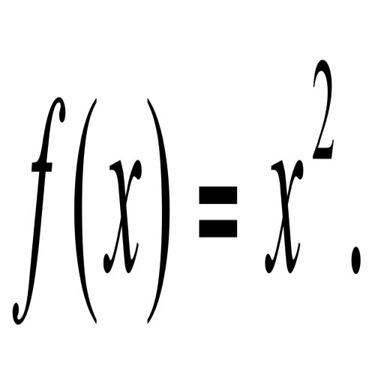

##### Solution

Set up a table:

|  |  |  |  |  |  |  |  |  |  |
| --- | --- | --- | --- | --- | --- | --- | --- | --- | --- |
|  | -4 | -3 | -2 | -1 | 0 | 1 | 2 | 3 | 4 |
|  | 16 | 9 | 4 | 1 | 0 | 1 | 4 | 9 | 16 |

Draw the graph:

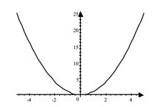

X

Y

The parabola has a turning point, called the *vertex,* at (0,0), and it follows that the function  has a minimum value of 0 when x=0.

An important feature of parabolas is that they are symmetrical about a vertical line, called the *axis of symmetry*, namely the vertical line through the vertex. For the graph of , the vertical line through the vertex, with equation x=0, (which coincides with the *y*-axis), is its axis of symmetry.

#### Example 3.14

Draw the graph for

##### Solution

Set up a table:

|  |  |  |  |  |  |  |  |  |  |
| --- | --- | --- | --- | --- | --- | --- | --- | --- | --- |
|  | -4 | -3 | -2 | -1 | 0 | 1 | 2 | 3 | 4 |
|  | -16 | -9 | -4 | -1 | 0 | -1 | -4 | -9 | -16 |

Draw the graph:

Y

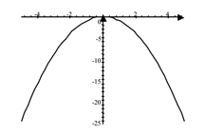

X

The vertex of the parabola is (0,0), and, in this case, the function  attains a maximum value of 0 at the vertex.

For the graph of, the vertical line through the vertex (which coincides with the *y*-axis), is again the axis of symmetry.

### Use Formulas

Parabolas need not have their vertices at the origin.

We can easily find the axis of symmetry and the vertex by using the following formula:

|  |
| --- |
| **For the graph of the quadratic function:**   * the axis of symmetry is: * the vertex (turning point) is: |

|  |
| --- |
| **Method to sketch parabolas by making use of formulas**  **Step 1:** Find the *y*-intercept.  **Step 2:** Find the *x*-intercepts.  **Step 3:** Find the axis of symmetry:  **Step 4:** Find the vertex:  **Step 5:** Draw the graph. |

#### Example 3.15

Draw the graph of  by making use of formulas.

##### Solution

**Step 1:** The graph intersects the *y*-axis where *x*. Substitute *x* into the equation : 

The *y*-intercept is at .

**Step 2:** The graph intersects the *x*-axis where *y*. Substitute *y* into the equation :

 where ,  and 

Substitute ,  and  into the quadratic formula, to solve for *x*:







The *x*-intercepts are at  and .

**Step 3:** The axis of symmetry is: 

For  and  this gives:



**Step 4:** The vertex is: 

For , and , this becomes:



**Step 5:** Draw the graph.



#### Example 3.16

Draw the graph of  by making use of formulas.

##### Solution

**Step 1:** The graph intersects the *y*-axis where *x*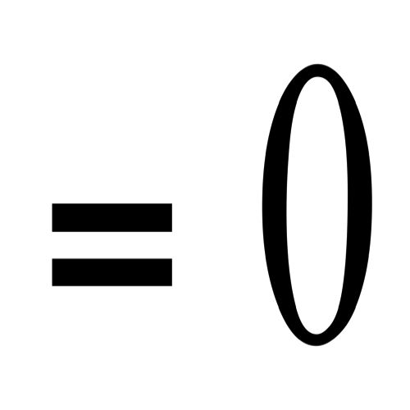. Substitute *x* into the : 

The *y*-intercept is at .

**Step 2:** The graph intersects the *x*-axis where *y*. Substitute *y* into the equation :

 where ,  and .

Substitute ,  and  into the quadratic formula and solve for *x* :











The *x*-intercepts are at  and 

**Step 3:** The axis of symmetry is 

For and  this gives:



**Step 4:** The vertex is: 

For ,  and  this gives:



**Step 5:** Draw the graph.



#### Example 3.17

Draw the graph of  by making use of formulas.

##### Solution

**Step 1:** The graph intersects the *y*-axis where *x*. Substitute *x* into the equation : 

The *y*-intercept is at .

**Step 2:** The graph intersects the *x*-axis where *y*. Substitute *y* into the equation :

 where ,  and 

Substitute ,  and  into the quadratic formula to solve for *x* :











The *x*-intercepts are at  and 

**Step 3:** The axis of symmetry is: 

For  and  this becomes:



**Step 4:** The vertex is: 

For ,  and  this becomes:



**Step 5:** Draw the graph.



#### Example 3.18

Draw the graph of  by making use of formulas.

##### Solution

**Step 1:** The graph intersects the *y*-axis where *x*. Substitute *x* into the equation : 

The *y*-intercept is at .

**Step 2:** The graph intersects the *x*-axis where *y*. Substitute *y* into the equation :

 where ,  and 

Substitute ,  and  into the quadratic formula and solve for *x*:









There are no *x*-intercepts.

**Step 3:** The axis of symmetry is: 

For and  this becomes:



**Step 4:** The vertex is: 

For ,  and  this becomes:



**Step 5:** Draw the graph:



### General Principles in Drawing Parabolas

|  |  |  |  |
| --- | --- | --- | --- |
| For  where | | For  where | |
| the parabola opens upward | | the parabola opens downward. | |
| the *y*-coordinate of the vertex represents the minimum value of the function, namely | | the *y*-coordinate of the vertex represents the maximum value of the function, namely | |
| the function has a minimum that occurs at | | The function has a maximum that occurs at | |
|  | Graph has 2 *x-*intercepts  Graph has 1 *x*-intercept  Graph has no *x*-intercepts |  | Graph has 2 *x-*intercepts  Graph has 1 *x*-intercept  Graph has no *x*-intercepts |

|  |  |
| --- | --- |
| Maths Literacy icon_1.jpg | Assessment activity 3.5 |

Draw the graphs of the functions defined by the following equations, by making use of the formulas.

In each case, give the coordinates of the vertex and say whether the function has a maximum or minimum value. No tables of function values should be used! (Make use of Excel to confirm your answers.)

1. 
2. 
3. 
4. 
5. 
6. 
7. 

### Finding the vertex by Completing of the Square

|  |
| --- |
| If the equation  is written in the form, (“completed square” form) then the axis of symmetry is, and the vertex is the point . Furthermore, if a is positive,  is a minimum function value, and if a is negative, is a maximum function value. |

|  |
| --- |
| **How to draw parabolas by completing the square**  **Step 1:** Complete the square:  **Step 2:** Find the y-intercept.  **Step 3:** Find the x-intercepts.  **Step 4:** Find the axis of symmetry:  **Step 5:** Find the vertex:  **Step 6:** Draw the graph. |

#### Example 3.19

Draw the graph of  by completing the square. (See example 3.9)

##### Solution

**Step 1:** To complete the square see section 2.1.2

 gives ,  and 

Substitute ,  and  into the formula and obtain:



**Step 2:** The graph intersects the *y*-axis where *x*. So substitute *x* into the equation . This gives 

Hence the *y*-intercept is at .

**Step 3:** The graph intersects the *x*-axis where *y*. So substitute *y* into the equation :  with ,  and .

Substitute ,  and into the quadratic formula to solve for *x* :









The *x*-intercepts are at  and .

**Step 4:** Axis of symmetry: 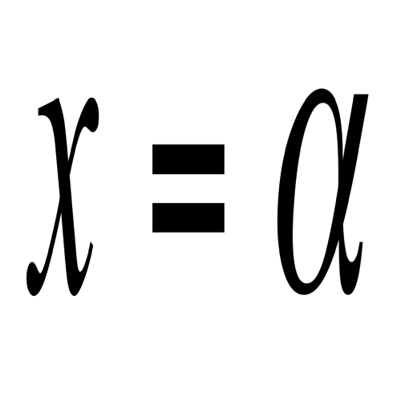, where 



Axis of symmetry: 

**Step 5:** Vertex:  where 



Vertex: 

**Step 6:** Draw the graph.



Note that  is a minimum function value.

#### Example 3.20

Draw the graph of  by completing the square. (See example 3.16)

##### Solution:

**Step 1:**  implies that ,  and .

Substitute ,  and  into the formula to obtain:





**Step 2:** The graph intersects the *y*-axis where *x*. Hence substitute *x* into the equation : 

The *y*-intercept is at .

**Step 3:** The graph intersects the *x*-axis where *y*. So substitute *y* into the equation :  where ,  and .

Substitute ,  and  into the quadratic formula and solve for *x* :









The *x*-intercepts are at  and 

**Step 4:** Axis of symmetry: , where .



Axis of symmetry: 

**Step 5:** Vertex: , where 



Vertex: 

**Step 6:** Draw the graph.



Note that  is a minimum function value.

#### Example 3.21

Draw the graph of  by completing the square. (See example 3.11)

##### Solution

**Step 1:**  gives ,  and .

Substitute ,  and  into the formula and obtain:



**Step 2:** The graph intersects the *y*-axis where *x*. So substitute *x* into the equation  : .

The *y*-intercept is at .

**Step 3:** The graph intersects the *x*-axis where *y*. So substitute *y* into the equation  : with ,  and .

Substitute ,  and into the quadratic formula to solve for *x* :









The *x*-intercepts are at  and 

**Step 4:** Axis of symmetry: , where .





Axis of symmetry: 

**Step 5:** Vertex: , where .



Vertex: 

**Step 6:** Draw the graph.



Note that  is a minimum function value.

|  |  |
| --- | --- |
| Maths Literacy icon_1.jpg | Assessment activity 3.6 |

Complete the square in order to draw the graphs in each of the following cases. (You already did this in assessment Activity 4.3) Give the coordinates of the vertex and say whether it is a maximum or minimum function value.

1. 
2. 
3. 
4. 
5. 
6. 
7. 

Some problems require from us to find the minimum or maximum value of a quadratic function. Such problems can be solved by using the standard form

which shows that the vertex of the parabola is the point. When  the vertex is the lowest point on the parabola; when  it is the highest point. These special points will be useful in solving certain problems.



 is the maximum value



## Icon_6.jpgApplications of Quadratic Functions in Engineering

#### Example 3.22

A body of mass  kg has kinetic energy,  joule (J). Find the speed v given that (where v is measured in meters per second).

##### Solution

Substituting  kg and  into the equation gives:





*…taking the square root on both sides*



Since v cannot be negative we have that  m/s.

#### Example 3.23

The bending moment, *M*, of a beam is given by  where *x* is the distance along the beam measured from the one end. At what distance is the bending moment.

##### Solution

We have to find x such that . Use the quadratic formula to solve for *x*:

 where ,  and 

Substitute ,  and  into the quadratic formula gives:







 **or** 

Sine *x* cannot be negative, the bending moment is 0 at distance .

#### Example 3.24

If an object is propelled upward from the top of a 63 meter building at 42 meters per second, its position (in meter above the ground) is given by , where *t* is the time in seconds after it was propelled. When does it hit the ground?

##### Solution

When the object hits the ground, its distance above the ground is 0. We must find the value of *t* that makes.

Use the quadratic formula to solve for *t*.

 where ,  and .

Substitute ,  and  into the quadratic formula to solve for t:







 **or** 

Sine *t* cannot be negative, the object will reach the ground after seconds.

#### Example 3.25

The voltage *V* after t seconds over two poles in a circuit is given by . Sketch the graph of *V* against *t*, indicating the minimum value of *V*.

##### Solution

**Step 1:** The graph intersects the *V*-axis where *t*. Hence substitute *t* into the equation  : 

The *V*-intercept is at .

**Step 2:** The graph intersects the *t*-axis where *V*. So substitute *V* into the equation , so that , with ,  and .

Substitute ,  and  into the quadratic formula and solve for *t*:







There are no *t*-intercepts (which means that the voltage is never 0).

**Step 3:** The axis of symmetry is: 

For and  this gives:



**Step 4:** The vertex is: 

Substitute,  and  into this formula:



**Step 5:** Draw the graph.



Note that the minimum value of the voltage is 2.

|  |  |
| --- | --- |
| Maths Literacy icon_1.jpg | Assessment activity 3.7 |

1. A vehicle moves with velocity *v* and constant acceleration *a.* It is given that  where *s* is the distance travelled and *u* is the initial velocity. If  *m/s*,  *m* and  *m/s*, find the value of *u*.
2. The displacement, *s*, of a particle is given by m, where  is the time, measured in seconds. Find the time taken for a displacement of 2 300 *m*.
3. A variable voltage in an electrical circuit is given by , where *t* is the time measured in seconds. Find the values of *t* for which the voltage V = 104.
4. The displacement, *s (in meters)*, of a body is given by  where *t* is the time (in seconds), *u* is the initial velocity and *a* is a constant acceleration. After how many seconds is  *m,* given that  *m/s* and  ?
5. A ball is thrown vertically upward from ground level at an initial velocity of 32 meters per second. The formula  gives its height, *s*, in meter after *t* seconds. Find the time taken for the ball to reach the ground.
6. After t seconds, the voltage *V* of a circuit is given by . Sketch the graph of *V* against *t*, and find the minimum value of *V*.
7. The height, *s* (in meters) of a projectile fired from the ground with respect to time *t* (in seconds) is given by . Sketch the graph of *s* against *t*, and find the maximum height reached by the projectile, and after how many second this maximum height is reached.

## Applications of Quadratic Functions in Economics

#### Example 3.26

The Total Revenue function is given by , where *Q* is the quantity sold of some commodity. Sketch the graph of *TR* against *Q*. For what value(s) of *Q* is *TR* zero? What is the maximum value of *TR*?

##### Solution:

**Step 1:** The graph intersects the *TR*-axis where *Q*. So substitute *Q* into the equation : 

It follows that the *TR*-intercept is at .

**Step 2:** The graph intersects the *Q*-axis where *TR*, so substitute *TR* into the equation :

 with ,  and .

Substitute ,  and  into the quadratic formula to solve for *Q*:







 **or** 

*TR* will be zero when  and also when .

**Step 3:** The axis of symmetry is: 

For  and  this gives:



**Step 4:** The vertex is: 

For ,  and  this becomes:



The maximum value for *TR* is 1250, when 25 units of the commodity are sold.

**Step 5:** Draw the graph.



#### Example 3.27

The Total Profit function is given by , where *Q* is the quantity sold of some commodity. Sketch the graph of *TP* against *Q*. For what values of *Q* is *TP* zero? What do we call the points where *TP* is zero? Give the intervals over which the Total Profit is positive and the intervals over which it is negative. What is the maximum value of *TP*?

##### Solution

**Step 1:** The graph intersects the *TP*-axis where *Q*. Hence, substitute *Q* into the equation : 

The *TP*-intercept is at .

**Step 2:** The graph intersects the *Q*-axis where *TP*, so substitute *TP* into the equation :

with ,  and 

Substitute ,  and  into the quadratic formula to solve for *Q*:







 **or** .

*TP* =0 if  and also if . These are the *break-even* points.

**Step 3:** The axis of symmetry is: 

For  and , we get:



**Step 4:** The vertex is: 

For ,  and , we obtain:



The maximum value for *TR* is 6,125, and this is attained when Q=2,25.

**Step 5:** Draw the graph.



Total Profit is positive for values of *Q* between 0,5 and 4, and it is negative for all other values of Q. The maximum value of *TP* is 6,125.

|  |  |
| --- | --- |
| Maths Literacy icon_1.jpg | Assessment activity 3.8 |

1. The Total Revenue function is given by , where *Q* is the number of units sold of a certain commodity. Sketch the graph of *TR* against *Q*. For what values of *Q* is *TR* zero? What is the maximum value of *TR*?
2. The Total Profit function is given by , where *Q* is the number of units sold of a certain commodity. Sketch the graph of *TP* against *Q*. For what values of *Q* is *TP* zero? What do we call the points where *TP* is zero? Give the intervals over which the Total Profit is positive and the intervals over which it is negative. What is the maximum value of *TP*?
3. Your college is selling tickets for a concert. Based on past experience, it has been determined that the profit they will make on selling *x* tickets (in hundreds) is given by the function. What is the maximum profit they can expect to make and how many tickets do they have to sell in order to accomplish this?
4. For a certain company, the cost to produce *x* units (in thousands) of a certain commodity is given by the cost function  in million rand. The revenue from selling *x* units is given by the revenue function . Find the maximum profit they can expect and how many of these units they have to produce and sell to make this maximum profit. [Hint: Profit function = Revenue function – Cost function. Find the maximum point of the Profit function.]

## Using Quadratic Functions to solve Word Problems

**We are now able to solve quadratic equations that arise in all sorts of application.**

Remember the six-step method to solve word problems:

|  |
| --- |
| **How to solve word problems**  **Step 1:** Read the problem very carefully so that you completely understand what the problem is asking you to do. Identify all the given information and what you are asked to determine.  **Step 2:** Represent one of the unknown quantities as a variable and try to relate all the other unknown quantities (if there are any) to this variable.  **Step 3:** If possible, draw a diagram to illustrate the situation.  **Step 4:** Write down an equation that relates known quantities to the unknown quantities. Use the diagram to help you to determine the equation.  **Step 5:** Solve the equation and write down the answers to all the questions.  **Step 6:** Check your answer(s).  Does it make sense? |

#### Example 3.28

Find two consecutive positive integers such that the sum of their squares is 113.

##### Solution:

**Step 1:** We want to find two consecutive positive integers such that the sum of their squares is 113.

**Step 2:** Let  the first integer.

Then  the next integer.

**Step 4:** The sum of their squares can be represented as 

**Step 5:**

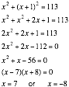

**Step 6:** Since the integers must be positive, we reject the solution

 Substitute the value  in the equation: 

The answer does make sense.

The two consecutive integers are 7 and 8.

#### Example 3.29

A ball is propelled vertically upwards from ground level with an initial velocity of 64 meter per second. The formula  gives its height, *s*, in meter after *t* seconds. What is the maximum height reached by the ball? After how many seconds does the ball return to the ground?

##### Solution

**Step 1:** We have to find the maximum height reached by the ball, and calculate how long it will take to return to the ground.

**Step 3:**



**Step 4:**  gives its height ,*s*, in meter after *t* seconds.

**Step 5:** The maximum or minimum value always occurs at the vertex.

For the quadratic function the vertex is . For  we have,  and . This gives the vertex



You should now recognize this as a parabola with vertex. The maximum height, 64 meters, is reached after 2 seconds.

**Step 6:** Substitute the value  in the equation:



The answer does make sense.

If it takes the ball 2 seconds to reach maximum height, it will take another 2 seconds to reach the ground. So the ball will take 4 seconds after propelled upwards to reach the ground.

#### Icon_6.jpgExample 3.30

Two cyclists left a crossing at the same time, one heading due north, and the other due west. After a while, they were exactly 20 kilometers apart from each other. The cyclist that went in a northerly direction had gone 2 kilometers farther than the cyclist that went in a westerly direction. What distance had each cyclist covered?

##### Solution

**Step 1:** Calculate how far each cyclist cycled.

**Step 2:** Let *x* be the distance traveled by the cyclist that went in a westerly direction. Then  is the distance traveled by the cyclist that headed north.

**Step 3:**



**Step 4:** Use the Pythagorean formula:



**Step 5:** 









Use the quadratic formula to solve for x:

 with ,  and 

Substitute ,  and  in the formula:







 **or** 

**Step 6:** Since the distances travelled must be positive, we must reject the solution . So the answer is .

Substituteinto the equation: 

The answer does make sense.

The cyclist that travelled to the west covered 13,107 kilometers and the other one 15,107 kilometers.

#### Example 3.31

A rectangular vegetable garden, 30 meter wide and 70 meter long, is surrounded by a walkway of uniform width. If the total area of the walkway is 80 square meter, how wide is the walkway?

##### Solution

**Step 1:** We have to find the width of the walkway, given that the area of the walkway is 80 square meter.

**Step 2:** Let *x* = the width of the walkway

The length of the outer rectangle is 

The width of the outer rectangle is 

The area of the outer rectangle is: 

The area of the inner rectangle is: 

**Step 3:**









**Step 4:** Area of the outer rectangle = Area of inner rectangle + Area of Walkway



**Step 5:** 







Use the quadratic formula to solve for x:

 where ,  and .

Substitute these values into the quadratic formula:





 **or** 

**Step 6:** Since the width of the footpath cannot be negative, we must reject the solution. Hence the solution is . Substitute the value  into the equation:



The answer does make sense.

So the width of the walkway is  meter.

#### Example 3.32

Suppose that 300 meters of fencing is available to enclose a rectangular vegetable garden, one side of which will be against the side of a river. Find the dimensions of the garden that will ensure a maximum area of the garden.

##### Solution

**Step 1:** We want to maximise the area of the vegetable garden, given that a total of 300 meters of fencing is available for three sides of the rectangular garden.

**Step 2:** Let *x* represent the width of the garden. Then  represents the length (see diagram).

**Step 3:**

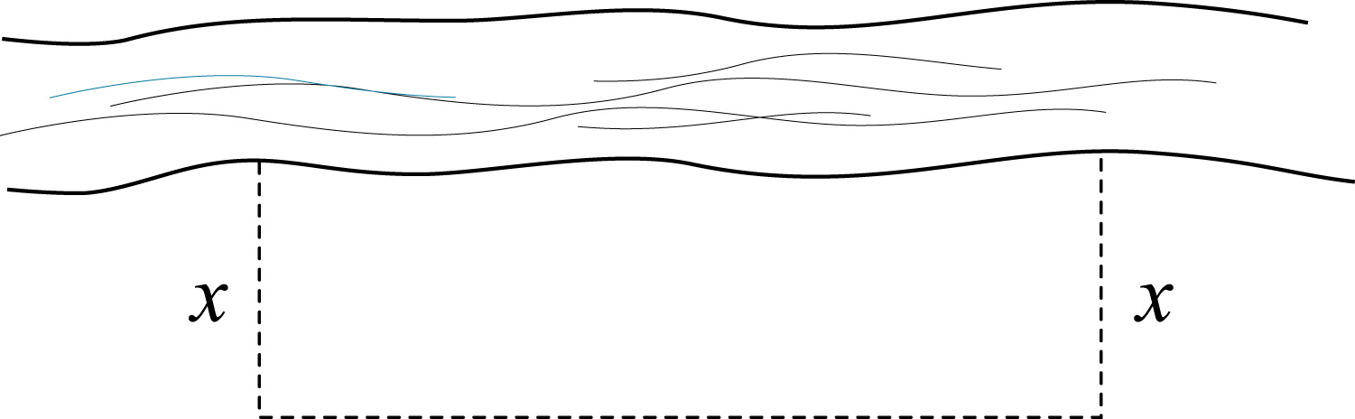

**Step 4:** From the sketch it is clear that the full 300 meters of fencing is used for three sides, two of which are of the same length, *x.*

The area *A* is given by 

**Step 5:** 





The maximum or minimum value always occurs at the vertex.

The vertex is: 

In our case: ,  and  and the formula gives:



The width is  meter and the length is  meter.

The maximum area is 11250 square meter.

**Step 6:** Substitute the value  into the equation:



The answer does make sense.

Hence, for a maximum area (of 11250 square meter), the width of the garden should bemeter and the length  meter.

#### Example 3.33

The length of a rectangular piece of cardboard is 1 centimetre more than its width. As shown in the diagram below, an open box is formed by cutting off a square of size 1  from each corner, and folding up the sides. If the volume of the box is 6 cubic centimetre, find the dimensions of the original cardboard.



##### Solution

**Step 1:** Find the dimensions of the original cardboard if the volume of the box is 6 cubic centimetre.

**Step 2:** Let *x* be the width of the cardboard. Then the length is .

**Step 3:**



**Step 4:** After the squares are cut out and the sides are folded up, the dimensions of the box are:

Length 

Width 

Height 

Since the volume is supposed to be 6 cubic centimetre*,* and , we have.

**Step 5:**

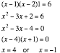

**Step 6:** Since the side lengths cannot be negative, we must reject the solution . So the answer must be x=4. Substitute the value  in the equation:



The answer does make sense.

We conclude that the dimensions of the original cardboard are:

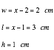

|  |  |
| --- | --- |
| Maths Literacy icon_1.jpg | Assessment activity 3.9 |

1. The sum of two numbers is 24. Find the two numbers if their product is to be as large as possible.
2. The formula  gives the distance in meter above the ground reached by an object after *t* seconds.
   1. What is the maximum height reached by the object?
   2. How long does it take for the object to reach its maximum height?
   3. How long does it take for the object to return to the ground from the time it has been propelled into the air?
   4. In how many seconds will the object reach a height of 192 meter?
3. A box has a length that is 20 cm longer than its width. The area of the rectangular top of the box is 800 square centimetre. Find the length and the width of the box.



1. You want to make a right-angled triangular flower bed. One leg of the triangle should be 1 metre shorter than the other leg. The area of the flower bed is 21 square meter. Find the lengths of the sides of the flower bed.



1. You are flying a kite such that it is vertically 7 meters higher above your hand than its horizontal distance from you. The string between your hand and the kite is 13 meters long. Determine the height of the kite above your hand.

|  |  |
| --- | --- |
| Maths Literacy icon_4.jpg | Group activity 3.10 |

The following web sites can be consulted for further exercises in quadratic equations.

To solve quadratic equations:

<http://math.about.com/library/blquadraticcalc.htm>

<http://www.jamesbrennan.org/algebra/quad_explorer/quadratic.html>

*(11-03-2009)*

To sketch the graphs of quadratic functions:

[*http://scienceshareware.com/qe\_ov.htm*](http://scienceshareware.com/qe_ov.htm)

*(11-03-2009)*

Do the following exercise by making use of the above web site:

Solve the equation  and sketch the graph of  by making use of these web sites.

|  |
| --- |
|  |



To make a printout of your graphs it is important to unlock the axesses.

Right click on the x or y , then make sure autoscale X and Y are set off.

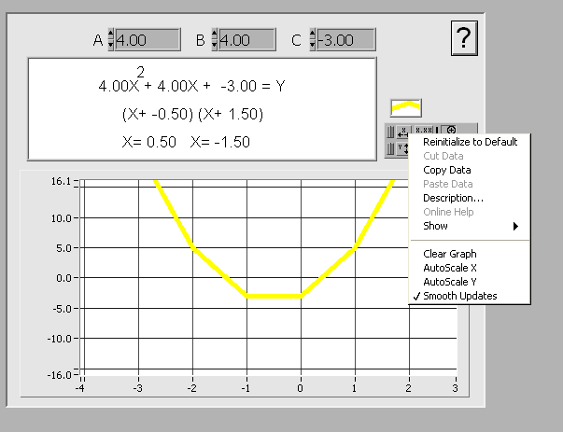

Draw now parabolos for each of the following cases by choosing a suitable scale. Make printouts of your graphs. Make sure your surname and student number are on the pages for handin.

1. 
2. 
3. 
4. 

# End of section comments

In this section we learned how to write and solve quadratic equations in applied problems. We have shown that the quadratic equation has many applications. Here are a few more applications in which the quadratic equation is indispensable: areas, tax, architecture, stopping, electronics, acceleration, planets, shooting, jumping, asteroids, tennis, flight, radio, weather, telescope, and golf.

This was also the last section of this module. I hope that you enjoyed your journey through the semester.

# Feedback

##### Answers to check on the ball problem.

1. 12 meters
2. 1 second
3. Later you will be able the sketch the graph. From the graph we can see that the maximum height is roughly 17 meters.

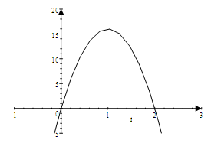

##### Answers to assessment activity 3.2

1.  **or**  
2.  **or** 
3.  **or** 
4.  **or** 
5.  **or**  
6.  **or** 

##### Answers to assessment activity 3.3

1. 
2. 
3. 
4. 
5. 
6. 
7. 

##### Answers to assessment activity 3.4

1.  **or** 
2.  **or** 
3.  **or** 
4.  **or** 
5. 
6.  **or** 
7.  **or** 

##### Answers to assessment activity 3.5

1. The vertex: 

There is a minimum function value at 



1. The vertex: 

There is a minimum function value at 



1. The vertex: 

The minimum function value is , when .



1. The vertex: 

The minimum function value is , when .



1. The vertex is .

The minimum function value is , when .



1. The vertex is .

The minimum function value is , when .



1. The vertex: 

The minimum function value is , when .



##### Answers to assessment activity 3.6

(Same answers as for learning activity 4.5)

##### Answers to assessment activity 3.7

1. There is no solution
2. 
3. 
4. 
5.  seconds

*t*

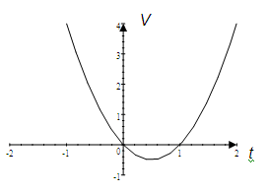

The minimum function value is .

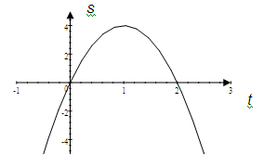

*t*

The maximum function value is 4.

##### Answers to assessment activity 3.8

*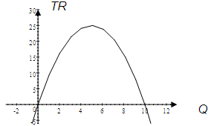*

*Q*

*TR* is zero for  and also for.

The maximum function value is 25.

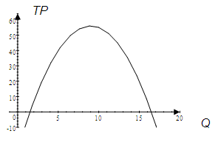

*Q*

*TP* is zero for  and also for. We call these values of Q the break-even points. The Total Profit will be positive for values of Q between 1,517 and 16,483 and it will be negative for values of Q smaller than 1,517 or greater than 16,483. The maximum function value (i.e., the maximum value of TP) is 56.

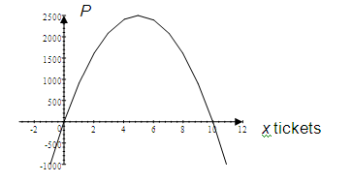

The maximum profit is R2 500, when selling 500 tickets.

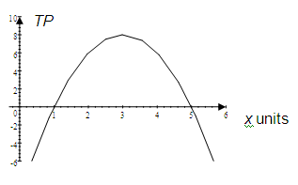

The maximum profit is R10 million, when selling 3 000 units.

##### Answers to assessment activity 3.9

1. The two numbers are both 12
   1. The maximum height is 512,25 meter
   2. It will take the object 5,625 seconds
   3. It will take 11,25 seconds to reach the ground
   4. It will take 0,343 seconds.
2. The length of the box is 26,3 cm and the width is 6,3 cm
3. The lengths of the sides are 6 and 7 metres
4. The horizontal distance is 5 meter and the vertical distance is 12 meter

##### Answers to group activity 3.10

1. 

|  |
| --- |
|  |



1. 

|  |
| --- |
|  |



1. 

|  |
| --- |
|  |



1. 

|  |
| --- |
|  |

****

# Tracking my progress

You have reached the end of this section. Check whether you have achieved the learning outcomes for this section.

|  |  |  |
| --- | --- | --- |
| **Learning outcomes** | **✓ I feel confident** | **✓ I don’t feel confident** |
| At the end of this section you should be able to competently do the following: |  |  |
| Solve a quadratic equation using the formula: |  |  |
| Complete the square for a quadratic expression using the formula: |  |  |
| Solve a quadratic equation after completing the square |  |  |
| Plot the graph for a quadratic function using the following formulas:  axis of symmetry is:  vertex is:  (Turning point) |  |  |
| Sketch the graph of a quadratic function by making use of completing the square |  |  |
| Find the maximum or minimum values of quadratic functions |  |  |
| Use quadratic equations to solve problems arising from various applications |  |  |

Now answer the following questions honestly:

1. What did you like best about this section?

|  |
| --- |
|  |
|  |
|  |

1. What did you find most difficult in this section?

|  |
| --- |
|  |
|  |
|  |

1. What do you need to improve on?

|  |
| --- |
|  |
|  |
|  |

1. How will you do this?

|  |
| --- |
|  |
|  |
|  |