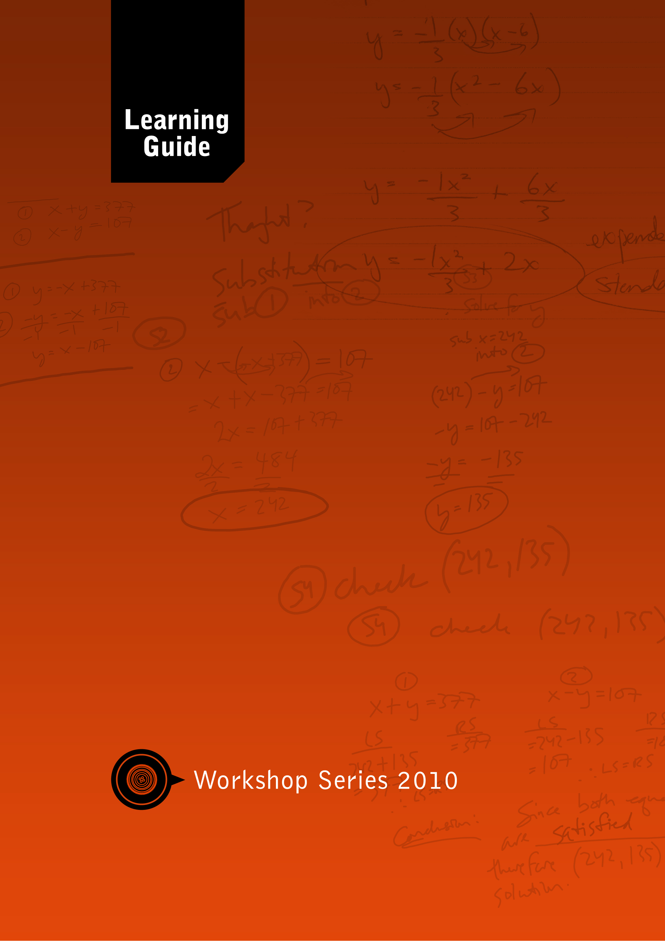

Maths

Literacy
Skills for a Changing World

Module Development Team

Module
Co-ordinator: …….

Lead Authors: …….
…….

Co-writers: …….
…….

Critical Readers: …….
…….
…….
Final Editing
& Consolidation: …….

Project Manager: …….

A Project of the: Free State Education and Training Trust (FSETT), led by the University of the Free State
PO Box 4345
Bloemfontein, South Africa, 9300
Telephone: +27 (0)51 5051222
Fax: +27 (0)51 5051277

Materials can be downloaded from: http://www.oerafrica.org

Creative Commons License:
Attribution Non-commercial Share Alike

Acknowledgements
Insert text here…

Introduction

Programme Map
Insert text for Introduction….

Icons
Icons are visual ‘signposts’ that give clear signals of what is expected of you. The following icons are used in the Student Guides for all the modules. You will soon become used to recognising each icon and the message it conveys.

Learning activity
When you see this icon, you will know that you have to do an activity to show how well you understand what you have read and learned. For some of the learning activities the writer will include some comments or advice. These comments should never be read before you have completed the preceding activity. These comments are also not intended to provide the final ‘answer’, since your opinion may be completely different from the writer’s and still be acceptable. The writer is simply providing you with an informed opinion.
Group activity
Whenever you see this icon you will know that you will work with some of your fellow learners on a team activity.
Assessment activity
This is the sign for assessment activities that you will complete and include in your portfolio. All these activities are marked by the facilitator and they will contribute to your total mark for the programme.
Resource file
When you see this sign you will know that you need to refer to the resource file/CD. It contains additional readings and articles that you may be asked to use to complete an activity.
Enrichment
Icon used in selected sections…

