

Unit Two:

Managing your   
Life

YGPS (Your Global Positioning System), Workshop Series 2010

Unit 2: Managing Your Life

# 1. Introduction

What is the first thing that comes to your mind when you hear the names Cyril Ramaphosa or Patrice Motsepe or Mirriam Makeba or Bill Gates?

1. They are all famous
2. They are all successful
3. They are all very wealthy
4. All of the above

Have you ever wished you could be successful? Or famous? Or wealthy?

Do not be fooled, success is not only for those who get a head start in life, come from the right families or get lucky – any person can be successful regardless of where they begin in life. If you are willing to learn the necessary skills you too can be one of the success stories. One of the most important skills that high achieving individuals have learnt is the ability to set clear goals and pursue those goals with an unwavering commitment.

In this unit we are going to focus on getting your priorities straight, setting smart goals and managing your time most effectively. Get ready to position yourself on **COORDINATE: LIFE MANAGEMENT.**

The unit has been divided into two parts to make your journey through it easier to negotiate. Part A focuses on managing your life through goal setting, and Part B focuses on developing skills of time management.

## Learning outcomes

The aim of this unit is to help you to:

* Identify your most important life priorities;
* Learn to set your own SMART goals;
* Identify your own time management style;
* Investigate ways to improve your own time management;
* Draw up your own monthly calendar, weekly planner and daily to-do list; and
* Make use of strategies to minimise procrastination and minimize interruptions.

# 2. COORDINATE A: Life Management

## Discovering your life’s mission

“Cheshire Puss,” Alice began,  
“would you please tell me which way I ought to go from here?”  
“That depends on where you want to get to.” said the cat.

*- Lewis Caroll in* [*Alice in Wonderland*](http://www.alice-in-wonderland.net/)

The first fundamental step to managing your life most efficiently is getting your priorities straight. The following activity is going to help you identify your life priorities.

|  |  |
| --- | --- |
| YGPS_activity icon.jpg | Learning Activity 2.1:  Beginning with the end in mind |

The following are actual words that appear on tombstones:

j0238641.wmf  

Although these two examples were quite entertaining, most often the message on someone’s tombstone is far more serious, for example:

j0238641.wmf  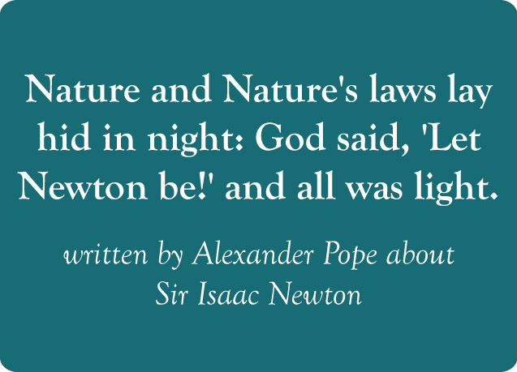

From these two tombstone engravings we get valuable information about how these people lived their lives. Belle Starr’s epitaph reflects the sparkle she brought into the lives of those around her, whilst Isaac Newton is remembered for the enlightenment he brought to scientific knowledge. In their death, the contribution of their lives is honoured.

You might be thinking right now, what does this have to do with figuring out your life priorities? In a moment you will be asked to close your eyes and picture your own funeral. Yes, you read correctly. You must picture four people who are going to speak in honour of you after you have died.

The four people are

1. Any one of your family members,
2. Any one of your close friends,
3. Someone who lives in your community,
4. One of your work colleagues.

Think about what you would **WANT** each of these people to say about you in a eulogy. How would they describe you? What type of accomplishments would they mention? How would they describe your personal relationships? Think of the comments they could make regarding your health and the way you took care of yourself.

Now, take 5 minutes to close your eyes and picture in your mind what each of them **WOULD** say about you. After you have thought about this, write down in the space below what you want each one of them to say.

|  |  |
| --- | --- |
| FAMILY  **E.g.** She always made time to care for her family members regardless of her busy schedule | FRIEND  **E.g.** She was an honest and open friend who helped me to grow and achieve my own dreams |
| CO-WORKER  **E.g.** She was a strong and inspirational leader | COMMUNITY MEMBER  **E.g.** She was well respected for her commitment to eradicating poverty in our community |

*(This activity is based on Steven Covey (1990), 7 Habits of Highly Effective People)*

Now that you know what you want people to remember your life for, you need to start making it your business to see that you start becoming that person. But how do you make that happen? The first step is to prioritise, what are the most important things you want to achieve? Once you know what your most important priority is, you can begin to focus yourself and your lifestyle towards achieving it.

## Prioritising your life’s mission

|  |  |
| --- | --- |
| YGPS_activity icon.jpg | Learning Activity 2.2:  What is your most important thing |

Brian Tracy (2006) in his book, Million Dollar Habits, points out that there are four areas in which people set goals for themselves. These four areas are:

1. Doing work that we enjoy and making a contribution to society through it
2. Financial independence and stability
3. Excellence in relationships
4. Health and fitness

Go back to the Activity 2.1 and examine each statement you would like people to make about you. For each statement you wrote in the four blocks, decide which category it fits into and write it down in one of the blocks below.

|  |  |
| --- | --- |
| WORK | FINANCIAL |
| RELATIONSHIPS | HEALTH AND FITNESS |

Perhaps you will notice that you have many statements in one block and no statements in another. Take some time now to fill in additional statements in blocks where there are no or very few statements.

The last step is for you to rate each statement on a scale of 1-10 indicating how important achieving this is to you. A score of 10 means that this is the most important thing in my life; whereas a score of 1 means that this is not very important to me. Remember each statement is rated individually so you can have more than one “5” or “6” rating for example.

Take a look at the 3 statements that received the highest ratings. **These can be considered your top 3 life priorities.** The next step in achieving the success you want is to set **goals** to help you achieve these 3 priorities. Read on to discover how to go about doing this.

## Going where? Setting SMART goals

Imagine you and a friend are planning a trip to Cape Town – you have everything packed – from hiking shoes, to bathing costumes, the whole works. You climb in the car and off you go. After about 4 hours of driving you notice a sign indicating Johannesburg 60km. NO! That is the wrong destination; you wanted to go to Cape Town – what went wrong? You are lost, why? Thinking back you realise that neither you nor your friend consulted a map before leaving and simply got onto the highway and started driving. Does this sound crazy? Of course it does, no one begins such a long journey without having a planned route of how to get there.

You should think of your goals as your personal roadmap to achieving your life mission. You are going to end up at the wrong destination if you do not have clear goals set for yourself in the short and long term. Goal setting is the process that helps you get clear picture of what you want, make an action plan to help yourself get there, launch into action, and persist until you reach your destination.

In a moment you are going to practice setting your own goals, but first there are 5 characteristics of effective goals that you must learn. The acronym we use for defining effective goals is **SMART.** Examine the diagram below to find out exactly what **SMART** goals are.

|  |  |
| --- | --- |
| YGPS_group activity icon.jpg | Group Activity 2.3:  Setting SMART Goals? |

Form groups of 3-5 people and discuss and review the table below. Then discuss which of the following goal statements could be classified as **SMART** goals, and why?

Statement One: My goal is to travel to the moon someday.

Statement Two: I am going to graduate from the UFS in three years with distinction.

Statement Three: I am going to spend at least five hours a day playing sport while I am at university.

Statement Four: I am going to open my own business by the time I turn 30.

|  |  |  |
| --- | --- | --- |
| **Setting SMART Goals** | | |
| **The S in SMART stands for Specific.** | | **Example** |
| **S** | When you set a goal it should tell you exactly what you want to achieve.  Use the following questions to help you set specific goals:  WHAT are you going to do? Use action words such as direct, organize, coordinate, lead, develop, plan, build etc.  WHY is this important to do at this time? When you have achieved this how are you going to benefit?  HOW are you going to do it?  Ensure the goals you set is very specific, clear and easy to understand. | An unspecific goal would read like this:  I am going to do better in my Maths class or  I want to be fitter.    A specific goal reads like this:  I am going to run 5km in a under 30 minutes or  I am going to obtain above 65% for my Maths class. |
| **The M in SMART is for Measurable.** | | **Example** |
| **M** | If your goal is measurable then you are able to clearly see your progress each step of the way. This is important because it helps you to track your progress and along the way and adjust your strategy as necessary. | If you take your goal to obtain above 65% for maths. You will be able to measure your progress at various points such as a class test or a term test. Each time you obtain feedback in any form regarding maths, evaluate whether you are on track or if you may need to adjust your strategy. |
| **The A in SMART is for Achievable.** | | **Example** |
| **A** | It is very exciting to set a goal and then to achieve it. However if you set goals that are unrealistic then the chances that you will not be able to accomplish them are great. This will lead to you feeling down and depressed about your goals and yourself.  Rather set a goal that will challenge you and stretch you slightly without setting yourself up for failure. When you set realistic goals you and you achieve them, this helps you to stay motivated and to keep pursuing your other goals. | For example, if you obtained a mark of 55% for Maths last year, it might be a very big stretch to set a goal of 85% in the next test. Try first for 60% then 65% and keep building up on your initial successes. |
| **The R in SMART is for Realistic.** | | **Example** |
| **R** | This does not mean that you must choose easy to reach goals. A realistic goal is one that you are both willing and able to work towards. In other words, a goal is realistic when you believe that this really is “do-able” for you. The principle to apply here is PUSH yourself beyond what you can do now, but not to the point where you breakdown and quit. | For example, if you have been obtaining a mark of just over 50% for Maths until now, it may be unrealistic to try for a distinction.  You could aim to get above 55% for the first test, above 60% for the second and aim for 65% in the final exam |
| **The T in SMART is for Time** | | **Example** |
| **T** | Set a timeframe for the goal: for next week, in three months, by the end of the year. Putting an end point on your goal gives you a clear target to work towards. If you don't set a time, the commitment is too vague and you are tempted to procrastinate. Without a time limit, there's no urgency to start taking action now.  . | For example: I want to run a 5km in under 30 minutes before the end of the 1st term.  OR  I want to get 55% for my first maths test this year. |

*(This activity is based on van Blerkom, 2006)*

|  |  |
| --- | --- |
| YGPS_activity icon.jpg | Learning Activity 2.4:  My SMART goals |

### Step 1

Look back at Activity 2.2. What did you indicate were your top 3 life priorities? Write them down in the space below.

|  |
| --- |
| **Number 1:** |
| **Number 2:** |
| **Number 3:** |

Use priority Number 1 and set yourself a goal relevant to this priority. Make use of the **SMART** characteristics (You will use your Number 2 and 3 Life priorities as part of the assessment for this module when you construct your portfolio).

|  |
| --- |
|  |
|  |
|  |

### Step 2

Find a partner in your class. Read your **SMART** goal to your partner. They must evaluate you in terms of how well your goal meets the **SMART** criteria. Write down any feedback you get in the spaces below:

|  |
| --- |
| **S** |
| **M** |
| **A** |
| **R** |
| **T** |

Now read your partner’s **SMART** goal and give him/her feedback.

### Step 3

Based on the feedback you have been given; write your revised goal down in this space.

|  |
| --- |
|  |
|  |
|  |

Excellent! You have now successfully identified your life priorities and learnt how to transform them into **SMART** goals.

This is **WHAT** you want to achieve, the next question to answer is **HOW** you plan to achieve it. The most important skill you will have to develop in this regard is time management. As you work through the next section you are going to learn to manage your time according to your priorities, minimise interruptions and avoid procrastination!

# 4. Coordinate B: Time management! Making my goals happen

## How to fit it all into a 24 hour – 7 day week?

How should you decide what you should do first each day, what you should leave for tomorrow and what you need not do at all? Read the following story to help you get a clearer picture.

|  |
| --- |
| One day an expert in time management was speaking to a group of business students. As he stood in front of the group of high powered overachievers, he said “Okay time for a quiz.” He then pulled out a large glass jar and set it on the table. He took out about a dozen fist-sized rocks and carefully placed them one at a time into the jar. When the jar was filled to the top and no more rocks would fit inside, he asked. “Is this jar full?” Everyone in the class said, “Yes”. Then he said, “Really?”  He reached under the table and pulled out a bucket of gravel. Then he dumped some gravel in and shook the jar causing it to work down into the space between the big rocks. Then he asked the group once more, “Is the jar full?” By this time the class was on to him. “Probably not,” one of them answered. “Good!” he replied.  He reached under the table and brought out a bucket of sand and started dumping the sand in the jar until it filled the spaces left between the rocks and the gravel. Once more he asked the question, “Is this jar full?” “NO!” the class shouted. Once again he said, “Good.”  Then he grabbed a jug of water and began to pour it in until the jar was filled to the brim. Then he looked at the class and asked, “What is the point of this illustration?” |

In the space below write down what you think the point of this illustration was.

|  |
| --- |
|  |
|  |
|  |
|  |

Now read the rest of the story to see what the actual lesson is.

|  |
| --- |
| One eager participant raised his hand and said, “The point is, no matter how full our schedule is, if you try really hard you can always fit some more things in it!” “NO,” the speaker replied, “That is not the point.”  “The truth this illustration teaches us is that if you don’t put the big rocks in first, you’ll never get them in at all. “  What are the ‘big rocks’ in your life? Your studies, your family, your education, your dreams, a worthy cause, teaching others, doing things that you love, your health, your friends?  Remember to put these BIG ROCKS in first or you’ll never get them in at all! If you sweat about the little stuff then you’ll fill your life with little things and you’ll never have the real quality time you need to spend on the big, important stuff. |

(This activity is based on Steven Covey’s First things first, 1996)

Reflect on the moral of this story. What did you write down? Did you write what the eager student thought the moral of the story was? Or did you think the same as the teacher? Ask the person sitting next to you what they first thought the point of the illustration was. Did either of you perhaps come up with something totally different?

|  |  |
| --- | --- |
| YGPS_activity icon.jpg | Learning Activity 2.5:  Focussing on your BIG ROCKS |

Use the picture below to fill in your top life priorities on the **BIG ROCKS** in the jar. The majority of your time should be focussed on activities that are related to these life priorities and not only small rocks that could fit in-between.



First, you are going to conduct an audit to see how you currently actually spend your time. This activity will help you to see if you are focussing your energy in the right way and on the right things.

It is important to remember that when you start with a task, you are automatically giving up everything else you could have done during that time. **Prioritising can therefore be explained as the process where you take conscious control of your choices and choose to spend more time on the projects and tasks that are important and valuable and less time on the ones that are not as important or valuable**. Without this habit you may work very hard, but you won’t be achieving the results you desire because what you are working on is not of strategic importance.

## My time audit

There is one area in life where all people are considered completely equal. Can you guess what that is? I am sure you can.

The truth is every person is given the same 168 hours or 7 days in every week. It is what we do with that time that differs vastly between us. The time you are allocated in each week is similar to a pie– everything you spend your time doing takes a piece out of that pie – take a look at the picture below to understand this more clearly.

The time audit is a technique to help you see if there are enough pieces in your pie, or if you have literally bitten off more than you can chew. You will complete an individual time audit in the following section.

### My Time Audit

Your time is like money – once spent you can never get it back!!

|  |  |
| --- | --- |
| YGPS_activity icon.jpg | Learning Activity 2.6:  How do you spend your time? |

|  |  |  |  |  |
| --- | --- | --- | --- | --- |
| My Time Audit YGPS_time icon_2.jpg  For each of the following activities, estimate the number of hours you spend each day. Write this in the first column. Then multiply this by the number of days in a week you would typically do this activity. Write this down in the next column. In order to calculate the number of hours per week you spend on each activity multiply these two numbers and write the answer in the last column. | | | | |
|  | **Hours per day** |  | **Number of days per week** | **Total hours per week** |
| Sleep (the recommended number of hours per night is 8). |  | X | 7 | = |
| Eating and general self-care (Remember 3 meals per day, time for bathing etc) |  | X | 7 | = |
| Watching TV |  | X |  |  |
| Spending time with friends and family |  | X |  |  |
| Exercise or other sports related activities |  | X |  |  |
| Attending class/school |  | X |  |  |
| Studying and doing homework |  | X |  |  |
| Other (like part-time work or hobbies) |  | X |  |  |
| NOW add up all the hours in the last column.  If your total is more than 168 YOU HAVE RUN OUT OF TIME!!!! |  |  |  |  |

Many people try to get too much done with too little time. Others spend too much time on unimportant tasks neglecting to focus on the things that matter most. In the next sections we are going to examine the keys to successful time management.

|  |  |
| --- | --- |
| YGPS_activity icon.jpg | Learning Activity 2.7:  Am I an effective time manager? |

When you want to take control of your time, you need to identify the aspects of time management that hinder your performance. You are now going to complete a short time management assessment to determine how effective you are at managing your own time.

**Step 1:** Connect to the internet.

**Step 2:** Google the words below:

### Mind tools time management test

**Example:**



**Step 3:** Follow the instructions of the online test.

For each question, click the button in the column that most applies. Once you have answered all the questions, click the “Calculate my total” button to add up your score.

|  |  |
| --- | --- |
| Write your result is this block |  |

**Step 4:** Continue to read the comments underneath your score too. These comments help you to identify specific areas where you can improve your time management.

This test points out key areas that are important for effective time management. The first two areas are goal setting and prioritization. We have already spent some time on these two topics in this unit.

If you scored low on the goal setting items, go back to the goal activity and see if your goals can be refined more according to the SMART criteria. Also click on the two online links in the feedback section to read the two articles [Personal Goal Setting](http://www.mindtools.com/page6.html) and [The Golden Rules of Goal Setting](http://www.mindtools.com/pages/article/newHTE_90.htm) to improve on this skill.

If you scored low on the priorities items, take a few minutes to review the materials we did earlier to remind yourself that the surest way to achieve your goals is to spend your time doing those things that are most important to you.

If you scored low on the procrastination or managing interruptions items, do not panic, we are going to deal with these two topics under the pitfalls to effective time management later in this module.

But first, we are going to turn our attention to an essential aspect of effective time management, namely scheduling. By now you should have decided what the big rocks in your life are and you will have set yourself SMART goals that line up with these priorities. Now, in order to be able to achieve your goals you must have a step-by step plan. This plan is known as your schedule.

## Schedules: My term, week and day

In order to fully equip yourself to schedule most effectively we are going to take a look at setting up a term calendar, a weekly planner and a daily to-do list.

|  |  |
| --- | --- |
| YGPS_resource icon.jpg | Resource Activity:  As an overview watch the time pressure video on your resource CD to get some initial ideas. |

### Planning the term ahead

Creating a term planner is the first step you should take when you begin to plan your schedule. It will benefit you greatly if you take time at the start of each term to plan the activities that will be happening for the entire term. The goal of having the term planner is to give you an overall picture of what you will need to get done.

The most efficient way to go about this is to break the term down into months and have a calendar for each month. The purpose of your term/monthly planner is to give you an overview of the most important events that will take place in the next 10-12 weeks in your life and then to spend your time accordingly. Your term planner should indicate to you when you are writing tests, when your assignments are due and any other special events such as sports days or the birthdays of your friends that will take place.

Once you have planned out the term using the monthly calendar, put it up in the place where you most regularly study. This way you will see it often and be reminded on a regular basis of the important events taking place.

|  |  |
| --- | --- |
| YGPS_activity icon.jpg | Learning Activity 2.8:  Setting up your term planner |

Use the planner on the following page to plan your next month using the following steps as a guideline.

Note that there is an additional monthly calendar at the end of the unit that you can make photocopies of and use to do your planning for the rest of the year and a digital copy of this document is also available on your resource CD.

1. On the top of the calendar fill in the month and the year
2. In the blank spaces just below this fill in the days i.e. Monday, Tuesday etc.. For example if the 1st of the month is on a Tuesday the first column will be Tuesday the next Wednesday etc.
3. Now fill in important events like tests, assignments, exams, etc. on the day they will be taking place.
4. Repeat this process for each of the months in the term.

|  |  |  |  |  |  |  |
| --- | --- | --- | --- | --- | --- | --- |
| **Month \_\_\_\_\_\_\_\_\_\_\_\_\_\_\_ Year \_\_\_\_\_\_\_\_** | | | | | | |
|  |  |  |  |  |  |  |
| 1 | 2 | 3 | 4 | 5 | 6 | 7 |
| 8 | 9 | 10 | 11 | 12 | 13 | 14 |
| 15 | 16 | 17 | 18 | 19 | 20 | 21 |
| 22 | 23 | 24 | 25 | 26 | 27 | 28 |
| 29 | 30 | 31 |  |  |  |  |

Now that you have completed your monthly planner, move on Activity 2.8 to learn how to complete your weekly planner.

## Weekly planner

|  |  |
| --- | --- |
| YGPS_activity icon.jpg | Learning Activity 2.9:  Setting up your weekly planner |

Use the planners on the following pages to practice setting up your weekly schedule. The first planner is an example of a student who has planned their week, use this as a guideline in setting up your own planner.

There is an additional planner at the end of this unit that you can make photocopies   
of to do your weekly planning for the rest of the term and a digital copy is available   
on your resource CD.

Once a week (usually on a Sunday afternoon or evening) you must set up your planner for the week ahead. Follow the steps below to help you do this.

1. Mark out your times for sleep. It is essential to ensure you get enough sleep – lack of sleep can lead to irritability, impaired ability to solve problems, a drop in concentration and a memory that cannot function as effectively as it should. Try to get at least 7-8 hours of sleep a night.
2. Mark on the schedule the times when you will have to attend class and be on campus.
3. Now use your monthly planner to mark on your weekly planner any special events that are happening in the week. For example, are there tests scheduled or do you have any assignments that are due?
4. Mark the times you will spend on meal times. When you get really busy it is easy to let healthy eating habits fall by the wayside – caution yourself against this. Eating healthy food is like putting petrol in your car – it gives you the energy to get where you are going.
5. Next, mark time in your schedule on a DAILY basis time to do homework, review the work you have done in classes for the day and studying for tests. Even if you do not have specific homework due for tomorrow, work on tasks that are coming up ahead. This is an excellent way to avoid stress and breakdown.
6. Mark in your schedule the times you spend on activities such as sport, cultural activities etc. Getting exercise is another way to lower your stress levels, keep healthy, see friends and have fun. Best of all, getting regular exercise can actually boost your ability to study effectively.
7. Now mark in your schedule the spaces you usually keep open for watching your favourite TV shows, chatting on the phone, and relaxing. Try to make some time each day for relaxing activities.
8. Mark the activities you do each week such as attending church, community service projects you may be involved in etc.
9. Last, but certainly not least, remember it is important to schedule time for you to reward yourself with activities you enjoy over the weekend. This will include time with your friends, shopping, reading, watching movies etc.

**Remember, that even the best planned week does not always run the way you thought it would. Unexpected events, problems and interruptions**

|  |  |  |  |  |  |  |  |
| --- | --- | --- | --- | --- | --- | --- | --- |
| MY WEEKLY PLANNER | | | | | | | |
|  | Mon | Tues | Wed | Thurs | Fri | Sat | Sun |
| 6-7am |  |  |  |  |  |  |  |
| 7-8am | Breakfast | Breakfast | Breakfast | Breakfast | Breakfast | Social time, friends, movies, etc. |  |
| 8-9am | School and classes | School and classes | School and classes | School and classes | School and classes |  |
| 9-10am | Church |
| 10-11am | Maths test |
| 11-12pm | School and classes |  |
| 12-1pm |  |
| 1-2pm | LUNCH | LUNCH | LUNCH | LUNCH | LUNCH |  |
| 2-3pm | Home work | Test preparation | Test preparation | Home work | Home work |  |
| 3-4pm |  |
| 4-5pm | Soccer practice | Home work | Home work | Soccer practice |  |  |
| 5-6pm |  |  |
| 6-7pm | TV | TV | TV |  |  |  |
| 7-8pm | SUPPER | SUPPER | SUPPER | SUPPER | SUPPER |  |  |
| 9pm on | Sleep | Sleep | Sleep | Sleep | Sleep | Sleep | Sleep |

|  |  |  |  |  |  |  |  |
| --- | --- | --- | --- | --- | --- | --- | --- |
| MY WEEKLY PLANNER | | | | | | | |
|  | Mon | Tues | Wed | Thurs | Fri | Sat | Sun |
| 6-7am |  |  |  |  |  |  |  |
| 7-8am |  |  |  |  |  |  |  |
| 8-9am |  |  |  |  |  |  |  |
| 9-10am |  |  |  |  |  |  |  |
| 10-11am |  |  |  |  |  |  |  |
| 11-12pm |  |  |  |  |  |  |  |
| 12-1pm |  |  |  |  |  |  |  |
| 1-2pm |  |  |  |  |  |  |  |
| 2-3pm |  |  |  |  |  |  |  |
| 3-4pm |  |  |  |  |  |  |  |
| 4-5pm |  |  |  |  |  |  |  |
| 5-6pm |  |  |  |  |  |  |  |
| 6-7pm |  |  |  |  |  |  |  |
| 7-8pm |  |  |  |  |  |  |  |
| 9pm on |  |  |  |  |  |  |  |

There is only one way to make your weekly planner work for you and that is to make use of it on a daily basis. Carry your schedule with you to classes and have it close on hand when you are studying and preparing for tests. If you do this you will be able to remain focussed on getting the most important things done first!

|  |  |
| --- | --- |
| YGPS_resource icon.jpg | Resource Activity:  Use your resource file to access the weekly and monthly planners electronically |

You will now move from having a weekly planner to learning how to manage life on a day to day basis.

## Daily to-do list

|  |  |
| --- | --- |
| YGPS_resource icon.jpg | Resource Activity:  Watch the short video on Reminders and Prioritizing. |

Using you weekly planner as a guide, you should make a list for yourself of all the actions you intend to do on a daily basis. You need to draw this list up for yourself on a daily basis and carry it around with you at all times to help you keep track of what still needs to be done.

On this list you will include items that are urgent (you absolutely have to get this done today), items that are not so urgent but that you would like to complete, and actions that are important, but not yet urgent. These important actions include activities that are related to the goals you want to achieve but the deadline is not close yet. The temptation is to put off doing the important activities and leaving them until they are urgent. This is a poor time management strategy and may lead to you not achieving your goals. Remember your daily to do list must help you to accomplish those **BIG ROCKS** in your life.

Let us take the example of a goal of obtaining a mark of 65% for maths the first Maths test in the term. On your monthly planner you notice that the test date is 3 weeks away. Make a commitment to revising the work you did in the Maths class on a daily basis, even if you do not have homework for the class. This way you can pick up any problems you have long before the test and you can get the necessary help you need. Remember if you leave it off the list, the chances are that you will never do it.

|  |  |
| --- | --- |
| YGPS_activity icon.jpg | Learning Activity 2.10:  Making your daily to-do list |

Make use of your monthly calendar, your weekly planner and the **SMART** goals you have set for yourself and create a to-do list for tomorrow using the following steps:

1. Write down the urgent tasks you have. E.g. complete English assignment due tomorrow. Indicate approximately how much time this activity will take you.
2. Write down the important tasks you intend to do, even though they are not yet urgent. E.g. Revise the work dealt with in the Maths class today. Indicate approximately how much time this activity will take you.
3. Make notes of any phone calls you have to make, emails you have to send or errands that need to be done.
4. Add any items from yesterday that you intended to do, but did not manage to get done.

|  |  |  |  |  |
| --- | --- | --- | --- | --- |
| **MY DAILY TO DO LIST** | | | | |
| ⬜ |  | **Time** |  | **NB to Remember** |
| ⬜ |  | **Time** |  |
| ⬜ |  | **Time** |  |
| ⬜ |  | **Time** |  |
| ⬜ |  | **Time** |  |
| ⬜ |  | **Time** |  |
| ⬜ |  | **Time** |  |
| ⬜ |  | **Time** |  |

Carry this list around with you during the day. As you accomplish each task tick it off, so that you can monitor and see what all you have accomplished. You will also be able to see if you are being unrealistic and setting too many tasks for yourself to do in a day.

Now you have 3 very powerful tools to help you achieve your goals. Remember the activities you schedule into your monthly, weekly and daily to do lists must help you to focus on the **BIG ROCKS** of your life – focus on the most important things first otherwise you will never be able to fit them in. To end off this module we are going to take a look at 2 things that are pitfalls to your well-managed life.

# 5. Pitfalls to effective self-management

Refer back to the time management questionnaire in Activity 2.6 where you identified areas for improvement in time management. So far in this module we have looked at the areas of scheduling and setting your priorities. To end this module we will examine the last two areas of effective time management: managing interruptions and procrastination.

## Managing interruptions

Having a plan and knowing how to prioritize it is one thing, but knowing how to minimise interruptions during the day is an additional skill you must learn.

**Remember**, interruptions are a natural and necessary part of life – there are many things that interrupt you whilst you are busy that cannot be avoided. Therefore you need to learn to manage the important interruptions effectively and minimise the unnecessary ones. Interruptions can take many forms including visits from friends, telephone conversations, family responsibilities, unexpected errands that must be run and many others. The best strategy for dealing with interruptions is avoiding them.

|  |  |
| --- | --- |
| YGPS_group activity icon.jpg | Group Activity 2.11:  Dealing with interruptions |

Essentially the most effective way to deal with an interruption is to avoid it completely. Can you list 3 ways to avoid interruptions? Write them down in the space below.

|  |
| --- |
|  |
|  |
|  |

Now form groups of 3-4 students. Share your ideas with each other. Together can you list at least 8-10 different ways to avoid interruptions? Write these ideas down and try them out next time you want to focus on studying without being disturbed.

|  |
| --- |
|  |
|  |
|  |
|  |
|  |
|  |
|  |

Unfortunately, it is not always possible to simply avoid interruptions and we have to settle for managing them as best we can. Use the following flow chart on the next page as a tool to help you decide the best way to deal with an interruption.

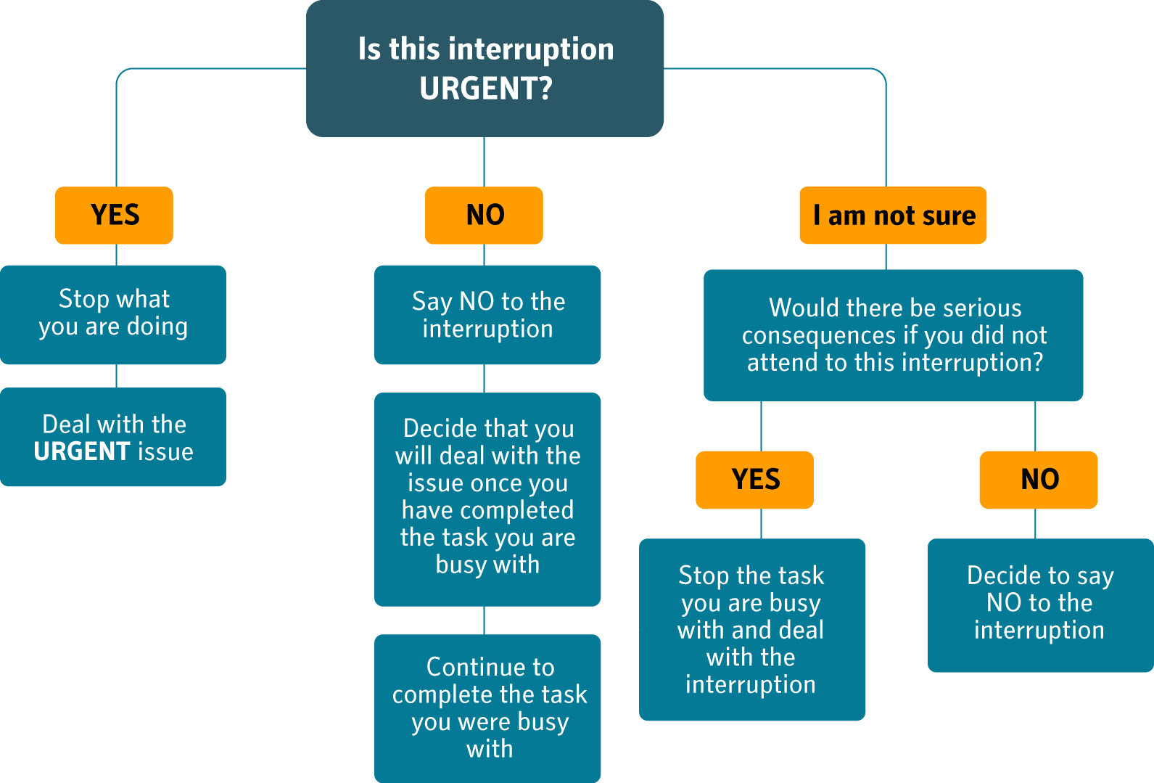

**DECISION MAKING CHART: HOW TO MANAGE INTERRUPTIONS**

## Procrastination

Do you ever hear your friends saying the following? Have you ever said?

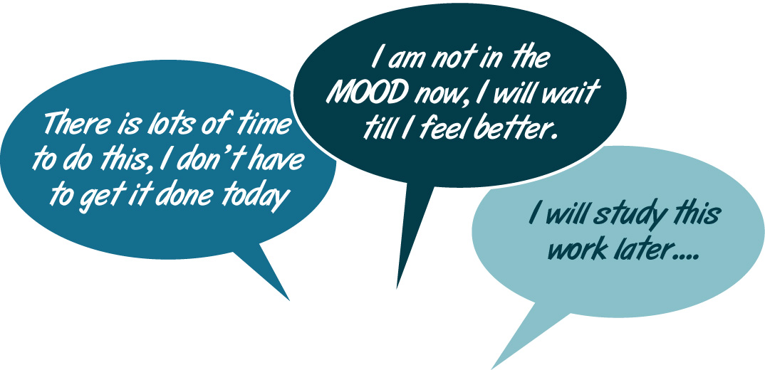

These are examples of **procrastination**. When you procrastinate you spend your time on doing a low priority task instead of an important or high priority task. The diagram below shows you the common reasons why people procrastinate *(Mindtools, 2009).*

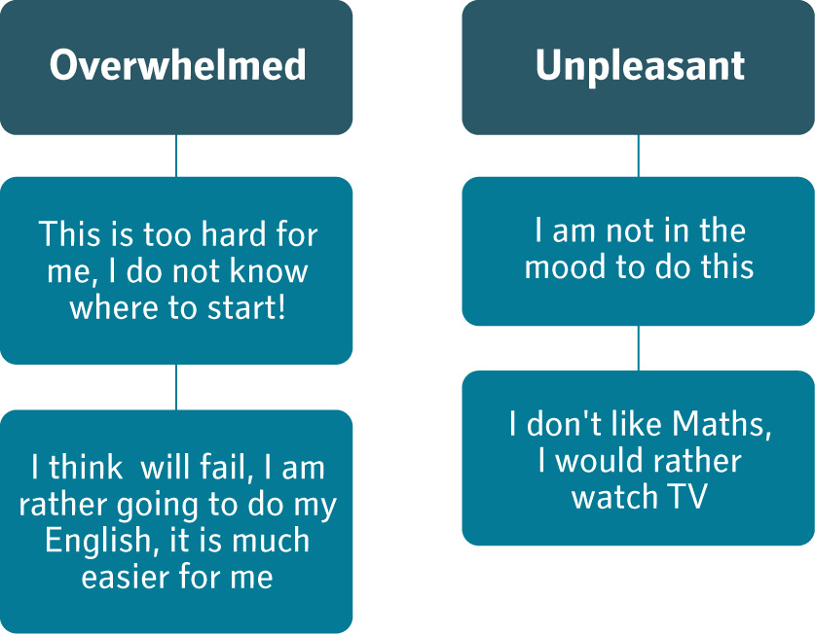

Making the excuse of “I’ll get to it later” has led to the downfall of many a good student (even those who have decided on their priorities and set SMART goals). After too many “laters” the work piles up so high that any task seems insurmountable. Procrastination is as tempting as it is deadly. The best way to beat it is to recognize or admit that you do indeed procrastinate and do something about it **immediately**.

### How to beat procrastination

As soon as you know that you procrastinate, you can begin to change your own behaviour. There are various ways to do this (Rosenthal, n.d.; Schimelphening, 2008). Here are some possibilities to consider:

1. **Set up a reward structure for yourself**

Make a target, for example: I am going to spend 20 minutes revising the work we covered in Mathematics today. Once you have done this allow yourself 10 minutes of an activity you really enjoy, such as watching sport on TV or listening to your favourite music. When you have something to look forward to, the unpleasant task does not seem so overwhelming anymore. In the space below write down 2 different ways you plan to reward yourself for sticking to your study goals:

|  |
| --- |
|  |
|  |
|  |

1. **Select a study-buddy.**

Select another person in your class who agrees to be your study partner. During the day together you can set study targets for the day and the week and then hold each other accountable. For example, set a goal of that you will each work on your English assignment for half an hour. In the afternoon you can SMS each other to check up if the work that you agreed upon has been done. This is an example of **POSITIVE peer pressure**. Look around at your fellow students, who do you think would be a good study-buddy for you. After class today speak to this person and ask them if they are willing to be a study-buddy for you for a specific class.

My study-buddy’s name is\_\_\_\_\_\_\_\_\_\_\_\_\_\_\_\_\_\_\_\_\_\_\_\_\_\_\_\_\_\_\_\_\_\_\_\_\_\_\_\_

1. **Break big tasks down to smaller more manageable tasks**

How do you eat an elephant? What?! Yes, how do you eat an elephant? One small bite at a time...

If you find the task ahead of you seems overwhelming, then it is helpful to break it down into a set of smaller tasks. For example: you have 50 pages to read for your English assignment it may seem as if it is too much for you. If you break it down the 50 pages into 5 sets of 10 pages each, then it does not seem as threatening. Set yourself a goal of reading 10 pages and then having a 10 minute reward-break. Before you know it you will have achieved the very thing you thought you could not accomplish.

For more practical ideas on how to overcome procrastination visit the following website:

<http://www.onlineorganizing.com/ExpertAdviceToolboxTips.asp?tipsheet=20>

# Conclusion

“You are where you are and what you are because of yourself.  
Everything you are today, or ever will be in the future, is up to you.  
Your life today is the total result of your choices, decisions and actions up to this point.  
You can create your own future by changing your behaviors.  
You can make new choices and decisions that are more consistent with the   
person you want to be and the things you want to accomplish with your life.”

*- Brian Tracy (2006)*

Every day you are creating your own destiny, what you choose to spend your time on will to a very large extent shape who and what you will be in 10, 20, 30 and even 40 years time. Make the commitment today to focus on the most important things and to persist in the face of challenges and difficulties in order to achieve your dreams.

|  |  |
| --- | --- |
| YGPS_assessment icon.jpg | Assessment Activity 2:  Create a Life Management Portfolio |

You are going to compile a “Life Management Portfolio”.

1. Refer back to the life priorities you set in Activity 2.1. You have already used priority number 1 to create a SMART goal. Now use priorities number 2 and 3 to create 2 more SMART goals.
2. Use the template for a monthly planner and complete the monthly planning for the month after the month you did in Activity 2.8.
3. Use the template for the weekly planner and set up a detailed weekly planner for one of the weeks in the month you planned in the assessment above.
4. Create a to-do list for a day in the week that you planned above.
5. Write a paragraph (150-200wds) reflecting on the following topic “The most useful lesson I learnt in this module is.......................”. In your paragraph share why this lesson was helpful to you personally and give an example of how you have adjusted your own behaviour in this regard.

**Remember**, you will be graded on the integration of your priorities, goal, monthly and weekly planners. In other words, if you have a test scheduled in your monthly planner for maths, then you will have study time for maths scheduled in your weekly planner.

Your assessment activities must be neatly presented as a mini-portfolio to your facilitator. Be creative and colourful in the presentation of your monthly and weekly planners.

# Tracking my progress

You have reached the end of this unit. Check whether you have achieved the learning outcomes for this section.

|  |  |  |
| --- | --- | --- |
| **Learning outcomes** | **✓ I feel confident** | **✓ I don’t feel confident** |
| I have completed the life priorities exercise and established what is most important to me in my life |  |  |
| I can set SMART goals |  |  |
| I have established how effective I am at time management and have identified ways in which I can improve on this |  |  |
| I can draw up a term planner by creating monthly planners |  |  |
| I can draw up a weekly planner based on my priorities and the events in my monthly calendar |  |  |
| I can make daily-to-do lists that will be specific enough to guide my daily activities |  |  |
| I am aware of how to manage interruptions and practice these techniques on a daily basis |  |  |
| I am aware of strategies to avoid procrastination and make use of these in my personal time management |  |  |

# Bibliography

Covey, S. (1996). *First things first.* Free Press.

Covey, S. (1990). *The 7 habits of highly effective people.* Free Press.

Creel, R. Overcoming procrastination. Retrieved from <http://www.onlineorganizing.com/ExpertAdviceToolboxTips.asp?tipsheet=20> on 23 February 2009.

Mind Tools. (2009).*How good is your time management?* Retrieved from [http://www.mindtools.com/pages/article/newHTE\_88.htm on 12 January 2009](http://www.mindtools.com/pages/article/newHTE_88.htm%20on%2012%20January%202009).

Mind Tools. (2009).*Golden rules of goal setting: Five rules to set yourself up for success.* Retrieved from [http://www.mindtools.com/pages/article/newHTE\_88.htm on 12 January 2009](http://www.mindtools.com/pages/article/newHTE_88.htm%20on%2012%20January%202009).

Mind Tools. (2009). *Personal goal setting: Find direction*. Retrieved from [http://www.mindtools.com/pages/article/newHTE\_88.htm on 12 January 2009](http://www.mindtools.com/pages/article/newHTE_88.htm%20on%20%20%20%20%2012%20January%202009).

Mind Tools. (2009). *Beating procrastination: Manage your time, get it all done*. Retrieved from <http://www.mindtools.com/pages/article/newHTE_96.htm> on 15 January 2009.

Rosenthal, E. Overcoming Procrastination. Retrieved from goforward.harpercollege.edu/uploaded/academicadvising/Procrastination.ppt on 19 January 2009.

Schimelpfening, N. (2008). *Stop procrastination now!* Retrieved from <http://depression.about.com/cs/selfhelp/a/procrastination_2.htm> on 15 January 2009.

Tracy, B. (2006). *Million dollar habits*. Entrepreneur Press. Retrieved from [www.briantracy.com](http://www.briantracy.com) 14 January 2009.

van Blerkom, D.L. (2006). *College study skills*. Boston:Thompson/Wadsworth.