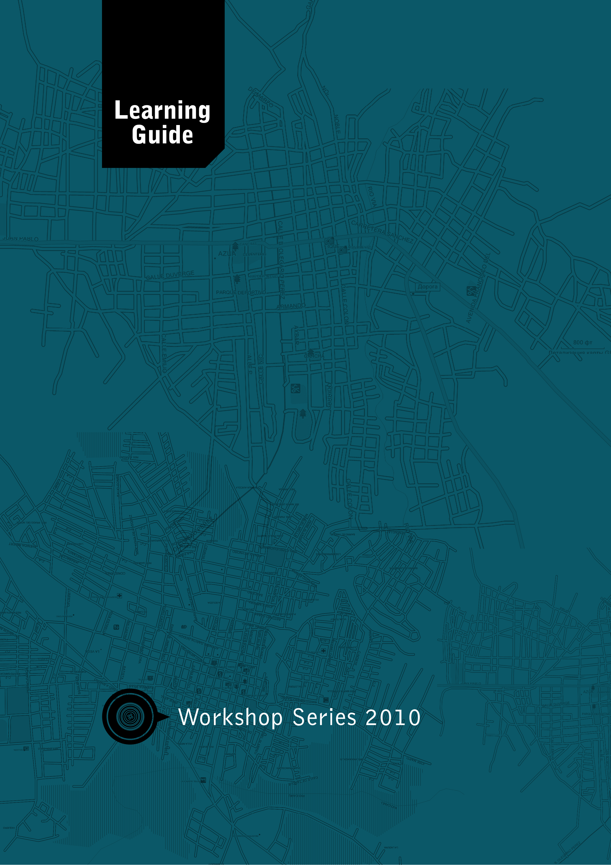

YGPS

(Your Global Positioning System)

Module Development Team

Module
Co-ordinator: Dr. Francois Strydom

Lead Authors: Dr. Francois Strydom
Ms. Melody Mentz

Co-writers: Dr. Mariette Koen
Dr. Oubaas Jooste
Ms. Magdel Pretorius
Ms. Isna Kruger

Critical Readers: Ms Alta Sharp
Ms Tebogo Moraka
Prof Mabokang Mapatsela
Final Editing
& Consolidation: Ms Merridy Wilson-Strydom

Project Manager: Ms Merridy Wilson-Strydom

A Project of the: Free State Education and Training Trust (FSETT), led by the University of the Free State
PO Box 4345
Bloemfontein, South Africa, 9300
Telephone: +27 (0)51 5051222
Fax: +27 (0)51 5051277

Materials can be downloaded from: http://www.oerafrica.org

Creative Commons License:
Attribution Non-commercial Share Alike

Acknowledgements
This learning guide is one part of a larger programme called Skills for a Changing World. The Skills for a Changing World Programme seeks to create educational opportunities through offering of a series of skills-based modules and supporting learning materials. For more information about the Skills for a Changing World programme please ask your facilitator for a programme brochure, or visit www.oerafrica.org.

The development of this learning guide was made possible through the generous financial support of the Ford Foundation. We would like to thank Dr John Butler-Adam from the Ford Foundation Southern Africa Office for his ongoing support of our work. The Skills for a Changing World materials are the product of a collaborative endeavour involving representatives of the following organisations:

- University of the Free State
- Free State School of Nursing
- OER Africa
- Central University of Technology

Sincere thanks are extended to the authors, co-writers, academic assistants, students who participated in our pilot workshops, and the numerous experts who acted as critical readers, evaluators and language editors during the drafting of these learning materials.

Introduction

YGPS Programme Map
The figure below shows the different coordinates that you will use to position yourself in today’s digital world. Each coordinate consists of a module section or sections.

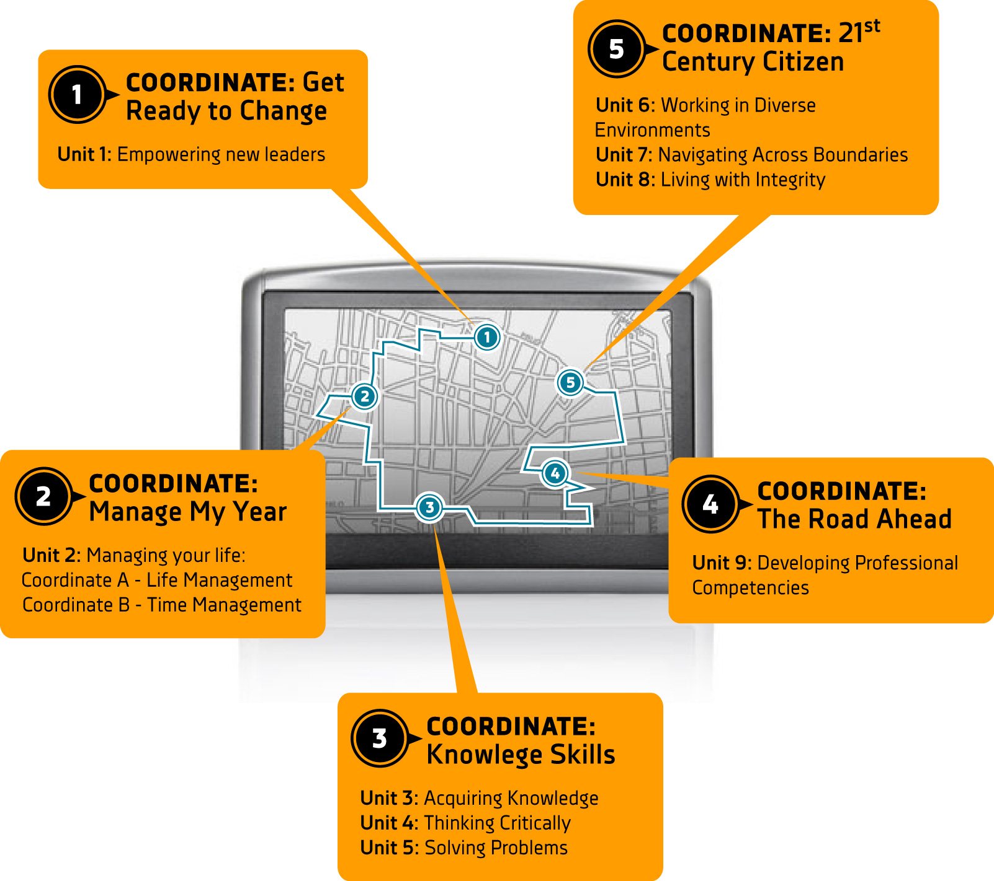

Information about the YGPS Programme
Before you start on a journey you usually find out all about the places you want to visit, the kind of transport you will use, how long it will take and how much it will cost etc. In the short sections below you will find all the information you need to ensure that your journey through the YGPS programme is a successful one.

What is YGPS about?
In this workshop series you will develop the skills that will not only empower you to become a leader but also maximise your chances of success in future studies, the workplace, and your life in general. YGPS stands for Your Global Positioning System. The aim of this programme is to help you to develop the skills to position yourself by understanding who you are and what you can contribute to your family, community, society and the world in the 21st century.

The programme will take you on a journey of self-discovery and empowerment by making use of reading, learning activities, multi-media resources (websites and video clips) and assessments.
Learn more about the Global Positioning System (GPS) at http://en.wikipedia.org/wiki/Gps

What will you learn?
We would like to provide you with a brief overview of what lies ahead in the YGPS programme. By the end of this programme you would have completed 8 units. The table below summarises the programme very briefly to give you a taste of what lies ahead.

Units | Description
Empowering new leaders | Introduces you to the opportunity to become a different kind of leader, and to reflect on who you are
Managing your life | Is where you will focus on developing your goals and develop the time management skills to ensure that you get there.
Acquiring knowledge | Focuses on teaching you the skills of learning and managing knowledge
Critical Thinking | Helps you to develop critical thinking skills
Solving problems | Combines problem solving and the use of sophisticated information gathering skills
Working in diverse environments | Enables you to develop an understanding of how to live and work in a diverse society
Navigating across boundaries | Develops your interpersonal skills and ability to work with people in different situations
Living with integrity | Understand the meaning and value of integrity in your personal life and for society
Developing professional competencies | Reflect on what you have learned and planning for a successful future

How much learning time do you need?
The learning materials have been developed for use in multiple settings. It is possible for learners/students to work through the all the learning materials from start to finish. It is also possible for certain sections to be selected as a focus, with the others being included as reference materials.

As the start of the specific programme you are participating in, you will be provided with a breakdown of how these learning materials will be used, and the learning time needed. Depending on the programme, you might be required to complete reading, learning or assessment activities outside of class time.

How will you learn?
This programme uses different ways of learning. Experienced facilitators will guide and support you throughout the programme. They will plan and organize suitable contact sessions during which you will use the learning guide and various other learning materials.
Much of what you will achieve depends on your own effort and commitment.
The most successful students are not necessarily the cleverest or the most experienced,
but rather those who are most disciplined, most organised, most willing to reflect
critically on their own learning, most able to practice what they are learning, and most
successful in managing their time.
To support you in your learning, there are two kinds of learning resources that you can use – this Learning Guide and a Resource CD. Each of these learning resources has a specific purpose:

The Learning Guide gives you information, guides you through activities and stimulates you to ask questions, helps you to find answers and share what you learn with your fellow students. The information in the Student Guide is not a sufficient source of learning in itself. You, the learner, have to complement the information contained in the Student Guide by reading, researching, discussing/debating and reflecting. Only then will your learning be an enriching experience.

The Resource CD contains a number of up to date articles, video clips and background information that you can read to deepen your understanding of what is dealt with in the module.

How will you be assessed?
The form that assessment will take will differ depending on the programme in which these learning materials are being used.

The Learning Guide includes a range of possible assessment activities. The range of possible assessment activities includes presentations, essays, a report, and self-evaluation exercises to help you evaluate how you are developing your skills. Formative assessment will take place throughout the module and in some programmes there will also be a final summative activity at the end of the module.

How to find your way in the learning guide?
Icons are visual ‘signposts’ that give clear signals of what is expected of you. The following icons are used in the Student Guides for all the modules. You will soon become use to recognising each icon and the message it conveys.

Learning activity
When you see this icon, you will know that you have to do an activity to show how well you understand what you have read and learned. For some of the learning activities the writer will include some comments or advice. These comments should never be read before you have completed the preceding activity. These comments are also not intended to provide the final ‘answer’, since your opinion may be completely different from the writer’s and still be acceptable. The writer is simply providing you with an informed opinion.
Group activity
Whenever you see this icon you will know that you will work with some of your fellow learners on a team activity.
Assessment activity
This is the sign for assessment activities that you will complete and include in your portfolio. All these activities are marked by the facilitator and they will contribute to your total mark for the programme.
Resource file
When you see this sign you will know that you need to refer to the resource file/CD. It contains additional readings and articles that you may be asked to use to complete an activity.

