African Storybook

Network of Open Orgs’ Collaborative Project:
Case studies that demonstrate the success of Open Educational Resources

Author: Rosa Leonor Ulloa Cazarez
Sistema de Universidad Virtual - Universidad de Guadalajara

Name of the initiative | African Storybook
URL | https://www.africanstorybook.org
Categorization of impact (access to education/ learner outcomes/ costs/ continuous professional development) | Access to education  Costs
Partners | - Saide  - Pratham Books’ Storyweaver  - Book Dash  - Room to Read  - Molteno Foundation  - Nelson Mandela Institute  - Nal’ibali  - Little Zebra Books  - READ  - Departments of Education
Funding sources | - Comic Relief  - Cameron Schrier Foundation  - Zenex Foundation  - Oppenheimer Memorial Trust  - European Union  - Google
Years it has been operational | 2014 - present

Description, purpose, and aims of the initiative
African Storybook (ASb) is a multilingual literacy project that works with educators and authors to create and publish openly licensed storybooks for early reading in African languages. The initiative was launched in 2014 to address the need for accessible storybooks and improved literacy. It is an initiative of Saide, a registered non-profit organization governed by a trust and based in Johannesburg, South Africa.

The project has a website that provides free access to readings with several mobile and desktop applications for reading, enabling offline reading and storybook creation. The website allows one to read, create, download, translate and adapt storybooks.

Successes and achievements
The African Storybook initiative enables children to read for learning and pleasure. It has a publishing model that makes the text available cost-effectively and contains more than 3,100 unique storybooks, most of which have African origins. Moreover, in 2016, storybooks produced in indigenous African languages accounted for more than 68% of total storybooks on the platform.

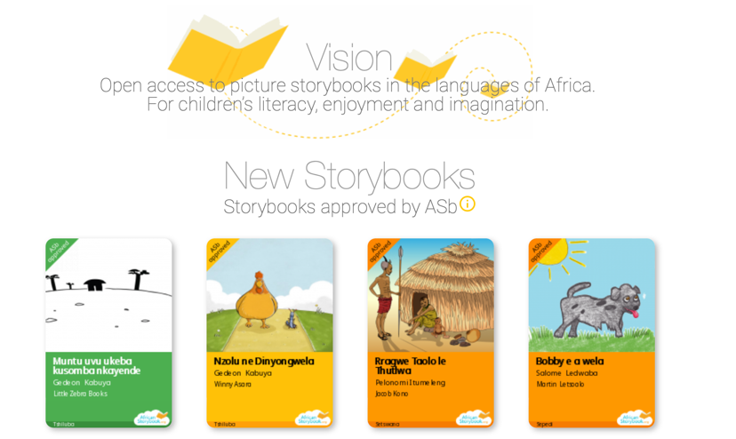
The initiative was piloted in Kenya, South Africa, Lesotho and Uganda, and then extended to Ethiopia, Rwanda, Cameroon, Democratic Republic of Congo, Nigeria, Ghana, Benin, Zambia, Zimbabwe, Mozambique and Namibia. As a result of the activities on the continent, it has the following outputs:
- 224 sub-Saharan African languages resources;
- 7,383 translations in sub-Saharan African languages;
- 3,178 unique storybooks;
- A story development app (the African Storybook Maker);
- A reading app (the African Storybook Reader);
- Translation and adaptation tools; and
- Guides and video guides.
Figure 1 African Storybook website
(last updated: 8th April, 2022).

In 2021, the African Storybook Maker won the Tech4Good Award in Education and it was the ‘Winner of Winners’. The award statement highlighted the beneficial characteristics of the Maker app to boost children's interest in their literacy; it has proven invaluable to target children and provide them with a creative and fun way to publish their own stories. Moreover, organizations working with language marginalized communities make the most of the app by publishing stories and books in their languages.

Evidence of impact
The African Storybook website provides several practical applications and guides that enable the offline reading of more than 5,000 picture storybooks for early reading over 200 African languages. They have been downloaded from the website approximately three million times at present. Some utilities of the website are:
- The African Storybook Reader app, to read, and re-use storybooks.
- The African Storybook Maker app, for educators to support children to create storybooks.
- The guide, which comprises a collection of tried and tested methods used to create storybooks.
- Examples of use, which demonstrate how partners are using the books innovatively in their contexts. These examples assist the team in finding out how children are reacting to the stories and how use of the storybooks encourages them to love reading and improve their reading and writing. The examples also demonstrate how storybooks are enabling inclusive educational practices with, for example, students with disabilities.

The Android downloadable version of the Maker app has more than 5,000 downloads and the Android downloadable version of the Reader app has over 10,000 downloads. Both apps can also be downloaded on iOS for iPad and iPhone.

Both applications have high ratings. Some user ratings include:

I just love it...its great and educative especially for early grade readers (User review of the Reader app)

Absolutely love this app, my three year old son loves books , and I love that I can read them to him in our mother tongue; Setswana (User review of the Reader app)

I love making books so I love it (User review of the Maker app)

Challenges and perceived failures

The initiative has experienced various challenges, which they have tried to solve iteratively. The key challenges are highlighted below.
- Working with departments of education and getting them on board has been challenging. There are various reasons for this, including the bureaucratic nature of the departments, difficulty in obtaining statistics on storybook use from government platforms, and the fact that governments want to undertake their own quality assurance processes. One way the team has tried to overcome this has been by collaborating with partners who have worked with the departments in the past.
- There have been issues with registration on the website, especially when users want to create, translate, and adapt storybooks. The team assists users in picking up registration issues in the backend. They also have internal discussions to simplify the registration process.
- Connectivity is not reliable in some areas, so users may start the registration process but leave it incomplete. In addition, accessing and downloading storybooks becomes an issue when there are connectivity problems.
- When the number of storybooks grows, the website may become slower, so the team is discussing how to reconfigure their storage to accommodate this.
- Some commercial publishers take the resources without appropriate attribution. ASb is considering instituting measures that require users to contact the team directly for large downloads of multiples storybooks. This is also a means of ensuring that proper quality assurance processes are undertaken.

Lessons learned and practices that made a difference
Throughout its operations, the team has learned several lessons which it has sought to apply. Key lessons are highlighted below.
- Building partnerships and continuously identifying new partners including local organizations who work with communities on the ground and international partners with a global footprint. This has helped the team to remain responsive and scale activities. The team also found that signing a memorandum of understanding has been beneficial in clarifying each partner’s responsibility, as well as recording how data and statistics will be shared.
- Finding partners with local language expertise who can translate and quality assure in local languages for use. ASb tries to link storybook creation, adaptation, and use with demand instead of just creating content. This ensures that they remain purposeful in the content that they are creating.
- Remaining responsive to those who reach out to the team for partnership or support. ASb does their best to build capacity. The team sees this as being linked to sustainability of its activities, and it aligns with their effort to strengthen the agency of communities.
- Identifying individual champions across the continent (e.g. educators, librarians, people who work with children, and writers). ASb assists these individuals in forming communities of practice to learn and share their skills.
- Learning that the community (families, parents, teachers) gradually shifts its focus from English to using local language. This is particularly the case because community members see how this shift assists children to read and write.
- Realizing that libraries are ideal hubs and attract children and many of the community libraries, especially in under-resourced contexts, where libraries support primary schools with resources. For example, a library in Kibera, Kenya works with over 30 primary schools for both local and outreach programmes.
- Learning that it is possible to engage the community and get stories that they value. Community members realise that with a bit of support, they can turn stories and local folk tales into storybooks by leveraging the benefits of open licensing.

Resources and publications
African Storybook Website Guides:
- Download and Read offline: https://www.youtube.com/watch?v=idSRtp1H5ik
- Download and Print: https://www.youtube.com/watch?v=LosHeKNvDo8
- Publishing a Translation online: https://www.youtube.com/watch?v=Hy5WtMwVsGA
- A short guide to Creating Storybooks with children
- A short guide to Getting started
- A short guide to Registering and logging in
- A short guide to Translating online
- An in-depth guide to Creating Storybooks with children
- An in-depth guide to Developing and translating African storybooks
- An in-depth guide to Preparing to use African storybooks with children
- An in-depth guide to Translation
- An in-depth guide to Using African storybooks with children
- YouTube channel: https://www.youtube.com/channel/UC0ANN4QxfGrl7VmjAbaSrMA

Book chapter:
- Welch, T., Tembe, J., and Wepukhulu, D. (2015). The African Storybook Project: an interim report. In: Language Rich Africa Policy Dialogue. The Cape Town language and development conference. Pp. 92-95. Available at: https://web.archive.org/web/20160424064228/http://www.teachingenglish.org.uk/sites/teacheng/files/E291%20Cape%20Town%20Publication_A4_FINAL_web.pdf

News and Magazines:
- Akinleye, A. (2015). Digital stories could hold the key to multilingual literacy for African Children. In: The Conversation (May 14th, 2015). Available at: https://theconversation.com/digital-stories-could-hold-the-key-to-multilingual-literacy-for-african-children-40405

Translating local insights into an international context
This initiative is easy to extrapolate into several contexts. The different website tools can adapt to different languages and features. Most of the storybooks are in English, allowing them to be used in several contexts to teach a second language or improve English reading skills.

The frameworks for the development tool (the Storybook Maker) are universal and not attached to a particular pedagogical or theoretical framework. This characteristic enables the easy adaptation of the tool to other educational contexts. They could be adapted to different educational levels as a literacy tool and creative tool.

Acknowledgements
Special thanks go to Dorcas Wepukhulu from African Storybook for her helpful insights in writing up this case study summary.

Recommended citation:
Ulloa Cazarez, R.L. (2022). African Storybook. Network of Open Orgs’ Collaborative Project: Case studies that demonstrate the success of Open Educational Resources. Available at: https://www.oerafrica.org/node/13635/materials

This work is licensed under a Creative Commons Attribution 4.0 licence
https://www.africanstorybook.org

In April 2022, these guides were being revised in line with new improvements to the website. The aim was to have six brief guides, which will soon be available on the website.
All guides are available on the African Storybook website: https://www.africanstorybook.org

