OER@AVU

Network of Open Orgs’ Collaborative Project:
Case studies that demonstrate the success of Open Educational Resources

Authors: Cynthia Jimes and Lisa Petrides
Institute for the Study of Knowledge Management in Education (ISKME)

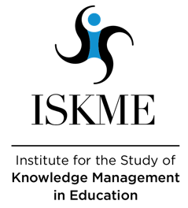
Name of the initiative | OER@AVU
URL | https://oer.avu.org
Categorization of impact (access to education/ learner outcomes/ costs/ continuous professional development) | Continuous Professional Development
Partners | - 27 partner institutions in 22 African countries  - Open Education Consortium (OEC)
Funding sources | - Primary support from the African Development Bank Group, with some support from the United Nations Development Programme  - Amount of funding: 13.64 million Units of Account (UA) for Phase II (2012-2016)
Years it has been operational | 2011-2018; the OER@AVU platform is still accessible

Description, purpose, and aims of the initiative
The African Virtual University (AVU) launched its OER initiative called OER@AVU in 2011. It was part of a larger project designed to increase access to affordable education at AVU’s 27 partner institutions spanning 22 countries. It sought to encourage the collaborative creation and sharing of open, distance, and e-learning resources.

Specific aims of the initiative included:
- Providing capacity building to partner institutions through a collaborative approach to the development, alignment, and quality assurance of OER and distance curricula; and foster subject matter expert interaction as educators work to develop curricula.
- Increasing access to higher education in sub-Saharan Africa by providing affordable education programmes in mathematics and science that are accessible outside of an institution’s physical campus.
- Creating opportunities for women, and employees more broadly, to advance their skills through flexible learning approaches available through Information and Communication Technologies (ICT)-enhanced education and OER.
- Providing a space for African educators to discover, share, and localize OER.

Successes and achievements
The initiative resulted in an initial set of over 200 openly licensed modules in teacher education, ICT basic skills, mathematics, physics, chemistry, and biology hosted on the AVU Open Education Resources repository, OER@AVU. The adaptable modules were made accessible via each partner institution’s Learning Management System, and were uniquely designed to promote the participation of female students in post-secondary mathematics and science programmes. In 2018, the project and its partner institutions added an additional 1,335 OER to the collection, including videos, textbooks, and learning objects extracted from the textbooks.

The initiative has received international awards, including the 2011 OpenCourseWare People’s Choice Award Winner: Best Emerging Initiative; the 2015 International Council for Distance Education (ICDE) Institutional Prize; and the 2017 Open Education Consortium (OEC) Individual Leadership Prize, among others.

Evidence of impact
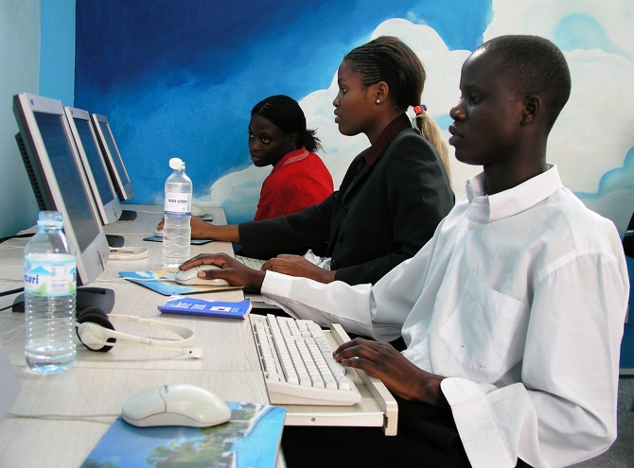
Within the context of the Research on Open Educational Resources for Development effort (ROER4D), Adala (2017) conducted a qualitative study to assess the impact of the availability of AVU OER on instructors’ ability to repurpose, create, and share OER. Through interviews and a survey of educators across 26 of AVU’s partner institutions, the study found that access to AVU OER positively impacted instructors’ ability to repurpose OER for their local course context — especially in cases where the OER were considered by instructors as useful and localizable to align with the learning standards of their institution, and where institutions provided systemic support for OER use through OER policies and guidelines. The study further showed that instructors who possessed ICT literacy skills were more likely to repurpose, create, and share OER, and that participation in these ‘open practices’ enhanced their overall interest and skills in course design and in localization of course materials for their unique instructional contexts.
Image courtesy of World Bank photo collection (CC BY-NC-ND 2.0)

Lessons learned
Adala’s (2017) research revealed that instructors’ prior ICT literacy and skills play a key role in supporting the creation and repurposing of OER for local course contexts, thus underscoring the importance of teacher CPD. Adala’s work further concluded that the integration of OER into broader curriculum policies at an institution is necessary to create system-wide impact that goes beyond the level of the individual instructor. This includes open licensing policies to guide the creation and use of OER, and policies that promote the use of OER for full degree programmes at the institution and not just for supplemental use in courses.

Diallo and Wangeci’s (2012) examination of the lessons learned from the early phases of the AVU initiative showed the importance of a collaborative strategy that decentralizes the work across partnering institutions, yet that ensures a high degree of ownership by each institution. Institutional engagement and ownership were fostered by allowing the partner institutions to collaboratively conceptualize and design the OER curriculum approach and the quality assurance framework used. The effort also ensured the inclusion of individuals from each participating country’s Ministry of Education alongside the administrators and academics at all participating institutions. Diallo and Wangeci (2012) also highlight the importance of the project’s emphasis on ‘harmonizing’ the OER content across participating countries and institutions as part of the curriculum development approach – which fostered the ability of faculty users to align the curriculum to their local instructional contexts.

Translating local insights into an international context
Insights from the OER@AVU case remain relevant to OER initiatives globally. Considering the increasing need to support distance learning in the context of the COVID-19 pandemic and future potential crises, institutions across the globe continue to turn to now widely available OER to build their online course content. OER can be immediately integrated into course management systems and adapted to engage students of diverse backgrounds, while also helping to address access and cost constraints faced by many students. And yet, a growing body of research has shown that faculty often encounter hurdles in identifying and repurposing OER to meet their local learning standards or course syllabi. The OER@AVU case study underscores the need to support OER discoverability and localization through tools that enable content use across regional and institutional borders, as well as the importance of a systems-based approach to the creation, sharing, and use of OER that leverages multiple communities — from state and campus administrators, to instructors, to library staff, to students themselves.

Resources and publications
- Adala, A. (2017). Assessing The Impact Of OER Availability On The Emergence Of Open Educational Practices In Sub-Saharan Africa: The Case of an Integrated Multinational Teacher Education Programme In Mathematics and Science. ROED4D. https://idl-bnc-idrc.dspacedirect.org/bitstream/handle/10625/58035/58118.pdf
- African Development Fund. (2011). African Virtual University Support Project Phase II (AVU II): Project Appraisal Report. https://www.afdb.org/fileadmin/uploads/afdb/Documents/Project-and-Operations/Multinational_-_African_virtual_university_support_project_phase_II__AVU_II__.pdf
- Bateman, P. (2006). The AVU Open Educational Resources (OER) Architecture for Higher Education in Africa, OECD Expert Meeting. https://www.oecd.org/education/ceri/38149047.pdf
- Diallo, B. and Wangeci, C. (2012). AVU Multinational Project II: A collaborative approach to implementing an eLearning project in 21 countries. Proceedings and Report of the 5th UbuntuNet Alliance Annual Conference. Dar es Salaam, Tanzania. https://repository.ubuntunet.net/bitstream/handle/10.20374/123/diallob.pdf?sequence=1&isAllowed=y

Recommended citation
Jimes, C. and Petrides, L. (2022). OER@AVU. Network of Open Orgs’ Collaborative Project: Case studies that demonstrate the success of Open Educational Resources. Available at: https://www.oerafrica.org/node/13635/materials

This work is licensed under a Creative Commons Attribution 4.0 licence
https://oer.avu.org

Where 1 UA = $1.56 U.S. Dollars. See https://www.afdb.org/fileadmin/uploads/afdb/Documents/Project-and-Operations/Multinational_-_African_virtual_university_support_project_phase_II__AVU_II__.pdf.
Aims listed in: African Development Fund. (2011). AVU Support Project Phase II: Project Appraisal Report. Available at: https://www.afdb.org/fileadmin/uploads/afdb/Documents/Project-and-Operations/Multinational_-_African_virtual_university_support_project_phase_II__AVU_II__.pdf
See oer.avu.org
Diallo, B. and Wangeci, C. (2012). AVU Multinational Project II: A collaborative approach to implementing an eLearning project in 21 countries. Proceedings and Report of the 5th UbuntuNet Alliance Annual Conference. Dar es Salaam, Tanzania.
AVU Press release. (2018). See https://oer.avu.org/page/news
Adala, A. (2017). Assessing The Impact Of OER Availability On The Emergence Of Open Educational Practices In Sub-Saharan Africa: The Case of an Integrated Multinational Teacher Education Programme In Mathematics and Science. ROED4D.

