Teacher Education through School-based Support in India (TESS-India)

Network of Open Orgs’ Collaborative Project:
Case studies that demonstrate the success of Open Educational Resources

Author: Igor Lesko
Open Education Global
Name of the initiative | Teacher Education through School-based Support in India (TESS-India)
URL | http://www.tess-india.edu.in/
Categorization of impact (access to education/ learner outcomes/ costs/ continuous professional development) | Continuous Professional Development
Partners | - The Open University U.K.  - Government of India’s Ministry of Human Resource Development  - Ministries of Education in seven states in India  - British Council  - Save the Children India.
Funding sources | UKAid (£10 million, 2012 – 2017), with in-kind contributions from Save the Children and the Education Ministries in each of the seven states in India where the programme was implemented
Years it has been operational | 2012 - present

Description, purpose, and aims of the initiative
Initiated in 2012, TESS-India is an award-winning programme established to strengthen and transform professional development activities and classroom practices in India (1,2,5,6,7). Through a collaboration with 200 Indian and international teachers and teacher education experts, the programme has developed nearly 200 Open Educational Resources (OER) in multiple languages. Indirectly, TESS-India also addresses the need and activities of the Government of India to significantly increase the number of qualified and trained teachers (in pre- and in-service teacher education) at India's elementary and secondary education levels (2). The programme aligns with the policy objectives of India’s National Curriculum Framework (2005) and the National Curriculum Framework for Teacher Education (2009) to create pedagogical practices that are inclusive, child-centered, and participatory (1,5,6,7). It is led by The Open University UK in partnership with India’s Ministry of Human Resource Development, Ministries of Education in seven states of India where the programme was implemented; and supported by the British Council and Save the Children India.

Successes and achievements
The programme spurred the development of a comprehensive toolkit with 191 OER in six languages to capacitate teachers and teacher educators with the knowledge to engage students in meaningful learning activities. The OER were not only translated but also localised for different cultural, social, political, and environmental contexts. For example, localisation activities led to the differentiation of OER in the Hindi language. Consequently, Hindi OER for each Hindi language state in India are unique (8). The toolkit consists of 105 teacher development units, 20 school leadership units, 10 principles of practice, 55 videos of authentic classroom teaching, and a compendium offering sample teaching and learning pathways through the OER. All the materials are available on the TESS-India website (1,2).

Furthermore, a Massive Open Online Course (MOOC) entitled ‘Enhancing teacher education through OER’ was developed and run in three presentations to support quality matters in teacher education. This six-week, task-oriented MOOC specifically targets teacher educators and is available in English and Hindi on the TESS-India website.

The programme has received several awards. It was the winner of the Guardian University Award (International Projects category) in 2017; the winner of the Open Education Consortium Creative Innovations Award in 2016; and the winner of the BOND Innovation Award in 2015.

Evidence of impact
TESS-India was implemented in seven priority states in India: Bihar, Uttar Pradesh, Madhya Pradesh, Odisha, Karnataka, Assam and West Bengal. The initiative’s OER were embedded into in-service teacher education programmes across all seven states and into pre-service programmes in five states (including Diploma of Education and Bachelor of Education qualifications).

It is estimated that TESS-India OER have impacted more than one million teachers and teacher educators, with a relatively low cost, thus contributing to strengthening the education systems and the creation of more effective teaching practices across the intervention states (2). More than 50,000 teacher educators and teachers completed the ‘Enhancing teacher education through OER’ MOOC (9).

The 2017 evaluation of TESS-India implementation in three of the seven states provides additional evidence of impact (6). The state government in Madhya Pradesh acknowledged the value of the TESS-India OER by providing funding for over 250,000 Secure Digital cards (also known as SD cards) loaded with the TESS-India OER to be distributed to all elementary teachers. The government provided additional funds to produce badges for presentation to teachers who completed the MOOC. At a local level, the evaluation found evidence of teachers valuing and displaying MOOC completion certificates in their classrooms, and use of social media groups. There was also evidence that the District Institute for Education and Training integrated resources and MOOCs into teaching schedules.

The evaluation also revealed that TESS-India OER were contributing to quality change in classrooms – they were becoming more active spaces of learning. Teachers were showing greater interest in their teaching; they were generating lesson plans with a wider range of activities for their learners; there was new use of different locally available resources; and there was more learner engagement in both pair and small group activities. The evaluators observed that teachers positioned children as ‘thinkers’, recognising the knowledge and experiences they brought to their learning and giving them responsibility for their learning in line with the approach in the national policy (6).

The findings also revealed that TESS-India resources and the MOOC contributed to a shift in teacher professional development amongst policymakers and teacher educators. In practice, this means moving away from cascade models to supporting teacher Continuous Professional Development (CPD) in classroom settings with support from teacher educators and experts (6). To date, there have been over three million downloads of the 55 TESS-India video clips.

Challenges and perceived failures

Initial challenges identified in 2014 concerned activities that were designed to support the localisation of educational materials in three states. Organized as workshops lasting two to three days, some participants in these workshops felt that the time allocated to the workshops and then to return revised materials to the project was too short. An additional challenge involved limited knowledge about OER amongst the participants, thus requiring additional OER awareness raising activities.

Dynamics between subject experts who were invited to localisation workshops to collaboratively adapt OER materials also played a role in the localisation process. In some instances, such dynamics slowed down localisation processes or led to limited adaptation. Efforts to explain the differences between OER and traditional textbooks, along with the need to focus on pedagogical principles rather than recreating texts as OER in different subject areas, were identified as key challenges by the workshop facilitators (5). Subsequently, the localisation process was reconceptualised to sufficiently ground the OER in the Indian context. The OER were rewritten to focus on the principles of practice. The revised OER were successfully localised in a process that was owned by each intervention state rather than external experts. This process was combined with extended familiarisation activities to ensure that each state group had considered how they wanted to use the localised OER (8).

Lessons learned and practices that made a difference
TESS-India’s successful implementation strategy may be attributed to the following main factors (10):
- Development of collaboration strategies with local stakeholders involved in the co-creation or adaptation of OER to create contextually relevant resources; and with stakeholders responsible for the implementation of teacher training activities.
- Focus on the localisation of educational resources to ensure that the different end users' nuanced linguistic, cultural and pedagogic needs in the intervention states were met.
- Alignment of the programme’s objectives with the national education priorities in India.
- Support from the national Ministry of Human Resource Development, and decision-makers and implementers across the different states.
- Availability of OER, created through the project, in multiple languages, formats, and mediums (video, text, online, and downloadable for offline use in a variety of file formats).
- Uptake of resources that were promoted through integrated engagement strategies such as the use of MOOCs.

Translating local insights into an international context
TESS-India built on the successes of an earlier but similar initiative designed to support teacher development in different subject areas through OER. Teacher Education in Sub-Saharan Africa (TESSA) was implemented in several countries in Sub-Saharan Africa between 2006-2009. OER developed under TESSA are available in four different languages (English, French, Arabic and Swahili). Furthermore, TESS-India OER are used extensively in the Transforming Teacher Education and Learning (T-TEL) programme, which aims to transform programmes of initial teacher education in all public colleges of education in Ghana. TESS-India resources are incorporated into training materials for college tutors and handbooks to guide student teachers during their three teaching practice periods.

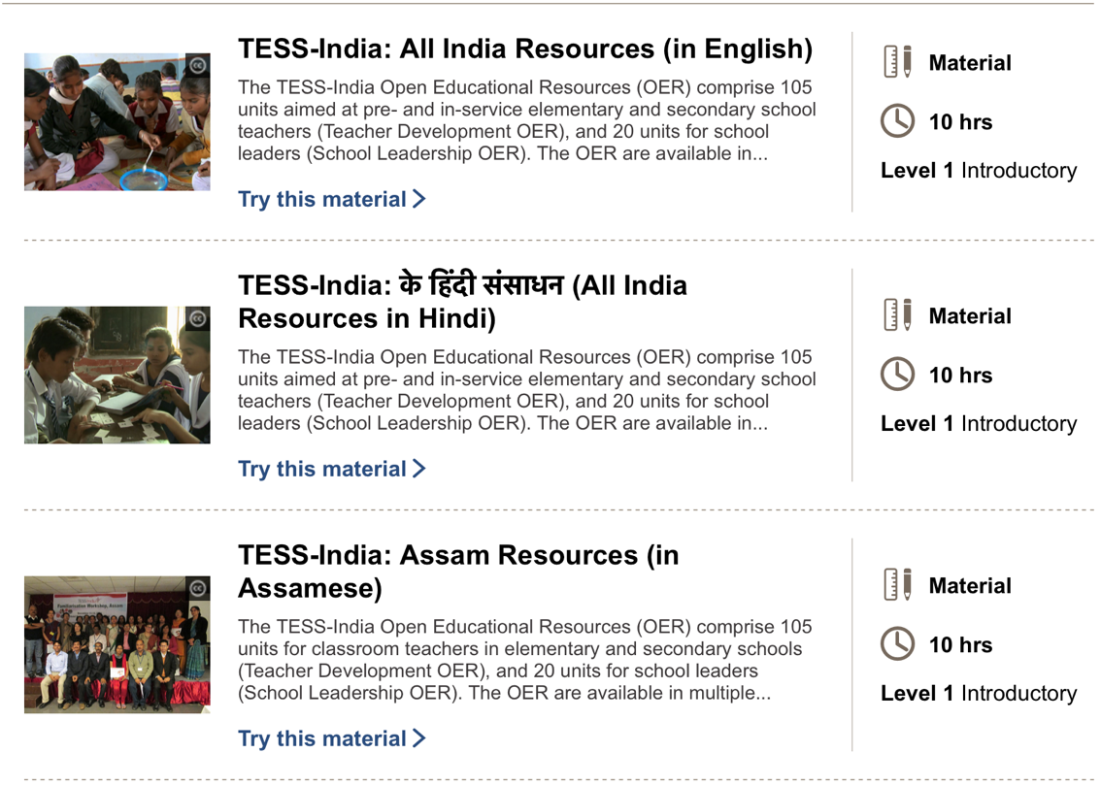
The lessons learned from TESSA and TESS-India indicate that OER can be effectively used across different contexts to support CPD activities for teachers and teacher educators with the goals of improving, strengthening, or transforming pedagogical practices. TESS-India’s successful implementation strategies serve as important insights for those who would like to implement OER initiatives to support teachers’ CPD activities in different countries. Amongst those, some of the key considerations include alignment of programmes’ objectives with national policy priorities; adequate support from and collaboration with key policy stakeholders located within national or state structures; and strong emphasis on collaborative localisation approaches to make educational resources contextually relevant.
Figure 1 TESS-India materials on the OpenLearn Create platform

Resources and publications
This case study was compiled based on information from several sources. These sources are listed below and can be consulted for a more in-depth understanding of the different aspects described in the case study.

Websites
- Tess-India: http://www.tess-india.edu.in/
- The Open University UK International Development Office: https://www.open.ac.uk/about/international-development/projects-and-programmes/tess-india
- Tess-India YouTube channel: https://www.youtube.com/channel/UCL9j8y4mGFyIQLvH-PvkghA
- Enhancing teacher education through OER (MOOC): https://www.open.edu/openlearncreate/course/view.php?id=2470

Publications/Reports
- Buckler, A., Perryman, L., Seal, T., and Musafir, S. (2014). The role of OER localisation in building a knowledge partnership for development: Insights from the TESSA and TESS-India teacher education projects. Open Praxis, 6(3), 221–233. Available at: http://doi.org/10.5944/openpraxis.6.3.136
- Wolfenden, F., Adinolfi, L., Cross, S., Lee, C., Paranjpe, S., & Safford, K. (2017). Moving towards more participatory practice with Open Educational Resources (OER): TESS-India Academic Review. The Open University. Available at: https://www.oerknowledgecloud.org/archive/TESS-India%20Academic%20Review%20Final%20130617_0.pdf
- NITI Aayog (2020). Continuous Professional Development using Open Education Resource (OER) of TESS-India. Available at: https://dmeo.gov.in/sites/default/files/2021-08/Package3_HRD_CaseStudy11.pdf
- Wolfenden, F. and Adinolfi, L. (2019). An exploration of agency in the localisation of open educational resources for teacher development. Learning, Media and Technology, 44(3): 327–344. Available at: https://doi.org/10.1080/17439884.2019.1628046Cross
- Wolfenden, F., Cross, S. and Henry, F. (2017). MOOC adaptation and translation to improve equity in participation. Journal of Learning for Development - JL4D, 4(2). Available at: http://jl4d.org/index.php/ejl4d/article/view/209
- Cross, S., Adinolfi, L. and Wolfenden, F. (2019). TESS-India: An approach to supporting teacher development and improving classroom practice. The Open University, Milton Keynes, UK.
- Wolfenden, F. (2015). TESS-India OER: Collaborative practices to improve teacher education. Indian Journal of Teacher Education, 1(3): 33–48. Available at: http://ncte-india.org/ncte_new/?page_id=1703c
- Das, D. & Anuja, S. (2018) TESS-India Independent Formative Evaluation Report. The Open University.

Online Newspaper Articles
- The Times of India. (2018). TESS-India project to be launched in five districts of Odisha. Available at: http://timesofindia.indiatimes.com/articleshow/62606776.cms?utm_source=contentofinterest&utm_medium=text&utm_campaign=cppst

Acknowledgements
A special thank you goes to the following people at the Open University UK who were involved in the management and implementation of the TESS-India programme and who contributed to this case study:

Prof. Freda Wolfenden and Dr Simon Cross for their extensive inputs to the case study.

Dr Leigh A. Perryman, Dr Alison Buckler and Tim Seal for their additional feedback and assistance.

For more information about the programme, please email tess-india@open.ac.uk or contact Prof. Freda Wolfenden (TESS-India Academic Director 2014-2019) at freda.wolfenden@open.ac.uk

Recommended citation
Lesko, I. (2022). Teacher Education through School-based Support in India (TESS-India). Network of Open Orgs’ Collaborative Project: Case studies that demonstrate the success of Open Educational Resources. Available at: https://www.oerafrica.org/node/13635/materials

This work is licensed under a Creative Commons Attribution 4.0 licence
http://www.tess-india.edu.in/

Note that these numbers correspond to references cited in the ‘Resources and publications’ section below.
English, Assamese, Hindi, Kannada, Odia and Bengali.
See http://www.tess-india.edu.in/
Bihar, Madhya Pradesh and Odisha
Madhya Pradesh, Uttar Pradesh and Bihar
See https://www.tessafrica.net/
See https://t-tel.org/

