Virtual University of Small States of the Commonwealth
Case studies on African OER initiatives in higher education

Introduction
The Virtual University for Small States of the Commonwealth (VUSSC) is a network of small countries that are committed to the collaborative development of free content resources for use in an educational context. Small states represent 32 of the 54 member countries of the commonwealth and, although there are significant variations among them, many experience similar challenges regarding access to high-quality post-secondary education. In response to this challenge, VUSSC was launched by commonwealth Ministers for Education at a conference in Halifax, Canada in 2000.

Since its inception, VUSSC has provided a collective mechanism for developing, adapting, and sharing courses and learning materials. It has also acted as a forum for institutions to build capacity and expertise in online collaboration, eLearning and information and communication technologies (ICT). Educational institutions work with VUSSC in designing, developing, and delivering post-secondary, skills-related courses and university-level programmes in areas that enhance their economic, social and community growth. To this end, VUSSC promotes the sharing and transfer of course content, learning materials, and resources using Creative Commons (CC) licences.

The initiative has focused on policy, practice, and research in open educational resources (OER); the main focus has been openly licensed content development. From September 2015 to June 2021 (spanning the Commonwealth of Learning’s Last Strategic Plan), VUSSC has reached 29,302 unique learners and helped 26 institutions to improve their capacity to leverage open and distance learning (ODL). These have been aimed at various levels, including undergraduate, postgraduate, and teacher education.

This case study is based on survey responses and interviews with a former Commonwealth of Learning (COL) education specialist and a current education specialist, both of whom have worked with VUSSC.

Description of the initiative
The VUSSC Management Committee was established in 2008 and plays an important role in helping the VUSSC achieve its goals. It comprises members nominated by their respective Ministry of Education and/or national institution who each serve a three-year term. It then works with an education specialist from COL, who provides support to achieve the committee’s primary goals.

Among various educational activities, VUSSC facilitates collaboration between experts and educators from small states in developing and sharing OER. In this regard, VUSSC has sought to assist small states to build the capacity of their educational institutions by creating accreditation mechanisms and facilitating educational programme offerings. Over the years, it has collaborated with various partners to carry out its OER-related work. These include ministries of education, universities, colleges, and development organizations.

VUSSC countries specifically decided to focus on the development of skills-related courses and programmes in areas such as agriculture, digital entrepreneurship, disaster management, fisheries, life skills, tourism, transportation and logistics, and the use of ICT. In response to emerging environmental issues, VUSSC has also integrated concepts such as climate change, sustainability resilience, and the Blue Economy into courses and programmes. Under CC licence, VUSSC course materials are freely available for reuse and adaptation to the specific context of each country. The materials can be used to offer credit-bearing qualifications and, in so doing, they strengthen educational capacity and access in member countries.

Through its OER materials development process, VUSSC aims to bridge the digital divide by leveraging online communication to develop education systems. Up until 2017, there were three key elements to this process. First, the respective countries and/or institutions would select representatives who became team leaders. Before course development commenced, COL hosted a leadership training workshop which allowed leaders to effectively deal with the social, administrative, and logistical issues associated with course writing. The expectation was that team leaders would share this knowledge with colleagues at their own institutions and with other team members when they gathered for the writing workshop. Next, the countries and institutions would elect representatives to participate in the training workshop. These participants met with team leaders so that they could develop the knowledge and skills for course design and development. COL provided an Instructional Design Template, as well as access to ‘Basecamp’, an online collaborative service. Once the course was completed, it was openly licensed and made available for national institutions in small states to offer, adapt, or use. This model was not sustainable as it required bringing together people from different parts of the world for face-to-face workshops and bootcamps. COVID-19 further eroded the possibility of returning to this model.

A new model, introduced in mid-2018, has followed a slightly different process. It uses an integrated, holistic approach to work with partners, where sharing of OER materials and courses is coupled with support and capacity building for design, development and delivery of courses and learning materials, as well as online assessment, learner support, quality assurance activities, and platform provision. These activities include the following shifts:
- Instead of bringing people together physically for course development activities, the team uses web-based collaboration and communication tools such as WhatsApp and cloud-based file sharing solutions such as Google Drive and Dropbox.
- VUSSC delivers training and capacity building activities through synchronous and asynchronous means including online workshops, structured courses spread over several weeks, massive open online courses (MOOCs), webinar series, and online self-instructional video-based short courses. This is a departure from the three- to five-day intensive face-to-face workshops in the previous model.
- VUSSC has also moved away from solely hosting training courses on the VUSSC platform and instead includes an option for partner institutions to have their own Moodle instance. VUSSC then supports the institutions to manage and use Moodle to offer their students online learning opportunities.

As noted, in parallel with the content development process, VUSSC has emphasised quality assurance. With this in mind, a sub-committee within the VUSSC management committee developed the Transnational Qualifications Framework (TQF), which member countries could use.

The Transnational Qualifications Framework
The TQF is a reference system that links national qualifications systems and frameworks in different states. It seeks to promote the credibility and reliability of qualifications developed by any national quality assurance agency or provider involved in VUSSC. The idea for the TQF emerged in 2007, when participating countries proposed the development of a qualifications framework. The following year, an international project team comprising experts from South Africa, Hong Kong, New Zealand, Canada, and Samoa, presented a draft document to senior officials of the 29 small states in Singapore. With the support of the South Africa Qualifications Authority (SAQA), VUSSC finalised a TQF ‘to support the development, international recognition, comparability and easy understanding of courses offered within the VUSSC context’.

As an instrument for the promotion of lifelong learning, the TQF caters for adult basic education and training, vocational education and training, and higher education. It has ten levels, each of which is attainable through various education and career paths. It uses learning outcomes and competencies to define qualifications. An outline of the TQF architecture is included below:

- TQF Architecture

Level | Qualification title | Minimum credits
10 | Doctoral degree | 360
9 | Master’s degree | 240
8 | Postgraduate certificate and diploma  Bachelor’s degree with honours | 120
7 | Bachelor’s degree  Graduate certificate and diploma | 360
6 | Advanced/Higher diploma  Associate degree/Foundation degree | 240
5 | Diploma | 240
4 | Advanced certificate | 120
3 | Certificate III | 40
2 | Certificate II | 40
1 | Certificate I | 40
*Definition of credit as per VUSSC, which is ten notional hours.

The TQF aims to make qualifications more readable and measurable, thus seeking to contribute to a more flexible workforce and easier comparison of qualifications.

The TQF makes it possible for courses and degree programmes that have been created for VUSSC to be adapted into recognised courses that students can take for credit through educational institutions in small states. Importantly, the TQF discourages ‘degree mills’ that try to sell fake qualifications online. The fact that courses can be accredited by a national authority using the TQF has been a significant advantage in promoting the use of OER, because it has allowed those who develop openly licensed content and courses to increase the value of the materials by accrediting them. Because the TQF permeates all courses or content that VUSSC develops, there is natural alignment between the TQF and OER advocacy at VUSSC.

In addition to creating full courses and programmes, VUSSC develops openly licensed units of content that other countries could adapt to fit into courses within their own institutions. This allows the content to be used more widely that in just one programme, thus improving its flexibility.

The TQF was last reviewed in 2015 and is currently undergoing a new review. This is particularly timely because changes in economies and technology combined with labour market demands have led to changes in the way education and training is organized. COL has contracted JET Education Services (JET) from South Africa to undertake this review, with the aim of modernising the framework.

Since 2013, VUSSC has been involved in several OER-related initiatives in countries around the world. This includes the following activities in Africa:
- Namibia – VUSSC is a lead partner in a consortium (with the Commonwealth Secretariat and the University of West Indies Open Campus) focused on professionalising youth work. VUSSC began working in 2021 with Namibian College of Open Learning to support it in repurposing OER Youth Work degree materials for the Namibian context so that it can offer the Bachelors in Youth Work and Community Development.
- Botswana – VUSSC is supporting the Botswana Open University (BOU), through its School of Business and Management Studies (SBMS), to design, develop, and offer a one-year competency-based online programme in Digital Entrepreneurship. The programme is still under development and is anticipated to be launched in mid-2022. The materials will be OER and the programme has a total of 120 recommended credits by the Botswana Qualifications Authority, which is in line with the National Credit and Qualification Framework (NCQF) level descriptor for Level 5 (to be confirmed when the programme launches). On the TQF it is projected to be placed at Level 4. The programme will target aspiring and practicing entrepreneurs who do not meet the university requirements for admission to undergraduate degree programmes.
- Mauritius – In 2020 VUSSC developed and piloted two online professional development courses for the disability sector and those educators who work with people with disabilities. The materials are licensed as OER and have since been customised for the Ministry of Education in Tonga who is currently offering them.
- Other African countries – The OER training courses in Assistive Technologies and Disability Needs Assessment began on 29 November 2021 with 35 participants from the Seychelles, Namibia, Mauritius, Lesotho, Eswatini and Botswana.

Development of the Bachelor’s Degree in Business Entrepreneurship at Botswana Open University (BOU)
This case study explores BOU because it demonstrates the role that VUSSC has taken in promoting the use of OER, providing insight into a successful example of VUSSC’s impact on OER promotion and use in Africa.

VUSSC spearheaded the collaborative development, adaptation, and sharing of the programme materials for the Bachelor of Business Entrepreneurship (BBE) degree at BOU. Specifically, VUSSC supported capacity building activities that helped staff from BOU (as well as National University of Lesotho, the University of Mauritius, and Solomon Islands National University) to develop a series of OER and prepare them for distance delivery. The training also covered ODL, pedagogical approaches, assessment, information technology (IT), quality assurance, and supervising student research.

The degree was designed to be an applied and tiered Bachelor’s programme with three entry and exit points, all based on OER. These tiers were:
- Certificate in Business and Entrepreneurship (Cert BE) – 120 Credits.
- Diploma in Business and Entrepreneurship (Dip BE) – 240 Credits.
- Bachelor’s Degree in Business and Entrepreneurship (BBE) – 360 Credits.

Students can enter at the Cert BE level and choose to exit on completion of the certificate programme or proceed to the diploma programme. This option is also available at the diploma level. Learners who complete all the course and programme requirements are awarded either a certificate or diploma. BOU began offering a Bachelor of Arts in Business and Entrepreneurship in Academic Year 2013/14 and graduated its first cohort of 26 students in 2016. The programme is registered on the TQF and aims to produce graduates who can successfully seek new business opportunities and apply various management skills to grow them.

The programme is offered through ODL over seven semesters (there are two semesters per year). Assessment is through topic activities, self-assessment exercises, tutor marked assignments and an examination per course. The initiative produced OER materials for 20 courses aimed at the undergraduate level and the materials have been used widely. A key finding from a 2019 evaluation study was that the BBE materials were even repurposed to populate the menu of two new programmes.

Strengths and achievements
VUSSC has sought to build capacity in OER development and use from the outset. This was particularly necessary because the turnover of people was high, so VUSSC had to continue to train people. A core activity of VUSSC is to develop skills in developing and repurposing OER. This involves skills development for OER users, focused predominantly on repurposing OER and licensing arrangements. In terms of OER creators, VUSSC focuses on capacity building for content development and creation of OER so that trainers can train others in their own country. Skills gained include: OER policy writing, licensing, OER content development, OER repurposing, and accreditation of OER courses including certification. This has had a cascading effect that helped to spread the concept of OER throughout the countries. More than 2,000 participants from 31 countries have been directly involved in VUSSC training courses and formal programmes, and approximately 110 courses and modules have been developed.

The content development process that VUSSC oversees has been highlighted as one of its key achievements.

Collaboration for course development itself is a dynamic process. Within the three weeks people from different countries are able to achieve their objective as well as establish networks for further collaboration online… As small developing countries, the needs and aspirations are very similar and the common aim is to produce materials which are of high quality, relevant, user-friendly, adaptable, and portable. The portability largely comes with the digital format. Quality and relevance are reinforced by the cross section of people who work together. They are not only educators but ‘stakeholders’ with various combinations of experience, interest, knowledge and skills on offer for the development of the selected course.

In addition, the fact that content development includes a diverse range of people with different expertise means that various potential users are catered for and multiple authors provide their expertise throughout the development process.

Through collaboration with higher education institutions around the world, VUSSC has been one of the first networks to develop openly licensed full programmes in several subjects, including business and entrepreneurship. These have been adopted and offered by universities in commonwealth countries (such as in the BOU case above), as well as on other platforms such as OERu.

VUSSC also worked with the University of Eswatini to develop an OER Guide for students in post-secondary education. The process entailed close collaboration to develop the guide, as well as advocacy to promote the concept of OER and the guide through special launches with students, lecturers, and the university committee responsible for management. As noted by the former education specialist who was engaged in the initiative, ‘we wanted everybody to buy-in and it worked well because it was accepted by faculties, accepted by management. It’s been downloaded widely by many other countries.’ To aid the process, VUSSC conducted a sensitization campaign, which helped to promote buy-in.

VUSSC has been able to significantly reduce the costs of developing courses by pooling resources and using OER.

We estimated that to develop a master’s programme would be more than $10,000. When we collaborated with countries, the resources they put in was minimal – allocating one or two staff. We didn’t have to develop the course from scratch. One country would develop content for one module and share it to have it peer reviewed. So they didn’t have to develop a full programme on their own. That reduced the cost in each country. Then we shared that with other countries. It was only the time that staff spent.

OER have also provided rich materials for teaching and learning through the use of learning videos, presentations and materials that supplement teacher’s notes. At BOU, for example, the BBE was repurposed for use in two new programmes. Two courses were redistributed and remixed for use in the Bachelor of Commerce curriculum and nine for the Bachelor of Business Accounting curriculum. This is an example of redistribution and remixing, as illustrated below by a BOU representative:

VUSSC has trained small states of the commonwealth on how to develop programmes using OER. This is a plus because at BOU we have managed to share materials from BBE with the new programme: BBA Leadership and Change Management (BBA-LCM) without paying for new modules. We have also managed to replace the BCom Human Resources Management programme for which we paid a lot of money to the XXXXX University in the past. We have cut costs by sharing courses from BBE.

The long-term outcomes of the BOU project include graduates obtaining employment, being promoted, or starting their own businesses. In addition, a high-quality curriculum has been implemented at BOU. This process, in turn, has enhanced the capacity of BOU staff to develop OER.

Another VUSSC achievement in this area is that the TQF allows countries to compare qualifications. For example, ‘If someone from the National University of Lesotho wants to do a degree in England, they could compare and transfer credit from one programme to another because it has been referenced to other frameworks’. In addition, countries have drawn from the TQF in developing their own frameworks, such as the European Union Qualification Framework.

Challenges
The VUSSC team found that not all countries adopted OER at the pace that they had initially hoped. This could be partially attributed to a lack of access to resources and unfamiliarity with the concept of OER. A related issue was that some countries experienced difficulties in motivating people to develop OER because not everybody saw OER as a valuable source of educational materials and therefore struggled to see their value in relation to materials not available with an open licence. After grappling with this issue, the VUSSC team realised that the TQF could act as a valuable resource. Because not all countries are at the same level of OER development, the TQF allows countries to easily compare the level of their materials with those from other countries. VUSSC also found that adoption increased when they used a bottom-up approach and involved people at all points in the process. Instead of COL or the Ministry of Education in the various countries deciding on the content areas, VUSSC and its interlocutors decided on the overall areas of need and then met every three years to review and come up with new area(s) of priority of the small states. In providing OER support, the VUSSC team also felt that it was important to allow people to take ownership of the process.

The education specialist at COL noted that buy-in to OER has been mixed for a variety of reasons, including the following:
- Political motivation – Although there is data that points to the cost savings and the pedagogical benefits of adopting OER, many decisionmakers and policy makers either do not understand how OER work or must navigate complex political networks to embed OER use.
- Institutional culture – Related to the above, most institutions do not recognise or incentivise work with OER. Adopting OER is time consuming for a faculty member and creating OER even more so. While individuals are acting as advocates, there is not a collective in many institutions. In addition, there is sometimes a conflict of interests. Academics are often the authors of textbooks which generate royalties, so there is even less incentive to engage with OER.
- Limited supply or knowledge about how to access OER – Open textbooks in specific disciplines are limited or perceived to be inferior. The effort involved in customising what is available is not acknowledged – which is related to point 2 above.

One element of ensuring sustainability of the initiative was to develop a strong collaborative network. A key challenge was that the materials authoring team needed to maintain momentum for project activities over a long period. Because the network involved multiple countries, VUSSC needed to find a way of engaging stakeholders from all the countries. Thus, every three years, it would bring representatives from each country together to identify areas of need, challenges, and priorities of individual countries. Then, people were grouped together to share content and country representatives reviewed each other’s content. VUSSC would also bring subject matter experts in, depending on what topic they were covering. This kept people talking and engaged.

All content that VUSSC developed has been published under an open licence. When this started, the team noticed that the content was much more valuable if it was related to national needs and recognised at national level. VUSSC would identify these needs and then develop and adapt content to suit them. It soon became apparent that this approach needed to be structured by being linked to accreditation processes. The TQF provided an opportunity to structure the process and allow content developers to make openly licensed course content more context-specific while ensuring that it was quality assured.

A final challenge that the VUSSC team experienced was that, because OER are open for adaptation and change for different circumstances, monitoring their quality can prove to be difficult, which might affect their consistent recycle and re-useability.

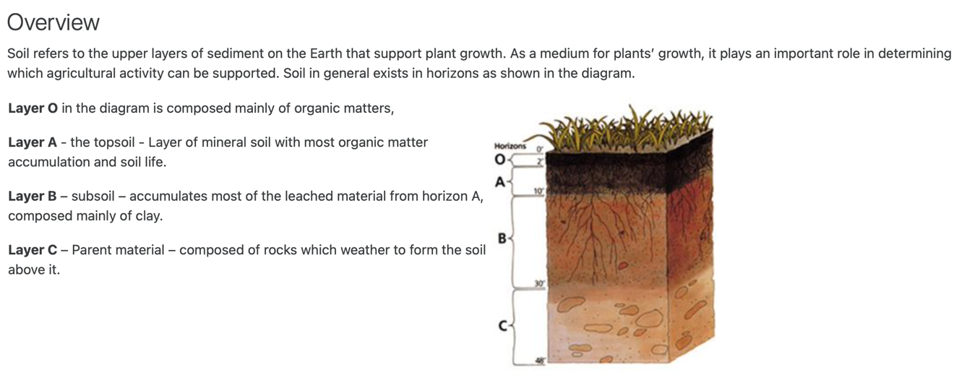
Figure 1 Sample of a VUSSC course – Introduction to Agriculture in Small States (CC BY-SA)

Sustainability
When VUSSC developed the TQF, the initiative gained significant momentum and many organizations became involved. VUSSC gained support from various qualifications bodies, including SAQA. Many national quality assurance and accreditation associations and bodies supported VUSSC to promote the TQF and became advisers regarding qualification matters because they saw the value in the TQF.

As the initiative grew, countries outside of VUSSC (such as India, Australia, and South Korea) began using its content. VUSSC developed a continuum to denote how far along countries were in adopting OER, the aim being that, with increased intervention and effort, countries would move along the continuum with the goal of reaching the highest level of implementation. In Botswana, for example, VUSSC worked with BOU and supported it to move along the continuum until it was sustaining the interventions. Key to the success in this regard was ensuring that there were champions on the ground who could build capacity and maintain momentum.

Lessons learnt
One of the main lessons that the VUSSC team learnt in rolling out its OER initiatives was the importance of reinforcing skill sets. The team initially assumed that all participants would have the necessary ICT skills but found that it needed to build capacity in this area. The model that it used focused on ‘the three Cs’ – capacity, collaboration, and content. This multi-pronged approach allowed VUSSC to improve OER capacity, promote collaboration between country representatives, and produce content as OER. However, a VUSSC representative notes that capacity building is still required, including information around copyright and how to adapt OER.

Through its work on the TQF, VUSSC realised the importance of champions in taking OER-related work forward. As a result, it identified one person in each country who would advocate for OER and use of the TQF.

VUSSC also found that monitoring and evaluation was crucial to measure impact and adjust its strategies.

Through the TQF, VUSSC also learnt the importance of providing structure to OER (through tools like the TQF). As one of the former team leaders at VUSSC notes, ‘if you want people to use [OER], you need to structure it’.

In efforts to ensure the quality of content that was produced, VUSSC developed guidelines and criteria. The TQF has level descriptors from level 1–10, which aimed to ensure the content that was developed matched the level descriptors and aligned with quality requirements. VUSSC would also inform countries that, before they offered a programme, it would need to be approved by an accreditation authority in the given country. Any VUSSC OER programme(s) being offered by an institution must have been accredited in the country where it is being offered. However, to give VUSSC-developed programmes international recognition, several were registered on the TQF. This guarded against double accreditation if the same programme was being offered in more than one country.

A final key lesson is the importance of policies at both the national and institutional levels to support OER adoption and sustainability. One of the findings from a 2019 evaluation of the project at BOU was that at the time the programme was being developed in 2012, there was neither an institutional nor a national policy in place to outline provision and practice regarding OER, highlighting a need for such policies to guide sustainable, high-quality OER use, development, and advocacy. Important to note however, is that in 2019 BOU developed and implemented an OER policy.

Conclusion
VUSSC’s approach to mainstreaming the use of OER by developing its own content, combined with a framework for accreditation alignment, has been effective by their criteria. It has used open practices as a methodology to advocate for the use and development of OER. The TQF has contributed to this by providing structure for OER integration, promoting sustainability of OER use. At its core, VUSSC has used its OER activities to promote learner empowerment and access.

The initiative is geared towards collaboration, developing resources, empowerment, and building OER capacity. As such, it has influenced larger numbers of people because countries and institutions have been given high levels of autonomy in how they use the OER and have thus integrated OER into courses and programmes at institutions around the world. VUSSC also builds human resource capacity through its OER activities. Overall, the way that VUSSC has promoted the use of OER enables small states of the commonwealth to participate effectively in global economies by developing courses and programmes that are contextually relevant, easily identifiable, and can be aligned with other accredited courses or programmes around the world.

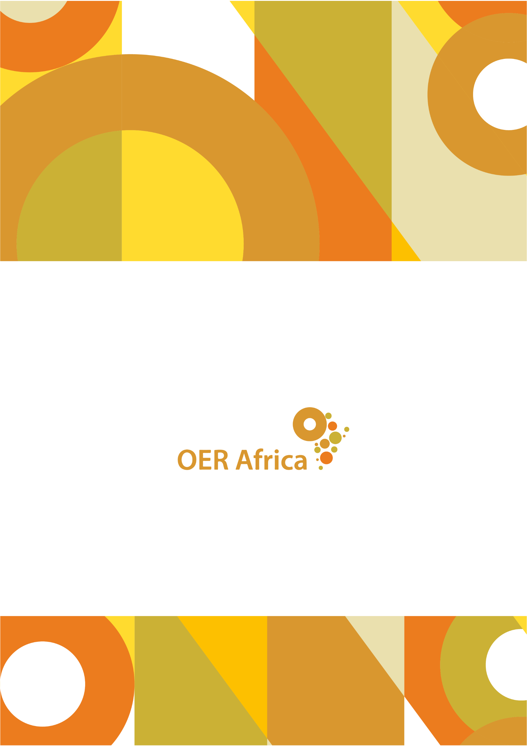
Unless otherwise stated, this work is licensed under a Creative Commons Attribution 4.0 licence

www.oerafrica.org

United Nations Sustainable Development Goals. (nd). Virtual University for Small States of the Commonwealth (VUSSC). Retrieved from https://sustainabledevelopment.un.org/partnership/?p=7702
Africa: Botswana, The Gambia, Eswatini, Lesotho, Mauritius, Namibia, Seychelles; Asia: Brunei Darussalam and Maldives; Caribbean: Antigua & Barbuda, The Bahamas, Barbados, Belize, Dominica, Grenada, Guyana, Jamaica, St. Kitts & Nevis, St. Lucia, St. Vincent and the Grenadines, Trinidad & Tobago; Pacific: Fiji, Kiribati, Nauru, Papua New Guinea, Samoa, Solomon Islands, Tonga, Tuvalu, Vanuatu; Mediterranean: Cyprus, Malta
Commonwealth of Learning. (nd). Virtual University for Small States of the Commonwealth (VUSSC). Retrieved from https://www.col.org/programmes/vussc/virtual-university-small-states-commonwealth-vussc
Survey response from Mr John Lesperance, former COL education specialist, 5 March 2020
Commonwealth of Learning. (nd). Virtual University for Small States of the Commonwealth (VUSSC). Retrieved from https://www.col.org/programmes/vussc/virtual-university-small-states-commonwealth-vussc
VUSSC. (2021). VUSSC Management Committee. Retrieved from https://vussc.col.org/index.php/about/
Survey response from John Lesperance, former education epecialist at COL, 5 March 2020
Commonwealth of Learning. (nd). Virtual University for Small States of the Commonwealth (VUSSC). Retrieved from https://www.col.org/programmes/vussc/virtual-university-small-states-commonwealth-vussc
Vaai, E.K. (nd). Virtual University of the Small States of the Commonwealth (VUSSC) model for development: Open Educational Resources. Retrieved from https://wikieducator.org/images/a/a1/Emma_Kruse_Vaai.pdf
Keevy, J., Chakroun, B. and Deij, A. (2010). Transnational Qualifications Frameworks. Retrieved from https://www.etf.europa.eu/sites/default/files/m/720E67F5F1CC3E1DC125791A0038E688_Transnational%20qualifications%20frameworks.pdf
Commonwealth of Learning. (2015). Transnational Qualifications Framework for the Virtual University for Small States of the Commonwealth – Procedures and Guidelines. Retrieved from http://oasis.col.org/bitstream/handle/11599/501/TQF.pdf?sequence=4&isAllowed=y
Commonwealth of Learning. (2015). Transnational Qualifications Framework for the Virtual University for Small States of the Commonwealth – Procedures and Guidelines. Retrieved from http://oasis.col.org/bitstream/handle/11599/501/TQF.pdf?sequence=4&isAllowed=y
Keevy, J., Chakroun, B. and Deij, A. (2010). Transnational Qualifications Frameworks. Retrieved from https://www.etf.europa.eu/sites/default/files/m/720E67F5F1CC3E1DC125791A0038E688_Transnational%20qualifications%20frameworks.pdf
Lesperance, J. (nd). Increasing access to higher education in small states. Retrieved from https://www.google.com/url?sa=t&rct=j&q=&esrc=s&source=web&cd=&ved=2ahUKEwi6q-_b7pbyAhWhoVwKHYW1BU0QFnoECAMQAw&url=http%3A%2F%2Fwww.cedol.org%2Fwp-content%2Fuploads%2F2012%2F07%2FAN13_Lesperance_VUSSC_CH_FINAL.doc&usg=AOvVaw2rILXb759YXRPyuACCaPCQ
BOU was previously known as Botswana College of Distance and Open Learning (or BOCODOL)
Interview with Dr Mairette Newman, education specialist at COL, 15 May 2020
Survey response from Dr Mairette Newman, education specialist at COL, 29 April 2020
Survey response from John Lesperance, former education specialist at COL, 5 March 2020
Interview with John Lesperance, former education specialist at COL, 15 May 2020
Email correspondence with VUSSC representatives, 28 October 2021
Vaai, E.K. (nd). Virtual University of the Small States of the Commonwealth (VUSSC) model for development: Open Educational Resources. Retrieved from https://wikieducator.org/images/a/a1/Emma_Kruse_Vaai.pdf
Vaai, E.K. (nd). Virtual University of the Small States of the Commonwealth (VUSSC) model for development: Open Educational Resources. Retrieved from https://wikieducator.org/images/a/a1/Emma_Kruse_Vaai.pdf
Hoosen, S., Moore, D. and Butcher, N. (2016). Open Educational Resources (OER) Guide for Students in Post-Secondary and Higher Education. Retrieved from http://oasis.col.org/handle/11599/2093
Interview with John Lesperance, former education specialist at COL, 15 May 2020
Interview with John Lesperance, former education specialist at COL, 15 May 2020
Survey response from John Lesperance, former education specialist at COL, 5 March 2020
Interviewee statement from 2019 Evaluation, shared via email correspondence with Dr Mairette Newman (COL), 15 May 2020.
Survey response from Dr Mairette Newman, education specialist at COL, 29 April 2020
Interview with John Lesperance, former education specialist at COL, 15 May 2020
See https://europa.eu/europass/en/european-qualifications-framework-eqf
Interview with John Lesperance, former education specialist at COL, 15 May 2020
Vaai, E.K. (nd). Virtual University of the Small States of the Commonwealth (VUSSC) model for development: Open Educational Resources. Retrieved from https://wikieducator.org/images/a/a1/Emma_Kruse_Vaai.pdf
Interview with John Lesperance, former education specialist at COL, 15 May 2020
Survey response from Dr Mairette Newman, education specialist at COL, 29 April 2020
Commonwealth of Learning. (nd). Virtual University for Small States of the Commonwealth (VUSSC). Retrieved from https://www.col.org/programmes/vussc/virtual-university-small-states-commonwealth-vussc

