Teacher Education in Sub-Saharan Africa
Case studies on African OER initiatives in higher education

Introduction
Teacher Education in Sub-Saharan Africa (TESSA) is a collaborative network that helps to improve the practice of teachers and teacher educators operating across the region. TESSA was conceived as an emergency response to the teacher training crisis in sub-Saharan Africa (SSA) and has been active since 2005, a time when there was a focus on the millennium development goals of Education for All. Today, it provides both a bank of open educational resources (OER) that are linked to school curricula and a network of educators who work to improve learning and teaching. The OER are designed to support teachers and teacher educators in developing active approaches to learning.

Coordinated by the Open University, United Kingdom (OU UK), the TESSA network includes 14 African institutions, while partners include the Commonwealth of Learning (COL), World Vision in Zambia, the South African Institute for Distance Education (Saide), the Kenya Institute of Special Education, the Kenyan Institute of Curriculum Development, the African Council for Distance Education, and the Zambian Ministry of General Education.

To date, the initiative has created approximately 100 OER in English, 75 of which are also available in Kiswahili, French, and Arabic. The OER cover primary school curricula, as well as handbooks and toolkits for teachers and teacher educators. The resources are aimed at teachers, teacher educators, and student teachers. The team has recently added resources to support foundation literacy and foundation numeracy. TESSA also has ten free online courses available, which are designed to mediate the TESSA OER.

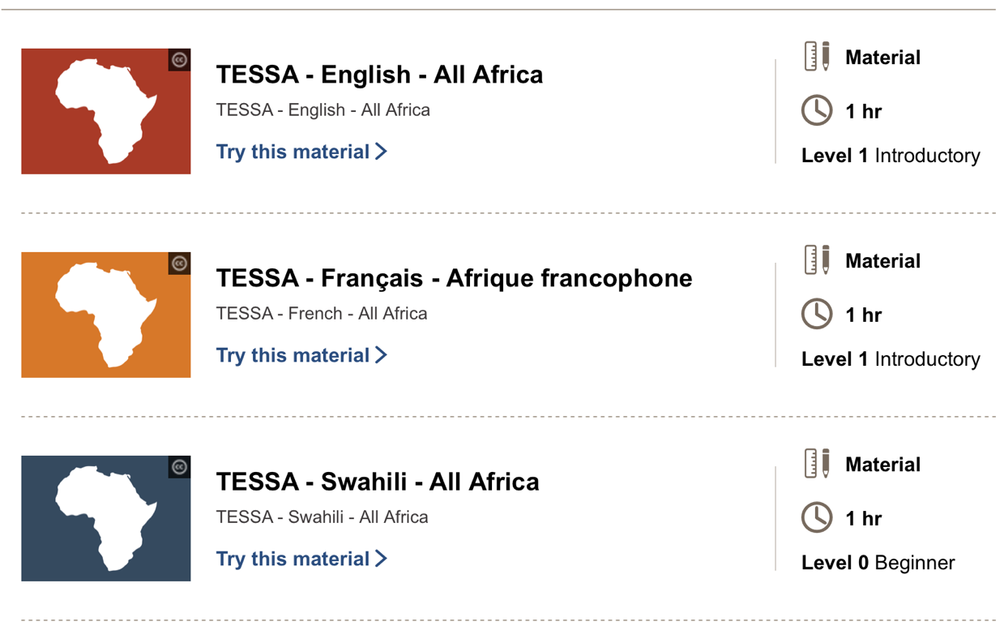
Figure 1 Sample of OER on the TESSA materials page (CC BY-NC-SA)

The TESSA Background and History provides a succinct summary of TESSA, as outlined below:

TESSA OER embrace a socio-cultural view of teacher learning, in which teachers (and teacher educators) learn through participation in, reflection on, and discussion of, practice. It is not a specific intervention, targeting a particular subject or skill. The OERs – which cover the whole of the primary school curriculum and some aspects of secondary science – are designed to open up possibilities for teachers, and the model of change is one of evolution and not revolution. The assumption is that solving problems in complex systems involves maximising discretion at the point where the problem is most immediate and ‘the closer one is to the problem, the greater is one’s ability to influence it’ (Elmore, 1980, 605). TESSA therefore targets classrooms rather than policy makers. The aim is to encourage small changes in practice that will elicit new responses from learners, which in turn will encourage teachers to try new approaches. TESSA OER form part of a ‘teachers toolkit’ (Leach & Moon, 2008).

This case study is based on desktop research; an online survey response and interview with the academic director; and digital resources provided by the academic director.

Description of the initiative
When it was formed, TESSA’s key objectives were to:
- collaborate with OU UK and other international organizations to create a network of African universities that focuses on the education and training needs of teachers in SSA,
- support the development of school-based teacher education modules where teachers develop their competencies and skills to meet the needs of learners in their classrooms, and
- design and build a multilingual OER bank that is freely available to all teachers in the region and is modular and flexible in format.

Since its inception in 2005, the initiative has evolved over three phases as follows:

Phase 1: 2005–2010
- OU UK formed a consortium of 14 institutions across nine African countries, in collaboration with international partners including COL, the National Commission for College Education (NCCE), and Saide. TESSA coordinators in each institution were supported by the project team as they worked to embed TESSA OER at their own institutions. TESSA’s implementation was ‘seen as a dispersed and decentralised process with discretionary activity occurring primarily within identified programmes and courses of partner institutions.’
- Over this period, participants developed 75 adaptable OER units to support primary school teaching in Arabic, English, French, and Kiswahili. The TESSA units provide classroom activities, examples and resources that are contextualised for ten African countries. They cover the primary curriculum, as well as some examples of secondary science, and were collaboratively written by the consortium. Teaching materials drew from research and demonstrated how research findings can be applied in the classroom. Representatives from participating institutions then contextualised the units for their countries. The units model an inclusive, activity-based pedagogical approach to teacher and student learning.
- In 2010, a set of TESSA case studies was published in which each partner institution set out their implementation plan.

Phase 2: 2010–2015
- Separately funded projects worked to extend TESSA’s impact and integrate TESSA OER into national teacher education programmes. The aim was to improve the quality of teacher education and the skills of pre-service and in-service teachers. This included:
  - extending and embedding the use of TESSA materials in institutions including universities, colleges and schools (Kenya and Ghana),
  - widening participation to include colleges of education, government agencies, and civil society organizations (Uganda and Zambia),
  - developing new materials (including TESSA Secondary Science, Teaching Practice Supervisors Toolkit and Inclusive Education Toolkit in Ghana, Zambia, Kenya, Uganda and Tanzania), and
  - exploring technological options for the delivery of TESSA OER, including tablets and mobile phones.
- The TESSA team used core funding to develop the TESSA website. The team also developed resources including handbooks, teaching packs, a teaching practice supervisors toolkit, and an inclusive education toolkit, while providing support for the network through newsletters and conference attendance.
- OU UK commissioned an independent evaluation of TESSA in 2010, which was completed in 2012, the findings of which informed Phase 3 of the initiative.

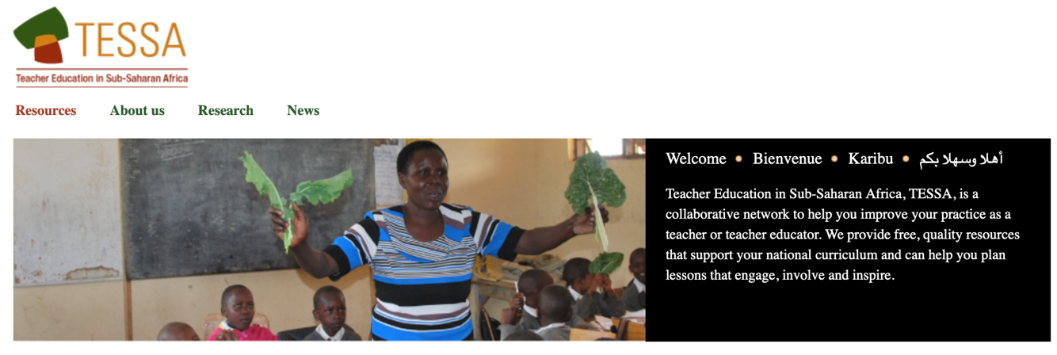
Figure 2 TESSA website homepage (CC BY-SA)

Phase 3: 2015–2022
In this phase, the initiative focused on raising awareness about TESSA and increasing engagement with TESSA materials. It also sought to improve the quality of learning and teaching in colleges of education and schools. Activities included:
- Expanding and improving the website.
- Writing and conducting the TESSA Massive Open Online Course (MOOC) for three cohorts. Each cohort consisted predominantly of teacher educators from universities, colleges of education, and ministry officials, but also included teachers and student teachers.
- Expanding the network through a TESSA Ambassador programme, and a small grant scheme.
- Developing new working partnerships with organizations and partners such as UNESCO, the African Council for Distance Education, and Ministries of Education in SSA.
- Working to embed TESSA in colleges of education in Zambia and Uganda. For example, TESSA held four workshops in Zambia:
  - In the first workshop, eight colleges of education representatives, eight ministry officials and 16 teachers mapped the TESSA materials to the Zambia school curriculum, resulting in the TESSA Curriculum Guide for Zambia.
  - In the second workshop, two representatives for each college of education attended a MOOC Facilitation workshop, after which they were asked to facilitate the MOOC in their college. This resulted in Zambia having the highest number of participants in the first presentation.
  - Two representatives from each college of education attended a third workshop in which the TESSA Teaching Practice Supervisors Toolkit was adapted for Zambia. It has been published as the School Experience Supervisors Toolkit.
  - The principal officer at the Ministry of General Education (MoGE) responsible for the colleges of education (who is also a TESSA Ambassador) used a TESSA small grant to run a workshop for representatives from the colleges of education to promote the use of the School Experience Supervisors’ Toolkit.
The aim of this work was to embed TESSA in the colleges and improve the quality of the supervision of the practical components of pre-service teacher education courses.
- Further embedding of TESSA in Francophone Africa. The TESSA MOOC has been translated into French and loaded onto servers in colleges of education. The course is being facilitated and is providing professional development for college tutors.
- Developing an online course to support early reading called ‘TESSA: Teaching Early Reading with African Storybook’
- Leveraging more funding to support TESSA activities, including a national programme for school-based continuous professional development (CPD) in Zambia.
- Exploring new technological options for the delivery of TESSA OER including Raspberry Pi computers, Universal Serial Buses (USBs), and mobile phones.

The team is currently involved in several ongoing projects that are not directly related to TESSA but can be traced back to it. The largest is the Zambian Education School-based Training (ZEST) in which TESSA resources and mediating materials are being integrated into their ongoing school-based CPD activities. This will be ongoing until June 2022 and possibly March 2023 (if the project receives additional funding for which it has applied). In Kenya, the team is working to get TESSA OER on the Kenya Education Cloud, as well as working with the Commonwealth of Learning and the Kenya Institute of Special Education (KISE) to support inclusive education.

Impact on teaching and learning
For OER users, the initiative focuses on improving teaching skills at all levels in the school system. The academic director for TESSA noted that, if OER users learn about writing OER through use, that is a bonus; the emphasis is on changing practice rather than resource development.’

Reflecting on TESSA’s impact on teaching practice, some teacher educators found the TESSA materials to be completely new and saw the materials as being an ‘eye-opener’. For others who were familiar with learner-centred activity-based methods, TESSA reinforced these theories and practices. As the 2012 evaluation notes:

Most importantly, the OER provided the means of achieving their ideals. Overall, TESSA has had significant impact on the identity and practices of teacher educators and a profound impact on those of teacher-learners. It has fused theory and practice; shifted perceptions from teacher as a “know it all” to “teacher as facilitator of learning”; and greatly enhanced the relevance of pupils’ learning experiences.

In terms of learning, TESSA improves learner participation and achievement. In schools and colleges, the materials have contributed to changing the trajectory of learners. For example, a small-scale study in Zambia found that the pedagogical approach that TESSA OER uses encouraged female learners to take a more active role in science classes at the secondary level. The 2012 evaluation made similarly positive observations about the impact of TESSA materials on teaching and learning, noting that:
- Many learners have been exposed to TESSA materials. There were approximately 295,000 enrolments in courses that used TESSA materials at partner higher education institutions (in several cases, the same student may have enrolled across a number of the modules that were using TESSA materials at the same institution). As the material is freely accessible, an indeterminate number of students in institutions other than the partner Higher Education Institutions (HEIs) have also been exposed to TESSA materials.
- TESSA has been used in diverse contexts. This includes use of materials in universities serving different languages, use in various cultural and socio-economic student populations, and use in different educational settings ranging from initial teacher education (ITE) to in-service programmes. The materials have also been used across curriculum areas, in contact teaching, and distance education programmes, as well as in short courses in CPD and mainstream Certificate, Diploma, Bachelor of Education (B.Ed), and Postgraduate Certificate in Education (PGCE) programmes.
- TESSA materials are fit for purpose. Although applications have been diverse, the materials have mostly been used in mainstream programmes for teacher training, especially for Diplomas in Education and Bachelors of Education Degrees. At the time of the evaluation, nine partner HEIs were using TESSA resources across all five curriculum areas for which these materials were available.
- The materials are used in creative ways that represent ‘forms of practice that correspond with best professional practices as described by leading education theorists’. Teacher educators and teacher learners noted various reasons for this impact, including that TESSA provides the resources and tools for activity-based learning; that they do not alienate practitioners by providing an abstract theory that does not align with their own theoretical approaches; and that the materials make learner-centred, activity based, and reflective practice real and achievable.
- TESSA OER have had a significant impact on the identity and practices of teacher educators and teacher learners. In fusing theory and practice, they have promoted the perception of the teacher as a facilitator rather than as the holder of knowledge.

TESSA has also supported capacity building in writing materials, but this was not a primary focus of the initiative. By working with TESSA, many people learnt about the process of writing materials and how to cater to one’s audience through different writing styles. TESSA had a clear template for materials development, but, when people adapted resources for different countries, they could change certain aspects of the template (although it was a requirement that other core aspects remained the same). For example, the learning outcomes, structure, and key activity remained the same. In other activities, names and places could change, together with the resources included to support activities. One of the three case studies could be changed completely to account for local contexts. Building and populating the template was a collaborative process. Once the team had developed a set of resources, different teams took the materials back to their institutions and versioned them for their context. This gave them a sense of ownership and got them to think about integrating the materials into their programmes.

Since 2010, additional OER have been added to the original set of TESSA materials and these have been shown to support teacher CPD. For example, the Tanzanian Government adopted a ‘competency-based curriculum’ which supports a cascading CPD programme for teachers in mathematics, physics, chemistry, and biology. In each of these subjects, there are 15 national facilitators who each trained 20 regional trainers per subject in each region of Tanzania. Those regional trainers went on to train local teacher educators to use TESSA materials, equating to thousands of secondary science teachers who have been exposed to TESSA OER. In a survey, teachers indicated that their pedagogical skills had improved; that there was more interaction in their classrooms and that the TESSA OER were valuable reference materials.

Strengths and achievements

Approach and relevance
When TESSA was first conceived in 2003, it was based on a general belief in a constructivist approach toward learning, which aimed to move away from the perception of learners as passive, empty vessels to be filled through education. Instead, it adopted the approach of knowledge being socially constructed through practice within a specific cultural setting. This approach conceptualises teaching as a problem-solving activity where teachers try different approaches in the classroom, reflect on the results, and then decide on the best way to develop the desired skills within their own context. Since 2005, many international governments have reviewed their curricula and promoted learner-centred teaching through curriculum and policy documents. Each country has expressed and understood this differently. At the centre is the idea that, together with knowledge, learners should develop skills and values. As a result, TESSA materials are becoming increasingly relevant. Prior to TESSA, teachers in many of the contexts where the project was implemented had limited resources to tell them how to teach skills (such as critical thinking, creativity, and problem-solving) and values (such as compassion, understanding others’ perspectives, independence, and lifelong learning). For example, TESSA is currently working on a project in Zambia where some teachers do not have copies of the school curriculum. TESSA materials go beyond teaching content and introduce skills and values. A strength of the materials is that they are not prescriptive. However, this can also become a weakness because teachers need to make sense of the materials themselves.

TESSA has used key partnerships to direct efforts at improving the adoption and use of TESSA OER. It formed these partnerships to undertake specific activities. As an example, three activities are outlined below, together with contributions from TESSA and partners.

Activity | TESSA activity | Partner | Partner contribution
Development of the course TESSA Teaching Early Reading with African Storybook (2018–2020) | Lead authors, managing production, hosting course on OpenLearn Create website, promoting of the course | Saide | Contributed to the authoring team and critical review, dissemination, support for implementers
Development of a school-based CPD course in Zambia (2017–2022) | Project lead – project management and academic team, authoring, materials production, leading workshops | World Vision Zambia (WVZ)  Ministry of General Education | WVZ: Implementing partner, project coordinator, monitoring and evaluation, IT support, logistics  MoGE: access to schools
Development of Pathways for Learning 2020 | Two free courses, webinars, access to applications to support learning, research activities | The African Council for Distance Education | Supporting webinars, communication, course promotion, facilitation, research activities

Adoption
TESSA OER have been used in programmes with an estimated combined enrolment of teacher-learners and in-service teachers of one million across a wide range of programmes in all partner institutions. The biggest contributors are the University of South Africa (UNISA), Open University Sudan, Open University Tanzania, and the National Teachers’ Institute in Nigeria. The evaluation explains:

TESSA has taken hold in different kinds of settings and contexts, in different models, and for different purposes. This was evidenced by:
      - the varied national policy contexts in which TESSA has thrived
      - a variety of certificate, diploma, and undergraduate degree programmes (both initial and in-service) delivered by partner institutions using TESSA OER and preparing teacher-learners across all phases of schooling
      - the deployment of TESSA resources for all core content subject and curriculum areas as well as for both contact and distance modes of teaching
      - TESSA incorporation in both ‘highly’ and ‘loosely’ structured modes of curriculum integration
      - the use of the OER in the development and delivery of new programmes initiated either by HEIs themselves, or in response to government mandate.

Thus, not only have TESSA materials been used by many teachers and teacher educators, they have also been adopted in diverse contexts and used for various applications.

Initiative’s responsiveness to contextual factors
Since its inception, TESSA has evolved to suit environmental factors on the ground. This includes adapting the following elements of the programme:
- The original consortium evolved into a network. The main TESSA advocates in 2019 (TESSA Ambassadors) are individuals who have actively sought out the network rather than being invited to join.
- Use of technology is still key, with a shift from computers and compact discs to greater use of mobile devices and Raspberry Pi computers.
- The ways in which TESSA is mediated for teachers and teacher educators has changed from a programme of workshops to online courses with an emphasis on local facilitation.
- Local activities are driven by TESSA Ambassadors through the provision of small grants.

TESSA champions and ambassadors
TESSA has found that identifying local champions has been a powerful way of promoting adoption of the materials. The team found that, as they introduced new resources or ideas, champions would emerge to take those concepts forward. TESSA spent a lot of time identifying and supporting champions, who included people in senior positions such as deans or heads of department and people who see their involvement in the programme as an opportunity to become better known and more expert in their institution.

As part of these efforts, they created the TESSA Ambassador Scheme for people who were interested in being champions. Criteria for entry include that the applicant needs to be enthusiastic about the materials and should be able to influence others. If they are accepted into the programme, TESSA sends the ambassadors a pack of resources to help them publicise the initiative. They also have a WhatsApp group to exchange ideas about how to use the materials. In addition, TESSA has a small grants scheme of approximately £1,500 per grant. Participants can design a local project which will help them solve a problem in their context. For example, a participant in Ghana was working in a college of education where they use TESSA materials to plan lessons that they could use in their teaching practice. The participant used a small grant to bring teachers from teaching practice schools into the college so that they could be inducted into TESSA and support student teachers when they were on teaching practice. To date, 13 small grants have been awarded. Moreover, 1,842 beneficiaries have been identified, alongside several thousands of teachers in Eastern Province in Zambia. This is a direct result of the Provincial Research Centre Coordinator including TESSA in his ongoing training programmes.

TESSA MOOC
The TESSA MOOC was a deliberate attempt to mediate the TESSA materials while using the MOOC as a platform to promote the materials. The team was pleased with the uptake. There were 6,970 participants over the three cohorts with a completion rate of 37% (compared to an average completion rate of 12–15% for MOOCs). Country representation was as follows:

Country | No. of participants
Zambia | 936
Nigeria | 1293
Kenya | 958
South Africa | 317
Uganda | 308
Ghana | 621

Challenges

Getting buy-in at an institutional level
As noted, TESSA OER conceptualise knowledge about teaching as subjective and socially constructed by an individual’s environment, whereas in-service and pre-service teaching courses tend to treat knowledge about teaching as objective and fixed. The disjuncture between theory and practice presented a challenge in that TESSA materials did not always fit into how teacher education was being implemented on the ground. However, TESSA’s practical approach, which provides the foundation for the materials, remains invaluable. In Kenya, for example, one partner involved in developing TESSA materials used them in class. The academic director highlighted the significance of this:

I think the way in is through teaching practice and school experience. When student teachers go into schools, they find that what they’ve learnt in college is highly theoretical, whereas the TESSA materials provide practical examples of how to teach things. In terms of the curriculum, my experience is that if you can persuade college lecturers to promote them through teaching practice and micro-teaching, that’s really helpful.

Challenges associated with the disjuncture between teacher education on the ground and the TESSA materials continue when considering how teacher learners are assessed. TESSA materials support pedagogical content knowledge in some countries like South Africa and Kenya, where the team has seen people use TESSA materials to introduce a practical element beyond the examination. This includes encouraging teacher learners to create a teaching and learning resource and evaluate it. At the end of their teaching practice, they give the resource to the school. The evaluation of this resource is part of the assessment. In those circumstances, TESSA is extremely useful because it allows for practical learning. However, teacher training ultimately culminates in an examination, which focuses more on a set of rules where teaching is presented as unproblematic.

Lack of professional collaboration between teacher educators
Another challenge uncovered during implementation of the TESSA initiative has been that, in several countries, there is little emphasis on CPD for teacher educators outside of master’s or PhD programmes. Governments provide training for teachers when they publish a new curriculum, but overall there is limited access to training opportunities for teacher educators. Because there is an insufficient culture of professional development for teacher educators and they are not regularly trained, the expectations of the new curriculum are not being introduced to pre-service teachers. Teacher educators are often seen as the providers of CPD. CPD needs to model the sort of pedagogy being promoted, but evidence suggests that teacher educators find this challenging.

Champions are not always on the ground
TESSA sees involving the right people on the ground as crucial to pushing the initiative forward. Over the years, however, ambassadors have been promoted to higher positions. This means that some of them are no longer on the frontline and are not actively promoting and using the materials. This has left a gap in promoting the use of TESSA materials.

Getting buy-in to materials on the ground
TESSA has highlighted two main challenges with regard to making use of their materials on the ground. The first is a lack of skills and willingness of teacher educators to read the materials and implement them. This includes having the confidence to adapt the materials. It arises because teacher educators see the materials as being for teachers and not directed at themselves. TESSA is not directly relevant to the examinations for which they have to prepare teacher learners. TESSA is tackling this challenge by promoting the use of TESSA materials to support teaching practice.

The second issue involves preconceptions of teachers as less expert and government officials as more expert. For example, district education officers act as intermediaries between the Ministries of Education and teachers. They work out of the local district office whose main role is monitoring. District education officers do not have recent teaching experience themselves, although they see themselves as experts and teachers as less expert, rather than both groups being expert in different ways. TESSA materials could be very useful to this professional group in their work supporting teachers, but it has proved difficult to convince them that this is the case. A second example is that, when an official was asked why the ministry in one TESSA country was reluctant to promote TESSA materials, the response was because they were not produced by the government, so people might question their expertise if they promoted them. The academic director adds:

…teachers have expertise in their individual schools. Both these groups of people [educators and district officials] are differently expert, whereas district officials see themselves as more expert. Linked to that is the view that the only materials you can use in school are the ones that have been approved by the government and a lack of realisation of the benefits that OER can bring.

In one project, TESSA provided a library of materials consisting of 75 units to several schools in SSA. However, when they returned to one of the schools three months later, the materials were still in their boxes. The academic director adds: ‘this school is next to the district education office, someone from the office works there.’This demonstrates the challenge of trying to introduce new materials into situations where the control is at the centre and the people in charge are significantly removed from the classroom.

Sustainability
The 2012 evaluation noted:

TESSA flourishes in the hearts and minds of teacher educators and their teacher-learners, and is certainly woven into the fabric of faculty practices. Nonetheless, in contact teaching programmes, where TESSA has been incorporated by an individual lecturer, sustainability is potentially threatened by staff mobility. Further, while there is evidence that management in partner universities has been convinced of the merits of TESSA, by and large, TESSA is not formally inscribed in curricula or in faculty statutes or guidelines. By contrast with contact teaching programmes, however, TESSA’s security of tenure appears to be assured in the distance programmes (which also account for the great majority of students). In such programmes, the integration of TESSA into curricula in ways that maintain and enhance programme design has involved much staff collaboration in carefully planned and structured processes. Learning materials thus developed are assets not easily discarded.

In terms of improving sustainability, TESSA would ideally like government organizations to buy into the concept behind TESSA materials, as these organizations are the guardians of the curriculum. The academic director added that it would be beneficial if the initiative was led from Africa, with the OU UK team acting in an advisory capacity. With this in mind, the team is looking to transfer ownership to an African organization.

The academic director noted that key to sustainability is finding champions, which includes finding a way to give people space regardless of their position in an institution. This involves developing a meritocracy where people are rewarded for the work that they do to advocate for OER and raising the profile of OER champions in the institution.

Lessons learnt
A key lesson that the project team has learnt is that TESSA OER need to be mediated instead of simply being distributed, particularly to help teachers understand the potential of active learning in motivating students. The team started off with mediation through word of mouth where local champions would mediate the materials by providing explanations and context. They also used the MOOC as a tool for mediating the materials:

The materials are demanding for teachers. The temptation is to make them more prescriptive, but I’ve got some colleagues who have done that but it hasn’t worked. [We are] getting the balance between being prescriptive and relying on teachers’ interpretation... We’re trying to tackle that through local champions who mediate the process, and mediations through courses like the MOOC to train up the champions.

Considering what kind of skills development would allow the TESSA team to implement the project more effectively, the academic director noted that being able to engage with resources critically would be beneficial. Ideally, OER users should be able to read a resource, make a judgement based on their own need, and then adapt it. This is a crucial skills development area for OER that has not had significant uptake in resource-scarce contexts. This might be because of the perception that it is ‘cheating’ if you use or adapt somebody else’s work. This is illustrated in the quotation below, which speaks to issues of agency and confidence in teachers:

Teachers don’t feel they have the agency to be able to make decisions for themselves. It’s about taking ownership of their own classrooms. They need the confidence to be able to make those decisions. District education people need to be more trusting of the teachers. There is a lot of talk about setting up Communities of Practice, but for that to exist, you need much flatter structures than there are in a lot of educational organizations.

Because TESSA fundamentally promotes active learning amongst teachers and teacher educators, finding ways to promote teachers’ agency and confidence is key for greater adoption of the materials.

The TESSA team has also learnt that there are requirements to develop skills in reflective practice. They have found that OER users often think that, if they admit that something did not go well, they will get into trouble for it. But reflecting on their own practice in the classroom is a very useful tool in teaching because that is how teachers learn and improve.

A final key lesson has been that, even though they were developed over ten years ago, the TESSA OER remain relevant and current. This is evidenced by the enthusiastic response the materials have had in Zambia, where they are being integrated into the existing structures and processes for school-based CPD and into the curriculum of all the government-run colleges of education. They have also recently been curated by the Kenyan Institute for Curriculum Development with a view to being made available on the Kenya Education Cloud. These initiatives will increase access to and use of the TESSA OER considerably, as teachers will be confident that they are considered relevant to their work.

Conclusion
The TESSA case study demonstrates how OER can be used as an empowering tool for educators at all levels, whether they are pre-service teachers, in-service teachers using the materials for CPD, or teacher educators. According to the academic director, the initiative has shown that OER on their own only provide a foundation, but users need supportive contexts to integrate them into their teaching practice. Over time, TESSA materials have changed the trajectory of learners and teachers by changing attitudes toward OER and promoting a culture of sharing and adaptation, while providing easy access to critical knowledge. Using TESSA does not solve problems, but it opens possibilities and increases teacher agency, empowering teachers to ‘own’ their problems and therefore the solutions. Moreover, TESSA’s CPD approach fundamentally focuses on educators as active agents – an approach that has been successful to this point and holds promise for further entrenching the importance of CPD for educators going forward.

The TESSA project has not ‘finished’. Rather the OER and the community that has formed around them are available and are evolving; they continue to be available to contribute to any initiative designed to improve classroom teaching and learning. The OER remain as relevant as ever, as they demonstrate to teachers, teacher educators and student teachers how to convert theory into practice.

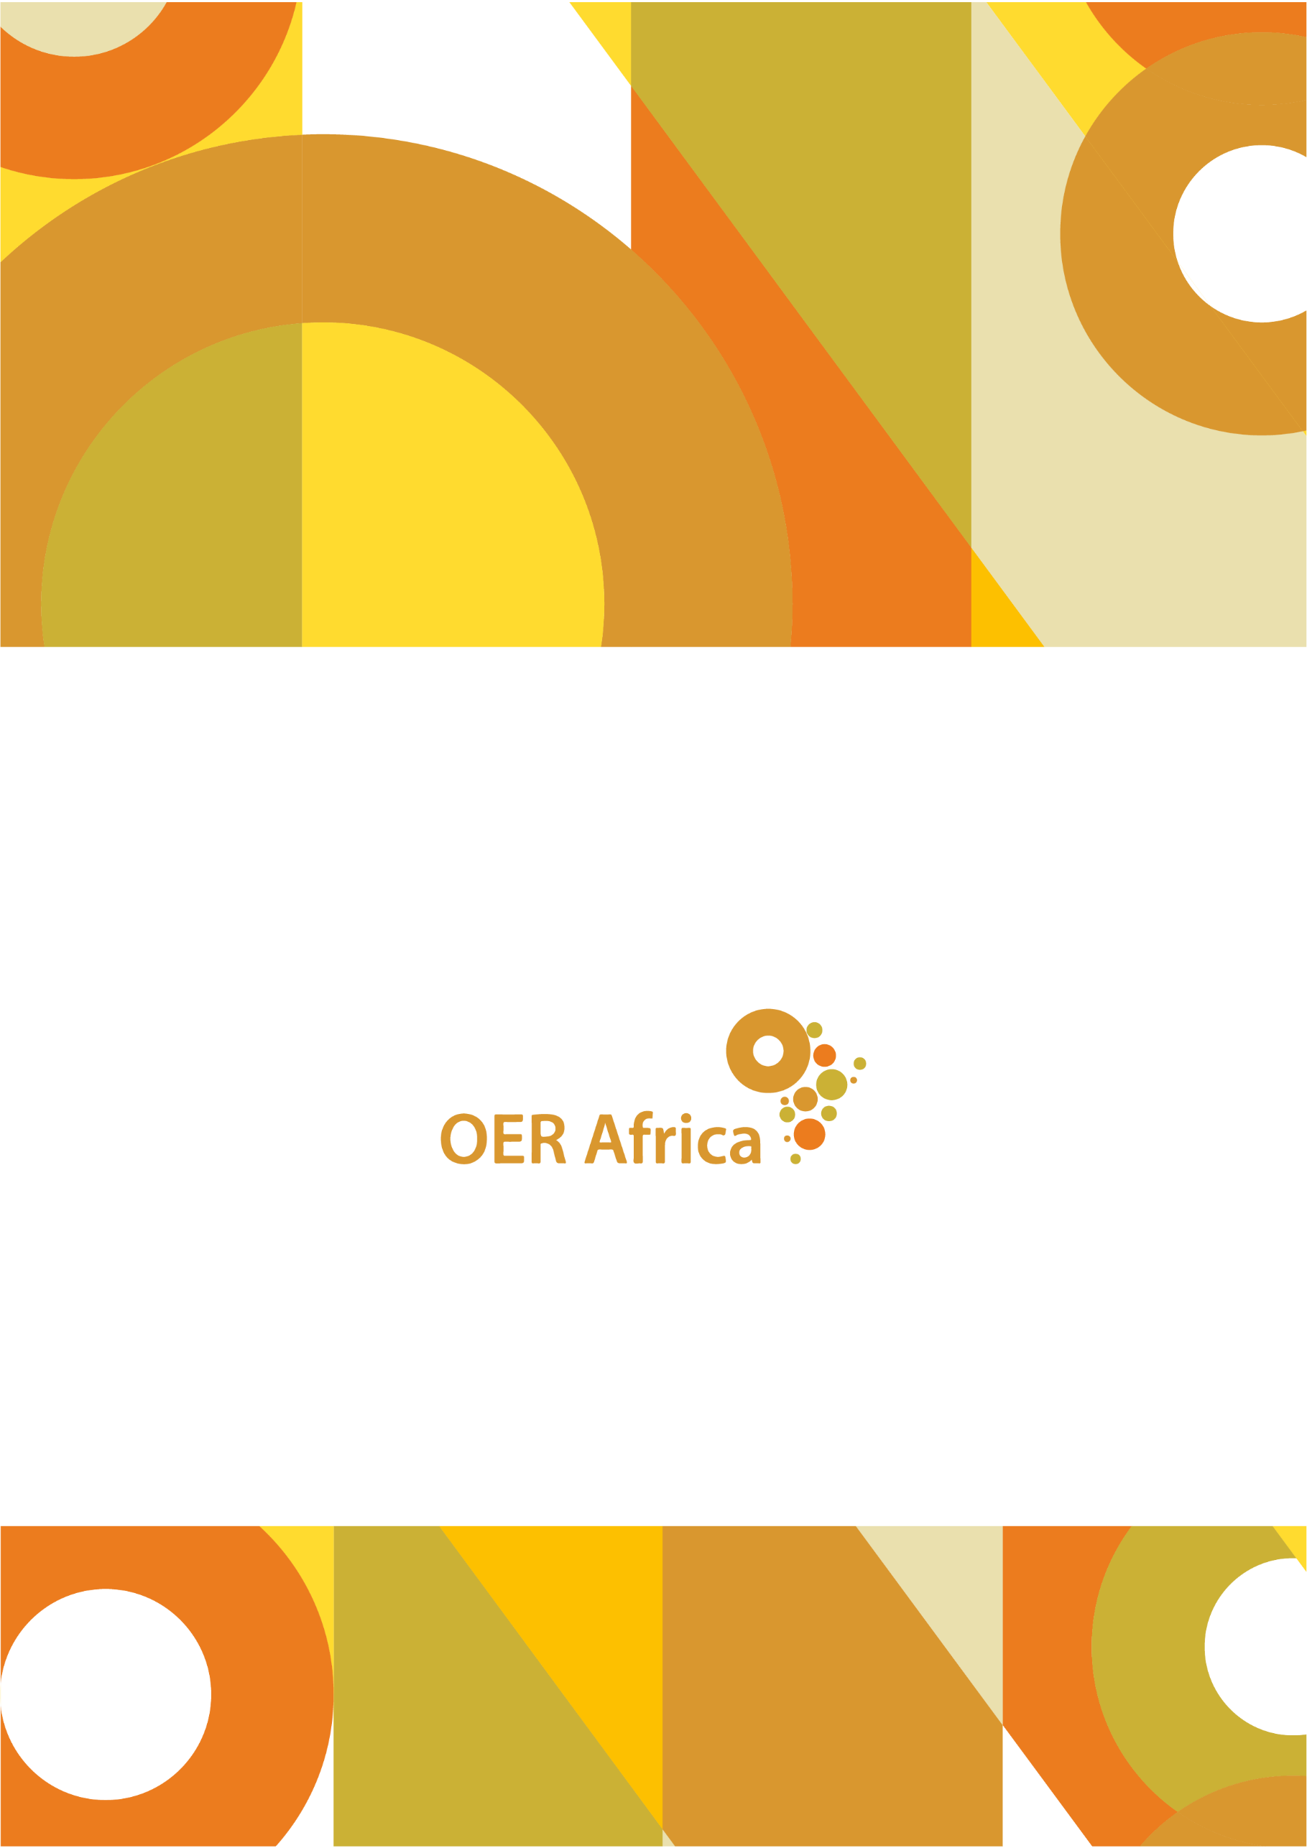
Unless otherwise stated, this work is licensed under a Creative Commons Attribution 4.0 licence

www.oerafrica.org

Teacher Education in Sub-Saharan Africa. (nd). About us. Retrieved from http://www.tessafrica.net/about-us
Survey response from Kris Stutchbury, Academic Director of TESSA, 19 February 2020
Taken verbatim from TESSA Background and History, document provided courtesy of Kris Stutchbury, Academic Director of TESSA
Harley, K. & Barasa, F.S. (2012). Teacher Education in Sub-Saharan Africa (TESSA). Formative Evaluation Report. Retrieved from http://www.tessafrica.net/sites/www.tessafrica.net/files/TESSA_Formative_Evaluation_Report_October_2012.pdf
Harley, K. & Barasa, F.S. (2012). Teacher Education in Sub-Saharan Africa (TESSA). Formative Evaluation Report. Retrieved from http://www.tessafrica.net/sites/www.tessafrica.net/files/TESSA_Formative_Evaluation_Report_October_2012.pdf
TESSA Background and History, document provided courtesy of Kris Stutchbury, Academic Director of TESSA
TESSA Background and History, document provided courtesy of Kris Stutchbury, Academic Director of TESSA
TESSA. (2020). About us. TESSA. Retrieved from http://www.tessafrica.net/history
TESSA Background and History, document provided courtesy of Kris Stutchbury, Academic Director of TESSA
Stutchbury, K., Chamberlain, L. and Rodriguez-Leon, L. (2020). Supporting the teaching of early reading: An evaluation of the TESSA: Teaching Early Reading with African Storybook Badged Online Course (BOC). The Open University, Milton Keynes. Retrieved from https://oro.open.ac.uk/70695/.
A series of small single-board, low-cost computers that plug into a computer monitor or television
TESSA Background and History, document provided courtesy of Kris Stutchbury, Academic Director of TESSA
Stutchbury, K., Gallastegi, L. and Woodward, C. (2019). Supporting Open Practices with Teachers in Zambia. Journal of Learning for Development - JL4D, 6(3) pp. 208–227. Retrieved from https://jl4d.org/index.php/ejl4d/article/view/367
Survey response from Kris Stutchbury, Academic Director of TESSA, 19 February 2020
Harley, K. & Barasa, F.S. (2012). Teacher Education in Sub-Saharan Africa (TESSA). Formative Evaluation Report. Retrieved from http://www.tessafrica.net/sites/www.tessafrica.net/files/TESSA_Formative_Evaluation_Report_October_2012.pdf
Teacher Education in Sub-Saharan Africa. (2015). TESSA presentations at DETA 2015. Retrieved from http://www.tessafrica.net/sites/www.tessafrica.net/files/files/TESSA%20presentations%20at%20DETA%202015_final.pdf
Harley, K. & Barasa, F.S. (2012). Teacher Education in Sub-Saharan Africa (TESSA). Formative Evaluation Report. Retrieved from http://www.tessafrica.net/sites/www.tessafrica.net/files/TESSA_Formative_Evaluation_Report_October_2012.pdf
Harley, K. & Barasa, F.S. (2012). Teacher Education in Sub-Saharan Africa (TESSA). Formative Evaluation Report. Retrieved from http://www.tessafrica.net/sites/www.tessafrica.net/files/TESSA_Formative_Evaluation_Report_October_2012.pdf
Teacher Education in Sub-Saharan Africa. (2015). TESSA presentations at DETA 2015. Retrieved from http://www.tessafrica.net/sites/www.tessafrica.net/files/files/TESSA%20presentations%20at%20DETA%202015_final.pdf
TESSA Background and History, document provided courtesy of Kris Stutchbury, Academic Director of TESSA
Interview with Kris Stutchbury, Academic Director of TESSA, 16 April 2020
Comments received from Kris Stutchbury, Academic Director of TESSA, 14 December 2020
Harley, K. & Barasa, F.S. (2012). Teacher Education in Sub-Saharan Africa (TESSA). Formative Evaluation Report. Retrieved from http://www.tessafrica.net/sites/www.tessafrica.net/files/TESSA_Formative_Evaluation_Report_October_2012.pdf
Taken verbatim from the TESSA Background and History, document provided courtesy of Kris Stutchbury, Academic Director of TESSA
Survey response from Kris Stutchbury, Academic Director of TESSA, 19 February 2020
Interview with Kris Stutchbury, Academic Director of TESSA, 16 April 2020
Comments received from Kris Stutchbury, Academic Director of TESSA, 14 December 2020
Comments received from Kris Stutchbury, Academic Director of TESSA, 14 December 2020
Interview with Kris Stutchbury, Academic Director of TESSA, 16 April 2020
Interview with Kris Stutchbury, Academic Director of TESSA, 16 April 2020
Harley, K. & Barasa, F.S. (2012). Teacher Education in Sub-Saharan Africa (TESSA). Formative Evaluation Report. Retrieved from http://www.tessafrica.net/sites/www.tessafrica.net/files/TESSA_Formative_Evaluation_Report_October_2012.pdf
Interview with Kris Stutchbury, Academic Director of TESSA, 16 April 2020
Teacher Education in Sub-Saharan Africa. (2015). TESSA presentations at DETA 2015. Retrieved from http://www.tessafrica.net/sites/www.tessafrica.net/files/files/TESSA%20presentations%20at%20DETA%202015_final.pdf
Interview with Kris Stutchbury, Academic Director of TESSA, 16 April 2020
Interview with Kris Stutchbury, Academic Director of TESSA, 16 April 2020
Comments received from Kris Stutchbury, Academic Director of TESSA, 14 December 2020

