Open Education for Eye Health
Case studies on African OER initiatives in higher education

Introduction
Low- and middle-income countries (LMICs) face critical shortages of resources related to eye health, such as limited training facilities and training personnel, as well as a shortage of ophthalmologists and eye care specialists. Open Education for Eye Health (OEEH), an initiative led by the International Centre for Eye Health (ICEH) at London School of Hygiene and Tropical Medicine (LSHTM), responds directly to these issues. The programme focuses on collaboratively developing and delivering a series of seven open online courses and associated open educational resources (OER). It aims to empower students, educators, managers, and leaders in eye health to build knowledge and skills in public health eye care and strengthen both clinical and teaching practice for the elimination of avoidable blindness.

Established in 2015, the ongoing initiative has a core team of five people, together with 130 individual collaborators from approximately 30 countries. OEEH also set up formal partnerships with various institutions, including the University of Cape Town (UCT) in South Africa and the College of Ophthalmology of Eastern Central and Southern Africa (COECSA) in Kenya. To date, the initiative has created approximately 300 OER in several disciplines, including Public Health, Global Health, Ophthalmology, Diabetes, Neglected Tropical Diseases, Trachoma, and Neonatal Care.

This case study is based on desktop research, an online survey response from one of the project leads, and an online interview with the two project leads who were working on OEEH at the time.

Description of the initiative
Prior to 2015, ICEH was able to train 15 to 20 people in a Master’s Degree programme on public health eye care annually, but was rejecting 60 to 100 applicants. This raised the issue of how to make knowledge accessible to all applicants. It therefore began exploring open education alternatives to bridge the knowledge gap effectively.

OEEH was conceived as a programme to collaboratively develop and deliver a series of seven open online courses and OER to empower students, educators, managers, and leaders in eye health to build knowledge and skills in public health eye care and strengthen both clinical and teaching practice to eliminate avoidable blindness. The OEEH team facilitates a process of content development for the programme and markets it with that audience in mind.

For content development of these courses, the OEEH team has instituted a structured process in which it briefs collaborators by setting out course objectives, learning outcomes, design, content creation, course delivery, and assessment. The team seeks to involve collaborators at each stage of this process. There is also an expert steering group for learning design, which helps map out student activities and agrees who could assist in writing content.

Skills development occurred for both OER developers (academic and technical) and OER users. For OER developers, this included digital teaching skills and capabilities. Academics navigated the content through learning design in partnership with the technical team. This was an informal part of the collaborations to co-create content. One example of this was working with collaborators to script, storyboard, and then film short educational videos.

The pace of change has overtaken the assumption that people need to be trained in digital skills. We’ve given people an opportunity to try it in a scaffolded way. One of the areas we felt digital education was important was at the trainer level.

For OER users, digital teaching skills and capabilities were more formally part of OEEH’s partnerships with COECSA and UCT. For example, COECSA educators worked with the eLearning team at UCT to create videos as part of contextualising one of the courses for their context. OEEH also ran two webinar series aimed at supporting eye health educators to develop their digital skills.

While the initiative does not yet have evidence on the scale of adoption, it does have anecdotal evidence from several ophthalmologists and eye health managers who have used the OER and courses as part of their professional team or residency training. An ‘impact’ survey that the initiative ran in 2017, one year after introducing their first course, found that 70% of the 139 respondents (across 45 countries) had reused, adapted, and/or shared the OER for teaching and learning purposes. Course participants provided positive feedback on how the course had assisted them:

We deal mostly with low-income group[s] and their issues are almost [the] same as I studied in [the] course. The course motivated me for community eye health care awareness and we started working with schools to give them basic awareness, early eye screening.

Taking the above into consideration, the perceived impact of the materials is wide because public health eye care training is often provided by eye care managers or clinical leads whilst they are ‘on the job’.

In 2016, the initiative, along with 37 collaborators from 12 countries, developed a massive open online course (MOOC) titled ‘Eliminating Trachoma (ET),’ an avoidable blinding disease caused by a bacterium. The MOOC focused on improving access to training, as well as equipping and mobilising health workers. These efforts were in aid of achieving ‘Global Elimination of Trachoma (GET) 2020’, the World Health Organization’s initiative to eliminate trachoma. At the time that OEEH published a conference paper on the MOOC in September 2019, more than 5,000 people from a diverse range of professional backgrounds and disciplines had participated in the MOOC. This included clinicians providing surgical services, programme managers, field workers administrating antibiotics, and teams implementing water and sanitation improvements. The initiative used a ‘value-creation framework’ to evaluate the impact of MOOC-based learning on trachoma elimination practices at the local level. A survey completed by 76 MOOC participants (84% of whom worked in eye care) indicated that most had gained immediate (88%) and potential (95%) value from participating in the MOOC. Half the responses from trachoma endemic regions indicated that they had reframed their goals and approach after participating in the MOOC.

Strengths and achievements
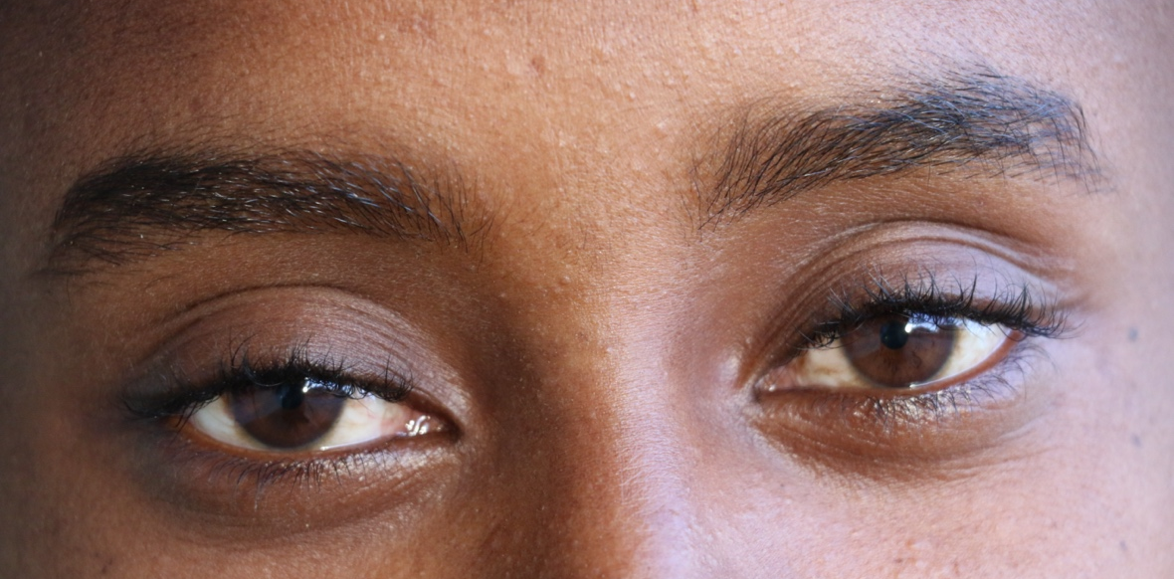
Quality has been a very important consideration for the OEEH team, which wanted to ensure that content was relevant at the local level. Steering groups have external members based in LMIC settings; for example, there were steering group members from Nigeria and Kenya for the ET MOOC. Moreover, the steering groups were careful about who they selected as content authors and facilitators. Where possible, they brought in voices from LMIC settings during construction of the course and as facilitators on the course. The steering groups have also brought in subject experts, therefore ensuring that evidence-based best practice is shared and is applicable.
Image courtesy of EU Civil Protection Humanitarian Aid, Flickr (CC BY-NC-ND)

The team spent much time agreeing on the learning design, which proved beneficial as there was then no need to adjust their approach as the initiative unfolded. This provided a good structure within which to design the content.

The Ophthalmological Society of Nigeria has applied continuing professional development (CPD) points to OEEH’s Global Blindness course that was coordinated by an ICEH/LSHTM alumnus. As of October 2020, OEEH has reached more than 37,000 people from 188 countries and territories, over 66% of whom reported working in health/social care and 58% of whom were based in LMICs according to their IP address. Moreover, open registration enables individuals and eye health teams to learn together and with colleagues from different settings. As a result of OEEH’s activities, more than 300 openly licensed educational resources, created with 110 collaborators from 25 countries, are available to download, reuse, share, and adapt for local training needs.

Challenges
A key challenge that the initiative has encountered is that although collaboration with experts from around the world has been key to the quality of the OER, it has proved to be resource intensive. After each course is launched, continuous work is required to update courses and keep them relevant. When OEEH started, it was very focused on the course content and learning design. As it has grown, however, the programme and its impact has become broader than the courses, so the team has had to consider innovative ways to partner with other institutions and networks.

Being grant-funded, a second challenge has been the need to develop a sustainable business model, which has required the programme coordinators to seek out mixed income streams by, for example, formalising courses.

Lastly, although OEEH started out as a knowledge-sharing initiative, it has received indications that many users want accreditation that would be recognised. In a similar vein, OEEH is operating in a medical system where hierarchy and adherence to accreditation norms is deeply ingrained. As such, the team has had to consider the best kind of accreditation for a global audience. With this in mind, OEEH is now looking into how it can reach professional practitioners through formal accreditation mechanisms and institutions. Recent progress has seen the OEEH team developing a postgraduate certificate using the open courses. The course is accredited for CPD and is also on demand on the FutureLearn platform. The postgraduate certificate is in its final approval stage.

In considering how they might implement the project more effectively, the OEEH project leads – based at the LSHTM – indicated a need for people who value innovation in education. Institutions remain tethered to their traditional business models, but new developments, including changes forced by the COVID-19 pandemic, are pushing people to innovate and explore new avenues. The project leads suggest that, at a global level, it is necessary to change the concept of what it means to share knowledge and where the ownership of knowledge applies. This requires dissociation from the idea that ‘quality’ education can only occur in traditional educational settings, instead becoming comfortable with the idea that open education can bring in a high-quality, accessible standard of education:

A big journey for us was going ‘open’ five years ago, now we think about it in the system of health educators and sharing to the network. It’s about sharing quality and not just content.

Improving digital capabilities and access was beyond the remit of the initiative, although it was a challenge that the initiative experienced. However, the OEEH project leads note that, through partnership and increased collaboration, these issues could be tackled more effectively.

The project leads also noted that being able to track the use and implementation of the project more effectively would have been extremely beneficial. One particularly useful mechanism would have been using a content dissemination platform that would grant the initiative access via the General Data Protection Regulation rules to access and view statistics.

Sustainability
Between 2015 and 2019, the initiative was funded by two organizations: The Seeing is Believing programme from Standard Chartered Bank and the Queen Elizabeth Diamond Jubilee Trust. Now that the funding cycle has ended, OEEH is trying to find ways of ensuring that the content remains relevant and up to date. The initiative secured additional funding until the end of 2020 to complete updates on the courses and also finalise one additional MOOC. It has delivered courses for free and has been limited in generating sufficient income to sustain itself based only on upgrades. Since 2021, the project has been delivering courses on demand, so as to enable busy professionals to have flexible access. The project leads anticipate moving to a mixed funding model and would potentially increase their revenue stream by formalising their courses. They note that they need to find creative solutions in the institutions and also need a global support network to sustain an open access model and a community of practice. Encouragingly, they indicate that knowledge sharing and collaborations are being valued more and more, a sign that these networks already exist and are growing.

The broader impact of the initiative has been multifactorial. It has contributed to putting public health eye care on peoples’ radars and assisted in creating a shared understanding of terminology used in public health. There is an assumption that leadership at the Ministries of Health have all the information they need to make decisions, but anecdotal evidence indicates that some public health officials have not come into contact with issues since they were in university. In that sense, the OER that OEEH produces are bridging the knowledge gap and informing key decision makers about current issues that are relevant to their work. Other anecdotal evidence indicates that, after using the OER, practitioners were able to change their approaches using what they had learnt:

Someone who worked at an NGO at grassroots level…changed their approach after what they learnt [and] got promoted.

Ultimately, OEEH’s approach to online learning enables ‘large numbers of eye health workers, educators and managers around the world to take a purposeful and self-directed approach to updating their own knowledge and delivering relevant professional development to eye health teams in their settings.’ This is an approach that promotes lifelong learning that is essential in the fast developing world of medical education and practice.

In considering the main areas where capacity building is still required to enable more effective implementation of OER practices, the project leads indicate that trainers and educators have not fully appreciated that OER are available for them to use and adapt, noting that ‘everyone seems to be driven by this idea that they have to create content.’

In addition, the project leads indicate that some people do not understand the rules around copyright, including the implications of remixing different licences.

Lessons learnt
First, a key lesson learnt has been that course development is very intensive work, so it is important for the team to recognise the work required and plan accordingly to reduce the risk of burnout.

Second, taking on a lot of courses is expensive and draining, so it is important to balance content delivery with uptake impact. This balance is particularly challenging to strike with a small team. Because delivering quality content is resource intensive, the temptation is to focus on the content and neglect the wider collaboration, networking, and marketing needed to drive uptake and impact. To aid this, the project leads have learnt that a good approach would be to embed collaboration within seed funding and planning.

Third, it is important to bring new collaborators onto the team and not lose sight of this process amongst the demands of open content and its delivery. Regular remote meetings starting from early on in the process were valuable in this regard.

Fourth, the project leads noted that, with the benefit of hindsight, they should have focused more on learning by doing, getting institutions to partner with OEEH and facilitate a process for them to create their own content. This would add to the open practices that the initiative wants to build.

Conclusion
OEEH demonstrates the benefit that OER can provide in low-resource settings where access to knowledge is key to uplifting communities and mitigating instances of preventable diseases. Evidence from the initiative’s impact assessment suggests that quality OER can have a significant impact on the ground in terms of professional development for health practitioners, educators, and managers. Speaking to their impact, the OEEH team stresses the importance of having a vision of the long-term impact of the initiative, as well as effective leaders who can ensure that ‘open’ gets the traction that it needs.

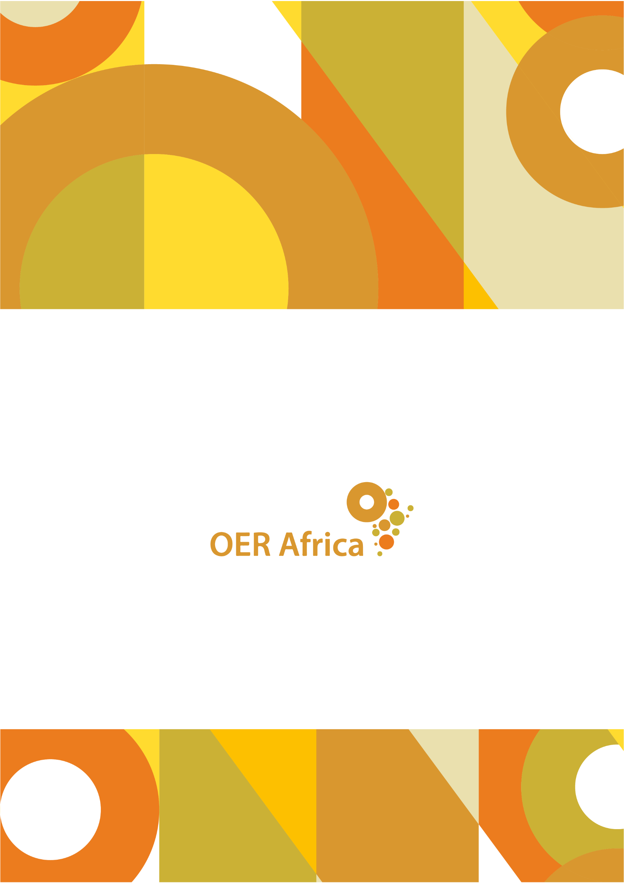
Unless otherwise stated, this work is licensed under a Creative Commons Attribution 4.0 licence

www.oerafrica.org

London School of Hygiene and Tropical Medicine. (2020). Open Education for Eye Health. Retrieved from http://iceh.lshtm.ac.uk/oer
Collaborators represented the following countries: Australia, Botswana, Brazil, Cameroon, Canada, China, Egypt, Ethiopia, Ghana, India, Ireland, Kenya, Malawi, Malaysia, Mexico, Morocco, Mozambique, Nepal, New Zealand, Nigeria, Paraguay, Rwanda, Saudi Arabia, Solomon Islands, South Africa, Switzerland, Tanzania, Uganda, United Kingdom, USA.
London School of Hygiene and Tropical Medicine. (2020). Open Education for Eye Health. Retrieved from http://iceh.lshtm.ac.uk/oer
London School of Hygiene and Tropical Medicine. (2020). Open Education for Eye Health. Retrieved from http://iceh.lshtm.ac.uk/oer
Interview with Sally Parsley (Technical lead) and Daksha Patel (Academic Lead), 9 April 2020.
Interview with Sally Parsley and Daksha Patel (Project Leads), 9 April 2020.
Parsley, S., Patel, D. and Leck, A. (2017). Assessing the impact of the Global Blindness MOOC. Slidedeck provided by Project Leads.
Parsley, S., Patel, D. and Leck, A. (2017). Assessing the impact of the Global Blindness MOOC. Slidedeck provided by Project Leads.
Patel, D., Leck, A., McCormick, I., Kennedy, E., & Parsley, S. (2019). Value creation framework to assess MOOC-based learning. Available at: http://oasis.col.org/bitstream/handle/11599/3259/PCF9_Papers_paper_110.pdf?sequence=1&isAllowed=y
According to the pre-course survey with a ~20% response rate for all enrolments
Survey response from OEEH Project Lead, 11 March 2020; This was collected for most enrolments but the quality of this data is contested, may undercount LMIC enrolments
Commonwealth Eye Health Consortium. (2020). Supporting public health training for eye care across the Commonwealth through Open Education. Retrieved from https://cehc.lshtm.ac.uk/oers/
Interview with Sally Parsley and Daksha Patel (Project Leads), 9 April 2020.
Interview with Sally Parsley (Technical Lead) and Daksha Patel (Academic Lead), 9 April 2020.
London School of Hygiene and Tropical Medicine. (2020). Open Education for Eye Health. Retrieved from http://iceh.lshtm.ac.uk/oer
Interview with Sally Parsley (Technical Lead) and Daksha Patel (Academic Lead), 9 April 2020.

