Kwame Nkrumah University of Science and Technology (KNUST)
Case studies on African OER initiatives in higher education

Introduction
Kwame Nkrumah University of Science and Technology (KNUST) is based in Kumasi, Ghana. It introduced the use of open educational resources (OER) in 2008 through its College of Health Sciences (CHS), when the William and Flora Hewlett Foundation sponsored a project to develop health-related OER. The CHS identified three strategic priorities for health education, which they sought to achieve through the Health OER Initiative:
- develop contextually appropriate teaching resources,
- increase student engagement with the local curriculum, and
- strengthen the core curriculum.

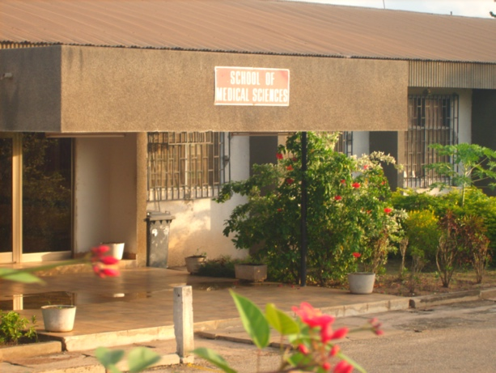
The Health OER Initiative began in November 2008 and was aimed at developing health-related OER through collaboration between African institutions, including OER Africa, the College of Health Sciences at KNUST, the University of Ghana (UG), the University of Cape Town (UCT), the University of the Western Cape, and the University of Michigan (UM). By late 2009, the partner institutions had submitted a successful two-year follow-on grant proposal to the Hewlett Foundation and launched an African Health OER Network, with the aim of developing a continent-wide network to share knowledge, address curriculum gaps, and use OER to advance health education. Although activities began in late 2008, the initiative was officially operational between 2009 and 2013.
Figure 1 KNUST School of Medical Sciences, Regents of the University of Michigan, Flickr (CC BY)

The initiative focused on policy, practice, and research regarding health-related OER. It covered eleven disciplines at both undergraduate and postgraduate levels. The initiative was inspired by the reality that CHS had an increasing number of medical students and therefore an increased demand for practical sessions. However, students were often unable to see what was happening in practical sessions because of their large numbers. As the former head of web application services for the initiative explained:

So to the health sector, it was a way to use OER as a means to disseminate information to the students so they could understand – especially their practical work – better… It was to ensure that students got the best possible education (considering growing numbers of students).

This case study is based on interviews with the former head of web application services for the initiative (based at KNUST), the head of the technical team from OER Africa, and a College of Science librarian at KNUST.

Description of the initiative
In February 2008, the president of UM, Mary Sue Coleman, visited KNUST and met with the then vice chancellor of the institution, Prof. KK Adarkwa, to discuss potential areas of collaboration between KNUST and UM. Between April and September 2008, subsequent meetings were held, and Dr N Cary Engleberg from the UM Medical School visited the KNUST Department of Clinical Microbiology as a visiting professor and to facilitate the OER development process at KNUST and UG.

In January 2009, the Health OER Design Phase commenced. The project team organized sensitization, policy, and production workshops for administrative heads and faculty members. This involved staff from the College of Health Sciences, the KNUST library, the Information and Communications Technology (ICT) Directorate, the Department of Communication Design, and other parts of the university as part of a strategy to ‘build a multidisciplinary team for the development and use of OER at KNUST’.

KNUST OER purchased basic equipment which included video cameras, laptops, microphones, graphic tablets, and software licences. This equipped the team to produce high quality OERs. The CHS and the Department of Communication Design (DeCoDe) explored the idea of having student teams work with faculty to co-develop resources.

The final process involved CHS faculty members creating instructional modules on self-selected topics in their areas of expertise in multiple formats. Content authors received technical support from media specialists and web designers to create appropriate and user-friendly content. An OER media specialist or a team of DeCoDe students assisted in creating images, videos, sound, and packaging for the learning modules. The production process is illustrated below.

Figure 2 KNUST OER production process, KNUST OER website (CC BY)
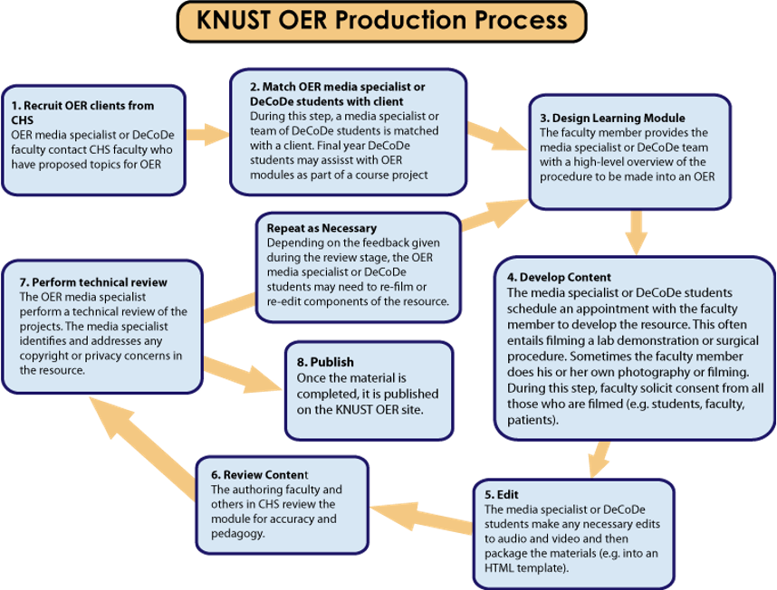

Content reviewers checked all materials for copyright using the dScribe process. Once the materials received clearance, the web administration team published them on KNUST’s dedicated OER website, which serves as a repository for the university’s OER.

The KNUST OER team needed to train staff as comprehensively as possible to allow them to create effective OER. This included Continuing Professional Development (CPD) training in ICT skills, Creative Commons (CC) licensing, instructional design, and communication design. They held face-to-face workshops as part of this training, where staff were taught how to develop materials such as videos and publish them.,

As a result of the initiative and its introduction of OER, KNUST experienced an acceleration in the development of e-learning materials for teaching and learning. Materials that the faculty developed included: medical, psychiatric, and obstetric case studies; clinical demonstrations; surgical and laboratory procedures using various formats such as videos, text and narrations; and drawings, animations, graphs, and other illustrations to enhance the learning experience. In the first six months, KNUST faculty created seven OER from scratch.

Institutional OER policy
One of the OER initiative’s main accomplishments was the development of an OER policy for the institution. The CHS OER team was aware that the reward structure at the university needed to evolve to incentivise faculty to create OER. In early 2009, CHS established an interdisciplinary committee of faculty, other staff, and librarians from across the university to evaluate existing faculty development and intellectual property policies at the institution. KNUST and OER Africa also signed a Memorandum of Understanding for the latter to provide support in reviewing KNUST’s policies to assess the extent to which they facilitated collaboration and alternative, open licences for its educational materials. OER Africa completed a review of the following KNUST policy-related documents which were supplied prior to the workshop:
- KNUST Corporate Strategic Plan 2005 - 2014,
- KNUST Network Operation Centre (NOC),
- List of Provosts and Deans,
- Quality Assurance Presentation (QAPU),
- College of Health Sciences Strategic Plan 2005–2014,
- Diagrams: Topology of wireless network; Fibre-optic backbone; Network operations centre.

A report on harnessing OER within the policy framework of KNUST prepared by OER Africa highlighted three areas for consideration from the review of the KNUST policy environment.

- A policy is clearly required to govern materials development. It will be useful to ensure that it takes account of the above analysis to create a policy environment supportive of collaboration and sharing and to ensure rigour in the management of the university’s intellectual property. Some additional observations are worth noting to feed into development of that policy:
  - The Human Resource Management policy must include references to copyright or intellectual property.
  - Workshop feedback suggests that materials development does not explicitly count when considering job re-categorisation and promotion, performance-based incentives, and letters of recommendation and this may need attention. It would be useful if performance appraisal could include contributions of OER.
  - It is unclear whether or not job descriptions/employment contracts take account of the need to transfer copyright to the institution.
- It will be important to include open licences (such as the Creative Commons framework) when organizing and executing training of staff and course writers on copyright issues and plagiarism. This will serve to deepen knowledge of the options available to manage intellectual property effectively.
- It will be useful for KNUST to begin its commitment to sharing resources with others on a limited basis in order to test the potential and explore the policy implications through action research.

Based on these findings, the interdisciplinary committee drafted a new policy and initiated a process of having three university administration committees review and approve it. OER Africa and UM also provided input on the draft policy, which was eventually approved in August 2010.

The policy for development and use of OER aims to:
- guide the development and review of OER materials prior to sharing them on a worldwide scale,
- clarify publication rights and licensing issues,
- outline policies regarding the use of required infrastructure (information technology, library, etc.) and other support services,
- identify human and other resources to support faculty in developing OER for teaching and learning, and
- define collaborations within and outside of the university and the intent to allow access.

African Health OER Network
In mid-2009, over 40 faculty and staff from eleven health science institutions in Africa met to discuss effective ways of sharing openly licensed health educational materials developed by and targeted toward African institutions. At the meeting, participants developed a Vision for the Health OER Network in Africa, which proposed the development of a network of African institutions. This network would be able to use OER to share knowledge, address curriculum gaps, and build communities of practice around health care education.

OER Africa and the consortium of African health institutions, including KNUST, University of Ghana, University of the Western Cape, University of Cape Town and UM, submitted a successful two-year grant proposal to the Hewlett Foundation in late 2009, which launched the African Health OER Network. Network participants were to provide the following services to one another:
- training and workshops,
- mentoring and consulting,
- providing reference services for finding OER on a given health topic,
- reviewing content for copyright, privacy, and endorsement considerations,
- producing and distributing content, and
- evaluating and assessing content.

OER Africa provided a technical team to assist with creating and managing metadata, developing the repository, and showcasing the project on the OER Africa website. The initiative held annual meetings where institutions would meet to talk about successes and challenges. In addition to the above, there have been other initiatives aimed at showcasing and implementing the use of OER at KNUST (for example, the library trains staff to understand OER). These smaller initiatives, however, are not the focus of this case study.

Strengths and achievements
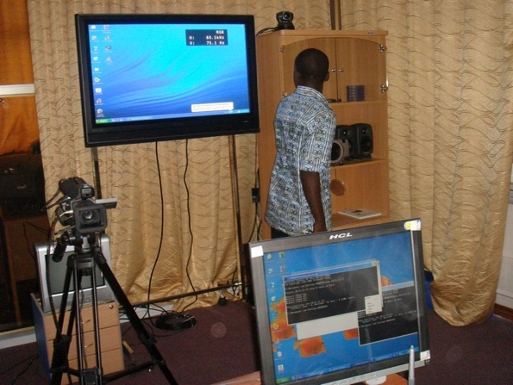
The KNUST Health OER project was instrumental in advancing Health OER at the institution. When the initiative was still active, it cited several achievements in promoting OER and engagement with medical resources. For example, the School of Medical Sciences at KNUST distributed two narrated animations via USB drives and CDs that explain the polymerase chain reaction (PCR) to 150 third-year students enrolled in Clinical Microbiology. The topic was chosen because of student feedback on the complexity of the procedure and difficulty they experienced in understanding it. A survey was administered to assess the student acceptability of the materials. There was a 73% response rate to the survey. On a 0-to-4-point scale used to rate the usefulness of the material (4 = “extremely helpful,” 3 = “helpful”, 2 = “neutral,” 1 = “not helpful,” and 0 = “unnecessary”), the average rating for the PCR animation was 3.5, indicating that students found the material helpful and derived value from it. No student rated the materials as “unnecessary” or “not helpful”. Most students (87%) indicated that the e-learning animations were one of the most important contributors to their understanding of PCR.
Figure 3 Distance Education Lab, Regents of the University of Michigan (CC BY)

These results led the KNUST team to conclude that OER:
- complements the teacher-student interaction instead of replacing it,
- makes the learning of complex scientific processes easier when audio and visual interfaces are used,
- brings the teaching and learning of laboratory-based and clinical demonstrations closer to the students, which does not always happen during the actual instruction due to the large class sizes, and
- facilitates in-class sessions as students are already familiar with the material.

The initiative had an impact on the availability of teaching and learning materials, particularly while it was still active. As Prof. Donkor, the former CHS Provost, noted in an article:

Combining the traditional in-class learning environment with OERs enhanced self-learning and resulted in more quality contact between [students] and faculty as students were already familiar with the material… The use of OERs promoted access on demand by students, better contact with the learning materials, learning at [student’s] own pace and [student-centred] approaches in teaching and learning.

One of the most prominent achievements in improving the availability of such materials was the development of an online repository, KNUST OER, to house all of the materials developed under the initiative, as well as other OER. Usage statistics indicate that between 1 June 2012 and 30 November 2021, the website had received 253,551 page views, with users spending an average of two minutes 30 seconds on the website. The bounce rate was particularly high at 77.2%.

Notably, KNUST’s involvement in OER enhanced the institution’s influence at a national level, with the KNUST institutional repository designated as the national Open Access repository. However, content on the website has not been updated in at least the last five years, so usage of the materials is declining. This was supported by usage statistics which indicated a noticeable decline in activity on the website from 2017.

There is also anecdotal evidence of the direct impact that the initiative had on teaching and learning. For example, a doctor in the United States was unsure how to treat a disease that one of his patients had because he was unable to diagnose it. However, he found the same symptoms in materials on the KNUST OER website, where another doctor spoke about difficulties in diagnosing the disease. This and similar signs that people were deriving value from the materials pushed the institution to want to produce more OER.

Related to this evidence is the fact that the KNUST OER initiative created a series of materials that are accessible to anyone in the world. As one interviewee explained:

Even today when you watch the videos, it gives you clarity. You can see the YouTube videos from students confirming the impact. It was exciting. It was helpful to people.

From the time it was established in October 2011, the KNUST OER YouTube channel had garnered 2,219,314 views as of 19 November 2021. It had nearly 7,000 subscribers and approximately 92 videos on its channel. The most popular video, ‘Benedict’s Test – Qualitative Test in Carbohydrates’, had 378,000 views. Videos have received several positive comments, a sample of which is provided below.

Thanks for this timely information you have posted. this is needed now in online lectures. keep up the good work.

Thank you so much. It’s understandable and helps a lot.

I have an exam on a few of these tests so thank you.

Although several comments on YouTube express how useful the videos are – particularly since the onset of COVID-19, where there have been unprecedented shifts to online learning – the most recent video on the YouTube channel was added on 25 February 2013. This suggests that, after the initiative, KNUST has not been able to sustain materials development through the same platforms that it was using during the Health OER initiative.

The benefits of providing multiple formats for students to learn from also became clear, anecdotally at least. The former head of application services for the KNUST Health OER Initiative explained:

Some students are not academically strong but are very good in practice. When you do this initiative, it becomes clearer to them that they seem not to forget anymore. You can use different approaches to teach students.

Other key achievements are outlined below.
- The institution drew down US$40,000 to enable it to invest further in specific OER activities. This money was used to do the following:
  - develop tools, content framework, and content resulting in a minimum of five pilot draft OER materials by faculty members,
  - approve policies by College Board, Academic Board and Council,
  - audit OER materials,
  - publish OERs,
  - establish metrics for teaching efficiency,
  - document baseline student competencies, and
  - analyse capacity for collaborative engagement.

- Extensive progress was made in producing OER, particularly due to collaborative efforts between the college and Cary Engleberg, a professor from UM who was on sabbatical in Ghana. This included completion of the following projects:
  - Case-based study of erythrocyte profiles and their relationship to pathophysiology. The study includes interactive problems, images, blood smears, explanatory videos, and self-assessment.
  - Interactive cases for background on the indications and complications of the procedures, narrated video of the surgery, and self-assessment.
  - Interactive, case-based programme with images and explanatory videos that interpret international standards of care in the Ghanaian context.
  - Instructional animations that explain the basis of some procedures (PCR, RT-PCR, ELISA, Gram stains) and videos of standard microbiological techniques (Gram, AFB, Giemsa stains, Formol-ether faecal concentration).
  - An exercise in recording the findings of mental state examinations of psychiatric patients.
  - A comprehensive programme of cases, instructional videos, animation, and self-assessment to instruct students and practicing physicians in the management of Buruli ulcer disease.

- Kathleen Ludewig Omollo, an intern from UM visited KNUST to provide support in the dScribe process and other relevant activities. This, together with the two visiting staff from UM, demonstrates how partnerships that upskill staff and share lessons learnt can be a crucial component of creating momentum for OER-related implementation at an institution.

- A librarian at the College of Science at KNUST explained that the initiative helped to promote problem-based learning and assisted lecturers. Instead of having to repeat an operation, creating videos allowed them to do it once and then refer students to the online materials.

As an interviewee noted, one can only see the impact of the initiative when one sees the downloads, the usage and the traffic. He added that the team can easily check from the traffic that people in Ghana are using the resources.

Challenges
Although an institutional OER policy was developed, it is unclear how far the university has progressed in implementing it and whether there have been efforts to measure implementation. This is directly related to the level of institutional buy-in and efforts to ensure that OER initiatives are sustainable in the long-term. As one interviewee noted:

From the way the website is looking, you can see it hasn’t really been implemented… Since the project ended, not much has been put on the platform.

He went on to explain that they did not have champions to move the project further, although there were external partners such as the University of Ghana, whose OER platform KNUST assisted in establishing.

A member of the technical team added that the OER development process often took a long time. This included the processes of having to train people to classify metadata, topics, and taxonomies. There were two groups involved in this – faculty and librarians in one group and technical staff in the other. The OER Africa team held dedicated workshops to train each of these groups at the institutions. However, people were often not available when the technical team wanted to set up sessions, so it took years of working with people to achieve the desired outcome. The same point was made by the former head of application services for the KNUST Health OER Initiative, who explained that advocacy efforts took a long time. In parallel, because the process was often lengthy and people had the advantage of being upskilled, some staff left to pursue career opportunities outside of the university.

It also became clear through the OER production process that faculty had not anticipated the time commitment that it would require:

The initial excitement of faculty to produce materials waned considerably when the reality of the time commitment required dawned on them. During the first production workshop for instance, 12 out of the 16 faculty present proposed to develop fourteen self-selected OER modules. A year later, only three of the original fourteen had completed their materials.

The corresponding decline in the number of faculty members actively producing OER was attributed to several factors, including that: the additional effort was not rewarded; there was a lack of administrative, technical, and infrastructural support for faculty; over-committed faculty were unable to release themselves from regular commitments to make time for OER related activities; and the team experienced funding constraints, which became more apparent as the programme grew. A case study on the initiative, developed in 2011, added that the concept of ‘open’ was also a tough sell to some faculty members, who saw open licences as a threat to their intellectual property and traditional methods of teaching.

Connected to this challenge was the fact that Department of Communication Design students were trained in multimedia design, but not in health sciences or pedagogical principles. Their limited subject knowledge made it difficult for them to understand the surgical and laboratory procedures they were filming. As a result, for example, students did not always focus the camera on what the lecturer wanted to highlight.

Another challenge involved access to devices and data, particularly for students. Although the institutional repository sought to improve access to educational materials by licensing them as OER and mounting them on the institutional repository, students sometimes did not have devices or data to access them. Even networks and internet access within the institution were often limited. However, from 2010 onward, several network infrastructure improvement projects took place. For example, in late 2010 Vodafone installed a 45 Megabit per second network on campus and offered bandwidth at a 50% discounted rate for the next six years.

Ludewig Omollo’s case study on the initiative highlights several ‘next Steps’ to advance the use and creation of OER across the university following the end of the KNUST OER Initiative in 2011. These included:
- adapting OER from elsewhere,
- incorporating OER into classroom teaching,
- continuing to refine the OER production process,
- establishing dedicated studios for OER on campus and at the hospital,
- continuing to recruite OER creators across campus,
- expanding OER into distance learning activities,
- increasing evaluation efforts, and
- offering regional OER consulting services.

One of the participants noted that the focus on OER never moved beyond the Health Sciences faculty at the institution. Moreover, OER was not expanded to distance learning activities and regional OER consulting services were not carried out.

Sustainability of the initiative
The 2010 - 2011 African Health OER Network Phase 2 evaluation noted that OER was ‘sustainable within Health Sciences, and probably the institution.’ However, it added that the main vulnerability was an over-reliance on the provost for implementation. OER Africa was unable to obtain an interview with the former provost, but other interviewees did note a level of inertia in OER-related activities once the initiative ended, which is corroborated by the lack of activity on the KNUST OER website.

Funding was also an issue, particularly regarding the costs of updating software and covering technical and administrative time. As one interviewee noted, sustainability always becomes a challenge when an institution runs out of funding for an initiative:

When it is left with the institution to carry on the mantle, it becomes a challenge. If you don’t have people to continue championing, it is a problem. I would have liked to see the website advance beyond materials from 2013… There was too much faith in the policy to ensure sustainability. But people move the policy.

There is a recurring theme throughout several case studies in this series, that once funding ends, there is not always a sustainability plan, or staff to work on the initiative part-time. This begs the question of how to embed projects within the structure of an institution from the design phase.

The KNUST team also highlighted a lack of awareness about OER as a barrier to institutional buy-in and therefore sustainability of the OER-related activities. Regarding the challenge of ensuring institutional buy-in to promote sustainability, the following was noted:

For a project like that to have good support you need institutional buy-in. Then you create a unit that will champion such a project. You also need to have instructional designers to promote a project like this. Funding is key, but once you have institutional buy-in, you have a unit who can champion this. This was missing at the university and the person who was championing it retired. When he left, the whole thing came to a halt.

In a similar vein, another interviewee noted that, once champions leave, momentum tends to be lost and that, since he had returned to the university after his studies, he had not seen any OER-related activities.

Given the aforementioned factors, it has been difficult to track usage and impact of OER at KNUST. As a librarian for the College of Science at KNUST explained:

We haven’t done much work on citation. The only way we can know the impact is by looking at the visits on the site but we would not be able to tell impact of usage.

This speaks to the challenge of using PDFs instead of links – PDFs make it difficult to track who is using the resource, how often, and the impact of the resource, while using links allows one to track usage more reliably and precisely by being able to see, for example, how frequently a link is clicked on and by users in what locations. The same interviewee indicated that in the backend, they can see downloads and traffic. As usage statistics were not available, it is unclear to what extent resources are being used.

In an article reflecting on how to sustain health OER initiatives at KNUST and UG, the authors used their experience at the two institutions to propose six areas that require institutional focus if OER sustainability is to be achieved. These are:
- using advocacy to drive the institutional adoption of OER in the first few years,
- establishing a structural framework within which OER activities operate,
- linking the tangible benefits of OER initiatives to core institutional priorities thus making a strong case for institutional funding,
- building capacity within the institution for OER production, including training faculty members on material development and pedagogy,
- systematising OER operations to facilitate scalability of material production, and
- developing motivation and reward systems to facilitate the active participation of stakeholders.

It is unclear whether these recommendations were taken forward.

Lessons learnt
The first lesson emerging from the initiative was the role that Communities of Practice could have played for staff who were trained, so that CPD could have continued even after the initiative ended. This includes CPD related to computer literacy, which the technical lead for OER Africa noted is something that is taken for granted. Communities of Practice could have provided an effective way of maintaining accountability for the repository while ensuring that staff could continuously upskill one another.

Interviewees also provided insight into the kinds of knowledge resources and skills development that would have allowed them to implement the project more effectively. This included information technology skills, communication skills, instructional design skills and advocacy.

It is also clear from the above that ongoing CPD is required, particularly because of the changing nature of technology and the fact that some staff leave while new staff come on board. Thus, establishing mechanisms for staff to upskill themselves in areas related to OER is crucial. This may include areas such as instructional design, communication design, understanding open access and OER, Creative Commons licences (benefits, what you can do with them), the open access movement, and open courseware and platforms.

Another lesson was the value of institutionalising the initiative as a means of making it sustainable. The former head of application services explained:

Maybe if we had a number of other colleges (we are six colleges), if it became more embedded in how we were doing things, it may have survived. Funds are important, but more important is integration of it into the university system.

Linked to this is the importance of taking measures to ensure that faculty-specific initiatives are not ‘pigeonholed’, but rather that the planning team takes measures to ensure that these kinds of initiatives can be expanded to other parts of the university where possible. This may require, amongst other measures, holding funding aside for institutional advocacy and sustainability drives.

Figure 4 KNUST OER Website, KNUST (CC BY)
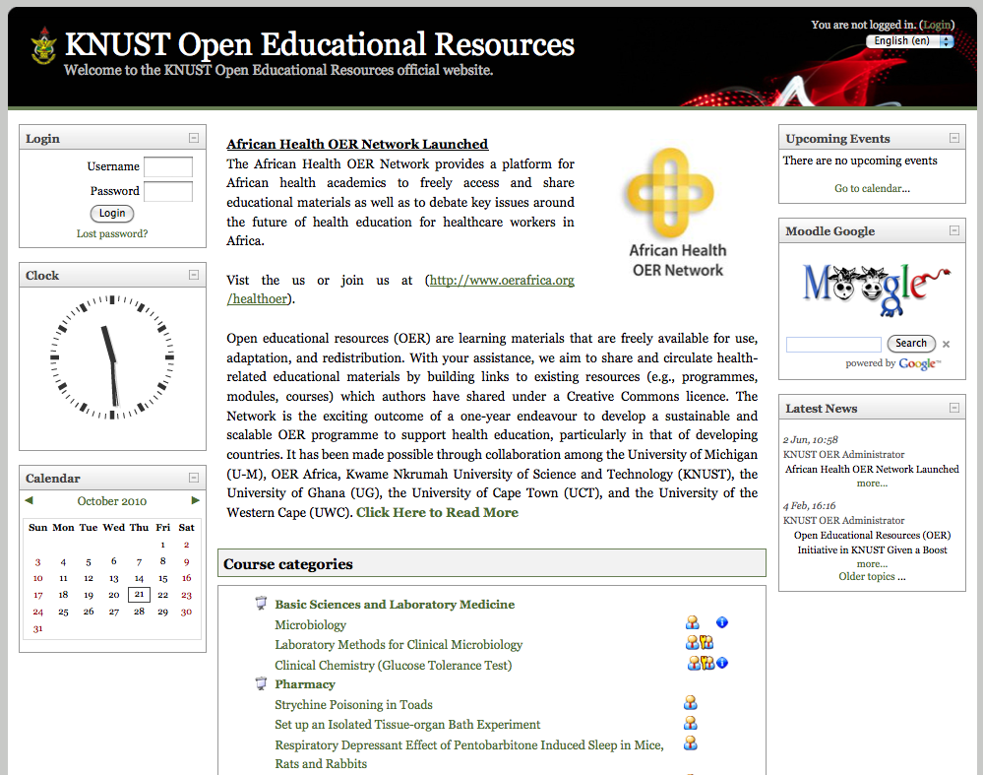

Similarly, the head of the OER Africa technical team noted that the design phase should include costing and should also outline processes that need to change to ensure that, when the initiative’s funding runs out, the initiative’s work can continue and that this becomes part of the institution’s running cost. She added that going in with a detailed project design was beneficial and having partners co-design processes was particularly useful because it allowed all partners to maintain a sense of ownership over the project and, in so doing, made the advocacy element easier.

Another lesson learnt in optimising implementation, provided by the head of OER Africa’s technical team, was the value in starting small so that the project team could develop a sense of available capacity and processes and then set realistic, achievable targets. In this, the country context, available technology, and institutional context is important to consider.

Conclusion
KNUST made significant progress in promoting the use of OER through its institutional repository, policy, and CHS’s lead role in the African Health OER Network. KNUST has also demonstrated the effectiveness of partnerships with other universities and organizations like OER Africa. These partnerships were instrumental in advocacy efforts and in upskilling staff at KNUST with the requisite skills to create and adapt OER. However, despite the progress that it made with regard to OER, the activities were not sustained, as evidenced by the lack of new content on the KNUST OER website and YouTube channel in particular, together with information from interviewees. This speaks to the importance of prioritising sustainability from the design phase of the project, to ensure that it is considered upfront and that it gives the initiative the best chance of long-term impact.

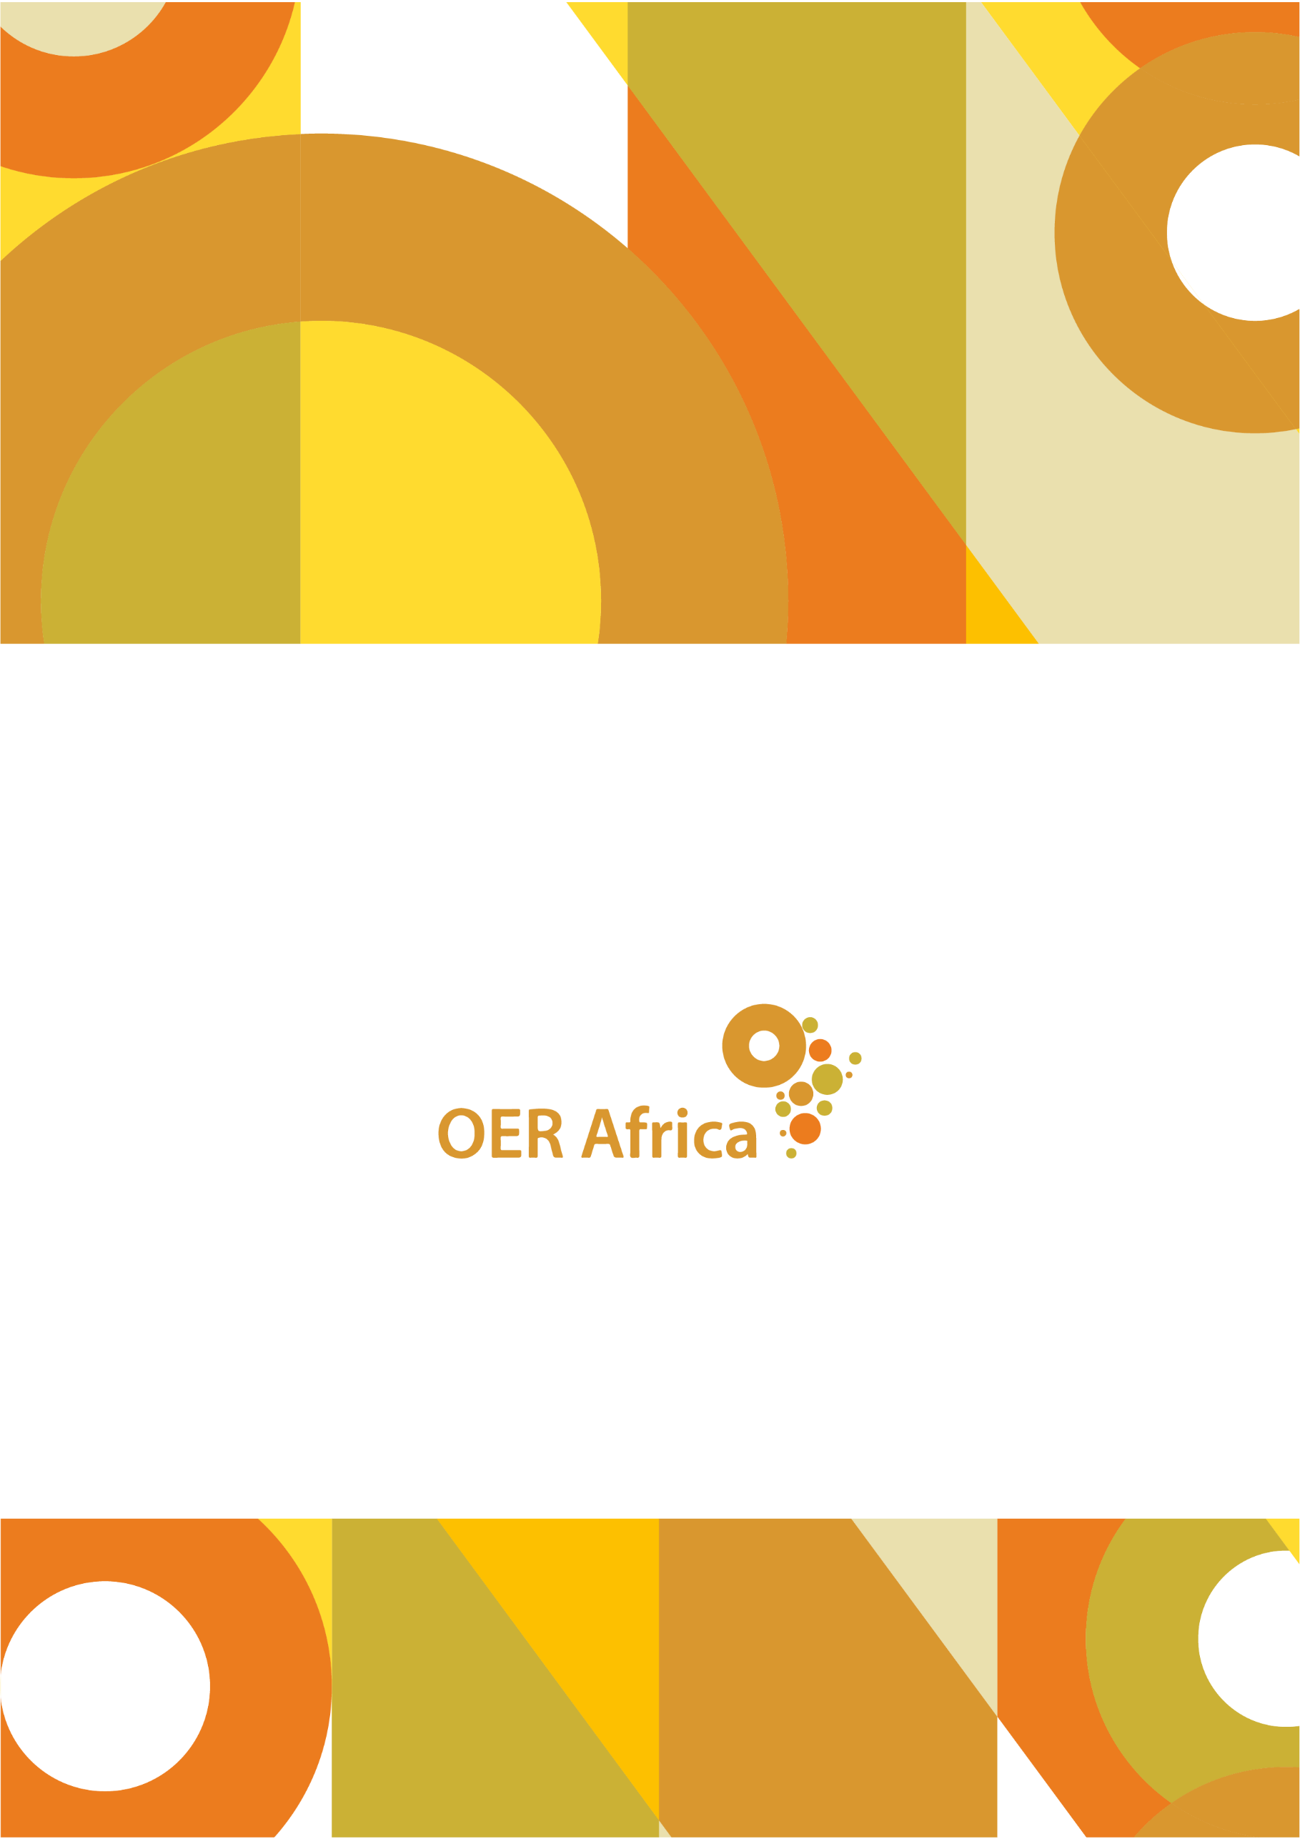
Unless otherwise stated, this work is licensed under a Creative Commons Attribution 4.0 licence

www.oerafrica.org

KNUST OER. (nd). History. Retrieved from https://websys.knust.edu.gh/oer/pages/sections.php?siteid=knustoer&mid=23&sid=123
KNUST OER. (nd). History. Retrieved from https://websys.knust.edu.gh/oer/pages/sections.php?siteid=knustoer&mid=23&sid=123
Interview with former head of application services for the KNUST Health OER Initiative, Dr John Serbe Marfo, 2 June 2021
Donkor, P. (2011). Developing and using Open Educational Resources at KNUST. Digital Learning Resources. Retrieved from https://www.oerafrica.org/system/files/9305/201105digitallearningresources-developingandusingoeratknust_0.pdf?file=1&type=node&id=9305
Open.Michigan, based at UM, developed and continues to refine a distributed OER production process called dScribe, which relies on student volunteers in UM courses to collect, format, and publish learning materials as OER.
Interview with former head of application services for the KNUST Health OER Initiative, Dr John Serbe Marfo, 2 June 2021
Interview with College of Science Librarian, Richard Bruce Lamptey, 13 April 2021
OER Africa. (2009). Supporting Collaboration and Harnessing of OER Within the Policy Framework of KNUST.
OER Africa. (2009). Supporting Collaboration and Harnessing of OER Within the Policy Framework of KNUST.
KNUST. (2010). Policy for Development and Use of OER.
Hoosen, S. and Ludewig Omollo, K. (2010). The African Health OER Network: Advancing health education in Africa through open educational resources. Retrieved from http://www.ajhpe.org.za/index.php/ajhpe/article/view/76/31
Donkor, P. and Tagoe, N. (2010). Health Open Educational Resources: Lessons from Kwame Nkrumah University of Science and Technology. Retrieved from http://oerworkshop.weebly.com/uploads/4/1/3/4/4134458/09_health_oer.pdf
Donkor, P. (2011). Experience with the Open Educational resources (OER) at Kwame Nkrumah University. eTransform Africa.
The percentage of single-page sessions in which there was no interaction with the page. A bounced session has a duration of zero seconds. Bounce rate also includes sessions that trigger only a single request to the analytics server, such as when a user opens a single page on your site and then exits without triggering any other requests to the analytics server during that session.
Google Analytics usage statistics, provided by Dr John Serbe Marfo, 1 December 2021
Hoosen, S., Butcher, N., Hornsby, D. and Ngugi, C. (2012). Strengthening and Sustaining the African Higher Education and Research Space (AHERS) through Information and Communications Technology, Open and Distance Learning, and Open Educational Resources. African Development Bank. Retrieved from https://www.techylib.com/en/view/hushedsnail/strengthening_and_sustaining_the_african_higher_education_and_res
Google Analytics usage statistics, provided by Dr John Serbe Marfo, 1 December 2021
Interview with OER Africa technical team lead, Monge Tlaka, 15 September 2021
Interview with former head of application services for the KNUST Health OER Initiative, Dr John Serbe Marfo, 2 June 2021
Interview with former head of application services for the KNUST Health OER Initiative, Dr John Serbe Marfo, 2 June 2021
OER Africa. (2009). Health OER Briefing Document. Retrieved from https://www.oerafrica.org/resource/health-oer-overview
Interview with an anonymous representative
Interview with an anonymous representative
Donkor, P. and Tagoe, N. (2010). Health Open Educational Resources: Lessons from Kwame Nkrumah University of Science and Technology. Retrieved from http://oerworkshop.weebly.com/uploads/4/1/3/4/4134458/09_health_oer.pdf
Donkor, P. (2011). Experience with the Open Educational resources (OER) at Kwame Nkrumah University. eTransform Africa.
Ludewig Omollo, K. (2011). Growing an Institutional Health OER Initiative: A Case Study of the Kwame Nkrumah University of Science and Technology.Retrieved from https://www.oerafrica.org/FTPFolder/Website%20Materials/Health/case_studies/2011.05%20Knust_Low_Res.pdf
Ludewig Omollo, K. (2011). Growing an Institutional Health OER Initiative: A Case Study of the Kwame Nkrumah University of Science and Technology.Retrieved from https://www.oerafrica.org/FTPFolder/Website%20Materials/Health/case_studies/2011.05%20Knust_Low_Res.pdf
Interview with OER Africa technical team lead, Monge Tlaka, 15 September 2021
Ludewig Omollo, K. (2011). Growing an Institutional Health OER Initiative: A Case Study of the Kwame Nkrumah University of Science and Technology.Retrieved from https://www.oerafrica.org/FTPFolder/Website%20Materials/Health/case_studies/2011.05%20Knust_Low_Res.pdf
Ludewig Omollo, K. (2011). Growing an Institutional Health OER Initiative: A Case Study of the Kwame Nkrumah University of Science and Technology.Retrieved from https://www.oerafrica.org/FTPFolder/Website%20Materials/Health/case_studies/2011.05%20Knust_Low_Res.pdf
Harley, K. (2011). 2010̶2011 African Health OER Network Phase 2 Evaluation: Consolidation and Sustainability. Retrieved from https://www.oerafrica.org/resource/2010-2011-african-health-oer-network-phase-2-evaluation-consolidation-and-sustainability
Interview with former head of application services for the KNUST Health OER Initiative, Dr John Serbe Marfo, 2 June 2021
Interview with OER Africa technical team lead, Monge Tlaka, 15 September 2021
Tagoe, N., Donkor, P., Adanu, R., Opare-Sem, O., Engleberg, N.C., Lawson, A. (2010). Beyond the first steps: Sustaining Health OER Initiatives in Ghana in Open Ed 2010 Proceedings. Retrieved from http://openaccess.uoc.edu/webapps/o2/handle/10609/4849
Interview with College of Science Librarian, Richard Bruce Lamptey, 13 April 2021
Interview with former head of application services for the KNUST Health OER Initiative, Dr John Serbe Marfo, 2 June 2021
Interview with College of Science librarian, Richard Bruce Lamptey, 13 April 2021
Tagoe, N., Donkor, P., Adanu, R., Opare-Sem, O., Engleberg, N.C., Lawson, A. (2010). Beyond the first steps: Sustaining Health OER Initiatives in Ghana in Open Ed 2010 Proceedings. Retrieved from http://openaccess.uoc.edu/webapps/o2/handle/10609/4849
Interview with former head of application services for the KNUST Health OER Initiative, Dr John Serbe Marfo, 2 June 2021

