**Advanced Diploma**

**Technical and Vocational Teaching**

**The political, economic and social context of TVET**

Department of Higher Education and Training

 

**Department of Higher Education and Training**

Advanced Diploma: Technical and Vocational Teaching

Module: *The political, economic and social context of TVET*

Author: Dr Andre Kraak

© Department of Higher Education and Training 2023

Department of Higher Education and Training

123 Francis Baard Street

Pretoria

0001

Website: [www.dhet.gov.za](http://www.dhet.gov.za)

This Module of the Advanced Diploma: Technical and Vocational Teaching (Adv. Dip TVT) was produced with the financial support of the European Union. Its contents are the sole responsibility of the Department of Higher Education and Training, and do not necessarily reflect the views of the European Union.



Creative Commons LicenseThis work is licensed under a Creative Commons Attribution 4.0 International License.

# Contents

Contents iii

Programme introduction ix

Module overview – A political economy framework 1

Module purpose 4

Module outcomes 4

Module structure 4

Module credits 4

Module time (notional hours) 4

Unit 1: A typology of capitalisms and their education and training requirements 5

Introduction 5

Unit 1 outcomes 5

The rise of neoliberalism 5

Neoliberalism and new public management 8

Shifting from a demand-led to a supply-side system 10

The road to a supply-side system 11

Understanding demand-led provision 12

Promoting value-adding 13

The changing nature of work 13

Computer numerical control 15

Additive manufacturing (AM) 16

Robotics 17

Where does South Africa stand in terms of these new technologies? 18

The changing nature of workplace learning 19

Expansive and restrictive learning in the workplace 20

Why do the continental European countries train more? 20

Managerial control 22

Four models of capitalist development 23

Conclusion of Unit 1: Implications for your role as college lecturer 28

Unit 2: The evolution of the apartheid economy and its decline 33

Introduction 33

Unit 2 outcomes 33

Some indicators of apartheid social inequality 33

The building blocks of apartheid 38

A developmental state for whites 38

The rise of a natural resource extraction economy 39

A capable civil service 41

Separate development 42

Key economic concepts required to understand apartheid’s political economy 43

Import-substitution economic policies 43

Export-oriented economic policies 44

Neoliberalism and global free trade 44

The decline of the apartheid economy 45

The rise and fall of the South African manufacturing sector 46

The collapse of apprenticeship training 47

Urbanisation and skills shortages 49

The slow de-racialisation of the labour market in the 1970s and 1980s 51

The skill shortages debate in the 1960s–1980s 51

The economic reforms of late apartheid – the triumph of market ideology 53

Vocational training reforms 54

A lack of cooperation between the state, business and labour 55

The end of apartheid 57

What comes next? 58

Unit 3: The core building blocks of post-apartheid economy and society 59

Introduction 59

Unit 3 outcomes 60

ANC and Cosatu policy proposals prior to the elections of 1994 60

The ANC’s growth through redistribution 61

Cosatu’s contribution to ANC economic policy 61

The Reconstruction Accord (1993) 63

The ANC’s Reconstruction and Development Programme (1994) 64

The successes of the RDP 65

Problems emerge with the RDP ministry 65

Phases in the post-apartheid journey 66

A phase of trade liberalisation and stabilisation 67

Mbeki’s achievements after GEAR 69

A more expansive set of economic programmes 69

The launch of AsgiSA , 2005 70

The limits of the Mbeki era 72

Mbeki’s removal as President in 2008 73

The rise of Zuma, crony capitalism and the illusion of a developmental state 73

Encouraging signs, 2009–2011 74

Planning 74

The National Development Plan 75

Taking industrial policy seriously 76

The complementarity of industrial and skills development policies 79

Corruption and state capture: ZUMA’s later years (2011–2017) 81

Another typology of capitalism – crony capitalism 81

Radical economic transformation 82

Impact of the Zuma era on South Africa’s economic performance 84

The Ramaphosa era (2018–2024) 86

Economic policy in the time of Ramaphosa 87

South Africa’s Economic Reconstruction and Recovery Plan 88

The political economy of post-apartheid society – what kind of capitalism? 90

What have you learned? 93

Summative assessment 93

Assessment Rubric 100

References 101

Acknowledgements

The Open Learning Directorate of the Department of Higher Education and Training (DHET) would like to acknowledge:

The European Union for funding the Capacity Building for TVET College Lecturers through Open Learning Programme (Sub-Programme 2 of the Teaching and Learning Development Sector Support Programme). The production of open learning courses for the Advanced Diploma in Technical and Vocational Teaching (Adv. Dip TVT) is a project of that programme.

The following universities, for making lecturing staff available to contribute to the project as subject matter experts, writers or critical reviewers:

* Cape Peninsula University of Technology
* Central University of Technology
* Durban University of Technology
* Nelson Mandela University
* Tshwane University of Technology
* University of Fort Hare
* University of the Free State
* University of Johannesburg
* University of Nottingham (UK)
* University of Pretoria
* University of KwaZulu Natal
* Vaal University of Technology
* University of the Witwatersrand

The Technical and Vocational Education and Training (TVET) Branch of the Department of Higher Education and Training for providing information whenever it was requested.

The following TVET Colleges for making lecturing staff available to contribute to the project as subject matter experts, writers or critical reviewers:

* False Bay TVET College
* Majuba TVET College
* South-West Gauteng TVET College
* West Coast TVET College, and
* Motheo TVET College for developmental testing of materials.

The University of the Free State for overall project management, and the Centre for Teaching and Learning for producing multi-media materials, resources and the e-learning (SCORM) versions of the courses, as well as uploading the materials on the National Open Learning System (NOLS).

*Saide,* (South African Institute for Distance Education) for their expertise in leading and co-ordinating the development and production of the course modules; quality assuring the learning design; and ensuring that the developed material is made available for use as Open Education Resources (OER), thereby contributing to the implementation of open learning in post-school education and training (PSET)

Acronyms and abbreviations

ADTVT Advanced Diploma in Technical and Vocational Teaching

AI artificial intelligence

AM additive manufacturing

ANC African National Congress

AsgiSA Accelerated and Shared Growth Initiative for South Africa

BEE black economic empowerment

CAD computer-aided design

CAM computer-aided manufacturing

CBD central business district

CNC computer numerical control

Cosatu Congress of South African Trade Unions

COVID-19 coronavirus disease of 2019

CSIR Council for Scientific and Industrial Research

DHET Department of Higher Education and Training

DNA deoxyribonucleic acid, a molecule containing the biological instructions for each species

DST Department of Science and Technology

DTI Department of Trade and Industry (1994–2019)

DTIC Department of Trade, Industry and Competition (established 2019)

Eskom Electricity Supply Commission

EU European Union

FET Further Education and Training

GDP gross domestic product

GEAR Growth, Employment and Redistribution Programme

GTR Growth Through Redistribution

HSRC Human Sciences Resources Council

ICT / IT information and communication technologies

IDC Industrial Development Corporation

IMF International Monetary Fund

IPAP Industrial Policy Action Plan

LME liberal market economy

NDP National Development Plan

NEDLAC National Economic Development and Labour Council

NGO non-governmental organisation

NIPF National Industrial Policy Framework

NPC National Planning Commission

NPM new public management

NQF National Qualifications Framework

NSA National Skills Authority

NTB National Training Board

Numsa National Union of Metalworkers of South Africa

NVQs national vocational qualifications

R&D research and development

RDP Reconstruction and Development Programme

SACP South African Communist Party

SADC South African Development Community

SETA Sector Education and Training Authority

TVET Technical and Vocational Education and Training

UK United Kingdom

USA United States of America

WIL work integrated learning

WTO World Trade Organization

# Programme introduction

The Advanced Diploma in Technical and Vocational Teaching (Adv. Dip TVT) programme seeks to provide a structured professional learning pathway for current and aspirant technical and vocational lecturers/teachers. The Diploma will equip them with the knowledge and competences to implement and manage teaching and learning in their TVET colleges effectively and in alignment with national goals.

This module is one of a set of modules that contribute to the Advanced Diploma programme. The overall purpose of the Advanced Diploma is to engage lecturers working in the TVET sector in conversations about what it means to be a quality teacher in a TVET college. Each Module in the programme explores this from a different angle, but for every module the foundational concept is about the type of teacher you want to be. We all know that the relationship between teaching and learning is interrelated, so in order to understand the type of teacher you want to be you will need to engage with what learning means in a TVET context.

We often think about vocational and technical or craft knowledge as different from theoretical knowledge. However, there is increasing recognition of the power of vocational and theoretical knowledge coming together to develop the skilled craftsperson whether it is in plumbing, baking, even mathematics and physics. This integration of theory and vocational knowledge is equally important in teaching as well. Teachers are constantly needing to make informed decisions and judgements as they select what to teach and how best to teach the specific content, concept or skill.

This leads to a question about how different forms of knowledge and skill are brought together and balanced in the curriculum and in teaching and learning.

## Approach to learning

To answer the question above in this diploma programme, a framework has been developed which is referred to as *know how*, *know it* and *know that*, or the HIT framework. This framework is introduced, referred to and deepened in different ways all the way through the programme.

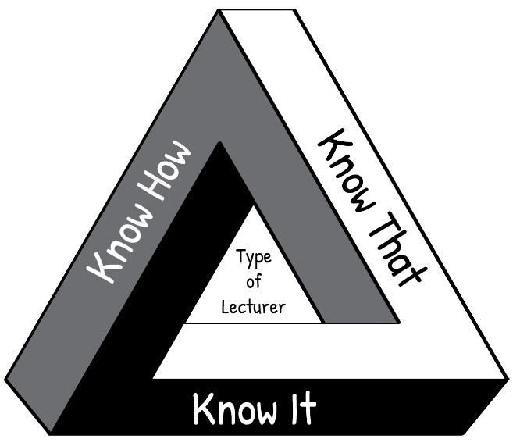

**“Know How”** is *procedural knowledge*, “in our bodies” or *embodied knowledge*.

For example, following a bread recipe.

“**Know It**” is *recognition*, the knowledge of what counts as good; wisdom; technical and theoretical judgments.

For example, is this sourdough good quality bread?

**“Know That”** is *propositional knowledge* or

*theoretical knowledge*, the knowledge of how and why, *cognitive knowledge*.

For example, the science of bread baking.

**Figure i: The HIT framework**

Think about your own craft of teaching. The kind of teacher you want to be, is one who knows **how** (the techniques of teaching), knows **that** (the science and theory behind teaching AND learning) and knows *it* (knowing and reflecting on what makes a quality teacher). Such a teacher enables students to actively engage with their learning and to develop their full potential.

If you are interested, click on the link provided to watch a short [video](https://youtu.be/JssDzbjlYik) in which Wayne Hugo discusses the “HIT model” of TVET knowledge and learning.

## Relating theory to practice

In this module new concepts are often introduced by developing them from a practical situation with which you are probably familiar. This process, which moves from your experience towards a more abstract level of theory is known as inductive learning. It makes learning easier and is very different from deductive learning, which starts by presenting abstract theories and principles, then requires you to “deduce” practical conclusions and concrete examples. You are encouraged to relate the ideas you learn from the Adv Dip programme to your own context and to try to think theoretically about your practice. In other words, to think about the rationale for your practice.

## Reflective practice and the use of a learning journal

One of the Adv. Dip TVT modules is called Reflective Practice, if you are interested, you can access it [here](https://oerafrica.org/system/files/13691/assets/13702/advdiptvtmodulereflective-practice.docx?file=1&type=node&id=13702&force=0). It covers the concept of reflection in the life of a TVET lecturer. Of particular importance is unit 2, which describes various models which facilitate reflection. The simplest reflective model that is discussed in this unit, is that of Terry Borton (1970). It consists of three steps as follows:

**Figure ii: Reflective model (after Borton, 1970)**

The three questions to prompt reflection leading to action:

1. What?

**What** happened? In this step you remember or describe the situation or event you have experienced.

1. So what?

**So,** if that happened**, what** does this show you or teach me?In this step you explore what new insights or knowledge the situation gives you.

1. Now what?

**Now** that I have learnt something new by reflecting on the situation, **what** should I do about it? In this step you think about what to do with the new awareness you have gained – i.e. how to make use of it to act more effectively in future situations.

Throughout the Adv. Dip TVT programme, you are encouraged to reflect on your practices at work in the college so that you can improve how teaching and learning takes place. We have embedded reflective practice throughout the programme, and at the end of most units in the modules you will find a reflective activity to complete. The reflective activity will enable you to make the most of what you have learnt throughout the unit, as well as assisting you to apply your learning in your workplace.

## Use a learning journal

Throughout the Adv. Dip TVT modules, we encourage you to use a *learning journal*. You can download the digital template to use for your learning journal [here](https://oerafrica.org/system/files/13691/assets/13702/advdiptvtmodulereflective-practice.docx?file=1&type=node&id=13702&force=0) or you can use the learning journal template in Appendix One. Save it where you can easily find it again. You can also use another template, or use a paper-based learning journal. You will use your learning journal to write notes and reflections and complete activities. Start your learning journal at the beginning of the programme, and keep it regularly updated throughout.

## Active learning

Most learning theorists tell us that new understandings and learning depend on, and arise out of, *action*. All the modules in the Adv. Dip TVT programme include activities. Your learning will be more fruitful if you engage systematically with the activities. If you do not do the activities, you will miss out on the most important part of the programme learning pathway.

Thinking activities

At various points in the module you are asked to *stop and think* and to take some time to reflect on a particular issue. These *thought pauses* are designed to help you consolidate your understanding of a specific point *before* tackling the next section of the module. One of the habits many of us develop through a rote kind of learning is to rush through things. Work though each module slowly and thoughtfully. Read and think. This is how we develop a depth of understanding and become able to use the ideas we learn. Try to link the issues raised in each thought pause with what you have read, with what you have already learnt about learning, with your own previous experience, and so on. Think about the questions or problems raised in the module. Jot down your ideas in your learning journal so that you can be reminded of them at a later stage.

## Linkages across modules

As you work through this and other modules, you will notice that topics or issues raised in one module may cross refer to the same issue or topic in another module, possibly in more detail. So for example, while there is an entire module dedicated to the investigation of *curriculum,* key issues related to curriculum will also be highlighted and discussed in a number of other modules including, modules dealing with pedagogy, psychology in TVET as well as in the method of teaching engineering and related design and electrical engineering modules.

## Access to readings

There are links to readings throughout the activities. We have tried as far as possible to provide links to Open Educational Resources (OER). In cases where this was not possible you will be directed in the activity to access these through your university library. The website link is shown in the reference list.

## Assessment

The activities contained in this module and the Adv. Dip TVT programme as a whole, promote a continuous and formative assessment process. This approach is intended to support your ability to relate ideas to practice and to contribute to your development as you work through the various modules of the programme.

You will also notice that each module includes a summative assessment task with the assessment criteria set out in an accompanying rubric. This summative assessment task is a model only, intended to illustrate the kind of assessment tasks that may be set by the university providing this programme.

## Module overview – A political economy framework

This module examines the relationship between the Technical and Vocational Education and Training (TVET) college sector and the South African economy, through both the apartheid and post-apartheid eras. As such, it is a study of the changing nature of the capitalist economy as it has evolved in South Africa – from its racial past under apartheid, to its de-racialised form in the current period.

The module is framed by a political economy approach. Political economy is an interdisciplinary branch of the social sciences, incorporating the disciplines of politics, economics, sociology, and development studies as well as the new field of innovation studies. Political economists study how economic systems such as capitalism work in the real world, including public policy implemented to advance the growth of national economies. Political economists study both the underlying roots of these policies and their effects or outcomes.

Political economy also has a strong international dimension. This is because, as the economies of more countries become interconnected through globalisation and international trade, the politics of one country can have a strong impact on the economy of another. Political economy is also a way of describing the social impact of economic policies, and more specifically, the way money and power are unequally distributed between different groups or classes, leading to inequalities in society.

#### The benefits of university study

Why have you registered for this qualification? Perhaps you want to improve your set of skills with a stronger academic foundation. Also, an additional qualification can assist in career promotion. These are good reasons for further study.

However, we can add to this list of benefits. University study assists us in shifting from lower-order to higher-order thinking. Higher-order thinking is critical if you want to be promoted in your career, especially to leadership and management roles. Such thinking allows you to see the bigger picture, and not just the discipline you teach in or the college you work in.

Conceptual understanding is about higher-order thinking, which is not focused narrowly on a single aspect or fact of everyday working life. This is lower-order, or micro-level thinking, which we all do most of the time to make sense of our immediate environment. However, we also need to think more broadly, to see the links between our immediate reality and environment (such as your college or your students’ workplaces) and the much wider context in which your college or workplace is situated. This requires stepping back and thinking abstractly, to be able to understand how the wider spectrum of systemic factors shapes our immediate reality. Figure 1 illustrates this distinction between abstract theoretical thinking and micro-level descriptive thinking.

Figure 1: Two levels of thinking about colleges descriptive and theoretical

(Source: Kraak, 2023)

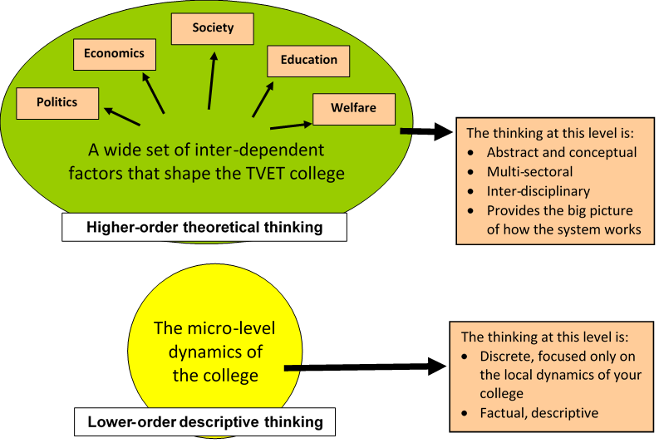

The employment prospects of your students are a good example of an immediate and pressing challenge facing you, as you lecture your students. If you were to focus only on the individual student, the good marks they achieve, and the conscientiousness and discipline they display in their work, you might think they are destined for great things regarding employment. But this lower-order thinking may not be correct. Your student might not acquire employment easily because of several contextual (higher-order) factors – for example, your college may be in a small mining town where the mines have closed and young people in the community are struggling to get jobs.

When you study at higher levels (the Advanced Diploma) you can use your new way of thinking to gain insights into the wider societal forces that shape future pathways for you, your students and your college. Most importantly, we get this higher-order knowledge through theoretical frameworks (for example, the political economy framework), which help explain all the inter-dependent factors that shape a particular phenomenon like college learning. After your studies, you will enter the community of college thinkers who apply the theoretical, political economy framework to everyday problems and issues – a framework we will develop together in this course.

#### Advice on study methods

This is a self-study curriculum, which requires that you take the initiative in determining your own learning progress. This is a big responsibility. But we can assist you with some useful study tips.

Our first tip would be for you to not only read this curriculum, but to also make detailed notes in your learning journal – ideally a hard cover A4 notebook that you can use for the entire module. Write down: (1) the key concepts and (2) the key lines of argument being developed in the text. Also write down your own opinion of the arguments made in the curriculum. Do you agree or disagree? Developing your own voice or opinion on the key debates in your profession is a key part of your learning in higher education.

The second study tip relates to the activities you need to do. Please talk to wise and experienced colleagues about the questions asked of you in the curriculum activities. If any of these colleagues are also studying for higher education courses, this is an advantage. You could create a formal or informal study group to go through your work together. Interviewing or talking to colleagues gives you different points of view on the topic under discussion. This does not mean their arguments are the correct ones. Rather, a colleague’s view is one of several that exist out there, including your own. Your learning task here is to synthesise all the opinions and evidence you collect on any issue, and to determine your own final line of argument on that issue.

The third piece of study advice is to learn how to improve your own writing and oral argument. These two skills are ultimately the main benefits of a university education. This is why we have set you several written assignments. A central tool in writing is to develop a line of argument on any issue, which normally has:

1. *An introduction*, where you set up what you intend arguing, for example, that you believe that neoliberalism or free market economics is a good thing (stated here purely for illustration purposes – you might want to argue the opposite).
2. *Evidence arranged sequentially*: To succeed in making this argument, you must rally your evidence (your main points) in a sequential order (you need to decide what piece of evidence should come first, then what logically follows from that in a coherent ordering, and so on).
3. *Analysis and critique*: the sequential line of evidence developed above empowers you to make some analytical comments, which might require critique – for example, that the evidence across the globe is that market economies work best, and therefore, the state should be kept small so as not to interfere too much with market forces. This argument is just an example and not necessarily one you support – but you might want to make it with the right evidence and analysis structure as outlined here.
4. *A conclusion*: this is the finale of your written work – it requires a final statement or summary of the logic you are making.

When you have mastered this type of writing, you’re on your way to successful lifelong learning. This structure is helpful to think about whether you’re writing a short response of one or two pages, or a longer one. You can use this structure, or an adapted version you make yourself, in all your writing in your learning journal.

#### The content of this module

There are three units to this module:

* *Unit 1:* *A typology of capitalisms and their education and training requirements*. As indicated earlier, there are many different types of capitalism globally, and we will present a typology that captures the most important features.
* *Unit 2: The evolution of the apartheid economy and its decline.* This economic history is important for you to be able to understand the background to the evolution of your own college. This historical inheritance will shape the way the college works and impacts on its students. It shapes your role as a lecturer as well.
* *Unit 3: The core building blocks of post-apartheid economy and society*. This unit focuses on the past three decades of South African economic history. It aims to show how the new post-apartheid economic policies have changed the economy for the good (such as significant de-racialisation), but also how old problems have continued into the current period, with no easy solutions in sight.

Unit 3 concludes with a focus on how this wider political economic context impacts on your role as a TVET lecturer, providing you with opportunities for innovative teaching. The theoretical lens of political economy will also expose the limits of your actions as a lecturer – for example, being able to ensure the employment of your students after graduating – because of the developmental route South Africa has travelled over the past six decades. This contextual background, highlighting both opportunities and limits, enables lecturers to develop strategies to capture the opportunities as well as to seek solutions to the problems facing colleges, such as limited employment opportunities.

## Module purpose

The purpose of this module is to enable TVET lecturers to debate and critically reflect on the relationship between the TVET college sector and the South African economy, through both the apartheid and post-apartheid eras, and to identify the socio-economic problems currently affecting this relationship.

## Module outcomes

By the end of this module, you will be able to:

1. Demonstrate an understanding of the history of the South African economy and society from the crises of the 1970s to the current period, and how TVET colleges have supported the economy and society during its differing historical phases.
2. Demonstrate an understanding of the economic policy context underpinning the South African economy and society, both during the apartheid and post-apartheid eras.
3. Demonstrate an understanding of the diverse challenges faced by TVET colleges in supporting the South African economy.

## Module structure

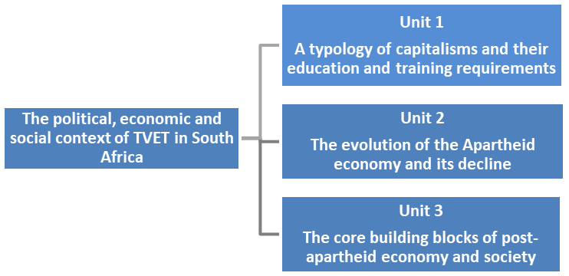

Figure 2: Module structure

## Module credits

This module carries 3 credits.

## Module time (notional hours)

The Module time is equivalent to 30 notional learning hours. It is anticipated that you will take approximately 30 hours to complete the module successfully. The 30 hours will include contact time with your Higher Education Institution (HEI), reading time, research time and time required to write assignments. It is also expected that some of your time will be spent talking to college colleagues about the various activities in this course. Each activity in this module indicates the suggested time for completion. It may take you less time, or more. Pace yourself in a realistic way, so you stay motivated.

# Unit 1: A typology of capitalisms and their education and training requirements

## Introduction

Unit 1 aims to give you a set of concepts and learning resources that will empower you to better understand the emergence of differing types of capitalist systems that have evolved over the past six decades. This will help you to better understand the important shifts that have taken place in the post-apartheid era. The aim was to replace the old racial economy with one that is more inclusive, that promotes the competitiveness of our products on world markets, and that ensures a decent livelihood for all citizens. This remains the central political and economic challenge facing South Africa today. Unit 1 is structured in the following way:

1. The rise of neoliberalism
2. The rise of supply-side systems of TVET provision
3. Dramatic changes in the world of work
4. Changes in the nature and importance of workplace learning
5. Identifying four different systems of capitalism globally

## Unit 1 outcomes

By the end of this unit, you should be able to:

1. Show an understanding of the causal factors underpinning the changes to global capitalism over the past six decades (1970s–2020s);
2. Identify the major changes in the nature of work and learning under the new capitalism;
3. Identify different systems of capitalism globally;
4. Show an understanding of how these contextual factors (the political and economic systems of the past six decades) have shaped the role of TVET colleges; and
5. Understand the limitations imposed on our TVET college system by a supply-side system of provision.

## The rise of neoliberalism

This first section of Unit 1 focuses on the most important triggers for change in the global economic system, which began occurring in the mid-1970s and early 1980s. The most important of these has been two industrial revolutions and the rise of a new political ideology that now rules the world – an ideology known as neoliberalism. The discussion also focuses on how neoliberalism has changed the TVET college system globally, through new practices introduced in the state civil services that govern these colleges.

The story begins in the mid-1970s. Depending on your age, you might remember the rise of two international politicians who played a very prominent role in shifts in the global economic landscape in the 1980s. They were the President of the United States of America (USA), Ronald Reagan, and the Prime Minister of the United Kingdom (UK), Margaret Thatcher. These two politicians represented a new form of right-wing politics that was very opposed to big government with its high taxes, and strong protection for trade unions and workers’ rights. In contrast, Reagan and Thatcher were supportive of free market capitalism. These views were also supported by many other governments across the globe, as well as influential international bodies, such as the World Bank and the International Monetary Fund (IMF).

The emergence of this free market ideology was a response to the acute economic crises of the 1970s. More specifically, the oil price shocks of 1973 were triggered when the leading Arab oil producers quadrupled the price of crude oil to the West, in retaliation to the West’s support for Israel in the conflict around Palestine. The high fuel costs saw profits shrink. There was a massive investment slump across the globe. Taken together, all these conditions resulted in the dual crises of high levels of inflation and unemployment. The inability of social democratic governments in the UK and USA to deal effectively with the growing crises was blamed on the ‘rigidities’ thrown up by big government, including its social welfare programmes and its high taxes.

Supporters of the free market, or what became termed the neoliberal school of thought, argued that ongoing levels of unemployment were due to a rigid labour market that prevented the proper functioning of the free market mechanism of demand and supply. This rigidity was the result of social democratic labour market institutions (like extensive rights given to trade unions, including participation in collective bargaining structures) and government labour market legislation, which determined minimum wages, employment protection and unemployment benefits. The neoliberals argued that these factors disallowed the employment of workers who were prepared to work at lower wages – which could reduce unemployment levels.

Let us try and unpack the ideology of neoliberalism to make understanding the concept easier. It has four central pillars:

1. The first pillar of neoliberalism is the importance of free markets in governing all economies.
2. The second pillar is that free markets must not be controlled or interfered with by large governments, who inevitably raise taxes to support expansive socio-economic programmes. In the view of neoliberals, higher taxes prevent the working of free markets because they reduce the funds available to entrepreneurs to reinvest in expanding businesses or in opening new enterprises. Neoliberals also support the privatisation of state-owned enterprises, such as the public utilities that govern our water, electricity and waste removal services.
3. The third pillar is that other actors in the economy, such as trade unions, should not have any say in determining economic policies, including how markets work, how governments tax, how workers are employed, and how entrepreneurs reinvest their profits.
4. The fourth pillar is the liberalisation of international trade, so that entrepreneurs from one country (most often the advanced and rich countries) can invest in any other country in the world, without government red tape (complex official routines or procedures that delay or prevent action), and most notably, without tariff protection on imports and the subsidisation of local industries. Indeed, since the rise of neoliberalism, the World Trade Organization (WTO) has banned tariffs on imports and subsidies for local industries. South Africa, as a developing nation, is not allowed to benefit from tariff protection on clothing, furniture and other competitive imports. This stands in sharp contrast to policies in earlier eras of economic development (1945–1970s), when the advanced economies of the world used tariffs and subsidies extensively to their benefit.

These new rules that govern the global economy have divided the world into two competing but unequal camps – the advanced economies versus the developing economies. It is unfair competition, as the developing economies in general have weak governments, poorly functioning markets, autocratic leadership and widespread poverty. It is a David and Goliath scenario, with Goliath always winning. This economic approach has attained dominance since the 1980s, throughout the capitalist world, particularly after the collapse of the socialist economies of the former Soviet Bloc territories in the early 1990s. Neoliberal economics is now the accepted economic wisdom of most governments across the globe.

Neoliberalism is the key economic concept describing current global economic relations between and within nations. You might have a better understanding of it now. It is an economic framework that shapes everything, including TVET college policies. In the next activity you will think about how neoliberalism will have impacted on your life in some way.

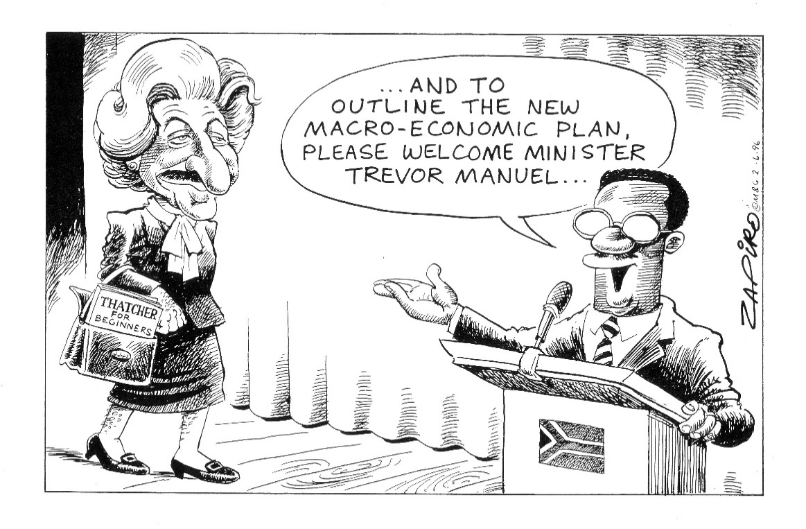

Figure 3: South African Minister of Finance in 1996, Trevor Manuel, being compared with Margaret Thatcher, Prime Minister of the UK in the 1980s

(Source: Permission granted by Zapiro)

Activity 1: Neoliberalism

**Suggested time:** 30 minutes

In this activity you will use your learning journal. As part of the programme introduction at the beginning of this module, you may have downloaded a digital template to use for your learning journal. If not, do that now, [here](https://oerafrica.org/system/files/13691/assets/13702/advdiptvtmodulereflective-practice.docx?file=1&type=node&id=13702&force=0). and save it where you can easily find it again. You can also use another template or a paper-based learning journal.

1. Read about the four pillars of neoliberalism in the context of your college.
2. Using any of the four pillars and their descriptions, name two examples of neoliberal economic policy that impacts on your college. Elaborate briefly on each example. Write your answers in your journal.

Pillar A – *The supremacy of free markets*: Your college is pressured by the Department of Higher Education and Training (DHET) to compete in local markets for training opportunities to earn additional income.

Pillar B – *Government’s role is reduced*: Employers don’t support government controlling vocational training; this is seen as too bureaucratic.

Pillar C – *Other actors like trade unions should not have a say in economic decision-making*: This is a contradictory pillar in South Africa, as trade union representatives sit on some college governing bodies and on the boards of Sectoral Education and Training Authorities (SETAs), which fund programmes in colleges. Nonetheless, the college sector is closer to the school system (which is tightly regulated) and less close to higher education (which gives lecturers a lot of autonomy). This means other actors, such as employers and unions, end up not having much influence over the governance of TVET colleges.

Pillar D – *Free trade in global markets is unconstrained by trade tariffs, subsidies and quotas*: This impacts on your college in a negative way because almost all state-of-the-art workshop technology is imported. Colleges are therefore shaped by global free trade, and they pay a big import price for this privilege.

Discussion of the activity

In answering this question, you thought about the descriptions of neoliberalism and its four pillars.

One example of pillar A would be the pressures to find additional private sector funding for the college. This push to generate income from the private market for training is a good example of neoliberalism’s influence on public education and training.

Another example, using pillar B, is the attitude of employers towards public colleges. Employers may only go for private providers as they believe the marketplace is best suited to acquire these services. They believe governments are not as capable as marketplaces in providing good quality training. Most governments are seen as excessively bureaucratic.

A third example – of pillar C, which is concerned about reducing the power of other actors in the economy – would be the SETAs, which have trade unions and other actors, such as non-governmental organisations (NGOs) and academics – represented on their boards alongside employers and the state. This makes for a very cumbersome board, with each large actor needing to take back any potential decision to their constituencies (the unions for example), before the final decision is confirmed. This leads to long delays. It also means that groups like the unions bring other labour issues into SETA forums, which should only focus on training issues, not matters such as wage negotiations and other strike demands. Employers would prefer a simpler SETA structure comprising only employers and the state.

A fourth example – of pillar 4 – the impact of trade liberalisation on your college – goes beyond just the issue of the high costs of imported technology. It also entails the negative impact of trade liberalisation on local economic sectors, like clothing, furniture and metal goods. These three industries used to produce the largest numbers of artisans annually, but they are now in rapid decline because of trade liberalisation. In short, they cannot compete with cheap Chinese goods. This decline has impacted on training and the TVET colleges, because only small numbers of new artisans are being trained.

## Neoliberalism and new public management

Another aspect of neoliberalism will be familiar to you – the emphasis in our government’s policies on meeting performance targets. Some would say it has become an obsession in the South African training environment. Meeting performance targets is a key part of neoliberal reforms. It is part of what is termed new public management (NPM).

Various techniques of public administration were introduced on a wide scale to fix the limitations of dominant traditional state bureaucracies. Advocates of NPM argued for more market-oriented approaches to public administration. They suggested that traditional forms of government were bloated, unresponsive and inefficient. Politicians and civil servants acted in pursuit of self-interest and not efficiency, and consequently, bureaucracies led to massive resource wastage. What was required, argued NPM advocates, were competitive markets for public services. The foundational principles of NPM are:

1. The introduction of explicit standards and measures of performance into the civil service;
2. Greater emphasis on output controls;
3. Greater competition in the public sector; and
4. The introduction of private sector styles of management practice in government departments.

The biggest and most destructive change introduced – impacting also on the public TVET college system – has been the obsession with establishing performance indicators for each line of public sector work. As an example, look at Figure 4 – from the DHET. It illustrates the scale of plans developed to entice employers to train and meet the targets set in each of these plans.

Figure 4: The extent of DHET plans that have annual targets

(Source: Kraak, 2023)

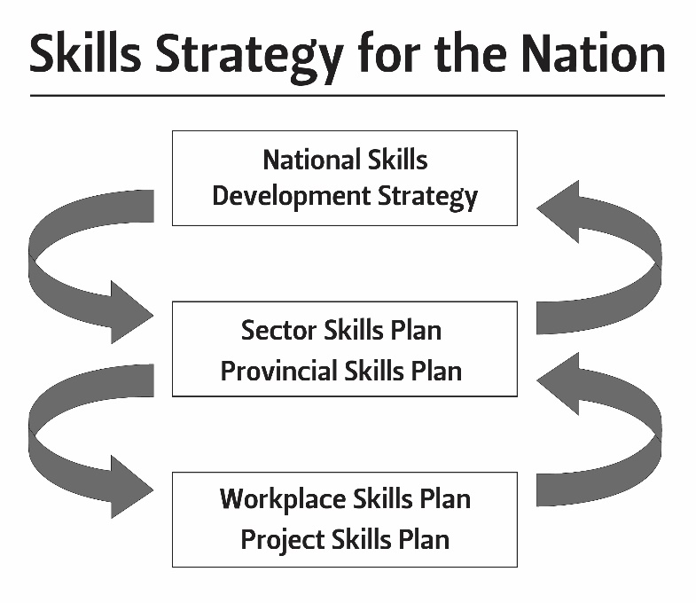

This has imposed a highly bureaucratic and rigid financial model of governance. Many of the goals contained in these plans have not been attained. This is because the bureaucracy around paperwork and the tight financial controls associated with these plans has led to a ‘tick-box’ compliance mode of working. A recent policy review of the South African training system by the National Skills Authority (NSA) is very critical of this compliance mode:

It creates a straitjacket of financial regulation, where the emphasis in provision is often quantitative performance targets set out by government programmes. Such compliance is an overly-legalistic reading of what a state must do – crudely interpreted by providers as the need to please the state auditors – while the complexities of ramping-up delivery and improving performance are not dealt with in any depth by more flexible and creative methods of regulation (NSA, 2018).

Employers have become disillusioned by the bureaucratic nature of the training system, and many have opted out entirely, pursuing their training through private institutions – or not training at all.

Activity 2: New public management

**Suggested time:** 30 minutes

Think about the foundational principles of NPM again:

1. The introduction of explicit standards and measures of performance into the civil service;

2. Greater emphasis on output controls;

3. Greater competition in the public sector; and

4. The introduction of private sector styles of management practice in government departments.

Identify two features of NPM in your college and give one example of each.

Discussion of the activity

One example (of NPM principle 1) is the tick-box culture which has now arisen because of this emphasis on reporting performance on all the plans as illustrated in Figure 4 earlier.

Another example (of principle 3) would be the pressure on colleges to find private income – to become more market oriented and compete for training opportunities against other public and private providers. Also, your performance management system (principle 1) is strongly influenced by NPM – do you have to meet key performance areas (KPAs) each year? These KPAs are at the heart of NPM. In your view, do they achieve what they set out to do? Or do we only pay lip service to these instruments?

## Shifting from a demand-led to a supply-side system

A second theme in Unit 1 is the dramatic shift in TVET college systems in the Anglo-Saxon world from a demand-led system, focusing mainly on employers’ apprenticeship needs, to a supply-side system, focusing on a much wider set of occupations that include many programmes in the services and financial sectors, as well.

Let us define the concept ‘Anglo-Saxon’ first. What does it mean?

Anglo‐Saxon capitalism is associated with all English-speaking countries which were formerly part of the colonial empire of Great Britain. Today it refers to the model of capitalism espoused by the leading economies in this economic bloc of countries – the USA and UK. It came into prominence in the 1980s under the leadership of Prime Minister Thatcher of the UK and President Reagan of the USA, who both advocated free market economies, minimal governmental control and deregulated labour markets which gave workers few rights. Most Anglo-Saxon countries (including South Africa) have tended to copy the policies of the UK and USA.

Historically, the British imposed a particular model of education and training on all its colonial territories, which closely resembled the education institutions developed in Britain. As an example, the college sectors in Britain and the colonies evolved similarly, from industrial schools focused on the early trades, to colleges that prioritised the apprenticeship system, to the eventual upgrading of some colleges into polytechnics (what South Africa has chosen to call universities of technology). The vocational route – as your modules, the ‘Philosophy of TVET’ and ‘TVET: The history and policy’ outline in more detail – was developed as an inferior track in the Anglo-Saxon world. It was often used as a place where truant youth who were in trouble with the police were sent as an appropriate form of punishment. The Anglo-Saxon tradition was also heavily class-based, with the elite children of the rich going to academic schools and university education, and the children of the working class going to TVET colleges. Inevitably, this vocational route acquired a bad name as a second- or third-rate education. This did not happen in the educational tracks of the social democratic countries of Europe, where vocational learning was developed as an equal partner to academic learning in schools and colleges. Think of the German apprenticeship system.

In more recent times, Anglo-Saxon colleges have been shaped by two additional factors, which emerged in the early 1980s. Firstly, the rise of neoliberalism took place in the UK and the USA (both Anglo-Saxon economies) and the ideology of neoliberalism was easily and quickly transported to all other Anglo-Saxon countries. Secondly, the decline of the manufacturing sector, and the consequent demise of the apprenticeship system, has been equally felt in almost all Anglo-Saxon economies since the 1980s, including South Africa. This has been in part because neoliberalism resulted in the weakening of the state’s role in the economy, which left all the Anglo-Saxon economies poorly equipped to deal with the rapid technological changes that have taken place globally since the 1980s. Countries outside of the Anglo-Saxon world – for example, Central and Northern European countries and the now developed economies of Southeast Asia, such as Singapore and South Korea – chose a different route, using the state to assist in more successfully incorporating the new technologies and new forms of work organisations within their manufacturing sectors. For South Africa, this Anglo-Saxon historical inheritance has been a major obstacle to economic development, as we will find out in Units 2 and 3.

Stop and think:

In what way do you think our schools, colleges and universities replicate the educational system in Anglo-Saxon countries?

### The road to a supply-side system

Neoliberalism has not delivered what it promised these Anglo-Saxon countries. In a paradoxical (contradictory) manner, a better vocational training system because of free markets and more private providers has not materialised. Rather, what has happened is that Anglo-Saxon employers continue not to train for their long-term skill needs, but rather to focus on their short-term profitability. In general, these employers have chosen not to upgrade technologically (largely to save costs and remain competitive within their existing local markets). This has left the state with the burden of needing to offer training opportunities to citizens using the public college system. However, without employer participation in these decisions, and without demand for these courses, this new system has taken on a supply-driven character. Many of the graduates of such a system remain unemployed.

We can now formally define demand-led provision and supply-side training systems:

* *Demand-led provision* comprises college courses that are in demand by employers, and where graduates acquire employment relatively easily after graduation. The centre of gravity for this approach is employer demand for skills.
* *A* *supply-side college system* focuses primarily on the state provision of training courses, with the centre of gravity being the education and training departments of governments. The courses are not necessarily linked to demand as expressed by employers. Rather, they are determined by what a college as an educational institution can provide in terms of its own expertise.

Unfortunately, many demand-led programmes are costly as they require expensive workshops and the latest technologies. There are often restrictions on the numbers enrolled on these demand-led courses, as technical workshops can only take 15–20 trainees per session.

Colleges are now expected to generate some of their own income and become more competitive in the market for training services. This is a new pressure on colleges since the arrival of neoliberal and NPM policy approaches. This means that often, those colleges that cannot offer demand-led courses then shift and choose programmes that are more generic, have lower-cost structures, and can enrol large numbers of students and make the most income. Unfortunately, many of these generic courses are not in demand with employers.

Activity 3: Demand-led and supply-side systems

**Suggested time:** 60 minutes

Read the definitions above of demand-led provision and supply-side systems again. Then answer these three questions:

1. Are most courses offered by your college demand-led or supply-side driven?
2. Which students from your college are more likely to get jobs after graduating – business studies or technical studies? Why is this?
3. Read this critique of supply-side systems of training. In your learning journal write up whether you think this critique is fair and whether it applies to the South African context as well.

*Critique of supply-side systems of training:* The global college literature is full of criticism of the ‘supply side’ route. In the UK for example, the criticisms of this approach have fundamentally to do with the fact that even though vast investments have been made in building the pillars of a supply-side route (for example, expanding mass access to TVET), these investments have not produced an equivalent outcome with respect to increased employment and enhanced economic growth. Countries such as the UK and South Africa are not more productive and competitive after nearly two decades of supply-side TVET reform. The supply-side model is not working. There is now an emerging consensus that demand-side interventions are necessary and that they are most effectively achieved in regional and local settings.

Discussion of the activity

If your college offers several programmes in engineering, including apprenticeships in these fields (for example, in the metal, automotive, paper and pulp, and energy and petroleum sectors – all sectors requiring artisans), then your college offers demand-led programmes. If the college offers largely business studies, public administration and service sector courses (for example, IT or finance courses), your college is likely to be supply-side driven, as many of the graduates in these fields will struggle to get jobs. The demand from employers to take these graduates is very low.

The central problem we are addressing here is if demand for training by employers is low, then little training will take place in workplaces – irrespective of what colleges do. Colleges then become supply-side institutions, providing training to individual students who may not get a job after graduating, because of the absence of demand (and therefore the absence of jobs requiring the skills those graduates obtained).

### Understanding demand-led provision

Bill Clinton, the former President of the USA, was once in a debate where he needed to defend his prioritisation of economic policies. He was attempting to argue that if the economy did not improve, no other social programmes in government would be able to grow and succeed. He then said to his critics: ‘It’s the economy, stupid!’

He was suggesting that without prioritising the growth of the economy, support for other social programmes would not be possible. This statement applies to vocational training too – if there is no demand for training services from employers, the training that is offered may be very wasteful. This is why a focus on the demand side is so important.

Demand-led approaches emphasise that it is the product market and the competitive strategy of a firm that determines that firm’s demands for skills – and certainly not national government’s TVET policies. If there is weak demand for a firm’s product, the firm will seek to stay in the market by trying to control costs, to lower prices. Training is one such cost and it is often the first item to be shelved when a firm experiences difficulty. Conversely, if there is high demand for the product, a firm can more easily allocate some of its profits to fund increased training. Such a firm is also more likely to invest in innovations in its product line, to grow the company. This growth strategy will require increased skills and more likely than not, the purchase of new technologies. It is therefore clear that demand for skills from employers is an important pre-requisite for a successful training intervention.

Another interesting element of the demand-led route to training is that improvements in skill are not sufficient on their own to move a company’s product market strategy towards more in-demand products. This shift will also require investments in capital equipment, product development and managerial innovation. Because of the high costs involved, many firms, particularly smaller firms, will not be able to afford going down this route.

### Promoting value-adding

A route such as demand-led training is termed ‘value-adding’ in the economic literature. Value-adding’ is a key concept of the whole module. The issue of value-adding arises in most developing economies because these countries were formerly colonised by various European powers who sought access to their abundant natural resources such as minerals, cotton, timber and food crops. Over time, these developing countries became trapped in exporting mineral and agricultural resources without any value-added to them through manufacturing processes. For example, South Africa has exported iron and steel for over a century, but it is unable to manufacture a wide range of iron and steel products that are in high demand in the local economy. Most of these metal goods must be imported. They include almost all metal machinery used in product manufacturing.

Such a value-added manufactured product will obtain a higher price on global markets than would a raw material, thereby increasing the income and profits earned by the owners of the natural resources. Innovative companies always seek to add new features to products, which place them in a more competitive position than their rivals selling a similar product. Greater value-adding allows owners of firms to charge more for their products, hence enhancing profitability.

Moving up the value chain of products, from low-value basic goods to more value-added tradeable items, is the central economic goal of many governments, world-wide. These governments choose to introduce various industrial policies to assist firms in purchasing the required technologies. This raises a second paradox, or contradiction, arising from neoliberal policy – a growth in demand will not be stimulated by free market policies on their own. Nothing will change significantly for small firms in terms of value-adding if they rely only on free markets. However, if the state assists small firms through industrial policy, these firms may choose to shift closer towards value-adding, because of the support of state finances to purchase the new technologies and to cover the costs of training.

Stop and think:

Consider this international trade example of value-adding: think of your favourite roasted coffee brand. Where were the beans grown and where were the beans roasted, packaged, marketed and sold? What was the value-added component?

Here is another value-adding example: think of a new entry-level Toyota with no frills, and then think of the new high-end Lexus models that are produced by Toyota. Why is there such a massive difference in the costs of these two cars made by the same manufacturer?

## The changing nature of work

A third focus of Unit 1 is to examine the changing nature of work. Hopefully you will be interested in this topic, as it outlines the nature of work, how it is structured, and how new technologies are used to assist or replace workers. All these issues have a direct or indirect impact on your work as a TVET lecturer, and how the young people you teach may or may not get their first jobs.

It is no surprise that the way work is organised has changed dramatically over the past six decades. These changes, triggered by the third and fourth industrial revolutions and by the triumph of market ideology, have led to a rise in new high-tech industries and jobs, digital automation, deskilling (where technology embedded in machinery has lowered the skill levels required by workers) and the casualisation of work (a process whereby many lower-skill jobs become contract appointments, and sub-contracting arrangements take the place of long-term job security).

The global economy has witnessed two industrial revolutions in the past six decades. Four such revolutions have taken place in the past 200 years. They are illustrated in Figure 5 below:

This module focuses only on the third and fourth industrial revolutions, which occurred in the past six decades. The third industrial revolution of the 1970s and 1980s entailed the discovery and rapid spread of information and communication technologies (ICT) across the globe. ICT technologies were also inserted into machinery to automate them further. These included IT-driven new technologies such as computer numerical control (CNC), Auto-CAM and CAD (computer-aided manufacturing and design software) and e-commerce.

Figure 5: The four industrial revolutions that have facilitated the rapid evolution of capitalism

(Source: Redrawn from https://www.getsmarter.com/blog/career-advice/the-4th-industrial-revolution-will-south-africa-be-ready-for-the-jobs-of-the-future/)

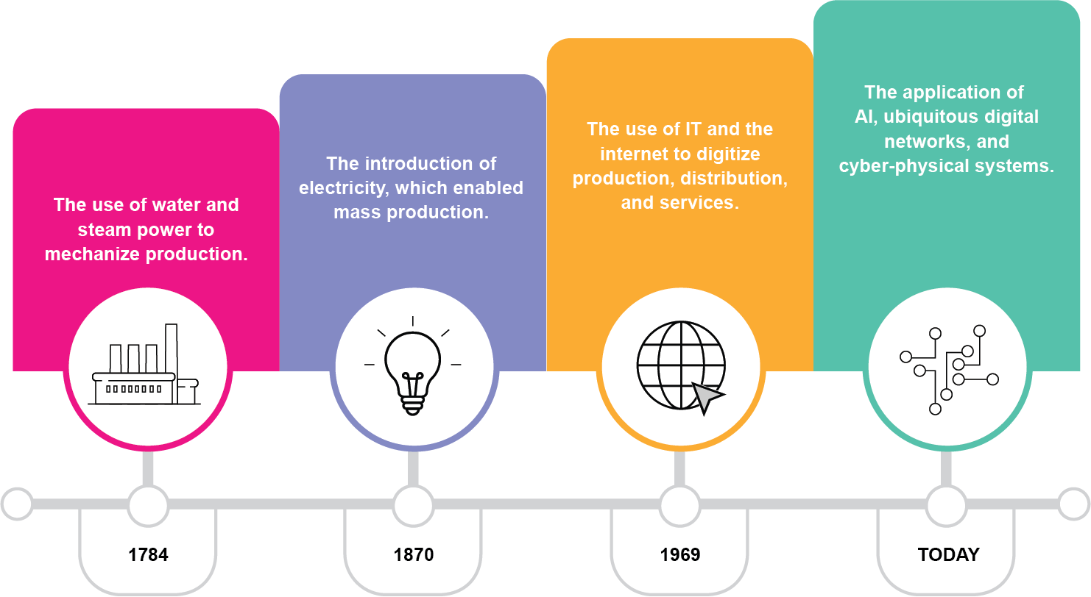

In South Africa, the adoption of these technologies was slow, largely because of the high cost of importing foreign technologies. This problem of falling behind technologically has continued with the introduction of digitalisation and the fourth industrial revolution, which began in the 1990s. For example, the new technologies of the fourth industrial revolution such as robotics, additive manufacturing (AM) and 3D printing build upon the capabilities offered by CNC and Auto-CAD technologies (products of the third industrial revolution). Again, the spread of these digital technologies has been extremely limited in South Africa to date.

Claus Schwab is the founder of the influential Swiss-based World Economic Forum, which hosts an annual gathering of global leaders in government and industry. Schwab is a key pundit of the positive gains to be made from the fourth industrial revolution. He argues that digitalisation is only one element of the full revolution underway. It entails the fusion of the following three things:

* Physical infrastructure: driverless and battery-driven vehicles, 3D printing, robotics as well as a whole range of smart materials (nanotechnologies);
* Digital or informational infrastructure: internet of things, cloud computing, artificial intelligence, virtual reality, big data, block chains); and
* Computational biology and associated technologies, such as gene-editing and digital implants. Gene-editing is a technique used to alter the DNA of a living organism to cure diseases like cancer. Digital implants are common among dog-owners – the digital chip implant under the dog’s skin can be read to provide the dog’s name and home address if the dog is found lost. Similarly, many humans with serious health problems use digital implants that monitor their health between face-to-face check-ups.

According to Schwab, this synergistic fusion of multiple innovations in very different fields is ‘on the brink of fuelling momentous change throughout the world’ (Schwab, 2016). For example, pundits of digitalisation argue that the new technologies can assist developing countries and sectors struggling with the task of catching up in terms of social and economic development.

The predictions of the future impact of the digitisation on production and the world of work are perhaps the most controversial aspects, with dramatic claims about change in the way goods will be produced in the future. One major claim is that digitalisation will assist workers in doing dirty and dangerous work – which would be a good thing. Another potential positive change is the profitable return to small-scale artisanal production (for example, a self-employed artisan producing manufactured goods such as high-end furniture, using computer-aided machinery in a small workshop – perhaps located in his/her garage). However, others claim that digitalisation and robotics will replace human labour with machine-led production, leading to greater unemployment. The jury is still out on whether digitalisation is good or bad in the world of work; not enough time has passed to assess its true impact. Notwithstanding this, digitalisation is clearly a major technological phenomenon to have impacted the manufacturing sector in general.

The next section briefly describes the nature and content of digital production technologies as they have evolved over the past six decades. These are:

* Computer numerical control (CNC) machinery;
* Computer-aided design (CAD) and manufacturing (CAM) software;
* Additive manufacturing (AM);
* 3D printing; and
* Robotics

### Computer numerical control

The genesis of CNC technology lies with the third industrial revolution of the 1980s. However, it now forms a highly complementary component of the new technologies emerging in digital manufacturing. Digital CNC technology can be a complement to 3D printing, CAD-CAM software systems and AM. CNC machines were introduced in the 1980s, largely in metal fabrication, but eventually with penetration into many other sectors, such as food processing, forestry, clothing and furniture. As indicated earlier, there were limits to the effective diffusion of CNC, the most serious being the high cost of the first machines and the need for a skilled IT technician to manage the technology.

CNC machines are controlled by an internal electronic device integrated in the machine, that drives all movements and functions during the fabrication process. These machines were rapidly adapted from the 1980s onwards, to automate production and replace the operator-driven production lines characterising the earlier industrial era. Prior to the 1980s, the operator was responsible for the quality of the final product, with quality being determined by manual loading of materials into the machine, monitoring for error, and managing processing speed. The introduction of CNC machines inverted this relationship, with the machine controlling material handling, quality monitoring and speed of production.



Figure 6: A CNC machine with a digital robotic arm

(Source: <https://en.wikipedia.org/wiki/CNC_router#/media/File:DMS_CNC_router_at_SITU_Fabrication_(12480).jpg> )

Other advantages offered by CNC machines over human operators is precision fabrication that ensures uniform quality in every piece made, by eliminating human error. CNC machines also reduce the down time on the shop floor – time ‘wasted’ making manual movements, changing tools and repositioning raw materials.

### Additive manufacturing (AM)

AM is a key component of the fourth industrial revolution technologies. It is primarily used to build a prototype of an envisaged new product. AM entails a digital copy of the product to be created (on a computer) with instructions then given to the 3D printer to begin building up a product by adding materials (usually a very durable plastic) one layer at a time. It does not require the use of cutting tools, coolants or any other machines. It enables design optimisation and the production of customised parts on-demand.

CAD and CAM software is another critical component of AM. This software creates a digital file on a computer, which outlines in three-dimensional detail the object to be produced so that it can control the printing/layering process. It is then sent to the 3D printer or CNC machine, which responds accordingly. AM privileges design and showcases what is made possible on the shop floor by the digitalisation of production. It is within this new technology that all the precision in fabrication is now located – if the CAD designs are wrong even in the slightest way, the resulting prototype will be flawed.

Figure 7 highlights an example of 3D printing and AM – the production of a plastic human heart:



Figure 7: A plastic human heart produced by a 3D printer and additive manufacturing

(Source: <https://en.wikipedia.org/wiki/Organ_printing#/media/File:Soft_Total_Artificial_Heart.jpg> )

This replacement heart was produced using a biocompatible plastic. As the plastic is being laid down, it is also seeded with human cells from the patient’s own heart, which will be eventually replaced with the artificial copy. After printing, the organ is transferred to an incubation chamber to give the human cells time to grow. After enough time, the organ is implanted into the patient. It is a good example of the integration of gene-cloning biotechnology with digital manufacturing capabilities; a phenomenal advance in human knowledge and medical care.

### Robotics

Robots are the most sophisticated of the new technologies to emerge. Robots are machines that can substitute for humans and replicate human actions. They can be used in different situations for a variety of purposes, but today many are used in dangerous environments (including inspection of radioactive materials, bomb detection and the deactivation of landmines). More important to our focus, robots are now also being used widely in manufacturing processes. Robots can take any form, but some are made to resemble humans in appearance.

Industrial robots are often combined with technological innovations from earlier industrial revolutions. For example, they may be joined to conveyer belts or to CNC machines to make the production process speedier, with fewer errors than those that arise under human labour, thereby meeting the high-quality standards of many modern products.

A big advantage of robots is their increased versatility. They allow the production process to move easily from one task to another. While CNC machines can adequately perform specific tasks separately like milling, drilling and turning, CNC robotics can do all these tasks in one operation.

The car industry globally, and in South Africa, uses robots extensively. In most automotive manufacturing plants, light robotic arms assemble smaller parts, such as motors and pumps, at high speed. Tasks such as screw driving, wheel mounting and windshield installation are all done by robot arms. Other industries have been slow to adapt this new technology – partly because of its high cost, but also because some production runs do not lend themselves to the mass production of goods that occurs with robotics. For example, high quality furniture and clothing are still in the hands of highly qualified artisans.

### Where does South Africa stand in terms of these new technologies?

What conclusions can we make from the above discussions? It is clear the evolution of the new information and digital technologies has triggered major changes in the world of work. Competitiveness is now not determined by inherited natural resources like cheap labour, minerals, cotton and timber, as was the case in the past, but through the effective application of the new technologies. This is why it is often said that we live today in a knowledge-driven economy. These changes have diffused within the leading technological sectors such as car manufacturing, aerospace engineering, production of electronic consumer goods and telephony. However, they have not spread to the same extent within the older manufacturing sectors in South Africa such as furniture, clothing, metal, food processing and construction. These sectors are still dependent on older technologies from the second industrial revolution – mechanised machinery in combination with hand tools.

The main message to be gained here is that the fourth industrial revolution is in its infant phase, and we cannot yet see its full impact clearly. It is likely to be a mixed bag of changes, with some being positive – for example, the phenomenal rise of cellular technology, and the applications that are being designed daily to apply this technology to all sorts of interesting social problems. One such example is the use of cell phones amongst tuberculosis patients to remind them of the need to take their medication daily, so that the medication can work optimally. However, other technological developments like robotics will no doubt replace humans with machines in the workplace, which will not be a good development.

Activity 4: Changing nature of work and technologies

**Suggested time:** 30 minutes

Your college is likely to have an interesting mix of technologies in use. Visit the workshops and computer labs before completing this task.

1. Reread the text about the changing nature of work, including Figure 5.
2. Map out which technologies from the first, second, third and fourth industrial revolutions your college is equipped with. To do this, copy the table into your learning journal, and add examples of these technologies in your college into the space under each industrial revolution. You can use the internet for assistance as well.

|  |  |  |
| --- | --- | --- |
| Summary of the main technologies used in TVET colleges in South Africa | | |
| **Industrial revolution** | **Year** | **Main technological developments introduced into the world of work** |
| **First industrial revolution** | 1760–1840 | Hand tools, such as hammers and wood carving tools already existed. Newly introduced: steam engines and the mass construction of factories dedicated to the fabrication of goods. |
| *Examples of these first industrial revolution technologies used in your college:* | | |
| **Second industrial revolution** | 1870–1914 | The introduction of electricity and railroads, mechanised machinery and conveyor belts. |
| *Examples of these second industrial revolution technologies used in your college:* | | |
| **Third industrial revolution** | 1970s | The introduction of the internet, ICTs, CNC machinery and CAD and CAM software |
| *Examples of these third industrial revolution technologies used in your college:* | | |
| **Fourth industrial revolution** | 1990s | The introduction of robotics, and the further digitalisation of production processes |
| *Examples of these fourth industrial revolution technologies used in your college:* | | |

Discussion of the activity

The general understanding of our college system is that colleges are not stocked with the latest digital technologies. This means your college might have to rely on older technologies. For example, in the training of cabinetmaker artisans for the furniture industry, hand tools such as planes (to reduce thicknesses and create smooth finishes), circular saws (for difficult round cuts), chisels (for carving designs) and mallets (hammers used to drive the chisel) have been used for centuries. These would be first industrial revolution tools.

Your college may have CNC training and access to such machines. They are usually linked to conveyor belts in factories to enable mass production of standardised goods. If these machines are in your college and the firms you support, then you are using tools of the second industrial revolution (mechanically driven conveyor belts) and third industrial revolution (CNC machines).

Some colleges are fortunate to have afforded the purchase of 3D printers. Does your college have access to one? Then you are using fourth industrial revolution technology.

## The changing nature of workplace learning

A fourth focus of Unit 1 is on the processes of learning in the workplace. Learning can take many forms – through informal, on the job training, which may last for only a few days or weeks, to formal classroom-based courses at external education and training institutions, where employees can upgrade their qualifications. Such learning can be restrictive (minimal in scale and depth) or expansive (extensive training).

Learning is also promoted by the way employers organise work. Examples of the new human resource management organisational forms:

* *Flattened hierarchies* have fewer managers and a flexible structure that relies more on workers to do their jobs without constant supervision.
* *The devolution of discretion* gives workers the autonomy to make some of the decisions in the production process without constant supervision and instructions from the top. This promotes trust and cooperation, which is the central governance mechanism in social democratic economies.
* *Teamwork* emphasises the important cooperation between workers to ensure efficient production without costly flaws in quality. Teamwork also allows for the rotation of employees across tasks, making them more knowledgeable about the total production process.
* *Just-in-time inventory practices* entail ordering input materials only at the point of needing them, thereby not requiring huge and costly storage facilities.

You can read more about industry-based work integrated learning (WIL) in the Advanced Diploma in Technical and Vocational Teaching (ADTVT) Module called [Effective Vocational Pedagogy in Industry-Based Work Integrated Learning](https://www.oerafrica.org/node/13691/materials).

### Expansive and restrictive learning in the workplace

How do employees learn? This is a major question this Advanced Diploma needs to engage with and answer. Other modules in the programme touch on this topic, for example, the module on industry-based work-integrated learning. We will also have a brief economically oriented discussion of this key issue here.

The reality of workplace learning is not entirely a good story to tell. This is because not all firms encourage training and learning in the workplace. Under apartheid, black workers were not offered training opportunities, in comparison to that received by white employees. In the current period, employers remain hesitant to use government training facilities such as colleges, instead preferring not to train, or to train using private training centres. Similarly, the UK has a very poor employer training record, scoring far lower on various European training indices than many of the continental European countries such as Germany and the Netherlands.

### Why do the continental European countries train more?

The main reason for the differences in training between countries such as the UK versus social democratic countries such as Germany and the Netherlands is that the first set of countries are liberal market economies (LMEs) that prioritise the free market in the provision of training. In short, this means that employers make all the training decisions. If the firm’s competitive strategy is based on the production and sale of low-cost, low-wage standardised goods (for example, cheap mass market clothing and furniture aimed at the internal market), then they will be unlikely to spend money on training. All they require are unskilled and semi-skilled workers who can be trained in-house in a matter of weeks. This reality describes the decision-making processes behind training strategies made by many South African and UK employers – both Anglo-Saxon economies.

In contrast, countries like Germany and the Netherlands are social democratic economies, where capitalism is based on negotiation and cooperation between the key actors involved (the state, employers and trade unions), and high levels of coordination and long-term planning by the state. Cooperation and networking are the central pillars of this economic framework. These new networking dynamics will not emerge naturally through the market mechanism. They must be consciously built as part of active public policy. For example, technological networks must be deliberately created and supported by a set of industrial and technology policy instruments such as local content programs, selective import protection to encourage technological learning, and strong research and development (R&D) facilities.

Fuller and Unwin (2010) explain another dimension to why some firms enable learning and others do not. They argue that the primary function of any workplace is not learning, but the production of goods and services. This reality places a potential constraint on the extent to which workplace learning can be promoted if the dynamics of production restrict such a learning orientation.

More specifically, Fuller and Unwin draw attention to the role of ‘managerial prerogative’ and its opposite, ‘worker discretion’, as managerial approaches to decisions about work organisation and job design. These authors indicate that the new forms of work organisation aimed at productivity and performance gains are often achieved by finding new ways of ‘squeezing more effort from the workforce’. Much of the rhetoric surrounding new organisational innovations such as ‘flattened non-hierarchical work relations’, ‘high performance systems’ and ‘teamwork’ are actually about work intensification, which leads to increased stress and responsibility – and not increased learning and skills acquisition.

To determine whether the workplace enables employees to learn and be trained, or to submit to more hierarchical control, Fuller and Unwin develop a continuum of learning possibilities from ‘expansive’ to ‘restrictive’. In their definitions, expansive learning is extensive – it covers formal and informal as well as on-site or off-site training. Most significantly, employers who support expansive learning see it as a major component of establishing their future profitability. A key to expansive learning is worker discretion and trust – the ability of management to devolve work activities to employees to work autonomously without strict forms of supervision. In contrast, restrictive learning is limited, exclusionary (not everyone gets trained) and entails work-intensification. A continuum of learning opportunities – from restrictive to expansive – can be developed (see Table 1).

Table 1: Characteristics of workplace learning environments

|  |  |
| --- | --- |
| **Macro-economic, social and political factors affecting the firm’s decision to train employees:** | |
| **Restrictive** | **Expansive** |
| Participation is restricted to immediate work team/area. Job rotation is discouraged. | Participation in different production activities (job rotation) is encouraged – job/team boundaries can be crossed. |
| A short-term approach is followed – get the job done. | A strong vision exists, promoting workplace learning and career progression. |
| Workers are seen as productive units, with fast transition from newcomer/trainee to fully productive worker. | There is recognition of and support for workers as learners – newcomers (including trainees) are given time to become experienced workers. |
| Workforce development is used only to tailor individual capability to meet organisational goals. | Workforce development is used as vehicle for aligning goals of the organisation and of the individual. |
| There is polarised distribution of skills – knowledge/ expertise is regarded as being confined to key workers. | Skills are distributed more widely through the workplace. |
| All training is on the job and limited to immediate job requirements. | Time is allocated for off-the-job reflection and deeper learning beyond immediate job requirements. |
| Managers are restricted to controlling workforce and meeting targets. | Managers are given time to support workforce development and facilitate workplace learning. |
| Discretion is limited to key workers, with no employee involvement in workplace decisions. | Workers are given discretion to make judgements and contribute to decision-making. |

(**Source:** Fuller and Unwin, 2010: 12)

The nature of learning in the workplace is not your responsibility. This task lies squarely at the feet of employers – many of whom do not train their workers extensively. However, you should be interested in whether firms lean more towards expansive training, as these would be good firms to send your students to for workplace experience and future jobs. This may not always be realistic, but it should at least be an ideal towards which you strive.

In the next activity you will think more about the changing nature of workplace learning.

Activity 5: Restrictive and expansive learning

**Suggested time:** 60 minutes

Read the section about the changing nature of workplace learning again. Then answer these questions to help your thinking:

1. From your experience of working with firms, identify one South African firm that offers restrictive learning, and a second firm that offers expansive learning**.** Elaborate on your choices, describing the company culture towards training. If you do not have access to and knowledge of firms, then create your own two imaginary firms, based on the information already given to you about what an expansive or restrictive firm looks like. Give these imaginary firms names – even as simple as ‘Firm A’ and ‘Firm B’.
2. What impact does this insight (about restrictive/expansive learning) have on your understanding of learning practices in your college? Does your college recognise the difference, and do your colleagues see expansive learning as important? If you can, write about companies at which your students have had a good or a bad experience of workplace integrated learning. If you are imagining two firms – Firm A and Firm B – answer these questions using your creative juices. Invent the relationships between Firm A and Firm B and an imaginary college. In so doing, you learn about the general characteristics of linkages between colleges and different types of firms – ones that value training, and others that don’t.

Discussion of the activity

To recap, the approach here is to answer the questions in the following way:

1. If you can, choose two firms in your locality that meet these criteria – one does extensive training, the other does not. Focus on them. You can also choose to write up two fictional firms – let your imagination run wild here.
2. From the activity you may have concluded that firms that lean more towards expansive training are better firms to send your students to for workplace experience and future jobs, because they will get a more comprehensive exposure to all kinds of work undertaken in the firm. In contrast, firms that don’t value training much, usually use it to teach unskilled workers a single task (for example, to take up a position on a conveyor belt), which they then repeatedly perform in their work. This route is a dead-end street for many workers, as they are not acquiring other work experiences that might hold the possibility of promotion to more demanding tasks.

### Managerial control

Wilkinson (2002) adds to the above analysis of learning in the workplace. He clarifies two important concepts – ‘managerial prerogative’ and ‘worker discretion’. He uses the first concept to highlight the role of coercive management in enforcing work rules and behaviours:

*Managerial prerogative* constitutes the right of employers to counter the power of workers and their trade unions on the shop floor through close monitoring and the enforcement of workplace discipline. It also comprises the offering of an efficiency bonus to the market wage to incentivise additional effort on the part of workers. In general, it involves securing the enforced cooperation of workers.

Another module in the ADTVT on the [‘Philosophy of TVET’](https://www.oerafrica.org/node/13691/materials) outlines the production system known as Taylorism. This system is best understood by looking at the role of mechanised conveyer belts in the mass production of the Ford Model T motor car in the 1920s. This was the first example of mass production in the world – made possible because of mechanised conveyer belts. These conveyor belts, associated with a strict system of time management, sought to increase profit for businesses by increasing the productivity of workers by breaking down the work process. This entailed breaking down the expertise of workers even further. Taylorism reduced the need for workers to have skills. They only needed to be able to do one simple task repeatedly at a specific point on the conveyor belt. They were not allowed to use their own ideas (their discretion) but rather, to do a task as management prescribed within a certain amount of time allotted for the task. Taylorism is over 100 years old and is still practised in many worksites, especially those driven by conveyor belt systems. Workers do one task repetitively throughout the rest of their working lives.

*Worker discretion* arises only in firms that recognise the central importance of cooperation for competitiveness in product markets. In these cooperative systems, leading edge human resource practices are combined with close relations with suppliers and customers. Such cooperation ensures a high quality of product delivered on time to the customer or supplier in the value chain. It is only in these environments that worker discretion can flourish. Discretion here refers to the degree of autonomy and responsibility exercised by workers in the world of work. Discretion is exercised in several ways, for example, in the conception and planning of work, in the execution of tasks, and in evaluation and monitoring of work outcomes. This approach to work requires high levels of trust between employers and workers (Wilkinson, 2002).

## Four models of capitalist development

We now focus on our final component of Unit 1 – the existence of differing capitalist systems across the globe. This section builds on several features of capitalism that we have already investigated. These include:

* The definition of capitalism, particularly understanding its current form, neoliberalism;
* The central focus of neoliberalism: the triumph of market forces over big government;
* The importance of value-adding in manufacturing production;
* The changed nature of work, which today includes the new digital technologies, and new forms of work organisation that offer workers discretion in the workplace;
* The influence of education and training systems on the current economic order, especially whether they are demand-led or supply-side driven systems;
* The nature of learning that is possible in the workplace – whether it is expansive or restrictive in scope; and
* The dominance of either managerial prerogative or worker discretion in the workplace.

Each of these features is an important element of the various capitalist systems that exist today. This is a vast topic, too big for a module like this. We have decided to focus on one typology of differing systems developed by Ashton et al. (2000). These authors offer us four models that are easy to understand:

*The liberal market economy (LME) model*: This model has already been discussed briefly. In this model, economic activities are coordinated by the market and the state’s role is kept to a minimum. The main role of government has been to try and make markets work more efficiently and to transfer the provision of social services away from purely state provision towards more competitive forms of market provision. In the UK variant of this model, the predominance of low-wage, low-value-added forms of production have led to the characterisation of this economy as being trapped in a low-skill form of production. Training here is seen as the responsibility of the employer and the individual – and not that of the state. In the training arena, the role of government is to focus primarily on areas of market failure, for example, the training of the unemployed.

This is not to say that Anglo-Saxon economies such as the UK and South Africa are entirely low skill in orientation. There are indeed high-skill sectors (such as automobiles, aerospace, finance and pharmaceuticals). They, however, exist in both countries in a small high-skill area of the national economy. They are surrounded by a much larger mass of sectors based on low-skill forms of production.

*The social democratic model*: Social democracy refers to the collaborative model of economic governance implemented by countries in Northern and Central Europe through cooperation between the state, employers and unions. These economies have used the resources of the state to drive industrialisation as a means of catching up with the advances already made by the LMEs of America and the UK in the first and second industrial revolutions.

Historically, European governments assisted the process of developing modern industries, especially after the devastation of the Second World War. For example, the banks, steel mills and car assembly plants were all majority-owned by the governments of these countries during the period from 1945 to the 1970s. Good examples are Fiat, Peugeot and Volkswagen. However, once they were established and profitable, governments de-linked and exited from direct forms of control over these firms. This occurred in the 1970s. Nonetheless, this history provided a different route as regards the role of the state in capitalist development to that of the Anglo-Saxon tradition.

A second dynamic in this model was the growth of a strong labour movement, which negotiated for itself a far greater role in production relations than simply determining wage levels. In the training arena, the strong artisanal tradition was extended into the new mass production industries, with workers acquiring significant say in the way production unfolded. This resulted in a strong tradition of cooperation between capital and labour continuing into the present period. Today market relations operate within a wider regulation framework determined through the ongoing collaboration between government officials, employers and the unions. This cooperation has led to a high degree of trust which underpins the attainment of higher-value-added production in these countries.

The existence of worker rights and a supply of highly educated workers encourages employers to invest in technology and training, allowing them to compete in higher-value-added product markets. Levels of inequality are far lower in these social democratic societies than is the case in LMEs. To ensure access to education for all and a sufficiently skilled workforce, government in this model is far more directly involved in the provision of education and training, and many of these Central and North European societies have built strong dual modes of provision in the senior secondary phase of schooling (academic schooling and TVET colleges) to ensure adequate flows of technically skilled labour into the economy. This is best epitomised by the German dual-system of apprenticeship training.

*The developmental state*: In the post-1945 era, the world economy has been dominated by the Western economies, and most Asian, East-Asian, Latin American and African economies have faced very unequal terms of trade. It has been very difficult for developing countries to break into this world market and catch up. However, a small group of East-Asian economies managed to do this (the Asian Tigers – Singapore, South Korea, Hong Kong and Taiwan) by using the state to intervene directly in the economy to protect local industries, spearhead the evolution of specific sectors targeted for growth, and raise the level of education and training dramatically to underpin these economic interventions with the required skills. High levels of foreign investment were also encouraged to assist in the establishment of new industries. In these societies, the ‘developmental state’ steered the economy through many phases of economic growth, initially based on low-wage, low-value-added manufacture, but more recently, towards higher-skill, higher-valued-added production destined for export markets.

These East-Asian developmental states were not initially democratic. In the early stages of development, they were politically repressive, curtailing the activities of unions and banning left-wing political parties. As these economies became more successful in higher-valued-added production for export, so restrictions on union activities have been relaxed and these societies have democratised their once authoritarian institutions – except Singapore which remains a one-party state. In the field of training, the state has played a major role, directly funding training using public funds, to ensure that the necessary skills are available to sustain the rapid pace of economic development (Ashton et al., 2000).

*The neo-market model*: This term refers to a mixed market and state model, not a fully-fledged LME. This model is based on state-led industrialisation. Member countries in this model are largely South American societies with an authoritarian history of government and an industrialisation model based on import substitution. Import‑substituting industrialisation was an economic strategy popular in many developing economies from the 1940s through to the early 1980s, as they sought to move beyond resource extraction and build local manufacturing capacity. This was achieved by supporting emerging industries through the application of import tariffs (adding additional costs to imports to make them more expensive and therefore less attractive than locally produced goods) and state subsidies for the local production of consumer goods. Subsidies were a means by which the state was able to help local capitalists by subsidising the costs of establishing local manufacturing firms.

This approach has inbuilt weaknesses in terms of growth as, historically, it has relied heavily on import-substituting industrialisation, the export of raw materials and the importation of most technologically advanced machine goods. In addition, these countries lack the advanced financial markets and regulatory structures associated with liberal market economies described above. In the past three decades, with global competitiveness based more and more on value-adding and not merely on access to raw materials, these countries have struggled to make the transition to a more globally competitive export-oriented economy. They have also initiated structural adjustment reforms, such as privatisation and trade liberalisation, in the hope that these changes would make free markets work more efficiently, including the market for vocational training (Ashton et al., 2000*).*

Ashton et al. argue that a national training system cannot be understood in isolation from its wider institutional context, as described in the four models above. In the neo-market and liberal market economy models, there is a strong linkage between the dominant form of production – low-value-added production – and the TVET system, with government policies and institutions being designed to meet the immediate skill needs of employers. Government does little more than deal with market failure – the training of the unemployed. In the social democratic and developmental state models, the attainment of higher-value-added production requires that the state carries a significant share of the costs of TVET with employers.

Activity 6: Understanding the Netherlands TVET college system

**Suggested time:** 60 minutes

The aim of this activity is for you to apply your new and existing knowledge of college systems to the case of the Netherlands. You are not expected to have a very detailed knowledge about this country.

1. Read the following text on the Netherlands TVET college system.
2. Then, write your responses to these two questions in your learning journal:
   1. List two major features of the Netherlands TVET college system that, in your view, make it an excellent system.
   2. Now contrast this excellent model with the TVET model that exists in South Africa. In what way does South Africa lag behind the Netherlands?

**The Netherlands TVET System**

Major change was brought about in the Netherlands TVET college system at approximately the same time that changes were beginning in democratic South Africa. New legislation in 1996 provided an entirely new institutional framework for Dutch TVET. The 1996 Act devised a set of interactions between institutions that would ensure far more effective system alignment and complementarity than was the case previously. The new elements that were introduced alongside existing institutions that were consolidated and merged included the following:

Seventeen sectoral bodies called Knowledge Centres (*Kenniscentra*) were established along the lines of broad economic sectors. These structures are very similar to our Sector Education Training Authorities (SETAs). The Knowledge Centres play a crucial role as the starting point for the design of national vocational qualifications (NVQs). Employers design job profiles of the skills needed in the economy. These occupational standards then serve as the basis for creating new qualifications, which are taught by Regional Training Colleges.

Forty-three Regional Training Colleges were formed out of the merger of hundreds of local training colleges. These colleges manage the school-based learning of senior secondary vocational education. All students (in both work- and school-based pathways) follow the same qualifications that are designed by the Knowledge Centres.

The Dutch vocational education system has three levels (see Figure 8). The system starts at a very early age, with Dutch children having to make their first educational choice at the age of 12 – to choose a vocational track through high school. This route begins with junior secondary TVET, continues after compulsory schooling at age 16 in senior secondary school as secondary vocational education, and peaks in post-school or tertiary professional higher education – applied or polytechnic higher education.

The general or academic schooling track has two streams – the senior general secondary education track, which feeds into professional higher education, and the pre-university education track which links with university education.

The vocational component of both senior secondary and higher education is large in the Netherlands. Vocational education comprises 16% of the total schooling system, but 35% of the secondary schooling system. Higher professional education – applied or polytechnic higher education – comprises 62% of all post-school tertiary training. In short, the tertiary TVET system is large in the Netherlands; larger than the academic track in higher education.

A major strength, therefore, of the Netherlands model is its emphasis on growing tertiary (post-school) TVET as the critical element in today’s labour market (and not secondary which is situated in the secondary school phase). Some of the senior vocation education programmes extend beyond the basic school phase of 12 years of education. They start at the end of compulsory education at 16 years of age and end at the average age of 20 years. Trainees then proceed to tertiary TVET. These trainees become highly skilled intermediate workers in the Dutch economy. The basic structure of the system is illustrated in Figure 8 below:

Figure 8: The structure of the education system in the Netherlands (Source: Altinyelken et al., 2010: 6)

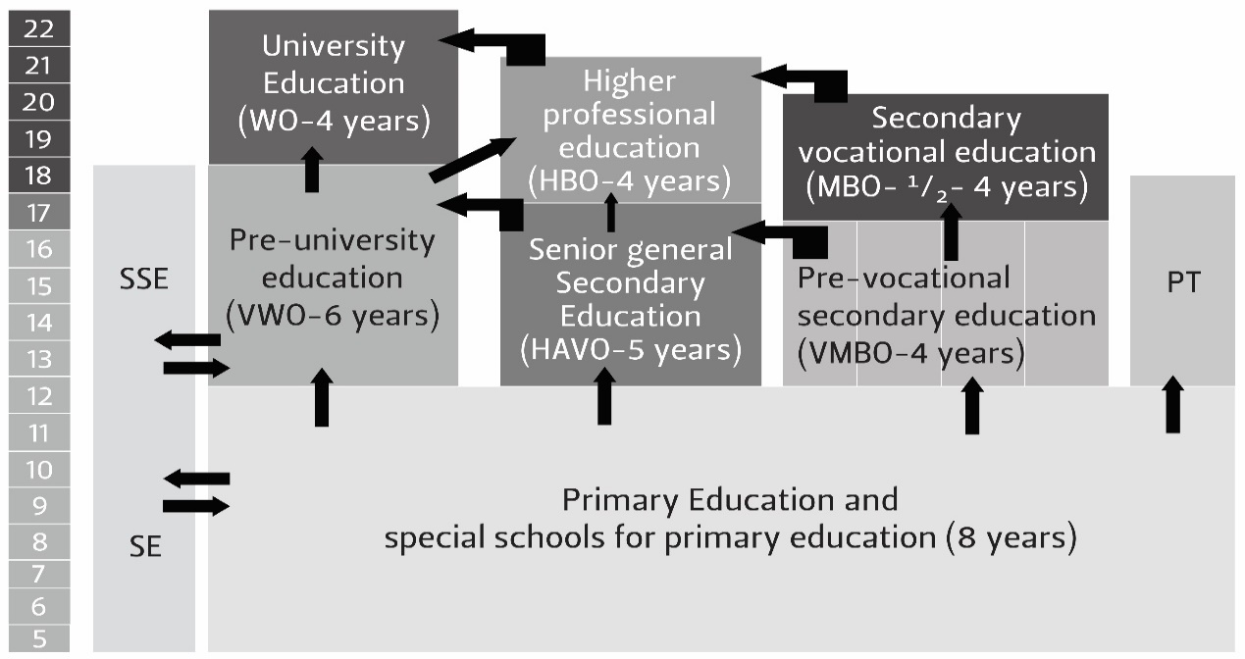

Ages 5 to 22 years

SE – Special Education

SSE – Senior Special Education

PT – Practical Training

**Senior secondary vocational education**

Students choose to study in one of four broadly defined fields: technical; economic and administrative; services and health care; and agriculture. Learning in the senior secondary vocational education (MBO) track is both classroom- and work-based. Students choose between two modes of provision:

The work-based route (apprenticeship): In 2008 this pathway enrolled 34% of the MBO students. A key feature of this route is that the work-based apprentices have an employment contract with an accredited employer, and they are paid the minimum wage. They typically spend 80% of their time as trainees in the workplace and 20% in college-based training. Students in this work-based route are found mostly in the technical sectors (metal, electronics, installation, building industry and car mechanics) but numbers are also growing in the care and health sectors, resulting in more and more women taking part in apprenticeships.

The college-based route: In 2008 this pathway enrolled 66% of the MBO students. It comprises students who enrol at one of the training institutions listed earlier: regional training colleges, specialist trade colleges or agricultural training centres. Their training includes one day a week at a workplace. Only accredited employers can provide training places to these students. The mix between classroom and workplace typically involves a minimum of 20% and a maximum of 60% spent in the workplace, during which time the trainee receives on-the-job training and a small training allowance.

**Assessing the Dutch system**

From this description we can see several strengths of the Dutch post-school system. Sung et al. (2006), who participated in a joint-European project reviewing nine different post-school systems in 2006, argue strongly that employer control of the Netherlands system is critical to its success. Employers occupy a pivotal position, which enables them to lead the skills development system through the sector skills councils – in this instance, the Knowledge Centres. Employers can identify the skills needs of their sectors through these centres.

Secondly, the Dutch TVET system benefits from the wider social solidarity underpinning Dutch economic and social life. These cooperative relations are derived from the fact that the Netherlands is a social democratic country. Each social partner has a shared responsibility and collaborative role in each of the stages of the skills development system. The actual content and volume of training as well as who benefits is decided annually through collective bargaining agreements between employers and unions across all sectors of the Netherlands economy.

Thirdly, the Dutch system is very flexible and seamless – there are no dead-end routes. Students on the vocational track can re-enter the academic track at any point in their learning journey. Similarly, students in the professional higher education route can choose to enter university education at any point and vice versa. All of this makes for a very integrated academic and vocational education subsystem – something post-apartheid South Africa aspired towards but never achieved.

Discussion of the activity

This activity and the writing exercise have given you the opportunity to determine the most critical features of an excellent or ideal-type TVET college system – a model we should aspire towards as a country. Your knowledge of our TVET system in South Africa will tell you that we fall far short of this successful European system.

In determining the strengths of the Netherlands system – and the extent to which South Africa falls far short – you should look for the key features of the Netherlands system.

The first key feature would be recognising the importance of focusing on tertiary TVET, and not just the senior secondary school equivalent TVET. Hopefully, you have made a strong argument using some of the evidence about this tertiary focus featured in the text insert above.

A second important feature is that Dutch employers are viewed as lead actors who can best inform a demand-led system. There is evidence in the text above about how employers play a central role.

A third feature is that their secondary school TVET system is very impressive, starting at 12 years old, and entailing 35% of all senior secondary students (equivalent to our Grades 10–12). The strength of the Dutch system is that this vocational route, starting at the young age of 12, is equal to the academic track, which runs through academic schooling into higher education. There is no stigma to following a vocational senior secondary education track – unlike the reality in South Africa, where TVET is generally considered inferior to academic schooling.

Finally, the Netherlands began reforming their TVET system in the mid-1990s – the same time that South Africa began reforming our own TVET system. These reforms strengthened the Dutch system, but little improvement is evident in South Africa.

In contrasting this Netherlands model with the TVET system in South Africa, you could argue that we lag very far behind the gains made by the Dutch system. With reference to some of our own TVET policy reforms, for example, state policy explicitly excludes tertiary qualifications (courses offered at National Qualification Framework Level 5 and above) from the mandate of TVET colleges – which may prove to be a huge mistake in the future. This is because in all the successful economies of the world (such as the Netherlands discussed above), educational authorities have built large tertiary components into their TVET systems. These are National Qualification Framework (NQF) levels 5 and 6 diploma levels, and NQF levels 7–10 in terms of applied degrees. In South Africa, TVET colleges are not allowed to offer certificates and diplomas outside of the secondary education level (NQF levels 1–4).

Employers have been marginalised and alienated by our current TVET system; they do not participate in the system. Also, our senior secondary phase of TVET in colleges is still considered an inferior track as compared with senior secondary education. The state reforms have not been able to break this stigma. The reforms have, in fact, triggered instability and fragility in the sector. To make matters worse, South African employers are now abandoning public provision and seek private providers – or they simply do not train at all. It is most definitely not a demand-led system.

## Conclusion of Unit 1: Implications for your role as college lecturer

Unit 1 has introduced you to an invaluable theoretical tool – political economy – which has equipped you to think about and understand key economic concepts that describe the state of our national economy over the past six decades. This is an important achievement. We have avoided a conventional economics module because this would have required you to understand the basics of macro-economics (essentially the monetary and taxation policies of government) and micro-economics (essentially industrial policy). Beyond the complexity of grasping these two economic fields, they don’t speak directly to the role of education in the economy in the same way a political economic focus allows us to do. In contrast to this, we have sought to offer you a module that links the educational and economic dimensions of our society together using one theoretical framework.

Secondly, the discipline of conventional economics prides itself for being non-ideological, driven only by data and econometric formulae. However, this is a limiting condition for our analysis, as capitalism has several problematic aspects to do with class inequality, which we are obliged to look at. Political economy allows us to discuss these inequalities in a sociological framework focused on politics, power and inequality. Conventional economics would not allow us this leeway.

Another plus of reading through Unit 1 and doing the various activities is that you have now become a citizen of the world – your training perspectives are globally informed, as we have tried to provide insights from many other countries. Table 2 below provides a summary of the new knowledge you have acquired about the TVET college systems of four countries in the world. This is powerful knowledge, as it allows us to see the weaknesses of our context better.

Will South Africa ever be able to break away from its supply-side characteristics? As with the UK, South Africa is trapped in a market-led model of skills development. Breaking out of this historically dependent route is not easy and requires substantial system change. For example, the ability to ramp-up skilling outputs requires state institutional capabilities and employer buy-in, which are currently not present in South Africa (nor in the UK).

However, individual colleges do have their own agency and reputation, and improvements can be obtained through the hard work of college leadership, lecturing staff and other local players – to link with employers in the region, to improve curricula and teaching methods, to modernise and acquire the best technologies, and to ensure placements for trainees during their time with the college. Colleges that go this self-improvement route do operate more successfully than colleges that simply accept their politico-economic fate. The former is the route we hope you will choose.

Table 2: Four ‘skill system’ country case studies

|  |  |  |  |  |  |
| --- | --- | --- | --- | --- | --- |
| **Four ‘skill system’ country case studies** | | | | | |
|  |  | **UNITED KINGDOM** | **NETHERLANDS** | **SINGAPORE** | **SOUTH AFRICA** |
|  | **Wider contextual factors** | | | | |
| 1 | Macro political economy of country | Liberal market economy | Social democratic economy | Developmental state (with one-party rule) | A developing economy |
| 2 | Role of state | Minimal role in terms of neoliberal doctrine, but in reality the state is very interventionist in imposing new qualifications and new training targets on sector skills councils without real employer buy-in | Governance based on a broad social compact between government, employers and unions which determine most socio-economic services, including training | Hugely interventionist in directly linking education and training to industrial policy needs over five decades | Primarily a liberal market economy, the country also suffers the limits of most developing economies in Africa – crony capitalism (corruption) also weakens the effectiveness of state services |
| 3 | Employer role | Has little say over operations and expenditure of sector skills councils | Employers have a strong say over the sector skills council system – they occupy the driving seat of the entire TVET system | Large employers have a big say, especially the government-linked companies and multinational corporations (MNCs) | Employers play a very limited role – many have opted out of the public TVET system |
| 4 | Demand-led or supply-side | A supply-side model, made up of public Further Education and Training (FET) colleges and a large pool of private providers who offer NVQs | Strong employer input of their skills needs, including the changes in demand, which are effectively communicated through to the supply side | Strong demand-side input from MNCs and employers –  also, long-term state-led economic planning determines future skill needs | A supply-side system with the state determining most of the training and TVET system objectives |
| 5 | Value of TVET qualifications in the labour market | Little purchase in labour market | High value of TVET qualifications | Training certificates well received in labour market | Many TVET college graduates find it difficult to obtain jobs as most employers do not respect the college certificates |
| 6 | Employment rates of graduated trainees | Not high | Employment uptake is very high | High uptake of TVET graduates | Very low |

What comes next?

The discussion in Unit 2 shifts to a focus on apartheid political economy – from 1948 until 1994. We will apply the concepts and models we have developed in Unit 1 to the analysis of apartheid, including most importantly, the following five themes:

* The apartheid economy as a developmental state under white rule;
* The adoption of import-substitution industrial policies;
* The absence of a large export-oriented value-adding manufacturing sector;
* Apartheid caught in the trap of a resource extraction economy;
* The triumph of free market ideology in the dying days of apartheid (1980s–1994); and finally
* The demise of the apartheid system in the 1980s and early 1990s.

# Unit 2: The evolution of the apartheid economy and its decline

## Introduction

Unit 2 explores the nature and impact of the apartheid economy on South African society, especially the way it racially shaped the economy and society from 1948 until 1994. The first section will look at some of the social inequalities under apartheid, such as the unequal provision of housing, electricity and medical cover to black and white citizens. After that, we will explore the most important building blocks of the apartheid system, which included:

1. A developmental state for whites only (review Unit 1 on developmental states);
2. The mining, energy and chemical sectors, based on resources that are extracted from the natural environment – white South Africans benefited enormously from the wealth created by this natural resource extraction economy;
3. A capable civil service that drove economic development from the 1920s onwards; and
4. Separate development, which created two highly unequal economies – one for whites, the other for blacks.

The third section focuses on the decline of apartheid, which was triggered externally by the shock of the 1973 global economic crisis (see Unit 1 for more on this issue). Internally, the demise of apartheid was fundamentally about:

* The collapse of the building blocks of apartheid, including import-substituting manufacturing and the failure of an alternative export-oriented economic strategy;
* The inability of the racial state to keep black citizens restricted to their homeland regions, which was made very difficult by the rapid rise of black urbanisation and the de-racialisation of the urban labour market in the 1970s onwards;
* The persistence of training at the low-skill end, with little training occurring higher up the NQF ladder; a short-term approach that was short-sighted, as the growing economy needed new skills at higher levels on the NQF ladder; and finally
* A more determined resistance to the repression of apartheid.

The last section of Unit 2 examines the desperate attempts by the late apartheid government to reform the system in the 1980s and early 1990s. In short, Unit 2 seeks to explain the rise and fall of the classical Verwoerdian ideology of strict separate development, and the triumph of market ideology in the 1980s as the new approach to managing the economy.

## Unit 2 outcomes

By the end of this unit, you should be able to:

1. Understand the extent of racial exclusion imposed on black South Africans by apartheid policies;
2. Provide a detailed account of the core building blocks of the apartheid economy; and
3. Show a deep understanding of the multiple factors that led to the demise of the apartheid system in the 1980s and early 1990s.

## Some indicators of apartheid social inequality

The depravations imposed by apartheid on black South Africans impacted on almost every aspect of their social lives, including where they lived and in what kind of dwelling, and employment or unemployment – from birth, through childhood and schooling to adulthood and old age.

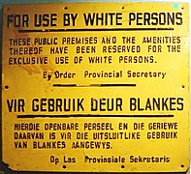

Figure 9: Sign restricting municipal services for whites only

(source: <https://commons.wikimedia.org/wiki/File:ApartheidSignEnglishAfrikaans.jpg> )

In 1993, 39% of all South African households had access to piped water inside their dwellings. However, among African households the percentage was only 18%, while for white households it was just under 100%. Similarly, while almost 100% of white households had a flush toilet, this was the case for only 34% of African households. In terms of grid electricity, again almost 100% of white households had access, compared to 37% of African households (Budlender: 2003).

Table 3 records the percentage of South African households in 1995 with access to formal housing; clean water; electricity for cooking; refuse removal services by the local authority; telephone or cell phone in the dwelling; and flush, chemical or pit toilets. This data reflects some progress in provision, which was made during the last years of apartheid regime. Indicators of provision of housing, water and toilets suggest reasonable provision. However, these blunt indicators do not differentiate between pit toilets or flush toilets, nor between household taps or communal taps for water – so the reality is much worse. Electricity, refuse collection and telephone connectivity were all still low, suggesting poor service provision in black areas.

Table 3: Percentage of households with access to services, 1995

|  |  |
| --- | --- |
| **Services** | **1995** |
| Formal housing | 65.8 |
| Clean water | 78.5 |
| Electricity for cooking | 55.4 |
| Refuse removal by local authority | 55.4 |
| Telephone or cell phone in dwelling | 29.1 |
| Flush, chemical or pit toilet | 86.6 |

(**Source:** Budlender, 2003: 177)

The data in Table 3 also does not differentiate between urban and rural areas. Non-urban areas were particularly hard hit in terms of lack of access to basic services. The difference between urban and non-urban was particularly marked in respect of access to electricity, refuse removal and access to telephones. The lack of access to telephones was particularly problematic, given that non-urban areas were at greater distances from most services and were generally less well-served by public transport. Not having land lines in this period meant extreme rural isolation.

Statistics SA revealed data on 13 rural areas that had been identified by the democratic government for accelerated rural development in 2002 – six years after the demise of apartheid. The average performance indicators for the 13 nodal areas included the following:

* 41% of households lived in traditional dwellings;
* Only 24% of households had piped water in the dwelling or on site;
* Only 18% of households used mainly electricity for cooking; and
* Only 18% of households had access to a flush toilet, chemical toilet or pit latrine with a ventilation pipe (Budlender, 2003).

This is the legacy of apartheid seven years into the advent of democracy. The provision of health services was also racially skewed – for example, access to medical aid coverage. According to the Council of Medical Schemes only 16% of the South African population belonged to medical schemes in 2000. This group of people received their health care primarily from private hospitals, where approximately 63% of medical skills were employed at a rate of 255 doctors for every 100 000 citizens. On the other hand, 84% of South Africans (predominantly African) were not members of a medical fund and depended on the public hospital system. Only 37% of SA’s doctors were employed in these public facilities at a rate of 29:100 000. Those with access to good health care comprised a relatively small group of people concentrated in urban areas, in comparison to most citizens, who lived in rural areas and who needed subsidised primary health care.

A third area of racial discrimination was in the opportunities available for employment. Table 4 illustrates the racial composition of artisans in 1990. Whites dominated the main trades in manufacturing, such as in metal and engineering, motor vehicle and electronics. However, Table 4 also reveals the interesting position occupied by African, Coloured and Indian artisans in the printing, building, furniture and jewellery industries. Part of the higher representation of black people in these sectors is historic – for example, many of those with slave ancestors, who were Malay and Indian slave traditional artisans, continued in these fields of employment. However, it was also an indication of the reforms of late apartheid, which allowed black people to enter these professions after 1981.

Table 4: The racial division of artisans across the skilled trades, 1990

|  |  |  |  |  |  |
| --- | --- | --- | --- | --- | --- |
| **Industrial sector** | **Africans** | **Coloureds** | **Indians** | **Whites** | **Percentage** |
| Other | 3 | 11 | 1 | 85 | 100% |
| Electrical | 6 | 7 | 4 | 82 | 100% |
| Metal and engineering | 9 | 9 | 3 | 79 | 100% |
| Motor | 11 | 9 | 5 | 72 | 100% |
| Printing | 17 | 21 | 14 | 48 | 100% |
| Building | 28 | 38 | 6 | 28 | 100% |
| Furniture | 38 | 47 | 6 | 9 | 100% |
| Jewellers and goldsmiths | 43 | 15 | 14 | 28 | 100% |

(**Source:** Central Statistics Services, 1990)

Table 5 highlights the dominance of the medical profession by white men. Males (64.9%) and whites (70.5%) dominate.

Table 5: The number of general practitioners who qualified at SA universities by population group and gender, 1991

|  |  |  |  |  |  |  |  |  |  |
| --- | --- | --- | --- | --- | --- | --- | --- | --- | --- |
| **Year** | **Total male** | | **Total female** | | **Total white** | | **Total Black** | | **TOTAL** |
| **N** | **%** | **N** | **%** | **N** | **%** | **N** | **%** | **N** |
| **1991** | 603 | 64.9 | 326 | 35.1 | 655 | 70.5 | 274 | 29.5 | 929 |

**Source:** Hall and Erasmus, 2003: 537

The racial profile of employed engineers is presented in Table 6 below. Almost 90% of professional engineers in 1990 were white.

Table 6: Racial profile of engineers, 1990

|  |  |  |  |  |  |
| --- | --- | --- | --- | --- | --- |
| **Year** | **African** | **Coloured** | **Asian** | **White** |  |
| **1990** | 2238 | 2704 | 1924 | 63205 | 72061 |
| **%** | 3 | 4 | 3 | 88 | 100 |

**Source:** Steyn and Daniels, 2003: 563.

Lastly, access to technical colleges (what are today referred to as TVET colleges) was highly restricted to separate institutions for different races. However, colleges for whites in the urban areas were the most well-resourced, and whites compromised 68% of enrolments in 1990. What is additionally significant about the data in Table 7 is the rapid pace at which black enrolments expanded once apartheid racial restrictions were lifted in 1994. Enrolments of whites in 2000 constituted only 12% of the total – a massive collapse of racial privilege in only one decade.

Table 7: College enrolments by race and gender (percentage), 1990 and 2000

|  |  |  |  |  |  |  |
| --- | --- | --- | --- | --- | --- | --- |
| **Year** | **Male** | **Female** | **White** | **Indian** | **Coloured** | **African** |
| 1990 | 61.7 | 38.3 | 67.8 | 8.3 | 6.4 | 17.6 |
| 2000 | 59.0 | 41.0 | 12.0 | 2.0 | 7.0 | 75.0 |

**Source:** Fisher, Jaff, L Powell and Hall, 2003: 337

In short, these snapshots of inequality in the apartheid labour market illustrate the wider exclusionary power of apartheid legislation – it trapped African people into low-skill, low-wage manual labour for their entire careers.

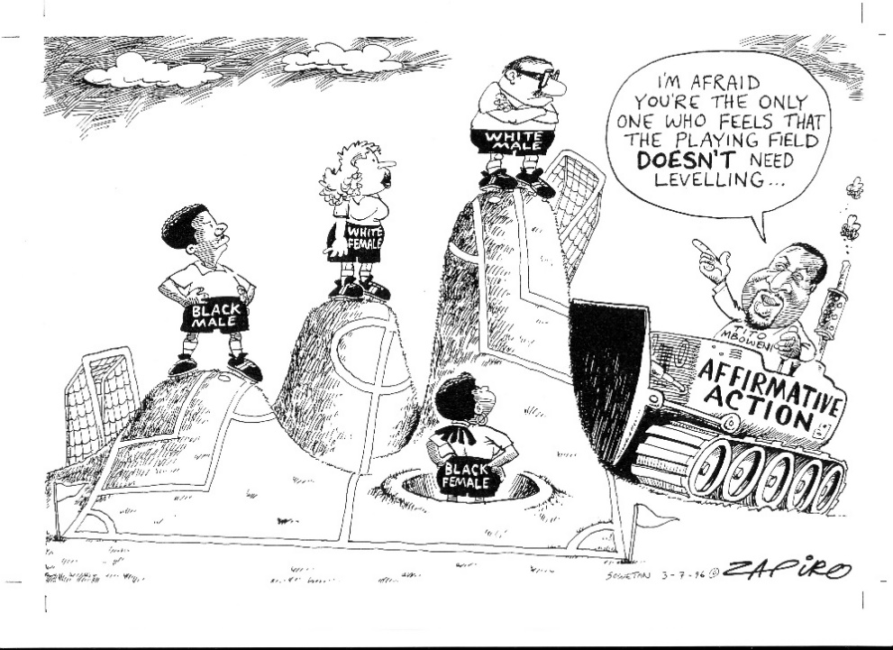

Figure 10: The politics of affirmative action

(Source: Permission granted by Zapiro)

Activity 7: The social conditions of apartheid

**Suggested time:** 60 minutes

1. Using the data from Tables 3 to 7, give examples of how white learners and graduates were advantaged by apartheid, and Africans were disadvantaged.
2. Re-examine Figure 10 above. It is about the unequal playing field experienced by black men and women as compared with the whites’ advantageous position in the economy and society. Again, using the data from Tables 3 to 7, write down your views on affirmative action (also termed black economic empowerment or BEE). Was affirmative action a legitimate programme initiated by the democratic government of 1994 to promote equality in the labour market?
3. In your view, did the affirmative action policies of government and industry succeed in resolving these problems today? Explain your answer.

Discussion of activity

The data in Tables 3–7 make the inequalities between white and black citizens quite clear. For example, Table 3 indicates that only 55% of households in 1990 had electricity, and this was used mainly for cooking. African learners at rural TVET colleges in this period probably did not have electricity for studying purposes at night. This is a major inequality.

Similarly, if you look at the tables describing the number of engineers and doctors, it is clear that whites in the early 1990s dominated these professions by huge margins. Additionally, whites also dominated the senior artisan trades, such as those in the engineering, electricity and motor sectors.

Therefore, affirmative action was a necessary policy to make the labour market a more equal playing field.

In Unit 3 (which examines the post-apartheid period) it will be interesting to see if your view of BEE remains the same, as corruption has emerged as a major problem in society, partly driven by BEE policies. Small black firms have been prioritised in government tenders, but often, the firm winning the tender looks black, but it is in fact fronting for a well-established white firm. Similarly, the coal supply to the Electricity Supply Commission (Eskom) is now a problem. In some cases, BEE firms have been given access to supply Eskom with coal. Many of these firms do not have the necessary technical expertise, and in some instances, the coal supplied has been of very low quality, resulting in serious damage to Eskom’s technical infrastructure. It is clear that the BEE policy framework, initially reflecting a noble goal, has been abused for corrupt purposes.

## The building blocks of apartheid

Let’s explore the key pillars of the apartheid system. There are four such building blocks:

1. A developmental state for whites only;
2. The mining, energy and chemical sectors, which lay at the heart of South Africa’s resource extraction economy;
3. A capable civil service that drove economic development from the 1920s onwards; and
4. Separate development, which created two highly unequal economies – one for whites, the other for blacks.

Each of these pillars will now be examined.

### A developmental state for whites

We discussed the developmental state as a typology of capitalism in Unit 1. Freund (2013) argues that white-ruled South Africa under apartheid can be described as a ‘developmental state under white rule’. The state shaped a dedicated professional civil service elite and created state-owned enterprises, both aimed at furthering industrialisation to the benefit of the white population.

South Africa’s development in the period from the discovery of diamonds and gold in the 1860s and 1880s respectively until the height of apartheid in the early 1970s was not the usual colonial project witnessed across Africa. This was because British colonialism did not anticipate the large-scale industrialisation or partnership with a local capitalist class that took place in South Africa. The usual result of colonial occupation was for the occupier to rule the colony directly with its own governance personnel. It was different in South Africa, with a local white capitalist class in charge of the economy.

Freund defines several waves of development from the 1880s onwards, which resulted in the emergence of the developmental state. The first led by Lord Milner (Governor of the Cape and High Commissioner of SA after the Anglo-Boer War of 1899–1901), was aimed at the reconstruction of a country ravaged and divided by war. The second and more influential development wave was the period of the PACT government, which established Iscor, the first state-owned company to emerge and which focused on the production of iron ore and steel. The PACT government, formed between the National Party and Labour Party between 1924 and 1929, also introduced import tariffs to protect local industry. This move signalled the start of what became a programme of import-substituting industrialisation, which lasted into the late 1980s.

The third wave – and ideologically the most significant – was in the post-war period, with the National Party’s victory in attaining political power in 1948. What stands out for Freund (Freund, 2013: 94) was a ‘remarkable period of planning much of which can be labelled as developmental’ – although in a racially exclusionary form. This planning entailed several commissions from the 1950s onwards, which mapped out the socio-economic contours of apartheid policy in minute detail. The state also consolidated its R&D capacity in this period – with the Council for Scientific and Industrial Research (CSIR,) the Industrial Development Corporation (IDC) and the Human Sciences Research Council (HSRC) all being formed in the 1940s. The fourth wave of development, which occurred in the late 1960s through to the 1980s, comprised the development of military power with the establishment of Armscor and included the emergence of a significant private sector manufacturing capacity around the armament needs of the state.

Beinart (2001) concurs with this overall assessment of South Africa’s development path. He describes apartheid as an ‘economic nationalist project’ aimed at using the state to build a developed Afrikaner capitalist society. Beinart was here referring to the state-owned monopolies that controlled 25% of manufacturing by the 1970s.

### The rise of a natural resource extraction economy

The second building block of apartheid has its roots in the colonial period. More specifically, with the advent of the second industrial revolution in the 19th century, European powers faced a huge demand for natural resources to enable their economies to grow. This was a period when major advances were being made in mechanised machinery (linked to conveyer belts that enabled mass production of goods), the emergence of the internal combustion engine giving rise to cars, trucks and buses, and last but not least, an external railway system that acted to speed up the logistics of factory production. Because of these developments in Europe, demand for natural resources from colonies in Africa, Southeast Asia and South America continued to grow.

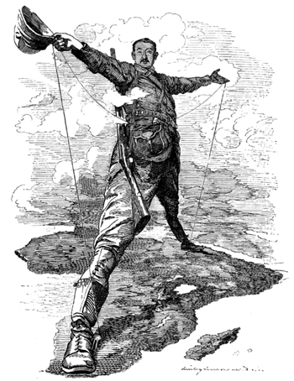

Figure 11: Cecil John Rhodes and his aspirations for the British Empire to conquer the entire African continent

(**Source:** <http://www.sahistory.org.za/sites/default/files/463px-punch_rhodes_colossus_copy_small.png>)

Figure 11 graphically represents the colonial project led by Cecil John Rhodes, Prime Minister of the Cape Colony from 1890 to 1896. Rhodes proposed a railway line from Cape Town to Cairo, in an attempt to connect the British Empire’s adjacent African possessions: South Africa, Rhodesia, Botswana, Zambia, Kenya, Uganda, Tanzania, and Egypt. The plan was never fully realised but reflected the brutal aspirations of conquest and resource extraction during the colonial era.

Fine and Rustomjee (1997) examine this extraction economy as it evolved after the Second World War. They argue that it gave rise to a mineral energy complex in the post-war period that was defined by the diversification of mining interests into manufacturing and the development of local energy and chemical manufacturing capacity. (Both energy and chemical production are offshoots of mining.) These authors argue that the development of a local mining capitalist class aided the process of building a mineral energy complex because their contributions to output, employment, exports and state revenue were crucial to the modernisation and growth of the South African economy. By the mid-1980s gold alone still accounted for more than half of the total South African exports.

As indicated above, the growth of a local capitalist class was a key feature of this process of development. These local capitalists emerged through the growth of several very large corporations:

* in mining (Anglo American, Gold Fields and De Beers);
* in manufacturing: textiles (the Frame Group), tobacco (Rembrandt), forestry, paper and pulp (Mondi and Sappi), alcoholic beverages (South African Breweries); and
* in banking (Standard, Barclays, Sanlam and Volkskas).

Beinart notes that by the late 1970s, Anglo American had diversified into more than 150 manufacturing, finance, news, agricultural and property companies. The company controlled a major slice of the entire national economy.

This long history of extraction in former colonial territories continues to this day and has defined the major role of these developing economies as sites for ‘natural resource extraction’. South Africa is a leading example of these economies. Being a resource extraction economy has become a trap for many countries. It has denied South Africa the ability to add value to raw materials such as iron ore, cotton, timber or agricultural crops such as coffee beans. Such value-adding in manufacturing has largely happened in Europe and the USA.

In short, natural resource extraction routes have often led to the under-development of the manufacturing sectors in those countries exporting natural resources. More recent attempts to catch up with the manufacturing exports of advanced economies have failed because these former colonial economies do not have the internal expertise to change from natural resource extraction to manufacturing exports. If they do succeed in adding value to natural resources, the products often cannot match the competitiveness, price, quality and innovation of European, USA and Southeast Asian exports.

Activity 8: Resource extraction, exports and imports

**Suggested time:** 30 minutes

1. The main function of a resource extraction economy is to export the raw materials that are mined in that economy. Can you think of three natural resources that are mined in South Africa and then exported?
2. Are these natural resources exported in raw form, or do they undergo some manufacturing processes before being exported as higher-value-added products in demand in the world economy?
3. Do we import products made from the natural resources we export? Think of steel products, high-quality paper or jewellery.

Discussion of the activity

The three questions above are designed to assist you in understanding a key feature of our national economy as developed under apartheid in the period from 1948 to the early 1980s. The biggest earner of profit for companies based in South Africa has been the export of raw materials. These raw materials – gold, diamonds, iron ore, cotton, timber chips and pulp – have all been exported without any addition to their value through manufacturing processes. For example, we exported gold and diamonds for the jewellery industry globally, but we have a very small local jewellery industry. Similarly, iron ore and steel are exported after limited value-addition to make steel from the iron ore. The steel is then exported to make steel-based manufactured products in Europe, the USA and East Asia. Timber chips are also exported in raw form, to become pulp – a key input in the manufacture of high-quality paper used in the more advanced economies of the world.

The next section shows that, although South Africa’s endowments of natural resources are a major plus, they are also a curse – in that South Africa’s manufacturing sector did not develop sufficiently. The apartheid economy had to import all these more advanced manufacturing products from the advanced economies of the world. These imports became very expensive once the exchange rates started to rise from the 1980s onwards. Today, key imports like digital technologies are far too expensive for small manufacturing firms to import because of unfavourable exchange rates (the exchange rate has been operating above 16 rands to the US dollar for the last few years). This makes imported goods expensive.

### A capable civil service

The third building block of apartheid was a capable civil service. The National Party, on its victory in 1948, immediately began replacing the largely English-speaking civil service leadership with people from loyalist Afrikaner ranks. Many were devoted, as Dubow (2014: 16) writes, to purist apartheid thinking, viewing it positively as the separate development of equal nations. Dubow provides the example of Verwoerd’s Secretary of Native Affairs, Werner Eiselen, who in the 1950s did much of the foundational thinking in relation to building apartheid. Like Verwoerd, he had worked as a professor at Stellenbosch University. The concept of a positive apartheid was Eiselen’s construct. He sought to restore African culture to an idealised ‘tribal’ state. These two men – Eiselen and Verwoerd – as Head of Department and Minister, ‘used the Native Affairs Department to fashion the idea of apartheid into practical existence’ (Dubow, 2014).

Eiselen was not the only senior civil servant committed to the apartheid system. Freund (2013) paints a picture of a vast civil service deployed to various planning commissions in the period after 1948, in which all the key details of apartheid policy were formulated. Planning was also strengthened through the greater utilisation of state R&D institutions such as the CSIR, IDC and HSRC. Institutional leadership of the state-owned enterprises also played a major role. An example cited by Freund is the figure of Hendrik van der Bijl who became head of Eskom and Iscor during this period and was instrumental in their growth and success (Freund, 2013: 98). He also promoted South Africa’s nuclear potential, particularly its vast resources of uranium, which was in demand across the globe. Freund’s last example of a developmental civil servant was Eugene Malherbe, an educationalist, who understood the need to strongly link education’s purposes to the capitalist economy – firstly, for the Afrikaner working class youth who needed training and economic upliftment, and secondly, for young Africans, who, in terms of apartheid policy, should be trained to pursue their own largely agricultural needs in their own ‘tribal’ areas. Freund saw the construction of this dedicated and skilled civil service as perfectly fitting another criteria of a developmental state –to possess a cohort of professionally trained civil service elites loyal to the developmental project at hand (Freund, 2013).

### Separate development

The fourth building block of apartheid was the racial segregation of society through policies known as ‘separate development’. Building on what had been established by British mining interests through their segregationist policies, apartheid planners constructed the huge apartheid structure of ‘separate development’ from 1948 until the late 1980s. They had one aim – to manage the delicate balance between freeing up a cheap African labour force from the rural areas without enabling a massive process of urbanisation into the towns and cities. The need to manage this reciprocal relationship was central to apartheid policies. Cheap African labour from the countryside needed to be made available, while ensuring that they continued to live in the countryside and not in the urban areas close to white settlements (Dubow, 2014). Thus, migrant workers lived in temporary barracks in the townships, but were forced to return to their family homestead in the so-called Bantustans during periods of leave.

This phenomenon has created what President Thabo Mbeki described in 2004 as South Africa’s ‘two economies’ – one for whites, the other for blacks. What was achieved over a period of about 40 years was to create a powerful divide between black poverty and white privilege, which still characterises South Africa today in almost all spheres of socio-economic activity (Hart and Padayachee, 2013).

The racial structure built up to achieve these goals has been widely documented by historians, some of whom have already been cited here. In this section, a brief sketch is provided of the separate development measures that were introduced.

The migrant labour system and all its influx control mechanisms (primarily the need to always carry a passbook in white areas) were central to this racial system of control (Dubow, 1989). They were accompanied by policies to develop the labour reserves in the countryside, which by the 1950s and 1960s had evolved into formal propositions about self-governing homelands and independent Bantustans. These ‘tribal’ territories were small allocations of land in the rural areas made to Africans in the 1913 and 1936 Land Acts. The bulk of productive land had already been conquered by force during the colonial era – to the benefit of white agriculture and white settlement (Dubow, 1989).

Other apartheid laws that were passed during this time included the Group Areas Act of 1950, which formalised an already segregated residential system in white towns and cities. However, there were cracks in the system and a few mixed residential areas did exist – such as District Six in Cape Town, and Sophia town in Johannesburg. These areas were brutally and systematically shut down by the apartheid state.

Education was perhaps the most destructive of apartheid’s laws imposed on African people. The Bantu Education Act of 1956 prohibited black people from entering white education and training institutions, which were restricted for whites only. Training institutions were seen in developmental state terms as a means of providing a range of vocations for Afrikaner youth who would otherwise have faced unemployment or low-skill labour. The resultant damage done to African education has not been erased since the demise of apartheid.

Activity 9: Separate development: Have things changed?

**Suggested time:** 30 minutes

The discussion above about the four pillars of apartheid highlights how separate development (or racial segregation) pervaded the entire society during the apartheid era – separate ‘homelands’, separate legal rights (blacks could only own property and vote in their homelands), segregated education, and a segregated labour market which denied black South Africans access to skilled jobs in the white economy. There is a strong view today that apartheid has been difficult to dislodge in its entirety because it was so cemented in our society and economy. Even with new policies under the democratic government since 1994, many of the building blocks of racial segregation still prevail.

1. In your learning journal write about three features of the apartheid system that you think have not been eradicated yet, and why you think they have been difficult to undo.

Discussion of the activity

This question is encouraging you to make a comparison between socio-economic life under apartheid South Africa in the early 1970s, when the apartheid system was at its height economically, and socio-economic life now. The most prominent feature of apartheid that has been impossible to change is the geographical structuring of our urban cities and towns. White suburbs were built on the best land and close to the central business districts (CBDs). In comparison, black people were housed in townships and squatter camps, with minimal social infrastructure. All these black township sites were located very far from the CBDs and key industrial zones – the latter being the location of most jobs. This geographical inequality has not been redressed much – the cities remain socially segregated. Most blacks still live in the townships and squatter camps. Most whites (with a small grouping of middle-class blacks) continue to live in the suburbs.

Another area suffering from limited change is the education system for black South Africans. These schools may have received additional infrastructure from the democratic government since 1994 (more permanent brick-and-mortar classrooms replacing the old prefabs and new science and computer labs), but they remain impoverished institutions with poor education outcomes. (You are probably familiar with all the school inequalities between white and black schools. List some of them.)

A further example of insufficient change lies with the TVET colleges. At the end of apartheid there were 150 college campuses across the country. However, many were in the homelands and townships, with poor technical infrastructure (old technologies) and poorly trained college lecturers. Employers and jobs were located far from these colleges. In contrast, the colleges located in white South Africa were well resourced, with good lecturers and strong links to employers. White graduates got jobs, many of them became artisans. Unfortunately, this apartheid-induced geographic division still exists amongst the 50 colleges that emerged after merger reforms were introduced in the early 2000s. Today, the college campuses located in former white areas and business districts do relatively well. The college campuses located in the old homeland areas continue to struggle.

## Key economic concepts required to understand apartheid’s political economy

It is now necessary to introduce a few important economic concepts that are linked to the idea of a resource extraction economy – which we have already discussed. There are two additional economic concepts that will assist us in understanding the severe economic difficulties that set in from the mid-1970s onwards. These concepts are: import-substitution economic policies; and export-oriented economic policies.

### Import-substitution economic policies

As already indicated in the text above, the main economic activity under colonial and apartheid rule was resource extraction, with most raw materials exported to Europe without any value-adding. How then did the South African economy produce or acquire goods for its own consumption needs?

The answer lies with import‑substituting industrialisation. This was an economic strategy popular in many developing economies from the 1940s through to the early 1980s as they sought to move beyond resource extraction and build local manufacturing capacity. This was achieved by supporting emerging industries through the application of import tariffs (adding additional costs to imports to make them more costly and therefore less attractive than locally produced goods) and state subsidies for the local production of consumer goods. Subsidies were a means by which the state was able to help local capitalists by subsidising the costs of establishing local manufacturing firms. It was an important policy option during this time because it assisted developing economies in overcoming the unfair terms of global trade, which made it unwise to rely solely on the export of primary products. In South Africa, import-substituting industrialisation was used from the 1920s until the mid-1990s to support white living standards through the employment of white labour and the manufacture of local consumer goods aimed at the white consumer market.

### Export-oriented economic policies

Export-oriented economic strategies are seen as the natural replacement for earlier import-substituting industrialisation strategies. An export-orientation began to be emphasised from the 1980s onwards.

Let us use a comparison between South Africa and Malaysia to understand this shift and its benefits. The economic paths of Malaysia and South Africa have been compared by policy analysts. Both countries were former colonies of the British, both adopted import-substituting policies, and both were at the same level of economic development in the 1950s. However, Malaysia today has overcome its dependence on income derived from exporting natural resources (mainly rubber) by developing its own manufacturing base. In the 1960s, it adopted an export strategy based on the manufacture of cheap electronic goods such as computer motherboards and other electronic components. This strategy required enticing foreign firms to invest, the creation of several export processing zones, and the development of a cheap semi-skilled labour force.

After the success of this strategy, in the 1980s Malaysia then gradually moved towards higher-value-added exports (the production and assembly of complete electronic goods rather than just specific components), which required a significant technological upgrade of the entire production system. Malaysian economic policies then emphasised the science and technology components required for technological upgrading – acquiring and adapting the new technologies, expanding R&D, and building a more skilled workforce.

In contrast, South Africa today remains trapped in the mineral extraction role of exporting raw materials. It has been unable to build the manufacturing sector to export value-added manufacturing products, like Malaysia and the other Southeast Asian developmental economies have done.

The shift to export-oriented economic policies was promoted by the rise of neoliberal politics in the 1980s (see Unit 1) through its emphasis on open economies and global free trade and the reduction of the state’s role in the economy. Export orientation became the mainstream economic policy from the 1980s onwards.

### Neoliberalism and global free trade

Most of the policy levers of import-substitution policies were abandoned in the 1980s and 1990s. These included restrictions to open trade such as subsidies from government for key industries such as agriculture and food production, and tariffs on imports. The collapse of these benefits forced developing economies to upgrade their manufacturing sectors so that local products could be competitive on global markets. Many Southeast Asian countries (Singapore, Hong Kong, South Korean, Taiwan and Malaysia) adapted well to this challenge. However, apartheid South Africa in the 1980s and early 1990s didn’t fare as well.

It is still a problem we face today – our manufacturing sectors are not competitive in global markets. Import-substitution policies provided a protective shield over the apartheid economy from the 1940s until late 1970s, which allowed local firms to produce products without worrying about cheaper imports. However, this backfired in the 1980s onwards as noncompetitive companies in metal, clothing, textiles and furniture struggled to halt the competition from China and other Southeast Asian economies. Many South African firms in these sectors closed in the 1980s and 1990s, as cheaper and better-quality imports were allowed in under the guise of global free trade and open economies.

Activity 10: Exports and imports

**Suggested time:** 30 minutes

1. You have just read about Malaysia, and how it has succeeded in transitioning from import-substitution to export-oriented economic policies. Why do you think these policies were successful?
2. Read the following clothing brand advert and then answer the question below:

*Maxhosa Africa is a South African knitwear brand founded in 2010 by Laduma Ngxokolo. Laduma’s vision was to create a modern Xhosa-inspired knitwear collection. Along his journey into exploring traditional Xhosa beadwork patterns, symbolism and colours, he discovered that they would be the best source of inspiration for knitwear, which he then reinterpreted into modern knitwear. Maxhosa designs showcase the beauty, culture, language and aspiration of the Xhosa people. Evolved and amended in a modern way and in a current design context it translates into a form that resonates with multiple fashion markets globally* (Maxhosa newspaper advert).

Why do you think Maxhosa Africa has failed to establish a strong export presence in foreign clothing markets, even though they offer a beautiful and unique product to the world?

Discussion of the activity

Malaysia, which was at the same level of economic development as South Africa in the 1950s, did benefit from import substitution as the first stage of their post-war economic policy. Local industries did well, especially in the newly emerging ICT sector. However, the shift to neoliberal economic policies emphasised global free trade and open economies. This meant that Malaysia would need to shift towards export-oriented economic policies – the second stage of their economic development. The most important change was the upgrading of the manufacturing sector to produce higher-value-added products. This required a more skilled labour force and the utilisation of the latest technologies. Malaysia managed this transition extremely well. South Africa did not.

Maxhosa, as a South African clothing company, faces many obstacles today. They face the difficulty of entering the very big and competitive high-end clothing markets of the world, and secondly, they face demands for high-quality products delivered on time. Building an export ‘brand’ from scratch is a challenging task. Accessing global markets is very difficult, especially for small firms and start-ups. Maxhosa has made some inroads here, but the route remains difficult.

## The decline of the apartheid economy

With the three economic concepts of natural resource extraction, import-substitution and export-orientated economies in hand, we are now ready to begin to understand why this repressive apartheid system began to crumble from the mid-1970s onwards.

The apartheid system, with its sophisticated form of developmental state, was successful only for a limited period. As indicated above, by the 1970s a range of problems began to emerge. Apartheid’s economic crisis had several interrelated dimensions. The crisis had an international dimension (South Africa’s heightened vulnerability to external global ‘shocks’ like the oil crisis of 1973 and the financial crisis of 2008) and a political dimension (the massive internal upsurge in labour and community‑based struggles since the mid‑1970s). Other determinants of crisis included global trade sanctions, which are estimated to have cost South Africa in the region of 20 billion dollars between 1985 and 1990 (Kaplinsky, 1990).



Figure 13: Anti-apartheid protests in Amsterdam calling for economic sanctions

(Source: <https://upload.wikimedia.org/wikipedia/commons/thumb/d/dd/Demonstratie_tegen_apartheid_Zuid_Afrika_in_Amsterdam_spandoek_met_Apartheid_i%2C_Bestanddeelnr_933-0714.jpg/640px-Demonstratie_tegen_apartheid_Zuid_Afrika_in_Amsterdam_spandoek_met_Apartheid_i> )

But it was the internal crisis within apartheid that was most critical. The next section discusses four major causes of this internal crisis:

1. The rise and fall of the South African manufacturing sector;

2. The collapse of apprenticeship training in the manufacturing sector;

3. Urbanisation and skills shortages; and

4. The slow de-racialisation of the labour market in the 1970s and 1980s.

### The rise and fall of the South African manufacturing sector

The manufacturing sector in South Africa grew at an impressive rate from the 1940s onwards. It soon became the dominant sector of the South African economy in terms of contribution to gross domestic product (GDP) as well as employment. By 1943 manufacturing had already overtaken mining as the largest contributor to GDP. During the boom era of the 1960s, manufacturing overtook agriculture as the largest employer of labour (Hindson, 1991).

By the late 1960s, South Africa was riding the crest of an economic wave. But this economic miracle ‘had feet of clay’ (Abedian and Standish, 1992). While GDP grew at a healthy rate of approximately 5% throughout the 1950s and 1960s, this growth rate plummeted during the 1970s and 1980s to a mere 1.1% in the 1980–1985 period, with individual years attaining negative growth. The slowdown in overall economic growth was acutely reflected in the fortunes of the manufacturing sector. One indicator of this was the substantial reduction in employment capacity during the 1980s.

A second indicator of crisis was that the contribution of manufacturing to GDP had shrunk. This percentage remained relatively static in the period 1965–1987, at the level of approximately 23% of GDP. This contrasts sharply with the experience of other developing economies, whose manufacturing contribution to GDP continued to grow. For example, in South Korea, the manufacturing sector’s contribution to GDP grew from 18% in 1965 to 30% in 1987.

South Africa’s import-substitution policies were aimed at building and protecting white economic privilege and the large-scale employment of white labour. The 1950s represented a critical period in the evolution of import-substituting policies. This was a period when import‑substituting manufacturing strategies focused on the enhancement of white living standards through the manufacture of consumer durables. By focusing on this narrow consumer market, the white capitalist class chose not to concentrate on the production of basic manufactured goods aimed at a larger, local mass market (for white and black consumers) and/or for the export market, as did the many newly industrialising countries during this period, who today are very successful exporters of manufactured products.

Ironically, the fact that import substitution was reliant on the existence of a highly skewed distribution of income in favour of privileged whites has constituted one of the greatest constraints on further growth. The logic of apartheid capitalism, which gave rise to a narrow (white) market for relatively sophisticated consumer goods, but which kept black wages low, meant that import‑substituting opportunities would ultimately become exhausted. This occurred by the mid‑1970s. During this period, white purchasing power peaked. Blacks historically were never a major part of the local consumer market for South African manufactured goods. The absence of a large local mass market therefore has denied South Africa the ability to exploit economies of scale in low-value‑added, labour-intensive consumer goods. This, in turn, has denied South Africa the benefits of value-adding and exporting – whereby incremental shifts in production, from low-value‑added production for the internal mass market towards higher-value‑added goods for the export sector, could be attained.

### The collapse of apprenticeship training

The second component of the economic crisis was the collapse of apprenticeship training. This occurred because one of the main consequences of manufacturing decline as described above was the decision by employers, in the face of poor economic performance, to cut costs, end training programmes and retrench workers. This is exactly what has happened to apprenticeship training in South Africa.



Figure 14: Total number of apprentices qualifying as artisans, 1970–2004

(Source: Indlela)

You can see from Figure 14 that the apprenticeship system remained strong until the mid-1980s when the graduation of artisans peaked at 13,500 in 1985. However, by this time severe problems had already set in, triggering a dramatic decline in enrolments in apprenticeship in key economic sectors.

The declines highlighted in Figure 14 are reflections of the severe economic recession that set in during the mid-1980s and that lasted well into the post-apartheid political dispensation after 1994. Why did this decline happen? When facing recessionary conditions (there is a decline in economic activity nationally, the price of goods rises and the demand remains low), firms will struggle to make a profit.

One of the ways of coping with recession is to introduce austerity measures (strict rules) to reduce costs and improve profit margins. This entails retrenchments, cancellation of training schemes and freezes on annual salaries increases. Another way is to use semi-skilled workers to doing more standardised work like fitting cabinets in kitchens and avoiding complex tasks that would require artisans. Another strategy is to poach experienced artisans from other firms, thereby avoiding the high costs of four years of training. A final factor is the lack of interest expressed by young people in doing a trade (especially when the sector is in economic trouble), making it even more difficult for employers to find good apprenticeship recruits.

In short, these economic difficulties force employers to be cautious. They begin to adopt conservative strategies, such as producing standardised goods for the local market to avoid the higher production demands of value-added products for the export market.

Activity 11: Collapse of apprenticeships in your college

**Suggested time:** 60 minutes

1. Copy the following table into your learning journal. Fill in the estimated numbers to record the student and programme enrolment profile of your college for last year.

|  |  |  |
| --- | --- | --- |
| **Programme composition of the FET college system by programme type, for last year** | | |
| **Programme** | | **Last year enrolments** |
| 1 | N1–N3 (FET level provision) |  |
| 2 | N4–N6 (post-FET provision) |  |
| 3 | NC(V) |  |
| 4 | Apprenticeships |  |
| 5 | Learnerships |  |

1. Now answer the following questions in your learning journal:
2. What is the most popular programme that students enrol for in at your college?
3. Do they acquire jobs with this popular programme?
4. How do you feel about graduates from your programmes facing unemployment after you have taught them for so many years?
5. Did a decline in apprenticeship occur in your college over the past two decades? What do you think caused this decline? Ask your older colleagues who may recall the reasons for this decline.

Discussion of the activity

In answering these questions, you will first need to gather data on programme enrolments at your college. They don’t have to be totally accurate. An informed estimate will be fine. The data on N1 and N2 courses are important, because these old programmes are still prerequisites for enrolment into apprenticeship schemes. Where do your N1–2 graduates go – into apprenticeships or some other programme?

If apprenticeship used to be offered at your college and then numbers declined (and/or it was terminated), try to find out from colleagues what were the main causes for this. As you saw in the reading before the activity, the decline could be because of recessionary conditions and the high cost of training. It might also be a lack of interest in these apprenticeship fields from young people. Or it could be that students were enticed into learnerships with their generous stipends. It is easier to get into a learnership with a stipend offered by a SETA than to be chosen by an employer to train as an apprentice. However, learnerships are not normally considered equal to an apprenticeship, and few learnership graduates get jobs. So that route has proved to be problematic as well. Where do your learnership students go after graduation? Are they employed? The module on ‘TVET: The history and policy’ may address this, in the section on apprenticeship policy.

### Urbanisation and skills shortages

A third internal problem triggered the apartheid economic crisis of the 1970s and 1980s. This was the mass urbanisation of hundreds of thousands of black South Africans from the countryside into the cities in search of jobs. This phenomenon eliminated a key pillar of apartheid’s unique form of racial capitalism – low wages that were enabled and perpetuated by the migrant labour system. Throughout the post‑1945 period, urbanisation was not allowed to proceed, even though the ability of the rural economy to support black families had collapsed. Overpopulation, land erosion and abysmal levels of infrastructure in the rural areas made it difficult for people to continue living off the land. The incompetent management of rural economies by homeland bureaucracies worsened the plight of people forced to reside there.

So, it was not surprising that by the 1980s urbanisation had become the most impactful social phenomenon in every metropolitan centre in South Africa. Cities and towns were faced with a massive population explosion, and had insufficient infrastructure and employment opportunities to accommodate the numbers. Coinciding with this process was a sharp rise in the levels of black unemployment and a massive growth in informal sector activity.

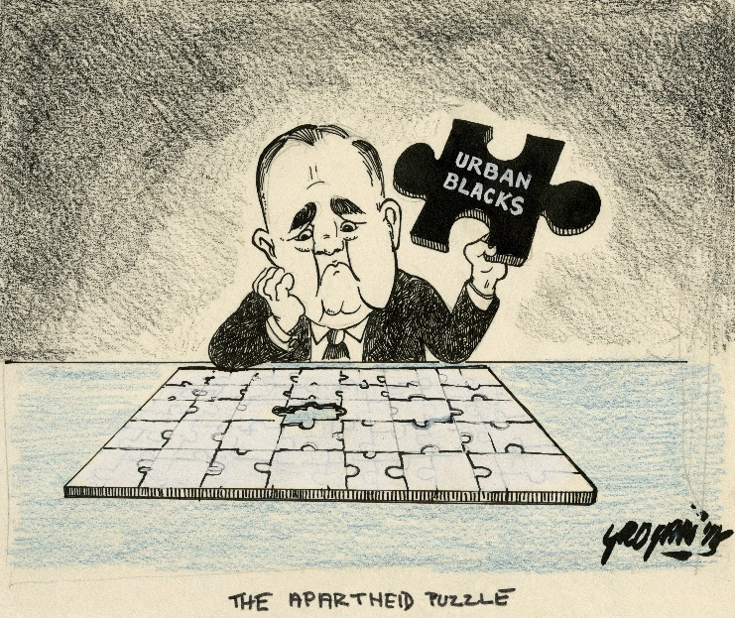

Figure 15: Prime Minister John Vorster ponders the African urbanisation dilemma

(Source: Permission granted for publication from UCT digital libraries and Tony Grogan, the cartoonist)

In the light of these problems, the apartheid government was forced by the mid‑1980s to introduce certain important reforms to its overall political economic framework. The first important change came in 1985 with the President’s Council publication of *An Urbanisation Strategy*. This report promoted the idea of ‘orderly urbanisation’ and suggested that African urbanisation was both inevitable and economically desirable. The report abandoned the old apartheid concept of territorial segregation and accepted the reality of a highly interdependent and interconnected set of economic relations between black and white South Africans (Morris and Padayachee, 1989).

The report recommended that reforms were needed to stabilise rather than undermine the process of black urbanisation. In July 1986, the state adopted much of the report’s recommendations and abolished key influx control measures such as the pass laws. The state also changed its position regarding urban settlements. It embarked on a policy that sought to differentiate between the settled and employed urban African working class of the cities and towns (the core labour force), and those who would be settled in highly controlled settlements on the peripheries of the urban areas (the peripheral labour force). The key social thrust of this new policy was decentralised apartheid and social differentiation: massive peri‑urban settlements were created outside of the stabilised urban areas.

The key economic thrust was two‑fold. A stabilised African workforce in the cities with better wages, social services infrastructure and job opportunities would generate greater demand for basic consumer goods. The large settlements on the periphery of the urban centres would also provide labour for decentralised, low-wage, labour-intensive small business and a kickstart to a more vibrant informal sector. The entire urbanisation strategy was viewed as a way of generating new opportunities for increased domestic demand, employment and economic growth.

The new urbanisation policy vision of the apartheid government was that ‘increasing urbanisation will create a demand for low‑cost goods; in turn the production of these goods will create income and further demand resulting in increases in income, employment and physical well‑being’ (Standish, 1992: 119). All these principles were enthusiastically adopted as official government policy. Government also stressed the growth of small businesses and the informal sector. After 1986 state efforts were focused on the deregulation of the economy and labour markets, in order that the informal and small business sectors could flourish.

### The slow de-racialisation of the labour market in the 1970s and 1980s

Strongly associated with the process of black urbanisation during this period was the slow de-racialisation of the apartheid labour market. For example, while the percentage share of whites employed in professional and semi-professional jobs declined progressively throughout the 1970s and 1980s, African employees’ share of jobs in these occupations increased noticeably.

The most important change occupationally, however, was the transition of African unskilled labour into semi-skilled labour, which began occurring in the late 1960s and 1970s. For example, by 1977, Africans constituted 67% of all semi-skilled labour in the metal industry, while whites occupied 16.4% of semi-skilled jobs. The converse applied a mere decade earlier. Hindson concludes from these figures that by the 1980s the number of African semi-skilled workers exceeded 2 million, thereby ‘superseding the unskilled African proletariat as the numerically dominant stratum of the African working class’ (Hindson 1991).

At the same time as this dilution of racial discrimination in the labour market, there was a marked increase in the education levels of the African population in the 1970s and 1980s. The percentage of African people with no formal education decreased from 41.1% in 1980 to 25.1% in 1991. The percentage of Africans with matric rose from 1.2% to 6.3%. However, even though these shifts reflect important social changes, the inequalities in the distribution of education and vocational skills remained. In 1991, 90% of white South Africans had obtained the junior secondary certificate, while the statistic for Africans was 20.5%.

## The skill shortages debate in the 1960s–1980s

Given all these labour market changes, it was not surprising that employers in the 1970s and 1980s complained about the need for a more skilled black workforce permanently resident in urban areas closer to places of employment. The educational deficit implicit in Verwoerd’s ‘Bantu Education’ policy was now kicking in, with shortages of machinists, artisans, technologists and engineers throughout the urban economy.

The rapid upskilling of over 2 million African workers from unskilled jobs to semi-skilled jobs – as discussed earlier – posed new problems. Amongst these new semi-skilled industrial workers there were also skill shortages such as an adequate degree of literacy, numeracy, technical comprehension, communication and paperwork skills. As a result of inferior ‘Bantu Education’ and inadequate industrial training, most African workers groomed for unskilled manual labour had not had sufficient education and training to develop these skills. Neither had they received an adequate general education that could serve as a foundation for further learning. These skill and educational deficiencies presented serious problems for employers who required a flexible semi-skilled labour force: workers who were capable of being easily retrained on‑the‑job, in the use and application of new machine technologies. With the rapidity at which technological innovations were occurring in this period (the era of the third industrial revolution) this problem became more acute.

The development route chosen by the apartheid state had a fundamentally negative impact on education and training. The legacy of import industrialisation and its massive dependence on foreign technology and know‑how denied South Africa the opportunity of developing local R&D expertise and ICT. Little higher-value‑added production was taking place. Value-added production, as defined in Unit 1, is the central activity of a manufacturing sector. Ideally, any country seeking development and growth should not be satisfied with just exporting its raw materials to large economies (for example, the US, European Union and Chinese economies) that require these inputs. Rather, it should seek to add value to the raw materials before looking for export possibilities. A good example would be to convert raw timber logs into furniture and/or paper and pulp. Unfortunately, many developing countries (most of whom historically were colonies of the European powers) have become trapped into exporting mineral and agricultural resources without any additional value-added to them through manufacturing processes.

Value-adding is also a critical pre-requisite for the manufacturing sector to access export markets. In fact, the higher the value-added, the better are the chances of success in export markets. This is because most consumer items have become very sophisticated products, shaped by new digital technologies and new design ideas (think how new car models change in design every year). In addition, the higher the value-added, the higher the price, and therefore the greater the prosperity for those countries that export. The big challenge, then, for all developing countries is to move up the value chain of products from low-value basic goods to more value-added tradeable items in demand on world markets.

This upgrading process requires both higher skills and the new technologies. The apartheid economy lacked both these key elements. A major limitation on South Africa shifting to greater value-addition is that our country has not been able to build up a well‑trained and experienced corps of industrial engineers and technicians needed for such an upgrading to higher-value-added production. The advanced and newly‑industrialised economies could only be effectively exploited through the plentiful supply of skilled labour. Thus, with the development of new computer‑led technologies and digitalisation, South Africa was destined to fall even further behind.

Activity 12: Black urbanisation in apartheid South Africa

**Suggested time:** 60 minutes

You have just read about urbanisation, de-racialisation of the labour market and skills shortages. You might want to read the text again and think about the following questions while you are reading. Then write down your thoughts in your learning journal.

1. Low wages and low skills were central factors in the economic success of apartheid up until the mid-1970s. Why do you think having an African labour force with low wages and low skills benefited apartheid so much?
2. Why did the rapid urbanisation of African migrants from these rural homelands and Bantustans threaten the economic foundations of apartheid?
3. How was the demand from employers for higher skills linked to this social process of African urbanisation? (Use the section above on the skills shortages to inform your answer).

Discussion of the activity

Question 1: Apartheid deliberately engineered a low-wage system for African workers. Its racial segregation policies sought to create two separate, unequal economies as a key building block of apartheid – one for Africans, the other for whites. This strategy was fundamentally about keeping African people linked to their ancestral land in the homeland areas so that they could be considered temporary workers in the white cities, factories, mines and farms. Also, by retaining a forced link to a homeland, the wage paid to African workers in the mines and city factories could be lower, because employers did not need to concern themselves with the social costs of employment in a city or mining town – costs such as transport to work, schooling and crèches. And finally, the low wages that African migrants were paid could be justified with the argument that they had access to some land and food production in the homelands, and hence, could supplement the wages with this additional resource (food).

Question 2: The rapid urbanisation of African workers from the rural homelands and Bantustans into the white cities was a major blow for apartheid policy, because it broke the causal link between the low wages paid to African workers being made possible by the subsistence income they derived in the rural areas. Also, under apartheid policy, their family (ancestral) home was understood to be based in a homeland, which freed employers and the government from the responsibility of housing millions of newly urbanised workers in the cities. With urbanisation, these economic benefits fell away. African workers had no home to go to in the white cities, and so they established vast (initially) illegal squatter camps near the white cities. Today these camps are massive black townships with millions of permanent black residents. The benefits of the homelands system fell away.

In addition, controlling migration to the cities also meant that the bulk of African people lived in the homelands up until the 1960s and 1970s. This served the repressive regime well, as it made mass protests against oppressive conditions very difficult. This advantage for apartheid fell away after the mid-1970s, and there was a massive rise in African protests in white urban areas from the 1980s onwards.

Question 3: Occurring parallel to the urbanisation process in the late 1960s and 1970s were demands from employers in the cities who argued that they needed a workforce with much higher skill levels. This was because the rapidly growing apartheid economy now faced critical shortages of machinists, artisans, technologists and engineers throughout the urban economy. In addition, as indicated above, those workers who migrated to the cities suffered certain skill deficiencies such as an inadequate degree of literacy, numeracy, technical comprehension, communication and paperwork skills. Most rural workers suffered from very poor levels of formal education, and therefore, they had not developed these skills, especially a basic command of the English and Afrikaans languages. Such workers could only be upgraded to semi-skilled workers if they had a minimum foundation of general education. Most did not.

Employers argued that, due to rapid urbanisation, it was now relatively easy to train African permanent workers in the cities – by building more schools (especially secondary schools) and training colleges (both public colleges and private training institutes). All of this began happening towards the end of the 1970s and during the 1980s onwards. Hence urbanisation and upskilling were complementary changes that further weakened the idea of holding onto grand apartheid policies of segregation.

## The economic reforms of late apartheid – the triumph of market ideology

This last section of Unit 2 will examine the attempts by the apartheid government to halt the decline and collapse of the apartheid system. These attempts took the form of significant reforms to key aspects of the old apartheid model. Most significantly, they took the form of a transition from a political economic philosophy, based on active state intervention in support of import-substitution policies, to a free-market philosophy. This shift represented a critical watershed in South Africa’s history.

This transition, which began at the end of the 1970s, entailed a shift in the thinking about the state’s role. The state was no longer seen as decisively shaping the racial capitalist character of South African life; instead market forces were allowed to be prominent in most spheres of the social system. Morris and Padayachee write that this transition represented the triumph within the state of a ‘market‑oriented, neo‑conservative group over the hardliner adherents of classic apartheid and import substitution’ (Morris and Padayachee, 1989).

The transition was triggered in the late 1970s by the appointment of four commissions of inquiry into state policy:

1. Wiehahn’s examination of labour laws (1979);
2. Riekert’s investigation of black urbanisation and community development (1979);
3. De Lange’s Commission of Inquiry into Education and Training (1981); and
4. The National Training Board’s review of training policy (1991).

Each of these commission reports stressed the importance of market forces. For example, both Riekert and Wiehahn emphasised the principle of self‑governance and decentralisation of decision- making, arguing that responsibility for training in a free market economy lay with the employer. State efforts should only be complementary to the market and not a permanent substitute (Wiehahn, 1982). These views laid the foundations of a market‑led economic policy framework which was to emerge in the late 1980s.

In the industrial training arena, substantial criticisms of the existing system were raised. The Wiehahn Commission argued that the South African industrial training dispensation had a number of serious shortcomings that hampered efforts to provide sufficient manpower of the right quantity and quality. Wiehahn described the existing industrial training system as a

complex network of legislation administered by a multiplicity of departments and bodies. The inevitable consequences are overlaps and gaps, lack of standardisation and coordination and dissipation of scarce resources in terms of money, manpower and time. (Wiehahn, 1982: 231)

Both Wiehahn and Riekert recommended the streamlining and rationalising of labour and training legislation, which culminated in the enactment of the Manpower Training Act of 1981. They also recommended the establishment of the National Manpower Commission and the National Training Board (NTB). Both bodies were set up to give advice to the Minister of Manpower on labour and training matters.

The recommendations of these four commissions of inquiry soon became the new state philosophy: maximum use of market forces to drive development; a limited role for the state; government should only be involved where market forces had failed. Government action and subsidies in industrial policy should serve only as a catalyst, a ‘leg‑up’ support action of temporary duration. The commissions argued that governing the economy should be left to market forces with little state interference.

### Vocational training reforms

As indicated earlier, the NTB undertook a major study into the nature of industrial training in South Africa in 1991 – three years before the first democratic elections were held and which the African National Congress (ANC) won. The NTB partnered with the HSRC, who did the research. The *Investigation into a National Training Strategy for the Republic of South Africa* (NTB/HSRC, 1991) highlighted several factors constraining the growth of private sector training:

* There was a lack of commitment to training among many employers.
* Many employers were production oriented. They felt that training employees meant that less production would take place.
* A lack of awareness among employers of the benefits of training made them reluctant to send workers for training.
* Employers had problems in identifying the actual training needs in their companies.

These criticisms should appear familiar to you, as we have discussed them in Unit 1 as the way in which LMEs operate. Such economies prioritise the production and sale of low-cost, low-wage standardised goods (for example, cheap mass market clothing and furniture aimed at the internal market). In response to these production conditions, employers are unlikely to spend money on training. All they require are unskilled and semi-skilled workers who can be trained in-house in a matter of weeks. In addition to criticising the poor training track record of employers, the NTB was also critical of the predominantly short‑term view held by most employers regarding training decisions and investments in new productive capacity:

The private sector provides a smaller percentage of its total budget for training than is done in other countries and such funds as are provided are subject to the vagaries of the business cycle. This seems to be the result of a short‑term view of training which should be seen as a long‑term investment in human capital. (NTB, 1989: 218)

The 1991 NTB/HSRC report elaborated on this criticism by arguing that employers’ obsession with the cost implications of training blinded them to the future growth benefits of such training. The report noted that, while state‑aided cash grant and levy systems could go a considerable way towards resolving this problem, ‘it is highly likely that many employers will still not be prepared to train their employees’. An NTB survey of training strategies amongst 2 194 enterprises found that only 23 enterprises had a complete training division and did purposeful and systematic planning of training.

### A lack of cooperation between the state, business and labour

Unit 1 also emphasised the centrality of cooperation between state, business and labour as a critical factor distinguishing different types of capitalism (free market versus social democratic). The history of such cooperation in South Africa has been minimal. The NTB identified the effects of this non‑cooperation on education and training at two levels. Firstly, there was little effective cooperation and planning between business and the education and training authorities over the nature and content of formal educational provision and the skill needs of industry. Most employers opportunistically benefited from cheap and unskilled labour. Liberal employers did complain about the exclusion of blacks from the education and training system and the consequent lack of black advancement, but little action was taken to change this low‑skill scenario.

The second level of non‑cooperation related to divisions within business itself. This surfaced most strongly in the problem of poaching, but also in the duplication of identical training facilities, the lack of sharing of these facilities, and the low utilisation of state regional training centres. The NTB noted that ‘duplication of training facilities often took place as a result of such factors as empire building and the need for prestige among some companies’. All in all, private sector training remained low and patchy, largely undertaken by a few big companies. Poaching was rife, with high labour turnover leading to low productivity (NTB/HSRC, 1989).

These divisions between business (largely English-speaking whites at the time) and the state (run largely by Afrikaners), were themselves reflections of deeper tensions. Business and the state historically never developed a joint vision or partnership about future economic growth in South Africa. Freund noted that South African business has always been opposed to a strong state role in industrial policy. This has its roots in the political, economic and cultural antagonism that emerged between the gold and finance corporations and the Afrikaner nationalist governments of the past. The belief amongst employers of a minimal state role in industrial policy took on a new form in this period of economic crisis – privileging the ideology of free enterprise – and this position held majority support even within the state. This approach denied South Africa the opportunity of following the developmental route of other developing societies, where the cooperative and collaborative relationship between business and the state was a central ingredient in their economic success.

Activity 13: Systems of capitalism: SA becomes a free market economy in the 1980s

**Suggested time:** 30 minutes

Before you answer the questions below, reread the sections in Unit 1 that describe neoliberalism and the characteristics of free market economies. Also remind yourself of the concept of a ‘developmental state for whites’, one of the four building blocks of apartheid discussed in Unit 2.

1. Describe the most important transition that occurred within the apartheid system – the shift from a society based on the state doctrine of racial superiority and exclusion (which created the ‘developmental state for whites’), to a society and economy governed by market (neoliberal) ideology.
2. A useful way of illustrating this transition is to create a table reflecting the differences between a ‘developmental state for whites’ and a ‘free market economy’ that ceded to black workers a few additional rights: to organise trade unions, to settle and live in the former white city areas, and to acquire training (to become artisans and semi-skilled workers). Copy and complete this table in your learning journal.

|  |  |  |  |
| --- | --- | --- | --- |
| **A representation of the transition of apartheid to free market capitalism, 1948–1994** | | | |
|  | **Characteristics of this type of capitalism in South Africa** | **The apartheid ‘developmental state for whites’, 1948–1979** | **The reformed apartheid ‘liberal market economy’, 1979–1994** |
| 1 | Role of state | The role of the state was to ... | These South African ‘free market’ reforms arose as neoliberalism began to emerge globally ...  A minimal role for the state ...  Privatisation ... |
| 2 | Employers’ role | The role of employers in building capitalism for whites was to ... | Employers were ceded a greater role in shaping the economy, including training. The state was to be minimalist ... |
| 3 | Demand-led or supply-side training | Strong demand-led training from the state, state-owned enterprises like Iscor and Eskom, and employers ...  Long-term, state-led economic planning ... | Training was to be employer-led, but because the 1990s was a period of recession and economic decline, employers did not choose to train ...  [For the following, use the data and discussion around Table 7:]  A significant decline in the training of apprentices was occurring ... |
| 4 | Employment rates of TVET college graduates | Employment rates were very high, but only for the benefit of white trainees ...  Blacks were not trained in the ‘white’ areas of South Africa ... | The training system was slowly de-racialised in the 1980s and 1990s, but because of the economic crisis of apartheid, training numbers dropped for both whites and blacks ... |

Discussion of the activity

Clearly, market ideology and the state-imposed dogma of racial supremacy are two very different ideologies. You have read about the factors that caused this shift: the rapid pace of black urbanisation and the need for a more skilled workforce to help deal with changing technologies in the 1980s and 1990s. The apartheid government was also signalling that it could not continue to support the high costs of industrial training for all workers, and that the state should play less of a role here, with employers taking on a bigger responsibility.

## The end of apartheid

Unit 2 has emphasised two major economic determinants of the crisis that was facing apartheid capitalism by the late 1980s. The first was the collapse of the economic benefits accruing from the import-substituting pathway travelled by the apartheid system since the early 1920s. The economy could no longer rely on income earned from raw mineral exports – it needed to produce a more diverse range of value-added manufactured products for export. But this could not happen because local firms had been protected by import-substitution policies. They became lazy and lacking in innovative ideas, and their products became uncompetitive on global markets. As such, import-substituting industrialisation had the knock-on effect of weakening the local manufacturing sector – a decline that continues in South Africa today.

The second internal economic determinant of crisis was the rapid pace of African urbanisation, which began to occur from the 1970s onwards. The reforms passed in the 1980s to end the pass laws and to allow for African urbanisation dealt a fundamental blow to the ideology of apartheid. The reality was that skilled and semi-skilled black workers were now desperately needed in the ‘white’ urban areas if the economy was to recover and grow. Hence, there was a need to reform the rigid rules of apartheid and to allow blacks to live and work in formerly white areas.

However, the end of apartheid was also made possible by other factors. These included an internal insurrection against apartheid by the people of South Africa, beginning with the school riots of 1976 and only ending with the democratic elections of 1994. This insurrection was led by anti-apartheid movements such as the United Democratic Front and the ANC (which operated ‘underground’ and from exile until 1990). The apartheid government was also fighting an expensive and difficult war in Southern Africa against the ANC and other liberation movements – including the countries of Namibia, Botswana, Angola, Mozambique, Zimbabwe and Zambia. These conflicts – both internal and external – had enormous costs. The apartheid fiscus could not afford to support the costs of these wars.

The dynamics of this conflict changed further when the Soviet Union collapsed in 1989. The Soviet Union had been a major supporter of the liberation movements fighting the apartheid army in the region. With it no longer posing a communist threat in Southern Africa, apartheid leaders felt it was now opportune to negotiate the end of the external conflict. One important outcome of this was that Namibia was granted independence in March 1990.

The National Party under the leadership of Presidents Botha and De Klerk also began negotiating internal peace with the ANC ,and February 1990 saw the unbanning of the ANC and Communist Party. The constitutional negotiations process then began in earnest and lasted from 1990 until 1994, with the new democratic constitution finally approved by the ANC-led parliament in 1996. After the elections of 1994, a Government of National Unity was announced. Cabinet positions were distributed between the ANC and National Party and included some of the old homeland leaders. This reflected Mandela’s commitment to reconciliation and reconstruction in a nation previously heavily divided.

## What comes next?

The discussion in Unit 3 shifts to a focus on the post-apartheid political economy – from 1994 until the present period. The discussion focuses on the following four themes:

1. ANC policy formulation prior to the elections of April 1994;
2. Mbeki’s betrayal of the idea of the Reconstruction and Development Plan (RDP), when his government launched the Growth, Employment and Redistribution Programme (GEAR) and closed the RDP ministry in 1996;
3. the rise of Zuma, crony capitalism and the illusion of a developmental state (2009–2018); and
4. the era of Ramaphosa.

Unit 3 concludes by outlining how this module will assist you in your work as a TVET lecturer, particularly in how you engage with external economic actors (such as employers) and, of course, the critical question of how to assist your graduates with employment prospects.

# Unit 3: The core building blocks of post-apartheid economy and society

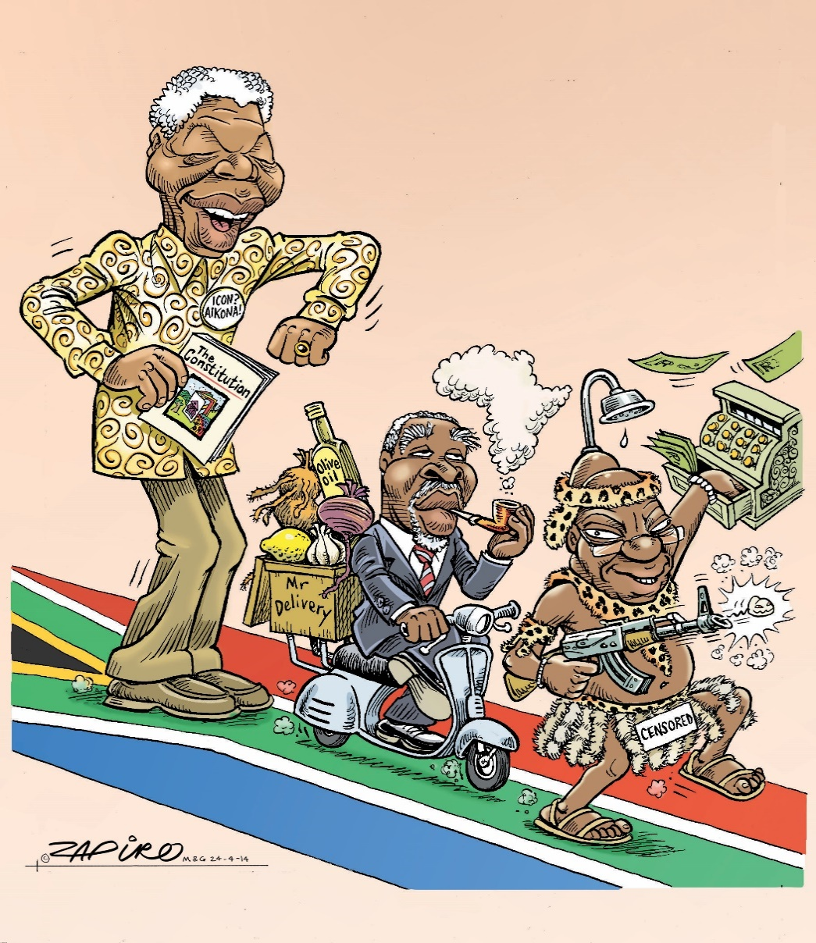

Figure 16: The stark contrasts between three presidents

(Source: Permission granted by Zapiro to use this cartoon)

## Introduction

South Africa has changed dramatically since 1994. For example, the South African army is no longer involved in a regional war, and conscripts are not called up every year to fight far from home. Political opponents of the government are no longer detained or killed in detention, because South Africa’s constitution strongly protects the freedoms of speech and association. Further, although racism still exists in our society, it is executed by individuals who cannot accept the new non-racial order. Racism is no longer enshrined in law as was the case under apartheid. For the poor, the new government has introduced a social grants system that extends to over 18 million people – 31% of the total population. And South African tourists, sports teams, artists and business delegations are free to visit and do business, with no sanctions excluding us from the rest of the world. All these developments have been liberating for most citizens.

Not everything has been positive though. There have been many plans since 1994, yet few have been successful and certain socio-economic conditions have worsened over the past three decades. The task of Unit 3 is to outline the economic policies that have been implemented since 1994. The discussion examines the achievements and failures of government.

The first focus is on three important policy processes that influenced ANC economic policy before the elections of 1994 when the ANC took office as the new government. The first was a policy approach developed by economists aligned to the ANC and Congress of South African Trade Unions (Cosatu). It was termed *Growth Through Redistribution* (GTR). The second process was the publication of a policy document by the ANC in 1994 which was entitled the *Reconstruction and Development Programme* (RDP). The third policy process was led by Cosatu officials (Bird and Schreiner, 1992; Von Holdt, 1991) which outlined the concept of a *Reconstruction Accord.* These policy processes (texts and debates) best reflect the inputs from all the anti-apartheid organisations and individuals on what South Africa should look like post-apartheid.

The second section focuses on what many members of the ANC saw as a betrayal of the idea of the RDP. This happened when the Mbeki government in 1996 launched a new official economic policy framework, Growth, Employment and Redistribution Programme (GEAR), and closed the RDP ministry. This is discussed under the heading ‘A phase of trade liberalisation and stabilisation (1996–2009)’.

The third section looks at the rise of Zuma, crony capitalism and the illusion of a developmental state (2009–2018). The analysis explores the policies and controversies of the Zuma presidency in what many commentators consider to be ‘nine wasted years’.

Lastly, the discussion examines the politics and economics of the Ramaphosa era (2018–2023). The discussion concludes by assessing ANC government economic policies in terms of the capitalist typologies developed in Unit 1.

## Unit 3 outcomes

By the end of this unit, you should be able to:

1. Provide a critical account of the economic, social and education and training policy ideas that emanated from civil society in the period 1989–1994, and determine their appropriateness in overcoming the damage of apartheid’s separate development; were they fit for purpose?;
2. Critically examine the success and failure of the post-apartheid government in formulating and implementing its economic, social, and education and training policies between 1994 and 2023 – identify factors internal to government as well as factors external and outside the direct influence of government;
3. Provide an understanding of the continuities between current conditions and those that existed under apartheid; and
4. Undertake continuous learning processes, so that you as lecturer can assist your graduates to acquire employment, for example, through good networking skills within industry, and through ensuring that only demand-led training initiatives are supported by your college.

## ANC and Cosatu policy proposals prior to the elections of 1994

This section outlines three important policy documents that were drafted by anti-apartheid organisations prior to the elections of 1994, and which strongly shaped the initial policies adopted by the ANC government after winning the election. They will be dealt with chronologically, as each have shaped the other in their evolution.

### The ANC’s growth through redistribution

The ANC developed an economic policy framework prior to the elections of 1994. It was known as Growth Through Redistribution (GTR). It had two related yet distinct aspects: an internal redistributive thrust which prioritised growth through the expansion of the basic goods sector (food, housing, transport, health services), and an external export thrust which sought global competitiveness for South African manufactures. The priority was to meet the basic consumption needs of the majority and to establish an internal mass market founded on rising productivity, rising wages and lowered production costs. Similarly, the development of export potential relied heavily on the development of mass consumption goods.

According to this logic, export capacity could only be built on the foundation of a sound internal mass market for manufactured goods. In the previous units you have seen how apartheid never developed a manufacturing sector that catered for both the basic consumer needs of blacks and whites, nor the higher-value-adding products in demand on global markets.

The GTR document also argued that an export orientation required modernisation of the economy, and adoption of the new ICT and new ways of organising work. This component of the GTR was further developed by the Industrial Strategy Project linked to Cosatu (Joffe et al., 1995). This group presented a strong critique of the inadequacies of South Africa’s manufacturing sector, particularly its inability to compete on global markets. Their policy prescriptions focused on developing export capacity in the manufacturing sector. Several key policy pillars were identified:

* The promotion of higher-value‑added production. This would entail catching up on the technological learning curve by moving initially from low‑value-added production for the internal market, to mass production of these products for the export market, and then finally, towards deepening export production in the direction of higher-value‑added products.
* The skilling of the industrial workforce.
* The promotion of the small and medium business sector.
* A social compact signed between business, labour and the state, which would reflect new cooperative relations on the shop floor, committing each actor to achieving industrial renewal as outlined above (Joffe et al., 1995).

The precise terminology of the label GTR was deliberate. ANC-aligned economists were interested in the link between the two critical elements of such a programme: achieving growth *through* redistribution. It evolved as a counter position to growth *and* redistribution, which was the more conventional neoliberal strategy of ‘trickle-down economics’ which, put simply, argued for growth first, redistribution after (and only if the economy could afford it). With the ANC’s approach to GTR, redistribution in society (for example, through the provision of mass housing, electricity and social grants) would form the basis for a new consumption-led growth path (ANC, 1990).

The GTR policy envisaged a strong interventionist role for the future state. The state would be ‘slim’, acting strategically to utilise scarce resources carefully. Most importantly, this enabling state would intervene decisively in the development of an export orientation as had occurred in the developing economies of Southeast Asia. This would entail the training of highly skilled technicians and engineers, developing a local R&D infrastructure and technological capacity, and targeting specific sectors for the development of value-added production.

### Cosatu’s contribution to ANC economic policy

Cosatu was far better prepared for the responsibilities that came in 1994 than was the ANC. It contributed to policy on the economy, labour market restructuring and skills development. It also took the lead in emphasising the need for social compacting. Adrienne Bird and Geoff Schreiner, both trade unionists in Cosatu, proposed the establishment of multipartite structures that included the state, business and labour, and that also represented the mass organs of civil society. Cosatu argued that representative organs of civil society should be included in decision‑making structures that were independent of the state and still capable of directly influencing state policy formulation (Bird and Schreiner, 1992). This attempt to get all the key role players together to negotiate the conditions under which the market was to be regulated by the state was rapidly implemented with the formation of the National Economic Development and Labour Council (NEDLAC) in February 1995. NEDLAC’s main function was to facilitate consensus between the state, business, labour and civil society regarding policies to do with industrial renewal, job creation, skilling, labour market restructuring and community development. NEDLAC went on to assist in negotiating the final details of the Labour Relations Act of 1995, which put in place one of the most progressive and consensual labour relations systems worldwide.

As indicated above, Adrienne Bird, a National Union of Metalworkers of South Africa (Numsa) official in the early 1990s, advocated for multipartite structures. She was instrumental in introducing SETA structures in 2000 when she was a senior Department of Labour official. SETAs were structured as multipartite organisations with members from the unions, business, civil society, the education and training sector, and from the state.

Activity 14: The SETAs as multipartite structures

**Suggested time:** 60 minutes

1. Read the *Daily Maverick* article [The three R’s – review, rethink and reimagine – are urgently needed to get skills development in South Africa back on track](https://www.dailymaverick.co.za/opinionista/2022-03-06-the-three-rs-review-rethink-and-reimagine-are-urgently-needed-to-get-skills-development-in-south-africa-back-on-track/) by Karl Cloete, a former Deputy Secretary General of Numsa. This article is not an open educational resource. You gain access to it through your university library.
2. Answer these questions about the article:
   1. What are Cloete’s views on trade union involvement in the multipartite boards that govern the SETAs?
   2. What are Cloete’s criticisms of the skills development programmes run by the SETAs since 2000?

Discussion of the activity

Regarding Question 1, Cloete is of the view that the trade union movement has not contributed sufficiently to the leadership of the SETA boards. This is partly because the union movement has stopped talking about and addressing the issue of skills development within the union movement itself – hence they have not taken good training ideas into the SETA boards that could have promoted the interests of their working-class members.

Cloete also criticises Cosatu for not sufficiently empowering workers and shop stewards to develop training demands and to fight for them. He writes that there has been ‘a failure to ensure that ordinary workers have a voice in defining skill needs and programmes’ within these so-called multipartite bodies.

In terms of fixing the SETAs so that they are more effective in achieving their training mandate, Cloete argues that unions are minimally involved today in the governance of the skills system, and unable to lead its renewal. Union representatives attend SETA board meetings but do not play a strategic role. In his view, multipartite governance of the SETA boards has proved disappointing as they have become sites for industrial relations conflict between management and labour, rather than as a creative forum for determining the most effective skills interventions for each economic sector.

Cloete is also critical of the structure of SETAs – they are hugely bureaucratic, putting more emphasis on ensuring compliance with government supply chain rules than providing a proper direction based on expert knowledge of each economic sector.

Regarding Question 2, Cloete raises a host of failures on the part of the SETAs. These include:

* The SETAs are obsessed with ‘bean counting’ through their annual training targets that must be met. However, very little attention has been placed on the quality of the training received and the employment outcomes of such training – do graduates get jobs?
* With an annual budget of R17 billion between them, the SETAs do not appear to make any indent on the high levels of unemployment in the country.
* The SETAs have allowed private providers – Cloete calls them ‘get-rich-quick service providers’ who drive a profit-orientated agenda – to take over a lot of the training paid for by the SETAs. This is bad news for the TVET colleges, which should be involved in this important training.
* Citing a 2009 Cosatu document, Cloete argues that most workers still do not have access to training at work. Many employers refuse workers paid time off for training, so they end up taking courses at weekends or at night, which they pay for themselves.
* Few workers have experienced the job mobility implicitly promised by the new system of education and training.
* The SETA structure set up to govern this new system has proved to be hugely bureaucratic.
* Cloete touches on the issue of maladministration and corruption, arguing that in some sectors, SETAs have become ATMs or cash cows, rather than the developmental institutions they were intended to be.
* In short, the SETAs are failing to contribute meaningfully to economic growth and development.

### The Reconstruction Accord (1993)

Another major contribution from Cosatu was the formulation of the Reconstruction Accord. The initial push for this came in the late 1980s. Cosatu realised that plant‑level and industry‑level bargaining were insufficient instruments to negotiate the crises affecting the broader South African economy and society (Bird and Schreiner, 1992). It was in this context that several bilateral and trilateral agreements were reached between Cosatu, employers and the state. These social contract agreements were not always popular in the union movement. For example, the more radical Numsa opposed the idea of social compacts with employers, whom they distrusted. Numsa demanded that the unions enter a Reconstruction Accord with the future state. Policies negotiated with the Reconstruction Accord could then be brought to bear on employers. The National Union of Mineworkers (NUM) also supported this position. Marcel Golding, General Secretary of NUM, stated:

All industries must undergo transformation and change. There are two ways we can respond. We can either stand by while the process takes place, or we can become centrally involved. Our union will fight to be a central player in the management of transition ... For us the struggle for greater control over the production process is starting with participation ... participation in decisions made at the work‑place ... But I think through this we are beginning to challenge management’s prerogative in decision‑making over what they believed was their exclusive right – setting targets, setting the production plan. (Golding, 1991: 21)

By early 1993, this position had solidified within Cosatu and the Reconstruction Accord became the official Cosatu policy position in the early 1990s. The key driving force behind the Reconstruction Accord was the urgent need for a workable programme of economic renewal. Cosatu dismissed the policy propositions of business. It was left, therefore, to the organised working class to play this role, in partnership with the state. The Reconstruction Accord constituted a multipartite deal between a future ANC government and the organisations of civil society, which would commit the state to a programme of ‘fundamental transformation to the benefit of workers and the poor’. The four central pillars of the Reconstruction Accord were:

* *A democratic political solution*: The new government must be effective and strong to implement the programme of economic reconstruction and development. Trade unions and other organs of civil society must be able to actively participate in and influence the decision‑making of government.
* *A programme of job creation*: This would be three‑pronged: (1) a short‑term public works programme; (2) industrial restructuring to meet basic needs and to create many more long‑term permanent jobs; and (3) government assistance to ailing industries.
* *Education and training for all*: This would involve an integrated education and training system administered by a single national department; a career‑pathing system based on the linkage of workers’ skills to pay and grading structures; and enabling unions to play a central role in the restructuring of work in areas such as health and safety, new technology, investment and work organisation.
* *A social wage package to end poverty*: This would include extending basic social services such as electricity, housing, water, sewerage and roads to the townships and rural areas; and establishing a national health system based on free and accessible health care (Cosatu, 1993).

The Reconstruction Accord was comprehensive and far-reaching. It influenced the next ANC policy document to emerge in this period: the Reconstruction and Development Programme (RDP).

### The ANC’s Reconstruction and Development Programme (1994)

The RDP was a result of collaboration between the ANC, the South African Communist Party (SACP), the union movement as well as inputs from civil society. It incorporated many of the ideas contained in Cosatu’s ‘Reconstruction Accord’. This collaboration with the union movement committed the ANC to a labour-driven development programme based on meeting the basic needs of people: jobs, land, housing, water, electricity, transport, health care, and social welfare. From 1994 to 1996 the RDP was the ANC government’s guiding document on its socio-economic policy orientation. The RDP document set out three key programmes to rebuild and further develop the South African economy and society. These were:

* *Meeting basic needs***:** This priority component aimed at addressing some of the stark social inequalities thrown up by apartheid. For example, about 17 million people in 1994 were living below the poverty level, and there was a shortage of about 1.3 million homes. Almost 12 million people had no reasonable access to water or adequate sanitation.
* *Developing human resources***:** In 1956, the ANC Freedom Charter document demanded that ‘the doors of learning shall be opened to all’. This component of the RDP sought to achieve that goal by giving all people – young and old, women and men – access to education, training and development. The RDP proposed one education and training system that provided equal opportunities to all, irrespective of race, class or creed. It also committed to 10 years of free and compulsory education for all children.
* *Building the economy*: The central goal for economic reconstruction and development was to create a strong and balanced economy that would end poverty and create jobs; address structural problems; protect worker rights; end all discrimination; and make the economy democratic by involving all stake holders, including trade unions and small business, in an open and transparent process of economic decision-making (ANC, 1994).

Stop and think:

Think back to Unit 2. Do you see in ANC and Cosatu documents of the early 1990s the strong emphasis on shifting economic policies away from reliance on mineral extraction and import substitution? These documents aimed at moving economic policies towards an economy that would both meet the basic consumption needs of all the people (the internal consumption market) and promote the export of higher-value-added products (the external market). The economic concepts of import substitution, higher-value-added production and export-oriented economies are central to understanding politics and economics in South Africa today.

### The successes of the RDP

The RDP represented a major vision for the country and its future, a programme of action that many citizens supported. This is why the ANC won the elections so convincingly in 1994 – because people supported the RDP. So, its major success (perhaps the only significant one) was to provide a vision for citizens that still appears relevant to our needs today.

A second success is perhaps the seriousness with which the ANC and Cosatu considered the need to transform the South African economy towards the promotion of higher-value‑added production. As suggested earlier, this would entail catching up on the technological learning curve by moving from low-value-added production for the internal market, to mass production of these products for the export market, and then finally, towards deepening export production in the direction of higher-value‑added products. The ANC today does not have the same clarity of purpose regarding economic policy as it did then. And the economic priorities of the GTR and RDP are still relevant today, largely because they have remained unattended to. There has been no implementation of the ideas contained in these noble policy documents.

A third strength, which forms part of the vision for the future, was the emphasis on a social compact – a recognition that economic progress is significantly helped when key actors cooperate and coordinate economic activities together. NEDLAC was considered the key organisation to promote this. But as suggested earlier, and in the activity on multipartite bodies, this social compact has not been forthcoming. Lead actors in the economy pursue their own interests and cooperate minimally. This reality is a major obstacle to growth and development.

### Problems emerge with the RDP ministry

The RDP was soon to face serious problems. The RDP ministry under the leadership of Jay Naidoo, the former General Secretary of Cosatu, struggled to shift from policy ideals to implementation. The new government lacked the capacity to implement it. Another problem was that the RDP did not spell out a detailed programme for attaining its main aims. It was broadly formulated and ended up as a ‘wish list’. However, a third pressure was the country’s economic and fiscal difficulties. The government could not mobilise sufficient funds to meet the RDP’s objectives without redirecting allocations from the mainstream government departments. In a climate of resource scarcity, competition among ministers was intense and the prospect of having their budgets cut and transferred to the RDP ministry was strongly resisted.

The final nail in the coffin for the RDP was the emergence of the first major currency crisis facing the new government in February 1996, when the value of the rand plummeted by more than 25%. To calm domestic business and foreign currency markets, the top leadership within the government rapidly formulated a more traditional neoliberal policy framework known as Growth, Employment and Redistribution (GEAR). GEAR was a product of technocrats working in isolation from the ANC’s other social partners – a very different policy process to that adopted in the formulation of the RDP. Regrettably, the RDP ministry was abolished in March 1996 (DoF, 1996).

Activity 15: The success and failure of the RDP

**Suggested time:** 30 minutes

1. In your view, what did the RDP achieve that was considered successful?
2. What problems led to its closure?

Discussion of activity

Successes: The successes listed above were not at the level of practical development programmes such as the mass construction of cheap housing. Rather, the successes were at the ‘ideas’ level, for example, giving South Africans a vision of a new society based on the humanistic principles of the RDP. Another success at this level of ideas was the RDPs economic and industrial policies, which emphasised the need for a shift to an exported-oriented economy driven by a strong manufacturing sector. This has never been achieved and it continues to be relevant today. The third great idea emanating from the RDP was the emphasis on building a social compact between the powerful actors in society – the government, employers, unions and organs of civil society. The idea here was that a multipartite society would lead us more closely to a social democratic form of capitalism committed to the well-being of all who live in the country. This goal is an ongoing challenge, with little success in becoming a permanent feature of our country’s governance. It remains a successful idea, albeit one that has not been fully implemented.

Failures: The RDP ministry was not properly structured as a government department, and hence several problems emerged. Firstly, it did not have the technical expertise in-house to implement the strategy. Secondly, it was not allocated a large budget, as a large chunk of the annual budget went to the established line departments such as housing, land affairs and education. Thirdly, it was criticised for being a long shopping list – there was no prioritisation of projects, making it difficult to implement.

## Phases in the post-apartheid journey

The analysis now shifts to an examination of economic policies introduced by the ANC as government of the day. This period from 1994 until the present can be considered in three phases. The next section outlines the key phases.

Zalk (2021) has usefully identified two distinctive phases in the economic development of post-apartheid society. The first is the phase of ‘macro-economic stabilisation’ discussed earlier in Unit 1. It has entailed largely monetary policy instruments to control spiralling debt, interest rates and inflation characteristic of the immediate post-1994 period. These were adverse conditions inherited from the dying apartheid regime. These economic stabilisation measures were brought about through the GEAR strategy implemented in 1996. Stabilisation was indeed achieved, with a mini boom emerging from 2000 to 2008 with growth rates peaking close to 5% during this period, and interest and inflation rates significantly lowered. Government was wealthy enough now to consider more expansionary activities such as infrastructure development and various micro-economic reform measures (state efforts to improve conditions for efficient private sector production of goods). Additionally, the government was able to introduce one of the world’s largest social grants systems in this period. However, the good news ended with the rise of the global economic crisis of 2008.

The second phase started with the impact of the global economic crisis, and the rise of Jacob Zuma as leader of the ANC in December 2007 and president of the country in June 2009. Zalk terms it a second phase defined by the ‘illusion of building a developmental state’: industrial policy aspirations (such as seeking a ‘developmental state’) were put on the agenda but were ultimately undermined by neglect, non-implementation and crony capitalism (corruption).

A final phase to be looked at is the Ramaphosa administration of 2018–2023. State capture did not end in 2019, even though Ramaphosa appointed a Judicial Commission of Inquiry to investigate corruption (the Zondo Commission). Corrupt practices continue into the present period. This phase also witnessed the devastation caused by the coronavirus disease (COVID-19) pandemic in 2019–2022; the collapse of the ANC as a unified and effective political organisation (because of acute factional conflicts within it); and the rapid deterioration of government services such as electricity, rail, water and healthcare.

Given all the above, the national economy is now (2023) in serious trouble. It is difficult to talk of coherent economic programmes that have been formulated, implemented and assessed in terms of impact during Ramaphosa’s presidency. Rather, the problems that South Africa continues to face suggest it has been a period of continuity with the Zuma era.

## A phase of trade liberalisation and stabilisation

As indicated earlier, the GEAR strategy was adopted in 1996. It proved to be a highly contentious step for the ANC government, especially within its own ranks. There have been several critics. However, Vusi Gumede, a political economist who worked in the Presidential Office of Thabo Mbeki, argues that GEAR was justified on the grounds that the economy that the ANC government inherited in May 1994 was in a bad shape, with double-digit inflation, very high interest rates, a negative GDP growth rate and very high government debt.

The GEAR policy framework sought to achieve a more competitive and outward (export) oriented economy. The strategy sought to attain a growth rate of 6% per annum and job creation of 400 000 per annum by the year 2000. Other goals of the policy framework were:

* an accelerated growth of non-mineral exports;
* a brisk expansion in private sector investment in new production activity;
* similarly, an acceleration in public sector investment;
* the promotion of labour-absorbing employment; and
* an increase in infrastructural development and service delivery.

The above socio-economic goals were supposed to be integrated with GEAR’s strong monetary and fiscal focus. These included:

* an austerity programme to reduce the budget deficit (a problem that arises when government has spent more than it earns through taxes);
* an exchange rate policy to keep the real effective rate stable at a competitive level;
* consistent monetary policy to prevent a resurgence of inflation; and
* a reduction in tariffs to facilitate industrial restructuring (average manufacturing tariffs were cut from 23% in 1994 to 8% by 2004).

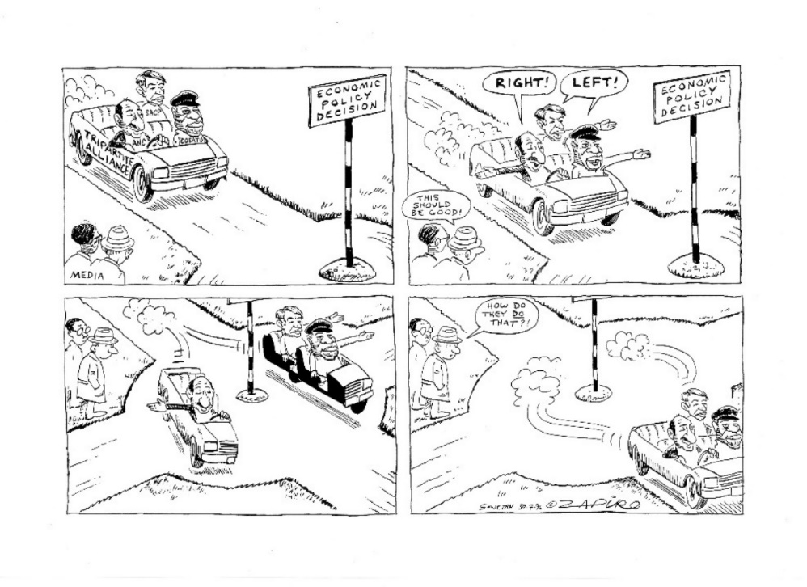

Figure 17: Left- and right-wing pressure within the ANC economic policy process, 1996

(Source: Permission granted by Zapiro to use this cartoon)

Activity 16: RDP and GEAR

**Suggested time:** 60 minutes

1. Go over the previous sections on various economic phases traversed by SA in the immediate post-1994 period, taking special note of the nature of the phase of trade liberalisation and stabilisation. Then answer the following two questions:
   1. Do you believe that GEAR betrayed the noble goals of the RDP?
   2. Was GEAR the needed stabilisation ‘phase 1’ that democratic SA urgently needed in 1996?
2. If you say yes to both questions above, how do you reconcile these diverging arguments? Can you develop a more balanced view from both perspectives?

Discussion of the activity

The termination of the RDP by the Mandela-Mbeki government in 1996 was a betrayal for members of the left in the tripartite alliance (the SACP and Cosatu), who were vehemently opposed to privatisation and free market policies. They saw GEAR as a neoliberal policy lever of macro-economic policy stabilisation – which it was. But it was in a more general way a betrayal of the socio-economic rights first included in the 1956 Freedom Charter (a key ANC document) which were also incorporated into the 1994 RDP – for example, the right of all citizens to have equal access to human rights, protection under the law, education, housing as well as health and welfare services. Most South Africans felt disappointed at the RDP’s demise, not just members of left-wing parties.

Unit 1 discussed the ‘stabilisation phase’ of countries facing financial problems in the mid-1970s, going into the 1980s. The successful Southeast Asian countries like the four Asian Tigers (Singapore, Taiwan, Hong Kong and South Korea) did not stop at financial stabilisation (austerity measures to lower government debt – basically cutting back state expenditure). Rather, they moved into a second phase of upgrading the manufacturing sector, shifting from low-value-added production to higher-value-added production, thereby increasing exports and economic growth.

Similarly, on taking power in 1994, the ANC government had no choice but to reduce debt, lower inflation and stabilise exchange rates. In this sense it followed the first step of stabilisation as taken by the Asian Tiger developmental states. However, it did not take the more important second step of upgrading manufacturing and exporting.

The end of the RDP was a tragedy of great proportions, which upset many citizens. It represented the best of our human goals. However, it was not implementable immediately, but only in the long-term. First, a phase 1 period of austerity measures was necessary. We thus need to adopt a more balanced view, based on pragmatism – which requires that we accept both that the RDP was a great piece of humanistic policy thinking, and that GEAR was unavoidable. What was required in the immediate context was a phase 1 period of austerity. The incoming ANC leadership were faced with the enormous problem of having inherited apartheid’s huge debts, and austerity is the only way of getting rid of such debts. As a later section of our discussion will show, GEAR was successful in stablishing macro-economic stabilisation (Phase 1) by the early 2000s.

The more significant problem with all of this was not that GEAR was a betrayal, or that phase 1 was wrong, but rather, that the ANC government never engaged in a phase 2 seriously enough from 2000 onwards. This entailed building a strong manufacturing sector and export base. After the mini boom of the early 2000s, the government failed to diversify the economy away from a heavy reliance on minerals extraction towards greater value-added products and their export to overseas markets. These phase 2 measures could have triggered important socio-economic benefits for citizens – most importantly, a growth in employment and the expansion of small firms operating in manufacturing.

### Mbeki’s achievements after GEAR

An important gain under the Mandela and Mbeki administrations was the rapid expansion of access to social services extended to poor (largely African) citizens – in both urban and rural contexts. It is evident that major progress was made in bringing key services to the people – such as formal housing, piped water, electricity and other municipal services – although access to these services was still skewed in favour of urban and white communities. For example, whereas 75% of Africans residing in urban areas had access to formal housing in 2003, only 62% of rural Africans had formal housing. Notwithstanding these shortcomings, the improved access to social services was a major achievement in the first decade of democracy.

Another of government’s achievements over the past decade was undoubtedly the macro-economic stability attained and the boost this gave to the national economy. These measures paid off. Economic growth rates improved significantly from the lows of the early 1990s (from 1% in the period prior to 1994 reaching 4.9% in 2005).

An important consequence of this improvement in the performance of the economy has been the gradual expansion of state expenditure on social and economic infrastructure since 2001. The increases in these expenditures reported for the years 2002 and 2003 were large, representing a significant shift in state economic thinking with respect to state spending. Another important budgetary shift in this period was the high growth rate in social services expenditure, which accounted for 57.6% of the total budget in 2002/03. The bulk of funds within this portfolio went to the social grants system, housing and community development.

South African exports also grew in this period (1994–2007). Exports to the EU, Southeast Asia and the Southern African Development Community (SADC) countries have grown by 38.4%, 15.6% and 12.2% respectively.

### A more expansive set of economic programmes

Perhaps the most important achievement of the government in the decade after the launch of GEAR was the subtle shift in economic policy away from a reliance solely on the austerity measures of monetary policy (often referred to as macro-economic policy) towards a more expansive micro-economic policy outlook. Micro-economic policies aim to improve the inputs needed in production in most manufacturing plants – these include the economic infrastructure of the country (railways, roads and ports), skills development, the costs of material inputs in production, and the science and technology capabilities of the country.

This important shift began in the early 2000s with the government emphasising a comprehensive basket of socio-economic policies to address the scourge of poverty and unemployment. These measures included: building stronger linkages between the formal and informal economies; increasing infrastructural investment; targeting key sectors; promoting BEE; encouraging labour-intensive production methods; promoting the Expanded Public Works Programme; and building a stronger social safety net for the poor.

These expanded investments by government occurred because it recognised that the further strengthening of the economy required action at the micro-economic level. It was seen as providing the necessary stimulus for growth, particularly through the lowering of input costs in production and through improved investment in infrastructure including road, rail, air transportation, water, energy and telecommunication services.

The new governmental approach was also influenced by developments in industrial policy globally.There was an important shift away from protectionist measures such as generous subsidies to support old economic sectors that were in decline. As indicated in Unit 1, measures such as tariffs and subsidies became unpopular in the 1980s onwards, because of neoliberalism’s emphasis on limiting state regulation of the economy and the promotion of free trade in open global markets.

### The launch of AsgiSA , 2005

All these socio-economic commitments coalesced in 2005 into one core political programme, the Accelerated and Shared Growth Initiative for South Africa (AsgiSA)*,* which was launched in July 2005. A central task for AsgiSA was to provide an overarching socio-economic perspective for all government departments to adopt in their own policymaking, thereby creating greater alignment and coordination between otherwise discrete policy elements.

The AsgiSA initiative was launched at the biannual Cabinet lekgotla in July 2005. By February 2006, a background policy document had been produced outlining the main components. First and foremost, the main thrust of AsgiSA was an acknowledgement that the very positive economic growth achieved in the 2000–2005 period had not gone far enough towards meeting the socio-economic goals of halving unemployment and reducing poverty and inequality. The economic achievements thus far – a healthy fiscal position, growth peaking at 4.9% in 2003–2007, subdued inflation and low interest rates – all provided a solid platform upon which a more confident government could pursue an accelerated growth phase (what we have termed the second phase of capitalist development).

The government therefore set a two-phase target. In the first phase, between 2005 and 2009, it intended to attain an annual growth rate that averaged 4.5% or higher. In the second phase, between 2010 and 2014, it sought an average growth rate of at least 6.07% of GDP. The AsgiSA policy document elaborated on those factors that inhibited faster economic growth. It identified six such ‘binding constraints’ to economic growth, which needed to be overcome if the AsgiSA growth targets were to be realised. These six constraints were:

* the volatility of South Africa’s currency;
* the cost, efficiency and capacity of the national logistics (transport) system;
* a shortage of suitably skilled labour;
* barriers to entry for small firms, limits to competition and limited new investment opportunities;
* the burden of the regulatory environment on small and medium businesses; and
* deficiencies in state organisation, capacity and leadership.

Countering these constraints required a series of decisive interventions. The government’s response to the ‘binding constraints’ fell into six categories: infrastructure programmes; sector industrial strategies; skills and education initiatives; ‘second economy’ interventions; macro-economic issues; and public administration issues.

The government began to ramp up public sector investment. It rose from below 4% in early years of democracy to above 6% cent by 2005. To reduce the backlog that had emerged in public infrastructure, public sector investment was planned to rise to around 8% of GDP. Of this, about 40% would be spent by public enterprises, mostly Eskom and Transnet, and mainly on power generation, power distribution, rail transport, harbours and an oil pipeline. Infrastructure development needed for the hosting of the World Cup in 2010 also assisted here. For example, Gauteng acquired its first rapid train system, the Gautrain, launched a few weeks before the soccer World Cup took place. The general purpose of all these new investments was to improve the availability and reliability of economic infrastructure services in response to rapidly growing demand for these services in the domestic economy.

It could be said that Mbeki’s shift to micro-economic reform through initiatives such as AsgiSA was the beginning of a shift to phase 2 – the technological upgrading and diversification of our manufacturing sector.

Activity 17: The successes of Mbeki’s reign

**Suggested time:** 30 minutes

1. Read the section on Mbeki’s achievements after GEAR again. As you read, identify some positive features of Mbeki’s presidency from 1999-2008. Then write whether the government under Mbeki’s leadership achieved success in these four key areas:
   1. Providing basic municipal services for the people
   2. Achieving macro-economic stability
   3. Increasing state expenditure on economic infrastructure
   4. Promoting exports

Discussion of activity

a) Major progress was made in bringing basic services to the people – for example, housing, access to electricity, water and sewerage services, especially for residents in the urban black townships and squatter camps. Unfortunately, basic services to rural areas still lagged behind those delivered in urban areas.

b) Attaining macro-economic stability was successfully achieved. Economic growth rates improved from the lows of the early 1990s (and average of 1% GDP growth) to 4.9% in 2005. This improvement continued to 2007 but was cut short by the global financial crisis which occurred in October 2008.

c) There was gradual expansion of state expenditure on economic infrastructure (for example, improved and new railways, roads and ports). South Africa’s hosting of the World Cup in 2010 helped this process a lot, as major urban infrastructure was upgraded for the event.

d) Exports to the EU, Southeast Asia and SADC also grew in this period (1999–2007), for example, an impressive 38.4% increase in exports to the EU was achieved.

Taken together, these four success areas suggested a significant improvement in the economic well-being of the South African economy during Mbeki’s administration. In contrast, Mandela, Zuma and Ramaphosa are not able to boast such powerful economic gains while in office.

### The limits of the Mbeki era

Although the Mbeki administration of 1999–2007 achieved many successes, it was also defined by several serious problems, which included:

* The projected growth of 6% and employment gains proved unattainable, and a low growth/low employment growth path ensued.
* Few support measures were offered to sectors exposed to rapid trade liberalisation. Only the auto and clothing sectors got various forms of support.
* A de-emphasis on public fixed investment prevailed as state-owned enterprises were commercialised with a view to selling them to BEE investors. The leadership of these state-owned enterprises therefore did not invest in new plants and increased output.

The World Bank termed this disappointing outcome ‘stabilisation without growth’. Altman and Mayer (2003) argued that GEAR and its jobless growth outcome worsened unemployment levels in South Africa. There was also a fall in the demand for lower-skilled labour, and the demand for higher-skilled labour has risen. This skewing of employment towards semi- and highly skilled labour was a major contributor to rising rates of unemployment. Most alarmingly, even though GEAR’s stabilisation impact led to export growth, averaging 5.5% per annum in aggregate and 11.2% per annum in the manufacturing sector, the absence of employment growth (jobless growth) appeared to be a perverse (abnormal) outcome. Trade liberalisation worsened this phenomenon in two ways. Firstly, GEAR increased value-adding in many exports. It therefore resulted in a demand for more skilled workers in manufacturing and services. Secondly, imports increased into previously protected sectors such as metals, plastic, clothing and furniture, leading to reduced local manufacturing output and decreased employment levels – thereby reducing the number of unskilled manual workers in demand.

The rapid formulation and implementation of GEAR in 1996 shocked many in the ANC who viewed the official ANC economic policy as being the RDP document. GEAR was viewed as a betrayal by many in the ANC and within its alliance partners. Even Rob Davies, a former Minister of Trade and Industry in the ANC government led by Jacob Zuma, has been very critical of the GEAR strategy. He maintained it was developed without prior consultation with any of the ANC’s alliance partners – the South African Communist Party and labour federation Cosatu. Davies (2021) bemoans the fact that GEAR led to the controversial scrapping of the RDP – a far more progressive economic programme committed to redistribution and overcoming poverty. Other criticisms by Davies includes the point that GEAR failed to meet its job creation targets. It did not yield the desired levels of foreign investment, either. Similar criticisms have come from the late Vichnu Padayachee, a political economist based at Wits University:

The South African economy has been characterised by low growth, rising unemployment and increasing inequality, which together with rampant corruption and governance failures combine to threaten the very core of the country’s stability and democracy. The neoliberal economic policies that the ANC-led government surprisingly adopted in 1996 have simply not worked. (Padayachee, 2019: 3)

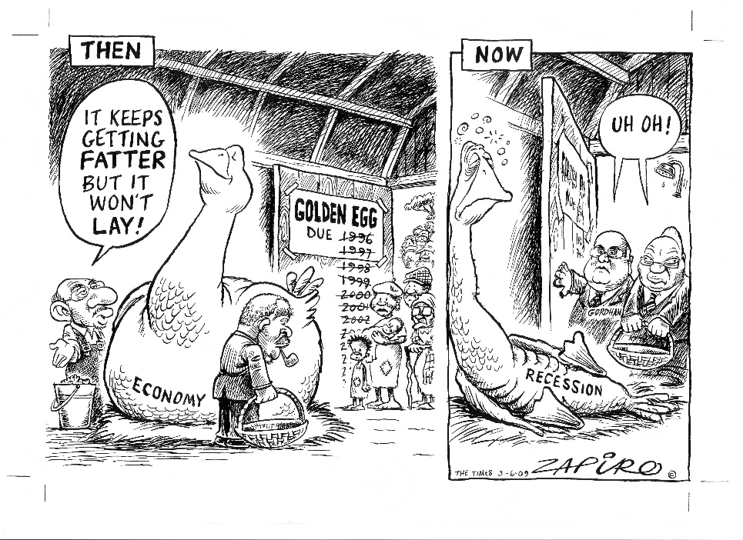

Figure 18: The boom phase of 2000–2007 is over, recession sets in

(Source: Permission granted by Zapiro to use this cartoon)

### Mbeki’s removal as President in 2008

The greatest blow to Thabo Mbeki’s legacy as president for nine years, however, was self-inflicted. The first self-imposed negative factor was his denialism about the effectiveness of anti-retroviral treatment for human immunodeficiency virus and acquired immune deficiency syndrome (HIV and AIDs) patients, which won him little support amongst ANC members and the broader society. The second factor was his decision to fire Jacob Zuma as Deputy-President in 2005 over his involvement in the arms corruption scandal. Zuma supporters were very unhappy with this decision. And his third blunder was to be seen as aloof and arrogant – which made him very unpopular in the ANC at precisely the moment he needed wider support. He was voted out as President of the ANC in Dec 2007 and removed as President of the country in September 2008. At the same time, Jacob Zuma was applauded in many circles – particularly in left circles such as the SACP and Cosatu. They mistakenly viewed him as a president who would introduce pro-poor programmes and break the obsession with neoliberal policies that characterised the Mbeki years.

## The rise of Zuma, crony capitalism and the illusion of a developmental state

The period of Zuma’s presidency – from 2009 to 2017 – is difficult to evaluate in the same way that the Mandela and Mbeki eras were assessed earlier. This is because both the Mandela and Mbeki presidencies were characterised by clear and coherent programmatic goals – peace, monetary stabilisation, improved social services to the people and the creation of a single unified state in the case of Mandela, and significant economic planning via GEAR and AsgiSA in the case of Mbeki. The implementation and impact of these programmes can be easily assessed – and much success was attained in this regard, although we have outlined several significant failures as well.

Initially, the activities of the Zuma administration appeared encouraging. For example, in the period 2009/2010, a National Planning Commission (NPC) was appointed, the National Industrial Policy Framework (NIPF), initially launched in 2007, was more formally adopted now as part of government’s official set of economic policies. This was not the case with Mbeki, where industrial policies were subordinated to the needs of monetary policy. The Zuma administration, in their advocacy of economic policy, also spoke enthusiastically about South Africa becoming a ‘developmental state’ led by an appropriately skilled civil service.

However, these initial positive signs were soon replaced by various negative developments in the Zuma administration. Zuma’s interventions were mostly political actions aimed at: strengthening his grip on power; weakening his opponents, often via Cabinet reshuffles; and advocating the ideology of radical economic transformation (see discussion later). These were all political moves aimed at being able to access state resources for corrupt ends. The shift to a captured state meant that all the good policy intentions of the Zuma government (and to a large extent, the Ramaphosa government) fell away. Almost all the attention of the Zuma leadership in government was allocated to devising new methods for self-enrichment – a set of corrupt practices that continued into the Ramaphosa era.

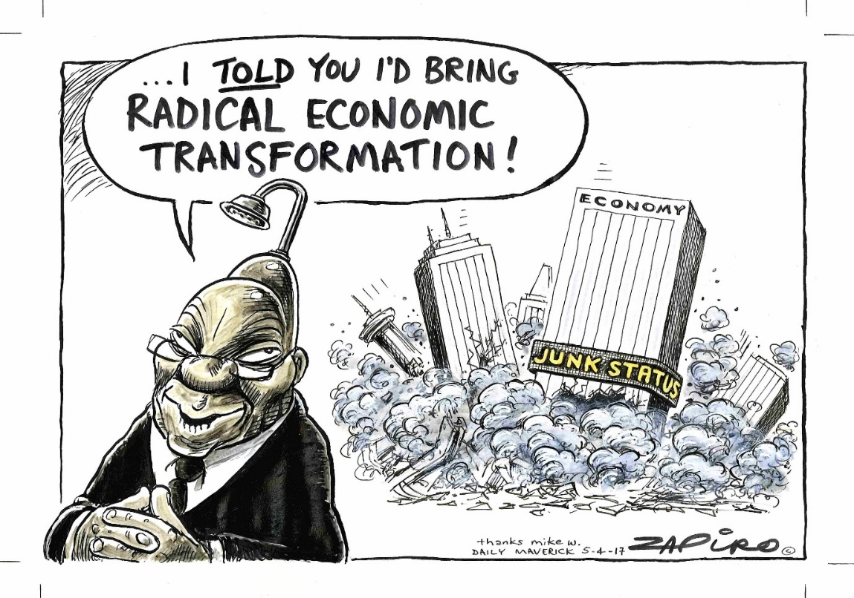

Figure 19: Interpretations of radical economic transformation

(Source: Permission granted by Zapiro to use this cartoon)

### Encouraging signs, 2009–2011

The Zuma administration introduced several new macro-level policy frameworks from May 2009 onwards, most of which sought to make the state work more effectively, especially in terms of shared cross-departmental programmes to grow the economy and create jobs. Government had come to realise that the complex overarching national programmes required an understanding of the complex inter-dependence of several state departments. These inter-dependencies require high levels of cooperation and coordination between state departments. Two new ministries in the Presidency – the ministries for National Planning and Performance Monitoring and Evaluation – were created to achieve such increased coordination and cooperation across state departments.

### Planning

Debates raged about the need for improved coordination and planning within the South African state in the build up to Zuma’s presidency. Once President, Zuma appointed the NPC, with Trevor Manual as its first minister. Its role was to develop medium- and longer-term strategic planning. The NPC published a Green Paper in 2009 (The Presidency, 2009)on the role and functions of national strategic planning. In the Green Paper, the NPC admitted that coordination among departments and spheres of government was inadequate, and the central machinery needed to drive joint action was weak:

Formal systems and structures cannot on their own guarantee an integrative approach to the work of departments and spheres of government. Fragmented policy making can lead to duplication of effort and contradictory outcomes. Given the Constitution’s allocation of roles and responsibilities to different spheres, uncoordinated actions can undermine the achievement of social and economic objectives.

The NPC noted further that negotiations between partners in planning tended to pursue narrow self-interests, and the outcomes were often a ‘minimum common denominator’ rather than an approach that helped society transcend its short-term limitations. The policy document suggested that there was little evidence of long-term planning in the public sector, let alone integration of such plans.

### The National Development Plan

In May 2010, President Zuma appointed the NPC to draft a long-term future vision for the country. The Commission’s first document, the 2011 *Diagnostic Report* set out South Africa’s shortcomings and socio-economic problems since 1994. These were:

1. Too few people are employed.
2. The quality of school education for black people is poor.
3. Infrastructure is poorly located, inadequate and under-maintained.
4. Spatial divides limit inclusive development.
5. The economy is environmentally unsustainable.
6. The public health system cannot meet demand or sustain quality.
7. Public services are uneven and often of poor quality.
8. Corruption levels are high.
9. South Africa remains a divided society.

The final plan, released in 2013, entitled *National Development Plan (NDP) 2030* (National Planning Commission, 2013) set out five interlinked priorities:

* Unite all South Africans around a common programme to achieve prosperity and equity.
* Promote active citizenry to strengthen development, democracy and accountability.
* Bring about faster economic growth, higher investment and greater labour absorption.
* Build a capable and developmental state.
* Encourage strong leadership throughout society to work together to solve problems.

Of the above priorities, the NDP emphasised the centrality of raising employment through faster economic growth, and improving the quality of education, skills development and innovation – two goals close to your professional life as a TVET college lecturer. Another strong emphasis in the plan was for the creation of stronger social compacts between government, employers and trade unions. These key actors in the economy would need to work together to achieve the faster economic growth envisaged in the plan.

The plan presented a long-term strategy to increase employment. However, to reduce the acute effects of poverty on millions of South Africans over the short-term, the plan proposed a number of short-term measures such as the expansion of public employment programmes to 1 million participants by 2015 and 2 million by 2020. NDP 2030 also aimed to strengthen primary health-care services and broaden district-based health programmes, such as the community health worker and midwife programmes, and health education. Efforts to improve the quality of educational provision in underperforming schools and TVET colleges were also adopted. Some of these short-term measures were implemented in the ensuing period.

Stop and think:

It is now ten years since the launch of the NDP. Do you think this plan is a mere ‘wish list’ of far too many issues for government to effectively deal with in a prioritised way?

Look up the definition of a ‘wish list’ on google. Here is one definition: ‘a list of desired but often realistically unobtainable objects or projects’. The main shortcoming with government wish lists is they tend to list all of society’s problems, but with no prioritisation to deal with the most severe issues that need immediate attention. The NDP is guilty of this shortcoming, largely because the government has not provided an honest reflection of its own capabilities. Can it fix 20 problems effectively and all at the same time, or can it only do 3 prioritised projects effectively at any one time?

If you take some of the sectors prioritised by the NDP, each are characterised by inaction on the part of government. For example, look how the following NDP goals have failed:

* Promote active citizenry to strengthen development, democracy and accountability: Nothing has happened.
* Bring about faster economic growth, higher investment and greater labour absorption: This did not happen. By 2013, when the NDP was released, Zuma’s government had already institutionalised state capture, whereby it pursued corrupted projects for self-enrichment of an ANC elite. The government did nothing to further its own policies, like building the manufacturing sector or improving the education and training system.
* Build a capable and developmental state: This proved to be an absurd aspiration by the ANC government. The government was moving in the wrong direction, towards ‘crony capitalism’, rather than towards a developmental state that required a highly expert and ethical civil service, and significant cooperation and coordination between key economic actors, such as business, labour and the government.
* Encourage strong leadership throughout society to work together to solve problems. This might have happened within civil society (think of the Gift of the Givers), which showed growing opposition to ANC government policies. Building civic-minded leadership didn’t happen because of government action.

The NDP is now a relatively worthless piece of paper. It describes idealistic goals our government will never be able to implement.

### Taking industrial policy seriously

The Zuma government also committed to a more proactive stance on the promotion of industrial policy, which had been considered a secondary priority to monetary policy during the Mandela and Mbeki eras. This was reflected in the Zuma government’s determination to implement the NIPF,which was launched in July 2007 by the DTI. This new emphasis on industrial policy was also reflected in statements made by Blade Nzimande, the Minister of Higher Education and Training, in July 2009:

The agenda we have now set out includes a coordinated skills development strategy, informed by an overarching industrial strategy, based on clear sectoral industrial strategies, placing particular emphasis on scarce skills. This will require re-focusing and possibly restructuring of the SETAs to be guided by this overarching objective, rather than the other way round. (Minister Nzimande, July 2009)

The overall vision of the NIPF was to facilitate diversification of the economy, away from its traditional reliance on minerals, towards increased value-addition. The strategy aimed to promote a more labour-intensive industrialisation pathway, characterised by sustainable, labour-absorbing manufacturing and service sectors.

The second Industrial Policy Action Plan (IPAP) was released in February 2010. It built on the above vision. It called for ‘stronger integration between sector strategies, skills development plans and commercialisation of publicly funded innovation’. This second plan proposed three clusters of industrial policy intervention, as highlighted in Table 8 below:

Table 8: The three clusters of South Africa’s industrial policy focus, 2010

|  |
| --- |
| **Cluster 1 – Qualitatively new areas of focus**   * Realising the potential of the metals fabrication, machinery and transport equipment sectors; * Building ‘green’ and energy-saving industries; and * Promoting agro-processing, linked to food security and food pricing imperatives. |
| **Cluster 2 – Scaled-up and broadened interventions in existing IPAP sectors**   * Automotive products and components, and medium and heavy commercial vehicles; * Plastics, pharmaceuticals and chemicals; * Clothing, textiles, footwear and leather; * Biofuels; * Forestry, paper, pulp and furniture; * Strengthening of linkages between cultural industries and tourism; and * Business process servicing. |
| **Cluster 3 – Sectors with potential for the development of long-term advanced** **capabilities**   * Nuclear * Advanced materials * Aerospace |

(**Source:** DTI, 2010: 54-55)

These 2007 priorities have been amended and added to since that date in four IPAP updates – for the periods 2010–2013, 2014–2016, 2017–2019 and 2018–2021. All these plans highlighted very impressive ambitions. However, The IPAP objectives ran the risk of being a long ‘wish-list’ of interventions. Most of these industrial policy goals, although well-crafted and well intentioned, led nowhere. Little follow through and implementation occurred.

There has been extremely bad press regarding the former Department of Trade and Industry’s (DTI) (now renamed DTIC) industrial policy initiatives during the past two decades. For example, in an early critique, Chang (1998: 10) criticised the lack of national policy coordination. Coordination was limited to very broad ‘framework’ exercises such as GEAR, that lacked a detailed vision of South Africa’s economic future. In more recent times, Kaplan (2019) repeats many of these criticisms. He views the multiple IPAPs as having failed to realise their objectives. He focuses specifically on the use of investment incentives in the form of subsidies to support the auto, clothing and textile industries. He argues that the main problem has been a lack of demand in the broader economy, and that the incentives failed to encourage local firms to invest further in their own businesses.

There are a wide range of industrial policies offered by the lead department (Department of Trade, Industry and Competition – DTIC) and other cognate departments like DHET and Department of Science and Technology (DST). These industrial policy instruments include:

1. *State assistance to small firms to access markets in global value chains:* The major challenge for any firm when starting business is to gain access to the key markets. This is often difficult because existing firms dominate entry and block others from entering. The DTIC has 45 small enterprise development agencies (SEDAs) across the country, with over 100 incubators that focus on helping new entrants start up their businesses and give them access to markets – both local and external. Firms can apply to make use of these facilities and training programmes.
2. *State grants to firms to assist the purchase of expensive imported digital technology*: One of the requirements for firms to upgrade the production environment to produce goods for export is to purchase the new digital technologies. These machines assist in speeding up production, improving quality and design, and reducing errors in production – all important requirements for products to be competitive on export markets. The DTIC now offers grants to firms who wish to purchase these costly technologies – all of which must be imported at highly disadvantageous exchange rates.
3. *State tariffs imposed on certain imports*: Many foreign competitors like China, Vietnam, Indonesia and India now produce a wide variety of consumer goods that are imported into South Africa at prices much lower than those achieved by local firms. Often, there is also the practice of dumping surplus products like poultry on South Africa’s local market because those foreign countries have had a good year and have huge surpluses of stock. These chickens are then sold locally at prices no local producer could ever afford to meet. To combat these problems, the DTIC is allowed by the WTO to impose tariffs on these imported products to protect local production and local firms and jobs. A tariff is essentially an additional cost imposed on an imported good by customs officials, making it more expensive than the local equivalent. Tariffs have been imposed in sectors vulnerable to cheap imports like clothing, textiles and poultry.
4. *State assistance in the promotion of exports*: If gaining access to local markets is a challenge, entering export markets is even more challenging for South African firms. One lever of assistance from the DTIC is to help fund the cost of sending local firms to trade shows (also called trade expositions) so that they can showcase the best of products from South Africa, and network with actors in the industry globally. This networking component is a critical part of firm learning, especially for those firms that want to upgrade to export production. They need to know what production methods, technologies and human resource strategies work best in the industry.
5. *Increased state procurement from local firms*: This lever of assistance from DTIC entails enforcing the state at national, provincial and local levels to buy only South African products for their supply chain needs. This policy is also called ‘localisation’ as it is aimed at encouraging the growth of a local manufacturing sector. The state is a major buyer, often the single largest buyer of certain commodities in an economy. Its buying power has significant developmental clout if used appropriately by the government. A good example are the DTIC regulations enforcing the purchase of local wooden desks and chairs for all schools in South Africa. This is potentially a major stimulus for what is in fact a declining industry in South Africa.
6. *State promotion of clusters*: Clusters are areas where all the key actors in an economic sector are located. For example, the George and Knysna area in South Africa has been a cluster for furniture production over the past 100 years. Key actors located in this region are owners of forests, sawmills, kilns and furniture firms. The area also includes public colleges and universities and private trainers, which contribute to the skills development of the sector. The DTIC has been trying to promote clusters in sectors such as furniture, clothing and metals, as they are all sectors dominated by small firms that would benefit from joint actions aimed at sharing resources – like joint bulk ordering of production inputs (the bigger the order, the lower the price paid); shared training facilities and programmes; shared technology centres or incubators and shared transport companies. These are the usual benefits that clusters offer firms who reside close to these shared facilities.
7. *Green energy incentives*: The transition to green energy technologies and away from energy derived from coal, petrol and gas is a critical task to ensure an end to the destruction of the natural environment and devastating implications of rapid climate change. Many government departments offer incentives for companies to go green, for example, in supporting the installation of rooftop solar panels, solar geysers and LED lighting. More significant support is offered by the Science Councils and the DST to firms and NGOs that do R&D in the development of alternative energy sources, such as via hydrogen technology or the mass storage of solar energy in various types of batteries. These research grants are often aimed at large companies that currently use significant coal, petroleum and gas resources and need to reduce their dependence on such antiquated technologies.
8. *Promoting science and R&D*: the Science Councils and the DST offer a wide range of R&D grants to firms that seek to innovate and find new environmentally cleaner methods of production, and that meet various social and economic needs. A good example is the post-COVID-19 focus on developing a vaccine industry in South Africa, as a critical extension of our pharmaceutical industry. Producing clean water from polluted and sea water is another example. Building safe and secure housing, using new and affordable materials and expanding food production are two other priorities. Of course, attempts by firms to use R&D to help upgrade production to enable greater export opportunities would be a major boost for the entire economy. One part of this would be for South Africa to manufacture its own technical machinery such as CNC machines and robots. DTIC and the DST have incentives and grants to promote many of these priorities.

### The complementarity of industrial and skills development policies

Complementarity means that the impact of skills policies IS strengthened if they are complemented with or accompanied by appropriate industrial policies for the sector being examined.

A high degree of inter-dependency exists between factors that shape the national economy and key aspects of it such as industrial and skills policy. Since 2009, the government has stressed the link between industrial and skills development policies. These two critical policy domains should be formulated and implemented together, so their implementation can be complementary. Most often, especially in LMEs (which do not give any importance to industrial policy interventions, as they believe the state should stay out of the regulation of the economy, leaving it all to free market forces), these policies are developed and implemented in silos – making their eventual outcome unsuccessful. There is no point in training artisans for the metals, clothing and furniture industries if industrial policy does nothing to turn around the slow demise of those industries. Their revival requires both industrial and training policies to reactivate declining sectors.

Let us take the example of the green energy sector, which is critical to a sustainable future, and which will grow exponentially in the next decades. Specific products emerging from this sector over time will include solar panels, electric car batteries and charging stations, and substitutes for plastic packaging, such as bamboo and cardboard. What skills would strengthen the development of these products? This should include personnel trained in each of these fields of manufacture, ideally in TVET colleges and universities of technology. At universities, some new disciplines would be needed, for example, in the use of hydrogen in generating energy. Perhaps we need to consider new artisanal and technician occupations in some of these green fields. This complementarity is currently lacking in government policy implementation.

In the next activity you will explore the important complementary link between skills policies and industrial policies.

Activity 18: Industrial policy instruments and skills policies in your sector

**Suggested time:** 60 minutes

1. Let us take the example of the green energy sector. Read through this table, which illustrates this important complementarity for the green energy sector:

|  |  |  |  |
| --- | --- | --- | --- |
| **The complementarity of industrial and skills development policies** | | | |
| **My chosen sector:** | | **Green energy** | |
|  | Chosen industrial policy instruments | Chosen skills development instruments (which include all forms of education and training) | How the skills initiatives complement the industrial policy initiatives |
| 1 | Promoting science and R&D | R&D into hydrogen and lithium batteries | The DST offers R&D research grants to promote research into hydrogen energy. It entails research partnerships with the very large and wealthy companies that can afford this type of costly long-term developmental research. |
| 2 | Increased state procurement of locally made solar panels | New artisanal occupations in manufacturing solar panels  Government can also offer small business courses that focus on the training of managers/owners of small solar panel installation companies. We need thousands of small companies employing tens of thousands of workers to install solar panelling on a mass scale in the next 30 years if we are to fully replace coal energy with safer energy sources. | The production of hydrogen-based energy cells and batteries will require entirely new occupations at semi-skilled, artisanal and professional (engineering and science) levels. |
| 3 | Subsidies for the local manufacture of sustainable plastic substitutes, such as cardboard and bamboo | Awareness courses in high school to advocate for a reduction in plastics and other environmental pollutants | We cannot rely only on state subsidies to firms that manufacture sustainable plastic substitutes, like bamboo and cardboard. We also need to change our mindset against high levels of plastic pollution through large societal awareness campaigns, e.g. in schools, colleges, universities and workplaces. Reducing plastic pollution (because of increased awareness) in society will complement the local manufacture of sustainable, biodegradable substitutes for plastic, such as cardboard and bamboo. |

1. Copy a blank version of the green energy table into your learning journal. Then follow these steps:
   1. Choose one economic sector that you are familiar with. It could be metal, energy, auto, furniture, construction, the services sector, etc.
   2. Using the green energy table as your guide, identify three instruments of industrial policy that would be good for your chosen sector.
   3. List ways in which skills development can strengthen these three industrial policy instruments.

Discussion of the activity

As is evident in my example for the energy sector, the industrial policy instruments for the energy manufacturing sector would be: (1) promoting science and R&D – especially to produce local hydrogen and lithium batteries; (2) state procurement of solar panels from local producers; and (3) state subsidies to firms that are manufacturing solar panels and/or substitutes to plastic packaging, like bamboo cups and cardboard containers for fast food packaging.

The complementary education, training and skills policies would be: (1) improving R&D in fields of hydrogen and lithium batteries; (2) encouraging new artisanal occupations in field of manufacturing solar panels; (3) offering small business courses that focus on the training of managers/owners of small solar panel installation companies; and (4) providing awareness courses in high school to advocate for a reduction in plastics and other environmental pollutants.

Please note that these skills policies for the energy sector don’t yet exist. So, in your answer, imagine what kinds of skills policies you think our country would need to complement your three choices of industrial policy for the sector. The various types of industrial policy available from government are listed in the above module text in bullet form, from 1 to 8. When you have completed your own table, compare your responses to my table for my chosen sector. Do you think you have captured your sector well? What changes would you make?

### Corruption and state capture: ZUMA’s later years (2011–2017)

A detailed study of corruption and state capture is beyond the scope of this module. Such an analysis would largely be about corrupted politics and failed states – and this takes us out of our focus on the implementation of economic and social programmes after the demise of apartheid. However, corruption and state capture are too important to not cover in any detail. This section therefore provides a brief outline of the dynamics of state capture and its implications for the economy.

In a nutshell, state capture entails the premeditated and coordinated activities of senior leaders in government aimed at the enrichment of a core group of beneficiaries, to consolidate political power and to ensure the long-term survival of this corrupted system. After Zuma’s presidency, large chunks of such corrupt activities persist and continue into the Ramaphosa era – take for example Eskom. Corruption in this institution has not ended yet.

The extent of corruption under the Zuma administration was first revealed by an important 2018 book published by Ivor Chipkin, Mark Swilling and other prominent South African scholars. The book was entitled *Shadow State: The Politics of State Capture*. It outlined the damaging impact of state capture on the South African economy and society:

State capture by shadowy elites has profound implications for state institutions. It destroys public trust in the state and its organs, it weakens key economic agencies that are tasked with delivering development outcomes and it erodes confidence in the economy. When there is no trust in public institutions there is little incentive to pay tax, large companies sit on cash rather than reinvest profits towards productive use, criminality proliferates, exploiting weaknesses in intelligence and crime enforcement authorities, and both finances and skills flee the country (Chipkin and Swilling, 2018: 23).

### Another typology of capitalism – crony capitalism

The extent of corruption – as described above – now requires the addition of another type of capitalism to the kinds we read about in Unit 1. This is the concept of crony capitalism. In the popular media, the term ‘crony capitalism’ has been used extensively to describe an economy in which success in business depends on close relationships between businesspeople and government officials. It usually entails favouritism in the distribution of legal permits, government grants, special tax breaks, or other forms of state support. Crony capitalism usually results in corruption as firms exploit their political ties to acquire an unfair edge in the marketplace, achieved most frequently by bribing government officials.

Corruption requires two or more players – not only government officials. Most importantly, several companies and individuals assisted these elites to capture the state. The Gupta-Zuma family network and Gavin Watson’s Bosasa network (which provided various services to our prisons) are two of the most prominent players, but there are many others. Unethical lawyers and accountants assisted as well, for a corrupt pay-off.

The main intention of these corrupt networks was to repurpose procurement procedures to benefit a particular network of unscrupulous business operators, politicians and officials. The most important procurement sites were the very large state-owned enterprises such as Eskom, Transnet, South African Airways (SAA) and Armscor – all of which receive massive government budgets annually.

### Radical economic transformation

Corruption was also advocated and promoted on an ideological level. An impression was deliberately created with these shifts in procurement activities that government was acting rationally, in line with its new political economic logic, which the Zuma government named ‘radical economic transformation’. Chipkin and Swilling (2018) argue that radical economic transformation has been turned into an ideological football kicked around by factional political players within the ANC. The reality is that radical economic transformation has been used to make a political project to repurpose state institutions for the benefit of a powerful and corrupt elite seem ideologically acceptable.

#### Radical economic transformation and the centrality of controlling state procurement processes

The idea of using the government’s procurement budget to realise social and economic outcomes is not new. It was the backbone of the apartheid version of the developmental state in the 1930s and provided a key platform in cultivating a local class of Afrikaner capitalists. A similar approach was adopted under Zuma’s presidency. Chipkin writes that from about 2011, sections of the ANC and various ministers and senior government officials, supported by elements of organised black business, began referring to the idea of radical economic transformation.

Initially, the National Treasury under the leadership of Pravin Gordhan opposed these radical economic transformation ideas – for example, the insistence that 30% of government contracts, especially those of state-owned enterprises, be set aside for black companies, irrespective of their experience, capacity or price. This resistance made the National Treasury and other state institutions (especially those involved in criminal investigations and prosecution such as the Hawks and National Prosecuting Authority) enemies of those who supported radical economic transformation. The Zuma administration moved to establish control over these uncooperative state institutions.

Mondliwa and Roberts (2021) add to this analysis. They write that President Zuma and his allies often made public announcements about the need to displace white monopoly capital, which was allegedly growing at the expense of the accumulation of black wealth. This narrative was used to remove ministers that were labelled ‘puppets of white monopoly capital’ and replace them with others, many of whom were to emerge later as having connections to the Gupta family associates linked to state capture.

Mondliwa and Roberts also highlight there were almost no efforts to support structural change or address the real impacts of monopoly power on the economy. The only significant programme was the black industrialist programme, involving financing by the IDC. This programme has not been very successful. Little other economic policy was drafted during this period. Older programmes, such as the incentive programme for the automotive industry, were also updated in this period. However, even the expansive support given to car assembly in South Africa had its limits, with critics saying it did not deliver on its promises of building local industrial capacity amongst auto component suppliers (Kaplan, 2019). Given this lack of new effective socio-economic policy, Zuma’s presidency has often been referred to as ‘nine wasted years’.

#### The scale of corruption

Journalist Marianne Merten (2019) reports that the cost of state capture hovers at around R1.5 trillion over the second term of the Jacob Zuma administration (2014–2018). This figure is constructed from the following contributions:

* South Africa’s Budget lost R252.5 billion between 2007 and 2019. In 2007, there was an impressive R9.5 billion surplus. By 2019, the Budget reflected a R246 billion debt that had to be plugged through borrowing and leaving less money for service delivery and governance.
* Because of the above, debt service costs have become the biggest budget item: R202.2 billion in debt repayments in 2019, up from R147.7 billion debt service costs in 2016.
* Economic growth plunged from 4.9% in 2006 to 2.3% in 2010. By 2014, economic growth had plunged to 1.5% – ending at 0.7% in 2018.
* R506 billion was wiped off the value of South African bonds and listed companies, where pension funds are heavily invested, after the March 2017 Cabinet reshuffle that saw Pravin Gordhan and Mcebisi Jonas booted from the finance ministry.
* Add into the mix that R200 billion was overspent on the power stations, Medupi and Kusile. Shoddy work continues to this day in a corrupt deal forged between the ANC investment company Chancellor House and the global energy company Hitachi.
* Eskom’s debt ballooned from R40.5 billion in 2007 to R254.8 billion in 2014, and R419 billion today, amid consistently above-inflation electricity price hikes – effectively 170% over the past decade.

The Cabinet reshuffle in March 2017 – when Pravin Gordhan was booted out of Cabinet – set off widespread protests across the country and public criticism of President Zuma’s government. Political support shifted to Cyril Ramaphosa, who narrowly beat Nkosazana Dlamini Zuma (Jacob Zuma’s proxy replacement candidate) in the internal ANC elections of December 2017. Ironically, in February 2018, Zuma too was removed from his position as President of South Africa, by the ANC Executive Committee – the exact same fate that had befallen Thabo Mbeki ten years earlier.

Activity 19: State capture and corruption

**Suggested time:** 30 minutes

1. Reread the section above about corruption, state capture and the ZUMA years (2011–2017). Pay attention to the quote by Chipkin and Swilling (2018). While you are reading, focus your thinking on state capture, corruption and socio-economic development.
2. Now write your own reasons why you think state capture and corruption are barriers to socio-economic development.

Discussion of the activity

Chipkin and Swilling clearly outline four blockages to socio-economic development brought about by state capture and corruption. These are:

* It destroys public trust in the state and its organs.
* It weakens key economic agencies that are tasked with delivering development outcomes.
* It erodes confidence in the economy.
* When there is no trust, there is little incentive to pay tax.
* Criminality proliferates, exploiting weaknesses in intelligence and crime enforcement authorities.
* Both finances and skills leave the country.

We can add the following blockages to socio-economic development:

* A corrupted civil service cannot deliver services in the way that ethical and expert civil servants in developmental states can. The idea of South Africa being a developmental state is dead in the water.
* The lack of planning for regular maintenance of state infrastructure (roads, rail, ports, water and sewage services, energy supply) and the absence of significant investments in new economic infrastructure has seen our country literally collapse as infrastructure erodes and stops working altogether. Think of the state of our rail system, electricity system, water supply, post office, port facilities, and the national airways company.
* The absence of an ethical leadership in the government and ANC results in copycat action among the rest of society – many see no harm in participating in corrupt activities, too, if their leaders are doing so. Even small things like not paying fines and municipal rates and electricity fees are corrupt activities. When ordinary citizens do this, it has a snowballing effect that is devastating for the future of our country and its socio-economic stability.
* The state is seen as failing in doing its basic duties – hence the ‘failed state’ slogan.

### Impact of the Zuma era on South Africa’s economic performance

The following table summarises the rise and fall of the South African economy since 1990 as has been discussed in the text so far. Table 9 shows that GDP under late apartheid was -0,56% in the period 1990-1993. This statistic reflects a shrinking economy. In contrast, the Mandela and Mbeki eras saw the GDP growth rate reach 4.86% in the years 2005–2008. This was impressive growth, which impacted significantly on the per capita income of citizens, which rose from a negative growth rate of -0.57% under late apartheid (1990–1993) to a growth rate of 4.86% during the Mbeki era of 2005–2008.

Table 9: South Africa’s GDP growth rate, 1990-2019

|  |  |  |
| --- | --- | --- |
| Year | GDP Growth rate | Growth rate in per capita income |
| 1990-1993 | -0.56% | -2.97% |
| 1994-2000 | 2.90% | 1.06% |
| 2001-2004 | 3.48% | 2.18% |
| 2005-2008 | 4.86% | 3.52% |
| 2009-2012 | 1.75% | 0.25% |
| 2013-2019 | 1.18% | -0.29% |

(**Source:** Hirsch, Levy and Nxele, 2021:75)

Not all was positive with the growth phenomenon during the Mandela and Mbeki eras. This growth was not based on a more diversified economy, with more factories up and running and producing value-added manufacturing products for export – which had been the formal goal of all economic and industrial policy since 1994. We know that this growth was driven largely by a commodities boom on world markets – South Africa’s mineral exports were in high demand. Growth was also due to the launch of social grants in 1998, which enabled demand for consumer goods to expand significantly. Poor people spent their social grants on household items such as food, school uniforms and transport, thereby expanding demand throughout the economy.

In contrast, the devastating impact of President Zuma’s ‘nine wasted years’ is reflected in the data, as well. By 2019, GDP growth had dropped to 1.18%. Although partly affected by the global economic crisis of 2008, the decline in the GDP growth rate was much more a result of the combination of poor policy formulation, poor implementation, neglect of critical economic infrastructure (like roads, rail and ports) and rampant corruption.

Activity 20: The nine wasted years of President Zuma

**Suggested time:** 60 minutes

We have talked a lot about economics in the sections on state capture and corruption. But state capture also affects our political, social, educational and legal lives.

1. From your own experience, describe in your learning journal three examples where state capture is threatening our political, social, educational and legal system. Choose three examples from the following socio-economic problem areas:
   1. Increased criminality across all spheres of social life
   2. Our legal system
   3. The education system
   4. South Africa’s international image
   5. Increased load shedding.

Discussion of the activity

From your experience as a citizen, you may have identified the following consequences of state capture and corruption in civic life:

* There has been a massive increase in criminality in our country. Some analysts call us a ‘mafia state’. Also, the police and the state prosecuting offices have been weakened by state capture, so very few successful prosecutions of corrupt people have occurred. The corrupt are not yet wearing the orange overalls of prison.
* Our legal system has been weakened by the campaign Zuma has led to defy his own prosecution in court. When Zuma refused to give evidence at the Zondo Commission in July 2021, an insurrection led by his followers erupted in KwaZulu-Natal, killing over 300 people.
* Education is on a downward trajectory because of corruption. For example, the inability of the state to eliminate pit toilets in schools is an outcome of corruption, as funds for this purpose are repurposed for corrupt ends. Similarly, corruption is being investigated at several universities, including the University of South Africa (UNISA) and Fort Hare. In this instance, there are significant corruption cases around supply chain tenders with outside actors. Even worse, corrupted people can purchase degree certificates at universities such as Fort Hare. The National Skills Fund is being investigated because it cannot account for R5 billion in missing funds.
* The international image of South Africa is suffering, a dynamic that negatively affects economic factors such as foreign investment and tourism. South Africa has lost its human rights ‘brand’ globally, which celebrated our success in ending a civil war and replacing it with a vibrant democracy with one of the most progressive constitutions in the world.
* The knock-on effect of continuing load shedding is huge in the social sphere. Small firms, not just factories but also small professional offices, such as those for dentists, doctors and ICT specialists close, unable to work without sufficient supplies of power. Sport, arts and culture are also affected in this way. Hospitals can’t do surgery without powerful back-up generators. Premature babies and older patients on life supporting machines risk death when the electricity is cut. Millions of baby chickens have died in their incubators when power cuts occur. The list is endless.

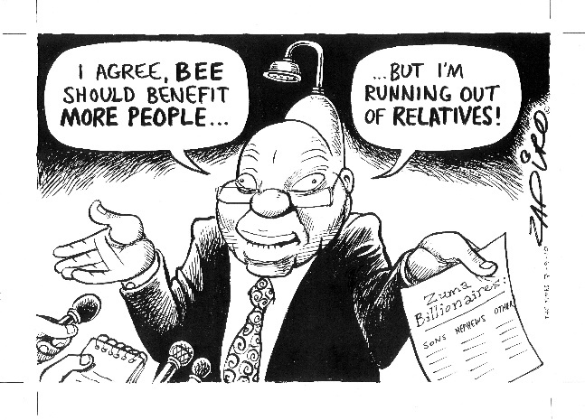

Figure 20: Interpretations of BEE

(Source: Permission granted by Zapiro to use this cartoon)

## The Ramaphosa era (2018–2024)

Assessing the economic policies published by Ramaphosa’s presidency is a difficult task. His tenure so far has had to deal with multiple crises that have created a chaotic environment within which to promote any kind of rational economic policy reform process. Amongst these crises are:

* Winning power far too narrowly in December 2017, leaving a large component of the Zuma-led radical economic transformation camp dominating the ANC Executive, Cabinet and public service.
* The COVID-19 catastrophe both globally and locally, particularly the initial lockdown of all social and economic activities, which disrupted the national economy severely, pushing millions of employees and thousands of firms out of work.
* The continuation of corruption, including most appallingly, the theft of funds intended for COVID-19 medical and socio-economic relief.
* The insurrection in July 2021 in KwaZulu-Natal and Gauteng, in which 300 people died and thousands of shops, factories, warehouses and malls were looted and gutted; triggered in part by jailing former President Zuma for his refusal to appear before the Zondo Commission on state capture and corruption.
* The collapse of most critical economic infrastructure such as energy, rail, roads, port facilities and water supply.
* An exponential increase in crime and violence across the country, including theft and vandalism of critical infrastructure.

Ramaphosa has been forced to respond to these pressures in three ways during his first term in office. Firstly, he has sought ‘unity’ in the ANC – presumably to protect his slim grip on power. However, this has meant little action taken against corrupt senior leadership in the ANC and government.

Secondly, he has formulated some economic policies, but as will be seen in the next sections, this has largely been the rehashing of older policies that have never been implemented – including the NDP. It appears as if a level of policy saturation has occurred in the ANC – it is now unable to define new and effective policy to rescue the country from its ongoing decline. Unfortunately, Ramaphosa appears to have become his own worst enemy, displaying a feeble and indecisive leadership style and embroiling himself in a financial scandal surrounding his game farm in Limpopo province.

The third focus of the Ramaphosa administration has been to fight corruption and crime. A new director of the NPA is in place, and a total of 28 major criminal inquiries and investigations into state capture and corruption have taken place. A total of 15 of these 28 investigations are related to the Gupta-Zuma network. Unfortunately, the wheels of justice turn slowly, and to date no major figures have yet been prosecuted and jailed for their corrupt misdeeds.

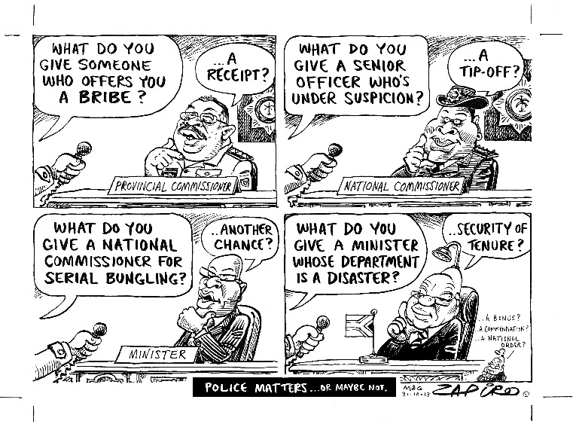

Figure 21: State capture and maladministration at its best

Source: Permission granted by Zapiro

### Economic policy in the time of Ramaphosa

Ramaphosa’s economic reform agenda has focused on the Economic Reconstruction and Recovery Plan launched in 2020 to deal with the devastation of COVID-19. Other initiatives include his focus on forging a social compact – a public-private partnership between the state, employers and unions – and the DTIC initiative focusing on ‘localisation’ (reducing imports through increased local production and consumption of ‘Proudly South African’ local goods). In addition, the Ramaphosa government has drafted industrial policy ‘master plans’ for each sector in the economy. These initially gained some traction, but not sufficient progress has been made to solicit enough public confidence in this approach.

### South Africa’s Economic Reconstruction and Recovery Plan

In his speech at the launch of the South African Economic Reconstruction and Recovery Plan, Ramaphosa emphasised that the plan builds on the common ground established through consultations with the key social partners – government, labour, business and community organisations. Its purpose was to introduce extraordinary measures to restore the economy to inclusive growth following the devastation caused by COVID-19.

Ramaphosa indicated that more than 2 million people lost their jobs in the second quarter of 2020. The economy contracted by 16.4% in the second quarter when compared to the previous quarter (the COVID-19 pandemic began at the end of March 2020, the end of the first financial quarter of 2020). This economic shock was unprecedented and would take an extraordinary effort to recover from. The objectives of the plan were to:

* Create jobs, primarily through aggressive infrastructure investment and mass employment programmes;
* Reindustrialise the economy, focusing on growing small businesses;
* Accelerate economic reforms to unlock investment and growth;
* Fight crime and corruption; and,
* Improve the capabilities of the state.

The plan committed to creating over 800 000 work opportunities in the immediate term in response to job losses; a growth rate of 3% over the ensuing 10 years; unlocking more than R1 trillion in infrastructure investment; reversing the decline of the local manufacturing sector and promoting reindustrialisation through deeper levels of localisation and exports; and resuscitating vulnerable sectors such as tourism, which were hard hit by the pandemic. Much of these commitments were existing policy positions of government in other policy documents – for example, the NDP and the NIPF. The plan received considerable criticism in the press and from academics. Executive Director of the Centre for Development and Enterprise, Ann Bernstein (2022), argues that:

This document – it is not a plan – it contains literally dozens of priorities, grouped together as ‘priority interventions’ ... There is little sense of what are the most important areas on which to focus and which actions need to come first. The plan is unworkably broad and ambitious. All these interventions are rendered more inadequate by the complete absence of any discussion of sequencing and prioritisation.

Bernstein adds that the plan was all-encompassing in its reach and ambition, while being completely naïve about the capabilities of the state and the challenges it faces. The plan failed to engage with the real causes of decline –corruption, mismanagement and the lack of implementation in many policy areas. Similarly, Mosala (2022) rejects the plan as a mere repackaging of old policies. In his view, it is nothing but buzzwords without meaning. The plan mimicked rhetorical calls for job creation and industrialisation made by previous policies without any operational plan and a new course of action.

Mosala (2022) interpreted the plan in relation to the worldwide talk of using a major crisis such as COVID-19 to reinvent and restructure the economy – and not to return to business as usual. As indicated in Unit 1, a deep crisis is not always just bad news. It can also be a useful trigger to force key actors to negotiate and compromise on a new growth path. If done effectively, such phases of stabilisation after a crisis can be very successful in leading to new long-term growth cycles (phase 2). A good example would be Finland, which in the 1980s experienced serious economic decline. The first contributing factor was the collapse of its dominance in the global markets for shipping and timber. The second factor occurred in 1989, with the fall of the Soviet Union, which had served as a key zone for Finnish exports. The main social and economic partners in Finland then negotiated a ‘new deal’ to resolve these economic problems. Today, Finland is the leading high-tech knowledge economy in the world. They turned their crisis into eventual success.

Ramaphosa’s recovery plan attempted to do this with the COVID-19 crisis. It did not seek to return to the pre-Covid-19 economic realities of our unequal economy, but to build a new economy for the future by stimulating equitable and inclusive growth. However, Mosala argues that for the plan to work, it required a capable and developmental state. Without addressing this and the issues of corruption, state intervention within the economy would remain parasitic and not developmental. Mosala gave the example of tourism, which was badly affected by COVID-19. With the crime rate reaching the highest levels ever, it is unlikely that international tourists will visit South Africa in larger numbers.

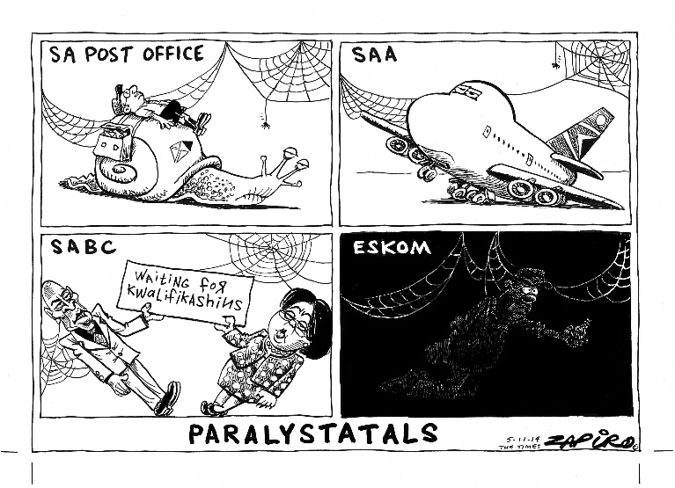

Figure 22: The demise of state-owned enterprises

(Source: Permission granted by Zapiro to use this cartoon)

Activity 21: The constraints on Ramaphosa to resolve societal problems

**Suggested time:** 30 minutes

1. From your reading of ‘The Ramaphosa era (2018–2024)’, write a short paragraph about each of three issues that you think were outside Ramaphosa’s control, and which made reforms very difficult. Do your writing in your learning journal.

Discussion of the activity

Ramaphosa came into office in 1918 with a lot of support and enthusiasm from citizens because it was thought that he alone was the leader to undo the damage of nine wasted years. However, there were events that made this task very difficult for him. These included:

1. The COVID-19 crisis, which was the most devastating global event to disrupt life as we know it. The ensuing economic and employment decline was not Ramaphosa’s fault, but it affected his image as an effective President when all the key indicators of the economy’s progress were published – all were in a downward trend. This did not instil confidence in him to effect changes.
2. Ramaphosa won the election to be ANC President with a very small margin. The reality was that his faction was a minority faction across the ANC, with leaders loyal to Zuma still holding important office in government and in the ANC executive. Factional politics dominated his first term in office, with him repeatedly stressing the unity of the ANC as being the primary goal. He has spent most of his time putting out fires and attempting to control the fallout from factional wars within the ANC.
3. The truth of corruption is that it began in the 1990s under Mandela and Mbeki, with the arms deal crisis. By the time Ramaphosa became president in 2017, it was out of control. This was not his fault. However, he remained an influential member of the national executive of the ANC throughout this time (1996–2014) and became Deputy President of the country in 2014. He did not play a role internally, by attempting to curb the growth in corruption and state capture, which were was so evident by the time he became Deputy President in 2014.

Although he was not personally responsible for any of these problems, his inability to fix them adequately has affected his image as a competent leader able to resolve societal crises.

## The political economy of post-apartheid society – what kind of capitalism?

This concluding section of the module will use the typology developed in Unit 1 as a means of describing the way in which apartheid capitalism has transformed itself after the transfer of power to the ANC in 1994. Nattrass (2014) suggests that the early period of post-apartheid South Africa was characterised by both the liberal and social-democratic typologies of market economies. For example, the GEAR economic framework of 1996 copied the classic neoliberal free market economics being punted globally by the World Bank and IMF. The neoliberal policy reforms comprised austerity measures and privatisation to reduce governmental debt, and trade liberalisation to promote open economies and increased exports.

In contrast to this stance, the new ANC government in the mid-1990s also developed very progressive labour market legislation, which has been admired across the globe. These labour market policies were similar to those policies adopted in social democratic economies. This mix of differing political economic systems – liberal market and social democratic – made South Africa a unique case in the world. However, the impressive policy developments of the period 1990 up to 1996 ‘floundered’ according to Nattrass, because

… the state preferred to act unilaterally with regard to macroeconomic policy, business was divided and preferred bilateral engagement with government and organised labour had a strong ideological preference for managing capitalism through a developmental state (Nattrass, 2014:57).

Nattrass maintains that these contradictory policy positions – ‘liberal’ versus ‘social democratic’ – led to significant policy inconsistency and tension in the governance of the country. She provides the example in 1996 where, on the one hand, collective decision-making bodies like NEDLAC were trying to negotiate labour market policy and a basic income grant for the poor, while on the other, GEAR’s neoliberal policies were being formulated – policies that placed emphasis on the introduction of austerity measures to overcome high government debt and run-away inflation.

Over time, the social-democratic goals have weakened and lost out to the austerity measures of GEAR. The social compact needed for social democratic policies to work began to crumble. A good example is how NEDLAC failed to be a place for dialogue, cooperation and coordination. Instead, it increasingly became a forum which both government and employers ignored. Today, NEDLAC is fairly toothless. GEAR emphasised core neoliberal principles like ‘fiscal discipline’ and greater ‘flexibility’ in the labour market, which would allow the employment of low-wage workers. What has subsequently grown is South Africa’s characterisation as an LME.

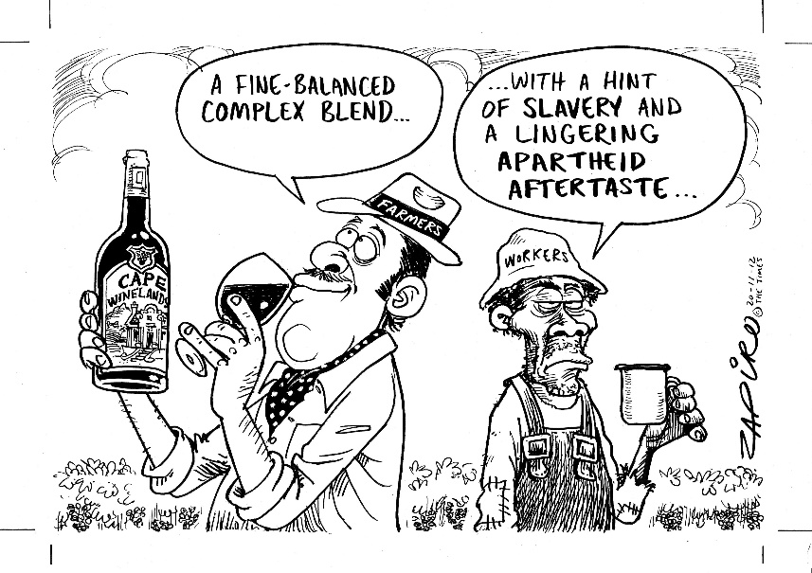

Figure 23: Apartheid capitalism does not disappear after 1994

(Source: Permission granted by Zapiro to use this cartoon)

This picture of incoherence in the political economic system governing South Africa has been made even more complicated by the addition of crony capitalism as another typology characterising its workings. Nattrass (2014) puts much of the blame for this development on the championing of BEE policies particularly under President Zuma. It unleashed the spread of patronage politics across the economy.

Nattrass (2014) writes that just as the old white corporate sector maintained power and control over vast swathes of the apartheid economy through interlocking directorships and shareholdings, a new black elite in the post-apartheid era had now emerged with members serving on each other’s boards and establishing close links with the ANC government.

Those included within this BEE elite comprise former politicians and senior civil servants, who on leaving government started their own private companies/consortia of companies and landed themselves generous procurement contracts with government. White corporate interests were keen to be part of this movement of co-opting the black elite within the power structures of white business. These white corporates would sell a share of the company at hugely discounted prices to the new BEE capitalists, with the debt owed underwritten by the corporates themselves, or though bank loans. In return, says Nattrass, those white companies were able to gain informal access to the black political elite, lucrative government contracts, mining licences and the like.

However, it was not long before this initial structure for elite access to power was corrupted further by cadre deployment of unqualified comrades to state-owned enterprises. It also extended to layer upon layer of civil servants in charge of procurement supply chains across all three spheres of government. Under the Zuma years, cronyism reached extreme proportions, with massive levels of corruption staining any credibility that the initial idea of BEE may have had.

This is a parasitic form of capitalism, based on obtaining shares in corporate firms in return for political favours and connections, rather than participating in productive investment in real economic activity. It is another form of diversion of financial investment from productive uses, which has weakened the possibilities for economic growth, employment opportunities and any form of social justice in one of the most unequal societies in the world.

## What have you learned?

### Summative assessment

A summative assessment usually happens at the end of a course. It is intended to assess how well you were able to achieve some of the module and unit outcomes of a course, either partially and/or indirectly. In this case you should be able to:

* Demonstrate some understanding of the diverse challenges faced by TVET colleges in supporting the South African economy by
  + Illustrating a link between contextual developments and changes in the economy to the changing role of TVET colleges;
  + Exploring ways in which you can assist your graduates to gain access to demand-led training opportunities and to acquire employment

#### A big picture

All the knowledge in this module provides you with the ‘big picture’ (see further discussion below). By now you will have general insight into the linkages and dependencies between many socio-economic factors that drive our economy and society. Ideally, at the end of this course, you not only know more about the political economy, but you also understand better how social, economic, political and geographic factors shape and influence what happens in your college. The big picture is also historical. You now have a view of how our country and the world has changed over the past seven decades, and how this change has impacted on TVET. Often, change does not move in the direction we wished for. Sometimes, conditions worsen before they improve. Change in education and training is very difficult to achieve.

In this summative assessment you will explore a company’s approach to employee training and decide whether a TVET college would want to set up a relationship with that company for purposes of sending students there for their work integrated learning (WIL) component of their course, or for possible future employment of students. You might find it helpful to draw on the work you did in Unit 1 Activity 5.

Activity 22: Summative assessment – to train or not to train?

**Suggested time:** 120 minutes

Imagine you are a journalist for a magazine. Your boss has asked you to write an article about the relationship between a TVET college and a local company. The title of the article should be ‘To train or not to train?’

1. First, read the section after this activity called ‘The big picture’, including Table 10 ‘Mapping the big picture’.
2. Then, follow these four steps to help with writing your article:
   1. Think about either a company that trains its employees, or one that does not train. If you can, choose a real company that you have worked with as part of your TVET college work. If you have no contact with a company and/or a college, create a company and a TVET college in your imagination. For example, choose an auto repair firm known as Victory Motors (an imaginary firm that trains) and Paradise College (an imaginary college that has links with the imaginary ‘Victory Motors’).
   2. Table 10 will help you to think about your chosen company’s approach to employee training, and their possible reasons for that choice. It will also help you to think about which type of firm your college would best have a relationship with to benefit your students.
   3. Use Table 10 to structure your article. Table 11 is a template based on Table 10. Table 11 will guide you to write an introduction to your article, and to discuss each of the contextual issues that shape and influence the decision of your chosen company to train or not to train its employees, and the relationship between the college and the company.
   4. Once you have completed Table 11, in your own words, you can turn what you have written into a narrative or storyline for your article.

Before you start to write, let us recap some ‘big picture’ contextual background to this task.

The big picture

The micro level or ‘small picture’ which you are very familiar with comprises you as the teacher, your classroom, the workshops and laboratories at your college, your students and your college in general. Your task is to lecture to your students in some disciplinary field, and then to assess them. It might also entail you assisting the placement office in your college with organising the annual WIL, which your students must complete, to qualify for their certificates.

The big picture refers to the wider (macro) contextual factors that shape our society and country. The macro factors can also influence micro-level activities, like the ability of your college to offer valuable WIL opportunities for students, and the eventual employability of your graduate students. We have discussed many of the macro factors that might influence a company’s decision to train or not in this module.

In Table 10 ‘Mapping the big picture’ you will read a comparison of two types of firms in South Africa – those that train (Firm A) and those that don’t train (Firm B). The comparison focuses on macro, contextual factors that impact on a company’s decision to train employees or not.

In the comparative matrix, you will read how Firm A uses the contextual factors to advance its economic interests – it modernises its technology and training infrastructure to produce higher-value-added products for export. Firm B is resistant to change, doesn’t see the need to modernise its production and skills, and views increased training and technological upgrading as a heavy cost that can be ignored.

The comparative matrix then moves on to explore some of the macro-economic, social and political factors that affect the college’s relationship to each type of firm. Does your college send students to Firm A type businesses (they take training seriously) or Firm B businesses that are not keen on spending money on training? It is likely that Type B firms are not keen to spend time and effort on training your students if they are not even training their own employees. Their primary objective is to make a profit, and survive the upturns and downturns of the economy.

It is more likely that Firm A will be interested in supporting your students and will give them the best possible exposure to a range of work tasks. For example, in factories, Firm A employers will rotate trainees across all the different workstations in the factory. This would include the warehouse where raw material inputs in production are ordered and stored; the manufacturing workshop where components of the product are fabricated; the assembly and finishing units where the final product is assembled and completed; and finally, the despatch area where final products are packed in cardboard and bubble wrap and then sorted in terms of consumer orders, awaiting transport to deliver the product to clients on time. There are also the administration, personnel and finance offices, which are part of most factories. WIL students would benefit enormously from experiencing what each of these units do towards the production and delivery of the final consumer product.

Table 10: Mapping the big picture

| **Mapping the big picture** | | | |
| --- | --- | --- | --- |
|  |  | **FIRM A (does training well):** | **Firm B (doesn’t do much training at all):** |
|  | **Macro-economic, social and political factors affecting the firm’s decision to train employees:** | | |
| **1** | **Location:**  Has rapid urbanisation affected your hometown/region?  If it has, where do all the migrating people live? In a township?  Do people find jobs easily in this region? | If urbanisation is evident, it is very likely that many migrants from the rural areas now live in squatter camps around the big cities and towns. In most cases, employment is not available to young people in these locations. Therefore, training does not happen much in these areas.  However, this firm is likely to assist with training of township youth to help the country out of its unemployment crisis. If there are many such expansive learning firms in your region, then a small dent in unemployment may be possible. | This non-training firm doesn’t care about its social image. It will not assist township youth out of unemployment through training – as this would incur costs. |
| **2** | **Racial composition of firm:**  Who is dominant in the professional and managerial jobs?  Have the racial profiles of local firms and all their occupations changed much over the past three decades? | This firm is committed to training, and so if a large enough number of black employees have been trained and promoted over the past 2-3 decades, then yes, the composition of managers and professionals may be racially mixed/non-racial.  Employment equity has been achieved. | Without training, workers are likely to remain in their current jobs for a very long time. This firm does not want to train as it incurs large costs and takes staff away from the shop floor. Hence its staff profile may not have changed since apartheid days and all managers and professionals may continue to be white. Employment equity has not been achieved.  Many firms in South Africa are still controlled by white people, most often through family ownership of the firm. The top positions in the small firm will go to family members. If the family is white, it will be very difficult to change the racial make-up of the personnel working in the firm.  If not, it is unlikely that the company will train its employees to become skilled. A company like this is also unlikely to employ many black students from your college after they have graduated. Small firms that are still owned by white families are likely to continue to employ family members and relatives in their firm. Outsiders like your college graduates may struggle to get into the more skilled jobs in those firms. |

|  |  |  |  |
| --- | --- | --- | --- |
|  |  | **Mapping the big picture** |  |
|  |  | **FIRM A (does training well):** | **Firm B (doesn’t do much training at all):** |
| **3** | **Style of management in the firm:**  Is management adversarial, conflictual or cooperative? | This firm is defined by its prioritisation of expansive learning. To do this effectively requires a form of cooperative management, whereby all employees learn from each other, and where all go on training courses. Cooperation and upskilling are key components of this type of firm. | Management in Firm B is very likely to be coercive and hierarchical – employees are given instructions in a top-down manner. Their input regarding production issues is not considered. |
| **4** | **Type of market:**  Does the business produce for the local market, or do they export higher-value-added products to global markets? | This firm is more likely to be able to export because it is committed to upgrading its workforce through training, so that they can handle the new digital technologies and export higher-value-added products to global markets. | This firm is more likely to focus on the internal markets in South Africa where competition for those goods is less, and where low-cost, low-wage, standardised products can be sold to local consumers without costly expenditures on upgrading to be able to produce higher-value-added products for export.  If they produce for the local market, these companies are not likely to offer WIL students a wide view of production as they have restricted their product offering to low-cost, low-wage, low-skill products for the local market. These firms will have antiquated, outdated technologies, old-fashioned managerial strategies, and a poor view of the value of training. |
| **5** | **Training of apprentices:**  Does the firm train apprentices, or does it poach skilled artisans from other employers? | It most definitely trains apprentices for its own use, and it may also perform an important societal role of training young unemployed persons as apprentices to help overcome unemployment and poverty. There are firms across the national economy that do this – they train beyond their own needs to upgrade the country’s skills base. | This firm poaches its artisan needs from other firms. It does not do any apprenticeship training at all and relies on its semi-skilled employees to do all the skilled tasks. This is how it keeps costs low. |
| **6** | **Learning in the workplace:**  Does the firm offer expansive or restrictive learning in the workplace? | This firm does expansive training, putting all staff through regular training at various intervals. Also, it may provide bursaries for staff who want to study further at university in part-time mode. | This is a case of restrictive learning; if any learning takes place at all. Employees do repetitive tasks, which require little training beyond a one-day introduction to the machines used and the work that needs doing. |
| **7** | **Technology:**  Does the firm use the latest digital technologies? | Yes, the firm will see new technology as part of the upgrading of the firm’s ability to produce higher-value-added products using CNC machines, robotics, 3D printing, e-commerce, and so forth. | No, it is unlikely because the firm is driven by the goal of minimising costs, maximising profits. Hence it is very unlikely to spend money on expensive machinery. ‘Business as usual’ defines their overall approach – nothing changes in the workplace.  Do local companies and businesses need to upgrade to the new digital technologies or not? This factor will determine whether these firms can utilise more skilled workers. If these firms do not export, they face less competition and fewer rivals in the local market, and therefore, they may believe that they have no need to change production to incorporate the new technologies. |
| **8** | **Government industrial and training policies:**  Would the firm apply for benefits from government’s industrial and training policies?  Do firms and companies approach government and make use of these incentives? | Because it values upskilling and purchasing the new digital technologies, this firm is very likely to apply for government’s industrial policy benefits – for example, grants to buy new machinery; grants to attend trade expositions overseas to promote the export of their products. The firm would also make use of government’s local procurement policies (‘localisation’). In terms of training, this firm is likely to also cooperate with the SETAs to help train unemployed youth gain valuable skills, through a learnership.  But a go-getter firm that makes use of these incentives to acquire the new technologies, for example, may be able to more easily modernise and shift to producing higher-value-added products for export. | This firm is focused only on low costs and low wages. It is therefore unlikely to buy new technology or train. It will probably have no desire to cooperate with the government to increase training or upgrade technological capabilities.  Many firms do not like working with government as they are seen as bureaucratic and slow. |
| **9** | **Type of capitalism:** Iss it:   1. Liberal market? 2. Social democratic? 3. Developmental state? 4. Neo-market model? or 5. Crony capitalism? | This firm exhibits the characteristics of firms in a social democratic economy. This is because social democratic economies function on the basis of cooperation between employers, labour and the state. Such cooperation is very advantageous for achieving high levels of training. Workers in these economies are therefore more technologically equipped to handle the new digital technologies and the upgrade needed to produce more value-added products for export. | This firm supports the idea of a liberal market economy. The central attributes of this form of capitalism are that market forces should determine the key outcomes in the economy. The state should not play a big role in the economy. In short, training is viewed as the responsibility of employers, who will decide on the volume of training based on market signals about price, cost and benefits. In this scenario, training is often seen as too expensive, threatening profits. Often, no training occurs. |
|  | **Macro-economic, social and political factors affecting the college:** | | |
| **10** | **Location:**  Has rapid urbanisation affected your college?  If it has, where do students live? In a township? Is the college close to where people work? Do people find jobs easily in this locality/region? | Many colleges are in rural areas far away from industries and employment possibilities. This is a consequence of apartheid policy, which sought to build colleges for Africans only in the homelands and Bantustans – all rural areas.  Firm A would be unlikely to locate itself close to a college that is in a rural area. This is because Firm A trains its workers, purchases the latest technologies and seeks to recruit skilled workers when positions become vacant. This is all best achieved in urban areas. Hence a college with Firm A linkages is very likely to be in an urban location. | Colleges in contexts where there is no training are mostly located in the rural and former homeland areas.  A Firm B type business that does not see the value of training and operates on the basis of low wages will be relatively indifferent to its location. Many such firms are in both contexts – rural and urban. In fact, some Firm B type businesses choose to locate in rural areas so that they can pay desperate formerly unemployed workers a very low wage.  However, this Firm B type business will not make much contact with the college in this rural context – because the firm does not value the work of colleges in training employees. |
| **11** | **Demand-led or supply-side training:**  Does your college respond to actual demand for skills in the area it is situated in, or does the college simply offer those courses it has expertise in, whether employers need these skills or not? | Training is likely to be demand-led because firm owners believe that to upgrade to higher-value-added production and higher profitability (the demand side), training is needed. There is a demand then for training from employers.  If your college is not graduating students with skills that employers in the area need, individual students will enrol at the college in the hope of finding employment, but there are no guarantees that they will be employed locally. | Likely to be supply-side training because the firm is not interested in the college. The college may then face the problem of training individual young people who are unlikely to be employed by Firm B and other firms like it in the region. This is supply-side training – a college providing training where there is no demand from employers for those skills. The college ‘supplies’ the training irrespective of demand for these skills. |
| **12** | **Relationship between TVET college and firm:**  Is it characterised by:   1. A close relationship of regular interactions: or 2. Minimal interaction? | The college is very busy working with the firm. This is because the firm believes training and skilling are the key ingredients for future prosperity and profitability. The firm will then approach the college to assist with training.  This firm takes training very seriously. They are committed to training all staff, as they understand the link between the upgrading of skills and increasing profitability and competitiveness.  This firm is likely to accept students for their WIL and to potentially offer students employment after they have graduated. | The college plays a minimal role in the life of this firm – because the firm does not send employees for training, nor does it recruit college graduates.  This type of company has a highly restrictive notion of training. Your students would not learn much by going to such firms for their WIL.  This firm is not likely to want to employ graduate students. |

Now that you have a ‘big picture’ use Table 11 to begin to write your article ‘*To train or not to train?*’. Table 11 is a clean and simple writing matrix. It provides the macro factors as the main content headings for your article, including an introduction and a conclusion.

Please do not copy word for word from Table 10. Put your answers in your own words and make it truly original. In the end you will turn the content into a narrative for a typical magazine article.

Use the table to plan your content. Then use the template section headings as your paragraph headings in the journalistic text/article. Try and imagine that it is really going to go into a magazine. Therefore, your writing must be of good quality for your imagined public readership. It is this journalist article that will be assessed, not the table. Submit only the article for assessment.

Table 11: The structure of your article

|  |  |
| --- | --- |
| **The structure of your article** | |
| **The key headings in your article:** | **Content of your article:** |
| **Introduction to firm and college:**  Introduction to firm: Describe the firm in terms of its economic sector, main product manufactured, skills profile of staff (e.g. how many professionals, artisans, apprentices, semi-skilled workers and labourers). These do not need to be accurate, but merely a guesstimate you must determine via speaking to the firm (or in your imagination).  Introduction to college: Describe the students, and the courses they are currently undertaking for the sector. | *Insert relevant text here* |
| **The location of your firm and college:**  Describe the location of your chosen firm (e.g. urban/rural; large industrial area, small business town).  Describe the location of your real or imaginary college. (Where do students live? In a township? Is the college close to where people work? Do people find jobs easily in this locality/region? and so on.) | *Insert relevant text here* |
| **Racial composition of firm:** | *Insert relevant text here* |
| **Style of management in the firm:** | *Insert relevant text here* |
| **Type of market:** | *Insert relevant text here* |
| **Training of apprentices:** | *Insert relevant text here* |
| **Learning in the workplace:** | *Insert relevant text here* |
| **Technology:** | *Insert relevant text here* |
| **Government’s industrial and training policies:** | *Insert relevant text here* |
| **Type of capitalism?** | *Insert relevant text here* |
| **Demand-led or supply-side training from the college:** | *Insert relevant text here* |
| **Relationship between TVET college and firm:** | *Insert relevant text here* |
| **Conclusion to journalist piece:** | Provide a tight summary of your main argument about how, for example, ‘Victory Motors’ does such a good training job, and how it works so well with ‘Paradise College’. |

### Assessment Rubric

|  |  |  |  |
| --- | --- | --- | --- |
| **Name of student:** | **Maximum mark** | **Mark** | **Comments**  (from your assessor) |
| **Conceptual understanding**  Student demonstrates understanding of at least eight of the core political and economic concepts and the contextual issues;  Student appropriately describes the impact of these factors on a company’s decision to train its employees;  Student appropriately describes the importance of these contextual factors in determining what type of relationship the college has with the company to support training and job opportunities.  **Originality**  The student’s work is original rather than copied from the assignment task.  **Quality of writing**  The student displays an ability to write well. There is a clear structure and logical argument, addressing the topic. There are no typing errors and layout makes it easy for the reader to follow. | 30  30  30  10 |  |  |
|  | **100** | **100** |  |

# References

Abedian, I and Standish, B (1992) ‘The South African economy: A historical overview’, in Abedian, I and Standish, B (Eds) *Economic Growth in South Africa: Selected Policy Issues*, Oxford University Press, Cape Town.

Altinyelken, HK, du Bois-Reymond, M and Karsten, S (2010) *Country Report: The Netherlands,* report of the GOETHE (Governance of Education Trajectories in Europe) project, The University of Amsterdam.

Altman, M and Mayer, M (2003) ‘Overview of industrial policy’, in Kraak, A and Perold, H (Eds) *Human Resources Development Review 2003: Education, Employment, and Skills in South* *Africa: Review 2003,* HSRC Press, Cape Town.

ANC [African National Congress] (1994) *The Reconstruction and Development Programme.* Umanyano Publications, Johannesburg.

ANC [African National Congress] (1990) *‘*Discussion document on economic policy’, pamphlet, ANC Head Office, Johannesburg.

Ashton, D, Sung, J and Turbin, J (2000) ‘Towards a framework for the comparative analysis of national systems of skill formation’, *International Journal of Training and Development*, 4 (1): 8–25.

Beinart, W (2001) *Twentieth-Century* *South Africa.* Oxford University Press, Oxford.

Bird, A and Schreiner, G (1992) ‘Cosatu at the crossroads: Towards tripartite corporatism or democratic socialism’, *South African Labour Bulletin*, 16 (6): 22–32.

Budlender, D (2003) ‘The social and human development context’, in Kraak, A and Perold, H (Eds.) *Human Resources Development Review 2003: Education, Employment, and Skills in South* *Africa,* Cape Town: HSRC Press.

Chipkin, I and Swilling, M (2018) *Shadow State: The Politics of State Capture.* Johannesburg: Wits Press.

Cloete, K (2022) [The three R’s – review, rethink and reimagine – are urgently needed to get skills development in South Africa back on track](https://www.dailymaverick.co.za/opinionista/2022-03-06-the-three-rs-review-rethink-and-reimagine-are-urgently-needed-to-get-skills-development-in-south-africa-back-on-track/), 6 March, *Daily Maverick*.

Cosatu [Congress of South African Trade Unions](1993) ‘COSATU – The way forward: Building the programme for economic reconstruction and development’, discussion document of the COSATU Executive Committee, COSATU Head Office, Johannesburg.

DoF [Department of Finance] (1996) *Growth, Employment and Redistribution: A Macroeconomic Strategy,* Pretoria.

DTI [Department of Trade and Industry] (2010) *2010/11–2011/12 Industrial Policy Action Plan: Economic Sectors and Employment Cluster,* Pretoria.

Dubow, S (1989) *Racial Segregation and the Origins of apartheid in South Africa, 1919-1936,* St. Martin’s Press, Oxford.

Dubow, S (2014) *Apartheid 1948–1994,* Oxford University Press, Oxford.

Fine, B and Rustomjee, Z (1997) *South Africa’s Political Economy: From Minerals-Energy Complex to Industrialisation*. Wits University Press, Johannesburg.

Freund, B, (2013) ‘A ghost from the past: The South African developmental state of the 1940s’, *Transformation: Critical Perspectives on Southern Africa*, 81 (1): 86–114.

Fuller, A and Unwin, L (2010) ‘Workplace learning and the organisation’, in Malloch, M, Cairns, L, Evans, K and O’Connor, B (Eds) *The Sage Handbook of Workplace Learnin*g. Sage, Parbhoo, 46–59.

Golding, M (1991) ‘Productivity: Participating to achieve control’, *South African Labour Bulletin*, 16 (2): 18–24.

Hart, K and Padayachee, V (2013) ‘A history of South African capitalism in national and global perspective’, *Transformation: Critical Perspectives on Southern Africa*, 81(1): 55–85.

Hindson, D (1991) ‘The restructuring of labour markets in South Africa: 1970s and 1980s’ in Gelb S (Ed.) *South Africa’s Economic Crisis*, David Philip, Cape Town.

Hirsch, A, Levy, B and Nxele, M (2021) ‘Politics and economic policy making in South Africa since 1994’, in Oqubay, A, Tregenna, F and Valodia, I (Eds) *The Oxford Handbook of the South African Economy,* Oxford University Press, Oxford.

Joffe, A, Kaplan, D, Kaplinsky, R and Lewis, D (1995) *Improving Manufacturing Performance in South Africa: The Report of the Industrial Strategy Project.* International Research Development Centre, Ottawa.

Kaplan, D (2019) ‘Time for a review and a rethink of South Africa’s industrial policy’, *Viewpoints*, (8*)*: 1–10.

Mondliwa, P and Roberts, S (2021) The political economy of structural transformation: Political settlements and industrial policy in South Africa’, in Andreoni, A, Mondliwa, P, Roberts, S and Tregenna, F (Eds) *Structural Transformation in South Africa: The Challenges of Inclusive Industrial Development in a Middle-Income Country*, Oxford University Press, Oxford.

Morris, M and Padayachee, V (1989) ‘Hegemonic projects, accumulation strategies and state reform policy in South Africa’, *Labour, Capital and Society*, 22(1): 66–107.

Mosala, S (2022) ‘The South African Economic Reconstruction and Recovery Plan as a response to the South African economic crisis’, *Journal of BRICS Studies*) 1(1): 56–68.

Nattrass, N (2014) A South African Variety of Capitalism? *New Political Economy*, 19 (1): 56–78.

NSA [National Skills Authority] (2018) *Evaluation of the National Skills Development Strategy (NSDS III) 2011–2016*. NSA, Pretoria.

NTB [National Training Board] (1989) *Guidelines for the Implementation of Competence‑Based Modular Training: A Manual for Trainers*, Government Printer, Pretoria.

NTB/HSRC [National Training Board/Human Sciences Research Council] (1991) *Investigation into a National Training Strategy for the Republic of South Africa*, HSRC, Pretoria.

Padayachee, V (2019) ‘Can progressive macroeconomic policy address growth and employment while reducing inequality in South Africa?, *Economic and Labour Relations Review,* 30(1): 3–2.

President’s Council (1985) *An Urbanisation Strategy for the Republic of South Africa*, Government Printer, Pretoria.

Schwab, K (2016) *The Fourth Industrial Revolution: What it Means and How to Respond*. World Economic Forum, Davos.

Standish, B (1992) ‘Resource endowments, constraints and growth policies’, in Abedian I and Standish B (Eds) *Economic Growth in South Africa: Selected Policy Issues*, Oxford University Press, Cape Town.

Sung, J, Raddon, A and Ashton, D (2006) ‘Skills abroad: A comparative assessment of international policy approaches to skills leading to the development of policy: Recommendations for the UK’, Research Report done for *Skills for Business*, Centre for Labour Market Studies, University of Leicester, United Kingdom.

Wiehahn, N (1982) *The Complete Wiehahn Report*, Parts 1–6, Lex-Patria, Johannesburg.

Wilkinson, F (2002) ‘Productive systems and the structuring role of economic and social theories’, Economic and Social Research Council (ESRC) Centre for Business Research, University of Cambridge, Working Paper No. 225.

Zalk, N (2021) Structural change in South Africa: A historical sectoral perspective’, in Andreoni, A, Mondliwa, P, Roberts, S and Tregenna, F (Eds) *Structural Transformation in South Africa: The Challenges of Inclusive Industrial Development in a Middle-Income Country*, Oxford University Press, Oxford.

## Appendix One: Learning journal template

The Adv. Dip TVT module called Reflective Practice covers the concept of reflection in the life of a TVET lecturer. The simplest reflective model unit 2, is that of Terry Borton (1970).

### Using a journal for reflection

Throughout the Advanced Diploma modules, we encourage you to use a learning journal. Start your learning journal at the beginning of the programme, and keep it regularly updated throughout. In each *activity* or *stop and think* reflect on the questions or problems raised.

For your learning journal, you can use:

* an A4 notebook with at least 100 pages lined and blank, or
* this template.

In your journal write notes and reflections, complete activities, add drawings, letters, stick in pictures or objects, use pens or paint or do anything else that makes it meaningful for you. Record your thoughts verbally, using the voice recorder on your cell phone, or even take a video.

### Journaling styles

In the module on Reflective Practice in Unit 1 you can explore different ways to document your reflections and how to develop a reflection journaling style that suits you. Consider using mind maps, sketch notes and symbols too.



Mind map



Sketch notes

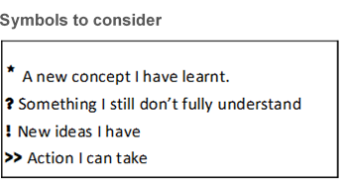

Begin your journal on the next page, if you are using this template.

### Module name:

#### Unit #

Remember to put a date each time you write in your journal.

#### Activity #