# Advanced Diploma

**School Leadership and Management**

## Leading and managing the school as an organisation Module 6

Department of Basic Education



**Department of Basic Education**

**Leading and managing the school as an organisation**

**A module of the Advanced Diploma: School Leadership and Management**

**© Department of Basic Education 2018**

Department of Basic Education 222 Struben Street

Pretoria South Africa

Tel: +27 12 357 3000

[https://www.education.gov.za](https://www.education.gov.za/)

This work is licensed under a Creative Commons Attribution 4.0 International License [(http://creativecommons.org/licenses/by/4.0/).](http://creativecommons.org/licenses/by/4.0/)) This means you are free to share (copy and redistribute the material in any medium or format) and adapt it (remix, transform, and build upon the material) for any purpose, even commercially, as long as you give appropriate credit, with a link to your source, and indicate if changes were made.

# Contents

Module 6: Leading and managing the school as an organisation 9

Overview 11

Unit 1: Leadership qualities and skills required to manage systems 15

Unit 1 - Section 1: Leadership approaches and actions 17

Unit 1 - Section 2: Problem-solving leadership skills 33

Unit 2: The importance of organisational systems in the school 53

Unit 2 - Section 1: Education management information systems 55

Unit 2 - Section 2: Data management 63

Unit 2 - Section 3: Manage other organisational systems 73

Unit 3: Lead and manage physical and financial resources 81

Unit 3 - Section 1: Framework for financial management 83

Unit 3 - Section 2: Implementing financial planning 99

Unit 3 - Section 3: Monitoring and managing financial and physical resources 109

Unit 3 - Section 4: Reporting on finances 127

Unit 3 - Section 5: Fundraising for sustainability 135

Unit 4: Creating and managing a safe and disciplined learning environment 143

Unit 4: Section 1: School safety: the reality 145

Unit 4 - Section 2: What legislation says about school safety 165

Unit 4 - Section 3: What safe schools look like, and how to achieve school safety 177

Unit 4 - Section 4: Managing learner discipline 187

Unit 5: Promoting and managing diversity and inclusion practices in the schooling context 195

Unit 5 - Section 1: Definitions of diversity and inclusion 197

Unit 5 - Section 2: Legislation pertaining to diversity and inclusion 217

Unit 5 - Section 3: Systems and processes for developing an inclusive and diverse school ethos 225

References 243

Appendix 1: Communication questionnaire 251

Appendix 2: Financial management policy – Quintile 3 school 253

Appendix 3: Financial management policy – Quintile 5 school 257

Appendix 4: Annual budgeting process requisition form 271

Appendix 5: Public school budget preparation form 273

Appendix 6: Exemplar stock-taking form 277

Appendix 7: Exemplar - Financial standing orders 279

**Acknowledgements**

This material is a product of a collaborative endeavour involving representatives of the following organisations and institutions:

Department of Basic Education - Education Management and Governance Development Directorate Education, Training and Development Practices SETA (ETDP SETA)

Zenex Foundation

Gauteng Department of Education

South African Institute for Distance Education (*Saide*) South African Principals Association (SAPA)

Personnel associated with Schools of Education at the following Higher Education Institutions were involved in developing and critically reviewing the course modules for the AdvDip (SLM) programme:

Rhodes University

University of Cape Town (Schools Development Unit) University of Free State

University of Kwa-Zulu Natal University of Pretoria

University of South Africa (Unisa) University of Venda

University of the Witwatersrand

Additionally, a number of education specialists and school principals were consulted.

### Acronyms and Abbreviations

|  |  |
| --- | --- |
| AdvDip (SLM) | Advanced Diploma School Leadership and Management |
| AGM | Annual General Meeting |
| BELA | Basic Education Laws Amendment Act |
| CAPS | Curriculum Assessment Policy Statements |
| CJCP | Centre for Justice and Crime Prevention |
| COD | Cash on Delivery |
| CoP | Community of Practice |
| DBE | Department of Basic Education |
| DDD | Data Driven Districts |
| DoE | Department of Education |
| EE | Equal Education |
| EFA | Education For All |
| EMIS | Education Management Information Systems |
| GAAP | Generally Accepted Accounting Principles |
| HEI | Higher Education Institution |
| HOD | Head of Department (Provincial) |
| HR | Human Resources |
| ICT | Information and Communications Technology |
| IQMS | Integrated Quality Management System |
| LSM | Learner Support Material |
| LSMC | Learning Support Materials Committee |
| LTSM | Learning and Teaching Support Material |
| LURITS | Learner Unit Record Information and Tracking System |
| MEC | Member of the Executive Council |
| NEIMS | National Education Infrastructure Management System |
| NGO | Non-Governmental Organisation |
| NNSSF | National Norms and Standards for School Funding |
| NSSF | National School Safety Framework |
| OECD | Organisation for Economic Cooperation and Development |
| PAM | Public Administration Management |
| PBO | Public Benefit Organisation |
| PFMA | Public Finance Management Act |
| POA | Programme of Assessment |
| PP | Professional Portfolio |
| RCL | Representative Council for Learners |
| SACE | South African Council for Educators |

|  |  |
| --- | --- |
| SARS | South African Revenue Services |
| SASA | South African Schools Act |
| SA-SAMS | South African School Administration and Management System |
| SASP | South African Standard for Principalship |
| SBA | School-Based Assessment |
| SBST | School-Based Support Team |
| SDP | School Development Plan |
| SGB | School Governing Body |
| SIP | School Improvement Plan |
| SMT | School Management Team |
| UNESCO | United Nations Educational, Scientific and Cultural Organisation |
| UNICEF | United Nations International Children’s Emergency Fund |
| WPP | Workplace Project |

**Module 6: Leading and managing the school as an organisation**

**AdvDip (SLM) Course Modules**

**Module 1** Professional Portfolio and Workplace Project

**Module 2** Leading and managing teaching and learning in the school

**Module 3** Leading and managing extra- and co-curricular activities

**Module 4** Leading and managing people and change

**Module 5** Working with and for the wider community



**Module 6** Leading and managing the school as an organisation

**Module 7** Working within and for the school system

# Overview

Welcome to *Module 6: Leading and managing the schools as an organisation.*

*Leadership is a process of influence leading to the achievement of desired purposes. It involves inspiring and supporting others towards the achievement of a vision for the school which is based on clear personal and professional values. Management is the implementation of school policies and the efficient and effective maintenance of the school’s current activities. Both leadership and management are required if schools are to be successful.* (Bush & Glover, 2003: 8)

This module foregrounds processes that the principal, together with the school management team (SMT) and the school governing body (SGB), is responsible for organising, planning, leading and monitoring within a school. The module focuses on building knowledge and capacity necessary for school leaders to make decisions and resolve issues that are beneficial to the overall management of the school, with the overall aim of achieving its core objectives, namely, quality teaching and learning. In support of this aim building knowledge of systems and processes that enable efficient financial, general, institutional and information management and administration are equally important.

Two key components of any organisation – organisational systems and the people who implement or utilise those systems – are brought together in this module. These two components are interdependent entities.

For an organisation, such as a school, to function optimally, it is imperative that these two components work together. People need well designed, effective systems (both procedural and technical) and systems need to be planned, organised and implemented by people who are well-trained, innovative and can solve problems.

Successfully bringing together systems and people depends greatly on the quality of ethical leadership and the quality of management and on an understanding of the complexity of change processes.

### Purpose

This module is intended to support aspirant school principals to understand the school as an organisation and to manage organisational systems holistically in context. It also provides support on managing the use of information and communication technology (ICT) and physical and financial resources. Finally it addresses issues related to building and enhancing the school as a safe, disciplined and caring environment conducive to effective teaching and learning.

### Module learning outcomes

By the end of this module you will be able to:

1. Demonstrate the personal and professional qualities and skills necessary for effective leadership and management of organisational systems, including ICT, and financial and physical resources.
2. Implement, evaluate, maintain and improve organisational systems for the school where possible, making use of appropriate information and communication technology (ICT).
3. Lead and manage the physical and financial resources of the school in a transparent and accountable way.
4. Understand and be able to apply relevant content knowledge and skills in the management of organisational systems, ICT and physical and financial resources.
5. Create, manage, innovate, and sustain appropriate systems and procedures to enhance a caring and disciplined environment and show commitment to following this through in the way in which teaching and learning is organised.
6. Understand and apply appropriate principles, practices, policies and codes to facilitate the implementation of inclusive education, address issues of diversity and develop a safe learning environment.

### Units

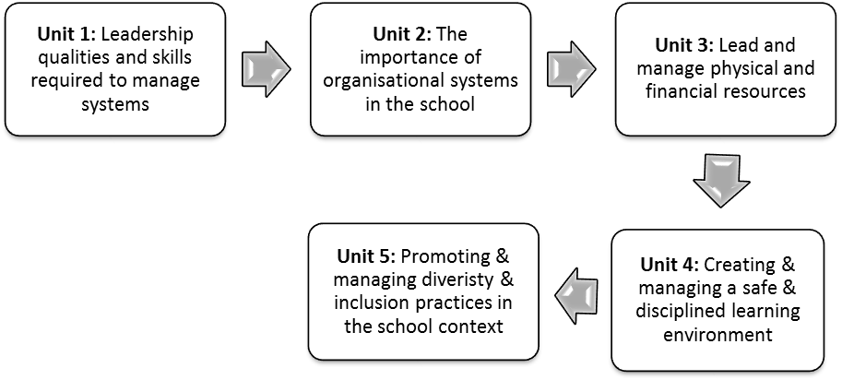

#### Figure 1: Units in Module 6: Leading and managing the school as an organisation

**Module credits and learning time**

This module carries 18 credits. This is equivalent to 180 notional learning hours.

It is anticipated that you will take approximately 180 hours to complete the module successfully. The 180 hours will include contact time with your Higher Education Institution (HEI), reading time, research time and time required to write assignments. It is also expected that at least half of your learning time will be spent completing practice-based activities in your school.

This will involve your individual work, and it will also require you to discuss these school-focused activities with your colleagues. Each activity in this module indicates the suggested time for completion. All these reflective and formative activities will form part of the Professional Portfolio (PP) and Workplace Project (WPP) which is explained in detail in *Module 1: Professional Portfolio and Workplace Project.*

Additional information and assessment requirements will be provided by your HEI.

### Exit level outcomes

This module contributes to the following four of the nine exit level outcomes (ELOs) of the AdvDip (SLM) qualification:

#### ELO 1

Demonstrate a sound knowledge of policy and legislation that frames best practice in school leadership and management in South Africa, whilst locating, arguing for and contesting bodies of knowledge.

#### ELO 3

Reflect on and develop own personal leadership attributes and characteristics , collaboration, knowledge of systems and processes, and demonstrate the ability to work effectively with others in the school context and beyond.

#### ELO 6

Select, and apply effective and innovative organisational systems and processes (such as HR, Finance, Safety, IT, etc.) to manage resources in a way that aligns with the school’s vision and mission, as well as to ensure compliance with legislation, policy and best practice in addressing a range of organisational needs.

#### ELO 8

Model ethical and values-driven leadership that adheres to professional standards of governance and Codes of Conduct for educators, and articulate why certain decisions are taken and standards are applied.

#### Take note

In most of the module activities it is suggested that you work collaboratively with either your school-based or your HEI community of practice (CoP). However, depending on when you are doing the activity, you may need to select which CoP you work with (it may not always be possible to work with the CoP that is specified in the activity). If it is not possible to work with a CoP, try to work with a colleague or work on your own.

**Unit 1: Leadership qualities and skills required to manage systems**

**Introduction**

The focus in this unit is on the role of the principal in setting up, and managing a number of different systems within the school as specified in the South African Standard for Principalship (SASP):

*The principal should provide for the effective organisation and management of the school and on the basis of on-going review and evaluation, he or she should strive continuously for ways to develop and improve organisational structures and functions. The principal is responsible for ensuring that the school and its people, assets and all other resources are organised and managed to provide for an effective, efficient, safe and*

*nurturing environment. These management functions require the principal to build and strengthen the capacity of those working in the school and to ensure that all available assets and resources are equitably deployed to maximum effect in supporting effective teaching and learning* (DBE, 2015: 16)*.*

SASP makes specific reference to the principal’s role in “changing and improving processes at the school” emphasising the principal’s responsibility for driving change. For example, a requirement of a principal’s strategic leadership capability is to “improve process solutions” while “keeping up to date with current developments in national education policy and schooling globally” (DBE, 2015: 10). In terms of 21st century technological and systems enhancements, this certainly implies a strong ICT capability. Executive leadership capability includes creating “a school as an organisation that is adaptable to change” (DBE, 2015: 11). An even more explicit requirement is that of the instructional leader who must “lead the school into the future through the use of ICT” (DBE, 2015: 11). Finally, requirements provided under *organisational* leadership in SASP are for the principal to “create processes for identifying and resolving problems and challenges in a fair, consistent and professional manner”; “design a system of communication for sharing good practices”; “establish implementable and clear management systems and processes”; and “analyse and use available data to improve practices at the school and in its classrooms” (DBE, 2015: 12, 16).

Given the SASP requirements, this unit looks primarily at personal leadership characteristics and practices that enable a school leader to drive a change process in order to improve organisational systems and processes. It therefore covers skills such as problem-solving and communication; the discipline of time management; openness to innovation; and a willingness to take risks (albeit small). This unit also looks at the need for an integrated and coherent approach to change and the need for integration of systems to prevent duplication of effort.

UNIT 1: LEADERSHIP QUALITIES AND SKILLS REQUIRED TO MANAGE SYSTEMS

This unit comprises two sections, depicted as follows:

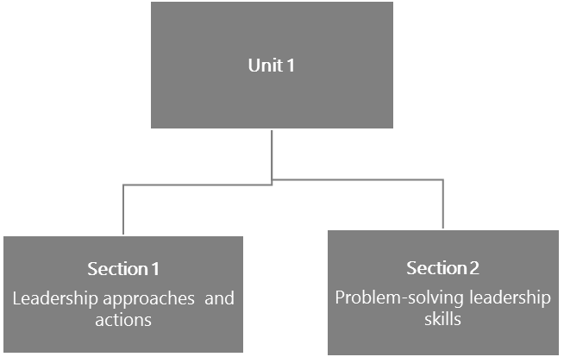

#### Figure 2: The structure of Unit 1

**Unit 1 learning outcome**

This unit has one learning outcome. By the end of this unit, you should be able to:

* Demonstrate the personal and professional qualities necessary for the effective leadership and management of organisational systems, including ICT, and financial and physical resources.

Section 1: Leadership approaches and actions

### Introduction

This section builds on the leadership approaches and actions that enable the implementation of useful systems within a school, as well as the positive attributes and behaviours that foster good implementation. The first topic investigates what is required for both compliance and accountability, which must always be considered together. Then the focus shifts to suitable practices for decision-making. Alongside this is an exploration of desirable communication skills. The final part of the section requires the school leader to explore action research skills as a methodology for change.

### Compliance and accountability

What is meant by compliance and accountability? This is an area that you looked at briefly in *Module 4: Leading and managing people and change*.

In discussing *compliance*, you need to ask questions, such as, “Compliance to whom?”, “Compliance for what?” and “How will you achieve compliance?” Equally, when discussing *accountability*, questions asked will relate to what compliance is and compliance to whom. You also need to carefully consider “Why are school leaders accountable?” and “How are school leaders accountable?”

**Compliance** can be explained as a *requirement to which one needs to conform*. In that case, an example of compliance in the South African education sector is about delivering the curriculum as designated by the Department of Education. In Gauteng, compliance would include delivering the curriculum against the *pace setters* that provide a calendar for progression through the curriculum. In KwaZulu-Natal, these are called *trackers*, but they serve the same purpose. Assessment protocols are also a matter of compliance.

Compliance is therefore about set standards and targets against which reporting should happen. According to this example, compliance is about what is delivered, by when, and it is assessed and reported in a particular way.

**Accountability**, according to Bush and Middlewood (2005: 65) is about being *answerable*. Both Fullan (2008:

102) and Elmore (2003) differentiate between internal and external accountability. Elmore is adamant that schools should place a strong emphasis on their internal accountability with regard to learner attainment, rather than the accountability required from external agencies such as the district or provincial education department (Elmore, 2003). This may seem rather radical, but think about who should really matter most in the school. It is, however, important not to misunderstand what Elmore is saying, because a key concept for him is what he calls *reciprocal responsibility* (2003) which implies that school leaders should be held accountable, but only to the extent that they have been supported by their district leaders. As discussed in Unit 2 of *Module 4: Leading and managing people and change*, Elmore is therefore placing accountability for learner progress and achievement (*why* you lead) above administrative accountability (*what* you manage).

UNIT 1 - SECTION 1: LEADERSHIP APPROACHES AND ACTIONS

This should remind you of Sinek’s Golden Circle as discussed in Unit 1 of *Module 4: Leading and managing people and change*. In a review of the literature on this subject, carried out for the National College for School Leadership by Bush and Glover, they found that schools require both visionary leadership and effective management:

*Leadership is a process of influence leading to the achievement of desired purposes. It involves inspiring and supporting others towards the achievement of a vision for the school which is based on clear personal and professional values. Management is the implementation of school policies and the efficient and effective maintenance of the school’s current activities. Both leadership and management are required if schools are to be successful.* (Bush & Glover, 2003: 10)

#### Stop and think

Would you define accountability as a leadership or as a management function?

Lock and Lummis from Western Australia (2014: 58) report that “principals are overloaded with work, unsupported and under-resourced to the extent that children’s education is at risk”, as well as raising an increasing “concern about the amount of time and stress [that] external compliance requests were placing on schools, particularly [on] principals.” It is likely that many South African principals would report similar concerns, however, it’s essential that you remember that leadership in not exclusively about the principal. This reminds us that leadership, management and accountability need to be distributed at all levels throughout the school (Spillane, 2006).

The following activity explores the attitudes of school leaders towards compliance and also looks ahead to how the *burden* of compliance can be minimised through distributed leadership as well as the choice and implementation of effective ICT systems.

SECTION 1: LEADERSHIP APPROACHES AND ACTIONS



**Activity 1: Compliance and accountability**

**Suggested time:**

30 minutes

**Aim:**

1. To reflect on attitudes towards compliance and accountability.
2. To look beyond the task to workable solutions.

#### What you will do:

1. Write a paragraph in which you list three ‘pros’ and three ‘cons’ of compliance and accountability as a school leader.
2. Complete the questionnaire below, adapted from a questionnaire on compliance tasks for school leaders developed by Lock & Lummis (2014: 64).
3. After completing the questionnaire, note down any further insights that you may have had with regard to compliance. Also note whether the insights might lead you to change the way that you respond to compliance requirements.
4. After having completed the questionnaire, write a statement about your responsibility as a school leader to ensure that compliance requirements are met. In your statement, consider your role in influencing how people in the school view and respond to compliance requests.

#### Table 1: Compliance questionnaire for school leaders

|  |  |
| --- | --- |
| **Statement** | **Response** |
| **Time and resources spent on compliance** | |
| How many hours per week, on average, do you estimate you spend in responding to compliance requirements from external authorities? |  |
| Identify the five most time-consuming compliance requirements and, if possible, state how much time you spend on each of these compliance requests. |  |
| Do you have administrative support in responding to compliance requirements? If so, indicate how many staff assist. |  |
| Does responding to compliance requirements have any impact on school resources, for example, ICT, teaching staff responsibilities being adjusted, overall staffing? |  |
| **Value of the request for compliance** | |
| Do you believe there are compliance requests which are unnecessary and/or duplicated? If so, please provide some examples. |  |

UNIT 1 - SECTION 1: LEADERSHIP APPROACHES AND ACTIONS

|  |  |
| --- | --- |
| **Statement** | **Response** |
| Are you always clear about the reasons for compliance requests? Briefly explain why or why not. |  |
| Are you able to identify compliance requirements to which responses are easy/difficult? Please specify and indicate the reason(s) for your selection(s). |  |
| **Impact on educational leadership, and personal cost** | |
| 8. Do compliance requirements impact detrimentally on your role as an educational leader? If so, please explain. |  |
| What advice would you give to potential or recently appointed principals regarding compliance requirements? |  |

(Source: Adapted from Lock & Lummis, 2014)

#### Discussion of the activity

As you consider the responses you wrote down, it’s important to reflect on whether you are building on what you have already learned in this programme, or whether you responded in a way that only draws on your previous experiences.

For example, did you focus on the burden of complying with demands from the circuit or district offices, getting frustrated with *what* you have to do, or were you able to think about who else in your team of leaders would be best placed to work with you – your distributed leadership? Were you thinking about *why* it might be important to comply with policy, demonstrating the shared responsibility and accountability you and your team pride yourselves in?

The content of your responses is really only important as a reflection of the way you are now thinking as a school leader. Of course, there might still be frustrations with late requests for, or duplication of, data, or questions about whether anyone will do anything with it. More importantly, you should be asking yourself how effectively your school is being led and managed, enabling you to access whatever data is called for.

Christie (1998: 288) makes strong links between school disorganisation and weak, absent or negligent leadership; poor school functionality overall; and also weak bureaucratic compliance. She says, “schools we visited showed clear signs of organisational breakdown in both structures and processes. There were problems with management and administration, including weak and unaccountable authority structures” (Christie, 1998: 288). Examples given include the frequent absence of the principal, lack of accountability by a principal who regarded themselves highly (self-reported), poor communication, and generally poor administration. Christie writes further (1998: 289) that “It seems clear that the breakdown of management and leadership within schools is an important part of dysfunction.” The link between a lack of systems, a lack of compliance and accountability, and a lack of leadership and management is clear.

This important work was done by Christie in 1998, and the question it raises is why many schools are still sitting with the same challenges more than a decade later? This programme offers a very real opportunity for school leaders to change both the way they think about leadership and management and their practice in schools. Firstly, this will only happen if you are serious about changing your focus from *what* you do, to spending more time and energy contemplating *why* you do what you do. Secondly, you will need the knowledge and skills to help you lead and manage your team and your school.

SECTION 1: LEADERSHIP APPROACHES AND ACTIONS

In this next part of the section, a collaborative approach to decision making will be examined. Communication as a leadership skill and the school leader as an action researcher will also be discussed.

As you start to consider how a consultative and collaborative approach can facilitate decision-making, you need to remember what you learned about relational and participative leadership and a transformative approach to leadership in Units 1 and 2 in *Module 4: Leading and managing people and change*. You are encouraged to go back to this section for a quick reminder.

### Consultation and collaboration to guide decision-making

Some leaders are highly skilled at making decisions and then telling others what that decision is. In many ways this is an easy way to get things going and sometimes it is justifiable and necessary. But often, such autocratic behaviour leads to resentment and resistance to the proposed change. However, there are leadership approaches that invite participation and collaboration such as the distributive leadership perspectives discussed in *Module 4: Leading and managing people and change.*

The next activity offers a collaborative decision-making tool that is simple to use yet allows for the participation of even a large group of people. The tool suggested is the bull’s-eye collaborative decision- making technique.



**Activity 2: Collaborative decision-making techniques**

**Suggested time:**

1 hour

**Aim:**

To introduce a simple technique that invites collaboration and participation when making decisions.

#### What you will do:

1. Study the information below on the *bull’s-eye collaborative decision-making technique*.
2. Practise the bull’s-eye technique with your school-based CoP. The aim is to use the technique to reach a group decision about an issue.
3. Reflect on how the technique worked, and what you would do differently next time. In your reflection, explain how the technique aids collaboration and buy-in from the included stakeholders.

#### Instructions: How to use the bull’s-eye collaborative decision-making technique

The aim of the bull’s eye technique is to explore group priorities and be in a position to select the most popular or urgent ideas, actions or concepts for action. The tool is also used to prioritise from a list and establish areas of commonality and difference. For these reasons, this tool can be used to establish a shared vision amongst employees that will ultimately focus their energy and motivate them to action.

UNIT 1 - SECTION 1: LEADERSHIP APPROACHES AND ACTIONS

#### The steps to follow:

1. Draw a bull’s-eye diagram (five concentric circles) on an A3 sheet of paper.



1. Each person participating writes one issue or concept related to the topic being discussed on a ‘card- sized’ piece of paper (cut A4 sheets into quarters).
2. The group reviews the notes and consolidates content by removing duplications, clustering, etc.
3. The cards are placed around the outside of the bull’s-eye.
4. Each person gets three moves. They can move one card three circles in, or three cards one circle each.
5. The process is repeated. A card can be moved *outwards* as well as *inwards*.
6. The group reviews the bull’s-eye and notes which concepts are closest to the bull’s-eye (the centre). Those closest to the bull’s-eye represent the group’s preferences and thus are priorities.
7. The group discusses the priorities that have emerged and ranks the priorities.
8. This exercise can be completed for many topics or choices. These topics may include organisational culture or accountability, an issue around organisational systems, or more personal goals such as wellness and happiness.

#### Discussion of the activity

The bulls-eye technique of getting many people involved has the advantage of being different and can be quite a lot of fun, however, some teachers may initially be resistant to actively participating and contributing towards the establishment of priorities. In these cases, the facilitator (or whoever is leading the process) can apply the following rules:

* Interrogate the concepts as presented;
* Assist the group to cluster concepts; and
* Help to eliminate repetitions.

The bull’s-eye technique could be used to:

* Make decisions collaboratively;
* Establish areas of common understanding within a group;
* Move a process forward; and
* Create a vision board for decisions related to goal-orientation and focus.

SECTION 1: LEADERSHIP APPROACHES AND ACTIONS

#### Why it works

The *bull’s-eye technique*, apart from being fun, includes everyone’s opinions and perceptions and combines these to make decisions that are at the forefront of the school and its culture. The key is the collaborative construction of these goals, which in turn facilitates ownership. Decisions that are collaboratively made tend to facilitate a culture of accountability as they contain internalised values and therefore an increased motivation to be successful. When priorities and objectives are clearly articulated, and misperceptions are eliminated, employees can identify their contributions to the broader outcomes of the organisation and focus their tasks on achieving these future outcomes.

Essentially, the *bull’s-eye technique* creates a visual dartboard or a vision board. Vision boards provide a constant reminder of the communal decisions of the school. In this way, they provide focus and allow visualisation to happen, which is a powerful motivator. Moreover, the process of building a vision board allows all school staff to engage with one another and be part of a process. As articulated above, their contribution to the decision may also be construed [interpreted] as their contribution to the success and vision of the school. This may facilitate a buy-in mentality whereby teachers become more invested in the school. This perception of investment contributes towards a culture of accountability, responsibility and organisational pride.

The next activity carries the theme of collaboration further as it addresses enhancing communication to increase participation and motivation of teachers.

### Good versus bad communication

The importance of clear and effective communication is widely accepted as a key leadership skill. However, it is one that is all too often sadly lacking. What is most frequently absent in many schools in particular, is communication that fosters collaboration and participation. Sezgin and Er (2016) report that in their study:

*Teachers perceived the school’s actual communication as being generally inefficient. In other words, the school principal didn’t adequately use the communication process to develop teacher collaboration and improve school activities.* (Sezgin & Er, 2016: 15)

Although this direct quote refers to one principal and one school, the perception does not appear to be uncommon in South African schools. The following activity allows you to explore this perception in your own context.

UNIT 1 - SECTION 1: LEADERSHIP APPROACHES AND ACTIONS



**Activity 3: Improving communication skills of leaders**

**Suggested time:**

1 hour

**Aim:**

To disclose uncomfortable perceptions by teachers about the communication style of principals.

#### What you will do:

1. Study the summary below on teachers’ perceptions of principals’ communication.
2. Write your personal communication manifesto [statement] by turning the *negatives* that have been reported, into *positives* that you can follow to improve your communication. This should be recorded in your Learning Journal.
3. In your CoP, and in pairs, practise communicating in a positive, empathetic, *listening* manner. Guide one another tactfully in how to improve your communication style.

#### Summary: Teachers’ comments on school principals’ communication

The kind of words used to describe the communication style of certain principals are: *disturbing*, *aggressive*, *sermonising*, *patronising* and *authoritarian*. Teachers felt that there was a communication overload in their schools, with too many messages *from too many mediums* bombarding them. Also, communication decisions tended to be made by the principals who mostly decided on communication topics and quite often changed topics during meetings.

Teachers also reported that their opinions were rarely requested, and then only during meetings and then often ignored. Teachers also commented that a lack of eye contact during communication and unwelcoming facial expressions further hampered effective communication.

(Source: Sezgin & Er: 2016: 13–16)

#### Discussion of the activity

The purpose of the activity was to expose uncomfortable perceptions about the way some principals communicate. Your participation in this AdvDip (SLM) programme, either as a currently appointed principal or as someone who aspires to be a school principal, means this is likely to be very personal to you. In *Module 4: Leading and managing people and change* you watched the following video: Sinek, S. 2010. How great leaders inspire action. TED Talks. Accessed from: <https://tinyurl.com/9k5gssr>(Duration 18:34 minutes). In this video Sinek said “People don’t buy what you do, they buy why you do it.” So, while you are not trying to sell a product, you are providing a critical service which has a great reliance on powerful communication.

SECTION 1: LEADERSHIP APPROACHES AND ACTIONS

In your responses, did you find yourself thinking beyond the skills of effective and efficient communication to the purpose of your communication manifesto? However much you might develop the skills of communication, if the underlying purpose is not rooted in ethical and transformative leadership, the message will remain distorted. Think of the example of certain politicians who are highly skilled communicators, very capable of convincing followers of their ethical commitment to public office, while secretly enriching themselves through corrupt actions. The lesson you must take from this is that while you are practicing your communication skills, which *can* be learned, you must match them with the integrity and ethics of Ubuntu or servant leadership, which you dealt with in *Module 4: Leading and managing people and change*.

An effective communication style is about both talking and listening, and especially about listening *attentively* to what is being said. It is not about formulating answers while the other person is talking. Feedback in a safe environment may help in suggesting one or two points for improvement.

There can be no doubt that in the complex school environment, with its many stakeholders, pressures, tasks and requirements, communication is often strained. But Helmer, Holt and Thompson (2015: 18) declare that “organizational communication has [been] demonstrated to be a crucial aspect in the success rate of any type of organization” and “communication is the cornerstone of any successful leadership, including education leadership”.

School leaders (remember that schools may have diverse leaders) have a challenging task in being required to communicate clearly, efficiently and effectively with the many stakeholders within and outside the school. So, what are the requirements or suggestions for effective, efficient, clear and easily understandable communication?

The first suggestion is relational (Helmer et al., 2015: 24): “Highly effective principals consistently *communicate genuine interest in others*, and show their human side by listening, empathising, and connecting with all stakeholders.” This is distinctly different to those principals who fail even to make eye contact with teachers.

The second suggestion is also about building relationships. Teachers report that they *dislike communication that occurs only at formal meetings*. What they would prefer (Helmer et al., 2015: 25) is some *corridor* or *informal* check-in discussions. These may combine a quick business-like matter with more relationship- building enquiries.

A third strong suggestion (Helmer et al., 2015) is that teachers like to be asked, and *have their opinions heard and incorporated in some* way, rather than being dismissed. A suggestion here is that the format, agenda- building and decision-making processes could be selected to be more collaborative. The bull’s-eye collaborative decision making process discussed previously could assist.

A fourth suggestion (Helmer et al., 2015) is for principals to *pay close attention to body language*. They could make eye contact in a non-threatening way, stand in a particular way, have a relaxed facial expression, and so on. These are skills that can be practised and improved.

A further suggestion (Helmer et al., 2015) includes *being careful of the medium of communication.* Emails are notoriously easy to misinterpret. And never send an email reply when angry or upset because your feelings will be apparent. It is good advice is to choose the medium according to the message.

UNIT 1 - SECTION 1: LEADERSHIP APPROACHES AND ACTIONS

Finally, as one teacher reported, it is not always what is said, but the *manner* in which it is said that sparks resentment and resistance. So remember to pay attention to your tone of voice.

The next activity takes the perceptions discussed in the previous activity and investigates a critically important leadership skill and tool – effective communication across the spectrum of stakeholders in the school. This work on communication looks at interrogating the communication skills and strategies as used by school leaders, as well as the overall nature of communication in the school, in the context of the impact of communication on school stakeholders.



**Activity 4: Interrogating school communication: How does your school fare?**

**Suggested time:**

2 hours

**Aim:**

1. To gather information on the approach, type and effectiveness of communication systems and practices in your school.
2. To devise a plan to improve communication where necessary.

#### What you will do:

1. Make 20 copies of the communication questionnaire provided in Appendix 1.
2. Administer the questionnaire to a range of 20 stakeholders from your school community.
3. Explain to each respondent that the questionnaire is designed to be anonymous.
4. Its purpose is to gather information on the principal, heads of department (HODs), colleagues and parents. It covers the type of communication, the tone of communication and the effectiveness of communication in your school community.
5. Once you have administered the questionnaire to a range of stakeholders, add up the score on each questionnaire.
6. Then compile the results into a comprehensive table.
7. Analyse the responses and summarise the findings. What is the perceived dominant communication method in the school? Depict the dominant approach to communication used in your school in a diagram. You could use arrows to indicate whether the communication all comes from above or whether it is a two way process or even a multi-directional and collaborative process. The depiction in Figure 3, may help you to think about how you can depict the communication approach diagrammatically.
8. If you can, use the *SmartArt* function in Microsoft Word on your computer to prepare your diagram.

SECTION 1: LEADERSHIP APPROACHES AND ACTIONS



#### Figure 3: Schematic representation of communication approaches

1. Prepare a discussion document on the findings to share at a future school-based CoP meeting. Use the diagram to illustrate your findings. The discussion document should ask questions about change actions that are necessary on a personal, departmental and school level with regard to communication approaches and methods in your school.
2. Broaden the discussion to consider what communication systems could be implemented to improve the frequency, quality and effectiveness of communication in the school. Practical suggestions need to be noted and an action plan for implementation developed. In facilitating this discussion, give some guidance on what you mean by a communications system, for example:
   * Why do you communicate? (The purpose – information, consultation, feedback, ideas, opinions, instructions.)
   * How do you communicate? (Meetings, notices, emails.)
   * When do you communicate? (Staff meetings, briefings, staff development sessions, individual interviews.)
   * What do you communicate? (Beliefs, information, advice, knowledge, invitations, opportunities.)
3. Write up the conclusions reached during your school-based CoP discussion and include these with your survey findings and diagram in your PP.

#### Discussion of the activity

The idea of asking for feedback from a number of school stakeholders may be daunting and leave a school leader feeling vulnerable and exposed. On the other hand, it offers an opportunity to be really collaborative and open-minded. The relational, participatory and collaborative leadership approach that is promoted by the Department of Basic Education (DBE), does require both time and effort, but learning from real data and feedback is an invaluable opportunity. To benefit from the process of asking for, and then receiving feedback about yourself and others, can only be derived if you are open to hearing what is being said, rather than becoming defensive or angry.

UNIT 1 - SECTION 1: LEADERSHIP APPROACHES AND ACTIONS

Try and accept what is valid about the feedback and make an effort to improve your own manner of communication and the tone of communication in the school overall.

Perhaps the results of the participative discussion could be a simple poster with a diagram depicting the *current* communication approach/direction and also a diagram or picture representing the *desired* one. This could be hand drawn or prepared using the SmartArt on a computer.

All of the skills, knowledge and attitudes covered in this section have been designed to enable you, as a school leader (in collaboration with stakeholders of course) to plan, implement and effect a change process that will help to improve the organisational systems in the school.

In the next part of this section, the focus is on using your leadership skills to effect a change in the school. You may want to take this idea even further as part of your WPP. Based on specific evidence that has been gathered, you will work collaboratively to initiate an action research process to bring about an improvement that strengthens an existing process or system in your school.

### School leaders as researchers

In *Module 1: Professional Portfolio and Workplace Project*, the role and function of a school leader as a reflective practitioner and as a scholar and researcher, were introduced and discussed. Through the course of this programme, you will have already established that change is ongoing, unavoidable and complex. It is therefore necessary for school leaders to be capable and competent as researchers who are able to use a variety of research tools and methodologies to lead and manage change. Given the nature of schools as dynamic organisations constantly reacting to and anticipating change, action research can be very useful as a systemic response to change processes in schools.

As introduced initially in *Module 1: Professional Portfolio and Workplace Project*, Pelton (2010: 8) describes action research (Figure 4) in a cycle which reflects its iterative [repetitive] nature.

SECTION 1: LEADERSHIP APPROACHES AND ACTIONS

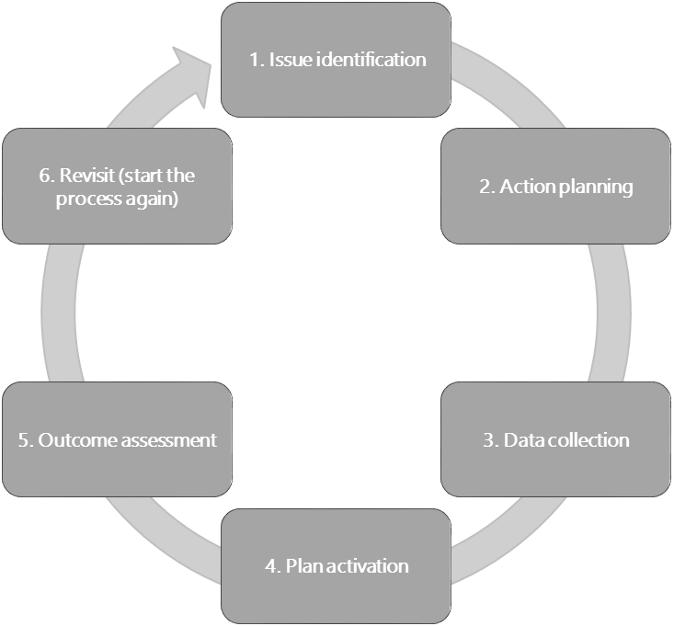

#### Figure 4: Action research cycle

(Source: Johnson, 2011: 79)

Each of the steps in the adapted cyclical process presented in Figure 4 is explained in Table 2.

#### Table 2: Steps in action research cycle

**Step Explanation**

Issue identification Decide on the issue, problem or topic in the school setting that needs to be researched. The purpose should be about school improvement, probably on improved practice.

Action planning This specifies the way the research issue will be researched, and by whom.

Data collection Collect data, as suggested by the nature of the problem. Either or both qualitative or quantitative data could be collected. Data needs to be organised in such a way that trends or patterns are identified. Ethics protocols need to be carefully observed.

Plan activation This part is about organising the data that has been collected and analysing it.

Outcome assessment The outcomes of the research are presented for examination. Key questions about what is missing and what needs further investigation must be examined.

Revisit/ reiterate/ reflect This step is perhaps the most crucial one. Action research involves revisiting, revising, reiterating and reviewing your findings and the questions. It also involves re-investigating and refining the questions or even asking different questions.

UNIT 1 - SECTION 1: LEADERSHIP APPROACHES AND ACTIONS

There are different action research models and processes (Johnson, 2011; Grundy, 1994; and others) but the key elements shown in Table 2 are common to most approaches.

An explanation for doing action research is supplied by Johnson (2011) and is as follows:

*Action research is an effective tool that school administrators can use to solve educational problems that do not have easy answers. Some of these problems include: student behavior, curriculum, school improvement plans, and other educational issues. Action research can also be used to evaluate program effectiveness to enhance student learning. Action research is a model that promotes inquiry, reflection of practice and analysis of data. It is a process that allows school administrators to address their own professional practice and improve student learning and achievement.* (Johnson, 2011: 78)



**Activity 5: Action research skills for the school leader**

**Suggested time:**

1 hour

**Aim:**

To look at the skills required by a school leader in order to initiate and facilitate an action research process in the school.

#### What you will do:

Building on what you have just read, do the following tasks:

1. Describe what you understand by the terms *iterative*, *participatory decision making*, *collaborative planning*

and *reflective practice*.

1. Prepare a short presentation for your SMT explaining why action research could be used in your school.
2. Give three examples of suitable action research projects that could be undertaken in your school.
3. Describe the skills that you understand school principals need to run an action research programme.
4. What sorts of challenges face a school principal wanting to set up an action research project and how could a principal and their team think about overcoming these challenges?
5. Do you yourself feel ready to undertake an action research programme?

#### Discussion of the activity

Perhaps the first thing you might have noticed in the Johnson quotation on action research (above) was the use of the term *school administrators*? The reason for this is that American literature frequently refers to school leaders and managers as *administrators*, which in the South Africa context means something very different in schools. What is important here is to confirm that this diploma is directed toward leaders and managers.

There is nothing really new to you when it comes to understanding action research because good leaders often do it, even if it is not formally called *action research.* Throughout this diploma you have been building

SECTION 1: LEADERSHIP APPROACHES AND ACTIONS

an understanding and practice of leadership and management that is based on collaborative, consultative planning and decision making. Constant and deep reflection keeps you aligned to the shared purpose behind what you do. You have developed a strong awareness that leadership/management is not an event, but an ongoing process during which you follow the cycle of identifying, planning, collecting data, acting and reflecting on the outcomes. Because change is ongoing, you never finish this process and as you refine your process of asking questions, planning and taking action, you are repeating the cycle, which is what the term *iterative* means.

Once you understand that what you and other leaders in your school might already have been doing is actually action research, you should easily be able to include the process, in a more formalised way, in the SMT’s practices. In this way action research will become a structured and integral part of your SMT’s procedures and practices, where every member shares a common understanding of *why* you believe it’s a powerful tool to help make the most of teaching and learning opportunities. It will also help to get everybody in the school motivated to be a part of the exciting development and growth.

When you considered suitable opportunities for action research projects, did you reflect on the vision of the school? Were the ethics and values of the school clear in your mind? Did you consider consulting and including colleagues through communicating regularly? Were your goals transformative, were you able to show commitment to seeing it through?

Once you have settled on some relevant action research projects, it will be important to bear in mind some of the common challenges you might encounter along the way. Johnson (2011: 83) reminds us that this kind of process takes time as it moves through the cycle, and there may be resistance from people who really need to be involved, especially those who are close to the issue being studied. When research questions are poorly formulated or participants are not thoroughly consulted or included in an ethical and participative way, your chances of success may be significantly reduced.

Drawing on the discussion above, it is apparent that suitable action research projects need to be about improvement in practice; something that excites and interests and concerns teachers; and something that must involve the teachers. It’s also important that school leaders who wish to initiate an action research project in their schools must have a transformative change agenda in mind. The envisaged change should be something that will impact on teaching and learning as well as on the wider community. The ethical requirements include sensitivity and care about observing and reporting on the behaviour, practice and interactions of people – whether they are teachers or learners. A principal wishing to initiate an action research project must understand the patience and tenacity required to *stick* with a project that may be rather *messy* and *complex* as opposed to *neat* and *simple*.

Getting yourself prepared to take on an action research project is a critical first step which can only be taken when you understand and believe why you want to be a leader of development and when you have already convinced others around you that your purpose is something they share and are included in. If you start small, for example, asking questions about the effectiveness of homework in you school and what could be done to make it more productive, you are likely to get a number of people interested in managing a real teaching and learning challenge.

## Section 2: Problem-solving leadership skills

### Introduction

This section of the unit sets the scene for how school leaders will manage all sorts of issues that occur in the school. It is about the leadership mindset that readily tackles problems and inadequacies within the system and works collaboratively and constructively to find a workable solution. The context of problem solving in this section, as in this unit and ultimately the module, is about leadership that works from *the inside out*. It is also about being inspired by why you choose to make a difference, which in turn helps you understand how you can address problems and finally what you can achieve in working with people who believe in the things that you believe in.

The three topics covered in this unit are:

1. A technique for gathering information and then identifying a problem.
2. Collaborative problem-solving skills.
3. Creative thinking and innovation in the school context.

The first topic concerns how to identify a problem correctly. A simple tool is offered as a way to accomplish this.

### Problem identification and data gathering

Facing a problem is common. However, many people will first try to solve the problem by coming up with solutions. This may not always be the best way to solve the problem, especially if you are not very clear about the full nature of the problem. An important step in problem-solving that many people often ignore is problem identification.

#### Example: Problem identification

*Apparent problem*: Some learners are not concentrating in class and learning is therefore hindered, especially after lunch break.

*Actual problem*: Some learners do not have lunch and therefore are not getting the energy they need to pay attention in class. Other learners are smoking dagga during break.

Problem identification, therefore, can be viewed as identifying the underlying root cause (or causes) rather than a symptom of the problem. It is the first step to problem-solving.

UNIT 1 - SECTION 2: PROBLEM-SOLVING LEADERSHIP SKILLS

To begin with, you need to look at data gathering in the school in order to improve teaching and learning. Here, you are considering data gathering not only in the context of action research, but also generally. The information and the activity is just an example of how and why data can and should be used.



**Activity 6: Using data to identify the root causes of a problem**

**Suggested time:**

1 hour

**Aim:**

To develop an understanding of the value of using data to improve teaching and learning.

#### What you will do:

1. Watch this YouTube video on data: Data Quality Campaign. 2014. *How data help teachers*. Accessed from: <https://tinyurl.com/o3zkfk5>(Duration: 1:50 minutes).
2. Write individual responses to the following questions in your Learning Journal:
   * At the beginning of the year, Ms Bullen receives data. What is this, and how does it assist her?
   * What kind of data does Ms Bullen collect about Joey during the year?
   * Capture three ideas about how data helps Ms Bullen with her learner, Joey.
   * What do you think is meant by the statement ”When teachers are empowered with data, everyone learns more”?
3. You have learned how Ms Bullen uses data about her learner Joey to support his learning:
   * Think about how you, as a school leader, could use data?
   * What type of data would be most useful to you?
   * Where do you think you can find data?
   * Record your ideas in your Learning Journal.

#### Discussion of the activity

In a world where most people are able to access considerable amounts of digital and other data about almost any subject, it would be surprising to discover that teachers were not using data to maximise the impact of teaching and learning. It would also be worrying if school leaders were not aware of important sources of data or were not encouraging and supporting teachers and learners to access and manage data professionally.

Schools collect lots of data on a regular basis and much of it is readily available to teachers. How difficult would it be, at your school, to monitor learner attendance, past and present learner performance and records of behaviour? If your answer suggests that records are not kept up to date or that data is not easily accessible to teachers, then this is a *symptom* of poor leadership and management (but it’s not the *cause*). It’s very obvious that without this simple data, goal setting and planning are not possible. It has often been said that data has no value unless it is turned into information, which then provides knowledge to guide actions.

SECTION 2: PROBLEM-SOLVING LEADERSHIP SKILLS

The data Ms Bullen collects about Joey clearly helps to identify that he is risk but more importantly, the data is shared with colleagues and parents in order to learn more about the problem. The video clip reveals a school leader who works and communicates collaboratively with teachers, learners and parents and confirms a form of leadership that works from *the inside out*.

*Module 1: Professional Portfolio and Workplace Project* introduced you to the basics of data-based evidence collection as the basis for implementing various improvement interventions. You will also be well aware of the useful range of data that is available via the South African School Administration and Management System (SA-SAMS). This system will be discussed in more detail in Unit 2 of this module. Of course, the value of using an information management system like SA-SAMS is completely dependent on the quality and quantity of data that is captured. School leaders who understand why they want good data will lead and manage the processes to capture accurate, *clean* data. Unit 2 of this module will explain this element of leadership and management fully. Effective school leaders build on the information they can gather from existing data and supplement this with documents, questionnaire, interviews or observations to enrich their source of knowledge about a particular problem before planning a course of action.



**Activity 7: Problem identification**

**Suggested time:**

30 minutes

**Aim:**

To practise the skill of problem identification by applying the *5 Whys Technique.*

#### What you will do:

1. Study the example of the *5 Whys Technique* provided in the textbox.
2. Together with a group of colleagues from your school-based CoP, identify a problem your school is facing. Write down what you think the problem is.
3. Apply the *5 Whys Technique* to the problem, recording each answer.
4. By the fifth *Why?* you should have drilled down to the root cause of the problem.
5. Write down what you have found the root cause of the problem to be.

#### Example: The 5 Whys Technique

One method used to explicitly identify and state a real problem (Kim: 2014) is by way of the *5 Whys Technique* – you simply ask “Why?” five times. By the time you get to the fifth “Why?” you should have found the ultimate cause of the problem.

**Problem:** In a local school, the principal is finding it difficult to get teachers to supervise extra- curricular school activities such as sports teams.

UNIT 1 - SECTION 2: PROBLEM-SOLVING LEADERSHIP SKILLS

Why? 1: Because teachers aren’t willing to stay after school hours.

Why? 2: Because teachers are swamped with other responsibilities and there are not enough teachers at the school.

Why? 3: Because teachers do not stand to benefit financially for their efforts in working extra hours.

Why? 4: Because there is a lack of funding to support the sports team with regards to sports personnel, equipment, infrastructure and other costs.

Why? 5: Because there has been no formal collaborative effort to plan and implement a school sports initiative in the community and raise the funds to do so.

#### Discussion of the activity

The first challenge your group might have experienced was writing down a common understanding of the problem. Often, as in the example above, the first thing you notice will be *symptoms* of a deeper issue. In the case above the principal notices that he has a problem convincing teachers to get involved, but he doesn’t know why. Whatever technique you might use to solve a problem, it unlikely to be successful until you have accurately identified the problem because only then can you start to work on solving it.

The *5 Whys Technique* is a very simple way to drill down deeper into a problem to identify the root cause of the problem. If this is not done, a symptom or behaviour related to a problem may be identified as the cause. If a symptom is treated instead of the actual reason or cause, efforts will be misdirected. Once you have identified the problem, you are more likely to be in a position to begin generating solutions to the problem. It sometimes happens that problems have more than one root cause in which case it might become necessary to ask more than five *Whys* but this will warn you that the problem is far more complex than you initially imagined.

### Collaborative problem-solving skills

Problem solving is a core requirement for school leaders. This is specified in the SASP (2015: 14), namely, “The school principals should … identify problems and challenges and find solutions which enhance teaching and learning.” Research by Brenninkmeyer and Spillane (2008) demonstrates that principals who are expert problem solvers typically collect more data, devote more time to the process and also spend more time following up with staff than their less successful colleagues. If you have been carefully working through the previous modules in this programme, you might well be questioning the focus on *the principal* in both the SASP and research findings. You have constantly been reminded that leadership and management in schools is *not limited* to the person of the principal, which is why the heading of this section is ‘collaborative problem-solving skills’.

SECTION 2: PROBLEM-SOLVING LEADERSHIP SKILLS

### Decision-making and problem-solving process

A standard approach to decision making and problem solving comprises a number of steps. Be careful not to get confused with the action research cycle presented in the previous section, which is more iterative, although of course, a problem can be revisited if the solution is not in fact workable. This generic example of the process provides a useful step-by-step approach that is inclusive and communicative:

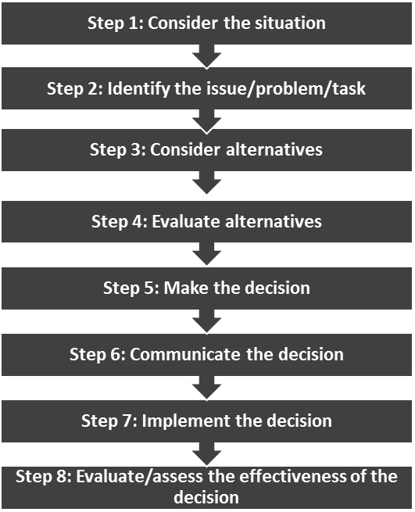

#### Figure 5: Decision-making and problem-solving process Step 1: Considering the situation

Considering the situation in which the decision is being made, is critical to making successful choices. This requires you to:

* *Select the right people* to participate in the decision-making process.
* *Choose an approach* for making the actual decision.
* *Create a climate* that promotes healthy debate and allows for diverse viewpoints. (Remember the Golden Circle *in Module 4: Leading and managing people and change*? Work towards a shared belief in why you want to tackle problems.)

#### Step 2: Outlining the issue

Once you have considered the background, you will be ready to introduce the issue to your decision-making team with the intention of identifying what the problem is – the problem statement. Once you have achieved a common understanding of the problem statement, use the *5 Whys Technique* to unpack the root cause or causes. This is the point where many school leaders make the mistake of trying to find solutions, before they understand the nature of the problem.

UNIT 1 - SECTION 2: PROBLEM-SOLVING LEADERSHIP SKILLS

Once you have successfully outlined and stated the issue, and analysed the causes, the next step is to *identify objectives* to determining a course of action. Ask your fellow teachers questions like: “What do we want to achieve with the decision we make?” and “What would you like to see happen as a result of the decision we make?” Invite your carefully identified and inclusive group to describe their vision of the outcome of the decision as vividly and specifically as possible.

Once you have created a *list of objectives*, it’s time to think about the strategy you are going to use within your school to achieve them. At this point, you and your team are ready to enter the next phase in the decision-making process — considering alternatives.

#### Step 3: Considering alternatives

In order to make the best, informed decision for the specific school situation, you need choices. These are derived from considering alternatives and weighing the benefits of a variety of options. Your goal at this stage in the decision-making process is to identify as many alternatives as possible. Brainstorming with your team is an effective way to generate different ideas and courses of action.

To start the brainstorming process, use a blank flipchart page or a sheet of newsprint, and ask your team members to suggest any ideas related to the problem that come into their heads. Or ask individuals to take a few minutes to develop their own lists of ideas to share with the rest of the group. Record the ideas but don’t discuss their benefits and drawbacks at this point. Instead, focus on *identifying as many alternatives as possible.* You can evaluate the ideas after you have a list of possibilities.

Some suggestions for encouraging team participation during your brainstorming sessions include the following:

* Encourage open discussion by making it clear at the outset that everyone’s input will be valued.
* Suggest that people try to think outside the box.
* Provide guidance at the end of every meeting by assigning actions and deadlines so specific people are accountable for moving the process forward.
* Thank people who share their ideas and viewpoints in a positive manner.

#### Step 4: Evaluating alternatives

Once you have identified the alternatives you want to consider, the next step is to evaluate those alternatives in the context of your school situation and make a final decision collaboratively.

You assess the alternatives by seeing how well each one meets the objectives you established at the outset of the process. Here are some variables the team should weigh up when evaluating an alternative:

* The *ethics* and *values* that guide you. Why are you choosing to be collaborative leaders and problem solvers?
* *Benefits:* What kind of improvement will you see in the school if you implement this alternative?
* *Costs:* How much will the alternative cost? Will it result in a cost saving now or over the long-term? Are there any hidden costs? Are there likely to be additional costs down the road? Does this alternative meet budget constraints?
* *Intangibles:* Will your school’s reputation improve if you implement this alternative?
* *Time:* How long will it take to implement this alternative? Could there be delays?

SECTION 2: PROBLEM-SOLVING LEADERSHIP SKILLS

* *Barriers:* Can this alternative be implemented realistically? Are there any obstacles that must be overcome? Will this alternative not infringe any departmental regulations?
* *Resources:* How many people are needed to implement this alternative? Are they available?
* *Risks:* What are the risks associated with this alternative?

#### Step 5: Making the decision

In a perfect world, you would have all the information you need and an unlimited amount of time to make a decision. Your choices would be clear and school *politics* would not influence your decision. Often, however, you need to make complex decisions quickly, with limited information. The techniques for evaluating the alternatives outlined in the previous section should help you *compare the pros and cons of each choice.*

#### Step 6: Communicating the decision

Your responsibility doesn’t end with the decision. You need to turn the decision into action. The way you communicate the decision and plan for implementation will determine your success. Many leaders overlook one of the most important aspects of the decision-making process: communicating the decision to everyone involved in, and affected by it.

The people you notify will include everyone who is responsible for implementing the decision as well as anyone who is affected by it. Your list should include:

* The participants and other key stakeholders;
* School staff who were not part of the decision-making group;
* The SMT;
* The SGB;
* The Department of Education (if necessary);
* Parents (as appropriate);
* External stakeholders (as appropriate).

Your message should include the following (as appropriate):

* The issue that needed to be addressed;
* Description of the objectives;
* The names and roles of the people involved in making the decision and why they were included;
* The alternatives considered;
* An explanation of the final decision and what it means for the key stakeholders;
* The implementation plan and timeframe;
* A request for feedback.

Providing incomplete communication about your decision can lead to confusion, disappointment, and unwillingness to support its implementation. It may be necessary to provide different messages to different groups – with more or less information, as appropriate.

UNIT 1 - SECTION 2: PROBLEM-SOLVING LEADERSHIP SKILLS

#### Step 7: Implementing the decision

Now that you have made a choice and communicated your decision to the appropriate people, it is time to identify the actions that will be required, assign resources, and establish deadlines. Consider the following when implementing your decision:

* Assign reasonable tasks with sufficient resources;
* Clarify expectations;
* Provide feedback on the implementation and recognise people’s contributions.

#### Step 8: Assessing the decision-making process

Many school leaders might wait to assess a decision until the end of the process, after it has been implemented. This is too late. If there is an error in the decision itself, or in its implementation, you may learn a useful lesson about how *not* to make or implement a decision, but it will be too late to repair the damage.

Assessing the decision-making process is an ongoing effort that *must occur throughout all the phases of the process.* Sometimes new information becomes available, or new conditions arise, which means you need to re-look at your objectives. It is at this stage that it may be necessary to revisit the problem if the solution is not workable.



**Activity 8: Problem solving**

**Suggested time:**

2 hours

**Aim:**

1. To use the *5 Whys Technique* to analyse a problem from your WPP.
2. To move towards generating possible solutions.

#### What you will do:

1. Select a problem you have identified from your WPP.
2. Together with three or four members of your school-based CoP, use the *5 Whys Technique* to understand the root causes of the problem.
3. Study the information provided in Figure 5, and the discussion of the eight steps in the decision-making and problem-solving process above.
4. Together with your CoP members apply the steps suggested in the activity above.
5. Reflect on how the problem-solving process worked. What went well, and what part of the process needs improvement? How collaborative and consultative was the process?
6. What data did you collect? How did you collect the data? How were the results reported/communicated?

SECTION 2: PROBLEM-SOLVING LEADERSHIP SKILLS

#### Discussion of the activity

The value of this activity will no doubt be closely related to the time and effort you put into following the steps outlined, however, simply following a set routine will very soon lose its appeal if it is not a reflection of your individual commitment to ethical leadership and purpose behind collaborative problem solving.

While typical problems that school leaders may face are depicted in the text box below, you will be aware that no two contexts are identical so there is seldom a simple *formula* to follow in searching for solutions. Therefore this unit will not attempt to provide a critique of your problem-solving efforts. The best way to do this is through ongoing critical reflection with your team members. This will encourage you to reflect on *why* you choose to lead in the way you do.

#### Summary: Problems that a principal might face

Communication Funding Governance

Lack of school infrastructure/facilities Learner discipline issues Maintenance

Managing the number of learners being enrolled Performance limitations

Poor learning environment Safety and security

Staff training Technology

The problem areas listed above are simply generic terms that might describe a broad range of challenges. Effective school leaders take on the task of identifying the specific nature of the problems in their school context so that they can be managed collectively and collaboratively.

Of course, problem solving is part of the action research process, so the general skills you are developing also apply to action research, particularly when you follow the principle of honest and deep reflection. A further similarity is the collaborative approach, where school stakeholders are actively involved in the process and become part of the solution (improving practice) when they are consulted and have their voices ‘heard’. This should remind you of earlier discussions on the importance of developing a positive school culture.

The next topic looks at another leadership skill that school leaders should be able to demonstrate, the ability to think laterally [creatively], to consider alternative ways of doing things, or even introducing new ideas entirely. In the section you will not focus on the theory of creativity and innovation. Rather, you will consider examples of *why*, *how* and *when* innovative school leaders introduced new ideas to their schools and how these worked. To get you thinking about this process, watch the video in the next activity.

UNIT 1 - SECTION 2: PROBLEM-SOLVING LEADERSHIP SKILLS



**Activity 9: Are schools killing creativity?**

**Suggested time:**

20 minutes

**Aim:**

To think about creativity in education and specifically in your school.

#### What you will do:

1. Watch the TED Talks video: Robinson, K. 2007. Do schools kill creativity? TED Talks. Accessed from: <https://tinyurl.com/cmvy687>(Duration: 20:03 minutes).
2. While you are watching the video, keep your Learning Journal open and have a pen with you. Try to answer the following questions by writing notes in your Learning Journal as you watch.
   * Does Robinson refer directly to school leaders showing creativity in their work?
   * Do you think school leaders should encouraging creativity among learners and/or teachers? Why?
   * What do you think school leaders could do to encourage creativity at their schools?

#### Discussion of the activity

It’s possible that you thought the video would be about creative leadership in schools, but as you will have seen, it’s not. It is however one of the most watched TED talk in history, so it definitely has something to say to school leaders! This talk was recorded in 2006 and has since attracted a lot of attention, not only because it is very entertaining but also because of the message it conveys. The argument for encouraging a creative orientation in education is compelling.

When Robinson poses the question *Do schools kill creativity?* he is referring to the people who govern, lead and manage schooling because organisations only exist because of the people within them. South Africa’s record of schooling has been criticised by many for quite a while. A programme such as the AdvDip (SLM) offers the opportunity for school leaders to begin to turn this situation around.

### Creative thinking and innovation

This module is all about leading and managing the school as an organisation. It is about the systems that are required in the school in order to create order, process, and provide the possibility of efficiency and effectiveness. Another of the skills that is required of a school leader is a creative and innovative mindset.

After having watched the TED Talk you will have a good idea what this means. Robinson (2015: 118) provides the following definition for creativity: “Imagination is the root of creativity…Creativity is putting your imagination to work. It is applied imagination. Innovation is putting new ideas into practice.”

Deliberate creative thinking can be used to spark off thoughts and develop new ideas far more quickly than always using the typical logical approach to a problem. You can learn to suspend judgement and look for more inventive solutions – and with practice this skill can lead to ongoing creative thinking.

SECTION 2: PROBLEM-SOLVING LEADERSHIP SKILLS



**Activity 10: Creating an enabling environment for innovation**

**Suggested time:**

30 minutes

**Aim:**

1. To assess the potential for innovation within your school’s current context.
2. To consider how to create a more enabling environment in which creative and innovative practices can be strengthened.

#### What you will do:

**Individual activity**

1. Complete the questionnaire in Table 3 on the openness of *your school* to creativity and innovation.
2. Add up your score and interpret the results (see text box).
3. Once you have reflected on the questionnaire outcome, consider what could be done to create a more enabling environment in which innovative practices can be strengthened at your school.
4. Make notes in your Learning Journal.

#### Table 3: Questionnaire: How creative and innovative is your school’s culture?

**No. Innovation catalyst Yes/No**

|  |  |  |
| --- | --- | --- |
| 1. | We have committed leaders who are willing to be champions of innovation. |  |
| 2. | We challenge teachers to think creatively and devise innovative solutions. |  |
| 3. | We have a burning desire to explore opportunities and to create new things. |  |
| 4. | We treat innovation as a long-term strategy rather than a short-term fix. |  |
| 5. | We have a deliberate, comprehensive and disciplined approach to innovation. |  |
| 6. | We are good at asking questions in the pursuit of the unknown. |  |
| 7. | We systematically generate ideas from a vast and diverse set of sources. |  |
| 8. | We encourage new ways of thinking and solutions from diverse perspectives. |  |
| 9. | We are able to freely voice our opinions, even about unconventional or controversial ideas (openness). |  |
| 10. | Our processes are tailored to be flexible and context-based rather than control- and bureaucracy-based. |  |
| 11. | Our workplace gives us the freedom to pursue new opportunities. |  |
| 12. | We simplify processes by minimising rules, policies, bureaucracy and rigidity. |  |
| 13. | We reward teachers for participating in potentially risky opportunities, irrespective of the outcome. |  |
| 14. | We are not afraid to fail, and we treat failure as a learning opportunity. |  |

(Source: Adapted from Rao & Weintraub, 2013)

UNIT 1 - SECTION 2: PROBLEM-SOLVING LEADERSHIP SKILLS

#### Summary: Interpretation of results

**Number of Yes answers:** /14

**Number of No answers:** /14

The interpretation of the scores will yield an obvious result. A really open, creative and innovative school culture will result in 12–14 ‘Yes’ scores. A school culture that is closed to innovation will result in a preponderance of ‘No’ scores.

If the ‘Yes’ score is on the high side – keep it up, and consider doing some of the other things you are not yet doing, and think of other ideas too.

**Discussion of the activity**

Simple questionnaires of this sort don’t give you a perfectly clear picture of your school culture, but they do provide a spark for your imagination. If you recall Robinson’s definition of creativity, he wrote “Imagination is the root of creativity” (Robinson, 2015: 118). So when you reflect on your scores, remember to ask yourself *why* you gave the answer you did and whether you would like to see this change or develop.

The higher the number of ‘Yes’ answers, the more open the school is to new, fresh, even startling ideas. Knowing the general attitude and beliefs of the school (and especially of the *early adopters* in the school), will enable the leader to know how radical, how creative, how large, the proposed new idea can be. If the general attitude is complacent and/or resistant to change, then it might be wise to introduce a very small change at first and let stakeholders (and especially the *early adopters*) make sure that it works.

Don’t despair if the results of the questionnaire on creativity and innovation in your school are not very encouraging. Robinson reminds us (2015: 192) that, “When embarking on change within schools, it may be necessary to break old habits that get in the way of learning.” It is also important to consider his argument (Robinson, 2015: 192) that the existing culture of a school, and the attitudes and expectations it creates in both teachers and learners, is the critical factor in generating or inhibiting original thinking and the habits and mindsets of innovators.

What is it that enables creativity and innovation to flourish in a school, other than the ‘existing culture’ as described above? Robinson (2015: 197) highlights the importance of the leader in helping to create a culture of enquiry and openness. This then filters to other leaders and further outwards to teachers in widening circles.

Finally, Robinson (2015: xvi) suggests that change-seeking teachers require “three forms of understanding: a critique of how things are; a vision of how they should be; and a theory of change for how to move from one to the other.” Innovation and change are of course powerfully connected, so this links with all the work done earlier on school readiness for change, and what you have chosen to make the focus of your WPP.

SECTION 2: PROBLEM-SOLVING LEADERSHIP SKILLS

To sum up, the features of an environment conducive to innovation include openness, creative thinking, questioning, encouragement of risk-taking, rewards for innovation, as well as a culture of enquiry, challenging the status quo, and learning from mistakes. The results of the innovation questionnaire indicate that if the school environment is simply not conducive to change and innovation, then the leader who wishes to inculcate that culture, will have to work very hard, with a team, to build such a culture. Many of the concepts covered earlier in the programme – such as, the type of leadership (collaborative, transformative, ethical, servant), an open and respectful communication manner, and a collaborative approach to problem solving – can all work together to shift the culture towards being more open and receptive.



**Activity 11: Possibilities for large-scale innovation in schools**

**Suggested time:**

30 minutes

**Aim:**

To provide an example of a significant educational innovation in an ordinary public school.

#### What you will do:

1. Read the newspaper report about a school that has attempted a creative innovation.
2. Respond to the questions that follow.
3. Write responses to these questions in your Learning Journal.

#### Report: ‘The light went on’ – Sun Valley principal on axing homework

Following Sun Valley Primary’s decision to scrap all school homework, News24 users had their say on the idea, with the overwhelming majority in favour of scrapping homework altogether. [News24] also spoke to principal Gavin Keller.

*****************************************************************************

In a survey on News24, the vast majority, 1 356 users (88.4%) of the 1 534 total respondents, felt that all schools should do away with homework completely.

80.8% said they were overwhelmed with the amount of homework their children brought home each day, with only 9.7% stating the allotted homework was adequate, and 9.6% stating they did not have children.

Only 7.5% of respondents felt homework was ‘very important’ to their child’s development, with half, 50.5%, indicating that it was only ‘moderately important’. 42% felt homework was ‘not important’ at all.

UNIT 1 - SECTION 2: PROBLEM-SOLVING LEADERSHIP SKILLS

Almost two thirds felt homework only became important once children reached high school level (Grades 8–12), with only 18.9% indicating that homework was important at primary school.

Lastly, 45.8% of respondents said their children spent more than 90 minutes on homework each week day, with a further 31.6% stating their children spent between an hour and 90 minutes on daily homework.

#### Default teaching mode

News24 spoke to Sun Valley Primary principal Gavin Keller to ask him about our users’ feedback.

“I think the results shout that for the whole homework concept, teachers go into ‘default teaching mode’,” Keller said on Tuesday.

“We have a tendency to be so pressurised by curriculum overload. When we don’t finish the work in class, we default to this idea of, ‘finish this for homework’.”

“When we unpacked this idea at our school, what it really meant was that our planning wasn’t good. We hadn’t got our macro-planning sorted, learning to cram all this material into 200 school day.”

“Teachers need those days to embed these particular ideas and values.”

#### The light went on

Keller said the school’s approach was informed by global research, including American scholar Bill Deresievicz’s Excellent Sheep, and was driven by one particular question: How can we develop innovation and creativity?

“We took the age of the child, that’s key. Your focus period if you’re in Grade 1 is only 7 minutes, only 10 minutes in Grade 7, and 17 minutes if you’re in matric.”

“Our goal is to never exceed that focus period for important tasks we assign.”

“We tell the children, ‘now you are going to do this task’, and they have until the allotted time or until the end of the period to finish the task.”

“Once the time’s up, they rule off and they hand in, and we assess them time-on-task. Can they do the work in the allotted time?”

The feedback was immediate, he said, which then made assessing their next teaching input that much easier.

SECTION 2: PROBLEM-SOLVING LEADERSHIP SKILLS

“We then could assess each child on a very personal basis; this group didn’t do well here, this group did well there, etc.”

“When we made that shift, the light went on.”

#### When you love reading, the sky’s the limit

Sun Valley Primary school has been running its focus group for six months now.

“There were two, very intensive assessments, and their grades [of those who didn’t do homework] have way exceeded even what we expected,” he said.

Keller said he hopes to alter teaching methods from volume-based work, to personalised performance.

“Our plan is there is no uniform homework, where each child is expected to complete the same homework, which was in itself very similar to the work they had done in class.”

“It’s based on personal performance tasks. It just gives the children a much better chance to do better in the areas that they struggle.”

He also said the school replaced the time children would traditionally spend on homework, with reading, which is also tailored to the child’s interests.

“As long as you spend a minimum of 20 minutes a day reading, you’re exposed to 1.8 million words a year, and you read within the 90th percentile of readers.”

“If you can read, you can learn. [And] if we can develop a love for reading, the sky’s the limit.”

(Source: News24, Herman: 2015)

#### Questions

1. The story describes a radical innovation that challenge certain things others might take for granted. The school principal leading this change seems creative and self-assured. Select key words or phrases from the story that describe Keller’s leadership approach.
2. Keller’s innovation could be described as a large, sweeping change. What circumstances do you think enabled that change?
3. Think of your school, and constraints that could prevent such a large and sweeping change.
4. Does change and innovation have to be ‘large’ and ‘grand’?

UNIT 1 - SECTION 2: PROBLEM-SOLVING LEADERSHIP SKILLS

#### Discussion of the activity

This interesting innovation gave you the opportunity to reflect on what you have already learned in this programme. Looking at the words/phrases you selected, did they take into consideration the ethics and values of the school and its community? Is there evidence that the leader is consultative and shares responsibility for this step? Do your chosen words say anything about *why* the schools has chosen to act as it has? Is there evidence of a research-based approach to problem solving and an acknowledgement of the complexity of change? In responding to the questions about whether your school could possibly consider such an innovation, and what different conditions might exist at the school in the case study, was your answer a series of excuses about why you can’t, or shouldn’t, or are unable to effect innovation? What might this say about your position in Sinek’s Golden Circle? Did you start with *why* you choose to do something, or did you fall back into thinking about *what* the problems might be?

By now you will probably agree that changes or innovations don’t have to be large or sweeping It is fine to start small and grow the belief in yourself and others that creative change is possible.



**Activity 12: Possibilities for small-scale innovation in schools**

**Suggested time:**

30 minutes

**Aim:**

To provide examples of meaningful, small-scale educational innovations in ordinary public schools.

#### What you will do:

The following short case studies are all based on reports from schools principals in township schools around Cape Town.

1. Read the six short cases which describe small innovations that, none the less, can make a big difference.
2. Could any of these innovations be implemented in your school? If so, which of these?
3. In your Learning Journal, explain your school context and describe how you could facilitate the implementation of one or more of these innovative strategies. Describe the positive difference that you believe could be achieved.

#### Case study: The principal who meets the learners at the school gate

A principal, who describes himself as being very hands-on, addresses the lack of punctuality at his school by *meeting* the children and parents at the gate every morning. This has the double effect of giving him first-hand knowledge of the regular late-comers, and allowing him to address the problem with the parents immediately.

SECTION 2: PROBLEM-SOLVING LEADERSHIP SKILLS

The approach he uses is to explain how the learner’s day is negatively impacted upon by late- coming.

#### Case study: Setting a positive tone for the day

Early morning teacher briefing sessions are an integral part of a functioning school. In order to set a positive tone for the day, a principal decided that the short staff meeting at the beginning of the school day, would only be used to discuss positive matters.

All school related problems are addressed in a weekly *no blame, no shame* workshop-style meeting specifically designed to address such matters. The workshops give a voice to all staff members and allow for shared solutions. For more personal staff matters, the principal employs an *open-door policy* which allows the teachers to raise matters that they feel cannot be raised in the workshops. Both these methods help to build up trust among staff and assist in issues being quickly resolved.

**Case study: An open-door policy for parents**

The open-door policy can be taken even further to include parent as well. In one school, a principal realised that due to the home circumstance or work commitments, parents are often unable to set appointments to see the principal ahead of time. She realised that turning parents away from the school can result in alienation and resentment. To avoid this, she encouraged the parents to pop in to see her or the deputy principal, as and when the need arose.

While this did complicate the principal’s schedule, she recognised that the benefits of this type of interaction with parents outweighed the disadvantages.

UNIT 1 - SECTION 2: PROBLEM-SOLVING LEADERSHIP SKILLS

#### Case study: Homework supervised at school

Having recognised that, due to a number of factors, doing homework tasks at home is not possible for many learners, several schools introduced afternoon homework periods, supervised by teachers on a rotational basis, or even run by parents or volunteers. The advantage of this scheme is that it allows for peer assistance and provides learners with a safe, disciplined and conducive environment in which to do their homework. In the case of one school, Mathematics and Science teachers in particular, are on hand to assist when called upon.

**Case study: Reading can be fun**

Engaging a team of volunteer *Reading and Spelling Moms* is a wonderful solution devised by one school to help learners who have been identified as having reading or spelling difficulties. The moms simply spend time reading to and with the children, incorporating spelling exercises in a non-pressurised situation. The school has found that this has led to a remarkable increase in the Foundation Phase literacy levels.

**Case study: Making money out of waste**

In many communities, the school fees barely cover the running costs of a school, and any other costs require additional funding. One school introduced a *recycling project*, to raise funds, and simultaneously teaching the learners about conservation.

This is how they approached the challenge: A financial goal was identified and costed. Then, a recycling company was approached to partner the school. The set goal was to purchase a school bus, since transport costs were forcing the school to cut back on some of its extra- mural activities. The school and the recycling company decided on the recycling of aluminium and glass only. All the learners and parents were encouraged to support the project. Lessons on conservation and the role of a school in conserving the environment formed a major part of the drive. Within a remarkably short time, the school could purchase the bus and shift their attention to the next goal.

SECTION 2: PROBLEM-SOLVING LEADERSHIP SKILLS

#### Discussion of the activity

These short cases show that it is possible to make small, innovative changes which can make a big difference to some seemingly challenging situations is a school community.

There are any number of innovative yet very practical ideas in these cases. Most of them are about small changes, and all of them are based on real schools in townships that are poorly resourced. In each example, the school leadership observed a problem and then found an innovative way to solve the problem.

What is also apparent from these cases is that innovation does not necessarily require funding. It is more about the idea, the vision for the future and the implementation of a plan of action. Whether any of these cases are an exact match to your school’s needs or not, they exemplify a variety of different problems and innovative solutions. It is hoped that engaging with these examples will serve as a stimulus for innovative practices to take root in your school.

UNIT 1 - SECTION 2: PROBLEM-SOLVING LEADERSHIP SKILLS

### Key points

Unit 1 focussed on the following key points:

* Leadership approaches and practices for compliance and accountability.
* Leadership approaches and actions which emphasise a consultative and collaborative way to guide decision making.
* Communication and the school leader as an action researcher.
* Analysis of communication styles and methods in the school.
* Problem identification, problem-solving skills, and creative thinking and innovation.

In Unit 2, the focus will be on the importance of organisational systems in the school – with an emphasis on ICT systems.

# Unit 2: The importance of organisational systems in the school

### Introduction

School organisation refers to how schools arrange and manage the resources of time, space (infrastructure and physical resources) and financial and human resources for maximum positivie effect on teaching and learning. Everything you have already covered in this programme confirms that teaching and learning is the core business of schools and that school leaders are both responsible and accountable for how well this is managed.

To achieve this, means having to balance many tasks efficiently and effectively implementing appropriate processes and systems. If a school’s systems are not properly organised and efficiently managed, tasks pile up, all sorts of backlogs may occur and paperwork including information and valuable data may get lost.

Good organisational systems that are well managed are necessary for the smooth operation of any school.

Typically, these include systems for curriculum delivery, human resources management (staff complement), systems for managing learner and parent information, finance, infrastructure and other physical resources, to mention only a few. Each of these systems is underpinned by data (information to be collected for reference or used for analysis).

Successful management of organisational systems requires an integrated information system that will enhance the day-to-day running of the school. Systematic collection of accurate data throughout the school system will allow for improved planning and monitoring while promoting accountability at all levels.

Collecting and managing data leads to the need for yet another organisational system, namely a data management system. A system for gathering, analysing and disseminating data throughout all the component systems in a school. While this can be done manually (e.g. data related to the curriculum delivery system, such as test and exam results, can be written up by teachers in their *mark books* and then transferred onto the school mark sheets) the use of appropriate information and communication technology (ICT), is a more effective and efficient way of storing, processing, analysing and disseminating learner results.

This unit will primarily look at how education information systems, such as the South African School Administration and Management System (SA-SAMS), will help school leaders to manage all the component systems that comprise the *overall* school organisational system. The broader implication of the implementation of ICTs in schools will also briefly be explored. The value of accurate (clean) data, used as the basis for decision making and, thus the necessity for school leaders to provide oversight and management of data collection and processing will also be discussed.

UNIT 2: THE IMPORTANCE OF ORGANISATIONAL SYSTEMS IN THE SCHOOL

This unit comprises three sections as depicted in Figure 6:

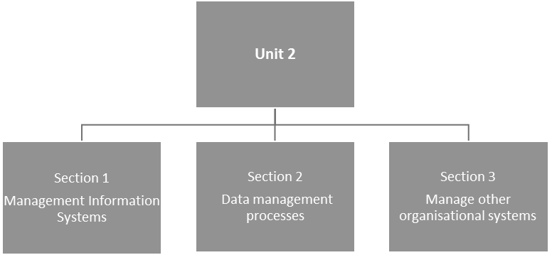

#### Figure 6: The structure of Unit 2

**Unit 2 learning outcome**

This unit has only one learning outcome. By the end of this unit, you should be able to:

* Implement, evaluate, maintain and improve organisational systems for the school where possible making use of appropriate information and communication technology.

Section 1: Education management information systems

This section will assist with understanding education management information systems (EMIS).

The intention of EMIS is to provide school leaders, administrators and teachers with the information required for informed planning, policy-making, and evaluation. This data is a very powerful tool for a collaborative and transformative school leader who is committed to the work of school management in the areas of leadership, decision making, workload, human resource management, communication, delineating roles and responsibility, and overall planning. It can even empower the school community to get involved in their children’s education.

In South Africa, the National Education Information Policy (DoE, 2004 as amended 2014) is the framing document that guides school leaders towards the goal of co-ordinated and sustained development of education information systems.

The DBE has an EMIS section which carries the responsibility of developing and maintaining an integrated education information system for the management of public schools. This Integrated information system is accomplished through the acquisition, processing, dissemination and reporting of quality education data.

This DBE section is therefore also the custodian of the South African School Administration and Management System (SA-SAMS).

SA-SAMS is a robust, actively developed and maintained computer application, specifically designed to meet all administration, management and governance needs of South African schools (public, specialised, full- service and independent). SA-SAMS provides schools with a free, easy to use and fully integrated software solution, containing all aspects of school administration, management and governance requirements, in one package. So, while the responsibility for providing the system rests with the DBE, school leaders are tasked with ensuring that the data their schools provide for input into the system are up-to-date, accurate and complete. This can only happen if all the school stakeholders share an understanding of the purpose of this organisational responsibility.

UNIT 2 - SECTION 1: EDUCATION MANAGEMENT INFORMATION SYSTEMS



**Activity 13: The National Education Information Policy**

**Suggested time:**

30 minutes

**Aim:**

To understand how the policy applies to schools.

#### What you will do:

1. Read the latest amendment to the National Education Information Policy, Government Gazette, No. 38223, 21 November 2014 which can be accessed at: <https://tinyurl.com/y3gdfhyx>
2. Familiarise yourself with the legislative framework that informs the policy, including the Protection of Personal Information Act (POPIA) (DoJ,2013) which can be accessed at: <https://tinyurl.com/y43gvnjy>
3. Summarise/highlight aspects directly related to schools (institutions) and write this up in your Learning Journal. Your response should include, but not be limited to:
   * Institutional EMIS officers;
   * Duty of parents, learners and educators to provide information.

#### Discussion of the activity

The purpose of the activity is to draw your attention to the importance of collecting and processing the information and how it will assist in improving all organisational systems within the school, but also the broader education system. To get the greatest benefit from the data you collect and the systems you use to turn the data into information that helps provide the knowledge and insight school leaders need to make good decisions, you need to manage the process of protecting data.

**ICT readiness**

ICTs stand for information and communication technologies which are defined, for the purpose of this unit, as a diverse set of technological tools and resources used to communicate, and to create, disseminate, store, and manage information.

The transformation from manual to computerised information systems will streamline the process and ensure that no element is excluded or duplicated. If EMIS is defined as a computer-based framework that automates the entire end-to-end management of education and its related information, even a small school running a single computer appropriately equipped and connected, can operate a management information system.

Some people take more readily to using technology than others and while you, as a leader will also be more, or less comfortable with technological tools, it is part of your responsibility to lead and manage the development of appropriate skills and attitudes and thus to support educators and administrators. The fact that people management skills are never separate from the technical skills is central to this unit.

Collaborative leadership draws on the skills and talents of people who are knowledgeable and capable even

SECTION 1: EDUCATION MANAGEMENT INFORMATION SYSTEMS

though they might not hold formal management positions in the school. If you really practise distributed leadership and your colleagues understand why you value their skills and abilities, you will already be well on the way!

Take a good, hard look at the ICT situation in your school right now and decide how to make the best use of what you have. It is very important to be realistic about what you can and cannot do.

* Keep your eye on what you want for the future – on the school vision and mission. While planning needs to be rooted in the present, ICT changes so rapidly that you always have to keep in mind where you want to go next.
* Take everyone along with you as you plan for the future. In other words, developing a shared vision and strategic implementation plan for the use of ICT in your school requires the involvement of all stakeholders.
* Develop systems for monitoring your planning and implementation. This will help to ensure quality.
* Pay attention to sustainability. Carefully plan and consider what can realistically be sustained in your school context. Think about your school’s financial context, available infrastructure, and human resource capacity.

It is important to understand ICT as a tool and not as an end in itself. It is not about just learning to use various ICT devices and applications, rather it’s about employing the range of potential uses that ICT provides. These include, using ICT to make communicating with school stakeholders more efficient, to streamline various administration tasks that teachers are required to fulfil, supporting learning, and using ICT to manage a range of general school administration and management tasks. This has implications for continuing professional development as well. Learning basic computer skills is not enough. It is necessary for school leaders to plan well-targeted professional development to support designated and willing staff members to learn how to use computers and other ICTs as tools to achieve the envisaged quality of learning and teaching as well as for the efficient implementation of all school-based systems. Training should therefore be contextualised, and the skills taught should be related to particular work or particular learning areas.

#### Take note

You are encouraged to access the following resource:

* *Saide,* 2005. *Managing ICTs in South African schools: a guide for school principals* . Accessed online at: <https://tinyurl.com/y6x7lnog>

Although technology has changed significantly in the more than ten years since this resource was published, many of the principles related to managing ICTs in schools are still relevant. To expand on the preceding discussion, see Chapter 2: *How can schools benefit from computers?* This provides some very interesting views from teachers on the benefits of using ICTs in a range of school-base situations.

UNIT 2 - SECTION 1: EDUCATION MANAGEMENT INFORMATION SYSTEMS



**Activity 14a: Current knowledge of ICTs in your school**

**Suggested time:**

30 minutes

**Aim:**

To establish what knowledge and ICT skills currently exist at your school.

#### What you will do:

At the next scheduled meeting of your school-based CoP, lead a discussion with your colleagues, using the following questions as a guideline:

1. What is ICT currently being used for in your school?
2. What ICT devices and resources do you have available at the school?
3. What would you and your school like to be able to use ICTs for that you are not currently doing?
4. Who are the people in your school who have the knowledge to assist in growing ICT skills?
5. How could you include ICT skills development in your School Development Plan (SDP)?

#### Discussion of the activity

A part of the school leader’s role is to take responsibility for school planning and staff development. The rapid advance of technology can leave schools far behind if someone is not providing the leadership to close the gap. While the State has a responsibility to support public schools, the provision of physical resources is not enough to allow the school to take full advantage of the opportunities that technology can provide. If you reflect on what you have learned about encouraging leadership among your colleagues at all levels in the school, you will no doubt remember the importance of leading *from the inside, out*. Encouraging and developing a collaborative approach to using ICT is a valuable tool for inclusive and effective organisational management.

This unit provides a good opportunity for you to use the skills you have developed throughout your engagement with previous modules in the AdvDiP (SLM) as you provide leadership for managing the school’s organisational systems using ICTs.

#### Stop and think

For many years there has been a lot of discussion around the positive value of using ICT in education, to the point that some authors writing in this field, almost seem to suggest that the use of ICT may be the answer to all educational challenges. In the AdvDip (SLM) programme, it is recommended that ICT be used to its fullest potential to ensure effective and efficient management of all school systems, however, the use of ICT for teaching and learning needs to

SECTION 1: EDUCATION MANAGEMENT INFORMATION SYSTEMS

be very carefully planned. The extract below, from the Organisation for Economic Co-operation and Development Report (OECD, 2015), emphasises that technology is not an end it in itself, rather it is about *how it is used* in the classroom that is important.

### How much should schools be investing in ICT?

The OECD states that its mission is to promote policies that will improve the economic and social well-being of people around the world. With its headquarters in Paris, it comprises 34 member-countries, the majority of which are in Europe, however in more recent years it has been joined by six non-European countries (i.e.

Australia, Israel, Japan, Korea, Mexico and New Zealand).

The 2015 OECD global report noted that investing heavily in school computers and classroom technology does not improve learners’ performance. The OECD think tank says frequent use of computers in schools is more likely to be associated with lower results. It states that while teachers had been “dazzled” by school computers, in fact, high achieving school systems, such as South Korea and Shanghai in China, have lower levels of computer use in school. Singapore, with only a moderate use of technology in schools, is top in the world for digital skills. Read the following extract for further information on this topic.

#### Extract: The 2015 OECD report

This report provides a first-of-its-kind internationally comparative analysis of the digital skills that students have acquired, and of the learning environments designed to develop these skills. This analysis shows that the reality in our schools lags considerably behind the promise of technology. In 2012, 96% of 15-year-old students in OECD countries reported that they have a computer at home, but only 72% reported that they use a desktop, laptop or tablet computer at school, and in some countries fewer than one in two students reported doing so. And even where computers are used in the classroom, their impact on student performance is mixed at best. Students who use computers moderately at school tend to have somewhat better learning outcomes than students who use computers rarely. But students who use computers very frequently at school do a lot worse in most learning outcomes, even after accounting for social background and student demographics.

The results also show no appreciable improvements in student achievement in reading, mathematics or science in the countries that had invested heavily in ICT for education. And perhaps the most disappointing finding of the report is that technology is of little help in bridging the skills divide between advantaged and disadvantaged students. Put simply, ensuring that every child attains a baseline level of proficiency in reading and mathematics seems to do more to create equal opportunities in a digital world than can be achieved by

UNIT 2 - SECTION 1: EDUCATION MANAGEMENT INFORMATION SYSTEMS

expanding or subsidising access to high-tech devices and services. Last but not least, most parents and teachers will not be surprised by the finding that students who spend more than six hours on line per weekday outside of school are particularly at risk of reporting that they feel lonely at school, and that they arrived late for school or skipped days of school in the two weeks prior to the PISA test. …

One interpretation of all this is that building deep, conceptual understanding and higher-order thinking requires intensive teacher-student interactions, and technology sometimes distracts from this valuable human engagement. Another interpretation is that teachers have not yet become good enough at the kind of pedagogies that make the most of technology; that adding 21st-century technologies to 20th-century teaching practices will just dilute the effectiveness of teaching.

If students use smartphones to copy and paste prefabricated answers to questions, it is unlikely to help them to become smarter. If you want students to become smarter than a smartphone, you need to think harder about the pedagogies you are using to teach them. Technology can amplify great teaching but great technology cannot replace poor teaching.

To deliver on the promises technology holds, countries will need a convincing strategy to build teachers’ capacity. And policy-makers need to become better at building support for this agenda. Given the uncertainties that accompany all change, educators will always opt to maintain the status quo. If we want to mobilise support for more technology-rich schools, we need to become better at communicating the need and building support for change.

(Source: OECD, 2015: 3–4)

The OECD report is important because it was a first-of-its-kind internationally comparative analysis of the use of ICT, specifically for teaching and learning. Although the South African context may be different to that in some of the OECD member states, there are important lessons to be learnt from this study.

In the majority of South African mainstream schools, which do not have essential infrastructure to support school-wide ICT systems, as well as not having the teaching capacity to confidently manage the use of ICTs in the classroom, the use of tablets and similar devices for teaching should not necessarily be a priority. It is therefore interesting to note the conclusion of the OECD 2015 report, which highlights that even in many economically wealthy European and other countries, having access to ICTs in schools is not a guarantee of academic success. In the report it is argued that, “building deep, conceptual understanding and higher-order thinking requires intensive teacher-student interactions, and technology sometimes distracts from this valuable human engagement” (OECD, 2015: 3–4)*.* The report goes on to say that it is also possible that (many) teachers have, “not yet become good enough at the kind of pedagogies that make the most of technology” (OECD, 2015: 3-4)*.*

SECTION 1: EDUCATION MANAGEMENT INFORMATION SYSTEMS



**Activity 14b: Making ICT work for your school**

**Suggested time:**

30 minutes

**Aim:**

To reflect on balancing the use of ICT in your school to support teaching and learning.

#### What you will do:

At the next scheduled meeting of your school-based CoP, lead a discussion with your colleagues, using the OECD extract and the following questions as a guideline.

1. What is the best use you can make of ICT in your school at the moment?
2. What developments would you like to see in the next few years and how can you get there?

#### Discussion of the activity

It is important to be realistic about what can and cannot be done – while at the same time keeping an eye on where the school wants to go next. Sustainability is an essential element. ICTs cannot be successfully integrated into schooling without careful planning and consideration of what can *realistically* be sustained financially and in terms of infrastructure and human resource capacity. This calls for sensitive and courageous leadership because it is about managing a process of change. Remember what you learned about the complexity of change and how a change to one part of a system affects all other parts? The value of a distributed leadership approach should be an important part of your response to this challenge.

#### Aspects to consider

* Schools need to develop a vision for ICT usage in the school that include steps to achieve this vision. This needs to be included in the school’s development plan.
* Consider all relevant national policies.
* Develop and implement an ICT policy specific to the school.
* Ensure all role players develop necessary computer literacy skills.
* Ensure management and administrative tasks are progressively done on computer, including administrative tasks of teachers.
* Appoint ICT coordinators for the school, to support different roles and responsibilities of the different role players. For example, responsibility for data management and security, or technical support. Consider this: at a school with a few computers the EMIS officer and ICT coordinator might be one and the same person.
* Budgeting and costing for ICT acquisition, maintenance and security.
* Involve parents/community to provide training, technical support, security, etc.
* The use of computers and applications such as spreadsheets, databases, and purpose-designed software to do a range of administrative tasks will assist the principal, other school leaders and teachers to complete their administrative tasks more effectively and efficiently.

UNIT 2 - SECTION 1: EDUCATION MANAGEMENT INFORMATION SYSTEMS

#### Take note

The main focus of this unit is on using ICT for management and administration, however if you would like to explore the use of ICT in teaching and learning, it will be valuable to familiarise yourself with the following DBE guidelines on e-education and on professional development in ICT:

* Department of Education. 2004. White Paper on e-education. Pretoria: Government Printer. Accessed from: <https://tinyurl.com/y42n678f>
* Department of Education. 2007. Guidelines for teacher training and professional development in ICT. Pretoria: DoE. Accessed from: <https://tinyurl.com/y6k6w9j5>

In the next section the focus will shift to the process of data management, once your school has implemented an integrated information system, such as SA-SAMS.

## Section 2: Data management

Although the National Education Information Policy (DBE, as amended, 2014) does not require all schools to use the South African School Administration and Management System (SA-SAMS) as an integrated information system, all schools should have a school administration system that complies with the national Learner Unit Record Information and Tracking System (LURITS) specifications. The LURITS aims to collect unit record data for each learner in South Africa, from Grade R through to Grade 12. The system also tracks the movement of each learner from school to school, even inter-provincial movements of learners can be traced. Each learner is to eventually be assigned with a unique learner tracking number which remains with the learner throughout their schooling. Individual educator records are also housed on LURITS.

There is other software available for sale but since SA-SAMS is provided free-of-charge by the Department of Basic Education (DBE), this unit will only reflect on SA-SAMS.

Successful management of organisational systems requires an integrated information system that will enhance the day-to-day running of the school. Collection of clean data throughout the school system will help to support improved planning and monitoring while promoting accountability at all levels. However to use data effectively it needs to be gathered, stored, analysed and disseminated throughout all systems.



**Activity 15: What information should be captured in a school data system?**

**Suggested time:**

30 minutes

**Aim:**

To determine what information or data should be recorded in a school’s information system.

#### What you will do:

**Individual activity**

Answer the question posed, writing your responses in your Learning Journal:

* What do you think school records should give priority to? In other words, what data is important to record/capture in a school’s information system?

#### Discussion of the activity

As you compiled your list of data that your school (and all schools) should capture in your Learning Journal, did you find that you were thinking like a leader who works from the inside out? In considering *what* data needs to be captured, did you ask yourself *why* it is important to capture this data? What’s the purpose in

UNIT 2 - SECTION 2: DATA MANAGEMENT

gathering data? If it’s only for compliance, you need to think again. Data is only useful when it is turned into information and knowledge, which helps you gain insight into the real purpose behind why you lead. As you review the list that is provided below, keep asking yourself why you need this type of data and how you will use it.

Based on the SA-SAMS, the following categories of data should be recorded by schools:

1. General School Information – including data such as school details, school year plan.
2. Human Resource Information – different Human Resources (HR) records such as leave, in-service training, qualifications and performance appraisals.
3. Learner and Parent Information – including learner biographical information linked to parent/family information. Also learner placement in terms of classes and subject groups.
4. Governance Information – including school governing body (SGB) membership and documentation and other relevant governance matters, such as discipline records.
5. Financial Information – a complete financial system, from budget to managing income, expenses, and bank reconciliations for a set financial year.
6. Curriculum Related Data – assigning learners to subjects, managing school-based assessment programmes and results; and allowing for different mark schedules.
7. Timetabling Information – allow school to set time tables for the different teachers and learners according to cycle, class and subject information.
8. Physical Resource Information – resource management including aspects such as learners support material, fixed assets and the physical infrastructure registers.

For a detailed list of all data captured and managed by SA-SAMS see the *SA-SAMS Overview Headings* on the Thutong portal website: <https://tinyurl.com/y4gnrl6x>

The collection of data should not only be seen as an *administrative* function. More importantly, the use of data is a *management* function and later in this unit, the use of data for *decision making* purposes will also be discussed. Data collection is also a task that teachers are required to undertake. For example, the capturing, storage and analysis of learner results as a critical part of curriculum management and development.

SECTION 2: DATA MANAGEMENT



**Activity 16: Exploring SA-SAMS**

**Suggested time:**

1 hour

**Aim:**

1. To explore the use of SA-SAMS for your school.
2. To find out how to maximise the use of this system.

#### What you will do:

**Individual activity Task 1:**

1. Complete a *KWL Chart* that tracks what you know (K), want to know (W), and have learned (L) about SA- SAMS. See Table 4.
2. Without referring to any notes or information:
   * Write down what you already know about SA-SAMS in the *(K) What I know* column. Don’t write anything else in that column.
   * In the middle column, (*W) What I would like to know*, fill in what you would like to know about SA-SAMS and how it could help your school.
   * As you go along fill in what you have learned in the final column, *(L) What I have learned.*

A KWL Chart is a good way of activating prior knowledge and can be used before, during, and after study sessions.

#### Table 4: KWL Chart

|  |  |  |
| --- | --- | --- |
| **KWL Chart** | | |
| (K) What I know | (W) What I want to know | (L) What I have learned |
|  |  |  |
|  |  |  |
|  |  |  |
|  |  |  |

UNIT 2 - SECTION 2: DATA MANAGEMENT

#### Task 2:

Now read the scenario below and complete the tasks that follow by writing responses in your Learning Journal.

#### Scenario: SA-SAMS

As a principal or school leader you have high aspirations for yourself, your school and your learners. You are aware that one of your important roles is to make sure your school administration runs smoothly in relation to record keeping, reporting and statistical analysis. You know you have to make a start in implementing an information system. You are also aware of the availability of SA-SAMS as a free information system endorsed by the Department of Basic Education.

You may not know much about SA-SAMS and how it works at this point, but you hope that it is going to solve a lot of your school’s administrative problems.

1. Visit the following websites and then answer the questions that follow:
   * The SA-SAMS website which can be accessed at: <http://www.sasams.co.za/>and/or
   * The Thutong portal website which can be accessed at: <https://tinyurl.com/y4gnrl6x>
   * Look at the image of the SA-SAMS main menu, Figure 7, taken from the website: <http://www.sasams.co.za/>

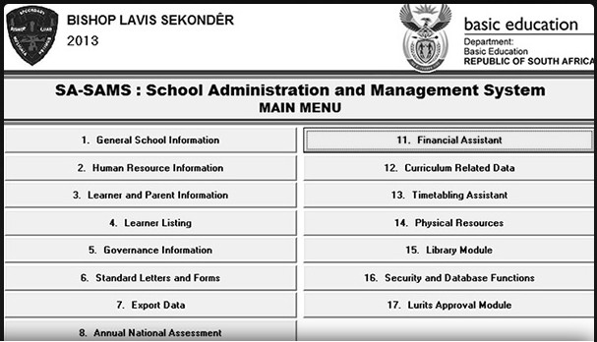

#### Figure 7: The SA-SAMS main menu

SECTION 2: DATA MANAGEMENT

1. Questions:
   * What is SA-SAMS designed to do?
   * What management information is contained (reported) under each of the main menu items. Use the following link to access the SA-SAMS manuals on the Thutong portal website: [https://tinyurl.com/ y4gnrl6x](https://tinyurl.com/y4gnrl6x) to find the answer.
   * Which staff members do you think should be involved in capturing data in SA-SAMS? Explain why.
   * Can you identify the appropriate SA-SAMS manual in which the steps for setting up school-based assessment (SBA) and the programme of assessment (POA) can be found?
   * If you were to experience a problem when using SA-SAMS that no one at your school could solve, where would you go on the SA-SAMS website to seek help?
   * Why do you think it is important that you, as a school leader, become familiar with the SA-SAMS application?

#### Discussion of the activity

The SA-SAMS website and Thutong portal offer a range of resources that will help you to understand how to use SA-SAMS. On the Thutong website you will find a comprehensive set of manuals and training videos that should help you to answer any query you may have. There is also a provincial helpdesk that will respond to queries.

Note that the different areas or aspects of school administration and management that are listed on the main SA-SAMS menu (Figure 7) are referred to as modules, e.g. *Governance Information* is *Module 5*, as per the menu numbering. For the full list see the Thutong portal website at: <https://tinyurl.com/y4gnrl6x>

In line with the data protection act, different user rights can be assigned to different users, thus making only certain parts accessible to each user. A specific level of data protection can be assigned to teachers, which will allow them to capture learner marks for only a specific class or grade. If you need further guidance on managing these levels of data protection. Start by asking colleagues in your CoPs who may be knowledgeable. This is exactly what the CoPs were set up for, to share information and to provide professional support to each other.

The SA-SAMS has an *administration* and *a management* component. As a principal, it is therefore important that you have a good working knowledge of SA-SAMS so that you can manage, monitor and support the use of this system by both administrators and teachers or HODs.

Teachers often feel overwhelmed by their administrative tasks and the perception that SA-SAMS is an added responsibility to their daily tasks, might not be well-received. As a school leader it is important to advise teachers that their SA-SAMS responsibility is not an add-on to their existing tasks, but rather a more effective and efficient way of storing, processing, analysing and disseminating learner results.

UNIT 2 - SECTION 2: DATA MANAGEMENT

**Data discussions**

Although it is critical to consider who will be involved in the data collection process and when the data collection should occur, it is not the only management aspect to consider. Data is simply facts or figures — bits of information, but not information itself. Data needs to be processed, analysed, organised and presented to make it meaningful or useful information which provides the knowledge necessary to use in making good decisions.

Discussions about the data that is collected and analysed will assist school teams to make meaning of the data by surfacing multiple perspectives, allowing the interpretation of the data and the making of data-driven decisions.

Though the data is the basis for this sort of discussion, it is the process of collaborative inquiry that determines the outcomes. It is therefore important that school leaders engage all staff in the process of data analysis and in this way foster a common understanding of issues as they emerge.

Essentially, the process of data analysis is a drilling-down process of investigation, analysis and reflection. For example, when a Grade 7 Maths teacher collects the marks from all her class tests for Term 1, she notices that the grade average has dropped after the last test. The analysis of her grade results should immediately alert her to the fact that there is a problem. She will need to *drill down* further and investigate and collect additional information which will help her to understand *why* it is that her learners have done particularly badly in *this* test. Once she has a clearer idea of what the problem is, she can plan how best to address the Maths concepts that the learners are struggling with. In this simple example, the teacher uses data that she has collected as a method to pinpoint the problem and to implement a targeted intervention to address the problem and improve learning and ultimately, to improve learner performance.

As a school leader, it is important that you model this approach to planning and problem solving, demonstrating that decisions on how to respond to a particular problem or challenge, are made on the basis of evidence, rather than on a subjective or circumstantial basis. As a leader, you need to engage all staff members in a collaborative process in which data on any given issue is discussed and the course of action to be taken is jointly agreed. In this way, using data to improve teaching and learning will becomes an entrenched practice in the department or phase that you lead or if you are a principal, in the school as whole.

The following section is intended to help you to put this into practice.

SECTION 2: DATA MANAGEMENT



**Activity 17: Collect and use data to improve teaching and learning**

**Suggested time:**

2 hours

**Aim:**

To understand the value of collecting and analysing data on learner performance to improve teaching and learning.

#### What you will do:

**Do this activity with your school-based CoP**

1. The following video provides an introduction to Data Wise. Date Wise is a model that encourages schools to use the data they collect to improve teaching and learning. Access the video at: [https://tinyurl.com/ yxk6m24b](https://tinyurl.com/yxk6m24b) (Duration 5: 38 minutes).
2. Watch the video and then read the sub-section below entitled *Using data more effectively at school level.*

This is a step-by-step account of the Data Wise approach introduced in the video.

1. Having read and engaged with the Data Wise approach, reflect on and discuss the use of data in your own schools. Use the following questions to guide your school-based CoP discussion:
   * What do you, as *a school leader* currently do with the marks, mark sheets and schedules at your school? Do you take time to analyse the results? Do you compare individual learner results to other learners’ results? Do you compare your own school’s performance with that of other schools?
   * Do you take time, as a *teacher*, to discuss the performance of the learners? What do you do with the information from these discussions?
   * Does your school use the data you collect to inform teaching and learning?
2. Discuss the advantages of using an approach like Data Wise in your school, as well as what you believe some of the challenges would be to using this approach.
3. Prepare a short, written report based on your discussion of point 4 and include it in your Professional Portfolio (PP).

#### Take note

You may like to consider researching the collection, analysis and use of learner assessment data to improve teaching and learning in your school as the focus of your Workplace Project (WPP).

UNIT 2 - SECTION 2: DATA MANAGEMENT

### Using data more effectively at school level

A group of academic staff and doctoral students from the Harvard Graduate School of Education and school leaders from three Boston public schools worked together for over two years to figure out what school leaders need to know and do to ensure that the piles of learner assessment results landing on their desks are used to improve learning in their schools. Their approach (the Data Wise approach) of organising the work of instructional improvement around a process that has specific, manageable steps helps teachers build confidence and skill in using data.

The Data Wise approach includes eight distinct steps school leaders can take to use their learner’s assessment data effectively. As discussed in the video, these steps are organised into three phases: *Prepare*, *Inquire*, and *Act.* The following information is based on the materials developed at Harvard University: Kathryn Parker Boudett, Elizabeth City and Richard Murnane. 2005. *Data Wise: a step-by-step guide to using assessment results to improve teaching and learning.*

#### Phase 1: Prepare

##### Step 1: Organising for collaborative work.

Ongoing conversations around data are an important way to increase staff capacity to both understand and carry out school improvement work.

School leaders who regularly engage their teachers in meaningful discussions of assessment results and other student data often describe themselves as being committed to building a *data culture* or *culture of inquiry*. A data team needs to be established to handle the technical and organisational aspects of the work, including compiling an inventory of data from various sources and managing this information.

Because looking deeply at learner performance and teaching practice can be uncomfortable at first, it may be necessary to use formal protocols to structure group discussions.

##### Step 2: Building assessment literacy

An essential step in the *Prepare* phase is to help teachers develop assessment literacy. To interpret results, it helps to understand the different types of assessments and the various scales that are used. To appreciate what inferences may be drawn from these reports and which differences in outcomes are meaningful, familiarity with key concepts such as reliability, validity, measurement error, and sampling error can really help.

#### Phase 2: Inquiry

##### Step 3: Creating a data overview

As the team moves into the *Inquiry* phase of the process, a good starting place is to have the data team create graphic displays of your standardised test results. Schools often receive assessment reports in a format that can be quite overwhelming.

SECTION 2: DATA MANAGEMENT

##### Step 4: Digging into student data

Once teachers have discussed the data overview, it is time to dig into learner data to identify a learner- centred problem – a problem of understanding or skill that is common to many learners and underlies their performance on assessments. In this step of the process, people look more deeply into the data sources you investigated for your data overview. Schools also go on to investigate other data sources to look for patterns or inconsistencies. The process of digging into data can deepen teacher’s understanding of student performance, help teachers move past *stuck points* (“We’re teaching it, but they’re not getting it!”), and allow teachers to come to a shared understanding of the skills or knowledge around which your learners need the most support.

A central premise of the data improvement process is that it is important to examine a wide range of data, not just results from standardised tests.

Schools can then triangulate their findings by using multiple data sources to illuminate, confirm, or dispute their initial hypotheses. Sources may include classroom projects, lab reports, reading journals, unit tests, homework, or teacher observations.

Another rich source of data is the learners themselves. Conducting focus groups with learners to talk about their thinking can be very helpful.

##### Step 5: Examining instruction or teaching

In order to solve a learner-centred problem, it is important at this stage to reframe it as a *problem of practice* that a school will tackle. Now the challenge is to develop a shared understanding of what effective instruction around this issue would look like. School leaders can help teachers become skilled at examining practice, articulating what is actually happening in classrooms, and comparing it to the kind of instruction that is needed.

#### Phase 3: Act

##### Step 6: Developing an action plan

In this first step of the *Act* phase of the work, the school begins by deciding on an instructional strategy that will solve the problem of practice you identified. The school then works collaboratively to describe what this strategy will look like when implemented in classrooms.

It then puts the plan down on paper. By documenting team members’ roles and responsibilities, the school builds internal accountability. By identifying the professional development and instruction the team will need and includes it in the action plan. Teachers know that they will be supported every step of the way.

##### Step 7: Planning to assess progress

Before implementing the plan, the school needs to figure out how it will measure its success. Too often, teachers skip this step and find themselves deep into implementation without a clear sense of how they will assess progress. School leaders can help schools decide in advance what short-, medium- and long-term data it will gather and how it will gather it. The school can then work together to set clear short-, medium- and long-term goals for learner improvement.

UNIT 2 - SECTION 2: DATA MANAGEMENT

##### Step 8: Acting and assessing

Once the school team has put their action plan ideas down on paper, they then need to put the plans into action, by asking questions like: Are we all on the same page? Are we doing what we said we’d do? Are our learners learning more? Where do we go from here? Implementation of the action plan can be like conducting an experiment in which you test your theories of how instructional strategies lead to better learning.

As the practice of using a structured approach to improving instruction becomes ingrained, schools may find it easier to know what questions to ask, how to examine the data, and how to support learners. Schools will also be able to go deeper into the work, asking tougher questions, setting higher goals, and involving more people in using data wisely.

#### Discussion of the activity

A lot of data is generated through information systems at school. As you will have learned by working through *Data Wise: Guide to using assessment results to improve teaching and learning,* much can be done with this information to improve teaching and learning.

In this activity you were required to reflect on what you currently do with learner results. Your team could start by analysing the mark schedules that are generally just filled in and filed away.

This is also an opportunity for you to draw on the leadership and management skills and values you have learned so far. For example, think about how you might restructure the agenda of your school management team (SMT) meetings to provide regular opportunities to analyse learner assessment results? Or data related to any other school matter, for example parent participation in school activities, or teacher absenteeism.

What data or information would you expect HODs to bring to the SMT meetings to make this exercise effective? What communication structures in your school could be used, or need improvement to share what you are learning with all stakeholders?

Other than using the Data Wise approach to analyse and discuss data, you can use it to apply the basics of evidence-based management. Evidence-based practice is about making decisions through the conscientious, explicit and judicious use of the best available evidence from data sources by:

* **Asking:** Translating a practical issue or problem into an answerable question.
* **Acquiring:** Systematically searching for and retrieving the evidence.
* **Appraising:** Critically judging the trustworthiness and relevance of the evidence.
* **Aggregating:** Weighing and pulling together the evidence.
* **Applying:** Incorporating the evidence in the decision-making process.
* **Assessing:** Evaluating the outcome of the decision taken.

In the next section you will reflect on using the integrated information system to improve other organisational systems.

## Section 3: Manage other organisational systems

This section reflects on how a well-integrated information system can add to the improvement of organisational systems – contributing to the strengthening of school processes and procedures and leading to greater efficiencies and more effective management and leadership of teaching and learning. Data collected and analysed, whether related to the school admission system, school financial management or learner results, is vital for informed decision-making.

Most public schools in South Africa make at least some use of the South African Administration and Management System (SA-SAMS) so it’s appropriate to use this system as an example of how to manage organisational systems, such as:

* Communication;
* Monitoring performance and planning for learners;
* Managing physical resources;
* Managing school finances;
* General administration.

Some of these organisational systems, such as finance management systems, will be discussed separately and in detail in Unit 3 of this module. Here the focus is on how information and communication technology (ICT) in general, and SA-SAMS in particular, can help you as a school leader to be as effective and efficient as possible.

If your school does not make use of SA-SAMS it is important to ensure that the system that you are using is a comparable system covering the same dimensions as those covered by SA-SAMS.

### Communication

As has been emphasised in various modules of the AdvDip (SLM), managing communication effectively is a critical skill for school leaders. Effective communication underpins the knowledge, skills and dispositions principals require to have a direct and indirect influence on learner outcomes. Good internal (in-school) and external communication strategies for engaging with teachers, learners, parents and the various provincial Department of Education offices is vital. Taking time to review your school’s communications strategy and ideas will be time well spent. Many problems, in and out of schools, can be directly traced to the effectiveness of your and your school’s communications – whether information was communicated or not, what was communicated, how it was communicated, and who communicated it.

In the following activity you will consider who school leaders communicate with, why and how they communicate.

UNIT 2 - SECTION 3: MANAGE OTHER ORGANISATIONAL SYSTEMS



**Activity 18a: Communications in your school**

**Suggested time:**

30 minutes

**Aim:**

To get an overview of communications in your school.

#### What you will do:

1. Use a table like Table 5 to get an overview of communications in your school.
2. Fill in the middle (*Why?*) and right hand (*How?*) columns.

#### Table 5: Overview of communications in your school

|  |  |  |
| --- | --- | --- |
| **Who?** | **Why?** | **How?** |
| Learners |  |  |
| Representative council of learners (RCL) |  |  |
| School management team (SMT) |  |  |
| Teachers |  |  |
| Teacher union representatives |  |  |
| Parents – current and prospective |  | Newsletters, face-to-face, presentations, phone, special events, class meetings, parent teacher evenings, emails, sms, the school website, Facebook, other social media platforms? |
| Administration and support staff |  |  |
| School governing body (SGB) Chair |  |  |
| SGB members |  |  |
| Traditional leaders (if applicable in your context) |  |  |
| Local principals from other schools |  |  |
| The Provincial Department of Education |  |  |
| The Media ? |  |  |
| Other? |  |  |

SECTION 3: MANAGE OTHER ORGANISATIONAL SYSTEMS

#### Discussion of the activity

This activity was intended to make you think about communication in your school holistically, focussing not only on who is receiving the communication, but also why and how. Giving some thought to the *who* should help you to think about the target audience, the *why* is important as it should help you to focus your communications and the *how* will remind you of the range of communication methods or modes that need to be taken into account.

Internal communication is just as important as communicating outside the school. Elements of good practice for internal communication include:

* Championing and being a good role model for clear and consistent communication.
* Matching your words to your actions.
* Being committed to open, two-way communication.
* Face-to-face communication.
* Communicating with empathy – communicating bad news as effectively as good news.
* Seeing communication as an essential leadership capability, not as a set of techniques.

### Communication with parents and caregivers

Typical information that needs to be communicated to parents includes:

* School events, promotions and fundraising;
* School policies, codes of conduct, opening and closing times;
* Contact information for accounts, heads of department or administration personnel;
* Current financial information including reminders for payments of fees or extramural activities;
* Community and security information;
* Individual learner reports, indicating progress or areas of concern;
* Sports information;
* Changes in scheduled activities.

The methods of school communication used to pass on important information to parents have changed over the years, especially with the advent of mobile devices, even though the information itself remains very much the same.

Some information will be time-sensitive, some will be more personal and some needs to be repeated several times so it stands to reason that different communication strategies are called for. Notices on boards at the school entrance, outside the classrooms and on a central noticeboard are a great reminder of upcoming events and long-term schedules but they are not ideal for personal reminders, however, this is where electronic communication may be really useful.

Emails, text messages and WhatsApp groups have proved to be a very good methods for schools to communicate with parents and care-givers of the children in their care. The fact that these electronic messages are quickly and easily accessible on most mobile devices makes them a valuable tool.

Whatever medium you choose the school should have a communication policy to guide the appropriate use and application of technology to communicate to stakeholders.

UNIT 2 - SECTION 3: MANAGE OTHER ORGANISATIONAL SYSTEMS

This policy should specify, among other things, who has the authority to approve the messages that go out. You can imagine the damage that could result from unauthorised, incorrect or poorly worded messages.

A communication policy and clear procedures help to establish boundaries and set expectations with all stakeholders. It’s important to note that in terms of communication, there should never only be one medium, but alternative methods should be in place as backups. Select the method that will be effective in the given context.

It is important that school leaders understands that regular and effective communication of information to parents is essential to ensure their active involvement in the education of their children.

### Using data to manage various organisational systems

This following activity exemplifies how using SA-SAMS helps to streamline, what might otherwise be a very onerous process of submitting standard reports to the Department of Basic Education (DBE).



**Activity 18b: Submitting reports to the DBE**

**Suggested time:**

30 minutes

**Aim:**

To streamline submission of school data to the DBE

#### What you will do:

1. Answer the questions and write your responses in your Learning Journal.
2. What process is used in your school to submit the following data to your district office?
   * Subject performance summary per grade;
   * Learner enrolment per grade.
3. How do you think SA-SAMS could help to improve these processes?

#### Discussion of the activity

An important point about an ICT-based integrated information system, is that it allows you, as an end-user, to capture data once, but then to reuse it in various formats, for multiple purposes as often as is necessary. For example, if you were to you compile a per grade subject performance summary report, or a learner enrolment per grade report, capturing the data first in hand-written form and then possibly transferring it to an Excel spreadsheet with each data set submitted by a different subject teacher, it would clearly be a lot of work. By using a general information system like SA-SAMS, you can generate *different* reports using the same data by simply filtering per subject and per grade and the system will automatically calculate the overall performance.

SECTION 3: MANAGE OTHER ORGANISATIONAL SYSTEMS

In another example, in a secondary school, learners may make their subject selection at the beginning of the school year. If this information is captured on SA-SAMS and then linked to other categories of information, such as the learner’s class, grade, any other data captured during enrolment, and ongoing test and exam results are also captured during the course of the year, the learner’s results profile is systematically built up. The relevant information can then be *pulled* out of the system as necessary. Capturing and storing data in this way provides an opportunity to build up a comprehensive picture of each learner in the school.

As SA-SAMS has been designed with various standardised report options such as the *Subject Performance Summary Per Grade* report, or the *Learner Enrolment Per Grade* report to meet the DBE’s data submission requirements it makes the submission of these reports really quick and easy.

### Using data to manage physical resources

The SA-SAMS *Physical Resources Module* is used to systematise data related to the school’s procurement and stock control management processes. It is a system for managing the schools assets. It comprises three distinct functions, namely, *Learner support material*, *Fixed assets* and a *Physical infrastructure register*. It includes management of a wide range of equipment and resources belonging to the school, including desks, chairs and other valuable assets.

Refer to the *Physical Resource Manual* on the SA-SAMS website:<http://www.sasams.co.za/>or on the Thutong Portal website: <https://tinyurl.com/y4gnrl6x>

#### Learner support material

There are five main functions for which you may want to use this section:

* You may want to add a book/other learning and teaching support material (LTSM) to your master register list.
* When you receive books/other LTSM, you will want to add this quantity to your stock (either new stock or existing stock).
* When you have books/other LTSM, you will want to distribute these learning materials through the educators and on to the learners. You will want to keep a record of where they are for retrieval at a later date.
* When these books/other LTSM are being returned, you will want to receive them back into stock so that they are available again.
* When books/other LTSM are lost or damaged you will need to permanently remove these books, out of stock.

#### Fixed assets

Similarly, there are five main functions for which you may want to use the *Fixed assets* section within SA- SAMS. If you haven’t yet used SA-SAMS for managing assets, you will have been using a manual asset register, which is likely to be very time-consuming. Reviews of school organisational management, suggest that this is one of the weakest elements of public schools organisational systems at present. As a school leader with a transformative agenda, SA-SAMS provides an ideal opportunity for you to implement and manage a more efficient way of managing the assets and resources in you school.

UNIT 2 - SECTION 3: MANAGE OTHER ORGANISATIONAL SYSTEMS

Further asset management examples:

* The school may want to add some equipment or fixed asset to the master register list.
* When you receive assets, you will need to add the quantity of the new assets to the stock (either new stock or existing stock).
* When you have assets, you will want to distribute these assets through the school. You will need to keep a record of where they are or retrieval at a later date.
* When these assets are returned, you will be need to make a record of having received them back into your stock count so that they are available to be issues again.
* When assets, e.g. books, are lost or damaged you will need to permanently remove these books out of stock.

#### Physical infrastructure

In terms of *Physical infrastructure* there is a nine-page register to complete, based on the DBE’s requirements.

The management of physical resources is also dealt with in detail in another unit of this module, but it is helpful to reflect on how SA-SAMS can streamline those processes.

### Managing the school’s finances

SA-SAMS offers a fully integrated financial system that enables schools to maintain and manage their day- to-day accounting practices and finances accurately. It includes functionalities which ensure the implementation and management of daily financial processes and procedures such as receipt payments, petty cash and banking; and it also makes financial reporting much simpler and easier.

Please refer to the *Financial Assistant Manual* on the SASAMS website: <http://www.sasams.co.za/>or Thutong Portal website: <https://tinyurl.com/y4gnrl6x>

To support school leaders and managers this module of SA-SAMS also contains information that will assist with managing school finances by tracking the budgetary spending monthly. Examples of reports that are easily available:

* Cash on hand;
* Monthly income statement;
* Detailed year to date statement;
* Balance sheet;
* Actual receipts and payments.

However, as stated above, the management of financial resources is dealt with more fully in Unit 3 of this module, but it is helpful to reflect ahead of time on how SA-SAMS can streamline those processes.

SECTION 3: MANAGE OTHER ORGANISATIONAL SYSTEMS

### General administration

SA-SAMS also supports several other organisational administrative systems, these include: *Human resources*, *Governance matters* and *Learner information* such as attendance.

* The *Human Resource Information Module* in SA-SAMS assists schools in the administration of the educators and staff/public servants’ information. It also contains tools for the processing and administration of leave, absenteeism, training, appraisals and all human resource related data and processes.
* The *Learner and Parent Information Module* in SA-SAMS and *Learner Listing Module* assist schools with the administration of the biographical data of learners and parents’ information. They also contains the processing and administering of attendance, disciplinary and extra-mural functions.

They further assists with the administration of the promotion procedures and placing of learners in register classes.

* The *Governance Information Module* keeps records of all issues related to the School Governing Body (SGB) as specified by the South African Schools Act (No. 84 of 1996). This module contains information on the membership, their training records, adopted policies and SGB functionalities such as the disciplinary and learner fee exemptions. While you will cover school governance elsewhere in this programme, it will be very useful to know how the SA-SAMS system can support an effective SGB.

For more information about these, refer to the different manuals on the SA-SAMS website: <http://www.sasams.co.za/>or the Thutong Portal website: <https://tinyurl.com/y4gnrl6x>

In conclusion, in your role as a school leader, it is important that you are able to lead your staff to an understanding of the value of collecting and using data and that you ensure that the appropriate capacity building and continuing professional development interventions are planned and implemented so that all staff members are able to use data effectively. A collaborative approach to interpreting, analysing and using the data for the improvement of all organisational systems and improvement of learners results (discussed in the Data Wise activity in Unit 2 Section 2 of this module) needs to be modelled and encouraged.

UNIT 2 - SECTION 3: MANAGE OTHER ORGANISATIONAL SYSTEMS

### Key points

Unit 2 focussed on the following key points:

* Section 1 focussed on school organisation and on how schools arrange and manage the resources of time, space (infrastructure and physical resources) and financial and human resources for maximum effect on teaching and learning.
* Section 2 focussed on data management and in particular, it explored the use and the functionalities of the South African School Administration and Management System (SA-SAMS) – an integrated information system.
* Section 3 reflected on how a well-integrated information system can add to the improvement of organisational systems. This will contribute to the strengthening of school processes and procedures and lead to greater efficiencies and more effective management and leadership of teaching and learning. Data collected and analysed, whether related to the school admission system, school financial management or learner results, is vital for informed decision-making.

# Unit 3: Lead and manage physical and financial resources

### Introduction

The Department of Basic Education (DBE) characterises managing the school as an organisation as one of the five core responsibilities of a school principal (school leader) (DBE, 2015: 11). For schools to effectively and efficiently progress towards the successful implementation of the national education policy mandate and their stated vision and mission, it is necessary for the school environment to be manage in a structured and organised manner. To do this requires the standardisation of various management, administrative and teaching and learning processes and procedures. These include the management and monitoring of the school finances, physical infrastructure, school staff, learner admissions, curriculum and co- and extra- curriculum implementation as well as managing the important links to the community in which the school is situated. Taken together, all these components make a school a complex system with many interrelated systems that need to operate together and therefore need to be well led and managed to ensure the smooth functioning of a school.

This unit focuses on two key aspects of organisational leadership and management, namely, the management of school finances and physical resources. *Module 2: Leading and managing teaching and learning in school,* comprehensively covered curriculum and instructional systems and management processes. While *Module 4: Leading and managing people and change*, focused on the management and systems required for managing school staff.

The topics in this unit are organised into the following five sections:

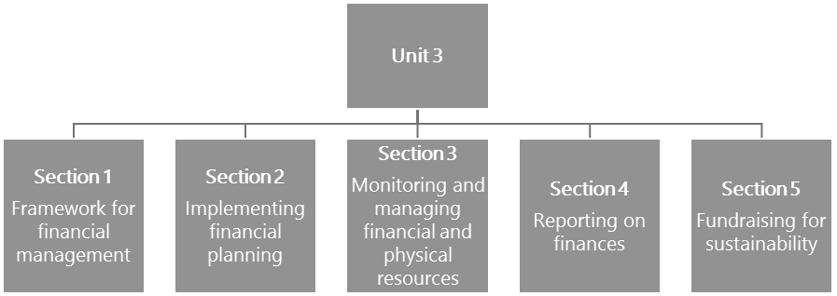

#### Figure 8: The structure of Unit 3

UNIT 3: LEAD AND MANAGE PHYSICAL AND FINANCIAL RESOURCES

### Unit 3 learning outcome

This unit only has one learning outcome. By the end of this unit, you should be able to:

* Lead and manage the physical and financial resources of the school in a transparent and accountable way.

Section 1: Framework for financial management

The outcome for this unit highlights the need to manage physical and financial resources in the school in a *transparent and accountable* way. The information in this section covers the scope of financial and resource management in the school, clarifying roles and responsibilities, and financial policies.



**Activity 19: The scope of financial and physical resources that need to be managed**

**Suggested time:**

20 minutes

**Aim:**

To identify the key components of financial and physical resources that need to be managed in a school.

#### What you will do:

With a colleague from your school-based community of practice (CoP), brainstorm and prepare a detailed list of the various components and aspects of finance and physical resource management.

#### Discussion of the activity

Check the list that you compiled against the components of a school financial management system listed here. These include:

* Having a school Financial Policy;
* Reporting on finances;
* The development and management of budgets;
* Managing income and expenditure in the school in line with policy requirements (national, provincial and school);
* Managing fundraising (to supplement the school’s income);
* Managing school assets (which are valuable resources that must be cared for);
* Managing the infrastructure (which is a valuable resource);
* Managing stock (which are also resources, but are consumed/used);
* Managing procurement (buying what is needed, at the right time and using the correct procedures).

How comprehensive was your list of matters that need managing? Did your list include any additional matters not listed above?

The next activity requires an examination of the *Policy on the South African Standard for Principalship* (DBE, 2015). It will clarify what is expected of school leaders in terms of financial and resource management.

UNIT 3 - SECTION 1: FRAMEWORK FOR FINANCIAL MANAGEMENT



**Activity 20: What are the financial responsibilities of a school principal?**

**Suggested time:**

30 minutes

**Aim:**

To enhance your understanding of what is expected of school principals with regard to financial management in the school.

#### What you will do:

**Task 1:**

**Individual activity**

1. Refer to relevant sections of the South African Schools Act (SASA)(DoE, 1996) (Chapter 3, Sections 16, 17, 20, 21) and Chapter 4 (Sections 34–44) to gain an understanding of the financial management responsibilities of school leaders. The SASA can be accessed online at: <https://tinyurl.com/y5zzg7fz>
2. Access the Standard for Principalship (DBE, 2015) online at: <https://tinyurl.com/ydebt4yp>

On pages 11–17, read through the sections that have been identified below: - Highlight the areas under Section 5.1.1.2 (Executive) and Section 5.1.1.5 (Organisational leadership) that speak to the requirements of the school leader that impact on the financial management of the school. - Highlight the knowledge and actions, under Section 5.1.3 (Managing the school as an organisation) and Section 5.1.4 (Managing quality of teaching and learning and securing accountability), that relate to the financial management of schools.

1. Create a table that summarises the leadership requirements, knowledge and actions required of school leaders as set out in this policy document.

#### Task 2:

**In your school-based CoP, discuss the following:**

1. Interpret and reflect on issues of accountability that are required from school leaders in the light of what you have just read.
2. What is your understanding of *facilitating, supporting and assisting the SGB*? What, in your opinion (and experience), does this entail for the school principal?
3. Discuss whether financial responsibility and accountability can be delegated to other parties.
4. Raise any concerns that you might have for further discussion.

SECTION 1: FRAMEWORK FOR FINANCIAL MANAGEMENT

#### Discussion of the activity

You should remember from earlier modules (for example, *Module 4: Leading and managing people and change*) that inspiring leadership works best from *the inside, out* – in other words, to understand *what* you need to do and *how* you can achieve it, you first need to make sure you focus on *why* you choose to lead and manage in the way you do. Physical and financial resources don’t manage themselves – people manage them. So, when your responses refer to systems, relationships, effective planning and teamwork, keep in mind the importance of ensuring that everybody understands *why* it’s important and what the underpinning purpose is behind these processes and procedures.

In your discussion, you may have identified the following (and other areas) that the Policy on the South African Standard for Principalship (DBE, 2015) requires. School leaders must:

* Create systems that build relationships;
* Create an atmosphere of transparency in working towards common goals;
* Create an environment where continuous school planning is built into all the school systems;
* Together with the school management team (SMT) and the school governing body (SGB), ensure that the school’s operational budget is managed carefully and responsibly so that the school has enough money for all its programmes and activities;
* Communicate with all stakeholders, regularly and efficiently;
* Delegate responsibilities according to proper management and leadership practices;
* Establish implementable and clear management systems and processes;
* Take responsibility and be accountable for all matters concerning the school. (Source: DBE, 2015: 11–12)

What is suggested is that the Standard requires a *stance* or way of engaging on the part of the school leadership, i.e. one that creates, enables and facilitates a focus on quality and accountability, and ensures that systems are in place to support this. These requirements need to be interpreted within the framework of SASA. Underpinning these requirements are specific competencies that school leaders are required to have

– in terms of knowledge and behaviours which you would have examined with your school-based CoP. What the policy suggests, is that to be effective as a school leader, firstly you need this knowledge and secondly, you must act in ways that reflect accountability to the school stakeholders. This means that *knowing* what is required, enables the school leader to *do* the right thing, which can only be understood if you are consciously aware of your purpose as a leader.

One way to facilitate both transparency and accountability is by ensuring that the school has a well thought out, easily applicable and clear Financial Policy that has been collaboratively constructed and clearly communicated.

UNIT 3 - SECTION 1: FRAMEWORK FOR FINANCIAL MANAGEMENT

#### Take note

Apart from SASA 1996 (Act no 84 of 1996) and its various *amended national norms and standards for school funding* which can be accessed at <https://tinyurl.com/y5zzg7fz>, it is incumbent on all school principals to familiarise themselves with the Public Finance Management Act (1999) (PFMA) and its amendments. This can be accessed on the national treasury website at: <https://tinyurl.com/y4g3paqd>

**School-based Financial Policy**

This preamble from a provincial department of education document provides guidance on the formulation of the SGB school financial policies:

*Each SGB should draw up a Financial Policy. This document should indicate clearly what the procedures and rules are for handling money at the school. It should provide a clear understanding of the responsibilities of the school leader, Treasurer, the Finance Committee, and other persons to whom specific tasks are delegated. The tasks delegated to certain people by the SGB must be clearly stipulated in writing.*

*A Financial Policy also outlines the controls and measures that the school is advised to employ concerning the financial affairs of a school that should ultimately result in the preparation of a set of financial statements that are submitted to the [province].* (GDE: 2014)

#### The Finance Committee

The Finance Committee (which is a committee that the SGB is required to set up) must take responsibility for:

1. Financial management, that includes, but is not limited to:
   * Raising and managing school funds and assets;
   * Preparing and presenting the respective school budgets;
   * Deciding on fees and enforcing the collection thereof;
   * Keeping financial records and statements;
   * Ensuring records and financial statements are audited.
2. Reporting on the school finances.
3. Convening the required meetings (Annual General Meeting, Special Meetings, Executive Committee Meetings, etc.) and reporting as required.
4. Reporting and handover before the end of their term of office.
5. Performing those functions allocated to them by the head of department (HOD). These could relate to admission, school property, purchase of learning and teaching support materials (LTSMs), extra-curricular activities, payment for services, etc.

SECTION 1: FRAMEWORK FOR FINANCIAL MANAGEMENT

#### Take note

Note that from time to time, Provincial Departments of Education may issue *guidelines* or *regulations* that are intended to clarify aspects of the implementation of legislation, e.g. SASA. School leaders must keep themselves informed about such guidelines and regulations and check whether any requirements change as a result. Your district office should be able to tell you about any new circulars, guidelines or regulations that have been issued. Remember that ignorance is not a proper defence.

The next activity examines the relationship between the principal, the SGB Treasurer, and the finance officer.



**Activity 21: Understanding the responsibilities of key financial role players in the school**

**Suggested time:**

1 hour

**Aim:**

1. To clarify the roles and responsibilities of the principal and SGB as described in SASA and in relation to financial accountability.
2. To explore the tensions that can arise around financial roles and responsibilities.

#### What you will do:

**Task 1:**

**Individual activity**

1. Write notes in your Learning Journal to reflect your responses to the following:
   * Think about how people in your school discuss financial arrangements and responsibilities. Are these easily resolved, or do tensions result?
2. Study the extracts from the article by Mestry (2004).
3. Prepare a table that compares and contrasts the roles of the SGB and the role of the principal as described by Mestry.

UNIT 3 - SECTION 1: FRAMEWORK FOR FINANCIAL MANAGEMENT

#### Extract: The SGB’s role

Mestry, (2004) describes the SGB’s financial role and responsibilities as follows:

*The school governing body is responsible and accountable for the management of funds of the school. The principal [school leader] must facilitate, support and assist the SGB in the execution of its statutory functions relating to the assets, liabilities, property and other financial*

*management issues*.

*Several tasks are entrusted to an SGB relating to the management of school property and finance. More specifically, an SGB must open and maintain accounting books. It must establish and administer a school fund; it must take measures to acquire, to manage and supplement resources such as textbooks, educational material and equipment. It has the duty to maintain,*

*improve and protect property of the school.*

(Source: Mestry, 2004: 129–130)

#### Extract: The principal’s role

In this following extract, Mestry describes the role of the school principal:

*The principal has no executive [no direct responsibility] role in relation to the SGB on property and financial matters. There are no specific duties relating to the assets, liabilities, and property, with financial management being entrusted to or vested in the principal. … the proper interpretation is to regard the principal as having a duty to facilitate, support and assist the SGB in the execution of its statutory functions relating to the assets, liabilities, property, financial management of the public school and also as a person to whom specified aspects of the SGBs duties can properly be delegated. On any of these interpretations the principal would be accountable to the SGB. It is also the SGB that could hold the principal accountable for financial*

*and property matters, which are not specifically entrusted upon the principal by the Schools Act*.

(Source: Mestry, 2004: 129)

SECTION 1: FRAMEWORK FOR FINANCIAL MANAGEMENT

#### Task 2:

**Individual activity**

1. Study the scenario below and be prepared to discuss the issues it raises in your next CoP meeting.
2. Make notes on your reaction to the title of the scenario. What relevance does this have, and what does the title on its own suggest about the matter of financial responsibilities?

#### Scenario: The ‘unholy’ triumvirate [threesome] of finance office, principal and SGB treasurer

The following three role players need to work together in a harmonious and constructive manner if a school’s finances are to be run efficiently and effectively.

* 1. The Finance Officer (most often a salaried staff member) who is charged with the day to day operational issues around finance.
  2. The SGB Treasurer (who is usually the Chair of the Finance Committee and also usually a parent) who has an oversight role on the running of finances and whose main duty is to see that the policies of the SGB are carried out.
  3. The principal, who is the accounting officer of the school.

The Governing Body Foundation reports that …*relationships within this triumvirate are, unfortunately, too often extremely fraught. Most commonly in our schools, the principal does not have financial qualifications or significant accounting experience. However, this does not release the principal from financial obligations or accountability*.

The Governing Body Foundation recommends that principals should concentrate their efforts on instructional leadership (Section 16A) and “*without abrogating* [abandoning] *financial accountability, leave the treasurer and Finance Officer to fulfil the roles to which they have been appointed.”*

(Source: Governing Body Foundation, 2017)

UNIT 3 - SECTION 1: FRAMEWORK FOR FINANCIAL MANAGEMENT

#### Discussion of the activity

The three key role players (who have been referred to as the *unholy triumvirate*) responsible for school finances, discussed in the previous scenario, are depicted in Figure 9.

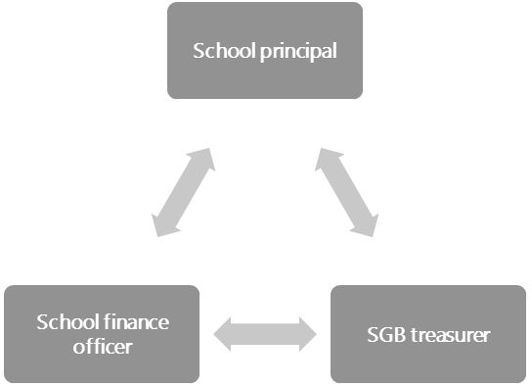

#### Figure 9: The three key role players responsible for managing school finances

Finance is an area where disputes can arise easily, because access to funds may be seen as access to power. As a principal and school leader, you need to exert all the qualities of ethical leadership and strength, while working collaboratively and in a transparent manner. This starts with being fully aware of the financial functions and responsibilities of both the governance functions of the SGB and the professional management functions of school leaders.

Table 6 provides a basic summary of the SGB and principal’s roles. You can use this to check against what you prepared in response to Task 1. Did you note that the principal’s financial function is not an executive one? The principal’s function is described as a SGB support function.

#### Table 6: Summary of the principal and the SGBs financial roles

**SGB (executive function) Principal (support function)**

Manage school property and finance; Support and assist the SGB in carrying out its functions with regard to:

Open and maintain accounting books; • School assets;

Establish and administer a school fund; • Liabilities (debt); Acquire, manage and supplement educational resources; • Property;

Maintain, improve and protect school property. • Financial management.

SECTION 1: FRAMEWORK FOR FINANCIAL MANAGEMENT

The support function of the principal is also reinforced in SASA (DoE, 1996). In SASA, Section 16A(2)(a), the

*professional management duties of a principal* are stated as being to:

* Implement educational programmes and curriculum activities;
* Manage educators and support staff;
* Manage the use of Learner Teacher Support Materials (LTSMs);
* Ensure the safekeeping of all school records; and
* Implement legislation and policy.

Note, there is no reference to financial responsibilities.

While in SASA Section 16A (2)(b)-(k), under *other duties required of principals,* it is stated, amongst others, that the principal shall:

* Attend all SGB meetings;
* Assist in the management of school funds;
* Take reasonable steps to prevent financial maladministration or mismanagement;
* Report maladministration or mismanagement to the SGB and HOD;
* Be a member of the Finance Committee.

Thus clearly defining the supportive role of the principal.

The SGB can delegate functions to the principal and hold them accountable for these delegated functions.

The use of the word *unholy* in the scenario implies some sort of trouble is likely to occur amongst the three key role players: the SGB Treasurer, the finance officer and the principal as the accounting officer. The Governing Body Foundation’s strong recommendations are however, not likely to meet with everyone’s approval. How can the school principal retain accountability without becoming too involved in day-to-day financial matters? And, in reality, it might be that only the finance officer has any direct and particular financial skills and knowledge. The situation may be worrying for many principals – how will they know that the correct procedures are being followed if they do not have any financial training?

Perhaps the best way to approach effective and efficient school financial management is to draw on what you have learned about ethical, collaborative and professional leadership and management. By including people with appropriate skills and providing support and policy certainty for this team, the joint efforts of a number of committed persons can eliminate the suspicions and mistrust that often undermine good governance.

Having examined the financial roles and responsibilities of school principals and the SGB, the focus in the following activities will be on the importance of having a good school-based Financial Policy as a guiding document to regulate financial management.

UNIT 3 - SECTION 1: FRAMEWORK FOR FINANCIAL MANAGEMENT

**The importance of having a school-based Financial Policy**

Having a Financial Policy serves as a guideline and standard for managing finances in the school. Policieis also serve as a protection for the Finance Committee and the principal as they form the basis for decision- making. A good policy will also provide guidelines for setting up recording and reporting systems which are necessary for managing over-expenditure and even fraud.

Managing and controlling the school finances in fee-paying schools is a key function of the SGB. SGBs of a Section 20 school also have financial responsibilities, which are discussed below. In a school with less available money, running the finances is even more challenging. The accounting systems that an SGB Finance Committee puts in place are therefore essential to keep a school financially viable.

Reports in the press suggest that fraud is a very real problem in some schools. There are cases where millions of rand have been stolen or misappropriated. Some of the incidents may be due to ignorance of correct procedures, but a high number are a result of mismanagement. School principals therefore need to try to ensure that they can secure assistance from a qualified, financially skilled person to be part of the SGB Finance Committee.



**Activity 22: Comparing school-level financial policies**

**Suggested time:**

1 hour

**Aim:**

To review two school-based financial policies from schools belonging to two different quintiles to clarify roles, responsibilities and accountability for financial management in each case.

#### What you will do:

**If at all possible, all three tasks in this activity should be undertaken with your school-based CoP**. **Task 1:**

1. Read the two examples of policies (Appendix 2 and 3). One is from a Quintile 5 school and one from a Quintile 3 school.
2. Study the extract from SASA (DoE, 1996 as amended 1997) which presents the financial responsibilities of the SGB of a Section 20 school.

SECTION 1: FRAMEWORK FOR FINANCIAL MANAGEMENT

#### Extract: Financial responsibilities of the SGB of a Section 20 school

**20. Functions of all governing bodies.**

1. Subject to *this Act*, the *governing body* of a *public school* must—
   1. administer and control the *school’s* property, and buildings and grounds occupied by the *school*, including *school* hostels, but the exercise of this power must not in any manner interfere with or otherwise hamper the implementation of a decision made by the *Member of the Executive Council* or *Head of Department* in terms of any law or policy;
   2. encourage *parents*, *learners*, *educators* and other staff at the *school* to render voluntary services to the *school*;
2. The *governing body* may allow the reasonable use of the facilities of the *school* for community, social and *school* fund-raising purposes, subject to such reasonable and equitable conditions as the *governing body* may determine, which may include the charging of a fee or tariff which accrues to the *school*.

(9) When presenting the annual budget contemplated in Section 38, the *governing body* of a

*public school* must provide sufficient details of any posts envisaged in terms of subsections

(4) and (5), including the estimated costs relating to the employment of staff in such posts and the manner in which it is proposed that such costs will be met.

(Source: Department of Education, 1996 as amended by Act No. 100 of 1997)

1. Determine what functions above need to be captured in the school’s Financial Policy.

#### Task 2:

1. Consider the usefulness of each policy (Appendix 2 and 3) for your school. Are there any gaps you can find? If so, what are they?
2. Discuss how well the roles and responsibilities are spelled out in each case.
3. Is there anything about the policies that makes them difficult to understand? If so, identify the difficulty and suggest how to improve the policy.
4. What changes, if any, would you suggest in each case and why?
5. What lessons would you take away from the exercise for your own school (whatever quintile it falls into)?

UNIT 3 - SECTION 1: FRAMEWORK FOR FINANCIAL MANAGEMENT

#### Task 3:

Check whether the two policies that you have looked at (Appendix 2 and 3) and your own school’s Financial Policy have the following four elements as suggested by Mestry (2004):

1. *A statement of the need for a policy.*
2. *A statement of the values and principles that should be brought to bear on that need. …. Values such as transparency, democracy and honesty should form the basis of the policy.*
3. *A statement of the guide for discretionary action.* [This sets out what actions must be implemented.]
4. *A statement of expected outcomes.* [This allows for policy review or evaluation.] (Source: Mestry, 2004: 131)

#### Discussion of the activity

In response to unequal access to quality public schooling, the SASA was amended in 2005 to establish a quintile system. Under this system, schools are categorised into five groups (quintiles), based on the relative wealth of their surrounding communities, with Quintile schools 1–3 typically located in poor communities and Quintile 4 and 5 schools, located in more affluent communities.

It is therefore important to note that the two policies reviewed are from schools in different quintiles which implies they are located in very different socio-economic communities and that there are very different financial situations prevailing in each of the schools.

A school’s quintile ranking is important as it determines the amount of funding that it receives each year and whether or not the school can charge fees. Learners attending Quintile 1, 2 and 3 schools do not pay school fees. Therefore, in order to compensate these schools for their loss in fee income, the state provides them with a larger norms and standards allocation than schools classified as ‘fee-paying’ schools in Quintiles 4 and 5. While the allocations differ significantly between Quintile 4 and 5 and Quintiles 1–3, Quintile 4 and 5 schools charge school fees, which should essentially make up for the additional funding needed to run the school.

Given the different quintile status of each school, it follows that there will be differences in the financial arrangements and responsibilities in each of the schools being compared. This in turn suggest that there will necessarily be differences in the policy content of each of the schools. The Quintile 5 school has to set, charge and manage fee income, which the Quintile 3 school does not need to do. Additionally, it is likely that the Quintile 5 school is designated as a Section 21 school which means that it has permission to manage its own finances.

The SGBs of no-fee schools rely entirely on state subsidies for their budgets. The budget then serves as a guide for the spending of the allocated funds. While the Finance Committee of an SGB in a Quintile 5 school must formulate and implement financial policy, draw up a budget and keep control of such budget, monitor and approve all expenditure, and ensure that all procurement is done through correct quotation and procedures. The Financial Policy, which must comply with relevant legislation such as SASA, must indicate how to control all aspects of the school funds and assets, including all property, as well as cash – and it must be reviewed on an annual basis.

SECTION 1: FRAMEWORK FOR FINANCIAL MANAGEMENT

Both policies provide information about the purpose of the policy and the objectives and both reference the relevant national/provincial policies that frame the school-based policy requirements.

Because of the differing quintile status of these two schools, one of the obvious differences between the two policies, is in the level of detail provided. The Quintile 5 policy provides information on more items and procedures than the Quintile 3 policy. In the Quintile 3 policy the roles of the principal and SGB are embedded in the description of the six items listed under the heading *Financial systems and procedures*. Whereas in the Quintile 5 school policy, far more detail is provided regarding the nature of each of the listed items, its purpose, the control systems, and who is responsible for managing the said item.

An evaluation of the two policies against the four elements mentioned by Mestry (which are not mandatory, but suggested) reveals that the four elements are not explicitly stated under the exact headings. Of the elements, perhaps the *guide for discretionary action* is spelled out the most clearly.

The comparison of the policies against the higher-level requirements stated by Mestry, makes the complexity of developing a good policy quite apparent. The question is, are SGBs capacitated in order to be able to ensure the development of a comprehensive yet user-friendly Financial Policy?

It is highly recommend that where SGBs do not have the required expertise to prepare and provide oversight of school-based financial policies, that they exercise the option of co-opting a person with the necessary skills onto the SGB.

The next activity reviews the components of an adequate school Financial Policy and provides an opportunity for you to identify areas for improvement in your own school’s Financial Policy and to recommend improvements to ensure that it is a helpful guiding document.

UNIT 3 - SECTION 1: FRAMEWORK FOR FINANCIAL MANAGEMENT



**Activity 23: Review your school’s Financial Policy**

**Suggested time:**

30 minutes

**Aim**

1. To think about what constitutes a relevant school Financial Policy.
2. To identify the necessary components of a good Financial Policy.
3. To propose changes to your own school’s Financial Policy in the light of this.

#### What you will do:

**Task 1:**

1. Find a copy of your school’s Financial Policy.
2. Mestry (2004: 131), lists four components of a good policy. Review your school policy in the light of the following questions drawn from Mestry:
   * Can you identify the *statement of the need* in your school Financial Policy? If this is not clear in the policy, create such a statement.
   * Can you identify the *statement of the values and principles* in the policy? If this is not clear in the policy, prepare a sentence that describes this. Values and principles drive policy. Values such as transparency, democracy and honesty should form the basis of the policy.
   * Can you identify the *guide for discretionary action* in your school policy? If this is not clear in the policy, create one. It contains guidelines for school administrators to follow when a *discretionary (financial) action* is necessary.
   * Can you identify the statement of *expected outcomes* in your school’s Financial Policy? If this is not clear in the policy, create a statement. ldentification of expected outcomes assists in the necessary process of policy review or evaluation. It allows the simple question, “Have these outcomes been achieved?”

#### Task 2:

1. Use the checklist in Table 7 to assess your school’s Financial Policy.

#### Table 7: School finance policy content checklist

|  |  |
| --- | --- |
| **Statement** | **Yes/No** |
| 1. All procedures for handling all monies that come into the school (fees, donations, payments) as well as procedures related to signatories to the bank account, documentation and recording transactions, are set out clearly in the school Financial Policy. |  |
| 2. The duties and responsibilities of all persons who deal with financial matters are set out clearly in the school Financial Policy. This includes the SGB treasurer, finance officer, principal, auditor, Finance Committee, HODs and also any educators who have delegated responsibilities for budgets. |  |

SECTION 1: FRAMEWORK FOR FINANCIAL MANAGEMENT

|  |  |
| --- | --- |
| 3. Financial control processes that cover all aspects of fund inflow and payments in the school are stipulated in the Financial Policy. |  |
| 4. The finance policy includes a section on financial control mechanisms that put in place control mechanisms that will contribute effectively to the safe and accurate administration of funds. |  |
| 5. Key control mechanisms for the following are developed and form part of the finance policy:   * Cash receipts and cash payments; * Tuck shop control (if the school has one); * School fees; * Management of assets; * Stock control — cleaning materials and stationery; * Petty Cash payments; * Budgetary control. |  |
| 6. The Financial Policy sets out how an auditor is appointed, how powers are separated, and that the principle of transparency applies. |  |

1. If any of the above elements are not covered in your school Financial Policy, suggest making the necessary amendments, to ensure that the policy is a clear, relevant and helpful guiding document.

#### Discussion of the activity

The question may be asked: Why should a school develop its own policies when legislation prevails? The response is:

* Legislation needs to be contextualised and must consider the diversity and ethos of individual schools.
* SASA is not intended to be a one-size-fits-all document.
* A school is entitled to go beyond the minimum requirements of SASA and apply the principles of the South African Constitution and the law to its own situation.

The SGB is charged with ensuring that the school’s policies are up to date and conform to the requirements of the law. This means that if any legislation is amended that impacts on policy and practice, then the school’s policy needs to be adjusted accordingly. This also applies to provincial regulations which are issued from time to time. Both the SGB and the principal are legally accountable in terms of the provisions of the school’s Financial Policy.

#### Take note

Some provinces assist schools by developing a useful policy template that can be adjusted and requires only contextual detail to be added.

All of the items in the school finance policy content checklist (Table 7) need to be included in a school’s Financial Policy. If they are not, the policy should be revised. This is to protect all parties involved in financial management and administration. The next section shows how procedures are implemented in the school.

## Section 2: Implementing financial planning

The legal provisions and processes related to budgeting stipulated in the South African Schools Act (SASA) apply to all public schools. This is regardless of whether they are no-fee schools or fee-paying schools. It is also not dependent on whether they are Section 20 schools (the majority of public schools) or whether they have Section 21 status (which provides additional management functions to the school governing body (SGB) such as managing their own finances). While, the Section 21 status may affect the complexity of the school budget, the purpose of having a budget and the basic processes for developing one, remain the same across all public schools.

#### Take note

Section 21 status schools are those schools that have been granted permission to manage their own finances. The Department deposits the school allocation into the schools’ account at the beginning of every financial year, after the school has submitted an audited annual financial statement report.

(See SASA, DoE, 1996 for further detail.)

Once the financial and resource management policy has been ratified, the business of implementing the policy commences. The first task required is to establish the financial needs of the school. These are derived from the aims associated with the school’s development plan (SDP). The SDP and the SIP (school improvement plan) were discussed in *Module 4: Leading and managing people and change* as part of the Integrated Quality Management System (IQMS) process. As highlighted above, the budget is also impacted on by the status of the school – whether it is a no-fee school or a Section 21 status school with allocated functions. Additionally, there may be provincial requirements, for example, some provincial departments specify a certain percentage to be spent on Learning and Teaching Support Material (LTSM), utilities, etc.

Factors to be considered when drawing up a school budget

* The School Finance Committee (a subcommittee of the SGB) is responsible for the preparation of the annual school budget with the assistance of the school’s financial staff.
* The budget is intended to determine the probable expenditure that the school will incur during the following year.
* Once the probable expenditure has been determined, the required school fee (if it is a fee-paying school) will be calculated to meet the budgeted expenditure.
* This calculation needs to include an estimation of the value of school fee exemptions to be granted, as well as providing for bad debts arising when parents default on their school fees. Experience from prior years will be the best indicator of what amounts or percentages need to be factored in for these items.

UNIT 3 - SECTION 2: IMPLEMENTING FINANCIAL PLANNING

* The school budget and the proposed school fee will then be referred to a general meeting (usually the annual general meeting or AGM) of parents of the school for approval.
* If it is a non-fee paying school, the school budget has to be drawn up in alignment with the provincial funding allocation.

Financial management starts with budgeting, which provides a spending plan and sets the activities to be performed in the school during the next financial year. In supporting the SGB with their functions in terms of SASA (DoE, 1996) and the Public Administration Management Act (DPSA, 2014), knowledge and skills related to budgeting are essential for a school principal.

#### Take note

You may need to develop a budget for your Workplace Project (WPP). This will provide an opportunity for you to implement what you have learnt about budgeting.



**Activity 24: Reflect on your own experience of budgeting**

**Suggested time:**

30 minutes

**Aim:**

1. To clarify the budgetary responsibilities of the school principal taking into account the status of the school;
2. The processes implemented;
3. The stakeholders involved.

**What you will do:**

**Task:**

1. To assist you in addressing the issues listed below, revisit Mestry’s (2004) description of the financial role of the principal as discussed in Activity 21.
2. Your response should take the form of a presentation that you could give at an SGB meeting. If possible, use a PowerPoint presentation. If this is not possible, divide your presentation into clear headings and have two or three points under each heading, to help your audience.
3. Key issues to be covered:
   * Explain the role of the SGB of a Section 20 school in budgetary control (if this applies to your school).
   * Explain the role of the SGB of a Section 21 school in managing the budgetary control (if this applies to your school).
   * State the steps or process your school uses in budgeting.

SECTION 2: IMPLEMENTING FINANCIAL PLANNING

* + Identify the different stakeholders/parties who are involved in the school budgeting process, and the roles they play in this process.
  + Reconcile the budgeting process used in your school with the proposed budgeting process in Table 8.

#### Discussion of the activity

Like so much else in the financial management of a school, drawing up the annual school budget is not just an accounting exercise. Although there are accounting and legal principles that need to be observed, preparing the budget also needs to be a transparent, consultative process that will engage with competing stakeholders needs and become a consensus document. Furthermore, the budget is not drawn up in a vacuum. The SDP and strategic plan must be used as the basis for the budget (refer to *Module 4: Leading and managing people and change*, Unit 4 where SDP is discussed). As it is an annual activity, drawing up the budget should be part of the normal annual routines of the SGB treasurer and the school’s Finance Committee. The appointment of a person who must co-ordinate the preparation of the budget from the inputs of the different departments must be minuted at a SGB meeting.

From this, it should be evident that budgeting is a process that involves various stakeholders. In the next sub- section the budget process, the stakeholders involved and their legal responsibilities will be examined in more detail.

**Principles to consider in the preparation of the budget**

* The budget must be realistic.
* A deficit [loss] budget will not be acceptable.
* All available sources of income (interest, donations, fundraising activities) must be considered.
* All possible expenses, capital, maintenance and revenue must be considered.
* Proper motivations must be prepared and presented to the SGB for all cost centres (see the pro-forma budget requisition form – Appendix 4).
* A separate budget preparation form must be completed for each category of income and expenditure.
* The budget must consider aspects such as changes in legislation, price increases and changes in interest rates as well as the short, medium and long-term goals of the school.
* All interested parties, especially those responsible for components of the school, such as teaching departments and extramural activities, must be requested to make inputs into the budget process.
* The budget must recognise the need to build up reserves for major school improvement initiatives such as major capital maintenance (money to be spent on new buildings, major repairs or equipment) and adequate working capital (funds for day to day expenses).
* Stock or asset control and maintenance costs need to be considered.
* Purchased assets (such as equipment) must be treated as expenses and written off in full in their year of acquisition.

### The budgeting process

As noted at the beginning of this section, while the requirement to prepare a budget is the same for both Section 20 and Section 21 schools, the process for Section 20 schools is simpler, as these schools do not charge fees. Preparing a school budget is therefore defined by the provincial department allocation. The budget preparation process for Section 21 school is more complex, as it entails the calculation of school

UNIT 3 - SECTION 2: IMPLEMENTING FINANCIAL PLANNING

fees (income) and planning for a wider range of day- to-day running costs (expenditure) for which the school is responsible for, i.e. costs the provincial department do not cover.

The process in Table 8 is proposed for the budget cycle:

#### Table 8: Proposed budget cycle process

**Step Term When Activity Responsibility**

1. Second Provincial

departments to supply dates

1. Third July – beginning

of third term

Formal review of SDP what has been accomplished; what is still in progress; and what still needs to be done or not.

Distribute budget requisition forms to all stakeholders, staff, cost centres – set deadline for return.

Principal SGB Chairperson School Development Team

Principal

3 August Process all information and draw up draft budget. Principal Finance staff

SGB Treasurer

4 September Present draft budget to all stakeholders in the school for

discussion and consensus.

Principal SGB Treasurer

5 Fourth October Commence adoption and ratification process. Principal SGB

Chairperson

6 November Adopt the budget. Parents’ AGM SGB Chairperson

7 November Ratify the budget. SGB

#### Step 1: SDP review

SGBs have a statutory triennial (three year) term of office. You can check the dates online at: <https://tinyurl.com/y5v7vzen>

It is thus typical for a newly elected SGB to adopt a new three-year strategic plan or SDP for their term of office. This should serve as the guiding document for the school budget. The SDP should be reviewed annually in terms of:

* What has been achieved;
* What is still in process of being achieved;
* What still has not yet been achieved;
* Additional objectives may be added each year;
* What has or should be dropped – as the strategic plan is not inflexible.

This review would form part of what could be referred to as the macro-level planning for the budget, but there is also micro-level planning in the form of the details required for the operational running of the school.

#### Step 2: Budget distribution

Each department or activity would need to prepare and submit a budget, according to agreed-upon plans. The budget template (Appendix 5) could be used to present the information.

SECTION 2: IMPLEMENTING FINANCIAL PLANNING

Note that all departments and activity centres need to understand the following **objectives** of budget preparation prior to gathering information:

* The annual budget will provide a measure according to which income and expenditure can be compared.
* The budget will enable controls to be instituted to monitor whether the school is meeting its goals and objectives as outlined in the budget.
* The budget will enable corrective measures to be determined monthly, which may lead to adjustments to the school’s financial planning.

#### Step 3: Budget collation

Note the following around the preparation of the annual school budget:

* All activities of the school will be related to one or more goals of the school as indicated by the mission statement and SDP.
* The budget will be drawn up after the goals of the school for the year have been determined.
* There are factors and principles to consider in the preparation of the budget and there are different approaches that the school can take – incremental, zero-based or activity-based budgeting.
* A combination of the three budgeting methods (incremental, zero-based and activity-based) is a good way to draw up an up-to-date, responsive and realistic budget. Different methods should be used to determine different allocations to different items in the budget.

Table 9 provides an explanation of each type of budgeting method:

#### Table 9: Budgeting methods

**Budgeting methods**

|  |  |
| --- | --- |
| **Zero-based budgeting** | In zero-based budgeting, the principle applied is that there is no carry over from a previous year and the budget process starts from a clean sheet. It is used when it is easy to identify budget items which can be separately priced according to current values. In addition, the budgeted amount for the previous year is irrelevant to the calculation. In a Section 21 school, the salary budget is a good example of this as there are a set number of posts with incumbents and it is possible to calculate the salary budget quite accurately. If an additional post is established, its costs can be accurately worked out and added to the  salaries budget. |
| **Incremental budgeting** | Incremental budgeting is used when it is difficult to identify the number of units or volumes of individual items and the budget is based more on an increased rand value than on the actual number of items. For example, paper used for printing. The projected amount budgeted in the current year will be increased by a predicted price increase. Another example is the school’s utilities budget where again the projected amount for the current year will be increased by the predicted increase in the price of water, electricity and refuse collection. It is not possible to work out exactly how many units of electricity will be used in any  given year and past consumption is the best indicator of what is needed in future. |

UNIT 3 - SECTION 2: IMPLEMENTING FINANCIAL PLANNING

**Budgeting methods**

**Activity- based budgeting**

Activity-based budgeting is like zero-based budgeting but is based on planned activities for a given year. For example, a school holds a major dramatic production every second year. Only in the year of a production would this item be included in the budget. Another example might be for the sport transport budget – there are a known number of away matches planned for the following year – say 6, so hiring a bus will have to be budgeted for six times. The fact that there were only 4 away matches during the current year is irrelevant to the new budget.

#### Key steps for Section 20 schools starting the budget process

* Ask each department in the school (grades/subjects, sports, administration) what their needs and wants are.
* Get them to work out the cost of their requests (number of items X cost per item).
* Requests should be prioritised and the most important must be indicated.
* The requests will be collated (put together) and the total amounts for each category will be calculated.
* If the requests exceed the allocated amount, then choices will need to be made.

#### Take note

The budget amounts requested by various school departments or activity centres may need to be adjusted at this point.

**Step 4: Present draft**

According to law:

* The parents must be given at least 30 days written notice of this annual general meeting (AGM).
* Copies of the proposed school budget and school fees must be made available to parents at least 14 days prior to the AGM.
* The approval of the majority of parents present, and voting is required for the school budget to be adopted.
* If the proposed school fee/s is/are not accepted at the meeting, the budget will have to be returned to the SGB/Finance Committee for revision – and the approval process and timelines will have to be re-started from scratch. In such a case, it would be advisable, via an amendment at the AGM, for the parents to vote and set an acceptable school fee/s so that the Finance Committee are able to trim the budget accordingly.

#### Step 5 – Step 7: Commence adoption and ratification process

* The budget must then be ratified by the SGB.
* Parents must be informed (usually by newsletter) of the fees set for the following year.
* A copy of the newly-adopted school budget must be submitted to the provincial education department.

SECTION 2: IMPLEMENTING FINANCIAL PLANNING

Once the budget has been drawn up and approved by the parent’s AGM and ratified by the SGB:

* In a no-fee school that has only Section 20 functions, the budget must be presented to the relevant provincial education department for ratification. The department will then administer it and pay submitted accounts accordingly, on behalf of the school or procure items such as textbooks and stationery centrally.
* In a no-fee school that has Section 20 functions as well as some Section 21 functions, the budget must be presented to the relevant provincial education department which will pay applicable amounts over into the school fund for the school to administer.
* In a fee-paying school with Section 21 functions, the provincial education department’s allocation is paid over to the school in full for it to administer along with school fee income.

Understanding a proper budgeting process and all the steps involved, allows for the SGB Finance Committee to work out when the process should start – which will be quite a number of weeks prior to the presentation of the budget to the parents. The principal should be a member of the Finance Committee and the SGB must be involved in the process.

Having reviewed the *budgeting process*, the focus in the next activity is on how to decide on budget line items.



**Activity 25: Managing the school budgeting process**

**Suggested time:**

1 hour

**Aim:**

1. To consider the items that should reasonably be included in a school’s budget.
2. To consider how to manage problems that arise around the preparation and appropriateness of the budget.

#### What you will do:

**Task 1:**

1. Refer to the budget template in the Appendix 5.
2. Survey the categories of costs and consider their relevance for your school. What items would you retain, which would you remove and why?
3. Evaluate your current school budget in light of the budget exemplar given, and the above notes.

UNIT 3 - SECTION 2: IMPLEMENTING FINANCIAL PLANNING

#### Task 2:

Read the following scenario and apply your knowledge of SASA to decide what the school’s response should be.

#### Scenario: Availability of the budget

A parent has requested their school to e-mail the full budget to all parents prior to the budget meeting. Should this be done?

(Source: Deacon *et al*., 2016: 118)

#### Task 3:

Study the notes below and use these to prepare a talk to be given to everyone in the school that is involved in the budget preparation.

#### Notes: Information to be available when preparing the budget

If the draft budget is compiled at the beginning of September, only eight months’ actual figures are available. Usually that is enough to establish the trend so that the figure can be projected accurately until the end of the year.

*Estimating the number of learners*

The number of learners used as the budgeting figure is a critical factor, especially if it tends to fluctuate a bit. It would be better to have a margin of error built in rather than have more learners in the school than budgeted for.

*Approximate budget percentages amounts per function*

Some accountants like to look at the structure of a budget in terms of percentage proportions,

e.g. the administration budget should not be more than, say, 10% of the operating budget; the salary budget (for SGB posts in a fee-paying school) should not be more than, say, 60% of the operating budget; the capital budget should be at least 10% of the overall expenditure budget.

*Departmental subsidy available*

Departmental subsidy figures are obtained from the per capita budget distributed to each

SECTION 2: IMPLEMENTING FINANCIAL PLANNING

school annually in terms of the norms and standards for schools funding. The amount varies depending on the school’s quintile. In no-fee schools, it constitutes the basic income figure, as fees cannot be charged.

*Fundraising*

All SGBs need to supplement the income of the school through fundraising activities. Some accountants consider that amounts raised through fund-raising should never be applied to the operational costs of the school because fundraising income is never guaranteed and operational costs are essential to the effective running of the school. Usually, capital expenditure items are optional and should only be commenced once sufficient money has been collected.

#### Discussion of the activity

As has been discussed, Section 20 and 21 schools have different formats for their budgets and only items that are relevant to your school should be included in the budgeting process.

The SGB will have to weigh the risks associated with publicly disclosing the full documented budget, against the parent’s request. It might give other, unintended recipients – such as other schools, suppliers or potential service providers – access to the school’s budget. The SGB must also consider the nature of the request. For example, a parent of a learner in hostel may stay too far from the school to come and inspect the budget in person, hence the request for the school to e-mail it. Under those circumstances, it would be a reasonable request, but it does not mean the e-mail should be distributed to all parents. The deciding factor should be fairness and, of course, transparency (affording the parent ample opportunity to prepare for the meeting).

Section 38(3) of SASA (DoE, 1996) provides “that the notice of the budget meeting must inform parents that the budget will be available for inspection at the school at least 14 days prior to the meeting.”

Mestry and Biusschoff (2016: 102) state that “A budget can be considered as the mission statement of the school expressed in monetary terms. How the income of a school is divided up and on what the money is spent, depends on the mission statement of the school.”

For example, if a school decides to spend its entire operating budget on upgrading the principal’s office instead of providing a safe and comfortable sick bay, that says a lot about the school’s priorities!

UNIT 3 - SECTION 2: IMPLEMENTING FINANCIAL PLANNING

#### Terminology: Some useful terminology

**Operating expenses** are everyday expenses incurred by a fee-paying school on a daily basis.

**Capital expenses** are monies used to improve the school’s facilities.

**Surplus**

Schools should budget for a surplus, if possible. This could provide a cushion in case of emergencies. If additional income turns out to be less than budgeted for, then it will only be the surplus that is reduced and there should still be sufficient funds to cover the normal operating expenditure budget. At the end of the financial year, the current year’s surplus could be added to emergency reserve funds or allocated to capital projects in the ensuing year.

Having examined the budget process and what should be included in a budget, the next issue to be examined relates to how well the school manage its resources. This is discussed in the following section.

## Section 3: Monitoring and managing financial and physical resources

In this section, the emphasis is on how the planned use of funds is implemented and the need for appropriate controls and management procedures to ensure that allocated funds are properly used.

Prudent [wise] financial management also involves the proper care and management of all assets and resources within the school. If the buildings and infrastructure, equipment, learning and teaching support material (LTSM), furniture and consumables are maintained, their distribution and use monitored, less wastage will occur and funds can be used more effectively and efficiently. Implementing rigorous controls is therefore necessary to monitor financial expenditure, keep track of stock, and to maintain assets.

The concepts covered in this section are:

* Managing the collection of fees (as applicable in fee-paying schools ), donations and subsidies;
* Budgetary control;
* Monitoring expenditure (variance analysis);
* Stock control;
* Maintenance of physical resources.

How can the South African School Administration and Management System (SA-SAMS) assist in managing physical and financial resources in the school in a transparent and accountable way? Refer to the respective SA-SAMS manuals in the SA-SAMS module 11 and 14 for more in-depth assistance on how this ICT-based application can be of value to your school. Manuals can be downloaded from [www.thutong.doe.gov.za](http://www.thutong.doe.gov.za/) or [www.sasams.co.za](http://www.sasams.co.za/)

In summary, the *Physical Resources* SA-SAMS module assists the school’s procurement or stock control officer to register and manage all the resources belonging to a school, this includes school chairs, desks, computers, etc.

The SA-SAMS module 14 has the following categories:

* Learner Support Materials (LSM);
* Fixed Assets;
* Physical Infrastructure Register;
* Stock (Reconciliation and Certificate).

The Financial Assistant SA-SAMS module is a fully integrated financial system that enables institutions to maintain and manage their day-to-day accounting practices and finances accurately.

UNIT 3 - SECTION 3: MONITORING AND MANAGING FINANCIAL AND PHYSICAL RESOURCES

The SA-SAMS module 11 can be divided into eight sections according to accounting practices:

* To prepare the system for the financial year;
* Income (accounts and documentation);
* Payments (accounts and documentation);
* Cancel or re- process documents;
* Monthly Bank Reconciliation;
* Monthly and Annually Reports (bank statements, reconciled statements, etc.);
* Printouts and Export Functions;
* Closing of financial year.

Within the Financial Assistant manual is a clear explanation of how the SA-SAMS module is linked to detailed accounting practices and when the different components should be used by either the financial administrator and/or by the school leadership.

This information can also assist in terms of developing the school financial policy.

#### Take note

As Financial Management is a function delegated to the SGB by SASA (DoE, 1996), the Governance Information SA-SAMS module 5 assists with the reporting on learners that are exempted from school fees. This report in SA-SAMS module 5 is automatically collated from information captured with the Financial Assistant SA-SAMS module. This is not applicable to no-fee schools.

While the focus in the next activity is on Section 21 schools, it is recommended that all school leaders should be aware of the required processes and procedures in Section 21 schools as part of a continuum of practices that form part of the overall public school funding system. With time, some Section 20 schools may want to apply for Section 21 status as well, a move that is encouraged by a number of provincial education departments.

SECTION 3: MONITORING AND MANAGING FINANCIAL AND PHYSICAL RESOURCES



**Activity 26: Self-managed (Section 21) schools**

**Suggested time:**

30 minutes

**Aim:**

1. To clarify the functions of a self-managed school governing body (SGB) (Section 21 school).
2. To identify the factors that facilitate effective financial management on the part of the school principal.

#### What you will do:

1. Read the short extracts from the article by Mestry (2016) entitled *The management of user fees and other fundraising activities in self-managing public schools* and answer the questions that follow.

#### Extracts: The management of user fees and other fundraising activities in self-managing public schools

**Extract 1:**

To be self-managed, SGBs are required to apply for additional functions to the provincial Head of Department (HOD), in terms of section 21 of the Schools Act. These functions include:

* + maintaining and improving the school’s property, buildings, grounds and hostel;
  + determining the extra-mural curriculum and the choice of subject option in terms of provincial curriculum policy;
  + purchasing textbooks, educational materials or equipment for the school; and
  + paying for municipal services provided to the school.

#### Extract 2:

The DoE applies criteria such as determining the capacity of SGBs and the timely submission of financial statements annually to the DoE, in order to grant schools these additional functions.

#### Extract 3:

Schools acquiring section 21 functions have the advantage of selecting their own suppliers, rather than relying on the district offices. They have the opportunity of negotiating better prices and obtaining substantial discounts from suppliers. In the event that funds are not fully utilised in the assigned financial year, the unspent funds may be utilised in the following financial year.

UNIT 3 - SECTION 3: MONITORING AND MANAGING FINANCIAL AND PHYSICAL RESOURCES

**Extract 4:**

To manage the finances effectively and efficiently, school managers ought to ensure that their role functions are clearly defined and the limits of their delegated authority are established; the budget reflects the school’s prioritised educational objectives; they seek to achieve value for money and are subjected to regular monitoring; they establish sound internal and external financial control mechanisms to safeguard the reliability and accuracy of financial transactions; purchasing arrangements achieve best value for money; all financial records are meticulously maintained; and all monies collected are receipted, recorded and banked promptly (Mestry & Bisschoff, 2009; Van Rooyen, 2012). To achieve the goals of the school, it is crucial that all financial activities undertaken by various individuals or committees are synchronised.

(Source: Mestry, 2016: 2–3)

1. Answer the following questions:
   * What functions may be allocated to self-managed SGBs?
   * What criteria does the Department of Education (DoE) use to evaluate whether schools can be self- managing?
   * What are the benefits for schools in managing their own funds? Is it not better to let the Department do all the work?
   * According to Mestry, what facilitates effective financial management on the part of school managers?

#### Discussion of the activity

Mestry (2016: 3) reports that “…schools that have been granted Section 21 functions perform much better financially.” Reasons given include the ability of such schools to recruit SGB members with financial and other expertise, and also that parents in such schools influence the appointment of governors. These parents are also reported to take a strong interest in the affairs of the school. Mestry (2016) also reports that:

*The findings also revealed that principals of self-managed schools still play a dominant role in meetings and financial decision-making. This is attributed to the principal’s position of power within the school, levels of education in contrast to parent governors, having first access to information received from the education authorities, and because principals are delegated the authority to execute decisions taken at SGB meetings.* (Mestry, 2016: 3)

Overall recommendations from the article include the need for strong financial management skills for both SGBs and for school leaders, as well as an *entrepreneurial* approach, so that different ways to fund-raise for the school can be implemented.

The next area of focus is the collection and management of monies for the school.

SECTION 3: MONITORING AND MANAGING FINANCIAL AND PHYSICAL RESOURCES

**Managing the collection of fees, donations and subsidies**

Accurate financial recording and reporting tools are essential for proper management of the school’s finances. The school also needs to keep track of what funds have been paid to the school, as opposed to those that have been promised but not paid.

* **For no-fee schools**, using the money as allocated by the Department correctly is essential.
* **For fee-paying schools**, it is important to establish the target collection amount (how much could be paid) and to monitor the rate at which it is paid. This information helps the Finance Committee to use the funds available wisely and effectively.

#### Table 10: Keeping track of funds paid to the school

**No-fee schools Fee-paying schools**

* Check that the *provincial subsidy* is allocated and used correctly against the categories – for utilities, LTSMs, etc.
* *Do not allow money* from one category to be used for another.
* A monthly *school fee collection statement* shows the

*actual* collections compared with the *collection target.*

* The schedule allows comparison with the previous year’s collections.

Checking regularly will allow you to take remedial action immediately.

The Amended National Norms and Standards for School Funding (2017) can be found at: [https://tinyurl.com/](https://tinyurl.com/y4vegopf) [y4vegopf](https://tinyurl.com/y4vegopf)

The next activity, deals with the matter of school-fee exemptions as it pertains to Section 21 Schools.



**Activity 27: Managing school fee exemptions**

**Suggested time:**

30 minutes discussion

**Aim:**

To examine the types of issues that may surface in fee-paying schools.

#### What you will do:

**In your school-based CoP**

1. Read the short case study presented and then prepare your response based on your understanding of the requirements prescribed in SASA (DoE, 1996; DBE, 2017)
2. Write your response in your Learning Journal.

UNIT 3 - SECTION 3: MONITORING AND MANAGING FINANCIAL AND PHYSICAL RESOURCES

#### Case study: School fee exemptions

A Section 21, fee-paying school in a rural town has set its fees at R12 000 per year. A divorced, single mother, Mrs X, has applied for the exemption of school fees for her two children. The chairperson of the SGB is an advocate and declines the application as follows:

* Mrs X was fully aware that the school was fee-paying when she enrolled the children at the school.
* Mrs X is divorced and has submitted a court order stating that her former husband is responsible for school fees, however, the Chairperson of the SGB holds Mrs X responsible for the payment as it is her signature that appears on the admission form.

Mrs X appeals to the HOD, who adjudicates in favour of her appeal. However, the SGB insists that Mrs X is responsible, and ignores the HOD’s outcome.

(Source: Adapted from GDE: 2016)

1. Develop a response to the situation, in accordance with SASA prescriptions. To guide your response, consider the following:
   * Was the correct procedure followed by the SGB, firstly in declining Mrs X’s application for exemption, then in ignoring the outcome of the HOD’s adjudication? Justify your response by referring to the duties and responsibilities of the SGB as detailed in relevant legislation and regulations.
   * Was the correct procedure followed in terms of escalating the matter to the HOD?
   * What recourse can Mrs X follow to resolve this issue? Highlight relevant policies and procedures in your response.
   * Be prepared to defend your response.

#### Discussion of the activity

School fee income should only be accounted as income once it has been received. This is because the collection of school fees is not guaranteed. It is important for the financial reports that are generated by the school to reflect the *actual* and not *anticipated* collections.

#### Extract: Pointers specifically, pertaining to exemption

Parents may apply for one of the various categories of exemption from the payment of school fees, in terms of section 3 (1) of the Regulations relating to the Exemption of Parents from the Payment of School Fees. The principal must inform the parents of the amount of school fees to be paid as well as the procedures for applying for exemption.

SECTION 3: MONITORING AND MANAGING FINANCIAL AND PHYSICAL RESOURCES

Section 5 of the Regulations provides for various categories of exemption, namely: total; partial; conditional; and no exemption.

According to section 6(7) of the Regulations, an SGB may impose certain conditions when granting conditional exemption. The SGB must offer parents the choice to apply for conditional exemption for the payment of school fees.

(Source: Deacon *et al*., 2016: 110)

In terms of recovering money related to school fee exemptions, Mestry (2016: 7) noted that the *Convention on the Rights of the Child* requires provincial departments of education to “reimburse schools with 25% of the fee exemptions granted to learners.” Does this happen in your school?

### Budgetary control

Regarding the use of supplier accounts in a school, these should be kept to a bare minimum. It is far better to pay cash on delivery (COD) for goods that have been ordered. Exceptions to this policy would be for contractual commitments like office equipment rentals and utilities such as photocopy and printing machines. By following the suggestions above, the school should not have any unexpected expenditure, and managing expenditure against the budget will be controlled.

The next activity affords an opportunity to discuss what a school could do when presented with an unexpected expense.



**Activity 28: Recommended action on excessive utility bill**

**Suggested time:**

30 minutes

**Aim:**

To explore options that a school Finance Committee should take to deal with a typical financial management problem.

#### What you will do:

1. Read the notes below on the Finance Committee’s responsibilities taken from SASA (DoE, 1996).

UNIT 3 - SECTION 3: MONITORING AND MANAGING FINANCIAL AND PHYSICAL RESOURCES

#### Notes: Broad responsibilities regarding budgetary control

The responsibility for budgetary control rests with the SGB. To do this, the SGB must establish a Finance Committee to which it will delegate the financial oversight of the school. However, on a day-to-day basis, the responsibility should be delegated to the finance officer and the principal.

All excesses in budgeted expenditure must be approved by the Finance Committee. Where possible excess expenditure will be balanced by increased income or reduced expenditure in other categories but without adversely affecting the school’s ability to meet its goals. Another responsibility of the SGB is to approve a Procurement Policy.

(Source: DoE, 1996)

1. Read the following case study, which presents a typical issue faced by a school.
2. In the light of the stated responsibilities of the Finance Committee and accepted financial management practice, suggest the action that should be taken by the SGB to address the problem presented in this short case study.
3. Prepare your response in your Learning Journal.

#### Case study: Excessive utility bill

A school has been struggling with an incorrect municipal water bill for a number of months, and the municipality now threatens to disconnect their water supply. For the past seven months, the school has only been paying their *normal* bill and cannot afford the additional R45 000 that the municipality is claiming the school owes.

**Discussion of the activity**

In responding to this problem, Deacon et al. (2016) provides the following advice:

*Firstly, the school should continue paying the average bill for their normal consumption. Secondly, the SGB must address an urgent letter to the municipality, requesting them to submit proof that the municipality is in fact authorised to recover the amount, as well as to inform the municipality that the school reserves the right to take legal action should their water supply be disconnected.* (Deacon *et al*., 2016: 99)

SECTION 3: MONITORING AND MANAGING FINANCIAL AND PHYSICAL RESOURCES

The fairly formal *advice* that the school is given in the example from Deacon et al. (2016: 99) begins to raise some questions about the management of financial issues in the school. Why has the problem been ongoing for a *number of months*, which now presents the school with the secondary problem of a possible water disconnection? Surely it makes far better management sense to query an apparently high water bill as soon as it is noticed? It’s also possible that the problem lies within the school – perhaps there is a water leak; there may faulty tap washers; toilet cisterns might need checking; possibly community members are coming into the school grounds after dark and taking water? This reminds you that risk management should always be put in place as a preventive measure, rather than as a reaction to a long-standing problem that has not been managed well.

Further to this, one wonders when the Finance Committee became aware of the problem – were proper oversight measures in place to monitor expenditure against the budget? The point of the discussion is to help school leaders recognise that school finances don’t manage themselves and that problems don’t go away if you choose to ignore them. If all of the possibilities above had been checked and managed by competent people, right from the start, then maybe the advice provided below will have some value!

The next section provides useful information about how to monitor expenditure against a budget. This enables the Finance Committee and the principal to understand how money is being spent, and to take the necessary action when necessary.

### Monitoring expenditure: variance analysis, expenditure control and an early warning system

Variance analysis is an essential part of the budget management process. Variance analysis is a comparison between *budgeted* and *actual* expenditure. In other words, variance is the *difference* between *planned* and *actual*. As a result of unforeseen factors, some budget items are under-spent and some over-spent. Variance analysis enables managers to monitor their budgets on a monthly or quarterly basis and take early corrective action, if necessary. Your school needs to run according to a budget. This is the source document, and you will compare *actual* against *budgeted* income and expenditure. We will now look at how to use variances to manage expenditure.

UNIT 3 - SECTION 3: MONITORING AND MANAGING FINANCIAL AND PHYSICAL RESOURCES



**Activity 29: Managing variances**

**Suggested time:**

30 minutes

**Aim:**

1. To comment on a case study that presents budget management issues.
2. To practise thinking about variances and variance analysis.

#### What you will do:

**Task 1:**

Read the following information on variances.

#### Information: Action to take around a variance

The first task is to state the reason for the variance. Remember, it is just as bad when you are below budget as it is when you exceed the budget. If the school is self-managed (Section 21), then any unspent funds can be used in the next financial year (Mestry, 2016: 2) whereas for Section 20 schools, unspent funds are “transferred to the National Treasury since no rollover of the budget is applied” (Mestry & Bisschoff, 2009 as cited in Mestry, 2016: 3).

When you spend *less than* budget, it raises the following question:

*Did you deliver what you were supposed to?*

If the answer to this question is “Yes”, then the reason for saving could be that you delivered a service or product of poor quality or that you had an inaccurate school plan and the costs were over-budgeted for. If the answer to the question is “No”, then the saving could be because of non-delivery of a service or product.

Alternatively, when you spend *more than* the budget, it raises the following question:

*Did you deliver what you were supposed to?*

If the answer to this question is “Yes” then the reason for the over-expenditure could be that you delivered more than you intended to, or the costs exceeded the amount budgeted for. If the answer to this question is “No”, then the over-expenditure could be because of poor budget planning.

SECTION 3: MONITORING AND MANAGING FINANCIAL AND PHYSICAL RESOURCES

#### Task 2:

Study the case study about a choir outing and then present a budget summary and variance analysis. Consider in your response:

1. How and why the budget overrun occurred.
2. What can or should be done to recover the over-spend?
3. What lessons about budget management can be learned from the story?

#### Case study: Choir trip chaos

A generous community member donated R1 500 to sponsor the school’s choir trip to a music competition. R1 000 was paid directly to the bus hire company and the remaining R500 was given in cash to the choir master for casual expenses during the trip.

The excited choir members all arrived early and the bus set off. At the venue, the driver demanded R100 for a ‘parking fee’ he said needed to be paid, and also said that he was normally supplied with lunch. So, the choir master gave him R150 of the cash contingency. Then, realising that some choir members had arrived without any lunch, the choirmaster bought takeaways for R600, using some cash of his own, and some funds from the other teacher accompanying the group.

All went well at the competition, with the choir coming in at third place. The choir members were so excited that they were running around, and a learner tripped and gashed her knee quite badly. It was bleeding and smeared with dirt. The teachers decided that they could not leave the wound open until the bus reached the school – a two-hour trip away – so they asked the bus driver to take them to a pharmacy where they purchased mercurochrome, cleansing wipes and a bandage. This cost about R65.

Although the choir did well, expenses overran the available budget by R315, and the two teachers were out of pocket.

UNIT 3 - SECTION 3: MONITORING AND MANAGING FINANCIAL AND PHYSICAL RESOURCES

#### Task 3:

1. Consider the following situation. These are the words of a teacher representative on an SGB (Xaba & Ngubane, 2010):

*…it is a hopeless situation. When what is budgeted for differs from the school expenditure, clearly there is no control. This is done hurriedly when books have to be audited. That is the part we absolutely never get to be involved in. As I said before, we are not involved. We are just told about this and that. I personally have never seen any bank reconciliations being done. Maybe they do it. Only the principal and the so-called finance officer know.* (Xaba & Ngubane, 2010: 150)

1. Do these words ring true? Do they represent a familiar situation with regard to managing and controlling and reporting on finances?

#### Discussion of the activity

Although the activity was based on a very specific case study, the idea is to create thought processes within school leadership on how to deal with budget variances in a responsible manner. The necessary policies and procedures should be developed and implemented. Matters to be considered might be:

* Reconciling of the budget allocated, with explanations/reasons for any variances.
* Who is responsible?
* Evidence of expenditure.
* Understanding financial management practices.

Although Mestry (2016) recommends that Section 21 status should be allocated to more schools, the lack of *financial capacity* and *will* reported above does not bode well. Xaba and Ngubani (2010: 153) reach a divergent opinion: they argue that SGBs face “immense challenges” with regard to managing school finances, and that the provisions in SASA giving certain responsibilities to SGBs should be reviewed.

The next topic is also about monitoring resources – in this case, how stock is managed and controlled, bearing in mind that stock is purchased from public money.

### Stock control

In typical commercial enterprises, careful asset management and stock control are factored into the calculation of profits and losses, and depreciation considered over set periods. In addition, the value of stock-on-hand available for sale is used in the calculation of gross profit. Although schools are not commercial enterprises in this sense, it is still vitally important to keep proper asset registers and to control stock-on-hand because damage to assets and/or stock and stock shrinkage affect the budget when equipment and supplies must be replenished. For this reason, it is advisable that the annual stocktake at a school takes place to fit in with the budgeting cycle (although from an accounting point of view it would normally take place to coincide with the entity’s financial year-end).

The next activity is about the importance of stock control and care of resources.

SECTION 3: MONITORING AND MANAGING FINANCIAL AND PHYSICAL RESOURCES



**Activity 30: Stock control**

**Suggested time:**

30 minutes

**Aim:**

To consider the importance of stock control in a school.

#### What you will do:

**Do this activity with your school-based CoP Task 1:**

Read the case study and then answer the questions that follow.

#### Case study: Broken chairs, broken dreams

A potential donor to a school is a businessman who had attended the school as a child. As an adult he made a lot of money selling fashionable but low-cost clothing. He paid a visit to the school and asked for a tour of the school. He had said that he wanted to help the school as much as possible. During the tour, he noticed a room with a jumble of broken desks and piles of textbooks lying on the ground. The tour ended at that moment and the donation never materialises.

1. Why do you think the tour ended and the donation never arrived?
2. Why is it important to care for and manage stock of all kinds?
3. How well does your school take care of stock?

UNIT 3 - SECTION 3: MONITORING AND MANAGING FINANCIAL AND PHYSICAL RESOURCES

#### Task 2:

1. Consider this case study.

#### Case study: A small request

A teacher approaches her HOD, requesting pencils and notebooks for learners. She also requests a box of chalk, a duster and a broom to sweep her classroom, which she would like to keep clean herself. The HOD shrugs his shoulders and says: “The order from the department has not been delivered. You will have to wait.” Disappointed, the teacher turns away, wondering how she is expected to work without basic materials.

1. Discuss the following question: Is this a frequent occurrence in Section 20 schools?

#### Discussion of the activity

As a principal it is essential to realise the importance of stock control.

Schools should do their best to care for the equipment and supplies that are provided. Otherwise, the same items have to be provided again and again. For example, the number of school desks and chairs need to be verified. Some of them may be broken and not repairable, so their replacement needs to be budgeted for.

Some may be broken but repairable (thus the repairs should be budgeted for) and some may be missing. If possible, the reason for missing items need to be ascertained – are they being stolen? If so, security procedures need to be re-assessed. Are they being *borrowed* and not returned? If so, greater control needs to be exercised.

Departments typically offer clear guidelines on the management of assets and stock control. For examples go to the following:

KwaZulu-Natal Department of Education – refer to Section 3.18.1 Risk Management and Control of Resources. Accessed from: <https://tinyurl.com/y2ujse6u>

Gauteng Department of Education – refer to Section 8.6 Procedure for Stores Control. Accessed from: <https://tinyurl.com/y5qcxbxb>

What does your provincial department have in place? Source the relevant guidelines for your province. How does this compare to what happens in your school?

To help you manage the school’s assets, refer to the exemplar of a stock control form, Appendix 6.

SECTION 3: MONITORING AND MANAGING FINANCIAL AND PHYSICAL RESOURCES

As principal it is also important to ensure that the correct procedures related to ordering and buying LTSMs are followed to ensure that educators have the necessary resources on time to enable them to teach. This is equally important in all schools regardless of their status. Late orders, incorrectly filled in orders and incomplete orders delay the process at the district level.

The following topic deals with the maintenance of school equipment and property. This is another important responsibility, whether a school has been allocated Section 21 responsibilities or not. For example, a tap simply dripping water and left for the department to attend to, is wasteful in any school.



**Activity 31: Maintenance needs and protocol**

**Suggested time:**

15 minutes

**Aim:**

To remind participants of the needs for forward planning in terms of budgeting for maintenance.

#### What you will do:

1. Read the summary from a research article on school maintenance.

#### Summary: School maintenance

A strong link has been made between learner achievement and well-maintained school facilities (Xaba, 2012: 216). However, the reality is that this task is not always planned and managed in a systematic and organised manner. Xaba (2012) reports that:

* Responsibility for maintenance may be delegated to a clerk or groundsman.
* Maintenance efforts were often *ad hoc* and based on the most urgent priority rather than planned.
* Repair tasks were often carried out by *people who were around*.
* The emphasis was more on the security of the premises rather than on maintenance.
* There was confusion between a maintenance plan and the SDP.

(Source: Xaba, 2012: 219–220)

UNIT 3 - SECTION 3: MONITORING AND MANAGING FINANCIAL AND PHYSICAL RESOURCES

1. With the findings of the research in mind, think of your own school and make a list of the most frequent maintenance needs that you have noticed. Consider whether they are handled quickly and carefully enough. Are there ways that skilled parents could be used to undertake some maintenance tasks? What would be the advantage of this action? What would the school need to be careful about?
2. Read the following scenario and discuss the correct protocols to be followed when maintenance is required. Think about how your school plans maintenance, given that funds may be controlled by the Department if your school does not have allocated functions.

#### Case study: Maintenance

Learnmore Primary wants to paint the school’s fence during the school holiday and needs to know whether the school should obtain anyone’s permission. The job will form part of the SGB’s annual maintenance programme and budget.

(Source: Deacon *et al.,* 2016: 136)

#### Discussion of the activity

Xaba (2012) found that maintenance in schools is not generally carried out in a planned and systematic way. He suggests that school maintenance should be planned and managed as follows:

#### Table 11: Planning and managing maintenance

**Maintenance organisation** This is about defining roles and responsibilities through an SGB committee.

**Maintenance inspection** Having regular scheduled building and infrastructure checks using checklists. This should result in a maintenance plan.

**Maintenance planning** Strategising about the best and most cost-effective ways to utilise and maintain the school’s facilities.

(Source: Xaba, 2012: 217–218)

Once again, this talks to organisational leadership of the school. The principal is required to “establish implementable and clear management systems and processes” (DBE, 2015: 12).

Deacon et al. (2016) state that,

*In terms of section 21(1)(a) of SASA, SGBs are responsible for maintaining and improving the property, buildings and grounds of the school. If the school had applied for Section 21 status and received it, and if the maintenance was budgeted for at the [previous year’s] budget meeting and approved by the parents, there is nothing preventing the SGB from proceeding with the work as no further permission is required as ordinary maintenance falls outside the scope of section 36(4).* (Deacon et al., 2016: 136)

SECTION 3: MONITORING AND MANAGING FINANCIAL AND PHYSICAL RESOURCES

For schools that do not have allocated functions, maintenance may be a bit trickier. Xaba implies that *ad hoc* maintenance by *whoever is around* is not a good idea. When people are *doing a favour*, they cannot so easily be held to a high standard. Jobs might also be left unfinished and this may result in a safety hazard for learners.

The next section focuses on financial reporting systems.

## Section 4: Reporting on finances

The South African Schools Act (DoE, 1996) has the following to say about financial reporting responsibilities:

***Financial records and statements of public schools***

*42. The governing body of a public school must:*

1. *keep records of funds received and spent by the public school and of its assets, liabilities and financial transactions; and*
2. *as soon as practicable, but not later than three months after the end of each financial year, draw up annual financial statements in accordance with the guidelines determined by the Member of the Executive Council.* (DoE, 1996: 26)

The principal needs to assist the school governing body (SGB) in getting records and statements ready. It is important to present clearly understandable financial statements to people who are not accountants. With regard to reporting, it is very important that information is accurate and that processes and reporting are transparent. There should be no attempt to *hide* information from parents; and information submitted to the District, should be a true reflection of the situation and not merely a completion of forms for the sake of compliance.

See below for the *ideal* in terms of financial reporting.

### Financial reporting processes

According to Clarke (2007: 279), ideally:

1. The financial management information provided to the SGB and staff needs to meet their needs by being:
   * Relevant;
   * Accurate;
   * Timely;
   * User-friendly.
2. The school provides the Department and its regional offices with accurate and up-to-date information according to the requirements of the Department.
3. The school complies with consistent financial reporting requirements on a timely basis.
4. The school has up-to-date, documented and approved financial regulations that are implemented consistently.
5. The school has up-to-date, documented, detailed and approved financial procedures that are tailored to the school’s needs and are implemented consistently in practice.

UNIT 3 - SECTION 4: REPORTING ON FINANCES

1. The school maintains proper accounting records throughout the year.
2. The SGB and staff have evidence that there is effective control over:
   * Financial management systems;
   * Income received;
   * Payroll;
   * Purchasing;
   * The system of banking cash and cheques;
   * Petty cash holdings and payments;
   * The system of taxation;
   * Voluntary funds;
   * The school’s assets.

The reality regarding financial reporting is often different. According to Xaba and Ngubane (2010: 150–151), whereas most schools do submit audited financial records, “it was apparent that not all reports provided a reflection of what was really happening at schools”. The following problems were reported (Xaba & Ngubane, 2010: 151–152):

* Officials doubt the authenticity of supposedly audited financial records – the numbers, for example, are often the same from year to year.
* Parents are apparently not provided with access to the financial reports.
* Information provided from the schools does not help parents to understand how funds are spent – in some cases, it seems that the obfuscation is deliberate.
* At the meetings, parents are told lies about how the money was spent.

Reports from some schools were more positive though, as follows:

*We have a format that we follow on a monthly basis. The financial report is given by the SGB in the staff meeting. The Finance Committee compiles a report on a monthly basis. The SGB meets with parents every quarter with the aim of giving a financial report…. At the end of the year, we give and explain the budget in an annual general meeting.* (Xaba & Ngubane, 2010: 152–153)

Parents may be interested and request financial information from the school. The next activity offers an example of such a request and whether or not it is reasonable. It also presents a case where collusion at a school resulted in fraudulent reporting.

SECTION 4: REPORTING ON FINANCES



**Activity 32: Reporting financial information to parents**

**Suggested time:**

30 minutes

**Aim:**

1. To determine what information parents are entitled to request, in what format and under what conditions.
2. To present information about what makes a financial report acceptable or not.

#### What you will do:

**Task 1:**

Read the following case study and decide whether the disgruntled parent is entitled to the information as requested. Make notes in your Learning Journal.

#### Case study: Provision of financial information

A disgruntled parent approached the SGB at Jusef Jacobs High. He does not believe that the school was managing its finances properly for the benefit of the learners. He is a chartered accountant and claims that nobody on the SGB knows what they are doing when it comes to financial issues.

Must the school provide him with the school’s financial documentation that he requests?

(Source: Deacon et al., 2016: 93)

#### Task 2:

Examine the extract from a news report below and determine what is wrong at the school. The report can be accessed online at: <https://tinyurl.com/yytcnwo8>

UNIT 3 - SECTION 4: REPORTING ON FINANCES

#### Extract: Report finds rampant corruption at Gauteng school

The Gauteng Department of Education is pursuing a criminal and civil case against former officials of a Johannesburg high school, following a report that highlights rampant corruption at the school.

‘*I am shocked by this. This is the most corrupt school I have ever come across*,’ Education MEC Panyaza Lesufi told reporters in Johannesburg on Monday.

He said the corruption ran into ‘*millions*’ but could not immediately provide an exact figure.

The forensic report by KPMG found that the former deputy principal appointed his daughter as a coach; and payments were made by the school - on behalf of its former principal - for levies on his holiday home, the installation of a carport at his home, hunting fees and for personal airline flights.

Lesufi also went through various other findings, which showed that the school had a ‘*secret investment account*’; that it had unauthorised bank account; teachers were overpaid; payments were made for classes that did not take place; teachers were appointed without due process; and that a debt collecting company appointed at the school belonged to a former school governing body (SGB) member.

Lesufi emphasised that this happened under the school’s governing body (SGB) from 2012 to mid-2014, and not under its current SGB.

(Source: Areff, 2015)

#### Discussion of the activity

In terms of section 43(6) of SASA (DoE, 1996), a stakeholder has the right to make enquiries (as contemplated in section 42), in response to which the SGB shall make available the requested documents for inspection.

Therefore, in relation to the case of the disgruntled parent, a stakeholder in the school, he has a right to inspect the documents at the school under supervision. The school is not obliged to provide him/her with copies thereof.

Section 59 of SASA (DoE, 1996) provides as follows: “A school must make information available for inspection by any person, insofar as such information is required for the exercise and protection of such person’s rights.”

His request is further strengthened by section 43(6) of SASA (DoE, 1996) which provides that an SGB must make available for inspection the records contemplated by section 42 (i.e. records of funds received and

SECTION 4: REPORTING ON FINANCES

spent, and the school’s assets, liabilities and financial transactions) at a stakeholder’s request.

Deacon et al. (2016: 93) note that it must be established that the person who requests access to the information has a real interest in it. Once the SGB has established the person’s *bona fides*, the request should be granted.

It seems surprising that the school, reported on in the news report was able to create financial reports and present these to the Department. There were many irregularities, such as fraudulent payments to the ex- school principal including levies, flights and many personal items. The school also had a number of bank accounts, which is not allowed. It is clear that there was collusion between the ex-principal and the former SGB chairperson. Unfortunately, when that happens, corruption is possible. But the question is, how did this massive irregular expenditure pass scrutiny at meetings? The report does not specify what role the finance officer or the SGB treasurer played in the fraud.

Mestry (2016) asserts that schools that manage finances effectively:

…*are subjected to regular monitoring … establish sound internal and external financial control mechanisms … [ensure] financial records are meticulously maintained; and all monies collected are receipted, recorded and banked promptly*. (Mestry, 2016: 3)

The SGB is thus required to account to school stakeholders as to how money is received and spent . Part of accounting for what is happening is through reporting – on a daily, weekly, monthly, quarterly, annual and *ad hoc* basis.

In the section above, you reviewed reporting of financial information to parents (and the Department). Table 12 provides an overview of some of the financial reporting that should take place in schools to ensure that finances are managed effectively and efficiently. These reporting mechanisms help to hold people accountable for actions and ensure transparency within the school community.

#### Table 12: The reporting cycle

**Timespan What is reported To whom Comment**

|  |  |  |  |
| --- | --- | --- | --- |
| At handover | Policy; Finance (including assets register); Staffing; School establishment (numbers etc.); Academic performance; Plans; Contracts in hand | SGB | Very important that information in the handover file is verified. Some matters (e.g. policy) may need to be reviewed and then revised. |
| Daily | Transactions, incoming and outgoing | Principal | Financial policy to be followed to the letter. |
| Weekly | Summary of cash-flow, receipts, invoices | Principal, Finance Committee chair | Ensure that correct signatories, etc. are utilised. |
| Monthly | Finance | Finance Committee | Look at year to date, against previous year, etc. |

UNIT 3 - SECTION 4: REPORTING ON FINANCES

**Timespan What is reported To whom Comment**

|  |  |  |  |
| --- | --- | --- | --- |
|  | Other committees | Chair (who must be an SGB  member) | As per remit. |
| Quarterly | Finance; Staffing; Teaching and Learning; Property and resource maintenance; RCL | SGB | Minimum number of meetings as set by SASA. More are recommended. |
| Annually |  | Parents |  |
|  | School Development Plan, incorporating School Improvement Plans | Department of Education | Based on a school evaluation process. |
| Every three years | Handover | Incoming SGB |  |

When it comes to audited report requirements, guidelines have been provided by provincial departments. For examples go to the following:

Western Cape Department of Education – provides guidelines on what is to be included in an audited financial report. See Section I4–I8 available at: <https://tinyurl.com/y45l833l>

KwaZulu-Natal Department of Education – guidelines for audited reports. Accessed from: <https://tinyurl.com/yy4lxzky>

Now that you have looked at financial reporting requirements as well as the financial cycle, you are going to look at the responsibilities of the principal.



**Activity 33: Summary of principal’s financial responsibilities**

**Suggested time:**

30 minutes

**Aim:**

1. To reflect on the extent to which certain financial and physical resource management processes are implemented correctly in your school.
2. To plan appropriate corrective action where necessary.

#### What you will do:

Do this activity with your school-based CoP if possible, if not possible, see if you can find at least one colleague to discuss this activity with.

1. Take time to think about each question in the checklist carefully and tick only those that fully apply in your school. For those that are not relevant, say with regard to SGB posts, indicate N/A.
2. With your school-based CoP, discuss the actions that are required.

SECTION 4: REPORTING ON FINANCES

#### Table 13: Principal’s financial functions checklist

**Function/circumstance Tick if**

**correct**

|  |  |
| --- | --- |
| The school has a long-term development plan, which includes the maintenance and development of its infrastructure and facilities. |  |
| The financial costs of the development plan have been calculated and a funding model developed to fund these costs. |  |
| The financial responsibilities of all school staff involved in administering and managing school funds are clearly defined to avoid unnecessary duplication of tasks. |  |
| The job descriptions of all school staff involved in administering and managing school funds prescribe the limits of their financial responsibility and authority. |  |
| All staff have been issued with a copy of the school’s policy with regard to the handling of school money and have signed to acknowledge receipt of the policy and to abide by its provisions. |  |
| The SGB is kept informed of all policy and policy changes relating to the funding of schools and the financial management of schools. |  |
| The school has an established system of internal financial controls. |  |
| The school’s system of internal financial controls is managed daily by the principal and/or the finance officer and/or person delegated with this responsibility. |  |
| Up-to-date finance reports reflecting the school’s financial position are prepared monthly for presentation to the SGB (or Finance Committee). |  |
| Formal prior approval is obtained from the SGB for expenditure on items not included in the budget. |  |
| Recommendations in the school’s audit report are considered and acted on promptly where this is required. |  |
| Inventories of all moveable assets are correctly and accurately maintained. |  |
| The school has adequate and appropriate insurance cover. |  |
| The school has a salary and conditions of employment policy, and adheres to its guidelines when making SGB appointments. |  |
| The use of the school facilities is monitored on a regular basis to see that they are optimally used and their use is cost-effective. |  |
| The school has a proactive cleaning and preventive maintenance plan, which ensures that all facilities and equipment are maintained to a high standard of operational effectiveness. |  |
| There are systems in place to monitor and minimise waste. |  |
| Staffing needs and costs are reviewed annually to ensure that all staff are optimally employed in terms of the level of skills and expertise. |  |
| Learner numbers are monitored quarterly to ensure that they match the school’s ideal curriculum and funding model. |  |
| Staff know the correct financial and physical resource management procedures to follow. |  |

(Source: Clarke, 2007: 289)

UNIT 3 - SECTION 4: REPORTING ON FINANCES

#### Discussion of the activity

Mestry, (2016: 78–79) clearly sets out the precise responsibilities of the principal with regard to school finances. SASA (DoE, 1996: 14) stipulates that “the professional management of a public school must be undertaken by the principal under authority of the Head of Department”. But what does this mean, in contrast to the SGB’s role of governance? With regard to finance, the principal must manage personnel and finance.

The precise responsibilities of the principal are to report to the HOD and to maintain records safely. So, the principal has a dual role: as a professional staff member *and* as a member of the SGB.

The last section of this unit explores the responsibility and the possibilities around fundraising for the school

– a responsibility assigned in SASA.

## Section 5: Fundraising for sustainability

Resources are always scarce and there is never enough money to enable the school to achieve all that is required. Therefore, all schools need to supplement their income through fundraising and income-generating efforts. This is not simply a *nice to do*, but a legislated requirement, as stated in Section 36 of SASA (DoE, 1996):

*A governing body of a public school must take all reasonable measures within its means to supplement the resources supplied by the state in order to improve the quality of education provided by the school to all learners at the school.* (DoE, 1996: 24)

However, that task is a lot simpler for some schools than for others. Consider the dilemma described by Clarke, (2007) below:

*Most fund-raising events, whether large or small, try to sell goods or services to the parents of learners, or to members of the community surrounding the school, or closely associated with the school. These are the very people who are already supporting the school, by attending functions, paying school fees, or by offering services to the school. When the fundraising requests are too frequent, potential supporters could become ‘tired’ or ‘fatigued’. Having a fundraising policy that sets out how fundraising can be conducted, which permissions need to be sought, and how frequently fund raising campaigns can be conducted, is essential. A fundraising policy also needs to give clear guidance to make sure that all monies collected or donations made, arrive at the correct destination.* (Clarke, 2007: 285)

The next activity provides an opportunity for school leaders to work with, and understand, what a breakeven point is and what it means.

UNIT 3 - SECTION 5: FUNDRAISING FOR SUSTAINABILITY



**Activity 34: Calculating the breakeven point when fundraising**

**Suggested time:**

30 minutes

**Aim:**

To identify appropriate fundraising activities and calculate the break-even point.

#### What you will do:

1. Refer to Appendix 7 (Example of standing orders) for the expectations regarding any activity planned as a fundraiser.
2. Bearing these in mind, select a fundraising activity relevant to your school and cost it properly.
3. Calculate the breakeven point and the profit if all the tickets were sold.
4. Explain how costs can and should be controlled during the planning and execution of the event.

#### Take note

The Finance Committee will have tough questions to ask, to ensure that the planned fundraiser makes money and does not end up costing the school money instead.

**Discussion of the activity Calculating breakeven point**

Schools can easily lose money because activities run unexpectedly at a loss. Projects and special activities of the school such as dramatic productions, the matric dance, and tours and sports tournaments must be separately budgeted for and accounted for. In costing these activities, breakeven points, such as the minimum number of participants required, need to be identified and enforced so that activities do not run at a loss.

When considering how to calculate the breakeven point of an activity a distinction needs to be made between fixed costs and variable costs:

* **Fixed costs** are those costs which are incurred, which must be paid and which are not affected by the number of participants. For example, for a school dance, the DJ must be paid, regardless of the number of people that attend.
* **Variable costs** are dependent on the number of participants, for example, the refreshments served at the school dance.

SECTION 5: FUNDRAISING FOR SUSTAINABILITY

So, if the school decides to organise a dinner-dance as a fundraiser, some typical fixed costs would be the cost of the DJ, the cost of the sound system, and the cost of the decor.

An example of a variable cost for a dinner-dance, would be the price to be paid per head for the dinner.

If the DJ is going to charge R1 000; the decor is going to cost R500; the cost of the dinner is R25 per head; and the price of the tickets has been set at R50 per head, how many tickets must be sold to break even?

The formula to calculate the breakeven point is as follows:

The sum of the fixed costs, divided by the price per ticket minus variable costs equals the number of tickets required to be sold to break even.

#### Breakeven point = sum of the fixed costs ÷ (price per ticket – variable costs)

In the example above, the total fixed costs are R1 500 (R1 000 plus R500); the price per ticket is R50; and the variable costs are R25 per person. Thus R1 500 **÷** (R50 – R25) = R1 500 **÷** R25 = 60 tickets. So 60 tickets must be sold to reach the breakeven point.

If the venue can accommodate 200 people what profit would be made if all the tickets are sold?

200 tickets at R50 per head R10 000

Less fixed costs R1 500

Less variable costs (200 plates of food at R25 each) R5 000

**Profit R3 500**

Some important questions arise out of this example:

* What should happen if only 60 tickets are sold?
* Is it worth all the work required to make a profit of R5 000?
* Should the price per ticket be increased to say R75 per head?
* If so, what would the breakeven point be, and what would the profit be if all 200 tickets were sold? (Breakeven is at 60 tickets sold at R50, and the profit on the sale of all 200 tickets at R50 would be R5 000.)
* There may be other ways to boost the profits at the function, for example, by selling tickets for a lucky draw for which prizes have been sourced free of charge.

Having explored the concept of a *breakeven point*, it is now time to think about fundraising possibilities.

UNIT 3 - SECTION 5: FUNDRAISING FOR SUSTAINABILITY



**Activity 35: Determining fundraising ideas for the school**

**Suggested time:**

20 minutes

**Aim:**

To brainstorm ideas for fundraising for the school.

#### What you will do:

In your school-based CoP group, generate ideas for raising funds for a school. The ideas that you consider should be suitable for the context and community that your school is located in. For example, it would not help to plan a very expensive event in an economically constrained context.

#### Discussion of the activity

The following are some suggestions for raising funds:

* Hire of school facilities, e.g. to community/church groups.
* School tuck shop/hire of space for food vendors.
* Sponsorship.
* Special fund-raising events, e.g. civvies day.
* Advertising boards on school premises.

#### Example: Venue hire

One of the easiest ways for a school to raise funds is by hiring out the school hall or other venues, if the property is suitable. Make sure that you enter into a written venue hire agreement; that adequate deposits are paid for possible damages; and that the hire charge will cover the costs of overtime to be paid to duty staff. Note that there may be restrictions on the provision of alcohol on school premises.

SECTION 5: FUNDRAISING FOR SUSTAINABILITY

#### Example: Donations

**How to handle donations correctly – donors and Section 18A tax deductions**

The provincial departments of education have registered public schools under their jurisdiction as a formal group for which the South African Revue Service (SARS) has issued a Public Benefit Organisation (PBO) number (Tait: 2011).

A taxpayer making a *bona fide* donation in cash or of property in kind to a Section 18A- approved organisation (e.g. a school), is entitled to a deduction from taxable income if the donation is supported by the necessary Section 18A receipt issued by the organisation.

This tax benefit to corporate donors is intended as an incentive to promote support of PBOs such as schools.

For more information about the PBO status of your school, you should contact your provincial department of education.

According to the regulations, all public schools are entitled to issue Section 18A tax certificates for *bona fide* donations in terms of Section 10(1)(cA) (i) of the Income Tax Act. A *bona fide* donation means that the donation must be used exclusively for public benefit activities such as developing school infrastructure.

School fees, entrance fees for school admission, and compulsory school levies are not regarded as *bona fide*

donations and therefore tax certificates cannot be issued for them.

The advantage of being able to issue a Section 18A tax certificate is that a donor to the school can deduct the amount of the donation from their taxable income and thereby reduce their tax liability. At the marginal tax level of 40%, this means that a donation of R1 000 to the school may result in a 40% saving of tax for the donor. So their donation of R1 000 only costs them R600. This could serve as an incentive for donors which would in turn be to the advantage of the school.

When a school receives a donation, they must issue a formal receipt to the donor. This should include the following:

* The name and address of the donor.
* The official reference number of the donor organisation.
* The name and address of the school issuing the receipt for the donation.
* The PBO number – either provincial or specifically for the school.
* The date when the donation was received.
* The cash amount of the donation, or its value and nature if not in cash.
* Certification that the receipt is issued for the purpose of section 18A and that the donation will be used exclusively for approved activities.

UNIT 3 - SECTION 5: FUNDRAISING FOR SUSTAINABILITY

As terms and conditions apply to the issuing of Section 18A tax certificates, it would be wise to get advice from your school auditors before proceeding. Note that in recent years, SARS requires donors who claim tax relief, to submit the PBO entity number of every PBO to which they have donated.

#### Take note

Take careful note of the following: Tax relief through a PBO may not be obtained for school fees, entrance fees for school admission, or compulsory school levies (Tait, 2011).

In this concluding section of Unit 3, the focus has been on the role of the principal, as a member of the SGB, and the requirement to manage fundraising initiatives to supplement the resources supplied by the state, in order to improve the quality of education in the school and to promote sustainability.

SECTION 5: FUNDRAISING FOR SUSTAINABILITY

**Key points**

Unit 3 has focussed on two key aspects of organisational leadership and management, namely, the management of school finances and physical resources. The following five aspects of physical resource and financial management were examined:

1. Creating a framework for financial management;
2. Implementing financial planning;
3. Monitoring physical and financial resources;
4. Reporting on finances;
5. Fundraising for sustainability.

Unit 4 of this module will focus on creating and managing a safe and disciplined environment for learning and on the school’s duty to ensure that the learner is safe and secure while at school.

# Unit 4: Creating and managing a safe and disciplined learning environment

### Introduction

As discussed in many of the preceding modules, the South African Constitution provides the legal and ethical basis for all policy and legislation in South Africa. The Bill of Rights (Chapter 2 of the Constitution) is a powerful legal statement of citizen’s rights and duties and makes specific reference to safety, children and education. Section 10 of the Bill of Rights refers to *Human dignity*, Section 11 deals with *Freedom and security of the person*, Section 28 refers specifically to *Children’s rights* and Section 29 confirms the right to *Education.* These provisions (and others) make it explicit that safety at school is a critical right for learners and their parents. As the school stands *in loco parentis* (in the place of the parent) it is the school’s duty to ensure that the learner is safe and secure while at school. A fuller discussion of the meaning and legal implications of *in loco parentis* can be found later in this unit as well as in Unit 2 of *Module 7: Working within and for the school system*. The reality, though, is that in many schools in South Africa, the actual situation is far from ideal. Despite legislation, policies and codes of conduct, the levels of violence and threat are unacceptably high.

School leaders and the staff need to work hard to turn this situation around, by *implementing* sound policies and codes of conduct for learners and teachers. You might be thinking that schools are already required to have these policies and codes in place, so what else can you do? That’s a good question because it suggests a need to start with an understanding of what ethical, relational and transformative school leadership is all about. You need to understand how an ethic of care helps to create a positive and safe teaching and learning environment – the core function of school leadership.

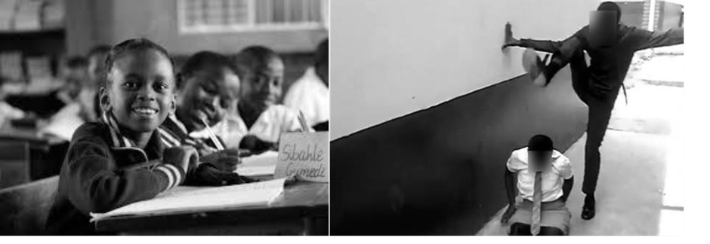

#### Figure 10: Which school would you want your child to go to?

UNIT 4: CREATING AND MANAGING A SAFE AND DISCIPLINED LEARNING ENVIRONMENT

This unit has four sections as shown in the Figure 11.

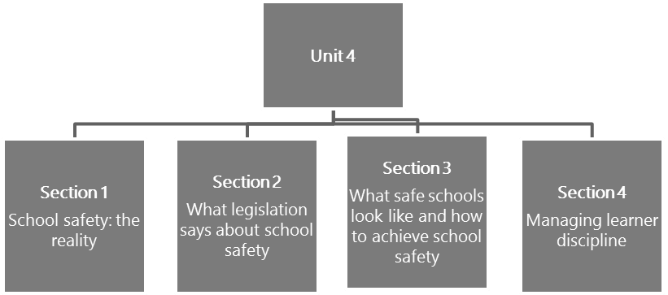

#### Figure 11: The structure of Unit 4

**Unit 4 learning outcome**

There is only one learning outcome for this unit. By the end of this unit you should be able to:

* Create, manage, innovate and sustain appropriate systems and procedures to enhance a caring and disciplined environment and show commitment to following this through in the way in which teaching and learning is organised.

Section 1: School safety: The reality

### The legal framework

The Constitution provides the overarching legal framework for school safety, but it’s not the only legislation you should be familiar with. The South African Schools Act (SASA) (DoE, 1996) makes clear provision for schools to admit learners and serve their educational and safety needs. The Children’s Act (Dept. of Social Development, 2006) governs the laws relating to the care, contact and the protection of children This is often referred to as the best *interests of the child*. With all of this high-quality legislation, why do many South African public schools face the challenges that feature so frequently in the media?

Section 7 of The Children’s Act deals with the *best interests of the child* and whenever a provision of this Act requires the *best interests of the child* standard to be applied, the following factors must be taken into consideration where relevant:

* + *the need to protect the child from any physical or psychological harm that may be caused by -*
  1. *subjecting the child to maltreatment, abuse, neglect, exploitation or degradation or exposing the child to violence or exploitation or other harmful behaviour; or*
  2. *exposing the child to maltreatment, abuse, degradation, ill-treatment, violence or harmful behaviour towards another person;*
  + *any family violence involving the child or a family member of the child; and*
  + *which action or decision would avoid or minimise further legal or administrative proceedings in relation to the child.* (Dept. of Social Development, 2006: 30–31)



**Activity 36: Schools and the best interests of the child**

**Suggested time:**

15 minutes

**Aim:**

To think about the safety shortcomings in many schools.

#### What you will do:

As an individual activity, write notes in your Learning Journal where you suggest what the underlying challenges and problems might be in schools that lead to the high incidence of issues relating to a lack of safety.

UNIT 4: SECTION 1: SCHOOL SAFETY: THE REALITY

#### Discussion of the activity

Safety can be compromised by external factors such as the weather (e.g. floods, cyclones); general political unrest; or danger arising from the structures in and around the school (e.g. electrical fires, inadequate and dangerous toilets, collapsing walls). But a significant contributor to safety violations is people. This includes those people bringing violence from *outside* the school, as well as those who may be violent inside the school, such as, teachers, other school stakeholders, parents, partners or learners. Whatever factors you might have considered in your response, school leaders cannot shrug their shoulders and say there’s nothing they can do about it.

This section of the unit firstly seeks to look at the reality of the safety in South African schools, and then looks at a number of the factors that either enable or interfere with the safety of a school. Issues of a safe school are looked at from different perspectives.



**Activity 37: What is a safe school?**

**Suggested time:**

2 hours

**Aim:**

1. To understand what constitutes a safe school in South Africa.
2. To understand the teachers’ basic duty of care for the learners, by analysing sections of a relevant academic paper.

#### What you will do:

1. In your Learning Journal, explain what you understand as a *safe school*. Use your own words or create a mindmap (as discussed in *Module 5: Working with and for the wider community*).
2. Now, explain what you understand as *a teachers’ duty of care*.
3. Read the article by Prinsloo (2005) titled *How safe are South African schools?* Available online at: Available at: <https://tinyurl.com/y5oy5eoo>
4. Review each of the extracts in the text boxes and answer the questions that follow.

#### Extract 1: How safe are South African schools?

*A safe school may be defined as one that is free of danger and where there is an absence of possible harm; a place in which non-teachers, teachers and learners may work, teach and learn without fear of ridicule, intimidation, harassment, humiliation, or violence. A safe school is therefore a healthy school in that it is physically and psychologically safe. Indicators of safe schools include the presence of certain physical features such as secure walls, fencing and gates; buildings that are in a good state of repair; and well-maintained school grounds. Safe*

SECTION 1: SCHOOL SAFETY: THE REALITY

*schools are further characterised by good discipline, a culture conducive to teaching and learning, professional teacher conduct, good governance and management practices, and an absence (or low level) of crime and violence.* (Squelch, 2001 cited in Prinsloo, 2005: 5).

#### Question:

Compare this definition to your own definition of a safe school. What are the similarities? What did you leave out? Rewrite this definition in your own words, adding elements from your original definition that you think are important to include. Share your definitions with your school-based CoP and note insights you might have gained from others.

#### Extract 2: How safe are South African schools?

*According to Oosthuizen (1998: 209) teachers in a school have a legal duty in terms of the common law principle, in loco parentis, to ensure the safety of learners in their care. Teachers as persons in loco parentis are vested with special status that empowers them to act authoritatively in terms of the law. Not only do they have both delegated powers (delegated by the principal [leader] of the school to act on his or her behalf) and original powers (powers originating in common law) of authority over learners on the school grounds and during the normal school session, but (in terms of common law) they are also granted authority over the learners during extramural activities on or away from the school grounds. According to Maithufi (1997: 260–261) there are two coextensive pillars to the in loco parentis role that teachers play: the duty of care (which implies looking after the physical and mental well-being of learners) and the duty to maintain order at a school (which implies teachers duty to discipline learners).* (Prinsloo, 2005: 9, 10)

**Question:**

Prepare a brief memo for newly qualified teachers at your school that explains a teacher’s duty of care, and what this means in terms of their role in the school community. Reflect on how this compares with your initial understanding of a teacher’s duty of care. The memo should be about one third to half a page long. Refer to the guideline supplied in the text box.

UNIT 4: SECTION 1: SCHOOL SAFETY: THE REALITY

#### Guideline: What is a memo?

A memo is a simple tool used for clear, brief and concise communication. It also serves as a record and convenient reference. It can be informative (as required in this task) or it can be a reminder about something, a record of a discussion, or a preparatory notice about something.

A memo typically has the following elements: To:

From:

Date:

Subject:

Message:

Note: MS Word provides a memo template for ease of usage.

**Discussion of the activity**

Before you started writing the memo about *what* teachers should do, did you make use of what you have already learned about providing leadership? It is critical that you should start with the issues of *why* this memo is important so that the new teachers come to share the same purpose behind an ethic of care (as discussed in *Module 4: Leading and managing people and change*). In the same module you learned that great leaders are able to lead transformative change. In this context it implies that they have a vision of safety that extends beyond the school gates and into the community as well.

In your reflections on a **safe school**, you might have considered some or all of the following key elements of the definition of a safe school:

* A safe school is safe for support staff, teachers and learners.

Reflection: *Does your original definition of a safe school encompass all of these groups/stakeholders?*

The school community includes parents, school employees, members of the community using school facilities, teachers and learners, and all these stakeholders need to feel safe, and all have a role to play in ensuring school safety.

* A safe school is free from ridicule, intimidation, harassment, humiliation or violence.

Reflection: *Does your original definition of school safety consider more than just physical violence such as fighting, corporal punishment, gangsterism, etc?*

This element of school safety means you need to broaden your understanding of what constitutes school safety to encompass a variety of behaviours including bullying, sexual harassment, theft, drug use, etc.

SECTION 1: SCHOOL SAFETY: THE REALITY

* A safe school provides physical and psychological safety.

Reflection: *Have you considered both the physical and psychological needs of a school in ensuring a safe environment?*

When you considered the concept of **a teacher’s duty of care**, did your reflections include the following ideas?

*South African teachers have an important duty towards the safety and the protection of learners, not only in terms of the Constitution and other legislation, but also in terms of their in loco parentis status (i.e. the teacher ‘acting as parent’). All these duties include responsibilities for the physical and psychological well-being of the learner (Bray, 2000: 66). The in loco parentis status of teachers furthermore forces schools to foresee the potential dangers to which learners may be exposed at schools and to act pro-actively by taking steps in the form of safety measures or policy to protect learners from harm.* (Prinsloo, 2005: 6)

Having thought about what constitutes a safe school in South Africa, as well as the duty of care *– in loco parentis –* of teachers, the next activity uses another article on safety in South African schools to delve more deeply into basic human needs and the damaging effects of a range of unsafe situations arising in schools. This activity is designed to help you consider how you might address school safety in your school.



**Activity 38: Exploring issues of safety in South African schools**

**Suggested time:**

2 hours

**Aim:**

1. The purpose of this activity is for you to work through a series of analytical tasks to determine the human need for safety.
2. To better understand the negative effects of unsafe situations.
3. To learn how to address school safety.

#### What you will do:

**Task 1:**

1. This activity is based on the following article: Masitsa, M. G. 2011. Exploring safety in township secondary schools in the Free State province. *South African Journal of Education*, 31(2): 163–174. Available online at: <https://tinyurl.com/y6runqvz>
2. Read the following extract from the article, and study Figure 12 which shows the levels of human need that must be satisfied in order to allow for a full range of human development.
3. Where appropriate record your responses individually in your Learning Journal.

UNIT 4: SECTION 1: SCHOOL SAFETY: THE REALITY

#### Extract 1: Exploring safety in township secondary schools in the Free State province

*According to Maslow (Department of Education, 2008: 87), human needs can be classified according to five levels of priority. The first and most pressing of these relates to the biological and physical need for survival. This is followed by a requirement for safety or a safe environment. Only once these needs have been addressed, can the process of belongingness, building self-esteem and self-actualisation begin. The preceding discussion not only stresses the value of safety in a school milieu, but confirms the view that education, in the true sense of the word, cannot occur in the absence of safety. Maslow regards safety as the search for security, stability, dependency and protection, as freedom from fear, anxiety and chaos and the need for structure and order. This implies that a person yearns for safety, thus making it an important requirement for survival and an important aspiration of a learner. In short, the adage ‘safety first’ is appropriately applicable to a school situation.* (Masitsa, 2011: 165–166)

1. In order to confirm the basic need for safety, and using the information above, summarise Maslow’s hierarchy of needs as illustrated in Figure 12.

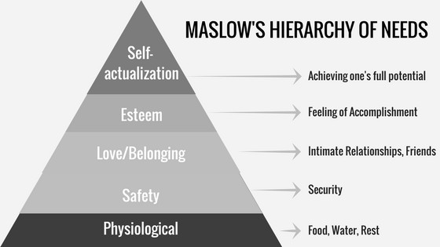

#### Figure 12: Maslow’s hierarchy of needs

(Source: McLeod, 2018)

#### Task 2:

1. This part of the activity has reference to Masitsa’s article above, as well as to an extract from: Ncontsa, V. & Shumba, A. 2013. The nature, causes and effects of school violence in South African high schools. *South African Journal of Education*, 33(3): 15pp.*.* Available online at: <https://tinyurl.com/y27sebu5>
2. Review the following extracts from the articles, and answer the question that follows:

SECTION 1: SCHOOL SAFETY: THE REALITY

#### Extract 2: Exploring safety in township secondary schools in the Free State province

*Thro (2006: 66) holds the view that if learners are subjected to physical violence, to bullying and intimidation and to a culture of illegal drugs, effective learning cannot take place. Trump (2008:*

*66) warns that if learners do not feel safe to learn and teachers do not feel safe to teach, the focus shifts from academic tasks to discipline and personal safety.* (Masitsa, 2011: 164)

**Extract 3: The nature, causes and effects of school violence in South African high schools**

*…the majority of the learner respondents believe that school violence causes chaos and leads to loss of learning and tuition time because the disruptions demand that the problems should be attended to. In this study, 64 (79.7%) of respondents reported that when there is a fight in one class, almost all the learners go to witness what is going on. In most cases, the intention by the onlookers would be to cheer those learners involved in the fight. The situation at the school becomes chaotic and teachers have to stop the fighting, leading to unnecessary loss of learning and tuition time.* (Ncontsa & Shumba, 2013)

**Question:**

How do the findings reported in Extract 3 support what is said in the Masitsa (2011) extract in Task 1 of this activity? Explain what you think the links are.

#### Task 3:

The Ncontsa and Shumba article uses a sample of 20 teachers and 80 learners, and while the short extract does not give explicit figures, what do you imagine might be significant in the way that learners react and the way teachers view the situation?

UNIT 4: SECTION 1: SCHOOL SAFETY: THE REALITY

#### Task 4:

1. Study the following tables (from the Ncontsa and Shumba article referenced previously) and read Extracts 4 and 5 (from the articles as referenced) before completing the task.

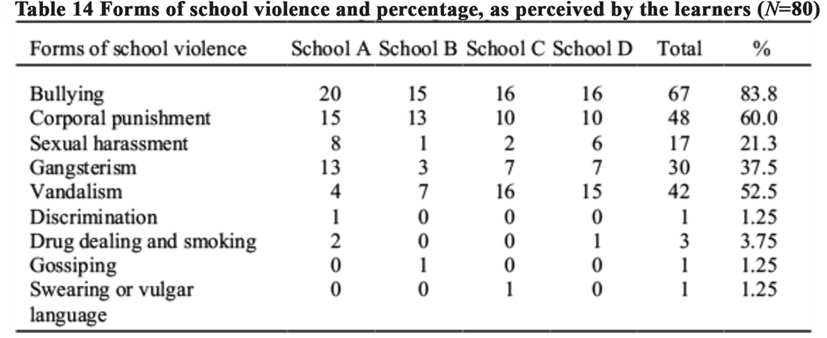

(Source: Ncontsa & Shumba, 2013)

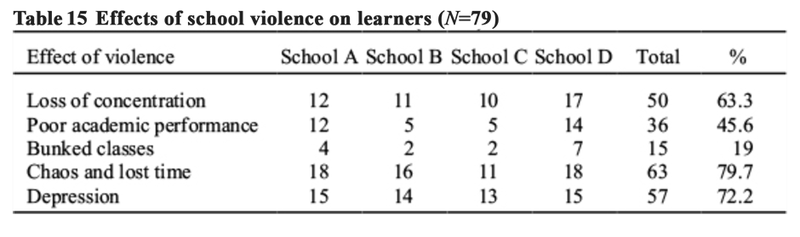

(Source: Ncontsa & Shumba, 2013)

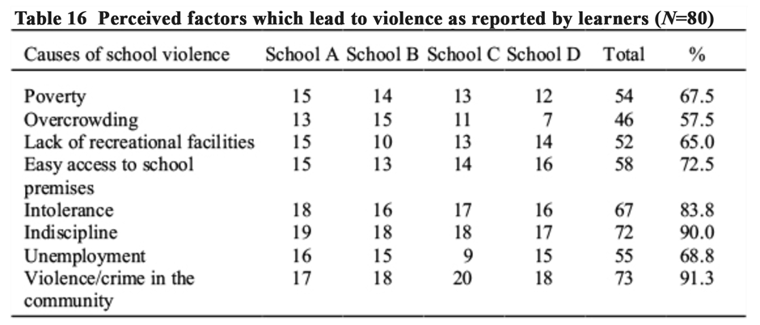

(Source: Ncontsa & Shumba, 2013)

SECTION 1: SCHOOL SAFETY: THE REALITY

#### Extract 4: Exploring safety in township secondary schools in the Free State province

*…the Department of Education, as an organ of government and the state, should ensure that schools are safe and secure during and after school hours … The Department of Education, School Governing Bodies and parents should act swiftly and decisively against a learner (or anyone for that matter), who is disruptive, who engages in violence or who is found guilty of a serious misdemeanour and who places the lives of teachers and/or learners in jeopardy. It is important for parents and teachers to send a strong message to children that home and school are working together to ensure a safe and secure school environment for everyone involved in education’ (Fritz, 2006: 2).*

*The schools should apply the following safety measures after discussing them with all stakeholders: ensuring that there is proper fencing around the school yard; demarcating the school area as out of bounds to strangers; controlling access to the school during and after school hours; encouraging learners to take responsibility for their part in maintaining school safety by, inter alia, reporting crime, learners who are in possession of drugs or weapons, strangers, suspicious objects inside or outside the school, and anything that poses a threat to learners or the school.*

*The members of the school governing body should use the powers granted to them by legislation to ensure school safety. Section 18A (2) of the Schools Act (RSA, 1996b) stipulates that the governing body must adopt a Code of Conduct aimed at establishing a disciplined, peaceful and purposeful school environment. The Code of Conduct should address aspects related to discipline and the safety of learners; the carrying of dangerous weapons; the use of illegal drugs; and bullying, fighting and harassment at school. Section 20(1) of the Schools Act (RSA, 1996b) grants the governing body power to administer and control the school’s property, buildings and grounds. The foregoing entails, inter alia, protecting and guarding all school property and playgrounds; keeping the grounds free of dangerous objects; and maintaining equipment in good working order. Section 5 (1) of the Schools Act (RSA, 1996b) grants the principal [school leader] power to take such steps as he/she may consider necessary for safeguarding the school premises, as well as protecting the people therein*. (Masitsa, 2011: 172)

#### Extract 5: The nature, causes and effects of school violence in South African high schools

*Based on the findings, the following recommendations should be implemented in order to reduce school violence:*

* *It is recommended that schools should educate learners, teachers and parents about these forms of violence prevalent in schools. Schools could conduct awareness seminars and*

UNIT 4: SECTION 1: SCHOOL SAFETY: THE REALITY

*workshops on the above-mentioned forms of school violence. Learners should be taught to tolerate others through teamwork during lessons.*

* *Since some boys have been found to be perpetrators of school violence, young learners or victims should be encouraged to report their perpetrators to the school authorities. Any learner found bullying other learners should be disciplined by the school. The school should make the parents aware of their child’s bullying before the child is suspended from classes.*
* *In order to protect schools against gangsterism and vandalism, more personnel should be employed to monitor entrances to schools.*

*Any teachers found using corporal punishment on learners should be charged in a court of law since corporal punishment is banned in South African schools.* (Ncontsa & Shumba, 2013)

1. Assume that an NGO has approached you to consider creating a programme to address school safety in your school. Using the information from the Ncontsa and Shumba, and Masitsa articles, prepare an oral presentation for the school governing body (SGB) to motivate for the introduction of a school safety programme. Your presentation should consider:
   * Three forms of school violence prevalent in your school.
   * Causes of the forms of violence prevalent in your school.
   * The effect or impact of school violence (you may use examples or incidences from your school to illustrate your points).
2. To complete your oral presentation, develop at least three recommendations that would be effective in addressing school safety in your school. You can either select recommendations from the articles above that would be appropriate in your context, or come up with your own recommendations. Include the stakeholders who have a role in implementing your recommendations and how they would address the issues. Fill in Table 17.

#### Table 17: Analysis of recommendations to address school safety

**Recommendation Stakeholders (Who is involved)**

**How/why it would help**

|  |  |  |
| --- | --- | --- |
|  |  |  |
|  |  |  |
|  |  |  |
|  |  |  |

SECTION 1: SCHOOL SAFETY: THE REALITY

#### Discussion of the activity

Has the information you have read changed your thoughts about how safe your school is? Is the problem more or less serious than you thought? Even more importantly, have you considered why your school might experience the challenges it does?

A close reading of the data presented and the accompanying extracts from academic articles seem to suggest that the writers are taking a largely reactive position to an educational phenomenon. They appear to focus on *what* is happening in schools and then suggest *how* schools, SGBs and departments of education should respond. There is no comment on *why* schools are experiencing safety issues. With the exception of some of the perceived factors in Table 14, there is very little that speaks to the importance of management and inspiring, transformative leadership. Doesn’t this remind you of Sinek’s Golden Circle (Sinek, 2010)? His view is that inspiring leadership works from the inside, out – starting with understanding *why* you do what you do, or in this case, why your school faces the challenges it does. It is common knowledge that there are public schools in South Africa that seem to defy the odds and have proud safety records – almost inevitably aligned to excellent learner achievement. So, what do these schools do that is different? What does leadership in these schools focus on? What examples do teachers set? Why do learners behave so differently there?

Why leadership is so important for learner achievement is summarised briefly in the following extract from SangariBlog, available at: <https://tinyurl.com/yytt2sjl>– and this is only a small sample of the literature on this topic.

*There is a growing body of evidence that school leadership has an impact on student outcomes second only to the influence of teachers in the classroom (Hattie, 2003; Leithwood et al, 2006; Tooley, 2009; Day et al, 2009; New Leaders for New Schools, 2009; Day et al, 2010; Barber et al, 2010).*

*A recent RAND Corporation report found that nearly 60% of a school’s impact on student achievement is attributable to leadership and teacher effectiveness, with principals accounting for 25% of a school’s total impact on achievement. Furthermore, the report found that, while effective teachers have a profound effect on student outcomes, this effect soon fades when the student moves on to another teacher, unless the new teacher is equally effective (New Leaders for New Schools, 2009). In order for students to have high-quality learning every year, whole schools must be high functioning, and this means they must be led by effective principals.* (SangariBlog, 2017)

Maslow’s hierarchy of needs, available at <https://tinyurl.com/kmspnbe>is a well-known diagram and it helps you to understand *why* you need to focus on safety in schools. It illustrates how important feeling safe is. Safety and security – along with biological and physical needs such as food, water, rest and warmth – are the most basic human needs. This means people cannot fully grow and develop healthy relationships and friendships (belongingness) and feelings of respect and accomplishment (esteem) or achieve their full potential (self-actualisation) if they do not feel safe. Thus, you cannot build a healthy school environment if learners, teachers and other members of the school community do not feel safe.

While it is important to understand what contributes to the lack of safety in schools, so that you gather information on the scope of the problem, it’s just as important to listen to voices that help you understand why certain things contribute to the problem, so that you can act collectively to manage a positive change.

UNIT 4: SECTION 1: SCHOOL SAFETY: THE REALITY



**Activity 39: Listening to learners’ voices**

**Suggested time:**

20 minutes

**Aim:**

To listen to learners’ voices about their daily school experience by asking *why* questions.

#### What you will do:

1. Watch the short video clip titled: *South African school kids fight violence*, available online at <https://tinyurl.com/y4ncclk5>
2. Schedule a meeting of your school-based community of practice (CoP) and facilitate a discussion based on the following questions (you can include additional questions of your own as well):
   * Why is it important for school leaders to listen to learner’s voices?
   * Why might some learners not report safety issues they have experienced?
   * Why might learners in your school bunk lessons or arrive late for the start of lessons?
   * Why might there be discipline challenges in certain teachers’ classrooms?
   * Why do some teachers not seem to experience serious discipline issues?
   * Why do some teachers still resort to corporal punishment?
   * Why is it important to keep asking the *why* questions?

#### Discussion of the activity

If you consider the purposes of schooling, fundamentally they are about the *why*, *how* and *what* of the children’s experiences at school, so it makes perfect sense for good leaders to listen to the learners’ voices about both the good and the bad they go through. For example, if learners do not always report incidences of bullying, theft, fighting or abuse to school authorities, why might this be? If they are reluctant to go to class, there is likely to be a reason for this – could it be an unprepared teacher who has to resort to corporal punishment to maintain order? Or, could it be through a fear of ridicule or verbal abuse? What about the possibility of gender discrimination or sexual harassment?

School leaders who are in touch with what is going on in the school usually know which teachers are respected and admired by learners, and which ones are not. They reflect on why this might be the case. Good leaders who ask these *why* questions, move on to asking *how* they can make provision to hear learner’s voices, so that *what* they hear is an authentic voice and not an assumption.

### Listening to everyone’s voices

It is not only the learners who don’t want to report violence at school. Teachers, who are supposed to be in charge in their classrooms, may also not want to report harassment or bullying that is experienced by either learners or by themselves. This may influence the overall reporting on the level of school violence.

Remember, school safety involves learners, teachers and non-teachers in the school, so you need to consider a variety of viewpoints when addressing school safety.

SECTION 1: SCHOOL SAFETY: THE REALITY

Have you considered how you can get learners, teachers, parents, the SGB and the Department of Education (DoE) involved in addressing school safety? These, and other stakeholders such as local businesses and members of the wider community, need to be included in efforts to make schools safer. This responsibility should remind you what it means to be a transformative leader.

Because this module focuses on systems and procedures needed to manage the school as an organisation, you need to be able to translate the principles of collaborative, relational and ethical leadership into policies and practices. This means that in order to implement measures to address school safety, you need resources. What resources do you need to implement your recommendations? Earlier in this unit you saw that a safe school is both physically and psychologically safe. How would you go about securing the physical resources needed? How do your recommendations address the need to develop the psychological features of a safe school? These psychological features include good discipline, a culture conducive to teaching and learning, professional teacher conduct, good governance and management practices, and an absence, or low level, of crime and violence.

These are just a few of the factors you need to consider if you are to develop realistic, long-term measures to make your school safer.

The next activity provides an opportunity to gather information from learners about school safety and then plan an intervention suitable for their school context.



**Activity 40: Learner perceptions of school safety**

**Suggested time:**

2 hours

**Aim:**

1. The purpose of this activity is for you to gather information from learners on their experience of school safety.
2. To propose a focused plan of action to address the most pressing need as expressed by

learners.

#### What you will do:

Arrange for a group equivalent to about 20% of the learners in your subject or phase to complete the short questionnaire on school safety in Table 18. It is recommended that 10% of the school learner numbers should complete the questionnaire. However a higher number of respondents in a survey increases the reliability of the results.

UNIT 4: SECTION 1: SCHOOL SAFETY: THE REALITY

#### Guidelines: Guiding principles for completion of the questionnaire

1. Assure the learners doing the questionnaire that their answers are anonymous.
2. Explain the options (A, B, C or D) carefully.
3. Ask learners to indicate which option applies.
4. Collate the answers, using the scoring sheet provided in Table 19.
5. Analyse the weak spots/areas needing attention.
6. Meet with colleagues and learners to discuss how to address areas of concern.
7. Make a presentation to the SGB about a priority area for learner safety that needs to be addressed. The presentation should include the recommendations from colleagues and learners.
8. You may be able to use the information in your Workplace Project (WPP).

#### Table 18: Questionnaire on learner school safety

|  |  |  |  |  |  |
| --- | --- | --- | --- | --- | --- |
| Thank you for helping us to collect information about your safety in and near the school. We will use the information to find ways to improve safety for you, the learner. | | | | | |
| **Instructions**   1. The questions are answered anonymously. (You must not put your name on the questionnaire.) 2. Please answer all the questions. 3. Answer all the questions truthfully. 4. Only choose one answer for each row. | | | | | |
| **The code letters mean:**  A: always feel safe B: mostly feel safe  C: am sometimes fearful  D: am mostly fearful | | | | | |
| **No.** | **The extent to which I feel safe:** | **Code** | | | |
| 1. | When I am at home: | A | B | C | D |
| 2. | When I travel to school: | A | B | C | D |
| 3. | When I am in the school playground or buildings: | A | B | C | D |
| 4. | When I am in class: | A | B | C | D |
| 5. | When I go to the toilet during class: | A | B | C | D |
| 6. | When I go to the toilet between classes: | A | B | C | D |
| 7. | When I go to the toilet during break: | A | B | C | D |
| 8. | When I am made to stay in at break by the teacher: | A | B | C | D |
| 9. | When I am made to stay in after school by a teacher: | A | B | C | D |
| 10. | When I travel home from school at the end of the day: | A | B | C | D |
| 11. | Apart from your C and D responses, are there any other examples of what makes you feel unsafe, in and near your school? If so, make a note of them here: | | | | |

(Source: Adapted from Clarke, 2007: 358)

SECTION 1: SCHOOL SAFETY: THE REALITY

#### Table 19: Scoring sheet for the learner school safety questionnaire

|  |  |  |  |  |  |
| --- | --- | --- | --- | --- | --- |
| **The codes for the responses are:**  A: always feel safe B: mostly feel safe  C: am sometimes fearful  D: am mostly fearful | | | | | |
| **Count up the number of responses for each code letter, and fill in the totals.** | | | | | |
| **No.** | **The extent to which I feel safe:** | **Code** | | | |
|  |  | **A** | **B** | **C** | **D** |
| 1. | When I am at home: |  |  |  |  |
| 2. | When I travel to school: |  |  |  |  |
| 3. | When I am in the school playground or buildings: |  |  |  |  |
| 4. | When I am in class: |  |  |  |  |
| 5. | When I go to the toilet during class: |  |  |  |  |
| 6. | When I go to the toilet between classes: |  |  |  |  |
| 7. | When I go to the toilet during break: |  |  |  |  |
| 8. | When I am made to stay in at break by the teacher: |  |  |  |  |
| 9. | When I am made to stay in after school by a teacher: |  |  |  |  |
| 10. | When I travel home from school at the end of the day: |  |  |  |  |
| 11. | Other examples of what makes participants feel unsafe in and near school, apart from their C and D responses: | | | | |

(Source: Adapted from Clarke, 2007: 358)

#### Discussion of the activity

Administering the questionnaire requires a bit of organisation and effort. However, the benefits that can be gained from the task, could be most rewarding. The very act of consulting learners and finding out what they think is important. It is about being open to their experience and their opinions. The results of the survey, if the numbers used are sufficiently high, have the potential to pinpoint areas of real concern. And of course, the most important thing is to act on the findings – to communicate with the school (learners, parents, the SGB) about the process and the findings and then to implement a suitable plan to address the area of greatest concern. If this process is handled well, and the chosen actions are implemented carefully, learners will feel cared for and respected.

The next activity looks at actual statistics gathered during a Centre for Justice and Crime Prevention (CJCP) research study – the 2012 National School Violence Study (Burton & Leoschut, 2012). The research was conducted nationally, and the number of schools surveyed were divided proportionally across the nine provinces. The sample consisted of 121 secondary schools and 5 929 learners. This study was conducted in 2012 as a follow-up to a study in 2008. The next follow-up study is being planned for the near future.

UNIT 4: SECTION 1: SCHOOL SAFETY: THE REALITY



**Activity 41: Examining statistics on school violence**

**Suggested time:**

2 hours

**Aim:**

1. To examine statistics on violence in schools.
2. To familiarise yourself with the extent of this challenge that needs close attention and firm action by school leaders.

#### What you will do:

1. Review each of the following graphs and answer the questions that follow.

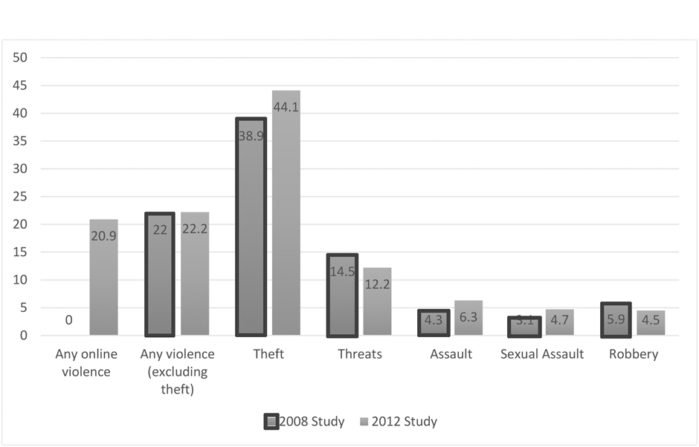

#### Figure 13: Experience of violence at school shown in percentages

(Source: Leoschut, 2013: 1)

1. When you compare the 2008 and 2012 percentages in the graph of experiences of violence at school, what is the overall trend of the findings?
2. The research bulletin translates the 22.2% of learners having experienced *any form of violence* into a number, which is 1 020 597 secondary school learners who had experienced some form of violence at school during the previous year. Is that number acceptable or not? Why or why not?

SECTION 1: SCHOOL SAFETY: THE REALITY

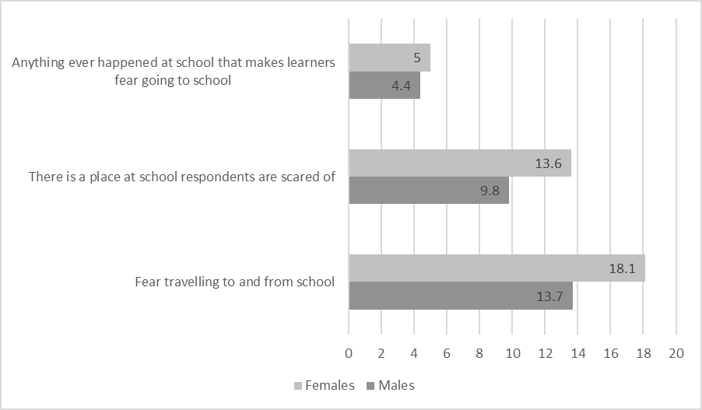

#### Figure 14: Feelings of fear by gender

(Source: Adapted from Leoschut, 2013: 3)

1. The report (Burton & Leoschut, 2013: 35) mentions that “schools seem to be places that elicit feelings of fear.” As a school leader, is a feeling of fear what you would like learners in your school to experience?
2. In the graph comparing the experiences of fear of male and female learners, clearly, female learners felt more vulnerable than male learners. What is the case in your school?

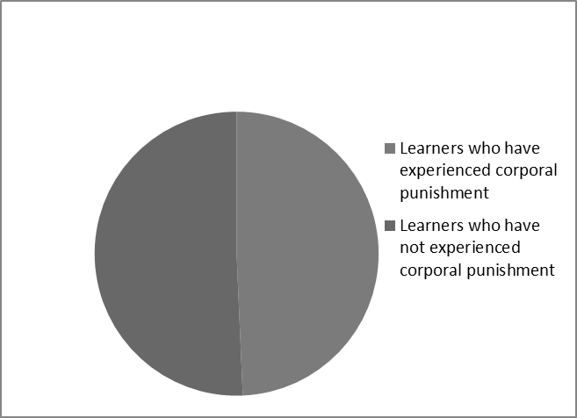

#### Figure 15: Percentage of learners who have experienced corporal punishment

(Source: Based on statistics from Leoschut, 2013: 3)

1. Comment on the percentage reported in the pie chart reporting on how many learners had been physically, hit, caned or spanked by teachers. Why do you think this is still the case even though corporal punishment is outlawed? As a school leader, what do you plan to do to ensure that this behaviour is not ever allowed in your school?

UNIT 4: SECTION 1: SCHOOL SAFETY: THE REALITY

#### Discussion of the activity

The trend of violent events at schools is slightly upwards since 2008. This is worrying as it suggests that whatever measures are being taken, they are not having the desired impact of reducing violent or criminal behaviour.

Also of concern is the fact that although corporal punishment has long been disallowed, almost 50% of learner’s report having experienced some form of corporal or physical chastisement during the past year. Elsewhere in this unit, you see that teachers are dismissive of the requirement that corporal punishment is not allowed. How will you as a school leader address this type of attitude in your school? A frequent response from teachers who still use corporal punishment, is that they still use it because the government banned it but did not offer any alternative measures. This seems to suggest that they have not made any structured effort themselves to consider appropriate discipline measures. Or more importantly, they have not asked why and how they could reduce the need for frequent punishment. You could plan a meeting with staff to discuss attitudes to discipline and make legal requirements clear. This should be followed by a meeting with parents to set requirements out clearly. The issue of corporal punishment is also further discussed in Unit 1 of *Module 7: Working within and for the school system*.

A useful insight gathered by a research report is that learners are more likely to report incidents of threat, intimidation and violence to their friends than to their parents. The report (CJCP, 2013: 3) indicates that this phenomenon has important implications for programmes designed to address violence. Peer-to-peer counselling should be a strong component of such programmes. You may want to refer to *Module 3: Leading and managing extra- and co-curricular activities* with its suggestions related to learner leadership, choice and agency.

Another important insight is that bullying is probably an *entry level* experience of violence for many learners: those who were bullied were more likely to fall victim to other types of violence such as robbery or theft.

The next activity is about the value and effectiveness of using cartoons to get social (and other) messages across. It also about the type of violence that is being experienced at schools, and what can possibly be done to address the challenge.

SECTION 1: SCHOOL SAFETY: THE REALITY



**Activity 42: Using cartoons as a way of exposing school violence**

**Suggested time:**

30 minutes

**Aim**

1. To think about getting a message across effectively.
2. To engage with *cartoon literacy*.
3. To consider the types of violence that occur in schools and how to deal with it.

#### What you will do:

**Task 1:**

1. With a friend or colleague, carefully look at the Zapiro cartoon.
2. What message or *social statement* is the cartoonist, Zapiro, making here? Is anything in this cartoon familiar to you?
3. Make a few short notes in your Learning Journal so that you are prepared to discuss the cartoon and your thoughts with your CoP when you next meet.

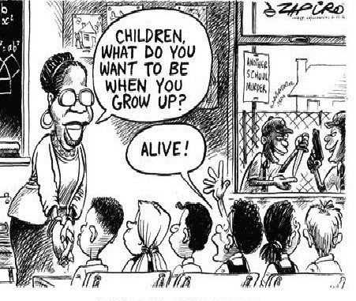

#### Figure 16: Cartoon by Zapiro, July 2007

(Source: <https://tinyurl.com/yygxfeul>)

UNIT 4: SECTION 1: SCHOOL SAFETY: THE REALITY

#### Task 2:

1. Have there been any incidents at your school recently that put learners and/or teachers at risk? Think about what caused the incidents – was it due to a natural event such as flooding; a poor maintenance issue such as a loose handrail; or was it due to human (mis)behaviour?
2. If you have had no incidents of this kind at your school recently, think about schools that surround you, experiences your fellow participants might raise and/or incidents you have read about in the media.
3. How did you or fellow colleagues and school leaders respond to the incidents described in this activity?
4. What could have prevented or minimised the severity of the incidents?

#### Discussion of the activity

Zapiro’s cartoon is a sad criticism of schools and schooling in South Africa – and of schools worldwide where a number of fatalities have occurred, often through learner-on-learner shootings.

This type of cartoon is a powerful tool, in the form of social satire.

#### Take note

Satire is defined in the Oxford Dictionary as: “the use of humour, irony, exaggeration, or ridicule to expose and criticise people’s stupidity or vices, particularly in the context of contemporary politics and other topical issues” (Oxford Dictionaries, 2018).

Longman’s Dictionary of Contemporary English defines satire as: “a way of criticizing something such as a group of people or a system, in which you deliberately make them seem funny so that people will see their faults” (Longman’s Dictionary of Contemporary English, 2018).

This section has examined the realities of what a safe school should look like; the duty of care of teachers; the theory of basic human needs; ways to address school violence; and the statistics on school violence.

The next section addresses the policies and laws and codes of conduct that frame what and how things should be done, to ensure that learners, schools and all stakeholders are safe.

## Section 2: What legislation says about school safety

### Introduction

The second section of this unit concentrates on setting out the codes of conduct, policy and legislation that prescribes what ought to be happening in schools in terms of ensuring that the environment is safe and secure for learners, teachers and school stakeholders.

The following activity is about the harsh reality of school violence. It speaks to codes of conduct that apply to schools as important guiding principles for expected behaviour and that align to the legal requirements for school management. As important elements that guide behaviour, codes of conduct will also be discussed in Section 3 of this unit.



**Activity 43: Encountering the harsh reality of school violence**

**Suggested time:**

45 minutes

**Aim:**

1. To analyse an example of violence perpetrated against a learner.
2. To think about why some teachers behave in this manner despite clear policies which they should be familiar with.

#### What you will do:

1. Share with a fellow school-based CoP member your experiences or knowledge of violence in the school.
2. How were the issues addressed, and what lessons have you learned as a school leader, as a result?
3. Write a summary of this discussion in your Learning Journal.
4. Access and watch this video (Mlambo, 2017) which has circulated on social media: [https://tinyurl.com/ y4xkqmqv](https://tinyurl.com/y4xkqmqv)
   * What was your reaction to the video and why?
   * How can school leaders ensure that this will never happen in their schools?

#### Discussion of the activity

Did your school-based CoP agree that the teachers’ actions contradict several human rights. Their actions are humiliating, cruel and are in breach of the primary provisions for teacher behaviour from the South African Council for Educators (SACE) Code of Professional Ethics (n.d.: 2) depicted in Figure 17.

UNIT 4 - SECTION 2: WHAT LEGISLATION SAYS ABOUT SCHOOL SAFETY

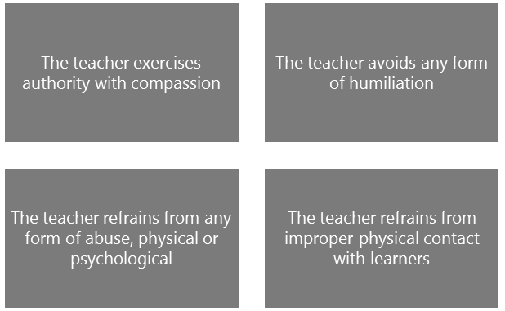

#### Figure 17: SACE Code of Professional Ethics: Provisions for teacher behaviour

KwaZula Natal Education MEC Mthandeni Dlungwane’s spokesperson, Kwazi Mthethwa (as reported by Mlambo, 2017), said the department was concerned that teachers continued to *dish out* corporal punishment despite it being banned in 1997.

In response to the video clip, Mthethwa (as reported by Mlambo, 2017) also advised learners to report violent incidents to their parents or school leaders. In turn, he reminded school leaders that they should report such incidents to the Department of Education, so that the department can institute disciplinary proceedings against the perpetrators. What you must remember is that it is often very difficult for anyone, let alone learners, to speak against abuse or intimidation of any kind. Finding ways to enable *speaking out* is very important. Mthethwa also advised families that if the school leader does not investigate the matter further, learners or their parents can report the incident themselves to the Department of Education’s District Office.

#### Stop and think

*Module 3: Leading and managing extra- and co-curricular activities* introduced the concept of learner leadership and agency. In the matter of school safety, this provides an ideal topic for learner leaders to get involved and make practical suggestions for improving learner safety.

The next activity looks at the key pieces of legislation that govern safety in the school. You need to remember that there are many other pieces of legislation that may apply, such as regulating the possession and use of weapons.

SECTION 2: WHAT LEGISLATION SAYS ABOUT SCHOOL SAFETY



**Activity 44: Review the legislation that frames safety in schools**

**Suggested time:**

1 hour

**Aim**

To review and familiarise yourself with the legislation that informs the school’s responsibilities and tasks around safety in schools.

#### What you will do:

1. Carefully read the summary of information on the legal requirements around learner safety based on three pieces of legislation, in preparation for answering the question on the case study that follows.

#### Summary: Information on the legal requirements related to learner safety

* 1. The Constitution (RSA, 1996), of which three sections in the Bill of Rights (Chapter 2) are of particular significance, is the most important guiding document. The first is Section 28 (2) which stipulates that “the best interests of a child are of paramount importance in every matter concerning the child.” Section 10 refers to “*the inherent dignity of each person and his or her right to have their dignity respected and protected*.” Similarly, Section 9 (1) specifies the rights to equal protection and benefit of the law for every person (*including* children).
  2. The second piece of applicable legislation is the South African Schools Act 84 of 1996 (DoE, 1996). Four sections of SASA apply in particular to learner safety and the responsibility for this. Firstly, Section 20 (1)(e) designates co-responsibility for “the best interests of the school” to the SGB, the principal and the school staff. Secondly, Section 15 affords the school status as a juristic person which means that the school has legal rights and responsibilities. The implication of this status is that the school must do everything possible to protect learners and the school – which is about safety policies and procedures and also insurance cover. Thirdly, this is because Section 60 (a) assigns liability to the State for damage or loss. Section 60 (b) limits the extent of liability to that not covered by the insurance policy. Fourthly, Section 8A talks to substance abuse in schools, primarily by declaring all schools drug-free and dangerous-object-free zones. Thus, Section 8A gives the principal “search and seize” powers with regards to alcohol, drugs and weapons. However, the principle of *reasonableness* applies, and school leaders must also be aware of the provisions of Section 14 of the Bill of Rights (which sets out the rights of privacy), as well as the limitations clause (Section 36).
  3. The Regulations for Safety Measures at Public Schools (DBE, 2001) as amended in 2006 is the third important guiding document. The regulations provide guidance on how to handle violence and substance abuse, access to the school, organising school activities, including

UNIT 4 - SECTION 2: WHAT LEGISLATION SAYS ABOUT SCHOOL SAFETY

transport, physical activities, emergency and fire procedures and early release of learners from school.

1. Review the brief case study that is based on a number of recent news reports on safety issues in schools.

#### Case study: Poles, pits and knives

School is a dangerous place to be. Over the last few years, a number of deaths have occurred on school premises. A learner was stabbed in a gang-related incident outside the school gates and died in the sickroom of his school.

Sizwe Kubheka, a learner at a school in Palm Springs, Johannesburg, died allegedly as a result of a beating on the head with a belt by a teacher.

Another learner was bullied and later died at home – although it is not clear whether he died of injuries he suffered from the bullying or from a pre-existing medical condition.

Two female teachers were shot dead in their classrooms by their estranged husbands – one in Bushbuckridge, one in Duncan Village.

Recently, a Grade 2 learner from Dalpark Primary school in Brakpan brought a loaded pistol to school, allegedly to harm another learner. A tragedy was narrowly averted when his intention was discovered. The learner was taken to the police station and subsequently received counselling for *behaviour change*.

Then, too, there have been the accidental deaths – whether these were caused by negligence or some inherent defect in equipment. A Grade R learner at a school in Laudium, Pretoria, died after a fall from a jungle gym.

A boy who jumped over a locked school gate became permanently disabled as a result of injuries sustained in the fall.

1. Respond to the following question: To what extent are school leaders responsible and accountable for safety issues such as those reported in the this case study ?

SECTION 2: WHAT LEGISLATION SAYS ABOUT SCHOOL SAFETY

#### Discussion of the activity

Without more detail on each of the reported cases, it is impossible to assign blame or full responsibility to particular school leaders, however, there is never an escape from some degree of responsibility as is emphasised in the discussions on the legal obligations of the school and its staff in *Module 7: Working within and for the school system*. Accidents are always possible in places where people spend many hours together, but it should be very clear that good organisational policies, processes and practices can go a long way to ensuring the safety of all school stakeholders. The incidents reported in the first part of the case either involve *external* threats brought into the school (such as the murderous husbands, the gang-related stabbing or the child who brought a pistol to school), or the *internal* threats (such as the beating by the teacher or the bullying by fellow learners). According to the regulations, school leaders must control who has access to the school. This raises the question as to whether stricter access control might have averted some of these tragedies? The case of the teacher who beat a child is a criminal case and the teacher should be charged accordingly.

In the second part of the case study, each of the examples could (and probably should) result in the schools concerned being sued for negligence.

Joubert (2016: 112–113) reports that in a number of cases where learners have been injured at school or during school activities, the Department of Education has been sued in terms of Section 60(1) of SASA.

However, there are also some examples of positive interventions related to learner safety and wellbeing. The *Safe and Caring* child-friendly schools programme run by the United Nations International Child Emergency Fund (UNICEF) (see text box) promotes integrated, community-oriented programmes that have been shown to result in an improvement in learner achievement and a reduction in teenage pregnancies.

#### Article: UNICEF’s Safe and caring child-friendly schools programme.

**What is a *Safe and Caring* school?**

Safe and Caring schools encapsulate UNICEF’s global Child-Friendly Schools Framework which was first conceived as a means of translating the principles of the Convention on the Rights of the Child, the South African constitution and other human rights instruments to improve school management and classroom practice. It will be implemented by the National Department of Education in partnership with UNICEF under the banner of Safe and Caring Schools. The framework attempts to define the provision of quality education in a holistic and integrated manner. The Safe and Caring Schools programme has six broad characteristics.

The school should be effective, rights based, gender responsive, health seeking and promoting, safe and secure, and partnership oriented.

This framework ensures that the rights of all children to a high-quality education is at the heart of the initiative. It is also designed to contribute to meeting the Millennium Development and Education for All Goals dealing with poverty, hunger, gender equality, child mortality, access to water and sanitation. Achieving these goals is dependent upon the success of education

UNIT 4 - SECTION 2: WHAT LEGISLATION SAYS ABOUT SCHOOL SAFETY

systems. The Safe and Caring Schools framework, with its holistic approach to access and quality, and with the success gained through experiences in other parts of the world provides the basis from which real progress towards the Millennium Development Goals can be made.

The framework lays emphasis on the learner being at the heart of the learning process, and the school at the centre of the education system. Schools are where investments designed to improve the quality of education come together in the teaching and learning process. Reforms to improve quality education should give appropriate weight to enabling schools to improve their own performance, by giving weight to leadership and management competencies at school level. And also of importance is giving children the opportunity to play. In partnership with SuperSport, that angle is part-and-parcel of the Safe and Caring Schools initiative. This gives children the opportunity to develop physically, mentally and emotionally.

(Source: <https://tinyurl.com/y25o7da4>)

In the next activity you are required to study an article written by an attorney on the legal framework that covers bullying in schools.



**Activity 45: Understanding the legal framework around bullying**

**Suggested time:**

90 minutes

**Aim:**

1. To examine the serious consequences of bullying in schools.
2. To understand the legal responsibility and requirements related to bullying.

#### What you will do:

1. Discuss and share with a fellow participant your own experience of bullying – at school, as a teacher, or at home. Were you ever a bully, yourself? Record your notes in your Learning Journal.
2. Read the following article that appeared on the Timeslive website.

SECTION 2: WHAT LEGISLATION SAYS ABOUT SCHOOL SAFETY

#### Extract: Bullying and its complex legal framework

*Over the past six to nine months there has been a disturbing increase in the number children being bullied at school. Parents are their wits’ end. Teachers, heads of school and governing body members are aware of these problems in their schools and simply do not know how to address them. They, too, are at their wits’ end. The statistics are frightening.*

* + *More than 3.2 million learners are bullied yearly in South Africa.*
  + *More than 67% of bully victims will not ask a teacher for help because they don’t think it will change their situation.*
  + *90% of school bullying is carried out by learners.*
  + *160 000 high-school learners bunk school daily to avoid being bullied.*
  + *One in 10 learners drop out of school to avoid being bullied.*
  + *16% of learners admit that they are victims of cyber-bullying.*

*In South Africa, over the past month alone, there have been three suicides of children younger than 15, due to what is believed to have been depression and/or desperation arising out of bullying. Following recent incidents at various schools across Gauteng, MEC Panyaza Lesufi stated that anyone who wanted to bully, and harm other learners would be removed from school. He said bullying and violence in schools would not be tolerated, and that the department needed to defend the rights of learners who were in those schools.*

*The South African legal framework*

*While it may seem that the adoption of a zero-tolerance policy is the only solution to this problem, it is unfortunately not this simple. The legal framework that applies to bullying in South Africa has many overlapping areas and conflicting rights and responsibilities. There are more than 20 Acts and pieces of legislation which deal with bullying, including:*

* + *The Constitution and Bill of Rights - bullying breaches at least six rights protected by the Bill of Rights - rights which a school has the duty to uphold;*
  + *The Children’s Act - this places an extremely onerous duty of care on educator and other staff in a school, which can even extend after school hours and requires staff to stand in loco parentis (in the place of a parent) in respect of children under their care;*
  + *The Schools Act;*
  + *The Protection from Harassment Act;*
  + *The Child Justice Act - which deals with how child criminal offenders are to be dealt with; and*
  + *The Protection of Personal Information Act.*

*There are also numerous inferred legal duties which pertain to bullying in schools. There is no one piece of codified legislation to assist in guiding educators and other stakeholders in attempting to eradicate bullying. There is not even a formal definition of ‘bullying’, and this only serves to exacerbate the problem. For the purposes of this article, bullying will be defined as: ‘a*

UNIT 4 - SECTION 2: WHAT LEGISLATION SAYS ABOUT SCHOOL SAFETY

*wrongful, intentional act, whether a physical act, gesture, verbal, written or electronic communication, taking place repeatedly, which is performed by either a single individual or more than one person’.*

*Risk of legal liability*

*Due to this complex and confusing network, schools and other educational institutions often find themselves in the position of being found to be legally liable for a failure to act correctly in either preventing bullying or reacting to it, where they were unaware that they had a duty to act.*

*Bullying and other incidents of violence by learners often lead to disciplinary measures having to be instituted, depending on the school’s Code of Conduct. While these hearings are regulated by the Code of Conduct, this is subsidiary to the Constitution, the Rules of Natural Justice and the Common Law. As a result, there have been many cases in our courts where disciplinary procedures have been found to have breached legal statutes, and schools have been ordered to reverse their findings and/or pay the wronged learner damages.*

*A criminal element*

*It must be borne in mind that certain acts of bullying not only transgress the provisions of a school’s Code of Conduct, but they are also criminal and punishable by law. These crimes can include assault, crimen injuria, (wilful injury to a person through the use of damaging language) rape, culpable homicide and even murder. If a child is being bullied at school by another child, in a manner which constitutes a crime, that child and her/his parents or legal guardians could bring a criminal charge against the bully with the South African Police Service.*

*If the bully is under the age of 10, s/he does not have criminal capacity and cannot be held criminally liable, but it does not mean that the bully will not face the consequences of her/his actions; the matter will simply be dealt with in a different way, with the child often being ordered to attend counselling or therapy, or another type of accredited programme which suits the needs of that particular bully. If charges are brought against a child who is over the age of 10, an enquiry will be held at a Magistrate’s Court to decide on the appropriate measures to be taken against the bully. These measures can include diversion (e.g.: a rehabilitation programme), but can also lead to the referral of the matter to a Child Justice Court, where criminal charges will be pursued against the child.*

*If the child or his parents do not want to take the matter so far as the criminal court, but still want to obtain some form of protection, a protection order can be obtained in terms of the Protection from Harassment Act against the bully at a Magistrate’s Court. This is akin to what is known in the US as a ‘Restraining Order’, but it also brings along with it all sorts of challenges, such as how does the school which the children attend deal with it?*

(Source: Harrington-Johnson, 2017)

SECTION 2: WHAT LEGISLATION SAYS ABOUT SCHOOL SAFETY

1. Hold an informal discussion with your school-based CoP on what they know about the legal framework around bullying.
2. Watch the short video clip on how to prevent bullying, available at: <https://tinyurl.com/y5aruku7>
3. As a leader in your school, you need to make sure that staff and parents understand the ramifications of bullying from a legal point of view. After having read the article very carefully, having understood how much the CoP members know about the legalities around bullying, and having watched the video, prepare notes for an informative talk to be given to the SGB and teachers at a meeting convened to discuss responses to bullying.
4. Your notes must:
   * Define bullying;
   * State the extent of bullying in South African schools;
   * Set out the legal framework;
   * Explain the consequences of bullying;
   * Provide a call to action.

#### Discussion of the activity

If there were a simple way to stop bullying in schools it would have been discovered a long time ago, but the reality is that it’s a social phenomenon that is not uncommon whenever or wherever people interact. Bullying is almost always linked to issues of power and authority, and ethics and values. These are also elements that underpin leadership so it is important to review what you have learned about these concepts in previous modules as you prepare for this task. The notes that you have been asked to prepare are intended to ensure that you think deeply about bullying in your school and the very serious consequences that can result not only for the bullied learner but also for the bully. The intention is also to ensure that bullying is dealt with properly and thoroughly. Too often, bullying goes unnoticed and unpunished so it’s important to remember the lessons of Sinek’s Golden Circle. If you start by asking yourself *why* you want to be a leader who is committed to stopping bullying wherever you come across it, go back to what you have learned about ethics and values, courage and compassion, collegial and distributed leadership and managing complex change.

Stopping bullying calls for collective and transformative leadership in schools. Harrington-Johnson (2017) summarises the status of bullying as follows:

*Bullying constitutes a significant challenge to school and child safety. It is arguably one of the most underrated and enduring problems in schools today, and while adults are often unaware of bullying, research shows that it is a reality in the lives of most South African children, whether they are bullies, victims or witnesses. Bullying is not something educators should or have to accept. Bullying is not just a normal part of growing up. It goes against every child’s and young person’s right to respect, safety and education in a safe and nurturing environment, and, given its possible consequences, needs to be clearly codified.* (Harrington-Johnson, 2017)

The videos in the previous activities showed horrifying cases of abuse of learners by teachers . In reality, both adults and learners can bully and be bullied.

The next activity looks at the correct way to manage a teacher’s sexual misconduct perpetrated against a learner.

UNIT 4 - SECTION 2: WHAT LEGISLATION SAYS ABOUT SCHOOL SAFETY



**Activity 46: Knowing the law about sexual misconduct**

**Suggested time:**

30 minutes

**Aim:**

To set out the law with regard to sexual misconduct, most especially by teacher in relation to learners.

#### What you will do:

1. Study the following case study and provide an opinion on the action that should be taken to address the issue as described, by answering the question that follows

#### Case study: The soccer coach

A teacher is a very keen soccer coach who has led the team to great success. He is popular with learners, parents and fellow teachers. The school principal goes along to attend a match at a neighbouring school. Whilst there, he notices that the girls from the host school flock around the teacher, and that he appears to be very friendly with one girl from the neighbouring school. On enquiry, he discovers that the girl is fifteen years old and is the sister of a star player. The principal is dismayed to see that there is a lot of hugging and touching, smiling and laughing banter. He decides to talk to the teacher upon return to the school. The teacher is highly indignant, saying that they are *just friendly* and that there is *nothing unacceptable* about the behaviour. In any case, he adds, “The learner is from another school, so what is the matter in any case?”

1. What would your advice be to this school leader? Provide a *legal* argument to support the advice you give.

#### Discussion of the activity

The first infringement is that this teacher seems to think that it is acceptable to be *friends* with a learner from another school. The SACE Code of Professional Conduct (n.d.) expressly calls for teachers to refrain from courting or any form of sexual harassment with *a learner at any school*. The second matter is that the teacher is rather too friendly with a girl who is only 15 years old, thus legally a minor. The judgment of whether harassment has occurred should not be left to this learner, as she is not likely to see the attention as *unwanted*. The definition of harassment in Joubert (2016: 253) is: “Unwanted conduct of a sexual nature.” However, Section 18 (1) (q) of the Employment of Teachers Act (RSA, 1998) states that: “if an teacher, while on duty, conducts himself or herself in an improper, disgraceful or unacceptable manner”, this constitutes misconduct. The issue for the school leader is firstly to be thoroughly familiar with the law and specifically

SECTION 2: WHAT LEGISLATION SAYS ABOUT SCHOOL SAFETY

the Employment of Teachers Act (RSA, 1998) Chapter 5, which deals with incapacity and misconduct. Secondly, school leaders should take responsibility for helping a teacher to understand that their behaviour may be not acceptable.

Mahlangu (cited in Joubert, 2016: 256, 260) specifically mentions that the unequal power relations between a teacher and learner skews interactions that may be *condoned* in other situations as *flirting*. An example could be social gatherings, completely separate from school. Also, teachers may use the promise of better marks or even money, to encourage learners to enter into a sexual relationship. The power relationship was used differently in a recent case where a male water polo coach at a leading boy’s school in Johannesburg threatened boys with violence, before coercing them into a sexual relationship.

Knowing what the law says about sexual misconduct is one matter. But equally important is for you as a school leader to determine what actions you could take to help learners to speak out and report inappropriate behavior, both to protect themselves and to stop it happening at all. One strategy could be to put learner leaders in place, who act as peer counsellors. Can you think of other practical strategies that you could implement?

After having looked at a range of legal frameworks for school safety in a number of areas, in the next activity, the physical safety of teachers and other members of the school community will be examined.



**Activity 47: Physical safety of teachers while on a school premises**

**Suggested time:**

30 minutes

**Aim:**

To apply legal understandings to a case of injury to a teacher that occurred at a school.

#### What you will do:

1. Study the following case study.

#### Case study: Ms Strauss and her injury

Joubert (2016: 213–214) reports that a teacher, Ms Strauss, was employed by the Governing Body of Paarl Girls’ High School. She claimed damages from the MEC for Education arising from an incident that occurred on 12 February 2001 while she was engaged in training learners at the school to throw the discus. She was struck on the forehead just above the left eye by a discus thrown by a learner and sustained serious injuries as a result. The claim was motivated by the following arguments:

UNIT 4 - SECTION 2: WHAT LEGISLATION SAYS ABOUT SCHOOL SAFETY

* The incident was alleged to have occurred while the plaintiff [complainant] was a teacher at the school and was ‘*acting upon the lawful instructions of the school principal [school leader] conveyed to the plaintiff by the sports head, to train or coach learners in discus throwing, for which the plaintiff would be remunerated by the governing body as an independent trainer*’.
* The plaintiff’s (Strauss) claim against the defendant (the MEC for Education) is founded on the latter’s own alleged negligence and also, by virtue of section 60 of the Schools Act, on the negligence of the school principal [school leader] or its governing body. As to the MEC’s own negligence, it was alleged, for example, that the MEC failed to provide safety nets around the discus circle and also that he failed to ensure that nets were provided by the school principal [school leader], the governing body or the school.

As to the plaintiff’s reliance on section 60 of the Schools Act, it was alleged that the ‘*school principal [leader], governing body and/or Head of Department failed to ensure that teachers and sports trainers or coaches were able to carry out their functions in an environment where the risk of injury was eliminated or that they failed to take reasonable steps such as the provision of safety nets to prevent injury to the plaintiff’*.

(Source: Joubert, 2016: 213–214)

1. Predict the findings of the matter, using the following questions as a guide:
   * What was the basis for the legitimacy of the teacher’s claim?
   * How was the MEC negligent?
   * How important was the absence of safety nets in the case?

#### Discussion of the activity

Joubert (2016) reports that the judgment on appeal was that:

*Section 60 of the Schools Act indicates that the state unconditionally accepts liability for any ‘damage or loss’ resulting from ‘any act or omission’ relating to ‘any educational activity’ conducted by the public school. This is general liability with the state and taking over the school’s responsibility towards any party who or which might have suffered loss or damage as a result of such action or omission*.’ (Joubert, 2016: 214)

Section 1 of this unit provided a background to what constitutes a safe school. Section 2 focussed on the legal frameworks that needs to be applied to ensure that learners, and all members of a school community are safe. The next section expands on what a safe school should be like and what can be done to achieve this.

## Section 3: What safe schools look like, and how to achieve school safety

If you were asked what a safe school looks like, how would you begin to describe it? Would it make sense to start with the outward appearance or with the ethos and culture of the school? Ideally, they should both reflect each other but it’s easier to change what a school looks like from the outside than it is to change what happens within. The concept of school culture is not new to you as it was introduced in *Module 1: Professional Portfolio and Workplace Project* and referred to again in *Module 3: Leading and managing extra- and co-curricular activities* and *Module 4: Leading and managing people and change*. As a reminder, the *culture of a school* is underpinned by ethics, morals and values. The *ethos of the school*, as an organisation, is reflected in the attitudes and aspirations of the people who make up the organisation. Consequently, it should be obvious that school safety is an outward manifestation of the ethos and culture of a school and the links between them don’t happen by accident. Inspiring leadership and effective management create and sustain the policies, procedures and practices that determine whether a school is a safe space for teaching and learning to flourish.

This section of the unit starts off by looking at examples of a safe school, and initiatives to create a safe school. Then it presents a framework for school safety and finally what should be included in a school’s code of conduct to assist with creating a safe and secure school for all stakeholders.

The first activity in this section presents school safety success stories – showing that some schools are taking action to address threat to their safety.



**Activity 48a: School safety success stories**

**Suggested time:**

1 hour

**Aim:**

1. To engage with some examples in which school safety has been effectively handled.
2. To consider whether these are viable options for your school.

#### What you will do:

**Individual activity**

1. Read the case study below in preparation for discussing positive ways to deal with safety in your school. The stories in the case study have been taken from various news reports.
2. Reflect on the role and example that has been set by the school leader in each of the stories reported. Also consider how others in the school (e.g. learners, teachers, the SGB, parents) could contribute.

UNIT 4 - SECTION 3: WHAT SAFE SCHOOLS LOOK LIKE, AND HOW TO ACHIEVE SCHOOL SAFETY

1. Besides the three types of interventions exemplified, are there any further suggestions that you could add? Record your suggestions in your Learning Journal.
2. Are any of the measures taken to address school safety of relevance to your school situation? Did you feel that they are workable and could be implemented? Record your responses in your Learning Journal.

#### Case study: Schools that are dealing with violence

**Success story 1**

Badirile Secondary School in Khutsong, Carletonville has a success story to report. Previously, this school was dangerous, with gang rivalry resulting in violence and even a stabbing death on the school premises. School governing body chairperson Mr Mkhabela said the stabbing incident was a *wake-up call* for the school. The new school leader, Mr Motlhabane, and his SGB decided to take action.

“It was a terrible incident and it’s something I would never want to witness. We said to ourselves that one life is too many and we will never witness the death of a child again, especially as a result of gangsterism,” said Mkhabela.

It has been a year since that fateful day and the school is proud that it has managed to turn the gangsterism situation around. Action taken included the enforcement of its disciplinary processes and a strong stance against gangsterism.

“We now apply our policies and, once a learner transgresses, it does not matter how big or how serious the matter is, we invite the parent so that we resolve it. If a learner who belongs to a gang brings a knife and stabs others, we suspend them. We apply policy and that has helped the school. Things are better now. The message is getting across,” said Mkhabela. The school now performs random searches, is installing CCTV cameras, and works closely with the police. There have been no acts of gang-related violence this year and several gang members have reformed. The school also offers counselling to gang members and alerts them to the future implications of their current activities.

#### Success story 2

A school leader has reported on his clear process for handling conflict between learners as his school experiences high levels of swearing and fighting. The process starts with the separation of the fighting learners, and a cooling-off time in separate spaces. The matter is always dealt with privately and the school leader is sure to remain calm and listen carefully.

The rule is that one person speaks at a time, and no interruptions are allowed. After talking about how they feel, the learners are encouraged to find a non-violent solution. The school leader also insists that the learner who is not at fault receives an apology.

SECTION 3: WHAT SAFE SCHOOLS LOOK LIKE, AND HOW TO ACHIEVE SCHOOL SAFETY

#### Success story 3

Pupils from Ithabiseng Secondary School in Senekal have pledged to work hard and stop the escalating violence and gangsterism on school premises. The pupils gathered under the theme *Enough is Enough with Violence and Gangsterism*. “Today is about us saying no to bullying, violence, drug use, gangsterism and trying to stop it from happening, not just our school and in our community, but at every school. It is important to stop it, so people stop getting hurt,” learner Tsoane Mokoena said.

#### Success story 4

In Botshobelo, a Safe Park has been established where children can complete homework under supervision and benefit from remedial and reading programmes in a safe environment. In addition to educational support, this programme facilitates peer support groups, structured life skills programmes and HIV/AIDS prevention programmes. The Safe Park programme also gives social workers the opportunity to detect and identify signs of abuse. Many of the children who attend have little or no adult supervision and are vulnerable to situations of abuse and exploitation. These Safe Parks offer a protected and nurturing space for these children to flourish.

#### Discussion of the activity

The stories all contain different reflections of policy and procedure, as well as indications of ethos and culture. When you read of a leader saying that he never again wants to witness the death of a child, there is a strong sense of moral purpose behind *why* he chooses to lead. Does your school leadership collectively show this kind of ethic?

The second story captures the commitment of a school leader to problem solving but seems to suggest that he carries this responsibility alone. The space for growth here might be through a form of distributed leadership and shared responsibility.

The example of the school creating a Safe Park provides an excellent example of transformative leadership that looks beyond the traditional boundaries of the school and embraces wider social structures and responsibilities. This demonstrates how it is possible for school leaders to manage complex change in a systemic way. Is it something that is possible at your school? Other possibilities (such as the third story) include involving learner leaders to develop and implement safety programmes.

Not all attempts to deal with anti-social behaviour are themselves ethically acceptable, even if they result in increased safety at schools. The example in Activity 48b may be offering a ‘solution’ to the problem of violence against learners but is worrying in other ways. Here, the parents have invited taxi drivers, whom they acknowledge carry guns, to act as vigilantes and look out for gangsters targeting learners travelling to and from school. This option is always going to be dangerous, as it may result in unlawful assaults or injuries to persons suspected of harassing learners.

UNIT 4 - SECTION 3: WHAT SAFE SCHOOLS LOOK LIKE, AND HOW TO ACHIEVE SCHOOL SAFETY



**Activity 48b: The ethics of school safety?**

**Suggested time:**

10 minutes

**Aim:**

To reflect on the ethics of actions that appear, on the surface, to be effective.

#### What you will do:

1. Read the case study below which has been taken from various news reports.
2. Do you think that vigilantism, as outlined in the following case, is *ever* a satisfactory option? Record your response in your Learning Journal.

#### Case study: Is vigilantism the answer?

Phadiela Cooper, the school leader at the Centre of Science and Technology (COSAT), a school in Khayalitsha, says that learners face serious problems during the commute to school.

Parents have considered patrolling the streets themselves. But Nolundi Jikwana, whose daughter is in Grade 9 at COSAT, says that strategy is dangerous. She says it was tried at another school, and parents were targeted by gangs.

“They [gang members] would come and attack their families,” Jikwana said. So some parents have proposed another idea for keeping their kids safe. Thembisa Xeketwana, who has a daughter at COSAT, said “We approached the taxi drivers. We said if they ever see gangs attacking students on the roads, they should give the gangsters a beating.”

Taxi drivers are a large and powerful group in Khayelitsha. Many come from tough backgrounds, and some carry guns. Several COSAT parents say taxi drivers are the only people that gangsters and robbers fear — and that’s why parents have asked them to act as vigilante law enforcers.

**Discussion of the activity**

Ethical leadership would find the solution proposed above filled with moral contradictions, especially as the threat of violence is foregrounded. The potential for this approach to lead to serious confrontation is frightening. Of course, the example is useful in that it raises other important questions such as why neither the police nor a Community Policing Forum is seen as an option by the parents of the learners at COSAT? This failure of community structures points to a deeper societal issue and a need for collective, transformative leadership.

SECTION 3: WHAT SAFE SCHOOLS LOOK LIKE, AND HOW TO ACHIEVE SCHOOL SAFETY

**Other positive options to make schools safer**

Options to explore could include:

* Schools linking up with safety programmes already operating in the community;
* *Buddy* programmes where bullied children can ask for a companion to walk with them or sit with them at break;
* Apps on cell phones that allow for instances of bullying to be reported;
* Programmes aimed at parents that teach them about cyberbullying.

### A framework for school safety

Approaches to ensuring that a school environment is safe and secure need to be systematic and considered. If this is not done, responses to accidents or safety events could be sporadic and *ad hoc*. A collaboration between the DBE, UNICEF and CJCP has resulted in the National School Safety Framework (NSSF). This was approved by the Minister of Basic Education in April 2015. The next activity allows for an exploration of the principles and practice of the NSSF. This is about putting the right structure in place in the school.



**Activity 49: Introducing a school safety framework**

**Suggested time:**

1 hour

**Aim:**

1. To introduce aspects of the NSSF.
2. To assess whether their school is implementing the NSSF, and if so, how thoroughly.

#### What you will do:

**Task 1:**

Study the meaning of the four building blocks of the NSSF (Makota & Leoschut, 2016: 19–20) depicted in the Figure 18, so that you can apply your understanding to the next part of the task. NSSF data and manuals are available at: <https://tinyurl.com/z8wcpy3>

UNIT 4 - SECTION 3: WHAT SAFE SCHOOLS LOOK LIKE, AND HOW TO ACHIEVE SCHOOL SAFETY

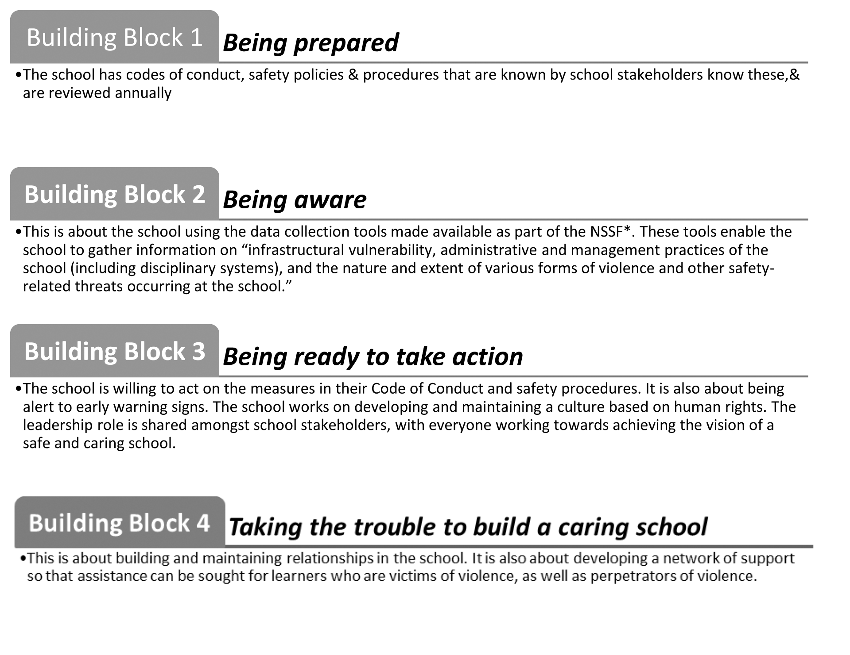

#### Figure 18: The National School Safety Framework Task 2:

Complete the questionnaire in Table 20, based on the four building blocks of the NSSF.

#### Table 20: Questionnaire on the four building blocks of the NSSF

**The building blocks of the NSSF Tick if this applies to your school Give an example**

**of a concrete action**

**if this applies to your school**

|  |  |  |
| --- | --- | --- |
| Your school is *prepared.* |  |  |
| Your school is *aware* of what is happening. |  |  |
| Your school is *ready to take action*. |  |  |
| Your school *takes the trouble to build a caring school.* |  |  |

#### Task 3:

1. If your school is not implementing the NSSF fully, make notes together with your school-based CoP for a report based on what your school should be doing to respond to safety issues in a more systemic and integrated manner.
2. The report is for the SGB and the purpose is to set out the shortcomings of the school’s current response and then short term, medium term and long-term actions that need to be taken to address the response.

SECTION 3: WHAT SAFE SCHOOLS LOOK LIKE, AND HOW TO ACHIEVE SCHOOL SAFETY

1. Access the materials and tools available for the NSSF from <https://tinyurl.com/z8wcpy3>in order to be fully prepared for your report. The article by Makota and Leoschut (2016) on the NSSF could provide further useful information for the report you need to prepare. Available at:<https://tinyurl.com/y46xk9qx>
2. Your report should recommend concrete actions to be taken.

#### Take note

A report serves to record and present information about a particular issue, in a formal way. The following information serves as a brief guide to compiling a report:

1. Basic details: date, title of report, your name and details, who the report is intended for.
2. Overview: brief description of what the report is about.
3. Background: what needs to be done and why.
4. Facts at hand: information and data relevant to the current situation and recommended actions.
5. Conclusion: brief statement of key points and your recommendations.

**Discussion of the activity**

The NSSF includes a number of tools. It is worthwhile to work your way through these and see how each can be used in your school. The better you understand the tools, the more effective your presentation to the SGB will be as you will be able to map out a detailed plan of action.

The NSSF may focus on an integrated and whole school response to school violence and safety, but at its core is a distributed leadership approach. The NSSF requires a response that includes and involves school stakeholders across all levels within the school. It is also about building a school culture that is supportive, based on human rights, inclusive and consultative.

Makota and Leoschut (2016: 20–21) point out that school safety actions must move beyond having policies and procedures in place and learner disciplinary processes, to information and communication efforts with a wide range of school stakeholders. The necessary efforts that are suggested include the referral of troubled learners where necessary; building a school culture that rejects violence; and offering counselling and training sessions to staff.

The next activity sets out the first step in establishing a safe school in line with the NSSF, which is the need for a well-written, clear school code of conduct.

In preparation for the activity, you need to ensure that you have access to your school’s codes of conduct for reference purposes. A school code of conduct for learners is a compulsory policy prescribed by SASA (DBE, 1996) and every public school is obliged to construct one for adoption by the SGB. The SACE Code of Professional Ethics is widely used as the equivalent code for teachers, but some schools have opted to develop their own code, usually based on the provisions of the SACE code.

UNIT 4 - SECTION 3: WHAT SAFE SCHOOLS LOOK LIKE, AND HOW TO ACHIEVE SCHOOL SAFETY



**Activity 50: What should learners’ and teachers’ codes of conduct include?**

**Suggested time:**

1 hour

**Aim:**

To assess what is required for a school code of conduct.

#### What you will do:

1. In your school-based CoP, discuss your schools’ learner and teacher codes of conduct.
2. Study the following suggestions made by Netshitahame and van Vollenhoven (2002) and then complete the assessment of your school’s code of conduct.

#### Summary: Recommendations about how schools can improve safety

Preparation of a school safety mission statement: this should reflect the context in which the school wishes academic learning to take place. The entire staff and school governing body should be involved and be acquainted with the mission statement of the school. The following is an example of a mission statement focussed on safety: “… to learn in a safe and secure environment, free of violence, drugs and fear.”

Banning of all forms of non-physical intimidation: name-calling, verbal abuse, sarcasm and bullying should be added to the learner’s code of conduct as actionable offences. Such threatening behaviour should not be tolerated.

Comprehensive school safety policy and rules: the school should prepare a clear school safety policy and safety rules. “This is to ensure that behaviour expectations and procedures are clearly communicated, consistently enforced and applied fairly. The enforcement procedures should be in line with SASA.”

(Source: Netshitahame & van Vollenhoven, 2002)

1. Assess the state of your school’s learner and teacher codes of conduct, by completing the brief questionnaire below:

SECTION 3: WHAT SAFE SCHOOLS LOOK LIKE, AND HOW TO ACHIEVE SCHOOL SAFETY

#### Table 21: Questionnaire on a school’s learner and teacher codes of conduct

**To be completed for each code of conduct**

|  |  |
| --- | --- |
| **My school’s learner/teacher code of conduct:** | **Tick if correct** |
| Reflects a strong school mission statement about safety. |  |
| Was developed in a consultative manner. |  |
| Is known and has been studied by all school stakeholders. |  |
| Has clear descriptions of what behaviour is acceptable or not. |  |
| Prohibits all forms of physical punishment, harassment or intimidation. |  |
| Prohibits all forms of non-physical intimidation. |  |
| Sets out sanctions for unacceptable behaviour. |  |
| Is implemented as stated in every case. |  |

1. If there are any statements that do not apply to your school’s codes of conduct, ensure that you address the issues, to avoid problems and ultimately improve the management of your school.
2. With your school-based CoP, work together to identify actions that should be undertaken to improve the codes of conduct in the school. Include the revised codes of conduct in your WPP.

#### Discussion of the activity

A useful place to start when considering the value and effectiveness of *codes of conduct* is to reflect on why they are no longer called *school rules*. You might remember from your own school days that school rules tended to be lists of behaviours that were deemed to be *not acceptable*, and what the consequences for breaking the rule would be. A code of conduct for learners, however, should start from the positive perspective of what is considered both *acceptable* and *desirable*. How will learners and their parents know what you expect of them and what your school values unless you tell them?

Netshitahame and van Vollenhoven (2002) assert that a good mission statement

…*may markedly increase the validity and credibility of the school’s effort to create and preserve a safe school environment for this will proof that the school governing bodies made the safety of the learners their priority and this will contain measures to ensure the learners’ safety*. (Netshitahame & van Vollenhoven, 2002: 5)

Actions to follow for the formation of a good code of conduct are outlined in the text box below:

#### Summary: Actions for the formation of a code of conduct

**Training programmes for teachers and school leaders**

This is focussed on classroom management, and should provide teachers with ways to manage their classrooms and also ensure their own safety.

UNIT 4 - SECTION 3: WHAT SAFE SCHOOLS LOOK LIKE, AND HOW TO ACHIEVE SCHOOL SAFETY

#### Implementation of a zero-tolerance approach

This requires clarification of what unacceptable behaviour and acts with regard to drugs and weapons are, and indicating very clearly the consequences for those who transgress. This approach will only succeed if it is clear that there are consequences for behaviour. This could include the withdrawal of privileges, suspension and even recommendation for expulsion.

#### Establishment of a school safety response team

Each school should establish a response team that should receive training which covers areas such as conflict resolution, anger management, breaking up fights, mediation techniques and first-aid.

#### School-community partnerships

Schools should be encouraged to form partnerships with the school community as “a tightly knit social network of approving and disapproving people are more effective determinants of learners’ behaviour and character than just a system of school rules.”

Finally, you are reminded that it is the function of the whole community to create a safe school and schools cannot achieve it alone.

(Source: Netshitahame & van Vollenhoven, 2002: 8)

#### Take note

How complete and useful is your school’s code of conduct? And is this a paper document or one that is actively used and where consequences are enacted?

The focus of Section 3 is on what safe schools look like and how to achieve the desired safety within schools – by learning from the successes of other schools and by establishing a framework for safety, including having a good, relevant code of conduct. Section 4 addresses how to manage learner discipline, maintain the desired order and minimise danger within the school.

## Section 4: Managing learner discipline

The following excerpt from *The Pretoria News* dated 21 June 2018, and available at: [https://tinyurl.com/](https://tinyurl.com/y5jolpel) [y5jolpel](https://tinyurl.com/y5jolpel) confirms what many of you know – that corporal punishment is still a favoured method of punishment in South African public schools.

*The latest survey released by StatsSA showed that a significant number of children in schools in the country still endured corporal punishment although it has long been outlawed.*

*Corporal punishment was most common in schools in the Eastern Cape (12,7%) and in the Free State (12,6%) and KwaZulu-Natal (10.1%). By comparison only 1,1% of learners in the Western Cape and 1,3% of learners in Gauteng reported being subjected to this sort of punishment.* (Ndlazi, 2018)

Given that corporal punishment is outlawed in South African schools, a different approach to dealing with disciplinary matters should be taken. This is especially important as traditionalists (in terms of attitudes to corporal punishment and its usefulness in *shaping* behaviour) will seize on examples of unacceptable behaviour as *proof* that a different approach to discipline is neither workable nor effective.



**Activity 51: A story of two schools**

**Suggested time:**

2 hours for reading and answering questions

**Aim:**

To analyse an article on corporal punishment and extract key points from the article.

#### What you will do:

1. Read the article by Makhasane and Chikoko entitled *Corporal punishment contestations, paradoxes and implications for school leadership: a case study of two South African high schools*. It is available online at <https://tinyurl.com/yxgb7xdz>
2. Makhasane and Chikoko (2016: 1) state: “Although corporal punishment is illegal in South African schools, it remains a contested issue in some communities.” In your experience, is this true? Explain in two or three sentences.
3. Find and list at least three reasons, according to the argument in the article, why corporal punishment is thought, by some, to be detrimental to learners.
4. Now find at least three reasons cited in the article as to why some teachers prefer corporal punishment to alternative disciplinary measures.
5. Review the following two quotes from the article regarding corporal punishment and answer the questions thereafter:

UNIT 4 - SECTION 4: MANAGING LEARNER DISCIPLINE

*I don’t know what corporal punishment is. As far as I am concerned, it has to do with culture. That is how we were raised. As an African, I know that corporal punishment was used when I was in school. But I did not leave school. In a way, it helped me in my education*. (Makhasane & Chikoko, 2016: 5)

*We are beaten all the time. Teachers use the hosepipe. If a teacher comes and asks us who was making noise, and we say we do not know, then he will beat all of us. They also beat us when we have not done homework.* (Makhasane & Chikoko, 2016: 5)

* What is your reaction to the two quotes? Explain in four or five sentences.
* In three or four sentences, summarise the analysis given in the article about quotes/findings such as those above.

1. The article makes a strong statement about schools where corporal punishment is used or condoned: “…continued administration or condoning of corporal punishment in a school is evidence of a dearth of leadership.” (Makhasane & Chikoko, 2016: 6)
   * Explain in your own words what you think the authors mean by a *dearth of leadership*.

#### Discussion of the activity

The focus of many arguments regarding the use of corporal punishment seems to be on the errant behaviour of learners. It’s not unusual to hear teachers and school leaders speaking about the challenges of *disciplining* learners and blaming a variety of social factors, including poverty, poor parenting, violence in communities, cultural practices, drugs and alcohol. There is no doubt that these factors contribute to learner behaviour, but how often do you hear the same teachers or school leaders speak about reasons for bad behaviour over which they have a direct influence? For example, should you consider the impact of teachers late coming or absence from school, poor subject knowledge, lack of preparation, weak leadership and poor management practices? By the same token, these factors are present in some South African schools.

The *dearth of leadership* referred to above suggests a lack of excellent leadership in schools as a contributing factor, and since this module is about leading and managing school as organisations, it is justifiable to reflect on this comment. In earlier modules (including *Module 4: Lading and managing people and change*), you focussed on ethical and value-driven leadership which calls on school leaders to reflect on their purposes in leading. Sinek’s video (Sinek, 2010) on inspiring leadership makes the point that working from the *inside out*, starting with questions of *why* you lead, helps you to consider how you lead and what you need to do. When you read about codes of conduct earlier, there was a comment that suggests the need to start with the positive, with the values that are commonly shared, with catching people doing things right and with rewarding positive behaviour. It would make sense to look at learner discipline in the same way before resorting to physical violence.

There is often confusion about the way some people use the words *discipline* and *punishment*. Do you ever refer to *corporal discipline?* Don’t you refer to excellent teachers as *disciplined* people? Don’t you want your code of conduct to lead to a *disciplined* school? Maybe, when you think about *disciplining* a learner, you should start with the understanding that *discipline* fits far better with good, expected behaviour than it does with bad, unacceptable behaviour and *punishment*.

SECTION 4: MANAGING LEARNER DISCIPLINE

It may be that you have teachers in your school who are dissatisfied with the long-changed regulations about corporal punishment. The Makhasane and Chikoko article makes it clear that there is resistance to not using corporal punishment. Teachers cite cultural reasons for not complying with the law. Other excuses are that without corporal punishment, the behaviour of learners deteriorates.

It is however your *duty* as an ethical leader in your school, to ensure that such practices do not happen. It is vitally important that you know and understand the reasons why corporal punishment is harmful to learners. You should be able to explain the reasons very clearly to your teachers. You should also be able to answer those teachers that refer to well-known arguments as to why corporal punishment is acceptable.

Of particular interest to school leaders is the assertion in the article that condoning corporal punishment signals a dearth or lack of leadership. Surely this is not a comment that you would like to be made about your leadership? The work in this section is about a different kind of control, and a different kind of leadership.

To reinforce the position taken in the article against the use of corporal punishment, see the following findings on a case regarding corporal punishment which makes a very clear ruling on the matter:

#### Case study: Corporal punishment

The case (as reported in Joubert 2016: 68) is entitled: Christian Education v Minister of Education 2000 (4) SA 757 (CC); 2000 (10) BCLR 1051 (CESA). This case challenged Section 10 of SASA because it violated the religious freedom of the applicants. The court found as

follows:

*Section 20 [of SASA] intends to promote respect for the dignity and physical and emotional integrity of all children. Any exemption, even on religious grounds, would disturb the symbolic, moral and pedagogical purpose of the measure, and would undermine the state’s duty to protect*

*people from violence.* (Joubert, 2016: 68)

Therefore, the ruling refused to permit corporal punishment.

Having reviewed corporal punishment as a forbidden form of learner discipline, the next activity explores other ways of dealing with disciplinary issues.

UNIT 4 - SECTION 4: MANAGING LEARNER DISCIPLINE



**Activity 52: Exploring principles of positive discipline**

**Suggested time:**

1 hour

**Aim:**

To explore positive alternatives to punishment so as to create a caring and safe learning environment.

#### What you will do:

1. Study the description of key aspects of positive discipline in the text box below.
2. Match the description of the behaviour with that described in each of the scenarios that follow and answer the related questions in your Learning Journal.

#### Extract: Key aspects of a positive approach to discipline

*Positive discipline focuses on discipline rather than punishment. It aims to teach children to understand and follow social rules, both inside and outside the classroom, without using physical or emotional violence. It emphasises teaching children to do things right rather than punishing them for doing wrong. It aims to encourage self-discipline and mutual respect within a non-violent and caring environment.*

*The positive discipline approach is rooted in a respect for human rights. It takes as its starting point that children have the right to a safe school environment, free from violence. It aims to build a culture of human rights where everyone, learners and teachers alike, are protected from harm and are treated with dignity and respect. Positive discipline aims to work with children and not against them.*

*The emphasis is on building on learners’ strengths rather than criticising their weaknesses and uses positive reinforcement to promote good behaviour. It involves giving children clear guidelines for what behaviour is acceptable and then supporting them as they learn to abide by these guidelines. The approach actively promotes child participation and problem solving, while at the same time encouraging adults to become positive role models for the youngsters in their care.* (Centre for Justice and Crime Prevention, 2013: 5)

SECTION 4: MANAGING LEARNER DISCIPLINE

#### Scenario 1: Sense of humour or verbal abuse?

A school which is encouraging a positive approach to discipline, has a teacher who states that he agrees with its principles. However, learners are terrified of him and often emerge from his classroom in tears or with a thunderous, angry look on their faces. He says that his rebukes are meant to be amusing and he cannot understand why learners get upset.

**Question 1:**

As a school leader, what would you do to explain to this teacher that his *humour* may not meet the requirements of a positive approach to discipline? Give practical examples of how he can and should change his approach.

#### Scenario 2: Despair and dismay

A *petite* teacher, after a few years of teaching, is still struggling with discipline and is despondent. She is really challenged by rowdy, *large* learners who tumble into her class, shoving and pushing. And trying to get their attention is a battle – which she fights by shouting and threatening detention, lines, or after-school tasks such as picking up papers in the playground. You can see that she is worn out and her teaching is ineffectual. She openly remembers when she was at school, and “bad behaviour was quickly sorted out by a few *jacks* (strokes of the stick).”

**Question 2:**

As a school leader, what plan of action could you suggest and work on with the HOD to assist this teacher to understand how a positive approach to discipline works? Make concrete suggestions, based on the information above.

#### Scenario 3: Catching a teacher doing something right

As a school leader, you are doing a few classroom lesson observations. On the advice of an HOD, you visit a particular teacher, who is young and mild-mannered but quietly efficient. You expect to see a run-of-the-mill lesson. But you are pleasantly surprised. The young teacher is

UNIT 4 - SECTION 4: MANAGING LEARNER DISCIPLINE

quietly confident. Learners are expected to line up before entering the class; there is a code of behaviour up on the wall, to which she refers once or twice when a learner enthusiastically shouts out an answer; the lesson starts in an orderly fashion; and you notice that she takes the time to acknowledge a learner who has struggled with an answer, when he completes the task.

#### Question 3:

As a school leader, what aspects of a positive approach to discipline can you detect in this teacher’s class? How could you use this example to assist other teachers who might be struggling with discipline?

#### Discussion of the activity

The first thing you might have noticed about these scenarios is that they all focus on values, behaviours and practices that can be influenced by school leadership and management. They do not adopt a negative attitude that looks for blame beyond the boundaries of the school and they all rely on an interaction between teachers and other school leaders. In the first two scenarios, there is no clear understanding of the positive meaning of *discipline*. It is about punishment when the teachers experience challenges. The distinction needs to be understood clearly and teachers need to be taught about acceptable, alternative ways to establish and maintain discipline. This is an opportunity for collaborative school management; for problem solving techniques to be practised; for research into alternatives; and for shared practices and a commonly held belief that a positive orientation to discipline can bring about change.

The third scenario describes a teacher who has begun to understand the transactions required for a positive approach to discipline to work.

A positive approach to discipline really rests on mutual respect from teacher to learner and from learner to teacher. There must of course also be mutual respect from school leader to teacher and from teacher to school leader. It is about stopping poor behaviour early on and having strategies in place to deal with it. It is about high expectations on both sides and noticing when someone has done something right. When there are infringements of behaviour, these are handled quickly, appropriately and then forgiven. It is about making the expectation of acceptable behaviour clear and the consequence of this behaviour evident.

A positive approach to discipline also includes channelling energies into useful activities that fall within the school’s responsibilities and the teachers commitment. Refer to *Module 3: Leading and managing extra- and co-curricular activities* regarding extra-curricular activities.

Creating a safe and disciplined environment for learning starts with surveying the landscape and determining the reality of school safety in South Africa. You then need to gain an understanding of the guidelines, policies and legislative frameworks. This will help you to do things in a way that will avoid problems arising when things are not made clear or done correctly. Discovering what makes a school safe and how to achieve it, despite particular challenges, is the next step. This is helped along by managing learner discipline early on, in as positive a manner as possible, and within the bounds of a clear and active code of conduct.

SECTION 4: MANAGING LEARNER DISCIPLINE

**Key points**

Unit 4 focussed on the following key points:

* Section 1 looked at the current reality related to school safety and some of the challenges that schools experience.
* Section 2 focussed on a close examination of the South African legislation related to school safety.
* Section 3 discussed *what safe schools should look like* and provided a number of examples of schools that developed good strategies for maintaining a safe school environment. This section also included a discussion on practical steps that schools could take to create a safe environment.
* Section 4 focussed on the challenges of learner discipline, looked at the DBE guidelines on discipline, particularly with regard to corporal punishment and also proposed some practical approaches which school leader could implement to manage discipline.

In Unit 5, the focus will be on diversity and inclusion.

# Unit 5: Promoting and managing diversity and inclusion practices in the schooling context

### Introduction

Two of the most pressing issues facing schools in South Africa today, are diversity and inclusion. Legislation and policy are clear about how schools and school stakeholders should be applying human rights principles and values of equity, equality, tolerance and respect. This unit offers approaches and processes aimed at improving responses to both diversity and inclusion.

This unit has four sections as shown in Figure 19.

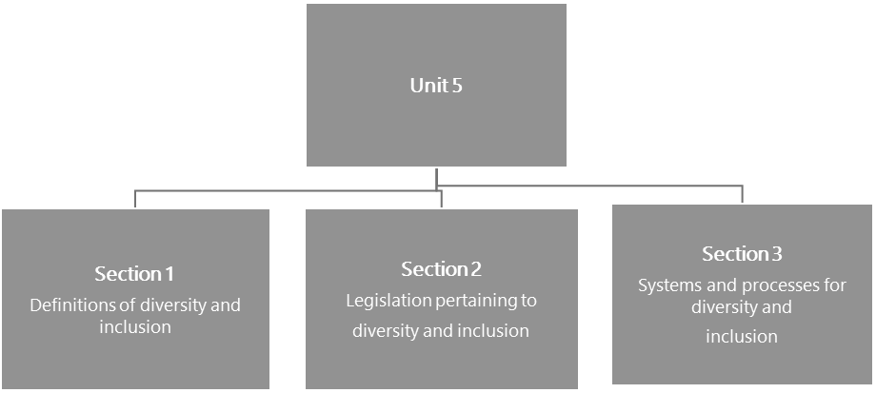

#### Figure 19: The structure of Unit 5

**Unit 5 learning outcome**

Unit 5 has only one learning outcome. By the end of this unit you should be able to:

* Understand and apply appropriate principles, practices, policies and codes to facilitate the implementation of inclusive education, address issues of diversity and develop a safe learning environment.

Section 1: Definitions of diversity and inclusion

### Introduction

Diversity and inclusion are related but also distinct terms that may appear to be easy to explain. However, in the context of South African education they have special significance given South Africa’s history and recent development as a democratic society. This section will commence with an examination of the differences and similarities between the terms to enable you to think systematically about each concept. How the two concepts overlap, and what systems and processes you will need to put into place, as a leader, to make your school the kind of place that lives up to the ideals set out in policies and laws, will also be discussed.

This section of the unit clarifies terminology and establishes a working definition for each term. Before you start your exploration of these concepts, remember that *inclusion* needs to be considered both as a term referring to differences between people as well as referring to special needs education.

This first activity explores the term *diversity*, clarifies the meaning of *difference* and aids your understanding of these terms.



**Activity 53: Exploring diversity**

**Suggested time:**

30 minutes

**Aim:**

To clarify your understanding of diversity and related terminology.

#### What you will do:

**Task 1:**

1. Make notes in your Learning Journal of *your* understanding of what diversity means, before reviewing the formal definitions that follow.
2. Think about and note examples of challenging moments you might have encountered with the issue of diversity in the school context.
3. If possible, share your thoughts with a fellow member of your school-based CoP.

#### Task 2:

1. Now, study the definitions of diversity provided here and then reflect on your own position and viewpoint on all aspects of diversity.
2. Taking the two definitions presented here into consideration, prepare a one-paragraph *diversity statement*

UNIT 5 - SECTION 1: DEFINITIONS OF DIVERSITY AND INCLUSION

in your Learning Journal that captures:

* + Captures what you believe diversity to mean for you as a school leader.
  + Areas or aspects of diversity where you may need to interrogate your position or assumptions.
  + A commitment to how you are going to work on areas of challenge in this regard.

#### Definitions: Diversity

Diversity is about “differences in culture, skills, religion, skin colour, ethnicity, thinking, communication styles, language, education levels, talents and goals” (Lesufi, 2017).

*Diversity has become a buzzword – a word popularly used, but loosely defined. People use diversity to mean cultural variety, numerical representation, changing social norms, and the inequalities that characterize the status of different groups. … there is still a need to reconstruct how we think – and how we behave – if we are to create a more just society … it involves discovering how race, class and gender – along with factors like age, ethnicity, sexual orientation, and religion – frame people’s lives. The point is not just that people are diverse, but that race, class and gender are fundamental axes of society.* (Andersen & Collins, 2001: 1)

**Discussion of the activity**

Did you *dig deep* to consider and include all aspects of diversity in your statement? Or are there areas pertaining to diversity that you find challenging or disturbing or that make you uncomfortable? If so, it is important to acknowledge this area of difficulty. Most especially, you need to be very clear about your personal position and also work hard on areas where you feel you might not match up to the standards and attitudes that are required of leaders. Issues of diversity can challenge the most fundamental beliefs – religious beliefs; views on gender; issues of culture, language, ability. In fact, almost any aspect of the human condition may involve judgment of others.

Where there is *difference*, possibilities for exchange, learning and creativity exist – but so do the possibilities for misunderstandings, challenge and conflict. The key to understanding how all citizens, and particularly school leaders, must respond to issues of diversity is found in the South African Constitution (RSA, 1996), specifically Section 9 of the Bill of Rights, which reads as follows:

*Section 9 - Equality*

1. *Everyone is equal before the law and has the right to equal protection and benefit of the law.*
2. *Equality includes the full and equal enjoyment of all rights and freedoms. To promote the achievement of equality, legislative and other measures designed to protect or advance persons, or categories of persons, disadvantaged by unfair discrimination may be taken.*
3. *The state may not unfairly discriminate directly or indirectly against anyone on one or more grounds,*

SECTION 1: DEFINITIONS OF DIVERSITY AND INCLUSION

*including race, gender, sex, pregnancy, marital status, ethnic or social origin, colour, sexual orientation, age, disability, religion, conscience, belief, culture, language and birth.*

1. *No person may unfairly discriminate directly or indirectly against anyone on one or more grounds in terms of subsection (3). National legislation must be enacted to prevent or prohibit unfair discrimination.*
2. *Discrimination on one or more of the grounds listed in subsection (3) is unfair unless it is established that the discrimination is fair.* (RSA, 1996: Section 9)

The Bill of Rights establishes that diversity, as you have understood it above to include a wide range of differences, is entrenched in law through the principle of *equality.*

Acknowledging, valuing, respecting and accommodating diversity as a combination of similarities and differences plays a central role in fostering and maintaining communities. School leaders play a major part in creating and maintaining this kind of ideal community. The concept of diversity encompasses acceptance and respect. It means understanding that each individual is unique, and recognising individual differences.

These can be along the dimensions of race, ethnicity, gender, sexual orientation, socio-economic status, age, physical abilities, religious beliefs, political beliefs, or other ideologies. Fostering and maintaining communities requires the exploration of these differences in a safe, positive, and nurturing environment. It is about understanding each other and moving beyond simple tolerance to embracing and celebrating the rich dimensions of diversity contained within each individual. It is important to see the diversity and plurality of different cultural forms; it is also important to understand how racism, sexism, homophobia and class relations shape the experience of groups and individuals, and specifically the power, privilege and prestige associated with being a member of a particular religious, cultural, language, or ethnic group. Following argument above, it is necessary to understand that people with disabilities or people with HIV and AIDS are also subject to racism and sexism, homophobia, xenophobia and class relations (National School of Government, 2016: 40).

Diversity is most often thought about in terms of a mixing of people from different backgrounds, cultures, races and religions. Sotuku and Duku (2015: 18) make the point that the political changes and ushering in of a democratic South Africa, led to the desegregation of the schooling system. In South Africa, the South Africa Schools Act (SASA) “created the opportunity for learners from diverse cultural backgrounds to attend public schools of their choice” (DoE, 1996). According to Morrow (1998) this has resulted in schools becoming cultural crossroads because they are points where people of different orientations, or with different sub-cultures, converge.

Responses to diversity within a school can vary widely. It may be that attitudes and responses are carefully considered and *reasoned*, or it may be that responses are unthinking and based on untested assumptions and beliefs which may be in direct contradiction of constitutional law.

The next activity should assist you to explore the meaning of the terms *inclusion* and *inclusive education* and clarifying the difference between inclusion and diversity.

UNIT 5 - SECTION 1: DEFINITIONS OF DIVERSITY AND INCLUSION

#### Stop and think

The motto on the South African national coat of arms is: !ke e: /xarra //ke, written in the Khoisan language of the /Xam people, literally meaning *diverse people unite*.



**Activity 54: Defining inclusion and inclusive education**

**Suggested time:**

30 minutes

**Aim:**

To clarify your understanding of inclusion and what is meant by inclusive education.

**What you will do:**

**Individual activity**

1. Formulate your understanding of *inclusion* in the context of education, before reviewing the formal definitions that follow. Make notes in your Learning Journal.
2. Make notes in your Learning Journal of examples of challenging situations you might have encountered with issues of inclusion in the school context.
3. In the same way you did in Activity 53, prepare a one-paragraph *inclusive education statement* in your Learning Journal that captures:
   * What you believe inclusive education means for you as a school leader.
   * Areas of inclusion where you may need to interrogate your position or assumptions.
   * A commitment to how you are going to foster a culture of inclusive education.

### Defining inclusive education in South African policy

Many definitions of inclusive education have evolved throughout the world. They range from extending the scope of ordinary schools so that they can include a greater diversity of children, to a set of principles which ensures that the student with a disability is viewed as a valued and needed member of the community in every respect.

Inclusive education in the South African context is defined as a learning environment that promotes the full personal, academic and professional development of all learners irrespective of race, class, gender, disability, religion, culture, sexual preference, learning styles and language. The Education White Paper 6 titled *Special needs education: building an inclusive education and training system* (DoE, 2001) is the primary South African policy document on inclusive education.

SECTION 1: DEFINITIONS OF DIVERSITY AND INCLUSION

#### Extract: Education White Paper 6 characterises inclusive education as follows:

1. Acknowledging that all children and youth can learn and that all children and youth need support.
2. Accepting and respecting that all learners are different in some way and have different learning needs which are equally valued and an ordinary part of human experience.
3. Enabling education structures, systems and learning methodologies to meet the needs of all learners.
4. Acknowledging and respecting differences in learners whether due to age, gender, ethnicity, language, class, disability or HIV status.
5. Changing attitudes, behaviour, teaching methodologies, curricula and the environment to meet the needs of all learners.
6. Maximising the participation of all learners in the culture and the curricula or educational institutions and uncovering and minimising barriers to learning.
7. Empowering learners by developing their individual strengths and enabling them to participate critically in the process of learning.
8. Acknowledging that learning also occurs in the home and community, and within formal and informal modes and structures.

(Source: Du Plessis, 2013: 78)

The inclusion of learners with special education needs or learning barriers, into mainstream classes, is part of a universal human rights movement (Du Plessis, 2013: 76–77)). It has therefore become imperative to create equal opportunities for all learners to learn and succeed.

In 1996 SASA legislated that public schools must admit all learners and must attend to their educational needs without any unfair discrimination. White Paper 6 describes the Department of Education’s commitment to providing educational opportunities for all learners so that all learners benefit from schooling. SASA alerts us to a shift from the past – a shift that views all children as having equal rights to education that fits their needs. This shift to include all learner’s needs suggested a system of education which recognises that there are children who have barriers to learning and that these barriers go beyond disabilities (Du Plessis, 2013: 78).

### Inclusive education: international definitions

Inclusion has been directly advocated since the Universal Declaration of Human Rights in 1948 and has been acted on in a number of key United Nations declarations and conventions. These include:

1. The 1948 Universal Declaration of Human Rights which ensures the right to free and compulsory elementary education for all children.
2. The 1989 United Nations Convention on the Rights of the Child, which ensures the right to receive education without discrimination on any grounds.

UNIT 5 - SECTION 1: DEFINITIONS OF DIVERSITY AND INCLUSION

1. The 1990 World Declaration on Education for All (Jomtien Declaration), which sets the goal of Education for All (EFA).
2. The 2000 Dakar Framework for Action which stipulates that all children have access to and complete free and compulsory primary education by 2015.

#### Definitions: International definitions of inclusion and inclusive education

**Definition 1**

The definition [of inclusion] provided by Akinsola and Chiresha (2016) reinforces the notion of

*worth*, *rights* and *learning together*:

*Inclusion can be interpreted as the philosophy and practice of giving equal rights and opportunities to children … with and without disabilities within and outside educational settings. In addition, it involves educating learners with and without disabilities in the same classroom settings. This practice is based on the notion that every child should be an equally valued member of society and the school culture.* (Akinsola & Chiresha, 2016: 133)

#### Definition 2

Booth and Ainscow (2011: 21) emphasise the importance of systems and values [of inclusion]: “Inclusion is about developing inclusive community and education systems and putting inclusive values into action.”

#### Definition 3

UNESCO (2005) defines inclusion as:

*…a process of addressing and responding to the diversity of needs of all learners through increasing participation in learning, cultures and communities, and reducing exclusion within and from education. It involves changes and modifications in content, approaches, structures and strategies, with a common vision which covers all children of the appropriate age range and a conviction that it is the responsibility of the regular system to educate all children.* (UNESCO, 2005: 13)

#### Definition 4

For Rayner (2007) inclusion means:

*…extending the scope of ‘ordinary’ schools to include a greater diversity of learners; promoting*

SECTION 1: DEFINITIONS OF DIVERSITY AND INCLUSION

*mainstreaming; promoting ‘education for all’, regardless of a number of diverse characteristics;*

*and promoting the idea that everyone belongs and is accepted.* (Rayner, 2007: 36)

**Definition 5**

Nasen (1998 cited in Rayner, 2007) provides the following definition:

*Inclusion has to encompass broad notions of educational access and recognise the importance of catering for diverse needs. Increasing mainstream access is an important goal. However, it will not develop spontaneously and needs to be actively planned for and promoted.* (Nasen,

1998 cited in Rayner, 2007: 35)

#### Discussion of the activity

Education White Paper 6 was published in 2001 so you are no doubt aware that it outlines policy for public schools to build an inclusive education system. It is based on the principle that all children are different and have different learning needs. It places the responsibility for providing appropriate support and managing barriers to learning on individual schools and school leaders.

In line with the Constitution and the Bill of Rights, the White Paper acknowledges and respects difference in learners, whatever the nature of these difference might be, and addresses the importance of enabling education structures, systems and learning methodologies designed to meet the needs of all learners. The responsibility for turning the principles of policy into successful practice falls on the shoulders of school leaders and it’s likely that you might have commented on the challenges this presents. Many school leaders have experienced the frustration of not having the ideal resources to successfully manage a differentiated curriculum or provide facilities for disabled learners.

One of the most difficult challenges that many educators are faced with is shifting their perspective from seeing barriers to learning as problems *within the learner*, to questioning whether the curriculum itself is responsive to their different needs. This is a fundamental change in thinking from expecting every learner to *fit in*, towards managing the learning environment to support the very real diversity they encounter.

The first part of Activity 54 asked you to consider what you believe about inclusive education. To do this you should be asking yourself *why* you hold this belief? Is it rooted in ethical, valued-driven and transformative principles? Is this belief part of your school culture; do others in the school believe what you believe?

The next activity provides an opportunity to explore different responses that schools have to diversity and inclusion, and think about how schools shape these.

UNIT 5 - SECTION 1: DEFINITIONS OF DIVERSITY AND INCLUSION



**Activity 55: Understanding dimensions of acceptance of diversity and inclusion**

**Suggested time:**

30 minutes

**Aim:**

1. To engage with different responses to diversity.
2. To categorise the responses.
3. To reflect on the response of your school to diversity and/or inclusion.

#### What you will do:

1. Read each of the brief case studies and then indicate whether the situation described is an example of rejecting or embracing diversity and/or inclusion. In each case give reasons for your answer. You could plot each of the schools on a line of continuum, according to whether they: reject or embrace diversity and/or inclusion. Record your responses in your Learning Journal.
2. Which schools comply with the legislation around diversity and inclusion, and which do not?

#### Case study 1: Muslim learners

A girls’ school in Johannesburg with a long, proud history now has a diverse school population. This partly as a result of a vibrant and successful scholarship programme which has enabled girls from very different backgrounds to enter the school and enjoy its rich programme of activities, including a strong music department. A number of Muslim girls have opted to embrace the hijab, or a headscarf, which they wear to school over the uniform and instead of the school blazer. Badges are displayed on the hijab or scarf. At the brother boys’ school, the code of conduct has been amended to permit boys who intend to learn to recite the Koran by heart, to wear a full beard. To mark the important step, a ceremony is held at assembly where the boy is given a cap to wear, as an indication that the facial hair growth has a meaning. The amended code of conduct states that the boy’s intention must be signed off by the principal and the Imam.

**Case study 2: Former Model C primary school**

A former Model C primary school has experienced a change in the composition of the school over the past number of years. The teaching staff and the SGB members are mainly Afrikaans

SECTION 1: DEFINITIONS OF DIVERSITY AND INCLUSION

speaking and mostly white, except for two educators who teach isiZulu. Only the maintenance staff and cleaners are black. The teachers are dedicated, mostly conscientious and very keen on doing a good job. The principal has been at the school since it was founded and was appointed as principal after having held the post of deputy principal for a number of years. He prides himself that he runs a ‘tight ship’. There are few discipline problems. He works well with the SGB who contribute their skills to the running of the school and even assist with maintenance. The learners are now a diverse group, with different mother tongues. The principal and the SGB made a decision to keep the different groups in separate classes ‘because it was easier that way’. They claim that the decision was made on the basis of language, not race, so that learners who needed extra attention were grouped together. One day a parent fetching her child from an outing noticed that the learners emerged from two busses – black learners from one, and white from another. Upon enquiry to the educator in charge, the parent was told ‘that was the learners’ choice’. Upon further enquiry to a few learners, they explained that they had been ‘directed’ to their places on the busses. The MEC for the province was then contacted.

#### Case study 3: Wheelchair-bound learner

A learner is admitted to a school designated as a ‘full service school’. The 11-year-old boy has brittle bone disease and is confined to a wheelchair. This makes moving around the school quite difficult, especially as it is built on a slope and has three levels. The principal does his best to ensure that the boy is able to access classrooms, but one teacher (who has been at the school for many years and considers herself very ‘senior’) refuses to move classrooms from her prime position at the top of the three storey school building. This means that the boy has to be carried in his wheelchair up the stairs for every Life Orientation lesson. If the wheelchair is dropped or his limbs are bumped, he could suffer another broken bone.

**Case study 4: School racism storm**

Klipspruit Secondary School pupils were forced to miss the first day of the third term yesterday when angry parents barred them from class in a protest against the appointment of a black principal.

The racial row over the new appointment led to parents, mostly from the Coloured area, locking

UNIT 5 - SECTION 1: DEFINITIONS OF DIVERSITY AND INCLUSION

the school gates and vowing to disrupt learning unless the Gauteng Department of Education rescinded its decision.

School Governing Body member Henry Charles said the racial tension was triggered by the community demanding the appointment of a Coloured principal. The community claims there is a lack of representation of Coloured people in school leadership positions.

Charles, who was part of a panel which interviewed applicants for the position, said: “During the process we were asked what criteria we were going to use with race. I stood up and said I would score five for Coloureds and I’ll score four for black people.”

“They said Coloureds and blacks are the same and I said but this is a Coloured area and they said I am being racist. We want a Coloured principal because this is a Coloured area,” he said.

The department spokesman Oupa Bodibe said: “The department has learnt the disturbing news that the community in Klipspruit West has rejected the principal because of skin colour. This action is strongly condemned, as it runs against the non-racial principles of our society. Educators are appointed on the basis of qualification and experience.”

(Source: Based on an article by Tankiso Mmakhetha, 2017)

#### Discussion of the activity

The schools in the case studies all have different attitudes and cultures that reflect beliefs about diversity and inclusivity. Perspectives on diversity range from *rejection*; to *acceptance* of diversity, inclusion and difference; to *embracing difference.* Attitudes and required behaviours with regard to inclusion can be plotted on a continuum with rejection of diversity (such as by hiding people with disabilities away) at one end of the continuum, through compliance and acceptance to fully embracing inclusion, at the other end of the continuum.

The continuum of attitudes and degrees of acceptance of diversity can be described as follows:

* **Rejection**: Some schools and individuals refuse to acknowledge the reality and value of diversity. Rejecting diversity means maintaining demographic and/or cultural ‘sameness’ and practising both overt and covert discrimination and exclusion.
* **Tolerance**: An attitude of tolerance is reflected when diversity is acknowledged, but there is no real engagement on issues of difference. It means simply recognising that difference exists. Although tolerance might seem to be a positive response to diversity, it actually limits progress by ‘sweeping difference under the carpet’.

SECTION 1: DEFINITIONS OF DIVERSITY AND INCLUSION

* **Compliance**: This means dealing with difference only on the level of adhering to external laws and rules. Schools that aim for compliance deal with diversity through policy and procedure, but may not embrace a truly differentiated curriculum or affect changes in organisational culture reflecting how differences are integrated and dealt with. Compliance often involves maintaining the status quo without breaking the law.
* **Embracing diversity**: Embracing diversity is reflected in an attitude that not only acknowledges and accepts difference, but that also sees people as individuals and values the differences between them. This involves the school actively engaging with issues of difference and adopting a holistic and strategic approach to achieving diversity and inclusion, and celebrating difference.

### Racism in schools

While this unit is directed towards school leaders valuing diversity and supporting inclusive education, it would be naïve to imagine that some of the case studies described above, and many other cases that have been reported could not simply be explained as examples of racism. So, what is the definition of racism?

If you have ever tried to write down *the* definition of racism, you will be sure to find individuals or groups of people who claim that your definition is wrong, or incomplete, or that it makes unfounded assumptions. Most dictionary definitions use language that speaks about prejudice or discrimination or antagonism against someone of a different race or ethnicity, based on a belief that one is superior to another. Throughout history there have been examples of institutionalised racism – such as the Holocaust, apartheid, slavery and segregation in the USA and Latin America. But what about examples of ethnic cleansing in the former Yugoslavia or Rwanda, or the near extermination of Native Red Indians in North America? And what about xenophobia? The point of this questioning is to remind you that however you might choose to define *racism* it is essentially about an abuse of human rights. This unit will focus attention on the principle of putting human rights at the centre of teaching and leadership in education, given that the citizens of South Africa subscribe to a common Constitution and Bill of Rights.



**Activity 56: Facing racism or ignoring it?**

**Suggested time:**

20 minutes

**Aim:**

To reflect on how incidents or racism (if any) are dealt with in your school.

#### What you will do:

1. Journalist Reni Eddo-Lodge wrote a book *Why I’m No Longer Talking to White People about Race*. It deals with race and racism in modern Britain. In this video she talks about how people deal with race in Britain. Watch the video at: <https://tinyurl.com/yywaq73z>(Duration: 3:25 minutes) and make notes in your Learning Journal.
2. Answer the following question in your Learning Journal:
   * Are you facing racism head on in your schools? Or are you choosing to ignore it?

UNIT 5 - SECTION 1: DEFINITIONS OF DIVERSITY AND INCLUSION

#### Discussion of the activity

Before 1994, South African education was very clearly divided by race and was premised on an apartheid ideology that favoured white people in very profound ways. Segregation and discrimination were enforced by law and policy and political and economic power was held by a white minority. The remarkably peaceful transition to a constitutional democracy created an opportunity for schools to become places where the principles enshrined in the constitution were modelled, upheld and defended, however, there are very few who might claim that this ideal has been achieved.

Evidence of discrimination, exclusion, inequality, abuse and neglect is all too commonly reported, and schooling remains divided both in terms of resources, access and outcomes.

While Reni Eddo-Lodge’s video presentation is based on her experiences in Britain and also does not specifically address the schooling context, it speaks to the issue of structural [systematised] racism and inequality, which is still an enormous challenge in South Africa generally and in particular, in many mainstream schools.



**Activity 57: Inequality in education**

**Suggested time:**

1 hour

**Aim:**

To reflect on how the legacy of racism and inequality in South Africa schools, continues to be a problem.

#### What you will do:

1. Access and read the following article by Nicholas Spaull, from the Department of Economics at Stellenbosch University: *Poverty and privilege: primary school inequality in South Africa.* It is available at: <https://tinyurl.com/y4a4smja>
2. After having carefully read the Spaull article, answer the questions that follow making notes in your Learning Journal:
   * How are former racial inequalities still evident in primary schooling in South Africa?
   * What factors other than race impact heavily on the outcomes of education?

#### Discussion of the activity

The article stresses the point that despite the political and social changes since 1994, the schooling system remains divided where the poorest 75% of public schools are considered to be dysfunctional and produce poor learner outcomes while the wealthiest 25% are viewed as functional and produce significantly better results. (You may remember this fact being discussed at the beginning of the AdvDip (SLM) programme in *Module 1: Professional Portfolio and Workplace Project* Part 1 Unit 1.) The wealthiest schools are also largely former white schools and while the demographics of learner populations has changed, learners predominantly come from the wealthier middle class (which includes black people). The majority of white

SECTION 1: DEFINITIONS OF DIVERSITY AND INCLUSION

learners also still attend these schools. Many former black schools remain homogenous both in terms of learners and educators and very little has changed. While the formal institutions of apartheid (racially segregated schools and different curricula), have been abolished, the informal institutions (representing mostly black schools) remain unchanged and far less functional.

Race and racism remain part of the inequalities observed in schools because while learner populations change regularly and rapidly, educators and school leaders change far more slowly for a variety of reasons. Many former white schools retain predominantly white teachers and SGBs, while conversely, many black schools have only black educators, leaders and SGBs. This doesn’t mean that racism is not possible in black schools, especially if you include different ethnicity as part of your definition. In this sense, xenophobia is a form of racism and equally abhorrent.

So, while racism is still a significant factor affecting diversity and inclusivity in schools, it’s not the only one. The challenges of raising the levels of functionality and learner performance in schools that constitute 75% of Spaull’s model of bi-modality are complex and demand the attention of school leaders just as urgently.

### Gender inequity in schools

Alongside racism as one of the dominant social evils facing South African society, is the issue of gender inequality. In the same way that racism is expressly rejected in the Constitution, so too is gender discrimination. There have been significant actions taken to bring about gender equality in government and the public service and these examples should be welcomed by all South Africans as a demonstration of the acknowledgement of diversity and inclusivity.

Can you confidently say that the same efforts have been made to address gender equality in the field of public education, which impacts on almost every citizen in some way or other? The next activity asks you to consider this question and reflect on the implications of gender inequity for school leaders.

UNIT 5 - SECTION 1: DEFINITIONS OF DIVERSITY AND INCLUSION



**Activity 58: Gender equity in school leadership**

**Suggested time:**

20 minutes

**Aim:**

To consider data reflecting the number of women in formal leadership positions.

#### What you will do:

1. Look closely at Table 22 and then respond to the questions that follow.

#### Table 22: Gender inequality in leadership of public schools

|  |  |  |  |  |
| --- | --- | --- | --- | --- |
|  | **Teachers** |  | **Principals** |  |
| **Female** | 265,179 | 72.5% | 8,070 | 37.3% |
| **Male** | 100,528 | 27.5% | 13,551 | 62.7% |
| **Total** | **365,707** |  | **21,621** |  |

(Source: Africa Check, 2018)

These figures were supplied by the director of media liaison and communications in the Department of Basic Education (DBE). The figures don’t account for all teachers in the country but reflects data on teachers in public schools whose salaries are paid by the state. In June 2018, there were 387 328 teachers and principals on the government’s payroll. Women made up 72.5% of state-paid teachers, but only 37.3% of principals.

1. Answer these questions in your Learning Journal:
   * What do you think the data presented in Table 22 tells you about women in formal leadership positions in South Africa?
   * Does the data explain why this situation exists? What reasons could you offer to account for this?
   * What can you, as a school leader take from this data for your own practice?

#### Discussion of the activity

The data makes it clear that while there are many more female teachers than male, there are significantly more male principals appointed in South African public schools than there are female principals, however, it doesn’t allow for much interpretation beyond this. For example, there is no indication how many female applicants there were for principal’s posts, nor does it tell you how many female applicants were rejected in favour of men (none of this data is captured). Consequently, it would be difficult to claim that this situation is a direct result of a systemic disregard for issues of diversity or inclusivity. The bottom line is that there is a gender imbalance as things stand.

Is it unrealistic to imagine that schools and school leaders could contribute to turning this situation around?

SECTION 1: DEFINITIONS OF DIVERSITY AND INCLUSION

Everything you have learned so far in this diploma favours the inclusion of many individuals in the process of leadership through a collaborative, invitational, ethical and transformative approach. The figures quoted in the data above make it very clear that if school leadership is inclusive and collaborative, many more women will be involved in leadership activities, even if it is at an informal level initially. It stands to reason that with such experience, more women will be able to exercise their constitutional right to compete equally with men for formal leadership positions. Perhaps this is where you can make a difference?



**Activity 59: Gender equity for learners?**

**Suggested time:**

20 minutes

**Aim:**

To consider the challenges faced by female learners in schools.

#### What you will do:

1. Read the following extract from a United Nations International Children’s Emergency Fund (UNICEF) publication by Girls Education Movement South Africa. You can access the full publication online at: <https://tinyurl.com/yxorkrm9>
2. Answer the questions that follow by making notes in your Learning Journal.

#### Extract: Girls Education Movement South Africa

Government schools grapple with many challenges including a poor quality of education, high attrition rates, low teacher morale, the devastating impact of HIV and AIDS, poor infrastructure, inadequate water and sanitation and poor mechanisms for inclusive education particularly for children with disabilities. Many learners from poor families go to school hungry. Girls and young women still report high levels of sexual abuse, harassment, exploitation and murder in their schools. South African society is to a large extent patriarchal. Girls and women are accorded lower social status and find themselves under the control and authority of men. The high levels of gender-based violence and the higher HIV infection rates among girls and women are tragic consequences of female disempowerment. Girls are socialised to become home keepers and child bearers, placing less value on their educational attainment. When girls perform well in subjects such as maths or science, they are not encouraged, nor do they have the confidence to pursue careers that rely on these skills. Many schools are not child or girl friendly. Some are situated far from homes, exposing girls to danger when they walk to and from school. Girls are at risk of being sexually harassed and exploited in schools by teachers and fellow students.

The Report of the Public Hearing on the Right to Basic Education states: “Of great concern

UNIT 5 - SECTION 1: DEFINITIONS OF DIVERSITY AND INCLUSION

were the accounts of teachers taking advantage of their positions of authority and coercing sex from girls. An example was given of a learner coming late and having to exchange sex with a teacher in order to be allowed onto the school premises that had been locked.” The lack of separate school toilets for boys and girls increases girls’ vulnerability to sexual violence.

Teenage pregnancies, which are said to be on the rise, are still stigmatised, making it difficult for young mothers to continue their studies despite legislation that protects their right to education.

(Source: UNICEF, n.d.: 1, 2)

#### Questions

1. Are the claims made in the extract true for all girls at all schools?
2. In what type of schools or circumstances do you think female learners are most vulnerable?
3. Are boys also vulnerable to abuse or other dangers at school? Describe some examples.

#### Discussion of the activity:

The extract presents a very depressing and concerning picture of public schooling in South Africa, particularly for girls. While many learners and parents might legitimately agree with the claims made by the writer of the extract, there will certainly be those whose experience is quite different. There are many schools that acknowledge the dangers and threats female learners might be exposed to and take measures to minimise these risks. These are frequently also the schools that record high learner success rates, lower levels of absenteeism, committed and knowledgeable teachers, supportive parents, and school leaders who encourage collaboration, participation, diversity, inclusion and transformation. It seems fairly obvious that schools which lack some or all of these features are more likely to be characterised by the challenges described in the extract above.

Boys are also not safe from many of the same threats that girls face simply because they are boys. Schools which lack leadership insight, or the skill necessary to acknowledge the value of diversity and the moral obligation of inclusivity, will always expose learners to levels of risk that are unacceptable. There has probably never been a time in the post-apartheid history of South African education when ethical and courageous leadership was more urgently needed.

Having considered the dimensions of diversity and inclusion and levels of acceptance, the next activity will focus on the reality of experiences of inclusion and consider reasons for resistance to inclusion.

SECTION 1: DEFINITIONS OF DIVERSITY AND INCLUSION



**Activity 60: Getting to grips with what inclusion really means**

**Suggested time:**

30 minutes

**Aim:**

To consider experiences of inclusion and reasons for resistance to inclusion.

#### What you will do:

**Task 1:**

Prepare a short reflection on your school and others that you know, describing the following aspects of the school with regard to inclusion (as defined in Activity 54):

* What is your experience of your school and the schools that you know, as to how inclusion is handled? Is it absent; an *add-on*; or are real efforts being made to ensure that the learners with barriers to learning are accommodated and cared for? Give concrete examples.
* What challenges does your school have with regard to inclusion? Are real efforts being made to ensure that the learners with barriers to learning are accommodated and cared for? Give concrete examples.
* Are the buildings and facilities available and accessible to all? Describe areas of concern.
* What measures have been taken to adapt the curriculum so that all learners can succeed?
* What, if any, evidence is there that the contribution of all learners is valued and recognised?

#### Task 2:

Read the comments in the two short cases studies based on information gathered from school stakeholders in response to inclusive education. These more positive statements are a counterpoint to the frequent grumbles that inclusion simply makes educator’s lives more difficult than they already are.

* Think about how common this kind of response is, and what you as a leader who believes in inclusion and wants to see learners accommodated and cared for, can do.
* Make practical suggestions about how to change attitudes from negativity to cooperation. You may choose to build on the practical suggestions provided in the case studies.

#### Case study: A school utilising a district-based support team

When our school admitted learners with barriers to learning for the first time, we had a variety that included sight, speech, hearing and learners with intellectual barriers to learning. We have established a Learner Support Team that consists of different grades, parents, and members of the Health Department, Social and Welfare Services, and the Children’s Protection Unit. The

UNIT 5 - SECTION 1: DEFINITIONS OF DIVERSITY AND INCLUSION

School-Based Support Team (SBST) has been trained in supporting other educators. When they come across problems they refer these to the District-Based Support Team.

#### Case study: Parental involvement in a full-service school

Parental involvement is not very good but we do try. For example, we are busy organising a seminar for parents, based on the discipline problems they have with their children. We conducted a survey to find out what problems they faced so that the talk would be directed at real problems and questions parents have. Later, we plan a talk by an Occupational Therapist on visual perception. But we need to raise funds to give speakers a fee, or else find professionals who will assist us pro bono [free of charge]. We call these parental support sessions.

(Source: Matthew Goniwe School of Leadership and Governance, 2014: 27)

#### Discussion of the activity

This activity required reflection on how well or otherwise your school and others are doing with regard to meeting the requirements of inclusive education. You will have noticed that the scenario is written by someone who constantly refers to “we”. Who are the people that you get involved at your school, and how do you work collaboratively? As a school leader, you would need to address areas of concern that were noted, making use of ideas arising from observations and from examples provided here, as well as those you could draw from your own interactions with colleagues and other stakeholders.

Whatever responses you have provided, it is important to remember that as a school leader, there is much that you can and should do to encourage the right kind of attitudes and behaviours among school stakeholders, which of course includes the parents and the community.

Suggestions found in the Matthew Goniwe School of Leadership and Governance booklet (2014: 16) include those depicted in Figure 20:

SECTION 1: DEFINITIONS OF DIVERSITY AND INCLUSION

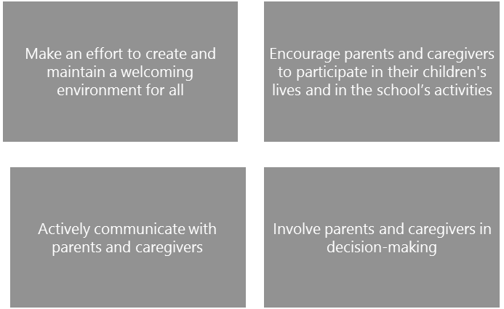

#### Figure 20: How to encourage the right attitude and behaviours

(Source: Adapted from Matthew Goniwe School of Leadership and Governance, 2014:16)

In this section, the meanings of diversity, inclusion and inclusive education have been reviewed and dimensions of acceptance of diversity and inclusion, and the realities of inclusion have been interrogated. The next section is about the legislation pertaining to diversity and inclusion, that must underpin what is done and how it is done.

## Section 2: Legislation pertaining to diversity and inclusion

The Constitution of South Africa protects all learners, including those with special educational needs. In particular, Section 9 of Chapter 2 (Bill of Rights) affords rights to all citizens no matter their gender, race/ ethnicity, age, culture, religion, economic status/class, language, disability, sexual orientation, nationality, job role/position or education.

*These [Constitutional] values summon all of us to take up the responsibility and challenge of building a humane and caring society, not for the few, but for all South Africans. In establishing an education and training system for the 21st century, we carry a special responsibility to implement these values and to ensure that all learners, with and without barriers to learning, pursue their learning potential to the fullest.* (DoE, 2001: 11)

Setting the standard and the baseline for understanding diversity and inclusion, are the international conventions to which South Africa is a signatory. These include:

* The United Nations Convention on the Rights of the Child, where Article 23 protects the rights of disabled children;
* The Convention on the Rights of Disabled Persons which embraces the principles of respect, dignity, mainstreaming and recognising the broad diversity within disability.

In respect of inclusive education in South Africa, the key guiding policies are:

* Department of Education. 2001. *Special needs education: building an inclusive education and training system.* Education White Paper 6. Pretoria: Department of Education. Accessed from: [https://tinyurl.com/ y4fxfvxx](https://tinyurl.com/y4fxfvxx)
* Department of Education. 2005. *Conceptual and operational guidelines for the implementation of inclusive education: special schools as resource centres.* Pretoria: Department of Education. Accessed from: <https://tinyurl.com/y4vbkato>

The first humorous activity is intended to get you thinking about the concepts of *difference* and diversity and what this means for school leaders and for teaching and learning.

UNIT 5 - SECTION 2: LEGISLATION PERTAINING TO DIVERSITY AND INCLUSION



**Activity 61: Exploring an understanding of diversity**

**Suggested time:**

30 minutes

**Aim**

To explore an understanding of diversity.

#### What you will do:

1. Look at the cartoon carefully – what do you think is the key message or idea that is being conveyed?
2. Do you think this message has any relevance in a school context and how you work with and treat learners who are *different* in any way?

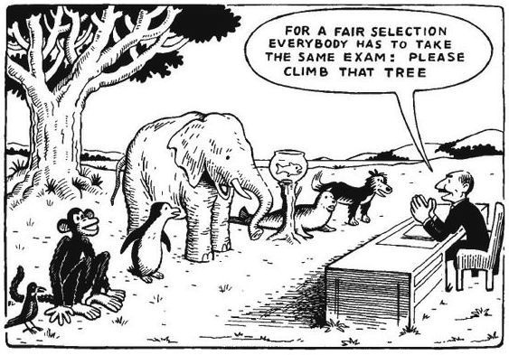

#### Figure 21: Please climb that tree! Discussion of the activity

There is possibly a sad truth to the visual humour of the cartoon. Often, people do not consciously set out to respond in a hurtful or inappropriate way, but deep-seated preconceptions, personal biases and lack of reflection on stereotyping, interfere with people’s ability to respond appropriately to situations or individuals that are seen to be different or *other*.

By working through the information and activities in this unit, you will be introduced to ideas about how to approach issues of diversity, whether they are issues of racism, xenophobia, sexism or sexual orientation, in a positive, inclusive manner and within the required policy framework.

SECTION 2: LEGISLATION PERTAINING TO DIVERSITY AND INCLUSION

The next activity in this section surveys the most important education legislation and policies that give effect to the principles and human rights that are enshrined in the South African Constitution and which manifest themselves in the various DBE directives and guidelines on supporting and managing inclusive education and diversity in the schooling context.



**Activity 62: Reviewing key legislation related to diversity and inclusion**

**Suggested time:**

1 hour

**Aim**

To acquire a global understanding of key legislation and regulations related to diversity and inclusion in schools.

#### What you will do:

Do this activity with your school-based CoP.

1. Share the five review tasks out among the members of your CoP. (Policy documents E and F should be reviewed together). While it would be ideal for the CoP members to work in pairs, if the group is not big enough, this may not be possible.
2. Each pair or individual should start by quickly reviewing the piece of legislation assigned them so as to determine the key issues.
3. Each pair should discuss the following two questions, related to their assigned piece of legislation, and prepare and a written response. If people are working on their own, they should still consider the questions carefully and prepare a written response. Keep a copy of the written responses in your Learning Journal.
   * What is the purpose of this piece of legislation?
   * How does it relate to diversity and/or inclusion?

#### Policy document A: Constitution – Act No. 08 of 1996

* Is based on the values of human dignity, the achievement of equality and the advancement of human rights and freedoms (Section 1a);
* Promotes the achievement of equality (Section 9 (2));
* Commits the state to non-discrimination (Sections 9 (3), (4) and (5)); and
* Protects the fundamental right to basic education for all South Africans – (Section 29 (1)).

UNIT 5 - SECTION 2: LEGISLATION PERTAINING TO DIVERSITY AND INCLUSION

#### Policy document B: South African Schools Act – Act No. 8 of 1996

1. Makes provision for public schools to admit learners and serve their educational requirements without unfairly discriminating in any way (Section 5 (2) and (6)). This includes:
   * prohibiting the governing body from administering any test related to admission;
   * taking into account the rights and wishes of parents of learners with special education needs in placement of such learners;
2. Recognises Sign Language as having the status of an official language for the purpose of learning at a public school (Section 6(4));
3. May exempt public schools for learners with special education needs from having a Representative Council of Learners (Section 11 (3));
4. Provides education (and support) for learners with special education needs at ordinary public schools and to ensure that the physical facilities are accessible for such learners (Section 12 (4) and (5));
5. Indicates that ordinary public schools that provide education to learners with special needs must co-opt expertise regarding special needs (Section 23(5) and Section 24); and
6. Requires the governing body to establish a committee on special education needs (Section 30 (2)).

**Policy document C: The Children’s Act – Act No. 38 of 2005**

**The care-giver of a child**

The Act defines the care-giver of a child as follows –

“a person who cares for a child with the implied or express consent of a parent or guardian of that child”.

This means, as a teacher, you have a responsibility to the child and you may be called upon to make judgments about what is in the ‘best interest’ of the child.

**Section 7 – Best interests of the child**

(1) Whenever a provision of this Act requires the best interests of the child standard to be applied, the following factors must be taken into consideration where relevant, namely -

(l) the need to protect the child from any physical or psychological harm that may be caused by -

(i) subjecting the child to maltreatment, abuse, neglect, exploitation or degradation or exposing

SECTION 2: LEGISLATION PERTAINING TO DIVERSITY AND INCLUSION

the child to violence or exploitation or other harmful behaviour; or

(ii) exposing the child to maltreatment, abuse, degradation, ill-treatment, violence or harmful behaviour towards another person;

1. any family violence involving the child or a family member of the child; and
2. which action or decision would avoid or minimise further legal or administrative proceedings in relation to the child.

(2) In this section “parent” includes any person who has parental responsibilities and rights in respect of a child.

#### Policy document D: Section 11 of the Children’s Act – Children with Disability or Chronic Illness

1. In any matter concerning a child with a disability due consideration must be given to -
   1. providing the child with parental care, family care or special care as and when appropriate;
   2. making it possible for the child to participate in social, cultural, religious and educational activities, recognising the special needs that the child may have;
   3. providing the child with conditions that ensure dignity, promote self-reliance and facilitate active participation in the community; and
   4. providing the child and the child’s care-giver with the necessary support services.

**Policy document E: Education White Paper 6. Special Needs Education, DoE, 2001**

* Provides information on *what Inclusive Education and Training* is.
* Discusses *how to* build an *Inclusive Education and Training System.*

UNIT 5 - SECTION 2: LEGISLATION PERTAINING TO DIVERSITY AND INCLUSION

#### Policy document F: Education White Paper 6. Special Needs Education: Special Schools as Resources Centres, DoE, 2005

* Developing special schools as resource centres: Guidelines for theoretical development and practice.
* Provides conceptual and operational framework for full-service schools.

**Discussion of the activity**

The various sections of the legislation referred to above all build on and contribute to the very clear purposes that are set out in the Constitution (Policy document A). It’s clear that children are not considered *differently* from adults when human rights, dignity and equality are at stake. The South African Schools Act carries this further by explicitly describing the responsibility of public schools and SGBs to equitably admit and support all children, regardless of their needs.

The Children’s Act extends the responsibility for the protection of children to all persons who act in any roles as care-givers and notably this includes educators, parents and guardians. The Act speaks clearly about the responsibility for children with special needs and their constitutional rights to the same freedoms that adults have. The legislation is consistent in acknowledging the value of diversity and the imperative of inclusivity, so it should come as no surprise to school leaders that their responsibility is equal towards every child. This responsibility extends logically and legally to every educator (and non-educator) who is involved in schooling, and school leaders must stand accountable for building an ethos and ethic of care among all. This is no small weight to carry, but the support services the Act refers to are outlined and explained in White Paper 6.

White Paper 6 provides the *what* and the *how* knowledge for everyone covered by the legislation above, but it cannot ensure a deep and shared belief in *why* diversity and inclusion must be at the heart of everything that happens at school. This is your key responsibility, as a courageous, ethical leader.

The Education White Paper 6 (DoE, 2001: 6–7) defines inclusive education and training as:

* *Acknowledging that all children and youth can learn and that all children and youth need support.*
* *Enabling education structures, systems and learning methodologies to meet the needs of all learners.*
* *Acknowledging and respecting differences in learners, whether due to age, gender, ethnicity, language, class, disability, HIV or other infectious diseases.*
* *Broader than formal schooling and acknowledging that learning also occurs in the home and community, and within formal and informal settings and structures.*
* *Changing attitudes, behaviour, teaching methods, curricula and environment to meet the needs of all learners.*
* *Maximising the participation of all learners in the culture and the curriculum of educational institutions and uncovering and minimising barriers to learning.*

SECTION 2: LEGISLATION PERTAINING TO DIVERSITY AND INCLUSION

#### Take note

The following resources are recommended as they provide guidance and support on how to lead and manage a range of issues related to diversity and integration in schools.

* Department of Education. 2000. *Values, education and democracy.* Pretoria: Pretoria: DoE.
* Department of Education. (Undated). *Challenging homophobic bullying in schools*. Pretoria: DoE.
* Department of Education. 2001. *Education for our common future: building schools for an integrated society.* Pretoria: DoE.
* Department of Basic Education. 2011. *Guidelines for responding to learner diversity in the classroom through Curriculum and Assessment Policy Statements.* Pretoria: DBE.

All the resources listed here can be accessed on the DBE website at: [https://tinyurl.com/](https://tinyurl.com/y2vlhvvs) [y2vlhvvs](https://tinyurl.com/y2vlhvvs)

In this you have reviewed key legislation pertaining to diversity and inclusion was reviewed. The next section provides insight into strategies, systems and processes for managing the implementation and promoting diversity and inclusion policies in schools.

## Section 3: Systems and processes for developing an inclusive and diverse school ethos

From the understanding of *diversity* and *inclusion* discussed above, it has been determined that these two concepts are interlinked, but that they also have different emphases and dimensions. Diversity is a broad, overarching concept that includes cultural, religious, racial, gender and language differences as well as differences of ability. Underneath the broad umbrella of diversity, inclusion narrows its focus to look at how we, as a society, include learners within the system who have barriers to learning, wherever this is possible. In this section, you look at strategies, systems and processes that the school leader can use to begin to create the kind of school ethos that is desired.

The United Nations Educational, Scientific and Cultural Organization (UNESCO) (2014: 205) sets the standard for including *all* in the education system without discrimination. Education *for all* is underpinned by the belief that it is necessary to make a special effort to reach the most disadvantaged so as to provide an equally opportunity for everyone to progress in life.

The UNESCO *Education for All* is underpinned by three principles, *respect, protection* and *rights* as set out in Figure 22.

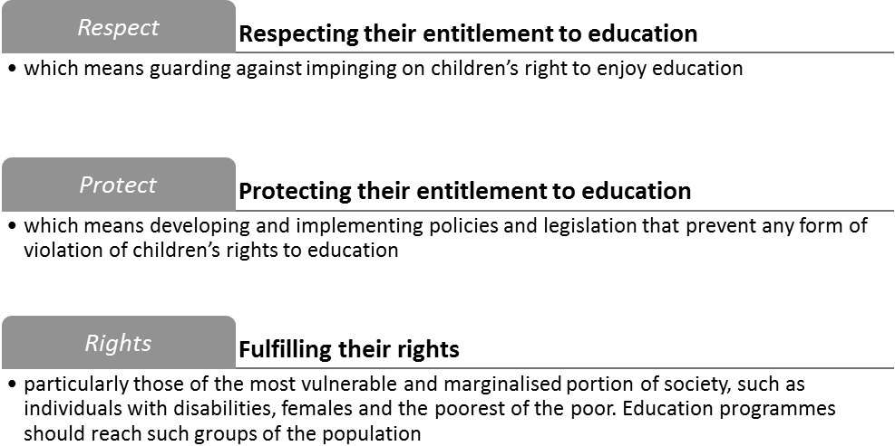

#### Figure 22: Pillars of UNESCO’s Education for All

(Source: Adapted from UNESCO, 2007: 3)

In this section, the focus is on the systems, procedures and process that schools move beyond policy and vision to implementation of school-based diversity and inclusion practices. The following activity is intended to promote reflection on the extent to which schools have made accommodations for diverse and inclusive school stakeholders or not.

UNIT 5 - SECTION 3: SYSTEMS AND PROCESSES FOR DEVELOPING AN INCLUSIVE AND DIVERSE SCHOOL ETHOS



**Activity 63: Putting policy into practice**

**Suggested time:**

30 minutes

**Aim:**

To assess the gap between policy and the practice demonstrated by the school in the newspaper story of a learner with a physical disability.

#### What you will do:

**Individual activity**

1. Read the newspaper story entitled “Teacher gives disabled child piggyback ride in school race.”
2. Answer the questions that follow. Write your response in your Learning Journal.

#### Case study: Teacher gives disabled child piggyback ride in school race

A teacher at a rural school in the Northern Cape stole many hearts recently when he picked up a disabled girl and gave her a piggyback so that she could take part in a 50-metre race with all her classmates. The teacher who is in charge of sport at the school and an ex-provincial rugby player, said he didn’t know why his actions had touched so many hearts, Netwerk24 reported. “I expect every guy to be like that,” he said. “That is how I was brought up.”

At the school’s inter-house athletics meeting, one of the starters called the physical education (PE) teacher saying there was a “problem”. When he got there, he saw five-year-old Angela was waiting – and raring to go. “The starter said there was a physically disabled [child] who wanted to run and that someone would have to help her.” He initially thought she was paralysed. “When I first saw her, I thought she was sitting on her knees. It was only when she got up, that I realised that she didn’t have lower legs.”

Without thinking twice, the PE teacher picked her up and put her on his back. “Angela giggled all the way.” He said it was a bit of a challenge running with her on his back. “At the start, I thought it would be unfair to run away from the other children. But it was heavy going with Angela on my back. I had to try hard not to finish last. But it isn’t where we finished the race which mattered. I couldn’t see Angela’s face while we were running, but when I put her down, she laughed all the time and was all smiles. That was the most precious. She and I had both enjoyed it.”

(Source: Du Toit, 2017)

SECTION 3: SYSTEMS AND PROCESSES FOR DEVELOPING AN INCLUSIVE AND DIVERSE SCHOOL ETHOS

#### Questions

1. What do the actions of the school teacher say about his attitude to the disabled learner?
2. Assuming the school does have a policy promoting inclusion, assess how well this school has done, in terms of procedures and practices, to accommodate learners with disabilities? Take all the facts of this case into consideration and explain your conclusion.
3. What procedure should have been in place at the school to have enabled Angela to participate in the school’s inter-house athletics meeting?

#### Discussion of the activity

A first reading of the story is heart-warming and the temptation is to say that the school is doing a great job, however, an assumption like this needs to be more fully tested if you are to get the full picture. An important and overarching principle to apply when dealing with learners with special needs is that of *reasonable accommodation*. But what does this mean? The explanation by United Nations Convention of the Rights of Persons with Disabilities is as follows:

*Necessary and appropriate modification and adjustments not imposing a disproportionate or undue burden, where needed in a particular case, to ensure persons with disabilities the enjoyment or exercise on an equal basis with others of all human rights and fundamental freedoms.* (Africa Disability Alliance, n.d.: 10)

The question to ask is whether the little girl had been given any reasonable accommodation by her school. What assistive devices have been provided to her? It was chance that a teacher decided to pick her up and carry her through the route. In fact he did not initially know that she was physically disabled. His action was certainly kind and well-meaning, but does it reflect a school-wide solution to her needs? What is her school not doing to accommodate her properly? These questions are challenging but necessary. Is it acceptable that her enjoyment of the day is dependent upon the kindness of one person? This example actually serves to highlight a problem that may be common in many schools, namely that this school did not have any agreed systems in place for enabling and managing the participation of a pupil with a physical disability.

#### Take note

You may want to consider expanding Activities 64 and 65 as part of your Workplace Project (WPP). The outputs of these activities can also be included in your Professional Portfolio.

Having examined the gap between policy requirements and actual procedures and systems for inclusion in the school in the Northern Cape newspaper report, the following activity requires you to assess the current situation in your school. Does your school have policies related to diversity and inclusion in place? How well is your school doing on the implementation of these policies? Is there perhaps also a gap between policy and implementation at your school?

UNIT 5 - SECTION 3: SYSTEMS AND PROCESSES FOR DEVELOPING AN INCLUSIVE AND DIVERSE SCHOOL ETHOS



**Activity 64: Assess accommodation of diversity and inclusion in schools**

**Suggested time:**

1 hour

**Aim:**

1. To review and access the degree to which diversity and inclusion are accommodated in your school.
2. To access the effectiveness of the systems and processes that have been put into place in

your school to support diversity and inclusion.

#### What you will do:

**Do this activity with your school-based CoP**

1. Complete the diversity and inclusion checklist provided in Table 23. The checklist will help school leaders and managers to check on the current status related to systems and processes that are in place to accommodate diversity and inclusion in the school.

#### Table 23: Diversity and inclusion status checklist

|  |  |  |
| --- | --- | --- |
| **Item** | **Yes** | **No** |
| **Policies and practices** |  |  |
| 1. The school Vision and Mission is clear about attitudes to diversity and inclusion. |  |  |
| 2. The school has prepared codes of conduct for all stakeholders (learners, teachers and SGBs). |  |  |
| 3. The school has school-based policy/guidelines that clearly stipulate behaviour, procedure and process requirements around diversity and inclusion. |  |  |
| 4. The school has a safety policy and documented procedures that take everyone’s physical, mental and emotional needs into account. |  |  |
| 5. The safety policy has been carefully and thoroughly communicated to all. |  |  |
| **Amenities and access** |  |  |
| 6. Issues of access, accessibility and safety for all learners have been carefully assessed. |  |  |
| 7. Regular maintenance is carried out to ensure that the premises are safe for all learners and staff. |  |  |
| 8. Assistance/processes are available for learners to use the toilets safely and easily. |  |  |
| **Safety** |  |  |
| 9. A school safety committee has been established. |  |  |
| 10. Staff members have been trained in first aid. |  |  |
| 11. A properly equipped first aid box is available. |  |  |

SECTION 3: SYSTEMS AND PROCESSES FOR DEVELOPING AN INCLUSIVE AND DIVERSE SCHOOL ETHOS

|  |  |  |
| --- | --- | --- |
| **Item** | **Yes** | **No** |
| 12. All staff and learners know the *Universal Precautions* if someone in the school community is ill or injured. (How to manage infection control in which all human blood and body fluids are treated as if they were known to be infectious for HIV and/or other bloodborne pathogens.) |  |  |
| 13. Incident records are properly kept. |  |  |
| 14. Learner information is treated respectfully and where necessary, kept confidential. |  |  |
| 15. Safety incidents are reported timeously. |  |  |
| 16. Safety signage is clear, readable and properly attached. |  |  |
| 17. Safety incidents are discussed to see if correct procedures were followed. |  |  |
| 18. Emergency procedures such as evacuation of the school premises due to fire or other emergency are clearly communicated to all school members and practised regularly. |  |  |
| **Diversity and inclusion** |  |  |
| 19. Difference is celebrated. |  |  |
| 20. Staff are trained in ways to support learners. |  |  |
| 21. An effort is made to question and problematise curriculum content rather than presenting it as a given. Various socio-cultural perspectives and approaches should be examined. |  |  |
| 22. Teachers and learners discuss ways in which to decolonise the curriculum. |  |  |
| 23. Accommodating different learning needs is a core feature of all curricula. |  |  |
| 24. Supportive assessment practices are explored. |  |  |
| 25. Learning and teaching support materials (LTSMs) that are factually correct and up to date but also reflect the experience and context of learners are selected. |  |  |
| 26. Teachers are assisted with ways to manage challenging learner behaviour. |  |  |

1. After you have completed the checklist, assess and identify areas in which your school is not accommodating diversity or the one most important area that you agree needs immediate improvement.
2. Arrange to meet with the school management team (SMT) to discuss a strategy for improving your school’s current response to diversity and inclusion.
3. To ensure the effectiveness of the meeting with the SMT you will need to:
   * Prepare an agenda for the meeting, outlining the items for discussion.
   * In preparation for the meeting, prepare and provide all meeting participants with a list of guiding documents (the policy and guideline documents discussed in Activity 62) at least a week before the meeting. Participants should read and review the documents to ensure that everyone is aware of the policy framework and requirements for diversity and inclusive education.

UNIT 5 - SECTION 3: SYSTEMS AND PROCESSES FOR DEVELOPING AN INCLUSIVE AND DIVERSE SCHOOL ETHOS

#### Discussion of the activity

Phasha (2015: 11) states that inclusive education is about removing barriers to achieving education. These barriers can be about access, active participation, and of course, academic success. What barriers to the promotion of diversity and inclusion were revealed as you completed the checklist? What intervention has been planned? Remember that not every intervention has to be on a large scale, you could start with small changes that could nevertheless yield results.

When planning an intervention with teachers on inclusion in the classroom, Tchatchoueng (2015: 221–222) has the following suggestions that can be used by teachers to encourage and foster inclusive teaching methods in the classroom depicted in Figure 23.

#### Inclusive teaching methods:

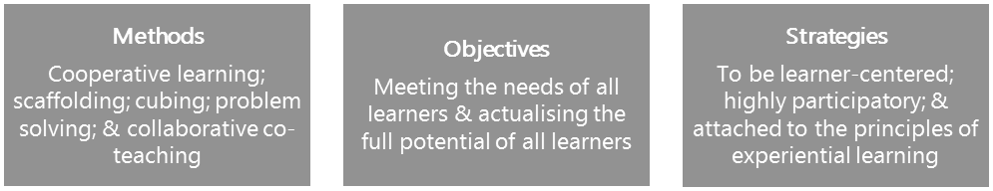

**Teaching and learning aims:**

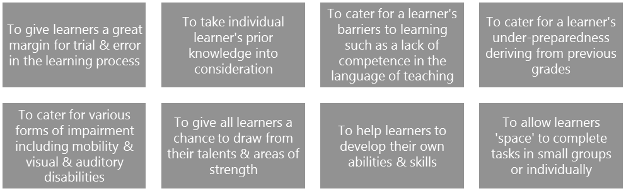

**Figure 23: Inclusive teaching methods**

(Source: Tchatchoueng, 2015)

SECTION 3: SYSTEMS AND PROCESSES FOR DEVELOPING AN INCLUSIVE AND DIVERSE SCHOOL ETHOS

**Principles for inclusive education**

The principles for inclusive education in the *Conceptual and operational guidelines for the implementation of inclusive education: special schools as resources centres* (DoE, 2005) described in Figure 24, need to be understood and incorporated into strategies and processes adopted by schools when addressing diversity and inclusion:

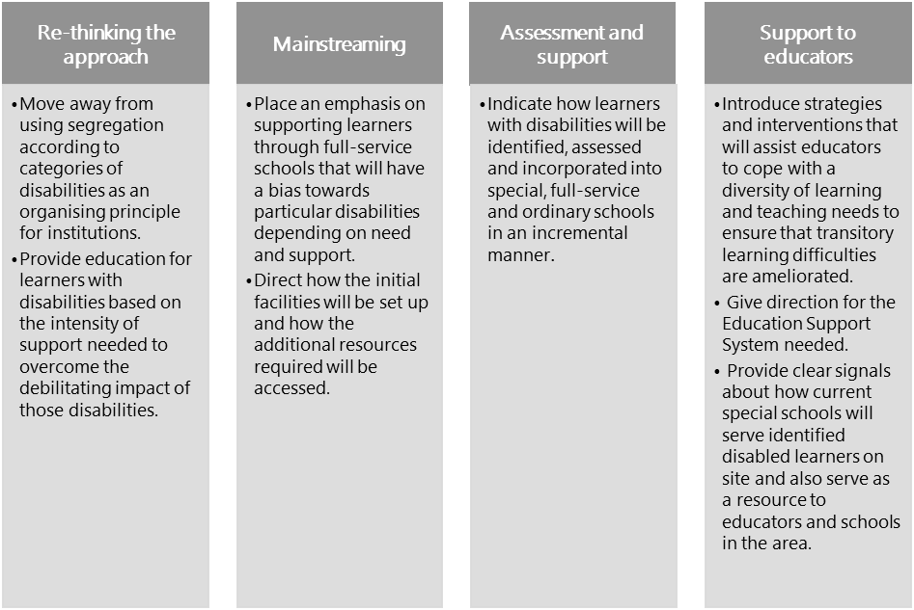

#### Figure 24: Principles for inclusive education

(Source: DoE, 2005)

A booklet entitled *Implementing inclusive education in South Africa* (DoE, 2002) provides the following reminder for school leaders about the strength of difference and the need for school leaders to ensure that learners from all backgrounds, circumstances and conditions need to be accommodated properly:

*One of the main challenges for …. inclusive education …., is to develop respect for oneself and for all others. This means accepting that, while we are all the same as humans, we are all different too. We come from different backgrounds and have different ways of doing things. The challenge for all of us is to learn to understand and accept that people’s similarities and differences are strengths that make our society richer and better. When differences about race, gender, language, ability, and sexual preference are not understood or accepted in society, then discrimination happens. The most important challenge of inclusive education is to address every kind of discrimination that affects the opportunities learners have to learn in classrooms and in schools.*

(Source: Extract from ‘The Best Practice Booklet, DoE, 2002:48-9).

UNIT 5 - SECTION 3: SYSTEMS AND PROCESSES FOR DEVELOPING AN INCLUSIVE AND DIVERSE SCHOOL ETHOS

Having considered the basic requirements of a school to embrace and enable diversity and inclusion, and reflected on the status of progress in this regard, the next activity provides a thoughtful way to think more deeply about intrinsic rights to respect for culture, diversity and difference by considering different ways to craft and present the curriculum.

### Decolonising the curriculum

As discussed in *Module 1: Professional Portfolio and Workplace Project*, student protests at higher education institutions (HEI) in 2015 and 2016 were centred around a number of challenging issues including funding, access, accommodation and gender-based violence, to mention a few. One particular issue, however, began to emerge as a powerful concern – that of the slow pace of transformation of institutional culture, related to the inappropriateness of the curriculum, teaching and assessment practices and the racial profile of lecturers. The violent protests were an expression of the frustration students felt at being alienated from the institutions and their way of working (Grant, Quinn & Vorster, 2018: 75).

The phrase *decolonising the curriculum* became a powerful driver for students to make their reactions known to the apparent reluctance of HEIs to grapple with the realities of a transformed social and cultural perspective of learning and teaching. This has forced leaders at most HEIs to introspect and reflect on, maybe for the first time, how their taken-for-granted curriculum, with its particular selection of appropriate knowledge, teaching and assessment strategies and other organisational practices might be impacting on a rapidly changing student body (Grant et al., 2018: 74).

The lesson for school leaders to learn from this is surely that these same students were learners at your schools just a few short years or months ago and are very likely to have had similar feelings about their educational experiences at school. In 2018, Mamphele Ramphele published an article *The missing link in our transformation process* and in which she wrote:

*We have grossly underestimated the impact of the legacy of colonial conquest and apartheid on our capacity to reinvent ourselves as citizens of a democratic and just society. The values of that legacy of a colour-coded male dominated exploitative system ingrained in our mind-sets undermine the evolution of a shared identity as South Africans characterised by respect for human rights, dignity and equality for all under the law* (Ramphele, 2018).

As a school leader you might not have direct influence over the content of the history curriculum, but you have the opportunity for guiding a powerfully transformative experience of teaching and learning for the educators and learners in your school.

SECTION 3: SYSTEMS AND PROCESSES FOR DEVELOPING AN INCLUSIVE AND DIVERSE SCHOOL ETHOS



**Activity 65: Approaches to decolonising the curriculum**

**Suggested time:**

2 hours

**Aim:**

To think about ways that your school could promote a more diverse and inclusive ethos by decolonising the curriculum.

#### What you will do:

1. Review each of the following five extracts.
2. Answer each related set of questions. At each point ask yourself: “How can this way of thinking help to encourage teaching approaches that decolonise the curriculum?”
3. Carefully record your responses to the questions and your reflections on how the suggested approaches can help to encourage a decolonised approach to the implementation of the curriculum in your school, and place this in your Professional Portfolio.

#### Extract 1: Responsive curricula

Inclusive education classrooms have a population which is very diverse, and which consists of learners with rich prior knowledge and strong readiness for the grade they are in. But these classrooms also have learners with limited prior knowledge and poor grade readiness.

Because of these differences in abilities among learners, the establishment of inclusive education classrooms requires that the curriculum be sufficiently adaptable to allow the teacher to respond flexibly to the variation in prior knowledge, levels of readiness, abilities and preferences that learners display in the classroom. Often, barriers to learning arise from the different interlocking parts of the curriculum, such as “the content of learning programmes, the language and medium of learning and teaching, the management and organisation of the classroom, teaching style and pace, timeframe for completion of curricula, the material and equipment that are available as well as assessment methods and techniques” (DoE, 2001: 32). All of these are aspects of the curriculum that should be adaptable and responsive to the different learning needs that learners have in the inclusive classroom environment.

(Source: Tchatchoueng, 2015: 221)

#### Question

What do you understand by the term *decolonising the curriculum*? Prepare an explanation/definition to share with the rest of the group.

UNIT 5 - SECTION 3: SYSTEMS AND PROCESSES FOR DEVELOPING AN INCLUSIVE AND DIVERSE SCHOOL ETHOS

#### Extract 2: A supportive learning culture

All learners learn in an environment in which they feel comfortable, appreciated, and safe. So, inclusive education teachers work toward maintaining a comfortable, pleasant, and safe classroom environment. In order to achieve this goal, one of the strategies that these teachers use is to obtain as much information as they possibly can about each of their learners and about their family background. In fact, details about individual learner’s background, and especially about the background of learners with special needs, are essential to provide a supportive learning environment for everyone in the inclusive education classroom. Besides an introductory session during which individual learners have a chance to volunteer substantial information about themselves, teachers often get the additional information they need from parents or carers during contact with them.

Some parents have many concerns about inclusive education, and about its impact on both the education and the holistic development of their children (this includes both parents of children with disabilities and parents of children without disabilities). These concerns have to be dealt with by the inclusive education teacher. So, maintaining a supportive learning environment in an inclusive classroom also goes hand in hand with showing understanding and keeping up a welcoming and friendly attitude toward all learners and their parents.

This includes listening respectfully and patiently to their worries and insecurities. It also entails providing them with the necessary explanations with regard to the benefits of inclusive education, and about measures that are being taken to enable all learners to benefit from learning and teaching within the inclusive education classroom environment.

(Source: Tchatchoueng, 2015: 219–220)

#### Question

1. In relation to Extract 2, assume that a parent emails you the following complaint:

*My son is smarter than most of the class and is doing exceptionally well. I feel that the teacher spends too much time looking after one of his classmates who apparently has some kind of learning difficulty. This child is wasting the class’s time, and this is unfair on my child as the teacher should be spending more time developing gifted children like my child. I have spoken to a few of the other parents and we think this child should be removed from their class and perhaps should be transferred to a school that has more children like that.*

1. Draft an email that responds to the parent’s concerns. Your email should:
   * Explain the concept of inclusive education.
   * Explain how teachers create a *supportive learning culture* in their classrooms.
   * Explain how both learners with and without disabilities can benefit in inclusive education classrooms.
2. Share the email you drafted with your peers and compare your responses.

SECTION 3: SYSTEMS AND PROCESSES FOR DEVELOPING AN INCLUSIVE AND DIVERSE SCHOOL ETHOS

#### Extract 3: Democratic leadership

One of the most important features of an inclusive classroom is the type of leadership that the teacher decides to foster within the classroom environment (DoE, 2001). One would expect, in an inclusive education classroom, the leadership to be very different from the *sit, fold your arms, listen and obey*-type of approach that is prevalent in more authoritarian settings. In an inclusive education classroom there is, instead, democratic leadership that allows learners to participate in decision-making. This type of leadership is evident when, on entering the learning site … learners are both “respectful and daring”. In fact, one should be able to pick up from the decor, e.g. posters and pictures (including learner’s own artwork) displayed on the walls, and from the cheerful ambience among learners, that they own the learning space and contribute meaningfully to their learning. For example, they contribute in establishing the rules of the classroom, and in ensuring that everyone gets a fair chance to participate in cooperative activities and in class discussions.

(Source: Tchatchoueng, 2015: 220)

#### Questions

1. Explain the difference between authoritarian leadership and democratic leadership. Use some practical examples to illustrate your points.
2. How can you encourage the educators at your school to adopt a more democratic approach in their classrooms?

#### Extract 4: Need more scientific study (1)

… but you still will break a leg if you believe you can jump from a high tree and fly without wings because of faith in your ancestors. It’s called gravity. Scientific facts do not change because of the androcentric biases [the assumption that the male view is the norm for all people] of Western culture or the pungent history of colonial botany in the European possessions.

(Source: Jansen, 2017)

#### Question

In your own words, explain what the author means in this paragraph by selecting the appropriate meaning from the list below, and give an explanation for your answer.

UNIT 5 - SECTION 3: SYSTEMS AND PROCESSES FOR DEVELOPING AN INCLUSIVE AND DIVERSE SCHOOL ETHOS

* Belief in ancestors is wrong and should not be taught.
* Belief in ancestors does not mean that science is wrong.
* Science is wrong because it was developed in the West.

#### Extract 5: Need more scientific study (2)

Of course, we should question science as a social and cultural enterprise.

1. We must demand greater investments in science and technology.
2. We need to press for more black and woman scientists and engineers.
3. We should broaden parameters for scientific inquiry and ask fresh questions about accepted wisdom when it comes to scientific knowledge.

But we should do that on the basis of logic, evidence and argument, and not through populist appeals to real human grievances, or by making spurious and untested claims based on nationalistic sentiments or ideological desires.

(Source: Jansen, 2017)

#### Questions

1. Do you agree that subjects such as life sciences and mathematics need to be decolonised? What about subjects such as literature and languages? Be prepared to debate your answers.
2. Write a response to the extract. What do you agree with, and what do you disagree with? How do you think teachers can take an inclusive approach to decolonising the curriculum?

#### Discussion of the activity

The matter of decolonising the school curriculum has gone as far as parliament, as can be seen in the following extract:

SECTION 3: SYSTEMS AND PROCESSES FOR DEVELOPING AN INCLUSIVE AND DIVERSE SCHOOL ETHOS

#### Extract: Baby steps to decolonise schools

Suren Govender, the [Department of Basic Education’s] chief director for curriculum, told Parliament last month that the curriculum has to be decolonised, saying: “For example, the way in which history has been written suggests that Livingstone discovered Victoria Falls but, in fact, it existed, and people lived there long before Livingstone arrived.”

(Source: Govender, 2017)

For a school leader to truly engage with the concept of decolonisation of the curriculum, it’s critical to acknowledge that the word *curriculum* does not simply mean the *syllabus* or the *content of school subjects* but refers to the learning standards and objectives, as well as assessment processes and intentions.

Curriculum also describes instructional practices, which includes the way educators plan, prepare and lead learning in their classrooms. With this broad understanding, consider the words you have used to describe the concept of *decolonising the curriculum*. Are they negative, such as *challenging*, *breaking down*, *getting rid of*; or positive, such as *adapting*, *responding to*, *including*, *revising*, *opening up*, *accommodating*? Have you been thinking about your role and your responsibilities in ensuring that the curriculum in your school is more broad-based, more applicable and less presumptuous about what is *right* and the *truth* than it might have been in the past?

This teaching philosophy or approach is aimed at giving the learners confidence and empowers them by strengthening their identity of where they came from based in part on their African history, language, traditions and social class. It’s about creating a learning and teaching environment in which the learners are acknowledged and could be proud of their own identity. This is a crucial first step to support learners in understanding how to navigate their way through, what is still the dominant European/American- centred culture that is prevalent in South Africa.

Is there room in your school, on a professional level, for lively debate about topics that may challenge thinking, assumptions and beliefs? Is that part of the school culture that you would like to encourage as a school leader?

Think about the tone of the email you drafted in reply to the parent. Ideally, it should be friendly and reassuring rather than stern or scolding. Perhaps the parent does not understand the concept of inclusive education and the innovative ways that inclusive education teachers can accommodate various learners’ needs. As the principal, it is important to support educators who are implementing inclusive education strategies in their classrooms and to educate the entire school community, including parents of learners with and without disabilities, on its benefits.

From the reading, you get the idea that authoritarian leadership is about an educator who expects learners to

*listen and obey*, while the educator is in full control of what happens in the classroom.

On the other hand, the key words from the reading that can be used to characterise democratic leadership are *respect, rules, fairness,* and *cooperation*. It is also clear that learners are encouraged to participate in

UNIT 5 - SECTION 3: SYSTEMS AND PROCESSES FOR DEVELOPING AN INCLUSIVE AND DIVERSE SCHOOL ETHOS

determining what happens in the classroom (like a democracy, where citizens participate in how the country is run by voting). This is an important difference between authoritarian leadership and democratic leadership. An authoritarian educator expects learners to sit quietly and obey their rules without question, whereas a democratic environment allows learners to discuss and participate openly. This is the type of environment where a supportive learning environment can develop.

In conclusion, Section 3 has focused on thinking about and planning to systematise and implement processes for developing a progressively more inclusive, and diverse school ethos and environment aligned to policy requirements. This has also included an examination of teaching and learning approaches that attempt to promote a decolonised approach to curriculum implementation.

SECTION 3: SYSTEMS AND PROCESSES FOR DEVELOPING AN INCLUSIVE AND DIVERSE SCHOOL ETHOS

### Key points

Unit 5 focussed on the following key point:

* Understanding and applying appropriate principles, practices, policies and codes to facilitate the implementation of inclusive education and to address issues of diversity in a safe learning environment.
* Section 1 focused on the definitions of diversity and inclusion.
* Section 2 focussed on legislation related to diversity and inclusion.
* Section 3 focussed on understanding how to implement the appropriate systems and processes that promote and enable diversity and inclusion practices in schools.

UNIT 5 - SECTION 3: SYSTEMS AND PROCESSES FOR DEVELOPING AN INCLUSIVE AND DIVERSE SCHOOL ETHOS

SECTION 3: SYSTEMS AND PROCESSES FOR DEVELOPING AN INCLUSIVE AND DIVERSE SCHOOL ETHOS

### Reflective Commentary Report on Module 6

The Reflective Commentary Report is used to record your reflections, thoughts and ideas related to your own learning and professional development journey as you work through this module (and later, the other modules of the AdvDip (SLM) programme). As discussed in *Module 1: Professional Portfolio and Workplace Project*, Unit 4, this information will also be useful when you prepare your Personal Professional and Organisational Development Plan (PPODP).

#### Take note

The reflective commentary that you prepare for this module is important as it has to be included in your Professional Portfolio which will be submitted for summative assessment.

**Suggested time:**

90 minutes

#### What you will do:

**Step 1:** If you have made any notes in your Learning Journal about Module 6, refer back to these notes now. **Step 2:** Reflect on your experience of working through Module 6. Make brief notes on what you think are the most important learning points.

**Step 3:** Read the guidelines below, to assist you to structure the writing of your Reflective Commentary Report.

#### Guidelines for writing a Reflective Commentary Report

1. Write a short introduction which explains *what* the focus of the reflection is.
2. Write the *story of your learning*. Put differently, explain what you have learnt from studying this module.
3. The application of your learnings to your school context: Explain *how you have applied* what you have learnt in this module to your own school.
4. The result of your attempts to use new learnings from this module in your context: Write up positive outcomes achieved as a result of you applying your new skills and knowledge related to *leading and managing the school as an organisation.*
5. Prepare and write up the conclusions that you can draw about these learnings and their application.

UNIT 5 - SECTION 3: SYSTEMS AND PROCESSES FOR DEVELOPING AN INCLUSIVE AND DIVERSE SCHOOL ETHOS

6. End your reflection by stating what you believe you *still need to learn* about *leading and managing the school as an organisation.*

**Step 4:** Write your Reflective Commentary Report, make sure you have addressed each of the points above.

**Step 5:** Read aloud what you have written, and make revisions as necessary.

**Step 6:** Share your Reflective Commentary Report with your HEI CoP partner. Ask your partner to give you constructive feedback. Carefully consider the input received from your HEI CoP partner and incorporate relevant feedback that you have received into your report.

**Step 7:** Ensure that you include your Module 6 Reflective Commentary Report in your Profession Portfolio.

# References

Abrahams, M. 7 February 2017. Do schools really need homework? *Independent Online*. 8 February 2017. Accessed from: <https://www.iol.co.za/lifestyle/family/homework-do-we-really-need-it-in-sa-schools-7662092>

Adu, E. O. & Olatundun, S. A. 2013. The use and management of ICT schools: strategies for school leaders.

*European Journal of Computer Science and Information Technology*,1(2): 10–16.

Africa Check. 2018. *Women teach and men lead? Gender inequality in South African schools examined.* Accessed from: [https://africacheck.org/reports/women-teach-and-men-lead-gender-inequality-in-south-](https://africacheck.org/reports/women-teach-and-men-lead-gender-inequality-in-south-african-schools-examined/) [african-schools-examined/](https://africacheck.org/reports/women-teach-and-men-lead-gender-inequality-in-south-african-schools-examined/)

Africa Disability Alliance. n.d. *African disability news*. Pretoria: ADA.

Africa on the Move. 2016. *South African school kids fight violence*. Accessed from: <https://www.youtube.com/watch?v=bQtGebxdbhw>

Akinsola, E. & Chireshe, R. 2016. An African perspective of disability in relation to current trends in inclusive education. In N. Phasha & J. Condy (Eds). *Inclusive education: an African perspective.* Cape Town: Oxford University Press. pp. 126–149.

Andersen, M. L. & Collins, P. H. 2001. *Race, class, and gender: an anthology*. Belmont, CA: Wadsworth.

Areff, A. 2015. Report finds rampant corruption at Gauteng school. News24, 10 August 2015. Accessed from: <https://www.news24.com/SouthAfrica/News/Report-finds-rampant-corruption-at-Gauteng-school-20150810>

Blau, I. & Shamir-Inbal, T. 2016. Digital competences and long-term ICT integration in school culture: the perspective of elementary school leaders. *Education and Information Technologies*, 22(3): 19pp. Accessed from: [https://www.researchgate.net/publication/289684933_Digital_competences_and_long-](https://www.researchgate.net/publication/289684933_Digital_competences_and_long-term_ICT_integration_in_school_culture_The_perspective_of_elementary_school_leaders) [term_ICT_integration_in_school_culture_The_perspective_of_elementary_school_leaders](https://www.researchgate.net/publication/289684933_Digital_competences_and_long-term_ICT_integration_in_school_culture_The_perspective_of_elementary_school_leaders)

Booth, T. & Ainscow, M. 2011. *Index for inclusion: developing learning and participation in schools.* 3rd ed. Bristol: Centre for Studies in Inclusive Education.

Boudett, K., City, E. & Murnane, R. 2005. *Data Wise: a step-by-step guide to using assessment results to improve teaching and learning.* Cambridge, MA: Harvard Education Press

Brenninkmeyer, L. D. & [Spillane](http://www.tandfonline.com/author/Spillane%2C%2BJames%2BP), J. P. 2008. Problem-solving processes of expert and typical school principals: a quantitative look. *School Leadership & Management*, 28(5): 435–468.

Burton, P. & Leoschut, L. 2013. School violence in South Africa: results of the 2012 National School Violence Study. CJCP Monograph Series, 12. Cape Town: Centre for Justice and Crime Prevention. Accessed from: <http://www.cjcp.org.za/uploads/2/7/8/4/27845461/monograph12-school-violence-in-south_africa.pdf>

Bush, T. & Glover, D. 2003. *School leadership: concepts and evidence*. London: National College for School Leadership. Accessed from: [https://dera.ioe.ac.uk/5119/14/dok217-eng-](https://dera.ioe.ac.uk/5119/14/dok217-eng-School_Leadership_Concepts_and_Evidence_Redacted.pdf) [School_Leadership_Concepts_and_Evidence_Redacted.pdf](https://dera.ioe.ac.uk/5119/14/dok217-eng-School_Leadership_Concepts_and_Evidence_Redacted.pdf)

Bush, T. & Middlewood, D. 2005. Leading and managing people in education. London: Sage.

Bytheway, A. 2013. *Managing ICT in education: the management issues.* Accessed from: <https://www.youtube.com/watch?v=BDbr01EKNuw>(Duration: 19:39 minutes).

Centre for Justice and Crime Prevention. 2012. *Positive discipline and classroom management: course reader.* Cape Town: Centre for Justice and Crime Prevention. Accessed from: [http://www.cjcp.org.za/uploads/2/7/](http://www.cjcp.org.za/uploads/2/7/8/4/27845461/positive_classroom_discipline_and_classroom_management_reader.pdf) [8/4/27845461/positive_classroom_discipline_and_classroom_management_reader.pdf](http://www.cjcp.org.za/uploads/2/7/8/4/27845461/positive_classroom_discipline_and_classroom_management_reader.pdf)

Christie, P. 1998. Schools as (dis)organisations: the ‘breakdown of the culture of learning and teaching’ in South African schools. *Cambridge Journal of Education*, 28(3): 283–300.

Clarke, A. 2007. *The handbook of school management*. Cape Town: MacCallum.

Committee for Children. 2017. How to prevent bullying in school. Accessed from: [https://www.youtube.com/](https://www.youtube.com/watch?v=q-MDDXLS9z4) [watch?v=q-MDDXLS9z4](https://www.youtube.com/watch?v=q-MDDXLS9z4) (Duration: 1:20 minutes).

Cronje, J. 2013. *Managing ICT in South African education.* SAICTED Flash MOOC. Accessed from: <https://www.youtube.com/watch?v=o1c2go4jvG4>(Duration: 14:06 minutes).

Data Driven Districts. n.d. DDD Dashboard. Accessed from: <http://datadrivendistricts.co.za/>

Data Quality Campaign. 2014. How data help teachers. Accessed from: [https://www.youtube.com/](https://www.youtube.com/watch?v=cgrfiPvwDBw) [watch?v=cgrfiPvwDBw](https://www.youtube.com/watch?v=cgrfiPvwDBw) (Duration: 1:50 minutes).

Data Wise. 2010. An introduction to Data Wise. Accessed from: [https://www.youtube.com/](https://www.youtube.com/watch?v=ek1QeqrvDOw&amp;t=28s) [watch?v=ek1QeqrvDOw&t=28s](https://www.youtube.com/watch?v=ek1QeqrvDOw&amp;t=28s) (Duration: 5:38 minutes).

Deacon, J., Colditz., Mellet, S. & van der Merwe, J. 2016. Case law handbook on education. Cape Town: Juta.

Department of Basic Education. 2001. *Regulations for safety measures at public schools - as amended in 2006.* Pretoria: Government Printers. Accessed from: <http://up2speed.co.za/LegDisplay3.asp?LegDoc=22>

Department of Basic Education. 2011. *Guidelines for responding to learner diversity in the classroom through Curriculum and Assessment Policy Statements.* Pretoria: DBE. Accessed from: [https://www.education.gov.za/](https://www.education.gov.za/AboutUs/DBEStructure/SocialandSchoolEnrichment/RaceandValues.aspx) [AboutUs/DBEStructure/SocialandSchoolEnrichment/RaceandValues.aspx](https://www.education.gov.za/AboutUs/DBEStructure/SocialandSchoolEnrichment/RaceandValues.aspx)

Department of Basic Education. 2013. [SA-SAMS manuals]. Pretoria: DBE. Accessed from: [http://www.thutong.doe.gov.za/administration/Administration/GeneralInformation/SASAMS/tabid/3346/](http://www.thutong.doe.gov.za/administration/Administration/GeneralInformation/SASAMS/tabid/3346/Default.aspx) [Default.aspx](http://www.thutong.doe.gov.za/administration/Administration/GeneralInformation/SASAMS/tabid/3346/Default.aspx)

Department of Basic Education. 2014. *National Education Policy Act, 1996 - Amendment of the National Education Information Policy.* Pretoria; Government printer. Accessed from: [https://www.gov.za/sites/](https://www.gov.za/sites/default/files/gcis_document/201411/38223gen1059.pdf) [default/files/gcis_document/201411/38223gen1059.pdf](https://www.gov.za/sites/default/files/gcis_document/201411/38223gen1059.pdf)

Department of Basic Education. 2015. *Policy on the South African Standard for Principalship*. Pretoria: DBE. Accessed from: <https://www.sapanational.com/files/POLICY-ON-THE-SASP--2-.pdf>

Department of Basic Education. 2017. *South African Schools Act, 1996. Amended national norms and standards for school funding.* Pretoria: Government Printer. Accessed from: [http://us-](http://us-cdn.creamermedia.co.za/assets/articles/attachments/68875_40818_gon394.pdf) [cdn.creamermedia.co.za/assets/articles/attachments/68875_40818_gon394.pdf](http://us-cdn.creamermedia.co.za/assets/articles/attachments/68875_40818_gon394.pdf)

Department of Education. 1996. *South African Schools Act No. 84 of 1996.* Pretoria: Government Printer. Accessed from: Accessed from: [https://www.gov.za/sites/default/files/gcis_document/201409/](https://www.gov.za/sites/default/files/gcis_document/201409/act84of1996.pdf) [act84of1996.pdf](https://www.gov.za/sites/default/files/gcis_document/201409/act84of1996.pdf)

Department of Education. 2000. *Values, education and democracy.* Pretoria: Pretoria: DoE. Accessed from: <https://www.education.gov.za/AboutUs/DBEStructure/SocialandSchoolEnrichment/RaceandValues.aspx>

Department of Education. 2001. *Special needs education: building an inclusive education and training system.* Education White Paper 6. Pretoria: Department of Education. Accessed from: [https://www.vvob.be/files/](https://www.vvob.be/files/publicaties/rsa_education_white_paper_6.pdf) [publicaties/rsa_education_white_paper_6.pdf](https://www.vvob.be/files/publicaties/rsa_education_white_paper_6.pdf)

Department of Education. 2001b. *Education for our common future: building schools for an integrated society.* Pretoria: DoE. Accessed from: [https://www.education.gov.za/AboutUs/DBEStructure/](https://www.education.gov.za/AboutUs/DBEStructure/SocialandSchoolEnrichment/RaceandValues.aspx) [SocialandSchoolEnrichment/RaceandValues.aspx](https://www.education.gov.za/AboutUs/DBEStructure/SocialandSchoolEnrichment/RaceandValues.aspx)

Department of Education. 2002. *Implementing inclusive education in South Africa: true stories we can learn from*. Pretoria: Department of Education. Accessed from: [http://www.thutong.doe.gov.za/inclusiveeducation/](http://www.thutong.doe.gov.za/inclusiveeducation/Policy/DANIDAProject/tabid/3318/Default.aspx) [Policy/DANIDAProject/tabid/3318/Default.aspx](http://www.thutong.doe.gov.za/inclusiveeducation/Policy/DANIDAProject/tabid/3318/Default.aspx)

Department of Education. 2004. National Education Information Policy. Pretoria: Government Printer. Accessed from: <https://www.education.gov.za/Resources/Policies.aspx>

Department of Education. 2004. White Paper on e-education. Pretoria: Government Printer. Accessed from: [https://www.education.gov.za/Portals/0/Documents/Legislation/White%20paper/](https://www.education.gov.za/Portals/0/Documents/Legislation/White%20paper/DoE%20White%20Paper%207.pdf?ver=2008-03-05-111708-000) [DoE%20White%20Paper%207.pdf?ver=2008-03-05-111708-000](https://www.education.gov.za/Portals/0/Documents/Legislation/White%20paper/DoE%20White%20Paper%207.pdf?ver=2008-03-05-111708-000)

Department of Education. 2005. *Conceptual and operational guidelines for the implementation of inclusive education: special schools as resource centres.* Pretoria: Department of Education. Accessed from: [https://www.education.gov.za/](https://www.education.gov.za/LinkClick.aspx?fileticket=XEOfBWiNwVQ%3D&amp;tabid=617&amp;portalid=0&amp;mid=2372) [LinkClick.aspx?fileticket=XEOfBWiNwVQ%3D&tabid=617&portalid=0&mid=2372](https://www.education.gov.za/LinkClick.aspx?fileticket=XEOfBWiNwVQ%3D&amp;tabid=617&amp;portalid=0&amp;mid=2372)

Department of Education. 2007. Guidelines for teacher training and professional development in ICT. Pretoria: DoE. Accessed from: [http://digitalclassroomresources.co.za/](http://digitalclassroomresources.co.za/DBE_Policy_Documents_and_Frameworks/guidelines_teacher_training.pdf) [DBE_Policy_Documents_and_Frameworks/guidelines_teacher_training.pdf](http://digitalclassroomresources.co.za/DBE_Policy_Documents_and_Frameworks/guidelines_teacher_training.pdf)

Department of Education. n.d. *Challenging homophobic bullying in schools*. Pretoria: DoE. Accessed from: <https://www.education.gov.za/AboutUs/DBEStructure/SocialandSchoolEnrichment/RaceandValues.aspx>

Department of Public Service and Administration. 2014. *Public Administration Management Act.* Pretoria: DPSA. Accessed from: [http://www.dpsa.gov.za/dpsa2g/](http://www.dpsa.gov.za/dpsa2g/documents%5Cacts%26regulations%5Cpamact2014%5CPAM%20Act2014.pdf) [documents%5Cacts&regulations%5Cpamact2014%5CPAM%20Act2014.pdf](http://www.dpsa.gov.za/dpsa2g/documents%5Cacts%26regulations%5Cpamact2014%5CPAM%20Act2014.pdf)

Department of Social Development. 2006. Children’s Act. Act 38 of 2005. Pretoria: Government Printer. Accessed from: [https://www.hpcsa.co.za/Uploads/editor/UserFiles/downloads/legislations/acts/](https://www.hpcsa.co.za/Uploads/editor/UserFiles/downloads/legislations/acts/childrens_act_38_2005.pdf) [childrens_act_38_2005.pdf](https://www.hpcsa.co.za/Uploads/editor/UserFiles/downloads/legislations/acts/childrens_act_38_2005.pdf)

Du Plessis, P. 2013. Legislation and policies: progress towards the right to inclusive education. *De Jure*, 46(1): 76–92. Accessed from: [http://www.dejure.up.ac.za/index.php/volumes/46-vol-1-2013/articles/du-](http://www.dejure.up.ac.za/index.php/volumes/46-vol-1-2013/articles/du-plessis-p) [plessis-p](http://www.dejure.up.ac.za/index.php/volumes/46-vol-1-2013/articles/du-plessis-p)

Du Toit, E. 2017. Teacher gives disabled child piggyback ride in school race. *News24*, 31 January 2017. Accessed from: [https://www.news24.com/SouthAfrica/News/teacher-gives-disabled-child-piggyback-ride-in-](https://www.news24.com/SouthAfrica/News/teacher-gives-disabled-child-piggyback-ride-in-school-race-20170131) [school-race-20170131](https://www.news24.com/SouthAfrica/News/teacher-gives-disabled-child-piggyback-ride-in-school-race-20170131)

Eddo-Lodge, R. 2017. *What happens when I try to talk race with white people.* Accessed from: <https://www.youtube.com/watch?v=1SynR1NYcpo>(Duration: 3:25 minutes).

Elmore, R. F. 2003. The challenges of accountability. *Educational Leadership,* 61(3): 6–10. Accessed from: [http://www.ascd.org/publications/educational-leadership/nov03/vol61/num03/A-Plea-for-Strong-](http://www.ascd.org/publications/educational-leadership/nov03/vol61/num03/A-Plea-for-Strong-Practice.aspx) [Practice.aspx](http://www.ascd.org/publications/educational-leadership/nov03/vol61/num03/A-Plea-for-Strong-Practice.aspx)

Fullan, M. 2008. The six secrets of change. San Francisco: John Wiley.

Gauteng Department of Education. 2014. *Public ordinary school financial policy*. Pretoria: Gauteng Department of Education.

Gauteng Department of Education. 2016. *The reorganisation of schools (ROS) programme*. Pretoria: Gauteng Department of Education.

Govender, P. 2017. Baby steps to decolonise schools. *Mail & Guardian*, 24 March 2017. Accessed from: <https://mg.co.za/article/2017-03-24-00-baby-steps-to-decolonise-schools>

Governing Body Foundation. 2017. A critical relationship – Finance Officer and Treasurer. *Undercurrents,*

7(18). Cape Town: Governing Body Foundation.

Grant, C., Quinn, L. & Vorster, J. A. 2018. An exploratory study of Heads of Departments’ responses to student calls for decolonised higher education. Journal of Education, 72: 73–88. Accessed from: <https://journals.ukzn.ac.za/index.php/joe/article/view/619/1193>

Grundy, S. 1994. Action research at the school level: possibilities and problems. *Educational Action Research*, 2(1): 23–37. Accessed from: <https://www.tandfonline.com/doi/pdf/10.1080/09650799400200007>

Harrington-Johnson, M. 2017. Bullying and its complex legal framework. *Sunday Times*, 13 October 2017.

Helmer, B. C., Holt, C., & Thompson, R. 2015. The principals’ communication: shaping campus morale and student learning. *National Forum of Educational Administration and Supervision Journal*, 32(2): 17–28.

Holt, G. 2014. Complying with accountability requirements and the impact on school leaders. *Australian Journal of Teacher Education*, 39(2): 57–69.

Information Regulator (South Africa). 2013. *Protection of Personal Information Act.* Pretoria: Department of Justice. Accessed from: <http://www.justice.gov.za/inforeg/docs/InfoRegSA-POPIA-act2013-004.pdf>

Jansen, J. 2017. Need more scientific study. *Herald Live*, 05 October 2017. Accessed from: <http://www.heraldlive.co.za/opinion/2017/10/05/jonathan-jansen-need-scientific-study/>

Johnson, C. 2011. School administrators and the importance of utilizing action research. *International Journal of Humanities and Social Science*, 1(14): 78–84. Accessed from: <http://www.ijhssnet.com/> view[.php?u=http:](http://www.ijhssnet.com/journals/Vol_1_No_14_October_2011/11.pdf)//www[.ijhssnet.com/journals/Vol_1_No_14_October_2011/11.pdf](http://www.ijhssnet.com/journals/Vol_1_No_14_October_2011/11.pdf)

Joubert, R. (Ed). 2016. *The law of education in South Africa*. Pretoria: Van Schaik.

Keller, G. 2015. ‘The light went on’ – Sun Valley principal on axing homework. News24, 25 November 2015. Accessed from: [https://www.parent24.com/Learn/Primary-school/88-of-news24-users-think-homework-](https://www.parent24.com/Learn/Primary-school/88-of-news24-users-think-homework-should-be-scrapped-20151124) [should-be-scrapped-20151124](https://www.parent24.com/Learn/Primary-school/88-of-news24-users-think-homework-should-be-scrapped-20151124)

Kim, C. 2014. Problem identification: the first step to successful problem resolution. Senior Design Class, Lecture 5 notes, Howard University, Washington DC.

Leoschut, L. 2013. *Snapshot results of the 2012 National School Violence Study*. CJCP Research Bulletin, No. 5 March 2013. Cape Town: Centre for Justice and Crime Prevention. Accessed from: [http://www.cjcp.org.za/](http://www.cjcp.org.za/uploads/2/7/8/4/27845461/rb5-snapshot_results_2012-school-violence-study.pdf) [uploads/2/7/8/4/27845461/rb5-snapshot_results_2012-school-violence-study.pdf](http://www.cjcp.org.za/uploads/2/7/8/4/27845461/rb5-snapshot_results_2012-school-violence-study.pdf)

Lesufi, P. 2017. Violence in schools is a public health risk. *News 24*, 03/12/2017. Accessed from: <https://www.news24.com/Tags/People/panyaza_lesufi>

Lock, G. & Lummis, G. 2014. Complying with school accountability requirements and their impact on school leaders. *Australian Journal of Teacher Education*, 39(2) 57–69. Accessed from: [https://ro.ecu.edu.au/cgi/](https://ro.ecu.edu.au/cgi/viewcontent.cgi?article=2264&amp;context=ajte) [viewcontent.cgi?article=2264&context=ajte](https://ro.ecu.edu.au/cgi/viewcontent.cgi?article=2264&amp;context=ajte)

Longman’s Dictionary of Contemporary English. 2018. [Satire]. Accessed from: <https://www.ldoceonline.com/dictionary/satire>

Makhasane, S. D. & Chikoko, V. 2016. Corporal punishment contestations, paradoxes and implications for school leadership: a case study of two South African high schools. *South African Journal of Education*, 36(4): 8pp. Accessed from: <http://www.sajournalofeducation.co.za/index.php/saje/article/view/1316/660>

Makota, G. & Leoschut, L. 2016. The National School Safety Framework: a framework for preventing violence. *African Safety Promotion*, 14(2): 18–23. Accessed from: [http://www.mrc.ac.za/sites/default/files/](http://www.mrc.ac.za/sites/default/files/attachments/2017-05-09/ASPVol14No2.pdf) [attachments/2017-05-09/ASPVol14No2.pdf](http://www.mrc.ac.za/sites/default/files/attachments/2017-05-09/ASPVol14No2.pdf)

Masitsa, M. G. 2011. Exploring safety in township secondary schools in the Free State province. *South African Journal of Education*, 31(2): 163–174. Accessed from: [https://www.ajol.info/index.php/saje/article/](https://www.ajol.info/index.php/saje/article/view/66449) [view/66449](https://www.ajol.info/index.php/saje/article/view/66449)

Matthew Goniwe School of Leadership and Governance. 2014. Managing inclusive schools. [Toolkit booklet.] Johannesburg: MGSLG.

McLeod, S. 2018. Maslow’s hierarchy of needs. *SimplyPsychology*. Accessed from: <https://www.simplypsychology.org/maslow.html>

Mestry, R. 2004. Financial accountability: the principal or the school governing body? *South African Journal of Education,* 24(2): 126–132. Accessed from: <https://www.researchgate.net/publication/278007261>

Mestry, R. 2016. The management of user fees and other fundraising initiatives in self-managing public schools. *South African Journal of Education,* 36(2): 1–11. Accessed from: [https://www.ajol.info/index.php/](https://www.ajol.info/index.php/saje/article/view/136825/126320) [saje/article/view/136825/126320](https://www.ajol.info/index.php/saje/article/view/136825/126320)

Mestry, R. & Bisschoff, T. 2016. *Financial school management explained.* 3rd ed. Cape Town: Pearson Education.

Mlambo, S. 2017. KZN teachers caught on camera beating pupils. *Sunday Tribune*, 27 August 2017. Accessed from: [https://www.iol.co.za/sunday-tribune/watch-kzn-teachers-caught-on-camera-beating-](https://www.iol.co.za/sunday-tribune/watch-kzn-teachers-caught-on-camera-beating-pupils-10956474) [pupils-10956474](https://www.iol.co.za/sunday-tribune/watch-kzn-teachers-caught-on-camera-beating-pupils-10956474)

Mmakhetha, T. 2017. School racism storm. *The Star*, 25 July 2017. Johannesburg.

Morrow, W. 1998. Multicultural education in South Africa. In: W. Morrow & K. King. (Eds). *Vision and reality: changing education and training in South Africa*. Cape Town: University of Cape Town Press.

National School of Government. 2016. *Lead facilitator development programme (LFDP).* Pretoria: NSG.

Ncontsa, V. & Shumba, A. 2013. The nature, causes and effects of school violence in South African high schools. *South African Journal of Education*, 33(3): 15pp. Accessed from: [https://www.ajol.info/index.php/](https://www.ajol.info/index.php/saje/article/view/91942) [saje/article/view/91942](https://www.ajol.info/index.php/saje/article/view/91942)

Ndlazi, S. 2018. Stats SA survey shows corporal punishment at school still exists. *The Pretoria News* 21 June 2018. Accessed at: [https://www.iol.co.za/pretoria-news/stats-sa-survey-shows-corporal-punishment-at-](https://www.iol.co.za/pretoria-news/stats-sa-survey-shows-corporal-punishment-at-school-still-exists-15610691) [school-still-exists-15610691](https://www.iol.co.za/pretoria-news/stats-sa-survey-shows-corporal-punishment-at-school-still-exists-15610691)

Netshitahame, N. E. & van Vollenhoven, W. J. 2002. School safety in rural schools: are schools as safe as we think they are? *South African Journal of Education*, 22(4): 313–318.

News 24. 2017. Using ICT to save water. News 24, 7 December 2017. Accessed from: <https://www.news24.com/SouthAfrica/Local/Peoples-Post/school-saves-water-20171211>

Organisation for Economic Cooperation and Development. 2015. Students, computers and learning: making the connection. Pisa, OECD Publishing. Accessed from: [https://www.oecd-ilibrary.org/docserver/](https://www.oecd-ilibrary.org/docserver/9789264239555-en.pdf?expires=1551259139&amp;id=id&amp;accname=guest&amp;checksum=9883036245A6D38AC10B0BA0EAB42559) [9789264239555-en.pdf?expires=1551259139&id=id&accname=guest&checksum=9883036245A6D38AC10B](https://www.oecd-ilibrary.org/docserver/9789264239555-en.pdf?expires=1551259139&amp;id=id&amp;accname=guest&amp;checksum=9883036245A6D38AC10B0BA0EAB42559) [0BA0EAB42559](https://www.oecd-ilibrary.org/docserver/9789264239555-en.pdf?expires=1551259139&amp;id=id&amp;accname=guest&amp;checksum=9883036245A6D38AC10B0BA0EAB42559)

Oxford Dictionaries. 2018. [Satire]. Accessed from: <https://en.oxforddictionaries.com/definition/satire>

Pelton, R. P. (Ed). 2010. *Action research for teacher education.* Maryland: Rowman & Littlefield Education. Phasha, N. & Nyokongi, D. 2015. Sexual violence in special school. In C. Okeke, M. van Wyk & N. Phasha.

(Eds). *Schooling, society and inclusive education: an Afrocentric perspective*. Cape Town: Oxford University Press.

Prinsloo, I. J. 2005. How safe are South African schools? *South African Journal of Education,* 25(1): 5–10. Accessed from: <https://www.ajol.info/index.php/saje/article/view/24963/20679>

Ramphele, M. *The missing link in our transformation process. News 24*, 28 August 2018. Accessed from: [https://www.news24.com/Columnists/Mamphela_Ramphele/the-missing-link-in-our-transformation-](https://www.news24.com/Columnists/Mamphela_Ramphele/the-missing-link-in-our-transformation-process-20180827) [process-20180827](https://www.news24.com/Columnists/Mamphela_Ramphele/the-missing-link-in-our-transformation-process-20180827)

Rao, J. & Weintraub, J. 2013.The building blocks of innovation survey. *Sloane Management Review*, 54(3). Accessed at: <http://sloanreview.mit.edu/files/2013/03/1d3719138f2.pdf>

Rayner, S. 2007. *Managing special and inclusive education*. London: Sage Publications.

Republic of South Africa. 1996. *Constitution of the Republic of South Africa*. Pretoria: Government Printer. Accessed from: <https://www.gov.za/documents/constitution-republic-south-africa-1996>

Republic of South Africa. 1998. *Employment of educators act no. 76 of 1998.* Pretoria: Government Printer. Accessed from: [https://www.education.gov.za/LinkClick.aspx?fileticket=PP77TXUY-](https://www.education.gov.za/LinkClick.aspx?fileticket=PP77TXUY-q4%3D&amp;tabid=185&amp;portalid=0&amp;mid=1828) [q4%3D&tabid=185&portalid=0&mid=1828](https://www.education.gov.za/LinkClick.aspx?fileticket=PP77TXUY-q4%3D&amp;tabid=185&amp;portalid=0&amp;mid=1828)

Ribbins, P. 2007. Leadership and management in education: what’s in a field? *South African Journal of Education*, 27(3): 351–376. Accessed from: [http://www.sajournalofeducation.co.za/index.php/saje/article/](http://www.sajournalofeducation.co.za/index.php/saje/article/view/116/27) [view/116/27](http://www.sajournalofeducation.co.za/index.php/saje/article/view/116/27)

Robinson, K. 2007. Do schools kill creativity? TED Talks. Accessed from: [https://www.youtube.com/](https://www.youtube.com/watch?v=iG9CE55wbtY) [watch?v=iG9CE55wbtY](https://www.youtube.com/watch?v=iG9CE55wbtY) (Duration: 20:03 minutes).

Robinson, K., & Aronica, L. 2015. Creative schools: revolutionizing education from the ground up. New York: Allen Lane.

SAIDE. 2005. Managing ICTs in South African schools: a guide for school principals. Johannesburg: SAIDE. Accessed from: <https://tinyurl.com/y6x7lnog>

SangariBlog. 2017. *The importance of leadership in high-performing schools*. Accessed from: <https://sangarisa.co.za/importance-leadership-high-performing-schools/>

Sezgin, F. and Er, E. 2016. Teacher perception on school principal communication: a qualitative study of a Turkish primary school. *International Online Journal of Educational Sciences*, 8(4): 10–19. Accessed from: [https://www.researchgate.net/publication/](https://www.researchgate.net/publication/309341020_Teacher_Perception_On_School_Principal_Communication_A_Qualitative_Study_Of_A_Turkish_Primary_School) [309341020_Teacher_Perception_On_School_Principal_Communication_A_Qualitative_Study_Of_A_Turkish_P](https://www.researchgate.net/publication/309341020_Teacher_Perception_On_School_Principal_Communication_A_Qualitative_Study_Of_A_Turkish_Primary_School) [rimary_School](https://www.researchgate.net/publication/309341020_Teacher_Perception_On_School_Principal_Communication_A_Qualitative_Study_Of_A_Turkish_Primary_School)

Sinek, S. 2010. How great leaders inspire action. TED Talks. Accessed from: [https://www.youtube.com/](https://www.youtube.com/watch?v=qp0HIF3SfI4) [watch?v=qp0HIF3SfI4](https://www.youtube.com/watch?v=qp0HIF3SfI4) (Duration 18:34 minutes).

Sotuku, N. & Duku, N. S. 2015. Indigenous African theories in multicultural education. In C. Okeke, M. van Wyk & N. Phasha. (Eds). *Schooling, society and inclusive education: an Afrocentric perspective*. pp. 17–38. Cape Town: Oxford University Press.

South African Council for Educators. n.d. The Code of Professional Ethics. Accessed from: <https://www.sace.org.za/pages/the-code-of-professional-ethics>

Spaull, N. 2012. *Poverty and privilege: primary school inequality in South Africa*. Stellenbosch Economic Working Papers: 13/12 July 2012. Accessed from: [https://www.ekon.sun.ac.za/wpapers/2012/wp132012/](https://www.ekon.sun.ac.za/wpapers/2012/wp132012/wp-13-2012.pdf) [wp-13-2012.pdf](https://www.ekon.sun.ac.za/wpapers/2012/wp132012/wp-13-2012.pdf)

Spillane, J.P. 2006. *Distributed leadership*. San Francisco, CA: Jossey-Bass.

Tait, K. J. 2011. Provincial education departments too lax over tax? Unpublished report.

Tchatchoueng, J. 2015. Inclusive education in the classroom: practical applications. In C. Okeke, M. van Wyk & N. Phasha. (Eds). *Schooling, society and inclusive education: an Afrocentric perspective*. Cape Town: Oxford University Press. pp. 217–243.

United Nations Educational, Scientific and Cultural Organisation. 2005. *Guidelines for inclusion: ensuring access to education for all*. Paris: UNESCO.

United Nations Educational, Scientific and Cultural Organisation. 2007. A human rights based approach to education. Paris: UNESCO. Accessed from: https://unesdoc.unesco.org/ark:/48223/pf0000154861

United Nations Educational, Scientific and Cultural Organisation. 2014. *UNESCO education strategy.*

2014(201). Paris: UNESCO.

United Nations International Children’s Emergency Fund. 2008. *Safe and caring schools*. Accessed from: <https://www.unicef.org/southafrica/education_4423.html>

United Nations International Children’s Emergency Fund. n.d. Girls Education Movement South Africa. Accessed from: <https://www.unicef.org/southafrica/SAF_resources_gembrief.pdf>

Xaba, M. I. 2012. A qualitative analysis of facilities maintenance – a school governance function in South Africa. *South African Journal of Education,* 32(2): 215–226. Accessed from: <http://www.sajournalofeducation.co.za/index.php/saje/article/view/548/297>

Xaba, M. I. & Ngubane, D. 2010. Financial accountability at schools: challenges and implications. *Journal of Education,* 50: 139-159. Accessed from: [http://joe.ukzn.ac.za/Libraries/No_50_2010/](http://joe.ukzn.ac.za/Libraries/No_50_2010/Financial_accountability_at_schools_challenges_and_implications.sflb.ashx) [Financial_accountability_at_schools_challenges_and_implications.sflb.ashx](http://joe.ukzn.ac.za/Libraries/No_50_2010/Financial_accountability_at_schools_challenges_and_implications.sflb.ashx)

Zapiro. 2007. Cartoon: What do you want to be when you grow up? *Mail & Guardian*, April 29 2008. Accessed from: <http://textarchive.ru/c-1579137-pall.html>

251

# Appendix 1: Communiaction questionnaire

#### Name of school: ………………………………………………………………………………… Date: ………………………o…s…it…io…n…: .…P………………………………….

**How ofte**:**n**A – Very often B – A couple of times a week C – Seldom

**Rating:**1 – Poor 2 – aFir 3 – Ecxellent

|  |  |  |  |  |  |  |  |  |  |  |  |  |
| --- | --- | --- | --- | --- | --- | --- | --- | --- | --- | --- | --- | --- |
| **Section A:yTpe of communication** |  |  |  |  |  |  |  |  |  |  |  |  |
| **Example/choice** | **Principa** | **lHow often?** | **Rating 1–3** | **HoD** | **How often?** | **Rating 1–3** | **Colleague** | **sHow often?** | **Rating 1–3** | **Parents** | **How often?** | **Rating 1–3** |
| Private conevrsation |  |  |  |  |  |  |  |  |  |  |  |  |
| ‘Corrido’ rdiscussions |  |  |  |  |  |  |  |  |  |  |  |  |
| Genear l staff meetings |  |  |  |  |  |  |  |  |  |  |  |  |
| SMS enquiries or instructions |  |  |  |  |  |  |  |  |  |  |  |  |
| Email |  |  |  |  |  |  |  |  |  |  |  |  |
| Handwritten notes |  |  |  |  |  |  |  |  |  |  |  |  |
| **Section B:oTne of communication** |  |  |  |  |  |  |  |  |  |  |  |  |
| **Example/choice** | **Principa** | **lHow often?** | **Rating 1–3** | **HoD** | **How often?** | **Rating 1–3** | **Colleague** | **sHow often?** | **Rating 1–3** | **Parents** | **How often?** | **Rating 1–3** |
| Amiable, friendly |  |  |  |  |  |  |  |  |  |  |  |  |
| Collegiale, sr pectful |  |  |  |  |  |  |  |  |  |  |  |  |
| Varies – apporachable or not |  |  |  |  |  |  |  |  |  |  |  |  |
| Aloof, distant |  |  |  |  |  |  |  |  |  |  |  |  |

APPENDIX 1: COMMUNICATION QUESTIONNAIRE

252

|  |  |  |  |  |  |  |  |  |  |  |  |  |
| --- | --- | --- | --- | --- | --- | --- | --- | --- | --- | --- | --- | --- |
| Demanding |  |  |  |  |  |  |  |  |  |  |  |  |
| Rude, abuseiv, ther atening |  |  |  |  |  |  |  |  |  |  |  |  |
| **Section C:fEfectiveness of communication** |  |  |  |  |  |  |  |  |  |  |  |  |
| **Example/choice** | **Principa** | **lHow often?** | **Rating 1–3** | **HoD** | **How often?** | **Rating 1–3** | **Colleague** | **sHow often?** | **Rating 1–3** | **Parents** | **How often?** | **Rating 1–3** |
| Upsetting |  |  |  |  |  |  |  |  |  |  |  |  |
| Unclea,rrushed |  |  |  |  |  |  |  |  |  |  |  |  |
| Contar dicot ry |  |  |  |  |  |  |  |  |  |  |  |  |
| Satisfacotry |  |  |  |  |  |  |  |  |  |  |  |  |
| Precise, ot the point |  |  |  |  |  |  |  |  |  |  |  |  |
| Excellent, motaitving, incluseiv |  |  |  |  |  |  |  |  |  |  |  |  |

# Appendix 2: Financial management policy – Quintile 3 school

**Note:** This is a sample financial policy.

#### Purpose of the policy

* + To help the school to meet its financial legal obligation.
  + To use the school’s financial resources in developing and protecting its interests.
  + To protect the staff responsible for finances by creating rules ensuring that they do their mandated tasks lawfully.

#### Objectives

* + To keep records of funds received and spent by the school and of assets, liabilities and financial transaction.
  + To supplement the provincial funds through fundraising.
  + To clearly describe procedures and rules for handling money at school, delegate and appoint personnel for specific tasks.
  + To draw a school budget, get it approved by the parent mass and encourage parent’s donations.
  + To appoint a person registered as an accountant and auditor to audit the financial records and statements.
  + To submit audited statement to the HOD within six months after the end of each financial year.

#### Quality statement

A financial co-operative environment shall prevail to ensure that all necessary resources supplied by the state are supplemented by the SGB and are of a competitive standard.

#### Legislative framework

* + The Constitution of the Republic of South Africa No 108 of 1996;
  + The South African Schools Act No 84 of 1996 (as amended);
  + Provincial Acts;
  + Amended National Norms and Standards for funding (January 2007);
  + Education Law Amendment Act, 4 May 2007;
  + South African Council of Educators Act;
  + National Education Policy Act no 27 of 1996;
  + Employment of educators Act 76 of 1998;
  + Relevant Circulars;
  + The Constitution of the Governing Body.

#### System and procedures

* 1. **Petty cash**
  + An imprest or float system shall be used and a float amount of R1 000 shall be kept on monthly basis or an extra amount shall be requested and approved officially from the chairperson/treasure of the SGB if necessary.
  + It shall be kept in a tin that is locked and kept in a safe place.
  + The money from the float shall purchase and pay for little items.
  + Vouchers determining the amount, what has been purchased and who was paid shall be kept.
  + An additional amount shall be added to the remaining amount, e.g. if R21.00 is left in the tin, only

R979 shall be requisitioned to make up R1 000.

* + A petty cash book shall be kept, monitored by the Finance Committee and signed by the Principle and treasure monthly.
  + Tippex and other correctional fluid may be not be used in the petty cash book, a mistake can be cancelled and people should sign on top of the correction.

#### Banking

* + The school shall keep a banking account with three signatories.
  + The signatories shall be the Principle, the treasurer and chairperson.
  + All monies received at school shall be receipted and deposited on daily basis.
  + Administrative deposit books shall be kept at school, deposit slips of school funds shall be brought to school for receipt making and sent back home as parent’s evidence of payment.
  + All payments from the school account shall be made by cheque.
  + The word ‘bearer’ shall be crossed out on the cheque to protect the cheques from being used by any other person.

#### Receipts and payments

The words *Not Transferable* or *Non-Negotiable* shall be written between crossing lines to ensure the money is only paid to the cheque’s bearer.

* + Cash and cash cheque payments and receipts shall be avoided.
  + People giving money shall be given receipts immediately.
  + A sign shall be put reminding people to ask for receipts after payments.
  + A receipt book and reconciliation forms shall be kept to control receipts, e.g. funds.
  + The finance committee and fundraising committee shall draw a management plan aimed at collecting funds, these would be approved by the SGB at the end of each year.

#### Depositing money in the bank

* + All monies received shall be deposited into the school account by a person permitted to do so on the same day if practically possible.
  + No cash shall be left to accumulate at the school before banking it.
  + Deposit books shall be used as permanent record of all money deposited. Reconciliation between deposit slips and receipts shall be done by the Financial Committee monthly.

#### Budget

* + The SGB shall prepare a budget each year.
  + Estimated income and expenditure shall be indicated.
  + The budget shall be presented to the parent mass (general meeting for approval).
  + The notice for the meeting shall be at least 14 days to give all parents a chance to attend.

#### The Structure of the Financial Committee Members of the Financial Committee

* Principal/School Leader – chairperson; and manages finance.
* Treasurer – manages day-to-today financial functions and reports to the SGB and other stakeholders.
* SGB Chairperson – helps the treasure to perform their duties.
* Admin clerk – reports receipts and payments.
* Staff members – collect funds, write cheques.

Signed: Rectifier (SGB Chairperson) Signed: Verifier (IDSO)

# Appendix 3: Financial management policy – Quintile 5 school

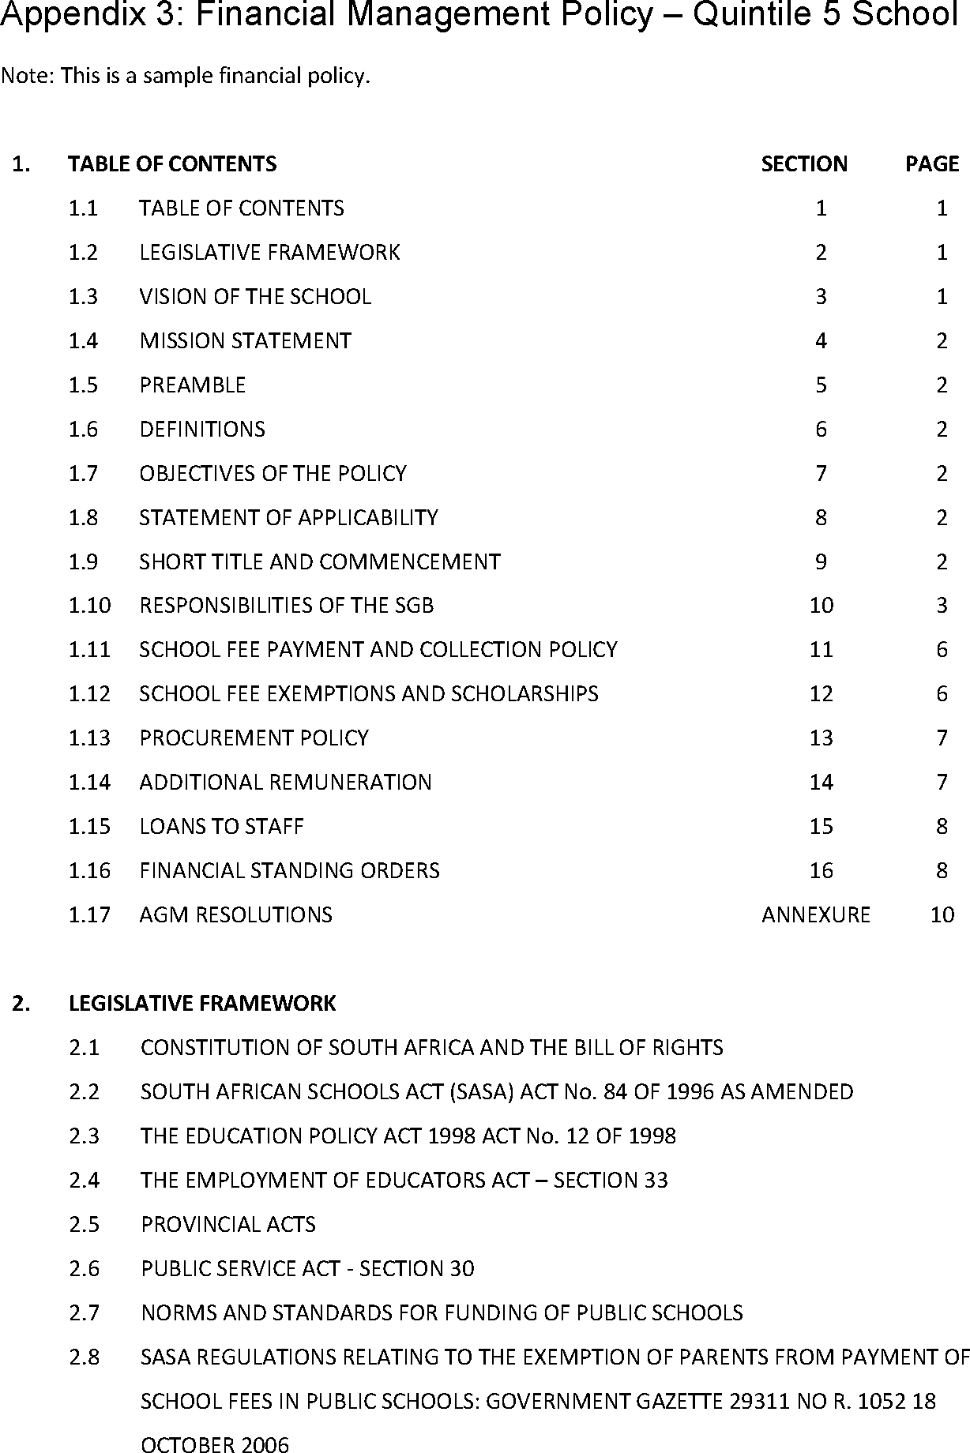

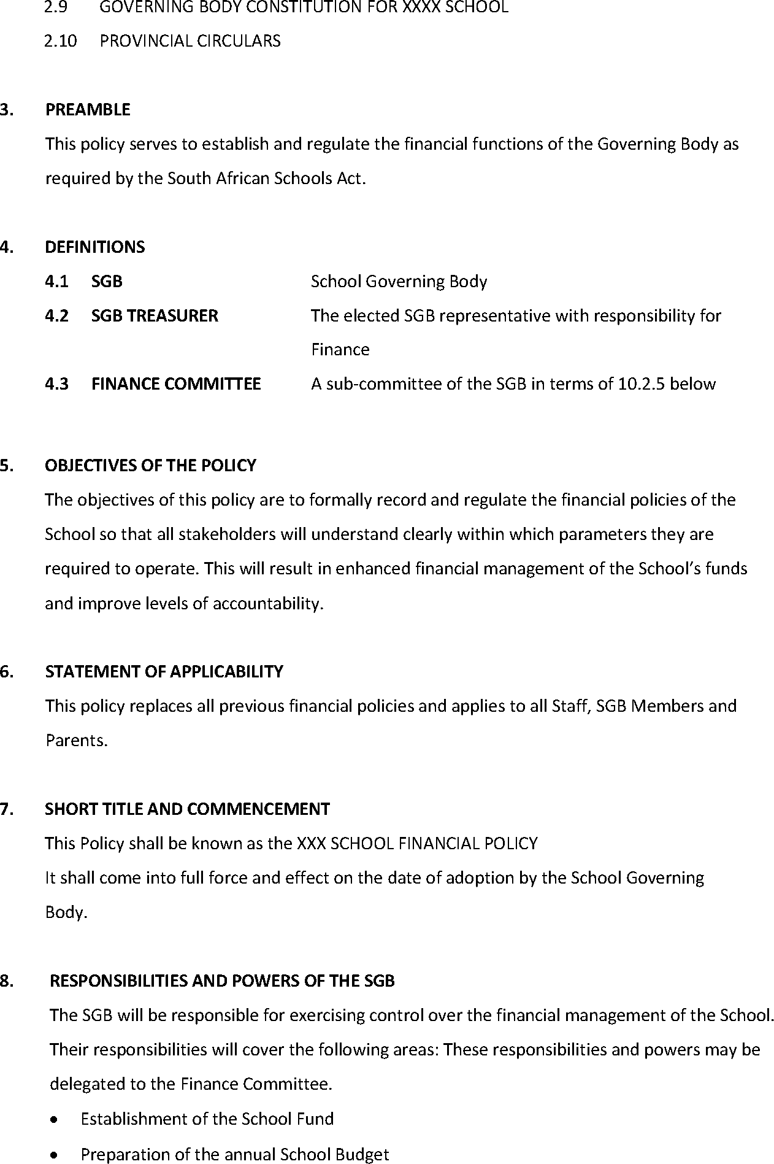

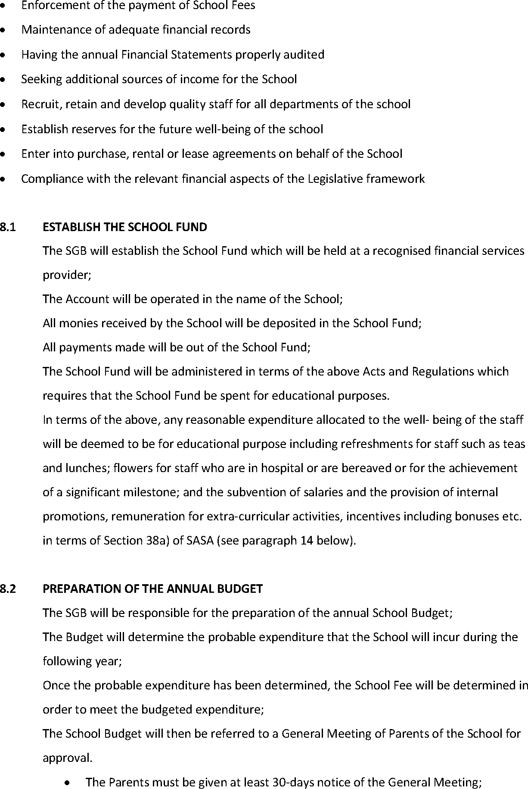

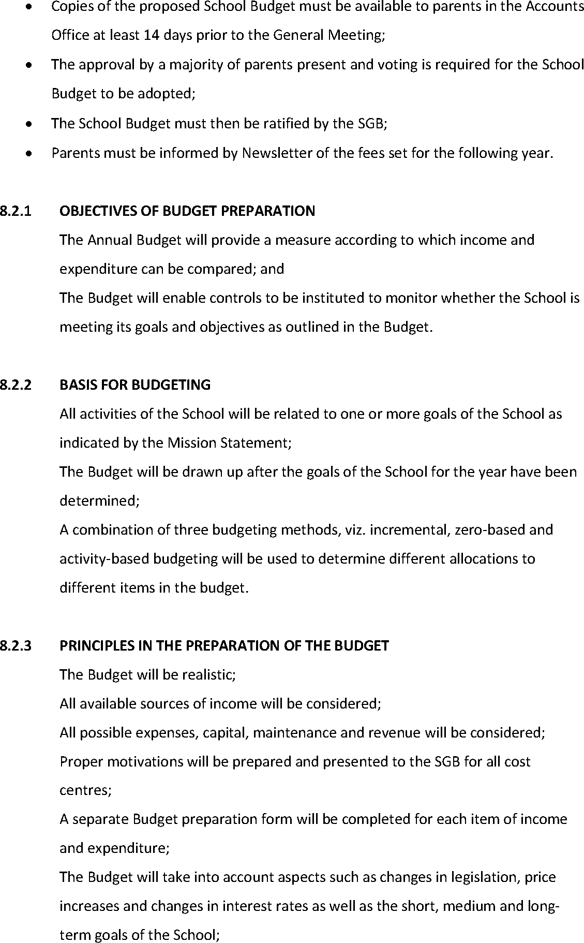

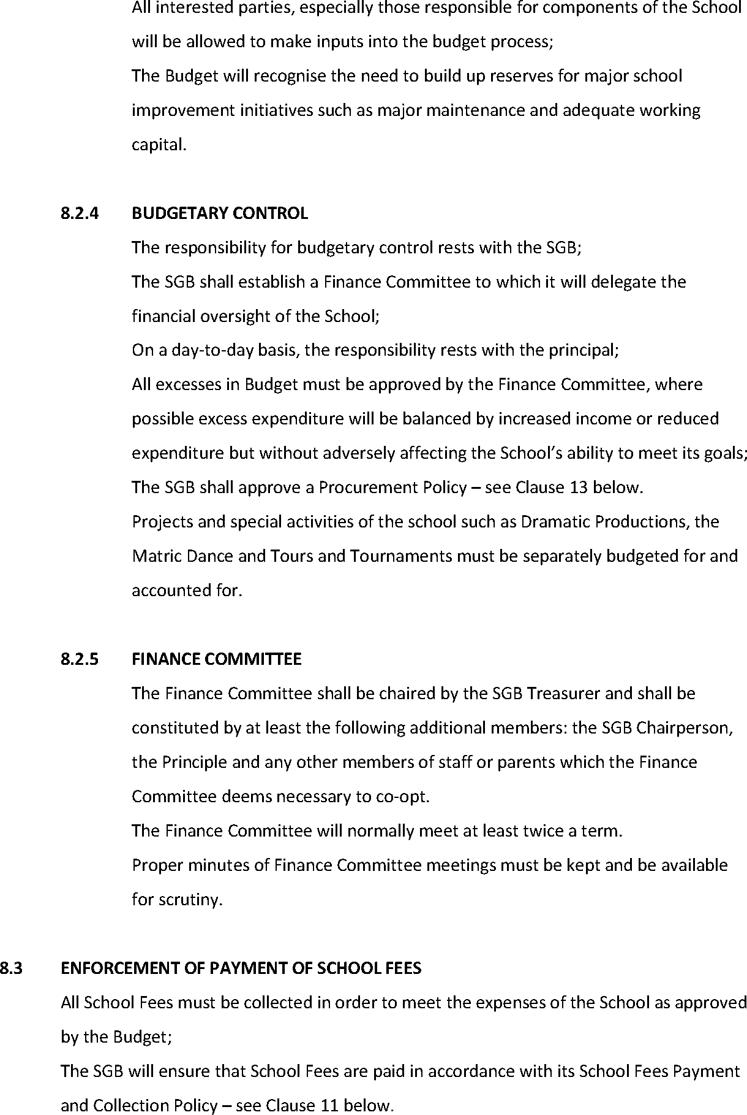



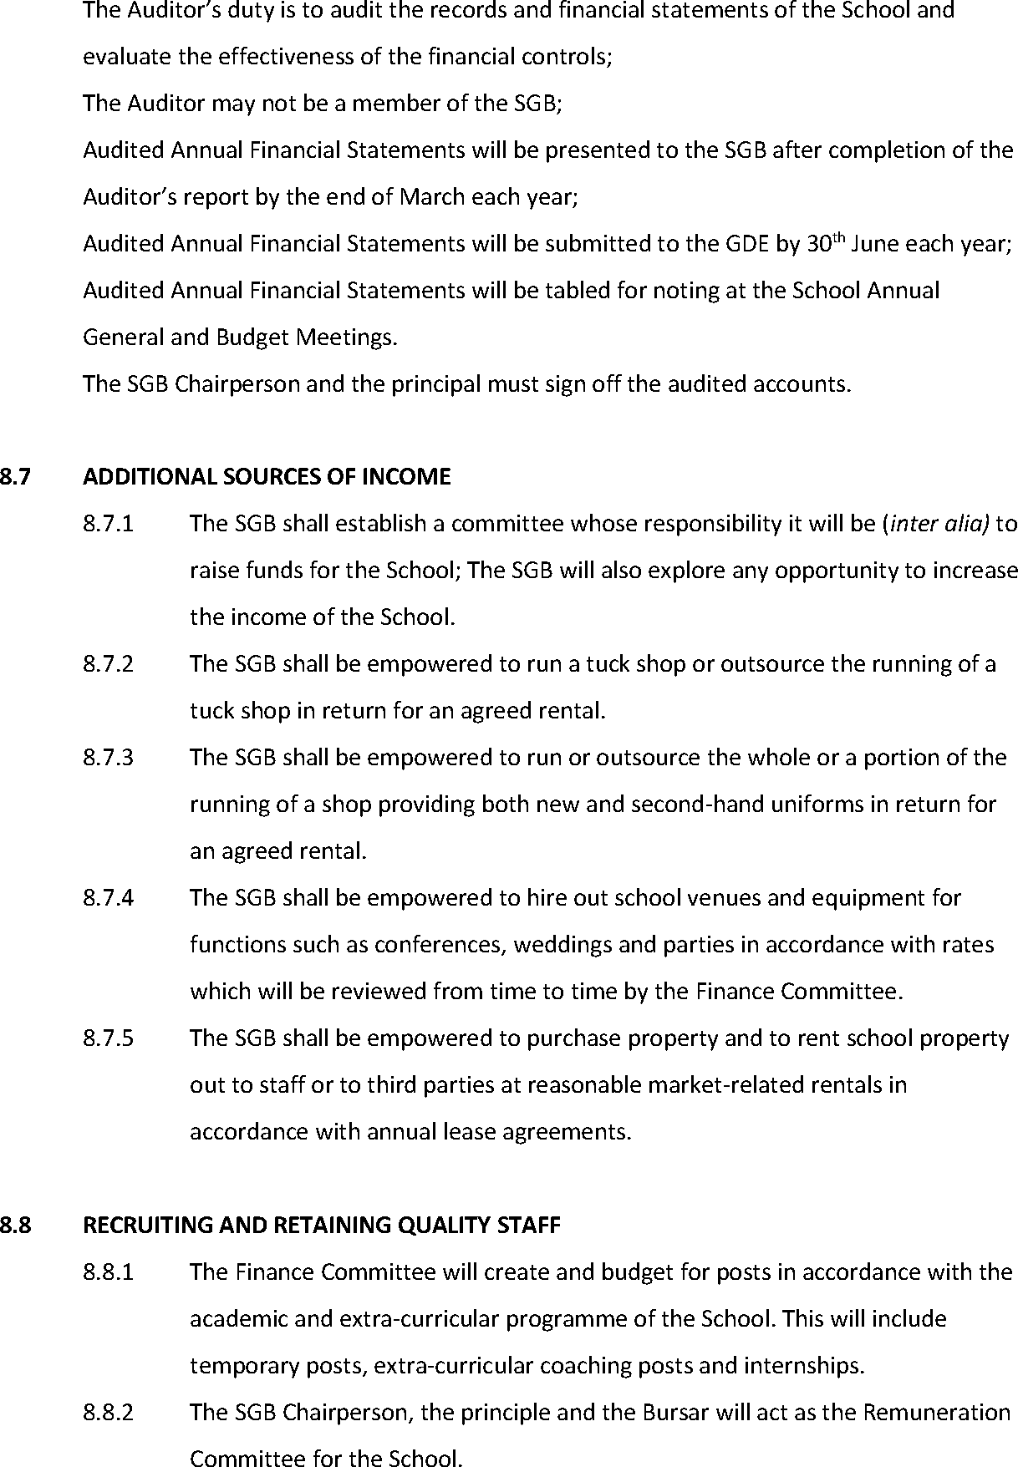



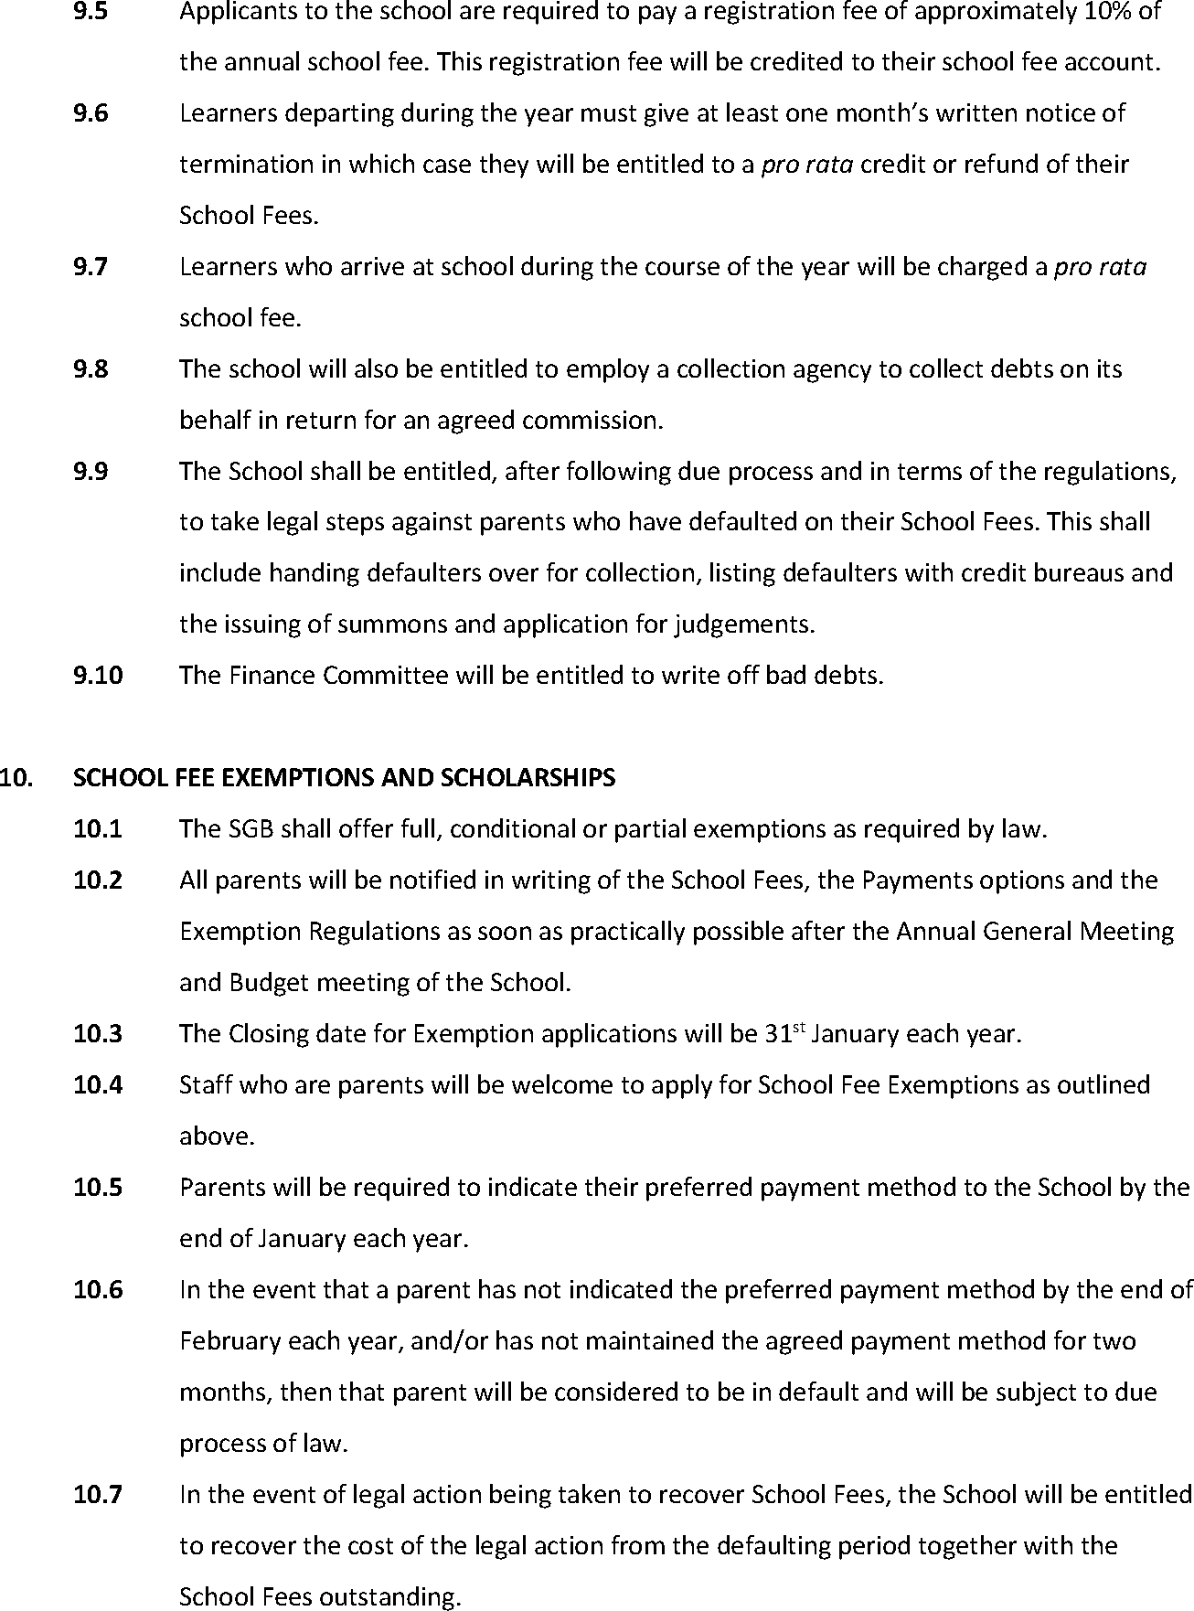

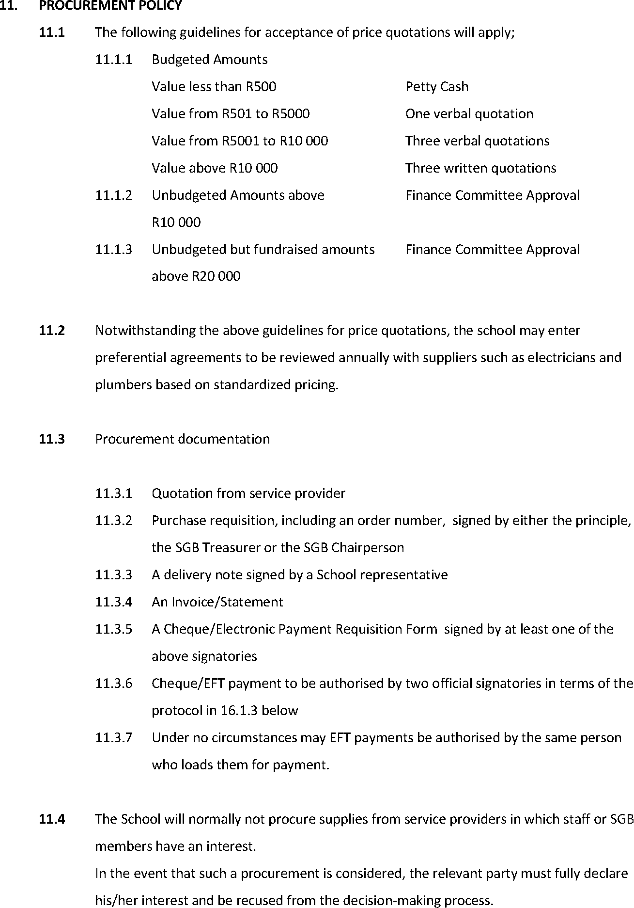



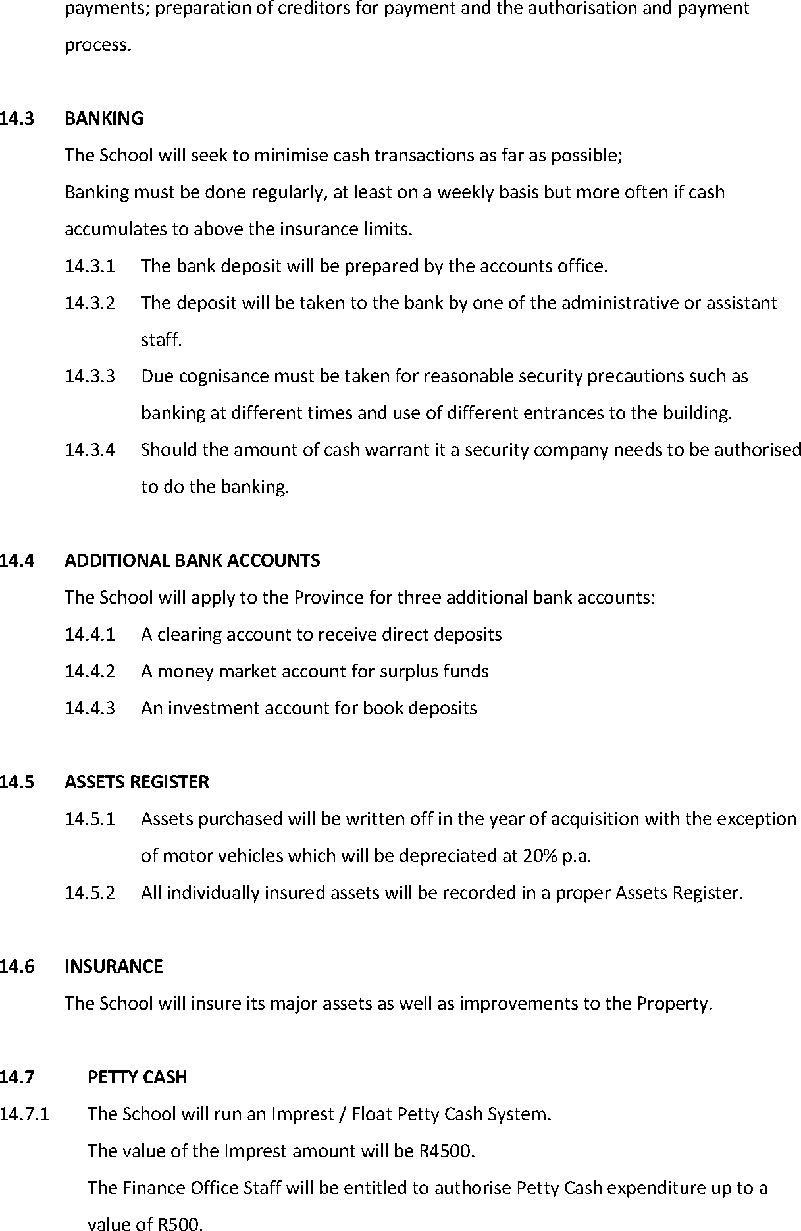



# Appendix 4: Annual budgeting process requisition form

#### XXX School

**Return to the Principal by**……………………………………………..

If you need more space please attach an additional page & feel free to adapt this form according to your needs.

|  |  |  |  |
| --- | --- | --- | --- |
| **SUBJECT/DEPARTMENT** |  | **YEAR** | **2018** |

|  |  |
| --- | --- |
| **CONSUMABLES** to be used up during the year, itemise please, e.g. paint for art | R |
|  |  |
|  |  |
| **REPAIRS** to specialised teaching equipment in your department, e.g. microscopes, stoves |  |
|  |  |
|  |  |
| **TEACHING RESOURCES** e.g. teaching reference material, software programmes, DVDs |  |
|  |  |
|  |  |
| **EQUIPMENT ‘**must have’ items which will last longer than one year, e.g. new microscopes |  |
|  |  |
|  |  |

**LTSMs** are ordered in rotation from the central budget. If it is your turn next, please state requirements

|  |  |  |  |  |  |  |
| --- | --- | --- | --- | --- | --- | --- |
| **GR** | **TITLE** | **AUTHOR** | **SUPPLIER** | **UNIT COST** | **NO** | **TOTAL** |
|  |  |  |  |  |  |  |
|  |  |  |  |  |  |  |

**CAPITAL ITEMS** major capital items – ‘nice to haves’? e.g. specialised scientific equipment for experiments

|  |  |
| --- | --- |
|  | R |
|  |  |

APPENDIX 4: ANNUAL BUDGETING PROCESS REQUISITION FORM

|  |  |  |  |
| --- | --- | --- | --- |
| **GRAND TOTAL** | | | **R** |
|  | | |  |
| **STAFF MEMBER’S SIGNATURE:** |  | **DATE:** |  |

|  |  |  |  |
| --- | --- | --- | --- |
| **OFFICE USE ONLY AUTHORISATION** |  | **APPROVED BUDGET ALLOCATION** | **R** |

# Appendix 5: Public school budget preparation form

Template

Note: In this example, the school has 19 categories of costs (‘cost centres’), with sub-categories. Activity heads are also asked to show what the budget is for the highlighted year, and to anticipate costs for the next two years.

|  |  |  |  |
| --- | --- | --- | --- |
| **Proposed budget for 20XX-20YY** | **20XX** | **20YY** | **20ZZ** |
| 1. **Administration**   * Accounting packages (for administration) * Flowers, gifts, funeral contributions * Office equipment (purchase, maintenance) * Stationery and consumable * Advertising and Postage * Telephone |  |  |  |
| 2. **Awards and bursaries**   * Badges, honours boards and framing * Prizes, bursaries, trophies, engraving |  |  |  |
| 3. **Bank Charges** |  |  |  |
| 4. **Cleaning Materials**   * Cleaning materials * Carpets * Overalls * Hygiene services * Toilet paper |  |  |  |
| 5. **Duplicating**   * Service provider * Duplicating paper |  |  |  |

|  |  |  |  |
| --- | --- | --- | --- |
| **Proposed budget for 20XX-20YY** | **20XX** | **20YY** | **20ZZ** |
| 6. **Educational Aids**   * Accounting * Afrikaans * Life Sciences * Business Studies * Computers * English * Geography * History * Mathematics * Media (Books and videos, consumables) * Science * Textbooks (all learning areas for Foundation and Senior phases) * Economics |  |  |  |
| 7. **Extra-Murals**   * Netball * Soccer * Choir * Debating * Chess * Catering committee |  |  |  |
| 8. **First Aids/Medical (Consumable)** |  |  |  |
| 9. **Grounds**   * Gardens * Lime, Fertiliser, compost * Equipment |  |  |  |
| 10. **Insurance**   * Premium * Vehicle tracking |  |  |  |
| 11. **Maintenance**   * Buildings and facilities * Electrical maintenance * Plumbing maintenance * General supplies (including paint, keys and locks) * Mower repairs * Tuckshop repairs * Tuckshop equipment |  |  |  |
| 12. **Printing** (certificates, reports, statements) |  |  |  |
| 13. **Photographs** (IDs, activities, and public relations) |  |  |  |
| 14. **Refreshments and catering**   * Staff tea * Sport * Functions and entertainment |  |  |  |

|  |  |  |  |
| --- | --- | --- | --- |
| **Proposed budget for 20XX-20YY** | **20XX** | **20YY** | **20ZZ** |
| 15. **Salaries and allowances**   * Caretaker * Office * Travelling (staff) * Social worker * Substitution and casual staff * Labourer * Educators * Tuck shop convenor and workers |  |  |  |
| 16. **Security**   * Alarm systems, burglar bars and gates * Guard for premises |  |  |  |
| 17. **Stationery**   * Chalk * Computer paper |  |  |  |
| 18. **Vehicles and transport**   * Repairs and Tyres * Fuel * Hire of buses * Licence Fees |  |  |  |
| 19. **Project – (name)**   * Development of soccer field * Replace window frames |  |  |  |

# Appendix 6: Exemplar stock-taking form

#### XXX SCHOOL

**ANNUAL STOCK-TAKING PROCESS**

ONLY DEPARTMENT-SPECIFIC ITEMS TO BE INCLUDED PLEASE CLASSROOM FURNITURE WILL BE COUNTED CENTRALLY

PLEASE RETURN TO THE PRINCIPAL BY ……………………………………………..

FEEL FREE TO ADAPT THIS TEMPLATE. USE ADDITIONAL PAGES IF NECESSARY.

TO SAVE WORK IN FUTURE YOU COULD DESIGN A SIMILAR COMPUTERISED SCHEDULE, LISTING YOUR STANDARD ITEMS OF STOCK WITH COLUMNS FOR EACH YEAR’S STOCKTAKE

|  |  |  |  |  |
| --- | --- | --- | --- | --- |
| **SUBJECT/DEPARTMENT** |  | | | |
|  | **NUMBER** | **NUMBER** | **NUMBER** | **NUMBER** |
| **DESCRIPTION** | **20WW** | **20XX** | **20YY** | **20ZZ** |
| **CONSUMABLES** ITEMISE PLEASE |  |  |  |  |
|  |  |  |  |  |
|  |  |  |  |  |
|  |  |  |  |  |
| **TEACHING RESOURCES** ITEMISE PLEASE |  |  |  |  |
|  |  |  |  |  |
|  |  |  |  |  |
|  |  |  |  |  |
| **EQUIPMENT** ITEMISE PLEASE |  |  |  |  |
|  |  |  |  |  |
|  |  |  |  |  |
|  |  |  |  |  |
| **LTSMs** ITEMISE PLEASE |  |  |  |  |
|  |  |  |  |  |
|  |  |  |  |  |
|  |  |  |  |  |

|  |  |  |  |
| --- | --- | --- | --- |
| **SIGNATURE:** |  | **DATE:** |  |

# Appendix 7: Exemplar - Financial standing orders

#### XXX Secondary School: FINANCIAL STANDING ORDERS FOR SCHOOL STAFF: ANNUAL BUDGET ALLOCATION

|  |
| --- |
| **1. Your department’s budget for 20xx of R… was approved subject to the following restrictions.** |
| The School can only spend money once income has been received. So theoretically you would be able to spend one twelfth of your budget each month. If income budgeted for is below target, then you can only spend in proportion to the reduction in income. If you need an expensive ‘once’ you will need to ‘save’ for it. |
| In addition, the School can only spend money once fixed costs such as salaries and utilities have been covered. Thus, in the event of a reduction in income, an even lower proportion of your budget can be spent depending on the proportion of fixed cost to variable costs in the overall school budget. |
| You may only spend your departmental budget on items for which you have budgeted |
| If you wish to re-allocate your budget this needs to be approved by the principal or by the Finance Committee. |

|  |  |  |
| --- | --- | --- |
| **2. ORDERING OF SUPPLIES** | |  |
| **IF BUDGETED FOR\***  *The only exception to the policy outlined below is for Consumer Studies purchases within the normal course of events and within budget. They may be purchased and expenditure reclaimed without an order number. | |  |
| **Obtain quotes in accordance with the procurement policy: viz.** | |  |
| Value less than R500 | Petty Cash, verbal quotation |  |
| Value from R501 to R2000 | One verbal quotation |  |
| Value from R2001 to R5000 | Three verbal quotations |  |
| Value above R5000 | Three written quotations |  |
| Unbudgeted Amounts above R2000 | Finance Committee Approval |  |
| **THEN OBTAIN ORDER FORM FROM …XXX…** who will indicate on the order form the amount budgeted for, the amount already spent for the year and therefore the amount theoretically available for expenditure. | |  |
| The order form must then be given to for authorisation. If s/he is not available for  an urgent purchase, Mr/s may be able to authorise the expenditure under certain circumstances. | |  |
| The order form (or in some cases the order number will suffice) must be given to the supplier who must quote the number on the invoice. | |  |
| The supplier will normally issue a delivery note (which must be signed by the recipient of the goods) and an invoice which must both be given to the Finance Office. | |  |
| The supplier will then issue a statement which will be processed by the Finance Office for payment. The signatory authorizing payment must be supplied with the full documentation chain e.g. copy of the order form, delivery note, invoice, prior to loading for payment on the School’s EFT system | |  |

|  |  |
| --- | --- |
| **IF NOT BUDGETED FOR** |  |
| In addition to the process outlined above, authorisation from the Finance Committee must be obtained for amounts above R…………….. |  |

|  |  |
| --- | --- |
| **3. ORGANISING ACTIVITIES THAT HAVE FINANCIAL IMPLICATIONS**  e.g. Matric Dance, Productions, Tournaments, Excursions |  |
| It is the School’s Policy that unless deficits are budgeted for in the Annual School Budget, that all activities must be budgeted so that at the very least they break even. Thus, all activities must submit a budget for approval either by the Principal or the Finance Committee well in advance of the activity. |  |
| Complete the attached proforma budget (or customise it if necessary). |  |
| The budget must be approved BEFORE invitations for the activity are extended or tickets sold. No payments in advance for activities will be made without a budget having been approved. |  |
| Support staff who are on duty during a function are paid overtime in terms of the Basic Conditions of Employment Act. The cost of their overtime must therefore also be factored into the activity budget. |  |