**Advanced Diploma**

**Technical and Vocational Teaching**

**Method of Teaching Electrical Engineering Infrastructure and Construction**

Department of Higher Education and Training

 

**Department of Higher Education and Training**

Advanced Diploma: Technical and Vocational Teaching

Module: Method of Teaching Electrical Engineering Infrastructure and Construction

Author: Professor Cuthbert Nyamupangedengu

© Department of Higher Education and Training 2023

Department of Higher Education and Training

123 Francis Baard Street

Pretoria

0001

Website: [www.dhet.gov.za](http://www.dhet.gov.za)

This Module of the Advanced Diploma: Technical and Vocational Teaching (AdvDipTVT) was produced with the financial support of the European Union. Its contents are the sole responsibility of the Department of Higher Education and Training, and do not necessarily reflect the views of the European Union.



This work is licensed under a Creative Commons Attribution 4.0 International License.

Creative Commons License

# Contents

Contents iii

Programme Introduction ix

Approach to learning ix

Module overview 1

Module purpose 1

Module outcomes 1

Module structure 2

Module credits 2

Module time (notional hours) 2

Unit 1: Health and Safety in engineering workshop practice 3

Introduction 3

Unit 1 learning outcomes 3

The Occupational Health and Safety Act 4

The importance of appraising students’ prior knowledge and misconceptions 4

Evaluating prior knowledge related to OHS in learning spaces and workshops 5

Using scenarios to evaluate prior knowledge and to teach about the OHS 6

Evaluating students’ misconceptions related to OHS 9

Using an anticipation guide to evaluate students’ misconceptions 10

Note 12

Concept maps: Consolidating and linking new learning in relation to OHS 15

In conclusion 20

Unit 2: How to teach the principles of electricity 21

Introduction 21

Understanding how to teach the concepts of electricity 21

Evaluating students’ prior knowledge on electricity 22

Big Ideas 25

Examples of how to unpack difficult concepts in the electricity topic 28

Electric current 30

Electron drift velocity 31

Conclusion to Unit 2 32

Unit 3: How to teach the concepts of typical circuit analysis techniques 35

Introduction 35

Unit 3 learning outcomes 35

Teaching how to understand basic concepts of circuits 35

a. Wonder and learn about circuits 36

b. The basic concepts of circuits 36

Teaching how to interpret electric circuit diagrams/schematics. 38

a. Constructing a simple electrical circuit with battery, wire and bulb 38

b. Use an ammeter to measure the current in a simple 1-bulb circuit 40

Suggestion for discussion with students 41

c. Measuring potential difference 41

d. Using real components 43

Bottom-up approach 43

Top-down approach 43

Towards learning how to develop an equivalent circuit using a reverse engineering process: a case study teaching approach 44

Conclusion 50

Unit 4: How to teach electrical troubleshooting, repair, and maintenance 51

Introduction 51

Unit 4 learning outcomes 51

Towards learning outcome 1: How to teach interpretation of electrical circuit diagrams 52

Towards learning outcome 2: How to teach systematic troubleshooting of electrical circuits 55

Towards learning outcome 3: How to teach electrical systems fault repair and maintenance 61

Conclusion to Unit 4 64

Unit 5: Assessment in the context of activity-based learning 65

Introduction 65

Unit 5 learning outcomes 66

Towards learning outcomes 1 and 2: Reflecting on your approach to assessment and relating assessment with curriculum and pedagogy 66

Bloom’s Taxonomy: Its relevance to learning design and assessment 68

Relevance to designing learning 68

A more holistic understanding of assessment 69

Conclusion to Unit 5 86

Conclusion to the Module 86

Exemplar: Summative assessment for the Adv. Dip TVT module Method of Teaching Electrical Engineering Infrastructure and Construction 87

Assessment Part 1: Troubleshoot and fix a fault in an electrical gadget 87

Instructions 87

Assessment Part 2: Self-reflection report 88

Instructions 88

References and Resources 92

Appendices 94

Appendix 1: Learning journal template 1

Appendix 2: Lesson Plan Template 3

Lesson Plan Template: Step 1 - The Big Picture (Expand, add or remove rows as required) 3

Lesson Plan Template: Step 2 - Detailed planning (Expand, add or remove rows as required) 4

Appendix 3: electron drift velocity calculation 6

Appendix 4: Skills, Knowledge, Attitudes and Values 7

Skills, knowledge, attitudes and values 7

Appendix 5: Bloom’s Revised Taxonomy of Learning Domains 9

Acknowledgements

The Open Learning Directorate of the Department of Higher Education and Training (DHET) would like to acknowledge:

The European Union for funding the Capacity Building for TVET College Lecturers through Open Learning Programme (Sub-Programme 2 of the Teaching and Learning Development Sector Support Programme). The production of open learning courses for the Advanced Diploma in Technical and Vocational Teaching (Adv. Dip TVT) is a project of that programme.

The following universities, for making lecturing staff available to contribute to the project as subject matter experts, writers or critical reviewers:

* Cape Peninsula University of Technology
* Central University of Technology
* Durban University of Technology
* Nelson Mandela University
* Tshwane University of Technology
* University of Fort Hare
* University of the Free State
* University of Johannesburg
* University of Nottingham (UK)
* University of Pretoria
* University of KwaZulu Natal
* Vaal University of Technology
* University of the Witwatersrand

The Technical and Vocational Education and Training (TVET) Branch of the Department of Higher Education and Training for providing information whenever it was requested.

The following TVET Colleges for making lecturing staff available to contribute to the project as subject matter experts, writers or critical reviewers:

* False Bay TVET College
* Majuba TVET College
* South-West Gauteng TVET College
* West Coast TVET College, and
* Motheo TVET College for developmental testing of materials.

 The University of the Free State for overall project management, and the Centre for Teaching and Learning for producing multi-media materials, resources and the e-learning (SCORM) versions of the courses, as well as uploading the materials on the National Open Learning System (NOLS).

*Saide,* (South African Institute for Distance Education) for their expertise in leading and co-ordinating the development and production of the course modules; quality assuring the learning design; and in ensuring that the developed material is made available for use as Open Education Resources (OER), thereby contributing to the implementation of open learning in post-school education and training (PSET).

Acronyms and Abbreviations

|  |  |
| --- | --- |
| AC | Alternating Current |
| ACAI | Approach to Classroom Assessment Inventory |
| AdvDipTVT or ADTVT | Advanced Diploma: Technical and Vocational Teaching |
| DC | Direct Current |
| DHET | Department of Higher Education and Training |
| ECD | Early Childhood Development |
| ECSA | The Engineering Council of South Africa |
| emf | electromotive force |
| GA | graduate attributes |
| GPS | Geographical Positioning System |
| HEI | Higher Education Institution |
| HIT framework or model | know How, know It and know That |
| KWL | Know, Wonder and Learn |
| LO | Learning outcome/s |
| LTIFR | Lost Time Injury Frequency Rate |
| MS Word | Microsoft Word |
| NATED | National Accredited Technical Education Diploma |
| NCV | National Certificate Vocational |
| OHS | Occupational health and safety |
| OHSA | Occupational Health and Safety Act (OHSA) |
| PhET | Physics Education Technology |
| PPE | Personal Protective Equipment |
| RLC | Resistor (R), Inductor (L), Capacitor (C) |
| SCADA | System Control And Data Acquisition |
| SKAV | skills, knowledge, attitudes, and values |
| SMART | specific, measurable, achievable, relevant, and time-bound |
| TVET | Technical and Vocational Education and Training |
| V | Volt |

# Programme Introduction

The Advanced Diploma in Technical and Vocational Teaching (Adv. Dip TVT) programme seeks to provide a structured professional learning pathway for current and aspirant technical and vocational lecturers/teachers. The Diploma will equip them with the knowledge and competences to implement and manage teaching and learning in their TVET colleges effectively and in alignment with national goals.

This module is one of a set of modules that contribute to the Advanced Diploma programme. The overall purpose of the Advanced Diploma is to engage lecturers working in the TVET sector in conversations about what it means to be a quality teacher in a TVET college. Each Module in the programme explores this from a different angle, but for every module the foundational concept is about the type of teacher you want to be. We all know that the relationship between teaching and learning is interrelated, so in order to understand the type of teacher you want to be you will need to engage with what learning means in a TVET context.

We often think about vocational and technical or craft knowledge as different from theoretical knowledge. However, there is increasing recognition of the power of vocational and theoretical knowledge coming together to develop the skilled craftsperson whether it is in plumbing, baking, even mathematics and physics. This integration of theory and vocational knowledge is equally important in teaching as well. Teachers are constantly needing to make informed decisions and judgements as they select what to teach and how best to teach the specific content, concept or skill.

This leads to a question about how different forms of knowledge and skill are brought together and balanced in the curriculum and in teaching and learning.

## Approach to learning

To answer the question above in this diploma programme, a framework has been developed which is referred to as *know how*, *know it* and *know that*, or the HIT framework. This framework is introduced, referred to and deepened in different ways all the way through the programme.

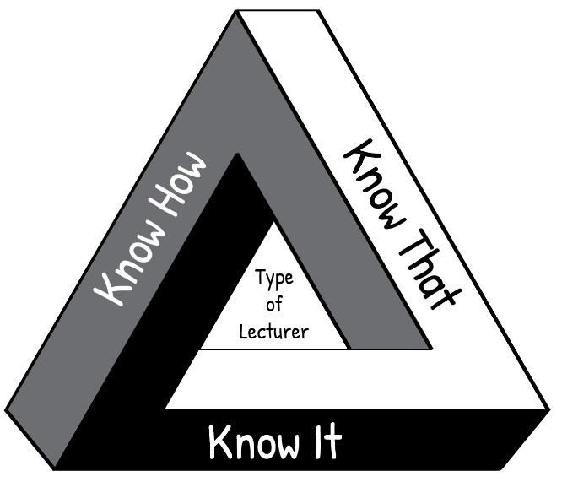

**“Know How”** is *procedural knowledge*, “in our bodies” or *embodied knowledge*.

For example, following a bread recipe.

“**Know It**” is *recognition*, the knowledge of what counts as good; wisdom; technical and theoretical judgments.

For example, is this sourdough good quality bread?

**“Know That”** is *propositional knowledge* or

*theoretical knowledge*, the knowledge of how and why, *cognitive knowledge*.

For example, the science of bread baking.

**Figure i: The HIT framework**

Think about your own craft of teaching. The kind of teacher you want to be, is one who knows **how** (the techniques of teaching), knows **that** (the science and theory behind teaching AND learning) and knows *it* (knowing and reflecting on what makes a quality teacher). Such a teacher enables students to actively engage with their learning and to develop their full potential.

If you are interested, click on the link provided to watch a short [video](https://youtu.be/JssDzbjlYik) in which Wayne Hugo discusses the “HIT model” of TVET knowledge and learning.

Relating theory to practice

In this module new concepts are often introduced by developing them from a practical situation with which you are probably familiar. This process, which moves from your experience towards a more abstract level of theory is known as inductive learning. It makes learning easier and is very different from deductive learning, which starts by presenting abstract theories and principles, then requires you to “deduce” practical conclusions and concrete examples. You are encouraged to relate the ideas you learn from the Adv Dip programme to your own context and to try to think theoretically about your practice. In other words, to think about the rationale for your practice.

Reflective practice and the use of a learning journal

One of the Adv. Dip TVT modules is called Reflective Practice, if you are interested, you can access it [here](https://oerafrica.org/system/files/13691/assets/13702/advdiptvtmodulereflective-practice.docx?file=1&type=node&id=13702&force=0) It covers the concept of reflection in the life of a TVET lecturer. Of particular importance is unit 2, which describes various models which facilitate reflection. The simplest reflective model that is discussed in this unit, is that of Terry Borton (1970). It consists of three steps as follows:

**Figure ii: Reflective model (after Borton, 1970)**

The three questions to prompt reflection leading to action:

1. What?

**What** happened? In this step you remember or describe the situation or event you have experienced.

1. So what?

**So,** if that happened**, what** does this show you or teach me?In this step you explore what new insights or knowledge the situation gives you.

1. Now what?

**Now** that I have learnt something new by reflecting on the situation, **what** should I do about it? In this step you think about what to do with the new awareness you have gained – i.e. how to make use of it to act more effectively in future situations.

Throughout the Adv. Dip TVT programme, you are encouraged to reflect on your practices at work in the college so that you can improve how teaching and learning takes place. We have embedded reflective practice throughout the programme, and at the end of most units in the modules you will find a reflective activity to complete. The reflective activity will enable you to make the most of what you have learnt throughout the unit, as well as assisting you to apply your learning in your workplace.

Use a learning journal

Throughout the Adv. Dip TVT modules, we encourage you to use a *learning journal*. You can find a digital template of the learning journal in Appendix 1. Save it where you can easily find it again. You can also use another template, or use a paper-based learning journal. You will use your learning journal to write notes and reflections and complete activities. Start your learning journal at the beginning of the programme, and keep it regularly updated throughout.

Active learning

Most learning theorists tell us that new understandings and learning depend on, and arise out of, *action*. All the modules in the Adv. Dip TVT programme include activities. Your learning will be more fruitful if you engage systematically with the activities. If you do not do the activities, you will miss out on the most important part of the programme learning pathway.

Thinking activities

At various points in the module you are asked to *stop and think* and to take some time to reflect on a particular issue. These *thought pauses* are designed to help you consolidate your understanding of a specific point *before* tackling the next section of the module. One of the habits many of us develop through a rote kind of learning is to rush through things. Work though each module slowly and thoughtfully. Read and think. This is how we develop a depth of understanding and become able to use the ideas we learn. Try to link the issues raised in each thought pause with what you have read, with what you have already learnt about learning, with your own previous experience, and so on. Think about the questions or problems raised in the module. Jot down your ideas in your learning journal so that you can be reminded of them at a later stage.

Linkages across modules

As you work through this and other modules, you will notice that topics or issues raised in one module may cross refer to the same issue or topic in another module, possibly in more detail. So for example, while there is an entire module dedicated to the investigation of *curriculum,* key issues related to curriculum will also be highlighted and discussed in a number of other modules including, modules dealing with pedagogy, psychology in TVET as well as in the method of teaching engineering and related design and electrical engineering modules.

Access to readings

There are links to readings throughout the activities. We have tried as far as possible to provide links to Open Educational Resources (OER). In cases where this was not possible you will be directed in the activity to access these through your university library. The website link is shown in the reference list.

Assessment

The activities contained in this module and the Adv. Dip TVT programme as a whole, promote a continuous and formative assessment process. This approach is intended to support your ability to relate ideas to practice and to contribute to your development as you work through the various modules of the programme.

You will also notice that each module includes a summative assessment task with the assessment criteria set out in an accompanying rubric. This summative assessment task is a model only, intended to illustrate the kind of assessment tasks that may be set by the university providing this programme.

## Module overview

Welcome to the Module on how to teach in the Electrical Infrastructure and Construction core learning area. This module, one of two modules on the teaching of engineering, will introduce you to some of the most important ideas about teaching electrical engineering. Unit 1 is a common unit to both engineering modules and covers Health and Safety in engineering workshop practice – a crucial topic for all practical subjects. The following three units cover the teaching of electricity as it relates to engineering. Unit 2 shows how to teach the principles of electricity, by eliciting students’ prior knowledge (including misconceptions), and unpacking the ‘big ideas’ of electricity. Unit 3 examines electrical circuits, how we can simulate, interpret and analyse them, with a view to subsequent diagnosing of potential faults. Unit 4 follows directly on; covering troubleshooting, repair, and maintenance of electrical systems. Unit 5 explains how to assess the extent to which students have acquired knowledge and skills in the module through activity-based learning, with practical examples based on authentic assessment. The module concludes with a summative assessment of the module.

## Module purpose

The purpose of this module is to equip the Technical and Vocational Education and Training (TVET) lecturer with the knowledge, skills, attitudes and values to effectively teach in the Electrical Infrastructure and Construction subject area at TVET Colleges.

## Module outcomes

When you have completed this module, you should be able to demonstrate competence in how to effectively teach the following:

* Safety protocols and occupational health compliance in the workplace.
* Concepts of Health and Safety in the workplace
* Fundamental principles of electricity
* Concepts of electrical circuit analysis
* Electrical troubleshooting, repair, and maintenance of electrical equipment
* Assessment of learning in the context of activity-based pedagogy

## Module structure

**Figure 1: Module structure**

## Module credits

This module carries 6 credits.

## Module time (notional hours)

This is equivalent to 60 notional learning hours. It is anticipated that you will take approximately 60 hours to complete the module successfully. The 60 hours will include contact time with your Higher Education Institution (HEI), reading time, research time and time required to write assignments. It is also expected that some of your time will also be spent talking to college colleagues about the various activities in this course. Each activity in this module indicates the suggested time for completion.

# Unit 1: Health and Safety in engineering workshop practice

## Introduction

The core business of Technical and Vocational Education and Training (TVET) colleges is to develop competent vocational and occupational professionals. In all professional practices, it is imperative that one can assess health and safety risks (hazards), preventing accidents, promoting safety, and that one has the capacity to act appropriately in cases of accidents. It follows therefore, that it is critical for all teaching and learning processes at TVET colleges to be fully compliant with health and safety imperatives. Occupational health and safety (OHS) knowledge and skills development must be completely integrated within all aspects of the teaching and learning processes at the TVET colleges. All TVET lecturers and workshop facilitators must be competent to evaluate and mitigate potential health and safety problems that they face in learning situations and in work practices. Teaching and training OHS to TVET college students has particular requirements, stemming from the fact that young people are still developing, physically, psychologically, and emotionally, and may therefore inherently pose various unique risk factors (Billorou & Sandoya, 2019). It is therefore important that as a TVET lecturer you are aware of and able to mitigate this additional challenge. It is for this reason, that this module commences with workshop practice and safety.

As the module unfolds, you will incrementally gain a deep understanding of the value of active learning and the need for lecturers to shift their teaching approach from transmission of content to a more active approach to teaching and learning. In the field of electrical and automotive engineering, this implies a practical, activity-based approach to teaching engineering content, including relevant health and safety content and concepts. Research undertaken by various prominent learning theorists such as Jean Piaget, Lev Vygotsky and Yrjö Engeström shows that people learn best by doing and engaging in activities that lead them to construct their own new knowledge and their own understanding of the topic or subject. This approach is referred to as a *constructivist* approach to teaching and learning.

Unit 1 therefore starts with a discussion on the importance of understanding what prior knowledge and/or misconceptions students may have of any given topic; in this case, health and safety content and concepts. We also stress the importance of designing lessons in such a way that they support the students to construct new knowledge on their existing foundational understanding of a topic or subject. In this unit, we also start to explore an active approach to teaching and learning that promotes students’ understanding of health and safety issues and that supports prevention practices alongside functional job-related skills. It is also important that occupational health and safety issues are not taught as separate from core engineering content, but rather that health and safety issues are integrated and taught in a way that makes explicit links and connections with real life (authentic) learning situations and which are linked to the workplace context.

## Unit 1 learning outcomes

By the end of this Unit, you should be able to:

1. Evaluate students’ prior knowledge and misconceptions related to occupational health and safety in learning spaces and workshops.
2. Explain the purpose of the Occupational Health and Safety (OHS) Act and the consequences of non-compliance.
3. Prepare and teach the content and concepts of occupational health and safety using an activity-based approach to learning.

## The Occupational Health and Safety Act

The intent of the Occupational Health and Safety Act (OHSA)(Act No. 85 of 1993)[1] is:

*“To provide for health and safety of persons at work and for the health and safety of persons in connection with the use of plant and machinery; the protection of persons other than persons at work against hazards to health and safety arising out of or in connection with activities of persons at work; to establish an advisory council for occupational health and safety; and to provide for matters connected therewith.”*

Employers and employees in the workplace in South Africa need to comply with the OHSA. In technical and vocational teaching, all stakeholders that are involved in teaching and related work, need to understand that it is a priority to ensure, through appropriate training, including through TVET programmes, that young people acquire the necessary knowledge, skills and risk identification and prevention behaviours to work. This is because safety in the workplace is of utmost importance and any injury incurred by any employee in the workplace could bring the workplace activities to an abrupt halt and as such, affect production.

## The importance of appraising students’ prior knowledge and misconceptions

Before commencing any teaching and learning process, it is important that you understand what your students already know about the topic or subject area. This is as true of health and safety as it is of any other subject in the engineering curriculum.

Prior knowledge is the information that students already know in the subject area, before new learning occurs. The role of the lecturer in teaching new knowledge, is to make sure that the student connects their existing knowledge with the new knowledge delivered in a lesson or series of lessons. Like building a house, the new layer of bricks is placed on an existing layer. For the bricklayer to know how much mortar to apply on the existing layer, and how much pressure should be applied on the new brick, he must test and confirm the condition of the existing layer. The same concept applies to a student learning new knowledge. The existing layer of bricks is the student’s prior knowledge. The new layer of bricks is the new knowledge to be learnt by the student. The bricklayer is the lecturer. Therefore, as a lecturer you need to find out what every student knows about the subject matter at hand as a first step in conducting a lecture on new material. This concept of evaluating the students’ prior knowledge is beneficial to both the student and the lecturer in achieving the course outcomes.

While some of the prior knowledge that students bring to class will conform to current scientific ideas and theories, it is likely that students will also have misconceptions about some of the subject matter knowledge. Dealing with misconceptions will therefore also be discussed a little later on in this section.

The focus of this section is on how to elicit students’ prior knowledge and misconceptions related to health and safety in the engineering workshop and workplace environment.

## Evaluating prior knowledge related to OHS in learning spaces and workshops

Activity 1: Brainstorm and list techniques for eliciting students’ prior knowledge about health and safety in the engineering workshop

**Suggested time**: 10 minutes

If possible, spend ten minutes with a colleague (or on your own) brainstorming possible techniques and methods for eliciting students’ prior knowledge about health and safety in the engineering workshop.

Jot your ideas down in your learning journal.

Discussion of the activity

There are several ways to elicit prior knowledge from students. How many did you think of? Did your list also include using a quiz to find out what your students already know and understand about a particular topic?

In the next activity, we are going to explore this method in more detail.

Activity 2: Using Multiple Choice Questions as a technique for eliciting students’ prior knowledge about health and safety in the workplace

**Suggested time:** 60 minutes (reading 20 minutes, quiz setting 40 minutes)

The purpose of this activity is for you to (re)familiarise yourself with health and safety in the workplace, and to develop a quiz.

1. Skim through the complete document [Health and Safety in the Workplace](https://www.labour.gov.za/DocumentCenter/Publications/Occupational%20Health%20and%20Safety/What%20every%20worker%20should%20know%20about%20health%20and%20safety%20at%20work.pdf?platform=hootsuite) to remind yourself what workers should know about health and safety.
2. Now refer to pages 7 to 10 and formulate 5 multiple-choice questions (MCQs) (each with 1 correct answer and 3 distractors,[2] a-d) on the content from those pages. Indicate the correct answer for each question at the end of the quiz. The purpose of the quiz is for you to obtain a quick view of how much your students know about worker duties, worker rights, and Health and Safety Representatives.
3. You can list the draft questions in your learning journal, but try to print them out on paper too.
4. Try the quiz out on your fellow students (in the Advanced Diploma: Technical and Vocational Teaching (ADTVT) course) or colleagues and improve the questions after you have seen their answers. This is an important step, as MCQs usually need to be refined so that they are clear and unambiguous.
5. If you are currently teaching at a TVET college, you could also try it on your current students. In your learning journal, summarise briefly what they know and don’t know about the content of the questions you asked.

Discussion of the activity

Keep the questions you have formulated, as you may get a chance later to try them out on TVET students if you could not carry out step 5. Even if you are familiar with the OHS Act, did skimming through the document remind you of aspects you might have forgotten? You probably found that developing even a short quiz is quite demanding, as you not only have to find a useful question to ask, but you need to develop effective distractors. Good distractors include common errors people make, or misconceptions in the field, and they can help you determine aspects of the students’ prior knowledge.

Here is an example of a possible MCQ you could use:

Which of the following is *not* one of the rights of a worker?

1. Access to health and safety rules and procedures of the workplace
2. The right to participate in inspections
3. The right to comment on legislation
4. The right to remove a safety guard from a machine

The answer is (d), but it may be considered too obvious, and does not elicit useful prior knowledge.

## Using scenarios to evaluate prior knowledge and to teach about the OHS

The rest of Unit 1 is structured as follows. Firstly, we present two scenarios concerning risk evaluation in the workplace. This is from the four key knowledge areas of OHS, and it is expected that you will be able to extrapolate into the other three which are: Workplace inspections and investigations, Responsibilities of role players and stakeholders in OHS and Enforcements and penalties. Activities are then formulated to explore and draw out abstract knowledge in the pedagogy aspects of students’ prior knowledge evaluation, demystifying misconceptions, and explanation of difficult concepts.

A second way of eliciting students’ prior knowledge is by using scenarios to generate discussion and determine what students know from their answers. Complete Activities 2 and 3, that provide examples of scenarios you might use with your own students.

Activity 3: Using scenarios (case studies) to evaluate prior knowledge and teach about OHS

**Suggested time:** 30 minutes

The purpose of this activity is for you to develop a scenario for students to analyse so that you can identify your students’ existing knowledge as well as gaps in their understanding, which may result in damage to equipment or machinery and/or put the student at risk of injury.

As a lecturer, you want your students to carry out a practical exercise. It could for example be:

Wiring up a star-delta starter board for an electric motor to be used in driving a pump at a farm, and the work must be done safely in an electrical wiring workshop.

Write the scenario in your learning journal.

1. As the lecturer, you need to write a paragraph or two describing the procedures that need to be followed to accomplish the tasks highlighted above in the scenario of *Wiring up a star-delta starter board safely*, for your students to read and analyse. Make some reference to the possible risks and hazards in the workshop, but do not make them explicit, as we want the students to evaluate them.
2. At the end of the scenario, pose three to five questions for students to answer, identifying the potential OHS risks and hazards to look out for, and how to make the situation safe. Your questions should attempt to elicit students’ prior knowledge (including possible misconceptions).
3. Show the scenario and questions to your fellow students (on the ADTVT course) or colleagues and ask them for comment.
4. If you are currently teaching at a TVET college, you could set the activity for your students to answer. In your learning journal, summarise briefly what they know and don’t know about the content of the questions you asked, i.e., summarise their prior knowledge.

Discussion of the activity

As in Activity 2, keep the scenario and questions you have developed, as you may get a chance to use them with TVET students if you could not carry out step 3 and/or 4. To develop a possible scenario for students to imagine, and identify possible OHS risks, were you able to write the description of the procedures to be followed in wiring up a star-delta motor starter board safely, in a clear step-by-step manner? You might even be able to set up a practical situation in a workshop that simulates the scenario and ask your students to answer your questions.

What sorts of key questions did you pose to check your students’ prior knowledge of wiring up a star-delta starter board for an electric motor safely? Possible questions you might ask:

* Do you need a sketch of the wiring diagram for the circuit?
* What components do you need?
* Can one use an ordinary knife or razor blade to strip the connecting wires?
* What Personal Protective Equipment (PPE) do you need for the job?
* Do you need the actual motor in testing whether the star-delta starter board works?
* What can go wrong?

Whether you provide your students with the written scenario to analyse or an actual physical demonstration, it remains important to write down their answers, so that you get an impression of their prior knowledge of this scenario and identify possible misconceptions they may have about the content. You may then subsequently use your knowledge of your students to teach the topic more effectively.

In this short unit, we cannot describe all the ways in which a lecturer can draw out students’ prior knowledge. Many of you will already know ways of doing this, such as simple questioning, brainstorming and whole class or group discussions. Here we show one different type of scenario that you can provide visually. In Activity 4, we would like you to think about how you can use an image, such as that in Figure 2, to elicit student understanding of unsafe behaviours in the workplace.

Activity 4: Using a visual image to elicit students’ understanding of unsafe behaviours in the workplace

**Suggested time:** 30 minutes

**Purpose:** To select an appropriate image, and to design a set of questions that you as a lecturer can use to elicit student understanding, and to relate unsafe behaviours to the OHS Act. The picture in Figure 2 shows various activities at a workplace. Analyse the image carefully using the knowledge that you already have about health and safety requirements at workplaces.

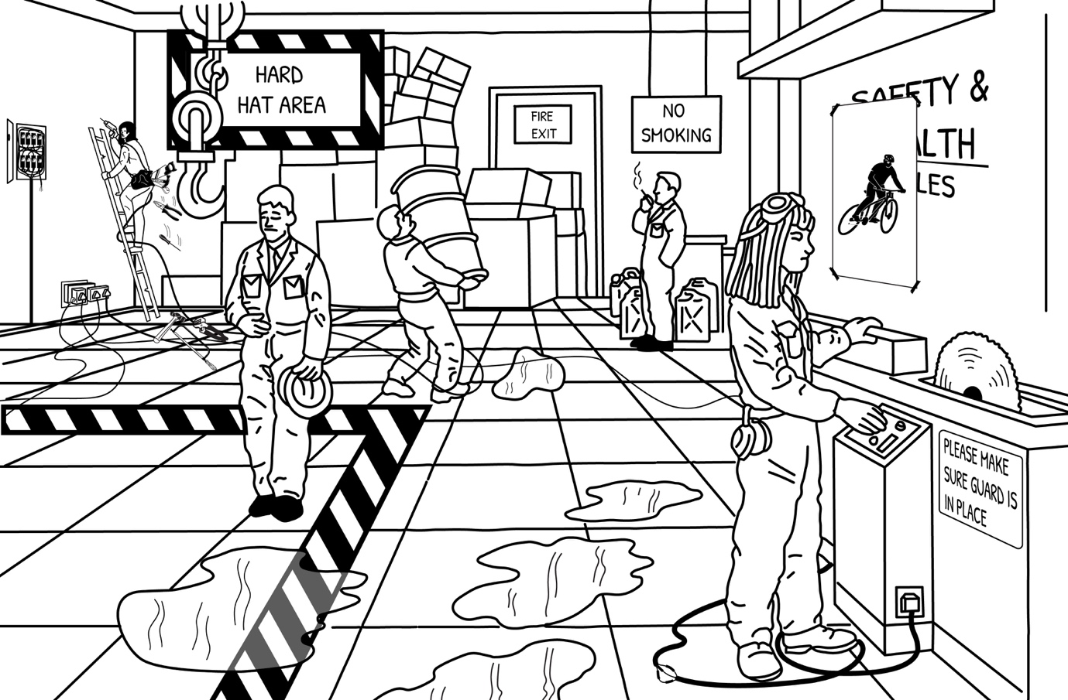

Figure 2: What could possibly go wrong at a workplace? (Source: Redrawn from internet image)

After having carefully studied the image, develop a set of 5 to 10 questions directly related to the safety issues illustrated in Figure 2, that you could discuss with your students; and link each question to the relevant section(s)/clause(s) in the 1993 OHS Act. A copy of the Act may be found at: <https://www.gov.za/sites/default/files/gcis_document/201409/act85of1993.pdf>.

Write the questions in your learning journal, together with the relevant clause references of the OHS Act. When developing each question, you should have in mind a clear solution for how to address the specific health or safety issue you have identified. If possible, share the questions with your colleagues for their views.

Discussion of the Activity

Issues of safety in the workplace are of paramount importance; you cannot start operations in any workplace before ensuring that safety measures are in place. Figure 2 depicts various safety issues; walkways are not clear of obstructions, wiring and cables are strewn all around and not properly coiled and stored, there are puddles of liquid on the floor representing a slipping hazard, the fire exit doorway is blocked by boxes, and personnel are not making use of PPE that has been provided to them, just to name a few. What kinds of questions did you set for your students? Did you include questions about the safe use of ladders? Using a hoist? Manual handling of heavy weights? Caring for and storing tools, clean surfaces? Appropriate Personal Protective Equipment? Was there anything else that you thought of? If you get a chance to discuss the questions with your own students, you can go further than the initial five questions, and get them to identify all the unsafe practices they can see in the image.

## Evaluating students’ misconceptions related to OHS

Stop and think

A misconception is a view or opinion that is incorrect because it is based on faulty thinking or understanding.

It is likely that as lecturers uncover students’ prior knowledge, several misconceptions will also be revealed.

The importance of uncovering prior knowledge and misconceptions, is that the lecturer then knows where to start when introducing a topic or where to focus his efforts in teaching the content.

As lecturers, we need to be aware of the common misconceptions that students may bring to our engineering classes. We can then plan our lessons and workshop sessions accordingly, to ensure that students can reinforce their correct preconceptions and understand why their erroneous conceptions are incorrect. Replacing misconceptions with correct understandings is not always easy, as sometimes these are deeply held. Misconceptions must be unlearnt. We therefore need to have techniques and strategies to both appraise students’ prior knowledge and to anticipate possible misconceptions, and then to use these insights to plan how best to sequence and structure or scaffold our teaching of any given topic or subject.

When evaluating students' misconceptions in the fields of electrical engineering, several techniques can be employed. Here are some examples:

**Use an anticipation guide:** This is an instructional tool used in education contexts to activate students' prior knowledge and/or misconceptions and to engage them in the learning process and stimulate their critical thinking skills. It is typically used before reading a text, starting a new topic, or introducing a lesson. This technique will be further explored in the next activity.

**Administer a conceptual test:** This is an effective technique to identify misconceptions. These tests typically present students with multiple-choice questions that require understanding of fundamental concepts. By analysing the responses, instructors can identify common misconceptions held by students.

**Administer questionnaires and surveys:** Designing questionnaires and surveys specifically targeted at probing misconceptions can help gather valuable insights. These can be distributed to students to assess their understanding of specific topics or concepts, allowing instructors to identify any prevalent misconceptions.

**Ask students to draw a concept map:** A concept map visually represents the relationships and connections between various concepts or ideas. It is a graphical tool that helps to organise and structure knowledge in a meaningful way and can assist in identifying any gaps or misconceptions. By examining students' concept maps, lecturers/facilitators can identify incorrect connections or missing links, which indicate misconceptions. This technique will also be further explored later in this unit.

**Set practical workshop tasks:** In electrical engineering, workshop practice can be used to assess students' practical understanding and identify any misconceptions related to the underlying principles. For example, observing students' conducting troubleshooting, analysing data, and discussing results can help uncover misconceptions they may hold.

**Implement a diagnostic assessment:** Ask questions about key concepts and get students to work out answers in pairs and then report back to the whole class. Follow this by facilitating a whole class discussion of the explanation provided, asking the students to diagnose or analyse whether the content reported on is correct or whether there are any misconceptions.

**Implement a formative assessment:** Regular formative assessments, such as quizzes or short assignments, can help identify misconceptions as they arise during the learning process. By providing immediate feedback and addressing misconceptions early on, instructors can prevent them from persisting and becoming entrenched. For more information visit this Australian webpage: <https://www1.curriculum.edu.au/sciencepd/teacher/assessment/resr_electricity.htm>.

Remember that creating a supportive and non-judgmental learning environment is crucial when evaluating students' misconceptions. It allows students to feel comfortable in expressing their ideas and enables instructors to effectively address and correct any misconceptions that arise.

In the following section we will explore two possible techniques for evaluating students’ misconceptions in more detail.

### Using an anticipation guide to evaluate students’ misconceptions

An anticipation guide consists of a list of statements or questions related to the upcoming content. These statements are designed to challenge students' assumptions, provoke discussion, and generate interest in the topic. The statements can be either true or false, or they can require a more nuanced response.

As stated above, an *anticipation guide* is used as a tool to activate students' prior knowledge and/or misconceptions and to engage them in the learning process. It is typically used before reading a text, starting a new topic, or introducing a lesson. The lecturer provides students with the anticipation guide before they start a new topic, whether it is being introduced through a discussion, a lecture or through reading a text related to the content that you plan to cover in the student’s study guide or textbook. The statements in the anticipation guide are based on key concepts, themes, or ideas that will be covered in the reading. In this instance, we would choose a text related to Health and Safety. An example of an anticipation guide is provided in Table 1 (in Activity 5a).

You can use an anticipation guide in several ways, including for:

* **Individual response:** Students read each statement and individually indicate whether they agree or disagree with each statement, often using a simple response format such as "A" for agree and "D" for disagree. They are encouraged to provide brief explanations for their choices.
* **Discussion:** Once students have completed their individual responses, the teacher facilitates a class discussion. Students share their opinions, reasons for their choices, and engage in debates about the statements. This encourages critical thinking and helps activate their prior knowledge.
* **Text exploration:** After the discussion, students read the assigned text or engage in the lesson related to the topic. They actively seek information that confirms or challenges their initial responses in the anticipation guide.
* **Post-reading reflection***:* After completing the reading or lesson, students revisit the anticipation guide and reconsider their initial responses. They compare their initial thoughts with what they have learned, revising their positions if necessary. This reflection encourages metacognition and helps reinforce their understanding of the topic.

By using anticipation guides, lecturers can assess students' misconceptions, foster engagement, build curiosity, and create a framework for active learning. It encourages students to take ownership of their learning, develop critical thinking skills, and make connections between their existing knowledge and new information.

The following two activities (5a and 5b) build on each other providing an opportunity for you to use an anticipation guide to identify and address students’ misconceptions related to occupational health and safety.

Activity 5a: Use an anticipation guide to evaluate students’ misconceptions on occupational health and safety

**Suggested time:** 30 minutes

The purpose of this activity is to learn how to evaluate students’ misconceptions using an Anticipation Guide.

One way of approaching the preparation of an *anticipation guide* is to provide students with a set of statements based on common misconceptions about any topic in engineering. In this case, the focus is on health and safety. Identify a misconception that you can discuss or get an example of a (TVET) student misconception and get your students to critique it.

If you have been lecturing in a TVET College for some time, you are likely to have a good idea about the kind of misconceptions that students typically have about health and safety in TVET workshops and workplaces. If you are new to teaching in a TVET College, you will need to give some careful thought to the issues what students may have misconceptions about. You could also google this topic and see what research on the topic reveals.

Use the Microsoft Word program or any other computer software on your computer to draw up a table like the one in Table 1 below. Copy the three misconceptions that have been included in the middle column (statement column) in Table 1, into your table.

Then think of four more possible misconceptions related to health and safety that your students may have and type them up into the middle column. Ideally your questions should not be too generic but should relate to an aspect of safety in the engineering workshop context. Think about safety in relation to work processes, tools, equipment, machinery etc. that your students are required to use during currently planned electrical engineering workshop practical sessions.

If possible, print out and make copies of your anticipation guide and try using it with one of your classes, to see how it works. Do this *before* your planned lecture or workshop session. After handing out copies of your anticipation guide to the students, ask them to work in pairs and to fill in the first column, in which they need to indicate whether they agree or disagree with the statement in the middle column.

Once your students have completed this short task, ask them to write their names on their anticipation guide and to hand them back to you.

**Table 1: Anticipation guide on evaluating misconceptions in health and safety**

**Student name/s:** _____________________________________________________________________

| Before class | | Statement | After class | | Reason |
| --- | --- | --- | --- | --- | --- |
| Agree | Disagree | Agree | Disagree | Why? |
|  |  | 1. A completely hazard-free workplace is impossible |  |  |  |
|  |  | 1. Health and safety is just common sense |  |  |  |
|  |  | 1. Some accidents are beyond our control and can just happen |  |  |  |
|  |  |  |  |  |  |
|  |  |  |  |  |  |
|  |  |  |  |  |  |
|  |  |  |  |  |  |

Take some time to carefully review and analyse your students’ responses. Make notes for yourself in which you record which students have misconceptions and which particular misconceptions they have. Also note which students do not have some or any misconceptions.

Discussion of the activity

Were you able to prepare and administer an anticipation guide to one or more of your classes? If so, we hope that this activity has helped you to get a better understanding of the misconceptions that your students have about occupational health and safety matters. Having identified the misconceptions that some or all students have and the knowledge gaps that have caused the students to hold these misconceptions, you can plan how best to address these misconceptions in your next lesson or workshop session.

Activity 5b: Plan and implement an activity-based lesson to address the misconceptions related to OHS identified using an anticipation guide

**Suggested time:** 60 minutes

The purpose of this activity is to implement a lesson in which students’ misconceptions, identified by using an anticipation guide, are addressed.

The steps below are intended to guide your planning:

1. Start by dividing your class into small groups and explain what the purpose of the lesson is and how the lesson will be structured.
2. Give each group one misconception to discuss and challenge them to explain and give reasons for why their misconception is incorrect. Allocate about 10 minutes for this discussion. Each group needs to elect one student to write down the group’s explanation of why the misconception is incorrect, and one student to report back to the whole class.
3. Invite each group to report back to the whole class on the misconception that they discussed.
4. After each group report-back, you should facilitate a whole class discussion in which you achieve consensus on why the misconception discussed is incorrect. Allocate about 20 minutes for the group report-backs and another 20 minutes for discussion.
5. Once all groups have reported back and agreement has been reached on why the misconceptions were incorrect, hand each student their anticipation guide which they had previously filled in. Ask them to now complete the information in the three last columns on the right-hand side of the anticipation guide (see Table 1, above).

### Note

To support your planning and preparation of a lesson to address the possible misconceptions held by your students, we discuss some of the most held misconceptions below. The first three relate to the first three statements contained in the exemplar anticipation guide in Table 1. You may draw on this content after the various groups have presented their feedback on each misconception to the class, and you are facilitating whole class discussions to reach consensus on why the misconceptions are incorrect

Think carefully about how much time to allocate for each component of the lesson. Here is a rough guide:

* Lesson Introduction: 5 minutes
* Group discussions: 10 minutes
* Groups feedback + whole class discussion on group feedback and consensus making on each item: 35 minutes
* Students’ individually complete their anticipation guide with reasons: 10 minutes

Total 60 minutes

**Misconception #1:** *A completely hazard-free workplace is impossible*

You may imagine that at least a few workplace injuries are inevitable, because predicting every outcome of every action taken doesn’t seem realistic (or likely). But this attitude could lead to completely preventable accidents occurring. You can achieve a hazard-free workplace, but it requires consistent discipline and dedication to recognise and mitigate every hazard.

To recognise hazards and control them, you and your workforce need to be situationally aware of both the hazards and the sources of these hazards:

• Energy

• Environment

• Equipment

• Employees (untrained people and those unwilling to behave safely)

Beyond this there must also be a universal willingness among all employees to take action to mitigate hazards.

**Misconception #2:** *Health and safety is just common sense*

Actually no. Although avoiding workplace injuries is possibly near the top of everyone’s agenda; a lack of knowledge can dampen the effect of even the best of intentions.

Employees perform tasks dangerously either because they don’t realise their behaviour is unsafe, or because they believe they may gain a payoff beyond the results of safe practices.

If you are an employer, it is your duty to regularly address safety, and this means providing adequate safety training for all employees, as often as they require it.

**Misconception #3:** *Some accidents are beyond our control and can just happen*

If you have a fatalistic view of the world, this will take away your personal power. Each individual worker has a great deal of power and control over the circumstances and situations around them. You and your colleagues (or employees) must understand the importance of knowing how to prevent personal injuries.

When you conduct a job briefing, you can reduce your risk by taking time to identify any hazards, then mitigating and controlling them. When you begin with the belief that you have no control, you will likely miss a hazard and, in turn, miss preparing yourself to prevent every injury. Engagement in hazard recognition and the control process for these, is the key to preventing injury.

**Misconception #4** *Workplace health and safety costs too much time and money*

Costs are unavoidable – you will have to spend some money implementing the safety measures necessary to uphold your workplace health and safety policies, such as training, equipment, and upgrading environmental elements. Of course, no company has an unlimited supply of time or money, but investing a little to prevent injuries and reduce risks will save you a lot more in the long run. The expenses you could incur to deal with a workplace injury or illness could end up being very significant and are often greater than the cost of preventative measures.

When you are deciding on which safety expenditures are essential, stop and consider the direct and indirect costs of even a minor injury. Add it up:

• Lost time of the injured PLUS

• Lost time required by others to attend to the injured PLUS

• Medical costs that can amount to thousands for a ‘simple’ injury

**Misconception #5:** *People are the cause of accidents*

This is not to say people don’t play a substantial role when accidents occur, but too often an unnecessary amount of the blame is focused on the people involved in an accident, with scant attention paid to mechanical or environmental factors that may have also contributed to the accident. Although there are situations where it is appropriate to blame the person for an error in their behaviour, this is only appropriate when it leads to future change.

**Misconception #6:** *Wrongdoers must be punished*

We are not saying that people who have acted unsafely (which has then led to an incident/accident) should not be held accountable for their actions. But, if a worker knows that they are bound to be punished for every infringement, they will go out of their way to avoid punishment and make it harder to enforce safety measures. Numerous studies have shown that conventional methods of punishment applied across the board have not been effective in improving safety after an incident has occurred. Consider a range of reprimands that you can apply to your unique situations.

**Misconception #7**: *It can’t happen to me*

This is often merely an excuse for not acting. Ensure that every person within your workplace is completely aware of the possible risks and how to manage and/or prevent them.

**Misconception #8:** *Relying solely on the ‘lost time injury frequency rate’[3] will give you a comprehensive and reliable measure of the company’s safety performance*

Sadly, this is not always true. For example, it is great if you have driven the Lost Time Injury Frequency Rate (LTIFR) down to a fraction of what it once was, but how hard should you pat yourself on the back if in just one workplace incident 11 people were killed?

Unfortunately, the LTIFR can trivialise serious personal damage. Use it, but not to the exclusion of any other measuring methods at your disposal.

**Misconception #9:** *Safety procedures are the answer*

A common mistake with safety management systems is they include extensive safety procedures – but workers do not know about them, care about them or use them! The procedures sit on the supervisor’s bookcase or a computer programme, with no one referring to them (or doing so on very rare occasions).

How do you approach the teaching of the health and safety issues?

Discussion of the activity

Did you find that the steps outlined in Activity 5b helped you to plan your lesson? Did you find the suggested time for each lesson step/component useful, or will you need to adjust the timing in the future? As lecturers, it is important to always spend a few minutes at the end of each lesson thinking about what went well and what may need to be done differently the next time you implement a similar lesson. This kind of reflection helps to strengthen teaching practice and professionalise lecturing in TVET colleges.

Were your students in their small-group discussions able to construct their own understanding of why each of the misconceptions was incorrect? Even if they were not able to get a full understanding of why each misconception was incorrect, it is important to provide students with an opportunity to think about problems and to actively build their own knowledge through interaction with peers. The whole class discussion after the breakout group activity provides an opportunity for you as a lecturer to mediate the discussion and help your students to consolidate new content knowledge and their learning in this field.

In Activities 5a and 5b an anticipation guide was used address misconceptions about occupational health and safety; but it is important to remember that as a tool, the anticipation guide can be used to address misconceptions related to any other aspect of TVET engineering curricula as well. This is regardless of whether it is applied in the National Accredited Technical Education Diploma (NATED) or in the National Certificate Vocational (NCV) programmes.

Through the previous activities, the first Unit 1 outcome, the evaluation of students’ prior knowledge and misconceptions regarding OHS, has been covered. We will now address, outcome 2, which is understanding the purpose of the OHS Act and consequences of non-compliance.

## Concept maps: Consolidating and linking new learning in relation to OHS

For students to consolidate and apply new learning, it is important that they can make connections and links between various concepts or ideas.

In Activity 4, concept maps are listed as a possible technique for evaluating students’ misconceptions. This technique can however, *also* be used as a method of students consolidating what they have learnt by representing it in a visual summary to reinforce learning.

To reiterate, a concept map is a visual representation (drawing or diagram) of the relationships and connections between various concepts or ideas. It is a graphical tool that helps to organise and structure knowledge in a meaningful way. Concept maps are a useful way of promoting active learning by encouraging students to organise and link their knowledge. They help students to identify the main concepts, their relationships, and the hierarchy of information, making it easier to grasp and remember.

Stop and think

Concept maps enable individuals to see the big picture, make connections, and gain a deeper understanding of complex ideas and relationships.

The following activity has two interrelated parts; in Activity 6a you will prepare 2 concept maps, then in Activity 6b, you will set the same task for your students to complete.

Activity 6a: Prepare concept maps related to the OHS Act

**Suggested time:** 30 minutes.

In this activity you are asked to prepare one concept map which visually depicts the purpose of having OHS regulations and one depicting the consequences of not complying with them.

1. Your concept map should answer the question: What is the purpose of occupational health and safety regulations?
2. Start by identifying the key concepts that explain the purpose of OHS regulations; you may want to brainstorm these with a colleague. Jot them down in your learning journal.
3. Think about how you would like to present this information visually. In particular, think about the sequence in which you present the information and how you will show the linkages.
4. Present the key concepts that explain the purpose of OHS regulations in a graphical (drawn) format. You can use the smart art graphic function in MS Word to generate a hierarchical block list like in the example below; or any other digital application; or any other suitable software platform or simply use a pencil to make a diagrammatic drawing in your learning journal.
5. The diagram or graphical representation needs to identify the main concepts related to the purpose of having OHS regulations, and to show the hierarchy of information - the rank and order in which information is presented and the relationships and connections between various concepts or ideas.
6. Refer to the example in Figure 3, below, to help you to design your concept map.

**Figure 3: Example to follow to start designing a concept map showing the purpose of OHS regulations**

1. Once you have completed preparing a concept map that summaries the key concepts that show the purpose of having OHS regulations, prepare another similar concept map, this time, depicting the *consequences of not complying with occupational health and safety regulations*.
2. Refer to the example in Figure 4, below, to help you to design your second concept map.

**Figure 4: Example to follow to start designing a concept map showing the consequences of not complying with OHS regulations**

Discussion of the activity

**Concept map showing the purpose of OHS regulations and role players’ responsibilities**

When you started planning how to present the information in a concept map, did you start by jotting down what *the overall purpose of OHS regulations* is? The overall purpose that needs to be highlighted in this concept map, is that the *primary goal of these regulations is to create a safe and healthy work environment*.

Branching out from the overall purpose are two key concepts, namely, that the OHS regulations aim to protect or *safeguard employees* from workplace hazards, injuries, and illnesses, *and* at the same time are intended to *promote employer responsibility* to provide a safe workplace and to comply with the regulations.

Then, branching from the need to *safeguard employees* is the need to minimise and*prevent workplace accidents*and generally to*ensure the physical and mental well-being of workers* by focusing on *reducing the occurrence of work-related injuries* and illnesses by providing *adequate safety equipment* and resources to safeguard employee health and well-being.

While one of the objectives under *promoting employer-responsibility*, is to emphasise the need for *employers to implement and enforce safety policies* and procedures and to *maintain compliance* with safety standards by highlighting the need for employers to *provide training and education to employees* regarding safe work practices; and conducting *regular inspections* to identify and address potential hazards or non-compliance.

This concept map demonstrates how the purpose of occupational health and safety regulations encompasses various objectives aimed at ensuring a safe and healthy work environment for employees while promoting employer responsibility and maintaining compliance with the regulations.

Figure 5, below, provides an example of a concept map that shows the purpose of OHS regulations, highlighting the key issues and concepts and how they are linked to each other.

**Figure 5: Example of a concept map that shows the purpose of OHS regulations**

**Concept map depicting the consequences of not complying with OHS regulations**

Revisit your *consequences of not complying with OHS regulation concept map*and assess whether you have included the same or similar potential consequences that can arise from failing to comply with occupational health and safety regulations, as discussed below.

As in the concept map setting out the purpose of OHS regulations, the consequence of non-compliance concept map is also structured around *two main branches – employees and employers.*

The central themes of the concept map emphasise that non-compliance can lead to *legal consequences* for the organization as well as have a *human cost.*

The *legal consequences* of non-compliance for the company or organisation include *fines and penalties* administered by the Inspections and Enforcement Services Branch: Occupational Health and Safety of the Department of Labour. In severe cases, employers may face *criminal charges for negligence* or wilful violations of occupational health and safety regulations. These may result in *legal claims from affected employees*or their families and can result in negative publicity and damage the reputation of the organisation.

*The human costs*are the potential harm and impact on individuals resulting from non-compliance. This includes the increased risk of workplace injuries and illnesses for employees which can have a significant emotional and physical toll on affected employees and their families. In extreme cases, failure to comply with safety regulations can result in fatal accidents or incidents.

This concept map demonstrates that the consequences of not complying with occupational health and safety regulations extend beyond legal penalties. Non-compliance can result in financial ramifications, criminal liability, lawsuits, reputational damage, harm to employees, and even loss of life. It highlights the importance of adhering to these regulations to ensure the safety and well-being of employees and the sustainability of the organisation.

Figure 6, below, provides an example of a concept map that shows the consequences of not complying with OHS regulations. Look at it carefully and see how it compares with your concept map? Are there elements in this example that you may not have included in your map? Conversely, have you identified any important elements that have not been included in the example below?

**Figure 6: Example of a concept map that shows the consequences of not complying with OHS regulations**

Now that you have had practice in designing and preparing concept maps, the next step is to put into practice and implement what you have learnt with your students. As mentioned above, preparing a concept map is a technique for supporting students to summarise their understanding of a particular topic or issue in a concise manner. It is also an opportunity for both you as a lecturer and for your students to apply what has been learnt.

For lecturers it is an opportunity to plan and implement another activity-based lesson to support your students to consolidate their learning related to OHS. Also, as stated above, concept maps are also useful as teaching tools for identifying gaps or misconceptions as well; while for students it is an opportunity to learn a new study skill, i.e., a technique for summarising key concepts.

Activity 6b: Use concept maps as a teaching and learning tool: Support students to consolidate knowledge

**Suggested time:** 90 minutes (30 minutes preparation and 60 minutes lesson)

The purpose of this activity is to provide lecturers with the opportunity to implement a lesson in which their students learn to design and use a concept map as a tool to consolidate their own learning.

1. Prepare a lesson plan using the template provided in Appendix 2:
   1. Topic: *Prepare a concept map that shows the purpose* *of OHS regulations*.
   2. Lesson purpose/objectives or outcomes *(what should your students be able to know and do at the of the lesson?)*.
   3. Decide how students will prepare their concept maps; will they do so using pencil and paper or will they do it on a computer in the College computer lab?
   4. List and prepare any resources that you may need for this lesson.
   5. Briefly describe lesson steps/processes *(what will you do first, how will you introduce the topic, do you need to remind of/recap any OHS content first? What new content – knowledge and skills will you cover? Explain what a concept map is, what are concept maps used for, and how to go about designing or constructing a concept map? What will your students do?)*.
   6. Describe the learning activity that students will undertake *(describe steps which students need to follow to complete the concept mapping activity).*
   7. Once all students have completed the task, ask students to share their work and facilitate a class discussion to confirm the key concepts.

Discussion of the activity

Did preparing your own concept map before teaching this lesson help you in your planning and in the lesson implementation?

Did you discuss the purpose of a concept map with your students? Did your discussion include explaining that concept maps are used to represent visually, the relationships and connections between various concepts or ideas? A concept map is a graphical tool that helps to organise and structure knowledge in a meaningful way.

Concept maps can be used for a variety of purposes, including understanding and learning. They can promote active learning by encouraging learners to organise and link their knowledge. They help learners to identify the main concepts, their relationships, and the hierarchy of information. Concept maps can also be used as an assessment tool to evaluate the understanding and knowledge of individuals. They allow for the identification of gaps or misconceptions in understanding.

In your discussion at the end of your lesson with your students, did you ask your students to summarise their key learnings from the concept mapping activity? It is always a good idea to get your students to reflect on new content and skills as this is a way of reinforcing new learning.

## In conclusion

The purpose of the OHS Act is to promote and maintain safe and healthy working conditions in the workplace. It sets out the rights and responsibilities of employers, supervisors, and workers to ensure the protection of their health and safety. The act typically applies to most workplaces and industries, aiming to prevent accidents, injuries, and occupational illnesses.

Complying with the OHS Act is crucial to ensure the well-being of workers, avoid legal consequences, protect the organisation's reputation, and maintain a productive work environment. It is essential for employers to prioritise workplace safety, implement necessary safety measures, provide adequate training, and regularly assess and address potential hazards to maintain compliance with OHS regulations.

As a TVET lecturer/facilitator, it is important to ensure that your students acquire the necessary knowledge, skills and risk identification and prevention behaviours required to safely operate in both college workshops and eventually in the workplace. This requires that occupational health and safety concepts and content are well integrated into all engineering programmes. To do this well, lecturers need to intentionally employ teaching methodologies and techniques that are tried and tested and that are known to support learning. These include eliciting and building on students’ prior knowledge; identifying misconceptions (if any exist) and engaging students in active learning by promoting a practical approach to learning about health and safety that allows students to develop prevention practices alongside functional job-related skills.

# Unit 2: How to teach the principles of electricity

## Introduction

You want to effectively teach the principles of electricity to your TVET students as a basis for them to learn new knowledge in the core learning area of Electrical Infrastructure and Construction. How do you go about it?

In this Unit, we explore possible approaches to the teaching of the principles of electricity. The sequence of the teaching process begins with you, the lecturer, getting to know what the students already know, including their misconceptions (introduced in Unit 1) of what are deemed *difficult concepts*. In Unit 1 we looked at various ways of determining what conceptions students bring with them to the classroom that form the basis for learning new knowledge. In the present Unit, we make further use of the ‘anticipation guide exercise’. We are exploring this technique, but as a TVET lecturer, it is your responsibility to explore other techniques. Your choice of which technique or combination of various techniques to use is a decision that you must make and depends on context and experience.

After establishing what the students know, you will notice that some of their knowledge is correct, but that they also hold some misconceptions. Furthermore, in the new knowledge that you want to teach them, there are also difficult concepts. The question is, how do you approach your teaching so that the students more easily access these difficult concepts. There are different techniques of breaking down large pieces of knowledge (big chunks) into smaller pieces to allow the students to make sense of the big chunks. In the present Unit, we present an example of a map of the key concepts (also referred to as *big ideas*) in electricity, together with examples of how to explain the concepts in a simplified manner. You are expected to either modify or create your own map of big ideas in electricity depending on the specific context of the content you are teaching.

Using the big ideas map, you then move on to the stage of unpacking these ideas for the students to make sense of them. With electricity, most concepts are abstract and that is what makes it difficult to comprehend them. A common approach to simplifying abstract ideas is the use of analogies. In this Unit, we discuss examples of such analogies. If you grasp the concept of analogies in explaining difficult ideas, then you will be equipped with knowledge and skills to search for existing and even formulate your own new analogies to improve students’ access to difficult concepts of electricity.

The approach in this module is to give you the conceptual framework on how to formulate your own pedagogy. It is not intended to prescribe a lesson plan, teaching recipe or blow-by-blow instructions on how to teach.

Unit 2 learning outcomes

By the end of this Unit, you should be able to:

1. Demonstrate techniques of evaluating students’ prior knowledge and misconceptions of electricity.
2. Identify that which makes it difficult to understand concepts of electricity.
3. Suggest, select, and use appropriate strategies to teach difficult concepts of electricity.

## Understanding how to teach the concepts of electricity

Imagine a life without electricity…….

* You open the door into your room and the first thing you do is flip the light switch on, but there is no light. You press on the TV remote control, but the TV does not light up.
* You open the refrigerator door to grab a glass of cold water, but the water is warm.
* You switch on your kettle for a cup of coffee, but the kettle does not heat up.
* You pull out your cell phone to call someone to say that something is wrong in the house, but the cell phone is dead.

In South Africa 2023, what comes into mind immediately is the controlled power cuts (load shedding) implemented by the power utility companies to avoid complete power grid collapse due to system overload. Electricity is now as essential to us as the air that we breathe. We often are not conscious of our breathing until someone chokes. Think of how similar this is to our dependence on electricity. Furthermore, just as air is invisible so is electricity. We only realise the importance of electricity when we flip on a switch and the light does not come on. In essence, the presence of electricity is only known through its effects. Electricity is critically essential to our lives, but do we understand what electricity is?

Can you explain the nature of electricity to a TVET student in an electrical infrastructure and construction programme? One of the most useful teaching approaches in this regard is to first evaluate what the students already know (prior knowledge) including misconceptions as presented in the next section.

## Evaluating students’ prior knowledge on electricity

Did you know that the brain disengages when it thinks it already knows something? One way to jump-start the brain out of its slumbering state is to give it startling or interesting information that it knows or doesn’t know such as ‘did you know that the human body uses electricity and without it, our heart will stop pumping blood’? Think of other examples that are relevant to the content that you are teaching and how you could unearth interesting facts to trigger the students’ curiosity about the new knowledge.

Determination of prior knowledge of students helps both the lecturer and the student in that it assists the lecturer to know from where to begin teaching the class and how to keep the students engaged and interested in the topic at hand by asking the right questions to test their understanding of the subject. It also assists the students to keep pace with the rate of engagement with the new knowledge.

One of the methods of evaluating students’ prior knowledge we introduced in Unit 1 is using an ‘*Anticipation Guide’*. Anticipation guides are a list of statements related to key concepts about the new knowledge. Before beginning your lesson, let the students either listen to or read the statements and then let them indicate whether they agree or disagree and why? This strategy elicits a response from the students based on their prior knowledge and misconceptions. The exercise builds curiosity in students as they will want to find facts to either confirm their existing ideas about the content or give them reasons to rethink them. Anticipation guides assist the students in setting a purpose for learning. Both you and the students revisit the anticipation guide after the lesson presentation to evaluate if the students still agree with their initial decisions and why.

An example of an anticipation statement is, ‘In electrocution, what kills is voltage and not current’. One can either agree or disagree but must give reasons.

Activity 7: Using an Anticipation Guide to evaluate students’ prior knowledge

**Suggested time:** 30 minutes

In your learning journal, carry out the following activity 7 as an example of what your students can also do in helping you to evaluate their prior knowledge.

Writing anticipation statements takes some thinking and good anticipation guide statements should:

1. Focus on the information you want your students to think about which relates to the learning outcomes.
2. Be based on the information in the course materials that either supports or opposes the statement.
3. Challenge students’ beliefs.
4. Be general rather than specific.

Instructions on how to use an anticipation guide:

1. Create an anticipation guide with 3-6 statements which are relevant to the learning objectives, as shown in the Table 2 template below. In Table 2 the examples of anticipation statements relate to the knowledge area of magnetism. You are encouraged to follow the same line of thought but instead formulate similar anticipation statements in the **knowledge area of electricity**.
2. If you get a chance to present this to students, allow them to complete the anticipation guide on their own. Explain to students that the anticipation guide is designed to assess their prior knowledge and get them thinking about the upcoming topic. Emphasize that there are no right or wrong answers at this stage. If possible, print out and make copies of the guide. Do this before your planned lecture or workshop session.
3. After handing out copies of your anticipation guide to the students, then ask them to discuss their responses with a partner or small group. After the brief discussion, give students the opportunity to change their responses if they want to.
4. Students read and/or listen and engage with your interactive lecture with the purpose of finding information about the statements and should be allowed to change their responses if they want to.

**Table 2: Anticipation guide (evaluating prior knowledge and misconceptions)**

|  |  |  |  |  |  |
| --- | --- | --- | --- | --- | --- |
| Before class | | Statement | After class | | Reason |
| Agree | **Disagree** | **Agree** | **Disagree** | **Why?** |
|  |  | 1. If the earth was not a big magnet, compasses used for direction tracking could not work. |  |  |  |
|  |  | 1. Elements that have magnetic properties have unique electron arrangements in their atoms. |  |  |  |
|  |  | 1. The force of gravity on objects is due to their magnetic attraction by the earth. |  |  |  |
|  |  |  |  |  |  |
|  |  |  |  |  |  |
|  |  |  |  |  |  |

Discussion of the activity

The aim of the anticipation guide, if implemented properly, is to improve information retention while making learning new knowledge fun and engaging. We hope that this activity has helped you to get a better understanding of the misconceptions that your students have about electricity. Next, conduct a short class discussion about the statements before presenting the new material. Ask students to explain why they agree or disagree. At the end of the class, once again, conduct a brief class discussion and ask students if they have changed their minds about any of the statements. Ask them to supply specific examples from the course material. This exercise allows you to identify students’ prior knowledge including misconceptions and gaps as an important step towards constructing new knowledge. It is important to note that among the information revealed through prior knowledge and misconceptions diagnosis are big ideas in the subject matter. By using an anticipation guide, you can effectively assess your students' prior knowledge, activate their thinking, and address any misconceptions or knowledge gaps before teaching a topic. It sets the stage for meaningful learning and can guide your teaching and learning strategies accordingly

Evaluating students’ misconceptions about electricity

There are various techniques of evaluating students’ prior knowledge including misconceptions. Here, we present suggestions on how to engage with misconceptions in Activity 8.

Activity 8: Engaging with misconceptions on electricity

**Suggested time:** 60 minutes

Use your learning journal to work on the following activity.

Using your own knowledge of your students and the Electrical Infrastructure and Construction field at TVET colleges, list three misconceptions about electricity that you think your students hold. Next, think of how you might dispel these misconceptions by doing something practical but simple in class or in your workshop. Copy and complete Table 3 illustrating the misconception and possible activity to encourage students to understand the true science.

Table 3

|  |  |  |
| --- | --- | --- |
| **Misconception** | **Correct scientific understanding** | **Activity to dispel misconception** |
| Example:  Electrons start at the negative terminal of a battery, and rush at nearly the speed of light through empty wires. | Wires are already full of free electrons. They move along the wires very slowly but everywhere at the same time, like a wheel. | Battery (e.g., AA battery)  Small light bulb or LED  Wire (insulated copper wire)  Battery holder or alligator clips (to connect the battery and wire) |
| 1. |  |  |
| 2. |  |  |
| 3. |  |  |

Discussion of the activity

Debunking misconceptions is an important step towards introducing new concepts. Whenever you teach a new concept, we suggest that you carry out a classroom-based diagnosis technique of the misconceptions held by the students. Ensure that you fully discuss what is happening in the activity, so that learning occurs. If you are not familiar with all the misconceptions that students hold about a particular topic, you can look them up online.

Some misconceptions about electricity are available at the following links:

<https://www.toppr.com/ask/content/posts/electricity/common-misconceptions-21886/>.

<https://iopscience.iop.org/article/10.1088/1742-6596/1108/1/012088/pdf>.

Now that we have identified the students’ prior knowledge together with what they may hold as misconceptions, we need to mediate the students’ construction of new knowledge. An example of a best practice teaching approach on introducing new concepts is the ‘big ideas’ approach. The next section is an example of an activity to reinforce the learning by working through the big ideas on electricity.

## Big Ideas

The concept of big ideas in any knowledge area connects and organises many facts, skills, and experiences, thus serving as a cornerstone of understanding. In this unit we place big ideas into a map (chart) of reference points that hold together related content of knowledge. Big ideas in science education, that form part of the basis of electrical engineering, are well described on the following website: <https://thescienceteacher.co.uk/big-ideas/>.

The generic concept of big ideas is relevant at any level of science and engineering. A big idea is a statement that encompasses several concepts and brings to the fore what teacher(s) see as crucial for learners to know to develop an understanding of a particular topic or major concept. Figure 7 shows a concept diagram for electric circuits. The words inside the boxes can be regarded as concepts in the sub-field of electric circuits.

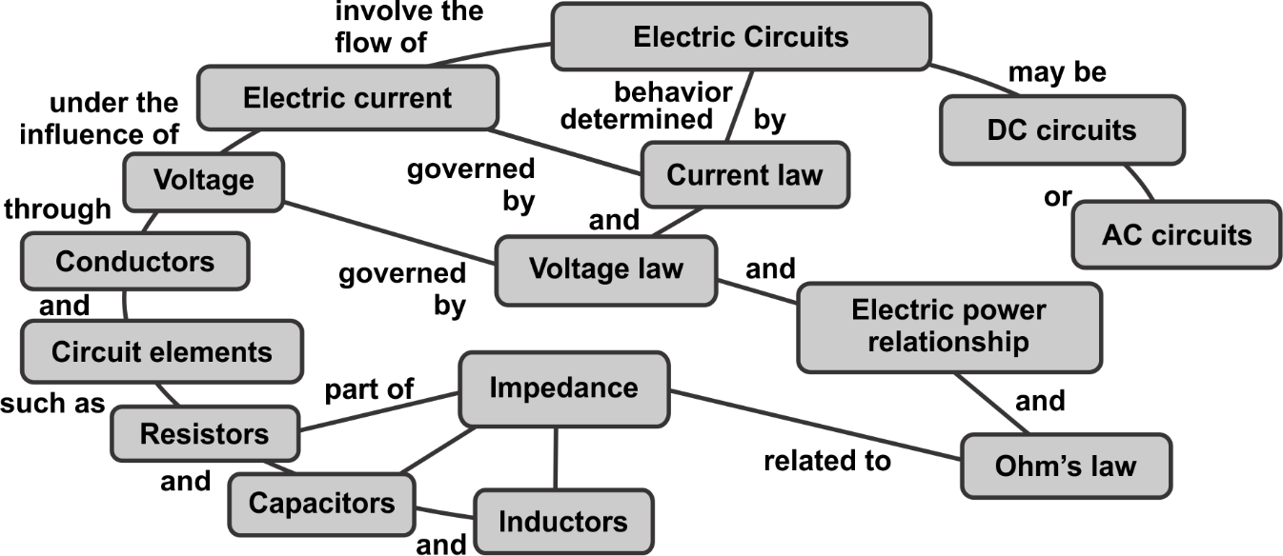

Figure 7: Concept diagram for electric charge (Source: Redrawn from <http://hyperphysics.phy-astr.gsu.edu/hbase/electric/ecircon.html>)

Up to this point in the module we have shown you how you may obtain a good understanding of what your students already know, both correct knowledge and some misunderstandings. We have introduced the concept of big ideas. You now need to proceed to the next stage of the teaching of concepts of electricity (identifying that which makes it difficult to understand concepts of electricity; the second learning outcome of Unit 2) by building on the students’ prior knowledge.

Let’s begin by doing another activity as explained below.

Activity 9: Working through the big ideas in the topic *electricity*

**Suggested time:** 30 minutes.

Complete the following exercise and do it in your reflective learning journal.

Refer to activities 7 and 8, and your own knowledge about the teaching of electricity to students. Try and trace out a common thread that connects common big idea words on electricity and concepts that are wrongly understood about electricity.

1. List down key words that represent big ideas about electricity.
2. Create a big idea chart like that given in Figure 7, but for the whole of the topic of electricity as taught to NCV students at TVET colleges. Ensure that your big ideas are big, for example you should include electric circuit, electric current, among others.

Discussion of the activity

As a lecturer you need to develop skills of mapping out those difficult and abstract ideas that make knowledge difficult to be understood by students. In the next section, let us explore an example of such a big idea chart for electricity.

As the mother hen that identifies big food chunks to crush for the chicks to pick at, the big concepts in electricity knowledge can be represented as in the chart in Figure 8. The lecturer makes decisions on how to structure them in a specific way depending on the intention of the specific lecture. The chart becomes a useful road map of sequencing the crushing of the big chunks.

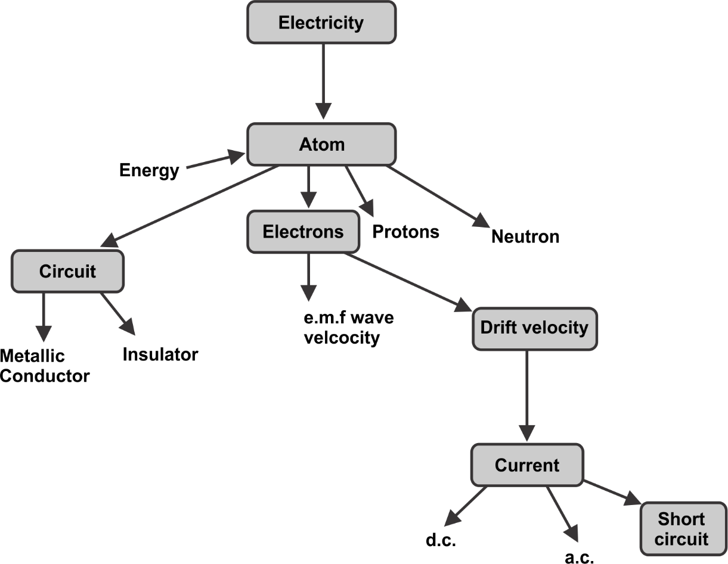

**Figure 8: Big ideas of electricity related to the context of this module**

In Figure 8, the big ideas are illustrated as encircled words. Each big idea is linked to the next through a sketched line. Attached to each big idea are subordinate (smaller) ideas. As it is up to you, the lecturer, to identify the big and subordinate ideas, you must as well think of how to link up these ideas in a way that helps to explain the subject matter at hand. Development of a big idea chart for a given topic is an important teaching skill of a TVET lecturer.

You may use the know *H*ow, know *I*t and know *T*hat (HIT) framework approach to learning (see *Programme Introduction*, and the AdvDipTVT module called *Psychology of Education for TVET*).

Of particular importance is Unit 1 (Knowledge and Learning in TVET) in the *Psychology of Education* module. For you to develop a big idea map as a tool for use in teaching difficult concepts in a knowledge area, you need to be equipped with three kinds of knowledge/skill. You need the knowledge of searching for and recognising the big ideas in the topic that you need to teach. Such knowledge is referred to as ‘*knowing that’*. It is cognitive knowledge which you must acquire through inquisitive engagement with the content of the topic of interest. This includes how the content fits into the bigger picture of the TVET. As a TVET lecturer, you need to have the ‘*knowing that’* knowledge in the learning area of electricity at TVET qualification level. Your pre-requisite qualification to be a TVET lecturer in Electrical Infrastructure and Construction core learning area is proof that you have the cognitive knowledge on electricity at the required level. You may need to refresh your knowledge content on electricity concepts. It speaks to the need for you as a TVET lecturer to continuously upgrade your cognitive knowledge on the technology of electricity.

After identifying the big and subordinate ideas, you proceed and map out these ideas in a manner such as illustrated in Figure 8. This is a procedural activity that requires a ‘*knowing ho*w’ skill and knowledge. In the context of electricity, the competency of drawing out the big idea chart is a function of experience as a lecturer in teaching students to understand difficult concepts. Practical experience as an electrical technologist is also helpful in developing the ‘*know how’* competence area. It is helpful for you to note that experience is only useful as an important aspect of continuous professional development, if you make a habit of using learning journals in your professional practice.

The third leg of the HIT framework is the knowing it. You need to judge whether the big and subordinate ideas map that you have developed, counts as a good example of a useful tool in effectively teaching a complex topic. The act of such judgement or evaluation requires experience and wisdom in the knowledge area of interest, and in the current context, it is electricity.

So far in this unit, we have used two examples of evaluating prior knowledge and misconceptions and proceeded to discuss how to draw out difficult concepts within the electricity topic. Remember that we covered other ways of evaluating prior knowledge in Unit 1, which you may use when teaching the electricity topic. After properly engaging with the various alternative ways of evaluating students’ prior knowledge you are now ready for the next learning outcome: ‘*Identify that which makes it difficult to understand concepts of electricity*’.

Let us return to the example of how to teach the concepts of electricity. The example of a big idea chart has been presented in Figure 8. In the figure, the big ideas are highlighted inside boxes and interrelated using arrows. Now we need to simplify these big ideas. The pre-requisite knowledge for such a process is the “knowing that” category of knowledge in the HIT framework. We suggest unpacking each big idea presented in the chart of Figure 8 in a manner that the student will more easily understand. The strategy is to highlight the following for each big idea: (i) what aspects of the big idea are difficult to understand; (ii) Use of ‘*did you know?*’ questions as a means of simplifying the big idea; and (iii) use of appropriate analogies in explaining the concept. This is intended to cover outcome 3 of this unit: what strategies can you use to teach the difficult concepts?

We have identified five big ideas here for elaboration with strategies to teach them: electricity, atoms, electric current, electron drift velocity, and direct & alternating current. We elaborate these into activities 10 and 11.

## Examples of how to unpack difficult concepts in the electricity topic

**Big idea**: Electricity

**What makes it difficult**: It is an abstract phenomenon, manifests in different forms e.g., as light, heat, force, commutation signal, sound etc.

**Strategy to simplify the big idea**: Use of ‘*did you know?*’ question: The word ‘*electricity*’ comes from the Greek word *Elektron*, which was their word for amber. An electron is a component of an atom and therefore the word ‘*atom*’ becomes the next big idea to be unpacked when exploring the concepts of electricity.

**Use of analogies, models and activities:** You may want to find out more about what amber is and read about electric charge at the following link:

<https://iu.pressbooks.pub/openstaxcollegephysics/chapter/static-electricity-and-charge-conservation-of-charge/>.

**Big idea**: Atom

**What makes it difficult**: Very abstract, invisible.

**Strategy to simplify the big idea**: Use of ‘*did you know?*’ question: Did you know that all matter is made of atoms. An atom is too tiny to be seen by the naked eye and is the smallest form of matter that cannot be chemically broken down any further. However, atoms themselves are made up of smaller particles. These particles are charged with two kinds of electricity, which are negative (electrons*: e-* in Figure 9) and positive (protons: *+* in Figure 9).

Atoms of different elements of matter differ from each other by the number of electrons, and the corresponding protons and neutrons that also attract each other. In fact, electrons are free to orbit the nucleus of the atom that consists of stationary neutrons and protons. The electrons however are not free to escape from the atom due to the attraction by the protons. Since an atom contains the same number of electrons and protons, the charged particles balance each other so that the whole atom shows no net charge. However, if an electron is provided with enough energy, it frees itself from the clutches of the atom, leaving behind a net positively charged atom which becomes a positive ion. But the freedom of the electron will only last as long as the energy that the electron contains is available, otherwise the electron will be attracted back to the atom.

Having understood the concept of electrons and protons behaviour in atoms, human beings decided to use this behaviour to their own benefit. We give the electrons energy either through chemical reactions in a battery, photovoltaic action in solar panels or electromagnetic induction in alternating machines. Once the electrons have acquired the energy, we direct them through a path that they easily flow along with minimum hindrance until they pass through a gadget, appliance, or machine that extracts the energy from the electrons and converts this energy to any form useful to us such as heat in a kettle or light in a bulb. We then direct the ‘tired’ electrons back to their “mother atoms” where they are received by their proton counterparts, and the cycle repeats. *Electrical energy utilisation is therefore through the movement of electrons*. The rate of flow of electrons is current. Therefore, the term current is a big idea in electricity and needs to be well understood. There is a common misconception on current that charge (electrons) flows through circuits at very high speeds. This misunderstanding must be unlearned, and we will do this by first explaining current as comprising of drifting electrons. The latter becomes another big idea to be unpacked.

**Use of analogies, models and activities:**

The main analogy used to represent an atom is the “planetary model” (Figure 9). In the model the nucleus is shown at the centre of the image (equivalent to the Sun in our solar system), surrounded by electrons that represent planets in a solar system. The model can be useful at a superficial level, as it shows a central massive body surrounded by orbiting bodies. However, the analogy breaks down when considering features such as size, the nature of attraction (electrical in the atom/gravitational in the solar system) and the nature of the orbiting bodies (electrons vs planets).

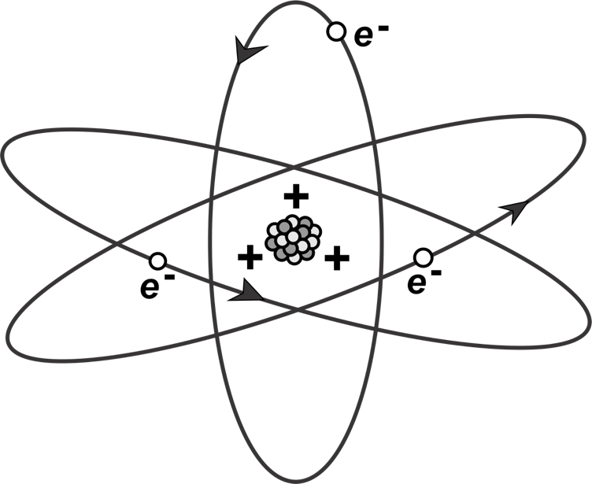

**Figure 9. Simplified (and not to scale) view of an atom is called the planetary model of the atom (Redrawn from** [**https://pressbooks.bccampus.ca/collegephysics/wp-content/uploads/sites/29/2016/04/Figure_19_01_03a.jpg**](https://pressbooks.bccampus.ca/collegephysics/wp-content/uploads/sites/29/2016/04/Figure_19_01_03a.jpg)**.)**

**Big idea**: Electric current

**What makes it difficult**: Rate of flow of charge that is invisible.

**Strategy to simplify the big idea**: The path of the electrons (current) is made up of metal wires as copper and aluminium that allow electrons to move with little hindrance. Electrons must be kept in their rightful path, and this is done in electric circuits by covering (insulating) the metallic wires with a material that does not allow electrons to move freely. Examples of such material are plastic, epoxy, air, rubber etc.

As soon as you switch on the torch, a path is established between one of the battery terminals where electrons are crowded (negative pole) with the other part of the battery where the positive ions (positive pole) are crowded. These electrons and protons are forced apart in the atoms of the battery material by a chemical reaction. The moment the switch is closed, the electrons on the wire end, in contact with the negative terminal of the battery, experience a push force. The force is called electromotive force (emf). This force (disturbance) travels down the wire at nearly the speed of light (3x108 m/s) through the torch bulb element to the opposite end of the wire in contact with the positive terminal of the battery. It is not influenced by voltage magnitude or current. This explains why the torch lights up instantly when flipping the switch. The force causes every electron in the torch element and rest of the wire to drift towards the direction of the battery positive terminal. In the rest of the wire the electron drift is minimally hindered as the wire being a metal has low resistance and the electrons are free to move.

**Use of analogies, models and activities:** Energetic electrons are reluctant to be directed to the appliance to do work. They look for the shortest route back to the source … and if they find a path to ‘*sneak out’*, they do so in a rushed manner and consequently give out all their energy in the process. Such energy often appears as fire which is called electric fire. The sneak-out event is called a short-circuit which is undesirable as it deprives the appliances of the supply of energetic electrons and causes electric fire. If you touch a bare conductor that is carrying electricity, electrons can flow through the body because the human body has salty fluids (ionised liquids). The body becomes a sneak-away path of electrons and this is how we get an electric shock. Notably, water comprises charged particles (ions) and therefore pouring water does not put out an electric fire as the electrons will simply take an improved sneak-away path.

Watch the following video: *What will happen if you put water on an electrical fire?* <https://youtu.be/2oekc2_XbCI>.

**Big idea**: Electron Drift Velocity

**What makes it difficult**: An invisible phenomenon.

**Strategy to simplify the big idea**: This drift of electrons is called current. The speed at which the charges drift in the conductor is called charge or drift velocity. The speed is quite low contrary to some misconceptions in this regard. It is in the order of half a cm per minute. The speed with which the effect of the emf is experienced in all parts of the conductor resulting a current flow is called the velocity of propagation of the electric field. The way the electrons drift, depends on whether the type of current is direct current (DC) or alternating current (AC). The two phases become another pair of big ideas in electricity and need to be unpacked.

**Use of analogies, models and activities:** In the element of the torch, the atoms do not allow easy movement of electrons (high resistance) and as a result the electrons ‘squeeze’ their way through the atoms and in doing so give out their energy in the form of heat and light.

**Big idea**: Direct current (DC) and alternating current (AC)

**What makes it difficult**: Since current is an invisible phenomenon, whether it is direct or alternating becomes even more difficult to conceptualise.

**Strategy to simplify the big idea**: If the source of the electric current is such that the electrons drift in one direction, then it is direct current (DC) electricity. Alternatively, the charge polarity on the terminals of the electricity current source can change cyclically from positive to negative many times within a second and this is called the frequency of the current measured in hertz (Hz). This type of electricity is called alternating current (AC). Alternating current sources include inverters such as those in solar photo voltaic systems and alternating electromechanical machines such as electricity generators.

**Use of analogies, models and activities:** See Activity 10: Comparing and contrasting DC and AC electricity.

Let’s do an activity that will help you formulate a means of identifying and developing the different kind of knowledge and skills held by yourself as an expert in using the big ideas mapping technique for teaching a knowledge area such as principles of electricity at a TVET college.

Activity 10: Understanding the concept of electric current using electron drift velocity

**Suggested time:** 30 minutes

Read the following explanations and analogies of electric current and electron drift velocity.

### Electric current

| Science concept | Analogy |
| --- | --- |
| Electric current is the flow of electric charge through a conductor. In a conductor, such as a wire, electric current is carried by the movement of electrons. While electrons themselves move relatively slowly, the electric current can travel at a much faster rate. | Imagine a group of people in a line passing a baton. Each person takes a step forward, passes the baton to the next person, and then steps back. Similarly, in a conductor, individual electrons move forward a tiny distance and then pass their energy to the neighbouring electron, creating a chain reaction. |

### Electron drift velocity

|  |  |
| --- | --- |
| Science concept | Analogy |
| Electron drift velocity refers to the average speed at which electrons move through a conductor in the presence of an emf. It is important to note that the drift velocity is much slower compared to the speed of individual electrons within the conductor. | To illustrate the concept, imagine a long line of people waiting to enter a stadium. When the gates open, the first person in line starts moving forward, and as they enter the stadium, they pass their spot to the next person in line, who then starts moving forward. Although each person moves slowly, the ‘*information*’ or progress of movement travels rapidly through the line. |

As a lecturer, you need to stress that the rate of flow is not as it might be expected.

In the case of electric current, the electric field created by a power source, such as a battery, causes a chain reaction. When a potential difference (voltage) is applied across a conductor, it sets up an electric force. This force is exerted on the free electrons within the conductor, causing them to drift slowly in the opposite direction of the field. Even though individual electrons move slowly due to collisions with atoms and other impurities within the conductor, the effect of their collective movement is what we observe as electric current. It is like how the movement of the people in the stadium line results in the overall progress of the group.

So, in summary, electric current is the flow of electric charge through a conductor, and electron drift velocity refers to the slow average speed at which electrons move through a conductor. While individual electrons move slowly, their collective movement results in the transfer of electric energy at a much faster rate, similar to how the movement of individuals in a line leads to the overall progress of the group.

What you need to do: Develop an analogy activity for your students, that they could physically carry out in the classroom context, using available resources, that would enable them to understand the two concepts of electric current and electron drift velocity. Try and ensure that the analogies in your activity are as accurate as possible; you can search for such analogies on the internet.

Discussion of the activity

Did you manage to develop activities for your students? One way is to use students to represent electrons. You can use a physical object to represent charge moving forwards. It is amazing to realise how slow the electrons drift in the conductor and yet electricity switches on instantly at the flip of a switch. It is a common misconception that electrons race down the conductor at the speed of light. Instead, it is the velocity of propagation of the emf that is in the order of the speed of light.

Once you have enabled your students to understand the concepts of electric current and electron drift velocity, work through Appendix 3 which is a calculation of electron drift velocity.

Notice that under DC current, the electrons drift at a speed of about half a centimetre per second in the direction of the positive terminal. How do the electrons drift if the source becomes AC?

Activity 11: Comparing and contrasting DC and AC

**Suggested time:** 30 minutes

The intention of this activity is to give you, the TVET lecturer, an example of how to stimulate students’ engagement with the concept of DC and AC electric currents. In your teaching practice you may use the exercise as it is or adapt it to fit the purpose of your specific context, if you have to explain DC and AC concepts.

Watch the following video on *AC vs DC* at <https://youtu.be/roZw9rbz0bs>.

You may also carry out the Physics Education Technology (PhET) simulation shown in video 2 yourself by searching on the PhET simulations pages at: <https://phet.colorado.edu/en/simulations/filter?subjects=electricity-magnets-and-circuits&type=html,prototype>.

What you need to do:

Using the explanations of AC and DC electricity presented in the videos and together with your own prior knowledge and as well as what you have learnt from this unit, copy Table 4 into your learning journal and list the advantages and disadvantages of AC and DC electricity.

**Table 4: Comparison of DC and AC electricity**

|  |  |  |
| --- | --- | --- |
| Type of electricity | Alternating Current electricity | Direct Current electricity |
| Advantages | * ………………………………………………… * ………………………………………………… * ………………………………………………… * ………………………………………………… * ………………………………………………… * ………………………………………………… | * ………………………………………………… * ………………………………………………… * ………………………………………………… * ………………………………………………… * ………………………………………………… * ………………………………………………… |
| Disadvantages | * ………………………………………………… * ………………………………………………… * ………………………………………………… * ………………………………………………… * ………………………………………………… * ………………………………………………… | * ………………………………………………… * ………………………………………………… * ………………………………………………… * ………………………………………………… * ………………………………………………… * ………………………………………………… |

Discussion of the activity

There are clear advantages and disadvantages to both DC and AC electricity. With the prevalence of renewable electric power technologies, there is renewed emphasis on application and further development of DC technologies. Wind and solar PV electric power technologies often entail inverting DC into AC power circuits. The need for the understanding of these technologies at TVET level is therefore increasingly becoming more important.

## Conclusion to Unit 2

Now that you have completed this unit, you should be able to plan and implement a lecture at a TVET institution using the following techniques.

* Use a tool such as an anticipation guide to evaluate the prior knowledge that the students possess.
* After having understood what the students know already, including misconceptions, you are now able to use the ‘*know that*’, ‘*know it*’ and ‘*know how*’ thinking model to formulate a big ideas diagram for the subject matter that you need to teach.
* Facilitate students’ access to difficult concepts by using representations such as analogies in simplifying the difficult concepts as well as the unlearning of misconceptions.

Unit 3 will seek an understanding of how to teach circuit analysis. Unit 4 will provide techniques of how to teach troubleshooting, repair and maintenance of electrical circuits.

# Unit 3: How to teach the concepts of typical circuit analysis techniques

## Introduction

The purpose of this unit is to equip you as a TVET lecturer with the knowledge and skills to teach electrical circuit analysis techniques more effectively. The concept of electrical circuit analysis is crucial as it underpins the understanding and simplification of electrical systems. It is essential to understand the constituents of electrical circuits and how to explain the concept of electrical circuit analysis to TVET students in a way that facilitates comprehension and retention of the concept. Every TVET lecturer who teaches electric circuit analysis techniques needs to be proficient in circuit analysis tools such as Ohm’s law, Nodal analysis, and Kirchhoff’s voltage and current law. If you need revision on such tools, we recommend that you go to the [Khan Academy website](https://www.khanacademy.org/science/electrical-engineering), and search for electrical engineering content that covers these topics. Other vital analysis tools such as Norton’s theorem and Thevenin’s theorem can be revised by searching online, for example on YouTube. It is therefore not the intention of Unit 3 to present the content material of circuit analysis techniques, but instead the unit focuses on effective *approaches* to teaching the circuit analysis techniques.

The dictionary definition of *analysis* is ‘*detailed examination/inspection of the elements or structure of something*’. In the context of electrical circuits, analysis is therefore a detailed characterisation of circuit components and sub-circuits. But firstly, what is a circuit? This unit begins with an activity on the basic features of a circuit, irrespective of context. Electric circuits are represented using circuit schematic diagrams. The competence to interpret circuit and wiring diagrams is therefore a basic requirement in the teaching of circuit analysis. In the present unit, we unpack the representations and functionalities of circuit diagram components through learning activities using the PhET platform for electric circuits simulations. These are the learning activities that you need to engage with and master as a lecturer. You will then be able to use such learning activities as part of your pedagogy on circuit analysis. To put together the components into circuit subsystems and systems, competences in circuit analysis techniques are needed. As a TVET lecturer, therefore you need to not only master the content knowledge but also devise techniques of teaching circuit analysis techniques. In the present unit, we present an activity-based learning technique called *reverse engineering*. It is a set of activities that you need to learn yourself as lecturer and after mastering the procedures you will be able to guide your students through the same processes.

## Unit 3 learning outcomes

By the end of this Unit, you should be able to:

1. Explain to students what a circuit is in general by using various analogies and then contextualise this into electrical circuits.
2. Teach how to simulate electrical circuits.
3. Teach how to interpret electrical circuit schematics as an important step towards effective circuit analysis and calculations.
4. Effectively teach students, using a reverse engineering approach, how to systematically analyse an electric circuit.

## Teaching how to understand basic concepts of circuits

As a lecturer, you may be tempted to just begin the lesson by presenting various circuit analysis techniques such as Ohm’s law. This is the approach in many textbooks and unfortunately, many lecturers whose teaching approach is textbook-chapter-based, follow the same approach. In the worst cases, some lecturers read out textbooks to students! With such a teaching approach, you will most likely lose many students’ attention. Instead, use activity-based learning, beginning with what the students already know about circuits In general in their everyday life experiences. Then transfer that knowledge to electrical circuits. The following activity is an example of how you can approach such a technique on teaching the concepts of electrical circuits.

Activity 12: How can we use analogies to enable students to gain insights about electrical circuits?

**Suggested time:** 60 minutes

The purpose of this activity is to meet the ‘*students where they are*’ regarding their knowledge on circuits. The concept of the present activity is to use more familiar representations and intuitive examples to understand the basic principles of any circuit.

### a. Wonder and learn about circuits

Firstly, watch the following two short videos comparing water circuits to electrical circuits. In each case, the water circuit is an analogy of the electrical circuit.

Video 1: *Water circuit analogy to explain electrical circuits* at <https://youtu.be/zEIHfT6Hq34>.

Video 2: *Visualising an electric circuit using water flow* at <https://youtu.be/yHpHCwcjzVU>.

In your learning journal, do the following:

1. List down what you already knew about electric circuits that is presented in the videos.
2. List down the new knowledge or perspectives that you have gained from watching the video.
3. Explain why both water and electricity flow systems as presented in the videos are called ‘*circuits*’. Try to formulate a general definition of the term ‘*circuit*’.
4. List down what else you would want to understand about electric circuits.
5. If you were to use the same learning activity as the first step in introducing the subject of electric circuits to your students, what would you keep and what would you change and why?
6. Watch the same videos with your peers and let them run through the above questions. Compare your answers with theirs and discuss what new insights you have acquired.

### b. The basic concepts of circuits

Now develop an activity that you could use with your students using the concept of a car racing track (e.g., Formula 1) as the analogy for an electrical circuit. In your learning journal, first recreate Table 5 and populate the table.

**Table 5: What features of a Formula 1 racing track are analogous to components in an electrical circuit?**

| Formula 1 Racing track feature | Function of the feature | Equivalent electric circuit feature (component) | Function of the component | Comment on how appropriate the feature is to the component, and what you would need to elaborate for the students |
| --- | --- | --- | --- | --- |
| Racetrack |  |  |  |  |
| Start line |  |  |  |  |
| Lanes |  |  |  |  |
| Barrier |  |  |  |  |
| Vehicles |  |  |  |  |
| Engine/fuel |  |  |  |  |
| Obstacles (specify 3) |  |  |  |  |

Finally, write an activity for a lesson that uses the concepts from Table 5 in providing the analogy between the racing track and the electrical circuit. Make sure that you describe how you would explain to students where the analogy of the racing track breaks down, i.e., when the track feature is not really analogous to the electrical circuit.

Discussion of the activity

In Table 5, it is the motor racing circuit that we have explored, but you could also develop a similar activity for other examples of circuits such as triathlons, horse racing and athletic marathons. A close analysis of all circuits shows that common features include the starting point. In electric circuits, this is the power source that is normally represented as a voltage or current source. There is normally a switch to connect the power source to the rest of the circuit. In any circuit, there are channels (lanes) through which the subjects (objects, animals, or people) move as they race. In electrical circuits, the channels are the connecting tracks, conductors or wires that connect various elements of the electrical circuit. The channels are defined by barriers. In electrical circuits, the barriers are called electrical insulation. You would need to explain to your students why insulation is relevant and how it works. Some circuits might have nodes or branches where channels intersect. In electrical circuits, they are nodes. Tracks such as horse racing have hurdles, while car racing circuits have chicanes and bends. In electrical circuits the ‘*hurdles*’ are in the form of components such as resistors, inductors, and capacitors. All circuits have an end/finishing line and in electrical circuits these are loads.

In addition to components, another common feature of circuits is that energy is highest at source and is expended in the circuit components. Depending on the specific function of an electrical circuit, most of the energy in electrical circuits is consumed in the load. In fact, it is a design principle to minimise energy losses elsewhere in the circuit and optimise efficiency of energy conversion at the source and load.

If you successfully use the above activity and discussion of circuit analogies as a means of introducing the subject of electrical circuit analysis, there is a greater probability that the students will understand the rest of the concepts of electrical circuit analysis. The next step in teaching electrical circuit analysis would be interpretation of electrical circuit diagrams/schematics as discussed in the following section.

## Teaching how to interpret electric circuit diagrams/schematics.

There are alternative ways of representing various types of circuits. Electrical circuits, for example, are represented schematically using lines that connect various symbols of circuit components. The components of the electric circuit are represented by specific standardised symbols. The first step towards understanding electrical circuits is to know how to interpret electrical circuit schematics. An example of an approach to teaching how to interpret electrical circuits schematics is to create simulations of electrical circuit diagrams. In Unit 2, we referred to PhET simulations produced by the University of Colorado, in the USA. To use simulations with your students, you need to become familiar with them, and here we provide instructions on how to use the circuit diagrams. We suggest you go through them using the simulations provided at the PhET website, shown as Activity 13. You can also use them in class with your students.

Activity 13. Using PhET simulations of circuit diagrams

Suggested time: 60 minutes

### a. Constructing a simple electrical circuit with battery, wire and bulb

Visit the PhET[4] [website](https://phet.colorado.edu/sims/html/circuit-construction-kit-dc/latest/circuit-construction-kit-dc_en.html) and follow the instructions outlined below (Figures 10 to 14).

You will see a page that looks like Figure 10.

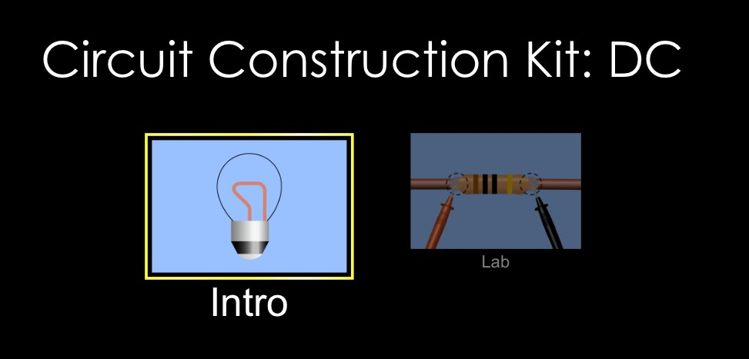

**Figure 10: Landing page of circuit construction kit**4

Click on the *Intro* window, and you will see the following page (Figure 11):

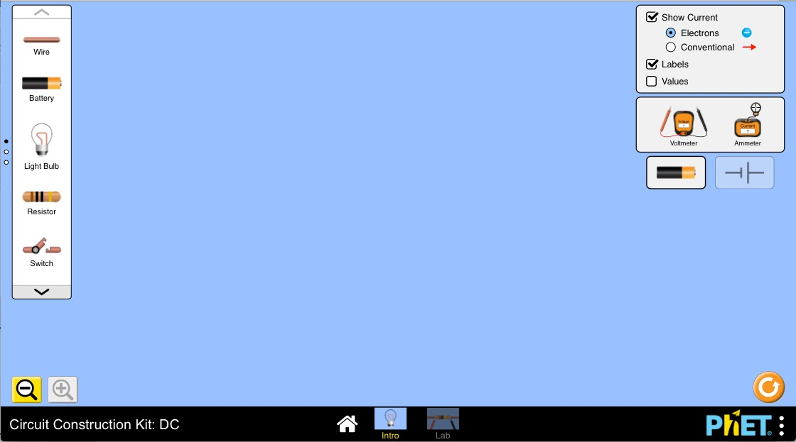

**Figure 11: Construction window of the Circuit Construction Kit**

On this page you can construct an electrical circuit by dragging different circuit elements into the middle of the page and connecting them together, as shown in Figure 12.

Ensure that the button at the top right of the screen that says *Conventional* is selected, so that the direction of the current flows from the positive side of the battery to the negative side. This is the conventional electron flow direction and yet the actual electron flow direction is the opposite.

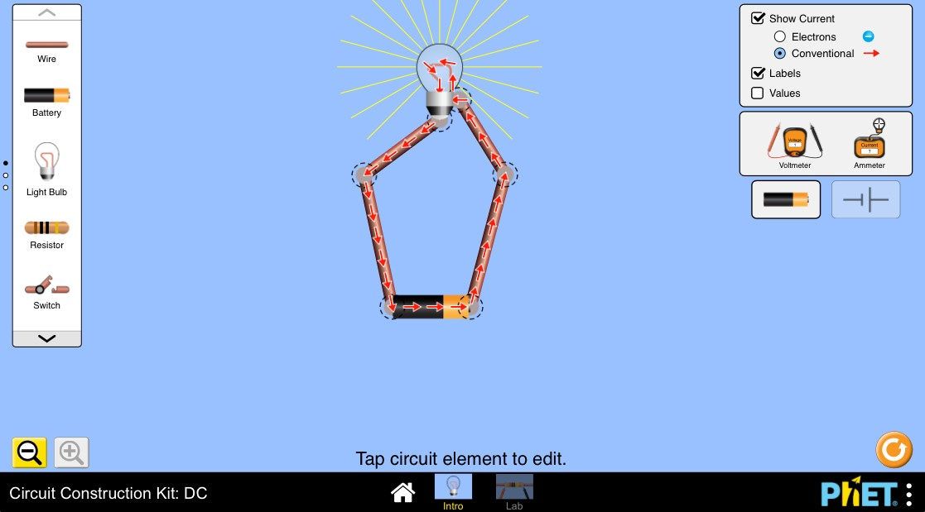

**Figure 12: Construction of a simple electrical circuit with battery, wire and bulb**

Connections are shown with a dotted circle (Figure 13):



**Figure 13: Connection symbol**

When you need to change something in your circuit, you can break a connection by clicking on that connection, and then clicking on the image of scissors (Figure 14).

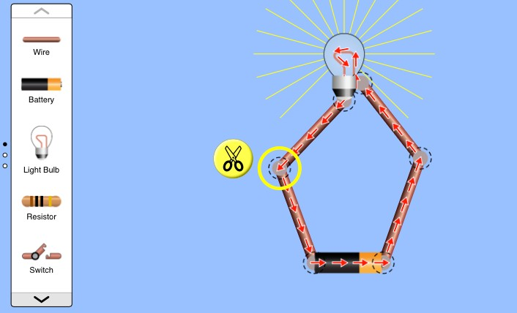

Figure 14: Click on a connection, and then click on the image of scissors to break the connection

You have now practised the basics of the circuit diagram construction.

### b. Use an ammeter to measure the current in a simple 1-bulb circuit

Create a circuit where the cell is connected in a loop with a light bulb, as shown in Figure 15, and measure the current at positions 1 and 2.

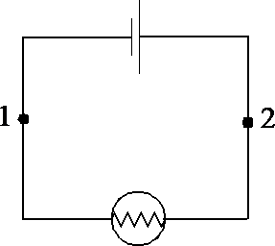

Figure 15: circuit with cell connected in a loop with a light bulb

In the Circuit Construction Kit, you can include an ammeter in your circuit, as indicated in Figure 16. The ammeter can be found on the right-hand side of the window, and you can drag it to the exact position where you want to measure the current.

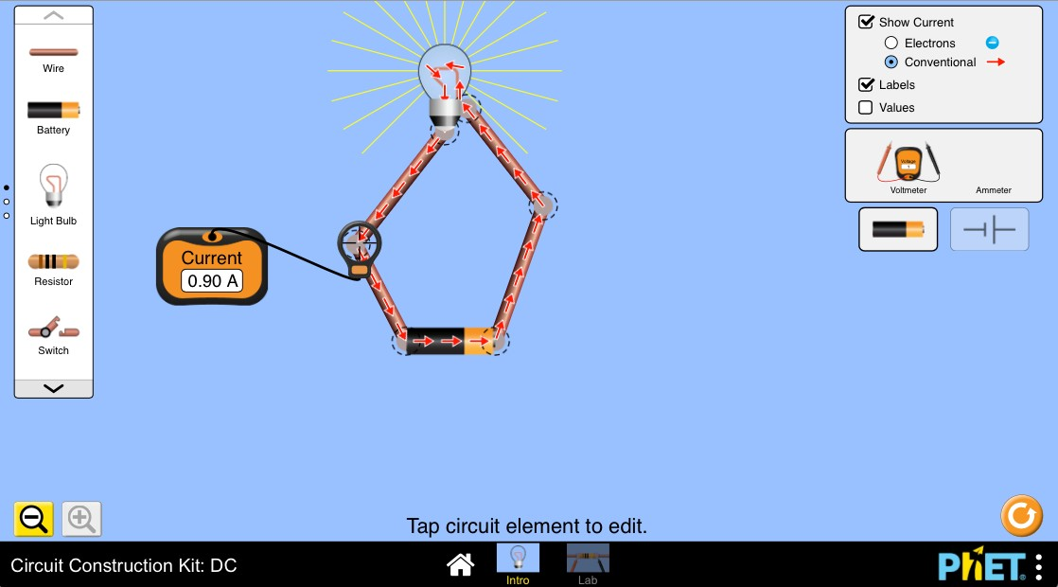

Figure 16: Ammeter measuring current in the Circuit Construction Kit

### Suggestion for discussion with students

In this activity, you should find that the current is *the same* at Points 1 and 2 in the circuit. This might appear strange, as you might think that the current is used up at the first bulb, so that there is less current flowing at point 2 in the circuit. But remember that current is defined as the rate of the flow of charges around the circuit, and so it is *not* used up by a bulb. The current flows from the cell, into the bulb, then back to the cell. No current is lost, or used up, in the process. Also refer to Activity 12. In the video comparing a water circuit and electrical circuit, notice that the rate of flow of water in every part of the circuit is the same irrespective of the pipe size. The same applies to the rate of flow of charge (current) in the same independent loop of the electric circuit, irrespective of different resistances in the circuit.

### c. Measuring potential difference

Create a circuit where the cell is connected in series with a switch and a torch bulb, as shown in the circuit diagram in Figure 17.

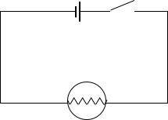

Figure 17: A series circuit with a cell, a battery and a switch

Connect your voltmeter to measure the *emf*, which is the potential difference across the cell. Record the voltage reading when you have closed the switch in your circuit.

Connect your voltmeter to measure the potential difference across the bulb when the switch is closed. Write down the voltage reading.

How does the potential difference across the resistor compare with the *emf* measured across the battery?

Connect your voltmeter to measure the potential difference across the switch when it is closed. Can you explain this reading?

In the Circuit Construction Kit, you can include a voltmeter and a switch in your circuit, as shown in Figure 18.

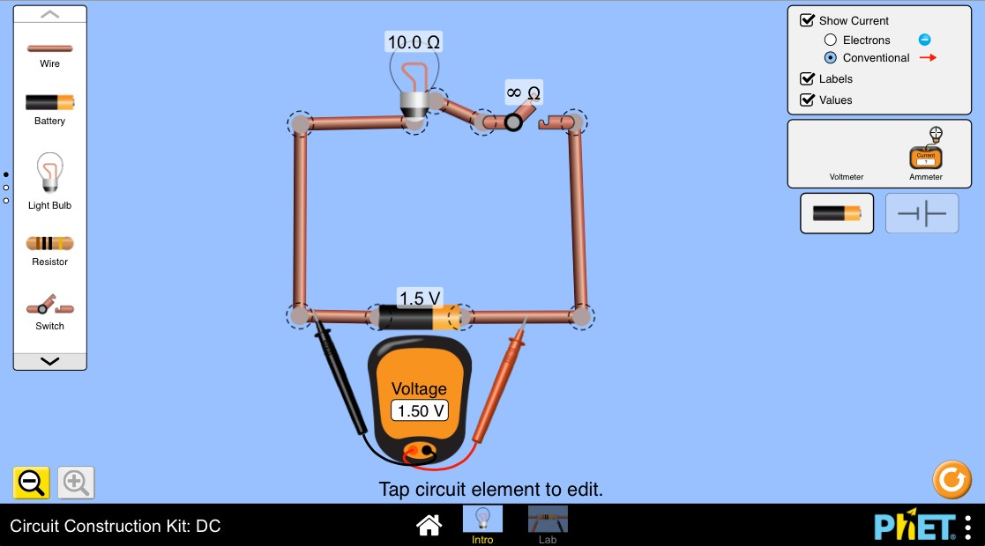

Figure 18: Circuit with a voltmeter connected in parallel to the battery.

From here on, you may find it helpful to select the option for *Values* on the top right-hand side of the screen.

To change the value of the potential difference for your battery, click on the battery and you will see a slider at the bottom that you can adjust. Change this to 1.50 V to show the voltage for a typical one-battery circuit as shown in Figure 19.

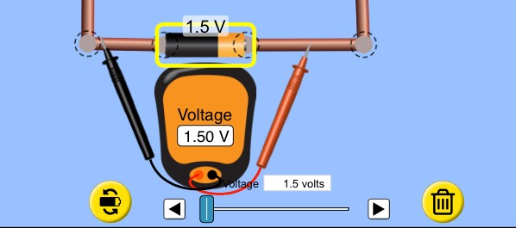

Figure 19: Click the *Values* button to see the voltage, current and resistance values in the circuit.

Discussion of the activity

In this activity you should find that the potential difference across a single battery is about 1.5 V. If you measured this with the switch closed, you would have found that it is like the potential difference across the light bulb.

You also should find that the potential difference across the switch is 0 V (while the switch is closed). This is because the switch is not a resistor, so it does not use up any of the electrical energy. It therefore does not cause a drop in the potential difference.

### d. Using real components

Repeat the simulated circuit construction and measurements but using real components. Compare the current and voltage measurements values in the case of simulations with the actual measured values. Check whether the values are the same. Discuss with the students, the possible causes of any differences.

Discussion of the activity

What we have done so far is to construct simple circuits by connecting components. We then proceeded to make simple voltage and current measurements. In practice, depending on the nature of the gadget or equipment, the electrical circuits can be a complex network of components and connecting tracks and conductors. To do any work on this circuit such as modification or trouble shooting, the following is necessary:

1. A schematic representation of the electrical circuit.
2. Analysis techniques to determine the various parameters at points in the circuit such as current, voltage, frequency, and power.

Students, therefore, need to be taught the skills for interpreting electric circuit schematics and analysing the circuits for various purposes and it is your responsibility as a TVET lecturer to teach them these skills. The question is, how best can you teach them? We suggest grouping up the methods into two categories, a bottom-up approach, and a top-down approach.

## Bottom-up approach

The bottom-up approach entails teaching how to use circuit analysis techniques by constructing an electrical circuit beginning with a simple circuit as in Activity 13a and introducing and demonstrating the basic laws of circuit analysis. As the circuit is constructed further into a mesh by introducing more components, more analysis techniques are introduced and practiced. Such an approach is the one we have already begun with through constructing a simple electrical circuit with a battery, wire, and bulb. To understand the behaviour of voltage current and power in such a circuit we use analysis laws such as Ohm’s law. When we make the circuit more complex for more functions such as connecting two bulbs in series or parallel as in Activity 12, video 2; the analysis of circuit parameters in turn requires more laws such as Kirchhoff’s voltage and current laws. The circuit can become further complicated, becoming a mesh, as more voltage and current sources are added together with more loads and other circuit components such as capacitors and inductors. Consequently, more complex analysis tools such as nodal analysis, superposition theorems, Thevenin’s theorem, and Norton’s theorem are needed to explain the analysis findings.

## Top-down approach

Another option for teaching circuit analysis techniques is to begin with a complex circuit and then systematically break it down into smaller sections, resulting in the simplest constituent circuits. At each stage in the breakdown process, we apply the relevant circuit analysis tools. Such analysis approach is consistent with a power engineering analytical modelling approach known as finite element analysis.

In the present unit we expand further on the top-down approach of teaching electric circuit analysis. We explore this method using the context of reverse engineering learning activities.

## Towards learning how to develop an equivalent circuit using a reverse engineering process: a case study teaching approach

Stop and think

Modern household furniture and appliances are now sold as dismantled pieces and packaged in boxes. If you have had an experience of assembling one, what are your reflections? If you were to dismantle a table for example for relocation, would you follow the same procedure as that of assembling, but in reverse?

Activity 14: What do you already know, wonder, and want to learn about reverse engineering?

**Suggested time:** 15 minutes

Recreate Table 6 below in your learning journal. Initially, let’s use the KWL chart for you to identify what you already know (K) and what you want to know (W) about reverse engineering in general. Fill in columns 1 and 2 and at the end of this unit, fill in column 3 (what you have learnt). If you are already a TVET lecturer with students, let them do the same exercise.

**Table 6: Know, Wonder and Learn (KWL) on reverse engineering**

|  |  |  |
| --- | --- | --- |
| **K**  **What I already *know about reverse engineering*** | **W**  **What I *want* to know about *reverse engineering*** | **L**  **What I have *learnt* about *reverse engineering*** |
| Write down what you already know about reverse engineering here. | Write what you would like to learn or need to learn about reverse engineering especially in the context of circuit analysis | At the end of the Unit, you will summarise what you have learnt reverse engineering as an approach towards circuit analysis. |

Discussion of the activity

It is likely that you will have some knowledge of reverse engineering, either from your training or experience. Electrical engineers are often called upon informally to “fix” a piece of electrical equipment that may have broken at home or at work, and they bring to bear their knowledge of electrical principles. When repairing equipment, you may have taken either the non-functional or an equivalent working device apart to determine how it is constructed. When doing so, you are carrying out a form of reverse engineering; we elaborate on the concept below.

You may use the following activity to introduce the concept of reverse engineering to students.

Activity 15: Exploring the concept of reverse engineering

**Suggested time:** 45 minutes

The intention of this activity is to expose you to the well-established engineering skills development technique that is known as reverse engineering.

First, watch the following video from the Khan Academy on reverse engineering of a hair dryer taken from their electrical engineering course. Go to: *Reverse Engineer hair dryer* at <https://youtu.be/WsFu92sc6-E>.

This is the Academy’s *hair dryer video 2*. The first video on the hair dryer was an examination of the plug, which is less relevant for us as it is specifically for USA voltage protection. Then go to the following link and read the explanation on the process of reverse engineering: <https://astromachineworks.com/what-is-reverse-engineering/#:~:text=More%20Contact%20Us-,THE%20REVERSE%20ENGINEERING%20PROCESS,and%20construction%20of%20the%20product>.

After watching the video and reading the web article, develop an activity for your students that uses reverse engineering of a circuit board that you have created for them. Your activity should include the following:

* A brief introduction to reverse engineering, pitched at the level of TVET students
* Safety precautions
* Familiarisation of the circuit (observation, rough sketch etc.)
* Circuit analysis using measuring instruments to measure appropriate variables, recording of measurements
* Component identification
* Accurate circuit diagram drawn
* Circuit reconstruction
* Testing and verification
* Discussion and conclusions

Discussion of the activity

An alternative method for teaching electrical circuit schematic interpretation is through reverse engineering. Reverse engineering involves systematically disassembling a system, process, gadget, or circuit to identify and understand its subsystems and components. By reconstructing the circuit, students can gain practical experience and learn how to interpret electric circuit diagrams. This approach is ideal for group discussions, allowing the lecturer to guide students through questions, cues, and analogies to generate interpretations and solutions. Once students grasp the circuit's purpose and working principle, the lecturer can introduce abstract theories and mathematical models that underpin the gadget's principles, limitations, performance, efficiency, and cost. Reverse engineering, the process of unravelling a machine's secrets by disassembling and analysing its parts, is widely used in manufacturing engineering and can be highly beneficial in education to enhance students' understanding of practical concepts alongside theoretical knowledge.

From the literature, it may appear as though the technique of reverse engineering is more applicable to mechanical engineering. However, reverse engineering is equally applicable to electrical engineering.

It is also apparent that reverse-engineering is an engineering design process but literally in reverse. Since design is a signature skill in engineering technology, reverse engineering becomes a big step towards overall design competency. It also follows that reverse engineering is a powerful approach for students to learn circuit analysis by doing it practically and retracing the design process. Furthermore, design is an iterative process, therefore reverse engineering is inherently iterative whereby you predict and try alternatives to see whether they work.

There are different approaches to applying reverse engineering as a means of conducting circuit analysis. An interesting technique is one that considers a circuit as a black box with input and output nodes. The reverse engineering-based analysis entails analysing the input signal in relation to the output signal for various input signal characteristics. Using the knowledge of anticipated circuit responses for various combinations of the Resistor (R), Inductor (L), Capacitor (C) (RLC) components in the black box, the architecture and component values may be systematically inferred.

In the next series of activities, we present an empirical approach to reverse engineering electrical circuits. It is a step-by-step procedure that is best applied on physical electrical circuits. These circuits can be any electrical part of a piece of equipment. Embedded in the procedure are various electrical circuit analysis and calculation techniques referred to earlier, such as Ohms law, nodal analysis, superposition theorem, Kirchhoff’s current and voltage laws, Thevenin theorem and Norton’s current and voltage laws. The product of the process is an equivalent circuit diagram/schematic, showing components (and their values) connected in a specific architecture.

The next activity is better regarded as a project to be conducted over a period of several days. After successfully executing the project, the last two learning outcomes of this unit should have been achieved:

1. Teach how to interpret electrical circuit schematics as an important step towards effective circuit analysis and calculations.
2. Effectively teach students how to systematically analyse an electric circuit.

This project is a typical first year engineering project at university. The author of this module successfully used such projects to teach engineering design and skills at first year level at a South African University for many years. It is best to assign the project to teams of not more than 3 students per specific case study. Since it is a project and inherently iterative, the time allocated to the project must be sufficiently long and the work can be spread out over several days with one to three hours allocated to the project per day.

Activity 16: Understanding how to characterise circuit blocks and components

**Suggested time:** A: 60 minutes; B: 60 minutes

Activity A is for you to carry out yourself, so that you have practised what students will do when you assign them to conduct it.

A. Obtain an electrical equipment/device such as a toy car, torch, electric heater, or a 2-plate electrical stove. Try and avoid too complex cases such as circuits with integrated circuits in printed micro-chips, as these will be difficult for students to understand. The intention is to grasp the fundamental concepts using basic circuit architectures. It is best to use functional gadgets if the resources are available otherwise the common practice is to work on faulty gadgets. Observe all necessary safety and health measures for working with electrical equipment. as discussed in Unit 1.

In your learning journal, recreate Table 7, as shown below. As you go through each of the activities below, fill in the corresponding columns.

1. Carefully examine the gadget and identify the main blocks of the circuit.
2. Write down the function of each circuit block.
3. Using measuring instruments such an oscilloscope, and a multi-meter, take appropriate measurements at the input and output for every circuit block.
4. For every block, determine the relationship between the output signal and the input signal.
5. Vary the input signal such as the voltage magnitude and frequency (if AC) over a reasonably wide range. Record the corresponding changes of the output signal as you vary the input.
6. Use the various applicable circuit analysis theorems to infer the type of components used and how they are connected. For you to do this, you need to recall and apply the appropriate circuit analysis tools such as Ohms law, nodal analysis, superposition theorem, Kirchhoff’s current and voltage laws, Thevenin theorem and Norton’s current and voltage laws. Where components are visible, take note of label information such as values and tolerances.
7. Make inference regarding the possible circuit architecture of the components in the circuit block.
8. Explain what you have done and share your reflections with your peers and take note of their feedback in your learning journal.

Table 7: Circuit block identification, analysis, and characterisation

|  |  |  |  |  |  |  |
| --- | --- | --- | --- | --- | --- | --- |
| Circuit block name  (Step 1) | Circuit block function  (Step 2) | Block input signal  (Steps 3, 4 & 5) | Block output signal  (Steps 3, 4 & 5) | Relationship between input and output  (Step 6) | Circuit analysis laws used  (Step 6) | The possible equivalent circuit sketch of the block  (Step 7) |
| 1 |  |  |  |  |  |  |
| 2 |  |  |  |  |  |  |
| 3 |  |  |  |  |  |  |
| 4 |  |  |  |  |  |  |
| 5 |  |  |  |  |  |  |

B. Now if you have access to a class of students, divide them into groups of appropriate size and assign one gadget to each group. Where possible ensure that each group has a different gadget. Each group runs the same learning activities as you did in Activity 16A being sure to observe all necessary safety measures for working with electrical equipment. They must create Table 7 in their workbooks and fill in the table as they run through the learning activity steps.

1. After each group has completed the learning activities, in a classroom setting, get each group to make a presentation and demonstration to the entire class and encourage the other groups to critique their presentations.
2. Identify common difficulties across the groups and discuss possible approaches to resolve them.

Discussion of the Activity

The intention of this activity is to apply inductive learning to analyse circuits, using reverse engineering in physical electrical equipment. The activity is a typical engineering design project and is therefore inherently iterative. Once the building blocks of the electrical circuit are identified and their functions understood, then the logical next step to explore with the students is how they all fit together and work as a unit. That is where the use of models and equivalent electrical circuits are essential. Knowledge of the electrical behaviour of electrical components is needed at this stage. You want them to understand what a resistor, inductor and a capacitor is. Here is where you must consider using analogies so that students are able to correlate the new knowledge with what they are readily familiar with. As an example, consider the analogy between water and electricity shown in Figure 20, reinforcing what was demonstrated in videos 1 and 2 of Activity 12. Just as the voltage is the ‘pressure’ or force that causes electron drift, water pressure either by means of pump or gravity (potential energy) causes water to flow thorough a pipe. The pipe has a certain bore (internal size), and therefore the volume of water flow depends on the pressure and how freely the water can flow through the pipe (the bore and friction). Similarly, potential difference, or the voltage, causes electron drift and the rate of the charge flow depends on the potential difference and the resistance (opposition) offered to the flow of the charge. The resistance of the conductor, which in turn depends on the diameter of the conductor and the type of the material used, is analogous to the friction (sand in the pipe or roughness of the pipe wall). Therefore, batteries are analogous to water pumps that circulate water through a hose pipe. Let the students think of other analogies that could explain the properties of inductors and inductance in general and similarly for capacitance and capacitors.

In summary the following are basic characteristics of inductors, resistors, and capacitors.

* The behaviour of a resistor is independent of frequency of the voltage i.e., whether AC or DC.
* In steady state, an inductor acts like a short-circuit for DC voltages and AC voltages of very low frequencies. With AC voltages of very high frequencies, it acts like an open circuit.
* In steady state a capacitor acts like an open circuit for DC voltages and AC voltages of very low frequencies. With AC voltages of very high frequencies, it acts like a short-circuit.

Figure 20: Using water flow to explain electrical flow (Source: [www.freeingenergy.com](http://www.freeingenergy.com) accessed on 03/03/2023)

In Unit 2 of this module, the abstract nature of electricity and the use of representations and analogies to facilitate the understanding of difficult concepts was presented. It can be argued that electrical equivalent circuits are electrical practitioners’ manuals. Models and equivalent circuits are what makes an otherwise abstract concept, tangible and real. It is real in the sense that complex networks of electrical systems can be reduced to a few blocks that encapsulate the fundamental principles and functions of the system.

In Activity 17, we progress further with the circuit block analysis that we started in Activity 16.

Activity 17: Production of the equivalent circuit

**Suggested time:** A: 60 minutes; B: 60 minutes; C 60 minutes

A. Formulation of the equivalent circuit diagram

The goal of the reverse engineering learning activities that we have engaged with thus far is to deduce the equivalent circuit of the device that we reverse engineer. This learning activity is the last leg of the process that converges into an equivalent circuit schematic.

1. For each block, further identify distinct “sub-blocks”. For example, a power supply unit (a block) can comprise of smaller blocks such as a rectifier circuit, voltage regulation circuit, the transformer and protection circuit etc. Now repeat steps 3 to 7 of Learning Activity 16 for the smaller blocks. You may need to repeat this further until all the blocks have been reduced to the smallest possible circuit units.
2. Connect into a single schematic diagram, the equivalent circuits of each block that you sketched in the last column of Table 7.

B. Circuit diagram validation.

The circuit schematics that we have sketched thus far need to be verified for accuracy. Before the advent of digital technologies, the approach used was mathematical circuit analysis techniques and comparing results with physical measurements. With modern digital technologies however, there are computerised circuit simulation platforms now available. This sub-activity introduces you to such simulations as a means of verifying the efficacy of a circuit diagram.

1. Construct the equivalent circuit of each block that you identified in Learning Activity 16 on the PhET simulation platform. You may need to revisit Activity 13 to remind yourself how to simulate circuits in PhET. The address for this on the PhET site is: <https://phet.colorado.edu/sims/html/circuit-construction-kit-ac/latest/circuit-construction-kit-ac_en.html>.
2. In the PhET simulation platform, measure the input and output signals. In your learning journal, record the obtained values in Table 8. As you do so, compare with the values that you entered in Table 7. Take note of any deviations.
3. Connect the various block circuits into a single mesh and repeat step 2.
4. Explain what you have done and your reflections on any measurement deviations, to your peers, and take note of their feedback in your learning journal.

**Table 8: Equivalent circuit simulation results**

|  |  |  |  |  |  |  |
| --- | --- | --- | --- | --- | --- | --- |
| Circuit block name  Circuit block function | | Block input signal | | Block output signal | | Notable differences |
| Measured | Simulated | Measured | Simulated |
| 1 |  |  |  |  |  |  |
| 2 |  |  |  |  |  |  |
| 3 |  |  |  |  |  |  |
| 4 |  |  |  |  |  |  |

C. If you have access to a class of students you would have already guided them through Activity 16B, where each group has their Table 7. Now guide them through activities 17A and B. They must create their own Table 8 and fill in the table as they run through the learning activity steps.

1. After each group has completed, in a class setting, let each group make a presentation and demonstration to the entire class and encourage other students to critique each presentation.
2. Identify common difficulties across the groups and discuss possible approaches to resolve.

Discussion of the Activity

The intention of this activity is to further apply inductive learning to analyse circuits using reverse engineering in physical electrical equipment. This teaching approach has the strength of closely linking theory with authentic situations. The approach we have taken can be reinforced by discussing the chapters on circuit analysis techniques in textbooks. Combining practical activities together with theoretical knowledge and practice questions is likely to provide the best approach to the teaching of circuit analysis for electrical engineering.

## Conclusion

Learning electrical circuit analysis can be fun for students if approached in a manner like that presented in this Unit. The summary of the approach is to first determine students’ prior knowledge on circuits. It is useful to analyse more familiar circuits as a launch-pad towards more abstract electrical circuits. The students then proceed on a journey of reverse engineering the design process through executing a case study. The well-established electrical circuit analyses techniques are embedded in the project and the output is an equivalent circuit diagram.

You will have realised that the teaching approach in this unit and indeed the entire module is that of activity-based learning. In most of these activities you must do the activity yourself and get feedback from your peers. You then conduct a self-reflection to evaluate what you have learnt. It is expected that after the self-activity and self-reflection you have gained the competency to teach the content. As a TVET lecturer, you can go further and put into practice the teaching by running the same learning activity with your students.

By now we hope that this module has enabled you to do the following:

1. Explain to students what a circuit is in general by using various analogies and then contextualising this into electrical circuits.
2. Teach how to interpret electrical circuit schematics as an important step towards effective circuit analysis and calculations.
3. Effectively teach students how to systematically analyse an electric circuit.

# Unit 4: How to teach electrical troubleshooting, repair, and maintenance

## Introduction

Every electrical circuit will malfunction, sooner or later. The malfunction is often termed a ‘f*ault*’. In fact, it can be argued that any gadget, system, or process will inherently malfunction due to ageing, wear and tear or other reasons. Even living creatures fall sick and get injured. Objects, gadgets, systems, and structures can malfunction irrespective of how perfectly they may have been designed and established. Consequences of failure are often undesirable as they can be catastrophic. Failure mitigations often commence as *diagnostics,* followed by repair and maintenance. Maintenance can therefore be either in fixing a fault or proactively preventing a malfunction.

In electrical systems, diagnostics is commonly referred to as troubleshooting, root cause analysis or fault finding. Competency in diagnostics and maintenance is therefore inherently important for all professional levels in electrical engineering. While there may be specialisation in the function of root cause analysis, a designer or operator needs to have good insights into what can go wrong to effectively execute their function. It is in this context that as a TVET lecturer, your competence to teach electrical fault troubleshooting, repair and maintenance is imperative. The intention of this unit is to develop your knowledge and skills in that regard.

The pedagogy in this unit is like that of the previous units of this module, in that it is activity-based learning. Since the focus is on electrical systems, the pre-requisite knowledge for this unit is the understanding of electrical circuit analysis techniques presented in Unit 3.

As we have discussed earlier in the module, the best practice in teaching of a new concept to students, includes evaluation of the students’ prior knowledge. Examples of various possible approaches to implementing students’ prior knowledge evaluation have been presented in the previous units 1 to 3. If you carried out the activities in the previous units, you should have acquired a degree of competence to devise an appropriate prior-knowledge evaluation technique for your students, to commence teaching the content of electrical fault-finding.

In the practice of fault-finding, observation of appropriate safety and health imperatives is a standard requirement in most contexts of the work. It follows therefore that when you evaluate the students’ prior knowledge, you do need to include their prior knowledge gained from Unit 1 on health and safety in the workplace. The latter however must be in the context of electrical-fault troubleshooting, repair and maintenance. The content of the present unit therefore does not include prior knowledge evaluation, but instead commences with teaching approaches to troubleshooting.

Teaching troubleshooting is like teaching a toddler how to walk; it is best done through practice. The practice however must be knowledge-based, systematic and logical. It is notable that as the wisdom develops with experience in troubleshooting, the practice will be a combination of both step-by-step procedural and inferential approaches.

## Unit 4 learning outcomes

By the end of this Unit, you should be able to effectively teach:

1. How to interpret electrical schematic/wiring diagrams for use in trouble shooting.
2. How to professionally troubleshoot an electrical fault.
3. How to repair a fault and execute maintenance on electrical systems.

## Towards learning outcome 1: How to teach interpretation of electrical circuit diagrams

Stop and think

If you want to travel efficiently from one location to another in a complicated geographical setup, you need to use a map, even if you are using a geographical positioning system (GPS). Would it be the same concept in the context of fault identification and location in a maze of components and tracks on a circuit board? What type of a map would you need and, what ‘map-reading’ skills would you need?

In Unit 3, we explained how to produce electric circuit schematics through a reverse engineering process. In the process you used various circuit analysis techniques. The student will need to know that in ‘best practice’ electrical engineering, every electric circuit in whatever context of application, must have an accompanying circuit diagram. In buildings and similar systems, electric circuit representations are in the form of wiring diagrams. One of the most important uses of these circuit representations is in tracing faults. Conversance with electric circuit diagrams is therefore a pre-requisite knowledge and skill in electrical fault-finding.

Activity 18: Interpreting an electrical circuit diagram

**Suggested time:** A - 60 minutes; B – length of session with students

A. Identify at least three YouTube videos on how to interpret an electric circuit diagram. As there are different electrical circuits depending on the type of equipment, gadget or system, choose three different types. Electrical circuit diagrams can be a complete wiring diagram that shows all the connections or simply a schematic diagram that shows the symbols of the main components and how they are connected. Therefore, the ability to translate from one circuit diagram to another circuit diagram is essential in electrical troubleshooting. Below are examples of videos that may be used.

1. *How to Read a Schematic* at <https://youtu.be/_HZ-EQ8Hc8E>.
2. *How to Read Electrical Diagrams* at <https://youtu.be/GHhcyH99inE>.
3. *How to read electrical drawings & wiring drawings* at <https://youtu.be/NYCsV6HG73k>.

For each video, in your learning journal, list down the key steps followed in understanding how the gadget, equipment or electrical system is represented by the circuit diagram. Note down any difficulties you have in listing the key steps. Once you have done this, you will have a set of steps for each video, ready to use with your students. In addition, draw out key common features from each video and, in your learning journal, write a brief summary of the best practice approach in the interpretation of electric circuit representations.

B. Once you have thoroughly prepared by reviewing the videos in detail, you can carry out the activity with a class of students, if you have access to them for teaching purposes.

Divide the students into groups of two, three or four depending on the size of the class and assign a video to each group. In your learning journal, adapt the following steps as an example of what your students can do in engaging with circuit diagrams:

1. Assign a video to each group to analyse.
2. From the video, each group must draw out and list down the key steps followed in understanding how the gadget, equipment or electrical system is represented by the circuit diagram. Like you did in preparation for the activity; alert the students to any of the difficulties you encountered while preparing the steps.
3. Let each group present their case to the entire class. At the end of each presentation encourage the audience to critique the presentation and the presenters to respond. You will have to help the students where they get stuck, get it wrong or where further clarification or refinement is needed.
4. End the session by drawing out key common features from all case studies leading to a summary of the best practice approach in the interpretation of electric circuit representations.
5. Review the session and note its key features in your learning journal.

Discussion of the Activity

The learning activities that you have gone through so far must have given you insights into what it takes to know how to interpret electric circuits and wiring diagrams. These are the competencies that you need to teach your students. In summary, acquiring the knowledge and skills needed to interpret electric circuit and wiring diagrams can be approached through systematic and practical approaches. Here are suggestions on how to go about it:

1. **Understand the Basics:** Begin by grasping the fundamental concepts of electric circuits, including its components such as resistors, capacitors, and inductors. Familiarize yourself with the behaviour of current, voltage, and power in circuits. This foundation will provide you with a framework for interpreting circuit diagrams. It is therefore essential to note that working carefully through Unit 3 is a pre-requisite for the current Unit 4.
2. **Study Diagram Symbols:** Acquaint yourself with the various symbols and conventions used in circuit and wiring diagrams and encourage your students to do the same. Each symbol represents a specific component or action within the circuit. Learn to identify common symbols such as resistors, switches, diodes, and transformers. Consult reference materials or online resources to aid your learning. This is a useful tutorial: <https://learn.sparkfun.com/tutorials/how-to-read-a-schematic/all>. While it is worth noting in general that there may be variations in the symbols used to represent electric circuit components, in general, there is much commonality across various standards of practice in the profession.
3. **Analyse Circuit Structure**: Develop the ability to analyse circuit structures and identify key elements. Determine how components are connected; whether in series or parallel configurations. Practice breaking down complex circuits into simpler sub-circuits to understand their overall function. This is the content we covered in Unit 3, and additional suggestions can be found at this website: <https://resources.pcb.cadence.com/blog/complex-circuit-analysis-and-simplification-methods>.
4. **Follow Circuit Flow**: Pay attention to the flow of current and the direction of voltage within a circuit. Use arrows and labels to guide your understanding of how energy moves through the system. By following the flow, you can comprehend the intended operation of the circuit and troubleshoot potential issues. These are the knowledge and skills learnt in the reverse engineering learning activities in Unit 3.
5. **Practice with Real-world Examples:** Engage in hands-on activities by working with actual circuits and wiring diagrams. Start with simple circuits and gradually progress to more complex ones. This was the approach adopted in Unit 3, that also included the use of circuit simulation software or physical kits to experiment, validate your understanding, and observe the practical implications of circuit diagrams. Beginning with the next learning activity 19, you will be working on circuits in real life physical objects.
6. **Seek Guidance and Resources:** Seek guidance from experts, instructors, or experienced practitioners in the field. They can offer valuable insights, clarify doubts, and provide practical tips for interpreting circuit diagrams effectively. Additionally, refer to textbooks, online tutorials, and educational websites to access supplementary learning materials.
7. **Apply Critical Thinking:** Develop a mindset of critical thinking when interpreting circuit diagrams. The HIT model approach that has been referred to many times in this module is called for again here. Always ask yourself, ‘why’ and ‘why not’ as you analyse the purpose and functionality of each component, as well as their interactions within the circuit. Consider potential implications of changes to the circuit and explore alternative designs or modifications.
8. **Practice Patience and Persistence:** Learning to interpret electric circuit and wiring diagrams requires practice and patience. Don't get discouraged by initial challenges or difficulties. With continued effort, exposure to a variety of circuits, and regular practice, you will gradually improve your skills and gain confidence in your ability to interpret these diagrams accurately.

Remember, learning to interpret electric circuit and wiring diagrams is a continuous process. As you gain proficiency, you can apply your knowledge to troubleshoot electrical systems, which is the subject of the present module. Other applications of this knowledge are in designing new circuits as in Unit 3, or in pursuing further studies in electrical engineering or related fields.

Since electrical circuit diagrams are representations of the real circuits in gadgets and electrical systems, the ability to link the representation with the real circuit is a key aspect of enabling an efficient troubleshooting process. Activity 19 is an example of a case-study approach to teaching such an important skill.

Activity 19: Linking electric circuit representation with the actual circuit

**Suggested time:** 60 minutes; B – length of session with students

A. Source a collection of a wide range of electrical gadgets; it is normally easier to use faulty household appliances such as radios, hair dryers etc. For each gadget, obtain or develop the corresponding circuit diagram. Note that user manuals often contain circuit diagrams that may be sourced from the Internet; otherwise follow the process of reverse engineering as presented in Unit 3 to develop a circuit diagram for each device. Prepare the following in advance for each of the devices, so that you are completely prepared for carrying out Activity 19B. In your learning journal:

1. Identify major and sub-sections of the electric circuit diagram. Most electric circuits typically comprise of the following sections: power units, connection tracks, control units and loads.
2. Write down the function of every subsystem, section, and components.
3. Use the circuit diagram to identify and locate every component in the real system. As a safety measure, ensure that the system is in an un-energised state in addition to other appropriate safety precautions.
4. Conduct basic in-situ tests and measurements using appropriate instruments and equipment such as a multi-meter to inspect and test individual components such as relays switches, motors, sensors, resistors, capacitors, diodes and continuity tracks.
5. Compare the measured values with the expected values obtained from the system documentation (datasheets) or previous baseline measurements.
6. Determine what can go wrong with each device; this is often referred to as hypothesis testing. Consider both specific component failures e.g., a faulty relay and broader system issues such as power supply fluctuations.
7. Deliberately introduce faults in the circuits; if the gadget studied is fault-free otherwise if the gadget is already faulty, ensure that the students do not already know about the fault, in activity part B.
8. Develop a worksheet based on steps 1 to 7 above that provides instructions for students to carry out a practical activity themselves.

B. Now, if you have access to a class of students, divide the students into groups and assign a gadget to each group. Provide each group with the worksheet you prepared in A8 (above) and guide the students through each of the steps 1 to 7 above.

Discussion of the activity

In various professions, representations are used as essential tools in designing and fixing problems. Examples are the following:

* In sport, tactic boards are used by team coaches such as in netball and football.
* Architects use architectural drawings and diagrams.
* Civil engineers use structural drawings.

In the electrical engineering professions, (electricians, technicians, and engineers) one needs to be proficient in relating physical circuits with their representations in the form of schematic and wiring diagrams. With digital capabilities, the circuit diagrams are conveniently represented in digital form or as simulations. Another trending technology is that of the whole gadget, equipment or system existing as a ‘digital twin’[5]. Whichever form of an electric circuit one uses, that representation is necessary for use in the process of troubleshooting. One way to represent an electrical gadget by circuit diagram is to use the schematic diagram in a user manual to build the circuit on a “breadboard”.[6] The following video is an example of using a breadboard to build a simple circuit: *How to Wire Circuits from Schematics* at <https://www.youtube.com/watch?v=vJUX9cvyYjU>.

You are advised to conduct some form of assessment to ensure that indeed the students have acquired circuit diagram interpretation competencies to the desired level. The final unit of this module (Unit 5) covers the assessment of learning in the context of activity-based pedagogy. Use the knowledge you gain in the unit to design and use appropriate rubrics to evaluate the extent to which the students acquire the requisite knowledge and skills in circuit diagram interpretation.

At this stage we would hope that your students are now competent in circuit diagram interpretation and ready to proceed with learning the actual complete cycle of troubleshooting as presented in the next section.

## Towards learning outcome 2: How to teach systematic troubleshooting of electrical circuits

Stop and think

There is a common idiom that states ‘there's more than one way to skin a cat’. While this statement can be quite offensive to animal lovers, could there be a figuratively useful meaning in the context of electric fault troubleshooting approaches? An explanation of the idiom is that there are many paths you can take to reach the same end.

Activity 20: Understanding approaches to root cause analysis of electrical faults

**Suggested time:** 60 minutes; B – length of session with students

A. Watch the following three videos on troubleshooting. For each video, in your learning journal, *list the steps involved in the logical sequence of troubleshooting* shown. You will likely need to watch each video more than once. Once you have listed the steps for all three videos, draw out key common features and provide a *summary of the best practice systematic approach* to electrical fault root cause analysis.

1. *How to spot a fault in a circuit, like a pro: hands on electronics* at <https://youtu.be/ye9dguKy_Cs>.
2. *Fault Finding Electrical Circuits - Electrician Life* at - <https://youtu.be/BK6ykUkJ-8A>.
3. *I Didn't Expect That! Fault Finding - Electrician Life* at - <https://youtu.be/tUyvLSfB3qE>.

B. Now if you have access to a class of students, divide them into groups of appropriate size, and assign one video to each group (you may include videos 1-3 above, as well as additional appropriate videos you have found). Depending on the size of your class, source additional fault-finding videos to use with the students.

Each group should make notes as they run through the following steps.

1. Each group of students must play and study their assigned video; and this may entail viewing the video many times.
2. The students must list the steps involved in the logical sequence of troubleshooting shown in the assigned video.
3. Each group is to present their case to the entire class. At the end of each presentation encourage the audience to critique the presentation and the presenters to respond. You may have to help the students where they get it wrong or where further clarifications are needed.
4. End the session by drawing out key common features from all case studies leading to a summary of the best practice systematic approach in electrical fault root cause analysis.
5. Compare the list drawn from the student activities with that you formulated in part A of this activity. To what extent are there differences?

Discussion of the Activity

A procedural approach to problem solving is the signature skill of the engineering profession. It can be argued that the reason why it is easier for engineering professionals to be intelligible to other professions (that may be completely unrelated to engineering) is because of the engineers’ problem-solving competencies. An example of a generic problem-solving procedure is one illustrated in the flow chart in Figure 21 below. If you analyse closely those steps that you gleaned from the videos (Activity 18), and listed in your learning journal, you should be able to map out a logical flow chart of the procedure like that in Figure 21. If you have completed Activity 20B with your students, let them map out their flow charts too.

In the next activity, we cover the best practice procedure of executing what you theoretically learnt in Activity 20. As with the rest of the activities in this unit, part A of the activity is for you to do and reflect through sharing with your peers. After you have acquainted yourself with the troubleshooting process flow chart, and if you already have students, then get the students to do the same activity but in groups. Since you would have already done it yourself, you have walked the path. When you guide the students through the project, you will be aware of the potential pitfalls and you will be an effective tour guide on the journey of troubleshooting.

The next stage in the learning process is to implement root cause analysis in case studies.



Figure 21: A typical engineering problem-solving process flow chart.

Activity 21: Learning how to do root cause analysis of electrical faults using faulty-gadget case-studies

**Suggested time:** 60 minutes; B – length of session with students

A. In Activity 18 you sourced a collection of a wide-range electrical gadgets such as faulty household appliances like radios, hair dryers etc. For each gadget you followed the process of reverse engineering to develop a circuit diagram for each device. Now you want to execute the root cause analysis procedure to identify the fault. Prepare the following in advance for each of the devices, so that you are completely prepared for carrying out Activity 21B. However, for Activity 21B, be sure not to reveal the fault location to the students. The troubleshooting procedure must not significantly deviate from the following steps. For each step, make notes in your learning journal.

1. Collect as much information as possible about the fault by:
2. Interviewing the user
3. Visually inspecting the faulty gadget
4. Reading the manual
5. Sourcing the circuit schematic
6. Sourcing maintenance and operational records

It is common knowledge that the nature of the problem and context of the system dictates the type of information to be collected.

1. Take appropriate safety measures including choice of appropriate tools and measurement instrument for the work.
2. Familiarise yourself with the circuit diagram and cross-check it with the physical circuit.
3. Identify main circuit blocks and signal routes.
4. At this stage, you can make an intelligent guess (hypothesise) about the possible cause of the problem.
5. Target the suspect problem areas of the circuit.
6. Conduct signal tracing:
7. Identify input and output nodes of the signal through the circuit blocks and components.
8. Follow the signal path through the circuit diagram starting from input towards the output.
9. Test and inspect the integrity of connections in the circuit.
10. Iterate until the fault is fully identified.
11. Document the findings.

B. Now if you have access to a class of students:

1. Divide the students into groups and assign a gadget to each group. Provide each group with a worksheet and guide the students through each of the steps 1 to 10 above.
2. Let each group present their case to the entire class. At the end of each presentation encourage the audience to critique the presentation and the presenters to respond. You will have to help the students where they get stuck, get it wrong or where further clarification or refinement is needed.
3. At the end of each presentation, reveal the actual fault that you identified in the gadget. If there are discrepancies, discuss.

Discussion of the Activity

We emphasised earlier the importance of experience in developing troubleshooting proficiency. The experience is not only hands-on. While troubleshooting is inherently a hands-on practice, it is equally important that critical thinking, and wisdom (ability to make appropriate judgements) are the other competences that the student needs to have to efficiently execute electrical fault troubleshooting. In that regard, the teaching of troubleshooting is incomplete without the students’ understanding of why each activity is done and what to do at crossroads of alternative decisions or when faced with unfamiliar situations in the troubleshooting process. As an example, in electrical engineering practice, there is a general rule that in a live circuit, the terminals of a current transformer must never be open circuited. If however in troubleshooting, you encounter a situation where you need to find out whether the fault is with the current transformer or the burden connected to the current transformer, it is inevitable that you disconnect the burden so that you may confirm the healthiness by measuring the current transformer output voltage before checking on the condition of the burden. If however you rote learnt that a current transformer must never be open circuited, you will not now deliberately open circuit this current transformer thus resulting in a failed troubleshooting process.

Critical thinking application of the HIT model of knowledge: This is where one not only knows the procedures of executing an act (know How) but is able to make credible judgements when faced with conflicting alternatives or unfamiliar situations (know It) and also knows why each part of the procedure is done (know That). You may need to recap on the concepts of the HIT model by engaging with the content in the Psychology of Education for TVET module of the Advanced Diploma Technical and Vocational Teaching which is available at this link: <https://www.oerafrica.org/system/files/13691/assets/13703/advdiptvtmodulepsychology-education-tvet.docx?file=1&type=node&id=13703&force=0>.

Activity 22: Making sense of the best practice logical steps in troubleshooting

**Suggested time:** 60 minutes; B – length of session with students

A. Use your learning journal to work on the following activity yourself. After completing this activity and self-reflecting on it, you then move to part B of the activity which entails guiding the students through the same activity.

1. Recreate Table 9 in your learning journal. In the far-left column, list down the key logical steps followed in a systematic troubleshooting procedure drawn from the previous activities 20 and 21.
2. For each procedural step, think about the reason why the action must be done and summarise the reasons in column 2 of the table. You may need to consult other literature and knowledge areas or revisit previous units such as concepts of electricity covered in the present module.
3. For the outcome of each troubleshooting procedural step, make a judgement on the extent of the usefulness of the action and whether the action could not have been done in a different and more effective way. Summarise the outcome of your reflections in column 3 of the table.

**Table 9: Using the HIT model in unpacking the best practice troubleshooting procedural steps**

| Know How | Know Why | Know it |
| --- | --- | --- |
| 1. Collect all necessary information about the fault: 2. Interview the user 3. Visually inspect the faulty gadget 4. Read the manual 5. Source the circuit schematic 6. Source maintenance and operational records | Ground truth eye-witness evidence is always the best. N.B. Any problem-solving procedure dictates collection of all evidence for analysis and triangulation to delimit the problem boundaries. | In any problem analysis process, context matters. What matters in one context may not in a different context and judgement in that regard requires evidence to act on. |
| 1. Observe all necessary safety precautions | There is always a risk of injury or of initiating further problems | Safety requirements are highly dependent on physical and time contexts. Furthermore, safety requirements evolve as the work unfolds. Proper judgement in this regard is necessary and requires not just blindly and literally following standards and traditional prescripts. |
| 1. Familiarise yourself with the circuit diagram and cross-check against the physical circuit. | Circuit diagram is the ‘map’ for navigating the complex physical and often space constrained electrical circuit space. | **……………………………………………………………………………………………………………………………………..** |
| 1. Identify main circuit blocks and signal routes. | …………………………………………………………………………………………………………………………………….. | …………………………………………………………………………………………………………………………………………………………………………….. |
| 1. At this stage you can make an intelligent guess (hypothesise) as to the possible cause of the problem/s. | …………………………………………………………………………………………………………………………………….. | …………………………………………………………………………………………………………………………………….. |
| 1. Target the suspect problem areas of the circuit. | …………………………………………………………………………………………………………………………………….. | …………………………………………………………………………………………………………………………………….. |
| 1. Conduct signal tracing: 2. Identify input and output nodes of the signal through the circuit blocks and components. 3. Follow the signal path through the circuit diagram starting from input towards the output. | …………………………………………………………………………………………………………………………………….. | …………………………………………………………………………………………………………………………………….. |
| 1. Test and inspect the integrity of connections in the circuit. | …………………………………………………………………………………………………………………………………….. | …………………………………………………………………………………………………………………………………….. |
| 1. Iterate the above steps until the fault is fully identified. | …………………………………………………………………………………………………………………………………….. | …………………………………………………………………………………………………………………………………….. |
| 1. Document the findings. | …………………………………………………………………………………………………………………………………….. | …………………………………………………………………………………………………………………………………….. |

B. Now if you have access to a class of students:

1. Continue with the student groups that did Activities 20 and 21. Guide each group as they run through steps 1 to 3 of part A of the present activity.
2. Let the student groups take turns to present their findings to the whole class explaining their table. It is often convenient to get the students to present to the entire class using Microsoft Power Point™ slides. After each presentation, the fellow students can be given an opportunity to reflect on the presentation with critiques and affirmations.
3. After all groups have presented and all feedback from the students considered, lead the class in trying to draw out the ‘golden thread’ through all presentations.

Discussion of the Activity

The purpose of a root cause search is to efficiently pinpoint and locate the initial cause of fault. In electrical circuits however, the cause of system malfunction is not always obvious. In some cases, the initial fault may be a breakdown of a single component but due to the resultant short circuit currents, many other components can burn beyond recognition. The footprint of the initial fault is therefore erased/masked out, rendering it difficult for the troubleshooter to pinpoint the initial cause. Such situations are common in forensic analysis even in other fields such as crime scene analysis, fire devastations, or motor vehicle, train, and aeroplane crashes. Similarly, troubleshooting a fault can therefore be a frustrating process if not approached with judgement that is informed by knowledge and experience.

When properly implemented, by the end of this activity the students must have acquired a 360 degree (all round) understanding of the concept and skills of troubleshooting.

After successfully and efficiently identifying the root cause of the fault; fixing (repair) to return the system to its original or even better functionality is the final stage. This takes us to the final learning outcome of this unit: how to teach electrical systems fault repair and maintenance.

## Towards learning outcome 3: How to teach electrical systems fault repair and maintenance

Stop and think

All things trend toward disorder (Figure 22). More specifically, the second law of thermodynamics states that “*as one goes forward in time, the net entropy (degree of disorder) of any isolated or closed system will always increase (or at least stay the same)*.”[7]

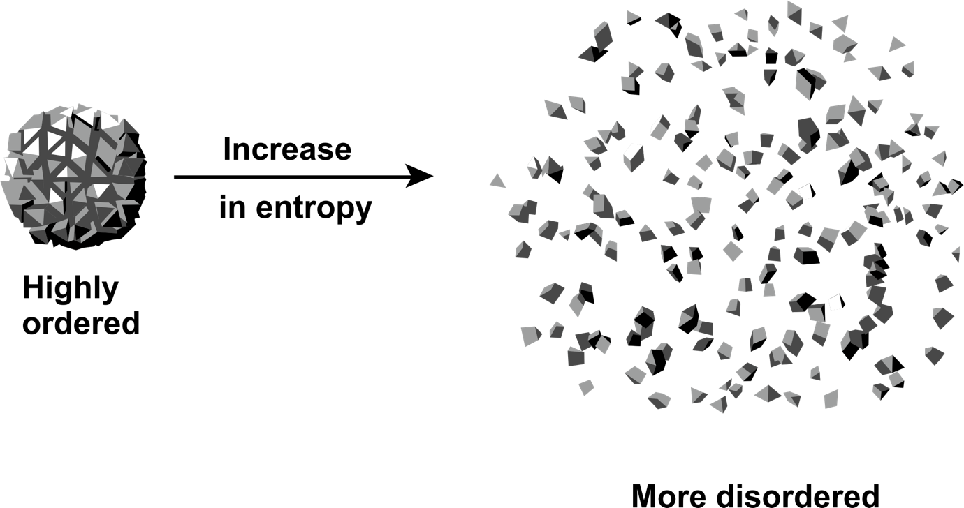

Figure 22: Entropy illustrated[8]

If chaos is indeed the natural state of things, is it the reason why any form of order has a natural tendency of getting disorderly unless subjected to direct action of *maintaining* order? Is repair work a form of restoring orderliness?

The act of maintenance of an electrical system such as domestic appliances, equipment, house or factory wiring, is to ensure continuity of its normal operating state. Fault repair, which is the ultimate end stage of a troubleshooting process, is therefore a form of restoration work.

There are different categories of maintenance work. Maintenance that is directly related to fixing a fault after troubleshooting is called fault maintenance. The intuitive purpose of maintenance is to anticipate and proactively prevent faults. Faults (malfunctions) are disruptive and can be costly. Therefore, preventative maintenance can be planned and implemented to avoid costly disruptions. In that regard, preventative maintenance can be routinely periodical, or ‘*condition based*’. Condition-based maintenance is where certain parameters of the system/equipment are continuously monitored on a condition-status dashboard. Any significant deviations of the parameters from the acceptable ranges trigger a call for maintenance. The resultant maintenance action is therefore targeted at rectifying the identified specific cause of condition deviation. Condition-based maintenance is therefore increasingly becoming popular as the best practice maintenance approach because of improved reliability and cost effectiveness.

The knowledge and skills for fault repair and maintenance need to be effectively developed in TVET students. TVET lecturers in the knowledge area of electrical engineering need to be competent in teaching fault repair and maintenance. As is the case in most hands-on vocational and occupational engineering professions, the best approach is activity-based learning. The next activity is for you to run through a typical procedure of fixing electrical faults. After you have mastered the procedure, you then guide your students to do the same. By the end of the activity, the students will have achieved the third learning outcome of the present unit i.e., knowing how to effectively repair electrical faults as well as how to conduct other forms of maintenance.

Activity 23: Generalisation of procedures in systematic electrical fault repair and maintenance.

**Suggested time:** 60 minutes; B – length of session with students

1. Use your learning journal to work through the following activity yourself. After completing and self-reflection on the activity, you then move to part B which entails guiding the students through the same activity as you did for Activity 22B.
2. Watch the video: *Board Repair Basics #1 – Introduction* at <https://youtu.be/i293n9VVpHg>. You may source more similar videos demonstrating fault fixing of different electrical equipment.
3. For each video, in your learning journal, list the steps involved in the logical sequence of fixing/repairing a fault. You will likely need to watch the video multiple times. Once you have listed the steps for the video/s, draw out key common features and provide a summary of the best practice systematic approach in electrical fault repair. Share your conclusions with your peers and make improvements where necessary, based on their inputs.

B. Now if you have access to a class of students, divide them into groups of appropriate size and assign one video to each group (you can include the video in A1 above, as well as additional videos you have found). Depending on the size of your class, source additional repair videos to use with the students.

Each group should make notes as you run through the following steps.

1. Each group of students must play and study their assigned video, and this may entail viewing the video many times.
2. The students must list the steps involved in the logical sequence of fixing an electrical fault shown in the assigned video.
3. Each group is to present their case to the entire class. At the end of each presentation encourage the audience to critique the presentation and the presenters to respond. You may have to help the students where they get it wrong or where further clarifications are needed.
4. End the session by drawing out key common features from all case studies leading to a summary of the best practice systematic approach in electrical repair.
5. Compare the list drawn from the student activities with that you formulated in B. To what extent are there differences?

Discussion of the Activity

You most likely have realised that most videos of electrical fault troubleshooting do not end with locating the fault but proceed to fixing the fault. Therefore, in teaching troubleshooting procedures, the same videos analysed in Activity 20 may be used for Activity 24, provided the video ends with fixing the fault. You will also have realised that once the fault has been identified, the approaches to fixing the fault vary widely depending on the nature of the fault, such that it becomes difficult to draw out a generic procedure. However, a generalised framework of electrical fault repair is needed, irrespective of diversities in the specifics and that is the reason you had to run through this activity.

The next stage of the teaching is that you guide the students into practicing the generalised fault repair procedure on real physical systems. This is exemplified in Activity 24.

Activity 24: Practical case study on fault repair.

**Suggested time:** 60 minutes; B – length of session with students

In learning activities 19A and 19B, you and student groups studied specific gadgets to link the circuit schematics with the actual physical circuits. You would have used the same gadgets in Activity 21A in learning how to do root cause analysis. Now you continue the journey towards restoring the functionality of the faulty gadget. In the next activity you work on formulating a generalised procedure of fixing the identified faults. In the activity, you use the same gadgets that you identified the faults in, in Activity 21 and the intention is to fix the faults.

A. Use your learning journal to work through the following activity yourself. After completing and self-reflecting on the activity, move to part B which entails guiding the students through the same activity as you did for Activity 23B.

1. For the identified fault circuit elements, decide on the necessary action to rectify the malfunction. Note that in electronic circuits, the solution is replacement of the component(s) with a new functional component. The replacement of the faulty components will entail the following:
2. Replacing or fixing the component if repair is an option
3. Selecting and using appropriate tools
4. Taking account of the required safety precautions
5. After repairing the fault, decide on and conduct the tests necessary to confirm restoration of functionality.
6. Document all the work done in repairing the fault, including updating the circuit diagram, if some design modifications have been done.

B. If you have access to the same class of students, put them into the same groups as for the activities 19B and 21B. Each group must work on the gadgets that they had been investigating in the previous learning activities. Each group should make notes as they run through steps 1 to 3 above, after which they do the following.

1. Each group is to present their case to the entire class explaining their findings. For each step. At the end of each presentation encourage the audience to critique the presentation and the presenters to respond. You may have to help the students where they get it wrong or where further clarifications are needed.
2. End the session by drawing out key common features from all groups, leading to a summary of the best practice systematic approach in electrical repair.

Discussion of the activity

This activity can be regarded as the capstone project on learning how to restore functionality of faulty electrical circuits. As you repeat this learning activity and the rest of the activities in the unit with the same student cohorts or across cohorts, be sure to use it as an opportunity for reflecting on your practice of teaching. The feedback process serves as an opportunity for your continuous improvement in your teaching skills. The question however is, how do you know that you are continuously improving and how do you know whether the students have achieved the learning objectives. In the next unit we explore the concepts of assessment in the context of activity/project/case-study based pedagogy. Assessment rubrics are best practice tools in project-based pedagogy.

You may have noticed that most of the learning activities in this module are hands-on, that is, requiring real-life objects such as electrical gadgets, equipment, or household appliances. This approach to teaching is informed by established teaching and learning theories such as situated learning, Piaget’s cognitive constructivism and experiential learning. In other professions such as medicine, an important aspect of learning in the knowledge area of anatomy is exploration of cadavers. Most Law schools run law clinics that serve the public through practicing students under the guidance of the professors that are qualified attorneys. The same concept is adopted in most learning activities in this unit.

The concept of using faulty household appliances as learning tools can be turned into financially sustainable models of teaching that double up as community engagement project. The TVET college can establish processes and systems that enable constant inflow of faulty appliances from the community for repair at the college. The outflow would then be the repaired and functional electrical appliances as deliverables from the teaching process of troubleshooting, repair and maintenance.

## Conclusion to Unit 4

We are now able to plan and implement activity-based teaching learning sessions to teach electrical fault-finding, repair, and maintenance at TVET colleges through the following:

* Interpretation and use of electric circuit representations to navigate through the maze of interconnected electrical components.
* Implementing troubleshooting processes that efficiently lead to precise location of faulty parts of an electric circuit.
* Effectively rectifying the fault and executing other maintenance requirements of the electrical system for restoring to the original functional state.

The approach in the teaching of this unit is not just to develop students’ competency in the ‘*know-how*’ but also in the ‘*know-why*’ every procedure of troubleshooting is done. Furthermore, the competency developed in this unit is the agility in making appropriate judgements for fit-for-purpose adjustments in troubleshooting and maintenance procedures. Such a wholistic approach to developing student competences should always be your objective.

Unit 5 will conclude this module with ways to evaluate the extent to which students have acquired knowledge and skills through activity-based learning. The ability of the lecturer to design and use assessment rubrics will be emphasised.

# Unit 5: Assessment in the context of activity-based learning

## Introduction

Stop and think

We have literally lived lives of being assessed. I remember my son at the age of five, being interviewed for a place at a pre-school. It is the school principal who conducted the interview of this poor child sunk in a chair in front of the executive desk facing the powerful man … and I was present as a passive witness. Ever since, and currently at university my son is being assessed in one form or another. I will not be surprised if he tells me today that he hates being assessed!

Think of how many times in your life so far that you have sat for a test, exam, or interview. Are you able to imagine the effort that goes into designing the assessment questions and process? Can designing and conducting an assessment be regarded as a puzzle?

It is easy to think that since we live lives of being assessed, we know how to assess. The same may be said about teaching. Since on average we spend most of the first twenty years of life being taught by teachers/lecturers at schools, colleges, and universities, we assume that automatically we know how to teach. The reality however is that in formal education, assessment is a distinct and specialised knowledge and skills area. Practitioners’ competences in assessment must be well developed. Essentially, every education practitioner, including TVET lecturers, must be competent in designing assessment tools and techniques and administering them. In this context there is an assessment module in the Advanced Diploma TVT programme called, ‘*Rethinking Assessment*’ and it is available at: [https://www.oerafrica.org/node/13691/materials](https://eur01.safelinks.protection.outlook.com/?url=https%3A%2F%2Fwww.oerafrica.org%2Fnode%2F13691%2Fmaterials&data=05%7C01%7Ccuthbertn%40vut.ac.za%7C4d8c815d1ae24d0306d708db73dd830b%7C1bad55d667ff456480adf00bca599df9%7C0%7C0%7C638231169278714379%7CUnknown%7CTWFpbGZsb3d8eyJWIjoiMC4wLjAwMDAiLCJQIjoiV2luMzIiLCJBTiI6Ik1haWwiLCJXVCI6Mn0%3D%7C3000%7C%7C%7C&sdata=2KQ9PeKgIyoZ02yX6SK2Vm5sTTu5%2Fv5866uXnJp%2FbSY%3D&reserved=0).

The ‘*Rethinking Assessment*’ module comprehensively covers the knowledge area of assessment in the context of TVET education. You are encouraged to engage with this module as it gives very useful insights and learning opportunities for you as a TVET lecturer in conducting assessments *for, of* and *as* learning. In the same module, self-assessment techniques are well emphasised, as they are an important aspect of reflective practice, which is a skill that you need to continuously improve on to ensure progressive growth in your profession as a TVET lecturer. The module on Reflective Practice is also worth working through, if you haven’t already done so. It may be accessed at: <https://www.oerafrica.org/system/files/13691/assets/13702/advdiptvtmodulereflective-practice.docx?file=1&type=node&id=13702&force=0>.

The focus in the present unit is to draw from the assessment module, to inform your learning of how to conduct assessments in the context of technical project-based learning. You will have realised already that the main approach to teaching in the present module of “*Method of Teaching Electrical Engineering Infrastructure and Construction*”, is that of hands-on activities. It is therefore imperative that you know how to effectively conduct assessments in that context and hence the purpose of this unit.

We begin the unit with exploring how you can evaluate your prior knowledge of assessment, that is, what you already know and wonder about assessment. We then review concepts in assessment through a critical review of relevant literature on assessment. Since the focus of the present unit is learning how to conduct assessment in the context of activity-based learning, we again refer to the Rethinking Assessment module and adapt the learning activity of exploring the relationship between Curriculum, Pedagogy and Assessment. We contextualise this activity into your knowledge area of electrical engineering. We will end the unit with learning how to design assessment rubrics for use in activity based learning. In designing the rubrics, we need to cater for the various interests of all the stakeholders in TVET education and by implication, assessment. The stakeholders are the students, the Government as represented by the Department of Higher Education and Training (DHET), the Industry as represented by the professional bodies and the TVET college management. You, the TVET lecturer are at the cross-roads of these interests, and it is your responsibility to manage the assessments in such a manner that the interests of all the stakeholders are met. This balancing act can be regarded as a puzzle that has to be solved. We will therefore explore engaging with assessment challenges as a puzzle. It is intended that as an assessment practitioner, you will be empowered with the thought processes of engaging with assessment challenges and solve them as puzzles in whatever context you may find yourself in.

## Unit 5 learning outcomes

By the end of this Unit, you should be able to:

1. Reflect on your current approach to assessment.
2. Understand the relationship between assessment and the other teaching and learning dimensions of Curriculum and Pedagogy.
3. Formulate an assessment puzzle for your teaching context.
4. Design effective activity-based learning assessment rubrics.

## Towards learning outcomes 1 and 2: Reflecting on your approach to assessment and relating assessment with curriculum and pedagogy

Stop and think

What is the purpose of assessing TVET students on an NCV or NATED course?

You may have already been teaching, have taught before or are yet to teach at a TVET college. Irrespective of your past teaching experiences, you have some prior understanding of what assessment is. At the very least, you know that it is a means of determining pass and fail marks. What else do you know about assessment?

Activity 25 is adapted from the AdvDipTVT assessment module, ‘*Rethinking Assessment*’. If you have already engaged with this module and done the activity, then revisit your learning journal to see how you completed the activity. In any case however, we advise you to work through Activity 25 as a ‘re-calibration’ and revaluation exercise. From the last time you did the survey, your approach to assessment may have evolved and it is important for you to be aware of this as we embark on the focused assessment journey in the present unit. Alternatively, you may not have worked through the ‘*Rethinking Assessment*’ module, so have not done the activity before and working through it now will be a valuable exercise for you.

Activity 25: What do you already know and wonder about assessment[9]

**Suggested time:** 45 minutes

The Approach to Classroom Assessment Inventory (ACAI) is an online survey developed by Queen’s University in Canada as part of a research study. The survey involves a series of questions about how you approach assessment. The research study targets schoolteachers and you will notice that references are made to schools. Just substitute ‘*college*’ in your own mind as you go through the questions. At the end of the survey, you will be provided with feedback in the form of a report about your assessment approach.

1. Read through the instructions to this activity (2-4 below), so that you are prepared before you start.
2. Click on this link: <https://interceptum.com/si/en/4800045> to complete the survey now. It should take you about 20 minutes.

As you complete the survey, pay attention to your own reactions to the following questions. Record your responses in your learning journal.

1. Are there any questions that use terms or concepts that you don’t understand?
2. Do the questions seem to be mostly about your
   * **knowledge** about assessment,
   * your **skills** as an assessor,
   * how you feel about assessment (your **attitudes**) or
   * what you believe is important or not important in assessment (your **values**)?
   * Or do they cover all of these areas?
3. Do any of the questions surprise you or seem to suggest an approach to assessment which feels wrong, or strange to you?
4. Do any of the questions make you wonder about aspects of assessment you haven’t thought about before?
5. What do you think about the way the survey questions are designed?
6. Do you have suggestions on improvement of any of the questions?
7. After you have completed the survey, download a pdf version of the feedback, and read it carefully. Does the feedback seem accurate to you? Make sure you keep your results as you will refer to them again later in the module. You may print them and stick them in your learning journal if you would like to. Discuss the report with your peers and figure out if it makes sense.
8. Now that you have explored your existing skills, knowledge, attitudes, and values about assessment, using the survey and become aware of aspects of assessment, where you would like to – or need to – learn more, summarise this using a Know, Wonder, and Learn (KWL) table (Table 10 below).

Recreate the KWL table of Table 10 in your learning journal. Let’s use the KWL table more broadly for you to identify what you know (K) and want to know (W) about assessment in general. This will help you to have your existing knowledge, skills, values, and attitudes about assessment with respect to electrical engineering in mind as we proceed. Complete the Know and What columns of the table now. We will return to this table at the end of the present unit and you will complete the Learnt (L) column in Activity 33.

**Table 10: Know Wonder and Learn (KWL) self-evaluation table**

|  |  |  |
| --- | --- | --- |
| **K**  **What I already *know about assessment*** | **W**  **What I *want* to know about assessment** | **L**  **What I have *learnt* about assessment** |
| Write down what you already know about assessment here. | Write what you would like to learn or need to learn about assessment here. | At the end of the unit, you will summarise what you have learnt about assessment here. |

Discussion of the activity

By accessing your prior knowledge about assessment and thinking about what you would like to (or need to) learn about it, you are preparing yourself to actively engage with new ideas and integrate your new learning into your existing framework of knowledge so that it becomes useful to you.

Hopefully, you are now ready to engage with new knowledge on assessments, let us explore some concepts of relating assessment with the two other key aspects of education systems; curriculum pedagogy. Making connections between assessment, curriculum and pedagogy enables us to holistically understand the practice of assessment.

## Bloom’s Taxonomy: Its relevance to learning design and assessment

Traditional assessments often focus on recalling factual information, concepts, and principles through questions. Some may go a step further by asking students to explain ideas in their own words. On rare occasions, students might have hands-on tasks to apply their knowledge and skills. However, in this module, we aim to move away from these older, less effective methods of teaching and assessment. Instead, we will adopt teaching and assessment techniques supported by sound educational research.

Research indicates that students learn best when they actively engage in the learning process and construct their understanding of new concepts and skills. Consequently, assessment tasks should also encourage active engagement. When designing assessments, it is crucial to move beyond mere recall of facts or occasional explanations. Instead, we should focus on authentic assessment that allows students to apply their knowledge and skills.

Moreover, it's essential for lecturers to gradually increase the complexity of authentic assessment tasks over time. Students should be challenged to apply higher-order thinking skills, such as critical thinking and problem-solving. This involves developing their ability to analyse, synthesize, and evaluate new information presented to them.

Bloom's Taxonomy, is a widely recognised framework that categorises educational objectives and learning outcomes into a hierarchy of cognitive levels – levels of thinking and reasoning. This taxonomy or categorisation of learning levels was developed by Benjamin Bloom and his colleagues in the 1950s and revised over the years. The taxonomy consists of six levels, each representing a different cognitive skill set, from lower-order thinking skills to higher-order thinking skills. The levels, in ascending order of complexity, are:

1. Knowledge: Remembering or recalling factual information, concepts, and principles.
2. Comprehension: Demonstrating an understanding of the material by explaining ideas or concepts in one's own words.
3. Application: Applying acquired knowledge to solve problems or complete tasks.
4. Analysis: Breaking down complex information into its constituent parts and understanding the relationships between them.
5. Synthesis: Combining elements in novel ways to create a new understanding or product.
6. Evaluation: Making judgments based on criteria and evidence, critiquing ideas or arguments.

### Relevance to designing learning

Learning progression: Bloom's Taxonomy provides a clear progression of cognitive skills, starting with basic knowledge and moving toward higher-order thinking. This framework helps instructors design learning activities that scaffold students' learning and gradually challenge them to develop more complex cognitive abilities.

Targeted learning objectives: By aligning learning activities with specific Bloom's levels, educators can clearly define the intended learning outcomes. For example, if the objective is to assess students' comprehension, instructors can design activities that require them to explain concepts or phenomena in their own words.

Encouraging critical thinking: Higher levels of Bloom's Taxonomy (analysis, synthesis, and evaluation) focus on critical thinking skills. Designing activities that require students to analyse, evaluate, and synthesize information helps them develop critical thinking abilities, which are essential for problem-solving and decision-making.

Differentiation and personalisation: Bloom's Taxonomy allows educators to cater to diverse learners' needs by offering activities at various cognitive levels. Students with different learning styles and abilities can engage with tasks that match their readiness and interests.

Relevance to designing assessment activities

Assessing depth of understanding: Bloom's Taxonomy helps create assessments that go beyond simple recall of facts. By incorporating questions and tasks that assess higher-order thinking, educators can gauge students' depth of understanding and application of knowledge.

Formative and summative assessment: Bloom's Taxonomy is valuable for both formative and summative assessment. Formative assessments can be designed to monitor students' progress across the cognitive levels, while summative assessments can evaluate their overall mastery of the subject matter.

Encouraging application and transfer: Assessments that involve real-world scenarios and problem-solving tasks (application level) promote the transfer of knowledge and skills to practical situations.

Validity and reliability: A well-designed assessment aligned with Bloom's Taxonomy enhances the validity and reliability of the evaluation process. It provides a clear structure for assessing the breadth and depth of students' understanding.

In conclusion, Bloom's Taxonomy serves as a valuable tool for designing learning and assessment activities that promote critical thinking, depth of understanding, and personalised learning experiences. It helps educators create a balanced and comprehensive approach to teaching and evaluating students' progress.

For more detail on Bloom’s Taxonomy and a ‘verb wheel’, also based on Bloom’s Taxonomy which is a useful tool to support the design of authentic assessment activities, see Appendix 5.

## A more holistic understanding of assessment

Assessment entails judging a student’s performance in relation to a set of goals/standards/criteria. The same applies to self-evaluation. Assessment is an integral part of the teaching and learning processes in an education system. The other key parts of teaching and learning processes are the curriculum and pedagogy. While it is understandable that Curriculum, Pedagogy and Assessment may be regarded as separate but connected entities of teaching and learning, other schools of thought define curriculum in such a way that it encompasses everything to do with an education system. Roberts (2015) defines curriculum as decisions on both the learning outcomes and how best to achieve them. Roberts’ definition also positions teachers and academics at the centre of what a curriculum is and their beliefs about education’s goals and purposes, subject matter, teaching, learning and students, teacher identity, institutional context, stakeholders, and the socio-political context, all influence the decision-making process and the teaching practices. In essence, curriculum is a process that takes as input, the knowledge that has potential for meaning-making to a state that is used to change the conscience of the knowledge acquirer. Metaphorically, a university/TVET education system can be modelled as a manufacturing process.

*“…….. as a production plant where the raw material (from secondary schools) is processed (lectures, tutorials and laboratories), quality assured (examinations) and delivered (as graduates) to society (the customer)” (Gibbon, Nixon, & Nixon, 2006)*

The same concept is illustrated in the cartoon presented in Figure 23. The cartoon poses a question on whether our education systems, and indeed the aspect of assessment, is producing the desired outputs.

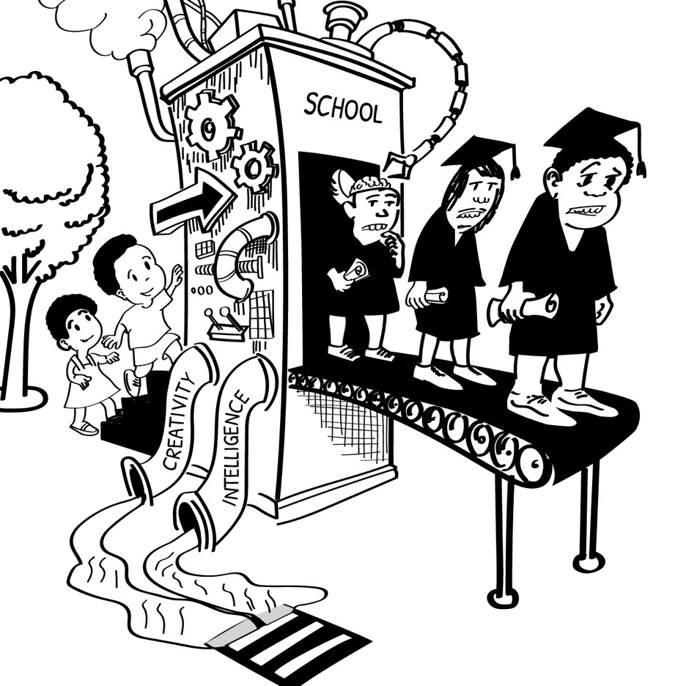

Figure 23: Is our education system producing the desired skills, knowledge, attitudes, and values (SKAV) quality in graduates? (Adapted from various images online)

Let us further analyse the cartoon through the next activity to unpack possible messages contained therein.

Activity 26: How do we characterise how our education systems impart knowledge, skills, attitude and values to the students as depicted in the cartoon in Figure 23?

**Suggested time:** 30 minutes

Carefully scrutinise the cartoon in Figure 23 and answer the following questions in your learning journal. When you completed learning activity 25, you were reminded about various aspects of assessment. Draw on this knowledge as you interpret the cartoon.

1. Considering the students entering the education system, list down as many characteristics as possible in the categories of skills, knowledge, attitudes, and values (SKAV) that the cartoon depicts. Think of how you would approach assessing these attributes as you did with prior knowledge in the previous units of this module.

Discuss your results with your peers and check out whether you can arrive at a consensus. If you are already a TVET lecturer, let the students do the same exercise by reflecting on their own experiences at the time they were novice students at the college. Do they identify with what is depicted in the cartoon?

1. In Figure 23, as the students disappear into the education system, judging by the various features in the cartoon, list down at least three consequences of how assessment may impact on students’ SKAV. What are the positives and negatives? Discuss with your peers.
2. Carefully look at the illustrations of the graduates exiting the education system. List down at least three characteristics being depicted and classify these features into SKAV competences. What are the positives and negatives? Discuss your findings with your peers and students.

Discussion of the activity

Let us enter the factory of the education system and explore how assessment interacts with the other aspects of the teaching and learning processes, curriculum, and pedagogy, in shaping up the SKAV competences of the students. As we do this, recall how your assessment approaches as evaluated in Activity 25, can contribute to the consequences in shaping up SKAV, especially in the context of activity-based learning.

Let us consider a conceptual framework of the education system, metaphorically illustrated as an industrial production process in Figure 24. The major components of the system comprise of the inputs, the production process, the control system (stakeholder influences) and the product (the graduates). The inputs to the curriculum system are the students and the knowledge that must be learnt. The prior knowledge and skills of the students is an important parameter in accordance with the constructivist learning theories.

The inputs proceed into the ‘production process’ which is the curriculum that comprises of pedagogy elements such as course materials, lectures and laboratory experiments, tutorials, and assessments for and as learning. These curriculum elements are organised in a network that is designed to optimise the process of interaction between the knowledge and the learner. If the production system were to be considered as a wire-drawing process in engineering, the raw material is a block of a metal (the learner) which undergoes re-shaping as it is pulled through a series of set of rollers. The SKAV of the students are being re-shaped/transformed. The various pedagogy elements in the curriculum such as lectures, tutorials, industrial excursions, laboratory exercises and formative assessments represent the rollers in the wire-drawing process.

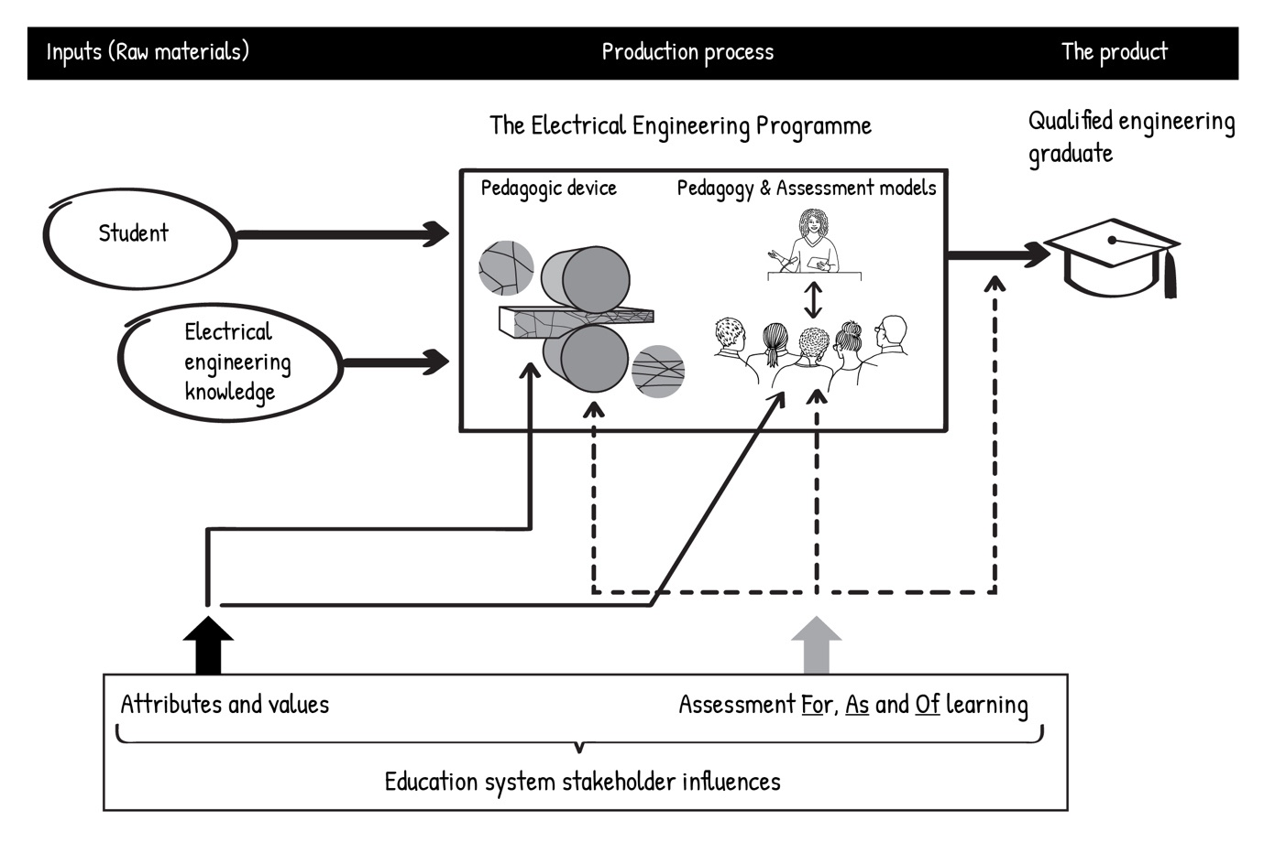

Figure 24: The conceptual framework of an education system metaphorically represented as a production process

Control and monitoring function in manufacturing processes, is done by the ‘brain’ of the plant and this is commonly known as the **S**ystem **C**ontrol **A**nd **D**ata **A**cquisition (SCADA). The equivalent in an education system is the system stakeholder influencers and, in the literature, these are alternatively referred to as Curriculum Orientations (Roberts, 2015). Every curriculum is situated in a specific context that is characterised by specific history, sociology, politics, economics, culture, and religious ideologies. The contexts are at different levels ranging from institutional level to geopolitical location. Curriculum exists to serve the needs of various stakeholders; the society in which it is situated. Curriculum is therefore inherently contextual.

The output of the curriculum (education system) is the transformed learner, with a new identity; and termed the graduate. Check out in the cartoon of Figure 23 how the graduates look different from how they looked when they entered the system as novices. What does this say about the education system?

The graduate is characterised by specific competences (C), perceived by Kirschner et al (1997) as a mathematical expression; C = f (K,Sk ,S) where K is knowledge, Sk is the skill and S is situation. Competences are a function of comprehension of facts and information (Knowledge) combined with the ability to use the knowledge to execute a particular task (Skill) and furthermore the ability to make appropriate judgements in applying the knowledge and skills differently in different Situations and still achieve the same outcome. This competence model is similar to the SKAV (Skills, Knowledge, Attitude and Values) and HIT (know How, know It and know That) models. A competent graduate is one that can make sense of the world and has specific skills to manipulate and create value from the world (situation) for the benefit of humanity and most importantly, able to do so in different situations. A qualified engineering graduate should be characterised by the minimum levels of the SKAV and confirmed through integrated assessments as illustrated in Figure 25. It is therefore imperative that the summative assessment that certifies a graduate (product quality assurance) must confirm the competences.

Stop and think

To what extent can an exam paper evaluate all competences of a student i.e., knowledge, skills, attitudes and values?

Luckett & Sutherland, (2000) argue that in the modern era, we cannot afford to take a business-as-usual approach to assessment in the higher education teaching and learning practice. The authors emphasise that assessment is not a scientific measurement exercise where empirical models are used to give precise results. Instead, they argue that assessment is inevitably judgemental.

“We therefore understand assessment to be an interpretative, human exercise based on professional dialogue and judgement rather than on objective measurement within a positivist epistemology where the assessments are de-contextualised or artificial and standardised and made to be reliable. If we understand assessment to be a dialogic, meaning-making process, then we need rather to build the context into the picture and take it into account when judgements are made”. (Luckett & Sutherland, 2000)

This conceptual claim on assessment is quite appealing. It resonates with the arguments in the literature for a triangulation approach in lecturer evaluations (Boughey, 2001; Nygaard & Belliugi, 2011). There are multiple stakeholders in assessment and therefore many purposes for assessment, and many assessment techniques. It therefore makes sense to use triangulation to make sure that all learning outcomes are assessed, and that the context of electrical engineering is considered. In that regard, assessment is indeed a judgement process. The application of the judgement concept is clearly demonstrated in Luckett & Sutherland’s (2000) integrated model of assessment as illustrated in Figure 25.

A close examination of the Integrated Assessment Model shows that it resembles the HIT model. In essence, it is the HIT model applied to assessment practice. The three circles are equivalent to the three “Know how’, ‘Know that’ and ‘Know it’ arms of the HIT model. Integrated assessment is therefore an assessment practice that evaluates all the three categories of SKAV competences.

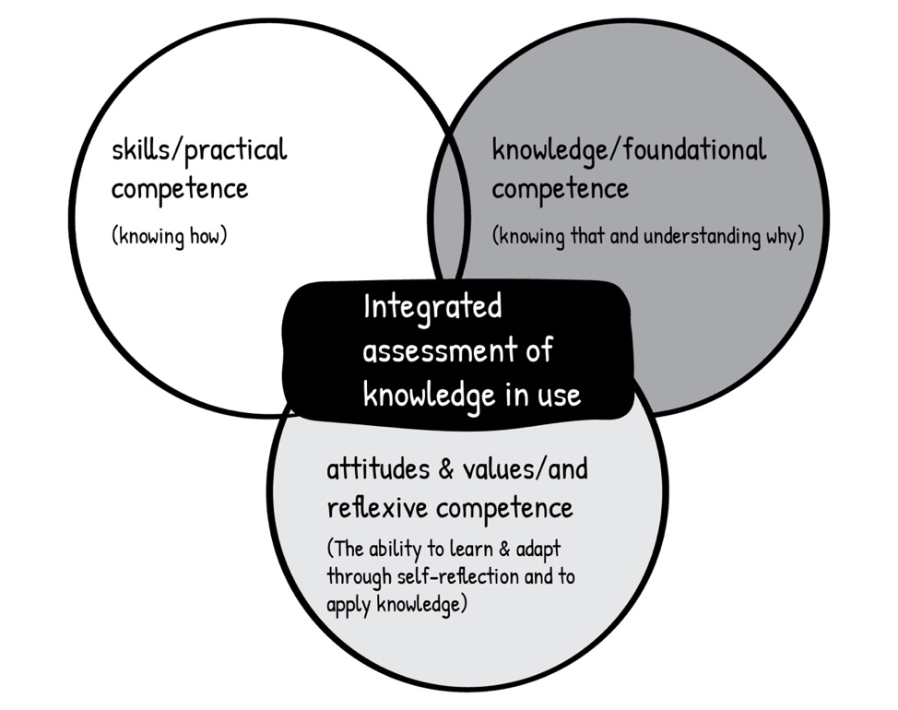

Figure 25: The integrated assessment model by Luckett & Sutherland (2000)

Integrated assessment entails designing and implementing assessment tools that evaluate the ‘concoction’ of competences in students at the exit point of the programme. In the model, the following competences are assessed integrally; skills/practical competence, knowledge/foundational competence, and attitudes/reflexive competence.

Stop and think

So far, we have looked at assessment from various angles and whichever angle you look at assessment from, it is evident that assessment is embedded in the entire spectrum of the teaching and learning process as illustrated in the framework in Figure 24. Has this reality changed your perception of assessment prior to engaging with this Unit and as revealed in your self-evaluation report from the ACAI survey in Activity 25? In other words, has there been any shift in your approach to assessment as evaluated through the survey that you went through in Activity 25? Read through the report that resulted from your own completion of the survey. Do you think at all differently now? Make notes of any reflections in your learning journal.

Let us link up the concept of integrated assessment with the four dimensions of assessment in the reports of the ACAI survey in Activity 25. The intention is to evaluate how stakeholders in education systems can influence various possible approaches of the lecturer, the assessor, in the four dimensions of assessment: purpose, process, fairness and theory.

Activity 27: How can stakeholders in education influence the lecturer’s approaches in each of the four dimensions of assessment?

**Suggested time:** 30 minutes

Refer to the page in your learning journal where you placed the ACAI survey report in which your approach to assessment was evaluated.

1. Recreate Table 11 in your learning journal.
2. The table is a matrix of the 4 dimensions of assessment and inclinations of the assessor as influenced by the pressures from the 5 stakeholders (covered in Activity 29) in assessments. In each sector of the 4 assessment dimensions, indicate the most dominant interest among the education stakeholders. We have completed the Purpose column for you, for example,

* for Assessment *Of* learning, the dominant influence is from students whose main interest from assessment is to obtain a pass mark.
* for Assessment *For* learning, the dominant influence is from professional bodies who demand that students must develop the required competencies.
* for Assessment *As*learning, the dominant influence is lecturers who need to know that students are learning through self-reflective assignments.

1. After completing the table, discuss your results with your peers. If you are already a TVET lecturer, work out the table with your students, and you may choose an appropriate opportunity for this, such as before you hand out an assignment.

**Table 11: Possible approaches to assessment across the four dimensions of assessment**

| **Assessment Dimension** | **Purpose** | **Process** | **Fairness** | **Theory** |
| --- | --- | --- | --- | --- |
| Possible inclinations of the assessor’s approach to assessment | Assessment *Of* learning  *Students – obtain a pass mark* | Design | Standard | Contextual |
| Assessment *For* learning  *Professional bodies – students must develop the required competencies* | Administration and scoring | Equitable | Balanced |
| Assessment *As*learning  *Lecturers – students are learning through self-reflective assignments* | Communication | Personalised |

Discussion of and reflections on the activity

A closer look at the various possible inclinations across the assessment dimension reveals the various degrees of influence of stakeholders in assessment and indeed the education system. As an example, in the dimension of assessment purpose, most students are more concerned with assessment of learning, that is, the final marks achieved through summative assessments compared to formative assessments. In assessment process, the employers in the industry are more interested in the dimension of assessment design where the emphasis is on the development and design of reliable assessments and test questions that measure student learning in relation to learning objectives. In the dimension of assessment fairness, parents of students would be more interested in the lecturer’s individualisation of learning opportunities and assessments that address each student’s unique learning needs and goals. Other stakeholders may emphasise other inclinations in the same assessment dimension. In essence therefore, it is apparent that the lecturers (the ones responsible for administering the assessments) can easily be at crossroads of conflicting inclinations from various stakeholders. The act of balancing these influences is complex and becomes synonymous with solving a puzzle, the assessment puzzle.

Activity 28 focuses on some of the challenges of designing and administering assessments.

Activity 28: Formulation of an assessment puzzle[10]

**Suggested time:** 90 minutes

The process of formulating an assessment puzzle begins with reflecting on something that you find confusing or perplexing; something which is an ongoing source of interest, curiosity, and concern to you. It could be as simple as, ‘*Why are these students fighting for marks?*’ or ‘*How do I know if my students have learnt anything?*’ or ‘*Are my assessment practices fair?*’

In preparation for the activity, read the example below of one lecturer’s assessment puzzle and their explanatory commentary on this puzzle.

Conversation with an ‘Assessment Monster’



‘Assessment’, you are a monster!

With emergency remote teaching and learning, you have become more chilling,

As I set an exam, I’m never certain whether the questions are fair.

The exam itself is venom that you spit out; you monster!

Like cattle to a slaughterhouse, students walk reluctantly to the exam hall,

Because they are going to face you, the monster!

Look at their faces as they await the ‘start’ announcement.

Adrenalin is streaming through their bodies.

You, Assessment, the monster, you cause anxiety/panic even in the smartest.

With the exam sitting over, it’s my turn to face you, you monster.

In front of me, a ‘mountain’ of 300 scripts; 1500 pages of scribble!

In five days, I must make sense and assign a mark to each script,

By the third day, I’m completely drained - mentally and physically.

My institution’s policy says marks must be uploaded not more than 3 days after the exam was written!

Couldn’t there be a better career?

During the term, you, Assessment, you rear your ugly head.

Unless they’re for marks, students are not interested in my tasks and quizzes.

I’ll assign some marks, but I want them to study my feedback comments.

Alas, as when peeling a nut,

they take the kernel and trash the shell.

Assessment, you monster, you fully control students’ approach to learning.

I wish I could do without you, Assessment, but alas,

I am told You are the ‘glue’ that holds together all stakeholders in higher education!

It looks like I cannot avoid You, the monster.

I must devise ways of taming you,

Assessment, you monster, …….my puzzle!

The case study lecturer offered the following explanation of their puzzle:

The puzzle focuses on the challenges of attempting to respond to the pressures exerted by different key stakeholders.

The first stakeholder pressure comes from students. Luckett & Sutherland (2000) argue that assessment determines how students learn, “*the cash nexus of learning*”. Boud (2007) cautions that assessment can be a key driver of learning, but if poorly designed and implemented, it can inhibit learning. Most scholars in the field of assessment emphasise the importance of assessment for learning (formative assessment) (Moeed, 2015). Lecturers and teachers are commonly advised to avoid assigning marks to formative assessment tasks so that students focus on the formative feedback comments, with Luckett & Sutherland (2000) going so far as to advise assessors to completely decouple formative from summative assessment. However, the formative assessment quizzes in my course must contribute marks to the overall summative outcome, otherwise students will not take them seriously. Some are quite combative and do not hesitate to use the ‘unfair’ word if they consider themselves overburdened. *Dealing with students’ emotional responses to my assessment practices is one part of the assessment puzzle that I still need to figure out how to address.* In the literature there is consensus that increasing numbers of students are more interested in obtaining pass marks than in in the learning process that leads to the pass mark.*Another piece in my assessment puzzle is the question of how to motivate students to meaningfully engaging in assessment for and as learning.*

The second set of stakeholder pressures are those of the engineering professional body. ECSA[11] requires assessment to be authentic. Authentic assessment involves evaluation of professionally relevant competencies and should stimulate students’ development of self-regulation skills (Villarroel, et al, 2018). In engineering, authentic assessments are best done through projects. *Designing effective assessment tools for project-based learning tasks is a third piece of my puzzle, made more challenging by students’ obsession with marks.*

The third set of stakeholder pressures is the requirement of the accrediting professional bodies and the institution’s standing orders on assessment that all assessment be credible, reliable and a true reflection of the student’s competences. Cheating needs to be guarded against – a difficult task when assessments are conducted on-line as was the case during the COVID-19 pandemic. *How to minimise cheating during assessments has become a major piece of the assessment puzzle* and is likely to become increasingly difficult to address with the rise of artificial intelligence tools such as ChatGPT. One way to solve this problem is to design authentic assessment tasks that require higher order thinking skills to be applied as we have discussed above and in the section on Bloom’s Taxonomy.

The fourth stakeholder pressure derives from social justice imperatives. Students use their prior learning as a foundation on which to construct and extend their knowledge and skills. In South Africa, as in many other countries, students begin a course of study with different kinds and degrees of socio-cultural capital which has been shaped by the socio-economic and educational contexts in which their informal and formal learning has been undertaken. Some scholars have argued that the failure of lecturers to consider students varied prior learning experiences, has contributed to limited success in higher education for potentially capable students (Boughey & McKenna, 2016; McKenna, 2010), and this has relevance for TVET. It is therefore imperative that the tertiary sector in South Africa finds way to enable success for greater numbers of students.

The fifth set of pressures emanates from the need to give effective feedback on assessments. Feedback loops are central to the learning process (Jarvis, 2009), to assessment for learning and to assessment of learning. *I am still seeking answers to the puzzle of how to give feedback that encourages students to be responsive to it.*

For Activity 28 we expect you to present an assessment puzzle related to one of the modules you teach and to offer explanatory and reflective comments on this puzzle. In doing so, use insights from your reading on teaching, learning and assessment and from your own experiences. Since most teaching/assessment problems are never finally ‘solved’, we expect you to include reflection on aspects of the puzzle that remain incomplete, partially resolved or unresolved.

In your learning journal, begin by formulating a few important questions about your current assessment practices and about the assessment challenges you experience in one of the modules that you teach:

1. Think of how best to present the assessment challenges you face. For example, you may choose to design a collage or a poster or to write a rap song or a poem (as in the above example).
2. If possible, show your draft presentation to one or more colleagues and get feedback from them to use in the final version of your presentation.
3. After completing your presentation, write your explanatory comments and reflections in essay form.

Discussion of the activity

Did you manage to articulate an assessment puzzle and present it in an interesting way to show your colleagues? Did presenting your puzzle in a non-traditional format help you or your colleagues to see it differently? Which of your assessment challenges have you managed to resolve, and which are still unresolved? Did the discussion with your colleagues help you to find solutions to any of your challenges? Have you any plans to find ways of resolving your challenges? Activity 29 may assist you to find solutions.

You have read through the case study lecturer’s reflections on their puzzle. To what extent are the reflections similar to yours that you produced in Activity 28, question 3? You may also have noticed that the case study lecturer’s reflections are informed by the scholarly literature on assessment and learning theories in general. You are also encouraged to engage with the new knowledge being produced in the assessment knowledge area. Continuous professional development endeavours you should involve yourself in, include participating at conferences and workshops, and reading and writing journal articles, amongst others.

The case study lecturer in Activity 28 identified a number of stakeholders whose interests provide pressure on the lecturer’s assessment practices. We now look at the pressure elements for the lecturer’s puzzle and ask you to analyse them and suggest possible approaches to solving your own puzzle.

Activity 29: Delineating the different stakeholder interests in the case study assessment puzzle

**Suggested time:** 30 minutes

Carefully study the assessment puzzle case study and complete the following in your journal.

1. For each of the five puzzle pieces (“pressure elements”) in the case study, fill in Table 12 below.
2. For your *own* assessment puzzle that you formulated in Activity 28, create a new Table 12, listing the stakeholders related to your assessment. Discuss your ideas with your peers, and if you are already teaching a TVET colleague, present your puzzle to the students. Work with either your peers or the students to complete the table.

**Table 12: Delineating the different stakeholder interests in the case study assessment puzzle**

| **Stakeholder in the education system** | **Pressure**  **(puzzle piece)** | **Possible assessment approach as a solution** |
| --- | --- | --- |
| Students | If the assessment has nothing to do with marks, then students have no interest |  |
| Professional bodies representing the industry |  |  |
| TVET College management |  |  |
| Department of Higher Education |  |  |
| Students’ parents |  |  |

Discussion of the activity

If this lecturer was your peer, how would you possibly advise him regarding possible approaches to solving his assessment puzzle. Discuss your solutions with your own peers. The stakeholders in education have been presented in this unit as the five listed in the first column in Table 12. Could there be more or fewer stakeholders in your specific context? Moreover, there could be instances where the puzzle pieces do not fit at all, such as where some stakeholder interests are contradictory. Have you encountered such situations before and how can one resolve them? The decisions that you will take will be inevitably judgemental, which is the inherent nature of assessment as discussed earlier.

Reflecting on the given case of the lecturer’s assessment puzzle, follow a similar approach in analysing your own assessment that you formulated in Activity 26. Discuss your analysis with your peers and make notes from the feedback in your learning journal.

A possible solution to one of the pieces in an assessment puzzle is the use of assessment rubrics. The concept of assessment rubrics is very well explained in Unit 5 of the Rethinking Assessment module of the Advanced Diploma Technical and Vocational Teaching. In the next section of this unit, we further explore the concept of using assessment rubrics, but in the context of activity-based learning in electrical engineering.

Towards learning outcome 4: Designing activity-based learning assessment rubrics.

When conducting assessments in activity-based learning, it is important to align the assessment methods with the objectives and nature of the activities. Here are some best practices to consider:

* 1. **Clear Learning Objectives:** Clearly define the learning objectives for the activity-based learning. These objectives should be specific, measurable, achievable, relevant, and time-bound (SMART). Ensure that the assessments align with these objectives.
  2. **Authentic Assessments:** Use authentic assessments that reflect real-world scenarios or tasks related to the activities. Authentic assessments can include projects, presentations, portfolios, group work, simulations, role plays, or performance-based assessments. They allow students to demonstrate their knowledge, skills, and understanding in practical and meaningful ways. Several of the activities in the current electrical engineering module can be regarded as authentic, in that they are based on real-world tasks, such as reverse engineering, planning activity-based lessons and constructing working circuits. Such activities can easily be adapted into assessments.
  3. **Rubrics and Criteria:** Develop rubrics or assessment criteria that clearly outline the expectations and standards for success. Rubrics provide explicit guidelines and criteria for evaluating student performance, enabling fair and consistent assessment. Share these rubrics with students in advance to help them understand what is expected of them.
  4. **Formative Assessment**: Incorporate formative assessments throughout the activity-based learning process. These assessments provide ongoing feedback and support to students, allowing them to monitor their progress and make improvements. Formative assessments can be in the form of self-assessments, peer assessments, class discussions, or checklists.
  5. **Varied Assessment Methods:** Use a variety of assessment methods to cater for different learning styles and preferences. Mix written assessments with hands-on tasks, group activities, presentations, and discussions. This ensures that students with diverse strengths and abilities have opportunities to demonstrate their understanding and skills.
  6. **Reflection and Self-Assessment:** Encourage students to reflect on their learning and assess their own progress. Self-assessment helps develop metacognitive skills and encourages students to take ownership of their learning. Provide guidance and prompts for self-reflection to guide students in evaluating their strengths, areas for improvement, and next steps.
  7. **Feedback and Feedforward:** Provide timely and constructive feedback to students on their assessments. Highlight their strengths and provide specific suggestions for improvement. Additionally, offer feedforward by guiding students on how they can apply their learning in future activities or real-life situations.
  8. **Collaboration and Peer Assessment**: Incorporate opportunities for collaboration and peer assessment within activity-based learning. Group work allows students to learn from and with each other, fostering teamwork and communication skills. Peer assessment can be structured with clear guidelines, enabling students to provide feedback to their peers and learn through the evaluation process.
  9. **Continuous Improvement:** Use assessment data to inform your instruction and make necessary adjustments. Analyse student performance patterns to identify areas where additional support or re-teaching may be required. Regularly reflect on the effectiveness of the assessments and make improvements to enhance the learning experience.
  10. **Fairness and Equity:** Ensure that assessments are fair and equitable for all students. Consider accommodations or modifications for students with special needs or diverse backgrounds. Be mindful of bias in assessment design and evaluation, striving for inclusivity and creating a supportive learning environment for all students.

Considering the various features of a best practice approach to assessing activity-based learning, as listed above, it can be argued that assessment rubrics can be designed in such a way that they incorporate characteristics of most of the listed features. Rubrics are assessment tools that can balance out the various requirements of stakeholders in education systems and therefore serve as a means of solving an assessment puzzle.

Stop and think

In the previous units of the present module, you have engaged in many learning activities. Do these activities impart the desired skills, knowledge, attitudes and values to your students. If so, how do you assess them?

Activity 30: Examine your assessment of key SKAV in activity-based learning[12]

**Suggested time:** 45 minutes

1. Unit 4 in the Rethinking Assessment module discusses the concepts of skills, knowledge, attitudes, and values. We have included the section on SKAV from that module in Appendix 4 in this module, that you should read now. Please ensure that you understand these concepts so that you can complete this activity. You can modify these SKAV by additions or modifications to align more to the specific content of your context. It is expected that values and attitudes are largely the same across different TVET fields, however they may differ and this is more so for skills and knowledge.
2. Recreate Table 13 in your learning journal, taking up a full page.

**Table 13: Assessment of skills, knowledge, attitudes, and values (SKAV) in the learning activities**

|  |  |  |  |
| --- | --- | --- | --- |
|  | SKAV that I teach | Do I assess these? | How? |
| SKILLS |  |  |  |
| KNOWLEDGE |  |  |  |
| ATTITUDES |  |  |  |
| VALUES |  |  |  |

1. Choose one activity from any of the units in the present module such as Unit 4, Activity 23 (Systematic electrical fault repair and maintenance). In the first column of the Table 13, list the skills, knowledge, attitudes, and values that you teach through the activity.
2. In the middle column, note whether you assess these or not (Y/N).
3. In the third column, note how you assess those that you noted Y for.
4. Now look at the SKAV which you indicated you teach but you do not assess in the middle column (N). Consider why you don’t assess these SKAV. Had you never thought about them individually before? Now that you have noted them, how might you assess them? Add your ideas to the third column. Use another colour pen if you can, to distinguish them.
5. Now consider the general skills, knowledge, attitudes, and values we have discussed in Unit 4 of the Rethinking Assessment module. Are there any SKAV that you have become aware of that are important for your students’ competence but which you don’t teach? Add these at the bottom of each category. Use another colour pen if you can, to distinguish them from those you already teach. In the third column, indicate how you might assess them.

Discussion of the activity

In this activity you’ve assessed whether you are teaching the SKAV you need to teach and whether you are assessing them. You've done this for just one activity of a unit, but it’s important to assess yourself regularly for every module that you teach. In fact, repeat the exercise for all the learning activities in the present module. You can include this as part of your reflective practice.

In Table 13, column 4, what possible assessment tools did you identify and list? We hope that among the assessment tools, you mentioned the use of rubrics. A definition of the term ‘*assessment* *rubric*’ refers to a scoring tool that lists the criteria for a piece of work or ‘*what counts*’.[13] In other words, an assessment rubric is an algorithm/decision matrix that integrates various aspects of assessment criteria to give levels of the student’s attainment of specific SKAV competences.

For more comprehensive content on assessment rubrics, revisit the learning activities 19 and 20 in the Rethinking Assessment module.

Activity 31: What do you already know and wonder about assessment rubrics?

**Suggested time:** 30 minutes

After having worked through Activity 25 where you evaluated your own prior knowledge on assessment, let us run a similar activity, but this time evaluating your prior knowledge on the use of assessment rubrics.

Recreate the KWL table in Table 14 in your learning journal. Let’s use the KWL table more broadly for you to identify what you know (K) and want to know (W) about assessment rubrics in general. This will help you to have your existing knowledge, skills, values, and attitudes about assessment rubrics. in mind as we proceed. Complete the Know and What columns (1 and 2) of the table now.

**Table 14: Know, Wonder and Learn (KWL) self-evaluation table**

|  |  |  |
| --- | --- | --- |
| **K**  **What I already *know about assessment rubrics*** | **W**  **What I *want* to know about assessment rubrics** | **L**  **What I have *learnt* about assessment rubrics** |
| Write down what you already know about assessment here. | Write what you would like to learn or need to learn about assessment here. | At the end of the Unit, you will summarise what you have learnt about assessment here. |

Discussion of the activity

By accessing your prior knowledge about assessment rubrics and thinking about what you would like to, or need to learn about them, you are preparing yourself to construct new skills, knowledge, attitudes, and values on the use of assessment rubrics in the context of activity-based learning.

Assessment rubrics can take different forms depending on the knowledge area, the context and the approach to assessment. However, there are generic features of rubrics that characterise them as a powerful assessment tool especially in project-based learning. It follows that for a rubric to be an effective assessment tool, considerable thought must be applied in the design of the rubric. Most TVET modules are best taught using hands-on activities. As a TVET lecturer therefore, your competence in designing effective assessment rubrics for project-based learning, is imperative. Activity 32 serves to guide you through a step-by-step procedure for designing an assessment rubric for a unit in the present module.

Activity 32: How to design an assessment rubric for use in activity-based learning?

**Suggested time:** 45 minutes

Designing an assessment rubric for evaluating students' knowledge, skills, attitudes, and values acquired through activity-based learning can be an effective way to measure their progress and achievements. Go through the following step-by-step procedure. By the end of the activity, you will have produced a “good practice” example of a project-based learning assessment rubric.

1. Choose one activity from any of the units in the present module such as Unit 4, Activity 23 (Generalisation of procedures in systematic electrical fault repair and maintenance).
2. **Define the learning outcomes**: Begin by clearly defining the learning outcomes you want to assess. In Unit 4 for example, the learning outcomes are listed just after the introduction section. You may need to expand each of the listed learning outcomes to reveal more clearly the skills, knowledge, attitudes, and values that you want students to acquire. At exit level, the SKAV descriptors are commonly termed graduate attributes (GAs), and this is the language that the Engineering Council of South Africa uses.
3. **Identify assessment criteria**: Break down each learning outcome into specific criteria that can be observed and evaluated. For example, if one learning outcome is problem solving, the criteria could include evidence of logical reasoning, problem-solving creativity in conceiving alternative solutions, choice of best solution, and validation of solution.
4. **Determine performance levels:** Determine the different levels of performance for each criterion:
5. Typically, to indicate different levels of achievement, rubrics use a scale (e.g., from level 1 to level 5) or descriptive terms (e.g., not yet competent, competent, highly competent, outstanding).
6. For each performance level, assign numerical mark ranges (e.g., 0-49% for not yet competent, 50-59% for competent, 60-74% for highly competent and 75-100% for outstanding). Consider what constitutes exemplary performance as well as lower levels of proficiency.
7. Typically, an overall numerical mark is needed for the assessment which might be an assignment, project, report, presentation, or demonstration. The overall mark becomes the sum of marks assigned to each criterion. You must decide the weight contributions of each criterion mark towards the overall mark.
8. **Create a rubric structure:** Organize the learning outcomes (Graduate Attributes or GAs), assessment criteria and performance levels into a rubric structure. Graduate attributes are characteristics of the graduating student that represent the competencies acquired by the student. A common approach is to use a table format with the GAs and criteria listed vertically and the performance levels horizontally, forming a matrix. Each cell in the matrix describes the expectations for that criterion and performance level combination. The last column to the right will contain the numerical mark attained in each criterion. At the bottom of the rubric provide a clearly labelled cell for overall mark.
9. **Provide descriptors:** In each cell of the rubric matrix, provide specific descriptors that explain what constitutes achievement at each performance level for each criterion. These descriptors should be clear, concise, and measurable (SMART: specific, measurable, achievable, relevant, and time-bound). Consider providing examples or indicators of evidence that would support each level of performance.
10. **Pilot and revise the rubric:** Before using the rubric with students, pilot it with a small group of colleague to ensure that it is clear, comprehensive, and effectively captures the intended learning outcomes. Gather feedback and revise the rubric as needed to enhance its clarity and usability.
11. **Communicate expectations to students:** Once the rubric is finalized, share it with your students. Clearly explain the criteria, performance levels, and descriptors, ensuring that they understand how they will be assessed. This will help students align their efforts and understand what is expected of them.
12. **Use the rubric for assessment:** When assessing student work, use the rubric as a guide. Evaluate each criterion based on the evidence presented by the students. Consider providing feedback to students that specifically references the rubric, highlighting areas of strength and areas for improvement.
13. **Review and refine the rubric:** After using the rubric for assessment, reflect on its effectiveness. Consider any challenges or areas for improvement that emerged during the assessment process. Revise the rubric as necessary to make it more accurate, comprehensive, and aligned with the intended learning outcomes.

Discussion of the activity

By following these steps, you can design an assessment rubric that effectively evaluates students' skills, knowledge, attitudes, and values acquired through activity-based learning. Remember to consider the unique aspects of your teaching context and adjust the procedure accordingly to meet the specific needs of your students.

We stated earlier in this Unit that assessment is not a scientific measurement exercise where empirical models are used to give precise results. Instead, assessment is inevitably judgemental. It is a decision-making process that entails triangulation of various evidence, some deterministic and some not quite deterministic. Assessment rubrics in that regard quite fit the purpose of triangulation and meeting needs of various stakeholder interests in assessment. A properly designed and used assessment rubric becomes an effective tool for solving assessment puzzles. Below is an example of an assessment rubric in use at an institution for evaluation of work-based learning. Study the rubric using the Activity 32 rubric design procedure as a lens through which you identify the strengths and weaknesses of the rubric. Suggest areas of improvement.

**WORKPLACE-BASED LEARNING RUBRICS FOR PROJECT REPORT**

| **ECSA Graduate Attributes** | **Candidate’s Surname & Initials** | **Not comply** | **Satisfactory to Excellent** | | | | |  |  | |
| --- | --- | --- | --- | --- | --- | --- | --- | --- | --- | --- |
| (1-4) | (5-7) | (8-10) | | Obtained mark | | Multiplying factor | Max mark | |
| **GA1**  Problem-solving | **Ch1** How does the candidate lead the reader logically toward the problem that is to be investigated? |_| Is the problem clearly stated or defined giving the research a central structure? |_| |  |  |  | |  | | X 1.75 |  | |
| **Ch2**  Does the candidate demonstrate a clear understanding of the issues that are at stake? |_| Does he/she know what others have written about this area and field of investigation? (Literature review) |_| Does he/she know what sort of conclusions they have come to? |_| Does he/she know what methods they have used to come to those conclusions? |_| |  |  |  | |  | | X 1.75 |  | |
| **SUB- TOTAL MARKS** | Pass …….. or Fail……. (tick) | | | | | | /35 | | |
| **GA4**  Investigation, Experiment and Data analysis | **Ch3** Does the candidate give a very detailed account of the exact experimental conditions, components, and equipment used to do the experimental research? |_| Would others be able to follow the account and get the same results? |_|  Is the application of the process (method) of research to this research project convincingly described, i.e. does the candidate understand and effectively apply the method? |_| |  |  |  | |  | | X 1.5 |  | |
| **Ch4** Are all the results obtained interpreted by the candidate? |_| How accurate are the results? |_| How much effort was made to validate the accuracy of the results? |_|  Does an objective reading of these results lead to potential answers to the research question?|_| |  |  |  | |  | | X 1.5 |  | |
| **Ch4** Does the candidate deal with the implications of the interpretation of the results? |_| Does the candidate demonstrate what the bearings are that the results have on the field of inquiry? |_| Does the candidate suggest further topics of research for other researchers? |_| |  |  |  | |  | | X 1.5 |  | |
| **Logical Development:** Does the candidate demonstrate that he/she has control of the “rhetoric of research” or the process of making an argument and convincing the reader of the results? |_| Does the structure of the document support this? |_| |
| **SUB-TOTAL MARKS** | Pass …….. or Fail……. (tick) | | | | | | /45 | | |
| **GA6**  Technical report | Is the report structured and presented to a standard consistent with best practice scholarly journals articles? |  |  |  | |  | | X 1.2 |  | |
| **GA6**  Presentation content | Is the presentation clear and professionally laid out?  Are the slides and use of media well executed? |  |  |  | |  | | X 0.8 |  | |
|  | **SUB-TOTAL MARKS** | Pass …….. or Fail……. (tick) | | | | | | | /20 | |
| **OVERALL TOTAL**  **Note: Any fail of a GA caps the overall mark to 45% if the overall mark is equal to or greater than 50%** | | **/100** | | | | | | | |
| **ASSESSOR NAME & SIGNATURE:** | | DATE |  | |  | |
| **MODERATOR NAME & SIGNATURE:** | |  |  | |  | |

Activity 33: Completion of the KWL Table 10 from Activity 25

**Suggested time:** 15 minutes

At the beginning of this Unit, you evaluated your prior knowledge on assessment by doing activity 25 in which you filled in columns 1 and 2 of Table 10. These were statements on what you already know (K) (column 1) and what you wonder (W) (column 2) about assessment. Now, after having engaged with new information on assessment in this unit, we hope that you have acquired new knowledge on assessment.

1. This is the time to revisit Table 10 in Activity 25 and fill in the third column. List as many statements as possible summarising the new knowledge that you have gained on assessment.
2. With the new knowledge gained, reflect on how your approach to assessment practice will change.

Discussion of the activity

You may have noticed that there is always new knowledge and skills to be learnt in assessment practice and that the learning process is continuous. We suggest that you now revisit the entirety of Activity 25 and compare the pdf report of your initial attempt with that your prepared after having completed this unit. This is a practice you are advised to engage in as frequently as possible throughout your career as a TVET lecturer. Be sure to keep records so that you may track your trajectory of continuous development as an assessment practitioner.

## Conclusion to Unit 5

You are now able to plan and implement assessments in the context of activity-based teaching and learning in the knowledge area of electrical infrastructure and construction. You are also able to continuously run self-assessments as a feedback process for continuous improvement in your assessment competences.

## Conclusion to the Module

The practice of electrical engineering at any professional level has a common challenge in that the knowledge and skills are based on the abstract phenomenon of electricity. It follows that the teaching of electrical engineering can be regarded as more difficult than in other engineering professions. On the other hand, humanity is increasingly becoming more dependent on the electrical form of energy as the standard of life improves during the twenty-first century. This module titled ‘*Method of Teaching Electrical Engineering Infrastructure and Construction*’ serves to equip the TVET lecturer with the competences to enable students to access the knowledge and skills more easily in the electrical engineering subject area. The approach is to integrate occupational health and safety knowledge and skills in the pedagogy that in turn is largely activity-based and self-reflective. The units we covered in this module were:

1. Health and safety in engineering workshop practice;
2. How to teach the principles of electricity;
3. How to teach the concepts of typical circuit analysis techniques;
4. How to teach electrical troubleshooting, repair, and maintenance; and
5. Assessment in the context of activity-based learning.

If teaching in these knowledge areas is conducted in the manner as guided in this module, attracting students to the profession and achievement of higher success rates at TVET colleges will be enabled.

# Exemplar: Summative assessment for the Adv. Dip TVT module Method of Teaching Electrical Engineering Infrastructure and Construction

**Suggested time:** 120 minutes

This assessment is intended to evaluate the competencies you gained through engaging with the knowledge, content and skills development exercises in the learning activities in this module. In the module, each of the 5 units has a set of learning outcomes which may be integrated into a set as listed below. The summative assessment is therefore designed to evaluate the integrated learning outcomes.

1. How to evaluate students’ prior knowledge in any learning knowledge area. This is a learning outcome that runs through all units in the module.
2. Demonstration of knowledge and skills of OHS as integrated in all the learning activities in the module.
3. Demonstration of competencies for explaining difficult concepts such as using big idea maps in topics of electricity.
4. Demonstration of competence in using a project-based approach (such as reverse engineering) for teaching how to conduct professional troubleshooting and fault repair.

The AdvDipTVT module, ‘*Method of Teaching Electrical Engineering Infrastructure and Construction’* is an exploration of techniques for effectively teaching key concepts in the knowledge area of electrical engineering at TVET colleges. It is hoped that you have been able, through your engagement with the learning activities and reflections in each unit, to gain deeper insights into the complexity of what it takes to be the facilitator of learning for TVET students. It is hoped that through the various opportunities to do self-reflection in the module units’ activities, you have managed to evaluate your own learning as a lecturer and are now able to deliver the best teaching in your own unique teaching context.

The assessment task is both practical and theoretical. The practical component of the summative assessment is a project. You must execute a reverse engineering project on a faulty electrical gadget and demonstrate learning outcome 4. In doing the project, assume that you are executing it as a demonstration to your students. If you have access to students, then execute the project in their otherwise do it to your peers. The deliverables are a technical report and a presentation to your assessor. The theoretical part of the assessment is a self-reflection report of one’s engagement with the theory and learning activities in the module. The deliverable is a written reflective, self-evaluation account which reflects learning outcomes 1 to 3. These learning outcomes are a consolidation of the learning outcomes of all units in the module. The deliverables are assessed using appropriate rubrics.

## Assessment Part 1: Troubleshoot and fix a fault in an electrical gadget

### Instructions

1. Obtain a faulty electrical appliance/gadget such as a hair dryer with variable settings.
2. Follow the generic engineering problem solving procedure to identify and fix the fault. Use the reverse engineering protocol in your investigation.
3. Produce a report of not more than five pages on the entire investigation. The report must be in a typical technical report format. The assessment criteria are detailed in the assessment rubric number 1, below. Another deliverable of the investigation project is 15-minute oral presentation using presentation slides to the assessor as your audience. The criteria for assessing the oral presentation are as in rubric 1, below.

## Assessment Part 2: Self-reflection report

### Instructions

1. Produce a report of not more than 12 pages on your overall reflection of your learning in this module demonstrating your deep theoretical and practical understanding of the module content; including your reflections and insights gained during your engagement with the content. Demonstrate what has helped to shape your thinking about how to effectively teach the electrical engineering knowledge and skills to TVET college students. The reflection piece must include the following:
2. How you integrated OHS competencies in the activity-based teaching of Units 2, 3 and 4.
3. How you evaluated your own learning and those of the students through the various self-reflection activities in each unit.
4. In your reflective self-evaluation, comment on
5. Challenges you faced in planning, preparing, or teaching the lesson, and how you responded to them.
6. What worked.
7. Opportunities of further improvements in the teaching techniques.
8. The self-reflection piece will be assessed against the set of criteria in assessment rubric 2, below. Please refer to these criteria as you prepare this final submission. Also note that as a final summative assessment, this submission should be your own, unaided work.

**Rubric for Assessment Part 1: The investigation project**

| **Graduate Attributes** | **Assessment criteria as aligned to the learning outcomes** | **Not acceptable** | **Acceptable** | **Excellent** | | **Marks** | | | | |
| --- | --- | --- | --- | --- | --- | --- | --- | --- | --- | --- |
| (1-4) | (5-7) | (8-10) | | Obtained mark | | Multiplying factor | Max mark | |
| Problem-solving | **Ch1** How does the candidate demonstrate to their students the logical approach to understanding the problem to be investigated? |_| Is there evidence of a sequential process of gathering initial information about the fault? |_| Is there evidence that indeed the gadget is non-functional? |_| |  |  |  | |  | | X 1.75 |  | |
| **Ch1** Were other possible alternatives to solving the problem other than reverse engineering explored? |_| |  |  |  | |  | | X 1.75 |  | |
| **SUB- TOTAL MARKS** | Pass …….. or Fail……. (tick) | | | | | | /35 | | |
| Investigation, experiment and data analysis | **Ch3** Is there evidence of the candidate’s ability to demonstrate to the students a systematic approach to disassembling the gadget? |_|  Do the processes manifest in-depth understanding of the processes learnt through the various learning activities in the Unit? |_| |  |  |  | |  | | X 1.5 |  | |
| **Ch4**  Is there evidence on the candidate’s ability to successfully demonstrate how to show the student the development of an electric circuit diagram when reverse engineering to identify the fault in the gadget? |_| |  |  |  | |  | | X 1.5 |  | |
| **Ch4**  Did the candidate successfully identify and fix the fault? |_|  Is the process followed repeatable? |_|  Is there evidence that the gadget’s functionality is fully restored? |_| |  |  |  | |  | | X 1.5 |  | |
| **SUB-TOTAL MARKS** | Pass …….. or Fail……. (tick) | | | | | | /45 | | |
| Technical report communication skills | Is the report structured and presented in a quality consistent with best practice engineering technical reports? |  |  |  | |  | | X 1.2 |  | |
| Presentation skills | Is the presentation clear and professionally laid out?  Are the slides and use of media well executed? |  |  |  | |  | | X 0.8 |  | |
|  | **SUB-TOTAL MARKS** | Pass …….. or Fail……. (tick) | | | | | | | /20 | |
| **OVERALL TOTAL** | | **/100** | | | | | | | |
| **ASSESSOR NAME & SIGNATURE:** | | DATE |  | |  | |
| **MODERATOR NAME & SIGNATURE:** | |  |  | |  | |

**Rubric for Assessment Part 2: Self-reflection report (weighting the same for all five criteria)**

Notes

The weighting is the same for all five criteria (i.e., 1 – 4 points). Because of this, poorly performing candidates may pick up a point or two against the first criterion, but will lose points against criteria 2, 4 and 5 if they have gained very little from the module. Thus, there is adequate scope in the rubric for the necessary discrimination.

| **Criteria** | **Excellent/outstanding (4)** | **Good (3)** | **Acceptable (2)** | **Not acceptable, does not meet competency requirements (1)** | **Student rating awarded, and comments** |
| --- | --- | --- | --- | --- | --- |
| **Reflective self-evaluation, comment** | | | | | |
| **1. Account of challenges faced, and of strengths/weaknesses of teaching methods where OHS is integrated into the various learning activities in the module.** | An insightful and sincere self-reflection on the lecturer’s success in integrating OHS compliances in own and students’ learning activities (*what worked, what didn’t work and what could have gone wrong if the OHS Act had not be complied with*). | A clear and sincere self-reflection on the lecturer’s success in integrating OHS compliances in own and students’ learning activities. Shows less consciousness of possible areas for improvements. | The facts are present and adequate but not properly integrated into a cohesive account. | Little or no idea of what is required in this task. Misses the point. Unable to identify OHS compliance requirements in the learning activities. |  |
| **2. Account of challenges faced, and of strengths/weaknesses of evaluating own learning activities in the module.** | An honest account that demonstrates insight, metacognition (thinking about your thinking) and an ability to grow professionally. (*What worked, what didn’t work, what would you do differently given another opportunity to teach?).* | A clearly self-reflective account, but with less sign of metacognition, or of insight, and less consciousness of possible areas of improvements. | The account is mainly factual, with little that could be described as evaluative or interpretive. | Little or no understanding of the concept of self-reflection. |  |
| **Total:** |  | | | |  |

# References and Resources

Activity 13 is adapted from National Senior Certificate for Adults (NASCA) Natural Sciences Learning Guide 4: Physics (2020). Department of Higher Education and Training, Pretoria, South Africa

Biggs, J., & Tang, C. (2011). Constructively aligned teaching and assessment. In J. Biggs, & C. Tang, *Teaching for Quality Learning at University: What the Student Does* (pp. 95-110). Berkshire, England: Open University Press. Retrieved July 30, 2023, from <https://cetl.ppu.edu/sites/default/files/publications/-John_Biggs_and_Catherine_Tang-_Teaching_for_Quali-BookFiorg-.pdf>.

Billorou, N. and Sandoya, J. (2019). *Guide for the mainstreaming of Occupational Safety and Health (OSH) in vocational training programmes*. Culinary arts. practical guidelines and tools for designers, teachers and training. Montevideo: ILO/Cinterfor.

Boud, D. (2007). Reframing assessment as if learning was important. In D. Boud, & N. Falchikov, *Rethinking Assessment for Higher Education: Learning for the Longer Term* (pp. 14-25). London: Routledge. Retrieved August 6, 2023, from https://www.researchgate.net/publication/305060897_Reframing_assessment_as_if_learning_were_important.

Boughey, C. (2001). Evaluation as a means of assuring quality in teaching and learning: policing or development. *Teach Your very Best: Selected Proceedings of a Regional Conference for Staff from Tertiary Institutions from SADC Countries*, (pp. 18-29). Windhoek.

Boughey, C., & McKenna, S. (2016, December). Academic literacy and the decontextualised learner. *Critical Studies in Teaching & learning (CriSTaL), 4*(2), pp. 1-9.

Gibbon, G., Nixon, K., & Nixon, M. (2006). Analysing the raw material: Who are our first years? *3rd African Regional Conference on Engineering Education*, (pp. 399-407). Pretoria.

Jarvis, P. (2009). Learning to be a person in society. In K. Illeries, *Contemporary Theories of Learning: Learning Theorists in their own Words* (pp. 21-34). Oxford: Routledge.

Kirschner, P., Van Vilsteren, P., Hummel, H., & Wigman, M. (1997). The design of a study environment for acquiring academic and professional competence. *Studies in Higher Education, 22*(2), 151-171.

Luckett, K., & Sutherland, L. (2000). *Assessment practices that improve teaching and learning.*

McKenna, S. (2010). Cracking the code of academic literacy: An ideological task. *Hutchings and Garraway*, 8-14. Retrieved August 7, 2023, from https://www.researchgate.net/publication/276174049_McKenna_S_2010_%27Cracking_the_code_of_academic_literacy_An_ideological_task%27_Beyond_the_university_gates_Provision_of_Extended_Curriculum_Programmes_in_South_Africa_Hutchings_and_Garraway_Editor.

Moeed, A. (2015). Theorising Formative Assessment: Time for a change in thinking. *The Educational Forum*, *79*(2),180-189.

Nygaard, C., & Belliugi, D. Z. (2011). A proposed methodology for contextualised evaluation in higher education. *Assessment and Evaluation in Higher Education, 36*(6), 657-671.

Republic of South Africa. (1993). Government Gazette V2267: 14918 Occupational Health and Safety Act. Cape Town. Retrieved July 30, 2023, from <https://www.gov.za/sites/default/files/gcis_document/201409/act85of1993.pdf>.

Roberts, P. (2015). Higher education curriculum orientations and the implications for institutional curriculum change. *Teaching in Higher Education*, *20*(5), 542–555

Scott, I. (2017, October 20). Without success, access will fail. Mail & Guardian. Retrieved July 30, 2023, from <https://mg.co.za/article/2017-10-06-00-without-success-access-will-fail/>.

Villarroel, V., Bloxham, S., Bruna, D., Bruna, C., & Herrera-Seda, C. (2018). Authentic assessment: creating a blueprint for course design. *Assessment & Evaluation in Higher Education, 43*(5), 840-854.

# Appendices

## Appendix 1: Learning journal template

The Adv. Dip TVT module called [Reflective Practice](https://oerafrica.org/system/files/13691/assets/13702/advdiptvtmodulereflective-practice.docx?file=1&type=node&id=13702&force=0) covers the concept of reflection in the life of a TVET lecturer. The simplest reflective model in unit 2, is that of Terry Borton (1970).

Using a journal for reflection

Throughout the Advanced Diploma modules, we encourage you to use a learning journal. Start your learning journal at the beginning of the programme, and keep it regularly updated throughout. In each *activity* or *stop and think* reflect on the questions or problems raised.

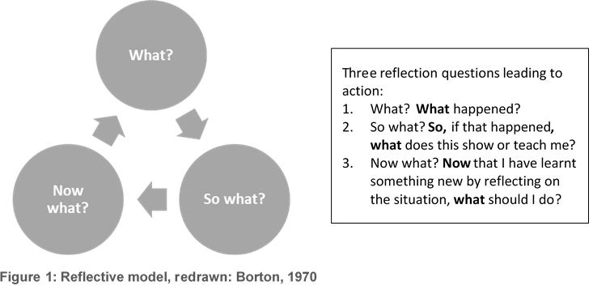For your learning journal, you can use:

* an A4 notebook with at least 100 pages lined and blank, or
* this template.

In your journal write notes and reflections, complete activities, add drawings, letters, stick in pictures or objects, use pens or paint or do anything else that makes it meaningful for you. Record your thoughts verbally, using the voice recorder on your cell phone, or even take a video.

Journaling styles

In the module on Reflective Practice in Unit 1 you can explore different ways to document your reflections and how to develop a reflection journaling style that suits you. Consider using mind maps, sketch notes and symbols too.

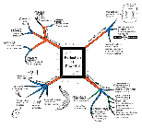

Mind map

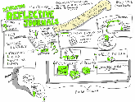

Sketch notes

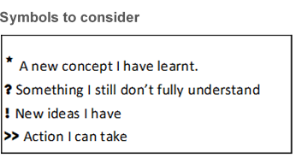

Begin your journal on the next page, if you are using this template.

Module name:

Unit #

Remember to put a date each time you write in your journal.

Activity #

## Appendix 2: Lesson Plan Template

### Lesson Plan Template: Step 1 - The Big Picture (Expand, add or remove rows as required)

|  |  |  |  |
| --- | --- | --- | --- |
| **Lecturer** |  | **Date** |  |
| **Lesson Title** | *(Your own title for the lesson)* | | |
| **Programme, Level** |  | **Subject** |  |
| **Module/Topic** | *(“Topics” as in 5 main Topics as per NCV Subject Guidelines)* | | |
| **Teaching Aims/Lesson Rationale** | *What is the purpose of learning about this topic, why is it important? What will it enable students to know/do?*  *(Should not be expressed in the same way as the learning outcomes (LOs.)* | | |
| **Learning/Subject Outcomes** | *(e.g., By the end of this unit, you should be able to: Generally, one or part of one LO, but not more than two LOs in a lesson.* | | |
| **Assessment Criteria (AC)/Standards** | *(Summative assessment and ACs may still be a long way off, but in “backward planning”, the students should know of the ACs as well as the LOs up front.)* | | |
| **Content** | *(What content needs to be introduced to enable students to achieve the LOs?*  *Note down one or two key “Take away” points)* | | |
| **Overall Teaching Approach/Method** | *(e.g., Eliciting prior knowledge; Identifying and addressing possible misconceptions; Demonstration followed by practising of skill; video followed by Q&A and problem- solving; short lecture followed by role-play; jigsaw learn-and-teach lesson, etc.)*  *What will I do? What will the students do?* | | |
| **Student Output** | *What sort of output are students expected to produce – written piece /research/presentation/ product of some sort/ practical application etc.* | | |
| **Resources & Equipment** | *What resources/materials/equipment will you as the lecturer need/will the students need?* | | |
| **Learning Environment** | *What sort of learning environment is needed, classroom or workshop? How should the learning environment be organised?* | | |
| **Formative Assessment and Feedback from Students** | *How will I – and the students – know whether they are learning and/or progressing? Provide students with feedback - What was successful, and what did not work so well?* | | |
| **Closure** | *What key concepts or terms do I want the students to take away – and bring back to the next lesson?* | | |
| **Lecturer Self-reflection and Review** | *What worked well and what could be improved?* | | |

### Lesson Plan Template: Step 2 - Detailed planning (Expand, add or remove rows as required)

| **Time**  (mins) | **Phase** | **Lecturer activity** | **Student activity** | **Resources/media/equipment** |
| --- | --- | --- | --- | --- |
| *5* | Phase 1: Spur motivation; link to experience or previous learning & work context | *Engage* ***-*** *describe how you will capture students’ interest, foster curiosity, spur motivation; link to students’ own experience, previous learning, and/or work context* | *(Students should preferably be active as early as possible)* | *(Fill in only where applicable)* |
| *5* | Phase 2: Introduce new content input, identify misconceptions and address them | *Show video, demonstrate, make a presentation, discuss, provide notes and handouts etc. Guidelines for activity must be clear; input only what content is necessary for activity* | *(Students as active listeners/ readers)* |  |
| *25* | Phase 3: Activity-based, self-directed, collaborative work | *Checks individuals’ progress; guide; support; takes note of errors and triumphs; challenges: “Have you tried this…?”* | *(Self-directed, collaborative work – individually, or in pairs or groups)* |  |
| *15* | Phase 4: Presentation & discussion | *Takes a back seat and takes notes, or acts as “master of ceremonies”* | *(Students make presentations to class; discussion can be organised in variety of ways)* |  |
| *10* | Phase 5: Reflection & closure | *Lecturer in charge of reflection and closure: link to LO(s), key concepts or terms. What will students* ***take away****?* | *(Students to engage in reflection and writing)* |  |
| **Formative assessment (FA)** | | *(Many strategies for FA. Student feedback may include pre- and/or post-assessment, quick checks, e.g. What do the students know already that is relevant? Do they understand the content, or can they demonstrate initial competence?)* | | |
| **Student output** | | *(e.g., Written classwork, ‘poster’ presentation or physical product – if any.)* | | |
| **Extended learning** | | *(e.g., Invite someone from the industry/colleague with expertise, downloaded videos for students to watch?)* | | |

**Source: AdvDipTVT Module: From interpreting curriculum to lesson planning (DHET 2020: pp 187 -188)[14]**

## Appendix 3: electron drift velocity calculation

Understanding the concept of electric current using the electron drift velocity calculation

The intention here is to give an example of how to illustrate the concept of electron drift velocity under DC.

Use the learning journal to work out the calculation.

The following example of electron drift velocity is adapted from the book ‘*A textbook of electrical technology*’.[15]

Read carefully to understand the procedure for determining the typical drift velocity of electrons in a copper conductor.

Suppose that in a metal conductor the number of free electrons available in a m3 is , and let their axial drift velocity be $v$ meters/second. In time $dt$, the distance travelled would be $v×dt$ meters. If the cross-section area of the conductor is $A$, then the volume is $Avdt$. The number of electrons contained in this volume is $nAvdt$. All these electrons will cross the conductor cross-section in time $dt$. If the charge of an electron is $e$ then the total charge $dq$ that crosses the cross-section in time $dt$ is $dq=enAvdt$.

Since current is the rate of flow of charge, then the current is given as:

$i=\frac{dq}{dt}=\frac{enAvdt}{dt}$ = $i=enAv$

Current density $j=i/A$ (ampere/m2) and therefore $j=\frac{enAv}{A}$ = $env$.

Assuming a current density $j=1.55×{10}^{6}A/m^{2}$, $n={10}^{29}$ for a copper conductor and $e=1.6×{10}^{-19}$ coulomb, by making $v$ the subject of the formula, $v=\frac{j}{en}$ and plugging in the values gives a drift velocity of 0.58 cm/min or rather about half a centimetre per minute.

Discussion

The calculation shows that the speed of electron drift velocity is relatively slow, in contrast to the electromotive force that travels down the wire at nearly the speed of light.

## Appendix 4: Skills, Knowledge, Attitudes and Values

Section on Skills, Knowledge, Attitudes and Values taken from the Advanced Diploma TVT module titled Rethinking TVET Assessment

### Skills, knowledge, attitudes and values

In Unit 1 we discussed how a person who has the competence to do a job has different kinds of skills, knowledge, attitudes and values that combine together. It can be difficult to separate these out and identify them individually when you see a competent person working. It’s a bit like trying to identify all the individual ingredients while eating a delicious cake: it might be obvious that it contains cocoa and nuts and flour, but it might not be so easy to tell what the other ingredients are and the quantities of each that are combined to create the delicious flavour and texture.

As a lecturer, it is your job to make sure that your students have all the ‘ingredients’ – SKAV – that will enable them to do their jobs well after they complete their TVET programme. Many of these will be spelled out in the curriculum but, as we have discussed, you may need to include other aspects that are important in industry or to strengthen your students’ foundation. In assessment, you need to keep checking the skills, knowledge, attitudes and values in different ways (Assessment for Learning) so that you can see where they need more explanation, demonstration or practice. You also need to have these clearly in mind when you do more formal tests and assessments, so that you remember to measure all of those that you have selected and taught.

Let’s briefly review the skills, knowledge, attitudes and values which you identified during the TVET Pedagogy module. It will be useful to look through the TVET Pedagogy module and your learning journal from that module to review your earlier learning.

Firstly, there are the *specific knowledge and skills*that are important for the specific technical competence you are helping your students develop. The knowledge will include theoretical knowledge which underlies the technical field as well as knowledge of the industry. Skills will include doing things that are involved in their field. The knowledge and skills may be quite different from those in another TVET programme. For example, someone who is studying to become an electrical engineer will need quite different skills than someone studying to be an Early Childhood Development educator or an assistant chef.

Then there are *general knowledge and skills* which are needed in virtually every field. These are sometimes called ‘soft skills’, ‘transversal skills’ or ‘21st century skills’, because they are particularly important in our rapidly changing world. These include skill sets such as:

* **Functional literacies:** Graduates need to have adequate literacy (reading and writing) and numeracy (maths) skills for the working world. Many students did not get a strong enough foundation in language and maths in their basic education. Learning in a second language can present a further barrier to developing the literacies they need for the workplace.
* **Technological skills:** Graduates need to know how to use basic technologies found in the workplace – such as how to use email, Microsoft Office, or operate a printer and projector.
* **General workplace skills:** Graduates need to have basic skills such as recording keeping or reporting.
* **Communication skills:** Graduates need to be able to understand clients’ needs, address problems appropriately and express information accurately.
* **Thinking skills:** Graduates need to be able to think in a range of different ways: for example, to be able to analyse, design or investigate.

Stop and think

Are your students’ skills in these areas adequate? Do you teach these, directly or indirectly, in your programme? If so, do you assess them? How?

When it comes to *values* and *attitudes*, there may be some that are different for different TVET fields, while others may be the same but be applied differently. For example, an electrical engineer, an Early Childhood Development (ECD) teacher and an assistant chef all need to have a strong value of ensuring people’s safety, although this value will be applied in very different ways: the electrical engineer will apply it by making sure electrical wires are always properly insulated, the ECD teacher by making sure there are no sharp objects in the classroom and the assistant chef by making sure none of the food that is served is spoiled, risking food poisoning. There are groups of values that are shared across fields. These include:

* **Craftsmanship:** Graduates need to take pride in their work and industry and be committed to a high standard of excellence.
* **Professionalism:** This includes attitudes and values such as confidentiality, keeping appropriate boundaries with clients and using funds in an appropriate way.
* **Self-regulation:** Graduates need to take responsibility for their work, their actions and their progress and find solutions to their problems.
* **Resourcefulness:** Graduates need to be willing to adapt to new situations, be persistent and not give up in difficult situations and believe that they have the ability to learn whatever they need to in order to succeed.
* **Collaboration:** Graduates need to be willing to work with others to achieve success and believe that there are things of value to learn from others.
* **Social responsibility:** Graduates need to care about the wellbeing of the community around them, see themselves as having a role in helping others and ensure that they don’t do harm to others or the environment.

## Appendix 5: Bloom’s Revised Taxonomy of Learning Domains[16]

2

1

Bloom’s three domains of educational activities or learning are: cognitive (knowledge/thinking), affective (feelings/emotive) and psychomotor (actions/skills). Typically, educators have mostly used Bloom’s **six cognitive levels** to design learning processes and outcomes, sequence and diversify learning tasks, set assessment activities and/or ask questions that go beyond recall (rote learning). In order of increasing complexity, these levels are:

**Remember** – Memorise verbatim facts and/or definitions.

Cognitive levels are not linear (thinking does not operate in hierarchies). Rather, use it in the sense of knowledge levels: **factual** (terms/info), **conceptual** (systems, categories), **procedural** (techniques/ methods) and **metacognitive** (thinking about thinking).

**Understand** – Explain content in own words, give examples/analogies.

**Apply** – Use information to solve new problems/challenges.

**Analyse** – Take concepts and break it down into smaller components, or critically look at a given context and question assumptions.

**Evaluate**: Differentiate between different processes and determine which one is better/more suitable, etc.

**Create**: Design own processes or create new artefacts (products or evidence of learning) e.g. a piece of creative writing, a poster, the solution to mathematical problem or a piece of research.

Bloom’s (revised) taxonomy is often presented as a diagram in the form of a triangle as illustrated below.

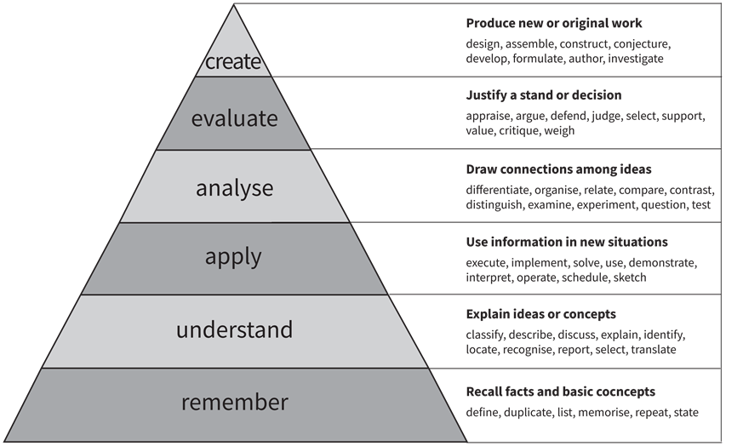

**Bloom's (revised) taxonomy**

(Source: Re drawn from Armstrong, 2016[17])

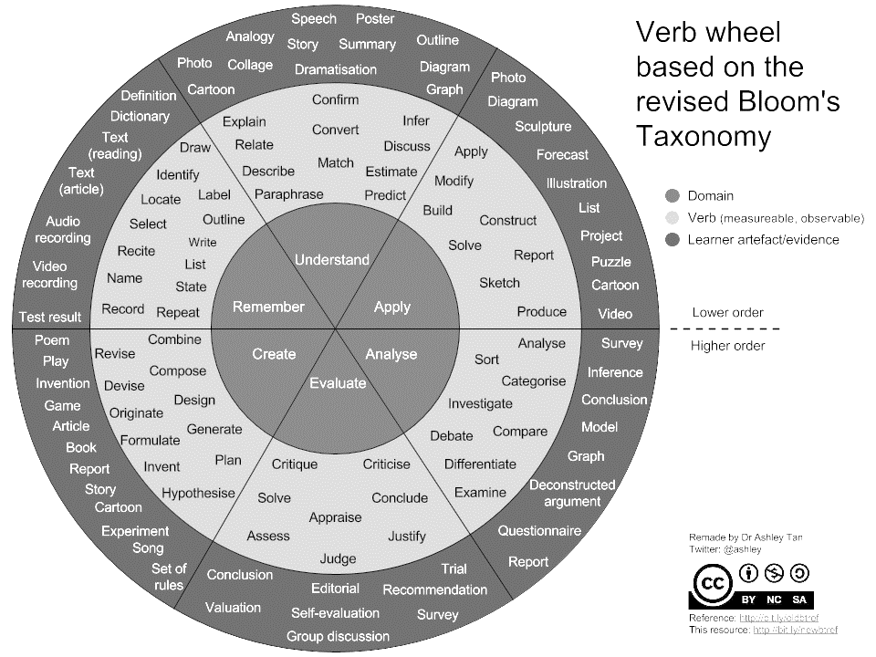

1

2

3

|  |  |  |
| --- | --- | --- |
| 1. **Core - Cognitive levels**  The wheel has no cognitive outcome start point. A teacher can start by challenging learners with a complex problem, requiring them to generate projects (Creating). | 2. **Hub - Verbs**  The wheel offers a number of verbs that are more observable and measurable and can be used in the formulation of learning activities and assessment tasks. | 3. **Rim – Example artefacts**  The wheel model also has examples of learner artefacts (products or evidence of learning). This not only reinforces the observable and measurable principle, it also provides examples of various types of assessment tasks. |

Copyright © Saide 2020

Attribution 4.0 International (CC BY 4.0)



1. [Health and Safety in the Workplace](https://www.labour.gov.za/DocumentCenter/Publications/Occupational%20Health%20and%20Safety/What%20every%20worker%20should%20know%20about%20health%20and%20safety%20at%20work.pdf?platform=hootsuite)
2. A distractor is a plausible but incorrect answer in a multiple-choice question. Don’t use obviously wrong answers or distractors to the question, or they won’t help you elicit prior knowledge.
3. LTIFR refers to the amount or number of lost time injuries, that is, injuries that occurred in the workplace that resulted in an employee's inability to work the next full workday, which occurred in a given period, relative to the total number of hours worked in the accounting period. In many countries, the figure is typically calculated per 1,000,000 hours worked.
4. https://phet.colorado.edu/sims/html/circuit-construction-kit-dc/latest/circuit-construction-kit-dc_en.html.
5. A digital representation of a physical object, process, service or environment that behaves and looks like its counterpart in the real-world as explained in <https://www.twi-global.com/technical-knowledge/faqs/what-is-digital-twin>.
6. A rectangular plastic board with a bunch of tiny holes in it. These holes let you easily insert electronic components to build and test an early version of an electronic circuit as shown in <https://www.sciencebuddies.org/science-fair-projects/references/how-to-use-a-breadboard>.
7. Sources: <https://fs.blog/entropy/#_ftn1> and <http://www.exactlywhatistime.com/physics-of-time/the-arrow-of-time/>.
8. Redrawn from https://linkedstarsblog.com.
9. Adapted from AdvDipTVT assessment module called ‘Rethinking Assessment’ available at [https://www.oerafrica.org/node/13691/materials](https://eur01.safelinks.protection.outlook.com/?url=https%3A%2F%2Fwww.oerafrica.org%2Fnode%2F13691%2Fmaterials&data=05%7C01%7Ccuthbertn%40vut.ac.za%7C4d8c815d1ae24d0306d708db73dd830b%7C1bad55d667ff456480adf00bca599df9%7C0%7C0%7C638231169278714379%7CUnknown%7CTWFpbGZsb3d8eyJWIjoiMC4wLjAwMDAiLCJQIjoiV2luMzIiLCJBTiI6Ik1haWwiLCJXVCI6Mn0%3D%7C3000%7C%7C%7C&sdata=2KQ9PeKgIyoZ02yX6SK2Vm5sTTu5%2Fv5866uXnJp%2FbSY%3D&reserved=0).
10. Adapted from an assessment document in Applied English Language Studies at the University of the Witwatersrand by Pippa Stein and Hilary Janks.
11. The Engineering Council of South Africa
12. Adapted from AdvDipTVT Rethinking Assessment Unit 4 available at: [https://www.oerafrica.org/node/13691/materials](https://eur01.safelinks.protection.outlook.com/?url=https%3A%2F%2Fwww.oerafrica.org%2Fnode%2F13691%2Fmaterials&data=05%7C01%7Ccuthbertn%40vut.ac.za%7C4d8c815d1ae24d0306d708db73dd830b%7C1bad55d667ff456480adf00bca599df9%7C0%7C0%7C638231169278714379%7CUnknown%7CTWFpbGZsb3d8eyJWIjoiMC4wLjAwMDAiLCJQIjoiV2luMzIiLCJBTiI6Ik1haWwiLCJXVCI6Mn0%3D%7C3000%7C%7C%7C&sdata=2KQ9PeKgIyoZ02yX6SK2Vm5sTTu5%2Fv5866uXnJp%2FbSY%3D&reserved=0).
13. Understanding Rubrics by Heidi Goodrich Andrade available at <https://www.k-state.edu/ksde/alp/activities/Activity7-1.pdf>.
14. <https://www.oerafrica.org/system/files/13691/assets/13707/advdiptvtmodule-intepretingcurriculumlessonplanning.docx?file=1&type=node&id=13707&force=0>
15. Theraja, B. L. & Theraja, A. K. (2005). *A Textbook of Electrical Technology*. Volume 1: Basic Electrical Engineering in S.I. System of Units. Ram Nagar, New Delhi: S. Chand & Company Ltd.
16. Bloom's Taxonomy was created in 1956 under the leadership of educational psychologist Dr Benjamin Bloom in order to promote higher forms of thinking in education. In the mid-nineties Lorin Anderson, a former student of Bloom, and David Krathwohl revisited the cognitive domain and made some changes, hence Bloom’s, revisedtaxonomy of learning domains.
17. Armstrong, P. 2016. *Bloom's taxonomy*. Nashville: Vanderbilt University Centre for Teaching. Accessed from: <https://cft.vanderbilt.edu/guides-sub-pages/blooms-taxonomy/>