Advanced Diploma
Technical and Vocational Teaching

Psychology of Education for TVET

Department of Higher Education and Training

Department of Higher Education and Training
Advanced Diploma: Technical and Vocational Teaching
Module: Psychology of education for TVET
Author: Ian Moll

© Department of Higher Education and Training 2020
Department of Higher Education and Training
123 Francis Baard Street
Pretoria
0001

Website: www.dhet.gov.za

This Module of the Advanced Diploma: Technical and Vocational Teaching (Adv. Dip TVT) was produced with the financial support of the European Union. Its contents are the sole responsibility of the Department of Higher Education and Training, and do not necessarily reflect the views of the European Union.

This work is licensed under a Creative Commons Attribution 4.0 International License

CONTENTS
Acknowledgements iii
Acronyms and Abbreviations v
Module overview 1
Purpose 1
Outcomes 1
Structure 2
Credits and learning time 2
Unit 1: Knowledge and learning in TVET 3
Unit 1 outcomes 3
The knowledge and skills of the craftsperson 3
The knowledge and skills of the baker of bread 5
Your vocational knowledge and skills 9
Conclusion to Unit 1 16
Unit 2: Key learning theories in TVET 17
Introduction 17
Unit 2 outcomes 18
Learning to use a sledgehammer 18
Reinforcement theory 19
Working memory 21
Constructivism 26
The theory of equilibration 27
The theory of mediation 31
Apprenticeship learning in communities of practice 34
Embodied learning 39
How the theories work together 43
Conclusion to Unit 2 45
Unit 3: Learning in practice in TVET 47
Introduction 47
Unit 3 outcomes 48
Embodied TVET learning 48
Conclusion to Unit 3 55
Unit 4: Learning myths in TVET 57
Introduction 57
Unit 4 outcomes 57
Is instruction a bad thing? 57
Do different learners have different learning styles? 64
Does a learner have multiple intelligences? 67
Do adults learn differently to children? 69
Conclusion to Unit 4 73
Unit 5: Challenges faced by TVET learners 75
Introduction 75
Unit 5 outcomes 76
Disability 79
Impairment and disability 81
Resourcing and under-resourcing 84
Conclusion to Unit 5 85
Summative Assessment Psychology of Education for TVET. 87
Rubrics for Model Summative Assessment for Unit 5 90
Comments 97
References 99

Acknowledgements

The Open Learning Directorate of the Department of Higher Education and Training would like to acknowledge:

The European Union for funding the Capacity Building for TVET College Lecturers through Open Learning Programme (Sub-Programme 2 of the Teaching and Learning Development Sector Support Programme). The production of open learning courses for the Advanced Diploma in Technical and Vocational Teaching (Adv Dip TVT) is a project of that programme.

The following universities, for making lecturing staff available to contribute to the project as subject matter experts, writers or critical reviewers:
- Cape Peninsula University of Technology
- Central University of Technology
- Durban University of Technology
- Nelson Mandela University
- Tshwane University of Technology
- University of Fort Hare
- University of the Free State
- University of Johannesburg
- University of Pretoria
- University of KwaZulu Natal
- Vaal University of Technology
- University of the Witwatersrand

The Technical and Vocational Education and Training (TVET) Branch of the Department of Higher Education and Training for providing information whenever it was requested.

The following TVET Colleges for making lecturing staff available to contribute to the project as subject matter experts, writers or critical reviewers:
- False Bay TVET College
- Majuba TVET College
- South-West Gauteng TVET College
- West Coast TVET College, and
- Motheo TVET College for developmental testing of materials.

The University of the Free State South Campus for overall project management, and the Ideas Lab on the South Campus for producing multi-media materials, resources and the e-learning (SCORM) versions of the courses, as well as uploading the materials on the National Open Learning System (NOLS).

The South African Institute for Distance Education (Saide) for their expertise in co-ordinating production and in ensuring that the developed material is made available for use as Open Education Resources (OER), thereby contributing to the implementation of open learning in post-school education and training (PSET).

Acronyms and Abbreviations

AdvDipTVT | Advanced Diploma: Technical and Vocational Teaching
CoP | Community of Practice
CAPS | Curriculum Assessment Policy Statements
DHET | Department of Higher Education and Training
TVET | Technical and Vocational Education and Training
WHO | World Health Organisation
ZPD | Zone of Proximal Development

Programme introduction
The Advanced Diploma in Technical and Vocational Teaching (Adv Dip TVT) programme seeks to provide a structured professional learning pathway for current and aspirant technical and vocational lecturers/teachers. The Diploma will equip them with the knowledge and competences to implement and manage teaching and learning in their TVET colleges effectively and in alignment with national goals.

This module is one of a set of modules that contribute to the Advanced Diploma programme. The overall purpose of the Advanced Diploma is to engage lecturers working in the TVET sector in conversations about what it means to be a quality teacher in a TVET college. Each Module in the programme explores this from a different angle, but for every module the foundational concept is about the type of teacher you want to be. We all know that the relationship between teaching and learning is interrelated. So in order to understand the type of teacher you want to be you will need to engage with what learning means in a TVET context.

We often think about vocational and technical or craft knowledge as different from theoretical knowledge. However, there is increasing recognition of the power of vocational and theoretical knowledge coming together to develop the skilled craftsperson whether it is in plumbing, baking, even mathematics and physics. This integration of theory and vocational knowledge is equally important in teaching as well. Teachers are constantly needing to make informed decisions and judgements as they make a selection of what to teach and how best to teach the specific content, concept or skill.

This leads to a question about how different forms of knowledge and skill are brought together and balanced in the curriculum and in teaching and learning.

Approach to learning
To answer the question above in this diploma programme, a framework has been developed which is referred to as know how, know it and know that, or the HIT framework. This framework is introduced, referred to and deepened in different ways all the way through the programme.

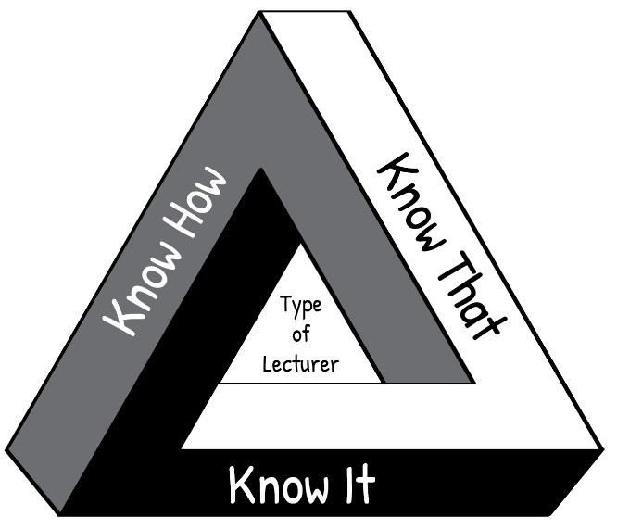
“Know How” is procedural knowledge, “in our bodies” or embodied knowledge.
For example, following a bread recipe.
“Know It” is recognition, the knowledge of what counts as good; wisdom; technical and theoretical judgments.
For example, is this sourdough good quality bread?
“Know That” is propositional knowledge or
theoretical knowledge, the knowledge of how and why, cognitive knowledge.
For example, the science of bread baking.

Figure 1: The HIT framework

Think about your own craft of teaching. The kind of teacher you want to be, is one who knows how (the techniques of teaching), knows that (the science and theory behind teaching AND learning) and knows it (knowing and reflecting on what makes a quality teacher). Such a teacher enables students to actively engage with their learning and to develop their full potential.

If you are interested, click on the link provided to watch a short video in which Wayne Hugo discusses the “HIT model” of TVET knowledge and learning.

Relating theory to practice
In this module new concepts are often introduced by developing them from a practical situation with which you are probably familiar. This process, which moves from your experience towards a more abstract level of theory is known as inductive learning. It makes learning easier and is very different from deductive learning, which starts by presenting abstract theories and principles, then requires you to “deduce” practical conclusions and concrete examples. You are encouraged to relate the ideas you learn from the Adv Dip programme to your own context and to try to think theoretically about your practice. In other words, to think about the rationale for your practice.

Reflective practice and the use of a learning journal
One of the Adv Dip TVT modules is called Reflective Practice, and covers the concept of reflection in the life of a TVET lecturer. Of particular importance is unit 2, which describes various models which facilitate reflection. The simplest reflective model that is discussed in this unit, is that of Terry Borton (1970). It consists of three steps as follows:

Figure 2: Reflective model (after Borton, 1970)

The three questions to prompt reflection leading to action:
- What?
What happened? In this step you remember or describe the situation or event you have experienced.
- So what?
So, if that happened, what does this show you or teach me? In this step you explore what new insights or knowledge the situation gives you.
- Now what?
Now that I have learnt something new by reflecting on the situation, what should I do about it? In this step you think about what to do with the new awareness you have gained – i.e. how to make use of it to act more effectively in future situations.

Throughout the Adv Dip TVT programme, you are encouraged to use a model to reflect on your practices at work in the college so that you can improve how teaching and learning takes place. We have embedded reflective practice throughout the programme, and at the end of most units in the modules you will find a reflective activity to complete. The reflective activity will enable you to make the most of what you have learnt throughout the unit, as well as assisting you to apply your learning in your workplace. Throughout the Advanced Diploma modules, we encourage you to use a learning journal. Keep a file (paper- based or electronic). You will use it to write notes and reflections and complete activities. Start your learning journal at the beginning of the programme, and keep it regularly updated throughout.

Active learning
Most learning theorists tell us that new understandings and learning depend on, and arise out of action. All the modules in the Adv Dip TVT programme include activities. Your learning will be more fruitful if you engage systematically with the activities. If you do not do the activities, you will miss out on the most important part of the programme learning pathway.

Thinking activities
At various points in the module you are asked to stop and think and to take some time to reflect on a particular issue. These thought pauses are designed to help you consolidate your understanding of a specific point before tackling the next section of the module. One of the habits many of us develop through a rote kind of learning is to rush through things. Work though each module slowly and thoughtfully. Read and think. This is how we develop a depth of understanding and become able to use the ideas we learn. Try to link the issues raised in each thought pause with what you have read, with what you have already learnt about learning, with your own previous experience, and so on. Think about the questions or problems raised in the module. Jot down your ideas in your learning journal so that you can be reminded of them at a later stage.

Linkages across modules
As you work through this and other modules, you will notice that topics or issues raised in one module may cross refer to the same issue or topic in another module, possibly in more detail. So for example, while there is an entire module dedicated to the investigation of curriculum, key issues related to curriculum will also be highlighted and discussed in the modules dealing with pedagogy, psychology in TVET as well as in the assessment module.

Access to readings
There are links to readings throughout the activities. We have tried as far as possible to provide links to Open Educational Resources (OER). In cases where this was not possible you will be directed in the activity to access these through your university library. The website link is shown in the reference list.

Assessment
The activities contained in this module and the Adv Dip TVT programme as a whole, promote a continuous and formative assessment process. This approach is intended to support your ability to relate ideas to practice and to contribute to your development as you work through the various modules of the programme.

You will also notice that each module includes a summative assessment task with the assessment criteria set out in an accompanying rubric. This summative assessment task is a model only, intended to illustrate the kind of assessment tasks that may be set by the university providing this programme.

Module overview

Purpose
This module is on the learning that takes place when we learn a technical craft or vocation. It is about the knowledge and skills that we expect our TVET students to acquire in the course of their studies at a TVET college. It draws on the discipline of psychology, and in particular the psychology of learning. As you work through this module, think about a number of different issues related to learning:

- What are the different ways we learn the knowledge and skills of a craft?
- How do different theories of learning help us to understand TVET learning?
- What previous ideas about learning have been shown to be wrong?
- What learning constraints and challenges do our South African TVET learners face, individually, culturally and socially?
- What is the learning diversity that we encounter across South African TVET colleges?

These are all questions that psychology can help us to understand. As a discipline, ‘psychology’ is usually understood to be the study of the mind. So it includes the study of how we think (cognition), of our emotions (affect), of how our brains work (neuropsychology), and how we operate as social beings (social psychology). As an applied field, ‘psychology’ is wide ranging, encompassing psychotherapy and counselling, human resource management, and of course the application of teaching and learning strategies in education and training contexts. This module is primarily concerned with the latter – and hence, the focus is on the psychology of learning in the classroom or workshop.

The module aims to investigate how the different forms of knowledge entailed in tool use and “craft” (i.e. vocational knowledge) are acquired through different kinds of learning processes. It will consider procedural knowledge (“knowing how”), declarative knowledge (“knowing that”) and expert judgements (“knowing it” ) in TVET, and consider how different theories allow the TVET lecturer to help develop such forms of knowledge in his/her students. Challenges and barriers to such learning in TVET classrooms and workshops will be examined.

Outcomes
By the end of this module you will:
- Have understood the relationship between knowledge and learning in TVET
- be able to evaluate different learning theories, including issues related to ‘adult learning’
- have developed a critical understanding of “multiple intelligences” and related ideas in the TVET classroom
- be able to identify different learning challenges in the TVET context to support students to overcome these challenges and ensure inclusive education
- have developed an enhanced understanding of the diverse nature and contexts of TVET students in order to accommodate and take care of their various needs in your teaching.

Structure

Figure 1: Module structure

Credits and learning time
This module carries 10 credits. This is equivalent to 100 notional learning hours. It is anticipated that you will take approximately 100 hours to complete the module successfully. The 100 hours will include contact time with your Higher Education Institution (HEI), reading time, research time and time required to write assignments. It is also expected that at least half of your learning time will be spent completing practice-based activities in your TVET College. This will involve your individual work on the activity, and may also require you to discuss these college-focused activities with your colleagues. Each activity in this module indicates the suggested time for completion.

Unit 1: Knowledge and learning in TVET

Unit 1 outcomes
By the end of this Unit, you should be able to:
- consider the different types of knowledge and skill entailed in tool use and ‘craft’ activity
- understand what needs to be learned in TVET
- understand your own strengths in relation to the knowledge and skills you have as a TVET educator

The knowledge and skills of the craftsperson
We sometimes hear people say that academic knowledge and vocational knowledge are worlds apart, and that the former (academic knowledge) is somehow better than the latter. Some say that academic knowledge is the prerogative of elites, that rich people are entitled to it, and vocational knowledge is the lot of ordinary people. However, what we now know, from psychology, is that thinking and doing (the activities of “the head and the hands” respectively) are very similar in both academic and TVET domains. People might want to think that brain surgeons should earn more money than plumbers, but we get very little support for this idea from the psychology of learning!

It is helpful here to think about terms like ‘vocation’ and ‘craft’. In the TVET domain, we usually refer to the idea that we are training and educating people who have vocations, like baking, bricklaying, hairdressing, cosmetology, human resource management, or fitting and turning. Sometimes we refer to them as craftspersons in recognition of the fact that they have expertise in various techniques or technical skills needed to get particular jobs done. They have craft knowledge.

But the gulf with the academic world is not so large, if one exists at all. In universities, there is increasing recognition of, say, the craft of doing mathematics, or history, or physics. And in TVET institutions, there is increasing recognition of the importance and power of the theoretical knowledge that the skilled craftsperson exercises in doing her work.

It is now widely recognised that there is both theoretical and vocational knowledge being developed in both academic and TVET institutions. However, our concern here is with how all these different forms of knowledge and skill should constitute the curriculum of the TVET college, and what learning should be encouraged in this regard.

There are three kinds of knowledge/skill that we need to recognise as important in TVET:
- procedural knowledge, the knowledge of how to do something. When we are skilled at a particular job, we know the procedures we need to go though in order to do it. This know-how is usually understood to be “in our bodies”, in our muscle-memory and our central nervous system; it is embodied knowledge. Common examples of this are knowing how to ride a bicycle or how to drive a car. In what follows we shall refer to this kind of knowledge as “knowing how”.
- propositional knowledge (also known as declarative knowledge or theoretical knowledge), the knowledge of how and why something works in the way it does. It consists of propositions usually established by scientific or social scientific inquiry. This is cognitive knowledge. In what follows we shall refer to this kind of knowledge as “knowing that”.
- recognition, the knowledge of what counts as a good example of something. This is the kind of knowledge that is built over time by a skilled practitioner who is continually acquainted with the products of particular craft practices (his/her own and those of others). This knowledge can be understood as wisdom. Examples of this are the ability of a veteran cabinet maker to recognise an excellent table, or the ability of an experienced hairdresser to recognise fine braiding or to recommend particular shampoos for different hair conditions. Such judgments are as much technical as they are aesthetic, and they rely as well on deeply understood theoretical knowledge. In what follows we shall refer to this kind of knowledge as “knowing it”.

Stop and think
In this Unit we are thinking about knowledge. In Units 2 to 5 we shall focus on learning. But keep in mind that there is a close relationship between these ideas: Education necessarily involves knowledge and learning. In TVET, learning is the acquisition of specialised knowledge. So the reason for discussing vocational and craft knowledge here is to lay the foundation on which we can go on to discuss vocational and craft learning. In the final activity of this Unit we start to think about the way you learned your various vocational and craft skills.

Activity 1: Knowing how, knowing that, knowing it

Suggested time: 20 min

In this activity, you will consolidate your understanding of the three different kinds of knowledge that are important to foster in a TVET course.
What you will do:
- Watch a short video in which Wayne Hugo discusses the “HIT model” of TVET knowledge and learning. You can read the article The HIT model of TVET knowledge (Moll, Hugo, 2020) to deepen your understanding of the HIT model.
- Think about your own specialist knowledge domain in TVET. Make a list of examples of each of the three kinds of knowledge – knowing how, knowing that, knowing it – that you have in this specialist area.

Discussion of the activity
Whatever your area of specialisation, you would no doubt have identified important aspects of your own knowledge that fit into each one of the categories of the HIT model. One thing you would have recognised in doing this activity is that your own practical knowledge, theoretical knowledge and accumulated wisdom of your own vocation or craft is very complex. It has depth and is wide ranging. The activity would also have led you to recognise the different kinds of knowledge that you need to be teaching to your own TVET students.

We shall develop these ideas further in the activities that follow in this Unit.

The knowledge and skills of the baker of bread
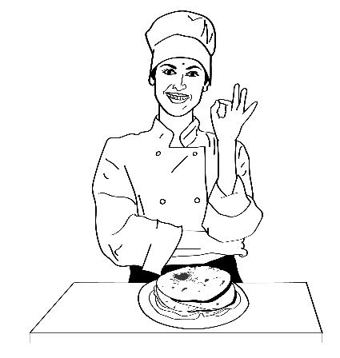
Bread is part of the everyday life of people all over the world. As much as there is diversity of people, so there is diversity of bread.

Stop and think
Think of different kinds of bread that you have encountered in your life. Think of the people who eat it, who love it, who make things with it, and who add it to their meals. You might be thinking of sliced white bread, crispy brown rolls, rough brown bread with pumpkin seeds, vetcakes, idombola, naan bread, pizza ….…. Think about the people who bake the bread, and the expert technical and vocational knowledge that they have. How and where did they learn this knowledge?

The experts who make the bread are our bakers. There’s a lot of stuff that they know: they are experts. They are the kind of experts that we as TVET educators want our students to become. Sometimes we don’t appreciate just how wide-ranging and comprehensive the knowledge of a good baker is. There are three kinds of knowledge and skill that a baker always has. First, to bake a good loaf of bread, bakers must be strong in one area of knowledge – they must know how to make bread. Second, they must know what happens when bread is baked: for instance, they understand how yeast works to make bread rise (what temperature the water must be in which it is dissolved, what happens when the bread dough is left to stand before being put in the oven, etc.). Third, as they gain experience and wisdom as bakers over time, they know what counts as a good loaf of bread. They know it. So, for example, they know why cake is not bread, and they can invent new and delicious kinds of bread to help them develop in their careers as bakers.

Activity 2: What do good bakers know?

Suggested time: 120 min

In this activity you will identify the different kind of knowledge and skills held by expert bakers.
What you will do:
- Watch two short videos: ‘How to make a sourdough starter’, and ‘Baking sourdough bread’.
- Read three short articles.
  - Lawandi, J. “The science behind the yeast and how it how makes bread rise.”. (This first article is not an OER. You will need to access it through your university library. The website link is in the reference list.)
  - Wikipedia, “Bread”; and
- Wikipedia. “Kinds of bread.”. In particular, compare the different types of bread in the table. (The second two readings are OER and you can link directly to them.)

- Read the two bread recipes below, the first for basic white bread, the second for a loaf of sourdough rye bread.

As you watch the videos and read the documents, make notes on what kind of knowledge about bread you can identify in them.

Simple white bread recipe
Ingredients
• 1 teaspoon sugar
• 1 package dry yeast (about 2¼ teaspoons)
• 1¼ cups warm water (about 40°C)
• 3 cups bread flour
• 1 teaspoon salt
• 1 large egg, lightly beaten
How to Make It
- Dissolve sugar and yeast in ¼ cup warm water in a large bowl; let stand 5 minutes.
- Add 1 cup warm water, flour, and salt to yeast mixture; stir until a soft dough forms. Turn out onto a floured surface. Knead dough until smooth and elastic.
- Place dough in a large, greased bowl. Cover and let rise in a warm place (30°C) for 45 minutes or until doubled in size. (Gently press two fingers into dough. If indentation remains, dough has risen enough.)
- Uncover dough, and punch dough down. Cover and let rise 30 minutes. Uncover dough and punch it down again. Cover and let rest 10 minutes.
- Roll up dough tightly, pressing firmly to eliminate air pockets. Place dough in a greased loaf pan. Cover and let rise 30 minutes or until doubled in size.
- Preheat oven to 200°C.
- Uncover dough; gently brush with egg. Bake at 200°C for 12 minutes. Reduce oven temperature to 170°C (do not remove bread from oven); bake an additional 15 minutes or until loaf sounds hollow when tapped.
- Remove from pan. Cool on a wire rack.
Adapted from https://www.myrecipes.com/recipe/simple-white-bread

Sourdough rye bread recipe.
Ingredients
• 1¾ cups water
• Sourdough Starter: 70 grams, 1/3 cup
• 1¾ cups Rye Flour
• 1¾ cups Bread Flour
• 2 tablespoons Molasses
• 1 tablespoons Fennel Seed
• 1 teaspoons Aniseed
• 1¾ teaspoons Salt
How to Make It
- In a large bowl, mix the starter into the water, then add the molasses and the seeds into the water.
- In a separate bowl, combine the flours and salt.
- Gradually stir the dry ingredients into the wet. After 15 minutes, mix again, let rest for 15 minutes and mix one more time as before.
- Cover the bowl and leave at room temperature for roughly 12-14 hours (this is called ‘proofing’).
- After the long proof, stretch and fold the dough into a round shape for baking. Cover again with plastic and let rest 15 minutes.
- Place the dough into bowl lined with a well-floured kitchen towel for the final rise. (between 1-1½ hours). Keep the dough covered to prevent it from drying out.
- Preheat your oven to 220°C.
- Place the dough on a greased baking pan, and score the dough with a sharp knife.
- Bake until the internal temp is about 90°C.
- Remove from pan; cool on a wire rack.
Adapted from https://breadtopia.com/sourdough-rye-bread/

- Copy Table 1 into a Word document, or reproduce it in a workbook or on a sheet of paper, and complete columns two and three. Pull examples of the different kinds of baking knowledge from the videos, articles and recipes, and complete the last two columns of the table.

Table 1 Types of knowledge
TYPE OF KNOWLEDGE | EXAMPLES OF THIS KIND OF KNOWLEDGE | WHY MUST A GOOD BAKER HAVE THIS KNOWLEDGE?
“Knowing how”  What do you do to make bread? | 1.
 | 2.
 | 3.
“Knowing that”  What do you know about why you do what you do and what happens when you make bread? | 1.
 | 2.
 | 3.
“Knowing it”  What are the features of the loaf that allow you to recognise that this is good bread? Or not such good bread? | 1.
 | 2.
 | 3.

Discussion of the activity

In the Sourdough Bread video – as there will be in any video about “how to bake bread” – there are a lot of things Oliver does to get to the loaf of sourdough bread. There is a sequence he goes through – prepare the ingredients, add starter to tepid water and mix well, add flour to the mixture, use your hands to mix the dough, allow dough to rest, fold … and finally bake for a given time. But he is not following a recipe. It is clear that he simply knows what needs to be done. And he is thinking simultaneously about a lot of things that need to be done. There is clearly a lot of evidence of him knowing how to bake bread. This is what we admire so much when we watch Jamie Oliver’s TV cooking programme for example.

The second video is also a ‘how to’ video but is also about how a starter, or ‘mother’ dough works. There is an underlying common-sense and knowledge about how to bake bread.

We can also see ‘knowing that’, in the ‘Sourdough’ video. Oliver explains how folding, proofing and shaping the dough ‘reconstitutes the gluten and produces bi-products such as lactic acid and acetic acid’, and how these ‘help your body to absorb more of the nutrients such as calcium, magnesium and iron. He also explains how the ‘ethanol and carbon dioxide … are trapped in the dough by strong gluten strands allowing your dough to rise’. He even gives a brief history of sourdough as ‘the oldest method of baking bread dating back to 3000BC in Egypt’. We see his strong theoretical knowledge at work. This propositional knowledge is also evident in the ‘Starter’ video, through comments about the temperature of the water you use, to the complex flavour produced by the lactic and acetic acids, and the bubbling created by the ethanol and carbon dioxide. In the Lawandi article, this scientific knowing that is taken to an even deeper level. Of course, a baker does not need to have detailed knowledge of chemistry, but there is no doubt that there is detailed theoretical knowledge at work in her abilities to bake good bread.

In both videos, there are also good examples of the accumulated wisdom of bakers acquired over time by acquaintance with the baking of bread. So Oliver makes judgements of how to feel with his hands when the dough is well mixed, for example, or when the starter is ready to use, and whether the bread has risen well by tapping it and hearing a “hollow sound”. Of course, not all of us would recognise that hollow sound in the same way as Oliver does! In other words, not all of us know it (bread) in the same way that Oliver, as an experienced baker, does.

The two recipes represent the beginning of the formalization of knowledge of the procedures of baking bread. One can only write up a recipe if one knows how to bake that particular kind of bread. So a bread recipe is the most basic example of the recording of procedures involved. It is basic knowing that, although not as theoretical or scientific as the other examples of this kind of knowledge that we have already considered. Nonetheless, the specific recording of the steps you go through when you bake bread is basic ’know that’ knowledge.

There are also good examples of knowing it in the recipes. These are all knowledgeable judgments that the experienced baker makes along the way which a novice baker would not recognise as easily as an experienced baker.

Look also at the table of ‘kinds of bread’ in the Wikipedia article. What criterion do we use to judge what counts as bread? How do we know that a vetcake or idombola is bread? How do we know that a koeksister or a black forest cake is not bread? What counts as a quality loaf of bread? These are questions that a baker with long experience answers easily, drawing on her accumulated wisdom. This is knowing it.

Your vocational knowledge and skills

Having thought about the specialist TVET knowledge and skills of the baker, you are probably in a better position now to think about your own knowledge and skills in a complex way. Just as a good baker has acquired extensive knowledge of all three kinds – knowing how, knowing it, knowing that (HIT) – in the course of her education, training and ongoing career, so you have too in your own specialist field of knowledge in TVET. It is important for you as a vocational educator to understand this expertise. Some of your knowledge and skills will be well established, part of your very nature. Some might require you to attend courses and training programmes to further develop your abilities as a teacher. The important thing to understand is that these different kinds of knowledge (HIT) together constitute the expert foundation that makes you the TVET educator that you are.

Activity 3: What do you know?

Suggested time: 40 min

In this activity you will identify the different kind of knowledge and skills held by you as an expert in a particular craft/vocation, and how you came to know them.

What you will do:

- Read the three mind maps in Figure 3, Figure 4 and Figure 5, below showing the specialist knowledge for the bricklayer, hairdresser or human resource manager.

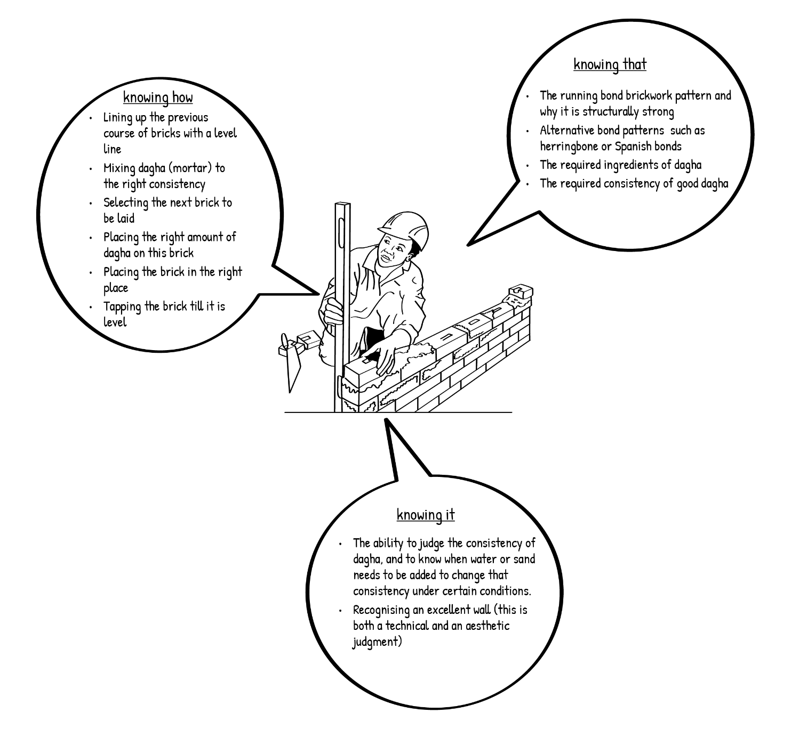
Figure 3 Specialist knowledge of a bricklayer

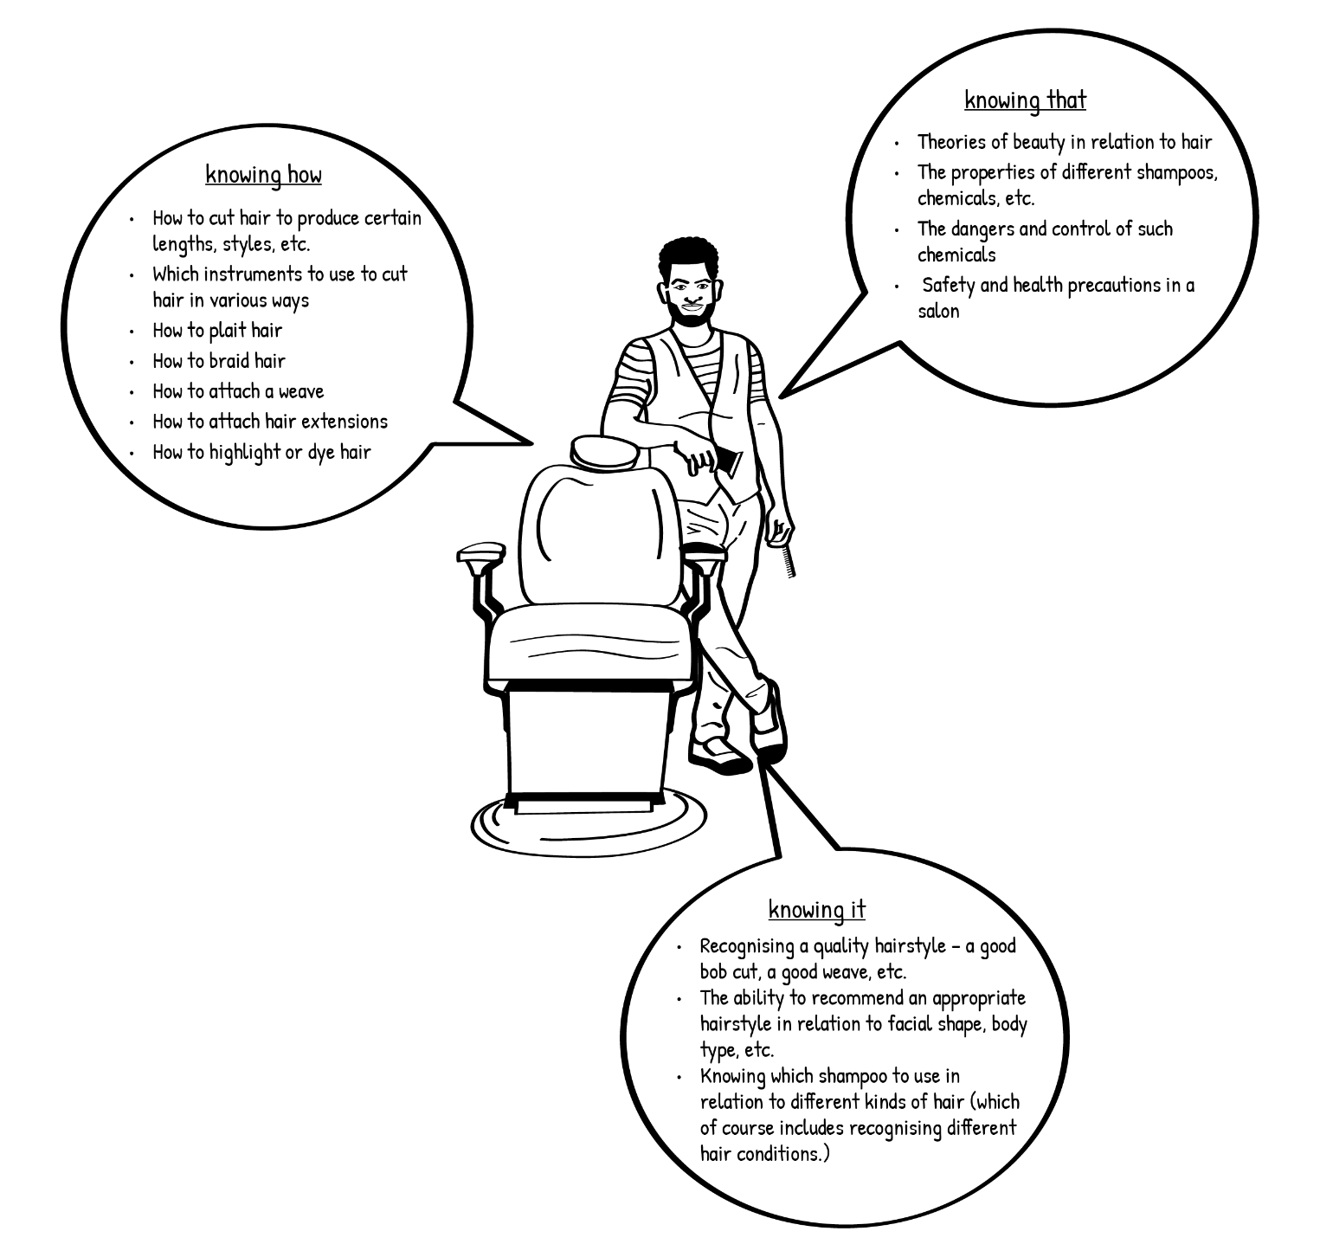
Figure 4 Specialist knowledge of a hairdresser

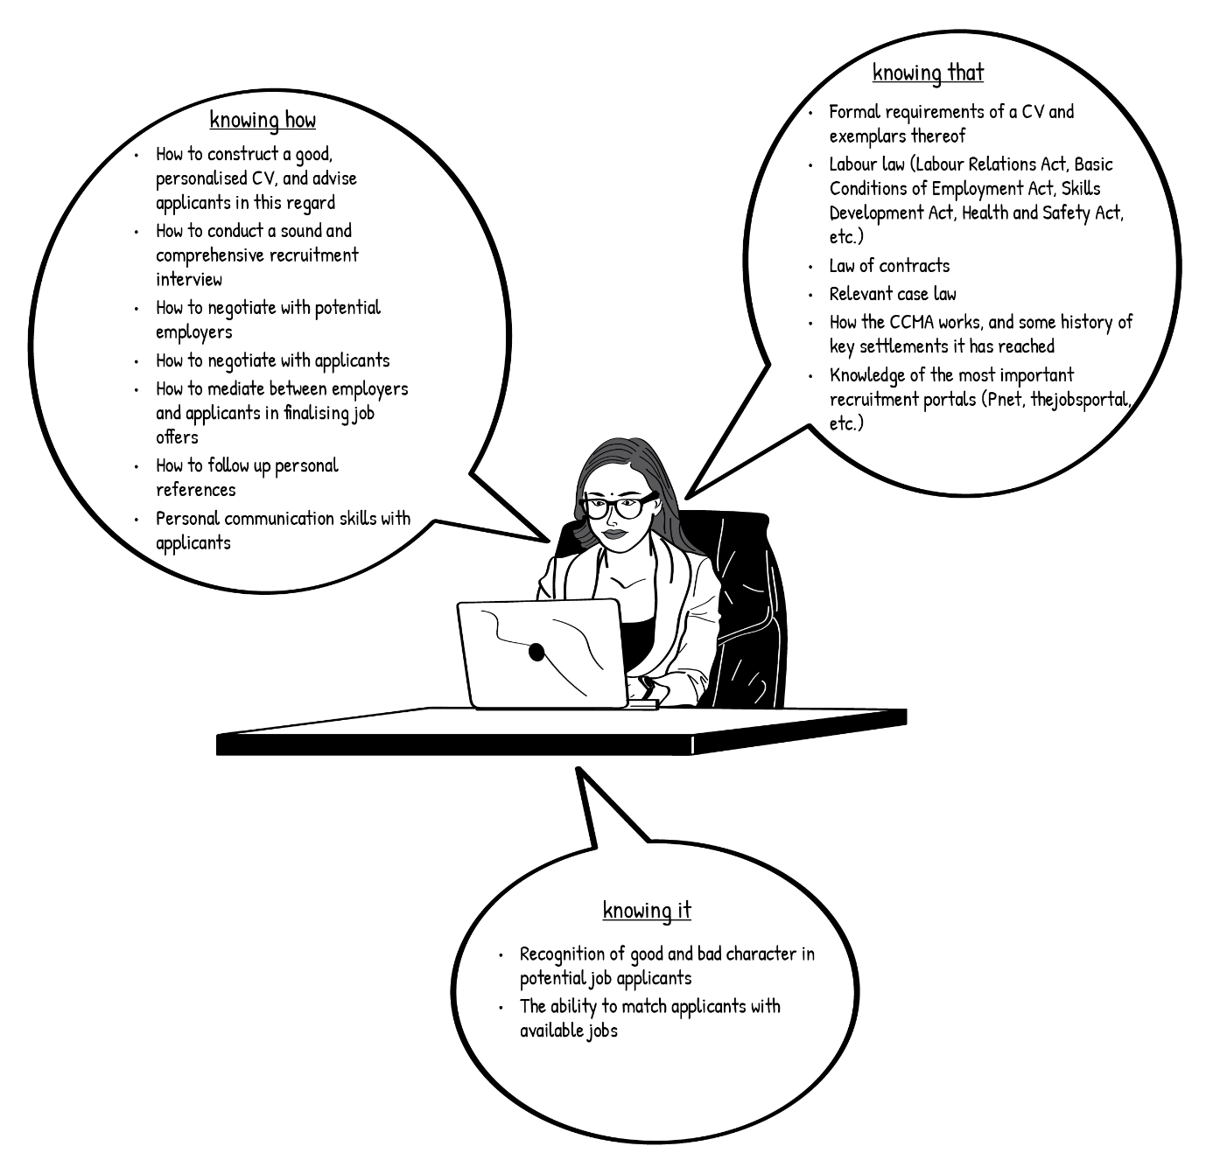
Figure 5 Specialist knowledge of an office professional

- Complete a mind map of your own, using Figure 6, to record examples of your own specialist knowledge in the appropriate boxes.

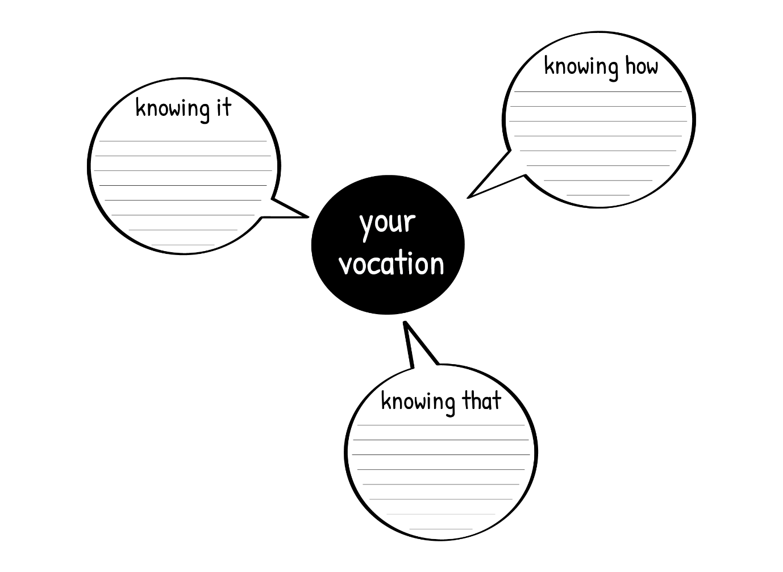
Figure 6 Your own specialist knowledge

- Think back to the second part of Activity 1 – this task is an extension of your initial thinking there.

Discussion of the activity
Activity 3 would have helped you think about the complexity of all the different kinds of technical and vocational knowledge that you have as a TVET educator. It would also have given you cause to think about how one learns such knowledge and skills. Think again about the specialist knowledge of the bricklayer, hairdresser and human resource manager. Did that help you to think about your own specialist knowledge?

Stop and think

The different kinds of knowledge that you have in your specialist TVET area now should be clear to you. It should be obvious that each kind of knowledge in TVET would be learned in a particular way, although it is equally obvious that they are learned together and complement each other. We can now go on to think a bit about this learning.

Activity 4: How did you learn it?

Suggested time: 40 min

In this activity you should think back to how you acquired your different kinds of expert vocational knowledge. So, for example, if you are a bricklayer, how did you learn to use a trowel? If you are a hairdresser, how did you learn to use curling tongs? If you are an HR practitioner, how did you learn to use and populate a job search portal on the Internet? Think about what tools you need to use in your own vocation. What tools do you need to use as a TVET lecturer?

What you will do:
- Look back over the way you have characterised your knowledge and skills in Activity 3.
- How did you learn each of these examples of knowledge?
- How would you expect your TVET students to learn each of the three kinds of knowledge that are represented there?
- Create your own tables like Tables 2, 3 and 4 below, and complete them.

If you are able to work with others, either in a group in class or in an online chatroom, this is a good activity to discuss ideas with your colleagues and learn from each other.

This activity takes us into Unit Two, in which we consider, from various theoretical points of view, how human beings learn vocational and craft knowledge in all of its aspects.

Table 2 Knowing that
How do you and your students learn the propositional knowledge (‘knowing that’) in your specialist vocational and craft field?

Table 3 Knowing how
How do you and your students learn the procedural knowledge (‘knowing how’) in your specialist vocational and craft field?

How do you and your students learn the practical wisdom (‘knowing it’) of your specialist vocational and craft field ?
Table 4 Knowing it

Discussion of the activity
Activity 3 would have helped you think about the complexity of all the different kinds of technical and vocational knowledge that you have as a TVET educator. It would also have given you cause to think about how one learns such knowledge and skills. When filling in the tables, you would have become aware of the very different ways in which we learn different things.

The kind of knowledge that we call ‘knowing how’ is usually learned in what we call apprenticeship learning. This is ‘learning from demonstration’, and refers to the way we learn practical skills by observing and being guided by an expert. It is learning where students observe, imitate, and practice such skills with help from a teacher. So a novice bricklayer would learn by watching a skilled bricklayer, imitating her, practising the laying of a brick, and being corrected and guided by her when he makes a mistake, until he gets it right for himself. Likewise, an apprentice hairdresser closely observes a skilled, experienced colleague using a hair straightener. He learns from his mistakes, which he becomes aware of sometimes by trial-and-error (spare a thought for the person in the chair), but more often by having them pointed out to him by his expert colleague. He then practices, and practices, under her guidance, until he too acquires the expertise. HR students also learn to populate a job recruitment website in this way. They watch their mentors doing it, try it themselves, have mistakes pointed out to them, try it again, receive further guidance from their mentors, and so on. This is apprenticeship learning, knowing how.

Content and factual knowledge, ‘knowing that’, is learned by reading and study. The novice bricklayer learns about the way cement is chemically activated by water, how the strength of dagha is determined by it ingredients mixed in the right proportions, and so on. The novice hairdresser studies the properties and effects of haircare chemicals in exactly the same way. So do novice HR practitioners when they read and learn about labour law, recruitment portals, the components of a job description, and the like. These novices all study factual knowledge, knowing that.

Wisdom, the knowledge of the wise vocational practitioner, grows over a lifetime of learning. This is what we call ‘knowing it’. It grows out of both ‘knowing how’ and ‘knowing that’, but it is more than just the sum of those parts. When reflecting on your own accumulated wisdom as a TVET practitioner and educator, you probably realised that you have much more of this wisdom of practice at your fingertips than your students do, even when they have mastered particular skills or sections of content knowledge. ‘Knowing it’ is a function of time. It is not an exaggeration to say that this knowledge is the most important component of what you need to be a good TVET educator. When you recognise what your students do not know, what they need, what they have learned, when they have qualified, then you are a fully-fledged lecturer in your field.

Conclusion to Unit 1
We are now in a position to think carefully about how students in TVET learn the knowledge that that makes skilled practice in any craft or vocation. In Unit 1, we examined the three kinds of knowledge that are part of the practical learning of any field of specialism in TVET:
- “Knowing how”, or procedural knowledge.
- “Knowing that”, or declarative knowledge.
- “Knowing it”, or the recognition of quality.

In Unit 2, we will seek an understanding of six of the most important theories that help us to think about and plan learning events in a TVET learning context.

In Unit 3, we will bring these two areas – TVET knowledge and TVET learning – together.

Unit 2: Key learning theories in TVET

Introduction
In Unit 1, we came to grips with what TVET learners learn, the three kinds of knowledge that constitute the skilled vocational practitioner.
- procedural knowledge, the knowledge of how to do something, “knowing how”.
- propositional knowledge, the knowledge of why something works, “knowing that”.
- recognition, the knowledge of what counts as a good example of something, “knowing it”.

In this Unit, we turn to the general question of what the learning process is in a TVET context, as understood through some of the main learning theories in psychology.

In Unit 3, we will bring the concerns of Units 1 and 2 together.

This Unit will examine six theories of how learning takes place in specific learning events, and how each of these can help us understand TVET more adequately. Each one of these theories of a learning event is, of course, part of a much broader overall theory of learning, and as we proceed through the Unit, we will locate each of them in a history of ideas in psychology about learning. By the end of the Unit, we will hopefully be able to build an understanding of how the complex learning of a TVET student needs to be provided for by the TVET lecturer.

The theories of how specific learning events occur are the following:

Reinforcement Theory Working memory Equilibration theory
Mediation theory Apprenticeship learning Embodied learning

- The theory of learning by reinforcement is rooted in Behaviourism, particularly that of BF Skinner, and later in its offshoot, Applied Behaviour Analysis. By the middle of the last century, Behaviourism was the dominant idea about learning. But strict behaviourism ran into the problem created by its denial of the human mind. Some adherents of behaviourism sought to soften it, and continue to work with reinforcement theory in promoting learning, including in education and training.
- But it was also challenged by memory research, an important part of Cognitivism, which brought the human brain and mind back into the picture. In relation to learning, working memory became the key concept to be used to understand education and training.
- Then came Constructivism, which accused both Behaviourism and Cognitivism of too passive a view of learning. Constructivists emphasized the active construction of knowledge by learners. Equilibration theory (Piaget) and mediation theory (Vygotsky) are two important constructivist contributions to understanding learning, including in TVET.
- Sociocultural learning theory, including apprenticeship learning (Communities of Practice) went beyond constructivism. It argued that that learning should be considered to be a social than a psychological process.
- Most recently, Embodied Cognition theory locates learning in our ongoing experience of our bodies as they are located in time and space. We learn as we internalise our experience of our own actions on the world. These actions become automatic in embodied learning, or ‘embodiment’.

Unit 2 outcomes

By the end of this Unit, you should be able to:
- Understand insights of some of the main theories of learning in Psychology with regard to the way they understand vocational learning.
- Consider how we might work with a number of these theories as lecturers in a TVET workshop.

Learning to use a sledgehammer

Before we move to consider the various theories, let us consider an example of a learning event of the kind that we often find in a TVET context.

Activity 5: Learning to use a sledgehammer

Suggested time: 30 min

What you will do:
- Watch a short video Learning To Use A Sledge-Hammer For The First Time in which a woman is learning and being taught to use a sledgehammer for the first time.
- Observe and make notes on everything you see in the video that gives an indication of how the learning is taking place.
- Guided by your notes, what key concepts should be included in a theory of TVET learning?

Discussion of the activity
In your notes, you may have mentioned the way the teacher models or demonstrates correct practice, particularly when he shows the learner how to lift the hammer and slide her hand along the handle as she swings the hammer. You may have spotted the way she imitates that practice as she starts to learn. You would no doubt have noticed the positive feedback (reinforcement) the teacher gives the learner when she succeeds. The theory that the teacher brought in to help her understand her actions was no doubt significant: the physics of the hammer, “allowing the weight to pendulum”, and the physiology of the hammerer – the buttocks, back and hamstrings moving together. You may have noticed how the learner actively adjusts the way she swings the hammer as she learns from her previous attempts, and gets better and more confident each time. And, perhaps another aspect of the activity, how the teacher intervenes at various points, correcting the learner, giving her instructions about what to do: “take half a step forward”, “bend your legs more”, etc. You might have commented that learning is collaboration, between the novice and the more skilled teacher. Finally, you might have noticed how both the learner and the teacher talk about having learnt how to use a sledge hammer as “getting the feel of it”, as having internalised it.

On the strength of your notes, you may have then suggested that many of the following key concepts about learning need to be included in any theory of TVET learning:
modelling, imitation, feedback, reinforcement, conscious action, instruction, collaborative activity, internalisation.

Let us move on now to consider how different theories have picked up various of these concepts.

Reinforcement theory

Behaviourism, and later, Applied Behaviour Analysis, gave us two important concepts to help us understand learning in TVET: reinforcement and the shaping of behaviour (also known as ‘progressive reinforcement’). These concepts are built on the idea that all the behaviours that we produce are caused by environmental stimuli. The learning performances of students in a workshop, for example, are controlled by the stimulus conditions of the learning environment that we set up there. In his laboratory work with rats and pigeons, BF Skinner found that the most important stimulus for learning is not the ‘eliciting’ stimulus (the one that comes before the response) but the ‘reinforcing’ stimulus (the one that follows the response). When a behaviour is followed immediately by a reward, then it will increase in both strength and frequency. Likewise, if a behaviour is followed by an unpleasant stimulus, then it will decrease in frequency. We all know this latter practice well – punishment – because it was such a strong part of our schools and many of our homes. However, Skinner insists that punishment cannot do much to help us build up new behaviours in the learner. For him, positive reinforcement is the most effective way to produce desired learning objectives. As TVET lecturers, our main job is to set up learning environments in which we manage reinforcement effectively.

The learning that we aim to produce in a workshop or tutorial using positive reinforcement is complex. For the most part, it is not possible to produce a desired behaviour with a once-off reinforcement. Rather, we need to start by identifying an existing behaviour (the ‘operant’) that looks something like the desired, ‘target’ response. Then, we employ reinforcement techniques to progressively change it in small steps towards that outcome. For example, if we want to train a pigeon to rotate three times in an anti-clockwise direction, we might manage positive reinforcement in the following way. You might want to watch this short video, “Skinner capturing the turn with a pigeon” as you think about this:

- reinforce a simple turn to the left
- reinforce a series of much more pronounced turns to the left
- reinforce a 180º turn to the left
- reinforce a full 360º turn
- reinforce two full 360º turns
- reinforce three full 360º turns …

and there you have it. This constant reinforcement of small steps towards a more complex behavioural response is called ‘shaping’. In the procedure mentioned above, we put in place a strong tendency in the pigeon to turn around and around. It will continue to do so as long as it is positively reinforced for producing this response.

Stop and Think
Have you noticed that these ideas about learning as the change of behaviour do not in any way mention things that we often think of as being inside a person, in the mind – things like thoughts, beliefs, feelings, emotions, the soul. Why do you think this is the case?

Behaviourists are interested only in SR connections, where S is the stimulus and R is the resultant behaviour, or response. In explaining learning, they deliberately deny the existence of the mind, or thoughts, or emotions, or anything that might be considered to be inside the learner. For them, it is not possible to observe or measure these things, and thus they cannot be part of a proper science of learning. Strong behaviourists have been known to refer to thoughts and feelings as ‘ghosts in a machine’ – we might believe in them, but they don’t really exist! From a strict Behaviourist point of view, a theory of learning should not consider internal states of mind. As Skinner, puts it,

Many supposed inner causes of behavior, such as attitudes, opinions, traits of character, and philosophies, remain almost entirely inferential ... no evidence of inner causes is available except the behavior attributed to them (Skinner, 1974, p.159).

No need to trouble ourselves with ideas about ‘the mind’ to produce an effective theory of learning for the classroom!

It is fair to say that, in contemporary psychology, such denial of mind is no longer taken seriously. This strong behaviourism was the dominant theory of learning up to about the 1960s. But after the demolition of Skinner by Chomsky in 1959 (more of this later), its influence receded. Nonetheless, there is a prominent school of thought in psychology which has continued to argue that the application of reinforcement theory is still the most effective way of producing positive learning outcomes. We might think of this as ‘soft behaviourism’; however, rather than referring to themselves as ‘behaviourists’, its adherents constitute themselves as the applied behaviour analysis movement. They do not deny the existence of mind, but continue to suggest that consideration of ‘inner states’ is not relevant in a functional analysis of behaviour, which they insist is necessary to control learning, and produce optimum performances in our learners. Reinforcement and shaping remain the central principles of learning and teaching. Stanley Bijou is an exponent of such applied behaviour analysis.

Activity 6: Learning and the analysis of behaviour

Suggested time: 30 min

What you will do:
- Following the brief outlines of behaviourism and applied behaviour analysis above, read the abridged version of the Bijou (1970) article, “What does psychology have to offer education – now?”. (This article is not an OER. You will need to access it through your university library. The website link is in the reference list.)
- Describe the central principles of the applied behaviour analysis movement that Bijou sets out.

Discussion of the activity
You would have noticed that Bijou is insistent that learning is defined as the observable change of behaviour. Concepts of mind do not come into the picture for him. Notice now the natural sciences provide the model of how we should predict and control the behaviour of human beings. More particularly, the scientific laws that we seek to establish, and apply in education (including TVET) are laws that link stimuli to responses. Learning theory is driven by the idea that, if we can find ways of systematically predicting and controlling the behaviour of learners in lectures, workshops and so on, we would be able to improve performance. One important thing to note is Bijou’s claim that behavioural analysis allows us to focus on an individual learner, rather than subjecting her or him to the norms of group progress.

Activity 7: The behavioural analysis of learning to sledge-hammer

Suggested time: 30 min

What you will do:
- Go back to the video Learning To Use A Sledge-Hammer For The First Time. Think about how applied behavioural analysts would explain the learning going on here.
- What central concepts about learning are coming through here?

Discussion of the activity
The behavioural analyst (BA) is interested in how aspects of the environmental experience of learner cause her behaviour to change. The BAs would identity stimuli that elicit this behaviour, such as the direct modelling of the correct behaviour by the teacher, and instructions that he gives such as “bend your knees more” and “take half a step forward. They would identify the behaviour produced by the learner (the response) as she imitates the stimuli provided by the teacher, and the positive feedback given by the teacher that reinforces and strengthens this behaviour, in the form of reinforcing stimuli such as smiling, laughing and lots of praise (“really good one”, etc.). There are some ‘ideas’ mentioned by the teacher here. But remember that the BA is not much interested in how the learner thinks, and therefore in how a concept like a pendulum might help her ‘understand’ what she is doing. She only has this ‘knowledge’ to the extent that she exhibits the behavioural responses associated with it! So for the BA, the concepts mentioned here are seen as utterances that serve as eliciting stimuli for the learner’s behaviour.

Working memory

The theory of working memory is part of a broader perspective in the psychology of learning known as Cognitivism, or alternatively as Information Processing Theory. This tradition moved beyond behaviourism and applied behavioural analysis by taking the mind seriously. While stimuli and responses do indeed play a part in learning, the really important thing is the way connections are made between them by the information processing activities of our working brain. If we do not understand the way the mind works, then we cannot understand learning: S mind R.

The shift away from behaviourism (and applied behaviour analysis) is dramatic. The watershed is generally acknowledged to be Noam Chomsky’s 1959 critical review of Skinner’s Verbal Behavior. He pointed out that the only way we can know for sure what links a specific S and a specific R in any SR connection, is to know exactly what is in the mind of the learner. How else, he asks, can Skinner know which S to look at for which R? In order for it to work, it requires a strong idea of a mind that actively links stimuli and responses to each other. Chomsky thinks that the essential processes of learning, such as attention, memory and language, are to be found in innate structures of the brain. We are born with them. To use the recent language of cognitive science, such learning processes are ‘hard-wired’ in the brain. In education, we need to take account of the hard-wired processes of learning that make it possible to do certain things in the classroom, and not others.

Stop and Think
Are the mind and the brain the same thing? This is one of the deep philosophical questions that is put on the table by Cognitivism. We shall not try to resolve it here. Suffice to say that, when considering the information processing that takes place between the perception of a stimulus by a learner (the ‘input’) and the performance or response that results from it (the ‘output’), cognitivist theorists tend to use the terms mind and brain interchangeably.

Memory is a central concern of Cognitivism. The ability to have and deliberately recall complex memories is crucial to explaining human learning (and that of many other animals). Each person has a unique store of information that affects our perceptions, thoughts, emotions, beliefs and opinions.
When we seek to understand how learning takes place, the theory of working memory is indispensable.

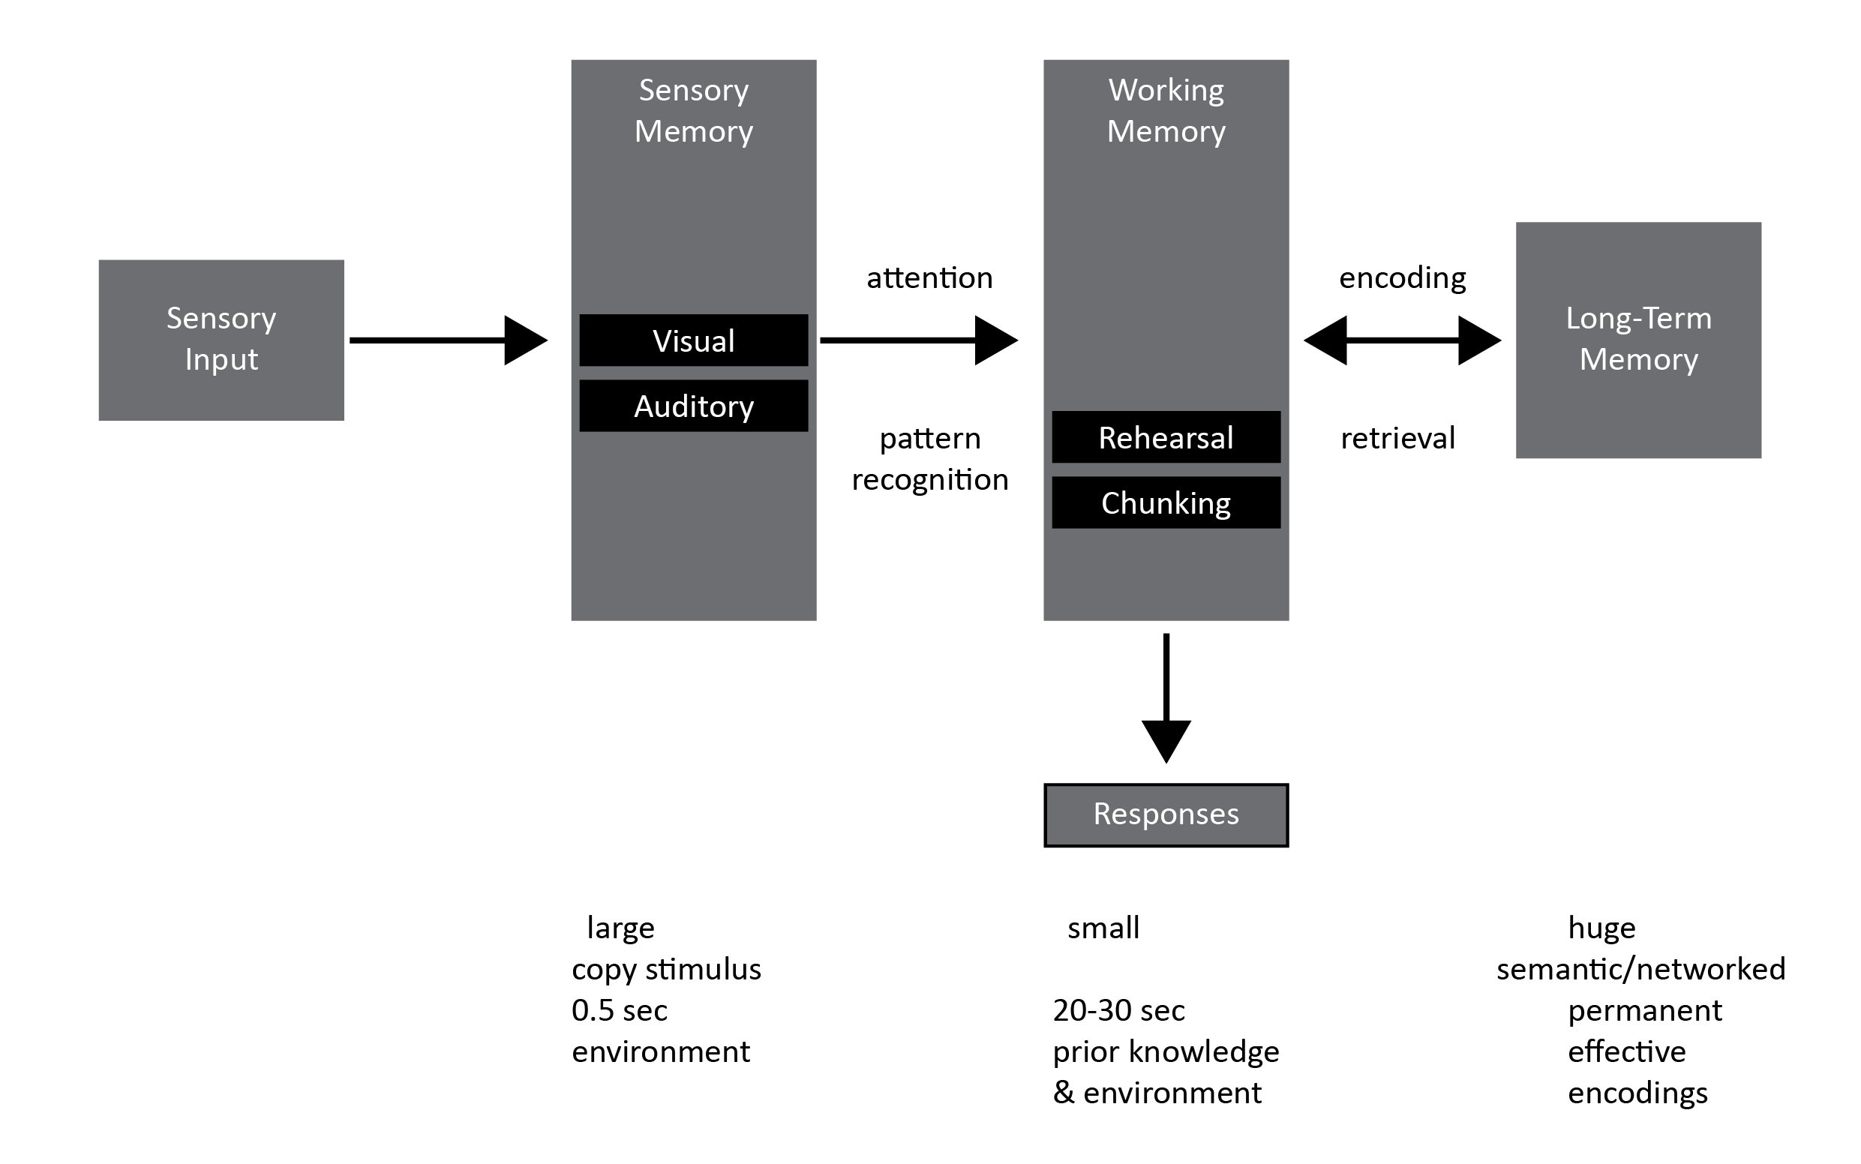
Redrawn from Atkinson, R.C. and Shiffrin, R.M. (1968). 'Human memory: A Proposed System and its Control Processes'. In Spence, K.W. and Spence, J.T. The psychology of learning and motivation, (Volume 2). New York: Academic Press. pp. 89–195.
Memorization has three significant facets:

- Sensory memory: This is ‘sensory attention’, in which the body is alerted and attends to incoming information. The first memory process is a perception through one or more of our senses and its reception by our brain. Cognitive science models how information is relayed by nerve cells from an external source to the brain. Sensory memory is large in scope: there are many things that our senses are aware of at any moment in time. But it is fleeting, its moments less than half a second in duration, and only some are drawn into working memory.
- Long term memory: This is the seemingly unlimited storage capability that our brains have, in which brain processes encode, or organise and exercise control over, information. Once we have processed information, it is stored in our brain, and can last a lifetime. A good example of long-term memory is our remembering of most of the places and related events we have been to in our lives – roads, people, houses, mountains, trees, games, parties, struggles etc. – even though we might have visited them only once. Long term memory is complex and organised in networks of information. It is huge in scope, and it appears to have no time limits. Because our memories are encoded into long term storage in this way, we can draw them into working memory (recall them) as we need to when we think and learn.
- Working memory: This is the thoughts, or units of information, that we can consciously hold in mind at any point in time. Working memory is neurologically limited in its capacity (Miller, 1956) – it can hold “seven plus-or-minus two” units of information in mind at any given moment, and it is time limited, typically lasting for only 20 to 30 seconds. Despite these limits, working memory is where learning happens. Long term memories develop when sensory information is processed (or rehearsed) by working memory so that it becomes more than just everyday observation. At any point in time, working memory selectively draws in encoded information from sensory memory, and recruits encoded information from long term memory, in order to make thinking possible. When you say, I remember (or recall) X or Y, you are saying consciously, from within the space of your working memory, that you are recruiting X or Y from your long term memory. Thinking and learning is thus understood to be the conscious processing of information drawn simultaneously from both prior knowledge (long term memory) and experience (sensory memory) in order to produce new understanding. It is conscious, in the sense that we are aware of it as we process it; it may or may not be self-conscious.

So to understand TVET learning, in whatever learning context (lecture, seminar, workshop, on the job), we need to understand the possibilities and limits of conscious attention and working memory.

Exercises to demonstrate the limits of working memory
Here are two brief tasks you can carry out with your students:
- Speak a series of seven numbers to them, and ask them to repeat them immediately.
e.g., “7382737” or “5192836”
You will find they are easily able to remember and repeat the number sequence to you.
Then speak a series of twelve numbers to them, and ask them to repeat them immediately. e.g. “528464938419” or “019264582601”
You will find that they get flustered as soon as you move beyond seven numbers; they will be able to remember and repeat only a few.

- Display the following sequence of letters on screen for 10 seconds; ask students to remember it and repeat it to you as soon as the display disappears:
CO VI DH IV AI DS TV ET AN CR UG BY
You will find that they find it difficult to remember the sequence, recalling only a small part of it.
Now do the same with this sequence of letters:
COVID HIVAIDS TVET ANC RUGBY
You will find that they remember the sequence very easily (note that the sequence of letters in each chain is identical).

The reason that they remember the first sequence of numbers and the second sequence of letters is because the requirements of each task remain within the limits of working memory. In the second task the letters are ‘chunked’ into a small number of meaningful units, and easily remembered.
There is cognitive overload in the tasks in which they do not remember the sequences.

Activity 8: Working memory and cognitive load

Suggested time: 30 min

What you will do:
- Following the brief outline of memory theory above, read the short article from Psychologist world entitled “Cognitive load theory: How the cognitive load of a learning task affects a person's ability to memorize it.” (This first article is not an OER. You will need to access it through your university library. The website link is in the reference list.)
- Describe the implications of working memory for understanding good teaching and training, and outline some of the ways in which cognitive overload can be avoided.

Discussion of the activity
The article discusses different kinds of cognitive overload, which can overwhelm working memory and hamper learning. Note the idea that the process through which information is received and memorized is hard-wired in the brain, and particularly in the limits of working memory. The brain links new information to already stored information in increasingly complex ways.

Intrinsic cognitive load refers to the amount of information presented to a learner and the connections between different elements within it. If this is too complex, then cognitive overload occurs. A teacher avoids such overload by presenting information gradually (for example, only two or three new, connected ideas per learning session) and in small steps.

Extraneous cognitive load occurs when a learner is distracted by irrelevant information not focused on the central ideas which form the core of the learning session. It can also occur when too many communication channels are employed to convey information at any one moment. For example, which of the following presentations of information about the brain is easier to understand (process in working memory)?
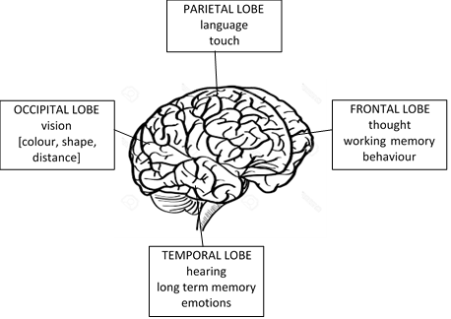
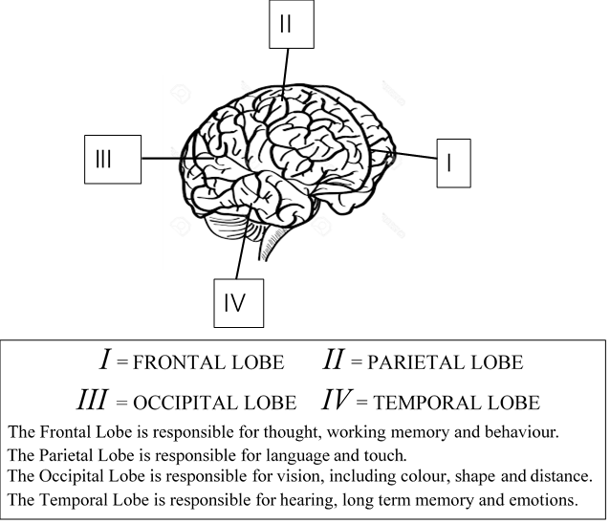
Obviously, the cognitive overload is greater in the presentation on the right. This is an example of the ‘split attention effect’, in which stimuli compete with rather than complement each other. There are too many ‘channels’ of information, and this interferes with the ability of the learner to focus on essential ideas. Teachers can overcome extraneous cognitive load by focusing on essential, meaningful information only. The use of ‘worked examples’ in teaching and training is an example of how a teacher can achieve this focus from moment to moment. They also, of course, assist with reducing intrinsic cognitive load.

Germane cognitive load is what you want to build as a teacher or trainer. This refers to a focus on essential information, but in such a way that it builds complexity and depth. Ideas and skills are always embedded in a complex web of other ideas and skills. Information that has been stored in long-term memory in a connected, meaningful and organized way is often much easier to retrieve. So what teachers need to do is build stronger ‘schemas’ by chunking information together in meaningful networks, so that more complex thinking and action can take place within the space of working memory. We saw an example of how this happens in the exercise we did earlier to illustrate the limits of working memory. Other things that teachers can do to maximise germane cognitive load are:
- help learners connect new ideas or skills with what they have previously learned material. The central principle should be, the next idea or skill to be learned must fit at least one of the existing schemas in learner’s minds, and be connected to a higher-level concept in the network.
- strengthen learners’ existing schemas by teaching them thinking techniques such as analogies, categories, hierarchies, taxonomies and matrices, which help them organize new information.
- Teach ‘worked examples’ of metacognitive strategies (e.g. summarising, outlining, synthesising) to learners to assist them to structure and sequence information.

Activity 9: The cognitivist analysis of learning to sledge-hammer

Suggested time: 30 min

What you will do:
- Go back to the video Learning To Use A Sledge-Hammer For The First Time. Think about how memory theorists would explain the learning going on here.
- What central concepts about learning are coming through here?

Discussion of the activity
In this learning event, the teacher seems to be able to maintain attention within the learner’s working memory quite well. The learner here, as in any everyday life situation, is inundated with sensory information. However, given the particular focus of her working memory at this time, her sensory memory seems to be filtering out most of this information, holding only relevant sense impressions long enough for them to pass into her working memory. In the sledgehammer learning event, her sensory memory discards information about the field of crops that she is in, the clouds in the sky, the camouflage pants of the teacher, the sound of birds nearby, the smell of the soil, etc. it focuses only on holding, raising and swinging the hammer. In this training episode there seems to be sufficient focus within working memory, which the teacher’s actions ensure. In modelling the task, he keeps his demonstration of the task to only a few focal points and steps, both in what he days and what he does. His words and actions do not interfere with each other.

Constructivism

Constructivism, like cognitivism, stresses the need to understand cognitive thinking processes if we are to understand learning and teaching. Both reject behaviourism because of its denial of the mind. However, Constructivism has a major disagreement with Cognitivism. It does not think that the processes of learning are all inborn, or ‘hard-wired’. Rather, it suggests that the knowledge and understanding of individual learners is constructed over time as they act on their environments and engage in social activities.

Perhaps the most important theorist of this kind of learning process was the Swiss psychologist Jean Piaget (1896–1980). The core idea of Constructivism is well captured in this view of education put forward by Piaget. He sees research on learning as divided into three distinct tendencies:

The first … regards all knowledge as being externally acquired, as originating from experience or verbal or audio-visual presentations, delivered by adults. The second is characterized by a surprising return to innate factors and internal maturation… in this case, education becomes in the first instance the exercising of a 'reason' already formed at birth. The third tendency, which is decidedly our own, … is of a constructivist nature, that is to say, it is characterized neither by a notion of external preformation (empiricism) nor of internal preformation (innate ideas), but rather by a notion of the continuous elaboration of successive structures. (Piaget, 1969, pp.13-14)

The argument is straightforward. Behaviourism (with other kinds of empiricism) is static and bad theory; innatism is static and bad theory; good theory needs the idea of an interactive mechanism which constructs new understandings out of both existing knowledge and experience. Piaget’s attack is on ‘preformation’, whether from outside or inside. He rejects the idea that, when a child learns, she passively receives knowledge. We often recognise that human beings are naturally curious about the world around them. They constantly engage with it in order to find out more about it, ask questions, make up hypotheses, imagine new possibilities, etc. Human beings actively construct their own knowledge. All of this seems to be motivated from within, and constitutes an important source of the explanation of learning.

The second major figure in the history of Constructivism is Lev Vygotsky (1896-1934). Vygotsky rejects behaviourism because it pretends that “learning is development”. He rejects innatism because it equates maturation with development: “maturation is viewed as a precondition of learning but never the result of it”. For him, there is an interaction between existing knowledge and experience that explains learning as the construction of new knowledge:

internal developmental processes … operate only when the child is interacting with people in his environment. … properly organized learning results in mental development and sets in motion a variety of developmental processes that would be impossible apart from learning. (Vygotsky, 1978, p. 91)

So he has much the same view of behaviourism and information processing theory as does Piaget. Each offers important insights, but neither explains the construction of learning.

Stop and Think
Here is a shorthand way in which we might think about the different views of learning that we have engaged thus far. Behaviourism thinks new knowledge is given to us by the environment, specifically by environmental reinforcement. Cognitivism thinks new knowledge is given to us by innate or ‘hard wired’ brain functions inherited at birth. Constructivism, however, rejects the idea that new knowledge is given to us. Rather, it is constructed by us in the course of our actions and social activity.

The theory of equilibration
Piaget advanced a constructivist conception of learning known as equilibration. Cognitive equilibrium refers to a state of balance between an individuals’ existing mental framework and the environment in which she finds herself. Such balance occurs when expectations, based on prior knowledge, fit with what she encounters the world. However, when there is a mismatch between her way of thinking and her environment, she naturally seeks a new equilibrium – this process of actively seeking equilibrium is what is meant by equilibration. When an individual encounters new information outside of her existing mental framework, she naturally attempts to adapt to it and incorporate into her changing knowledge structures.

Piaget describes learning in this way:
To know an object, to know an event, is not simply to look at it and make a mental copy or image, of it. To know an object is to act on it. To know is to modify, to transform the object, and to understand the process of this transformation, and as a consequence to understand the way the object is constructed. An operation is thus the essence of knowledge, it is an interiorised action which modifies the object of knowledge. (Piaget, 1964, p.15)

What does Piaget mean by this? The core of his theory of learning is the recognition that we learn from our actions (or ‘operations’) on the world. The very fact that we are alive means that we are always acting on the world. On the one hand, we act on the environment by interpreting it and co-ordinating its features so that they fit with our existing knowledge. This, Piaget called assimilation. But, at the same time, the objects in our environment (for example, an object to be manipulated, an image to be perceived, a tool to be used, a person to be related to, a task to be carried out, or a problem to be solved) demand more complex actions, and so we must also constantly change ourselves, change our thinking and actions, in order to be able to deal with the new knowledge inherent in the universe of objects. This Piaget called accommodation. Assimilation and accommodation work together to produce equilibration, an ongoing process that refines and transforms mental structures,

So, in any learning, there is a tension (or a lack of balance, a ‘disequilibrium’) between what we already know how to do and what the world requires us to do. It is in action that the learner responds, by regulating herself to produce a new equilibrium in the form of a more sophisticated understanding of the world. Crucially, as a learner engages in these actions, she becomes increasingly aware of them, or the new forms of co-ordination, integration and transformation of knowledge that they entail, and her understanding of them grows. Ultimately, she internalises her own actions as new forms of understanding and knowledge.

Activity 10: Learning as equilibration

Suggested time: 30 min

What you will do:
- Following the brief outline of Piaget’s theory of equilibration above, read the two short extract from his writings in the box below. These are ‘Acting to know’ from his article ‘A theory of development’ (1968), and an extract from his book on education, To understand is to invent (1978).
- Describe the implications of equilibration for understanding good teaching and training.

The theory of Equilibration: “Acting to Know”
(Piaget, 1968. pp. 140-141) – introduction to the extract by David Sills and Robert Merton.

Jean Piaget developed a theory of knowledge and the cognitive processes whereby people come to know the world. It is one of the most important psychological theories of the twentieth century. From Piaget’s perspective, all knowledge is constructed through our action in the world. He argued that we can only know about things if we act on them. Very small babies get to know the world around them by touching and tasting things – all mothers get exasperated by their children constantly putting things in their mouths! As the child gets older, she literally gets to know her world by moving about in it, learning to crawl and then walk, moving about bumping into things, learning what’s hard and what’s soft, grabbing things and learning what’s heavy and what’s not. Furthermore, Piagetian theory shows that action continues to be very important for all thinking throughout our lives. Older children and adults, too, use action to know the world. Sometimes these actions may be physical like those of the small child, but more often than not, the action increasingly happens in the mental realm.

Piaget explains that the development of knowledge occurs through the process by which we seek a state of equilibrium or balance between our previous knowledge and new things we encounter in the world. We understand new things by seeking a balance between the known and the unknown. We all mentally adjust and readjust our thinking in response to new objects and events, actively weighing up and balancing our knowledge and moving forward. Piaget identified two mental processes that enable us to perform this balancing act: assimilation and accommodation. Read the following extract written by Piaget himself in which he summarises the process of coming to know things.
- "Knowledge of an object does not consist of having a static mental copy of the object but of effecting transformations on it and reaching some understanding of the mechanisms of these transformations. An intelligent act consists above all of co-ordinating operations, uniting, ordering (in the sense of introducing order), etc. These operations, which derive from the subject’s internalisation of his own actions, are the instruments of the transformations that knowledge is concerned with.
- Logical relationships are, first and above all, operational structures. Although their most advanced forms are certainly expressed by language, their origins are found in the co-ordination of the subject’s own actions. Even at the sensorimotor, preverbal level, a child is involved in activities that include uniting, ordering, introducing correspondences, etc.; and these activities are the source of operations and logico-mathematical structures.
- Knowledge is not determined strictly by the knower, or by the objects known, but by the exchanges or interactions between the knower and the objects (between organism and the environment). The fundamental relation is not one of simple association but of assimilation and accommodation; the knower assimilates objects to the structures of his actions (or of his operations), and at the same time he accommodates these structures (by differentiating them) to the unforeseen aspects of the reality which he encounters."

Active methods of education
(Piaget, 1978, pp.15-17)

“The very optimistic outlook resulting from our research on the development of basic qualitative notions [of education], which ought to constitute the foundation of elementary instruction in the sciences, would seem to suggest that a fairly far-reaching reform in this area would help answer society’s need for scientists. But this depends on certain conditions that are doubles those of all intellectual training, although they seem to be particularly important in the various branches of scientific training. The first of these conditions is, of course, the use of active methods which give broad scope to the spontaneous research of the child or adolescent and require that every new truth to be learned be rediscovered or at least reconstructed by the student, and not simply imparted to him. Tow common misunderstandings, however, have diminished the value of the efforts made in this field up to now. The first is the fear (and sometimes hope) that the teacher would have no role to play in these experiments and that their success would depend on leaving the students entirely free to work or play as they will. It is obvious that the teacher as organiser remains indispensable in order to create the situations and construct the initial devices which present useful problems to the child. Secondly, he is needed to provide counter-examples that compel reflection and reconsideration of over-hasty solutions. What is desired is that the teacher cease being a lecturer, satisfied with transmitting ready made solutions; his role should rather be that of a mentor stimulating initiative and research. Considering that it took centuries to arrive at the so-called new mathematics and modern, even macroscopic, physics, it would be ridiculous to think that without guidance toward awareness of the central problems the child could ever succeed in formulating them himself. But conversely, the teacher-organiser should know not only his own science but be well versed in the details of the development of the child’s or adolescent’s mind. The work of the psychogenetic experimenter is consequently indispensable to the effective use of active methods. Thus, in the era now opening up in education, closer cooperation is to be expected between basic psychological research (not “tests” or most of the devices of so-called applied psychology, which, in fact, like eighteenth century medicine, attempted to apply what was not known), and systematic educational experimentation.”

Discussion of the activity
Piaget’s view is that cognitive development, and therefore possibilities for learning, results when an individual is confronted by some form of disequilibrium in her exploration of the world. She encounters an unfamiliar object by acting on it. Note his idea that, to know something (an object, an event, a concert, etc.) is not just to observe and make a “static mental copy” of it. To know an object is to act on it, to “effect transformations on it and reach some understanding of the mechanisms of these transformations”. Learning comes about through understanding this action and its consequences.

His view of teaching is that it should “create the situations and construct the initial devices which present useful problems” for the learner, that is, to produce a state of disequilibrium. Secondly, says Piaget, the teacher needs to “provide counter-examples that compel reflection and reconsideration of over-hasty solutions”. A good teacher is “a mentor stimulating initiative and research”. (all Piaget, 1978, p. 16). So the role of the teacher should be to create appropriate learning environments or situations that create a state of disequilibrium in thought. The learner “can receive valuable information via language or via education directed by an adult only if he is in a state where he can understand this information” (Piaget, 1964, p.23).

So Piaget uses the ideas of assimilation accommodation and equilibration to suggest that an effective teaching process takes place in three phases:
- A learner is comfortable in her mode of thought and action, her existing knowledge, and is therefore in a state of equilibrium. The teacher must recognise this state of equilibrium (existing or prior knowledge).
- The teacher then “presents useful problems” that provoke disequilibrium, by ensuring that the learner encounters, and assimilates, something in the world which makes her aware of shortcomings or gaps in her existing thinking.
- The teacher presents (represents) a more sophisticated mode of thought to the learner that eliminates the shortcomings of the old one. The learner acts on, or accommodates, this new knowledge to reach a new understanding (i.e. reaches a more stable equilibrium).

The theory of mediation

The Byelorussian psychologist Vygotsky (1896-1934) developed a theory of the social construction of knowledge and cognitive processes. He was particularly interested in the way that human beings learn in social relationships with other people. This led him to investigate the importance of learning in schools or other educational institutions for our overall development as human beings in contemporary society. Part of Vygotsky’s contribution was his account of the mediator-learner (or teacher-learner) relationship, the way it provides the conditions for new learning to occur, and, on the basis of this learning, for the learner to develop new forms of understanding. We can all remember mentors or teachers who made a particularly important contribution to our own learning and development: Vygotsky's theory provides us with an understanding of exactly how and why such mentoring is so important for learning.

Vygotsky’s most well-known concept is the zone of proximal development (ZPD). By this he means the space within which all meaningful learning takes place – the space between what the learner already knows and can do by herself, and what she cannot do on her own but can do under the guidance of and with the support of someone else who is more skilled and knowledgeable. You can see why the idea of mediation is so important in his thinking – it is activity that takes place between two people that makes learning possible and that explains learning. Here are two definitions of the zone of proximal development put forward by Vygotsky. The first allows us to understand how the prior knowledge of the learner makes new learning possible:

The zone of proximal development defines those functions that have not yet matured but are in the process of maturation, functions that will mature tomorrow but are currently in an embryonic state. These functions could be termed the 'buds' or 'flowers' of development rather than the 'fruits' of development. (Vygotsky, 1978, p.87)

The second allows us to understand how the relationship with a mentor makes new learning possible:

[The zone of proximal development is] the distance between the actual developmental level as determined by independent problem solving and the level of potential development as determined through problem solving under adult guidance or in collaboration with more capable peers. (Vygotsky, 1978, p.86)

Lev Vygotsky introduced us to the notion of teaching as semiotic mediation. A teacher (here we can include a schoolteacher, a master craftsperson, an adult caregiver, a more experienced colleague, etc.) is seen to mediate, or to interpret and pass on to the learner, the knowledge that a community has built up over time. Vygotsky put forward the notion of the ZPD to model how it is that teachers mediate new understandings. For him, there are two levels of development that exist simultaneously in a developing student: the actual level of development, which is manifest in what the student can do without help, and the potential level of development, which is manifest in the stuent’s abilities with optimal guidance from a teacher. The gap between these two levels of development is the ZPD, and it is obviously an enormously useful contribution to our ideas about learning.

Vygotsky is often praised for his understanding of how language provides the tools on the basis of which learning takes place. He gives us insights into how spoken language allows teachers to mediate new forms of understanding to learners – this is the idea of semiotic mediation, or the mediation of meaning using language. What we might call ‘classroom talk’ goes on all the time in any teaching-learning situation. Skilled teachers are able to use the specific language in relation to any task that will bring the solution firmly into the ZPD of the learner.

As we move on to consider technical and vocational learning, it is important to realise that Vygotsky is not only interested in spoken language in his theory – although he regarded this as very important (his most well-known book was entitled Thinking and Speech). He also allows us to understand non-language-based tools of mediation, such as the use of gestures, images, pictures, maps and other signs that model tacit forms of knowledge.

Activity 11: The mediation of learning

Suggested time: 30 min

What you will do:
- Read the following extract written by Vygotsky himself in which he summarises the importance of the teacher-learner relationship in coming to know things.
- Describe the implications of mediation for understanding learning.

The theory of Mediation
Extract from Vygotsky (1955) – “Learning and mental development at school age.”

"The essential difference in the case of the child [when compared with the way an animal learns] is that he can imitate a number of actions which go beyond ("depass") the boundaries of his own potentiality, if not to a limitless extent. With the help of imitation in collective activity, under adult guidance, the child does much more than he can do with understanding, independently. The divergence between the level of performing tasks which are accessible under guidance with adult help, and the level of performing tasks which are accessible to independent activity, defines the zone of the child's proximal development.

It is only necessary to recall [this] example … We have before us two children with a mental age of seven but one, with a little help, can do tests up to nine years, the other only those proper to seven and a half. Is the mental development of these two children equivalent? Their independent activity is equivalent but from the point of view of future potentiality for development the children differ radically. That which a child is in a position to do with adult help we call the zone of his proximal development. This means that, with the aid of this method, we can measure not only the process of development up to the present, the stage already accomplished, the processes of maturation that have taken place, but also those processes which are in the course of becoming established, which are now only maturing, developing.

What the child can do today with adult help he will be able to do independently tomorrow. The zone of proximal development allows us, therefore, to determine the child's next steps, the dynamics of his development, to consider not only what development has been brought about but what will come about in the process of maturation."

Discussion of the activity
Vygotsky’s theories include a sustained understanding of the importance of the mediation of social and cultural knowledge to learners in good educational practices. Learning is located in a relation between the individual and the social, mediated through cultural artefacts (or objects) and language. The space within which it takes place, within which the learner can “go beyond the boundaries of his own potentiality”, is the ZPD. And as the definition of the upper limits of the ZPD suggests, the key mechanism of learning is the mediation of prevailing cultural symbols and tools to the learner by a teacher (more broadly, by a person more knowledgeable and skilled than the learner in relation to the task at hand):

In the mediated learning situation, adults or more competent peers place themselves between the environment and the child, thus radically changing the conditions of the interaction. The mediator selects, changes, amplifies, and interprets objects and processes for the child. (Kozulin, 1998, p.60)

Teachers are mediators of meanings and more complex actions.

Activity 12: The constructivist analysis of learning to sledge-hammer

Suggested time: 30 min

What you will do:
- Go back to the video Learning To Use A Sledge-Hammer For The First Time. Think about how equilibration theorists and mediation theorists would explain the learning going on here.
- What central concepts about learning are coming through here?

Discussion of the activity
Piagetian insights into this learning event might be the following:

- The learner acts on the objects in focus using her available knowledge, which in this case includes acting on the sledgehammer to the extent that she knows how to do so. She probably has an available schema, or mental framework, for ‘hammer’ which produce her initial picking up and holding the unfamiliar, much larger, longer and heavier object. (Assimilation).

- She notes the demonstration of the use of the sledgehammer by the teacher. Her use of language indicates some degree of initial understanding (also Assimilation).

- She then tries to swing the sledgehammer Herself for the first time. As she does this, she discovers limitations in her ability to use the tool – look for example at her failed initial attempt to hit the stake. She also discovers that there are things she can do with relative success – note her initial full swing of the hammer. But despite her teacher’s praise, you can see that she realises immediately that she can do it better next time. She realises her mistakes; she discovers that she does not know how to do certain things to their full extent (Disequilibrium).

- In subsequent swings of the sledgehammer, she makes certain adjustments, including in the way she stands, the way she holds the tool, the full extent of swing that she executes. She is not always sure of what will happen, but the action she is engaged in with the sledgehammer seems to suggest to her what to do. (Accommodation).

- As she repeatedly tries the initially unfamiliar action with the sledgehammer and recognises that it is working, she practises and consolidates it. She internalises it. It becomes part of what she now knows, somehow built into her very being through the experience she has had learning to use the tool (the overall culmination of the process of Equilibration).

When examining a learning event like this one, one can also use Vygotsky’s ideas to identify the particular moments in which the mediation moves of the teacher suggest that the learner has acquired new understanding. Putting these different moments together across the whole, we can get a sense of the mediated learning process that takes place over a series of spoken and gestural exchanges between the learner and teacher.

- The first move the teacher makes is simply to draw the attention of the learner to the task – “I can show you on the ground”. The learner focuses immediately on the sledgehammer and the teacher’s actions in relation to it. This is not a new understanding as such, but simply a deliberate focusing of her existing knowledge on the task at hand.

- When the learner attempts to pick up the hammer to swing it, the teacher makes a mediation move. He identifies and names the mistake she makes in initially holding the hammer. The learner’s next attempt shows some learning, in that she starts to refine her action and gets the lift and hold right. The teacher continues to make such interventions – mediations – throughout the entire learning episode.

- At various points, the teacher provides the learner with new conceptual tools to help her respond to the demands of the task – the comparison of the swing of the hammer with a pendulum, and the recognition of the coordinated “transfer of power from the back” are observations that the teacher makes to try to mediate an improved performance of the task.

So from a constructivist perspective, the notions of equilibration and mediation both provide us with insights into how this learner actively constructs her new skill of using a sledgehammer.

Apprenticeship learning in communities of practice

The theory of Communities of Practice is a prominent sociocultural perspective on learning. It seeks to describe the collaborative, social learning processes amongst people who participate together in a shared profession, occupation, craft, or interest group. It rests on the broader claim of sociocultural theory that human learning is fundamentally social, and not individual, in nature. As such, it is part of a broad family of theories known collectively as Sociocultural Theory, made up of distributed cognition approaches to learning. These include:
- Activity Theory, which is concerned with the cultural-historical activity systems which create the possibilities and limitations for all human actions.
- Learning Organization theory, which conceives of an organization as the entity that learns, rather than adopting the more modest constructivist position that an organization provides the social and cultural conditions within which individual learning takes place.
- Connectivism, which is a relatively new ‘learning theory’ intimately connected to computer culture and e-Learning. It claims to be “a learning theory for the digital age”, and understands learning in contemporary society as distinctively (exclusively?) collaborative learning in networked computer environments.

These theories all share the view that the mind is ‘distributed’ across the brain, the body, cultural artefacts and social relations. So, the mind and the brain are not the same thing at all from this perspective (see the ‘stop and think’ task on p.16). The mind is not just an individual thing.
The impetus for this shift in thinking about learning has been described as a ‘second cognitive revolution’:

An all-out effort to establish meaning as the central concept of psychology – not stimuli and responses, not overtly observable behavior, not biological drives and their transformation, but meaning. (Bruner, 1990, p.2)

The crucial thing about this ‘revolution’ is that the study of learning shifts away from the notion that it is an individual action, to the idea that it is primarily a social and cultural phenomenon, located in cultural collaboration between people. Obviously, it is influenced by Vygotsky’s idea that learning is socially constructed. But Vygotsky believed that social processes are internalized to become the forms of cognition of the individual person. Sociocultural theorists have discarded any idea of an individual, psychological account of learning. It might be said that advocates of the ‘second cognitive revolution’ have moved beyond constructivism in their attempts to understand learning.

Two important concepts in this broad sociocultural approach to learning are the connected concepts of distributed cognition and situated cognition. Consider the following question:
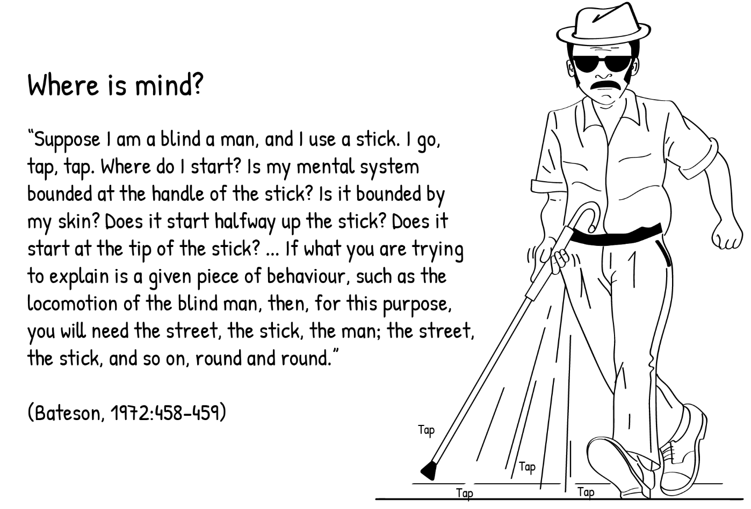

For sociocultural theory, the ‘mind’ is not contained only in the brain and central nervous system, as conventional wisdom would have it. Nor is it, so to speak, ‘under the skin’, bounded by extremities of the human body. Rather, learning is understood to be distributed across all the different elements that make up human activity.

[The mind] is contained as much in the tools that we use (e.g. the stick) and the culturally-defined space that we live in (e.g. the pavement), as it is in the hands, the body and the brain. When we focus only on the individual learner, we lose sight of the fact that we think always by means of cultural artefacts and practices. Learning is necessarily embedded in cultural practices. (Moll, 2012. P18)

This is what sociocultural theorists mean when they say that learning is situated. Learning is, by definition, collaborative.

The theory of Communities of Practice (CoP) is a theory of situated learning. The context of learning is a community of people who interact and learn together in a common practice. Its members continually build relationships that enable them to learn from each other. They take part in cooperative activities and discussions, help each other, share information, and together develop new understandings of technical knowledge in their field. Together, they create a system of shared ideas, commitments and memories. They develop resources such as tools, texts, specialist terminology and routines that in some way contain the expertise of the community. However, a community of practice involves much more than the knowledge or skill associated with undertaking some task. Because members are involved in an ongoing set of relationships over time, the community of practice develops a strong sense of joint enterprise and identity. Examples of such a community are the following:
- a group of learners at a school or university who hang out together and support each other in their studies;
- a group of shop-floor technicians working together on similar problems;
- a network of computer programmers and technicians in an IT company who communicate regularly online in order to explore novel software solutions;
- a gathering of first-time learnership candidates in a factory helping each other cope;
- a group of lecturers at an FET college who meet regularly over lunch and informally discuss their students, what they teach, and how they do assessment.

CoP learning theory works centrally with the idea of apprenticeship learning. An apprentice is someone learning how to do a specialised job through on-the-job training, under the guidance of skulled employer, a ‘master of the trade’, so to speak. An apprentice helps a craftsperson or a tradesperson in order to learn the craft of trade herself.

Lave and Wenger (1991), who first proposed the idea of CoP, carried out careful ethnographic studies of how apprentices learn. They discovered that when ‘newcomers’ (novices, beginners) join an established community or group, they start to participate in a limited way in the activities associated with the CoP, on its ‘periphery’. Initially they spend periods of time observing and carrying out basic tasks under guidance. An apprentice baker, for example, first observes and makes sense of what the master baker does, before actually doing any baking herself. In time, she starts to take on small, simple jobs, gradually learning how the group works. As she learns more skills and acquires more bakery knowledge, she takes on more and more complicated jobs, always under the watchful eye of the master baker. Lave and Wenger describe this socialization process as legitimate peripheral participation. This describes the social relationships and processes in which the learner participates in order to learn. She moves from the periphery to the centre of the practice; from novice to expert.

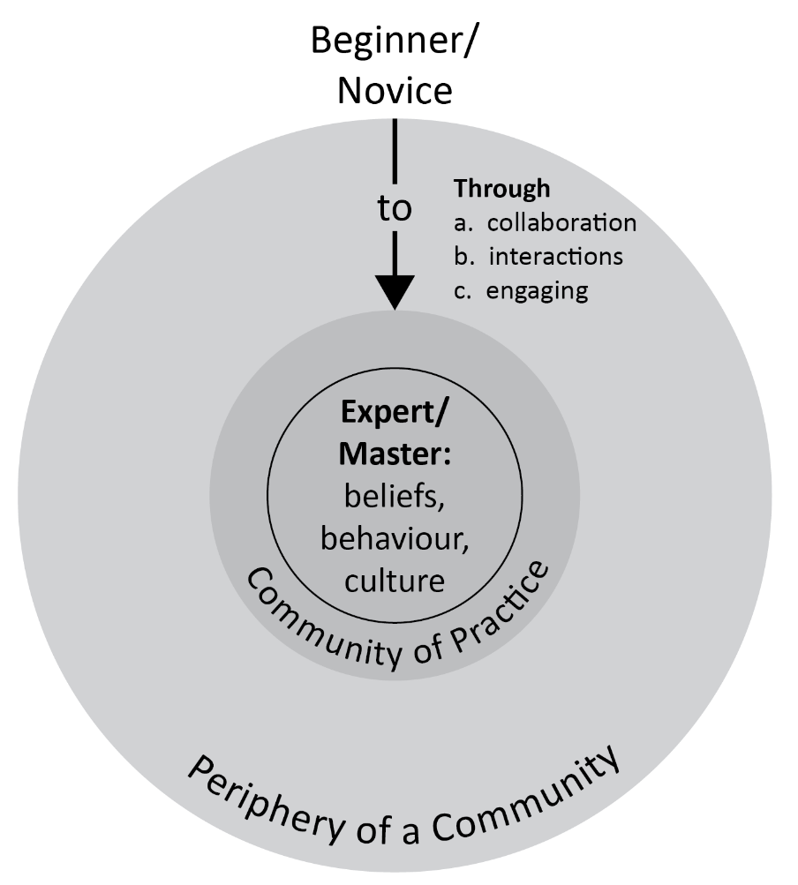

Activity 13: Communities of learning

Suggested time: 30 min

What you will do:
- Following the brief outline of CoP above, read the extracts from Wenger’s (1998) book, Communities of Practice, in the box below.
- Describe the implications of ‘legitimate peripheral participation’ for understanding good teaching and training.

The theory of Communities of Practice
The following extracts are taken from Etienne Wenger’s (1998) book, entitled Communities of Practice: Learning, Meaning and Identity pp.4-5, 86 & 95:

“The primary focus of the theory of communities of practice is on learning as social participation. Participation here refers not just to local events of engagement in certain activities with certain people, but to a more encompassing process of being active participants in the practices of social communities and constructing identities in relation to these communities. Participating in a playground clique or in a work team, for instance, is both a kind of action and a form of belonging. Such participation shapes not only what we do, but also who we are and how we interpret what we do. A social theory of learning must therefore integrate the components necessary to characterize social participation as a process of learning and of knowing. These components include the following:
- Meaning: a way of talking about our (changing) ability – individually and collectively - to experience our life and the world as meaningful.
- Practice: a way of talking about the shared historical and social resources, frameworks, and perspectives that can sustain mutual engagement in action.
- Community: a way of talking about the social configurations in which our enterprises are defined as worth pursuing and our participation is recognizable as competence.
- Identity: a way of talking about how learning changes who we are and creates personal histories of becoming in the context of our communities.
[…]
“The negotiation of meaning is a fundamentally temporal process, and one must therefore understand practice in its temporal dimension. Some communities of practice exist over centuries - for example, communities of artisans who pass their craft from generation to generation. Some are shorter-lived but intense enough to give rise to an indigenous practice and to transform the identities of those involved. For in- stance, such communities may form as people come together to handle a disaster. The development of practice takes time, but what defines a community of practice in its temporal dimension is not just a matter of a specific minimum amount of time. Rather, it is a matter of sustaining enough mutual engagement in pursuing an enterprise together to share some significant learning. From this perspective, communities of practice can be thought of as shared histories of learning.
[…]
“If practices are histories of mutual engagement, negotiation of an enterprise, and development of a shared repertoire, then learning in practice includes the following processes for the communities involved:
- Evolving forms of mutual engagement: discovering how to engage, what helps and what hinders; developing mutual relationships; defining identities, establishing who is who, who is good at what, who knows what, who is easy or hard to get along with.
- Understanding and tuning their enterprise: aligning their engagement with it, and learning to become and hold each other accountable to it; struggling to define the enterprise and reconciling conflicting interpretations of what the enterprise is about.
- Developing their repertoire, styles, and discourses: renegotiating the meaning of various elements; producing or adopting tools, artifacts, representations; recording and recalling events; inventing new terms and redefining or abandoning old ones; telling and retelling stories; creating and breaking routines.”

Discussion of the activity
One way to think about how apprentices learn is to think of it as step-by-step learning. This is the case in two senses:
- When they learn initial, simple tasks, they do so one step at a time, constantly guided by the master craftsperson. As the tasks they engage become more and more complex, the same step by step learning is evident, as they acquire new, task-oriented knowledge and gain mastery over more and more complex skills. At some point they have learnt most of what the master can teach them – they have become experts in their own right. Wenger’s discussion about how understanding and fine-tuning the enterprise makes this social learning process clear.
- The ‘legitimate peripheral participation’ notion emphasises how these apprenticeship learning processes proceed on a step-by-step basis, as the apprentice moves from the periphery of the community to the centre. Any particular master-apprentice relationship does not exist in isolation but is part of a broader CoP of such relations. The “mutual engagement in pursuing an enterprise together to share some significant learning”, that a master craftsperson and an apprentice learner participate in, is part of a broader community of collaboration. The extracts from Wenger make this participation idea clear as it relates to learning.

Activity 14: The sociocultural analysis of learning to sledge-hammer

Suggested time: 30 min

What you will do:
- Go back to the video Learning To Use A Sledge-Hammer For The First Time. Think about how CoP theorists would explain the learning going on here.
- What central concepts about learning are coming through here?

Discussion of the activity
It is easy to understand this exchange as a small segment of a ‘master-apprentice’ relationship in a small segment of time. The teacher teaches new skills, that he himself has acquired from others (he often refers to them), related to the practice of sledgehammering. He uses words and gestures (and jokes) to guide the learner – they use the ideas of their craft together. They share insights and ideas together as the learning event proceeds. In short, they understand themselves and the importance of their work by relating to each other. One can see the accumulated wisdom in the teacher being passed on to the learner. One can see that his relationship is part of a broader community of learning relationships in a CoP.

Embodied learning
Cognitive processes are deeply rooted in the body’s interaction with the world. Embodied learning, or somatic learning as it is sometimes called, regards the body the site of learning. This idea goes back to the phenomenological idea of being-in-the-world:

My body is geared onto the world when my perception presents me with a spectacle as varied and as clearly articulated as possible, and when my motor intentions, as they unfold, receive the responses they expect from the world… [This is] the basis of my life, a general setting in which my body can coexist with the world. (Merleau-Ponty, 1996, p. 250)

The view of learning presented here emphasises that new understandings are produced through the body and embodied ways of being in the world. We construct knowledge through direct bodily engagement with the world – knowledge is the sense we have of inhabiting our bodies, our sense of ‘being-in-the-world”. Embodied learning involves being attentive to the body, its experiences and transformations, as a way of knowing. Our awareness of our bodily experiences is the source of learning, in that we engage the world through lived body experiences of physicality, sensing, and being. The mind is considered to be embodied in ways that draw meaning and learn “grounded in and through our bodies” (Lakoff and Johnson, 1999, p. 6).

We saw this idea of mind being located in the entire body and its actions in the world, rather than just in the brain, in the quote from Bateson earlier (see p.28).

However, unlike the sociocultural theorists, embodied learning theorists strongly reject the idea that the mind is an entity that is contained in elements that exist outside of the human being. It is not distributed across the brain, the body and tools, artefacts, texts, culture; etc., and neither is learning. It is within the body, it is indeed ‘under the skin’.

Of course, the mind is situated in tools, in artefacts, in spoken language, in society, in culture. But to say that it is situated in the social is not to say that it is social. One can see the similarity here with the ideas of Piaget and Vygotsky on internalisation, discussed earlier. For Piaget, learning takes place when a learner internalises the consequences of her actions to become the transformed structures of her own thought. For Vygotsky, learning is the internalisation of the structure of what is originally a social relationship of mediation between a teacher and a learner, by the learner, to become the forms of her own thought. The notion of the internalisation into the body of thinking and action is an important aspect of embodied learning theory.

An interesting contributor to ‘embodied learning’
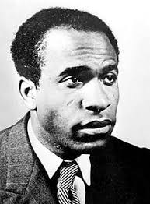
Franz Fanon, the famous African psychiatrist, political activist and decolonization theorist wrote about the dehumanising experiences of colonised people in Africa. He suggested that the experience of colonial domination, military suppression, racism and exploitation by black people at the hands of European colonisers was very often internalised by them as their own state of being-in-the-world. They took on the identity of the colonised. As Fanon put it, “if there is an inferiority complex, it is the outcome of a double process… primarily, economic…. subsequently, the internalization – or, better, the epidermalization – of this inferiority" (Fanon, 1967, p.11). Embodied learning is indeed ‘under the skin’.
en.wikipedia.org

Piaget and Vygotsky both recognized the extraordinary influence of action on learning, and both are arguably forerunners of embodied cognition theory. Piaget demonstrated that our experience of our actions on the world form our learning in infancy (e.g. as a baby gains an understanding of holding and shaking a rattle). These learning processes persist into adulthood (e.g. as student learns about the complex concept of a pendulum). In a similar way, Vygotsky demonstrated how learning can be formed by social activity (e.g. when an infant learns to point as an adult interprets her grasping gesture as an indication that she wants something, or when a student learns to use a power drill under the tutelage of TVET lecturer).

Embodied learning theory has a particularly important contribution to make to our understanding of the accumulation of wisdom over time. The longer that one spends practising a trade, a craft or a vocation, the more one acquires the wisdom associated with that enterprise, and the more one is able to recognise expertise in others. Here is a very insightful description of a woodworking lecturer. This captures very well the nature of wisdom that is acquired over time by a TVET practitioner, which he uses all the time in judging the expertise of his students:

The more time I spend in Jerry Devries’ carpentry workshop, the more I notice the various ways his mix of attention and perception, knowledge of the field, and values plays out in the day-to-day routines of working with wood. Consider, for example, the sharpening of the senses that develops in the woodworking environment. ‘Use the eyes to test straightness, squareness, and symmetry,’ writes the author of an early-twentieth-century pedagogical tract, ‘before applying any other testing instruments.’ Jerry, like other expert carpenters I observed, is able to estimate length at a glance. He can eyeball a structure for misalignment, an angle that's off, gaps, bows, sags in an assembly. He troubleshoots the cause of problems through the look of things. He has an eye, and a touch, for texture… He scans for flaws, spotting a place high up on the interior wall of the display case where a screw has barely broken through the wood. This ability has been characterized by several cognitive researchers as disciplined perception – and we saw it in another kind of work with the hairstylists. It is disciplined because it emerges from one's training and depends on – and helps constitute – a body of knowledge. And what is perceived is connected to systematic action; here perception has meaning and consequence for assembly and repair. The woodworker's visual skill is so much a part of the work that it's easy to miss its special quality. (Rose, 2004, pp.72-73]

All of these forms of knowing become internalised, and thus embodied. But what embodied learning theory is particularly concerned with is the embodiment of wisdom over time. Good technical education and training, just as much as the practical skills that constitute its outcomes, rely not only on apprenticeship learning and the principles are spelt out in textbooks, but also on the wisdom that is built up over years of practice by a craftsperson. This knowledge is tacit, and it must be passed on to learners over time in craft contexts. What an experienced practitioner and TVET lecturer has, that a novice or beginning student cannot have for some time, is an image of the whole, of the final product, in mind. This sense of the whole cannot be captured easily in words, yet it is the core of the wisdom that each of these lecturers offers to their students in the training process.

Activity 15: The embodiment of learning

Suggested time: 30 min

What you will do:

- Following the brief outline of embodied learning theory above, read the summary of an extract from Hyland’s article “Embodied learning in vocational education and training” in the box below.

- Describe the implications of embodiment for understanding good teaching and training.

Bringing the body back into learning
The following is a paraphrasing and summary of a short section of an article by Terry Hyland, entitled “Embodied Learning in Vocational Education and Training” (2018, pp.7-8).
You will read this article more closely in Unit 3.

When we recognise that the mind is embodied’, we affirm the common sense idea that minds are developed through the mechanism of the body and its senses. The ‘bodily turn’ in educational theory over the last few decades is a recognition of the failure of educational programmes to take a number of brute facts about physical learning into account in the design of curricula and pedagogy. John Dewey’s whole philosophy of education was underpinned by research on how humans learn. In How We Think, he suggested that mastery of the body should be understood to be an intellectual problem in learning. He outlined a notion of holistic, bodily development for all aspects of education, both general and vocational. His well-known advocacy of ‘occupations’ in school – modes of activity which reflect adult work and social life – was based on the idea that ‘physical activity and deft manipulation’, if well designed and taught, are essential to overall development. Arguments in the philosophy of education – drawing mainly on the ideas of Jean-Paul Sartre and Maurice Merleau-Ponty – have brought the ‘embodied subject’ back into educational discussions as a way of remedying the undermining of the physical in the learning/teaching encounter. Sartre conceived the essence of human existence – the notion of ‘being for-itself’ – as the location of the human body in the world, its actions in relation to material objects, and its relationships with other embodied beings. This influenced Merleau-Ponty’s idea that our experience of the movement of our bodies gives us access to our environment. This is the original and primary way in which we understand our worlds. Recognition of our embodiment – our intellectual, embodied location in the world – has a very strong claim to be a central concern in education. The development of both embodied and intellectual capabilities has become influential in vocational learning as a broad field of educational research, theory and practice. The problem of absenting the body in VET programmes results in an inadequate conception of vocational competence and, sometimes, inadequate practices in developing this competence.

Discussion of the activity
Hyland argues that embodied learning theory helps us to re-examine the role of ‘the physical’ in TVET. The craft learning process is necessarily psychomotor, bodily, physical, manual (whatever one wants to call it), and this theory allows us to overcome the division between mind and body that has plagued traditional learning theory. Note Hyland’s discussion of Merleau-Ponty’s idea that our experience of the movement of our bodies is the original and primary source of learning. Our active use of our hands (and by extension, our whole body) is what constitutes learning: skills are “built up and passed on generationally, in a hands-on, in-practice fashion” (2018, p.9). Embodied learning is about working with the hands, which Hyland calls “the instruments of executive action, our tools to manipulate the world so that our wishes can be fulfilled” (p.13). Actions of our hands such as “twisting, pulling, lowering, releasing, bracing, pressing, balancing [and] lifting”, and tool-enabled extensions of our hands, such as “sawing, milling, planing, threading, stitching, turning [and] drilling” (p14) are the activities through which learning takes place.

The attainment of wisdom is also crucial as an outcome over time of embodied learning. Deep knowledge of the ‘ways of materials’ is acquired through disciplined observation in the course of developing vocational knowledge over time. The following quotation from John Dewey is worth repeating here, because of the insight it provides into how the accumulated wisdom of the experienced TVET educator is brought to bear in the design of learning events for TVET students:

Intelligent consecutive work in gardening, cooking, or weaving, or in elementary wood and iron, may be planned which will inevitably result in students not only amassing information of practical and scientific importance in botany, zoology, chemistry, physics, and other sciences but (what is more significant) in their becoming versed in methods of experimental inquiry and proof. (Dewey in Hyland 2018, p.7).

Activity 16: The embodiment of learning to use a sledge-hammer

Suggested time: 30 min

What you will do:
- Go back to the video Learning To Use A Sledge-Hammer For The First Time. Think about how embodied learning theorists would explain the learning going on here.
- What central concepts about learning are coming through here?

Discussion of the activity
All the learning going on here can be understood as the improvement of the body. The guided practice that the learner engages all aimed at the honing and refinement of the thinking body. The models that the teacher provides are body models. The theories that he introduces are articulated as theories of bodily movement. One can also see the tacit wisdom of the teacher at work here. His use of his own body in teaching reflects years of his own embodiment of sledgehammering, and when he intervenes in or criticises a particular action that the learner makes, he clearly does so with an image of the full, efficient swing of the hammer in mind.

How the theories work together

The various theories of learning in this Unit give us important insights in relation to TVET learning. There are also different perspectives, and often deep theoretical disputes between them. Although psychologists and philosophers may be most interested in how the various theories are not compatible with each other, as TVET lecturers our main interest is in how they can work together to inform our education and training practices. It is significant that the main points of contention concern the mind in learning. Theorists and researchers work on questions of this kind:

- Is the mind important, indeed does it exist, when it comes to learning?
- Are our skills and ideas ‘preformed’ in the mind, or do active processes create new understandings?
- Is mind an individual thing, in the brain or in the body, or is it comprehensible only in culture and society at large? (see Moll, 2012).

As you worked through this Unit, it would have become clear that, over the past century or so, learning theorists have clarified certain questions for us. Given what we now know about thinking and the brain (memory, for example), it is pretty much accepted that behaviourism was wrong in its refusal to consider the inner workings of the mind in its approach to learning. Similarly, cognitive science has demonstrated that there indeed aspects of learning that that are ‘hard wired’ into us, ‘given to us’ in our genes. It also seems clear that embodied cognition theory has made it clear that individual human beings do indeed learn. But it is also the case that many important debates about learning are very much alive in contemporary research.

There is an ancient parable about the way people come to know and understand something that they have never encountered before:
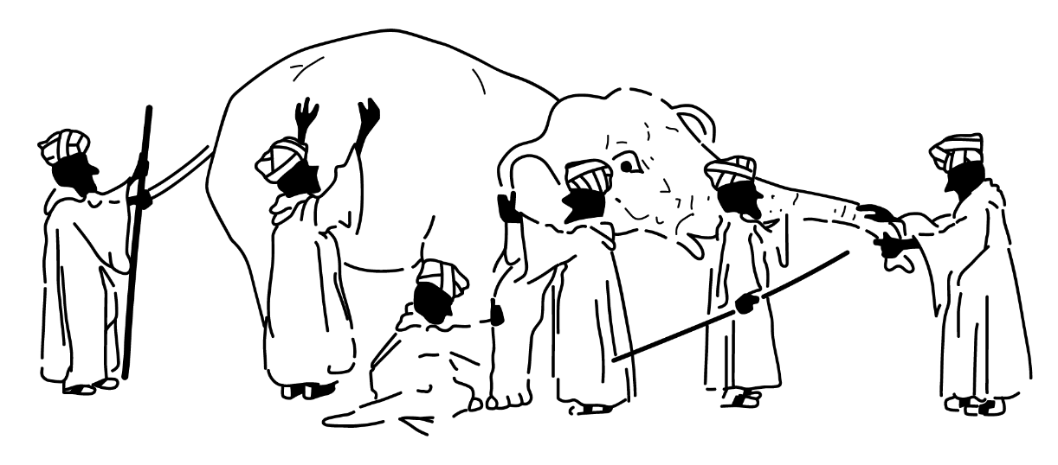

A group of blind men heard that a strange animal, called an elephant, had been brought to the town, but none of them were aware of its shape and form. Out of curiosity, they said: "We must inspect and know it by touch, of which we are capable". So, they sought it out, and when they found it they groped about it. In the case of the first person, whose hand landed on the trunk, said "This being is like a thick snake". For another one whose hand reached its ear, it seemed like a kind of fan. As for another person, whose hand was upon its leg, said, the elephant is a pillar like a tree-trunk. The blind man who placed his hand upon its side said the elephant, "is a wall". Another who felt its tail, described it as a rope. The last felt its tusk, stating the elephant is that which is hard, smooth and like a spear.”

Source: https://en.wikipedia.org/wiki/Blind_men_and_an_elephant

All of these are reasonable perceptions about the elephant, steps along the way towards learning what the elephant is. At the end of the day, it is the same elephant that we want to know: the elephant is what it is. We will never know the elephant in full, but our grasp or different parts of it and therefore of the whole, will continue to grow.

We would like to suggest that this is the best way for teachers to use learning theories to think about how their students learn. Each theory that we have covered in this Unit is a particular viewpoint on TVET learning. As we think about the theories, and argue about differences between them, as we dismiss some and accept others, and figure out how we might combine their insights to achieve our goals in the classroom or workshop, it is important to keep in mind that we are always learning about TVET learning. The theories we have encountered here help us to do that.

Each theory examined in this Unit helps us think about what we might focus on in TVET teaching, training and learning:
- Applied Behavioural Analysis suggests that managed reinforcement in a carefully-sequenced programme of instruction can lead a learner step-by-step towards the achievement of required learning outcomes.
- Cognitivism suggests that learning opportunities that do not overload the attention of students and their ability to remember new knowledge and skills can ensure successful learning.
- Constructivism suggests that rich learning experiences and encounters with more knowledgeable people, in which learners will actively take control of their own learning, can be provided in all learning contexts.
- Sociocultural learning theory suggests that collaboration through participation in communities of vocational practice provides the learning conditions for the acquisition of the knowledge and skills required for success in a TVET context.
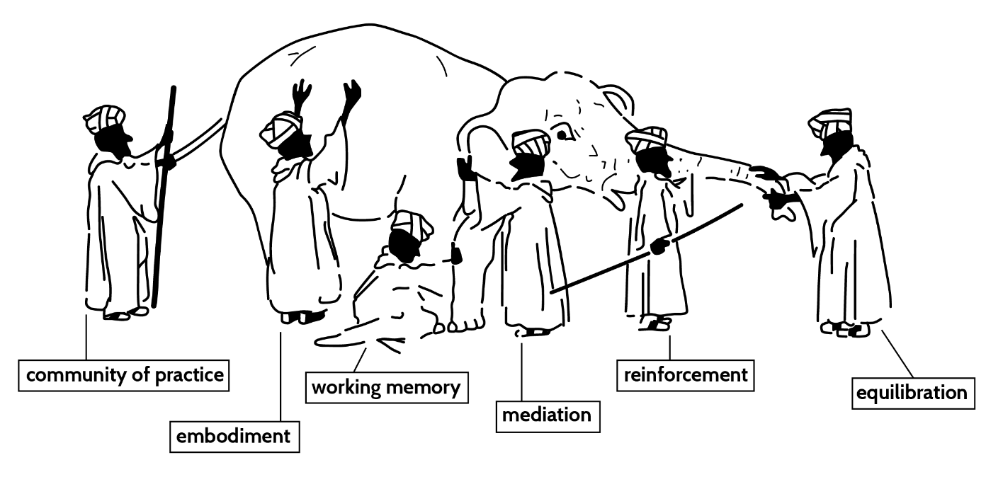
- Embodiment is the way we learn and acquire technical and vocational skills and understanding as our own, to be carried across different workplaces as we pursue our careers.

Conclusion to Unit 2

In Unit 2, we engaged with six of the most important psychological theories of learning that help us in a TVET learning context:
• Behaviourism, and particularly its idea of learning by reinforcement.
• Cognitivism, with a focus on working memory in learning.
• Piaget’s Constructivism, through his account of learning as equilibration.
• Vygotsky’s Constructivism, particularly the notion of mediation in the ZPD.
• Sociocultural Theory, in the form of Communities of Practice (CoP) theory.
• Embodied Cognitions theory – learning as embodiment.

We are now in a position to think carefully about how students in TVET actually learn knowledge that makes skilled practice in any craft or vocation. Unit 3 brings it all together.

Unit 3: Learning in practice in TVET

Introduction

We are now in a position to think carefully about how students in TVET learn the knowledge that that makes skilled practice in any craft or vocation. In Unit 1, we examined the three kinds of knowledge that are part of the practical learning of any field of specialism in TVET:
- “Knowing how”, or procedural knowledge.
- “Knowing that”, or declarative knowledge.
- “Knowing it”, or the recognition of quality.

In Unit 2, we gained an understanding of six of the most important theories that help us to think about and plan learning events in a TVET learning context. These learning contexts are many and varied in TVET – workshops in which electricians or boiler makers are trained, construction sites on which bricklayers or plasterers learn their trade, salons in which beauticians or hairdressers practice their initial skills, college kitchens in which bakers or pastry-chefs are trained, and so on. There were six learning processes that might be at work in these training events:
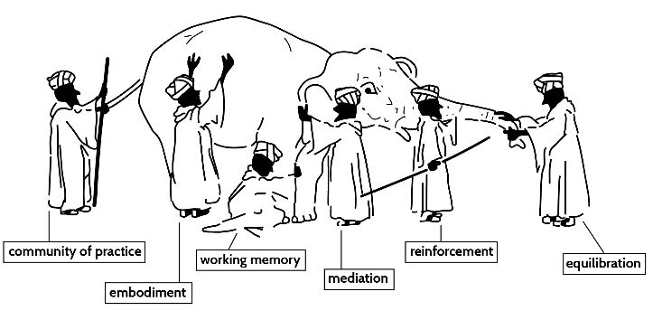

- Reinforcement
- Working memory
- Equilibration
- Mediation
- Apprenticeship (CoP participation)
- Embodiment

So Unit 2 worked with the general question of what the learning process might be in a TVET context, as understood through some of the main learning theories in psychology.

In Unit 3, you will use what you now know about knowledge and learning in TVET, to think about how learning takes place in particular teaching events:

  - First, we will go back to our earlier example of learning to bake bread, and think about what a learner does.
  - Second, we will examine an example of teaching learners how to wire a plug correctly, and think about how learning might happen in that situation.
  - Finally, we will ask you to provide an account of your own teaching in a TVET learning context, and how you think about learning in that situation.

There are no ‘right answers’ here. As we move through the various examples of learning in TVET, you will be asked to interpret and understand the learning of practical craft skills using, and build your own explanation of them.

Unit 3 outcomes

By the end of this Unit, you should be able to:
- consider the distinctive learning of craft and manual work by TVET learners
- build your own particular understanding of TVET learning, in relation to the different theories of learning in relation to the three types of knowledge in TVET

Embodied TVET learning

Our starting point here is to go back to consideration of embodied learning in TVET. You will remember Hyland’s concern that “embodiment can be seen as an essential feature of almost all learning, but is especially important in vocational spheres in which the applications of the psychomotor and physical aspects of activity and performance are central” (Hyland, 2018:1). So the focus here is on the question of the body in learning, how the body moves in space as we use tools to change the physical world, and how the body takes into itself (’internalises’) new craft and manual skills.

Consider this description of embodied learning in a carpentry workshop:

[It is evident, as Amber uses] the band saw to cut a half circle shape into a wooden panel,...how much she is learning – how much she is teaching herself – as she works. Power tools bring their own challenges, their own opportunities to master sequence and procedure and physical skill. Amber has had to use a whole number of different tools to get to the point she is at now. She started with the table saw (a circular blade that comes up through a slit in the table) to cut one-quarter of an inch off the width of the board, she had first to make sure one edge of the board was straight, so she had to plane it by running it through the jointer. Then she had to adjust the height and angle of the table saw blade, … set the guide against the board appropriately, and control the wood through her own stance and movement. ‘…. [then she uses the band saw] The blade … is narrow and can twist as it curves through the wood. To protect against this – and to ensure a smooth cut – Amber is moving slowly and precisely, making a series of ‘relief cuts’ into the section of the panel to be cut away, essentially breaking up the curve into smaller units, cutting each in turn. … Over the past hour, Amber has run through possible problems with the tools that she must use to fashion the panel: As she encountered various problems, she adjusted the way she used the tools, fitted different blades, etc…. She learned from mistakes all the time, and so built up her knowledge of the way power tools work … [her] mastery of procedure will increase as will [her] feel for the tools, [her] finesse with them… considering the wide range of ways one can cut and join, [Amber] will begin to make wiser decisions about which kind of saw or router or sander to use, given the materials and task at hand (Moll et al, 2005, p.63).

One can see how the process of embodied learning takes place here. The student acts on the wooden panel using her previously embodied knowledge, which in this case includes ‘knowing how’ to hold a tool, ‘knowing that’ different saws are designed for different kinds of wood cuts, and some degree of accumulated wisdom about using tools. As she does this, she discovers limitations in her physical ability to use the machine tool, she discovers that certain things she tries do not work in the way they are supposed to, she makes mistakes, she realises that she cannot do certain things to their full extent. Therefore, as she works with the tools, she adjusts her movements, the way she stands, the way she holds the tools, the depth of cuts that she makes into the wood, and the amount of force she applies on the tool. She does this ‘by feel’ – in other words, it is her body at work learning:
She tries out various options, some of which seem to be suggested by the wood as she works, some of which she thinks about more clearly as she encounters problems. She is not always sure of what will happen, but the actions she is engaged in with the tools seem to suggest to her what to do. Once she tries something new with the tool and recognises that it is working, she practices it and consolidates it. It becomes part of what she now knows, somehow built into her very being through the experience she has had learning to use the tool (Moll et al, 2005, p.104)

What is clear here is how the body learns as it acts on the world. And the body includes the brain, the nervous system, the muscles, the skeleton, the eyes, the ears, the fingers, the hands - in other words, the body thinks, and because it thinks, it learns. In TVET, we need to get rid of the idea that there is a distinction between the head and the hands.

Activity 17: Reading Hyland (2018), again

Suggested time: 60 min

In this activity, you will focus your attention on exactly what we mean by concepts like the following, to understand TVET learning:
- technical knowledge
- the learning of techniques
- craft knowledge and learning
- vocational knowledge and learning
- physical learning
- psychomotor learning
- manual learning

What you will do:

- Previously, you read an extract from Hyland’s (2018) article, “Embodied learning in vocational education and training”. Remember he is trying to bring ‘embodiment’ back into our understanding of TVET. Now you should read the whole article carefully. (This article is in an open access journal. You can access it by clicking on the link.)
- Identify some examples of what Hyland means by each one of the above concepts. Are there any other concepts you might want to add to the list above?
- Decide whether these concepts are all synonyms for each other, or are there different ideas being expressed here?

Stop and think
As you read the Hyland article, you will see him suggesting the following: “marginalisation of embodiment and the physical [in TVET] is regrettable in that … it serves to reinforce the notion that only the cognitive aspects of learning are of interest and value in vocational development” (2018, p.1). At the same time, we have spoken in this Module of ‘embodied cognition’, ‘embodied learning’ and ‘embodiment’ as synonyms. So how are these words being used here? Hyland is suggesting that the thinking body should not be ignored. When ‘embodied cognition’ theorists use the term, that is what they mean, that it is the body as a whole that thinks, and not just some abstracted intellectual thing. Perhaps Hyland could have rephrased this quotation?

Discussion of the activity
All of these concepts refer to the specific kind of learning that we try to produce in a technical and vocational college. So they are all in some sense synonyms for each other. But there are also differences in emphasis between them – so for example, some emphasise the skills of the body, some bring out the kind of knowledge that we try to teach. This obviously includes manual, physical, bodily skill in relation to any task; it also includes the theoretical knowledge that is a necessary part of being able to perform each task. So, for example, a baker must know how to measure or estimate ingredients, knead dough, add yeast, etc. and know that these things need to be done in a particular sequence and at particular temperatures. She must also be able to recognise when the dough is ready for baking, and when the bead is baked. All of these concepts, between them, cover all the different kinds of knowledge that are important in a TVET context.

Note though that the baker does not need to know how yeast works, in other words, what the chemical and psychical properties of yeast are. These are things that chemistry or physics studies. One useful way of thinking about this is to say that the TVET learner or practitioner needs to know how to work it, but not necessarily how it works (which is another kind of propositional knowledge).

So let us try to identify these different kinds of knowing and learning in different TVET activities.

Here is a useful characterisation of some of the human actions or activities within which technical and vocational learning can take place, drawn from Lucas, Spencer and Claxton (2012, pp. 59-84). None of them, either individually or together, constitutes a theory of learning. But they do help us think about what kinds of learning happen in TVET context:
- learning by watching
- learning by imitating
- learning by imagining
- learning by practising or trial and error / making mistakes
- learning by listening, transcribing and remembering
- learning by trying to answer questions
- learning through posing questions / enquiry /research
- learning by having our certainties /assumptions disrupted
- learning through feedback
- learning through conversation or co-operating with peers
- learning by teaching and helping
- learning by real-world problem-solving
- learning by drafting and sketching
- learning by designing and making
- learning on the fly (quick, informal moments of learning)
- learning by being coached
- learning by competing
- learning through simulation and role play
- learning through virtual environments
- learning through games

As you read through this list, think about which action or activity is associated with procedural, propositional or recognition knowledge in TVET. You might also want to think about how the different theories of learning encountered in the previous Unit might interpret each of these.

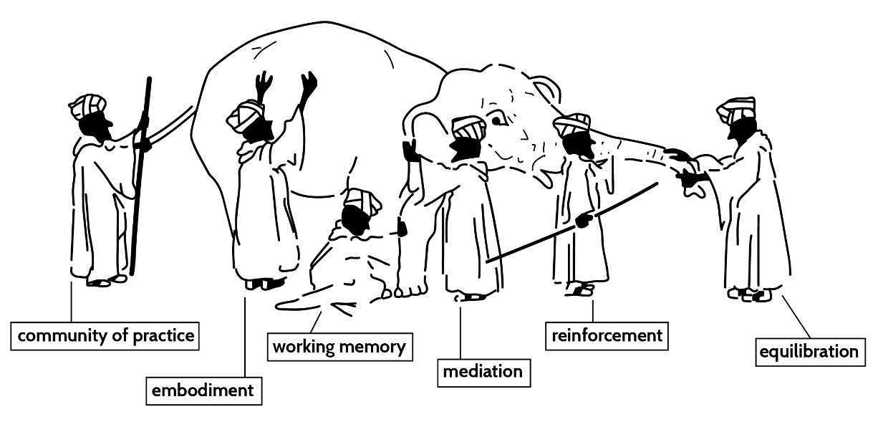
Now we get to a very important part of our thinking in this Unit. Even when we recognise that the most important kinds of knowledge that we learn in TVET is embodied, this does not mean we should use only embodied cognition theory to explain it. Yes, technical and vocational knowledge is embodied in the sense that we know it in our bodies, we know it in the way our bodies move within space and encounter objects in the world. We “have a feel for it”. But, it is as much our heads as it is in our hands; it is as much in the way we use tools and in the way we think practically about what we are doing. Consider again our metaphor of the way different people come to know the body of the elephant (its embodiment, as it were) from different perspectives. It seems that different theories of a learning process can provide us with different insights into TVET learning, as long as we put them together in a way that is coherent.

Some 120 years ago, one of the earliest pragmatist psychologists warned of the danger of believing that any theory of learning can provide us with recipes for effective teaching practice:
You make a great, a very great mistake, if you think that psychology, being the science of the mind’s laws, is something from which you can deduce definite programs and schemes and methods of instruction for immediate schoolroom use (William James, 1899, Section I).

His point was that teachers, including TVET lecturers, do not normally think about learning by deducing practice in this way. Teachers tend to operate with practical wisdom, and very seldom with an explicit, overall, “grand theory”. They tend to be practical in their approach, and draw on a range of ideas about education to make decisions about their teaching. However, they do draw on theoretical insights from time to time when it helps them understand their practices better. So, for example, they may think about the ZPD and mediation when they plan what to say to learners in any particular class, or they may mention the name of a theorist, like Piaget or BF Skinner, in staffroom discussions to claim support for their own practical ideas about learning. Teachers and lecturers tend to think about learning in terms of questions like "Would that activity work with my class?" or "How can I help them improve their braiding skills?" They use theory about learning to the extent that it helps them think about their practice.

So that is the approach we will ask you to adopt in the tasks that make up the rest of this Unit. What ideas about learning have you gleaned from our discussions so far that help you to understand your own teaching practices?

Activity 18: Learning to bake bread

Suggested time: 60 min

In this activity (and the next one), we ask you to carry out what could be called a ‘thought experiment’ – to imagine yourself in a particular situation, to report on it, and to consider its consequences.

What you will do:

- Go back to the video, “Baking sourdough bread”, and watch it again. As you do so, imagine yourself to be a baker in a well-stocked and well-equipped kitchen, baking your first loaf of sourdough bread by following the video.

- Make brief notes on the following:
- What procedural know-how is being conveyed by the teacher? Go back to Unit 1 to assist you with this.
- What am I, as the learner, doing as I gain mastery over it?
- What theory (or theories) of this learning event help me to best understand it?

- Make brief notes on the following:
- What propositional knowledge (‘knowing that’) is being conveyed by the teacher? Go back to Unit 1 to assist you with this.
- What am I, as the learner, doing as I come to understand it?
- How is it helping me to think about and improve my practice?
- What theory (or theories) of this learning event help me to best understand it?

- As you answer Questions 2 and 3, think about the third kind of knowledge that we have identified in TVET contexts, ‘knowing it’ or the wisdom that allows one to recognise good practice or good outcomes of practice. Such wisdom arises on the basis of years of accumulated procedural and propositional knowledge. So it would be hard for a learner to notice this in himself or herself in any learning event.

Discussion of the activity
As indicated earlier, there is no ‘right answer’ here. In Unit 1, you noted Oliver’s ‘know how’ throughout the video, preparing the starter and adding yeast, kneading dough, baking, and so on. But what do you as a learner do as you watch? You probably imitate and carry out the steps that he is modelling for you. You pause and even repeat parts of the video to make sure you get everything right? You listen carefully to his instructions and try to implement them exactly? You possibly flop first time, and then repeat the exercise which works better as you remember and correct your mistakes. In trying to understand this acquisition of procedural knowledge, you might well have thought about how Oliver provides and reinforces a stimulus or two in what he does. In repeating the video, you might have found yourself thinking about the limits of working memory. You would certainly have thought about Oliver as a mediator, and perhaps yourself as an apprentice.

Oliver draws continually on propositional knowledge as he proceeds, He ‘knows that’ the reaction of flour and water produces ethanol and carbon dioxide that causes the dough to rise, and that kneading dough strengthens strands of gluten, etc. Note what kind of propositional knowledge he introduces: it is not abstract chemistry or physics, but specific knowledge that allows bakers to understand why they knead dough. As you learn from the video, you think about these points. Perhaps you stop and take notes on them, so that you can follow up and read more about them later. You might a have thought about equilibration to explain this curiosity and need to know more, or other theories may have come to mind.

As you watch Oliver deciding when the starter has doubled in size, and when the bread is fully baked and fluffy enough, your wisdom starts to grow, although you do not recognise it at this time. It is important, once you have completed this activity, that you discuss the theoretical understanding you have come up at each stage with and how you have applied them, with your peers or your teacher.

Activity 19: Learning how to wire a plug

Suggested time: 40 min

In this activity, you will do exactly what you did in the previous one, but in relation to another example of technical knowledge. Try to bring all the insights you now have about identifying different types of TVET knowledge, and explaining how we learn them using ideas from psychology, to bear here.

What you will do:

- Watch the video, “How to install a South African electrical plug top”. As you do so, imagine yourself to be a novice who does not yet know how to wire a plug.

- Make brief notes on the following:
- What procedural know-how is being conveyed by the instructor / teacher?
- What am I, as the learner, doing as I gain mastery over it?
- What theory (or theories) of this learning event help me to best understand it?

- Make brief notes on the following:
- What propositional knowledge (‘knowing that’) is being conveyed by the instructor?
- What am I, as the learner, doing as I come to understand it?
- How is it helping me to think about and improve my practice?
- What theory (or theories) of this learning event help me to best understand it?

Discussion of the activity
Note the procedural knowledge, the ‘know how’, of the instructor throughout the video. He models and speaks about each step of the task: selecting the necessary tools, cutting and “tearing” the cable, stripping the wires, preparing the pins, connecting the wires, reconstructing the plug, and so on. From this and the previous activity you will realise that procedural knowledge is learned, and therefore best taught, on a step-by-step basis, and you might have used reinforcement theory – specifically ‘shaping’ – to think about this. But maybe not, if you are not inclined to any kind of behaviourism! Instead, you might have thought about this as the stages in an apprenticeship (CoP theory), and about the careful mediation of each step of the task. Again, you might have found yourself thinking about the limits of working memory, and about how the measured pace of the video takes this into account for you as a learner.

As in the previous Activity, the instructor draws on focused propositional knowledge to allow you to understand why the plug must be wired in the way it is – the specification of the brown wire as live, and its required positioning (“R on the right”), the blue as “L on the left”, and the yellow/green wire as the “earth”. You might have thought that he left out some important facts along the way – given that he cannot be sure how much theory of the plug is understood by the viewer, he have discussed more carefully what a live wire is, a neutral one and the earth, and how each works. Did you ask yourself what would happen if you connected the wrong wire to the wrong pins? You would probably blow up your kettle or your TV! The instructor might have explained these things better. The knowledge of which tool to use for each step of the task is also ‘knowing that’ that helps your practical learning. All of this propositional knowledge is crucial to the successful achievement of the task. Mediation theory would allow you to notice these missed opportunities for mediation. Or equilibration theory would help you understand these as moments of disequilibrium in your learning. Again, once you have completed this activity, discuss the theoretical understandings you have come up at each stage with and how you have applied them, with your peers or your teacher. Grow your wisdom in collaboration with others!

Stop and think
Which of the theories that we have covered in the Module allows you to best understand ‘knowing how’, ‘knowing that’ and ‘knowing it’?

Activity 20: Explaining your students’ learning

Suggested time: 120 min, but perhaps over a day or so to allow discussion as you proceed.
In this activity, you will consolidate your theoretical understanding of the way your students learn the different types of TVET knowledge.

What you will do:
- In your journal, reproduce and complete Table 5.
- Find as many opportunities as you can to discuss your thinking with your colleagues as you work on this task.

Table 5 Examples of knowledge
Examples of procedural knowledge that I teach my students | How do they best learn it? | Therefore, how should I teach it? | Which theory of a learning event best helps me understand this?

Discussion of the activity
As you think about and complete this table, recognise how your wisdom about what counts as learning in technical and vocational education and training contexts is slowly increasing

Conclusion to Unit 3

We have now covered the main theories of learning that are evident in the way that educators seek to engage with TVET knowledge around the world. In the next Unit, we will examine some popular learning ‘theories’ which are sometimes invoked, but which have been falsified over time by neurological, psychological and educational research. We might call them ‘learning myths’.

Unit 4: Learning myths in TVET

Introduction

In previous Units, we have engaged extensively with the question of knowledge in technical and vocational education, and with how psychological theories of learning help us to understand its acquisition by our students. In this Unit we turn our attention to a number of theories of learning, or at least working ideas, which have been falsified by researchers. In non-academic language, they are just plain wrong! Unfortunately, however, there are many people in education and training institutions who operate with them as if they are true. This leads to many misconceptions and errors, not least in TVET contests. The learning myths that we will cover in this Unit are the following:

- Instruction is bad and works against the natural way learners construct knowledge.
- Learners have different learning styles, and should not all be taught in the same way.
- Each learner is equipped with multiple intelligences; we must educate all of these.
- Adult learning is completely different to that of children.

Unit 4 outcomes

By the end of this Unit, you should be able to:
- evaluate the following popular theories of learning which have been falsified:
  - instruction is bad
  - learning styles and multiple intelligences
  - adult learning
- understand the implications of these false ‘theories’ for the TVET classroom.

Is instruction a bad thing?

Constructivist accounts of learning are associated with the notion that learners actively construct their own understandings and meanings. This has led certain theorists to claim that instruction in formal education settings is counterproductive, that it undermines the spontaneous and authentic learning that learners must engage in, both individually and culturally.

What do we mean by instruction? It has often been thought of as the purposeful direction of the learning process. The term refers to a situation in which a teacher deliberately takes learners along a particular pathway of learning towards a particular learning outcome, which is conceived in advance. Along the way, the teacher provides all the necessary information to students, in a manner that explains fully the concepts and procedures that they are required to learn. Direct instruction is conceived as the mirroring of the knowledge and practices of a knowledge discipline by a teacher. So, for example,
The course of instruction in science should be a mirror image of a science discipline, with regard to both its conceptual structure and its patterns of inquiry. The theories and methods of modern science should be reflected in the classroom. In teaching a science, classroom operations should be in harmony with its investigatory processes and supportive of the conceptual, the intuitive, and the theoretical structure of its knowledge. (Hurd, 1969, p.16)

So Instruction is the way a student comes to learn and practice the approaches of a knowledge discipline, and to understand the concepts and principles upon which it is based.

There is a brand of “constructivism” that advocates the idea that students learn best in an unguided/ minimally guided environment, generally understood as a learning event in which, rather than being presented with essential information, they discover or construct essential information for themselves. This approach is variously styled as ‘discovery learning’, ‘experiential learning’, ‘problem-based learning’, and, of course, ‘constructivist learning’. This so-called ‘constructivism’ suggests that it is only by solving actual problems in information-rich settings that learners can acquire complex knowledge. The implication is that ‘instruction’ that makes learning strategies explicit disrupts the natural processes by which learners exercise their unique ‘learning styles’ and prior experience to construct new knowledge.

The opposition between the two supposed ‘camps’ are often systematised in the following way:

Table 6 Summarised from Reeves, 1992
Objectivism  Instructivist  Behavioural  Sharply-focused  Reductionist  Abstract  Teacher proof  Errorless learning  Extrinsic  High  Non-existant  Non-existent  Mathemagenic  Unsupported | Epistemology  Pedagogical Philosophy  Underlying Psychology  Goal orientation  Instructional sequencing  Experiential Value  Role of instructor  Value of Errors  Motivation  Structure  Accommodation of Individual  Differences  Learner Control  User Activity  Cooperative Learning | Constructivism  Constructivist  Cognitive  Unfocused  Constructivist  Concrete  Equalitarian facilitator  Learning from Experience  Intrinsic  Low  Multifaceted  Unrestricted  Generative  Integral

However, this strong set of apparently related oppositions can be shown to be based on a series of false dichotomies (or contradictions), by constructivist theory itself. Together, they constitute the myth that instruction is a bad thing for the way learners construct knowledge.

A major error such dichotomies make is to confuse the acquisition of procedural knowledge with the construction of propositional or declarative knowledge. ‘Minimally guided instruction’ confuses the experiencing and practicing of procedures of a discipline with a propositional (or theoretical) understanding of the methods and epistemology of the discipline itself. There is an enormous amount of contemporary research which demonstrates that propositional knowledge does not emerge from procedural knowledge, unless there is explicit and timeous mediation of necessary information – in a word, instruction – by a teacher along the way. The evidence is that, if mediation or instruction does not take place, the working memory of learners simply becomes overloaded and they get confused (Kirschner et al, 2006). The constructivist Deanna Kuhn (2007) clearly demonstrated, in relation to the same evidence, that learners of all ages tend to know how to construct knowledge when given essential information. And there is no evidence that partial information which they ‘discover’ themselves improves their ability to construct a representation, when compared to instruction of all essential information. Actually, the reverse tendency seems to be the case. The distinction between instruction and construction, as proposed in Table 6 above, collapses. As one commentator puts it, instruction enables learners to “see themselves as agents who make choices about how to construct knowledge” (Winne, in Kuhn, 2007, p.109).

Perhaps the main demonstration of the myth that opposes instruction to construction in learning, is the fact that neither Piaget nor Vygotsky (the parents of constructivist learning theory) believed anything of the sort. While Piaget defended the tenet that in pedagogy, “one should lay the stress on activities which are generated spontaneously by the child” (1969, p.14), it is also clear that he did not hold the view that instructional guidance by the teacher was not necessary to ‘constructivist learning’. As he puts it in discussing his notion of "active methods of education". You saw this in the previous Unit:

It is obvious that the teacher as organiser remains indispensable in order to create the situations and construct the initial devices which present useful problems to the child, he is needed to provide counter-examples that compel reflection and reconsideration of over-hasty solutions. (Piaget, 1978:16).

And Vygotsky, of course, regarded systematic instruction as absolutely necessary to creating the conditions for the construction of knowledge by learners in a formal schooling situation. His distinction between the nature of spontaneous concepts, mediated to and internalized by learners in everyday life contexts, and scientific concepts, mediated to and internalized by learners in school, makes this quite clear:

Table 7 From Moll, I. (2001, p.10). The notions here are distilled from Vygotsky’s book, Thinking and Speech (1934:168-241).
 | Spontaneous or Everyday Concepts | Systematised or Scientific Concepts
WHERE ACQUIRED | In the course of everyday activities | In schools and other formal learning contexts
HOW ACQUIRED | Spontaneously, in action | Via instruction, in lessons
MOTIVE | Activity - The learner and others engaged in mutual activity | Development - A teacher deliberately intends to develop the learner's knowledge
NATURE | Unsystematic, learned by trial and error in context | Systematic, learned by drawing attention to salient features in de-contextualised setting
AWARENESS | Unconscious - we can do it, but cannot say how | Conscious - we exercise voluntary attention
DIRECTION OF DEVELOPMENT | Upwards - towards true concepts | Downwards - towards true concepts

Activity 21: Construction vs. instruction?

Suggested time: 50 min

In this activity, you will compare the view that direct instruction in school undermines how learners construct knowledge, with the view that instruction supports the possibilities of construction, and evaluate both.

What you will do:

- Compare the contents of Table 6 and Table 7 above, Reeves’ 1992 characterisation of what he terms “Instructivism vs Constructivism”, and Vygotsky’s 1934 distinction between the learning of “Spontaneous and Scientific” concepts.
- Answer these three questions, either in a tutorial discussion or by making brief notes:
  - What assumptions about teaching and training in a formal education institution does each author hold that leads him to take the view he does about instruction?
  - Why does Reeves think instruction is bad, and Vygotsky think it is necessary?
  - Why does the current author argue that Vygotsky is correct?

Discussion of the activity
Vygotsky’s concern is with what the conditions are under which knowledge is constructed in school learning. His view is that systematic instruction is a necessary part of creating these conditions, because school knowledge is deliberate, explicit and disciplinary in its concepts and procedures. It is not possible for students to learn how to construct knowledge for themselves unless they are deliberately instructed in – i.e. provided with the essential information relating to – those concepts and procedures. So Reeves’ distinction between ‘Instructivism’ and ‘Constructivism’ collapses, along with all the supporting distinctions along the same lines that appear in his table. Some examples of this are the following:
- Reeves’ dichotomies or ‘oppositions’ suggest that instruction does not involve thinking (it is just “behavioural”),
- that disciplinary knowledge is “errorless” in its development.
- Even more misconceived are his notions that the construction of knowledge is not abstract, sharply focused, highly structured, nor mathemagenic (“gives birth to learning”).

Vygotsky’s theories on concept formation in everyday and school contexts make it clear that objective knowledge is indeed cognitively constructed in social activity. It is worth noting here that the other major forebear of constructivist thinking, Piaget, suggested the same in this notion that the invention (construction) of knowledge by a child is the reinvention of human knowledge as a whole. Both in content and the developing structures of thought.

Activity 22: Collapsing the distinction

Suggested time: 40 min

This activity takes you through the thinking and arguments that lead to the conclusion that Instruction is NOT bad and does NOT work against the natural way learners construct knowledge. You will work with a typical representation of the instruction myth, in Table 8, taken from a random website on “Constructivism” (Anonymous, undated).

What you will do:
- Examine Table 8 carefully, and make sure you understand the various differences it is claiming between “traditional” and “constructivist” classrooms. Draw on what you learned about learning theories in Unit 2 to help you do this, and if necessary discuss it with your lecturer or peers.
- Indicate in your own way, on Table 8 or a table of your own, what misconceptions about learning you can see.

Table 8 From Anonymous (undated); based on the work of Brooks and Brooks, 1993).
Traditional Classrooms | Constructivist Classrooms
Curriculum is presented part to whole, with emphasis on basic skills | Curriculum is presented whole to part with emphasis on big concepts
Strict adherence to fixed curriculum is highly valued. | Pursuit of student questions is highly valued.
Curricular activities rely heavily on textbooks and workbooks. | Curricular activities rely heavily on primary sources of data and manipulative materials.
Students are viewed as "blank slates" onto which information is etched by the teacher. | Students are viewed as thinkers with emerging theories about the world.
Teacher generally behaves in a didactic manner, disseminating information for students. | Teacher generally behaves in an interactive manner mediating the environment for students.
Teacher seeks the correct answer to validate student learning. | Teacher seeks the students' points of view to understand students' present conceptions for use in subsequent lessons.
Assessment of student learning is viewed as separate from teaching and occurs almost entirely through testing. | Assessment of student learning is interwoven with teaching and occurs through teacher observations of students at work and through student exhibitions and portfolios.
Students primarily work alone. | Students primarily work in groups.

Discussion of the activity
When you thought about the contrasting classrooms, you would have realised that the main assumption is that instruction is the opposite of construction in learning. This thinking leads to the idea that in all aspects of education and training there is no place for systematic input by the teacher. The myth that instruction is a bad thing, at all times and in all circumstances, takes over.

We recognise that instruction is not the enemy of learning tasks that are based on problem-solving or discovery learning. We are not trying to stick within the same mythical dichotomies, and just shift our allegiance from one side to the other! In fact, well timed instruction can help to scaffold such tasks to allow learners to be even more effective in relation to them.

So, the first myth has been busted! Instruction is not bad and does not work against the natural way learners construct knowledge.

Look at Figure 6 as an example of how you might have marked up Table 8 in completing this task.

Figure 6: An example of how you might have marked up Table 8 in Activity 22

Do different learners have different learning styles?

A continuing question in psychology, not least that related to education and the study of learning, has been that of the significance of individual differences. You have seen that most of the theories about learning that we considered in Unit 2 put forward a general idea about what learning is – in other words, a theory that applies to all learning in all people. Of course, they also all recognise to some degree or another that different people learn and develop differently. A behavioural analyst would recognise that each person has a unique reinforcement history. Vygotskian constructivists and CoP theorists locate the distinctive learning of individuals as being situated in diverse social environments – so cultural contexts and individuals within them are recognised as learning differently. And for embodied cognition theory, different bodies learn differently.

Of the theories we covered in Unit 2, working memory theory and Piaget’s equilibration are perhaps the ones that are least tolerant of some idea of individual differences. Working memory is identically limited, by the brain, in exactly the same way, for every single person – regardless of his or her gender, race, culture, geographical location, socioeconomic context, or whatever other identity marker we might think of. And Piaget conceived of central, ‘operative’ cognitive structures as the motive force in all people for all specific forms of cognitive action and growth – sometimes referred to as ‘G’ (general intelligence). He regarded the question of individual differences in cognition as unimportant. When giving his first lectures on equilibration theory in the USA in the 1960s, he was asked, what about individual differences? His answer was, reputedly, “that is an American question, and I am not interested in it”.

There is widespread belief in the existence of different learning styles in different people. Individuals are understood to be hard-wired to learn effectively in relation to certain kinds of knowledge and tasks, and not so effectively in relation to others – and there are vast individual differences amongst any population in this regard:

Many people recognize that each person prefers different learning styles and techniques. Learning styles group common ways that people learn. Everyone has a mix of learning styles. Some people may find that they have a dominant style of learning, with far less use of the other styles. Others may find that they use different styles in different circumstances. (Learning styles online, undated)

Stop and Think
Do different TVET learners have different learning styles? Think, for example, about the training of different technical, vocational or craft skills – such as baking bread, wiring a plug, bricklaying, braiding hair, etc. – for different learners. Do we need to teach them in a range of different ways in order to ensure that they all have equal opportunities to learn?

You may want to argue along the following lines: my visual learners need to see me modelling the use of the tools required for each of these activities, my auditory learners need to hear me telling them how to use them, and my kinaesthetic learners need to do it for themselves to learn the appropriate tool use. This is the VAK theory of learning styles. It seems to make sense.

However, cognitive psychologists and neuropsychologists have become increasingly sceptical of the idea of individual learning styles over the past decade or so. One problem is very few people seem to agree on an accurate description of each supposed learning style. Coffield et al (2004) identified 71 competing theories of ‘learning styles’ at work in educational practices. This just creates conceptual confusion about what it is we are talking about. Some of these claimed divergent learning styles are:

- CONVERGENT – DIVERGENT
- LEVELER – SHARPENER
- FIELD DEPENDENCE – INDEPENDENCE
- IMPULSIVE – REFLEXIVE
- HOLIST – SERIALIST
- VERBALIZER – VISUALIZER
- ACTIVISTS – REFLECTORS – PRAGMATISTS – THEORISTS
- VISUAL – AUDITORY – KINAESTHETIC (VAK)

All of them share the common assumption that different people have different brains and that they therefore learn differently. And further, that they must therefore be taught differently. But, as can be seen from this list, there is very little consensus as to what a learning style actually is. This already seems to sow the seeds of doubt about ‘learning styles’.

The truth is that there is very little scientific research evidence in psychology for the existence of these different learning styles. Contemporary neuropsychology seems to provide the ultimate reasons to doubt individual learning styles. And in education research, there is very little evidence that the various learning style models really do help to enhance the quality of teaching so as to improve learning.

Activity 23: Evidence for learning styles?

Suggested time: 50 min

In this activity, you will think about whether or not learning styles exist as properties of individual learners.

What you will do:

- Read the DEMOS report (Hargreaves, 2004), particularly the section on learning styles on pages 10 to 12. (The DEMOS report is an OER and you can link directly to it.)
- Watch the Willingham video, “Learning styles don’t exist”. (This video is downloadable and you can link directly to it.)
- Think about and make notes on the following questions:
- Why are Hargreaves and his colleagues cautious about recommending that teachers use the idea of learning styles in the classroom?
- Why does neuropsychology cast doubt on the existence of learning styles?

Discussion of the activity
Willingham makes it clear that the key prediction of any learning style theory has not held up to scrutiny in neuropsychological research. This prediction is that people’s brains are predisposed to learn in a particular way (e.g. visually or auditorily or kinaesthetically in the VAK theory), and that they will therefore always learn information best when it is organised and represented in a way that is consistent with that predisposition (images or sound or movement respectively for VAK). Research evidence in neuropsychology has not found this prediction to be true, for two reasons: (i) Purely visual information is processed by working memory and stored in long term memory (that is, learned) visually; kinaesthetic experiences kinaesthetically; and so on. (ii) Given that most information is multimodal, the brain processes it multimodally. There is no evidence that visual learners tend predominantly to process such information visually, and so on. Also, from a cognitive psychological perspective, the processing of information is not specific to one or other brain function. Rather it is processing at the level of meaning, which is cultural and social. These are Willingham’s reasons for suggesting that “learning styles do not exist”.

The conclusion is obvious – if there is a ‘style’ in learning, then it is evident in the nature of the material that is being presented, not in the mind or brain of the learner.
In discussing the “neuromyth” of learning styles, Geake (2008) emphasises the connectedness of the whole of the working brain (or mind) at every moment of thinking and learning. Geake does this in order to dismiss the idea that learners should be tested to determine which is their dominant learning style, and then be taught accordingly. He points out that experienced teachers have long understood the effectiveness of “multi-sensory pedagogies”, such as the simultaneous seeing and hearing of the same information, in order to teach meaning:

Much good pedagogy … is based on coincident bimodal information processing, especially sight and sound, or sight and speech, as demonstrated by every early years teacher pointing to the words of the story as she reads them aloud. (Geake, 2008, p.130)

He expresses surprise that so many good teachers seem to be taken in by the myth of learning styles. He shows that there is plenty of evidence from many neuropsychological studies that such an assumption is wrong: “focusing on one sensory modality flies in the face of the brain’s natural interconnectivity” (2008, p.130).

Hargreaves et al. (2004) pick up this theme. They suggest that theories of learning styles may actually harm the academic prospects of learners. The idea that learning styles are largely fixed, innate, and different in different learners – “which is curiously reminiscent of now largely abandoned notions of fixed and inherited intelligence” – leads teachers to label students and provide only materials and resources that are “appropriate” to them, thus cutting off their intellectual achievements (Hargreaves et al, 2004). One commentator, in an extensive literature review, suggests that, “rather than being a harmless fad, learning styles theory perpetuates the very stereotyping and harmful teaching practices it is said to combat” (Scott, 2010, p.5).

It is worth reading the DEMOS report in full. It also discusses doubts about the idea of multiple intelligences, which we shall get to in a moment. More generally, it gives us a sense of the context of brain science within which doubts about learning styles arise, and also makes links to other ideas that have been discussed in this Module, such as ‘learner centredness’ and the Lucas et al (2012) list of vocational learning actions that appears on page 46.

So, the second myth has been busted! Learners do not have different learning styles, and can sometimes all be taught in the same way.

Does a learner have multiple intelligences?

Howard Gardner’s (1985) theory of multiple intelligences (MI) looks in many ways like a theory of learning styles. It also separates human cognition into specific 'modalities', and suggests that there is a particular way of thinking, teaching and learning associated with each. It also locates each particular intelligence in a functional area of the brain – one of the criteria that Gardner puts forward to decide whether something can count as “an intelligence” is that there must be neurological evidence that it works in an identified area (or areas) of the neo-cortex. However, there is one crucial difference between MI and the various learning style theories that we have considered. It regards all human beings as having all intelligences at work in their brains, and does not consider just one of them to be dominant or take precedence over the others.

Gardner proposed seven intelligences:
- Visual-Spatial Intelligence: spatial sensitivity, pictorial and image-based understanding.
- Verbal-Linguistic Intelligence: language-based understanding, in speech and writing.
- Logical-Mathematical Intelligence: logical reasoning, including mathematical operations.
- Bodily-Kinaesthetic Intelligence: bodily based understanding, in movement and touch.
- Musical-Rhythmic Intelligence: sensitivity to rhythm and timing, musical ability.
- Interpersonal Intelligence: understanding intentions, motivations and desires of others.
- Intrapersonal, Intelligence: self-regulation of one’s own intentions, motivations and desires.

Stop and Think
Does each TVET learner have multiple intelligences? Think, for example, about what he or she is thinking and doing when engaged in a craft activity – such as baking bread, wiring a plug, bricklaying, braiding hair, etc. Or is it better to think of this as the learner having one holistic intelligence (”the whole brain”, so to speak), which has many facets, engaged together in carrying out the activity?

Activity 24: Evidence for multiple intelligences?

Suggested time: 30 min
In this activity, you will think about whether or not multiple intelligences exist as properties of individual learners.

What you will do:

- Go back to and think about your answers to Activity 23.
- Read the section of the DEMOS report (Hargreaves, 2004) on multiple intelligences, from page 14 to page 15. (The DEMOS report is an OER and you can link directly to it.)
- Discuss or make notes on the following questions:
- In what ways do you think that neuropsychology might cast doubt on the existence of multiple intelligences?
- Should we be cautious about recommending that teachers use the idea of multiple intelligences in the classroom?

Discussion of the activity
You probably recognised that Gardner might run into problems in his notion that functional areas of the brain must be associated with each of the intelligences he identifies. And this is in fact the case. Neuroimaging studies have now shown us quite clearly that any human activity involves complex, simultaneous interactivity across all neurons in the whole brain. But Gardner is insistent:

MI theory demands that linguistic processing, for example, occur via a different set of neural mechanisms than does spatial or interpersonal reasoning. The fact that the processing may occur in somewhat different regions of the brain for different people … is interesting but irrelevant to the identification of intelligences per se. (Gardner, 1999, p.99).

However, neuropsychologists in general have not accepted this argument. Over the past decade or so, research in this discipline has suggested strongly that there is not a one-to-one mapping of the human actions envisaged in each one of the MI intelligences and a particular lobe of the neo-cortex of the brain. It is the case that different localities of the brain are strongly associated with the different lobes, as indicated in Figure 7:

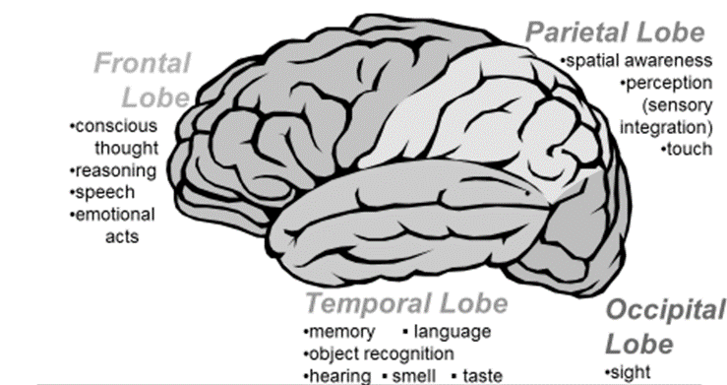

Figure 7: Localities of the brain

But this does not mean that, when a person is engaged in a logical reasoning task, only a region of the frontal lobe is ‘firing’. Nor does it mean that, when a TVET learner practices using a particular tool in a workshop or salon, that only parts of the parietal lobe are exhibiting electrical or chemical activity. There are many such examples that one may come up with. There is overwhelming neurological evidence that the whole brain is ‘firing’ when any person is engaged in any psychological or social activity.

Apparent neurological location does not mean that our actions and activities in psychological terms (thinking, feeling, learning) or in social terms (driving on the left-hand side of the road, social distancing, etc.) involve only a part of the brain. The point is, as some neuropsychologists have put it, that the way a human being (a ‘mind at work’) goes about representing and acting on the world is not reducible to any particular location of neurological activity in the brain (Geake, 2008; Goswami, 2004; Waterhouse, 2006). In other words, it is argued that there are no multiple intelligences, but rather multiple applications of the same multifaceted, complex intelligence.

Ironically, if we turn Gardner on his head in relation to learning and teaching, in precisely the same way that we did to ‘learning styles’, then MI can provide us with a useful understanding of properties that exist in the knowledge, skills, disciplines and materials to be taught. In Gardner’s own words, “seven kinds of intelligence would allow seven ways to teach, rather than one … the mind can be mobilized to introduce a particular concept (or whole system of thinking) in a way that children are most likely to learn it and least likely to distort it” (Gardner, 1985).

So, the third myth has been busted! There are no multiple intelligences, but rather multiple applications of the same multifaceted intelligence.

Do adults learn differently to children?

It seems obvious that adults and children are different. For starters, children’s bodies differ from adults’. They are smaller, have thinner skin, but more of it per kilogram of body weight. They breathe in more air per kilogram of body weight than do adults. They lose body heat more easily. Therefore, they tend to get sick or injured more easily than adults (Covid-19 notwithstanding!).
Their working memories are smaller than those of adults. If adults can process seven plus-or-minus two units or information (see pg.17), then for children it is five-plus-or-minus two, up to about age 10. Very young children have limited hand-eye and fine motor coordination. Cognitively and emotionally, they are egocentric and believe that everyone sees the world the way they do. And children’s brains are not fully developed. Nowadays, neuroscientific consensus is that brain development persists until about age 25.

But now we run into problems. When do children become adults? At age 4, age 9, age 13, age 25? It seems clear that children have much less experience than adults. They are likely to have much less ‘foreknowledge’ in social situations (‘prior knowledge’ in educational situations). In South African law, “legal adults” (those aged 18+) can make adult decisions, without fully developed brains. In traditional San culture, children become adults when they pair off with each other and start having their own children. There is a blurred distinction between adulthood and childhood.

So, does this mean adults learn differently to children? If one looks to the work of Malcolm Knowles (1968, 1973), then andragogy (“adult education”) is sharply distinguished from pedagogy (“child education”):

Table 9 Based on Malcolm Knowles (1968, 1973)
Need to know | Adults need to know the reason for learning something. | Children do not yet understand why learning will be relevant to them.
Foundation | Experience provides the basis for learning activities. | Children do not yet have substantial experience related to their learning.
Self-concept | Adults need to be involved in decisions on their own education. | Teachers are responsible for the education of children.
Readiness | Adults are most interested in learning immediately related to their working and personal lives. | Children’s learning is preparation for an adult future.
Orientation | Adult learning is problem-centred. | Children’s learning is content-oriented.
Motivation | Adults are internally motivated. | Children are externally motivated.

Activity 25: Adult learning vs. child learning

Suggested time: 30 min

In this activity, you will draw on your own knowledge and experience to figure out how much adult learning differs from that of children.

What you will do:

- Carefully consider Knowles’ distinctions in Table 9 above.
- Make two lists, alongside each other, of examples of adult learning and child learning.
- Take note of any example of learning which does not clearly fit on one side or the other.

Discussion of the activity
It would probably become obvious to you very soon, that given the way educators and psychologists talk about children these days, that the column on the right of Table 9 is not necessarily the way children are thought about in schools anymore. It might well have also occurred to you that their might be certain situations in which some of the content on the right could appropriately refer to adult learners (perhaps those registered as students in TVET colleges?). In other words, while there are useful ways of thinking about the learning of both adults and children, in certain situations, on both sides of the table, there is no hard and fast distinction between adult and child education as Knowles would have it.

There are indeed many reasons to believe that the hard distinction between andragogy and pedagogy is a myth. We go on now to explore some of these.

Terminology
The etymology of the words “andragogy” and “pedagogy” is Greek. The former derives from άνδρας (andras), meaning "man", and ἀγωγός (agogos), meaning "leader". The latter comes from παιδί (paide), meaning “child”, and agogos. So originally, andragogy denotes "leading a man" and pedagogy denotes "leading a child". Knowles makes much of these different meanings to develop his theory of adult learning. However, in educational usage around the world, pedagogy has become a ‘term of art’ which implies consideration of teaching, learning and curriculum of all people, regardless of whether we consider them to be adults or children.

One only has to think about the most influential theoretical contributor to adult education, Paulo Freire, to realise that there is not much theoretical mileage to be made out of distinguishing andragogy and pedagogy. Two of his most influential books, Pedagogy of the Oppressed (about non-formal, community-based political education)(1970) and Pedagogy of the City (about primary, secondary and tertiary formal education institutions)(1993) spring to mind. TVET college lecturers and University academics quite reasonably talk about ‘pedagogy’ in their institutions. The reason why the term has become so widely used to refer to the education of adults is precisely because the lines drawn in Malcom Knowles’ distinction have become so blurred.

There is an unfortunate history to the use of the term andragogy in South Africa, in Fundamental Pedagogics, considered to be the formalisation of apartheid ideology in education in theoretical terms. Amongst the “pedagogic essences” were requirements that an adult leads a child to an “understanding and experiences of otherness” (the fact that he is different from others) and an “understanding of the demands of being human” (to be considered a "proper" person with his distinctive culture). This then became elided with a justification for separate development, that each person [read black and white person] be educated to accept his otherness and distinct cultural humanity (see Landman et al, 1975). In this context, fundamental pedagogues seized on the term ‘andragogy’ to refer to the education of people who had achieved this understanding of otherness (“proper” adults, is it were). One of my revered teachers, Wally Morrow, was of the view that this history is reason enough to oppose the use of the term in South Africa.

The nature of learning
If you think back to the various theories of learning that we covered in Unit 2, you will notice that none of them make a key distinction between the way that adults and children learn. Each of the descriptions of learning processes encountered there – reinforcement, working memory, equilibration, mediation, apprenticeship learning (CoP) and embodiment – equally refers to the learning of children and adults, no matter how we conceive them.

Yes, there are accounts of adult–child differences in some of the theories. We have already mentioned the fact that the scope of working memory in younger children is smaller than in adults. But with regard to learning, the way that working memory works to process information consciously, and store in in long term memory unconsciously, is identical in adults and children.

And is Piaget not the archetypal theorist of learning in children being radically different to that of adults? In answering this question, let us first get out of the way one of the most commonly expressed reasons why people think of him in this way: Piaget wrote only about cognition and learning in children, and not in adults. This is simply not true! He wrote insightfully about adolescent learning, and also extensively about the INRC group (Identity – Negation – Reciprocity – Correlation) – the complex of sophisticated logical operational schemas that characterise fully developed adult cognition (e.g. Piaget 1952, 1957, 2001).

Second, consider Piaget’s stages of cognitive development in children, which suggest that before about age 12, children’s thinking is successively sensorimotor, egocentric, and concrete, but not yet formally abstract. Many interpreters of Piaget have taken his related research to be evidence of a fundamental difference between child and adult learning. However, there is a distinction that Piaget makes in his writings (e.g. 1968), which shows us why this interpretation is wrong: that between figurative and operative aspects of thought. Figurative thought refers to what thought contains at any point in time; it is a static description of the momentary structure of thought. This is what Piaget seeks to describe in the stages - the thinking of such-and-such a child is concrete, of such-and-such an adult is abstract, or whatever. Here, there is indeed a conception of child–adult differences. ‘Figurative’ describes the punctuated moments in the structure and content of thought over a lifetime. But is does not account for learning. It is the ‘operative’ structures of thought that drive learning:

The development of knowledge is a spontaneous process tied to the whole process of embryogenesis. … which we must re-situate in its general biological and psychological context…. Learning presents the opposite case. In general, learning is provoked by situations …. [e.g.] by a teacher…. So I think that development explains learning. (Piaget, 1964, p.6)

Piaget’s point is that equilibration drives learning, and equilibration is an identical mechanism in all people, no matter the stage they are at in their lives. This seems to be the reason why Piaget’s theory of the stages of development has become less and less influential in education over the years, and why the theory of equilibration has become more prominent.

There is no sense in any of the other major learning theories that adults and children learn differently. Reinforcement of new repertoires of behaviour works the same, adults and children all have ZPDs, enter communities of practice, and think and learn using their bodies.

Institutional location
In our society, schooling for children is compulsory. As a result, their learning tends to be highly regulated. They are subjected to restrictive disciplinary regimes ranging from formal examinations to school uniforms. The curriculum that governs their learning tends to be strongly specified, sequenced and paced – the current CAPS curriculum in South Africa is a good example of this.

Many adult learners, on the other hand, are volunteers. Most adult education courses require them to be self-regulating. They tend to choose what they want to study, with strong career and personal goals in mind – this is why that sector markets its courses much more actively, with glossy pamphlets, ‘free’ laptops and the like (hopefully not to the point where the choice of a course gets lost). And many of the courses adults study are less formal, more problem-based, less timeline driven, and more open ended in terms of content. Now when Knowles formulated the distinction between andragogy and pedagogy, this is partly what he was thinking about. The institutional location of adult learners is often different of that of children.

But what of TVET education in colleges, or indeed of technical and academic education in universities? It seems that they sit somewhere between the practices of compulsory schooling for children and open ended adult education in the non-formal sector. And that, of course, immediately collapses the distinction between child and adult learning. It is not that they learn differently, but the institutional contexts of their learning need to be different according to the purposes of their learning. It is useful to look back to the distinction Vygotsky made between non-formal learning of spontaneous concepts, and the ‘school learning’ of scientific concepts.

Table 10 From Moll, I. (2001, p.10). The notions here are distilled from Vygotsky’s book, Thinking and Speech (1934:168-241).
 | Spontaneous or Everyday Concepts | Systematised or Scientific Concepts
WHERE ACQUIRED | In the course of everyday activities | In schools and other formal learning contexts
HOW ACQUIRED | Spontaneously, in action | Via instruction, in lessons
MOTIVE | Activity - The learner and others engaged in mutual activity | Development - A teacher deliberately intends to develop the learner's knowledge
NATURE | Unsystematic, learned by trial and error in context | Systematic, learned by drawing attention to salient features in de-contextualised setting
AWARENESS | Unconscious - we can do it, but cannot say how | Conscious - we exercise voluntary attention
DIRECTION OF DEVELOPMENT | Upwards - towards true concepts | Downwards - towards true concepts

A moment’s reflection makes it clear the adults can learn spontaneously or in a systematised way; so too can children. The issue is about the nature of the knowledge and skills being taught, and about the appropriate institutional location for these to be passed on to learners. It is not about supposedly inherent differences in the way that adults and children learn.

On the strength of social meanings, the nature of learning, and the nature of educational institutions, there seems to be no good reason to hold to a strong distinction between the way that children and adults learn. So the fourth myth is busted! Adults do not necessarily learn differently to children.

Conclusion to Unit 4

Earlier on in the Module we examined the main contemporary psychological theories of learning that are at work in TVET. Initially we discussed how the strong view of Behaviourism – the denial of the human mind – came to be considered as a myth, to be replaced by a softer version of behavioural analysis. In this Unit we have engaged with four other commonly held ‘theories’ which are sometimes invoked, but which have been falsified over time by neurological, psychological and educational research. We might also call them ‘learning myths’. In the next and final Unit of the Module, we go on to build on what we have learned to consider how TVET can be made as inclusive as possible.

Unit 5: Challenges faced by TVET learners

Introduction

Men and women all over the world who are disabled make meaningful contributions in technical and vocational fields, provided they are given opportunities to overcome the barriers to learning and personal development they have often faced in society. This was the original spirit of ‘inclusive education’. The meaning of inclusion today has in fact broadened, beyond just the notion of “physical disability” (a medical concept) to the notion that all marginalised persons are disabled by society, including but not limited to those with physical impairments. This approach to inclusion is now accepted internationally as the most ethical and efficient way to provide education for the population at large.

In relation to TVET, the tendency in the past has been that persons with disabilities have had limited access to mainstream vocational skills programmes. The challenges, or barriers to learning, that they have faced have been institutional. TVET training programmes were limited and few in number, and offered only in segregated centres catering to ‘special needs’. The level and type of training disabled people have been able to access has resulted in poor formal and informal employment prospects. However, with the rise of an international order based on human rights, many countries are now committed to an education system based on barrier-free access for persons with disabilities (YPRPD, 2016). South Africa is one of these.

In this Unit, we will initially establish the educational and political context in which these ideas about disability and inclusion are being implemented. However, our aim is not to concentrate on the broader governmental, policy or institutional issues related to inclusion in TVET. Our particular concern in this Unit is with learning, and how barriers to learning are experienced by students and lecturers in TVET colleges. For those who might wish to explore these broader issues more fully, we recommend the excellent International Labour Organization policy brief, “Making TVET and skills systems inclusive of persons with disabilities” (ILO, 2017).

Going forward then to examine the learning barriers experienced by students in TVET colleges, we will explore these challenges through this Unit at three levels:
- Disability (the idea that society can disable learning)
- Impairment (the idea that bodily limitations can restrict access to learning)
- Equity (the idea that resourcing can hold back learning)

We will examine issues concerning student learning across these different levels, and consider thwat they mean for teaching strategies in South African TVET colleges. These issues are then related to diverse learning needs and challenges encountered in these colleges.

Importantly, while these different aspects will be examined separately, they exist on the ground only in relation to each other. Together, they work as related learning challenges and constitute the conditions of existence for each other. This will hopefully become clearer as we proceed through the Unit.

Unit 5 outcomes

By the end of this Unit, you should be able to:
- understand the importance of inclusive education in TVET
- describe the contemporary sense in which disability is conceived as social marginalization
- understand the diverse learning needs and challenges faced by TVET learners, in the South African context
- know how one might support students to overcome these challenges
- evaluate, and plan to accommodate such learning challenges in your own TVET context

Activity 26: South African inclusive education policy

Suggested time: 45 min

In this activity, you bring to the fore your knowledge of our national policy framework, for purposes of your engagement with this Unit.

What you will do:
- Make notes on what you already know about international and South African policies on disability, and the overcoming of barriers restricting access to education for the population at large. You may want to mention particular pieces of legislation or policy documents that are particularly relevant here.
- Discuss these policies with your colleagues or your lecturer, to establish whether or not you have a shared understanding of the issues. Pay particular attention to the implications of these policies for your TVET college.

Discussion of the activity
South African policy and legislation on disability and inclusive education issues is cutting-edge, when compared with anywhere else in the world. The most recent Department of Higher Education and Training (DHET) policy for the post-school sector is called the Strategic Disability Policy Framework in the Post School Education and Training System (DHET, 2018). It includes specific national targets on inclusive vocational training, including a programme to accelerate access and success for persons with disabilities. Here, the word “disability” is being used in its broadest sense. The international legal consensus is that educational systems must be inclusive, that “exclusion from, or limitation to, educational opportunities on the basis of socially-ascribed or perceived differences, such as by sex, ethnic/social origin, language, religion, nationality, economic condition, or ability” (UNESCO, 1960), should be prohibited. This policy framework is underpinned by a range of global and local policy guidelines, including the following:
- United Nations, Universal declaration of human rights (1948)
- UNESCO, Convention against discrimination in education (1960)
- United Nations, Convention on the rights of persons with disabilities (2006)
- UNESCO, Education for all (2016)
- Department of Education (South Africa), Education White Paper 6: Special needs education: Building an inclusive education and training system (2001)
- Department of Women, Youth and Persons with Disabilities (South Africa), White paper on the rights of persons with disabilities (2016)
- Department of Higher Education and Training (South Africa), Strategic disability policy framework in the post-school education and training system (2018)

In this context, inclusive TVET represents a new strategic direction for the overall provision of education and training in society. This strategy includes different training options, ranging from college-based learning, through on-the-job apprenticeship learning, to lifelong workplace learning. In the first place it is a strategic policy direction which seeks to include persons with disabilities – defined as those who experience barriers, or challenges, related to physical or intellectual impairment – in accessing the TVET system. However, the policy is much broader than that. It is about the deliberate drawing in of all marginalised groups in society, including women and disabled people, including the pre-employed, employed and unemployed, into a wide-ranging institutional system that provides diverse courses and training programmes aimed at maximum access for all to the labour market. In South Africa, as the International Labour Organisation points out, there is an added dimension which is distinctive of (perhaps unique to) this nation given the exclusionary legacies of apartheid. These polices seek to ensure access of all disadvantaged groups in the population to inclusive vocational and technical training (ILO, 2017, p.2).

In TVET colleges, these policy imperatives call on lecturers to take particular note of, and respond to, the barriers to learning experienced by all marginalised groups, including disabled persons, women, and socially and economically disadvantaged groups. It is a bottom-line requirement of the institutional context of a TVET college that it enhance and develop its capacity to teach trainees with disabilities alongside non-disabled trainees.

Activity 27: Thinking about barriers to learning in TVET

Suggested time: 50 min

In this activity, you will review your current understanding of what inclusion is, in TVET teaching and learning in South Africa.

What you will do:
- There are two ideas that are often used to describe inclusive education and training in South Africa and other parts of the world. These are ‘mainstreaming’ and ‘inclusion’. Sometimes they seem to complement each other, and might be used together to describe changes to be made to, say, a learning space (like a workshop) or a curriculum in a TVET college. At other times, they seem to be used in opposition, signal two different ‘camps’ who argue with each other about the way to best overcome the exclusion of disabled or marginalised learners in the community. Study Table 11 below, taken from Education White Paper 6 (DOE, 2001) and evaluate what you think about the ideas that are expressed in it.
- Discuss with colleagues and make notes on the following:
  - How would these ideas help understand the situation in your own TVET college?
  - How could different marginalised groups in the community that your college serves be included and/or mainstreamed in the training programmes that you offer?
  - What changes would be needed to enable learning for learners with disabilities?

Table 11 The distinction between mainstreaming and inclusion in Education White Paper 6 (DOE, 2001, p.17)
‘Mainstreaming’ or ‘Integration’ | ‘Inclusion’
Mainstreaming is about getting learners to ‘fit into’ a particular kind of system or integrating them into this existing system. | Inclusion is about recognising and respecting the differences among all learners and building on the similarities.
Mainstreaming is about giving some learners extra support so that they can ‘fit in’ or be integrated into the ‘normal’ classroom routine. Learners are assessed by specialists who diagnose and prescribe technical interventions, such as the placement of learners in programmes. | Inclusion is about supporting all learners, educators and the system as a whole so that the full range of learning needs can be met. The focus is on teaching and learning actors, with the emphasis on the development of good teaching strategies that will be of benefit to all learners.
Mainstreaming and integration focus on changes that need to take place in learners to that they can ‘fit in’. Here the focus is on the learner. | Inclusion focuses on overcoming barriers in the system that prevent it from meeting the full range of learning needs.  The focus is on the adaptation of and support systems available in the classroom.

Discussion of the activity
You would probably have used both terms in your discussion of your own college context. For example, people often talk of ‘mainstreaming’ disabled learners into a post-school learning institution, by modifying or adapting the lecture halls, classrooms, laboratories, or workshop within it to accommodate the needs of these learners. At the same time they use the term ‘inclusion’ to refer to broader imperatives in the community to ensure that no learner is excluded from the institution. So ‘mainstreaming’ is one of the ways that ‘inclusion’ can be achieved in any community TVET college. This seems to be the way that White Paper 6 uses the terms, despite the scare quotes it puts around “fit into” in the table. For example, it suggests that intellectually impaired individuals might be more easily included by mainstreaming than those with physical impairments:

We are persuaded that the inclusion of learners with disabilities that stem from impaired intellectual development will require curriculum adaptation rather than major structural adjustments or sophisticated equipment. Accordingly, their accommodation within an inclusive education and training framework would be more easily facilitated than the inclusion of those learners who require intensive support through medical interventions, structural adjustments to the built environment and/or assistive devices with minimal curriculum adaptation (DOE, 2001, p.25).

In other parts of society, however, disabled persons insist that inclusion cannot be achieved by mainstreaming. For example, the organised Deaf community in South Africa insists that, as a distinctive community, with its own language (SASL) and culture, it is entitled to its own special schools. This goal, however, is not necessarily achievable in post-school education. You might have reflected on this dilemma in your responses to question 2.

Reflecting on learning itself, you would have been clear that in achieving inclusion in a TVET college, lecturers will need to improve their skills and knowledge about the kind of teaching and learning support that is required. To paraphrase this recognition in White Paper 6:
- In mainstream TVET, multi-level instruction will be necessary so that lecturers can prepare learning tasks and practicals with variations that are responsive to individual learner needs;
- In special TVET colleges, or special facilities within a college, new approaches and technologies that focus on the development of disabled learners’ strengths and competencies rather than on their shortcomings will be required (DOE, 2002, p.18).

Quite how these two dimensions are reflected in your college would no doubt have been part of your discussion.

We have now considered two dimensions of the basic enabling conditions in a TVET college that would be required to make inclusive learning possible - the policy environment and the institutional environment. Let us now turn our attention to the various ways in which inclusive learning itself is understood.

Disability

The idea of disability, that persons can be disabled, has been a contested issue throughout history. The word itself has in fact been used only in relatively recent times, and it has come with growing humaneness in relation to those people in our societies whom we now think about as ‘the disabled’.

But traditionally, this was not the case at all. In ancient Greece, supposedly the cradle of “western thought”, both of the ‘biggies’, Plato and Aristotle, were of the view that such ‘deficient’ children should be killed in infancy, and certainly not have valuable educational time wasted upon them. In Uganda, traditional practices required the killing of children with ‘deformities’, regarding this as an act of mercy. Both Ugandan and Greek law now regard these practices as murder (Africa Diplomatic, 2018). One interesting thing is that, as human rights awareness has grown over time, so the terms we now use to describe what we today think about as disability have been very closely related to theories of learning in psychology. Montessori, at the turn of the 19th Century, referred to “idiot children” who were “feeble minded”, to reflect her view that children’s abilities were innate, God-given sensibilities. She was of the opinion that “the abyss between the inferior mentality of the idiot and that of the normal brain can never be bridged” (Montessori, 1912:39). Behaviourists came to be closely associated with the terms retardation: if your expected behaviour has not been reinforced over time, then it has been retarded. And cognitivists work with the terms like learning disorder and learning deficit (think ADHD!): if your brain is wired in such a way that it has a deficiency in how a person uses the information gathered, then it has an information processing disorder. More recently, constructivists, sociocultural theorists and embodied cognition theorists have articulated the term disability in various ways, as we shall see. The point is that your theory of learning, in both conceptual and applied terms, is closely tied to the way you go about providing inclusive learning opportunities for your students.

In contemporary policy debate, these issues are taken up in an important debate between the medical model and the social model of disability. The movement away from Montessorian, and later behaviourist and cognitivist ideas, to more contemporary theories of learning, described in the paragraph above, can be understood as a movement from the medical to the social model. It is, in fact, the movement towards inclusive education that we want to explore in TVET education.

Activity 28: The medical and social models of disability

Suggested time: 60 min

In this activity, you will consider definitions and understandings of the different models of disability, and how these relate to the way diverse learners learn in a TVET context.

What you will do:
- Watch the two short videos, one from National Disability Arts Collection and Archive called “Social Model of Disability” and the other from Scope called “What is the social model of disability?”. (These videos are not OER. You will need to access them through your university library. The website links are in the reference list.)
- Read the Wikipedia article Social model of disability. (This article is an OER and you can link directly to it.)
- Reproduce Table 12 below, allowing it to cover a number of pages. In discussion with your colleagues (in class or perhaps via a WhatsApp group or similar), fill it in to make the differences between the two perspectives clear.

Table 12 Medical and social models of disability
THE MEDICAL MODEL OF DISABILITY | THE SOCIAL MODEL OF DISABILITY
Main characteristics: | Main characteristics:
Conception of the TVET learners: | Conception of the TVET learners:
How disabled learners learn, and how to support them in my TVET college: | How disabled learners learn, and how to support them in my TVET college:

Discussion of the activity
You would have realised that the contrasts between the two models of disability are quite stark. The medical model portrays disability as a biological or medical deficiency; these people are conceived of as abnormal. In contrast, the social model regards disability as diversity, to be understood as one of many differences to be found amongst normal people, just as gender, age or race are differences.

In the medical model, the power to identify and change disabled people lies with professionals, particularly health professionals, whose knowledge and practice is supposed to be driven by science. Frequently, the lives of disabled people are taken over completely by these professionals. Their decisions determine where disabled people live, go to school, and what kind of work they can do (indeed, whether they can work at all). Disabled people are understood as the problem to be fixed (cured, as it were) so that they cope with the world as it is. These professionals determine what kind of support is provided to disabled people; the medical view tends to be that a medical or therapeutic cure, or an individual psychological (behavioural) intervention, will make the person less disabled and more ‘normal’.

In contrast, the social model of disability locates the problem in society and culture, in the inability of society to adapt to and accommodate the needs to people in all their diversity. It is society that disables people, not people who have inherent disabilities. The social model conceives of overcoming disability, not as a ‘cure’, but as intervention and support that improves the ability of disabled people to participate in, contribute to and benefit from society. The idea is that the interaction between the individual and society needs to be enabled more effectively. When society changes the problems experienced by a person with a disability disappear. In this Unit, we describe these problems as barriers or challenges to learning:

Disablement is the loss or limitation of opportunities to take part in the normal life of the community on an equal level with others due to physical and social barriers. (Disabled People’s International, 1981).

Stop and Think
Some people argue, while sympathetic to the human rights issues at stake here, that the sharp contrast between the medical and social models of disability politicises the issue of disability too much. Advocates of disability rights tend to subscribe to the social model, and view the medical model as the formal practice of the oppression and degradation of disabled people. Others argue, that while the issue of civil rights should be primary (they have accepted the critique of the authoritarian and exclusionary practices of doctors and other health professionals in the past), there is nonetheless a place for judicious medical and therapeutic interventions to assist the lives of disabled people. What do you think?

If you as a lecturer in a TVET college take a social view of disability, as South African national policy does, then there are a number of things you might do to support disabled learners in your courses. The spirit of your answers on the right of Table 12 would no doubt have been about the things that you can do in your own classes: use of appropriate non-discriminatory language, curriculum adaptation, diverse forms of information presentation, physical learning aids, etc.

Impairment and disability

The international consensus on how we understand disability has tended up to now not to take the extreme view of the social model of disability. In other words, it has not rejected out of hand that there might be certain bodily conditions that create the conditions under which people experience the disabling effects of society. It is not that the social model of disability is being rejected. There is an acceptance in international policy (e.g. that of the various United Nations agencies, including the WHO) and in South African government policy, that the worst excesses of the medical model of disability should not be returned to, and continue to be overcome. So inclusive education is the central policy across all education and training sectors. But the disabled body has been brought back in, so to speak, by consideration of the notion of impairment as one of the contributing conditions to the social experience of disability.

Stop and Think
How is this debate about disability and impairment related to the various theories of learning that we covered in Unit 2 of this module? We indicated earlier that “the movement away from … behaviourist and cognitivist ideas … can be understood as a movement from the medical to the social model”. Relate this to what you know about the way the medical profession tends to work with people who have disabilities.

There are all kinds of drugs used by psychiatrists to correct or control what are understood to be intellectual or behavioural disorders related to the brain’s information processing functions. The link to cognitivism is clear. And there are all kinds of therapeutic interventions, by psychologists and occupational therapists, which rely on behaviour modification reinforcement techniques. The link to behaviourism is clear. These techniques work. But as the opponents of the medical model would have it, they work to make people “fit into” society, and they are firmly managed by medical professionals. Constructivist learning theory, on the other hand, started to emphasise the idea that learners might be prevented from realising their natural tendencies, in individual and social activity, to construct knowledge by obstacles they encounter in the world. Here is the shift from the medical model to the social model. No longer is it the medical profession that is to the fore, but rather the people that the learner encounters in normal, routine social life that create the conditions that enable or disable learning and development. Teachers and lecturers are foremost amongst them. Sociocultural theorists went on to develop the ideas about how social and cultural barriers can disable people, and embodied cognition theorists went on to elaborate the idea of the disabled body, of impairment in relation to the social model of disability.

The notion here is simply that people who have a bodily impairment of some kind and experience some form of social exclusion as a result, are disabled people. Society disables them. This is clear if you consider those who wear glasses: their eyesight is impaired, but they are not discriminated against. They are not disabled. People who use hearing aids, on the other hand, are often stigmatised and discriminated against by communication barriers. They are disabled. So all kinds of disability are constructed by the fact that people who have impairments are excluded from social participation by virtue of their individual physical being. Examples include physical impairments, sensory impairments (deafness, blindness), chronic illness (e.g. HIV/AIDS, diabetes), epilepsy, learning difficulties, dyslexia, speech impairments, and diminutive stature. The lives of these people are disabled by society. In a TVET context, their learning is disabled by society unless inclusive education is fully implemented.

Activity 29: Impairment and disability

Suggested time: 50 min

In this activity, you will seek to understand how bodily impairment has been brought back into the picture as part of the international consensus on the social model of disability.

What you will do:
- Read the WHO document, “Towards a common language for functioning, disability and health.” Pay particular attention to the section on the concepts of impairment, functioning and disability (pp.9-14). (This article is not an OER. You will need to access it through your university library. The website link is in the reference list.)
- Discuss or make notes on the following:
  - What is an “impairment”, and how does it affect the functioning of an individual in society? Why is this so?
  - How can the social model of disability incorporate a recognition of bodily impairments, without resorting to the outdated ideas of the medical model?
  - What can you specifically do in your TVET college to support learners who have impairments?

Discussion of the activity
The WHO (2001) has developed an assessment tool, the International Classification of Functioning and Disability (ICF), to measure and describe disability around the world. The WHO conception understands the full functioning of a person in society as the pivotal issue. In other words, no person should be excluded from full participation in society, by virtue of an impairment or for any other reason. If this happens, then that person is deemed to be disabled.

The social model of disability has come to follow the lead of the ICF, and makes a distinction between 'impairment' and 'disability'. A person is considered to have an impairment when he or she has a defective organ, mechanism of the body, or limb. A disability is understood to be the disadvantage caused to that person by society, when her sensory, mental or physical impairments are not accommodated, and she is excluded from the social mainstream. The ICF has transcended the medical model of disability, which articulates ‘disability’ only in terms of its medical status. The impairment becomes the sole focus of the disability, so that it becomes a medical problem to be diagnosed, treated and cured – in a word, ‘normalised’ – by doctors and supplementary health care professionals.

The imperative here is that TVET systems and institutions must strive to transform themselves to overcome the medicalisation of disability, and lecturers should be part of this struggle as much as they can be. TVET colleges, in terms of the social model of disability, need to become inclusive with regard to different forms of impairment in students, and should cease to be disabling institutions. There are also smaller things lecturers can do on a day-to-day basis.

You would no doubt have thought of a number of simple things you can do in your own TVET context to assist and support students who experience disabilities by virtue of one or other impairment. Some examples might have been:
- Producing handouts in larger fonts for visually impaired students.
- Making PowerPoint presentations available before lectures. Language and educationally disadvantaged students often process ideas more slowly because of cognitive overload, and can be assisted to identify and record key points by seeing slides beforehand.
- Meeting visually impaired and deaf students before the beginning of a course to design specific adapted documents and aids so they can read them.

Finally, and given prevailing thinking about the use of ICTs in education and training, you would have considered the use of assistive technologies in TVET inclusion. Some of these might be necessary to put in place the basic conditions for learning required by diverse learners in your institution:
- Computer aids to assist students who experience reading and writing difficulties, such as voice recognition software, screen-reading and text enlargement hardware, and non-visual desktop access programmes.
- Technologies to assist students with hearing difficulties, such as audiobooks and recorded course materials, voice activated word processing in lectures, and assistive hearing devices or software.
- Cognitive aids, including computer-based and electronic devices, to assist students with challenges in attention, memory, and thinking skills.
- Book holders, automatic page turners, adapted pencil grips, and the like, to assist students with motor disabilities related to educational activities.

Of course this is all in addition to basic universal design to ensure access to learning spaces, such as mobility aids (wheelchairs, crutches, prosthetic devices, etc.), and physical modifications in the built environment (lifts, ramps, grab bars, wider doorways, adaptive switches, etc.).

Resourcing and under-resourcing

One of the issues that many far-flung, deep rural education institutions seem to struggle with in South Africa is the resourcing of basic requirements for learning and teaching to occur. Often a lack of tools, building materials, chemicals, care products, and writing and drawing implements, present major challenges of access to learning for students. This lack of resources can be considered to be as disabling for learners as any of the other social conditions we have engaged with earlier in this Unit. However, it is also the case that local ingenuity has found ways to overcome some of these barriers to learning. For example, talking to colleagues familiar with conditions in some of our more isolated TVET colleges, it becomes clear that lecturers have employed candles and sharp sticks to replace unavailable soldering irons, in teaching soldering in an electrical workshop. There are no doubt many other examples of such improvisation in our colleges.

Activity 30: Local resources

Suggested time: 45 min

In this activity, you will think about how local resources, both at the level of the community and physical resources, might be utilised where budgetary and supply challenges are experienced by your college.

What you will do:
- Complete Table 13 below, describing innovations in learning and teaching practice to overcome resourcing constraints, that you are aware of in your own or other TVET colleges. Follow the example of learning how to solder using a candle.

Table 13 Innovations in learning and teaching practice to overcome resourcing constraints
UNAVAILABLE RESOURCE | SUBSTITUTE “LOCAL” RESOURCE | IMPROVISED LEARNING
Soldering iron | Candle and sharp stick | Demonstration and then practice by students. Solder is melted using a candle and shaped onto electrical wires using the stick.

Discussion of the activity
We have encountered other examples of this kind of improvisation in TVET colleges. You might have mentioned how, in the absence of hydraulic jacks in a college, community resources are brought in to lift cars onto brick platforms in car mechanic workshops (the substitute resources are the bricks, and most importantly a “number of strong men” – sadly, nobody mentioned women). Or you might have been aware of Hospitality lecturers in the Northern Cape, who in the absence of working stoves and electricity, use village clay ovens, or the cooking fires of local homesteads and hotbox technology, to teach their chefs in training.

There are also instances where lecturers might bring in local, indigenous wisdom to overcome resourcing problems. For example, in Limpopo where some colleges experience a shortage of commercial beauty products, Cosmetology lecturers might introduce Baobab oil into their classes. This oil has been part of skincare in local communities for centuries. It is used as a moisturiser, a massage oil or a hot soak for dry nails, and has chemical properties that improve skin elasticity and regenerate skin cells. It is harvested by local people directly from Baobab trees. Similarly, in the Free State, Building lecturers might introduce a local Sotho building technology, ‘rammed earth’, into their courses if there is a shortage of bricks and cement in the college. Rammed earth building technique constructs a frame of wood or reeds, and then clumps mud into it layer by layer until the desired wall is achieved. Rammed earth walls have been shown to be as strong structurally, and as elegant as, brick-and-mortar technology. The technique offers everything by way of building science, engineering know-how and construction skills that is needed in a TVET building course.

These instances of the incorporation of local knowledge all give us good examples of how barriers to learning associated with poor resourcing can be overcome by innovative lecturers. We should be careful here, though. Such innovations should not become a justification or an excuse for the under-funding of TVET colleges. Local wisdom and local resources should add to, and not substitute for, the normal resourcing of these institutions.

Conclusion to Unit 5

This Unit considered the way learning is enabled or disabled by social, institutional and environmental conditions in a TVET learning context. It located the push for inclusive education in international and local policy, and highlighted the concepts of disability and impairment in the contemporary debates. You will, as a TVET college lecturer, need to plan for and participate in inclusive practices as the diversity of the student base is broadened. Hopefully, the issues covered in this Unit will help you to do that planning.

Summative Assessment Psychology of Education for TVET.

Based on the content of Unit 5, “Challenges faced by TVET learners”.

TASK A 20 marks

Answer the following multiple choice questions:

- The social model of disability
⃝ regards disability as difference, just as a person’s gender, age or race is a difference.
⃝ focuses on all disabled persons trying to function in an inaccessible society.
⃝ argues that society is disabling.
⃝ all of the above.

- The World Health Organization (WHO)
⃝ rejects entirely the idea that physical injuries can cause disability.
⃝ adopts a social model of disability.
⃝ argues that disability in Africa manifests differently to the way it does in Europe.
⃝ insists that only drugs should be used to treat children with learning disabilities.

- The International Classification of Functioning and Disability (ICF)
⃝ draws on both the medical model and the social model of disability.
⃝ has a chapter on the specifics of disability for each of the five continents.
⃝ draws only on the medical model of disability, because it is published by the WHO.
⃝ replaces the term ‘medical’ with ‘functioning’.

- The International Classification of Functioning and Disability (ICF) is based on
⃝ the TVET system in Geneva, Switzerland.
⃝ the medical model of disability.
⃝ South African White Paper 6 on Special Needs Education.
⃝ none of the above.

- The medical model of disability includes emphasis on the following:
⃝ drugs prescribed to cure disabilities.
⃝ the hospitalization of physically disabled people.
⃝ special schools or colleges for blind learners.
⃝ all of the above.

- The medical model of disability would seek to achieve the following:
⃝ the inclusion of physically disabled and learning disabled youth in TVET programmes.
⃝ the enrolment of people in wheelchairs at TVET colleges.
⃝ limiting the influence of medical professionals in TVET colleges.
⃝ none of the above.

- According to SA government disability policy, the following persons cannot be regarded as disabled:
⃝ women challenged by patriarchal society.
⃝ unemployed township youth challenged by the lack of job opportunities.
⃝ doctors challenged by a shortage of mental hospitals for intellectually disabled patients.
⃝ deaf students challenged by the lack of voice translation software in a TVET college.

- Whom amongst the following would you not expect to find in an inclusive TVET college:
⃝ foreign nationals residing in South Africa.
⃝ psychiatric nurses.
⃝ students in wheelchairs.
⃝ middle aged women students.

- The South African Education White Paper 6 on Special Needs Education
⃝ compares mainstreaming with inclusion.
⃝ rejects the provision of special schools for Deaf learners.
⃝ argues that inclusive education is applicable only in schools and not in TVET colleges.
⃝ None of the above.

- Inclusive education is
⃝ closely associated with the medical model of disability.
⃝ the education funding model for TVET in South Africa.
⃝ concerned with the education of women who are marginalised in male dominated society.
⃝ none of the above.

TASK B 20 marks

Write a brief paragraph of between 20 to 30 lines on each of the following:

- How the rise of a human rights culture in world politics led to an increasing concern with inclusive education and the social model of disability.

- The way the WHO uses a focus on ‘functioning’ to develop a model of disability that draws from both the medical and social models. Read the document, “Towards a common language for Functioning, Disability and Health” (WHO, 2002), and draw evidence from it in support of your argument. (This article is not an OER. You will need to access it through your university library. The website link is in the reference list.)

TASK C 30 marks

Using ideas contained in the following quotation, write an essay of approximately 1500 words in which you:
- Compare and contrast the main ideas of the medical and social models of disability.
- Draw out the implications of your analysis for the development of inclusive education in a TVET college.

“The social model of disability distinguishes an 'impairment' from a 'disability'. An impairment is said to be where a person lacks part or all of a limb, has a defective limb, organ or mechanism of the body. A disability is said to be the disadvantage caused to that person by society taking no account of people with sensory, mental or physical impairments and excluding them from the mainstream.
“The medical model only sees disability in terms of medical status and seeks to provide a remedy through rehabilitation or repair. Where the impairment is the focus of the disability, then it becomes a medical problem which has to be treated, improved or made 'normal' by doctors by using a cure or care approach. This gives the medical profession phenomenal power since they are the ones who normally assess a person’s right to physical, financial, and healthcare assistance.” (DSS, 2006).

TASK D 30 marks

This is a practical task, in which you are asked to think about how you would transform your TVET college environment, and design new learning spaces, learning materials, and learning processes to accommodate more diverse learners in future. You are asked to think about the principles of inclusive education and training, particularly the shift from the medical model of disability to a more inclusive social model of disability, in carrying out this task.

- Identify the learning space in which you normally teach students the practical vocational and technical skills associated with your craft specialism. So for an Engineering Drawing lecturer, this may be a computer laboratory in which you teach CAD, or a classroom containing thirty drawing boards, in which students practice their industrial drawing skills. For a Carpentry lecturer, it may be a woodwork centre, and for a Cosmetology lecturer, a mock salon set up in one of the classrooms on campus. And so on. Spend some time – perhaps over a day or two when opportunity presents itself – observing the environment at work. Make notes or voice notes recording your observations.

- Presumably this space was designed and built at a time when inclusive education was not the planning priority in TVET education. Describe this learning environment in detail, taking into account the nature of the room itself, the furniture within it, the communication technology available, the learning equipment and materials within it, etc. Point out features of the learning space that would constitute barriers to learning for different categories of disabled learner.

- Describe how you would redesign and change the physical learning space in order to overcome some of these barriers to learning.

- Describe how you would adapt, add to and use the available communication technologies to overcome some of these learning barriers.

- Describe the learning materials and learning aids you would seek to provide to the disabled learners to help them overcome these learning barriers.

- Prepare a PowerPoint presentation on your findings and decisions, and present it to your peers.

TOTAL: 100 marks

Rubrics for Model Summative Assessment for Unit 5

TASK A RUBRIC 20 marks

The correct answer is ►

- The social model of disability
⃝ regards disability as difference, just as a person’s gender, age or race is a difference.
⃝ focuses on all disabled persons trying to function in an inaccessible society.
⃝ argues that society is disabling.
► all of the above.

Each of the first three answers reflect the idea that society disables the individual, which is the way the social model defines disability.

- The World Health Organization (WHO)
⃝ rejects entirely the idea that physical injuries can cause disability.
► adopts a social model of disability.
⃝ argues that disability in Africa manifests differently to the way it does in Europe.
⃝ insists that only drugs should be used to treat children with learning disabilities.

The social model of disability is the core of the International Classification of Functioning and Disability (ICF), but within it the WHO makes a distinction between 'impairment' and 'disability'. A person who is considered to have an impairment (say as a result of a physical injury) may be disabled by society on the basis of the impairment.

- The International Classification of Functioning and Disability (ICF)
► draws on both the medical model and the social model of disability.
⃝ has a chapter on the specifics of disability for each of the five continents.
⃝ draws only on the medical model of disability, because it is published by the WHO.
⃝ replaces the term ‘medical’ with ‘functioning’.

Part of the legacy of the medical model has been taken into the ICF, with the notion of an ‘impairment’. But the worst form of the medical model has been rejected.

- The International Classification of Functioning and Disability (ICF) is based on
⃝ the TVET system in Geneva, Switzerland.
⃝ the medical model of disability.
⃝ South African White Paper 6 on Special Needs Education.
► none of the above.

The ICF explicitly distances itself from most ideas in the medical model, and is not based on any particular country’s systems.

- The medical model of disability includes emphasis on the following:
⃝ drugs prescribed to cure disabilities.
⃝ the hospitalization of physically disabled people.
⃝ special schools or colleges for blind learners.
► all of the above.

All three possible positive answers are associated with medical model thinking.

- The medical model of disability would seek to achieve the following:
⃝ the inclusion of physically disabled and learning disabled youth in TVET programmes.
⃝ the enrolment of people in wheelchairs at TVET colleges.
⃝ limiting the influence of medical professionals in TVET colleges.
► none of the above.

All three possible positive answers are objectives of an inclusive education strategy.

- According to SA government disability policy, the following persons cannot be regarded as disabled:
⃝ women challenged by patriarchal society.
⃝ unemployed township youth challenged by the lack of job opportunities.
► doctors challenged by a shortage of mental hospitals for intellectually disabled patients.
⃝ deaf students challenged by the lack of voice translation software in a TVET college.

The kind of challenge referred to in the third alternative is not thought of as a disability – in any case this would be a very ‘medical model’ thing to say. All the other situations are disabling social conditions.

- Whom amongst the following would you not expect to find in an inclusive TVET college:
⃝ foreign nationals residing in South Africa.
► psychiatric nurses.
⃝ students in wheelchairs.
⃝ middle aged women students.

A TVET college is not an institution in which psychiatric care is provided. All of the other categories of people here would be the beneficiaries of an inclusive education policy.

- The South African Education White Paper 6 on Special Needs Education
► compares mainstreaming with inclusion.
⃝ rejects the provision of special schools for Deaf learners.
⃝ argues that inclusive education is applicable only in schools and not in TVET colleges.
⃝ none of the above.

Education White Paper 6 compares mainstreaming with inclusion on pg.17.

- Inclusive education is
⃝ closely associated with the medical model of disability.
⃝ the education funding model for TVET in South Africa.
► concerned with the education of women who are marginalised in male dominated society.
⃝ none of the above.

The principle of inclusion arises from the social, not the medical model of disability, and it is not a funding model. It does specify that women should be fully included in society.

TASK B RUBRIC 20 marks

Write a brief paragraph of between 20 to 30 lines on each of the following:

- How the rise of a human rights culture in world politics led to an increasing concern with inclusive education and the social model of disability.
The answer should contain at least five points like the following:
- The international order is based on the International Declaration of Human Rights.
- Most countries have formally committed themselves to an education system based on barrier-free access for persons with disabilities
- The legal consensus is that educational systems must be inclusive.
- There should be no discrimination on the basis of sex, ethnic/social origin, language, religion, nationality, economic condition, or ability.
- There are a number of international legal declarations which underpin inclusive education.
- There are a number of South African laws and government policies which enforce inclusive education.
- In the past, TVET training programmes were offered only in segregated centres catering to ‘special needs’.
- The training disabled people received excluded them from many job opportunities.
(Give one mark for naming the issue, and one mark for explaining it in more detail).

- The way the WHO uses a focus on ‘functioning’ to develop a model of disability that draws from both the medical and social models. Read the document, “Towards a common language for Functioning, Disability and Health” (WHO, 2002), and draw evidence from it in support of your argument. (This article is not an OER. You will need to access it through your university library. The website link is in the reference list.)
The answer should contain at least five points like the following:
- WHO uses multi-dimensional health measures as the basis for health systems assessment.
- The health goal of a health system is measured on the basis of ICF.
- Impairments are problems in body function or structure such as a significant deviation or loss.
- Body Functioning is the physiological functions of body systems (including psychological functions).
- Body Structures are anatomical parts of the body such as organs, limbs and their components.
- Activity is the execution of a task or action by an individual.
- Participation is involvement in a life situation.
- Activity limitations are difficulties an individual may have in executing activities.
- Participation Restrictions are problems an individual may experience in involvement in life situations.
- Disability is a result of participation restrictions and activity limitations.
(Give one mark for naming the issue, and one mark for explaining it in more detail).

TASK C RUBRIC 30 marks

Using ideas contained in the following quotation, write an essay of approximately 1500 words in which you:
- Compare and contrast the main ideas of the medical and social models of disability.
- Draw out the implications of your analysis for the development of inclusive education in a TVET college.
“The social model of disability distinguishes an 'impairment' from a 'disability'. An impairment is said to be where a person lacks part or all of a limb, has a defective limb, organ or mechanism of the body. A disability is said to be the disadvantage caused to that person by society taking no account of people with sensory, mental or physical impairments and excluding them from the mainstream.
“The medical model only sees disability in terms of medical status and seeks to provide a remedy through rehabilitation or repair. Where the impairment is the focus of the disability, then it becomes a medical problem which has to be treated, improved or made 'normal' by doctors by using a cure or care approach. This gives the medical profession phenomenal power since they are the ones who normally assess a person’s right to physical, financial, and healthcare assistance.” (DSS, 2006).

Assessment Criteria
Less than 40% The essay is a weak, careless answer that does not come close to required standards expected in AdvDip level work. It is of extremely poor writing quality, and no meaningful engagement with the questions and course material is evident.

40% - 49% The essay does not demonstrate an understanding of the issues and arguments related to the quotation. It does not answer the questions (i.e. “compare and contrast” and “draw out implications”) adequately and/or sufficiently. The focus may be on a different issue, or it may be addressing the quotation, but not the essay topic. The writing is poor and/or incoherent and little or no attempt is made at referencing. Minimal effort is evident.

50% - 59% This essay manages only basically to answer the questions. The issues tend to be treated superficially and course materials are not consulted adequately.The response may also get some issues or points incorrect, and there is a general lack of integration - meaning that points are raised separately and not linked to each other. Similarities and differences between different ideas are not noted or commented on. There is also a tendency to approach issues definitionally.

60% - 69% This essay answers the questions adequately and attempts to highlight issues raised in the course in more in-depth ways. There is clarity about what different points mean, and an attempt is made to address differences and similarities between them. There is also an attempt to develop a coherent argument and to draw out implications carefully. Referencing is generally sound.

70% - 74% This essay more than adequately answers the questions. A consistent and clear argument is provided There is clarity about similarities and differences between different perspectives. The essay integrates them well. There is also clear, thoughtful engagement with course content and materials. Implications for TVET are also elaborated and justifications provided. The essay is generally well written and carefully referenced.

75% - 80% This essay presents a strong, clear answer to the questions which is coherent throughout. There is insightful engagement with course content and materials, and development of ideas beyond them in carefully articulated ways. Engagement with TVET is well integrated into the main argument. Meticulously referenced.

81% upwards This essay is distinctive work. An excellent answer to the questions is apparent throughout. There is exemplary engagement with the course and its materials, and development of ideas beyond them in carefully articulated ways. Engagement with TVET is superbly integrated into the main argument. The style, flow and referencing is exceptional.

TASK D RUBRIC 30 marks

This is a practical task, in which you are asked to think about how you would transform your TVET college environment, and design new learning spaces, learning materials, and learning processes to accommodate more diverse learners in future. You are asked to think about the principles of inclusive education and training, particularly the shift from the medical model of disability to a more inclusive social model of disability, in carrying out this task.

Assessment Guidelines
The expectation for Task D is that the AdvDip student will be summatively assessed on his/her presentation at the end of the process. This should ideally include evaluation of the presentation slides themselves, as well as the live or online presentation of them. Institutions may also decide to turn this into a project that is submitted in the form of a written report. The summative evaluation rubric appears at the end of this document. Suggested assessment criteria (which could be used as guidelines for formative assessment during the period of the task) appear after the different stages below.

- Identify the learning space in which you normally teach students the practical vocational and technical skills associated with your craft specialism. So for an Engineering Drawing lecturer, this may be a computer laboratory in which you teach CAD, or a classroom containing thirty drawing boards, in which students practice their industrial drawing skills. For a Carpentry lecturer, it may be a woodwork centre, and for a Cosmetology lecturer, a mock salon set up in one of the classrooms on campus. And so on. Spend some time – perhaps over a day or two when opportunity presents itself – observing the environment at work. Make notes or voice notes recording your observations.

- Presumably this space was designed and built at a time when inclusive education was not the planning priority in TVET education. Describe this learning environment in detail, taking into account the nature of the room itself, the furniture within it, the communication technology available, the learning equipment and materials within it, etc. Point out features of the learning space that would constitute barriers to learning for different categories of disabled learner.

Different types of learners: The Deaf, visually and physically disabled learners, intellectually disabled learners, social position and class, literacy and learning backgrounds?

- Describe how you would redesign and change the physical learning space in order to overcome some of these barriers to learning.

Mobility barriers, access barriers, comfort barriers, line of sight & hearing impediments?

- Describe how you would adapt, add to and use the available communication technologies to overcome some of these learning barriers.

Adaptive technologies for physical impairments.

- Describe the learning materials and learning aids you would seek to provide to the disabled learners to help them overcome these learning barriers.

Printing, braille, auditory and visual aids, whiteboards, pens, paper? Adapted and specialised tools and materials?

- Prepare a PowerPoint presentation on your findings and decisions, and present it to your peers.

Accessible communication and presentation technology.

ASSESSMENT RUBRIC: TASK D

Name of student: |  | Max mark | Mark | Comments
- Description of the classroom or learning environment.  Details are comprehensive, including consideration of the physical environment, communication technologies and learning materials. Prevailing barriers to learning are well understood in terms of inclusive education principles. |  | 20
- Description of redesign of and changes to the physical features of the learning environment.  All related barriers to learning described in A are considered, and appropriate changes are suggested to overcome them where possible. |  | 20
- Description of adaptations to ICTs and other communication technologies.  All related barriers to learning described in A are considered, and feasible, appropriate technology adaptations are suggested to overcome them. |  | 20
- Description of provision of learning materials and learning aids required to improve the inclusion of disabled learners.  All related barriers to learning described in A are considered, and additions and modifications are suggested to overcome them. |  | 20
- Overall quality of the presentation,  including overall grasp of inclusive (“universal”) design for TVET. |  | 20
 | 100

References

Africa Diplomatic (2018) https://africadiplomatic.com/2018/03/19/meps-condemn-killings-of-disabled-children-in-uganda/ Downloaded on 30 April 2020.

Anonymous (Undated). Traditional classrooms vs constructivist classrooms. http://www2.vobs.at/ludescher/Ludescher/LAcquisition/Constructivist/seite7.html Retrieved on 15 April, 2020.

Bateson, G. (1972). Steps to an ecology of mind. New York: Chandler Publishing.

Bijou (1970). What does psychology have to offer education – now? Journal of Applied Behavior Analysis. 3. 65-71. https://www.ncbi.nlm.nih.gov/pmc/articles/PMC1311091/

Brooks, J. G., & Brooks, M. G. (1993). In search of understanding: The case for constructivist classrooms. Alexandria, VA: Association for Supervision and Curriculum Development.

Bruner, J. (1990). Acts of meaning. Cambridge, MA: Harvard University Press.
Cape Town Project Centre (undated). The hot box. https://wp.wpi.edu/capetown/projects/p2009/energy/background/other-sustainable-options/the-hot-box/

Coffield, F., Moseley, D., Hall, E. & Ecclestone, K. (2004). Learning styles and pedagogy in post-16 learning: a systematic and critical review. VOCEDplus. http://www.voced.edu.au/content/ngv13692

DSS (Douglas Silas Solicitors). (2005). https://www.specialeducationalneeds.co.uk/social-model-vs-medical-model-of-disability.html Downloaded on 30 April 2020. Educational Psychologist. 41. 75-86.

Fanon, F. (1967). Black Skins, White Masks. New York: Grove Press.

Hyland, T. (2018). Embodied learning in vocational education and training. Journal of Vocational Education and Training. 71(2). https://www.tandfonline.com/doi/full/10.1080/13636820.2018.1517129

Freire, P. (1970/1996). Pedagogy of the oppressed. London: Penguin.

Freire, P. (1993). Pedagogy of the City. New York: Continuum.

Gardner, H. (1985). Frames of mind: the theory of multiple intelligences. New York: Basic Books.

Gardner, H. (1999). Intelligence reframed. New York: Basic Books.

Geake, J. (2008). Neuromythologies in education. Educational Research. 50:2. 123-133/

Goswami, U. (2004). Neuroscience and education. British Journal of Educational Psychology. 74.
1–14.

Hargreaves, A. (2004). About learning: Report of the Learning Working Group. London: DEMOS.

Hurd, P. D. (1969). New directions in teaching secondary school science. Chicago, IL: Rand McNally.

ILO (International Labour Organizaton) (2017). Making TVET and skills systems inclusive of persons with disabilities. Policy Brief. September 2017.

James, W. (1899). Talks to teachers on psychology. New York: Henry Holt. http://www.gutenberg.org/files/16287/16287-h/16287-h.htm

Kirschner,P., Sweller, J., & Clark, R. (2006). Why minimal guidance during instruction does not work: An analysis of the failure of constructivist discovery, problem-based, experiential, and inquiry-based teaching.

Knowles, M. S. (1968). Andragogy, not pedagogy. Adult Leadership. 16:10. 350–386.

Knowles, M. S. (1973). The adult learner: A neglected species. Houston TX: Gulf.

Kozulin, A. (1998). Psychological Tools: A Sociocultural Approach to Education. Cambridge MA: Harvard University Press.

Kuhn, D. (2007). Is direct instruction an answer to the right question? Educational Psychologist. 42. 109-113.

Lakoff, G. & Johnson, M. (1999). Philosophy in the Flesh: The Embodied Mind and Its Challenge to Western Thought. New York: Basic Books.

Landman, W.A. van Zyl, M. & Roos, S. (1975) Fundamenteel-pedagogiese essensies. Durban: Butterworths

Lave, J. & Wenger, E. (1991). Situated Learning: Legitimate Peripheral Participation. Cambridge, Cambridge University Press.

Lawandi, J. “The science behind the yeast and how it how makes bread rise.” https://www.thekitchn.com/the-science-behind-yeast-and-how-it-makes-bread-rise-226483

Learning styles online (undated). Overview of learning styles. http://www.learning-styles-online.com

Lucas, B., Spencer, E.M. & Claxton, G. (2012). How to teach vocational education: A theory of vocational pedagogy. Technical Report. London: City and Guilds Centre for Skills Development.

Merleau-Ponty, M. (1996). Phenomenology of Perception. Delhi: Motilal Banarsidass.

Moll, I. (2001). Vygotsky and Vygotsky-speak: understanding the relationship between schooling and everyday knowledge. Journal of Education. 26. 5-22.

Moll, I. (2012). Learning and computing: theoretical perspectives on the pedagogic integration of ICTs. In McCabe, K. & van Wyk, K. (Eds.). Teaching and e-Learning in South African schools. Cape Town: Macmillan.

Moll, I., Steinberg, C. & Broekmann, I. (2005). Being a vocational educator: A guide for lecturers in FET colleges. Johannesburg: SAIDE.

Montessori, M. (1912). The Montessori Method. New York: Frederick Stokes.

National Disability Arts Collection and Archive, video Social Model of Disability, November 2017. https://www.youtube.com/watch?v=24KE__OCKMw

Piaget, J. (1952). Essai sur les transformations des opérations logiques. Paris: Presses Univ. France,

Piaget, J. (1955/1995). The growth of logical thinking from childhood to adolescence. In Gruber, H. & Vonèche, J.J. (Eds.). The Essential Piaget. Northvale: Jason Aronson.

Piaget, J. (1957). Logic and psychology. New York: Basic Books.

Piaget, J. (1964). Development and learning. In Ripple, R. & Rockcastle, V. (Eds.). Piaget rediscovered. Ithaca: Cornell University.

Piaget, J. (1968). Genetic Epistemology. New York: Columbia University Press.

Piaget, J. (1969). Où va l'education. Paris: Denoël/Gonthier.

Piaget, J. (1978). To understand is to invent. New York, Grossman.

Piaget, J. (2001). Studies in Reflecting Abstraction. Hove: Psychology Press.

Piaget, J. (1964). Development and learning. In Ripple, R. & Rockcastle, V. (Eds.). Piaget Rediscovered. Ithaca: Cornell University.

Piaget, J. (1968). A theory of development. In Sills, D. & Merton, R. (Eds.). International Encyclopaedia of the Social Sciences. New York: McMillan.

Psychologistworld. Cognitive load theory. How the cognitive load of a learning task affects a person's ability to memorize it.
https://www.psychologistworld.com/memory/cognitive-loadtheory#:~:text=How%20the%20cognitive%20load%20of,person's%20ability%20to%20memorize%20it.&text=Cognitive%20Load%20Theory%20(or%20CLT,to%20create%20long%2Dterm%20memories.

Reeves, T.C. (1992). Evaluating what really matters in computer-based education. http://www.educationau.edu.au/archives/cp/reeves.html

Republic of South Africa, Department of Education (2001). Education White Paper 6:

Republic of South Africa, Department of Higher Education and Training (DHET). (2018). Strategic disability policy framework in the post-school education and training system. http://www.dhet.gov.za/SiteAssets/Gazettes/Approved%20Strategic%20Disability%20Policy%20Framework%20Layout220518.pdf

Republic of South Africa, Department of Women, Youth and Persons with Disabilities (YPRPD). White paper on the rights of persons with disabilities (2016).
https://health-e.org.za/2016/04/07/white-paper-the-rights-of-person-with-disabilities

Rose, M. (2004). The Mind at Work. London: Penguin.
Scope, video What is the social model of disability?, August 2014. https://www.youtube.com/watch?v=0e24rfTZ2CQ

Scott, C. (2010). The enduring appeal of learning styles. Australian Journal of Education. 54:1. 5-17.

Skinner, B.F. (1974). About behaviorism. New York: Knopf.

Special Needs Education. Building an inclusive education and training system. Pretoria: Department of Education.

UNESCO (1960). Convention against Discrimination in Education. Paris, 14 December 1960.

UNESCO (2014). Education for all.
http://www.unesco.org/new/en/education/themes/leading-the-international-agenda/education-for-all/theefa-movement/.

United Nations (1948). Universal declaration of human rights. New York: United Nations.

United Nations (2006). Convention on the Rights of Persons with Disabilities.

United Nations (2006). Convention on the Rights of Persons with Disabilities. http://www.ohchr.org/EN/HRBodies/CRPD/Pages/ConventionRightsPersonsWithDisabilities.aspx

United Nations (2016). Sustainable development goals. http://www.un.org/sustainabledevelopment/sustainable-development-goals/

Vygotsky, L. (1955). Learning and mental development at school age. In Leontiev, A.N. & Luria, A.R. (Eds.) Selected Psychological Works. Moscow: Progress.

Vygotsky, L. (1978). Mind in Society. Cambridge, MA: Harvard University Press.

Vygotsky, L.S. (1934). Thinking and speech. In Rieber, R.W. & Carton, A.S. (Eds.). The Collected Works of L.S. Vygotsky. Volume 1: Problems of General Psychology. New York: Plenum Press, 1987.

Waterhouse, L. (2006). Multiple intelligences, the Mozart effect, and emotional intelligence: A critical review. Educational Psychologist. 41:4. 207–225.

Wenger, E. 1998. Communities of Practice. Cambridge: CUP.

Wikipedia The social model of disability https://en.wikipedia.org/wiki/Social_model_of_disability

World Health Organization (WHO) (2001). International Classification of Functioning, Disability and Health (ICF). https://www.who.int/classifications/icf/en/

World Health Organization (WHO) (2002). Towards a common language for functioning, disability and health. Geneva. https://www.who.int/classifications/icf/icfbeginnersguide.pdf?ua=1

Related research has sometimes indicated that working memory might hold five to nine units of information, or only two to four, when it comes to the ‘chunking’ of complex knowledge, at any one time. However, the key point remains the same: working memory is very limited in scope and in time.
Writers on apprenticeship learning wrestle with trying to find a gender-neutral term for ‘master’. Central to the ‘master-apprentice’ relationship is the idea of gaining mastery over time by working with and for a skilled craftsperson. It is important that we do not lose this sense of what learning is in an apprenticeship. Perhaps the solution is to degender the term ‘master’, as every woman who has obtained a Master’s degree has done.
This was Gardner’s (1985) initial theory. He has since flirted with other possibilities, such as naturalistic, existential and moral intelligences.
“A word or phrase that has a precise, specialized meaning within a particular field or profession” (Oxford Dictionary).
A hot box can be used to continue cooking food after it has been partially cooked on a fire. A pot of boiling food is sealed in a homemade, insulated container. A hot box can be made with a cardboard box, and used cloth maize bags stuffed with newspaper or sand. A pot of food can be brought to the boil inside five minutes, and then placed in the hot box. It will continue to cook for hours (see Cape Town Project Centre, undated).

