**Advanced Diploma**

**Technical and Vocational Teaching**

**Rethinking TVET Assessment**

Department of Higher Education and Training

**

Department of Higher Education and Training

Advanced Diploma: Technical and Vocational Teaching

Module: Psychology of education for TVET

Authors: Tom Waspe, Bobbie Louton

© Department of Higher Education and Training 2020

Department of Higher Education and Training

123 Francis Baard Street

Pretoria

0001

Website: [www.dhet.gov.za](http://www.dhet.gov.za)

This Module of the Advanced Diploma: Technical and Vocational Teaching (Adv. Dip TVT) was produced with the financial support of the European Union. Its contents are the sole responsibility of the Department of Higher Education and Training, and do not necessarily reflect the views of the European Union.



Creative Commons LicenseThis work is licensed under a Creative Commons Attribution 4.0 International License

# Contents

Contents 2

Acknowledgements iv

Acronyms and Abbreviations 5

Module overview 1

Purpose 1

Outcomes 1

Structure 2

Credits and learning time 2

Unit 1: The role of assessment in effective teaching and learning 3

Introduction 3

Unit 1 outcomes 3

A new understanding of assessment 5

Curriculum, pedagogy and assessment work together to develop students’ competence 7

Assessment serves learning in a number of ways 10

Unit 2: The purpose of assessment to improve learning 13

Introduction 13

Unit 2 outcomes 13

Assessment for Learning (AfL) 14

Assessment as Learning (AaL) 20

Unit 3: The purpose of assessment to document learning 29

Introduction 29

Unit 3 outcomes 29

From **assessment** policy to assessment practice 30

Planning assessment of learning 35

The role of accountability in Assessment of Learning 38

Comparing the purposes of assessment 40

Unit 4: Deciding the focus of assessment 45

Introduction 45

Unit 4 outcomes 45

Skills, knowledge, attitudes and values 46

Assessing different aspects of TVET knowledge: the HIT model 48

Assessing different levels of performance and understanding 51

The SOLO taxonomy 57

Unit 5: Types of assessment 63

Introduction 63

Unit 5 outcomes 63

Summative and formative assessment 64

Baseline and diagnostic assessment 65

Norm-referenced assessment and criterion-referenced assessment 67

Unit 6: Assessment tasks 73

Introduction 73

Unit 6 outcomes 73

Performance assessment 74

Constructed response questions 78

Unit 7: Ensuring quality in assessment 89

Introduction 89

Unit 7 outcomes 89

Criteria for quality assessment 90

Validity of assessment 90

Reliability of assessment 91

Fairness in assessment 94

Unit 8: Using the results of assessment to improve teaching and learning 99

Introduction 99

Unit 8 outcomes 99

Gathering and using data in the teaching and learning processes 100

Error analysis 102

Using feedback effectively 103

Conclusion 109

Summative assessment task 111

References 113

# Acknowledgements

The Open Learning Directorate of the Department of Higher Education and Training would like to acknowledge:

The European Union for funding the Capacity Building for TVET College Lecturers through Open Learning Programme (Sub-Programme 2 of the Teaching and Learning Development Sector Support Programme). The production of open learning courses for the Advanced Diploma in Technical and Vocational Teaching (Adv Dip TVT) is a project of that programme.

The following universities, for making lecturing staff available to contribute to the project as subject matter experts, writers or critical reviewers:

* Cape Peninsula University of Technology
* Central University of Technology
* Durban University of Technology
* Nelson Mandela University
* Tshwane University of Technology
* University of Fort Hare
* University of the Free State
* University of Johannesburg
* University of Pretoria
* University of KwaZulu Natal
* Vaal University of Technology
* University of the Witwatersrand

The Technical and Vocational Education and Training (TVET) Branch of the Department of Higher Education and Training for providing information whenever it was requested.

The following TVET Colleges for making lecturing staff available to contribute to the project as subject matter experts, writers or critical reviewers:

* False Bay TVET College
* Majuba TVET College
* South-West Gauteng TVET College
* West Coast TVET College, and
* Motheo TVET College for developmental testing of materials.

The University of the Free State South Campus for overall project management, and the Ideas Lab on the South Campus for producing multi-media materials, resources and the e-learning (SCORM) versions of the courses, as well as uploading the materials on the National Open Learning System (NOLS).

The South African Institute for Distance Education (Saide) for their expertise in co-ordinating production and in ensuring that the developed material is made available for use as Open Education Resources (OER), thereby contributing to the implementation of open learning in post-school education and training (PSET).

# Acronyms and Abbreviations

|  |  |
| --- | --- |
| AaL | Assessment as Learning |
| AdvDipTVT | Advanced Diploma: Technical and Vocational Teaching |
| AfL | Assessment for Learning |
| AoL | Assessment of Learning |
| CRA | Criterion-referenced assessment |
| ICASS | Internal Continuous Assessment |
| NRA | Norm-referenced assessment |
| PAT | Practical Assessment Task |
| PoA | Portfolio of Assessment |
| PoE | Portfolio of Evidence |
| SKAV | Skills, knowledge, attitudes and values |

Programme introduction

The Advanced Diploma in Technical and Vocational Teaching (Adv Dip TVT) programme seeks to provide a structured professional learning pathway for current and aspirant technical and vocational lecturers/teachers. The Diploma will equip them with the knowledge and competences to implement and manage teaching and learning in their TVET colleges effectively and in alignment with national goals.

This module is one of a set of modules that contribute to the Advanced Diploma programme. The overall purpose of the Advanced Diploma is to engage lecturers working in the TVET sector in conversations about what it means to be a quality teacher in a TVET college. Each Module in the programme explores this from a different angle, but for every module the foundational concept is about the type of teacher you want to be. We all know that the relationship between teaching and learning is interrelated. So in order to understand the type of teacher you want to be you will need to engage with what learning means in a TVET context.

We often think about vocational and technical or craft knowledge as different from theoretical knowledge. However, there is increasing recognition of the power of vocational and theoretical knowledge coming together to develop the skilled craftsperson whether it is in plumbing, baking, even mathematics and physics. This integration of theory and vocational knowledge is equally important in teaching as well. Teachers are constantly needing to make informed decisions and judgements as they make a selection of what to teach and how best to teach the specific content, concept or skill.

This leads to a question about how different forms of knowledge and skill are brought together and balanced in the curriculum and in teaching and learning.

Approach to learning

To answer the question above in this diploma programme, a framework has been developed which is referred to as *know how*, *know it* and *know that*, or the HIT framework. This framework is introduced, referred to and deepened in different ways all the way through the programme.

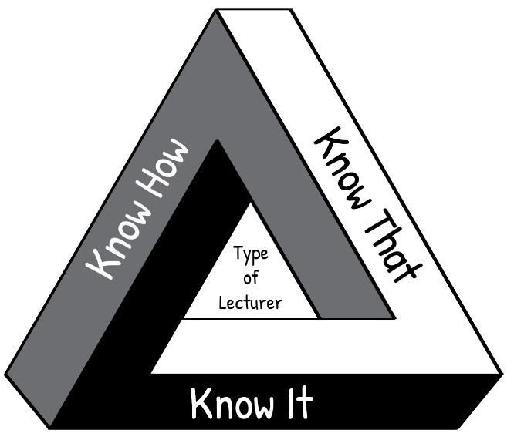

**“Know How”** is *procedural knowledge*, “in our bodies” or *embodied knowledge*.

For example, following a bread recipe.

“**Know It**” is *recognition*, the knowledge of what counts as good; wisdom; technical and theoretical judgments.

For example, is this sourdough good quality bread?

**“Know That”** is *propositional knowledge* or

*theoretical knowledge*, the knowledge of how and why, *cognitive knowledge*.

For example, the science of bread baking.

**Figure 1: The HIT framework**

Think about your own craft of teaching. The kind of teacher you want to be, is one who knows how (the techniques of teaching), knows that (the science and theory behind teaching AND learning) and knows it (knowing and reflecting on what makes a quality teacher). Such a teacher enables students to actively engage with their learning and to develop their full potential.

If you are interested, click on the link provided to watch a short [video](https://youtu.be/9GD-DgNLaxw) in which Wayne Hugo discusses the “HIT model” of TVET knowledge and learning.

Relating theory to practice

In this module new concepts are often introduced by developing them from a practical situation with which you are probably familiar. This process, which moves from your experience towards a more abstract level of theory is known as inductive learning. It makes learning easier and is very different from deductive learning, which starts by presenting abstract theories and principles, then requires you to “deduce” practical conclusions and concrete examples. You are encouraged to relate the ideas you learn from the Adv Dip programme to your own context and to try to think theoretically about your practice. In other words, to think about the rationale for your practice.

Reflective practice and the use of a learning journal

One of the Adv Dip TVT modules is called Reflective Practice, and covers the concept of reflection in the life of a TVET lecturer. Of particular importance is unit 2, which describes various models which facilitate reflection. The simplest reflective model that is discussed in this unit, is that of Terry Borton (1970). It consists of three steps as follows:

**Figure 2: Reflective model (after Borton, 1970)**

The three questions to prompt reflection leading to action:

1. What?

**What** happened? In this step you remember or describe the situation or event you have experienced.

1. So what?

**So,** if that happened**, what** does this show you or teach me?In this step you explore what new insights or knowledge the situation gives you.

1. Now what?

**Now** that I have learnt something new by reflecting on the situation, **what** should I do about it? In this step you think about what to do with the new awareness you have gained – i.e. how to make use of it to act more effectively in future situations.

Throughout the Adv Dip TVT programme, you are encouraged to use a model to reflect on your practices at work in the college so that you can improve how teaching and learning takes place. We have embedded reflective practice throughout the programme, and at the end of most units in the modules you will find a reflective activity to complete. The reflective activity will enable you to make the most of what you have learnt throughout the unit, as well as assisting you to apply your learning in your workplace. Throughout the Advanced Diploma modules, we encourage you to use a learning journal. Keep a file (paper- based or electronic). You will use it to write notes and reflections and complete activities. Start your learning journal at the beginning of the programme, and keep it regularly updated throughout.

Active learning

Most learning theorists tell us that new understandings and learning depend on, and arise out of action. All the modules in the Adv Dip TVT programme include activities. Your learning will be more fruitful if you engage systematically with the activities. If you do not do the activities, you will miss out on the most important part of the programme learning pathway.

Thinking activities

At various points in the module you are asked to *stop and think* and to take some time to reflect on a particular issue. These *thought pauses* are designed to help you consolidate your understanding of a specific point *before* tackling the next section of the module. One of the habits many of us develop through a rote kind of learning is to rush through things. Work though each module slowly and thoughtfully. Read and think. This is how we develop a depth of understanding and become able to use the ideas we learn. Try to link the issues raised in each thought pause with what you have read, with what you have already learnt about learning, with your own previous experience, and so on. Think about the questions or problems raised in the module. Jot down your ideas in your learning journal so that you can be reminded of them at a later stage.

Linkages across modules

As you work through this and other modules, you will notice that topics or issues raised in one module may cross refer to the same issue or topic in another module, possibly in more detail. So for example, while there is an entire module dedicated to the investigation of *curriculum,* key issues related to curriculum will also be highlighted and discussed in the modules dealing with pedagogy, psychology in TVET as well as in the assessment module.

Access to readings

There are links to readings throughout the activities. We have tried as far as possible to provide links to Open Educational Resources (OER). In cases where this was not possible you will be directed in the activity to access these through your university library. The website link is shown in the reference list.

Assessment

The activities contained in this module and the Adv Dip TVT programme as a whole, promote a continuous and formative assessment process. This approach is intended to support your ability to relate ideas to practice and to contribute to your development as you work through the various modules of the programme.

You will also notice that each module includes a summative assessment task with the assessment criteria set out in an accompanying rubric. This summative assessment task is a model only, intended to illustrate the kind of assessment tasks that may be set by the university providing this programme.

# Module overview

As a TVET lecturer you already have at least fifteen years of experience with assessment. Firstly, you experienced assessment at school and college when you were a student and then you became an educator who assessed others. It is possible that most of this assessment has focused on marks: its purpose was to report academic performance to the institution which would then issue a pass or fail, a certificate or a qualification.

In recent years, assessment has come to mean more than the formal process of exams, marks and promotion, however. Assessment is now also seen as a continuous and informal process which is part of teaching and learning every day. This new understanding of assessment has had a big impact on the way the curriculum is organised and the way teaching and learning is approached – whether at schools, colleges or universities.

The focus of this module is assessment in the TVET context. Its aim is to get you to think about assessment in new and creative ways: this is why this module is called **Rethinking** TVET Assessment. During the module you will have the opportunity to try out different approaches to assessment through a variety of tasks and activities. This will help you to apply these concepts to your teaching and assessment practices in your particular TVET programme.

## Purpose

Rethinking TVET Assessment is designed to support lecturers in designing professional assessments of and for learning that will enable them to assess their students effectively, efficiently and fairly. This module focusses on the kind of assessment that is an integral part of regular activity in every TVET classroom, laboratory or workshop every day. It does not focus on large-scale examination assessment. It provides a framework for thinking about TVET assessment and for creating and implementing changes to lecturers’ assessment practices that enhance learning for all students.

## Outcomes

By the end of this module you should be able to:

1. describe how curriculum, pedagogy and assessment work together in teaching and learning
2. understand the value of Assessment for Learning and Assessment as Learning and apply their principles to teaching and learning
3. understand the role of accountability and policy in Assessment of Learning
4. compare the purposes and planning requirements of assessment *for* learning, *as* learning and *of* learning
5. identify the skills, knowledge, values and attitudes and integrated competences you need to assess and their level of complexity
6. compare different types of assessment tools
7. discuss the advantages and disadvantages of different types of assessment tasks
8. understand the importance of validity, reliability and fairness in assessment
9. plan how to provide feedback effectively to your students
10. reflect on your approach to assessment and on your learning.

## Structure

Figure 1: Module structure

## Credits and learning time

This module carries 8 credits. This is equivalent to 80 notional learning hours. It is anticipated that you will take approximately 100 hours to complete the module successfully. The 100 hours will include contact time with your Higher Education Institution (HEI), reading time, research time and time required to write assignments. It is also expected that at least half of your learning time will be spent completing practice-based activities in your TVET College. This will involve your individual work on the activity, and may also require you to discuss these college-focused activities with your colleagues. Each activity in this module indicates the suggested time for completion.

# Unit 1: The role of assessment in effective teaching and learning

## Introduction

As a TVET lecturer you are required to conduct a range of different assessments of your students’ learning. Have you ever given much thought to the purposes of each of these assessments? What information do they provide and how is this information used? Does it benefit your students – or teaching and learning – directly? Are there any assessments that you are required to do which don’t seem to achieve their purpose – or perhaps don’t even seem to have a purpose?

In this module, we explore how assessment can be used to achieve valuable purposes in teaching and learning and how to design it effectively to do so. In this first unit, we start by exploring how the curriculum, pedagogy and assessment work together to ensure that teaching and learning are effective and we look specifically at the role which assessment has in teaching and learning.

## Unit 1 outcomes

By the end of this unit, you should be able to:

1. describe how curriculum, pedagogy and assessment work together in your TVET programme
2. discuss the role of assessment in teaching and learning
3. reflect on your current approach to assessment.

The current understanding of how people learn is that we don’t just take in new knowledge given to us by an educator, but we actively *construct* new knowledge for ourselves by relating it to what we already know. A very good teaching and learning practice which supports learning is to identify what you already know about a new topic before you begin new learning about it and to ask yourself what you would like to find out about it. Thinking about the topic before you begin brings what you already know to the surface and stimulates your curiosity about what you don’t know. This is often called ‘activating prior knowledge’. This helps you to be ready and motivated to add new knowledge to your existing understanding of the topic.

A Know, Wonder, Learn (KWL) table is a tool that is designed to help a person activate their prior knowledge and construct new knowledge as they engage with a new learning experience. Before starting a new learning experience, you reflect on what you already **K**now. You take a moment to **W**onder about the topic and think about what you want to know and learn. This helps you begin to develop your own learning pathway. After completing the topic, you reflect on what you have **L**earnt. This helps to integrate your new knowledge with your prior knowledge so that it is useful and accessible to you.

Here is what a KWL table looks like:

Table 1: KWL table for activating your prior knowledge (K) and your aims (W) *before l*earning and reflecting on what you have learnt *after* learning (L).

|  |  |  |
| --- | --- | --- |
| **K**  **What I already *know*** | **W**  **What I *want* to know** | **L**  **What I have *learnt*** |
| Write down what you already know about the unit or topic here. | Write down what you would like to learn, or should learn, about the unit or topic here. | After completing the unit or topic, write down what you have learnt here. |

In this module, you will create a KWL chart in your learning journal for each unit. You will be using a learning journal frequently. You can use any A4 notebook or binder. A learning journal helps you to learn more deeply by thinking about and writing down your thoughts, ideas and questions about the new concepts with which you are engaging. Your learning journal is personal and you may write down anything that you think is interesting or helpful to you, in addition to the responses you are asked to write down in different activities. You might want to add drawings, diagrams, mindmaps or sketchnotes. It can be very helpful to your ongoing professional growth to use a learning journal permanently as one of your professional habits as a lecturer. When you write down your observations, reflections and ideas about your teaching on a daily basis it can help you to see what you are doing that is working well and what you could adjust to get better results. You will explore a range of ways to use a learning journal in the Reflective Practice module in this programme.

Before we begin to explore the topic of assessment, let’s do an activity to help you identify what you already know about assessment and what you want to learn.

Activity 1: What do you already know and wonder about assessment?

**Suggested time: 45 minutes**

The Approach to Classroom Assessment Inventory (ACAI) is an online survey developed by Queen’s University in Canada as part of a research study. The survey involves a series of questions about how you approach assessment. The research study targets school teachers and you will notice references are made to schools. Just substitute ‘college’ in your own mind as you go through the questions. At the end of the survey you will be provided with feedback about your assessment approach.

1. Click here: <https://interceptum.com/si/en/4800045> to complete the survey now. It should take you about 20 minutes.

As you complete the survey, pay attention to your own reactions to the questions. In particular:

* Are there any questions that use terms or concepts that you don’t understand?
* Do the questions seem to be mostly about your **knowledge** about assessment, your **skills** as an assessor, how you feel about assessment (your **attitudes**) or what you believe is important or not important in assessment (your **values**)? Or do they cover all of these areas?
* Do any of the questions surprise you or seem to suggest an approach to assessment which feels wrong, or strange, to you?
* Do any of the questions make you wonder about aspects of assessment you haven’t thought about before?
* What do you think about the way the questions are designed?

1. After you have completed the survey, download a pdf version of the feedback and read it carefully. Does the feedback seem accurate to you? Make sure you keep your results as you will refer to them again at the end of the module. You can print them and stick them in your learning journal if you would like to.
2. Now that you have explored your existing knowledge, skills, attitudes and values about assessment using the survey and become aware of aspects of assessment where you would like to – or need to – learn more, summarise this using a Know, Wonder, Learn (KWL) chart.

Draw a KWL chart in your learning journal. In the later units of this module you will do a KWL chart for the topic of that unit. However, as we begin this module, let’s use the KWL chart more broadly for you to identify what you know (K) and want to know (W) about assessment in general. This will help you to have your existing knowledge, skills, values and attitudes about assessment in mind as we proceed. Complete the Know and What columns of the table now. We will come back to this table at the end of the module and you will complete the Learnt column then.

|  |  |  |
| --- | --- | --- |
| **K**  **What I already *know about assessment*** | **W**  **What I *want* to know about assessment** | **L**  **What I have *learnt* about assessment** |
| Write down what you already know about assessment here. | Write what you would like to learn or need to learn about assessment here. | At the end of the module, you will summarise what you have learnt about assessment here. |

Discussion of the activity

By accessing your prior knowledge about assessment and thinking about what you would like to, or need to, learn about it you are preparing yourself to actively engage with new ideas and integrate your new learning into your existing framework of knowledge so that it becomes useful to you.

## A new understanding of assessment

When you were a student, just hearing the word ‘assessment’ may have made you uncomfortable. It may have been strongly linked to exams and other situations which resulted in judgements which had serious consequences for your life: a ‘pass’ or ‘fail’, or earning a qualification or not. Many of your students may not express happiness when you mention assessments as well. In fact, as a lecturer you may still have many negative associations with assessment. Your college assesses your teaching through a range of requirements which can also potentially result in negative consequences if you don’t meet their criteria. And the requirements you have to fulfil in terms of assessing your students can be very time consuming and not very enjoyable.

A serious danger when lecturers are under time pressure to comply with many assessment requirements is that they can begin to focus teaching and learning on the content that they know will be on the assessment. This is sometimes referred to as ‘teaching to the test’. If this happens, the whole purpose of education has been reversed: instead of assessment serving learning, learning serves assessment. It’s important that you monitor your teaching and learning and ensure that learning takes first priority and is not sacrificed to assessment requirements.

The scene shown in Figure 2 provides a typical example of what happens in a system that places emphasis on marks and on passing and failing, rather than on what has to be learned. These students are not thinking about where they could improve their learning. They are only concerned with passing and with comparing their marks with those of their peers.

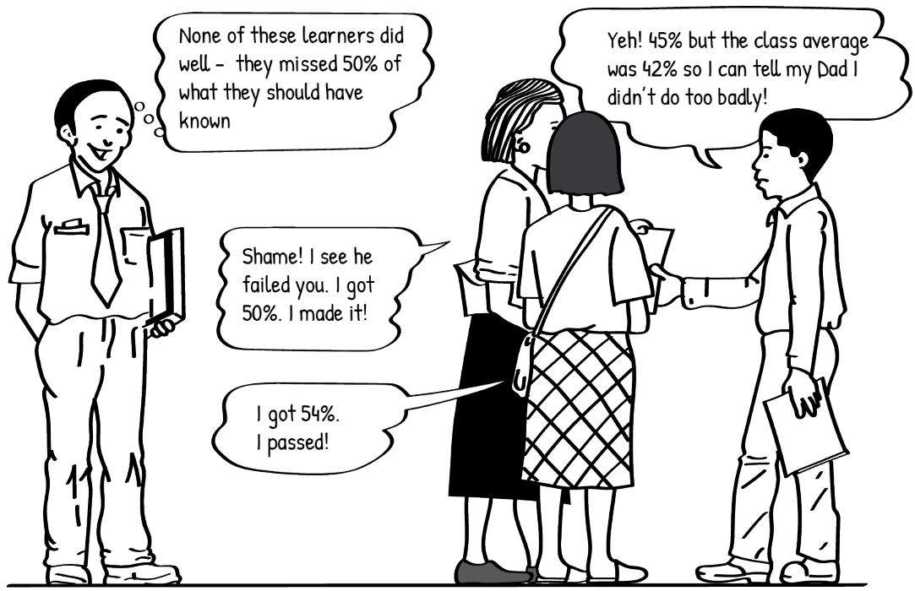

**Figure 2: A lecturer (left) watches three students (right) discuss their results**

**(Moll et al., 2005)**

This powerful – and often negative – role which assessment has played in education came from decades of education being influenced by behaviourist learning theory. Education was organised a bit like a factory, with educators handing out knowledge, students being required to write a test or exam to demonstrate that they have learnt the knowledge, and the system either rewarding the student (with a pass or a qualification) for having performed acceptably or punishing the student for not performing acceptably (a fail or low mark). The learning outcomes were dealt with quite separately, rather than being integrated together. This kind of an approach is not effective for finding out if students understand and can do the key things they need to be able to in order to progress to the next level of learning or to the work place.

Over the past hundred years new learning theories have challenged this approach. Cognitivist and constructivist learning theories and research have shown that knowledge builds up using simpler and then more complex kinds of thinking processes. Learning needs to start with what you already know in daily life and work to more specialised or abstract knowledge and then you need to be able to move this across to different situations in a real-life situation so that you can use it in the workplace. Students develop knowledge and skills by interacting with new ideas and constructing new knowledge for themselves and with their peers and lecturer, rather than being ‘fed’ information. Having students sit at a desk and write a test is not necessarily the most effective way to check whether they have developed those skills. Instead, lecturers need to be continually checking (assessing) what students know and can do to see if they are constructing knowledge and skills successfully and if they are progressing towards their competence goals. This shifts the focus of assessment to finding out where students are in their progress so as to adjust teaching approaches to best help them along the way, rather than judging students’ ability to reproduce knowledge at the end of the learning process. Assessment thus becomes a teaching and learning tool, helping to ensure that teaching fits the needs of the individual students as well as possible.

You may already be using assessment as a tool to improve teaching and learning. Some of the ways you do this may be very informal: you might not even write anything down, but do the assessment in your head and make decisions about teaching and learning based on what the assessment tells you. Your students may not even be aware you are assessing them. In fact, it may be such a natural process for you to assess them as you listen to them discuss concepts or watch them practice skills that **you** may not even be aware you are assessing them!

While assessment of competence at the end of learning still has its place in a formal system of progression to different levels of education and earning qualifications which are recognised in the workplace, this is only one aspect of assessment. Let’s look at assessment’s proper role in education.

## Curriculum, pedagogy and assessment work together to develop students’ competence

Education involves providing a student with learning experiences that enable them to develop a certain level of competence that they are seeking to attain. In the TVET context, their goal is usually to attain a level of competence required to enter a particular industry. If you analyse what makes up the competence that they need, you can see that it is a combination of knowledge, skills, attitudes and values all working together to enable a person with that competence to understand and do things that a person without that competence cannot.

In formal education, providing students with learning experiences that enable them to develop their target competence involves three processes which work together: curriculum, pedagogy and assessment. Let’s look at the role that each of these plays in enabling students to develop competence.

**Curriculum.** Firstly, the level of competence that a student needs to develop by the end of their education needs to be clearly understood and described so that everyone involved in the educational process knows what the goal is. Then the competence is analysed to identify all of the skills, knowledge, attitudes and values (SKAV) that make it up. In the TVET context, the Department of Higher Education and Training (DHET) and specific TVET colleges need to decide what skills, knowledge, attitudes and values are important and the standard of competence that students need to achieve in this by the end of their education. When they think about what is important, they need to consider what is important to students, in terms of their own career goals, what is important to the industry that they will be going to, and what is important to society, which will be using their services. If the curriculum leaves out things that are important in industry, the student might reach the standard the curriculum set but not be able to get a job in industry. If the curriculum only teaches **knowledge** but no **skill, attitudes** or **values**, companies may find that even though the student has a qualification, they really don’t have the competence necessary to the job. The knowledge, skills, attitudes and values which are decided to be important are organised into a plan for teaching these in a logical order and using effective approaches. This is broken up practically into different modules, courses, years of study and levels of qualification.

**Pedagogy.** Next, the lecturers in a programme teach the SKAV identified in the curriculum to their students. However, this is not just a matter of explaining concepts or information to them. As humans we can’t learn **skills** just by having someone explain them to us – they need hours of modelling, experimenting, practice and feedback to enable us to slowly develop competence. The **attitudes** and **values** that are required for competence also can’t simply be ‘told’ to a person. We develop attitudes and values by being exposed to different ways of looking at and doing things and these often shift as we have a range of different experiences over time. Even **knowledge** – concepts and information – which might seem the easiest to simply ‘tell’ to a person and expect them to remember it isn’t really learnt effectively that way: even if we do manage to remember it, it doesn’t become *ours* – part of our own way of thinking and reacting. For us to really gain new knowledge, we need to be actively involving in exploring it, challenging it and trying it out. This means that for lecturers to teach their students the SKAV they need to develop competence they have to skilfully use a range of different methods, activities and techniques. This is called **pedagogy.**

**Assessment.** As lecturers teach, they need to constantly watch to see if their approaches are working effectively and their students are learning well and, if they are not, they need to try different teaching methods or learning activities. Lecturers should not just blindly teach the curriculum but watch for where their students might need more background knowledge than what the curriculum provides or where maybe new things happening in industry need to be taught which aren’t included in the curriculum. Checking what students understand and can do is called **assessment**. It is something expert lecturers are doing all the time in informal ways as they observe their students practising or problem-solving in groups, listen to their conversations and have discussions with them. Students' current knowledge, skills, values and attitudes are identified and checked against what they were before learning and also checked against the standards of competence they are trying to achieve by the end of the module, course or programme. Formal education involves many levels of formal assessment, as well, where students are required to demonstrate their knowledge, skills, values and attitudes in a way that lecturers can document: such as a test or exam, a project, a presentation or a demonstration of a skill.

Figure 3 shows the relationship between these three processes in education.



**Figure 3: Curriculum, pedagogy and assessment work together to ensure quality teaching and learning**

Assessment is the focus of this module. If you have explored the curriculum and pedagogy modules you will see that assessment is closely tied to both curriculum and pedagogy. When you measure (assess) what students have learnt this needs to be directly linked to the standard that was set and the plan laid out in the curriculum to reach the standard. At the same time, if you measure that students have learnt what is in the curriculum and it shows they weren’t actually taught what was in the curriculum adequately, your assessment needs to feed back into teaching to adjust the pedagogy that is used. Assessment is thus an important part of making sure that quality teaching and learning are happening.

Let’s explore how this works in your TVET programme.

Activity 2: Explore the relationship between curriculum, pedagogy and assessment in your TVET programme

**Suggested time: 30 minutes**

1. In your learning journal, make a table with 3 columns, as follows, taking up a full page:

|  |  |  |
| --- | --- | --- |
| **Curriculum**  What are the important knowledge, skills, attitudes and values that make up this competence? | **Pedagogy**  What teaching methods and learning activities provide the most effective learning opportunities for students to develop the SKAV that make up this competence? | **Assessment**  What are the different ways I can check if my teaching is effective and students’ knowledge, skills, attitudes and values are progressing toward competence? |
|  |  |  |

1. Select either your TVET programme or a single course that you teach.
2. In the first column, list the key knowledge areas, skills, attitudes and values that are involved for a student to reach the target level of competence at the end of the course or programme. You have identified these during the module TVET pedagogy and can refer to the list you made then if it helps you.
3. In the middle column, identify the teaching methods and learning activities that you think effectively enable students to develop these skills, knowledge, attitudes and values.
4. In the third column, list the ways you check to see if students are developing the knowledge, skills, attitudes and values you are trying to teach.
5. Do you find that in your actual teaching of the curriculum, your pedagogy and assessment remain clearly aligned to each other? Write down any thoughts you have about this.
6. Compare your tables and your ideas with those of two of your peers taking this module.

Discussion of the activity

By thinking about how your teaching practices can best implement the curriculum and how your assessment practices can check that your teaching is effective and that students have learnt what the curriculum identifies as important, you can more consciously keep these three aspects of learning aligned so as to ensure that teaching and learning are enabling your students to develop the integrated knowledge, skills, attitudes and values that will result in the level and kind of competence that will equip them to be successful in their careers.

## Assessment serves learning in a number of ways

The overall purpose of assessment is to find out what students know and can do. But this is not just to decide what mark to give them or to award them a pass or a qualification at the end of the programme.

One purpose of assessment is to find out what students know ***before*** they start learning new content so that you can adjust teaching and learning to ensure you don’t leave any gaps between what they already knew and the new content you teach, as well as to ensure that you don’t waste time teaching content they already know well. The purpose of this kind of assessment is often called *assessment* ***for*** *learning* because you use the information it gives you to plan teaching and learning. While you are teaching, you may ask students questions about what they are learning, listen carefully to discussions they are having in their groups or carefully observe them as they practice a skill to see if they are confused about any concepts or instructions or if they need additional teaching or practice. Based on this informal assessment you might decide to explain a concept or instruction again or demonstrate a procedure or skill again. This informal assessment during teaching and learning gives you valuable information which you can use immediately to adjust your teaching in order to improve learning. This is also *assessment* ***for*** *learning*. In Unit 2 we explore this purpose of learning further.

The purpose of many of the formal assessments you are required to do by the college is to find out what a student has learnt after teaching and learning on a topic is complete. The purpose of this *assessment* ***of*** *learning* is often to see if the student has achieved the learning objectives of a course or programme to an adequate standard and can be certified as competent for the knowledge and skills taught in that course or programme. If so, the student will get a formal certification or qualification which enables them to apply for a particular job in industry or continue their studies at a higher level. If the assessment of learning shows the student has not achieved the learning objectives, the student may have to repeat the course. In Unit 3 we explore assessment of learning as a purpose of learning.

A particular assessment can have several purposes at the same time. For example, the main purpose of a final exam may be the *assessment* ***of*** a student’s *learning* to determine if they have developed the competence required and can be certified or passed. But *assessment* ***of*** *learning* in the form of final exams may also be analysed to find out your students’ pass rate and the college may use this to assess your performance as a lecturer. You may also reflect on the final exam results to see where students’ competence was weak and use this to improve teaching and learning going forward – thus using the exam as *assessment* ***for*** *learning*. Similarly, when you are informally assessing *students* ***for*** *learning* as you walk around the classroom or workshop during an activity, you may later use what you observed to inform comments you write on a report card or feedback you give to the student at the end of the course. You are thus using an informal assessment you did for the purpose of *assessment* ***for*** *learning* for another purpose – *assessment* ***of*** *learning*.

Let’s look at the purposes of the assessments you do on a regular basis.

Activity 3: Purposes of assessment

**Suggested time: 15 minutes**

1. In your learning journal make a table with three columns, filling a blank page. Label the columns as follows:

|  |  |  |
| --- | --- | --- |
| **Assessment** | **Purpose** | **Effectiveness** |
|  |  |  |

1. In the first column, list all the different assessments you do on a regular basis.
2. In the second column, identify the purpose of each assessment. Try to note if the purpose is assessment **for** learning or assessment **of** learning. If you’re not sure, just describe the purpose as you understand it. Consider whether the assessment is used for more than one purpose.
3. Now evaluate whether you think the assessment is effective in achieving its purpose/s or not. Write ‘effective’ or ‘ineffective’ in the third column. If you write ‘ineffective’, note down your reason in the column as well.

Discussion of the activity

Thinking about assessment from the perspective of purpose rather than just as a requirement you have to meet using certain methods and instruments is important in order to ensure that assessment is really doing what it needs to do. This can help you to evaluate your assessments and see where they need to be modified to ensure they are effective in achieving their purpose. It may also help you to see where there are opportunities to use one assessment you are doing for additional purposes that benefit teaching and learning. The following process can help you to plan, develop and use assessment methods that are ‘fit for purpose’.

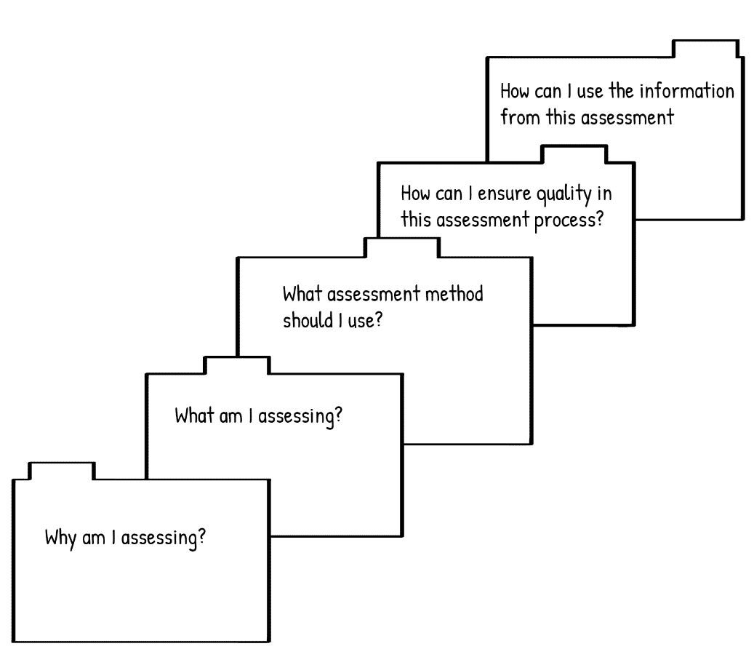

**Figure 4: Model for the assessment planning process (Adapted from Earl, 2006)**

This module follows the structure of this assessment planning process so that you can explore how it can help you step by step. In the following two units we will explore the purposes of assessment more deeply, investigating the first question in the model: *Why am I assessing?* We will address the other questions as the module progresses.

# 

# Unit 2: The purpose of assessment to improve learning

## Introduction

In this unit and the next, we focus on the first step in the assessment module that you were introduced to in Unit 1: *Why I assessing?* In other words: what is the purpose of assessment, or of a particular assessment?

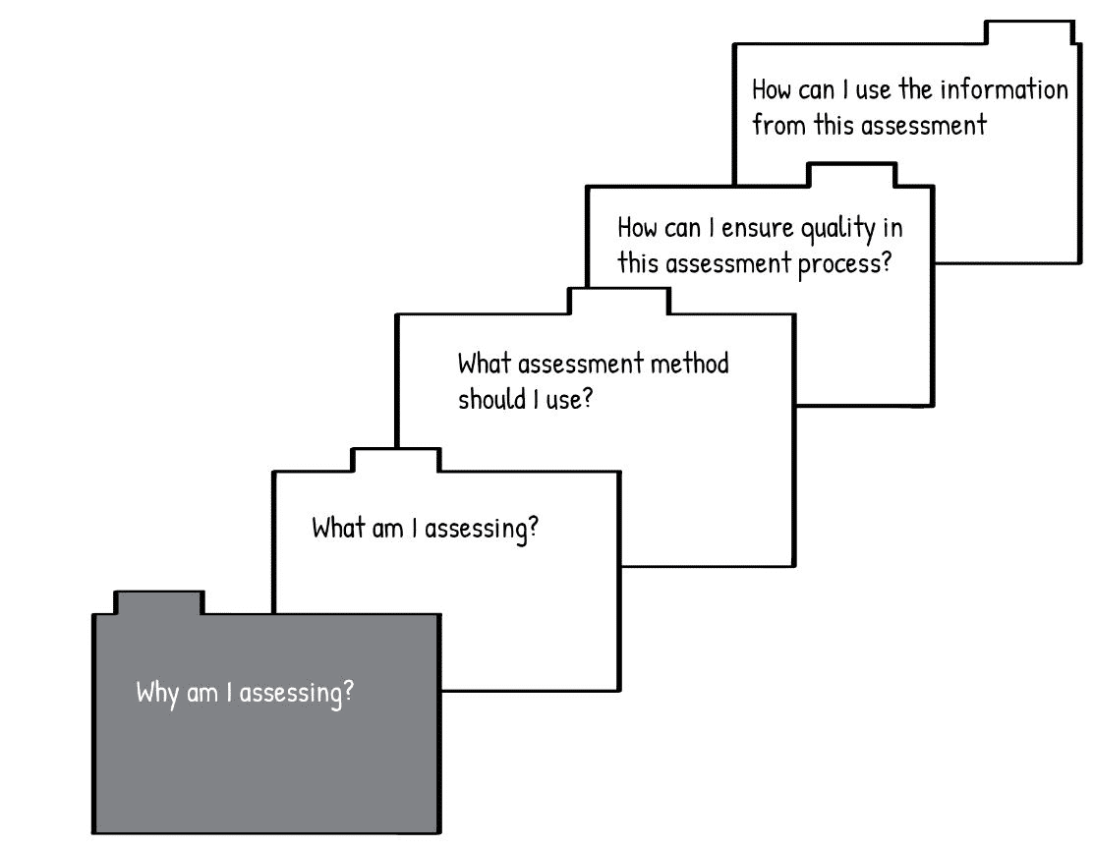

**Figure 5: Unit 2 addresses the purpose of assessment for learning (Earl, 2006)**

As we discussed in Unit 1, one of the main purposes of assessment is to collect information about what your students know (or can do) about the topic which you can use to adjust your teaching in order to improve learning. This purpose is assessment ***for*** learning. You can assess **for** learning *before* you start the topic to find out what they already know so that you can build on that, rather than leaving gaps or teaching what they already know. You can also assess **for** learning continuously *during* teaching and learning to check how your students’ learning is progressing and identify where you need to adjust your teaching. One form of Assessment for Learning is Assessment ***as*** Learning. This involves students assessing themselves as a way to aid their learning. We will focus on this aspect of Assessment for learning in the second half of this unit.

## Unit 2 outcomes

By the end of this unit, you should be able to:

1. understand the value of Assessment for Learning and apply its principles to teaching and learning.
2. understand the value of Assessment as Learning and apply its principles to teaching and learning.

Activity 4: Create a Know, Wonder, Learn (KWL) chart

**Suggested time: 15 minutes**

Create a KWL chart for Unit 2 in your learning journal. Focus your questions on the learning outcomes for this unit. For example:

|  |  |  |
| --- | --- | --- |
| **K**  **What do I already *know*** | **W**  **What do I *want* to know** | **L**  **What I have *learnt***  (after completing the unit) |
| about Assessment of Learning and Assessment as Learning? | about Assessment of Learning and Assessment as Learning? | about Assessment of Learning and Assessment as Learning? |

Fill in the first two columns now.

Discussion of the activity

By accessing your prior knowledge about this topic and thinking about what you would like to, or need to, learn about it you prepare yourself to actively engage with new concepts and integrate new learning into your existing framework of knowledge so that it becomes useful to you.

## Assessment for Learning (AfL)

Assessment for Learning involves checking what your students understand and can do as the learning process is happening so that you identify any misunderstandings, difficulties or gaps in knowledge and adjust your teaching to address these. You can use a range of different kinds of information to make your students' learning 'visible' to you as you are teaching them. Assessment for learning can also be used by students to adjust their learning strategies before or during a teaching and learning process. When lecturers commit to learning as the focus of assessment, they create a classroom culture which supports students’ success.

Let’s use the assessment planning model to explore how Assessment for Learning works at different stages.

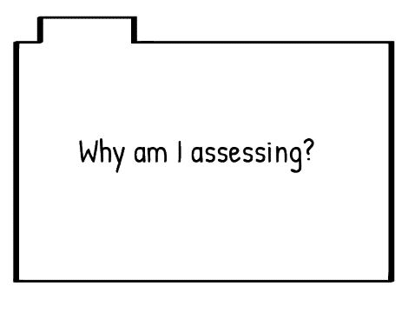

The **purpose** of Assessment for Learning is to find out what students know and can do so that teaching can be adjusted to enhance learning.

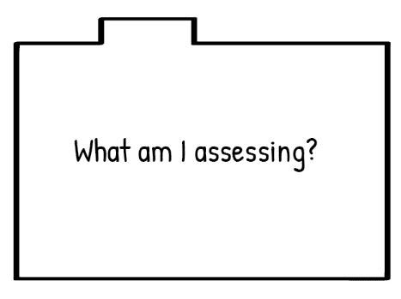

The **focus** of Assessment for Learning is to find out what students’ SKAV are at the point of assessment in comparison to the learning outcomes. If you assess for learning **before** you have started teaching then you are assessing **prior knowledge** – what your students already know, can do, and what their existing attitudes and values are. When you assess for learning at different points **during** teaching and learning you are looking to see where students have developed a strong understanding; where they are confused or may have misunderstood something; where they are having difficulty developing a skill or where the skill is progressing well; where they are developing attitudes and values which support competence or where these still need development.

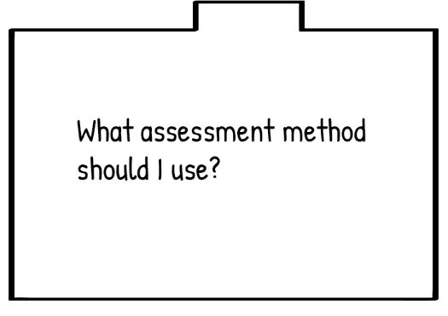Assessment for Learning can be done using a wide range of methods as it is not usually linked to policy requirements and formal reporting procedures. Think about which methods would best give you the information you are looking for. Informal methods can be effective: for example, watching to see if students show that they understand concepts during a class discussion, observing students working together on a project, or asking students questions individually about what they know and why they are approaching a task in a particular way. You can also use more formal methods: for example, have your students write in a learning journal regularly and read these routinely give weekly quizzes; or using baseline or diagnostic tests. Choose the method based on how students could most easily demonstrate whether or not they have the particular knowledge, skills, values or attitudes you are looking for. Not all students can demonstrate their learning in the same way equally well. One student may best be able to demonstrate it orally, while another might more easily be able to show you through a practical demonstration. Design assessments so that they offer different ways for students to show their learning.

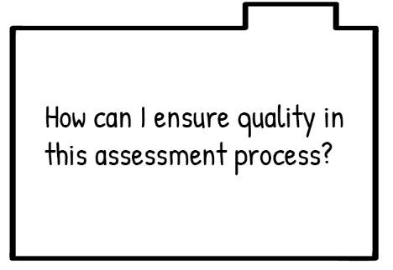

**Continuously assess in different ways.** Assessment for Learning needs to be of a high enough quality that you can use it to make decisions about teaching and learning and provide detailed feedback to students. You need to ensure that you are actually getting a clear picture of how your students are thinking and what it is that they understand or find confusing. A single assessment is rarely enough to produce detailed insights into students’ learning. Instead, use a range of assessments in different modes (e.g., oral, visual, active, written) and do them at different times to keep your students’ progress ‘visible’ during the teaching and learning cycle. By staying alert for what students’ discussions, processes and products during different learning tasks can tell you about their competence you can ensure you have detailed and reliable knowledge of each student’s current understanding and ability.

**Keep detailed notes.** Much of what you find out from assessment for learning will help you make decisions about teaching, such as whether you need to go back and reinforce earlier concepts, whether students are ready to move on, or whether you need to move at a slower or quicker pace. This doesn’t require formal reporting or extensive record-keeping. Making notes about your analysis of assessments done for learning can be extremely valuable, however. Firstly, it makes it possible for you to give your students detailed and descriptive feedback individually which can help them make adjustments which improve their learning. Secondly, by writing down what you observe about students with similar needs or interests you can group students or provide different options for activities which respond to these.

### C:\Users\sheilad\South African Institute for Distance Education\AdvDipTVT(058) - Documents\Module Assessment\Artwork\UseInfo.pngAdjusting teaching practices

The information you gain from assessments which you conduct for learning can help you keep your teaching aligned with learning outcomes. You may realise that you have been focusing on certain aspects of the curriculum and neglecting others more than you had realised. It may alert you to the fact that students have not yet grasped the concepts you are teaching and you should not move on yet, even though you had planned to. It might also show you that students are comfortable and confident with the new concepts and you can move forward more quickly than planned. You may notice that a particular activity is not working effectively for some students and you might decide to try a different kind of task or bring in some additional teaching and learning resources to support them. You may find out from assessment for learning that students are particularly interested in a certain aspect and you can design projects or presentations to enable them to pursue this line of interest further. You may also find that some students need more individualised support to overcome gaps or difficulties.

### Feedback to students

Students learn from assessment when the lecturer provides specific, detailed feedback and direction to each student to guide their learning. To be successful, feedback needs to be immediate and identify the way forward. It should not simply tell students whether their answers are right or wrong or tell them their mark. This kind of feedback offers very little direction for moving forward. Descriptive feedback makes connections between students’ thinking and the learning that is expected. It addresses gaps or misunderstandings so that the student can make sure their foundational knowledge is solid before moving on. By sharing detailed feedback with students you also model to them how you assess their competence and what you think they need to do to improve it; this helps them learn how to assess themselves and identify how to take their learning forward on their own.

Activity 5: Observe and use Assessment for Learning

**Suggested time: 1 hour**

Read the following scenario which describes how a TVET English lecturer planned her Assessment for Learning. Then complete the learning tasks that follow.

### An example of Assessment for Learning

Thabile is an experienced TVET English lecturer. Over the last term she focussed her teaching on reading texts for meaning. She carefully chose literature that she thought would help to develop students’ comprehension skills before, during and after reading and listening. During the reading activities, Thabile observed a wide range of achievement. For example, some students were noticing various authors’ writing techniques, some were requiring much guidance in responding to texts and some were showing interest in detective stories. Thabile saw that she needed to challenge the proficient writers and provide guided practice for those who were just emerging as writers. She decided to focus on the process of writing. She used differentiated teaching through Assessment for Learning to address the needs of all students in her classroom. For example, she planned activities that gave different students different tasks to match what she had learned about their learning needs.

Let’s look at Thabile’s Assessment for Learning through the lens of the assessment model.

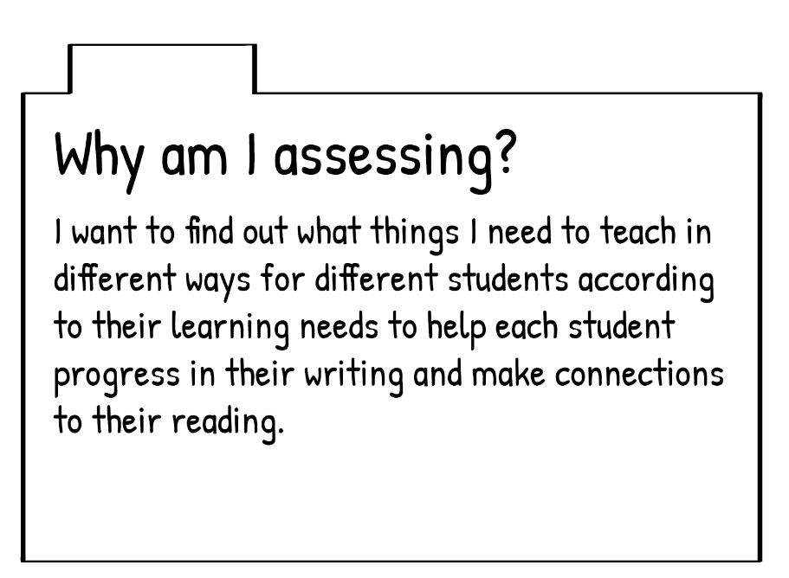

Purpose: Thabile’s purpose for assessment is to customise her teaching practice to the specific needs of her students.

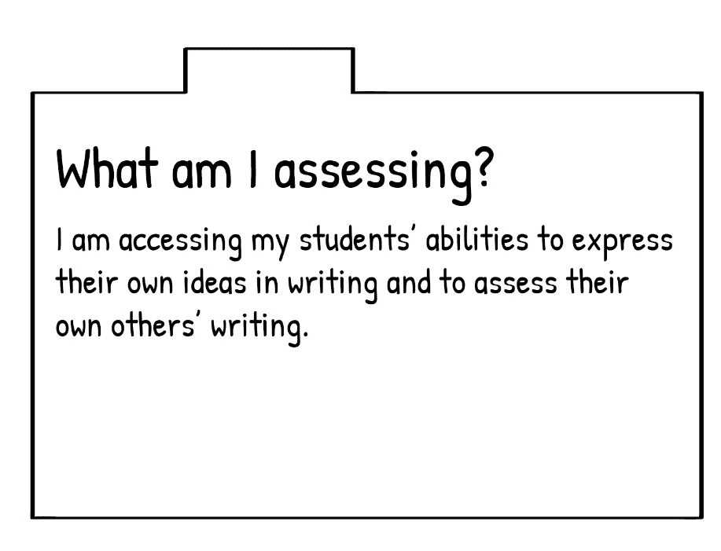

Focus: She has targeted specific skills which she wants to assess.

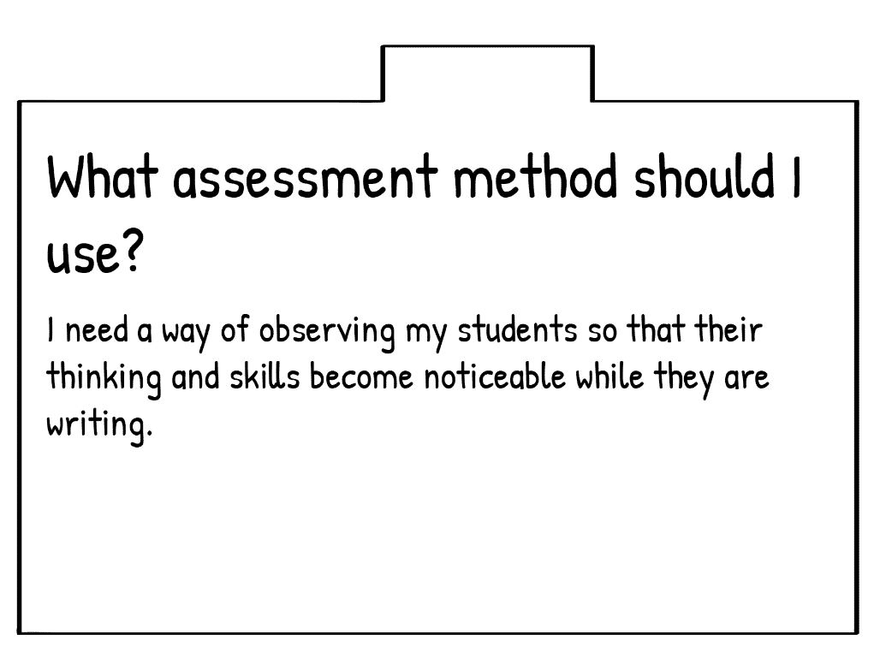

Method: She has identified what the method needs to achieve, but has not selected methods yet.

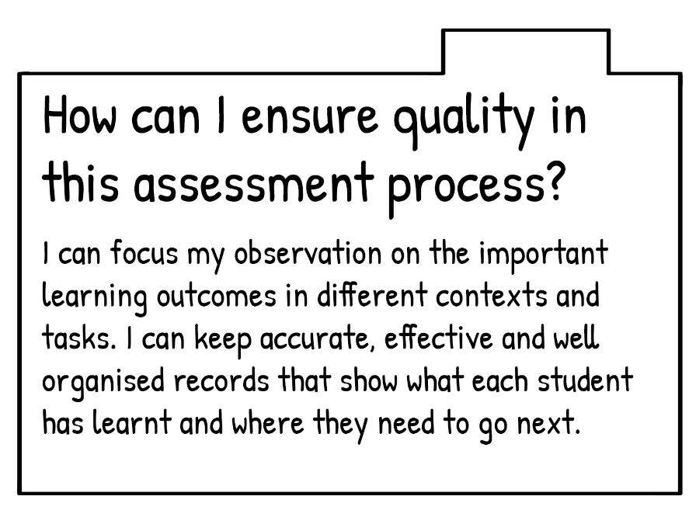

Quality: She intends to focus on learning outcomes and keep records to ensure quality.

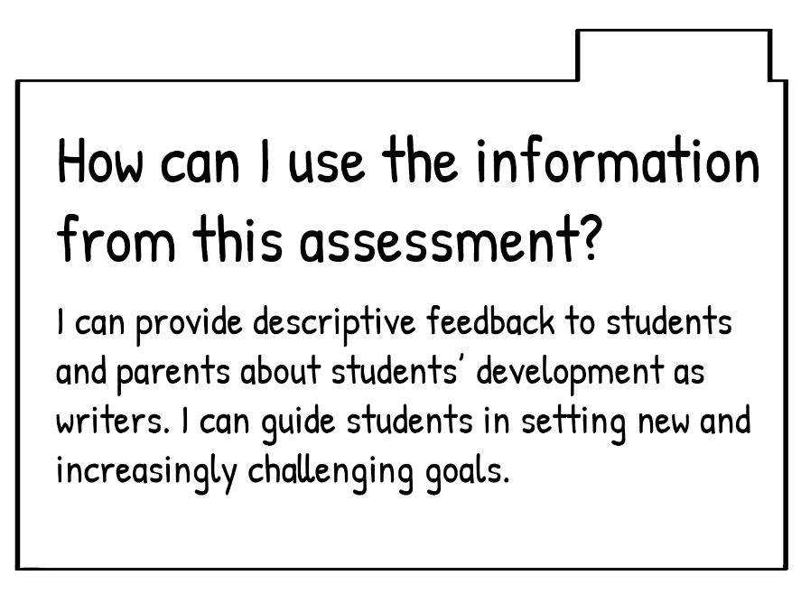

Using the information: She plans to use the information to give feedback and guide students in setting goals.

1. Thabile has decided what her methods should achieve but has not chosen them yet. What methods would you recommend for her to use to achieve her purpose?
2. Compare how Thabile plans to use the information with her original purpose. Can you see a difference? Do you think the purposes she notes at the end could also be achieved using the same methods?
3. Think of an assessment task that you have used before for Assessment for Learning or one you would like to try. Write your planning ideas under each heading of the assessment model in your learning journal:

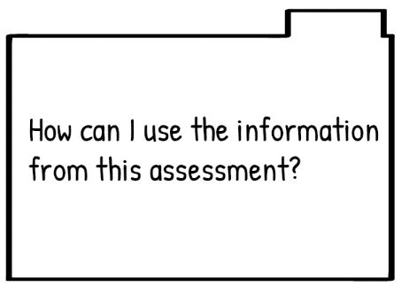

1. Share your plan with two of your peers in this module. Ask them to evaluate it and give you feedback. Do the same for them. Did evaluating their plan and hearing their feedback give you any insights into how you could improve yours, or other ideas you might like to try for Assessment for Learning?

Discussion of the activity

Using a planning tool in your learning journal when you want to design assessments for learning can help you make sure that your methods align to your purpose and your intended use.

Use the following example to help you evaluate your plan, and those of your peers, for an Assessment for Learning task.

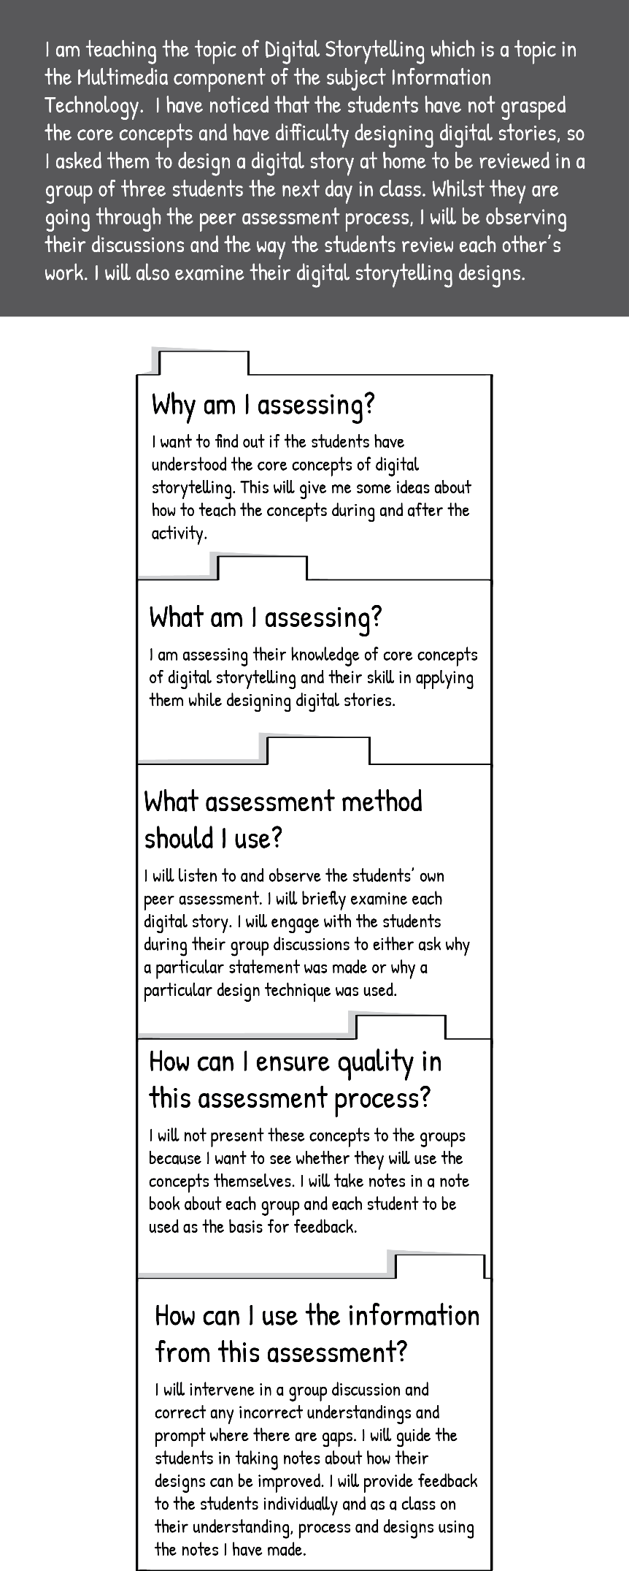

## Assessment as Learning (AaL)

Assessment ***as*** Learning involves the student assessing the way that they are thinking and learning and using what they find out to make adjustments to the way they approach learning. The ability to notice your own thoughts and processes and ‘think about how you are thinking’ is called *metacognition*. And the ability to make changes to your thoughts and processes as you observe them is called *self-regulation*. One of the most important goals of your teaching is to help your students develop their ability to manage their own learning by reflecting on what they know and can do and make effective decisions about how to learn further on their own. A student who can do this will be able to continue learning and improving their expertise throughout their career, even without a lecturer to guide them.

Assessment as Learning, as you can see, is fundamentally different from the traditional model of assessment where the lecturer marks the student’s work and then provides a mark as feedback. Instead of the lecturer being the one who ‘knows all’ and the student being the one who ‘knows little’, the student is seen to be one who already knows many things and is on a lifelong journey of learning and increasing competence – as is the lecturer. In this process, the one who is learning is actively involved in making sense of new knowledge, relating it to their prior knowledge, reorganising their understanding so that the new knowledge is integrated, and using it to increase their competence.

**Figure 6: In Assessment as Learning students assesses themselves (OR Tambo School of Leadership (2019)**

In Assessment as Learning you as a lecturer thus are involved in modelling to your students how to assess their own knowledge, skill, values and attitudes. Involving your students actively as assessors in the assessment process does not mean you no longer need to assess them! Rather, your role in Assessment as Learning is to design learning and assessment that allows students to think about, and monitor, their own learning. Self-monitoring and self-assessment are complex and difficult skills that take time to develop.

There are several things you can build into teaching and learning which can help students to develop these skills over time:

* Create an environment where it is safe for students to risk being wrong and where support is readily available.
* Model self-assessment and reflection. You could do this by taking time at the end of each lesson to review what has happened during the lesson and comment on your own teaching: for example, noting what you think worked well, where you should have planned more time for an activity, what you have learnt from students during the lesson and what you will do in the next lesson based on what you learnt from reflecting on this lesson. By inviting them to participate in this – giving you specific feedback on what they thought was effective or could use improvement in your teaching approach – you allow them to join in the assessment. Also, very importantly, you model to them that identifying and naming our own mistakes or weaknesses is not ‘failure’ but rather is a positive and important part of learning and improving, and is nothing to be embarrassed or defensive about. This will help them to feel more comfortable identifying where their competence is weak and needs improvement.
* Work with them to develop clear criteria for what they are trying to achieve and set goals for their learning. Guide them as they monitor their own progress.
* Provide exemplars and models of good practice and quality work that reflect curriculum outcomes.
* Help students learn to question their own thinking by encouraging discussion and debate and asking them for their reasons for their opinions or judgements. Encourage them to question your thinking as well and model to them that you are willing to consider that you could be wrong and adjust your position: this is what enables you to keep developing and improving throughout your career.
* Provide regular and challenging opportunities for students to assess themselves so that students can become confident and competent self-assessors.
* Monitor students’ descriptions of their processes and knowledge and provide descriptive feedback on their accuracy.

In order to plan, develop and use Assessment as Learning we can again use the assessment model.



In Assessment as Learning both you and your students are assessing. They are assessing themselves to become aware of their learning, see it accurately and use what they see to plan their approach to learning going forward. You are assessing them to see how they are progressing in developing the habits of mind and skills to monitor, challenge and adjust their own learning.



Students are assessing their own knowledge, skills, attitudes and values in relation to learning outcomes and identifying where adjustments or further learning or practice are needed in order to achieve learning outcomes.

You, the lecturer, are assessing students’ abilities to assess their learning accurately against learning outcomes and use their knowledge of their learning to plan their approach to learning going forward.



Teach students how to use self-assessment methods such as reflective models to monitor their own learning. Choose methods that allow students to consider their own learning in relation to models, exemplars, criteria, rubrics, frameworks, and checklists that provide images of successful learning. Assess your students by reviewing their reflective journals, asking them to identify their learning and reviewing their goals and plans with them.

Quality in Assessment as Learning depends on how well the assessment engages students in considering and challenging their thinking and in making judgements about their views and understanding. Lots of opportunities and practice with different kinds of tasks and situations are needed for students to develop these skills. It is vital that students keep their own records of their self-assessment, goals and progress and that you keep records as you monitor how their self-assessment skills are developing over time.



Students use the information from self-assessment to plan their learning goals going forward. Self-assessment is also ‘used’ by students in a more subtle way in that it serves to build their self-reliance and self-confidence as practitioners because they know how to find out if they are doing well and they know what to do about it if they are not.

Although Assessment as Learning is designed to develop independent learning, students cannot accomplish it without the guidance and direction that comes from detailed and relevant feedback.

If all feedback does is provide direction for what students need to do—that is, if the feedback doesn’t refer to students’ own roles in moving forward to the next stage of learning—they will be perpetually asking you questions like “Is this right?”, “Is this what you want?” Rather, feedback needs to encourage students to focus their attention on the task and adjusting their approach, rather than on getting the answer right.

You will use your own assessment of your students' self-assessment to determine their progress with developing these skills and whether they need more and different kinds of opportunities to practice self-assessment and to plan these.

When students reflect on their own learning and are required to communicate it to others, they deepen their understanding of the topic, their own learning strengths, and the areas in which they need to develop further. Students can present their self-assessment results to you in writing or in one-on-one conferences or in small group discussions with their peers.

The following scenario provides an example of Assessment as Learning in the context of teaching students to complex problems in various subject areas.

|  |
| --- |
| Scenario: Assessment as Learning Thandi recently began working with her engineering students on solving complex problems in various engineering classes. She knew that key factors for success in solving problems independently are determination and persistence. She also knew that students must learn to identify their own thinking processes about how they approach problems and become comfortable with trying other approaches. She took the following steps to create an Assessment as Learning experience for them.  C:\Users\sheilad\South African Institute for Distance Education\AdvDipTVT(058) - Documents\Module Assessment\Artwork\Why 2.png  Her purpose for the assessment was that it should help students gain awareness of the strategies they use and what motivates them when they solve a problem.  C:\Users\sheilad\South African Institute for Distance Education\AdvDipTVT(058) - Documents\Module Assessment\Artwork\What 2.png  The students would be focusing on assessing their problem-solving strategies and motivation.  Thandi would be focussing on assessing her students’ ability to recognise their own thinking and strategies and identify what motivates them.  C:\Users\sheilad\South African Institute for Distance Education\AdvDipTVT(058) - Documents\Module Assessment\Artwork\Method 2.jpg  To help students become aware of their thought processes and strategies and explore what motivated them, she had them each keep a learning log in which they reflected regularly. To assess their progress, she kept her own record of conversations and focussed observations as the students worked in small groups and whole-class settings.  To support her students in beginning the process of recognising their thoughts and motivations, Thandi discussed with them the value of persistence in problem-solving. She provided some examples to explain what persistence is as a value and attitude and how it works as a skill. She had students reflect on whether they valued persistence and whether it was an attitude they used to approach problems. She had them list in their learning logs how they recognised when they were persisting and when they were not. Here is a sample from one student’s reflection journal.  C:\Users\sheilad\South African Institute for Distance Education\AdvDipTVT(058) - Documents\Module Assessment\Artwork\Journal 2.jpg  **(Earl, 2006)**  C:\Users\sheilad\South African Institute for Distance Education\AdvDipTVT(058) - Documents\Module Assessment\Artwork\Quality 2.jpg  Thandi engaged the students in a discussion about the characteristics of persistence that they had listed in their logs and how these play out in a range of problem-solving situations in different subjects. During the discussions, she recorded these characteristics in a long list. Together, they refined the list by sorting and grouping. They ended up with a few criteria that they all agreed described what persistence looks like in any problem-solving situation. Here are the criteria they developed together.  **Our Criteria for Persistence in Problem-Solving**   * I reread the problem carefully several times in order to fully understand it. * I break the problem into parts to find out what I know and what information I need to find. * I check notes, books and other resources to find ideas that might be useful in solving the problem. * I ask other people focussed questions to try to find helpful ideas (but I do not ask for the solution). * I draw diagrams or use objects as models to think about the problem in many ways.   The students used these criteria as a guide when problem-solving and reflecting on their problem-solving processes. Thandi used the criteria to guide her observations of the students as they worked at solving complex problems and shared their reflections. When observing the students she noted, for example, whether they reread the problem carefully, what information sources they referred to. If they asked for help, she noted if their request for help was an attempt to be given the solution or to get hints about how to generate their own solution. To follow up on her observations of each student, Thandi had a brief conversation with them in which she focussed on:   * How did you know you were persisting? * What was your thinking process as you worked through the problem? * What decisions did you make along the way? * Can you tell me more about the decisions? * How do your thinking and decision-making fit with your goal for persistence?   Thandi related each student’s self-assessment to her observation notes and the student-developed criteria. She focussed on the student’s own determination of which strategies increased their level of persistence and generated successful problem-solving, and how the student saw their level of persistence in comparison to her observations.  A few of them thought they were persisting, when actually they were simply skipping difficult questions or seeking help from peers without attempting to solve the problems on their own. Others thought they were not persisting enough, yet Thandi’s notes showed that they were requesting hints only after they expended great effort and time. The majority of her students, however, were accurate in their estimation of their own persistence.  C:\Users\sheilad\South African Institute for Distance Education\AdvDipTVT(058) - Documents\Module Assessment\Artwork\UseInfo 2.jpg  Based on what they learned from their self-assessments and Thandi’s observations, the students reviewed what persistence in solving problems looks like. Together they revised and refined their criteria.  Thandi arranged the students in pairs: one who was proficient at monitoring his or her own persistence, and the other who was still moving toward this awareness. Over the next several weeks, the pairs were called upon periodically to use their criteria to review their persistence in whatever activity they were engaged in. Over the course of the term, the students became their own best assessors, learning with increasing independence to monitor adjust, and take charge of their own learning. |

Activity 6: Applying Assessment as Learning to your teaching and learning context

**Suggested time: 1 hour**

Choose one of the vocational subjects you teach. Spend some time thinking about how you could integrate Assessment as Learning into this course. You can review the content on Assessment as Learning and the example of Thandi to help you. You can also discuss ideas with your peers in this course.

Now ask yourself these questions, jotting down your responses in note form in your learning journal:

1. Are there ways that you already get students to identify their thought processes, analyse their processes or assess their progress? If so, list them.
2. Describe the strengths and weaknesses you see among your students in terms of their self-regulative abilities.
3. Think about how you could improve your Assessment as Learning practice to help students develop their metacognition and their self-regulation. Use these questions to guide you:
4. How could you create a supportive classroom environment where your students feel safe to assess and question themselves?
5. How could you model self-assessment to your students?
6. How could you guide them to set learning goals and monitor their progress toward achieving them?
7. What kind of exemplars and models of good practice and quality work could you provide them that reflect learning outcomes?
8. How could you help them to question their own thinking, tolerate uncertainty, or be willing to modify their thinking, when learning something new?
9. How could you provide regular and challenging opportunities for them to practice assessing themselves?
10. How could you provide descriptive feedback to your students on their self-monitoring?
11. Now create a table with 3 columns in your learning journal. Using your responses from question 3, in the first column, brainstorm a list of tasks or activities which you could use in your course for Learning as Assessment. They could be activities or tasks you already use which you adapt to include students assessing themselves, or they could be new activities.

In the second and third columns write what your students’ role and what your role would be in the task.

|  |  |  |
| --- | --- | --- |
| **Task/activity** | **My students’ role** | **My role** |
|  |  |  |

1. Now make up a plan for how you will place these activities or tasks in the course. There might be some you will introduce at the beginning of the courses – such as using a learning journal throughout the course or using a KWL table for each new content area. Others you may use once for particular content you are teaching. Others may involve expanding Assessments of Learning or Assessments for Learning to include students in a way that involves them in their own assessment. Structure your plan on the page in a way that makes sense to you so that you can implement it easily in your teaching.

Discussion of the activity

Making your own self-assessment practices visible to your students is a powerful way to model self-regulation to them. Show them how you have used KWL charts in this course – or complete one yourself if you are doing an activity with them that gives you an opportunity to learn as well – for example, watching a documentary on your industry or going on a field trip. Or choose a new article from a publication in your field and read it together, all using a KWL chart, and compare your results. You can also model how you are continuing to learn as an educator. Your KWL chart could involve strategies you are trying in your classroom. For example, with regard to Assessment as Learning you could do a chart for a particular lesson:

|  |  |  |
| --- | --- | --- |
| **I know…** | **I wonder…** | **I learnt…** |
| that helping my students to learn to recognise their thinking will deepen their learning. | if I place them in small groups after giving them a challenging task to discuss the thoughts they had about the task and the strategies they used if this will be effective? | that at first they were not sure what to say but as I provided prompting questions and they started exploring their thoughts they got into a lively discussion comparing how they had each seen and approached the task. I learnt this was an effective way to facilitate AaL. |

You can regularly take time at the end of the lesson to reflect together in a group discussion about learning that has happened, challenges that were encountered and how strategies were found to overcome these. In these discussions, model self-assessment by commenting on your own self-assessment of your teaching in the lesson: noting where your strategies worked well and what you would try differently next time, acknowledging any mistakes you made. Showing them that you assess your mistakes to see what you can learn from them – rather than hiding them or feeling ashamed of them – is a powerful way to create a safe environment for them to acknowledge and assess their own errors.

Activity 7: Reflect on this unit

**Suggested time: 20 minutes**

Review Unit 2, then return to the KWL table you started in your learning journal at the beginning of this unit and review what you wrote in the first two columns. Then complete the third column as you reflect on what you have learnt about Assessment for Learning.

Discussion of the activity

Considering what you have learnt in light of what you already knew and what you wanted to learn helps you to integrate your new learning into your broader knowledge structures so that you can begin to use it.

In the next unit, we continue to explore the purposes of assessment, turning to Assessment ***of*** Learning.

# Unit 3: The purpose of assessment to document learning

## Introduction

One of the main purposes of assessment is to summarise students’ achievement in order to record and report their level of competence to those who need this information – including the students themselves. This purpose of assessment can often dominate the assessment requirements of TVET colleges.

Assessment **of** Learning involves creating opportunities for students to demonstrate whether or not they have achieved the learning outcomes of the course or programme at a satisfactory level of competence to move to the next level within the education system or to enter the workplace. The results of this kind of assessment are often public as they provide evidence of a student’s achievement to the college, the students themselves and sometimes to outside groups such as employers or other educational institutions. The results of Assessment of Learning often play a powerful part in decisions about students’ future studies or opportunities.

As we ‘rethink’ assessment in this module, we are shifting the focus away from doing assessment in order to meet the administrative and bureaucratic requirements of TVET colleges and instead to doing assessment for purposes which powerfully impact teaching and learning. In our discussion of Assessment of Learning, then, we will not spend time on administrative requirements such as Portfolios of Assessment (PoA) and Portfolios of Evidence (PoE). The aim, instead, is to develop your expertise as an assessor.



**Figure 7: Unit 3 addresses a second key purpose of assessment (Adapted from Earl, 2006)**

## Unit 3 outcomes

By the end of this unit, you should be able to:

1. discuss the purpose of Assessment of Learning in the TVET context.
2. understand how to plan Assessment of Learning that complies with assessment policy.
3. understand the role of the accountability system in TVET assessment and the roles of key stakeholders in this system.
4. compare the purposes and planning requirements of assessment *for* learning, *as* learning and *of* learning.

Remember to create a KWL chart for Unit 3 in your learning journal as you did in the previous units. Fill in the first two columns now.

## From **assessment** policy to assessment practice

In Unit 1 we looked at how the curriculum identifies what needs to be taught and then this is carried through into practice (pedagogy). On a broader level, all TVET policy has to be carried through into practice. The official policy documents of the Department of Higher Education and Training (DHET) lay out requirements and guidelines for curriculum, pedagogy and assessment. There are a large number of policies addressing different aspects of assessment. These provide norms and standards as well as assessment requirements for admission into courses and programmes, for progression within the system and for awarding certificates and qualifications. They address the assessment of all TVET subjects, internal and external assessments and quality assurance and standardisation of assessments.

We won’t discuss all of these policies here, but you should know about them and where to find them in case you need to reference them in your design and administration of assessments. Most of these policies should be accessible at the DHET TVET website.

* Policy and Criteria for Assessment of Qualifications on the General and Further Education and Training Qualifications Sub-Framework (GFETQSF) Umalusi
* Policy for the National Certificates (Vocational): Qualifications at Levels 2 to 4 on the National Qualifications Framework (NQF)
* National Policy on The Conduct, Administration and Management Of The Assessment Of The National Certificate (Vocational)
* National Policy Relating to the Examination of Formal Technical College Instruction Programmes
* TVET Curriculum Instruction, Internal Continuous Assessment (ICASS) Guidelines for the NC(V) Qualifications 2020
* TVET Curriculum Instruction, Internal Continuous Assessment (ICASS) Guidelines for Report 191 Qualifications 2020
* Policy for the National Certificate (Vocational), A Qualification at Level 4 on the General and Further Education and Training Qualifications Framework of the National Qualifications Framework Umalusi
* Report 191 Subject Syllabuses which include assessment guidelines
* NC(Vocational) Subject Guidelines
* NC(Vocational) Assessment Guidelines
* TVET resource documents regarding general TVET management and administration including some assessment aspects: <http://www.dhet.gov.za/SitePages/TVETColleges.aspx>
* TVET resource documents regarding curriculum and assessment requirements and policies: <http://www.dhet.gov.za/SitePages/DocCurriculumDocuments.aspx>

Policy comes down from different levels of decision-makers and is implemented by many different people with the TVET system. Eventually, policy comes down to the level of individual lecturers who have to implement assessment policy in their teaching and learning, as illustrated in Figure 8. Do you ever feel like the lecturer in this image?

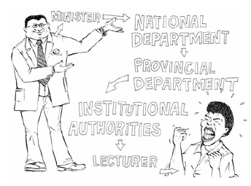

**Figure 8: Policies are formulated by decision-makers and implemented at different levels of the TVET system**

**(Moll et al., 2005)**

Activity 8: Use a subject plan template

**Suggested time: 30 minutes**

The TVET Curriculum Instruction, Internal Continuous Assessment (ICASS) guidelines for the NC(V) and Report 191 Qualifications specify requirements for formal internal (classroom-based) assessments such as tests, examinations, practical tasks, assignments and projects. They also mention additional supporting tasks such as tests, quizzes, observations, discussions, practical demonstrations and informal classroom interactions as ways to assess students’ progress on a daily basis (DHET, 2019). The ICASS Guidelines provide numerous templates and other tools to help lecturers plan and implement their assessment strategies which can be very useful.

1. Examine the following example of a macro subject assessment plan provided in the ICASS Guidelines.

**Example of a subject assessment plan from the ICASS Guideline for NC(V) (DHET, 2020)**

|  |  |  |  |  |  |  |  |  |  |  |
| --- | --- | --- | --- | --- | --- | --- | --- | --- | --- | --- |
| **Subject Name** |  | | **NC(V) Level** | |  | | **Year** | |  | |
| ***No*** | ***Assessment Task*** | ***Assessment tool*** | ***Topics & Subject Outcomes*** | ***Time and mark allocation*** | ***Examiner*** | ***Moderator*** | ***Question paper submitted for pre-assessment moderation*** | ***Assessment date*** | ***Memo discussion*** | ***Moderation of marked tasks***  ***(post-assessment moderation)*** |
| 1 | Test | Marking memo | Topic 1: SOs 1-4  Topic 3: SOs 1-2 | 1 hr  50 marks | Ms G Training | Mr E Edu | 03 February | 22 February | XXX | 01-04 March |
| 2 | Assignment | Rubric or memo or checklist | Topic 2: SOs 1-2 & 4  Topic 3: SOs 2-4 | 2 hrs per day for 3 days  75 marks | Ms P Test | Mr E Edu | 24 February | 8-10 March | XXX | 15-19 March |
| 3 | Internal examination | Marking memo | Topic1: SOs 1-4  Topic 2: SOs 1-4  Topic 3: SOs 1-4  Topic 4: SOs 1-3 | 1 hr  100 marks | Ms G Training & Ms P Test | Mr E Edu | 27 May | 20 June | 2-4 June | 7-11 June |
| 4 | Assignment | Rubric or memo or checklist | Topic 1: SOs 1-4  Topic 2: SOs 1-4  Topic 3: SOs 1-4  Topic 4: SOs 1-3 | 1 hr per day for 4 days and 2 hrs on day 5  100 marks | Ms G Training | Mr E Edu | 18 June | 26-30 May | XXX | 2-6 August |
| 5 | Test | Marking memo | Topic 2: SOs 3-4  Topic 4 SO 5 | 2 hrs or more  50 marks or more | Ms P Test | Mr E Edu | 10 August | 16 August | XXX | 26-31 August |

1. Using the example as a guide, create a planning template for one of your TVET subjects and fill in the first row.

**Template for a subject assessment plan (Adapted from DHET, 2020)**

|  |  |  |  |  |  |  |  |  |  |  |
| --- | --- | --- | --- | --- | --- | --- | --- | --- | --- | --- |
| **Subject Name** |  | | | | | **NC(V) Level** |  | | **Year** |  |
| ***No*** | ***Assessment Task*** | ***Assessment tool*** | ***Topics & Subject Outcomes*** | ***Time and mark allocation*** | ***Examiner*** | ***Moderator*** | ***Question paper submitted to the moderator - pre-assessment moderation*** | ***Assessment date*** | ***Memo discussion*** | ***Moderation of marked tasks***  ***(post-assessment moderation)*** |
| 1 |  |  |  |  |  |  |  |  |  |  |
| 2 |  |  |  |  |  |  |  |  |  |  |
| 3 |  |  |  |  |  |  |  |  |  |  |
| 4 |  |  |  |  |  |  |  |  |  |  |
| 5 |  |  |  |  |  |  |  |  |  |  |

Discussion of the activity

While TVET assessment policy does not require you to use a template to plan assessment, this may be a useful tool for you to use and develop.

The assessment guidelines provide broad principles and procedures that need to be followed when assessing TVET students and then spells out what is to be assessed from the actual curriculum of the subject in a section called ‘Assessment of Subject Outcomes’.

Each TVET subject consists of a number of topics and a topic has content which includes knowledge, skills and attitudes. Each topic includes a number of subject outcomes. Table 2 provides an example from the Welding (Level 4) Assessment Guidelines:

**Table 2: Assessment Guidelines Topic 1: Principles and techniques of welding (pipe) (DHET, 2015)**

|  |  |
| --- | --- |
| **SUBJECT OUTCOME** | |
| **1.1 Identity and describe welded joint in pipes** | |
| **Range: Butt welds in pipes; in line and at an angle; the importance of gas backing.** | |
| **ASSESSMENT STANDARDS** | **LEARNING OUTCOMES** |
| * The type of pipe weld connections are identified and discussed | * Identify and discuss types of pipe weld connections |
| * Joint preparations are identified | * Identify joint preparations |
| * Methods of joint preparations are described | * Describe the methods of joint preparation of pipes |
| * The adaptation of joint preparation methods of pipes is explained | * Explain the adaptation of joint preparation methods of pipes |
| * Tube to plate welds and branch connections are identified and drawn | * Identify and draw tube to plate welds and branch connections |
| * The methods of performing tube to plate welding is described | * Describe the method of performing tube to plate welding |
| * Branch connections (set-on set-in and set through). |  |
| **ASSESSMENT TASKS OR ACTIVITIES** | |
| * **Theory test or questionnaire** * **Project assignment** * **Research portfolio** * **Or combination of the above** | |

A **subject outcome** is comprised of assessment standards and learning outcomes. An **assessment standard** describes the level at which the student should demonstrate their achievement of a learning outcome (SKAV) and the ways they should demonstrate their achievement. The assessment standards serve three purposes:

* to help teachers to know when students have achieved a learning outcome;
* to show the minimum levels which students should achieve at a particular TVET level; and
* to show students’ level of achievement and progress.

A **learning outcome** is a clear statement of what a student is expected to be able to do, know about and/or value and how well they must do this to meet the assessment standard. It states both the content of learning and how its attainment is to be demonstrated.

As you can see from the example, the ICASS guidelinesprovide more general guidelines for assessment methods and instruments to be used. There is room for the lecturer to decide on a variety of assessment methods and design a variety of tools.

It is important that as a lecturer you ensure that these assessments are designed to fairly reflect a student’s competence and that the results are recorded and calculated accurately. It is important that you provide a variety of opportunities for your students to demonstrate their competence, as students might not all perform as well on the same kind of assessment task even if they are equally competent.

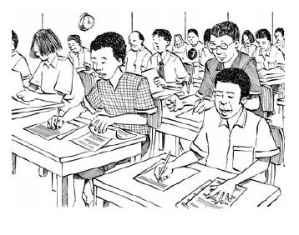

**Figure 9: Assessment of Learning**

**(Moll et al., 2005)**

## Planning assessment of learning

Let’s apply the assessment planning model to Assessment of Learning.



The purpose of Assessment of Learning is to determine a student’s level of competence so that it can be reported to stakeholders (the student, the college or other educational institutions, potential employers). The purpose of this may be for making decisions about whether the student can progress to the next level of study or whether the student is competent for the workplace.



Assessment of learning measures the knowledge, skills attitudes and values students have attained at the end of a learning cycle in comparison to the standards for competence.

Methods must be chosen for Assessment of Learning which enable students to demonstrate the level and complexity of their competence. Methods must thus include not only tests and examinations but also a rich variety of products and demonstrations of learning – such as portfolios, exhibitions, performances, presentations, simulations and multimedia projects. Methods must allow students to demonstrate their knowledge, skills and attitudes in ways that relate to real life and current knowledge in their field. Because of the use of Assessment of Learning for reporting, certification and awarding qualifications, Assessment of Learning usually involves formal and standardised assessment methods with specific requirements you need to follow.



Assessment of learning needs to be very carefully designed to ensure that it yields information that is accurate and of a high quality as it will be used for certification of students’ competence which can close or open doors to future opportunities for the student. This official recognition of a student’s competence must be rigorously linked to defined standards of achievements set by the TVET curriculum and assessment policies to make sure that a qualification or certification from one TVET college doesn’t mean something completely different than it does from another TVET college. The assessment process should thus be *valid* and *reliable*. Valid means that the assessment really does correspond to the learning outcomes of the curriculum. Reliable means that the assessment is done accurately, fairly and the results are consistent with the results you have gotten through other forms of assessment. We will look at these two concepts in more depth in Unit 7.

It is important to keep detailed records of the various components of the assessment as these provide evidence of the quality of the assessment. Your records should include a description of what each component measures, how accurate it is, the criteria and reference points that are used, and supporting evidence related to the outcomes. Keeping detailed and descriptive records also enables you to provide meaningful reports to students, parents and others. Providing just a letter grade or percentage to represent a student’s achievement is inadequate.



Reporting the results of assessment of learning needs to be appropriate for the audiences for whom it is intended. It should provide enough detail and description for the results to be easily understood. Reporting only a student’s average score provides little information about that student’s skill development or knowledge. Students and other stakeholders need more detailed information about their level of competence in order to make informed decisions affecting the students’ future.

Meeting with the student (and, in the case of young students, their parents) is one way to provide feedback to a student which allows you to discuss the many different aspects of the student’s progress and success. This reinforces students’ responsibility for their learning and promotes self-regulation.

Activity 9: Design an assessment activity for a learning outcome

**Suggested time: 45 minutes**

Choose and access an Assessment Guideline for one of the TVET subjects that you teach from the TVET DHET website at <http://www.dhet.gov.za/SitePages/DocCurriculumDocuments.aspx>. Choose one learning outcome and design a relevant assessment activity for that learning outcome. Copy the following table, in which an example from Early Childhood Development is provided, into your learning journal.

|  |  |  |  |  |
| --- | --- | --- | --- | --- |
| **Topic** | **Subject outcome** | **Assessment Standard** | **Learning Outcome** | **Assessment task** |
| Growth and develop-ment | Identify and explain growth and develop-ment | The difference  between growth and develop-ment is explained | Explain the difference between growth and development | Work in pairs.  This is a written research assignment.  Research the following ages and their corresponding stages of development   * Neonate * Infant * Toddler * Pre-schooler   Write a description of each stage of development and find photographs or pictures from magazines, the internet, etc., to illustrate each description.  Ensure that you reference all the sources you consulted correctly.  Your lecturer will use the rubric below to assess your work.   |  |  |  |  |  |  | | --- | --- | --- | --- | --- | --- | | **Criteria for assessment** | **Levels** | | | | | | **1** | **2** | **3** | **4** | **5** | | * Neonates are described accurately and in detail. |  |  |  |  |  | | * Infants are described accurately and in detail. |  |  |  |  |  | | * Toddlers are described accurately and in detail. |  |  |  |  |  | | * Pre-schoolers are described accurately and detail. |  |  |  |  |  | | * Each stage of development is illustrated |  |  |  |  |  | | * The illustrations add meaning to the assignment. |  |  |  |  |  | | * The assignment includes a bibliography of all sources consulted. |  |  |  |  |  | | * The assignment is grammatically correct and well presented. |  |  |  |  |  | | **Key:**  1 = Not achieved (0-39%)  2 = Not yet competent (40-49%)  3 = Competent (50-69%)  4 = Highly Competent (70-79%)  5 = Outstanding (80-100%) |  |  |  |  |  | |

**(Rubric adapted from e!Vula Training, 2008)**

Discussion of the task

The topic and subject outcome describe the important knowledge, skill, attitude or value to be acquired and the assessment standard and the learning outcome describe what achievement of that will look like when demonstrated. When lecturers or assessors prepare an assessment task or question, they must ensure that the task or question addresses an aspect of a subject outcome. The relevant assessment standard must be used to create the rubric to assess the task or question. The descriptions must clearly indicate the minimum level of attainment for each category on the rating scale.

## The role of accountability in Assessment of Learning

Being accountable means that you are responsible for your actions or for achieving certain results. You may be asked to report results and explain what you did to achieve these results. In the context of an educational system, accountability is part of the administrative process of making sure institutions and educators do what they are supposed to do: train and educate students to a defined level of competence. Some assessments are used for the purpose of accountability: their results are reported to different stakeholders in TVET education to show that lecturers, programmes or colleges are fulfilling their responsibility adequately.

The accountability system at a TVET college involves a network of stakeholders with different stakes (interests or investment) in the success of the college – in other words, its successful training and education of students. In the diagram in Figure 10, the large circle represents the college.

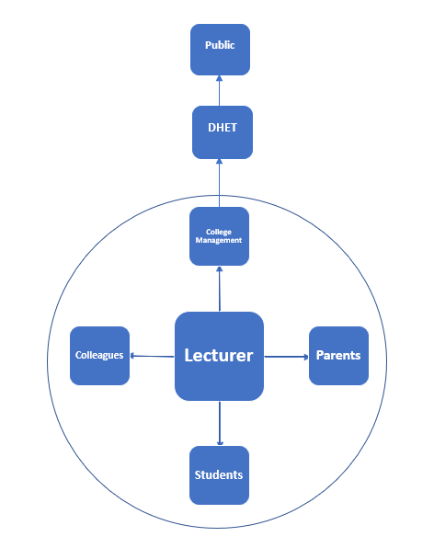

**Figure 10: Stakeholders within the TVET accountability system (Adapted from Dyer, 1973)**

Firstly, lecturers should be accountable to their s**tudents** on a daily basis. They are responsible for teaching the content students will need for the workplace in a way that enables them to learn it effectively. They are responsible for making teaching and learning interesting and challenging and helping students to progress in their learning. Lecturers are accountable to students on a daily basis.

Secondly, in the case of students who are still under age, lecturers are accountable to **parents** for the educational development of their children. They need to provide parents with information about students' progress regularly.

Thirdly, lecturers are accountable to their **colleagues** at the college, at other educational institutions and in the workplace, in terms of providing accurate and appropriate information on students’ progress which those professionals might need. To promote understanding among different professionals involved in a student’s learning journey or entry into the workplace, lecturers should be willing to participate in activities and discussions which develop shared professional understanding and improve the quality of teaching and learning.

On the next level, lecturers are accountable to the **college management**. This can be a stressful aspect of accountability for lecturers because it focusses on lecturers' compliance with regulatory requirements and their students’ marks and pass rate. Lecturers are required to submit a progress report for each student to the relevant stakeholders – students, parents, guardians or employer – each term. The college may take disciplinary measures against lecturers if they do not achieve the required pass rates.

Stop and think

If lecturers are under pressure to ensure their students have a high pass rate, do you think this has a positive impact on teaching and learning? Could it negatively impact learning? What has been your own experience?

The college – including its lecturers – is accountable to the national **Department of Higher Education and Training (DHET)**. The college principal and governing body have a legal responsibility to ensure the finances of the college are used effectively to benefit students' education.

Ultimately, DHET – including its TVET colleges and lecturers – is accountable to taxpayers. The general public is kept informed about the quality of education provided by their taxes through assessment of and reporting on colleges’ performance.

While accountability at all of these levels is important, accountability systems – including the assessments they require – should never take the focus off of the real learning that takes places in the classroom, laboratory and workshop.

Activity 10: Assessment for accountability

**Suggested time: 20 minutes**

1. Read this short case study and then answer the questions that follow:

### Case study

Thandeka was a new college lecturer doing her first block practice in the Information Technology department at a TVET college. At the end of the first semester the Head of Department met with Thandeka. He noted that in the classroom her lessons were organised well, she had clear expectations of students’ learning and used effective teaching methods. He noted that she had worked with the class to produce an interactive computer application and was becoming actively involved in developing a computer club at the college. Her Portfolio of Assessment, however, needed improvement. The learning objectives were appropriate but there was insufficient detail about the content, presentation and organisation of the lessons. Her comments about individual students dealt with the content covered rather than assessing the quality of their response.

Thandeka realised that she had considered the Portfolio of Assessment a waste of time. It was time-consuming and was written for others rather than serving as a useful working document for her own teaching. As a result, she had kept a separate notebook of working notes, ideas and organisational points for her own learning. She decided to bring the two documents together. She increased the level of detail in her lesson plans and this in turn meant she did not need to provide descriptive detail in the assessment records. Instead, she focused on analysing the learning which had taken place against the objectives she had identified and reflecting on how she could use this to inform her future planning.

1. Do you think that by requiring her to keep a Portfolio of Assessment the college placed a burden on Thandeka that could have negatively impacted her teaching? How could this be handled differently?
2. Why might the head of department have insisted upon changes in the Portfolio of Assessment although Thandeka's practice appeared satisfactory? Why do you say this?
3. What advice on Portfolio of Assessment and record-keeping would you give Thandeka?
4. Think about the accountability systems in your programme and college.
5. Who are you accountable to and what are the requirements you have to fulfil?
6. What is your role in holding others accountable?
7. Does Assessment of Learning for accountability purposes have a positive or negative impact on your teaching and learning? Explain why you say so.

Discussion of the activity

Accountability plays an important role in education but meeting the requirements put in place by accountability systems can also be stressful and time consuming for lecturers. A Portfolio of Assessment is used primarily for compliance and accountability purposes and requires considerable time and effort to prepare. If it could be used to directly support the actual practices of teaching and learning in the classroom this would be of benefit to lecturers.

The results of Assessment of Learning and the resulting pass rate are the primary sources of information used for accountability by the college. As a result, the focus of teaching and learning can shift away from ensuring students learn at a deep level and develop integrated competence and instead become focussed on meeting college compliance requirements and achieving acceptable pass rates. Instead of assessing students’ learning, lecturers can end up teaching for assessment. Lecturers need to find a balance between their priority of teaching and learning in the classroom and meeting the requirements of accountability systems that does not result in ‘teaching to the test’.

## Comparing the purposes of assessment

We have spent two units exploring the purposes of assessment: Assessment for Learning (which included an exploration of Assessment as Learning) and Assessment of Learning. The following table summarises and compares these main purposes of assessment using the stages of the assessment planning model. Read through the table to help you consolidate what you have learnt in this unit. Focus on the differences and similarities between the purposes of assessment.

**Table 3: Comparison of the purposes of assessment (Adapted from Earl, 2006)**

|  |  |  |  |
| --- | --- | --- | --- |
|  | Assessment for Learning | Assessment as Learning | Assessment of Learning |
| **Why Assess?** | To enable teachers to determine next steps in advancing student learning | To guide and provide opportunities for student to monitor and critically reflect on their learning and identify next steps | To document and report student’s competence in relation to curriculum learning outcomes |
| **Assess What?** | Each student’s progress and learning needs in relation to the learning outcomes | Each student’s thinking about their learning, the strategies they use to support or challenge their learning and the mechanisms they use to adjust and advance their learning | The extent to which students can apply key knowledge, skills, values and attitudes identified in learning outcomes |
| **What Methods?** | A range of methods that make students’ skills and understanding visible | A range of methods that enable students to become aware of their thinking processes | A range of methods that assess both product and process |
| **Ensuring Quality** | * Accurate observations and interpretations of student learning * Clear, detailed learning expectations * Accurate, detailed notes for descriptive feedback to each student | * Guide student to reflect on, monitor and adjust their thinking and learning processes appropriately * Support student to challenge their thinking * Students record their own learning | * Accurate, consistent and fair judgements based on high-quality information * Clear, detailed learning expectations * Fair and accurate summative reporting |
| **Using the Information** | * Provide each student with accurate descriptive feedback to use in their further learning * Provide different learning experiences based on knowledge of students’ differences | * Determine where student needs more guidance or practice to develop awareness of their thinking and strategies for managing their learning * Provide feedback to students on their progress. | Document and report on student’s competence for progression to next level of study or awarding of qualification. |

Activity 11: Consolidate your knowledge of the purposes of assessment

**Suggested time: 30 minutes**

1. Look at the following graphic. The TVET lecturers in this graphic were asked the question: “Why do you assess?” and the graphic depicts their answers.

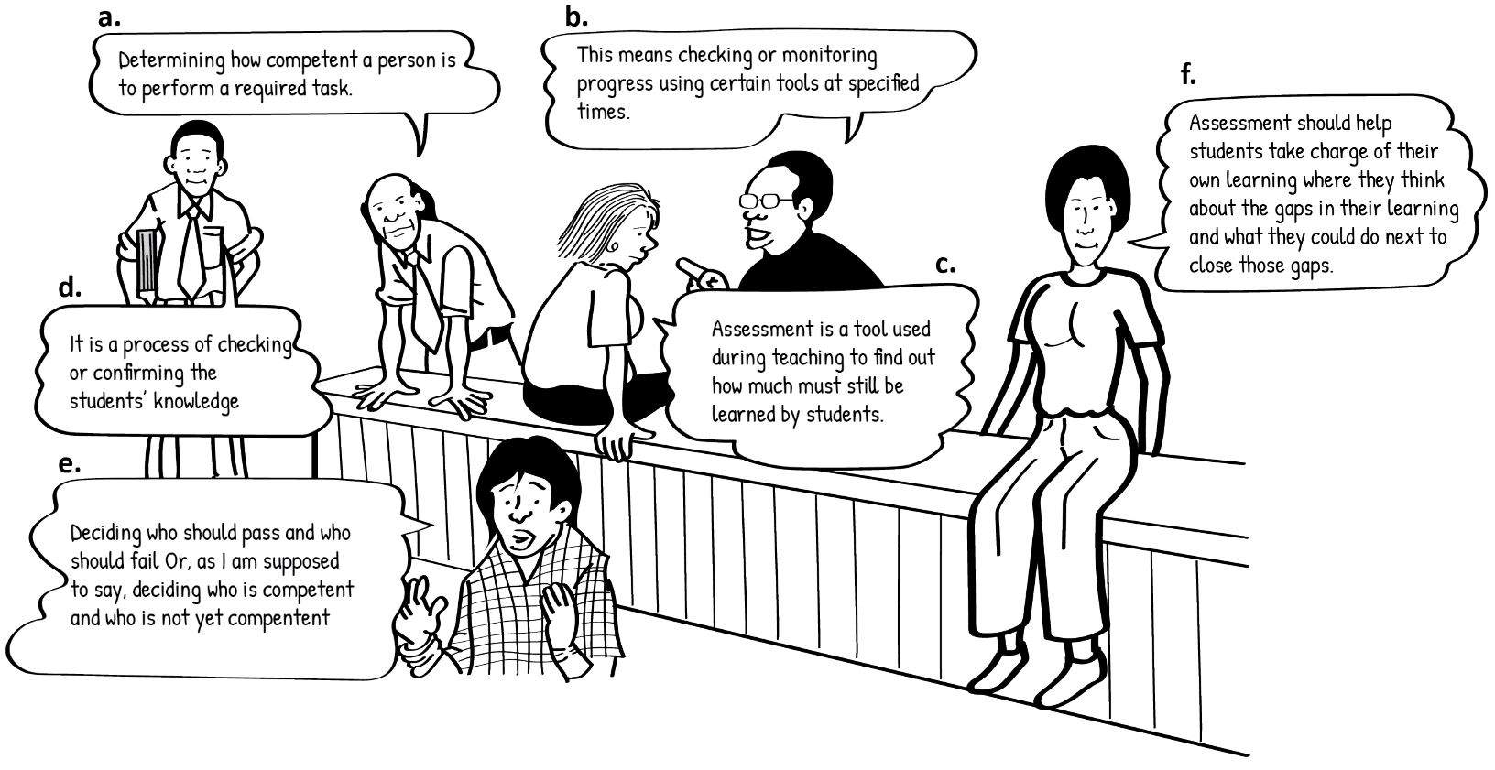**Different purposes for assessment (Moll et al., 2005)**

In the table below answer the question: What are the purposes of assessment that are put forward in each of these statements? There may be one or more purpose in each statement. Use the acronyms AoL, AfL, AaL.

|  |  |
| --- | --- |
| **Statement** | **Purpose** |
| a |  |
| b |  |
| c |  |
| d |  |
| e |  |
| f |  |

Discussion of the activity

There is a strong statement of the Assessment **of** Learning purpose in point (e). This lecturer focuses on judging the final outcome of a learning process for the year and making a decision as to how a student should proceed. Although we might say that she is a bit confused about the difference between judging someone a failure and as “not yet competent”, her focus is still on judging a final outcome.

In contrast, point (c) is about Assessment **for** Learning. Here, the lecturer is concerned with identifying what she needs to concentrate on in her teaching to help fill the student’s knowledge gaps.

Statement (f) is a strong statement about Assessment **as** Learning because the purpose of assessment here is seen as a way to help a student take charge of their learning.

The other three statements (a, b and d) all show an understanding of the balance in that is needed in TVET assessment practice (Moll et al., 2005).

1. Use the following chart to help you think about the purposes for which you use assessment. Which statement best fits your current use of assessment **for** learning, **as** learning and **of** learning? Do you have a clearer understanding of this since you took the online survey at the beginning of the module? Do you think any of your attitudes or values about assessment have changed?

**Assessing your use of assessment for different purposes**

|  |  |  |  |  |  |  |  |  |
| --- | --- | --- | --- | --- | --- | --- | --- | --- |
| **Emergent** | | |  |  | |  | | **Proficient** |
| I have little practical experience with developing assessments for different purposes and I don’t know if I’m doing it or not but I don’t plan it intentionally. | I am using assessment for different purposes and feel awkward about doing it right and have to plan carefully to keep a balance. | I have internalised the key dimensions of assessment for different purposes and they are becoming automatic, especially when I think about what I want to do in advance. | | | I routinely plan and analyse my teaching and assessment practices to clarify the assessment purpose and ensure my practices fit the purpose. | | I intentionally integrate the different purposes throughout my lessons and units and making ongoing adaptations automatically. | |
|  |  |  | | |  | |  | |
| Place a tick in the cell above which best represents your current position | | | | | | | | |

1. Reflect on what you have learnt in this unit. You may want to page through it again or discuss your learning with a peer. Now complete the third column of the KWL chart you started in your learning journal at the beginning of this unit, summarising what you’ve learnt. You are doing AaL!

Discussion of the task

Reflecting on your current knowledge, skill, attitudes and values with regard to using assessment for different purposes is an Assessment as Learning task which helps you to identify where you are in your learning journey and how you still need to develop further.

# Unit 4: Deciding the focus of assessment

## Introduction

In Units 2 and 3 we considered the purposes of assessment. Once we are clear about why we are conducting an assessment we need to decide what, exactly, to assess. This unit addresses the second question in the assessment planning model: *What am I assessing?*

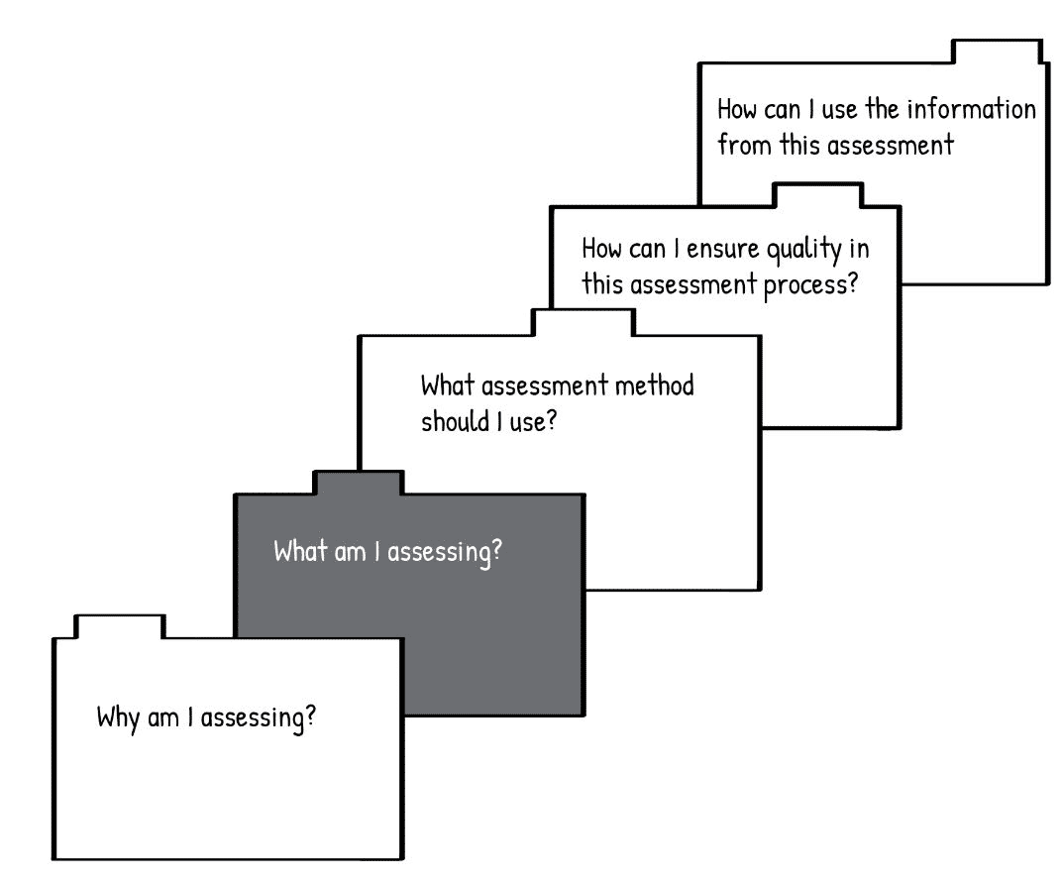

**Figure 11: Unit 4 focuses on the question of what to assess (Adapted from Earl, 2006)**

In TVET you need to assess whether students have developed the full range of knowledge, skills, attitudes and values (SKAV) that were identified in the learning outcomes that guided your teaching and learning. Also, the ‘working competence’ that graduates need when they enter the workplace is more than a collection of separate competencies: students need to combine these usefully and this needs to be assessed as well. In addition, as students progress through their TVET programme they need to work with increasingly complex SKAV and so assessment needs to target not only the SKAV but also the levels identified in the learning outcome.

## Unit 4 outcomes

By the end of this unit, you should be able to:

1. determine if and how you are assessing the SKAV identified in your learning outcomes and addressed in your teaching and learning.
2. apply the concepts of ‘know that’, ‘know how’ and ‘know it’ to identify integrated abilities that you need to assess.
3. use Bloom’s revised taxonomy and the SOLO taxonomy to analyse the levels of complexity of the knowledge and skills which you need to assess.

Create a KWL chart for Unit 4 in your learning journal as you did in the previous units. Fill in the first two columns now.

## Skills, knowledge, attitudes and values

In Unit 1 we discussed how a person who has the competence to do a job has a combination of different kinds of skills, abilities, attitudes and values that combine together. It can be difficult to pull these apart and identify them individually when you see a competent person working. It’s a bit like trying to identify all the ingredients while eating a delicious cake: it might be obvious that it contains cocoa and nuts and flour, but it might not be so easy to tell what the other ingredients are and the amounts that are combined to create the delicious flavour and texture.

As a lecturer, it is your job to make sure that your students have all the ‘ingredients’ – SKAV – that will enable them to do their jobs well after they complete their TVET programme. Many of these will be spelled out in the curriculum but, as we have discussed, you may need to include other aspects that are important in industry or to strengthen your students’ foundation. In assessment, you need to keep checking the skills, knowledge, attitudes and values in different ways (Assessment for Learning) so that you can see where they need more explanation, demonstration or practice. You also need to have these clearly in mind when you do more formal tests and assessments, so that you remember to measure all of those that you have selected and taught.

Let’s briefly review the knowledge, skills, attitudes and values which you identified during the TVET Pedagogy module. It will be useful to look through the TVET Pedagogy module and your learning journal from that module to review your earlier learning.

Firstly, there are the **specific knowledge and skills** that are important for the specific technical competence you are helping your students develop. The knowledge will include theoretical knowledge which underlies the technical field as well as knowledge of the industry. Skills will include doing things that are involved in their field. The knowledge and skills may be quite different from those in another TVET programme. For example, someone who is studying to become an electrical engineer will need quite different skills than someone studying to be an Early Childhood Development educator or an assistant chef.

Then there are **general knowledge and skills** which are needed in virtually every field. These are sometimes called ‘soft skills’, ‘transversal skills’ or ‘21st century skills’, because they are particularly important in our rapidly changing world. These include skill sets such as:

* **Functional literacies.** Graduates need to have adequate literacy (reading and writing) and numeracy (maths) skills for the working world. Many students did not get a strong enough foundation in language and maths in their basic education. Learning in a second language can present a further barrier to developing the literacies they need for the workplace.
* **Technological skills.** Graduates need to know how to use basic technologies found in the workplace – such as how to use email, Microsoft Office, or operate a printer and projector.
* **General workplace skills.** Graduates need to have basic skills such as recording keeping or reporting.
* **Communication skills.** Graduates need to be able to understand clients’ needs, address problems appropriately and express information accurately.
* **Thinking skills.** Graduates need to be able to think in a range of different ways: for example, to be able to analyse, design or investigate.

Stop and think

Are your students’ skills in these areas adequate? Do you teach these, directly or indirectly, in your programme? If so, do you assess them? How?

When it comes to **values** and **attitudes**, there may be some that different for different TVET fields, while others may be the same but be applied differently. For example, an electrical engineer, an ECD teacher and an assistant chef all need to have a strong value of ensuring people’s safety, although this value will be applied in very different ways: the electrical engineer will apply it by making sure electrical wires are always properly insulated, the ECD teacher by making sure there are no sharp objects in the classroom and the assistant chef by making sure none of the food that is served is spoiled, risking food poisoning. There are groups of values that are shared across fields. These include:

* **Craftsmanship.** Graduates need to take pride in their work and industry and be committed to a high standard of excellence.
* **Professionalism.** This includes attitudes and values such as confidentiality, keeping appropriate boundaries with clients and using funds in an appropriate way.
* **Self-regulation.** Graduates need to take responsibility for their work, their actions and their progress and find solutions to their problems.
* **Resourcefulness.** Graduates need to be willing to adapt to new situations, be persistent and not give up in difficult situations and believe that they have the ability to learn whatever they need to in order to succeed.
* **Collaboration.** Graduates need to be willing to work with others to achieve success and believe that there are things of value to learn from others.
* **Social responsibility.** Graduates need to care about the wellbeing of the community around them, see themselves as having a role in helping others and ensure that they don’t do harm to others or the environment.

Stop and think

Do your students have these values and attitudes? Do you teach these, directly or indirectly, in your programme? If so, do you assess them? How?

Activity 12: Examine your assessment of key SKAV

**Suggested time: 45 minutes**

1. Draw the following table in your learning journal, taking up a full page.

|  |  |  |  |
| --- | --- | --- | --- |
|  | **SKAV that I teach** | **Do I assess these?** | **How?** |
| **SKILLS** |  |  |  |
| **KNOWLEDGE** |  |  |  |
| **ATTITUDES** |  |  |  |
| **VALUES** |  |  |  |

1. Choose one course, module or unit that you teach. List the skills, knowledge, attitudes and values that you teach in the first column.
2. In the middle column, note whether you assess these or not (Y / N).
3. In the third column, note how you assess those that you noted Y for.
4. Now look at the SKAV which you indicated you teach but you do not assess in the middle column (N). Consider why you don’t assess these SKAV. Had you never thought about them individually before? Now that you have noted them, how might you assess them? Add your ideas to the third column. Use another colour pen if you can to distinguish them.
5. Now consider the general skills, knowledge, attitudes and values we have discussed in this section. Are there any SKAV that you have become aware of that are important for your students’ competence but which you don’t teach? Add these at the bottom of each category. Use another colour pen if you can to distinguish them from those you already teach. In the third column, indicate how you might assess them.

Discussion of the activity

In this activity you’ve assessed whether you are teaching the SKAV you need to teach and whether you are assessing them. You've done this for just one unit or course, but it’s important to assess yourself regularly for every course that you teach. You can include this as part of your reflective practice.

## Assessing different aspects of TVET knowledge: the HIT model

We have considered the skills, knowledge, attitudes and values that are important for a student to develop the competence they will need to succeed in their careers. However, competence is more than a long list of individual parts. If you bought a car and were given all the parts neatly arranged on a table, you would have all of the physical components that you had paid for but you would still not have any transportation! If you invited guests over for a birthday party and put all of the ingredients for a delicious chocolate cake out on the table and told them to help themselves, they would not be telling their friends the next day what a wonderful cake you made – even though every part that makes up a delicious chocolate cake was there. In addition, if you buy a car or make a cake and one or two components are missing or are of poor quality, it doesn’t matter that some parts are of high quality: the end product is a failure.

Similarly, if you send a graduate into the workplace who has excellent technical skills but arrives late, is rude to customers and records sales inaccurately they will be considered incompetent. Similarly, if you send a graduate into the workplace who is always on time, and behaves professionally but actually doesn’t have the technical knowledge or skill to do the job, they will also be considered incompetent. So it is not enough to assess your students and say they got 80% for this skill, 60% for that knowledge, 30% for that attitude and give them a final ‘pass’. This approach would not produce a cake or a car that anyone would want, and it probably will not produce a graduate that any workplace will want, either!

So knowledge, skills, attitudes and values need to be taught in a way that they become well-developed, balanced and integrated and we need to assess not only that students have developed the individual SKAV but that they are integrated as a working competence.

Winch (2017) identifies three ways of looking at integrated abilities which can be helpful. He calls these ‘knowing **that**’, ‘knowing **how**’ and ‘knowing **it**’. You have explored these ideas in previous modules, but let’s review them again here as we consider how they could be useful for assessment.

**Knowing that** is having a theoretical understanding of something: for example, knowing about the systems that need to be assembled to make a car and understanding how they work; or knowing the recipe for a delicious cake.

**Knowing how** is being able to do something: actually assembling the systems of a car so that they work smoothly and safely; actually knowing how to make a cake. A person who **knows that** doesn’t necessarily **know how**. For example, they might know that the egg helps to keep the cake from breaking apart and the baking powder makes it rise, but they haven’t ever made a cake successfully.

And a person who **knows how** doesn’t always have a deep **knowledge of that**. For example, they might make delicious, perfect cakes every day but be completely unaware of the role that the egg or the baking powder play.

Stop and think

What forms do ‘knowing how’, ‘knowing it’ and ‘knowing that’ take in your specific TVET area?

### Activity 13: Knowing ‘how’, knowing ‘that’ and knowing ‘it

**Suggested time: 1 hour**

1. You have seen the HIT model in the short [video](https://youtu.be/9GD-DgNLaxw) in the Programme Introduction section at the beginning of this module. Watch that video again if you need to. As you watch it think about how each type of knowledge appears in your TVET programme and how it could be assessed.
2. You can read the article [The HIT model of TVET knowledge](https://www.oerafrica.org/resource/hit-model-tvet-knowledge) (Moll, Hugo, 2020) to deepen your understanding of the HIT model. As you read it think about how each type of knowledge could be assessed in your TVET area.
3. Discuss the following questions with your peers in this module:
4. How you can recognise that a competent person has ‘know how’, ‘know that’ and ‘know it’ in your TVET field?
5. What does it look like when a competent person is using all these areas well together in your TVET?
6. What does it look like if a person is weak in one of these areas? Consider each one.
7. How could you design assessments so that your students could demonstrate ‘know how’, ‘know that’, ‘know it’ as well as an integrated HIT competence?
8. Look over the table you created in Activity 12. How do the different skills, knowledge, attitudes or values you have listed contribute to the development of your students’ ability to ‘know how’, ‘know it’ and ‘know that’? Mark them with an ‘H’, ‘I’ or ‘T’ as you review them.

Are there any SKAV that should be added to what you are already teaching your students to ensure they are balanced and strong in their ‘know that’, ‘know how’ and know it’? If so, add these to your table in Activity 12.

1. Now choose another TVET subject that you teach. Copy the table below into your learning journal. In the first row of the table give an example of each type of knowledge from that subject. Write down any relevant topic or learning outcome from that subject that is representative of that type of knowledge. In the second row write down how you think that example of knowledge should be assessed.

**HIT table**

|  |  |  |  |  |
| --- | --- | --- | --- | --- |
|  | **Know that** | **Know how** | **Know it** | **Integrated HIT** |
| **Example** |  |  |  |  |
| **Assessment** |  |  |  |  |

Discussion of the activity

An example HIT applied to the subject Welding is provided here.

**HIT table with example**

|  |  |  |  |  |
| --- | --- | --- | --- | --- |
|  | **Know-that** | **Know-how** | **Know-it** | **HIT** |
| **Example** | **Open circuits, arc voltage and welding current** | **Prepare the welding environment** | **Types of welding current and polarity** | **Welding protective eyewear, gloves, protective footwear, protective clothing.** |
| **Assessment** | **Open circuits, arc voltage and welding current is explained in a test question and marked summatively by the lecturer** | **The welding environment is prepared by the student and observed by the lecturer and marked with a checklist** | **Types of welding current and polarity are identified by being pointed out by the student and is observed by the lecturer who marks using a checklist.** | **Personal Protective clothing is identified, and its use and purpose is explained by the student in a presentation and observed by the lecturer using a scoring rubric.** |

## Assessing different levels of performance and understanding

We have looked at how competence can be analysed to identify individual skills, knowledge, attitudes and values which can then be taught and assessed individually. We have also looked at how having individual SKAV doesn't automatically mean you have competence and how these abilities need to be observed and assessed when they are combined and working together in more complex ways. We've looked at the HIT model as a way of thinking about combined abilities. However, another aspect we need to think about is how abilities develop and progress over time. A student in the earlier stages of a programme isn't expected to have the same level or complexity of knowledge and skill as a student at the end of the programme and the assessment criteria are thus different. In addition, a competent person in a TVET field needs to use knowledge and skills at different levels depending on what they are doing. They are not always working at the most complex, difficult level of their knowledge and skill, but need to be able to shift easily across different types or levels as they do routine work, solve problems or innovate. In this section, we look at two tools which assist with assessing this: Bloom’s taxonomy and the Solo taxonomy.

### Bloom’s taxonomy

Bloom’s taxonomy is a conceptual tool for designing and analysing learning tasks and assessment activities. It has two dimensions: firstly, it looks at what kind of **cognitive processes (thinking)** the task requires the student to use; and secondly, what kind of **knowledge** the student is required to demonstrate in the task.

### Cognitive process dimension

This dimension deals with a range of different thinking skills or processes. They are arranged in a pyramid, as shown in Figure 12, from simplest (at the bottom) to most complex (at the top). The broad base at the bottom represents that a person develops basic abilities on which they build increasingly more complex abilities. The goal is not that we should work at higher and higher levels and leave the simpler levels behind. A competent person uses all the levels continuously in different situations.

The six levels are each identified with a verb – an action word – which gives a broad idea of how we use that kind of thinking process. However, there are really clusters of closely related processes at each level and so a cluster of action words is often linked to each level to help us think about how that cognitive skill might look in different situations. You can see clusters of actions for each level under the description of the level to the right of the pyramid. In some fields theorists or practitioners have developed lists of actions related specifically to their field to help them identify these thinking processes at work in their context.

See Figure 12, below.

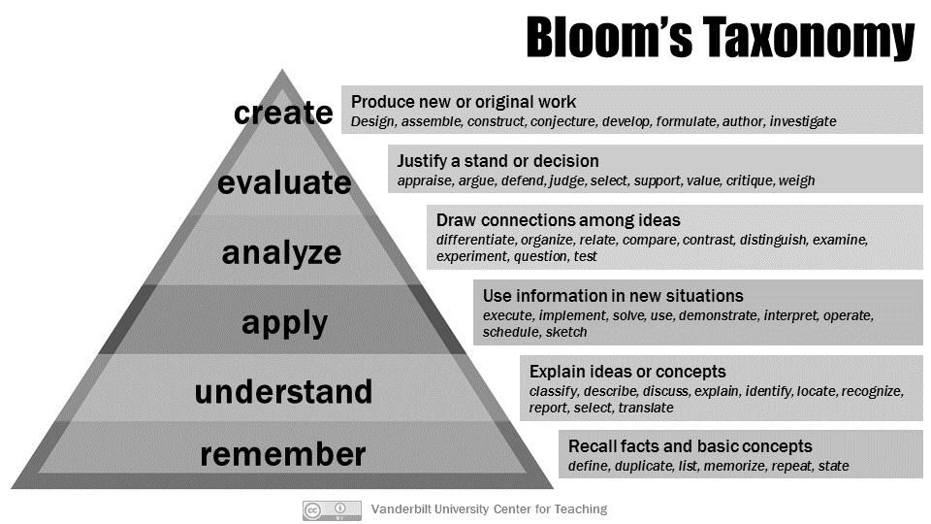

**Figure 12: Bloom’s taxonomy arranges thinking and doing skills from simplest, at the bottom, to most complex, at the top**

(*Note: this version of Bloom’s taxonomy is actually a revision of Bloom’s original model. The revision was done by Anderson and Krathwohl in 2001 to incorporate new ideas from research.)*

Let’s look at each level of the pyramid.

### Remember

To remember knowledge is the simplest cognitive process. It involves memorising, recalling what has been memorised or identifying what has been learnt from a list or text that is presented. Assessment questions that check a student’s ability to remember knowledge might ask the student to ***define, list, state, identify, find*** or ***name***,for example.

### Understand

Understanding involves a person making meaning for themself from the educational experience: e.g. watching a demonstration, looking at a diagram or listening to an explanation. Assessment questions that check a student’s ability to understand might start with words like: ***explain, compare, summarise, interpret, give an example*** or ***classify***.

### Apply

Applying is the thinking process that is involved with *using* knowledge or a procedure in a familiar or new situation. Assessment questions that check a student’s ability to apply might start with words like: ***use, implement, carry out, show*** or ***execute***.

### Analyse

Analysing involves breaking knowledge down into its parts and thinking about how the parts relate to its overall structure. Some ways you might construct a learning task to help students develop this, or an assessment task to measure if they have developed it, is to have them ***differentiate, compare, organize, integrate, take apart*** or ***structure***.

### Evaluate

Evaluating involves making judgements by comparing something against criteria or a standard. Assessment questions may ask the student to ***check, reflect, detect, critique, experiment, judge*** or ***monitor***.

### Create

Creating involves putting things together to make something new. Assessment questions that check a student’s ability to create might start with words like: ***design, construct, plan*** or ***produce.***

Activity 14: Identify Bloom’s cognitive processes in your TVET area

**Suggested time: 30 minutes**

1. Create a table like the following in your learning journal. Make it large enough to fill a page.

|  |  |
| --- | --- |
| **COGNITIVE PROCESS** | **EXAMPLES** |
| **REMEMBER**  *e.g. define, list, state, identify, find, name* |  |
| **UNDERSTAND**  *e.g. explain, compare, summarise, interpret, give an example, classify* |  |
| **APPLY**  *e.g. use, implement, carry out, show, execute* |  |
| **ANALYSE**  *e.g. differentiate, compare, organize, integrate, take apart, structure* |  |
| **EVALUATE**  *e.g. check, detect, critique, experiment, judge, monitor* |  |
| **CREATE**  e.g. *design, construct, plan, produce* |  |

1. Choose a final assessment you use in one of your courses. Work through it, analysing the questions to identify the cognitive process the student is required to use. Use the words under each main cognitive process to help you identify cognitive processes, but also think of other ways questions might be worded that relate to a particular cognitive process.
2. Now look at your table. Did you find lots of examples for some cognitive processes and few for others? Does this fit the level of the course that the assessment is for? For example, if the course is introductory, it might be appropriate that there is more use of the more basic cognitive processes than the higher ones; if this is a more advanced course then there should be regular use of higher-level cognitive processes as well.
3. Do you think your findings reflect weaknesses or strengths in your assessment practices? What can you do to strengthen your practices?
4. Share your learning with a peer in this module. As they share theirs, think about whether there are any insights they have had which could benefit you.

Discussion of the activity

As you think about what thinking processes you are assessing in your assessment questions, you are also assessing your own assessment practices. You can use what you notice about your strengths and weaknesses to adjust your teaching and assessment practices. This is Assessment as Learning in action.

### The Knowledge Dimension: ‘knowing what’

The Knowledge Dimension of the revised Bloom’s taxonomy relates to knowing ***that***. It has four categories: factual, conceptual, procedural and metacognitive.

* **Factual knowledge** refers to isolated bits of information, such as definitions of terms or specific facts.
* **Conceptual knowledge** consists of knowledge of principles, theories and models, how these can be generalised (used in situations other than the one in the learning experience), and how these relate to each other in terms of categories, structures or systems of information.
* **Procedural knowledge** includes rules of thumb, techniques and methods as well as knowledge about when to use these procedures.
* **Metacognitive knowledge** includes being aware of one’s thinking processes and knowing how to organise or direct these effectively.

The two dimensions of Bloom’s taxonomy – cognitive process and knowledge, can be combined into a matrix, as shown in Table 4, which you can use to plot which kind of knowledge (rows) and which cognitive process (columns) are being used together in a task. Let’s take an assessment task where the student is asked to “apply the reduce-reuse-recycle approach to conservation." You would select the ‘apply’ column of the cognitive process dimension and ‘procedural knowledge’ row of the knowledge dimension, as an approach is a method or technique. The X in Table 4 marks the cell where the ‘apply’ column and ‘procedural knowledge’ row intersect.

**Table 4: Matrix of knowledge and cognitive process dimensions (Bekker, Tanya, 2015)**

**Cognitive Process Dimension**

**Knowledge Dimension**

|  |  |  |  |  |  |  |
| --- | --- | --- | --- | --- | --- | --- |
|  | **REMEMBER**  **Recognising**  **Recalling** | **UNDERSTAND**  **Interpreting**  **Exemplifying**  **Classifying**  **Summarising**  **Inferring**  **Comparing**  **Explaining** | **APPLY**  **Executing**  **Implementing** | **ANALYSE**  **Differentiating**  **Organising**  **Attributing** | **EVALUATE**  **Checking**  **Critiquing** | **CREATE**  **Generating**  **Planning**  **Producing** |
| **Factual knowledge** |  |  |  |  |  |  |
| **Conceptual knowledge** |  |  |  |  |  |  |
| **Procedural knowledge** |  |  | **X** |  |  |  |
| **Meta-cognitive knowledge** |  |  |  |  |  |  |

Activity 15: Identify types of knowledge and relate to cognitive processes

**Suggested time: 90 minutes**

This activity continues with the analysis of a final assessment you began in the previous activity.

1. Draw the following table in your learning journal.

|  |  |
| --- | --- |
| **TYPE OF KNOWLEDGE** | **EXAMPLES** |
| **FACTUAL** |  |
| **CONCEPTUAL** |  |
| **PROCEDURAL** |  |
| **METACOGNITIVE** |  |

* 1. Study the final assessment you selected to identify examples of different types of knowledge. Note these in the table.
  2. As you did with cognitive processes, consider the balance or spread of examples you have found across the types of knowledge. Is this appropriate for the level of the course?
  3. Think of additional assessment tasks you could create to require students to use knowledge types that were not covered adequately in the assessment.

1. Now let’s relate the cognitive process dimension to the knowledge dimension, as shown in the example just before this activity. Do this with a peer, working together on one person’s task and then the other’s.
   1. Choose an assessment task from the assessment you have been using.
   2. Identify the **learning outcome** for this task.
   3. Identify the **cognitive process** and **knowledge type** which the **learning outcome** targets. In the table below, find the cell where these intersect under **Outcome** for **Topic 1**. Place an ‘X’ in the cell.
   4. Now identify the **cognitive process** and **knowledge type** which the **assessment task** requires the student to use. Mark the cell where they intersect under **Assessment** for **Topic 1.**
   5. Does the ‘X’ for the outcome fall in the same row and column as the assessment task? In other words, does the assessment task require the student to use the same cognitive process and knowledge type that the learning outcome identifies? If not, how could you revise the assessment task to ensure that it corresponds to the learning outcome?
   6. Now do the same for the other two assessment tasks and switch to your partner’s tasks.

**Taxonomy table which can be used for planning or analysing learning outcomes and assessment tasks.**

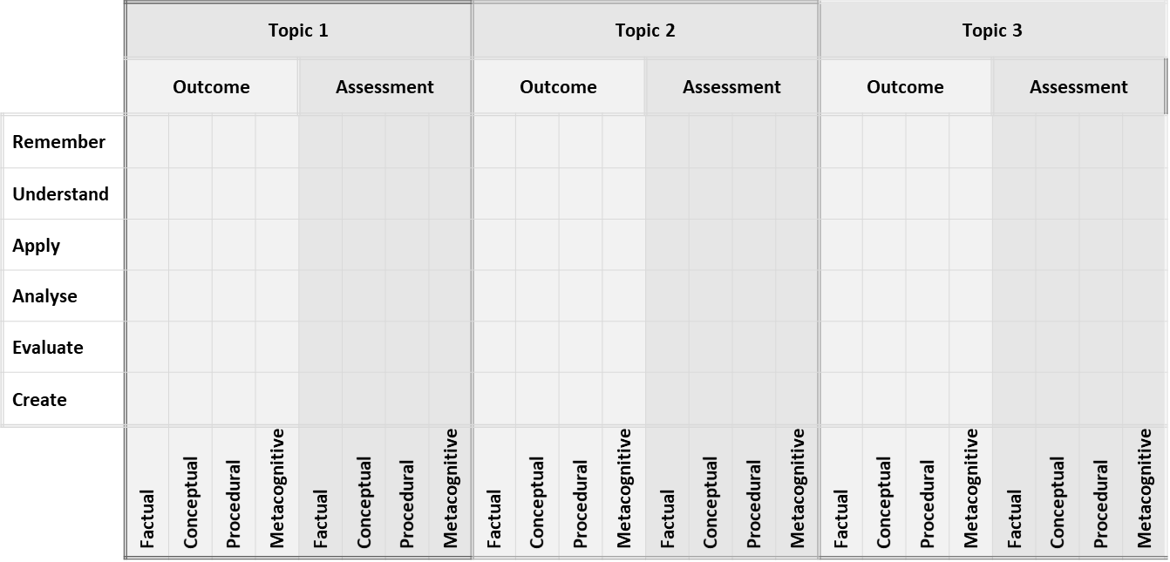

Discussion of the activity

This activity has given you practice identifying the cognitive process and type of knowledge targeted by a learning outcome and required by an assessment task. You have also practised comparing the requirements of the learning objective and assessment task to ensure that the assessment task actually assesses whether the student's competence meets the learning objective and does not require a higher or lower level of cognitive process or knowledge.

Now we look at another framework that can be useful for identifying the level of complexity of the competency you need to assess: the SOLO taxonomy.

## The SOLO taxonomy

The SOLO taxonomy was devised by Biggs and Collis (Biggs and Collis 1982; Biggs, 1995; 1999). SOLO is an acronym for Structure of the Observed Learning Outcome. The five levels of the SOLO taxonomy progress from the simplest level of learning to the most complex:

1. **Pre-structural**. At this level the student knows individual facts but can’t relate them to each other.
2. **Unistructural:** At this level the student can make obvious connections between pieces of information and develops a single idea about the topic.
3. **Multistructural:** At this level the student makes a number of different connections between new knowledge and concepts, but these are not yet becoming integrated into a comprehensive understanding of the topic.
4. **Relational:** The student is now able to understand how different knowledge within the topic works together in the topic as a larger whole.
5. **Extended abstract:** The student’s understanding moves beyond the topic. They make connections between this topic and other topics. They are able to use principles and ideas that they used in the context of the original topic in new contexts.

Figure 13 below shows the five levels and transitions between them graphically.

**Figure 13: Levels of the SOLO taxonomy (Redrawn from slides developed for Wits School of Education by Dr Tanya Bekker and adapted from Hook and Mills, 2011)**

Now let’s look at how you might assess a student’s competence at each stage.

At the prestructural level, the student doesn’t demonstrate a basic understanding:

**Figure 14: Prestructural level of the SOLO taxonomy (Redrawn from slides developed for Wits School of Education by Dr Tanya Bekker and adapted from Hook and Mills, 2011)**

At the unistructural level, the student shows basic understanding of single, isolated pieces of information. They will be able to answer questions asking them to define, identify, label, find, or match, for example:

**Figure 15: Unistructural level of the SOLO taxonomy (Redrawn from slides developed for Wits School of Education by Dr Tanya Bekker and adapted from Hook and Mills, 2011)**

At the multistructural level they know quite a lot of content and can make connections between it. They can answer questions where they are asked to describe, list, or outline, for example:

**Figure 16: Multistructural level of the SOLO taxonomy** **(Redrawn from slides developed for Wits School of Education by Dr Tanya Bekker and adapted from Hook and Mills, 2011)**

At the relational level, students can link their knowledge together to understand the topic on a broader level. They can answer questions where they are asked to analyse, organise and apply, for example:

**Figure 17: Relational level of the SOLO taxonomy (Redrawn from slides developed for Wits School of Education by Dr Tanya Bekker and adapted from Hook and Mills, 2011)**

At the extended abstract level, students are able to relate concepts from the topic to concepts from other topics. They can respond to questions where they are asked to generalise, plan, predict or prove something:

**Figure 18: Extended abstract level of the SOLO taxonomy (Redrawn from slides developed for Wits School of Education by Dr Tanya Bekker and adapted from Hook and Mills, 2011)**

Similar to the Revised Bloom’s Taxonomy there are action verbs associated with each level indicating levels of understanding, as shown in Figure 19.

**Figure 19: Actions (verbs) associated with the levels of the SOLO taxonomy (Accessed from** [**https://www.johnbiggs.com.au/academic/solo-taxonomy/**](https://www.johnbiggs.com.au/academic/solo-taxonomy/)**)**

Activity 16: Integrate your learning and reflect on your cognitive processes

**Suggested time: 45 minutes**

Now let’s pull together what you have learnt in this unit and reflect on the levels of complexity you have been required to use. Work with a partner or small group of peers.

1. Examine the following table. It presents the different frameworks we have explored in this unit, arranging knowledge and processes from simplest to most complex. By the time your students graduate from your TVET programme they need to be comfortably working at the most complex levels, indicated in bold at the bottom of each column, in order to have the ‘working competence’ required for success in their careers.

|  |  |  |  |  |
| --- | --- | --- | --- | --- |
| LESS COMPLEX  MORE COMPLEX | **SKAV to HIT** | **Bloom’s cognitive processes** | **Bloom’s knowledge types** | **SOLO taxonomy** |
| Individual  Know how, that, it  **Integrated HIT** | Remember  Understand  Apply  Analyse  Evaluate  **Create** | Factual  Conceptual  Procedural  **Metacognitive** | Prestructural  Unistructural  Multistructural  Relational  **Extended abstract** |

1. What similarities or overlaps can you see between the different levels of the different models. Are some levels identical, or only similar?
2. Which model/s do you think could be most useful to you in your assessment practices? Would you combine them in some way?
3. Now choose a practical final assessment which is used toward at the end of your TVET programme. Analyse it using each of the models above.
4. Now reflect on the task that you have just done. What levels of complexity did it require of you?

Do you think doing activities like this expand your own professional competence in terms of your HIT for assessment, your ability to create effective assessments, and your ability to

1. Complete the KWL chart that you started at the beginning of this unit.

Discussion of the activity

Using tools like the SOLO and Bloom’s taxonomies can help you assess your own teaching: are your teaching methods and the learning activities you provide enabling your students to develop higher levels of skill and understanding? If lecturing from the front of the class is your dominant teaching method this can result in students' learning being focused on lower levels of thinking and understanding. If assessments are geared at this level, they may pass. But when they enter the workplace and have to take responsibility for organising, designing and using what they have learnt in one situation in a new situation, they will need ‘working competence’ – competence at the most complex levels of each of these models. Again, you cannot correct this by including questions which require higher-level thinking processes in your assessment tasks if you haven't provided adequate learning opportunities for your students to develop their competence at these levels. So part of your assessment practices needs to be to assess whether you are teaching all of the skills, knowledge, values and attitudes that your students need in order to reach the level of competence you are aiming for and then ensure that your assessments are carefully aligned to what you have taught.

# Unit 5: Types of assessment

## Introduction

Now that we have considered **what** you need to assess when you plan an assessment, the next step is to consider how to design the assessment. This relates to the third question in the assessment planning model: *What assessment method should I use?* In this unit we will explore types of assessment and in the following unit we will explore different ways to design assessment tasks.

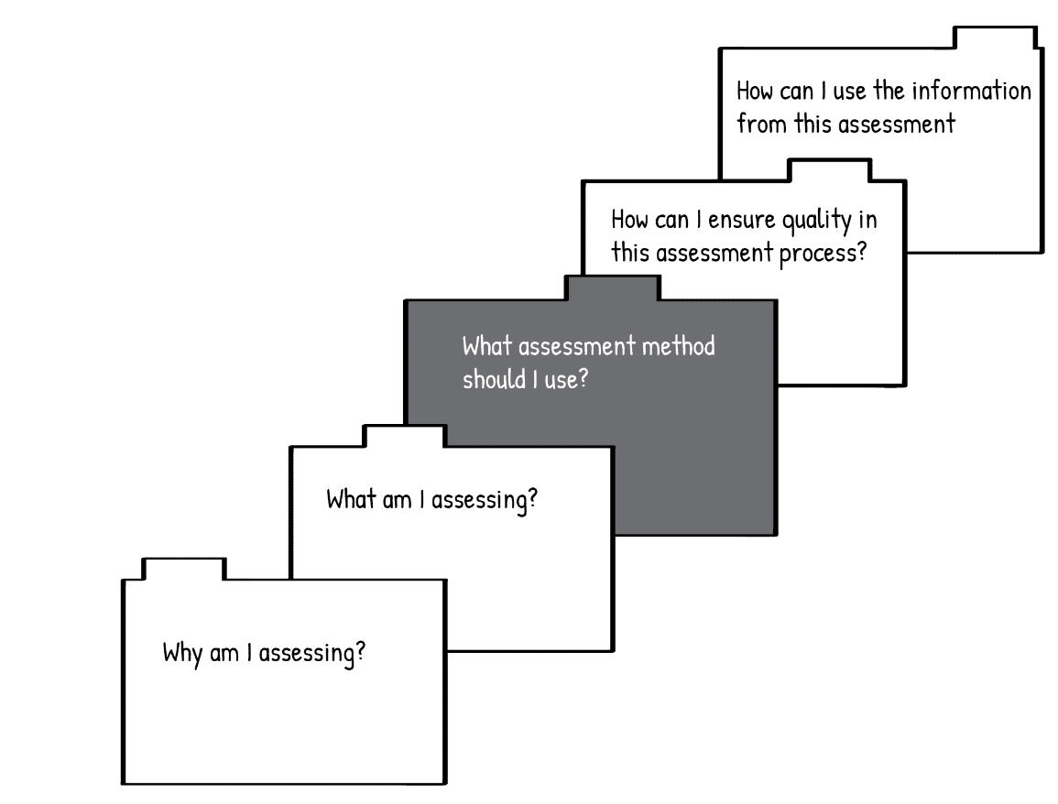

**Figure 20: Unit 5 focuses on the types of assessment methods that can be used (Adapted from Earl, 2006)**

In this unit, we will explore **summative and formative assessment**, **baseline and diagnostic assessment**, and **criterion-referenced and norm-referenced assessment.** You will have the opportunity design a rubric for a criterion-referenced task.

## Unit 5 outcomes

By the end of this unit, you should be able to:

1. compare the uses of formative and summative assessment.
2. discuss the value of baseline and diagnostic assessment.
3. explain the purposes of criterion-referenced and norm-referenced assessment.
4. design a criterion-referenced rubric.

## Summative and formative assessment

***Formative assessment*** occurs **before or** ***during*** teaching. It is a way of assessing students’ progress, providing feedback and making decisions about further instructional activities. It is assessment **for** learning purposes. ***Summative assessment*** is conducted ***after*** instruction primarily as way to document what students know, understand and can do. It is an assessment **of** learning and its aim is to ‘sum up’ the learning that has taken place.

There isn’t always a clear split between formative and summative assessment: some activities may fall somewhere in the middle. For example, a test at the end of a section of material may be used for marks (summative) but the lecturer may also analyse it to identify which competences need strengthening going forward (formative).

Formative assessment can be planned or interactive. In planned formative assessment, the lecturer plans ahead how they will gather information to find out how far the learning has progressed – perhaps by giving a brief class test or special task. Interactive formative assessment is not planned ahead in this way; it happens naturally during the learning activity as the lecturer helps students extends their learning in different ways. Again, there isn’t always a clear split between planned or interactive formative assessment: some activities may fall somewhere in the middle.

Activity 17: Identifying summative and formative assessment

**Suggested time: 20 minutes**

1. Read the following scenario about a cosmetology lecture and answer the questions that follow.

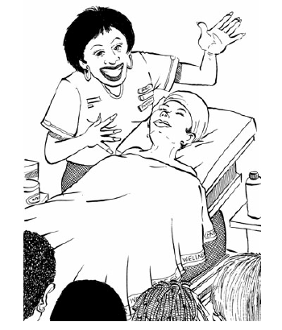Lindi is teaching a lesson on how to use make-up to make faces of different shapes appear more oval. Lindi plans to give a short lecture about the different face shapes and what the rule is about where to use dark or light make-up to modify the appearance of the face. During the lecture, Lindi guides the discussion to see if the students are understanding what she’s explaining to them. She starts the demonstration by choosing a student to serve as a model and asking the class to analyse what facial shape the model has based on what she has taught them during the lecture. She can see from what the students are saying that some of them are not yet able to apply the concepts she taught them about identifying the shape of the person’s face. She explains again and points out the features on the model’s face that they should be looking for. Eventually, all of the students are able to correctly identify the shape of the model’s face. Now Lindi can proceed with demonstrating how to apply the make-up. As she does, she explains what she is doing.

After the demonstration, she has the students work in pairs for an activity. They draw a picture of their partner’s face and identify the shape. As they do this, Lindi moves from group to group, discussing the drawings that the students are doing. She notices which students are able to identify facial shapes correctly. Then, using the theory that they have learnt, the students shade in the drawing to show how they would apply the make-up. Lindi collects the completed drawings and assesses them to see which students have achieved the learning outcomes.

In the next session, students will have an opportunity to apply make-up to two other students’ faces. Then they will have an exam. Lindi has noticed that using three different assessment modes –observation, illustrative planning sketches and the examination – provides all of her students with a fair opportunity to demonstrate whether they have achieved the learning outcome (Adapted from Moll et al., 2005).

1. Based on your current understanding of summative assessment make a list of all the summative assessments Lindi made or intends to make.
2. Based on your current understanding of formative assessment, make a list of all the formative assessments Lindi make.

Discussion of the task

The essential difference between formative and summative assessment is how the results are used. In formative assessment, results are used to adapt teaching going forward so as to ‘form’ the students’ learning effectively. In summative assessment, results are used to ‘sum up’ the learning that has taken place at the end of a course or cycle.

## Baseline and diagnostic assessment

Baseline assessment and diagnostic assessment are two kinds of formative assessment which are particularly useful. **Baseline assessment** is used at the beginning of new learning to identify the student’s prior knowledge, skills, attitudes and values (SKAV). This helps lecturers to plan their teaching so that it doesn’t repeat what students already know or leave gaps between what they already know and new knowledge. It also creates a record of what each student knew at the start of a new course or cycle which can be compared with an assessment at the end of the learning cycle to measure how much a student’s competence has developed during the learning cycle. **Diagnostic assessment** is used to identify specific learning barriers experienced by specific students. This helps lecturers design appropriate support and differentiate teaching and learning to address their students’ different needs. Let’s look more closely at each of these.

### Baseline assessment

Read the following scenario which demonstrates the need for baseline assessment.

Lebogang is about to teach her class about electrical circuitry. Before she begins, she asks the students whether they can light a bulb using just a battery and some wire. Dineo and Sipho both say “yes” – which is the correct answer. Lebogang proceeds with the lesson and asks them to draw circuit diagrams. Dineo’s diagram is incorrect. Lebogang can see that Dineo does not actually have a basic knowledge of the key concepts. Sipho, on the other hand, draws a perfect circuit diagram. While this would earn him full marks in an examination, when Lebogang questions him about his diagram, he explains that not only the battery and wire but also the socket is needed to light the bulb. Lebogang had assumed that her students would already know that the sockets were only there to hold the bulbs and were not necessary for the circuit to work (Adapted from Brooks, 2002).

Stop and think

How could Sipho’s misunderstanding have been avoided?

Most of us can remember experiences as learners or students when the teacher pitched the lesson badly – either going over our heads because the starting point was too advanced or quickly losing our interest because there was too much overlap with what we already knew. As a lecturer, you can include baseline assessment in your lesson planning to avoid this. You will need to be open to making changes to your original plan based on what you find out about your students from the baseline assessment. Baseline assessment can be conducted using structured activities such as quizzes and question/answer sessions or less structured approaches such as brainstorming or having students write a journal entry on a topic.

### Diagnostic assessment

Diagnostic assessment is primarily used to diagnose students’ difficulties and to guide lesson and curriculum planning. The following two scenarios illustrate the role of diagnostic assessment.

### Scenario A

Ms. Sebatane, an N2 lecturer, notices that Thabo is struggling with computer programming in the subject Information Technology, yet she is unable to identify clearly which skills are giving Thabo the greatest difficulty. Ms. Sebatane is skilled at using a variety of programming diagnostic tests and administers a test to identify the specific skills that are giving Thabo trouble. She now can provide Thabo with the specific help that he needs.

### Scenario B

You are teaching one of your colleague’s classes as they are in the hospital. You begin delivering a lesson only to be met with stares of confusion from the students. When you ask the students if they understand what you are teaching, they reply that they have no idea what you're talking about.

Now imagine teaching that same class after conducting a pre-test to determine what the students already know about the topic. How would that have changed both your experience as the lecturer and the experience of the students?

### Benefits of diagnostic assessment

As you may have realised, diagnostic assessment benefits both the lecturer and the students. Firstly, when a lecturer knows exactly what students know or don't know about a subject matter they can focus lessons on the areas students still need to learn about rather than what they already know. Diagnostic assessment thus helps lecturers to plan meaningful and effective lessons.

Secondly, it enables lecturers to differentiate teaching and learning for different students. It may show a lecturer that a small group of students needs additional teaching on a particular portion of a unit or course of study. The lecturer can then plan extra time and practice for that group. On the other hand, it may show that another group of students has already mastered a large portion of a unit of study. The lecturer can then develop activities that allow that group to go beyond the standard curriculum for that topic through independent or small group study. If you are working with a student on technical skills, it is helpful to use a diagnostic assessment to work out the student's current technical level, what skills the student has already become skilled at, how the student compares to other students and what the student's attitude towards technical learning is. Knowing this information will guide not only what you teach the student but also how you teach them.

Activity 18: Using baseline and diagnostic assessment

**Suggested time: 20 minutes**

1. In your journal create a table like this one:

|  |  |  |
| --- | --- | --- |
| **Situation** | **Baseline or diagnostic assessment chosen** | **Purpose/benefit of assessment** |
| 1. |  |  |
| 2. |  |  |

1. In the table, list 6 situations you have experienced in teaching or learning where a baseline or diagnostic assessment could have benefitted teaching and learning.
2. In the second column, indicate whether you would have used a baseline or diagnostic assessment.
3. In the third column, write how you think the assessment would help.

Discussion of the activity

The main difference between baseline and diagnostic assessment is that baseline assessment is used before learning to find out what students already know while diagnostic assessment is most often used when a problem has been identified and you want to find out more about it so that you can address it. However, as with summative and formative assessment, the two can overlap. For example, you could do a baseline assessment and identify that several students lack prior knowledge in a certain area that they are expected to for the course; this serves a diagnostic purpose even before the problem arises in the classroom. You can then plan to give those students more foundational activities to begin with to ensure they will be able to grasp the new content in the course. Both forms of assessment could be designed as formal, well-structured assessments or as informal, less structured assessments.

## Norm-referenced assessment and criterion-referenced assessment

You may have heard of two other types of assessment: norm-referenced assessment (NRA) and criterion-referenced assessment (CRA). The difference between these is not so much how the assessment is done, but what the assessment looks at and how the results are used. **Norm**-referenced assessment (NRA) compares students against other students’ performance while **criterion**-referenced assessment (CRA) compares students’ performance against the criterion of the assessment standard. Let’s explore each of these.

### Norm-referenced assessment (NRA)

Norm-referenced assessment provides us with information that tells us where a student stands compared to other students. This is done by comparing the student’s performance to the average of performances by other, similar students. Such information is useful only for certain types of decisions. NRA interpretation describes the performance in terms of the relative position held by a student in some known group: e.g. the student typed **faster than 90%** of the class members.

Stop and think

In your experience as a TVET lecturer can you think of situations or decisions in which the rank order of the performance of students is necessary or useful – to the student, the college, or to your teaching practice?

Rank ordering of students based on results is often used by TVET colleges to decide which applicants they will accept in courses or subjects which have a limited capacity. In some circumstances, rank ordering is also used for making decisions about the progression of students to higher levels of study.

Rank ordering and comparisons of students are also done in the standardisation (sometimes called the normalisation process) process of the examination results. Here the students are ranked and their results are compared against a historical norm for the subject involved. If there is a deviation from the norm, marks are adjusted to bring them close to the norm. The marks are adjusted in such a way that the rank order of the students is not compromised.

As you can see, norm-referenced assessment is useful for certain purposes, but it is not useful across teaching and learning processes. Let’s compare this with criteria-referenced assessment.

### Criterion-referenced assessment (CRA)

Criteria-referenced assessment provides information about a student’s level of competence with reference to particular knowledge or skills. This kind of assessment is done by comparing a student’s performance to the criterion of the assessment standard. The results of the assessment describe the specific performance that was demonstrated by the student: e.g. typed 40 words per minute without error. Such information helps a lecturer decided whether a student needs more practice of a skill. It says nothing about the student’s place or rank compared to other students and so it, too, is useful only for certain types of decisions.

Stop and think

In which situations or decisions are knowing the level of knowledge or skill of your students necessary or useful?

Activity 19: Distinguish CRA from NRA assessments

**Suggested time: 10 minutes**

1. Now that you have an understanding of the difference between norm-referenced and criterion-referenced assessment, see if you can identify which kind of assessment is indicated in the following examples. Write either ‘CRA’ or ‘NRA’ next to each item.
2. Thandi’s information technology score placed her near the bottom of the class.
3. Sipho defined 90% of the welding terms correctly.
4. Lindiwe can identify all the parts of the engine.
5. Thabo surpassed 85% of the level 3 students on the multimedia test.

Discussion of the activity

The correct answers are:

1. NRA. Thandi is being ranked in her class.
2. CRA. Sipho is being evaluated against a criterion (defining welding terms correctly)
3. CRA. Lindiwe is being evaluated against a criterion (identify the parts of an engine)
4. NRA. Thabo is being compared to the performance of other students.

Norm-referenced tests identify how much students differ from each other, while criterion-referenced tests identify each students’ competence. Each kind of assessment can be useful to you in your teaching, depending on which kind of information you are looking for.

It may be difficult to tell by looking at an assessment if it is intended to be used for norm-referencing or criterion-referencing purposes. Because norm-referenced assessments aim to rank students, they may be designed with questions that range from easy to difficult and may not include any questions that all students are likely to answer correctly. This results in a wide spread of results, making it possible to rank students at different levels. In contrast, criterion-referenced assessments aim to find out if students have mastered specific knowledge and skills and thus focus on testing students’ achievement of outcomes without concern for whether only a few, or most, of the students taking the assessment will be able to answer a question.

As with formative and summative assessment, assessments can also be designed, or used, for both purposes. For example, norm-referenced tests can be made more descriptive, allowing results to be analysed against a criterion as well. Or a criterion-reference test can be analysed to compare the results against a norm.

### Using a rubric for criterion-referenced assessment

A rubric is a useful tool for criterion-referenced assessment at the classroom level as it allows you to assess competence at different levels. Table 5 provides an example of a rubric from the ICASS guidelines.

**Table 5: Example of a rubric (DHET, 2019) Rubric for pre-service inspection of a vehicle**

| **Criteria** | **Assessment Criteria** | **Level 4:**  **Outstanding** | **Level 3:**  **Highly Competent** | **Level 2:**  **Competent** | **Level 1:**  **Not Yet Competent** | **Marks** |
| --- | --- | --- | --- | --- | --- | --- |
| 1 | Prepare the work area according to site procedures.  (max. 5 marks) | **Work site procedures:** (provide list of procedures) | | | |  |
| All of the work site procedures were followed correctly (5 marks) | Most of the work site procedures were followed correctly (4 marks) | Adequate work site procedures were followed correctly (3 marks) | Little or no work site procedures were followed (0-2 marks) |  |
| 2 | Perform a pre-service inspection (max. 10 marks) | **Aspects to check:** (provide list of aspects) | | | |  |
| Outstanding performance of pre-service inspection was demonstrated – included all aspects to be checked (8-10 marks) | High level performance of pre-service inspection was demonstrated –included most aspects to be checked (7 marks) | An adequate performance of pre-service inspection was demonstrated (5-6 marks) | Little or no pre-service inspection was performed (0-4 marks) |  |
| 3 | Inspect, remove and rotate the wheels according to procedures (max. 20 marks) | **Procedures:** (provide list of procedures) | | | |  |
| Demonstrates excellent understanding of the task and observed all procedures (13-15 marks) | Demonstrates high level of understanding the task and observed most procedures (11-12 marks) | Demonstrates an adequate level of understanding the task and observed some procedures (8-10 marks) | Demonstrates little or no understanding of the task. (0-7 marks) |
| 4 | Adjust headings correctly and safely (max. 20 marks) | **Procedures:** (provide list of procedures  **Tools:** (provide list of tools) | | | |  |
| Student adjusted the headlights using all of the appropriate tools and procedures safely and correctly (16-20 marks) | Student adjusted the headlights using most of the appropriate tools and procedures safely and correctly (14-15 marks) | Student adequately adjusted the headlights using some of the appropriate tools and procedures safely and correctly (10-13 marks) | Student adjusted the headlights using few of the appropriate tools safely and correctly (0-9 marks) |  |
| **Total** | | | | | | **50** |

Rubrics may be designed in different ways, but usually have these four features:

### Description of the competency

A competency is assessed by a student demonstrating it in some way. The student could demonstrate ‘know how’, ‘know that’ or ‘know it’, for example. An example of demonstrating ‘know how’ could be the welding of a joint between two pieces of metal. An example of demonstrating ‘know that’ could be explaining a theoretical concept verbally, in a PowerPoint presentation or in an essay. An example of demonstrating ‘know it’ could be identifying the main elements of an ECD classroom.

### Dimensions of the competency

Breaking up the competency into different dimensions for assessment reminds both students and lecturers to consider the different parts of a competency and not just focus on one aspect. For example, for an oral assessment it could be important that the student have well-prepared content, interesting visuals to accompany it, and also pronounce their words clearly, make eye contact with members of their audience and use their body language to show interest in their topic. All of these aspects could be included as dimensions on the rubric. They do not all need to have the same weighting, though: some dimensions can be allocated more possible points than others.

### Scale with levels of competency

The scale is divided into levels. Each level should be described clearly using language that is descriptive rather than judgemental. The example from the ICASS policy uses Outstanding / Highly competent / Competent / Not yet competent. You could use Excellent / Good / Adequate / Needs improvement or simply 4 / 3 / 2 / 1. Or you could carefully choose terms which you think are appropriate. The ICASS guideline (DHET, 2019) recommends using 4 levels because it forces the assessor to decide whether the student’s performance falls in the upper half or lower half of the 4 levels, rather than ‘sitting on the fence’ and choosing the middle category. Each level must be allocated a number of marks or a range of marks. The marks should be allocated so that if a student’s performance was found to be at the minimum level of competence for each dimension the total marks would represent a pass.

### Assessment criteria

Each criterion indicates the level at which the competency is demonstrated for each. Each criterion should be a brief, clear statement.

Stop and think

Look at the example of the rubric from the ICASS policy shown in Table 4 again. Can you identify the four features?

Now look at the 4th dimension from the rubric in Table 5. Notice how the description of the demonstration of a competency stays the same except for one word which identifies that level at which the competency was demonstrated: ‘all’ for Level 4; ‘most’ for Level 3; ‘some’ for Level 2; and ‘few’ for Level 1.

**Table 6: Criterion 4 from the rubric shown in Table 5**

|  |  |  |  |  |  |
| --- | --- | --- | --- | --- | --- |
| **Dimension** | **Assessment Criteria** | **Level 4:**  **Outstanding** | **Level 3:**  **Highly Competent** | **Level 2:**  **Competent** | **Level 1:**  **Not Yet Competent** |
| 4 | Adjust headings correctly and safely (max. 20 marks) | **Procedures:** (provide list of procedures  **Tools:** (provide list of tools) | | | |
| Student adjusted the headlights using **all** of the appropriate tools and procedures safely and correctly  (16-20 marks) | Student adjusted the headlights using **most** of the appropriate tools and procedures safely and correctly  (14-15 marks) | Student adequately adjusted the headlights using **some** of the appropriate tools and procedures safely and correctly  (10-13 marks) | Student adjusted the headlights using **few** of the appropriate tools safely and correctly (0-9 marks) |

Here is an example from welding that shows a different scale and criterion for a single dimension:

**Table 7: Rubric for welding**

|  |  |  |  |  |
| --- | --- | --- | --- | --- |
| **Dimension** | **Advanced**  **4 points** | **Proficient**  **3 points** | **Basic**  **2 points** | **Below basic**  **1 point** |
| **3**  **Appearance** 100% smooth with uniform, dense ripples; doesn't show the bead travelling too fast or slow. | Weld shows a constant speed and uniformity the entire length. | Weld shows a constant speed with some blemishes that are minimal. | Weld shows definite areas of speeding up and slowing down. Ripples tend to be coarse. | Weld has been done too fast or too slow. Weld is not complete. Trapped impurities in the weld. |

In this example, the levels of the scale are termed Advanced / Proficient / Basic / Below basic. The description of the criterion for each level is detailed but more of the description changes from one level to another. For a person familiar with welding the difference in levels of performance may be obvious; to a person who doesn’t know how to weld it is less obvious.

It's important to make sure that each criterion is written clearly so that it would be interpreted the same way by all students and lecturers. Make sure that the criteria do not overlap but each address a separate aspect. Also, make sure that each criterion describes something which actually can be observed (or heard) when the student demonstrates it.

The ICASS guidelines (DHET, 2019) also advise that:

it may be necessary to include the list of aspects being assessed in a criterion as part of the rubric so that the lecturer who is carrying out the assessment will know when a student has or has not covered all aspects required for a highly competent rating. For example, the list of items which needs to be checked in the criterion on the pre-service inspection of a motor vehicle [ ] could be provided as a separate list as part of the rubric to the lecturer to support the assessment process. The list of items can then be ticked off during the assessment process to assist the lecturer at arriving at a level of competence for a student per criterion. For example, if a student is able to include 8 out a possible 10 aspects in the pre-service inspection, he/she should be allocated 8 marks out of 10.

Activity 20: Create a rubric for your own teaching

**Suggested time: 1 hour**

Lecturers who design and use rubrics regularly are able to do so quite quickly as they can start with a rubric they have designed for a similar assignment and modify it. When you first start designing rubrics, the process might take a bit more time. This time is not wasted, however. Using a rubric can reduce time spent marking as well as improve the quality of the feedback you provide during marking. Giving feedback to students soon after they do an assessment creates another opportunity for them to learn, as they compare your feedback with their attempts to demonstrate their competency in the assessment. Using a rubric can also make you more aware of your teaching styles and methods, which enables you to choose more consciously about how to design teaching and learning and your assessment of what has been taught and learnt.

You can also involve your students in developing rubrics. This promotes self-regulation and helps to ensure that they are clear about what is expected of them during the assessment.

1. Choose one learning outcome from a topic in one the subjects that you teach. Choose an outcome that involves the student applying theoretical knowledge as well as performing a skill.
2. In your learning journals, or using Microsoft Word, design a rubric for an assignment or test.
3. Share your rubric with two peers who are taking this module. Explain your rationale for your design to them and ask for their feedback.
4. After looking at your peers’ rubrics and considering their feedback on yours, make any improvements you can think of to your rubric.

Discussion of the activity

You have now created a rubric which you can modify for different assessments over time. Once you use this rubric, you may find you want to make further adjustments. You may also find that it helps you to become more aware while planning and teaching lessons of the different dimensions of that competency which you need to help students develop.

Activity 21: Reflect on what you have learnt in Unit 5

**Suggested time: 20 minutes**

Now reflect on what you have learnt in this unit by completing the third column in the KWL table which you started at the beginning of this unit in your learning journal.

Discussion of the activity

You were probably already familiar with some of the types of assessment discussed in this unit, and with the use of rubrics, when you started this unit. By engaging with new theoretical explanations, examples and opportunities to apply what you learnt you may have developed a greater **appreciation** (value and attitude) of how these different types of assessment can aid teaching and learning; a more complete, detailed or useful **understanding** of these types of assessment (knowledge); as well as improved **skill** for using them confidently and competently in your teaching.

# Unit 6: Assessment tasks

## Introduction

In this unit, we continue to explore the third question in the model for the assessment process: *What assessment method should I use?* In Unit 5 we looked at types of assessments. In this unit, we will look at ways to design different kinds of assessment tasks and questions.

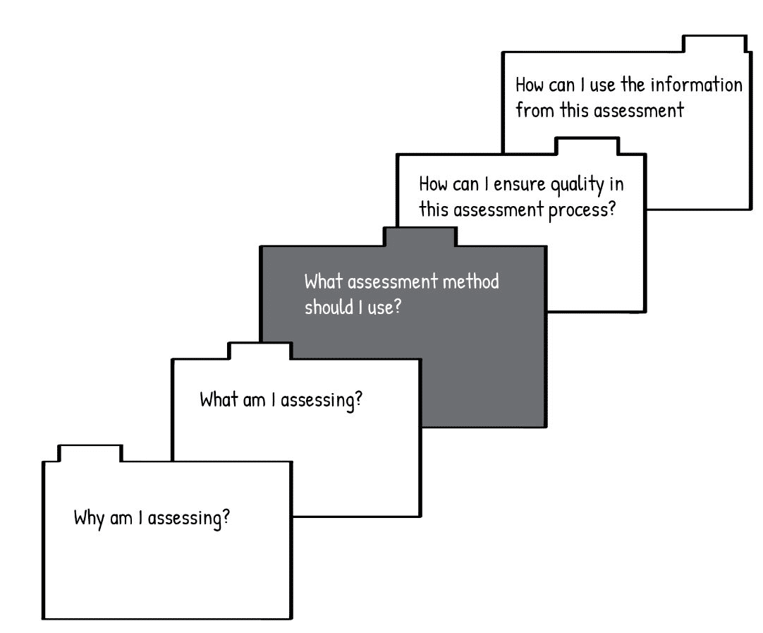

**Figure 21: Unit 6 looks at different assessment tasks that can be used (Adapted from Earl, 2006)**

Individual assessment items can be distinguished on the basis of whether the student is provided with several possible responses and asked to select the correct response (called ‘selected response’) or whether the response is constructed completely by the student (called ‘constructed response’). There is a great variety of different ways to design selected response and constructed response questions. Each has its particular advantages and disadvantages. Understanding these will help you to design effective and fair assessments. In general, constructed responses tell you more about what students know, understand and can do because they have to generate the response themselves rather than choosing from the given responses. One of the most common – and useful – types of constructed response assessment in TVET is performance assessment. In performance assessment, a student is asked to perform an activity to demonstrate their knowledge, skill, attitudes and values in an actual activity – not just answer correctly about knowledge and skill on a written exam – in order to be assessed as competent. In this unit, we will look at performance assessment as well as how you can use constructed response and selected response questions in assessment.

## Unit 6 outcomes

By the end of this unit, you should be able to:

1. identify and design effective performance assessment tasks.
2. understand and analyse constructed response questions.
3. understand and analyse selected response questions.

Remember to begin this unit by creating a KWL chart for performance assessment, selected response questions and constructed response questions in your learning journal. You might want to look through a couple of assessments to see if you already know how to identify different kinds of constructed and selected response questions. Complete the first two columns of your chart now.

## Performance assessment

Performance assessment involves a student actually performing an activity to demonstrate their knowledge, skill, attitudes and values to the assessors. If possible, the activity that the student is required to perform should be the actual criterion for competent performance on the job: for example, ‘weld two metal plates together’, ‘construct a wall frame’, ‘issue an airline ticket’ or ‘detect faults in a computer’. The activity can be assessed in an actual workplace or in an environment which simulates the workplace – a workshop, kitchen or hair studio, for example. Because performance assessment enables the student to demonstrate skills, knowledge, attitudes and values working together in an integrated way, it is possible to assess these different aspects as well as their successful use in combination as ‘know that’, ‘know how’, ‘know it’ and even the integration of these together as ‘HIT’ – successful working competence ­– using a single assessment task. Performing the task may take a few minutes or as long as several weeks. Because performance assessments usually involve assessing just one – or small number – of performance tasks the task needs to be designed very carefully to ensure it will give an accurate and fair representation of the student’s general competence. It also means that the assessors need to be highly competent as they are assessing several competencies, or dimensions, through observation at the same time.

### Characteristics of performance assessment tasks

Linn, Robert et al. (2008) identify six aspects of performance assessment in TVET which are valuable to consider:

* **The assessment activity reflects the criterion activity or realistic workplace activity**. The performance assessment can occur in the workplace or in a simulated situation.
* **Assessment is multi-dimensional, including not just ‘know that’ but also ‘know how’ and ‘know it’**. Most authentic workplace activities require combined knowledge, skills and attitudes rather than just abstract knowledge (know that) alone. Performance assessment can capture much more than a written test, which is only able to capture ‘know that’.
* **A product or a process – or both – can be assessed.** Performance assessments can involve the assessment of a product (e.g. a business plan, a soup or a stained microscope slide) or the observation of a process (e.g. a presentation, the use of a fire extinguisher, operating a forklift). In some settings, it will be more appropriate to assess the product rather than the process. For example, in the domains of painting and creative writing there may be many acceptable processes to achieve a product, so the product is important rather than the process. In other domains, such as auto mechanics, both process and product need to be assessed.
* **Assessment spans a continuum from simple to complex activities**. In performance assessment there is a continuum of complexity ranging from the performance of a small, simple skill sample (e.g. turning on an oven) through to a complex multi-dimensional activity (e.g. planning, preparing and serving a three-course meal). The term *restricted performance* refers to assessment of specific skills and *extended performance* refers to the integration of knowledge, skills and attitudes in the assessment of more complex learning outcomes.
* **Performance assessment is open-ended**. The assessments are not fixed-choice. A student may respond to a task in a number of ways, some of which may be unexpected by the assessor. This is more likely to occur as the complexity of the set task increases.
* **Scoring requires human judgement** **(‘know it’).** Performance assessments are usually rated by human scorers using predetermined criteria. In other words, assessors must have a high enough level of expertise to do the activity competently themselves in order to assess it. The assessors can score the performance holistically or globally, based on an overall impression, or analytically, using a list of criteria which are organised into a rubric or checklist.

### Addressing the limitations of performance assessment

Because performance assessments take more time, assessors can give students only one or two assessment tasks to perform, resulting in a smaller sampling of their competence. This results in the possibility that the sampled abilities do not well represent the students’ general abilities, which may have been higher or lower than those that were demonstrated. One way to address this problem is to include more assessment tasks of shorter length in the assessment, to broaden the sample. Another strategy is to choose a task which is very typical of the subject area being assessed. A third strategy is to choose a complex or advanced task. The assessor can infer from the student’s performance whether they could also perform a range of less complex activities. Because a poorly chosen task could potentially be a major source of measurement error this aspect needs to be carefully considered.

Assessors of multi-dimensional performance tasks need to be well trained in the necessary skills of observation and recording. Having more than one assessor improves reliability and generalisability. High levels of reliability across assessors can also be achieved by using well-defined rubrics.

Results may not be accurate if the performances of students across workplaces, colleges or regions are compared.

### Scoring tools for performance assessment

Performance assessments are commonly evaluated using checklists, rating scales or rubrics. As we discussed rubrics in Unit 6, we will look at checklists and rating scales here. When the DHET designs PATs and ISATs for the TVET colleges they are normally accompanied by relevant checklists and rating scales. Checklists and rating scales are also recommended in the TVET ICASS Guidelines.

**Checklists**

For some performance assessments you can create a list of the skills, knowledge, values and attitudes that you expect to see in either the student's performance or in the finished product. With a checklist, you simply list the component or combined skills, knowledge, attitudes or values and check them off as you observe each one. Once you have completed the checklist, you will have a list of SKAV that the student demonstrated during the assessment (those that are ticked) as well as a list of SKAV that the student did not demonstrate (those that were not ticked). This can be useful for diagnostic and feedback (Assessment for Learning) purposes, as well as enabling an accurate Assessment of Learning.

Checklists are most appropriate when the assessment involves observing demonstration and finished products that include a variety of steps or characteristics. Checklists require the assessor to choose between two options: ‘yes’ and ‘no’, for example. This does not allow the assessor to make any judgment about how well each skill was completed. Providing a column on the checklist to make comments about each item enables different degrees of completion to be acknowledged, errors in the student's performance to be identified and excellence to be noted. In some cases, it may be possible to total the number of ‘yes’ responses as a score or percentage, but in other cases this is not very meaningful. The checklist can rather be analysed to write a summary of the student’s performance and areas where more development is needed. The checklist and summary can then be discussed with the student to provide feedback.

**Rating scales**

A second way to score performance assessments is with a rating scale. These are very much like checklists but with one additional characteristic. As with checklists, you start out with a list of SKAV. However, after each item, you are expected to rate each student on how well the task was performed. The scales have three or more points on them.

Rating scales have two advantages over checklists. Firstly, they allow the lecturer to indicate levels of performance rather than having to choose between ‘performed’ (e.g. ‘yes’) and ‘not performed’ (e.g. ‘no’). If, for example, the student completed the skill but not as well as they should have done on an item, you can award them three out of the five possible points for that item.

The following is a combined checklist and rating scale for a Business Practice PAT on the topic of the design and presentation of a code of conduct (adapted from DHET, 2017). Note that sub-tasks 1 and 2 use a rating scale and sub-task 3 uses a scored checklist.

**Table 8: Example of a PAT checklist/rating scale (DHET, 2017)**

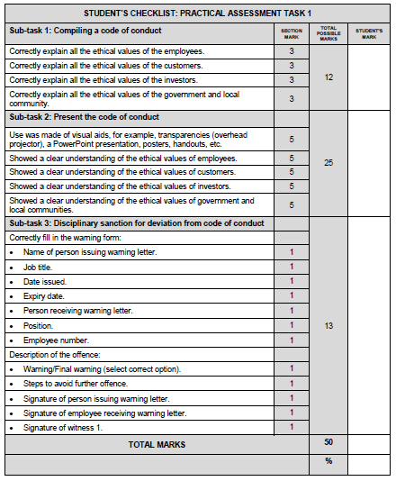

Activity 22: Design a performance assessment task (PAT)

**Suggested time: 2 hours**

In this activity, you will design a performance assessment task (PAT) for the learning outcome that has both skill and knowledge components. You can modify the practical assessment task you analysed in Activity 14 at the end of Unit 4 or develop a new assessment task if you wish. Complete the following tasks to design your PAT in your learning journal.

1. Identify the outcome and describe the task and the assessment standard.
2. Describe how you will address the limitations of the assessment (as discussed in the section ‘Addressing the limitations of performance tasks’.
3. Referring to the work you did in Activity 14 in Unit 4, identify each component involved in demonstrating the learning outcome to the required standard and how each will be demonstrated by the student. Consider:
4. **SKAV:** knowledge, skills, attitudes and values
5. **HIT:** If SKAV should be demonstrated as know that, know how, know it or HIT
6. **Cognitive processes** (Bloom): if the task requires students to remember, understand, apply, analyse, evaluate, create (or other actions falling within these broader categories)
7. **Knowledge dimension** (Bloom): if the knowledge components require factual, conceptual, procedural and/or metacognitive knowledge to be demonstrated
8. **Levels of complexity** (Solo): if the student is required to work with unistructural, multistructural, relational or extended abstract levels
9. Design either a checklist with a rating scale or a rubric to mark the assessment. Ensure that the assessment tool covers each of the components in Question 2 and that each is weighted appropriately.
10. Present your PAT to two or three of your peers in this module in a small group. Explain how you have addressed all of the aspects in Question 1. Ask them for feedback and consider how you could use this feedback to improve your PAT.
11. Evaluate your peers’ PATs as they present them and consider what feedback you can give them that might help them improve their PATS. Also consider whether you can gain any insights or ideas from their designs which you could use to improve yours.

Discussion of the activity

In this activity, you have worked with the concepts you have learnt in this model at a higher level of complexity. In terms of Bloom’s taxonomy, you are **applying** the knowledge, skills and values you are learning to **analyse** the components of a competence and **create** an assessment task and then **evaluate** your peers’ assessment tasks. You are working with **factual, conceptual, procedural** and **metacognitive** knowledge as you design, use feedback to think about how you have designed, and improve your design. As you work with different models, relating them to each other and to your TVET outcomes, you are working at the highest level of complexity on the Solo taxonomy: **extended abstract.** This is difficult work, and as you do it your own expertise is expanding and deepening. Step back and reflect on whether you can see your own ‘**know that’**, **‘know how’** and **‘know it’** for assessment developing as you engage with this model. As you do so, you are also sharpening your metacognitive and self-regulatory abilities!

## Constructed response questions

We have looked at performance assessment as a type of constructed response assessment which involves practical demonstration. Constructed responses can also be used in oral and written assessment.

The most common and effective way to assess knowledge is simply to ask a student a question. This can be done informally for Assessment for Learning at any time during teaching and learning. Depending on your question, you may be able to assess if students **‘know that’** on simpler levels (e.g. showing that they remember or understand **factual** or **conceptua**l knowledge (Bloom’s knowledge dimensions) or on more complex levels: applying what they’ve learnt or giving their analysis of something. Your question may require them to relate a concept to another concept (relational) or relate concepts from one topic to those in another (extended abstract). A simple question can be crafted as a constructed response assessment tool for formative, baseline or diagnostic assessment or Assessment for Learning. Constructed response questions are also used frequently in written summative Assessments of Learning: tests and exams.

### Completion questions

With completion questions, students are presented with an incomplete sentence with one or two blanks and write their responses in the blanks. The responses which a student can give are quite limited: for example, a word, phrase, number or symbol. Completion questions are effective in assessing students’ **unistructural, factual** and **conceptual** knowledge using the cognitive processes **remember** and **understand**.

Here is some guidance on designing completion questions:

* Paraphrase sentences from textbooks and other instructional materials. Do not take statements directly from textbooks.
* Word the sentence so that only a single answer is correct. Word the item so the answer is brief and specific.
* Blanks for answers should be equal in length, and towards the end of the sentence.
* If answered in numerical units, specify the unit required.
* Avoid clues to the correct answer.

### Activity 23: Analyse constructed response items

**Suggested time: 10 minutes**

For each of the following examples identify which principle from the guidance above has not been applied and say why:

1. Poor: Jan Van Riebeeck first landed in ‘South Africa’ ________.

Improved: Jan Van Riebeeck first landed in ‘South Africa’ in ________.

Better: Jan Van Riebeeck first landed in ‘South Africa’ in the year ________.

1. Poor: In 2020, ________ decided to impose a South African lockdown because of the coronavirus pandemic.

Improved: The name of the president who decided to impose a lockdown in South Africa in 2020 because of the coronavirus pandemic was _________________________.

1. Poor: The distance between the moon and the earth is ________.

Improved: The distance between the moon and the earth is ________ kilometres.

Discussion of the task

The principles that were not applied in these questions are as follows:

1. Word the sentence so that only a single answer is correct. In the first example, students could logically provide correct answers having nothing to do with the year. In the improved version an answer like ‘a boat’ would also be correct.
2. Place blanks towards the end of the sentence.
3. If answered in numerical units, specify the unit required.

### Short answer items

For short answer items, the student responds with a word, a few words, a sentence or two or a paragraph. This type of constructed response question is often more effective than completion questions for assessing knowledge and cognitive processes at different levels of Bloom’s taxonomy. Firstly, this type of question is similar to how teachers phrase questions during teaching and learning and thus may feel more familiar to students. Secondly, while completion questions require students to interpret the question from the sentence, this is not necessary with short answer questions.

In the following examples short answer items are used to assess deep understanding:

**Example 1**

**Compare two different points of view about whether it is best to have National Health Insurance for the health system.**

This question requires the student to **analyse** (Bloom) using **conceptual knowledge** (Bloom) at a **relational** level of complexity (SOLO).

**Example 2**

**What is the implication for the environment of using more coal-powered power stations to provide electricity?**

This question requires the student to **evaluate** (Bloom) using **conceptual knowledge** (Bloom) at an **extended abstract** level of complexity (SOLO).

Short-answer items can assess a range of knowledge and skills by designing questions which limit the student to using targeted knowledge and skills.

### Selected response questions

In contrast to constructed response questions, selected response questions require students to select a response from two or more possible responses that are provided. These can be scored quickly and accurately because they do not result in unique responses from every student, but as responses are provided for the student to choose from there is the risk that a student who doesn’t know the correct response will guess the correct response.

Although we have all taken selected response tests, this does not mean they are easy to design! There are a number of design options that can be used. We will look at binary choice, matching and multiple choice.

### Binary choice question design

The slide in Figure 22 explains **binary choice items** and provides guidance on how to design them effectively.

**Figure 22: Binary choice items**

Activity 24: Evaluate binary choice questions

**Suggested time: 10 minutes**

1. Using the criteria from Figure 22, indicate whether the design of the true/false item is good (G) or poor (P). Write the reason for your answer under the question. Do not answer the question itself. In the space under your reason write a better alternative.

|  |  |  |
| --- | --- | --- |
| * 1. Students with a high IQ always get high marks. | T F | G P |
| * 1. Mandela said: “Education is the most powerful weapon which you can use to change the world”. | T F | G P |
| * 1. If a plane crashed on the South African­-Mozambique border, half the survivors would be buried in South Africa and half in Mozambique | T F | G P |
| * 1. A cup with hot water that has a spoon in it will cool quicker than a similar cup with the same amount of hot water that does not have a spoon in it. | T F | G P |
| * 1. No elected South African politicians have not been elected to terms longer than five years. | T F | G P |

### Discussion of the task

This is what we thought about the design:

|  |
| --- |
| * 1. P: This item is poor because the adverb “always” is an absolute and this would force a F choice.   Better: Students with high IQ **often** get high marks. |
| * 1. G: It is factually correct that Mandela made that statement. |
| * 1. P: This proposition is simply illogical on two levels. Survivors do not get buried and the division into a half is completely arbitrary.   Better: If a plane crashed on the South African–Mozambique border, the deceased would be buried in their respective countries. |
| * 1. P: This sentence is too long.   Better: Hot water in a cup will cool more quickly if a spoon is placed in the cup. | |
| * 1. P: The double negative makes the sentence very confusing.   Better: South African politicians are elected to five year terms of office. | |

While binary choice questions are generally best suited to the simpler cognitive processes in Bloom's taxonomy, it is possible to design them to require students to use higher-level cognitive processes. The following examples require students to **apply** what they have learned about electricity and resistance to a scenario.

|  |  |  |
| --- | --- | --- |
| **Example 1**  Other things being equal, an electric stove with greater resistance will be hotter than a stove with less resistance. | **T** | **F** |
| **Example 2**  Thabo is building a new electric motor. His decision to use thicker wire results in less resistance. |  |  |

By making selected response items **interpretive** they can be used for assessing students’ abilities at the higher cognitive levels of Bloom’s and SOLO taxonomies. The graphic in Figure 23 explains how to use selected response interpretive questions.

**Figure 23: Selected response interpretive items**

The following examples show how interpretive binary choice questions can be designed to require students to use higher-level cognitive processes.

**Example 1**

If the second part of the sentence explains why the first part is true, circle T for true; if it does not explain why the first part is true, circle F for false. How would you answer each of these questions?

Food is essential because it tastes good. T F

Plants are essential because they provide oxygen. T F

Reggie is tall because he has blue eyes. T F

**Example 2**

Two citizens spoke at an Alexandra council meeting. Here are their statements. Use the information to help you answer the questions.

**CITIZEN A:** The old Mandela house should be restored and used as a museum. A museum would help the people of the community learn about their heritage and would attract tourists to Grenville. We should not sell the property to the tyre re-treading company. Alex is overcrowded, and a factory would bring even more people into the area. In addition, a factory’s industrial waste would threaten the quality of our water.

**CITIZEN B:** Alex needs a new factory. The factory would provide needed jobs. The tax money it would bring into the community would help improve our streets, schools and other city services. A museum, on the other hand, would hurt our local economy. Taxes would have to be raised to pay for the restoration of the Mandela house. A museum would not create enough jobs to solve our unemployment problem.

Write the letter A next to each statement that Citizen A would most likely agree with.

Write the letter B next to each statement that Citizen B would most likely agree with.

________ Jobs are the foundation of a community.

________ Pollution problems will multiply.

________ We are in danger of losing the history of our community.

________ Hanging on to the past hurts the future.

**Figure 24 provides a checklist for designing interpretive questions.**

**Figure 24: Checklist for writing interpretive exercises**

### Matching questions

Matching items measure the extent to which students know related facts, associations and relationships. Students could be asked to match terms with definitions, dates with events, or symbols with names, for example. An advantage of matching is that the teacher can efficiently obtain a good sampling of a large amount of knowledge. Matching can also be easily and objectively scored.

In a matching item, the item on the left is called the *premise*. The item on the right is called the *response*. The student’s task is to match the correct response to each premise. Examples are shown in Figure 25.

**Figure 25: Matching item examples**

Figure 26 outlines some of the advantages and disadvantages of matching questions.

**Figure 26: Advantages and disadvantages of matching items**

Figure 27 provides guidance on how to design matching questions.

**Figure 27: Guidelines for matching items**

Activity 25: Evaluate a matching question

**Suggested time: 10 minutes**

1. Look at the matching question in the following graphic and then evaluate the question using the criteria on the right.

Discussion of the task

The matching question is poorly designed. All of the criteria on the right apply to the question.

### Multiple choice questions (MCQs)

**Multiple choice questions** differ from binary choice questions in that the student is provided with several responses to choose from. Usually, there is one correct response. But it is also possible to have the student select which responses are correct, in which case any, all, or none of the responses may be correct. Multiple choice questions offer several advantages. They are more reliable than binary choice items because while a student who doesn’t know the answer to a question has a 50% chance of guessing the correct responses when there are just two possible responses to choose from (e.g. ‘yes’ or ‘no’), with multiple choices the possibility of guessing the correct response decreases. Multiple choice questions can also be designed for diagnostic assessment by carefully designing the incorrect responses (which are called ‘distractors’) on the test to reflect possible misconceptions which students have or errors which they frequently make. By analysing which, or how many, of your students selected particular wrong responses you can identify where further intervention is needed in teaching and learning.

It can be difficult to think of enough appropriate distractors (incorrect response options). If the distractors aren’t reasonable, it will be obvious to the student which answer is correct simply because the distractors are too obviously wrong.

The following multiple choice questions are poorly designed. Under each example, the flaw in the question’s design is identified.

**Example 1**

Who was the third president of the democratic South Africa?

1. Jacob Zuma
2. Kgalema Motlanthe
3. Siya Kolisi
4. Thabo Mbeki
5. Nelson Mandela
6. Cyril Ramaphosa

**Design flaw:** Option C is too obviously false.

**Example 2**

In a circle, what is the relationship between the radius and the diameter?

A. The radius is equal to ¼ of the diameter.

B. The radius is equal to ½ of the diameter.

C. The radius is equal to ¾ of the diameter.

D. The radius is equal to the diameter.

**Design flaw:** The use of repetitive words in the options. Better wording would be:

In a circle, what is the relationship between the radius and the diameter? The

radius is equal to

A. ¼ of the diameter.

B. ½ of the diameter.

C. ¾ of the diameter.

D. the diameter.

Stop and think

Which cognitive processes and types of knowledge are students required to use to answer the questions in the two examples? Are they on the lower or higher levels of complexity?

The examples above require students to use the simplest cognitive skill – remembering – and work with knowledge at the lowest levels of complexity: unistructural and factual. This is the simplest form of ‘knowing that’. It can be more difficult to write multiple choice questions which assess the more complex levels of students’ cognitive processes and knowledge. One way to raise the level of complexity is to use graphs, complex diagrams, longer texts or scenarios depicting problems to create a context that already contains complex elements such as relationships and analysis and then ask multiple choice questions that relate to these complex aspects.

Activity 26: Analyse the level of complexity of multiple choice questions

**Suggested time: 10 minutes**

Read the following multiple choice questions and indicate what levels of complexity the student is required to work at in terms of Bloom’s cognitive process and knowledge dimensions and the SOLO taxonomy.

1. Shaunda has decided to make two magnets by wrapping wire around a nail and attaching the wires to a battery so that the electric current can create a magnetic force. One magnet (A) uses thin wire and the other magnet (B) uses thick wire. Which magnet will be the strongest?

a. A

b. B

c. A and B will be the same

d. Cannot be determined from the information provided

Levels of complexity:

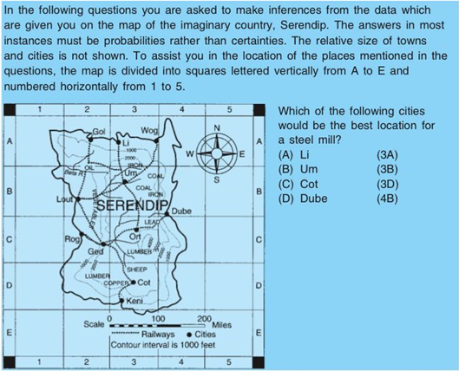

From **(Stones, 2017)** Levels of complexity.

Discussion of the activity

Question 1 involves **understanding** (Bloom) conceptual knowledge (Bloom) and **applying** (Bloom)it to a new problem by **relating** (SOLO) the concepts of electrical current magnetic force to each other, then **analysing** (Bloom) what the outcome will be.

Question 2 requires students to work with **conceptual knowledge** (Bloom) from different domains (geography and steel industry) – which is an **extended abstract** level of complexity (SOLO) – to **evaluate** (Bloom) the best position for a steel mill. The student needs to integrate ‘know that’ about the steel industry and about the way maps are designed with ‘know how’ about how to read maps. Factual (steel mill), conceptual (different priorities for a steel mill) and procedural (correctly interpreting and using the map legend) knowledge are involved.

### Activity 27: Reflect on what you have learnt in Unit 6

**Suggested time: 20 minutes**

Now reflect on what you have learnt in this unit by completing the third column in the KWL table which you started at the beginning of this unit in your learning journal.

### Discussion of the activity

In this unit, we have investigated using constructed response and selected response tasks for assessment. We explored the design of practical assessment tasks as well as approaches to designing written test questions to assess knowledge and cognitive processes at specific levels of complexity. Remember, all of these assessment tools can be used in different ways for baseline and diagnostic assessment, for formative and summative assessment, and for norm-referenced and criterion-referenced assessment instruments. Some can be used informally during teaching and learning: for example, you can conduct practical assessments of your students while watching them practice skills or analyse their comments during class discussions as part of Assessment for Learning.

# Unit 7: Ensuring quality in assessment

## Introduction

When you considered why to assess, what to asses and how to assess during the previous units, you realised that assessment needs to be designed very carefully to avoid inaccurate results which can result in a variety of problems. You have looked at how to design assessment tools well so that they measure what they are designed to measure. In this unit now, you will focus on key concepts to guide the design, use and evaluation of assessment tasks and instruments to ensure that all of these are of a high **quality**.

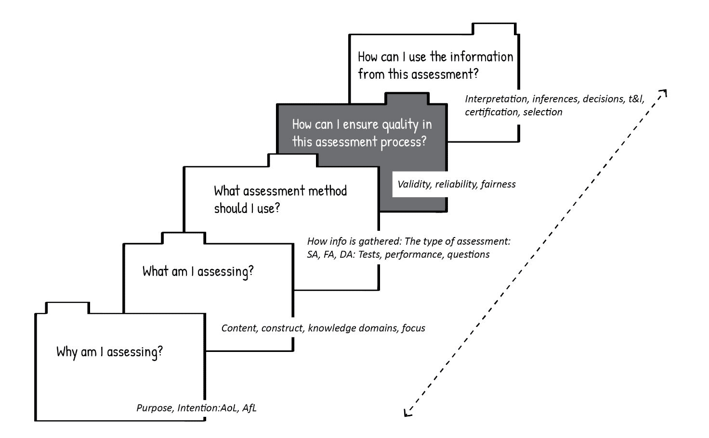In the assessment model we are using in this module, quality is the fourth stage in the assessment process. As you have seen, quality needs to be a high priority at every stage of the assessment process.

**Figure 28: The influence of quality criteria on the process of assessment (Adapted from Earle, 2006)**

## Unit 7 outcomes

By the end of this unit, you should be able to:

1. Understand the concepts of validity, reliability and fairness and explain their importance in assessment.
2. Apply principles for ensuring validity, reliability and fairness when you evaluate or design assessments.

How do you understand the concepts of validity and reliability at present? Draw a KWL table in your learning journal and complete the first two columns before you start engaging with this unit.

## Criteria for quality assessment

To be able to make a judgement on the quality of assessment we need criteria for evaluating the quality of assessment.

Stop and think

Which criteria do you consider important to ensure that assessment is of a high quality? Do you use these in your assessment practices?

Different theorists emphasise different criteria as important to ensuring that assessment is of a high quality. However, most experts agree that validity, reliability and fairness are essential.

Figure 29 represents the relationship between these concepts. Validity is the key dimension of quality assessment and reliability and fairness are important aspects of validity.

**Figure 29: Quality assessment**

Let’s look at each of these concepts in more detail.

## Validity of assessment

Validity in the context of assessment is about whether the assessment results were interpreted correctly or used in a way that accurately reflects the students’ competence. While an assessment might be conducted accurately and the results might be calculated accurately, if the conclusions that are drawn about the results are not accurate or trustworthy, the assessment process is not valid. If an assessment is misinterpreted or used for purposes that were not intended, it may result in poor decisions and problematic consequences. This does not mean there was anything wrong with the test or other assessment instrument that was used. But conclusions were drawn from the results that weren’t true.

In fact, students could take a test and the results could be used for various purposes and some of them may be valid and others not. For example, if the results of an electrical engineering test are used to make conclusions about a student’s knowledge of electrical systems, that may be valid. If it is used to draw conclusions about a student’s ability to communicate in writing, however, that is probably not a valid use of those assessment results. If you informally assess a student as having poor thinking skills because they do not feel confident in the language of teaching and learning and so do not express their reasoning clearly, your assessment is not valid. It might be valid to assess them as having weak communication skills in the language of teaching and learning, but you actually don’t know anything about their thinking skills because they are experiencing a barrier to expressing their thoughts. Your assessment is not valid because it draws conclusions about something that wasn’t actually assessed and your conclusions may not be true.

So, how do we ensure that assessment results are being correctly understood and used in a way that is valid? Here are several strategies to incorporate into your assessment practices.

* Choose assessment methods that enable your students to clearly demonstrate their competencies.
* Design assessments so that the learning outcomes run clearly through them and can be easily analysed.
* Design assessments to cover all aspects or dimensions of a competency. As we discussed in Unit 4, using a rubric can help you to identify the different dimensions. This will help you avoid designing an assessment which really only allows your students to demonstrate some dimensions and evaluating your students as being weak in other dimensions because they didn't demonstrate those –without realising that you didn’t give them the opportunity.
* Ask a colleague to look at your assessment tool and your results and see if they understand the results in the same way you do.
* Design a range of different kinds of assessments which give your students different kinds of opportunities to demonstrate their competence, as different students with equal levels of competence will be able to demonstrate it best in different situations.

## Reliability of assessment

Reliability addresses the question: *How confident am I that this assessment process provides enough consistent and stable information to allow me to make statements about a student’s learning with certainty?*

When lecturers make statements about a student’s learning, they are saying what the student knows and can do from the evidence that is available to them. If the assessment process is reliable, the statements about a student’s learning should be similar when they are made by different lecturers, when the learning is measured using different methods, or when students demonstrate their learning at different times. If you are unsure about whether the statements you make about a student’s learning would be the same under all these conditions, what you are saying may not be reliable. You would need more information from different methods and collected at different times about the student in order to be sure that your statement is reliable.

The concept of error in assessment is critical to our understanding of reliability. In every assessment there is some degree of error.

When you assess a student, you observe what the student knows by them demonstrating it in some way. You can’t directly observe their knowledge, only how they are demonstrating it at a particular moment. There might be factors making their knowledge appear different than it is – thus causing a degree of error. So when they demonstrate their knowledge in an assessment you are really scoring what you **observe:** which is their real knowledge plus or minus whatever degree of error is present.

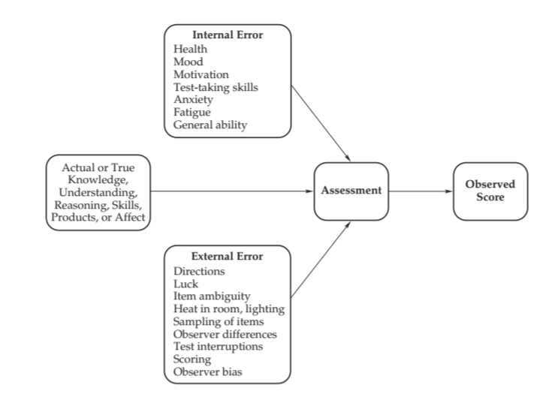Figure 30 below shows how different sources of error influence assessment results.

**Figure 30: Assessment error (McMillan, James, 2014)**

During assessment, the actual or true knowledge demonstrated by the student is observed along with internal factors and / or external factors which result in a degree of error. Internal factors could be that the student is ill, feels anxious, has poor test-taking skills or is very tired, for example. These could result in a degree of error which makes their actual knowledge appear less than it is. Similarly, external factors like the exam room being too hot or cold, interruptions during the exam, the test items only covering a narrow range of knowledge, or the lecturer disliking the student could also result in a degree of error, making the student’s actual knowledge appear less than it is.

The actual or true knowledge or skills are captured to some extent by the assessment, but the internal and external sources of error also contribute to the score. In the end, you get an observed score that is made up of the actual or true performance plus some degree of error:

Observed Score = True Score + Error

This does not mean that some assessments are reliable and others are unreliable. There is likely to always be some degree of error, so it’s more useful to think in terms of low, moderate, or high reliability. Because of this, small differences between students’ assessment scores should not be considered too highly. A few percentage points’ difference may actually indicate a similar level of competence but with different degrees of error influencing the assessment.

There are many ways to promote reliability:

* Use a variety of assessment tasks to provide a range of information. The more information gathered, the clearer the picture of a student’s learning profile.
* Students can show their learning in many different ways. To get a good understanding of a student’s learning, allow the student to demonstrate their competence in a way that suits their individual strengths. For example, one student may choose to do an oral presentation to demonstrate understanding of a concept, while another may choose to complete a written text.
* Provide clear guidelines for the assessment procedures and for scoring assessments. You can use a variety of systematic processes—for example, scoring keys, rubrics, rating scales and continua—to make statements about students’ work in relation to the learning outcomes.
* Work with other lecturers to review students’ work. By working together, you will establish agreement among yourselves about what is expected and what can be learned from a particular assessment, increasing the reliability. Using independent scorers, on the other hand, can help you identify error factors.
* Make sure the assessment procedures and scoring are as clear and objective as possible.
* Continue assessment until results are consistent.
* Try to eliminate or reduce external factors which could introduce error.

Activity 28: Recognising validity and reliability

**Suggested time: 20 minutes**

Each of the following scenarios describes an assessment in which either validity or reliability is a problem. Specify which of Validity or Reliability is a problem and indicate your reason.

1. A class is given an exercise to assess if they can apply what was taught in class. During the exercise most students are confused by the instructions of the activity as the instructions are not clearly phrased. The class does not perform well on the assessment.

VALIDITY / RELIABILITY

Reason:

1. A student is about to enter the exam hall to write an exam when he receives a phone call giving him very bad news. He writes the exam but does not perform well.

VALIDITY / RELIABILITY

Reason:

1. Two classes have been set the same assessment activity but they haven’t covered the same work.

VALIDITY / RELIABILITY

Reason:

1. A class has been set a short test to assess the work they have covered for the last three months.

VALIDITY / RELIABILITY

Reason:

1. Students are given a multiple choice test but they have never been assessed in this way before.

VALIDITY / RELIABILITY

Reason:

1. Twin sisters are taking the same course but are taught by different lecturers. They are given the same task: to create a poster related to the topic. They create identical posters and submit them to their lecturers. One of the sisters receives 80% and the other receives 65%.

VALIDITY / RELIABILITY

Reason:

1. A TVET English student jokes to her friend that she hopes her essay is marked first by their lecturer as she seems to award higher marks when she starts marking a set of papers and lower marks as she progresses through the pile.

VALIDITY / RELIABILITY

Reason:

Discussion of activity

Check your responses here:

1. Reliability

Poor instructions lead to external assessment error and a greater difference between the observed score and the true score.

1. Reliability

Negative emotions during assessment can result in internal assessment error. If the student had taken the test under stable emotional conditions it is possible they would have scored higher.

1. Validity

Assessment should relate directly to the content taught and learnt otherwise what the students have been taught and learnt is not being assessed and the results are invalid.

1. Validity

Assessment should relate directly to the content taught and learnt otherwise what the students have been taught and learnt is not being assessed and the results are invalid.

1. Reliability

If students do not understand the assessment method well it may result in external assessment error.

1. Reliability

If assessors do not use the same standards and criteria this results in external assessment error.

1. Reliability

Reason: If an assessor does not use the same standards and criteria when assessing all students it will result in external assessment error.

If you found that some of your answers were different from these, read through the discussion of reliability and validity in this section again and discuss your reasons for your choices with your peers. You can also read more about validity and reliability on the internet to deepen your understanding of these concepts.

## Fairness in assessment

A fair assessment is one that provides all students an equal opportunity to demonstrate what they have learnt. If some students have an advantage over others because of factors unrelated to what is being taught, then the assessment is not fair. A student’s race, gender, ethnic background, disability, or any other personal factor should not prevent them from having the same opportunity to demonstrate their competence as other students. Providing students with accurate information about the assessment and ensuring that they have had the opportunity to learn the knowledge, skills attitudes or values that will be assessed are also important aspects of fairness.

Stop and think

Fairness has a direct bearing on validity and reliability. What things can you think of that could threaten fairness in assessment?

Let’s look at some of the criteria which help to ensure that an assessment is fair.

### Orient students toward learning outcomes

When students know the learning outcomes and assessment criteria in advance, it helps to orient them towards achieving these outcomes and they are likely to be more motivated to develop their competence rather than just focusing on performing for a test.

### Ensure opportunity to learn

In order for an assessment to be fair, students need to have been given enough time and resources to learn, with supportive conditions and effective instruction, as well as adequate time and resources to complete the assessment.

### Consider prerequisite knowledge and skills

It is unfair to assess students on knowledge or skills which rely on other knowledge or skills which they don’t have, or to require that they use these skills in order to perform well on the assessment. An example of this would be using complex language on an assessment when your students come from different language backgrounds. They may all possess the knowledge and skills you want them to demonstrate, but some of them may not be able to understand the questions on the exam because they have been written in unnecessarily difficult language. Similarly, if you give an example on an exam question which only students from one cultural group are likely to understand or know about, it is unfair to the others.

### Do not stereotype students

Stereotypes are judgments about how groups of people will behave based on characteristics such as gender, race, socioeconomic status or physical appearance. It is your responsibility to judge each student on their performance on assessment tasks, not on how others who share characteristics of the student perform. Stereotypes can be based on groups of people, such as ‘women are not good welders’ or ‘students from rural areas work harder than students from cities’. Or you may just judge a student based on one interaction or one characteristic – whether positive or negative – and then be tempted to view them through this lens: such as ‘she is a natural leader’ or ‘he is so lazy’. You could also have lower or higher expectations of a student because of a disability, their socioeconomic background, or another factor.

### Avoid bias in assessment tasks and procedures

Be careful that there is no bias towards or against a student in the design or contents of an assessment. This could include representing a particular gender, race, religious background, disability or other characteristic negatively or making it more difficult for a person with a certain personal characteristic to complete the assessment.

### Activity 29: Recognising fairness

**Suggested time: 90 minutes**

1. Think back on your experience as a learner during your basic education and later as a student.
   1. Can you remember situations where you felt that an assessment was unfair – for you, or maybe for another student? Think about peers with disabilities, of the opposite sex, or from other language, cultural or religious backgrounds than you. How might they have experienced the same situation differently than you did? Make notes in your learning journal about these experiences.
   2. Reflect on how you handle those aspects or situations you experienced as unfair as a learner or student now, as a person responsible for assessment.
2. Now survey three students at your TVET college about their view of, and experience with, fairness in assessment. Ask them:
   1. How would you define ‘fair’?
   2. Are there times when you have felt an assessment was unfair – for you or someone else – at this college? What about it was unfair? What would be required to make it fair?
   3. What do you think needs to be considered or done to make sure an assessment is always fair?

Make notes in your journal about the students’ responses and reflect on what they have shared. Do you think their criticisms are valid? Are you responsible for some of the practices they consider unfair? What changes could you introduce that could make assessment fairer?

Now form a group with two or three of your peers for the remaining tasks in this activity.

1. Share your findings from tasks 1 and 2 with your peers, referring to your notes as needed. If you gain any new insights from listening to them when they share their findings, add them to your learning journal.
2. A model for fairness in classroom assessment is shown below. The model captures important aspects of fairness, organized by the sequence of steps lecturers take in their instruction and assessment. At each step, there are factors lecturers should consider. Note the importance of confidentiality.
3. 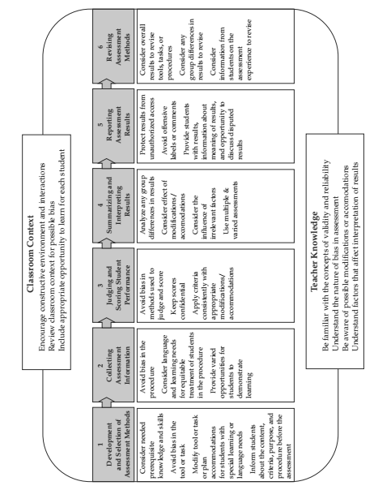Walk through the model together and discuss each step. Consider:
4. How is it the same or different than what you do in your assessment practice currently?
5. How could aspects you are not currently using benefit your assessment practice?
6. How could they be implemented practically?

**Figure 31: A model for fairness (Adapted from McMillan, James, 2014)**

1. Now reflect together on what you have learnt in this unit by completing the third column in the KWL table which you started at the beginning of this unit in your learning journal. Compare your understandings of validity and reliability with those of your peers.

Discussion of the activity

In this activity, you have explored the concept of fairness from your own perspective as a learner and student and from the perspective of students at your college and discussed your findings with your peers. This has helped you to identify ‘blind spots’ where, as a lecturer, you may not have been aware of unfairness in your assessment practices. From that awareness, you have engaged with your peers on a model for fairness in assessment and explored how you could use it to make your assessment practices fairer.

By reflecting on the learning you have done in this unit you have further integrated it into your existing knowledge and values so that it will guide you in your future assessment practices. By working collaboratively you have been able to benefit from your peers’ learning and insights in addition to your own.

# Unit 8: Using the results of assessment to improve teaching and learning

## Introduction

In this final unit we focus on the final stage of the assessment planning model: *How can I use the information from this assessment?*

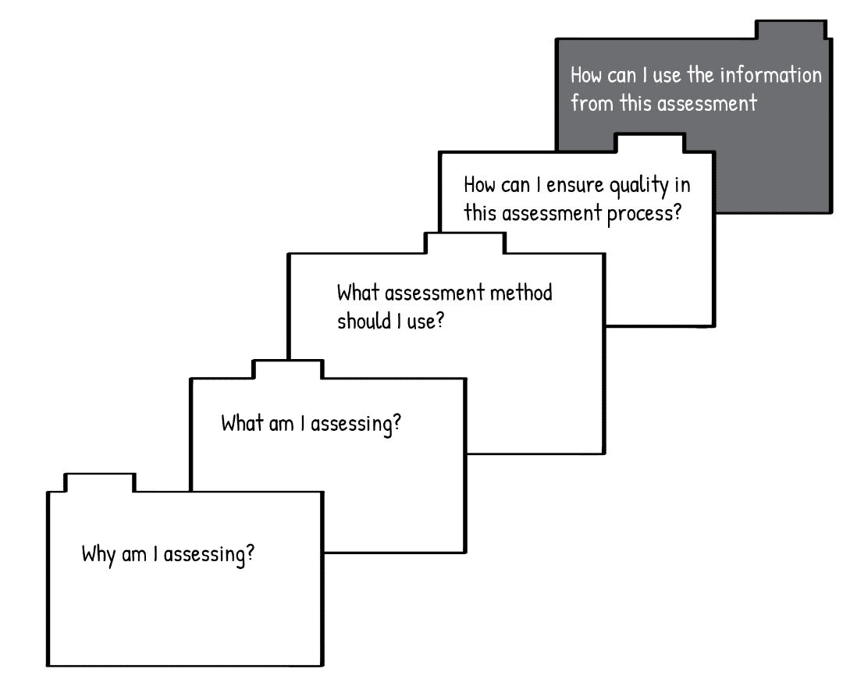

**Figure 32: Unit 8 focusses on the final stage of the assessment module (Adapted from Earl, 2006)**

Throughout this module we have discussed how assessment can be used to improve teaching and learning when it is designed **for** learning or **as** learning. We have seen that an assessment that is conducted for one purpose can sometimes be used for other purposes as well – although this must be done carefully to ensure that the interpretation of data for another purpose is reliable and valid. In this unit we explore the roles of quantitative and qualitative data, error analysis and providing feedback in ensuring that the assessment results contribute to improved teaching and learning.

## Unit 8 outcomes

By the end of this unit, you should be able to:

1. discuss the role of gathering data as part of a cycle to improve teaching and learning.
2. analyse errors in your students’ responses and use these to modify teaching and learning.
3. understand how to provide feedback effectively to your students.

Remember to create a KWL chart for the learning outcomes of Unit 8 and complete the first two columns.

## Gathering and using data in the teaching and learning processes

A typical teaching and learning cycle involves several steps which we could identify as follows:

1. Determine learning outcomes (from the curriculum, possibly with adjustments) to ensure students will develop the kinds and levels of competency they will need for success in their careers
2. Engage in teaching and learning
3. Determine assessment standards based on learning outcomes, develop assessment tasks, and assess (during and after teaching and learning)
4. Analyse assessment results to identify patterns and insights, reflect on their meaning and draw conclusions about what was effective and what was not in terms of learning outcomes, teaching approaches, learning experiences and assessment tasks.
5. Based on conclusions, modify learning outcomes, teaching approaches, learning experiences and assessment tasks for the next cycle

**Figure 33: Assessment yields new learning which is used to modify the next teaching cycle**

Stop and think

Do you always go through all these steps? In particular, do you do steps 4 and 5? If so, how formally do you do this? Do you do it in writing? Do you do it with your colleagues?

To effectively engage in steps 4 and 5 you would need data collected in step 3. The data which step 3 generates obviously depends on the purposes and types of assessments that were done. Some data will be ***quantitative*** and other data will be ***qualitative***.

**Quantitative** data is data that can easily be counted – it shows the ‘quantity’ of responses of a certain type. It can be analysed to produce different statistics such as percentages. This is sometimes called ‘hard’ data: the responses are usually clear-cut. Binary questions such as true / false and multiple choice questions give you clear hard data: this student answered ***this many*** questions correctly; or ***this many*** students answered Question 5 correctly. The assessor is interested in looking at patterns in the scores and the aggregate (combined) scores of students.

**Qualitative** data, on the other hand, is data that shows the quality of responses more clearly than the number of responses. There might not be a clear choice between correct and incorrect answers, and the assessor is interested in seeing how the student answers the question: do they provide a strong rationale for their answer; do they use original or creative ideas. It is sometimes called ‘soft’ data.

Activity 30: Identify quantitative and qualitative data in your assessment tasks

**Suggested time: 30 minutes**

1. Complete the following table to practice distinguishing between quantitative and qualitative data.
2. In the ‘example’ column give an example of the type of assessment from one of the TVET subjects that you teach.
3. In the form of data columns under the appropriate heading identify an assessment question or task from your example which generates either quantitative or qualitative data. If it does both, note that in both columns.

|  |  | **Form of data** | |
| --- | --- | --- | --- |
| **Type of assessment** | **Example** | **Quantitative** | **Qualitative** |
| Formal formative assessment |  |  |  |
| Informal formative assessment |  |  |  |
| Formal summative assessment |  |  |  |
| Informal summative assessment |  |  |  |

1. Share your table with a peer and explain your reasons for classifying the example as generating quantitative or qualitative data or both. After listening to your peer’s feedback and justification for their own examples, see if you would like to make any changes to your table.

Discussion of the task

Becoming more aware of what type of assessment task generates what type of data helps you develop your expertise as both an assessor and a designer of assessments, so that you can ensure that your assessments generate data that is useful to you.

To be able to make decisions about improving teaching and learning you need to find out why students did well or poorly on assessment tasks and assignments. One way to do this is to analyse the errors that they have made.

## Error analysis

Lecturers recognise wrong answers on an assessment all the time, but understanding the nature of an error and what caused it – especially if it’s an unfamiliar error – requires attention to patterns and flexible thinking about meaning. Error analysis involves looking at the errors in students’ work to try to understand why they made these errors.

Some of the errors students make will simply be careless – the student may not have read the question carefully, or may have written their correct answer next to the incorrect question number. However other errors can reveal that students have not grasped key concepts or are lacking certain skills. Analysing errors can be a goldmine in terms of finding insights about where your teaching is not covering knowledge, skills, values and attitudes adequately or where you need to look for more effective teaching methods or refine your assessment tasks. This, in turn, can lead to increased competence and higher achievement by students.

To do an error analysis, you need to start by linking the assessment question back to the learning objective in the curriculum and the assessment standard that relates to it. This ensures that your analysis stays grounded in what you actually set about to teach your students. There are curriculum mapping templates that can help you do this in detail. You can then analyse the question to be sure you have identified the knowledge and skills the student needs to use to answer it correctly and the processes they need to use in order to reach the correct answer. Also consider what range of responses could be correct or if there is only one correct response.

Then analyse the student’s answer, looking for the knowledge and skills that are evident and the processes that were used. Identify where there were errors in any of these aspects. Consider how these errors came about. Was your explanation of a concept not clear enough? Did the student not practice the skill enough?

Once you have identified the errors and considered the causes, think about what you can learn from this and how you can feed that into future lesson planning and assessment to improve teaching and learning. Consider also if you could revise the question to improve it.

Activity 31: Analysing errors

**Suggested time: 90 minutes**

1. Copy the template below into your learning journal. Copy only the bold text. Make the table big enough to fill a page.
2. Choose an assessment you have given your students recently and select an error from one of the student’s responses. Then fill out the table.

### Error analysis template

|  |
| --- |
| **Name of course:**  **Name of assessment:**  **Assessment question:**  *[Copy the assessment question here]*  **Learning outcome which the question assesses:**  *[Copy the relevant learning outcome here]* |
| **Analysis of correct answer:**  *[Indicate the correct answer or range of correct answers.]*   * What knowledge of facts or processes or skills are required to answer this question correctly? * What range of responses could be considered correct? |
| **Analysis of student’s answer:**   * What facts or processes or skills did the student demonstrate in their answer? * Where can you identify errors in their factual or procedural knowledge? |
| **Insights or adjustments for future teaching or revision of assessment question:**   * What am I able to see that I can use or change next time I teach to address the causes underlying the error? * Do I need to adjust the learning outcome ­– or add another learning outcome – to ensure students develop the foundation they need in order to develop this competency? * Do I need to revise the assessment standard and/or task to match the learning outcome more closely? |

1. Reflect on the insights or ideas you had while filling out the table.
2. Share your error analysis with your peers and have a look at theirs. Is there anything new you can learn from their error analyses which you could use to improve your teaching practice?
3. Discuss with your peers how error analysis could be done for assessments of various practical skills in your different TVET courses.

Discussion of the task

Rather than marking assessments just to determine students’ marks, you can analyse the particular errors they have made to gain insight into what is effective about your teaching practice and what changes you could make to make it more effective. The template you have used in this activity has helped you become familiar with error analysis, but you could expand the template, adding any details which are useful to you. Once you are clear in your mind about what you are looking for when you are analysing an error you could work without a template.

## Using feedback effectively

As we have seen throughout this module, feedback is an important element of Assessment for Learning. It is powerful because it increases both the student’s learning and student’s motivation to learn. Feedback shows students where their understanding or actions are correct and why –or where they are not and why not. By having clarity about where they are in their learning journey and what is needed to improve their competence, students can take ownership of and monitor their learning. This helps them become more engaged with the learning process and also, as a form of Assessment as Learning, helps them to develop their self-regulatory skills.

Before we start discussing feedback in detail let’s do an activity to explore which teaching intervention are most effective.

Activity 32: Which teaching interventions are best?

**Suggested time: 60 minutes**

Geoff Hattie is a researcher who has done a huge amount of research on education. Looking through his data, he identified a number of factors which impact learning and compared their impact on learning. The factors he identified are listed in the table below in alphabetical order.

1. Read the list carefully. Then number the factors, starting with the one you think has the greatest impact on learning as number 1 and continuing to the one you think has the least impact. If you are not sure what a particular item means, skip it.

**Factors identified by Hattie which impact learning (Adapted from Hugo, 2014)**

| **Factor** | **Order of importance** |
| --- | --- |
| Ability grouping/streaming |  |
| Acceleration |  |
| Advance organisers |  |
| Affective attributes of students |  |
| Aims and policy of the institution |  |
| Audio-visual aids |  |
| Behavioural objectives |  |
| Bilingual programmes |  |
| Calculators |  |
| Challenge of goals |  |
| Class environment |  |
| Computer-assisted instruction |  |
| Direct instruction |  |
| Feedback |  |
| Finances/money |  |
| Home factors |  |
| Homework |  |
| Individualisation |  |
| Instructional media |  |
| Instructional quality |  |
| Instructional quantity |  |
| Learning hierarchies |  |
| Mass media |  |
| Mastery learning |  |
| Parent involvement |  |
| Peer tutoring |  |
| Peers |  |
| Physical attributes of students |  |
| **Factor** | **Order of importance** |
| Physical attributes of the institution |  |
| Programmed instruction |  |
| Questioning |  |
| Remediation/feedback |  |
| Retention (fail students) |  |
| Simulation & games |  |
| Student’s disposition to learn |  |
| Students’ prior cognitive ability |  |
| Educator in-service education |  |
| Team teaching |  |
| Testing |  |

This is how Hattie ranked the list of factors in education based on their impact on learning:

**Hattie’s ranking of factors which impact learning (Adapted from Hugo, 2014)**

|  |  |
| --- | --- |
| **Factor** | **Order of importance** |
| Feedback | 1 |
| Students’ prior cognitive ability | 2 |
| Instructional quality | 3 |
| Instructional quantity | 4 |
| Direct instruction | 5 |
| Acceleration | 6 |
| Home factors | 7 |
| Remediation/feedback | 8 |
| Student’s disposition to learn | 9 |
| Class environment | 10 |
| Challenge of goals | 11 |
| Bilingual programmes | 12 |
| Peer tutoring | 13 |
| Mastery learning | 14 |
| Educator in-service education | 15 |
| Parent involvement | 16 |
| Homework | 17 |
| Questioning | 18 |
| Peers | 19 |
| Advance organisers | 20 |
| Simulation & games | 21 |
| Computer-assisted instruction | 22 |
| Instructional media | 23 |
| Testing | 24 |
| Aims & policy of the institution | 25 |
| Affective attributes of students | 26 |
| Calculators | 27 |
| **Factor** | **Order of importance** |
| Physical attributes of students | 28 |
| Learning hierarchies | 29 |
| Programmed instruction | 30 |
| Audio-visual aids | 31 |
| Individualisation | 32 |
| Finances/money | 33 |
| Behavioural objectives | 34 |
| Team teaching | 35 |
| Ability grouping/streaming | 36 |
| Physical attributes of the institution schschool.05 | 37 |
| Mass media | 38 |
| Retention (fail students) | 39 |

1. Do you agree with Hattie’s findings? Even if you disagree with the order of items on the list, why do you think feedback has such a great impact on student learning? Write your reasons in the space below.

Discussion of the task

Hattie (1999) concluded that the simplest thing that an educator can do to improve learning is to continually give small amounts of feedback to students about what they are understanding, what they are not understanding and why, and the next steps they can take to continue their learning. To know what your students understand and can do at any moment, you need to be engaged continually in informal formative assessment of their learning. Notice how important the quality and quantity of teaching are to learning on the list compared to many other factors which sometimes take our attention.

### The most effective types of feedback

Hattie also studied how effective different types of feedback were compared to others. He found that giving student small bits of feedback about being on the right track or how to proceed next was very effective. Reinforcement – which is verbally agreeing or nodding your head when a student is expressing concepts correctly or doing a task correctly, verbally describing the process they are doing correctly, or summarising the concepts they are expressing correctly – is also very effective. One of the least effective forms of feedback was praise (Hattie and Timperley, 2007).

Stop and think

Why do you think that praise could be such an ineffective form of feedback?

Based on their findings, Hattie and Timperley (2007) developed a model which identifies four different focuses of feedback:

1. **feedback about the task:** for example, indicating that students’ answers were right or wrong or indicating the next step
2. **feedback about the processing of the task:** for example, identifying strategies that students have used successfully; identifying strategies that students have used unsuccessfully and commenting on why they didn’t work; suggesting other strategies to try
3. **feedback about self-regulation**: for example, commenting that the student has managed their learning effectively (such as feedback about student self-evaluation or self-confidence), and
4. **feedback about the student as a person:** this includes praise and criticism.

Feedback that focuses on the first two aspects – the quality of the student’s work or the process or strategies used to do the work – is most helpful. Feedback that focuses on the third aspect, self-regulation, can be effective if students make the connection that they will get the results they want if they make an effort. These three kinds of feedback reinforce the student’s knowledge or skill, focussing their attention on their attempt to increase their competence (Brookhart, 2017).

Feedback which focuses on praising or criticising the student was least effective, as it does not focus the student’s attention on their learning. Praise – such as saying, “Good work! You are so clever!” – tends to focus on the student as a person. Praise shifts the student’s attention to ‘winning’ the lecturer’s positive judgement of them; this can raise the level of anxiety for students as they practice, wondering what their lecturer will think about their work. Reinforcement, on the other hand, focuses the student’s attention on what they are doing correctly and helps them to take pleasure in their competence rather than how the lecturer feels about them; this helps to build their trust in their own judgement which in turn builds their ability to manage their own learning (self-regulation).

### Giving feedback effectively

Brookhart (2017) provides a number of recommendations for giving feedback:

**What feedback to give**

As we have discussed, feedback should focus on the student’s work, the processes the student uses, or the student’s self-regulation and not on the student’s personality or character. If possible, talk about the relationship between the student’s work and the processes they are using. Describe what they are doing or what they need to do rather than judging their work as ‘good’ or ‘bad’.

It may be useful to compare the student’s work against the learning outcomes to help them see their progress and where they need to focus more attention. It may also be useful to compare their work against their past performance (for example, a baseline assessment) so that they can see how much progress they’ve made.

**When to give feedback**

Provide feedback immediately on knowledge or a skill that is simply right or wrong. Delay feedback slightly when you are encouraging students to think deeply, struggle with a problem on their own, or work collaboratively to find solutions. Always consider when students would be the most interested in feedback. For example, immediately after trying a challenging task they will be interested to find out how they did; the more time that passes after the experience the less they will care.

**How much feedback to give**

Prioritize the most important points and focus on those that relate to key learning objectives. Be specific to the task and the student. Consider the student’s level of expertise – don’t overwhelm them with feedback about aspects they are not yet ready to work on.

Consider whether feedback should be limited to whether the student is correct or incorrect, or whether to extend it – explaining why and connecting it to other knowledge and to values and attitudes.

During a task, give students just enough feedback to help them move forward. This could involve asking them a question which you think they will be able to work out by themselves. By giving them clues rather than answers they are able to build their confidence in their ability to solve problems themselves. Give them feedback that makes them ask themselves questions, rather than ‘dumping’ solutions on them. This will help them to become more flexible and independent in their thinking.

**How to communicate feedback**

Think about whether it would be most effective to communicate your feedback through comments in person or a discussion, in writing, or through a demonstration. Interacting with the student directly is most effective whenever possible. A demonstration is effective when a student needs to see an example.

Communicating feedback individually to students communicates your personal awareness of and concern for their learning, which can be motivating to them. Giving feedback to the whole class is effective when your feedback will be of relevance to most of the students.

Make sure you are clear when you communicate to students. Don’t use vocabulary or concepts they are not yet familiar with.

The tone you use to communicate feedback is important. Use positive comments to describe what the student has done right or well wherever possible. If you feel you need to make a negative comment, accompany it with a positive suggestion about how they can improve it. Choose your words carefully to show respect for your students and their work. Treat them as a colleague in industry, asking their opinion as well. Choose words that communicate that you see the student as the master of their work.

Activity 33: Assess a lecturers’ use of feedback

**Suggested time: 20 minutes**

In this activity you watch a video and assess a teacher’s feedback against a set of criteria. The video you watch is not in a South African TVET context. Even though the level of the students is different from your context, the principles of giving feedback still apply. You will also notice that in this case you are not evaluating feedback on a formal assessment activity. Again, the principles of feedback apply to assessment **for**, assessment **as** and assessment **of** learning. Think about what kind of assessment is happening.

1. Watch the videos [*Teacher provides feedback to students - Example 6*](https://www.youtube.com/watch?v=uad6DWC9BKI) and [*Teacher provides feedback to students - Example 4*](https://www.youtube.com/watch?v=gYUAamVuwaU)
2. For each video, draw the follow rubric in your learning journal. Make it big enough to take a whole page. You don’t need to copy the criterion descriptions; you can refer to them here as you complete the rubrics in your journal. Then assess the video using the rubric. Choose the level of competence of the lecturer’s feedback for each criterion and in the relevant cell write a brief justification for your choice

| **Dimension** | **Criterion** | **Level of competence** | | |
| --- | --- | --- | --- | --- |
|  |  | **Excellent** | **Good** | **Needs improvement** |
| **What** | Feedback focusses on student’s work, processes or self-regulation, not on student personally |  |  |  |
| **When** | Feedback timed well for student; immediate if simple correction; allows time for independent thinking |  |  |  |
| **How much** | Feedback appropriate amount and depth;  Focusses on objectives and student level of expertise;  During a task gives only what they need to continue independently. |  |  |  |
| **How** | Appropriate choice of verbal, written or demo.  Clear and not over students’ heads.  Positive.  Appropriate choice of individual or group.  Shows respect for student and their work in tone. |  |  |  |

1. Complete the ‘Learnt’ column of the KWL chart you started at the beginning of the unit.

### Discussion of the activity

Giving good feedback is a skill that requires practice. Observing other teachers and lecturers give feedback may have made you more aware of your own feedback practices. Keep what you have learnt in this unit in mind and try to experiment with these different dimensions of feedback in your lecturing. After experimenting, reflect on how what you tried impacted teaching and learning. Experimenting and reflecting on what you’ve tried is a powerful way to continue to develop your own expertise as a lecturer.

Stop and think

How you would apply the same principles in a practical situation, such as in a practical welding assessment. How would feedback be the same and how would it be different?

## Conclusion

In this module you have travelled through the process of planning effective assessment: considering firstly the role of assessment in teaching and learning, the purposes assessment, how to identify the components of learning outcomes that need to be assessed and the types of assessment methods you can use to assess them. You have considered aspects that influence the quality of assessments and, finally, explored how to make use of the data that results from assessment. During this journey you have had the opportunity to analyse different types of assessment tasks and apply your developing knowledge, skills, values and attitudes to assessment in your TVET courses.

We began this module with Activity 1, in which you completed an online survey about your assessment approach and began a KWL table on the general topic of assessment. That activity helped you to access your prior knowledge and think about what you wanted to learn about assessment. It also served as a baseline assessment, documenting your knowledge, skills, values and attitudes about assessment before beginning new learning in this module. In this final activity, let’s return to what you did in Activity 1 and measure the change – learning – that has happened in your knowledge, skills, values and attitudes about assessment.

Activity 34: Assessing your learning over this module

**Suggested time: 90 minutes**

1. Complete the online Approach to Classroom Assessment Inventory (ACAI) again by clicking here: <https://interceptum.com/si/en/4800045>.

As you complete the survey, once again pay attention to your own reactions to the questions (this is metacognition) and jot down notes about this in your learning journal. In particular:

* Do you notice concepts or terms which you did not understand the first time you did the survey?
* Are you more conscious of which questions target your **knowledge, skills, attitudes** or **values** about assessment?
* Do you notice a change in your attitudes or values when you consider some of the questions?
* Do any of the questions make you realise that you still have unanswered questions about assessment?
* What do you think about the way the survey questions are designed?

1. After you have completed the survey, download a pdf version of the feedback and compare it, category by category, with the feedback you received the first time you did the survey. Do you agree with it?
2. Summarise how you see your approach to assessment at this point in a paragraph or bullet list in your learning journal.
3. Now complete the final column of the KWL table you began in Unit 1. List key phrases or concepts which represent to you what you have learnt in this module.

Discussion of the activity

In this final activity you have used Assessment as Learning to become aware of your own learning over the course of this module. We encourage you to use this approach to continue to identify what you want to or need to learn – about assessment or any other aspect of education – as you continue your professional development.

# Summative assessment task

Design an assessment task for a course that you teach using the assessment planning model and assessment knowledge, skills, attitudes and values you have learnt in this module. Use the criteria provided under each dimension to guide you.

|  |  |  |  |  |
| --- | --- | --- | --- | --- |
| **DIMENSION AND CRITERION** | **Excellent** | **Good** | **Needs development** | **Inadequate** |
| 1. **PURPOSE**   **AfL/AaL/AfL and learning outcome/s clearly identified**  **(10)** | AfL/AaL/AfL and learning outcome/s are clearly identified | AfL/AaL/AfL and learning outcome/s are identified | AfL/AaL/AfL and learning outcome/s are identified but are not clear | AfL/AaL/AfL and learning outcome/s are not identified |
| 1. **FOCUS**   **SKAV or integrated abilities and level of complexity are identified and link to outcomes**  **(30)** | SKAV or integrated abilities and level of complexity are clearly identified and clearly linked to outcomes | SKAV or integrated abilities and level of complexity are identified and linked to outcomes | SKAV or integrated abilities and level of complexity are not clearly identified and/or are not clearly linked to outcomes | SKAV or integrated abilities and level of complexity are not identified and/or are not linked to outcomes |
| 1. **METHODS**   **The assessment type and task/question design enable the student to demonstrate the focus SKAV at the specified level**  **(30)** | The assessment type and task/question design are well suited for the student to demonstrate the focus SKAV at the specified level | The assessment type and task/question design give the student an adequate opportunity to demonstrate the focus SKAV at the specified level | The assessment type and task/question design do not give the student an adequate opportunity to demonstrate the focus SKAV at the specified level | The assessment type and task/question design do not give the student an opportunity to demonstrate the focus SKAV at the specified level |
| 1. **QUALITY**   **The design of the assessment task is valid, reliable and fair.**  **(5)** | The design of the assessment task is valid, reliable and fair. | The design of the assessment task is adequately valid, reliable and fair. | The design of the assessment needs improvement in its validity, reliability and/or fairness. | The design of the assessment is not valid and/or not reliable and/or not fair. |
| 1. **USE RESULTS**   **A plan for how results will be used is presented, clearly linked to the purpose in Step 1**  **(25)** | A plan for how the results will be used is presented which utilises the data effectively and is clearly linked to the purpose/s identified in Step 1 | A plan for how the results will be used is presented which is linked to the purpose/s identified in Step 1 | The plan presented for how the results will be used is not clearly linked to the purpose/s identified in Step 1 | A plan is not presented for how the results will be used |
| **TOTAL: 100** | | | | |

# References

Bekker, Tanya, 2015. Assessment.

Brookhart, S.M., 2017. How to give effective feedback to your students. ASCD.

Brooks, V., 2002. Assessment in secondary schools: the new teacher’s guide to monitoring, assessment, recording, reporting, and accountability. McGraw-Hill Education (UK).

DHET, 2006. National Certificate (Vocational) A qualification at Levels 2, 3, 4 on the NQF.

DHET, 2015. ASSESSMENT GUIDELINES WELDING NQF LEVEL 4.

DHET, 2017. Practical Assessment Tasks for Vocational Subjects - ICASS and ISAT LECTURER’S GUIDE BUSINESS PRACTICE LEVEL 4.

DHET, 2019. ICASS Guidelines for NC(V).

DHET, 2020. 2020 Templates NC(V) ICASS Guidelines.

Dyer, H.S., 1973. How to achieve accountability in the public schools. Phi Delta Kappa Educational Foundation.

Earl, L.M., 2006. Rethinking classroom assessment with purpose in mind: Assessment for learning, assessment as learning, assessment of learning. Manitoba Education, Citizenship and Youth.

Earl, L.M., 2012. Assessment as learning: Using classroom assessment to maximize student learning. Corwin Press.

e!Vula Training, 2008. TVET First Early Childhood Development NQF Level 2 Student’s Book. Macmillan, Gauteng.

Hattie, J., 1999. Influences on student learning.

Hattie, J., Timperley, H., 2007. The power of feedback. Review of educational research 77, 81–112.

Hook, P., Mills, J., 2011. SOLO Taxonomy: A Guide for Schools, Book 1: A Common Language of Learning. New Zealand: Essential Resources Educational Publishers.

Hugo, W., 2014. Cracking the code to educational analysis. Pearson Education, Cape Town.

Krathwohl, D.R., Anderson, L.W., 2001. A taxonomy for learning, teaching, and assessing: A revision of Bloom’s taxonomy of educational objectives. Longman.

Linn, Robert, Miller, M., Gronlund, N., 2008. Measurement and assessment in teaching. Pearson Education.

Martin McMillan, James, 2014. Classroom Assessment: Principles and Practice for Effective Standards-Based Instruction : (p. 12)., Kindle Edition. ed. Pearson Education Limited, Essex, England.

Moll, I., Steinberg, C., Broekmann, I., Gewer, A., Bialobrzeska, M., Allais, S., 2005. Being a vocational educator: A guide for lecturers in FET Colleges. South African Institute for Distance Education (SAIDE).

Moll, I. Hugo, W. 2020 The HIT model of TVET knowledge, https://www.oerafrica.org/resource/hit-model-tvet-knowledge

OR Tambo School of Leadership (2019).  *ANC Basic Economics – Student Guide.* Johannesburg: OR Tambo School of Leadership.

Steinberg, Carola, 2015a. The three message systems.

Steinberg, Carola, 2015b. Assessment.

Stones, E., 2017. Psychology of education: A pedagogical approach. Routledge.

Van Blerkom, M.L., 2017. Measurement and statistics for teachers. Taylor & Francis.

Winch, C. (2017). *Teachers’ know-how: A philosophical investigation.* New Jersey: Wiley Blackwell

Wits School of Education, 2013. Teachers’ Knowledge of Error Analysis.