HARAMAYA UNIVERSITY
COLLEGE OF AGRICULTURE AND ENVIRONMENTAL SCIENCES
DEPARTMENT OF RURAL DEVELOPMENT AND AGRICULTURAL EXTENSION

REGIONAL MSc PROGRAM ON:
AGRICULTURAL INFORMATION AND COMMUNICATION MANAGEMENT (AICM)

MODULE ON:

PERSPECTIVE OF AGRICULTURAL EXTENSION (RDAE 511)

BY
BELAY KASSA (Professor)
DANIEL TEMESGEN (PhD)

NOVEMBER 2011

Perspective of Agricultural Extension by Haramaya University is licensed under a
Creative Commons Attribution 3.0 Unported License.

Table of contents
Background of Haramaya University vi
Overview of the module vi
Purpose of the module vi
General Introduction to the Module vii
How you will be assessed vii
Topic One: Concept and Philosophy of Extension 1
1.1 Extension and development 2
1.2 Extension and Rural Development 2
LEARNING tasK for topic one 3
Topic Two: Genesis of Extension Education 5
2.1 The History of Extension 6
2.2 Extension and Formal Education 6
2.3 Objectives and Principles of Extension 7
Assessment tasks for Topic Two 9
Topic Three: Extension Education and Society 11
3.1 Extension and Information Technology Development 12
3.2 ICT as a tool for Extension 13
Topic Four: Extension Methods and Approaches 17
4.1 Evolution of Alternative Agricultural Extension Approaches 17
4.2 Extension goals 18
4.3 Extension Approaches /Extension delivery alternatives 19
4.4 Extension Approaches in Ethiopia 19
4.5 Approaches in Supporting Agricultural Innovation 20
4.6 National Agricultural Research Systems (NARS) 20
4.7 Agricultural Knowledge and Information System (AKIS) 20
4.8 Innovation Systems 21
Assessment tasks for Topic Four 22
Topic Five: Conceptual Foundation on Extension Impact 25
5.1 The Impact of Agricultural Extension 26
5.2 Measuring Extension Impact 26
5.3 Statistical Methods and Issues for Economic Evaluation 27
Topic Six: Extension Policy and Organizational Issues 29
6.1 Extension Policy 29
6.2 Organizational Issues in Extension Agencies 31
6.3 Extension Staffing Issues 32
6.4 Extension Funding 32
Assessment tasks for topic six 34
Topic Seven: Organizational Linkages in Agricultural Extension Service 36
7.1 The New Roles of Extension 36
7.2 Farmer organizations 37
Assessment tasks for topic seven 39
Topic Eight: Gender Issues in Agriculture Extension 41
8.1 Gender in Agricultural Extension 42
8.2 Improving Women's Access to Extension 43
8.3 Improving Training Programmes for Women 45
Assessment tasks for topic eight 46
Topic Nine: Strengthening Research-Extension-Farmer linkages 49
9.1 Agricultural Technology Development 50
9.2 Systems Analysis in Technology Development and Transfer 50
9.3 Mechanisms to solve Linkage Problems 50
9.4 Farmers’ Linkages with their Organizations 51
Assessment tasks for Topic Nine 52
Topic Ten: Extension's Role in Sustainable Agricultural Development 55
10.1 Emerging challenges for sustainable agriculture 56
10.2 Resource-Conserving Technology Development and Transfer 57
10.3 Incorporating Farmer Experimentation 58
10.4 Challenges for Supportive Policy 59
Assessment tasks for Topic Ten 61
Topic Eleven: Privatizing Agricultural Extension 63
11.1 Forces for Change 64
11.2 Other Arrangements 67
11.3 Alternative Funding and Delivery 67
11.4 The Context for Extension Privatization 68
11.5 Implications of extension "privatization" 71
Assessment tasks for topic Eleven 72
Topic Twelve: Non-Governmental Organizations in Extension 75
12.1 NGO/Non-State Actors 76
12.2 Characteristics of NGOs 76
NGOs exhibit some specific characteristics including: 76
Assessment tasks for topic TWELVE 77
Topic Thirteen: Indigenous knowledge in Research and Extension 79
13.1 Concepts of Indigenous knowledge (IK) 80
13.2 Types of Indigenous Knowledge 80
13.3 Importance of Indigenous Knowledge 81
13.4 Differences and Similarities Between Indigenous (IK) and Scientific Knowledge (SK) 81
13.5 The Role of Indigenous Institutions in the Pastoral Communities 82
Assessment tasks for topic THIRTEEN 87

List of tables

Table 1 : Type of assessment and contribution to overall assessment 9
Table 2: Icons and their descriptions 10
Table 3: Learning Task for Topic 1 11
Table 4: Assessment for Topic 2 16
Table 5: Assessment for topic 3 22
Table 6: Assessment for topic 4 28
Table 7: Assessment for Topic 6 40
Table 8: Assessment for topic 7 47
Table 9: Assessment for topic 8 52
Table 10: Assessment for topic 9 60
Table 11: Assessment for topic 10 66
Table 12: Assessment for topic 11 74
Table 13: Assessment of topic 12 86
Table 14: Assessment of topic 13 91

List of Figures

Figure 1: Rural Electricity and ICT could create a new opportunity for future of extension 23
Figure 2: A Rural woman using computers 23
Figure 3: Energy saving stove technology introduction 29
Figure 4: A farmer discussing about high yielding variety of vegetable crop 30
Figure 5: A farmer grown high yielding variety of potato crop 37
Figure 6: Field monitoring by extension staff from Haramaya University on performance of improved technology 43
Figure 7: Community Training on natural resource management 48
Figure 8: Method Demonstration on Broad Based Maker Technology 49
Figure 9: A woman farmer participated in growing high yielding vegetable variety 54
Figure 10: A woman with her partner participated in extension program 55
Figure 11: Farmers interaction with extension enhance linkages 62
Figure 12: Natural resource Conservation Activity 67
Figure 13: Water conservation technology by a farmer 68
Figure 14: Farmer experimentation on Forage 69
Figure 15: large commercial farm 77
Figure 16: Traditional conflict resolution in pastoral community 95

Background of Haramaya University
The present Haramaya University can be traced back to the agreement made in 1952 between the governments of Ethiopia and the United States of America which resulted in the establishment of the Imperial College of Agriculture and Mechanical Arts. Oklahoma State University in the USA embarked on establishing physical plants and staff to run the college’s academic, research and extension programs. The four-year B.Sc in Agriculture was started at Haramaya campus in 1954 with both limited staff and facilities available. The College became a chartered member of Addis Ababa University following the contractual termination of Oklahoma State University in 1967. Consequently, it was re-named the Alemaya College of Agriculture in 1989.

In the last few years, the University has witnessed tremendous expansion in the number of faculties, departments, students, staff and physical infrastructure. Apart from undergraduate programs, the university has widely been engaged in the expansion and diversification of graduate programs at Masters and PhD level.

Overview of the Module
Haramaya University has been offering MSc programs in Rural Development and Agricultural Extension since 2005. More recently it has launched a new regional MSc Program in Agricultural Information and Communication Management (AICM) that is being implemented through the Regional Universities Forum for Capacity-Building in Agriculture (RUFORUM) and is supported by the AgShare sub-project. The objective of the sub-project is to create a comprehensive set of course modules for the ‘Perspectives of Agricultural Extension’ course currently being offered by Haramaya University within its AICM Master’s Degree program. The overall goal of the postgraduate programme is to enhance the competence of agricultural information professionals, agricultural researchers and other development workers in AICM while strengthening the capacity of universities to provide higher-level education and research services in this field.

Purpose of the Module
This module aims at providing AICM students with an understanding of the perspectives of agricultural extension. Specifically, the module aims to:
- Enable student understanding of agricultural extension perspectives in the current changing scenario of agriculture
- Enhance students’ understanding of Information and Communication Technology and Management within the existing agricultural extension system and the changes that need to be considered
- Produce graduates who understand the importance of agricultural information communication management and are self-sufficient in applying it in their agricultural extension practice
- Produce graduates who will strengthen the capacity of the extension system in the area of Information and Communication Management (ICM)so as to provide services in technology diffusion and uptake

General Introduction to the Module
Extension education is an applied behavioural science the knowledge of which is applied to bring about desirable changes in the behavioural complex of human beings. This is usually achieved through the use of various strategies and programs of change, and the application of the latest scientific and technological innovations. Extension education is a discipline, with its own philosophy, objectives, principles, methods and techniques which must be understood by everyone connected with rural development. Extension education principles, methods and techniques are applicable to all development sectors such as agriculture, health, education and industry. This makes extension important in all walks of life. The module content will therefore, cover the above-mentioned basics of agricultural extension.

The course module is divided into thirteen topics in total. Click here to see the topics.

Each topic in the module consists of an introduction, objectives, outcomes and summary. Assessment activities in the form of assignments, field work, cases studies and reflections are also found under all the topics except topic five. These activities will help you in your attempt to learn, critically analyse and understand the contents of the topics.

How you will be Assessed?
In order for you to successfully complete this module you need to have a minimum of 75% attendance at all classes. You will also be required to undertake five types of assessment in the programme. The assessment types and their contribution to the final overall assessment can be seen in the table below.
Table 1 : Type of assessment and contribution to overall assessment
Type of assessment | Contribution to final overall assessment as %
Assignments | 25
Field work | 10
Reflection | 10
Exam | 55

As you can see from the above allocation of marks, you will be assessed on a continuous basis and in a variety of ways. All four types of assessment are compulsory and contribute to your final assessment mark. In order to successfully complete the programme, you need to get at least 50% for each one of the four types of assessment and also satisfy the 75% attendance requirement. Detailed instructions on how to complete the associated tasks successfully are found in the Module Assessment Document that can be obtained by clicking on this hyperlink.

In your module there are also a number of learning tasks that you will need to complete in class in order to gain a proper understanding of the various topics covered. Although not all these activities carry marks, it is recommended that you complete them .The icons seen in the table below are used to represent the different learning and assessment tasks you are expected to complete.
Table 2: Icons and their descriptions
Icon | Tasks to be completed | Comments
 | Learning tasks | These tasks are designed to help you learn and understand the different topics in the module. Some may require you to work on your own and others will involve group work. Your instructor will help facilitate completion of these tasks
 | Assignments | There are assignments for this module. Note that assignments are compulsory and contribute to your final assessment mark. Please start working on your assignments well in advance of the due date and submit them on time.
 | Field work | Field work is an important component of your assessment and all the associated tasks are compulsory and contribute to your final assessment mark.
 | Case Studies | Case studies are important as they teach you to analyse persons, events, decisions, periods, projects, policies, institutions, or other systems that are studied holistically by one or more methods. These tasks are compulsory and contribute to your final assessment mark.
 | Reflection | As a rural development and extension professional reflection is an important component of your work with people as this will enable you to reflect on your own practice and improve it as you go along. These tasks are compulsory and contribute to your final assessment mark.
 | Assessment | You will be assessed end of each topic and it will be marked.

Topic One: Concept and Philosophy of Extension

This topic introduces the basic concepts of agricultural extension and its functions through text readings, discussions and class activities. You may be familiar with the basic concepts of extension and have some practical experience in the field of extension which will help you in reflecting on, and sharing your experiences with others, thus developing new insights.

Learning objective
To introduce you to the basic concept of extension and its operations in the different development sectors, as well as its specific functions in agriculture and rural development.

Learning outcome
Upon successful completion of this topic you should be able to understand the broader application of extension methods and principles to various development sectors as well as to agriculture and rural development.

Table 3: Learning Task for Topic 1
Learning Task
Task | Description | Done by | Estimated time on task
Class task | Development of a 5 minute PowerPoint presentation to the entire class | Group work | 2 hours

1.1 Extension and Development
The use of the word extension originated from University extension which was used in England back in the 19thcentury. Initially it was used to refer to agricultural and a few other social development issues. Later it started functioning as an instrument in other development sectors. Today, it is becoming common to apply the concept and principles of extension to different areas of development, both rural and urban. In Ethiopia for instance extension principles and methods are being applied successfully in the health, marketing, micro and small enterprise development sectors.

1.2 Extension and Rural Development
When agricultural extension is used to achieve rural development goals, it functions for wider purposes. For instance it deals with non-farm rural development such as rural micro enterprise development and marketing. Extending the function of extension beyond that of agriculture is becoming common practice in Ethiopia. Considering the diversification of livelihoods in the agriculture and non-agriculture sector for rural development it seems appropriate for extension to play the wider role of rural extension in this case. With regards to agricultural diversification, extension methodologies can be used for crop production, livestock, natural resource conservation, and nutrition, etc. In some cases it can be based on the types of livelihoods people for example, pastoral extension, and in other case it uses agro-ecology as base such as in the case of dry land areas extension. In other words, based upon its application and use, various nomenclatures are given. There are other emerging purposes of extension due to the rapid socio-economic changes taking place in both urban and rural areas. These may serve to create new audiences and new programmes reflecting these changes. Some of the likely purposes extension could take include food security, youth development in the food processing, food safety, environment and climate change, entrepreneurship development and related development programmes.

Note – Click on the following hyperlinks to access additional notes on:

- The concept and functions of extension

LEARNING tasK for topic one
(Click on this hyperlink to see the mark allocation)

Objective of the learning tasks
Exploring the understanding of your group with respect to the concept of agricultural extension and how the concept is currently being used in practice. What are your thoughts about this?

Why do it? (Motivation for doing the activity)
There is a need to establish a starting point and a common understanding of the concept and so identify the gap between the current practice of extension and the actual theoretical functions associated with it.

What (to do)
Form a small group in a semi-circular seating arrangement and complete the following tasks:
(55 minutes)
- Answer the following questions:
- Based on your own field experience what do you understand by the term extension?
- What do you think the functions of extension should be?
- How can the concept of extension be applied in broader development arena?
- Develop and present to your classmates a 5 minute PowerPoint presentation based on your group’s responses to the questions.
- After all the group presentations discuss the questions further by reflecting on what you now have learnt (1 hour)

Please note: Although only 1 person will present the group report make sure that you include the names of ALL the group members on the first slide.

Feedback from the group / facilitators
On conclusion of the activity we will all share and discuss the presentations made and work toward a common understanding.

Summary of the topic
You have learnt that there is a gap in applying extension concept and function in practice through your assignment exercises. You also understood that extension has got multiple functions in development and emerging areas of extension functions with the current rapid socioeconomic changes taking place.
References and further reading materials
These materials can be accessed by either clicking on the hyperlinks or can be found in the library at your institution.

- FAO, 2001. Agricultural and Rural Extension Worldwide: Options for institutional reforms in the developing countries. ftp://ftp.fao.org/docrep/fao/004/y2709e/y2709e.pdf

- Burton E. Swanson, 2008, Global Review of Good Agricultural Extension and Advisory Service Practices FAO Rome ftp://ftp.fao.org/docrep/fao/011/i0261e/i0261e00.pdf

PowerPoint presentation is attached here

Topic Two: Genesis of Extension Education

In the previous topic, we learnt about the concept, practice and function of extension and the gaps that exist between the principles and practice of extension based on your experiences. Now under this topic we are going to discuss the genesis of extension and how modern forms of agricultural extension emerged with their own objectives, principles and subject matter.

Learning objective
To help you understand the historical development of agricultural extension as a science and an instrument for social change.

Learning outcome
At the end of this topic the students should be able to understand the historical development of agricultural extension services as social innovation and as an important force in agricultural change.

Table 4: Assessment for Topic 2
Assessment
Task | Description | Done by | Estimated time on task | Mark Allocation
Assignment | A two page assessment report | Group work | 1 hr 15 min | 2.5
Assignment | A group discussion and the development of a 5 minute PowerPoint presentation to the entire class | Group work | 1 hours | 2.5
TOTAL MARKS |  |  |  | 5

2.1 The History of Extension
Extension as a practice has a long history both ancient and modern. It can be argued that extension dates back to times when human civilization started farming. There is archaeological evidence that indicate people sharing information on better methods of agricultural practices during ancient Mesopotamian civilization. Extension practices have been mentioned as success story that led to the transformation of agriculture and rural areas in many parts of the globe. Extension has evolved in different forms with different purposes over time. In the end it has evolved into a formalized public service that receives huge budget and human resources and undertaken by governments with the objective of improving the abilities of rural people to adopt technologies and new practices so as to adjust to changing conditions and societal needs.

The modern history was related to certain problems faced by farming community which led to the birth of more or less organized form of extension. For instance outbreak of potato blight in Europe in 1845 has led to existence of extension service. The other example is the births of modern structured extension service in USA come to existence because of Morrill Act of 1862, the second Morrill Act in 1890, and the passage of the Smith-Lever Act, 1914 with establishing the Cooperative Extension Services.

Note -Click on the following hyperlinks to access additional notes on:
- Evolution of extension.
- The history of extension in Ethiopia
- Look at the Video showing the History of Extension in Haramaya
Video\Extension_at_Alemaya.wmv

2.2 Extension and Formal Education
When extension is put into action for purposes of educating rural people, it is not considered to be formal education but rather it is non-formal education. However in instances where it is taught in university settings it is considered to be formal education which can lead to the attainment of a professional certificate. Click here to refer to a table showing the difference between formal and extension education.

Usually there is confusion differentiating between extension service and extension as a discipline. Extension is a fully fledged discipline having its own philosophy, objectives, principles, methods and techniques. It is a branch of applied behavioural science which looks at ways of bringing about desirable changes in human behaviour through education and communication by using the latest science and technological innovations. However, extension service is the art of communicating and providing service to the users using extension principles and methods. Extension principles and methods can be applied to various disciplines and are classified based on the purpose for example health extension, marketing extension etc.

2.3 Objectives and Principles of Extension
The objectives of extension can be expressed in terms of the end towards which our efforts are directed. Even if the fundamental objective of extension is the development of the people, the specific objectives that have been developed over time in the history of extension can be categorized as follows:
- The dissemination of useful knowledge and information relating to agriculture, including the use of improved technologies and improved cultural practices in a variety of farming practices
- To improve all aspects rural people lives within the framework of the national development policies and people’s need for development

- Principles of Extension
Extension work has evolved basic working principles which are necessary for an extension worker to follow in planning and practicing extension activities. These principles are mentioned below.
- The extension work must be based on the needs and interests of the people.
- Extension work should be based on the knowledge, skills, customs, traditions, beliefs and values of the people.
- Extension encourages people to take action and work out their own solutions to their problem rather than receiving ready-made solutions.
- An extension programme should be flexible so that necessary changes can be made whenever needed to meet the varying conditions and need of the people.
- Extension work should be based on the full utilization of local leadership.
- Extension should be a co-operative action involving participatory activity in which people co-operate to pursue a common cause.
- The success of extension education has to be measured by the level of satisfaction of the people i.e. the extension beneficiaries.
- Extension should be based on constant evaluation. The effectiveness of the work is measured in terms of the changes brought in knowledge, skills, and attitudes and the adoption of changed behaviour of the people, and not merely in terms of achievement.

- Operational Principles of Extension
Extension:
- Goals revolve around self-development of people through educational resources
- Enables the people to manage changes in the social and economic arena.
- Programmes address people's needs and their priorities.
- Uses a group approach to enhance cost-effectiveness, creativity and to encourage democratic processes.
- Helps people become educators by encouraging them to participate in development of the learning activities.
- Is flexible and innovative in program approaches.

Assessment tasks for Topic Two
(Click on this hyperlink to see the mark allocation)

Objective of the assessment tasks
To explore the understanding of the class group with respect to what lessons they have learnt from the evolution of agricultural extension of three selected countries.

Why do it?
There is a need to establish a starting point and common understanding on the historical development of agricultural extension.

What (to do)
Form a small group in a semi-circular seating arrangement and complete the following tasks: (45 minutes)
- Select any one of the following countries (USA, Japan or India) and assess its historical development of extension and its contribution to that country’s agricultural transformation.
- Compare your findings to the historical development of extension in Ethiopia
- Write down the lessons you have learnt as a group from the previous activity and use them to prepare and present 10 minute PowerPoint presentation.(15 minutes)
- After the class presentations continue with your group discussions based on what you have learned from the presentations (1hr.15 min)
- Submit a two page summary of group report on the overall lessons learned in this regard.

Please note: Although only 1 person is supposed to submit the group report make sure that you include the names of ALL the group members.

Feedback from the group / facilitators
On conclusion of the activity we will all share and discuss the presentations and work toward a common understanding.

Summary of the topic
You have learned that Agricultural extension is a fully fledged discipline. It is both the science and art of bringing change to people’s behaviour. It is about an action for educating rural people to help them change and manage the change by themselves through programs and activities that address people's needs and the priorities.

References and further reading materials
These materials can be accessed by either clicking on the hyperlinks or can be found in the library at your institution.

- FAO, 2001. Agricultural and Rural Extension Worldwide: Options for institutional reforms in the developing countries. ftp://ftp.fao.org/docrep/fao/004/y2709e/y2709e.pdf

- Burton E. Swanson, 2008. Global Review of Good Agricultural Extension and Advisory Service Practices FAO Rome ftp://ftp.fao.org/docrep/fao/011/i0261e/i0261e00.pdf

PowerPoint Presentation is attached here

Topic Three: Extension Education and Society
In the previous topic, we discussed the evolution of Agricultural extension as a fully-fledged discipline and examined the differences between extension as a service and as a science. Now under this topic we will be discussing how socioeconomic changes occur in society in terms of expanding infrastructure, urbanization, and how they may require dynamism in extension. This will be covered through reading, discussions, video cases and assessments you will be doing.

Learning objective
The objective of this topic is to enable you to understand the implications of the locale-specific nature of farming systems and the effect of rapid development of information technology (IT) in extension.

Learning outcome
At the end of the topic you should be able to analyse how the specific nature of farming systems and the development of information technology affect the kind of changes required in extension services.

Table 5: Assessment for topic 3
Assessment

Task | Description | Done by | Estimated time on task | Mark Allocation
Video\Infrastructures.wmv  Reflection on video | A three minute video will be shown | Group | 1 hour | 1
Report | A two page reflection report on the lessons | Group | 1 hr15 minutes | 2
TOTAL MARKS |  |  |  | 3

3.1 Extension and Information Technology Development
The continuing rapid development of telecommunications and computer-based information technology (IT) is probably the biggest factor for change in extension, one which will facilitate and reinforce other changes. There are many possibilities for the potential applications of these technologies in agricultural extension. IT will bring new information services to rural areas and farmers as users. Even if every farmer does not have a computer terminal, these could become readily available at local information resource centres. Extension workers can be trained to help farmers to access computers both individually and in small groups. The future will thus call for more able, independent, client-oriented extension workers. The emphasis will be on the quality of interaction between agent and client rather than on the movement of "messages" through a hierarchical system.
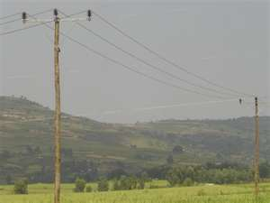
Figure 1: Rural Electricity and ICT could create a new opportunity for future of extension
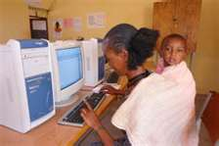
Figure 2: A Rural woman using computers

Recognition of the locale-specific nature of farming systems and the agricultural information systems support the decentralization and devolution of extension services. This recognition also implies that extension workers and farmers can be jointly involved in the verification and adaptation of new technology, and thus that the extension workers acknowledge and respect farmers as experimenters, developers, and adapters of technology. They could thus devote more energy on facilitating communication within their local areas. The devolution of extension services to become local organizations is a reasonable corollary of this. Developments in mass media technology, already apparent over a decade ago, will continue to support this localization of extension effort.

ICT refers to technology which is used for the exchange of data through interaction or transmission. It ranges from radio to satellite, mobile phone. Such tools have become more accessible and affordable for the holder farmer today. ICT enabled extension services are useful for improving the capacity and livelihoods of poor smallholders. One of the best examples of these services is the use of the mobile phone short messaging system (SMS) to provide livestock price information in Ethiopia. This can be expanded into providing information to farmers about commodity prices, and other advisory services from a database with information. ICT-enabled extension services can also be a tool to provide information on local weather forecasts for farmers and pastoralists.

In resource-constrained environments one can use satellites or remote sensors (to gather temperature data), Internet (to store large amounts of data), and mobile phones (to disseminate temperature information to remote farmers cheaply). This would help to prevent crop losses and mitigate effects from natural adversity. Software can be used to support financial management for cooperatives a practice which is becoming more relevant in smallholder farming. Simple accounting software has allowed cooperatives to manage production, aggregation, and sales with increased accuracy.

3.2 ICT as a tool for Extension
The developed world has well developed ICT infrastructure which contributes to agricultural information knowledge sharing and linkage. However in Ethiopia and similar countries ICT development in rural areas is still in its early stages to heavily depend on it for extension even if it is beginning to be used in various capacity building programs. ICT can be applied in extension by creating online extension services for diagnosis of production problems, provision of information on new technologies and marketing etc., continuous learning for extension workers, facilitation of networking, interactive communication and partnership among the extension and research system among others.

Internet speeds and cell phone coverage is increasing rapidly in Ethiopia where even rural areas people are using it to access market information for their produce. In addition the connecting of communities to electricity is expanding into rural areas. This coupled with the emerging of rural towns and expansion of the road infrastructure is expanding the opportunities for use of ICT in extension. More recently social media have been found to have great potential and can be used for the facilitation of knowledge sharing and collaboration in agriculture.

Assessment tasks for Topic Three
(Click on this hyperlink to see the mark allocation)

Objective of the assessment tasks
To enhance your understanding with respect to societal changes that requires changes in the use of the more conventional methods and techniques of agricultural Extension

Why do it? (Motivation for doing the activity)
There is a need for you to develop a common understanding on the changes required in the conventional methods and techniques of agricultural extension within the current context of societal change.

WHAT (to do)
Form a small group in a semi-circular seating arrangement and complete the following tasks:

- Watch a video film ( Video\Infrastructures.wmv) about changes in the rural society brought about due to infrastructural development.
- Based on what you learned through watching the video, as a group discuss the changes that you think should occur in agricultural extension methods and techniques.
- What are the lessons you learned from the video? Discuss this with your group (45 minutes)
- Based on your group responses prepare and deliver 10 minute PowerPoint presentation to the entire class (20minutes)
- After each group presentation there should be further group discussion in which you reflect on the lessons learnt (1 hour)
- Prepare and submit a two page group report on the lessons to your instructor.

Please note: Make sure that you include the names of ALL the group members at the top of your submission

Feedback from the group / facilitators
On conclusion of the activities we will share and discuss on the presentations made and work toward a common understanding.

Summary of the topic
This topic argues that the condition of ICT infrastructure rural areas continues to improve in Ethiopia and elsewhere in Africa. Given these developments, extension has to look into exploiting the available opportunities for e-extension. This approach implies the increased need for capacity building in the area of infrastructure and human resources development.

References and further reading materials
These materials can be accessed by either clicking on the hyperlinks or can be found in the library at your institution.

- FAO 1993. The potentials of microcomputers in support of agricultural extension, education and training. Rome: FAO.

- ICT in Agriculture Sourcebook: Connecting Smallholders to Knowledge, Networks, and Institutions. Found at :http://www.ictinagriculture.org/ictinag/node/105

PowerPoint presentation is attached here

Topic Four: Extension Methods and Approaches

In the previous topic we discussed about how the conditions of ICT infrastructure in rural areas is improving in Ethiopia and elsewhere in Africa and how to exploit the available opportunity for e-extension. Now under this topic we are going to discuss about the alternative approaches of extension, alternative ways of organizing it, and main approaches so far used globally.

Learning objective
To enable you to understand major goals and alternative ways of organizing extension services.
Learning outcome
At the end of this topic you should be able to reorganize alternative extension services of the different approaches.

Table 6: Assessment for topic 4
Assessment
Task | Description | Done by | Estimated time on task | Mark Allocation
Field work | Field visits followed by development of a video | Group work | One day | 2
Field work | 4 Pages of report | Group work | 4 hours | 3
Field work | 5 minute PowerPoint presentation | Group work | 5 minutes | 2
Video\Research Extension Framers Linkage.wmv Reflection on video | A three minute video on participation of farmers on extension will be shown | Group work | 15 minutes | 1
Assignment | A four pages of assessment report | Group work | 2.5 hours | 2
TOTAL MARKS |  |  |  | 10

4.1 Evolution of Alternative Agricultural Extension Approaches
Different technology generation and dissemination approaches have been developed and implemented in developing countries since the early 1950s. A review of the principal approaches is presented in the following sections. Transfer of information and skills has existed since the emergence of permanent agriculture. Today's practice however is different in that the process is dominated by organizations, and its scope has extended from disconnected local events to a complicated large scale, and even worldwide activity.

4.2 Extension goals
In the past, the goal of extension work was shaped based on the features of the system such as its organizational structure, the choice of clientele, its operational design, and the methods used as well as the interest of the funding agency. However, two broader goals can be identified namely, technology transfer and human resource development, in other words a technical or a broader socioeconomic view of development.

- Technology Transfer
The research-extension-farmer linkage, especially in developing countries, is based on a simple model referred to as the Research-Extension-Farmers linear model. It is a conventional way of transferring technology developed in research system. Research plays a crucial role in contributing to the development of new technology.

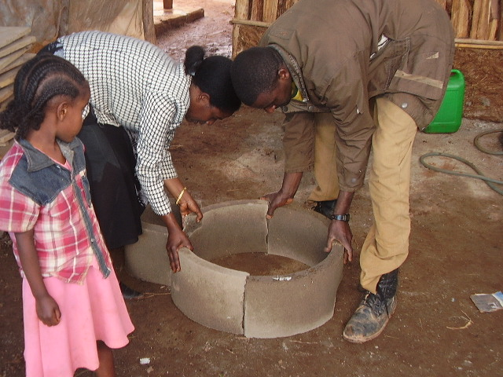
Figure 3: Energy saving stove technology introduction

- Human Resource Development
The human resource goal of extension is broader than that for technology transfer however the goals are interrelated. Currently there is a view that human resource development is a genuine goal of extension. The fact that Human resource development is an important desired outcome of any extension system explains the role of extension in empowerment of the people.

4.3 Extension Approaches /Extension delivery alternatives
The choice of alternatives in delivering extension depends on many factors: The following are the main alternative extension delivery mechanisms. Each mechanism of providing extension services has its own features, advantages and disadvantages. These alternatives are as follows:
- Public or private, Government or nongovernment
- Profit, non-profit or cost-recovery based
- General, commodity based or Multipurpose or single purpose
- Technology driven or need oriented

For further reading on this section refer to the recommended reading materials at the end of the topic.

4.4 Extension Approaches in Ethiopia
In Ethiopia a range of extension approaches have been used. These will be discussed in relation to the objectives, activities, and organizing agents and clients of each approach. You will find out about the interesting historical developments in extension approaches in the linked recommended reading materials.
The establishment of the land grant college at Haramaya (the then Alemaya college of Agriculture and Mechanical Arts), Agricultural technical schools (Ambo and Jimma) as well as area development projects such as ARDU, WADU and CADU, and the regular extension activities under the Ministry of Agriculture are the main developments in the history of agricultural extension in Ethiopia.
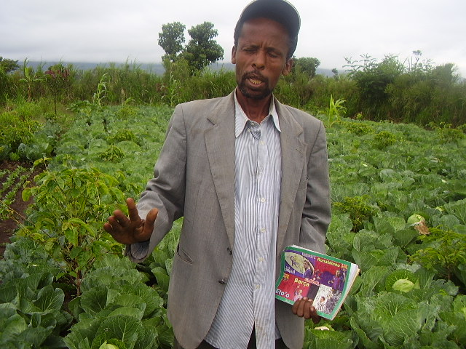
Figure 4: A farmer discussing about high yielding variety of vegetable crop

4.5 Approaches in Supporting Agricultural Innovation
Supporting approaches of agricultural innovation has changed over time. The National Agricultural Research Systems (NARS) were the dominant approach before 1990. In the 1990s, the Agricultural Knowledge and Information System (AKIS) become prominent concept while recently; the concept of Agricultural Innovation Systems (AIS) is dominating literatures gaining preference in terms of strengthening the broad spectrum of involvement of multiple actors in science and technology development and dissemination of innovations.

In the following sections we will be discussing the similarity, differences, purpose, actors, strengths and limitations of the three approaches to supporting agricultural innovations.

4.6 National Agricultural Research Systems (NARS)
The activities based on the National agricultural research systems (NARS) concept focus on a strategy for strengthening research organizations by providing them with infrastructure facilities, management capacity and other institutional support. The NARS comprises an institutional system which is responsible for coordinating and implementing scientific research that contributes to the growth of agricultural and natural resources.

4.7 Agricultural Knowledge and Information System (AKIS)
The Agricultural knowledge and information system (AKIS) links and integrates farmers, researchers, Agricultural educationists, extensionists and encourages them to exploit and promote reciprocated learning and to create, share, and make use of agriculture-related technology, knowledge and information. Farmer communities are at the centre of the knowledge triangle created. The AKIS concept recognizes that research is not the only means of generating or gaining access to knowledge. Although the AKIS also focuses on research supply, it gives much consideration to the links among the knowledge actors and the recognition of farmers’ demand.

4.8 Innovation Systems
Supporting research systems possibly will add to the delivery of new knowledge and technologies. However, this approach may not essentially advance the capacity for innovation in the agricultural sector as a whole. In recent times the model of an innovation system that takes into consideration holistic planning knowledge production and use, has gained in popularity. It focuses on enabling attitudes, practices, governance, and policies that permit the knowledge to be used for productive purposes. An innovation system can be referred to as system comprising of actors in the agricultural sectors that collectively demand and supply knowledge and technology, and the mechanisms and the rules by which these different agents interact.

The innovation systems focus not only on the science suppliers but also on the interaction and totality of actors involved in innovation. It focuses on the factors that affect the demand and use of new and existing knowledge in an original and practical way. Thus innovation is viewed within a socioeconomic dimension and not simply as discovery and invention. The scope of innovation includes not only technology and production but also takes into consideration a variety of factors such as attitudes, practices, and new ways of working, management, and marketing changes. The innovation systems concept emphasizes adaptive tendencies as a central element of innovation capacity.

Assessment tasks for Topic Four
(Click on the hyperlink to see the mark allocation table)

Objective of the assessment
To enhance your understanding of how alternative extension services and approaches could be organized.

Why do it? (Motivation for doing the activity)

This activity will help the class develop a common understanding of the different approaches and services of agricultural extension.

What (to do)
- Form a small group and sitting in a semi-circle discuss the following 3 questions. (45 minutes)
- With the help of your instructor select any of the eight Extension approaches and assess the major characteristics, weakness and strengths of the approach.
- What are the series of extension approaches and programs implemented since 1950s?
- Choose any one of the extension approaches used in Ethiopia and discuss their successes, strengths, and weaknesses.
- Collect the group responses to the questions and use them to prepare a 10 minute PowerPoint presentation and present it to the entire class (15 minutes)
- Have a further group discussion based on the presentations (1 hour)
- Watch a video (Video\SEPs.wmv) on the Participatory Extension Approach based on a village stay of mid-career students. Then carry out the following tasks:
  - Reflect on the video shown and the lessons learnt
  - Develop a video case
- Review the findings of the 3 activities you have just completed and individually prepare and submit a 2 page report on these findings.
- A field visit will be arranged at a later date to develop cases on innovation systems analysis and gaps.

Please note: Although only 1 person is supposed to submit the group report make sure that the names of ALL the group members are included.

Feedback from the group / facilitators
On conclusion of the activities we will share and discuss the presentations and work toward a common understanding

Summary of the Topic

This topic argues about the objectives of Extension, ranges of alternative approaches, purpose of establishments of various institutions and projects which have led to the development of Extension and changing approaches for supporting Agricultural innovation.

References and further reading materials
These materials can be accessed by either clicking on the hyperlinks or can be found in the library at your institution.

- Agricultural and Rural Extension Worldwide,
http://www.fao.org/docrep/004/y2709e/y2709e05.htm

- Belay, K. (2003), Agricultural Extension in Ethiopia: The Case of Participatory Demonstration and Training Extension System, Journal of Social Development in Africa, 18 (1):49-83.

- Belay, K. (2008). Linkage of Higher Education with Agricultural Research, Extension and Development in Ethiopia, Higher Education Policy, 21 (2): 275-299.

Belay ,K.Evolution of Agricultural Extension Approaches in Sub-Saharan Africa, a Literature Review

- Belay ,K. State of Agricultural Extension in the Countrythe Contribution of Sasakawa Global 2000 (SG 2000) to Ethiopia

- Rajalahti, R, Janssen, W. and Pehu, E. (2008), Agricultural Innovation Systems: From Diagnostic toward Operational Practices, Agricultural and Rural Development Discussion Paper 38, World Bank, Washington, DC http://www.ipms-ethiopia.org/Training-Materials

- Daniel, T. 2010 Extension strategies and programs in Pastoral areas, chapter of a book on Land use in pastoral areas PFE

- Vince Ashworth. 2005 The challenges of change for agricultural extension in Ethiopia

PowerPoint presentation is attached here

Topic Five: Conceptual Foundation on Extension Impact

In the previous topic we discussed the different extension approaches. We also looked in to extension approaches that have been tried globally and we also learned about various Ethiopian extension approaches through the discussions and assignments you did. Now under this topic we are going to discuss about relevant concepts used to measure extension impact.

Learning objective
To introduce you to the conceptual themes of measuring extension impacts

Learning outcome
At the end of the topic you should be able to apply the methods of measuring the impact of extension.

5.1 The Impact of Agricultural Extension
Assessing the impact of extension is a difficult task. Even if it is difficult to assess the impact of extension on production, the improvements in the use of improved technologies and the subsequent increase in productivity levels in areas where intensive extension programs have been undertaken are considered a positive contribution of agricultural extension. In Ethiopia, it has been reported that extension programs have had a positive and significant impact on food security and poverty reduction in general. Likewise, the programs have impacted household fixed assets positively and significantly. Therefore, it is recommended to policy makers that investing in extension contributes to reduction in poverty.

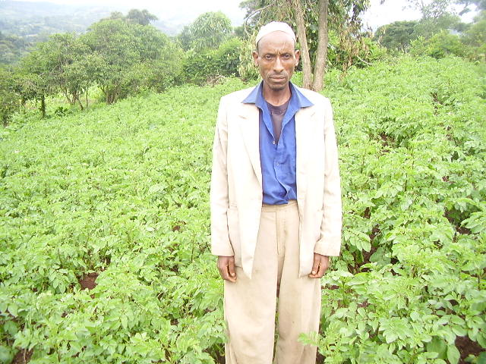
Figure 5: A farmer grown high yielding variety of potato crop

5.2 Measuring Extension Impact
Most extension impact studies do not consider all aspects when measuring impacts. Most methods used to measure impacts show a statistical relationship between the quantity of extension services made available to farmers and increases in awareness, knowledge, adoption, and productivity. Farmer awareness, knowledge, adoption of technology or practices (AKAP) and changes in farmers' productivity is a convenient method to see the ultimate economic impact of extension. Changes in farmer behaviour will also be reflected in quantities of goods produced, the quantities of inputs used, and in their prices. These, in turn, can be measured as surplus, which is the added value of goods produced from a given set of inputs made possible by the extension activities.

While the AKAP sequence has a natural ordering, resources in the form of skills and activities by both extension staff and farmers are required. Knowledge requires awareness, experience, observation, and the critical ability to evaluate data and evidence. Knowledge leads to adoption, but adoption does not necessarily lead to productivity. Productivity depends not only on the adoption of technically efficient practices but also on infrastructure and marketing. The AKAP sequencing is related to the flow of new technical information, and to the existing state of un-adopted technology. We can see this interrelationship more clearly in the context of productivity gaps.

5.3 Statistical Methods and Issues for Economic Evaluation
Estimation of extension impact is subject to a number of problems which are also faced in the evaluation of other public sector investments. The approach commonly used is a statistical analysis relying on data measuring extension activities at the farm level. Alternatively, statistical analysis can be undertaken where observations refer to aggregate extension services supplied to a given region in a specific time period.

Summary of the topic
You have learnt that it is important to measure whether extension services are achieving their intended socio-economic impact or not. There are two conceptual themes which are relevant to measuring extension impacts. These are the awareness-knowledge-adoption-productivity (AKAP) sequence and the "growth gap" interrelationship between extension and research.

References and further reading materials
These materials can be accessed by either clicking on the hyperlinks or can be found in the library at your institution.

- Agricultural and Rural Extension Worldwide,
http://www.fao.org/docrep/004/y2709e/y2709e05.htm

- Beyene, 2011. Lessons from impact evaluation studies on agricultural Extension in sub Saharan Africa: why contradictory in results

- Judy L. Baker, 1999.Evaluating the Poverty Impact of Projects: A Handbook for Practitioners. Found at: www.pnud.ne/rense/Bibliothèque/BM01.pdf

PowerPoint presentation is attached here
MAP: From Evidence to Policy

Topic Six: Extension Policy and Organizational Issues

In the previous topic we discussed about the measurement of extension impact. You also shared practical examples from your field experience on measuring the impacts of extension. By now you are familiar with the economic impacts of extension efforts than before. Now under the current topic we shall discuss policy and organizational issues in extension.

Learning Objective
The objective of this topic is to acquaint you with Agricultural extension policy and organization issues

Learning outcome
At the end of the topic the student should be able to analyse extension policies and design sound policies applied in sustainable agriculture and rural development.

Table 7: Assessment for Topic 6
Assessment

Task | Description | Done by | Estimated time on task | Mark Allocation
Assignment | A two page assessment report | Group work | 3 hr 25 minutes | 3
TOTAL MARKS |  |  |  | 3

6.1 Extension Policy
Maintaining effective extension policy is a recommended practice for the normal and stable functioning of extension. Lack of realistic and stable extension policy is reflected in lack of clarity in mission, functions, clients, organizational structures, program priority and responsiveness to changes in the agricultural sector. Therefore, effective extension service delivery requires formulating clear, comprehensive and responsive policy at different levels in the nation.

- The Scope of Extension Policy
In Ethiopia, Agricultural extension policy is a part of national development, poverty reduction policy in general and of agricultural and rural development policy in particular. Therefore, agricultural extension is the main policy instrument which governments use to stimulate agricultural and rural development. The Ethiopian extension policy declares coordination with research, input supply, and credit and marketing systems, as well as some flexibility to reflect agro-ecological diversity. The policy has defined the mission and goals for agricultural extension, the responsible agencies and personnel, the clientele to be served, and the broad programmatic areas to be addressed.

- Extension Mission and Goals
Although extension has a broad and universal significance, its mission and goals may need to be adjusted according to national objectives and the context and stage of agricultural and rural development in a given country. This mission then should be reflected in a statement of goals and objectives that are agreed upon and assigned to extension in a supporting policy document.

- Extension Approaches and Functions
National extension systems can pursue one of several different extension approaches in implementing extension policy. Most extension systems in Ethiopia as well as similar developing countries give primary attention to technology transfer, given national agricultural policies that emphasize increasing food production and achieving national food security. Therefore, the extension approach pursued should reflect the mission of extension, and thus define the functions, programmes, and tasks that should be carried out by the extension.

- Coverage of Extension
Broadly speaking, the subject matter of extension is implied in the mission statement and even in the title of the extension service. What differentiates between agricultural and rural extension is the subject matter that the extension service will include in its programmes and the target groups to be served among the rural population. Very narrow subject-matter coverage such as the promotion of food and cash crops and animal production may invite a costly proliferation of several specialized and uncoordinated extension initiatives. Broader subject-matter coverage, such as promoting the entire farming system, sustainable agricultural and rural development, leads to a more unified agricultural extension system. Another issue is whether the extension system should include socioeconomic and sustainable development messages.

- Geographical Coverage
Geographical coverage can be an important policy issue because of both political and cost implications. Most political leaders try to influence the geographical coverage of effective extension service. When the extension funding is to be provided by different levels of government (cost sharing), then the structure of extension reflect these different sources of funding. Extension personnel will tend to be more responsible to those levels of government that provide extension funding. For example, if local governmental units provide some extension funding, then extension personnel will tend to be more responsive to the needs of farmers and political leaders within these local government units than they are if all funding comes from the national government. In short, having multiple sources of funding, especially from different levels of government, will increase the number of shareholders and result in an extension system that has a broader base of support and more responsive to stakeholders at the local level.

- Clientele or Target Beneficiaries
A common criticism of extension services in developing countries is their neglect of the vast number of small-scale farmers in favour of fewer numbers of large farmers, or the very limited attention given to women farmers. This is a policy issue because of its implications for the mission and goals of extension, the priorities for technology generation by research, the cost-effectiveness of extension, and the socio-political goals of growth with equity and poverty alleviation.

6.2 Organizational Issues in Extension Agencies
Under this sub topic four different forms of extension organizations and their distinguishing feature will be discussed. The extension organization embodies different aspects of an extension system, and it provides the management framework for the extension service. This is a policy issue because it affects the scope, magnitude, and structure of the extension system, including factors such as control, cost-effectiveness, and the impact of the extension service. For purposes of illustration, examples of different countries will also be discussed. The other policy issues needed to address in a national extension programs includes the quality and number of the technical and professional staff in the organization, stability, and funding.

- Forms of extension organizations
Such organizations can either be:
- Centralized organizations-Function from the top down. Central planning and control dominates, and clientele participation and feedback in the programme are generally limited.
- Decentralized organizations- It is characterized by de-centralized extension planning and programming, management, and the control of activities and resources are vested in regional or local government
- Cooperative types of extension organization and funding- A unique feature of this form of extension organization is the partnership between the national and local governments in funding, programming, and managing the activities and resources of extension.

- Pluralistic forms of a national extension system.
This is an emerging form of extension organization by which many publicly and/or privately funded organizations, including nongovernmental organizations (NGOs), are broadly involving in agricultural extension programmes.

6.3 Extension Staffing Issues
By the nature of the mission and work that an extension system carries out, its worth to society is largely reflected by the quality and number of the technical and professional staff in the organization. These are issues that need to be addressed in the extension policy.

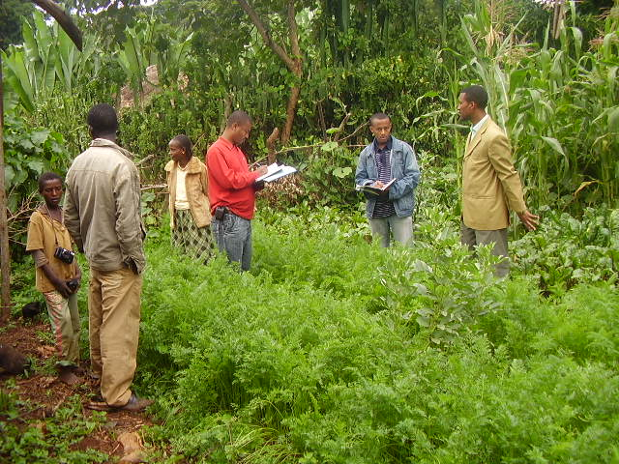
Figure 6: Field monitoring by extension staff from Haramaya University on performance of improved technology

6.4 Extension Funding
The most difficult and challenging policy issue facing extension today is to secure a stable source of funding. With the widespread trend to cut government budgets, including structural adjustment programmes, many policy makers have the impression that public extension is both expensive and a drain on the government's limited resources.

In countries where funding support to extension is low, the funding for extension should be increased to levels that reflect the anticipated economic rates of return and the social benefits when public funds are properly invested and managed. The issue of funding extension continues to be the most difficult policy issue faced by extension. This issue is complicated by the increased demand for more extension services on the part of increasing numbers of farm households who have fewer land and water resources. Furthermore, extension is being called to integrate sustainable development messages into its extension programmes.

- Stability
A good extension policy promotes extension system stability, yet allows sufficient flexibility to reflect the dynamic nature of the agricultural sector. Extension should not be rigid; rather, "It should be responsive to all major groups of farm people and sufficiently inclusive to allow public, private, and non-governmental organizations to contribute fully to the agricultural development goals of the country". Frequent organizational changes within extension system, such as being transferred from one government agency to another, directly impact the organization's effectiveness. Such instability is costly in that trained staffs are poorly utilized and opportunities for improved productivity will be lost.

Assessment tasks for topic six
(Click on this hyperlink to see the mark allocation)

Objective of the assessment task
To enhance your understanding of extension policies and how such policies are applied in sustainable agriculture and rural development

Why do it? (Motivation for doing the activity)

To enable you to analyse the extension policies and extension policies in sustainable agriculture and rural development

WHAT (to do)
Form a small group in a semi-circle seating arrangement and then complete the following tasks using the following attached policy documents as references.

Agricultural Growth Program (AGP)
Growth and Transformational Plan

- Refer to the Ethiopian agricultural extension and rural development policy documents and then as a group, analyse how the policies were formulated and reflect on the lessons learnt.
- Using your group responses prepare and then give a 10 minute PowerPoint presentation to the whole class
- After the class presentations continue your group discussions. (15 minutes)
- Prepare a five page group report of your analysis and the lessons learnt. (3 hrs)
Please note: Make sure that you include the names of ALL the group members.
.

Feedback from the group / facilitators
On conclusion of the activities we will share and discuss the various presentations and work toward a common understanding.

Summary of the topic
We have learnt that the problems of maintaining an effective agricultural extension service can be related to the lack of a rational policy or an unstable policy framework. Lessons from the past can serve as a guide to the future in formulating relevant and useful extension policies in developing countries. There is a need to devise policies that address both farmers' needs and environmental concerns. The other policy issues needed to address in a national extension programs should be the quality and number of the technical and professional staff in the organization, stability, and funding stability.

References and further reading materials

These materials can be accessed by either clicking on the hyperlinks or can be found in the library at your institution.

- Agricultural extension worldwide, www.fao.org

- Ministry of Agriculture and Rural development 2010 Community level participatory planning agricultural growth program Addis Ababa

- Ministry of agriculture 2009 Agriculture Growth Programme (AGP) Guideline on Market Centres and Physical Market Development MOA

- Ministry of agriculture, 2009 Farmers training centers OPERATIONAL MANUAL /GUIDELINE/ Addis Ababa

- Ministry of Agriculture and Rural development, 2010 Guideline on Farmers’ Innovations and Adaptive Research

PowerPoint presentation is attached here

Topic Seven: Organizational Linkages in Agricultural Extension Service

In the previous topic we discussed agricultural extension policy and organizational issues applied to many developing countries with a specific focus on Ethiopia. By now you should be able to analyse similar policies in the future. Now under the current topic we shall discuss on organizational linkages in agricultural extension services. You will be given time for discussion, and do assignments.

Learning objective
The objective of this topic is to acquaint you with the need for extension to work with farmers and their organizations to strengthen linkages in research and extension.

Learning outcome
On completion of this topic you should be able to mobilize, organize and empower farmers to actively participate in research and extension systems.

Table 8: Assessment for topic 7
Assessment

Task | Description | Done by | Estimated time on task | Mark Allocation
Assignment | A two page assessment report | Group work | 3 hrs 25 minutes | 3
TOTAL MARKS |  |  |  | 3

7.1 The New Roles of Extension
Historically, extension has mainly involved in technology transfer. However, recently the need for farmer cooperatives in providing various input, marketing, and educational services to the farmers is growing. The demand for knowledge and skill in organizing farmers in to effective cooperative has also increased. For instance, in Ethiopia cooperatives of different kinds are flourishing both the number and capital. In this aspect extension is expected to take a leading role in organizing and empowering farmers. Community mobilization and facilitation skills have to be part of training and education programmes for both the medium and higher level Extension professionals.

- Empowering Role of Extension
The empowerment role can be a foundation of the new approach to extension. Extension professionals need to develop a new philosophy where their role is to help farmers and rural communities organize themselves and take charge of their growth and development.

- Human Resource Development Role
The human resource development approach empowers people and has implication to all other roles. The entire philosophy of human capacity building is to encourage rural communities to understand and to improve their planning, implementation, and monitoring skills of development programs.

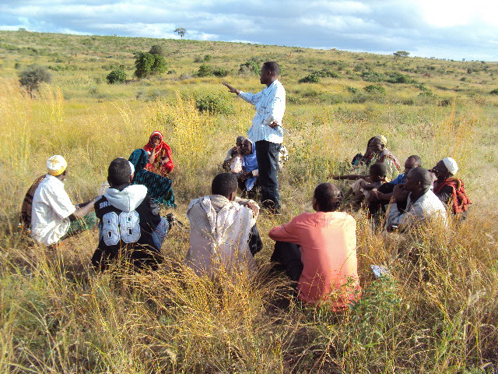
Figure 7: Community Training on natural resource management

7.2 Farmer organizations
Farmer organizations (FOs) can be grouped into two types:

- Community-based, resource-oriented organizations. This type of organization could be a community level cooperative or association dealing with inputs needed by the members to enhance the productivity of their businesses based on land, water, or animals.

This group of organizations can generate income from the sale of inputs and outputs. The income can then be put back into the organization by spending it on extension, data generation, business planning, and administration. It is essential to have professional and honest management with constant monitoring and periodic rounds of evaluation.

- Commodity-based, market- oriented organizations. These organizations specialize in a single commodity and opt for value-added products which have expanded markets. They are designated as output-dominated organizations. These FOs are generally not small and have to operate in a competitive environment. Research, input supply, extension, credit, collection of produce, processing, and marketing are all integrated to maximize the returns on the investments of the members who invested in the collective enterprise.

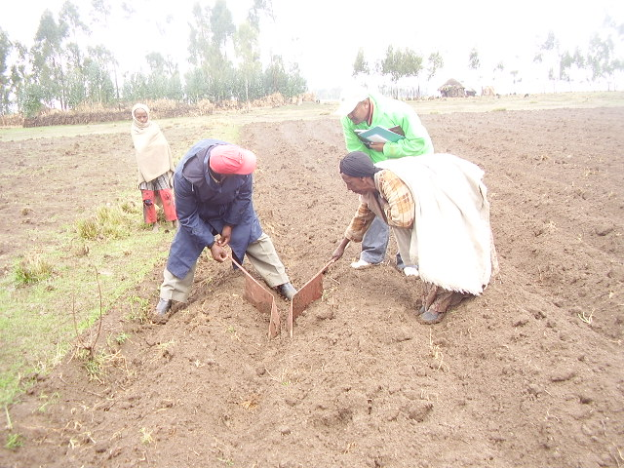
Figure 8: Method Demonstration on Broad Based Maker Technology

Assessment tasks for topic seven
(Click on the hyperlink to see the mark allocation)

Objective of the assessment tasks
The task aims to enhance your understanding of how to empower farmers so that they can actively participate in research and extension systems.

Why do it? (Motivation for doing the activity)

The tasks will teach you how to motivate farmers to organize themselves.

What (to do)
Form a small group and sit in a semi-circle and complete the following tasks:
- Discuss ways in which farmers could be organized into a group.
- Discuss the social action model with regards to organizing farmers.
- Collect the group responses and use them to prepare and then present a 10 minute PowerPoint to the class
- Continue with group discussions after the class presentations (15minutes)
- Prepare and submit 2 pages of group report on your findings. (3 hours)

Please note: Make sure that you include the names of ALL the group members at the top of your submission

Feedback from the group/facilitators)
On conclusion of the activities we will share and discuss the various presentations and work towards a common understanding.

Summary of the topic
You have learned that extension facilitates the empowerment of farmers through their organizations, by allowing more local resources to be mobilized and helping in the efficient utilization of resources on a sustainable basis. Extension has becoming increasingly demanding, location-specific and flexible, and often the need for quick decisions which calls for extension reforms. In this regard the main direction of reform extension service is towards decentralization of services with the firm belief that the services should be closer to the client at grass root level, so that it becomes more relevant.

References and further reading materiaLs
These materials can be accessed by either clicking on the hyperlinks or can be found in the library at your institution.

- Agricultural extension worldwide, www.fao.org

- Belay, K. 2008, Linkage of Higher Education with Agricultural Research, Extension and Development in Ethiopia, Higher Education Policy, 21 (2): 275-299.

- Belay ,K ,2003 State of Agricultural Extension in the Country the Contribution of Sasakawa Global 2000 (SG 2000) to Ethiopia

- Belay Kassa2003 Agricultural research and extension linkages in Ethiopia Extension A historical survey

PowerPoint presentation is attached here

Topic Eight: Gender Issues in Agriculture Extension

In the previous topic we discussed the growing role of extension in organizing and empowering farmers. Cooperatives are increasing and diversifying their activities and now play an important role in improving livelihoods of the rural community. Their contribution to the national economies is also improving. They are becoming key actors in innovation systems. In the current topic we shall discuss the Gender dimension of Agricultural extension services.

Learning objective
The objective of this topic is to give you insights into the Gender issues relating to agricultural extension.

Learning outcome
The students should be able to do gender analysis in Agricultural extension and design strategies to improve Gender equity in extension programs/ services

Table 9: Assessment for topic 8
Assessment

Task | Description | Done by | Estimated time on task | Mark Allocation
Field visit | Gender analysis exercise | Group work | 6 hrs | 2
Assignment | A four page assessment report | Group work | 3 hrs 35 minutes | 3
TOTAL MARKS |  |  |  | 5

8.1 Gender in Agricultural Extension
Classically in extension, a household is conceptualized as a programme unit. A household consists of individuals working in similar ways towards a common goal under the leadership of a male head. However, in reality the household is a much more complex and dynamic social entity. While it is useful to draw attention to the fact that there is division of labour along gender lines and it has profound implications for the organization of agriculture, men's and women's responsibilities and privileges vary along socio-cultural and socioeconomic lines specific to a particular time and place. The key role played by women in agriculture in the past was generally not acknowledged in government data and decision-making. This situation has changed over the last two or three decades, and much has been achieved in giving recognition to the importance of women in the agricultural sector. Gender mainstreaming is the current global approach in advancing gender equality and equity. At the level of national government there is a move towards incorporating a gender perspective into policies, plans, programmes and projects to ensure that these impact on women and men in an equitable way.

The advantage of a gender mainstreaming approach is that it allows for the advancement of gender equality and equity regardless of whether it is women or men who are disadvantaged and whose position needs to be addressed. In some regions and sectors, for example, women may be in a more advantageous position than men and gender analysis can reveal this. However, given the fact that historically it is women, who have tended to be disadvantaged, and that a number of inequalities remain, projects and programmes may need to target women specifically in order to bring about gender equality.

Much has been written about the past failures of government extension services in reaching women farmers and the cultural bias which has in many countries prevented women from active participation in group training, extension meetings and most importantly, access to inputs such as fertiliser and credit. These services have been predominantly staffed by men and they have tended to direct their services to male farmers or heads of households, excluding female-headed households and women members of male-headed households. However, any consideration of gender in relation to these points must be considered in the context of the changes which are taking place.

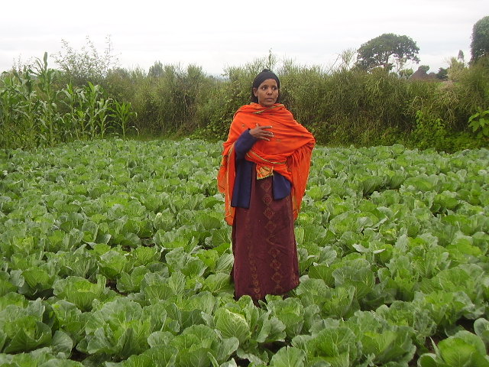
Figure 9: A woman farmer participated in growing high yielding vegetable variety

8.2 Improving Women's Access to Extension
Agricultural extension strategies traditionally have focused on increasing production of cash crops by providing men with training, information, and access to inputs and services. This male bias is illustrated in farmer training centres, which have been established to provide residential training on technical subjects. First, most of the training centers do not provide separate washing and sleeping accommodations for women and do not provide facilities for the care of babies or young children which may not attract women to attend training programs. Second, women's daily workloads do not usually allow them to be absent from home for residential training; even attending short courses may cause overwhelming problems in arranging substitute care for children or the home. And third, even where attendance of women is quite high as a proportion of the total, women are given instruction mainly in home management and craft subjects and not in technical agriculture.

Further, extension services have been staffed predominantly by men. Only in countries such as the Philippines have women field staff been deployed in sufficient numbers and with sufficient resources to become effective agents of change among women farmers. The recommended selection criteria, such as title to land, literacy, or cooperative membership, as well as male extension staff's assumptions about women's roles in farming, have usually excluded women involvement.

In some countries, individual contact has been complemented by group contact, but not only, where it may be difficult for male change agents to have any type of contact with individual women. In many cultural settings, group extension significantly increases women's access, because the group context calms fears that may arise out of interacting with a male extension agents.

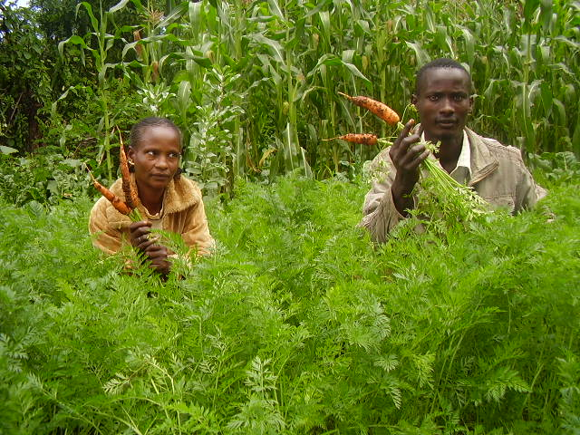
Figure 10: A woman with her partner participated in extension program
- Gender in Research and Extension in Ethiopia
Initially, the conventional extension approach to female farmers was related to the reproductive and domestic roles that underestimated the productive role. The gender aspect was not recognized as a significant factor in designing the rural development strategies used. All the focus of extension services targeting women farmers were associated with their traditionally accepted domestic roles (more on household management, nutrition, cooking, and family planning). This home economics extension program was an important way of reaching women farmers, and could have been more effective if it had been addressing the productive role of women as well.

Development policy makers and planners are becoming increasingly more aware of the crucial contributions of women farmers to agricultural production and food security. Nevertheless, agricultural policies on the whole still do not address the needs of women farmers adequately. Where the roles and needs of women farmers are recognized in policy, this tends not to be adequately translated into practice in agricultural development programs and planning. Agricultural research also gives inadequate attention to women farmers and their needs. As has been pointed out, for example, women and men farmers are often responsible for different agricultural tasks. Research is generally focused on the improvement of production and technologies for men agricultural tasks, while those of women are neglected. In addition to this, female-headed households are even more invisible to researchers, donors and policy makers.

Therefore, despite a remarkable growth and expansion of institutions and programs, Ethiopia’s agricultural research system still has some gaps. These gaps include lack of gender as a part of the research organizational structure, program formation, as well as research trials/experiments initiation, review and approval procedures.

8.3 Improving Training Programmes for Women
The following suggestions are made for improving and redesigning extension training programmes for women:

1. Adapt programmes to women's needs and skills.
2. Allow sufficient time to enable women to acquire new skills and adjust schedules to fit women's existing workloads.
3. Provide training in agricultural and other productive activities, not just home and family welfare topics.
4. Emphasize activities for which there is an actual income-generation potential.
5. Ensure the involvement and full participation of women from poorer and less educated backgrounds.
6. Use trainers who are not only technically competent, but also understand the needs and aspirations of rural women.
7. Provide practical field experience in the use of innovations.
8. Shift more resources to community -based training rather than residential training.

Assessment tasks for topic eight
(Click on the hyperlink to see the mark allocation)

Objective of the assessment tasks
To enhance your understanding of how do gender analysis in agricultural extension.

Why do it? (Motivation for doing the activity)
This activity will teach you how to design suitable strategies to improve gender equity in extension programs/ services.

What (to do)
Complete the following tasks:
- A field visit will be arranged to a village
- At the village you will carry out a gender analysis exercise to assess the extension services offered in the village. (6hours)
- What lessons did you learn from the gender analysis exercise?
- Based on your findings prepare and make a 10 minute PowerPoint presentation to the entire class.
- Continue with group discussions after the class presentations.(25 minutes)
- Prepare and submit a four page report on the lessons learned from the village gender analysis exercise.(3 hours)

Please note: Make sure that you include the names of ALL the group members at the top of your submission

Feedback from the group/facilitators)
On conclusion of the activities we will share and discuss the various presentations and work towards a common understanding.

Summary of the Topic
Agricultural extension strategies traditionally have focused on increasing production of cash crops by providing men with training, information, and access to inputs and services. This male bias is illustrated in farmer training centres, which have been established to provide residential training on technical subjects. However, development policy makers and planners are becoming increasingly more aware of the crucial contributions of women farmers to agricultural production and food security. Nevertheless, agricultural policies on the whole still do not address the needs of women farmers adequately. From your field visit, you have understood the situation through gender analysis in agricultural extension and discussion on how to design improvement in gender equity in extension programs/ services

References and further reading materials
These materials can be accessed by either clicking on the hyperlinks or can be found in the library at your institution.

- Agricultural extension worldwide, www.fao.org

PowerPoint presentation is attached here

Topic Nine: Strengthening Research-Extension-Farmer linkages

In the previous topic we discussed about the gender issues in agricultural extension. The importance of gender analysis and gender mainstreaming were also discussed. By now you have an insight into the gender perspectives of agricultural extension. Now under the current topic we shall discuss on how to strengthen research-extension-farmer linkages.

Learning objective
The objective of this topic is to acquaint you with the important roles that farmers and farmer organizations can play in the development and dissemination of technology.

Learning outcome
You should be able to design mechanisms to improve linkages among the farmers and farmer organizations with the research and extension in innovation systems.

Table 10: Assessment for topic 9
Assessment

Task | Description | Done by | Estimated time on task | Mark Allocation
Assignment | A two page assessment report | Group work | 2.5hours | 2
Assignment | Two page of report | Individual | 2.5 hours | 2
Video\Research Extension Framers Linkage.wmv  Reflection on video | A three minute video will be shown | Group | 1 hour
TOTAL MARKS |  |  |  | 4

9.1 Agricultural Technology Development
Technology is the application of knowledge in practical production purposes. Generally, technology solves problems of humankind for the purpose of improving life. Agricultural technology is related to the daily life of the rural people. Agricultural technologies can be categorized into two major types:
- Material technology, where knowledge is applied into a technological product such as tools, equipment, improved varieties or hybrids, improved breeds of animals.
- Knowledge-based technology such as the technical knowledge, and management skills.
The transfer of material technology to farmers generally involves the production, distribution, and sale of technology products. Therefore, the transfer process for material technology requires training and the disseminating of technical knowledge and management skills. On the other hand, most knowledge-based technologies are generally taught through farmers vocational training programs.

It is important to note that different types of crop or livestock technologies have both hardware and software components. For example, a new crop variety, as a type of material technology, cannot be fully exploited without having a complementary set of agronomic or crop management practices, including pest management. Likewise, improved breeds of livestock generally require higher levels of management, including improved nutrition, housing, and preventive health practices. Therefore, the functional relationship or linkages, both within and across different categories of technology, must be carefully examined.

9.2 Systems Analysis in Technology Development and Transfer
Systems analysis is an effective procedure to use in identifying linkage problems, since it is a problem-solving methodology. A system is an organized set of functions and linkages that can be managed to achieve a specific goal or set of objectives. Every system is a part of larger system, is composed of subsystems and share common properties with other system. Therefore, systems analysis helps in making clear the functions and linkages within an Agricultural technology system and extension system. Technology development and transfer activities in agriculture involve complex, interdisciplinary processes and inter institutional relationships. Systems analysis help managers to analyse, manage, and monitor the various functions and linkages of the technology development and transfer.

9.3 Mechanisms to solve Linkage Problems
Linkage help to improve resource use by avoiding the duplication of effort and ensuring critical tasks which do not fall through the institutional cracks. In an effective ATS, numerous groups depend on one another to develop improved technology to farmers.

The two basic types of linkage mechanisms are organizational and managerial. Organizational mechanisms involve the structural modification of the research and/or extension organization or the organizations that are involved in an ATS. The other major type of linkage mechanism involves a range of managerial interventions. The managerial linkage mechanisms include resource allocation procedures such as allocating time and financial resources for specific linkage activities. The actual types of linkage mechanisms between research and extension could be horizontal linkages which generally involve planning, review, and collaborative activities. While vertical linkages with each organization tend to involve resource allocation, training, and communications etc.

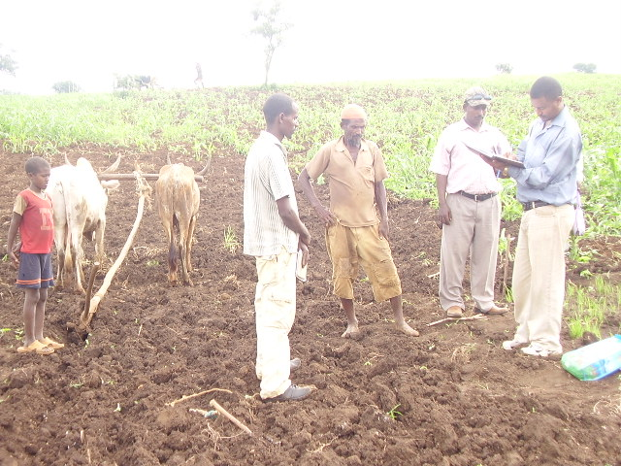
Figure 11: Farmers interaction with extension enhance linkages

9.4 Farmers’ Linkages with their Organizations
Organizational mechanisms within an extension system include improving planning and feedback linkages with farmers and their organizations. Farmers can be formally represented on permanent extension advisory committees at the district, regional, and national levels. In general, members in these advisory committees would be elected by farmers through their respective organizations, from the bottom up. Finally, there should be crop, livestock, and/or a general research advisory panel organized at the provincial and/or national level to provide the opportunity for stakeholder input into research policies, priorities, and other concerns that cut across the research system. At these higher system levels, agribusiness representatives (input suppliers and processors) may join farmers in being represented on these research and extension advisory committees.

In addition to these formal linkage mechanisms, both research and extension personnel would be expected to have regular, informal contacts with different groups of farmers in their respective service area. These linkages would occur through farmer participation in RRA or PRA activities (periodic needs assessment); also, they would occur while carrying out joint on-farm trials and demonstrations and during meetings and field days where farmers would have the opportunity to articulate different problems and concerns. The value of both formal and informal farmer feedback systems depends, in large part, on whether research and extension personnel, including senior management, are listening to what farmers and their representatives are saying. Too often, research and extension have become top-down, bureaucratic organizations that are not receptive or responsive to the needs of farmers. However, to become demand driven, research and extension organizations, directors, specialists and other research and extension personnel must be listening to what farmers are communicating through both informal and formal linkage mechanisms.

Assessment tasks for Topic Nine

(Click on this hyperlink to see the marks allocation)

Objective of the assessment tasks
To enhance your understanding of the roles that farmers and farmer organizations play in the development and dissemination of technology

Why to do it? (Motivation for doing the activity)
These tasks will enable you to better understand the mechanisms used to improve linkages of farmer organizations with the research and extension in innovation systems.

What (to do)
Watch a 10 minute video (Video\Research Extension Framers Linkage.wmv) entitled “Farmer interaction with researcher and extension workers” then answers the following questions:
- What constraints did you observe in the effective rollout of agricultural technologies?
- How these constraints can be overcome?
- What are the lessons you have learnt from the video case?
- As a small group prepare and present to the whole class a 10 minute PowerPoint presentation on the lessons learned.
- After all the presentation further group discussion will follow.

FEEDBACK from the group / facilitators
On conclusion of the activities we will share and discuss on the presentations and work toward a common understanding.

Summary of the topic
You have learnt that there should be close working relationship between agricultural research, extension, farmers and farmer organizations. In addition, the important roles those farmers and their organizations can play, in disseminating technology, providing effective feedback, setting priorities and improving relevance of programs should be appreciated by research and extension.

References and further reading materials
These materials can be accessed by either clicking on the hyperlinks or can be found in the library at your institution.

- Agricultural extension worldwide, www.fao.org

- Belay, K. (2008), Linkage of Higher Education with Agricultural Research, Extension and Development in Ethiopia, Higher Education Policy, 21 (2): 275-299.

- Belay Kassa2003 Agricultural research and extension linkages in Ethiopia Extension: A historical survey.

PowerPoint presentation is attached here

Topic Ten: Extension's Role in Sustainable Agricultural Development

In the previous topic we discussed how to design mechanisms to improve linkages among the farmers and farmer organizations with the research and extension in innovation systems. Now under the current topic we shall discuss about the role of extension in sustainable agricultural development.

Learning Objective
The objective of this topic is to familiarize you with the role extension can play in sustainable agriculture and rural development and the challenges in its application.

Learning outcome
On completion of this topic you should be able to apply extension techniques to overcome the challenges in sustainable agriculture and rural development.

Table 11: Assessment for topic 10
Assessment

Task | Description | Done by | Estimated time on task | Mark Allocation
Assignment | Two page of report | Group | 3 hours | 2
Discussion | PowerPoint presentation | Group | 1o minutes
Reflection | One page report | Group | 1 hour | 1
TOTAL MARKS |  |  |  | 3

10.1 Emerging challenges for sustainable agriculture
In the recent past, agricultural development policies have been remarkably successful at emphasizing external inputs as the means to increase food production. This has led to growth in global consumption of pesticides, inorganic fertilizer, animal feed-stuffs, and tractors and other machinery. These external inputs have, however, raised the issue of environmental concern. The basic challenge for sustainable agriculture is to make better use of internal resources. This can be done by minimizing the external inputs used, by regenerating internal resources more effectively, or by combinations of both at optimum level.

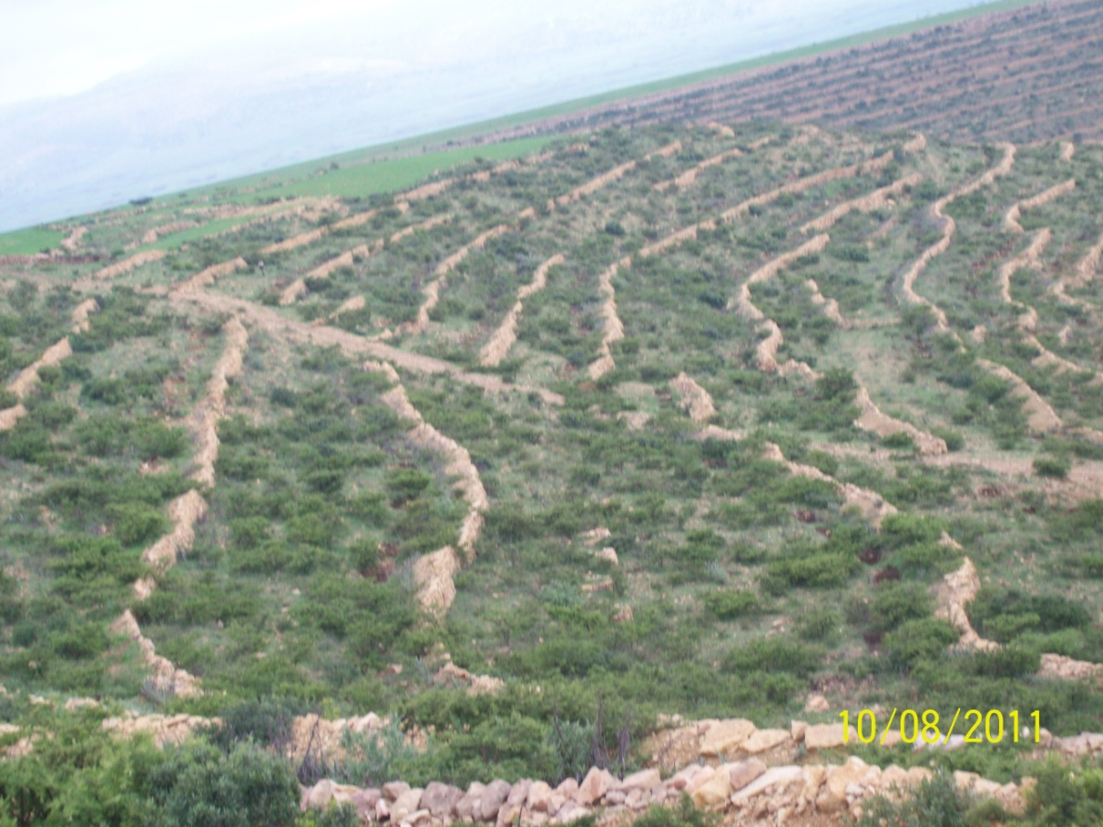
Figure 12: Natural resource Conservation Activity
Evidence is now emerging that regenerative and resource-conserving technologies and practices can bring both environmental and economic benefits for farmers, communities, and nations. They have made use of resource-conserving technologies such as integrated pest management, soil and water conservation, nutrient recycling, multiple cropping, water harvesting, and waste recycling. In all, there has been action by groups and communities at the local level, with farmers becoming experts at managing farms as ecosystems and at collectively managing the watersheds or other resource units of which their farms form a part. However, the challenges in this respect are that most policies still actively encourage use of high level of external inputs and technologies.

- Sustainability and Levels of Action
A necessary condition for sustainable agriculture is that large numbers of farming households must be motivated to participate in resource management. The success of sustainable agriculture therefore, depends not just on the motivations, skills, and knowledge of individual farmers, but on action taken by groups or communities as a whole. This makes the task more challenging.

10.2 Resource-Conserving Technology Development and Transfer
Although many resource-conserving technologies and practices have been widely proven on research stations to be both productive and sustainable, the total number of farmers using them is still small. This is because these technologies involve the substitution of management skills, knowledge, and labour for external inputs. The modern approach to agricultural research and extension however, has to emphasize on comprehensive packages of technologies. Few farmers are able to adopt the whole modern packages of production technologies without considerable adjustments. Part of the problem is that most agricultural research still occurs at the research stations, where scientists experience conditions quite different from those experienced by farmers. This is true of many sustainability-enhancing innovations. Even though resource-conserving technologies are productive and sustainable, if they are imposed on farmers, then they will not be adopted widely.

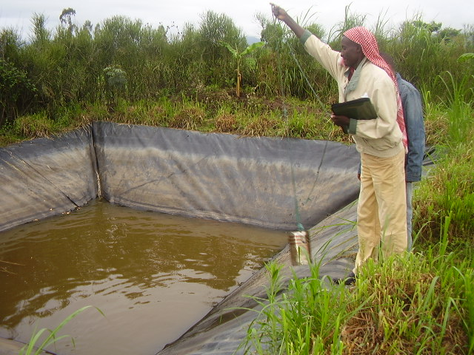
Figure 13: Water conservation technology by a farmer

Alley cropping, an agro-forestry system comprising rows of nitrogen-fixing trees or bushes separated by rows of cereals, has long been the focus of research. Many productive and sustainable systems, needing few or no external inputs, have been developed. They stop erosion, produce food and wood, and can be cropped over long periods. For instance, despite millions of dollars of research expenditure over many years very few farmers have adopted these alley cropping systems as designed.

10.3 Incorporating Farmer Experimentation
In general, modern agricultural science and extension has poorly understood the nature of "indigenous" and rural people knowledge. For many, what rural people know is assumed to be "primitive," "unscientific," or overtaken by development, and so formal research and extension must "transform" what they know so as to "develop" them. An alternative view is that local knowledge is a valuable and underused resource which can be studied, collected, and incorporated into development activities. Neither of these views though, is entirely satisfactory because of the static view of knowledge implied. It is more important to recognize that local people are always involved in active learning, in (re)inventing technologies, in adapting their farming systems and livelihood strategies. Understanding and supporting these processes of agricultural innovation and experimentation have become an important focus in facilitating more sustainable agriculture with its strong locality-specific nature.

The problem with modern agricultural science is that technologies are finalized before farmers get to see them. If new technologies are appropriate and fit a particular farmer's conditions or needs, then they stand a good chance of being adopted.
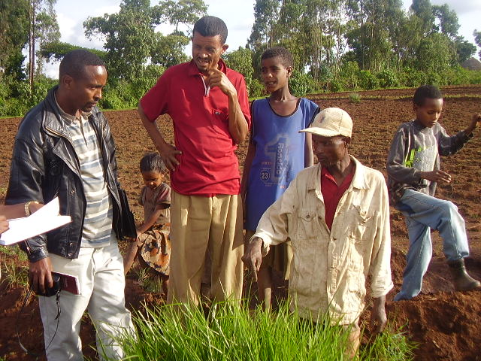
Figure 14: Farmer experimentation on Forage
The alternative is to seek and encourage the involvement of farmers in adapting technologies to their conditions. This constitutes a radical reversal of the normal modes of research and technology generation, because it requires interactive participation of professionals and farmers. Participatory Technology Development (PTD) is the process by which the knowledge and research capacities of farmers are joined with those of scientific institutions, whilst at the same time strengthening local capacities to experiment and innovate. Farmers are encouraged to generate and evaluate indigenous technologies and to choose and adapt external ones on the basis of their own knowledge and value systems.

However, researchers and farmers participate in different ways, depending on the degree of control each actor has over the research process. The most common form of "participatory" research is researcher-designed and implemented, even though it might be conducted on farmers' fields. Many on-farm trials and demonstration plots represent nothing better than passive participation. Less commonly, farmers may implement trials designed by researchers. But greater roles for farmers are even rarer.

Although technology development must involve farmers, it does not mean that scientific research has no place. Research will have to contribute on many fronts, such as in the development of resistant cultivars, knowledge about the life cycles of pests, biological control methods, and suitable crops for erosion control, and processes in nitrogen fixation. Such research also gives insight into complex processes such as the movement of nutrients in the soil and their accessibility for plants. But all these contributions must be seen as providing choices for farmers as they make farm-specific decisions and move the whole farm towards greater sustainability.

10.4 Challenges for Supportive Policy
For sustainable agriculture to succeed, policy formulation must arise in a new way. Policy processes must be enabling and participatory, creating the conditions for sustainable development based more on locally available resources and on local skills and knowledge. Effective policy processes will have to bring together a range of actors and institutions for creative interaction and address multiple realities and unpredictability.

The management of higher level systems, whether common grazing lands, fisheries resources, communal forests, national parks, and watersheds, requires social organization comprising the key stakeholders. All successful moves to more sustainable agriculture have in common coordinated action by groups or communities at the local level. But the problem is that platforms for resource use negotiation generally do not exist, and so need to be created and facilitated.

Different methodologies are emerging to help stakeholders achieve collective resource management capacity. Well known ones are participatory rapid appraisal (PRA) and other related methodologies. In addition, the soft system methodology (SSM) developed for a corporate environment is highly promising for resource use negotiation. For stakeholders who have come to appreciate the fact that they share a problem, SSM takes them through a number of steps which allow them to create a "rich picture" on the basis of their multiple perspectives, reach some accommodation with respect to major causes of the problem, and hence decide on collective action.

Extension has an important role to play here by making visible the interdependence between stakeholders and the extent to which the resource unit on which they depend has been destroyed by their uncoordinated action and the collective impact of their individual activities. It is within policy contexts thus made conducive for sustainable agriculture that technology development and extension can be especially effective.

Assessment tasks for Topic Ten

(Click on this hyperlink to see the marks allocation)

Objective of the assessment tasks
To help you cross-examine conservation technology packages and look in to farmers’ participation

Why do it? (Motivation for doing the activity)
The tasks will enable you to understand conservation technology packages used to overcome the challenges in sustainable agriculture and rural development.

What (to do)
- With the help of your instructor select any conservation technology package in the locality and discuss the extent of farmer participation in it.
- Based on your findings prepare and make a 10 minute PowerPoint presentation to the entire class.
- After the class presentations are completed continue with group discussions and reflection (submit one page report of your reflection exercise (1hour)
- Prepare a two page group report assessing farmer participation in the conservation technology package. (2 hours)

Please note: Although only 1 person is supposed to submit the group report make sure that you include the names of ALL the group members

Feedback from the group / facilitators
On conclusion of the activities we will share and discuss on the presentations and work toward a common understanding

Summary of the topic
We have learned that the basic challenge for sustainable agriculture is to make better use of local internal resources. The location-specific nature of sustainable agriculture implies that extension must make use of farmers' knowledge and work together with farmers in order to make impact. Indigenous technology development practices and farmer experimentation are important for ensuring sustainability.

References and further reading materials
These materials can be accessed by either clicking on the hyperlinks or can be found in the library at your institution.

- Chambers, R., Pacey, A., and Thrupp, L-A. (Eds.). 1989. Farmer first: Farmer innovation and agricultural research. London: Intermediate Technology Publications.

- ILEIA (Center for Information on Low External Input and Sustainable Agriculture) (1989), Participatory Technology Development, Proceedings of the ILEIA Workshop on Operational Approaches forPTD, ILEIA/ETC,Leusden, the Netherlands

PowerPoint presentation is attached here

Topic Eleven: Privatizing Agricultural Extension
In the previous topic we discussed sustainability in agricultural development and the key role of extension. The challenges in balancing the environmental concerns with profitability and policy issues in this regards has also been dealt. Now under this topic we will discuss about the alternative way of delivering extension.

Learning Objectives
The objective of this topic is to help you understand public extension services and the challenges to its effectiveness and the need for change.

Learning Outcome
You should be able to analyse public extension services and design appropriate institutional and organizational mechanisms to apply to different situations.

Table 12: Assessment for topic 11
Assessment

Task | Description | Done by | Estimated time on task | Mark Allocation
 | PowerPoint presentation | Group | 10 minutes | 1
Group Discussion | Two pages of report | Group | 2 hour & 25 minutes | 3
TOTAL MARKS |  |  |  | 4

11.1 Forces for Change
In the developing world the declining relative importance of agriculture for economic growth, the increasing education and wealth of smaller populations of rural producers, and the increasing use of externally purchased inputs have changed the nature of publicly funded extension services. This has led to a questioning of the means of delivery of extension services by governments. In developing countries, however, publicly funded extension is considered to be important as the contribution of agriculture to the national economy and employment is still high, but still questions are raised about the structure and forms of extension delivery.

- Globalization
Coincidental with a shift toward more conservative political ideologies and free-market economics, global developments suggest increased competition in agriculture. While countries will focus more on their comparative advantages, they also in many cases, still face national food security concerns and abject rural poverty.

- Resource Scarcity for Public Extension
Governments in recent times are less able to continue providing all the services previously provided. With costs rising, limited resources available, and changes in the prevailing philosophy of the appropriate extent of government intervention, governments have been slow to increase appropriations for many publicly funded activities. Some functions of government have been curtailed, and others have been privatized. Such changes have been particularly significant in the formerly centrally managed economies.

While the unit cost of extension staff in many countries is low, large staff sizes translate into large government outlays. As a result of financial concerns, many countries have examined alternative structural arrangements, including the feasibility of reducing public sector extension expenditures (with associated staff reductions), changes in tax raising and charges for government extension services, as well as commercialization and privatization. A number of countries have moved towards reducing, recovering, or shifting the burden of the costs associated with provision of public sector agricultural extension, particularly by transferring "private good" functions to private industry.

Concerns about the costs of extension need to be judged against the economic and social returns associated with successful extension. While more research is needed on measuring the economic payoff from investment in public sector extension services, available research tends to indicate, in contrast to some current criticisms, that extension in many instances provides high rates of return and is, therefore, a profitable public investment.

In addition, not all extension expenditure can be measured by benefits from technology transfer and the benefits of extension concerned with human development are difficult to quantify in the short term.

- Strategies for Change
Public sector extension faces criticism for its cost and its lack of efficiency and for not pursuing programmes that foster equity, and is confronted with a number of possibilities for change.

There has been a trend, perceptible throughout various extension systems undergoing adjustment, of greater flexibility and multiple partners in funding agricultural advisory services. The three major policies adopted by government and farm organizations regarding privatization of extension include:
1. Public financing by the taxpayer only for the kinds of services that are of direct concern to the general public
2. Direct charging for some individual services with direct return (in the form of improved income)
3. Mixed funding shared between public and private professional association contributions for some services where the benefits are shared.

A pervading development in new forms of financial support for extension is the trend towards using mixed sources of funding and using strategies aimed at gaining access to additional sources of funding. In several developing countries, public-private extension coordination is already established. Alternative patterns indicate a fostering of private corporate initiatives, encouraging cooperative ventures by farmers, coordinating public-private extension services, and privatizing the public system.

The need for improved and expanded extension activities, together with a strengthening philosophical view of less government involvement in national economies, has led to a number of strategies for changing the way extension services are delivered.

- Commercialization
In some countries agricultural advisory service now operate under user-pay and commercial criteria. The consulting fees received from farmers and contractual arrangements with government for the supply of policy information and rural intelligence to government are the sources of income for the agencies involved in offering the advisory services.
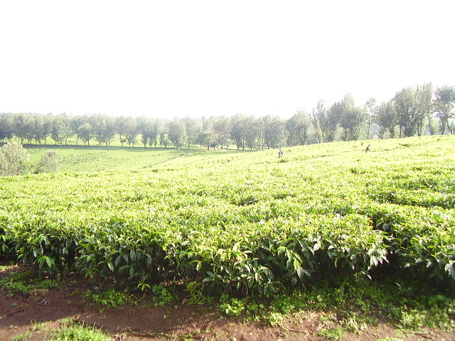
Figure 15: large commercial farm

- Cost Recovery
Other public extension systems have moved toward cost-recovery approaches. Some countries have developed a fee-based system among large-scale farmers.

- Voucher Systems
Some countries have replaced public extension delivery systems with vouchers that are distributed by government services for farmers to use in hiring private extension consultants. Coupons attached to agricultural bank loans, committing a certain percentage of the loan for extension services, have also been used.

- Privatization
Some countries have transferred their public extension service with initial government financial support, to the farmer associations. The elements of the extension service responsible for linking research and the privatized extension services, policy preparation, implementation, promotion and regulatory tasks remain under the aegis of the Ministry of Agriculture. The "privatized" extension service is governed by a board on which farmers' organizations and the government are equally represented.

A review of extension services determined that, for government-provided services conferring essentially private benefits to individuals, rather than cost recovery by government fee charging, it is more desirable and more efficient that private advisers deliver such services. However, because of the complexities of extension service delivery and the varying nature and levels of development of different agricultural sectors, a number of constraints were identified which precluded universal application of such a principle.

In most cases, governments have not actually "privatized" their agricultural extension services. In its pure sense, privatization implies a full transfer of ownership (usually by way of sale) from government to a private entity, with that entity meeting all costs and receiving any profits. In the case of extension, governments have followed a number of distinct pathways such as commercializing the service while retaining it as a public agency, shifting public sector delivery services to private sector delivery of the service while maintaining oversight and basic funding of delivery, or pursuing cost-recovery measures to pay for the service. Thus the phrase "privatization of agricultural extension" generally is misleading.

11.2 Other Arrangements
Some countries have never developed public sector agricultural extension services, leaving the function of agricultural extension to private sector commodity enterprises or industry agencies, albeit often with some government financial subsidy.
In other cases, non-governmental organizations have been used to supplement public sector extension services, especially in the area of rural development. This arrangement has certain advantages for increasing extension coverage and encouraging farmer participation in technology systems, but it also has certain inherent limitations.

In most countries, private sector companies are already important contributors to technology transfer and the advancement of agricultural development through, mainly, contract arrangements with farmers. Rightfully, the private sector has come to be acknowledged as a major information provider to both large and small farmers involved in mono-cropping. The characteristic of "privatized" extension systems is a focus on commercial farms. It is salutary to state the obvious relation to decisions regarding private and public provision of extension: When extension is delivered privately, it represents a commercial decision; when extension is delivered publicly, it is a political or bureaucratic decision. In determining whether to privatize, it is important, in the first instance, to establish whether an extension programme is designed to help commercial enterprises or small-scale farming and rural development.

11.3 Alternative Funding and Delivery
Diverse directions have been taken and multiple means of payment (public and private) have emerged as governments have opted for alternative financial and delivery arrangements to pay for and deliver public sector agricultural extension services. Extension provision is often multi-institutional and organized in ways that are not necessarily independent.
Where the public sector provides extension, the alternative funding arrangements include:
1. General tax-based public funding for agriculture, including funding of agricultural extension services, that is, the traditional public sector mode of funding extension.
2. Commodity tax-based public funding this is through Para fiscal tax, for example on an agricultural commodity such as coffee, as in El Salvador.
3. Fee-based public funding, in which fees are charged, usually to large farmers for extension service, for instance in Mexico's grain rich northern region.
4. Contract-based commercialization of public services, whereby contract-based arrangements are made between farmer and public sector extension services, as in New Zealand.

Where the private sector provides extension, the alternative funding arrangements include:
1. Government revenue-based vouchers, provided to farmers who then contract with private sector agents for extension information provision, as in Chile.
2. Public credit revenue-based coupon schemes attached to agriculture loans, obligating the farmer-borrower to use a percentage of the loan for extension advising purposes.
3. Membership and fee-based, including commodity tax-based funding, whereby farmers pay membership and service fees, and the private organization (e.g., a chamber of agriculture) also receives funds through a public cess or par fiscal tax charged on agricultural commodities, which funds are then transferred to the private sector organization; the private sector then provides the extension services - although public sector officials generally sit on the chamber's governing board.
4. Membership fee plus commercial sponsorship by groups of input suppliers, where farmer groups are provided non advisory, educational extension services by a consortium of privately employed agricultural consultants with partial financial support from rural sector commercial sponsors - such groups can operate on a large scale, with coordinated extension objectives
5. Privatization, whereby provision and, eventually, agent salary payments are shifted to a farmers' association or another private entity.

11.4 The Context for Extension Privatization
The debate on the role of the public sector is not limited to the context of agricultural extension, but encompasses the larger concerns of public policy and institutional and organizational development. Indeed, the degree of government versus private involvement in an economy is an enduring philosophically and politically vexing question. The move toward privatization and efforts to decentralize government functions relate to this theme.

- The Privatization Debate
There are two themes in the broader privatization debate: first, a "political economy" consideration of the role and size of government in an economy, which focuses on whether or not there is a failure of private markets; and, secondly, an expressed need to reduce government outlays. While many reassessments of publicly funded extension have reflected the second theme, it is worth considering the rationale for public versus private activity in an economy.

In mixed economies, the prevailing economic justification for government involvement in an activity such as agricultural extension is market failure, whereby the market mechanism alone cannot perform all economic functions for appropriate resource allocation. Market failure may arise because some goods or services are public goods (such as publicly funded agricultural research knowledge) which can be consumed in a non-rival fashion by all members of society without any individual's consumption reducing the amount available for other individuals. Because the benefit of providing such goods cannot be appropriated by individuals, individuals generally will not provide such goods in a society even though there may be significant gains for producers and consumers. Some extension activities are clearly concerned with public goods subject to market failure. Other activities (such as individually tailored advice) confer appropriable private benefits which could be adequately supplied by private markets.

Private goods sometimes are subject to market failure, whereby the operation of private markets does not provide certain services at a socially optimal level or where external costs or benefits are accrued by others rather than the provider of the goods. Market failure also may arise when current generations place insufficient value on preservation of resources for future generations. These latter circumstances are particularly characteristic of land and water degradation. Publicly funded conservation extension is often directed to overcoming such market failures.

Government support for the provision of extension services may reflect that such services would be inadequately provided without intervention or, for reasons of equity, because services would not be available to the extent thought socially desirable. Some situations for agricultural extension clearly reflect private goods; other situations clearly are characterized as public goods. There is a lot of fuzzy ground in the middle where it is not particularly clear that an extension activity is conferring a public or private good. In such situations, the extent of publicly funded extension is likely to be determined by the political influence brought to bear by relevant interest groups.

The philosophical thrust of the general privatization debate has centred, on the one hand, on whether certain government activities could be performed more efficiently by private agencies operating in private markets and, on the other hand, on whether inequities may arise because not all individuals have access to resources to purchase privately supplied services.

- The Debate with Respect to Extension
While much of the public policy debate related to extension has focused on either so-called privatization or commercialization as means of reducing government out-lays, other aspects need consideration. The commercialization experience of Agriculture, while not without its problems, provides examples of some of the arguments for commercialization. Commercialization is perceived to have had a positive effect on moving "beyond the farm gate" into an involvement of the extension staff in the entire production-processing-transporting-marketing chain. There also has been the shift in focus to a client orientation and a concern to identify and produce results rather than simply to engage in activities.

In economically developed countries with a predominance of larger-scale commercial farming, increasingly the technologies of modem, industrialized farming are being developed by non-government industrial institutions; such technologies are appropriable for private marketing and generally have little need for government extension. In developed economies, it is more difficult to argue for publicly funded extension for rural industries containing fewer producers who are closely linked and integrated with research systems.

The weaknesses of privatization are more apparent in the context of developing countries, where the situation may be quite different. For instance in African agriculture, funding by user fees may not be viable. An erroneous assumption may be that recipients of government services are generally being subsidized by the government.

- Rationales for privatization
The rationale for private sector provision of agricultural extension services is generally based on an expectation of increased efficiency with the operation of private markets and with the resulting efficiencies contributing to the growth of a country's GNP. In contrast, the rationale for public provision of agricultural extension services is based on the following points: (1) much agricultural information is a public good; (2) only government extension services are likely to promote concern for natural resources management; (3) public sector extension may enhance the education of farmers who often lack adequate access to educational institutions; (4) the public service often provides information that reduces risk to farmers; (5) the service may provide information that reduces transaction costs; and (6) an extension service may be concerned with community health issues related to possible human hazards such as accidents and poisonings linked to agricultural chemicals.

The argument for privatization is based upon:
- More efficient delivery of services
- Lowered government expenditures
- Higher quality of services

Privatization may have some attendant disadvantages because of unequal access to resources and because of a diversity of "agencies" and the associated difficulty of coordinating external groups and other government departments. Private delivery agents will be less responsive to government policy direction, and there may be linkage problems with public applied research organizations.

While the process of information transfer amongst farmers traditionally has been characterized by a cooperative, free exchange of information, industrial information traditionally has been a private good characterized by patent rights, process licensing, the use of paid consultants, and differentiated production and marketing processes. In developed economies with commercialized agriculture sectors, many of these features of industrial information transfer are becoming more common in agriculture. The trend to privatization will be stronger the more such circumstances exist. The range of different circumstances prevailing in agricultural extension worldwide suggests that a wide variety of approaches should prevail.

11.5 Implications of extension "privatization"
In general, a more commercialized approach broadens the focus of extension personnel and makes an extension service more responsive to client needs and changing economic and social conditions. But other immediate implications of privatization appear to include:
- The tendency toward a reduction of linkages both among organizations and among farmers in the exchange of agricultural and other relevant information;
- The tendency to enhance large-scale farm enterprise to the detriment of small-scale farming;
- The diminishing emphasis on public-good information and the advancement of knowledge as a saleable commodity; and
- The trend toward agricultural development services that cater primarily to large-scale farming.

- Institutional Implications
The new developments highlight greater institutional pluralism. Extension, interpreted broadly, now is often a mixed system or a "complex" where services are provided by private and public sector entities. The larger context in which a mix of public and private services operates presents a new challenge with new potential roles and responsibilities for the public sector. A major premise of this topic is that policy makers must consider the entire agricultural extension complex when planning to allocate funds or seeking alternative funding arrangements for the public sector.

Assessment tasks for topic Eleven

Click on this hyperlink to see the mark allocation

Objective of the assessment tasks
The objective of this assignment is to make you understand the role and responsibility of public extension
Why do it? (Motivation for doing the activity)
To enable you to understand role and responsibility of public extension

What (to do)
Form a small group in a semi-circle seating arrangement and complete the following tasks:

- Considering public extension as one of the alternatives providers of extension services among many discuss on the role and responsibility of public extension.
- Prepare a 10 minute PowerPoint presentation on from your group discussion to the entire class (15 minutes).
- After all the presentations re-form your group and reflect on the various assessments made by the different groups (15 minutes).
- Prepare and submit a two page report on the group assessment ( this should be completed in 1hrs 45 minutes time)

Please note: Although only 1 person is supposed to submit the group report make sure that you include the names of ALL the group members
.
Feedback from the group / facilitators
On conclusion of the activities we will share and discuss on the presentations and work toward a common understanding.

Summary of the topic
You have learned that in many parts of the world in recent times there has been a reduction in the funding for public extension. A number of issues have risen concerning equity, lack of efficiency and reduction of external funding. This situation requires a number of possible changes. In many countries various cost-recoveries, commercialization, and privatization alternatives have been adopted to improve agricultural extension. Privatization involves introducing or increasing private sector participation. The alternative of privatization is debatable in the context of developing countries where small scale farmers form the majority of the agricultural sector.

References and further reading materials
These materials can be accessed by either clicking on the hyperlinks or can be found in the library at your institution.

- Agricultural extension worldwide, www.fao.org

- Hercus, J. M. (1991). The commercialization of government agricultural extension services in New Zealand. In W. M. Rivera and D. J. Gustafson (Eds.), Agricultural extension: Worldwide institutional evolution and forces for change. Amsterdam: Elsevier.

- OECD (Organization of Economic Cooperation and Development) 1989. Survey on effects and consequences of different forms of funding agricultural services. Paris: OECD doc. AGR/REE 89, 7.

- The World Bank 2004 Privatization of Extension Systems Volume 2 Case Studies of International Initiatives, Agriculture and Rural Development Discussion Paper 9
Extension Reform for Rural Development

- The World Bank 2004 Revitalization Within Public Sector Volume 4Case Studies of International Initiatives, Agriculture and Rural Development Discussion Paper 9
Extension Reform for Rural Development

PowerPoint presentation is attached here

Topic Twelve: Non-Governmental Organizations in Extension

In the previous topic we discussed the public –private extension delivery system debates. You learned about the different alternative mechanisms by which extension can be organized and applied in different situations. Now under this topic we will be discussing the role of Non-governmental Organisations (NGOs) in extension.

Learning Objective
The objective of this topic is to help you understand the role of NGO/Non-State actors in extension and explore the potential to collaborate with public sector extension.

Learning outcome
You should be able to develop strategies that lead to the strengthening of linkages between
Non-governmental development organizations within innovation systems.

Table 13: Assessment of topic 12
Assessment

Task | Description | Done by | Estimated time on task | Mark Allocation
Assignment | Compare the activities of a local NGO involved in extension to the government extension interventions in the locality | Group | 1 hour
 | A two page report | Group | 1 hours 10 minutes | 2
TOTAL MARKS |  |  |  | 2

12.1 NGO/Non-State Actors
NGOs are defined here as non-state development-oriented organizations. These are mainly the west based NGOs that provide services either directly to the rural poor or to grass-roots local organizations, and with the local branches of international NGOs that enjoy varying degrees of autonomy. There exists wide diversity of origins and philosophy. Some NGOs were set up by professionals or academics, other are based on religious principles, on a broadly humanitarian culture, and yet others were set up as quasi-consultancy concerns in response to recent donor-funding initiatives. Their ideological orientations also differ widely in relation to agricultural technology: many are concerned with low external input agriculture, others pursue fundamentally organic approaches.

12.2 Characteristics of NGOs

NGOs exhibit some specific characteristics including:
- The majority of NGOs are small and horizontally structured with short lines of communication and are therefore capable of responding flexibly and rapidly to clients' needs and to changing circumstances. NGOs often maintain a field presence in remote locations, where there is few government facilities. However, because NGOs’ projects are small in size that they rarely address the structural problems. Small size, independence, and differences in philosophy also limit learning from each other's experience and the creation of effective forums, at national and international level.
- They have pioneered a wide range of participatory methods for diagnosis and introduced approaches for testing new technology and incorporate local knowledge systems. However, NGOs have limited capacities for agricultural technology development and dissemination.
- Most NGOs are more accountable to external funding agencies than to the clientele they claim to serve.

These previously listed characteristics have several implications for extension services which aim to develop closer links with NGOs in that Government organizations at different levels have to bring an open agenda into the partnership of GO and NGOs.

Assessment tasks for topic TWELVE

Click on this hyperlink to see the mark allocation
Objective of the assessment tasks
The objective is for you to understand the role of NGO/Non-State actors in extension.

Why do it? (Motivation for doing the activity)
To enable you to be able develop strategies that lead to the strengthening of linkages between
Non-governmental development organizations within innovation systems.

What (to do)
Form a small group in a semi-circle seating arrangement and complete the following tasks:

- Select one NGO working in the locality and discuss its role in extension and compare it with a local government extension agency.
- Prepare and present a 10 minute PowerPoint presentation on the lessons learned from your discussion. (15 minutes)
- After all the presentations re-form your group and reflect on the various assessments made by the different groups. (45 minutes)
- Prepare and submit a two page report (1hr)

Please note: Although only 1 person is supposed to submit the group report make sure that you include the names of ALL the group members

Feedback from the group / facilitators
On conclusion of the activities we will share and discuss on the presentations and work toward a common understanding.

Summary of the topic
We have learned that the strength of NGOs is mainly due to the fact that because the majority of NGOs are small and horizontally structured with short lines of communication, they are therefore capable of responding flexibly and rapidly to clients' needs and to changing circumstances. A weakness associated with their small size means that their projects are rarely able to address the structural factors that underlie poverty. Some NGOs are more accountable to external funding agencies than to the clientele they claim to serve.

References and further reading materials
These materials can be accessed by either clicking on the hyper links or can be found in the library at your institution.

- Chambers, R., Pacey, A., and Thrupp, L. A. (Eds.), 1989. Farmer first: Farmer innovation and agricultural research. London: Intermediate Technology Publications.

- Henderson, P. A., and Singh, R. 1990, NGO-government links in seed production: Case studies from the Gambia and Ethiopia. Agricultural Research and Extension Network Paper No. 14. London: Overseas Development Institute.

- Trujillo, E. 1991 "The generation and transfer of agricultural technology: The role of NGOs and of the public sector." Santa Cruz, Bolivia.

PowerPoint presentation is attached here

Topic Thirteen: Indigenous knowledge in Research and Extension

In the previous topic we discussed about the role of Non-governmental organizations in extension and rural development. You have learned about the importance of creating important linkages with the NGOs. The weakness and strengths of the NGOs have also been discussed. Now under this topic we shall discuss about the Indigenous Knowledge Systems (IKS) in research and extension.

Learning objective
The objective of this topic is to help students understand concepts, and types of indigenous knowledge and the implications of incorporating IK into research - extension system.

Learning outcome
The students should be able to apply the principle of incorporating indigenous knowledge into research-extension system to facilitate mutual learning between farmers and researcher.

Table 14: Assessment of topic 13
Assessment

Task | Description | Done by | Estimated time on task | Mark Allocation
Assignment | Two page of report | Group | 1 hours | 2
Reflection | Group discussion and reflection on indigenous knowledge of farmers | Group | 1 hour | 1
TOTAL MARKS |  |  |  | 3

13.1 Concepts of Indigenous knowledge (IK)
Indigenous knowledge (IK) is broadly speaking, the knowledge used by local people to make a living in a particular environment. Terms used in the field of sustainable development to designate this concept include indigenous technical knowledge, traditional environmental knowledge, rural knowledge, local knowledge and farmer's or pastoralist's knowledge.

Indigenous Knowledge (IK) can also be broadly conceptualized as the knowledge that an indigenous (local) community accumulates over generations of living in a particular environment. This definition encompasses all forms of knowledge, technologies, know-how skills, practices and beliefs that enable the community to achieve stable livelihoods in their environment.

Indigenous knowledge can be defined as "A body of knowledge built up by a group of people through generations of living in close contact with nature" (Johnson, 1992). Generally speaking, such knowledge evolves in the local environment, so that it is specifically adapted to the requirements of local people and conditions. It is also creative and experimental, constantly incorporating outside influences and inside innovations to meet new conditions. It is usually a mistake to think of indigenous knowledge as 'old-fashioned,' 'backwards,' 'static' or 'unchanging
Indigenous people are the original inhabitants of a particular geographic location, who have a culture and belief system distinct from the international system of knowledge (e.g. the Tribal, Native, First, or Aboriginal people of an area). Some feel that such a definition is too narrow, in that it excludes peoples who may have lived in an area for a long period of time but are not the original inhabitants. This has led to widespread use of the term local knowledge, a broader concept which refers to the knowledge possessed by any group living off the land in a particular area for a long period of time. Under this approach, it is not necessary to know if the people in question are the original inhabitants of an area, the important thing is to learn how people - aboriginal or non-aboriginal - in a particular area view and interact with their environment, in order that their knowledge can be mobilized for the design of appropriate interventions.

13.2 Types of Indigenous Knowledge
While IK research originally emphasized indigenous technical knowledge of the environment, it is now accepted that the concept of IK goes beyond this narrow interpretation. IK is now considered to be cultural knowledge in its broadest sense, including all of the social, political, economic and spiritual aspects of a local way of life. Sustainable development researchers, however, have found the following categories of IK to be of particular interest:
- resource management knowledge and the tools,
- techniques, practices and rules related to pastoralism,
- agriculture, agro-forestry, water management and the gathering of wild food;
- classification systems for plants, animals, soils, water and weather;
- empirical knowledge about flora, fauna and inanimate resources and their practical uses;
- and the worldview or way the local group perceives its relationship to the natural world.

While research may focus on a particular category or type of IK, any IK under investigation must be viewed in terms of the overall cultural context. IK is embedded in a dynamic system in which spirituality, kinship, local politics and other factors are tied together and influence one another. Researchers should be prepared to examine any other aspects of a culture that may play an important role in shaping the IK in question.

13.3 Importance of Indigenous Knowledge
There are two basic reasons why it is important for research and extension to consider. First and foremost, incorporating IK into research –extension can contribute to local empowerment /Local capacity-building/ and, increasing self-sufficiency and strengthening self-determination. Utilizing IK gives legitimacy and credibility in the eyes of both local people and outside scientists, increasing cultural pride and thus motivation to solve local problems with local resources. Second, indigenous people can provide valuable input about the local environment and how to effectively manage its natural resources.

13.4 Differences and Similarities Between Indigenous (IK) and Scientific Knowledge (SK)
What are the differences? There are three basic differences between IK and SK:
- Substantive grounds
- Methodological and epistemological differences
- Contextual differences

- Substantive Grounds
This refers to the subject matter history and distinctive characteristics of indigenous and scientific knowledge.
- IK is anchored to a particular “social group” in a particular “setting” at a particular time.
- IK is concerned with immediate and concrete necessities of people daily lives whereas SK makes (constructs) general explanations and does not give emphasis to daily lives.
- IK encompasses non-technical insights-ideas, wisdom, perceptions and innovative capabilities.

- Methodological and Epistemological Differences
  - SK is open, systematic, objective and analytical. It builds on prior achievements for advancement; however, IK is closed, non-systematic, holistic rather than analytical, without an overall conceptual framework.
  - IK advances on the basis of new experiences, not on the basis of deductive logic. .
  - IK supporters attack on the dogmatism and intolerance of scientists towards insights and methods of inquiry outside the established and institutionalized science.
  - IKs have of closed nature

- Contextual differences
IK is specific to local context in terms of social group and time (temporal and spatial differences) whereas SK is diverted from such epistemic framework to attain universal Validity.

In the face of evidence that suggests contact, diversity, exchange, communication, learning, and transformation among different systems of knowledge and beliefs, it is difficult to adhere to the view that separates IK and SK. Evidence from the past indicates that the failure of technical solution-oriented development policies and, programs is attached to making a clear distinction between IK and SK. This ignored the contexts in which they were implemented.

Thus emphasis must be given to the continuous interaction or interweaving of IK and SK in which SK provides theoretical framework and IK helps to discern the cultural situation in which policies are implemented. Bridging the dichotomy implies associating science with culture making the indigenous of the ‘western’ knowledge. The above situation can happen if there is a suitable environment for conservation of indigenous knowledge.

The following two conditions contradict the above recommendation:
1. If IK is inherently scattered and local in character, and gains its validity from being deeply implicated in people’s lives, then the effort to isolate and document it is contradictory.
2. Because of the dynamic nature of IK and its changing character with the changing needs of peoples, the above strategy of conservation seems ill-suited in preserving IK.

13.5 The Role of Indigenous Institutions in the Pastoral Communities
Institutions are a sets of commonly accepted codes or rules that govern or influence the behaviour that allow organizations to interact and understand the relationship between organizations and institutions, that is, the formal and informal rules of the game in society. This is critical because implementation of many development interventions, including projects and policy reforms, depends on institutional changes. It is often assumed that institutions (including markets) function smoothly and according to formal rules. In practice, though, transaction costs, ineffective enforcement and lack of competition or accountability can lead to sub-optimal performance of government, market, or civil institutions.

The indigenous institutions play the role of governing the behaviour of individual member of the society. The indigenous institutions are organized to serve the social, economic, security and development needs of its members. They also have the responsibilities of decision-making and enforcement of resource use rules through political authority.

There are traditional norms and values that pastoral communities depend on for smooth operations in arid and semi-arid ecological zones of Ethiopia. With minor differences in their operations Somali, Borana and Afar pastoralists do have their own indigenous institutions led by Ugaz, Abba Gada and Kedo Abba respectively. The Gada system unifies all Borana people while the Kedo Abba structure is only clan specific traditional leadership. Similarly in Somali, each clan has own Ugaz but with different names such as Sultan, Gareda, Waber, Malaq, etc. The existing evidence shows that most issues among the Somali are dealt with at clan level.
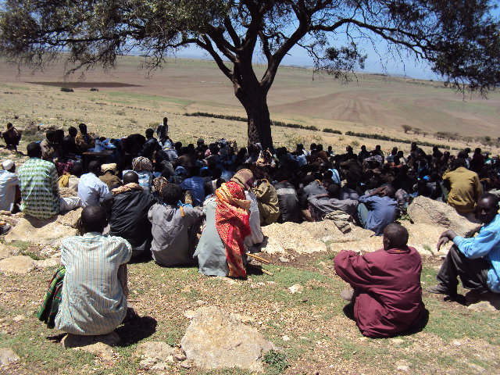
Figure 16: Traditional conflict resolution in pastoral community

- Traditional Conflict resolution method in Pastoral community

The Gada system is the most powerful traditional system governing natural resources. In Borana Oromo indigenous system, laws regarding livestock production involve rangeland and water resources management as core components of the indigenous institutional system, which still strives to be adhered to. Management of these resources are closely bound to the pastoral livelihood and strictly observed by the society. Every member of the society is required to respect customary laws. Under the general assembly, Abba Gada has the highest authority in the system and has own cabinet ministers made up of clan representatives called Hayyu. At lower levels of the structure, different people such as Bokku are given different responsibilities. The institutional structure extends to community and village levels where the actual administrations and management of resources take place.

In Afar, the authority is hereditary based on clan ties. Each clan has clan leader (Kedo Aba), lineage (Dala Aba or sometimes called Dabala Aba), youth leaders (Fei’ma Aba) and elders groups. The Traditional leaders reinforce co-operation and social solidarity between clans through shared rituals, resource sharing and the practice of paternalistic cross-cousin marriage called Absuma. Afar society has its customary laws and rules inherited from ancestors to encourage peaceful co-existence and discourage mischievous acts, murder, theft, adultery and violence.
In Somali society, the ultimate authority and leadership is vested on Ugaz. Below Ugaz, in the hierarchy of leadership, there is a council of elders constituting sub-clan representatives. The council meets only if there are critical issues concerning the clan. The sub-clan representatives are responsible for issues related to the daily lives of the community at village level or Reeri.

Traditional rules and regulations form the foundation of oppressed women's position which is reflected in harmful traditional practices, limited right of girls’ access to education, systems of marriage and divorce and the associated rights and benefits of women in having access to and control over resources and benefits including their roles in community affairs, decision-making, labour division, etc.

There is a consensus that the traditional rules and regulations can support implementation of government pastoral development policies if the two work closely and in collaboration. Attempts to reduce harmful practices would also be successful when the participatory approach is followed.

However, under the current system, some of the cultural values and rules have been challenged. For example, the formal institutions on the basis of human right conventions are challenging the exclusion and out casting of cabana from the system. Elders complain that cabana is increasing now days as formal institutions give them protections. The traditional systems such as the Gada system is also challenged by the expansion of farm lands, shrinking rangelands, religious influence, poverty, resource use conflict, internal changes, and state influences.

In Afar and Somali societies, religion has high value and even dominates the enforcement of traditional rules and regulations. It is so important in that, without the consent of the religious leaders, it would be difficult to think of cultural changes and influence the community. The religious leaders have the authority in the cases of marriage and divorce decisions. Enforcement of the traditional and religious rules affects women and girls through the marriage and divorce systems, inheritance of property, encouraging polygamous marriage system, prohibiting women participation in community affairs such as public meetings with men, and promoting harmful traditional practices such as female genital mutilation, limited decision making power, lack of control over key resources and benefits, unbalanced labour division among gender groups, etc.

With the diminishing roles of the traditional system of management of natural resources, forests are cut down for fuel wood, charcoal and other uses, wild animals are killed for consumption, etc. Such natural resources degradation is also because of lack of alternative survival strategies for the poor social groups.

Currently, there is no clear demarcation as to the responsibilities of the traditional administration and government administration in resource management and other community affairs. The indigenous institutions are losing their power of enforcing sanctions they might want to impose on resource abusers. The institutions may not be able to impose sanctions and fines on the resource abusers and those violating customary laws without recognition from kebele leadership. This holds true among the three communities.

The following can be generalized from the analysis of the pastoral institutions regarding similarities and differences among the three regions:
- Traditional systems are stronger in Borana while the religious rules are dominating in Afar and Somali regions. The role of indigenous institutions in natural resources management is systematic in Borana area and this could be encouraged and developed.
- In most cases, the formal government institutions, especially the Kebeles, are replacing the functions of traditional leadership. But effective natural resources management and pastoral development could be achieved through integration of the indigenous institutions with formal government structures. The Afar case could be cited as good example, where the traditional leaders are assigned as advisors at woreda level to establish good links to the communities they represent. In Oromia, the integration is only informal. In Somali, the role of traditional and religious leadership overlaps to a high degree.
- The indigenous institutions are run by elders who have accumulated knowledge of the ecology and adapting the production systems based on experiences. They have structures up to grassroots level to handle different issues being near the community members. It was observed, on the other hand, that younger people who lack the knowledge and experiences lead pastoral associations i.e. Kebeles. The structure of formal administration is not compatible with pastoralism, which is mobile. There are also areas in which indigenous institutions and the kebele leaders are working together harmoniously, especially in Afar region.
- The pastoral communities have strong ties with indigenous and religious institutions. The influences of the indigenous institutions in Afar and Oromia and Islam religion in Afar and Somali are crucial in an attempt to bring social changes needed for development. Policies that acknowledge and associate development efforts with indigenous institutions in a way that their values and roles are appreciated would be fundamental.

Assessment tasks for topic THIRTEEN

Click on this hyperlink to see the mark allocation

Objective of the assessment task
To enable you to understand how to incorporate indigenous knowledge into a formal research-extension system to facilitate mutual learning.

Why do it? (Motivation for doing the activity)
This activity serves to help you appreciate the benefit of mutual learning.

What (to do)
Form a small group in a semi-circle seating arrangement and complete the following tasks:
- Choose one example of farmers indigenous knowledge in farming from your own experience in your own area discusses it in your group.
- Prepare and present a 15 minute PowerPoint presentation on the lessons learned from the group discussion to the entire class.
- After all the presentations re-form your group and reflect on the various assessments made by the different groups (45 minutes).
- Prepare and submit a two page report ( 1 hr)

Feedback from the group / facilitators
On conclusion of the activities we will share and discuss on the presentations and work toward a common understanding

Summary of the topic
You have learned that Indigenous Knowledge encompasses all forms of knowledge, technologies, know-how skills, practices and beliefs that enable the community to achieve stable livelihoods in their environment. Types of IK include: resource management knowledge and the tools, techniques, practices and rules related to pastoralism, agriculture, agro-forestry, water management and the gathering of wild food. Incorporating IK into research-extension can contribute to local empowerment /Local capacity-building/ and, increasing self-sufficiency and strengthening self-determination. The indigenous institutions are organized to serve the social, economic, security and development needs of its members. They also have the responsibilities of decision-making and enforcement of resource use rules through political authority.

References and further reading materials
These materials can be accessed by either clicking on the hyper links or can be found in the library at your institution.

- Adalla, C.B. and Hoque, M.M. 1989 Farmer Participatory Research as an Example, ILEIA Newsletter, 5 (3): 12-14.

- Chambers, R. and Ghildyal, B.P. 1985, Agricultural Research for Resource-poor Farmers: The Farmer-First-and-Last Model, Agricultural Administration, 20 (1): 1-30.

- Christopher (1996), Poverty, Pluralism and Extension Practice, Gatekeeper Series No. 64, International Institute for Environment and Development (IIED), London, UK.

PowerPoint presentation is attached here

