English Literacy
& Language Development
Skills for a Changing World

Module Development Team

Module Co-ordinator:
Arlys van Wyk

Author(s):
Willfred Greyling
Arlys van Wyk

Critical Reader:
Laura Drennan

Reviewers:
Alta Sharp
Tebogo Moraka
Mabokang Mapesela

Skills for a Changing World Programme Coordination:
Merridy Wilson-Strydom

A Project of the: Free State Education and Training Trust (FSETT), led by the University of the Free State
PO Box 4345
Bloemfontein, South Africa, 9300
Telephone: +27 (0)51 5051222
Fax: +27 (0)51 5051277

Materials can be downloaded from: http://www.oerafrica.org

Creative Commons License:
Attribution Non-commercial Share Alike

Acknowledgements
The development of this programme was made possible by the generous donation of the Ford Foundation. The materials are the product of a collaborative endeavour involving representatives of the following organisations:

- University of the Free State
- Language development staff in the Department of English at the UFS
- Free State School of Nursing
- Central University of Technology, Free State
- Mindset Network
- OER Africa

Sincere thanks are extended to the authors, co-writers, academic assistants and the numerous experts who acted as critical readers, evaluators and language editors during the drafting of these learning materials.

Introduction

1. Programme Map
Skills for a Changing World (NQF 4/5) curriculum

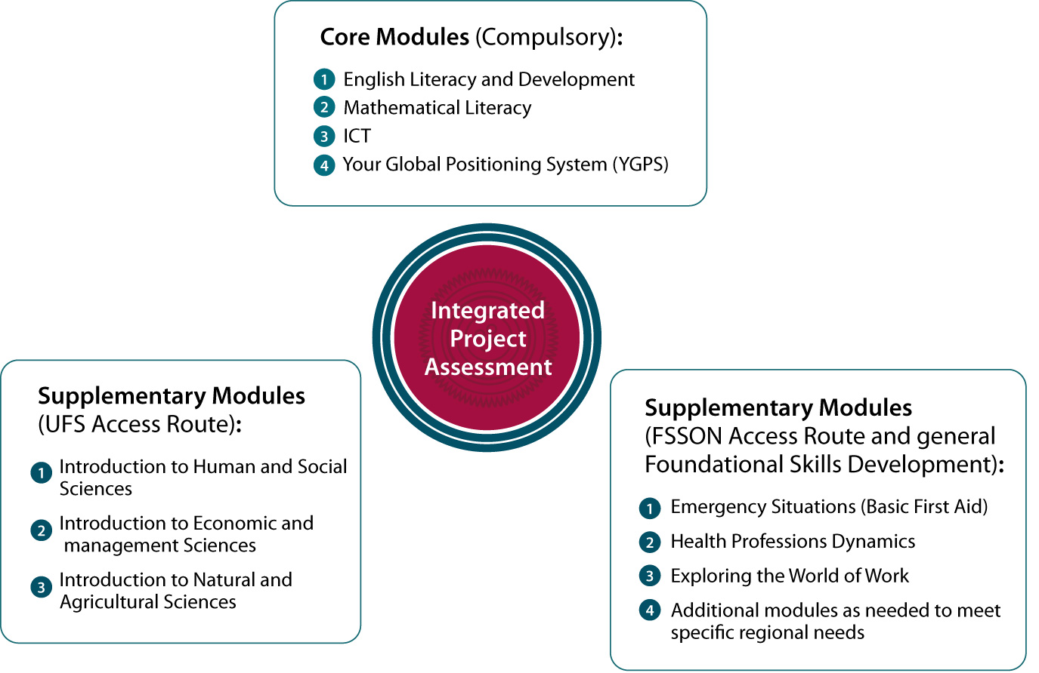

- What is this module about?
- What will you learn?
- How much learning time do you need?
- How will you learn?
- How will you be assessed?

…See the module map on the following

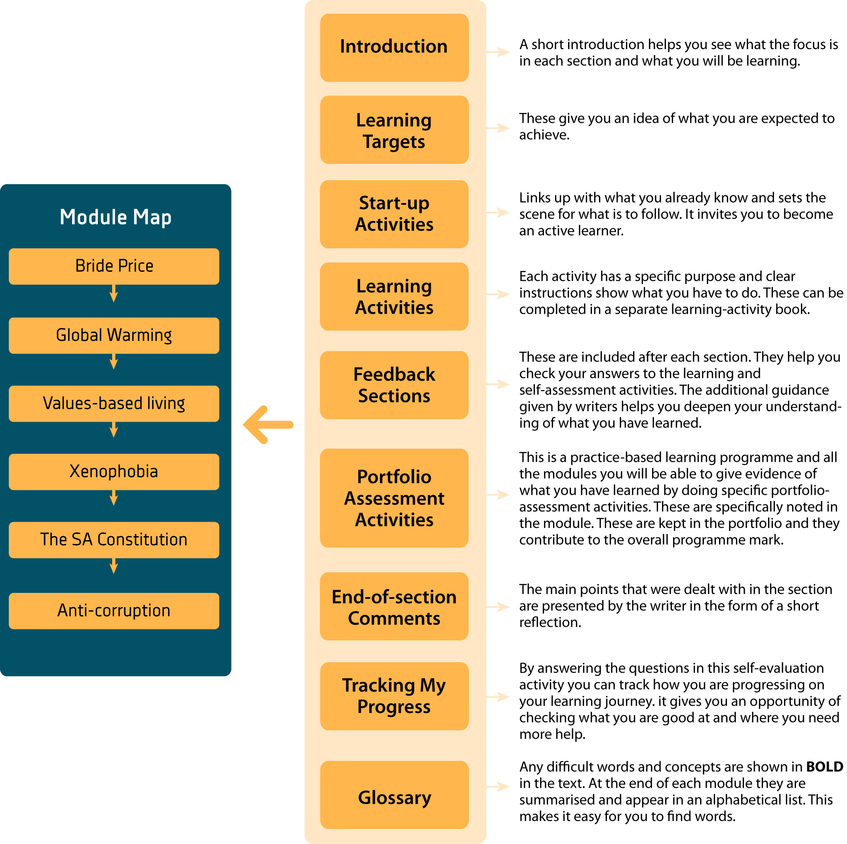

3. Module Parts & Outcomes
Part 1: Bride price
Part 2: Global warming
Part 3: Values-based living
Part 4: Xenophobia
Part 5: The SA Constitution
Part 6: Anti-corruption education
Skills Pack: Components

Outcomes
By the end of the module, students will show their ability to:
- reflect on reading texts critically by applying a step-by-step method (this means
- that you analyse, reconsider and question what you read);
- write a correct and organised essay on a debatable topic ;
- listen for a purpose in various communicative contexts;
- discuss topics in pairs and groups;
- present information, arguments and opinions in PowerPoint shows; and
- use old and newly-gained knowledge, skills, values and attitudes in your answers

How will you be assessed?
In the table below, we give an outline of the topics, the notional hours assigned to them, and the assessment tasks. We show in the table what you will be required to do in terms of assessment. As stated earlier, we assume that an average student will need 160 notional hours (16 credits x 10 hours per credit) to complete the course. As part of your orientation, you should look at the topics, notional hours and assessment tasks listed below. Some of the activities in the course will require out-of-class activity. Therefore, it will be important that you constantly review your time management.

Part / Notional hours | Description | Assessment
Part 1: Bride Price
50 Notional hours | What is bride price? In part 1, we look how people of different cultures might see the idea of bride price. | Writing a letter to the author of the article with the title, “Lobola for my love.” See the task at the end of Part 1 for the rubric.  [20 marks]
Part 2: Global Warming
50 Notional hours | We are destroying the world, or so it seems. In part 2, Global warming, we want to make students aware of our impact on the planet. How do you view this life-threatening aspect of our experience? | Write a paragraph consisting of a topic sentence and four supporting sentences. Follow the rubric presented in writing task 3.4.3 in Part 2 of the module.  [20 marks]
Part 3: Values-based living
50 Notional hours | In Values-based living, we require students to reflect on their values. These values, we argue, must be sustained within a framework of living where we develop our emotional intelligence. | 3.1 Writing about your personal experiences. Write two paragraphs, following the guidelines you have practised so far, in which you try fulfil the criteria in the relevant rubric.  [40 marks]
3.2 Following the rubric for PowerPoint presentations (in 3.2), answer the group learning activity 2.9 by doing a group presentation
[30 marks]
3.3 Consolidating vocabulary: Following the rubric in 3.3, use the selected words to write out a clear, logical 150-word.
[30 marks]
Part 4: Xenophobia
50 Notional hours | In Part 4 we focus attention on the evil of xenophobia. Students are required to question the idea, take a position, argue a case and use technology-based support for their message. | 4.1 Writing a journal entry: Using the guidelines and the rubric in 3.1, write out a one-page answer. You have to read your answer again to make sure that it is socially acceptable.  [30 marks]
4.2 Two paragraphs: Following the rubric in 3.2, write out two paragraphs on the meanings of two words and phrases.
[30 marks]
4.3 Phrase-embedding exercise: Write out a 40-word paragraph in which you use the words and phrases in a written message of your own.
[40 marks]
4.4 Producing new ideas: Follow the rubric in writing your own three-paragraph answer based on De Bono’s random-word technique. You have to use the word “melt” as your random word.
[40 marks]
4.5 Writing a one-page summary of others’ opinions. Respond to assessment task 3.6.
[30 marks]
4.6 PowerPoint presentation: Respond to task 3.7 for assessment purposes.
[30 marks]
Part 5: Has SA’s Constitution failed?
50 Notional hours | Part 5 poses a question about the SA Constitution. Have some of the clauses in the constitution become a tool in the hands of dishonest individuals who try to freeze and interrupt legal processes? What is your view? | 5.1 A 250-word opinion piece: Complete assessment task 3.1.  [40 marks]
5.2 Denominalisng a text: Complete assessment task 3.2
[40 marks]
5.3 A 120-word summary: Complete assessment task 3.3
[60 marks]
5.4 PowerPoint: Complete assessment task 3.4
[30 marks]
Part 6: Anti-corruption Education
50 Notional hours | How do we deal with the curse of corruption? Part 6 on anti-corruption education deals with society’s reaction to the wave of corruption that has hit the world. Once again, how do you see ethical behaviour? | 6.1 Writing an essay: A 400-word essay.  [50 marks]
6.2 Two PowerPoint presentations:
[2 x 20 = 40 marks]
Total 600 marks
No examination, there will be an integrated assessment task
Total of notional hours: 320

A Time Check is included at the beginning of each module. It is a useful time management tool as it shows how much time you are expected to spend on each of the sections and it allows you to record how much time you actually spent. Take not of the notional hours when you do the time checks.

A sample time-check table:

 | TIME  CHECK | Sections | Suggested time input | Actual time spent

Codes for assessment
The table below consists of codes that will be used when your work is assessed. These codes are used to show you where and how your learning will be corrected.

Abbreviation/Code | Explanation | Examples
ArtI  ArtU  ArtA | Article error, specifically incorrect article,  or article under-use  or article abuse | articles: a, an, the  - I attend *an university (*a)  - I am training to be * engineer (*an)  - Her mother has *the cancer
Adj | Incorrect describing word used | - Her mother is *beautiful (*adj)
Adv | Incorrect form of the adverb | - He played the game *well (*adverb)
Vb | Verb error in form | - They *singed in the choir (*sang)
Tns | Tenses | - Past: I walked to work  - Present: I walk to work  - Future: I will walk to work
Conc | Concord error | concord: agreement between words in gender/number/case and person  - My son *watch television (*watches)  - The queen lost her shoes
Cap | Capitalisation error | - *i love soccer (*I)
Pron | Pronoun error, including pronoun concord error | pronoun: takes the place of a noun (I, you, he she, it, they / me, you, him, her, it, us, them)  - Tom and *me went to the shop (*I)
MVb | Main verb is missing from the sentence | The main ‘doing word’ has been left out of the sentence
SF | Fractured syntax, parallelism abuse | syntax: sentence structure
G | Grammatical error unspecified above
Sp | Spelling error
HFE | See high-frequency errors in Language Pack
Voc | Incorrect word choice
WO | Incorrect word order
 | Correct
X | Incorrect
 | Word(s) missing
( ) | Reformulate, omit or shift words in brackets
Par / | Paragraph is needed
?] | Meaning is unclear – rewrite

When facilitators give feedback, they are required to give qualitative feedback, focusing on the high-frequency problems (problems that occur often) in the students’ responses. Remember to look at the file on high-frequency errors whenever you need to.

4. Information about the module
Before you start on a journey you usually find out all about the places you want to visit, the kind of transport you will use, how long it will take and how much it will cost.

As you start on your learning journey of this module, here is some important information.

Make sense of messages and produce sense-making messages
In your LEARNING, we would like you to make you aware of THREE PROCESSES:

- You have to understand what you read in texts and what you listen to in spoken communication. Making sense of information is the most important first step in ALL learning. If you cannot make sense of texts in this, or any other module or course, you will not be able to learn. To promote your learning, develop your reading skills and all skills that will assist you in making sense of messages, both spoken and written. You have to support your learning by developing your reading skills and all the skills that will help you make sense of both written and spoken messages.

- You need to make connections between form (structure) and meaning. Even though meaning comes first, they are linked with very specific ways of saying or writing.

- Remember that practice makes perfect, so you must write and speak English as often as possible. Use the new knowledge you have gained as see your learning as a language experiment in different circumstances. Each time you meet with others, in and out of class, you should experiment and keep a journal – this is one of the most worthwhile activities you can do. In this way, you can keep track of and improve on the way you say things.

Critical reflection
We say that we make sense of our learning by stepping back and try find words to assign meaning to what we have experienced. Reviewing your responses to activities in the course, re-reading journal entries, and re-visiting facilitator feedback are very important steps in developing your critical-reflective skills.

Use the following grid to reflect on your learning at the end of each part and at the end of the module.

My learning journey
What I am expected to know and do | I feel confident | I still need practice
Reflect on reading texts critically by applying a step-by-step method (this means that you analyse, reconsider and question what you read)
Write a correct and organised essay on a debatable topic
Listen for a purpose in various communicative contexts
Discuss topics in pairs and groups
Present information, arguments and opinions in PowerPoint shows
Use knowledge, skills, values and attitudes to produce linked answers across modules

Icons
Icons are visual ‘signposts’ that give clear signals of what is expected of you. The following icons are used in the Student Guides for all the modules. You will soon become used to recognising each icon and the message it conveys.

Learning activity
When you see this icon, you will know that you have to do an activity to show how well you understand what you have read and learned. For some of the learning activities the writer will include some comments or advice. These comments should never be read before you have completed the preceding activity. These comments are also not intended to provide the final ‘answer’, since your opinion may be completely different from the writer’s and still be acceptable. The writer is simply providing you with an informed opinion.
Group activity
Whenever you see this icon you will know that you will work with some of your fellow learners on a team activity.
Assessment activity
This is the sign for assessment activities that you will complete and include in your portfolio. All these activities are marked by the facilitator and they will contribute to your total mark for the programme.
Resource file
When you see this sign you will know that you need to refer to the resource file/CD. It contains additional readings and articles that you may be asked to use to complete an activity.

Language pack and URLs
Using CONTROL + CLICK you can access files within the course and URLs (uniform/universal resource locator) on the world-wide web. Remember that the URLs will only work if you are logged onto the internet.

For example, we have included files on cohesion, journaling and tenses which you may click on for more information. We have included the URLs so that you can access various topics such as mind-mapping, study techniques, reading strategies and online dictionaries.

Glossary
Special terms and phrases used in this learning guide are explained here.

Word | Explanation
Topics | These are the themes of the texts we have selected for the course. We selected texts that focus on social issues. These topics are therefore contentious.
Language functions | These are utterances or sentences which have a specific objective or communicative goal. Examples: giving directions, stating an opinion, apologising, and the like.
Scenarios | These are generally real-life contexts we simulate to develop learners’ problem-solving skills.
Pre-reading activities | These activities are used before reading to prepare learners for the process. Examples: speculating (wondering) about a topic of a text, or its title, applying SQRRRR or some other strategy (SQRRR: Survey, Question, Read, Recite, Relate and Review).
While-reading activities | These activities take place during reading. Examples: note-taking, question-answer mediation of text, and the like.
Post-reading activities | These activities take place after reading a text. Examples could include questions and answers, and a range of communication-gap activities.
Comprehensible input | When learners read texts, they have to understand the message in the text. These meanings are the sources of information and knowledge that learners have to be able to access.
Comprehensible output | Learners’ written or spoken texts have to be understandable (i.e. comprehensible).
Feedback loops | We tend to work with three steps: (a) Learners have to access information and/or produce knowledge; (b) they have to use the knowledge in response to questions and/or activities; and (c) they are then given feedback which they have to use to compare their responses with analysed sample responses. This is known as a feedback loop. The last step may be replaced by qualitative teacher feedback.
Sample response | These are the authors’ attempts at producing a response which may serve as examples for learners’ self-evaluation attempts.
URLs | A web-address for a specific website on the internet.
Control +click | This function may be used to access a file in the Skills Pack, or a URL on the web.
Notional hours | These are the total number of hours an average student will need to master the content of a module.

