INTRODUCTION TO ROBOTIC SYSTEMS AND ENGINEERING
Details of institution that has developed the module
Name of University | First Technical University Ibadan
Name of institutional contact | Prof. Adesola S. AJAYI
Email address of institutional contact | vc@tech-u.edu.ng

Details of Creative Commons licence (https://creativecommons.org/licenses/)
Licence type

Details of the authors of/contributors to the course and their role (You can delete any sections that don’t apply.)
Lead author (+ email address) | Assoc. Prof. Oyetunde A. ADEAGA (oyeadeaga@tech-u.edu.ng)
Responsible for: | Coordination and development of the module ‘Introduction to Robotic Systems and Engineering’
Co-author/co-contributor | Prof. Adesola S. AJAYI
Responsible for: | Overall review and provision of technical advice and support to the module development team
Co-author/co-contributor | Dr Abiodun E. ADEOYE
Responsible for: | Development and Facilitation of the Module II
Co-author/co-contributor | Dr Oludamilare B. ADEWUYI
Responsible for: | Development and Facilitation of the Module III

Information regarding format of material to upload onto the OER Africa repository
Primary resource (Not PDF) | Ms Word
Will a Moodle common cartridge be uploaded as well? | Not Applicable
(A Moodle common cartridge is a .ZIP file of your module – if it is created in Moodle – that can be imported into another university’s Moodle platform.)

Course details
Module title: | Introduction to Robotic Systems and Engineering
Under- or Post-graduate? | Intermediate (Third Year) Undergraduate | Year of study: | 3
Class contact time (hours): | 36 | Number of credits: | 3
Private/online study hours: | 24 | Number of weeks of study: | 12
Total student learning hours: | 125 | Number of units of study: | 3

Programme(s) which might include this Module: | Mechanical Engineering, Mechatronics Engineering, Electrical & Electronic Engineering, Computer Engineering, Software Engineering, Physics with Electronics, Biomedical Engineering
Pre-requisite student abilities and knowledge: | Pass in Elementary Mathematics I, II, III, IV; Pass in General and Experimental Physics I, II, III
Pre-requisite (or co-requisite) modules: | Applied Mechanics (Statics & Dynamics)

Aim of the module: | To introduce you to the concept, purpose, generic structures, workspace, actuators and drive and man-machine interface, the modelling and control of Robots, and the application of Robotic in manufacturing
Brief description of module: | Introduction to Robotic Systems and engineering as a complete module, is essential for all engineering students as it is a path to the future of the field and world work force. The use of sensors, actuators, algorithms, codes and programming languages is the right trend towards the future as being accomplished by artificial intelligence cum deep learning cannot be overemphasized. Nevertheless, this module was formulated to clear ambiguities in the subject area as there exist many versions prior but for the inapplicability to developing countries. The integration of soft (generations of algorithm leading to codes and coding for computer programming) and hard skills (in form of fabrication of components and devices) required in the field of robotics enhances employability skills and also prepare students for the future. General overview of the course involves; The General Robot Structures, General Definitions (The Robot: definition, types, classification and uses. The workspace, coordinates and transformations), Robot modelling, Robot Actuators and Drive Systems, Robot Sensors, Robot-computer interface and programming: Forward Kinematics, Inverse Kinematics, Robot Control and Programming. Robots with external sensors, Robot manufacturers and assembly kits, Robot Applications in Manufacturing. Therefore, at the end of this course, you will be to:  (i) describe general structures of Robot; (ii) define a Robot and identify one when available; (iii) classify Robots and define their relative uses; (iv) narrate the evolutionary history of Robot; (v)understand and define the workspace for Robots; (vi) explain the term coordinate as they relate to the study of Robotics; (vii)describe processes involved in Robotic transformations; (viii) explain Robot modelling and control; (ix)describe Robotic actuators and drive systems in details;(x)identify Robot sensors and be able to explain their significance in Engineering with examples; (xi)describe robot-computer interface programming in relation to manufacturing and therapeutic medicine; (xii) describe Robots with external sensors; (xiii)identify and describe Robot manufacturers and assembly kits with their applications and (ix) appreciate Robot Applications in Manufacturing.  Furthermore, this module will develop you towards the total awareness and possible application of Robotics to the betterment of life and knowledge. The peculiarity of this module is such that it uses contemporary approaches in both delivery of lecture and knowledge impartation.  The module might seem technical but persistent consultation of the embedded concept of object based educative items will eventually make it the simplest to assimilate. The module also contains adequate learning materials provided with purposeful assessment tools and method while paying attention to all the blended activities and attending to all the assessment tools. All assignment are expected to be submitted as and when due and should also be kept for references. The module was developed and compiled by competent and ready-to-teach staff, should you need any clarification. You may contact: oyeadeaga@tech-u.edu.ng  adeoye.abiodun@tech-u.edu.ng;  oluwadamilare.adewuyi@tech-u.edu.ng

Intended learning outcomes: | At the end of this module, you will be able to:  1. narrate the origin, history and evolutionary trends of robotic systems and engineering  1. describe the concept of robotics systems in relation to its technicality  2. distinguish robots from humanoids  3. explain the motives behind robots design and manufacture  4. conceptualise simple robots for simple jobs  5. formulate simple algorithm that will drive your conceptualised robot  6. develop simple codes to implement robotic algorithm
Indicative content: | The module is divided into 3 units with 11 topics viz:  Familiarization of Students with the Course and its content.  Unit 1: (i)The general overview of the Module  (ii)Definition and Classification of Robots and their applications.  (iii)Description of Workspace for a Robot, Robotic transformations and the coordinate systems,  (iv)Design Techniques in Robotics  Unit 2: (i)Robot modelling  (ii)Robot actuators and drive systems  (ii) Robotic and robots control.  Mid-Semester Assessment  Unit 3: (i)Robot-computer interface and programming  (ii)Robots with external sensors.  (iii)Robot manufacturers and assembly kits.  (iv)Robot Applications in Manufacturing and production.
Form of final/summative assessment: | Evaluation of the modules is as below;  Formative Assessments  Continuous Assessment  - Attendance = 5%  - Assignments = 15%  - Ability to complete Assignments = 10%  - Mid-Semester Examination = 10%  - End of Semester Examination = 60%  Total = 100%  Marks range Final grade Grade Point Description  80 - 100 A 5.0 Excellent  75 - 79 B+ 4.5 Very good  70 - 74 B 4.0 Good  65 - 69 C+ 3.5 Above Average  60 - 64 C 3.0 Average  55 - 59 D+ 2.5 Below Average  50 - 54 D 2.0 Fair  45 - 49 E+ 1.5 Pass  40-44 Below 40 E F 1.0 0 Marginal Fail

Assessment of module-level learning outcomes
Module-level learning outcome | Module assessment task
- Recognition and appreciation of robots and robotics within the context of developing nations | e-tivities and physical activities to include –  Sparks such as, padlets, slido, discussion forum, scorm, rubric, quiz, puzzle, storyboard, case study, individual and group presentations, term paper, seminars, projects mid-term and end term examination.
- Familiarisation with the technical terms used in robots and robotics
- Purposeful classification of robots and identification of areas where robots are helpful and harmful
- Identification and description of the workspace for robots and the transformation in robotics
- Robots components identifications and modelling
- Preliminary designs in robotics and robot fabrication

Significant features or elements of module
- Purposeful connection of learning outcomes to the learning activities and assessments
- The diversity and inclusiveness of the pedagogical tools and the focus of learner’s centeredness.
- The inclusiveness of the assessment tools and feedback mechanisms used in scaffolding the module.
- Accepting feedbacks from the purposeful connection and implementation of the learning activities and assessments
- Learners centeredness and consideration
- Needful capacity building
- Room for immediate improvement when it is necessary

Student profile in the context of this module:
What is the target group of students who would do this module? | Intermediate level
What skills should a student have already mastered before starting this Module? | Computer appreciation and application
What prior knowledge of the subject matter should a student have? | Computer programming knowledge
Knowledge | Coding

Non-expert support:
What skills and prior knowledge of the subject matter  should facilitators have already mastered before starting to deliver this Module? | - Mathematics skills  - System thinking ability  - Use of sensors and actuators expertise
What skills do support staff need in order to support the delivery of this module? | - Computation  - Computerisation  - Design thinking  - Solution thinking

Quality assurance matters
How will feedback on module be obtained from students? | - Feedback from quizzes, assignments, and successful execution of codes during blended learning and face- to- face sessions.  - Peer feedbacks with a view to accounting for constructive criticisms from peers during group discussions and presentations of assignments.  - Moderator’s feedback on graded assignments, mid-semester and end of semester assessment grades.
How will student feedback be used to improve module? | Student consideration towards dictating redesigning and modification of the module in-line with the appropriate feedback with a view to friendliness and interest capturing.
A certificate, signed by the university’s Head of Quality Assurance, confirming that the module meets the requirements of the PEBL QA rubric is attached. |  | Yes ☐ No ☒

UNIT 1, Week ( i-iv)
Unit-level overview |  | Unit/section | 1/ i-iv
Topic Title: | Familiarization with students, the course and synopsis
Aim of the topic: | To introduce students to facilitator also the subject matter such as Identification and Classification of robots
This topic covers: | 1.Concept of robotics  2.Introduction to robots  3.Essence of robots  4.Types of robots  5.Identification of robot workspace and coordinates  6.When and how robots are used
Intended learning outcomes: | At the end of this unit, you will be able to;  - explain the concept of robotics;  - give a generic and specific definitions of robots  - identify when the use of robots will be of advantage and otherwise  - Be able to define the workspace for a Robot.  - Explain the term coordinate as they relate to the study of Robotics  - Describe transformation and processes involved in Robotic transformations
Unit Synopsis | 1.Theoretical understanding of essence of robotics and robotics in the past and prospects  2.Ability to understand the evolutionary trend in robots and robotics engineering

Overview of student activity: | - initiation of familiarisation with course-mates and facilitator(s)  - Active discussion among course-mates on self-perception about robots and robotics  - Linking robots with robotic systems and engineering
Detailed explanation of ALL student and teacher engagement with the unit:  (This should be presented in the order that the activities take place. So if students do work online before coming to the lecture, that should be shown ahead of what happens in class.  If there is more than one opportunity for face-to-face contact, or more than one online task, there should be a separate section for each instance, and they should be presented in the template in the same order that students encounter them.)  Content – such as lecture material – can EITHER be shown here OR added as clearly identifiable addenda to the document. If you plan to use addenda, you should ensure that this are cross-referenced in this section.) | Purpose of the unit
Students should be able to
1.identify the basic type of robots and the employability core values in the module
2.Recognise the significance of robotics with alliance to modern demands
3.Introduction to business aspect of robotics
 | Preparatory reading | Number of hours | 1
 | Humanoid Kanpur. Sensors and Actuators: Robotics Club (Science and Technology Council, IITK). October 11th, 2017. pp 10
 | Face to face | Number of hours | 1
 | You will be able to participate in group discussion as regards employability core values and career opportunities in robotic engineering during the face to face lecture
 | Online activities / tasks | Number of hours | 2
 | A 3-minute video presentation will be made available via the e-tivities section in the University LMS coupled with puzzle in spark section
 | How are the learning outcomes in this unit assessed? | Number of hours | 2
1.Rubric assessment for e-tivity 1.1
2.e-tivity in 1.2 also
3.Multiple choice questions test for knowledge testing at the end of Unit 1 in introductory mechanics and electronics
4.Correct answers to the test questions will be displayed and discussed

Some pertinent questions
Which learning resources/ references will scaffold the students’ learning? | David C. (2009). Robot Building for Beginners. Second edition. Apres Publishers. USA
Where in this unit are students expected to work collaboratively? | Face to face sections on attributes and identification of various robots.
How has an inclusive approach been incorporated in this unit? | Role play, claim staking, many e-tivities, diverse learning resources - hard copy of Robot building for beginners, spark and video clips are provided to cater for students with different learning abilities.
How will feedback on unit be obtained from students? | The use of padlet, discussion forums and end of manual chapters assessments and online quizzes, self-feedbacks, peer feedback, tutor feedbacks etc.
How will student feedback be used to improve unit? | By redesigning the module sections and make the module more teachers’ and learners’ friendly.
At which point(s) will students receive formative feedback on the work they have done in the unit? | At end of each assessment task during online and face to face and also at the end of the semester.
How are students enabled to access the resources? | Hard copy of learning resources has been provided for your use for offline sections, online links to the video clips as well as the university library.
Where in this unit are students expected to work collaboratively? | Face to face sections to demonstrate various robots and robotics as an essential part of modern life  Aso during offline inter-personal chat
How will feedback on unit be obtained from students? | Using padlet, discussion forums and end of manual chapters’ assessments and online quiz, self-feedback, peer feedback, tutor feedback and learners’ feedback.

Constructive alignment of unit level outcomes with module level outcomes, learning activities and assessment
(Pressing <Tab> at the end of the table will provide additional rows in the table, if required.)
Intended unit learning outcomes: | No of module-level outcome | Activity where students engage with this outcome | Where and how is this outcome assessed?
At the end of this unit, you will be able to:
- understand the basic concept of Artificial Intelligence in modern technological applications; | 2 | Online talks and face to face | Both online and face to face
- initiate critical approach towards robotics | 2 | Face to face discussions | Both online and face to face
- narrate the history of robots and robotics | 2 | Debate | Both online and face to face
- familiarise with all classmates and facilitators | 2 | Online talks and face to face | Face to face

Overview of student activity: | e-tivities 1: 1  Title 1: Overview of the Course 2: Definition and Classification of Robots and their applications. 3&4:Description of Workspace for a Robot, Robotic transformations and the coordinate systems  Purpose At the end of this e-tivitiy, you will be able to: 1. identify and describe general structures of Robot. 2. define a Robot and identify one when they see it. 3. classify Robots and define their uses. 4. narrate the history of Robot. 5. define the workspace for a Robot. 6. explain the term ‘coordinates’ as they relate to the study of Robotics  Brief summary of overall task 1.Study the puzzle below carefully and try to identify those words relating to history and evolutionary trends in robotics 2.Consequently, as you watch the videos on robotics, you will be able to have thorough understanding of trends in robotics. 3.Use these features to do the e-tivities which follows.  Spark 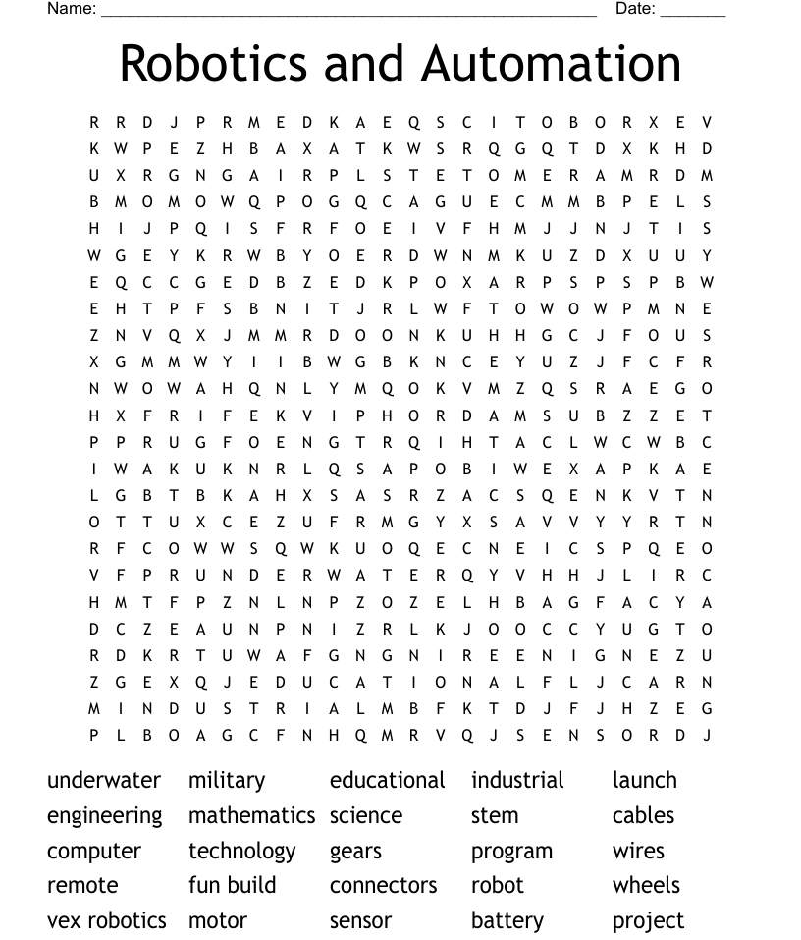  Individual Contribution Concentrate while watching these videos https://www.youtube.com/watch?v=uoC2ZGRI8a8 https://www.youtube.com/watch?v=TK-h4oATYSI https://www.youtube.com/watch?v=Uzf-K7UtD78 1. Identify the suggested 21 words from the puzzle above, crossing them to form words. 2.Search for the meaning of those words you were able to form from the spark 3. Using a storyboard classify the robotic hierarchy you were able to identify above. 4. Review the attributes of each classification. 5. Describe the interrelationship between the identified words  Dialogue Begins After brief discussion, assignments are to be submitted the next two weeks to the module facilitators via, Robotics Team LMS vc@tech-u.edu.ng, dvc@tech-u.edu.ng, oyeadeaga@tech-u.edu.ng, adeoye.abiodun@tech-u.edu.ng; oluwadamilare.adewuyi@tech-u.edu.ng  e -moderator interventions 1.All tutors will monitor the discussions, participation and the performance on the e-tivities, guide students on the way to interact in the platform, and ask questions. 2.e-moderators will post the dates for submission of their assignments and expects feedbacks from learners. 3.Analyse and harmonize the feedbacks by making positive remarks on those completed e-tivities to motivate and encourage those who were not able to complete as well as put up suggestions to help those who have challenges.  Schedule and Time You have one Unit to complete the above tasks. The timelines below will help you keep to these schedules. - Watch the videos by Tuesday - Post your storyboard by Thursday - Comment on another colleague’s work by Friday  Next Communication and modelling ,Skills of real life situation
UNIT 2 Week (v-vii)
Unit-level overview |  | Unit/section | 2/ v-vii
Topic Title: | Design Techniques in Robotics  Communication and modelling ,Skills of real life situation
Aim of the topic: | To teach students the essence and methods of communication in robotics and skills required in both simulation and real life situation
This topic covers: | Design Techniques in Robotics  Week v: Robot modelling  Week vi: Robot actuators and drive systems  Week vii: Robot sensors
Intended learning outcomes: | At the end of this topic, you will be able to;  i.describe transformation and processes involved in Robotic transformations  ii.explain Robot modelling and control  iii.describe Robotic actuators and drive systems in details  iv.identify Robot sensors and be able to explain their significance in Biomedical Engineering with examples.  v.describe robot-computer interface and programming and related them to therapeutic medicine.
Unit Synopsis | - Theoretical understanding of essence of robotics and robotics in the past and prospects  - Ability to understand the evolutionary trend in robots and robotics engineering

Overview of student activity: | e-tivity 2: 1  Title Cognition and Understanding  Purpose At the end of this e-tivitiy, you will be able to: i. initiate arguments as regards robotics, sensors and actuators ii. evaluate arguments, information and ideas in robotics engineering design. iii. use range of approaches to addressing problems and issues in manufacturing industries. iv.  Brief summary of overall task - First, study the puzzle below carefully and try to identify those words relating to robotics - Consequently, as you watch the 3 minutes videos on robotics, you will be able to have the thorough understanding of robotic systems. - Critically review the significance of each robotic terms. - Use these features to do the e-tivities which follows.  Spark 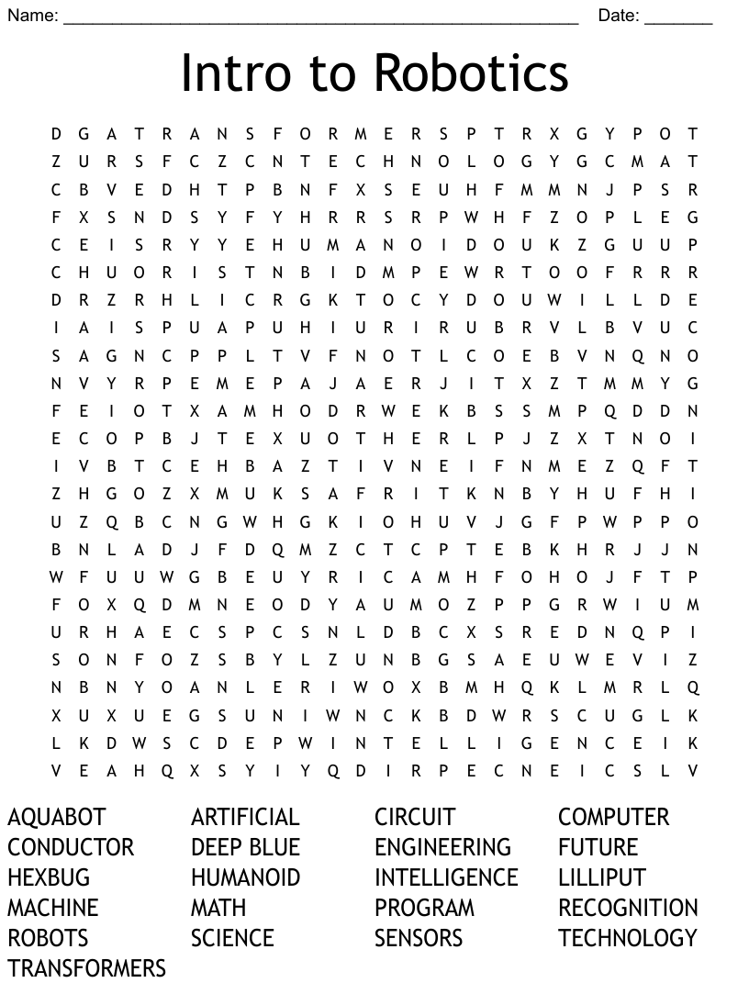  Individual Contribution 1. Concentrate while watching these 3 minutes (average) videos https://www.youtube.com/watch?v=N-QyvP3FqKI https://www.youtube.com/watch?v=66WYARKYz5c https://www.youtube.com/watch?v=djQt-XIuaZo 1. Identify the suggested 21 words from the puzzle above, crossing them to form words. 2.Search for the meaning of those words you were able to form from the spark 3. Using a storyboard classify the robotic hierarchy you were able to identify above. 4. Review the attributes of each classification. 5. Describe the interrelationship between the identified words  Dialogue Begins After brief discussion, assignments are to be submitted the next two weeks to the module facilitators via, Robotics Team LMS, vc@tech-u.edu.ng, dvc@tech-u.edu.ng, oyeadeaga@tech-u.edu.ng, adeoye.abiodun@tech-u.edu.ng; oluwadamilare.adewuyi@tech-u.edu.ng  E-moderator interventions - All tutors will monitor the discussions, participation and the performance on the e-tivities, guide students on the way to interact in the platform, and ask questions. - e-moderators will post the dates for submission of their assignments and expects feedbacks from learners. - Analyse and harmonize the feedbacks by making positive remarks on those completed e-tivities to motivate and encourage those who were not able to complete as well as put up suggestions to help those who have challenges.  Schedule and Time You have one Unit to complete the above tasks. The timelines below will help you keep to these schedules. - Watch the videos by Tuesday - Post your storyboard by Thursday - Comment on another colleague’s work by Friday  Next Communication and modelling , Skills of real life situation

Detailed explanation of ALL student and teacher engagement with the unit:  (This should be presented in the order that the activities take place. So if students do work online before coming to the lecture, that should be shown ahead of what happens in class.  If there is more than one opportunity for face-to-face contact, or more than one online task, there should be a separate section for each instance, and they should be presented in the template in the same order that students encounter them.)  Content – such as lecture material – can EITHER be shown here OR added as clearly identifiable addenda to the document. If you plan to use addenda, you should ensure that this are cross-referenced in this section.) | Purpose of the section:
 | Understand and be able to communicate and model robots using skills of real life situation
 | Preparatory reading: | Number of hours | 2
 | https://doi.org/10.4000/ctd.2578 and https://www.northeastern.edu/graduate/blog/robotics-skills/
 | Face to face time: | Number of hours | 2
Title | Communication and modelling , Skills of real life situation
Purpose | At the end of this you will be able to:  i. use super computers for simulation study in robotics.  ii. appreciate literary skills in robotics  iii. enable the communication of abstract concepts in written and verbal forms

 | Online task: | Number of hours | 2
 | Brief summary of overall task With concentration watch the less than 3 minutes under-listed you tube videos https://www.youtube.com/watch?v=llnFFtMo6gw https://www.youtube.com/watch?v=wqfj3TgGpW4 https://www.youtube.com/watch?v=_8YCc3pJDPI https://www.youtube.com/watch?v=K_xIJBlbjg4 - Watch the each video carefully and try to identify the steps and framework of modelling of robots and the engineering. - Note the rules governing robotics system. - Review the samples and examples given and use these features to do the e-tivities which follows.
 | How are the learning outcomes in this unit assessed? | Number of hours | 3
1. By the use of formative assessment quizzes.
2. Using rubric assessment for e-tivities 2.1
3.Take the Multiple Choice Questions test at the end of chapter 2 in the introduction to Robotic Systems and Engineering
Total number of hours |  |  | 6

Constructive alignment of unit level outcomes with module level outcomes, learning activities and assessment
(Pressing <Tab> at the end of the table will provide additional rows in the table, if required.)
Intended unit learning outcomes: | No of module-level outcome | Activity where students engage with this outcome | Where and how is this outcome assessed?
At the end of this unit, you will be able to:
- understand the basic concept of Artificial Intelligence in modern technological applications; | 2 | Digitally and physically | Digitally and physically
- initiate critical approach towards robotics | 2 | Digitally and physically | Digitally and physically
- narrate the history of robots and robotics | 2 | Debate | Digitally and physically
- familiarise with all classmates and facilitators | 2 | Digitally and physically | Physically

Detailed explanation of ALL student and teacher engagement with the unit:
(This should be presented in the order that the activities take place. So if students do work online before coming to the lecture, that should be shown ahead of what happens in class.
If there is more than one opportunity for face-to-face contact, or more than one online task, there should be a separate section for each instance, and they should be presented in the template in the same order that students encounter them.)
Content – such as lecture material – can EITHER be shown here OR added as clearly identifiable addenda to the document. If you plan to use addenda, you should ensure that these are cross-referenced in this section.)
Module-level outcomes addressed:
1, 2, 3 and 4
Purpose of the unit/week/section:
To prepare the students and the tutors for the task ahead
Over to you: (a description of the process of the section)
The application of online and face to face teaching in combination with relevant e- tivities
Pre-topic activity: |  | Number of hours | 6
Consultations of literature and videos
Face to face time: (if applicable) |  | Number of hours | 2
Online activity: |  | Number of hours | 2
What should students do? | Abide by all instruction from tutors and build interest in the module
Where do they do it? | Both physically and digitally
By when should they do it? | As timed by tutors
E-moderator/tutor role
Guidance and instructional
How are the learning outcomes in this unit assessed? |  | Number of hours | 1
As stated above
How does this section link to other sections of the module?
Sequentially

UNIT 3 Week (i-iv)
Unit-level overview |  | Unit/section | 3/ i-iv
Topic Title: | Robotic Control, Manufacturing and Applications
Aim of the topic: | To acquaint learners with simple robot control sequence and how they are used in manufacturing processes
This topic covers: | Week 9: Robot control.  Week 10: Robot-computer interface and programming  Week 11: Robots with external sensors.  Week 12: Robot manufacturers and assembly kits.  Week 13: Robot Applications in Manufacturing and in Engineering
Intended learning outcomes: | At the end of this topic, you will be able to;  1. describe robot-computer interface and programming and related them to therapeutic medicine.  2. model robots with external sensors  3. identify and describe Robot manufacturers and assembly kits with their applications.  4. describe simple robot applications in manufacturing processes
Unit Synopsis | 1.Linking of cods with robot modelling and programming  2.Linking typical manufacturers of robot and assembly kits  3. Application of robots and robotics to therapeutic medicine, fire mishap, accidents prevention, process simulation etc.

Overview of student activity: | e-tivity 3: 1  Title Control of robots and application to real life situations  Purpose At the end of this e-tivitiy, you will be able to: i. identify and explain robotic controls and applications ii. evaluate arguments, information and ideas in robotics engineering design. iii. use range of approaches to addressing problems and issues in manufacturing industries.  Brief summary of overall task 1.Study the puzzle below carefully and try to identify those words relating to robotic control systems 2.Consequently, as you watch the videos on robotics control, you will be able to appreciate and evaluate robotic systems and its application to engineering. 3. You will also be able to know the essence of studying robotic engineering 4.Use these features to do the e-tivities which follows.  Spark 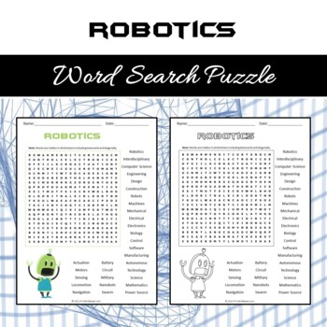  Individual Contribution Concentrate while watching these average of 3 minutes videos https://www.youtube.com/watch?v=mGuDXlZEoSc https://www.youtube.com/watch?v=OzJ9V3UMnh4 https://www.youtube.com/watch?v=ddkUszFVTUk 1. Identify all the suggested words from the puzzle above, crossing them to form words. 2.Search for the meaning of those words you were able to form from the spark 3. Using a storyboard explain robotic control systems you were able to identify above. 4. Review the attributes and peculiarity of each control system. 5. Describe the interrelationship between the identified words, the control systems and their application in manufacturing.  Dialogue Begins After brief discussion, assignments are to be submitted the next two weeks to the module facilitators via, Robotics Team LMS, vc@tech-u.edu.ng, dvc@tech-u.edu.ng, oyeadeaga@tech-u.edu.ng adeoye.abiodun@tech-u.edu.ng; oluwadamilare.adewuyi@tech-u.edu.ng  E-moderator interventions - All tutors will monitor the discussions, participation and the performance on the e-tivities, guide students on the way to interact in the platform, and ask questions. - e-moderators will post the dates for submission of their assignments and expects feedbacks from learners. - Analyse and harmonize the feedbacks by making positive remarks on those completed e-tivities to motivate and encourage those who were not able to complete as well as put up suggestions to help those who have challenges.  Schedule and Time You have one Unit to complete the above tasks. The timelines below will help you keep to these schedules. - Watch the videos by Tuesday - Post your storyboard by Thursday - Comment on another colleague’s work by Friday  Next Communication and modelling , Skills of real life situation

