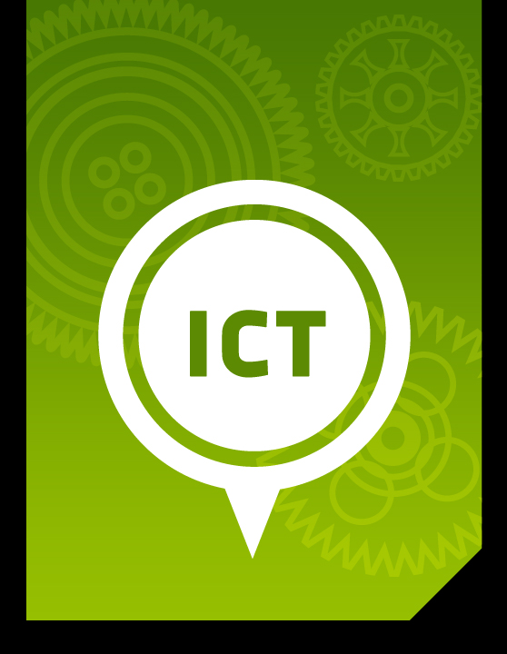

Part 1:

Introduction
to ICT

ICT Module, Workshop Series 2010

Unit 1: Introduction to ICT. What are ICTs?

1. Introduction
These should all look familiar to you. Fill in the table by completing the names of these various devices and what they are used for.
 | Name | Uses
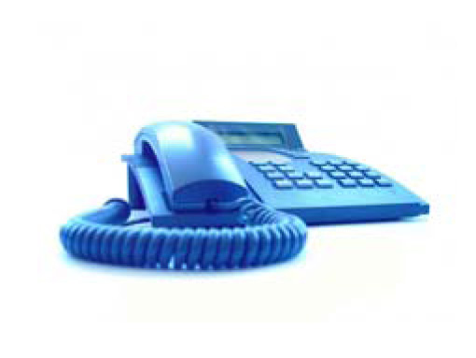
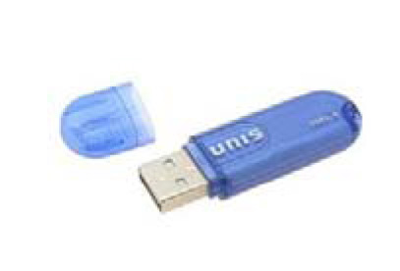
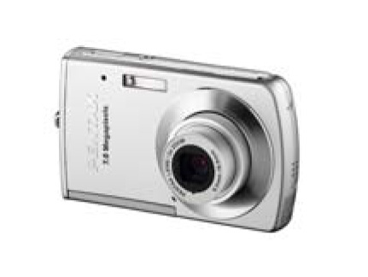
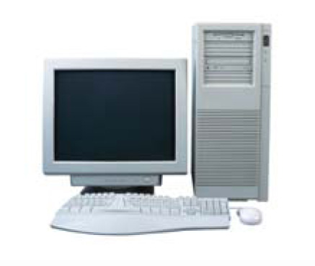

The devices in the table are examples of ICTs. ICT stands for Information and Communication Technologies, and these ICTs are all around us. We use them every day and for so many tasks they are unavoidable. They are often great time savers, although sometimes they can also help us waste time. Many people enjoy them because they are seen as excellent productivity tools.

Learning outcomes
Learners will be able to:

- Identify examples of ICTs that exist in their environment
- List possible uses for specific ICTs
- Transfer digital images from a cell phone/digital camera to a computer
- Identify benefits and problems regarding the use of ICTs

Start up activity 1.1

In groups, make a list of as many ICT devices as you can.

- Use your past experiences to identify as many information and communication technologies that you can think of as a group. Use a brainstorm technique where the group lists everything that is mentionedby the members of the group.
- Use the block below for your list of ICT examples. Your facilitator will then lead a discussion where the group needs to refine your list, removing items from the list that do not qualify as examples of Information and Communication Technology.
- Now that the group has generated an ‘approved’ list of items, see if you can write a definition for the term “Information and Communication
- Technologies” in the space provided, which could be included in a technical dictionary.

Our list of ICTs

Our definition of ICT (Information and Communication Technologies)

What are ICTs?
Compare your group’s list of ICTs and definition with the following and see how accurate you were.
Definition:
“ICTs are the technologies used in the conveying, manipulation and storage
of data by electronic means.”
ICTs should not be considered fixed or static. New ICT devises are being developed and being sold daily. If you were to try this same exercise in a year’s time, the list might look very different.

Simple Definitions
Convey: to transport, to carry, to take from one place to another. To communicate; to make known.
Manipulate: To influence, manage, direct, control or tamper with something to one’s own advantage.
Storage: A place for storing goods.
Data: information. A collection of object-units that are distinct from one another.

Wiktionary

Group Work &
Practical Portfolio Activity 2.1

This activity requires you to record instances of information and communication technologies (ICTs) that are present on campus, on the route home and in and around your local community.

- Use a digital camera or digital phone camera to photograph examples of ICT devices.
- Bring your camera/phone, software CD that accompanies the camera/phone, as well as any cables required to class.
- If necessary, install the software (your facilitator will assist you).
- Download your photographs from the camera to a computer.
- Print out the photographs.
- Glue the pictures onto a large sheet of paper leaving enough space to write in a description and add labels.
- Next to each picture write out the following details:
  - Name of ICT device;
  - Location where device was seen;
  - Reason why you consider it to be an example of ICT. Describe how you believe it specifically conveys, manipulates and stores data electronically.
- Take a digital photograph of your poster for your electronic portfolio.

There are various ways of transferring images from a cell phone or digital camera to your PC. Once you have completed transferring your images to your computer with the help of your facilitator, document the steps taken to do so on the following page, so that you may repeat this in the future on your own.

STEPS in transferring images from my cell phone/digital camera to my computer:

STEP 1:

2.2 Examples of ICTs
ICTs are all around us; such as:
- using an ATM
- phoning home
- using the World Wide Web at an Internet café
- playing online games using a PS3 console
- buying groceries at a supermarket
- booking movie tickets using the ‘no queue’ kiosk
- using a satellite navigation system to find your way around while driving

In all these examples data is electronically put into the device, stored, manipulated and ultimately transmitted. A simpler model of how all ICTs work is the Input – Processing – Output - Storage model:

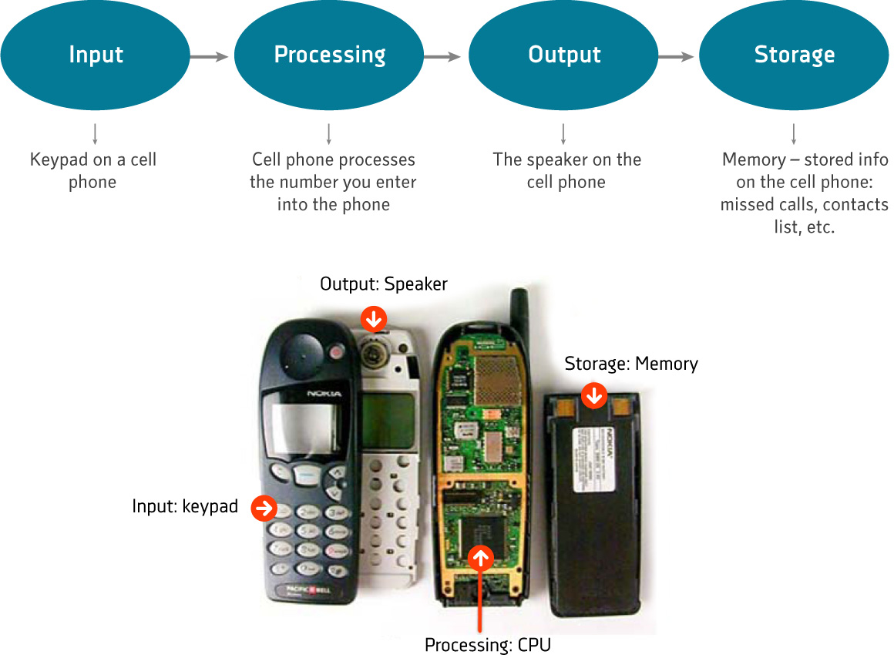

Learning Activity 2.2.1

Complete the following table by filling in the blank cells. Identify input, and output components of each device. There might be more than one possible component per device so list as many as you can think of.

ICT Device | Input component | Processor | Output component
Cell Phone | Keypad | Microprocessor | Speaker
Bank ATM |  | Microprocessor
Personal Computer (PC) Computer System |  | Central Processing Unit
Supermarket Checkout Scanner |  | Microprocessor
Car Satellite Navigation System |  | Microprocessor
See the Feedback section later in this lesson to see how well you did.

2.3 Data vs. Information
It is important that you understand the difference between data and information with regard to ICTs, as they are NOT the same thing.

Data: Is the raw material that we would input into an ICT device, such as figures, small facts and numbers that, on their own, have little value or meaning.

Information is processed data. That is data that has been reorganized so that it now contains some meaning.

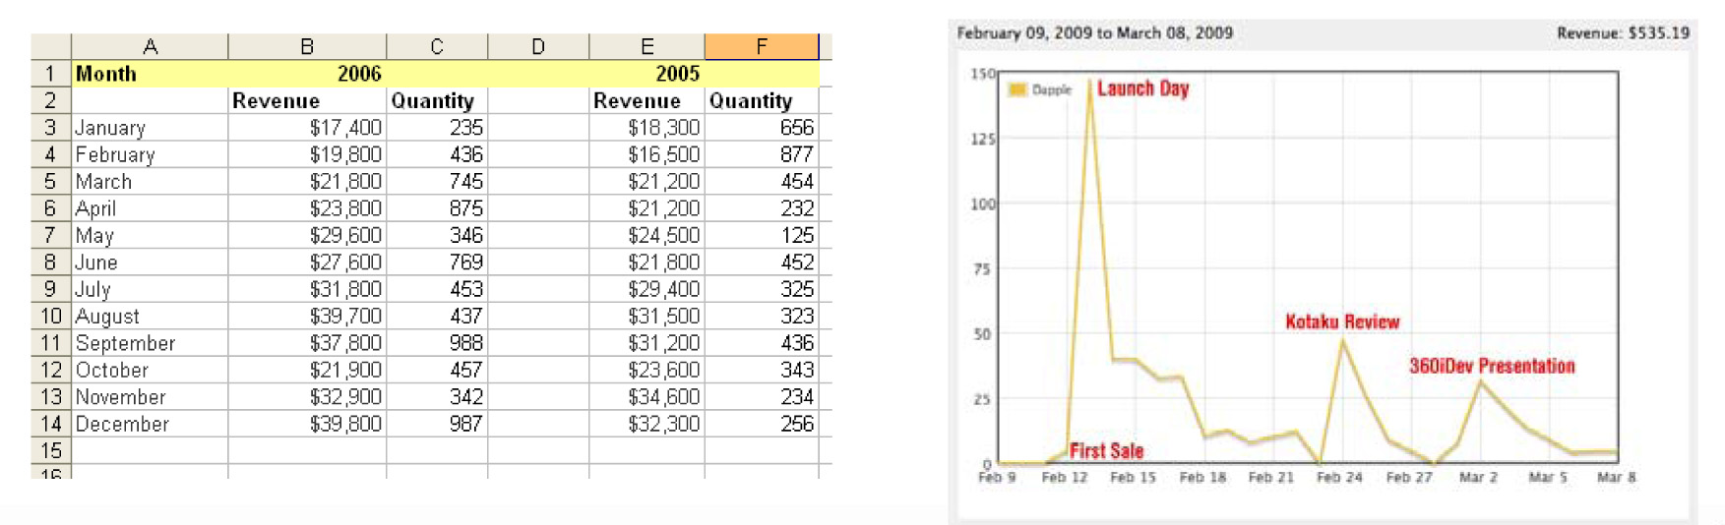
DATA | INFORMATION

2.4 Benefits of ICTs

Some benefits of ICTs include:

Remember the old day when you had to stand in long queues at the cinema to purchase a movie ticket or wait for weeks for mails to arrive at the post office?

Now, you can skip the queue and buy your tickets online instead and receive instant messages via e-mail. These are some of the benefits of ICTs – how many can you think of? Consider how much time and effort ICTs save us on a daily basis and jot them down in the space provided.

Group Learning Activity 2.4.1

Think of a business that you are familiar with. Perhaps it’s the shop up the road or the company where a family member is currently employed. Think of ways you could improve this business by using computers or other ICT devices.

Write a paragraph in the space provided on how you think ICTs might improve the business.

2.5 Problems concerning ICTs
The cautions that should accompany the use of ICTs are many and continue to grow as ICTs develop further. News articles often report on paedophiles who stalk young people in Chat Rooms and nasty viruses that can destroy your data and equipment. Consider the following examples of such problems regarding ICTs.

Virginity sales go online
May 31 2009 at 10:16AM
By Hazel Booth
Earlier this month, an 18-year-old Romanian-born student living in Germany auctioned her virginity online in an effort to raise cash for her studies. Alina Percea confirmed that an unnamed 45-year-old Italian businessman paid her £9 000 (R108 000) to sleep with her.

http://www.iol.co.za/index.php?set_id=1&click_id=3&art_id=vn20090531015723343C538583

'Beware of rising ATM fraud'
September 12 2008 at 08:29AM
By Christina Taylor and Devin Hermanus
Police are warning the public to be careful at ATMs, with cyber crimes such as bank card "skimming" on the rise.
Superintendent Jerome Hardenberg, SAPS Crime Prevention Awareness officer in the Western Cape, told a media briefing on Thursday that card "skimming and copying" devices and card-reading software were being brought into the country by organised crime syndicates which identified a market.
"It's a definite cause for concern because there has been steady flow of this kind of crime." Card skimming involves swiping a stolen card through a small hand-held device, recording the card's information.
Hardenberg said skimmers working in teams can distract ATM users with offers of assistance, then quickly take a card and pass it behind their backs. An accomplice will then skim and return it without the victim being aware the card was missing, sometimes in less than a minute.

http://www.iol.co.za/index.php?set_id=1&click_id=13&art_id=vn20080912061731575C223003

Italian cops clamp down on child porn
June 20 2009 at 04:17PM

ROME - Italian police arrested 14 people and placed more than 250 under investigation in the country's biggest sweep against Internet child pornography, authorities said in a statement.
The 14 people who were arrested were in possession of cruel and violent videos that partly originated from a porn server based in Germany, the statement said.
Authorities also conducted 300 searches and seizures in 68 towns and cities across the country in the operation codenamed Smasher.
Police confiscated 800 computers and 40,000 items of data storage, including DVDs, CDs and memory sticks containing more than 150,000 pornographic films, the statement said. - Sapa-AFP
http://www.iol.co.za/index.php?set_id=1&click_id=3&art_id=nw20090620160543418C284067

Group Learning Activity 2.5.1

In groups, discuss what problems or cautions you feel users of ICTs should be aware of. Use the table below to list these problems or cautions. Then as a group rate these issues as either mild, serious or dangerous threats.

 | Problem Scenario | Mild  Threat | Serious Threat | Dangerous Treat
1
2
3
4
5
6
7
8
9
10

See the Feedback section later in this lesson to see how well you did.

3. Conclusion
ICTs are all around us, by now you should be able to identify them easily and also explain why a device could be categorised as ICT or not. Furthermore, you have a general idea about what benefits can be derived from using ICTs as well as what you need to be cautious of when working with ICTs.

4. Feedback
Learning Activity 2.2.1

Below in bold are possible answers to the task of identifying input and output
devices for various ICT devices.

ICT Device | Input component | Processor | Output component
Cell Phone | Keypad | Microprocessor | Speaker
Bank ATM | Keyboard, Surveillance  Camera and card reader | Microprocessor | Money dispenser, ATM screen, Receipt dispenser, receipt printer
Personal Computer (PC) Computer System | Keyboard, mouse, digital camera or cam | Central Processing Unit | Monitor, speakers, printer
Supermarket Checkout Scanner | Scanner | Microprocessor | Till Price Display, Till slip printer, till receipt
Car Satellite Navigation System | Car positioning sensor | Microprocessor | Readout Screen

Group Learning Activity 2.3.2

There are in fact numerous issues that need to consider when using ICTs. These also vary with the device. Below are just a few suggestions. It is quite possible that your group found others.

 | Problem Scenario | Mild  Threat | Serious Threat | Dangerous Treat
1 | Identity theft – Criminals using your online identity to pose as yourself and embark on illegal activities using your name.
2 | Hackers – Programmers who attempt to break online security features to access data or financial accounts
3 | Viruses – Malicious code designed to propagate itself and damage software and hardware
4 | Spyware – Covert code designed to collect data about yourself and inform others about your habits and preferences
5 | Ergonomics – Some people experience headaches, muscle strains or poor posture from spending too much time in front of computer screens
6 | Time Wasters – Sites like FaceBook that are superficially engaging but take up a lot of time with little benefit

5. Tracking my progress
You have reached the end of this section. Check whether you have achieved the learning outcomes for this section.

Learning outcomes | I feel confident | I still need practice
Identify examples of ICTs that exist in their environment
List possible uses for specific examples of ICTs
Transfer digital images from a cell phone/digital camera to a computer
Identify benefits and problems regarding the use of ICT

What did you like best about this section?

What did you find most difficult in this section?

What do you need to improve on? How will you do this?

Skills Pack: Refer to pages 13 - 16 for information on computer hardware
See OpenLearn at http://openlearn.open.ac.uk/mod/resource/view.php?id=210525
Skills Pack: Transferring digital images to your PC, see page 11 and 12
English Skills Pack: Mind-mapping, topic and supporting sentences, page 17

