Part 3:

The Basics of MS Word

ICT Module, Workshop Series 2010

Part 3: The Basics of MS Word

Section 1:
Formatting Text & Paragraphs
Microsoft Office Word is used to create and share professional-looking documents. This user-friendly programme contains tools that make it easy for you to format your documents quickly in order for them to communicate to the reader more effectively. You can change the appearance of text, tables, and graphics throughout the entire document, as well as create your preferred style or colour scheme; this is what is referred to as formatting.

In this Part of the module, you will be introduced to the basic tools you need to use MS Word effectively in your studies or in the workplace.

1. Introduction
Do not feel demotivated if you have had minimal experience with a computer; you will soon discover that they are surprisingly easy to use. This Section focuses on developing skills in terms of formatting text, paragraphs, as well as entire documents so that you can prepare documents that look professional and are impressive. Have a look at the learning outcomes below to see what formatting entails.

Learning outcomes
On completion of this Section, learners will be able to

Demonstrate basic MS Word skills in terms of:
- Selecting texts using a variety of methods
- Cutting, copying and pasting pieces of text
- Using the undo/redo command effectively
- Identifying and using all the commands in the Font and Paragraph group
- Using styles effectively
- Inserting page breaks and section breaks
- Changing the layout of a page
- Changing page margins
- Inserting headers, footers and page numbers 26

2. Selecting Text
In order to make changes to text, you must select it first. MS Word provides many ways to do this.

To select lines, paragraphs or the entire document without scrolling, click the empty space in the left-hand margin of the text – this is called the Selection bar. When you are in the Selection bar, the pointer becomes a right-pointing arrow.

Further methods of selecting text include:

Action | Selects
Double-click the mouse on a word | selects only the word
Click in Selection bar beside a line | selects the whole line
Double-click in selection bar | selects a whole block of text
Click at beginning of a text block; hold down the <Shift>key and click at the end of text block | selects a block of text
Press Ctrl A | selects ALL the text

3. Cut, Copy, Paste and Undo/Redo
These are important functions to get to know, as they allow you to move items around in a document, get rid of them when necessary, or delete changes that you made to the document. You will make use of these often in MS Word. Study the image below of shortcut icons and refer to the table of functions.

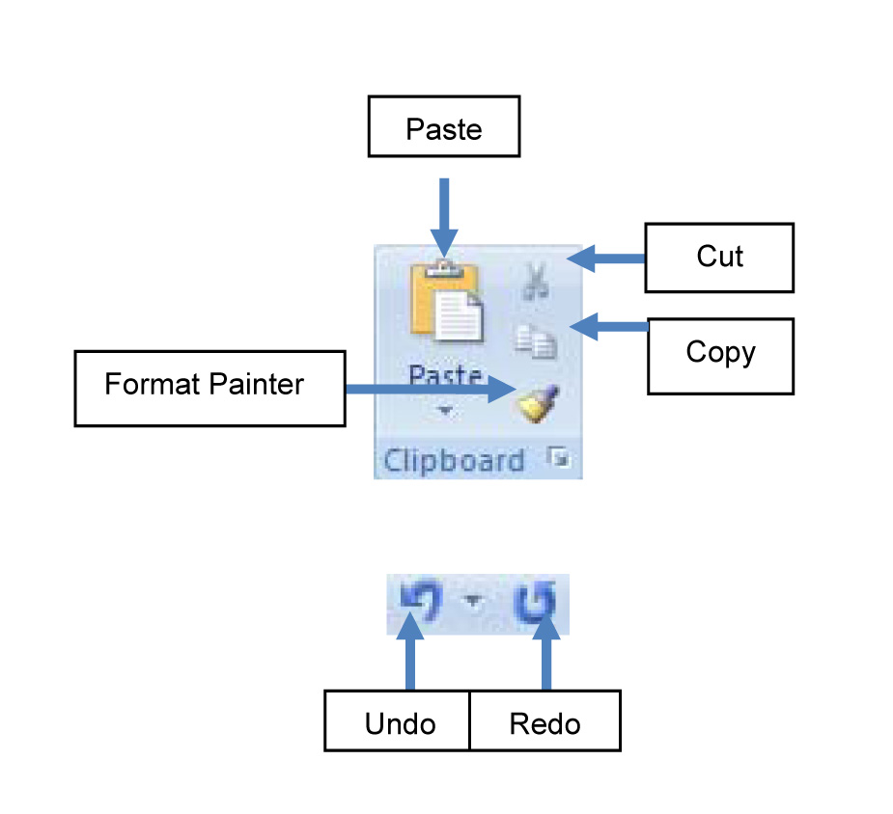

Shortcut icon | Function
CUT
removes selected text
PASTE
replaces cut text
COPY
makes a copy of selected text
FORMAT PAINTER
copies formatting from one place and applies it to another
UNDO
deletes changes made
REDO
replaces deleted changes

Learning Activity 3.1

Now you need to apply what you have learned so far. Duplicate the follow text and complete the instructions that follow. Once you have completed the activity, save the document in the location specified by your facilitator as follows (replace Name and Surname with your own name and surname):

NameSurname_Part3_Activity_3.1

AAAAAAAAAAAAAAAAAAAAAAAAAAAAAAAAAAAAAAAAAAAAAAAAAAAA
AAAAAAAAAAAAAAAAAAAAAAAAAAAAAAAAAAAAAAAAAAAAAAAAAAAA
AAAAAAAAAAAAAAAAAAAAAAAAAAAAAAAAAAAAAAAAAAAAAAAAAAAA

BBBBBBBBBBBBBBBBBBBBBBBBBBBBBBBBBBBBBBBBBBBBBBBBBBBB
BBBBBBBBBBBBBBBBBBBBBBBBBBBBBBBBBBBBBBBBBBBBBBBBBBBB
BBBBBBBBBBBBBBBBBBBBBBBBBBBBBBBBBBBBBBBBBBBBBBBBBBBB
BBBBBBBBBBBBBBBBBBBBBBBBBBBBBBBBBBBBBBBBBBBBBBBBBBBB

CCCCCCCCCCCCCCCCCCCCCCCCCCCCCCCCCCCCCCCCCCCCCCCC
CCCCCCCCCCCCCCCCCCCCCCCCCCCCCCCCCCCCCCCCCCCCCC
CCCCCCCCCCCCCCCCCCCCCCCCCCCCCCCCCCCCCCCCCCCC
CCCCCCCCCCCCCCCCCCCCCCCCCCCCCCCCCCCCCCCCCC

Instructions:

- CUT the second paragraph of text (Bs) and PASTE it below paragraph 3 (Cs).
- COPY the last line of Bs and PASTE it at the beginning of the Cs.
- CUT the last 4 As from paragraph 1 and PASTE them at the end of the last row of Cs.
- Now skip a line and create a new paragraph under the Cs of 4 rows of small ‘d’s.
- Use the Format Painter and copy the formatting of text in the Cs and apply it to the new paragraph of Ds.
- Save the updated document.

4. Font and Paragraph Commands
Font and paragraph commands include:
- Changing font style, size and colour
- Making text bold, italicized or underlined.
- Changing the alignment of text; and
- Creating bulleted or numbered lists.

You might not be familiar with some of the above-mentioned terms. The
following are definitions and examples to help you understand what they are:

1. Fonts refer to different types of writing styles:
- Garamond font
- Rockwell font
- Comic sans font

2. Alignment refers to the position of text on a page:

“Align text left” looks like this:

AAAAAAAAAAAAAAAAAAAAAAAAAAAAAAAAAAA
AAAAAAAAAAAAAAAAAAAAAAAAAAAAAAAAAAAAAAA
AAAAAAAAAAAAAAAAAAAA
AAAAAAAAAAAAAAAAAAAAAAAAAA

“Align text right” looks like this:
BBBBBBBBBBBBBBBBB
BBBBBBBBBBBBBBBBBBBBBBBBB
BBBBBBBBB

“Centred” text looks like this:

CCCCCCCCCCCCCCCCCCCCCCCCCCCCCC
CCCCCCCCCCCCCCCCCCCC
CCCCCCCCCCCCCCCCCCCCCCC

“Justified” text creates a neat block of text like this:

DDDDDDDDDDDDDDDDDDDDDDDDDDDDDDDDDDDDDDDDDDDDDDDD
DDDDDDDDDDDDDDDDDDDDDDDDDDDDDDDDDDDDDDDDDDDDDDDD
DDDDDDDDDDDDDDDDDDDDDDDDDDDDDDDDDDDDDDDDDDDDDDDD
DDDDDDDDDDDDDDDDDDDDDDDDDDDDDDDDDDDDDDDDDDDDDD

3. Bulleted and numbered lists refer to a list of text that either has bullets at the beginning of each point, or numbers at the beginning of each point.
Look at the following examples:

Bulleted text:
- AAAAAAAAAAA
- BBBBBBBBBBBBB
- CCCCCCCCCCCCCCC
- DDDDDDDD

Numbered text:
1. AAAAAAAAAAA
2. BBBBBBBBBBBBB
3. CCCCCCCCCCCCCCC
4. DDDDDDDD

Look at some of the other options available to us from the Font and Paragraph groups of commands.

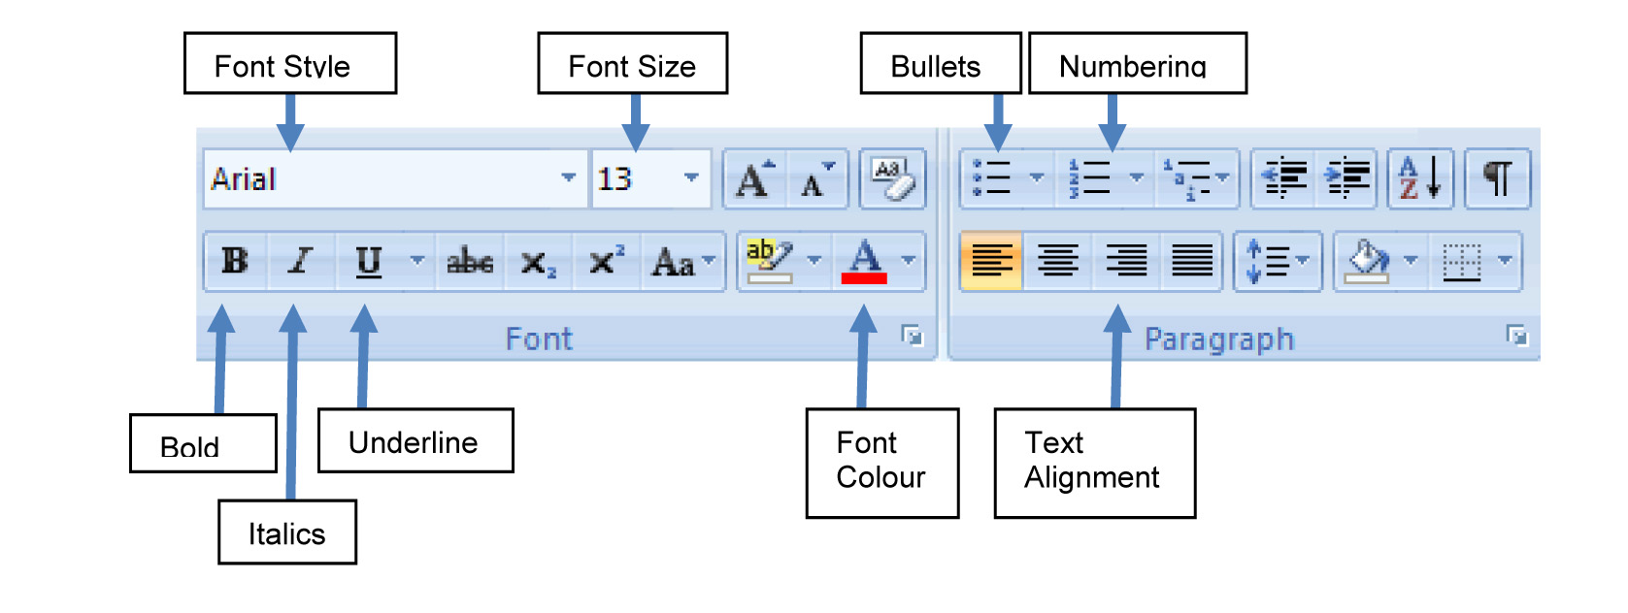

TASK: Now, experiment a little with a partner and complete the table on the following page.

 |  | Name | What does it do?
1 | 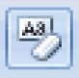
2 | 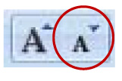
3 | 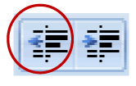
4
5
6
7 | 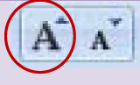
8 | 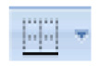
9
10 | 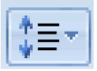
11
12
13 | 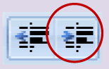
14

5. Working with Styles
When you use a computer, you want to be as efficient as possible. You want to be able to create and format documents with minimal effort, yet give them a professional appearance. The following table provides information on formatting and styles.

MS Word Styles  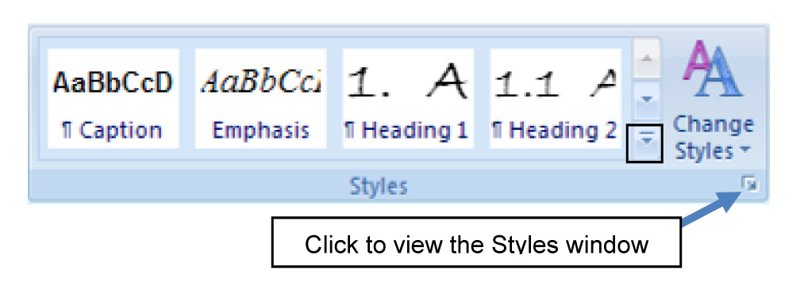  Note: the default (automatic) settings for a new document are usually as follows: 12 point Times New Roman, English, single spacing, Left alignment, and widow/orphan control. | Location – Home tab (Styles)  A style is a set of formatting characteristics that you can apply to text, tables, and lists in your document to quickly change their appearance.  How to:  To apply an existing MS Word Style, all you need to do is place your cursor anywhere in the piece of text and select a style. The style will be applied to any piece of text separated by a hard return (Enter).
Paragraph Style  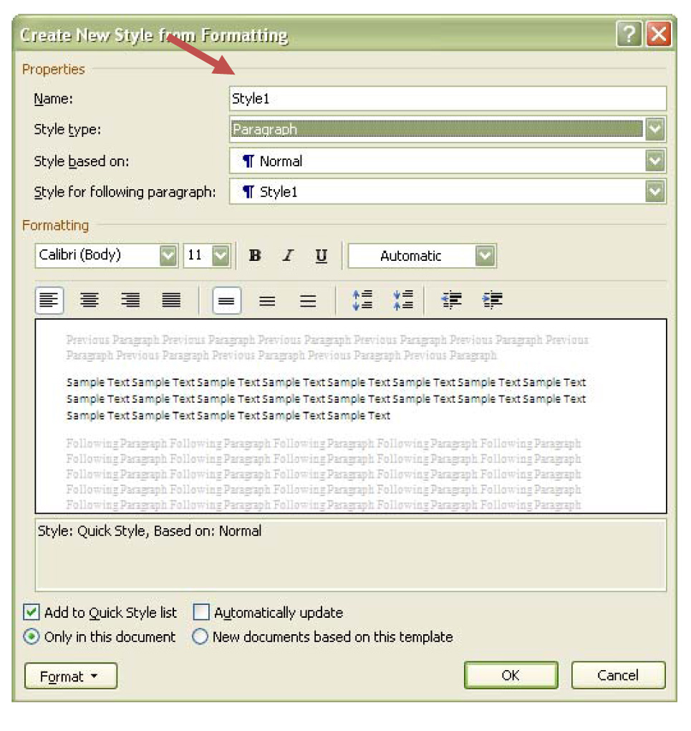 | Location – Home tab (Styles)  A paragraph style controls all aspects of a paragraph's appearance, such as text alignment, tab stops, line spacing, and borders, and it can include character formatting.  How to:  - Open the Styles window.  - Click on the icon for “New Style” at the bottom of the window.  - Give the style a name.  - Make sure the “Style type” is Paragraph, and make sure the Based on option is Normal.  - Select a font style; font size and font colour.  - Select whether you want to make it Bold, italics or underlined.  - Select a paragraph alignment.  - Select line spacing.  - Select option to indent text if suitable.  - Adjust spacing before and after the paragraph.  - Click “OK” when done.
Character Style  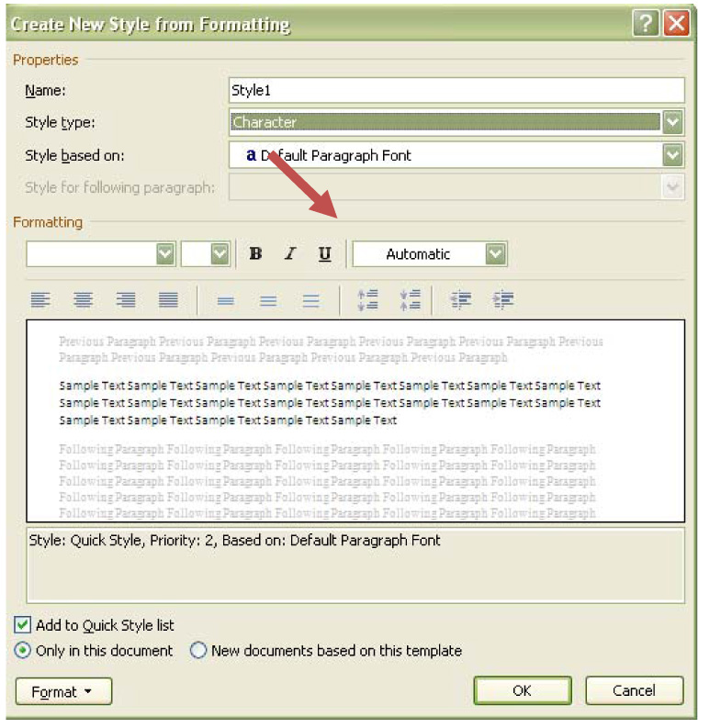 | Location – Home tab (Styles)  A character style affects selected text within a paragraph, such as the font and size of text, and bold and italic formats.  How to:  Unlike a paragraph style that can format font, border, language, line spacing, alignment and indents, a character style can format only fonts, borders and languages. To create a character style make sure the Style type selected is Character and the Based on option is Default Paragraph Font. You might use this tool if you wanted quotations to stand out, for example.
Inserting Section Breaks and Page Breaks  Select to see Section Breaks  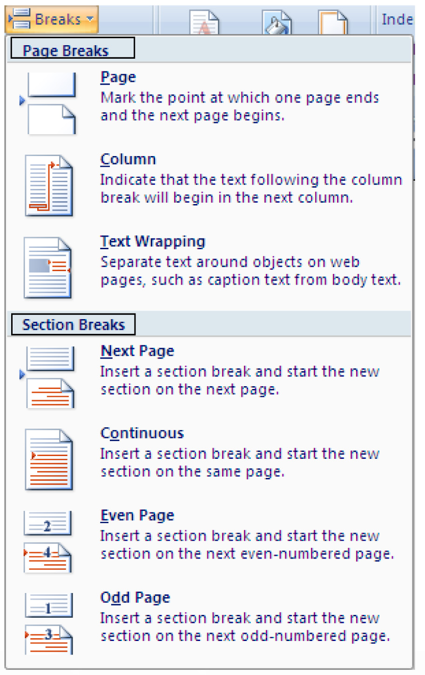 | Location – Page Layout tab (Page Setup)  To apply different formats throughout the document, you need to add section breaks, which are markers that divide the document into sections enabling you to format each section separately.  In other instances you may want to use the same formatting, but start text on a new page instead of waiting for MS Word to start a new page for you, in which case you will use a page break.  How to:  - Click on place on the page where you want to insert a page break or section break  - Click on Page Layout  - Click on the arrow next to Breaks  - Click on Page to insert a page break  - Click on Next Page to insert section  - break  - 6. Remember to add another section break should you want to return to the original formatting
Changing Page Orientation  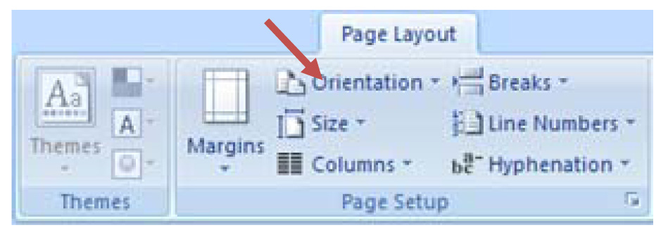 | Location – Page Layout tab (Page Setup)  Landscape orientation – Page is displayed horizontally, long sides of the paper are at the top and the bottom.  Portrait orientation – Page is displayed vertically, short sides of the paper are at the top and the bottom.  How to:  - Click on Page Layout  - Select Orientation  - Choose either Landscape or Portrait
Changing Page Margins  At top and left-hand side of page  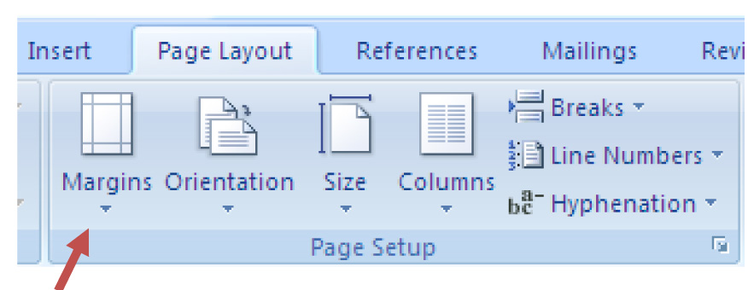 | Location – Top and left-hand side of page OR Page Layout tab (Page Setup)  Generally, all text and images are included between the margins.  How to:  - Click on Page Layout  - Click on the small arrow under Margins  - 3. Select an option or click on Custom Margins to set your own margins
Inserting Headers, Footers and Page Numbers  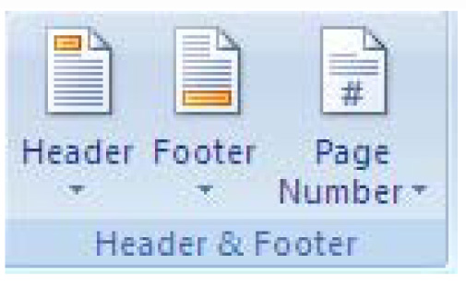 | Location – Insert tab (Header & Footer)  A header or footer contains text or graphics that are printed at the top or bottom of every page in a document. A header is printed in the top margin – footer is printed in the bottom margin. Common items placed in headers/footers are Title of Document, Student Number, Page Numbers and Date.  How to insert a Header and Footer:  - Click on Insert  - Click on the small arrow under Header or Footer  - Select the layout option you prefer  - Type in the text that you want to have appear as either a Header or Footer  How to insert Page Numbers:  - Click on Insert  - Click on the small arrow under Page Numbers  - Select the layout option you prefer  - You can click on Format Page Numbering if you want your page numbers to start at a specific number
Inserting a Drop-Cap  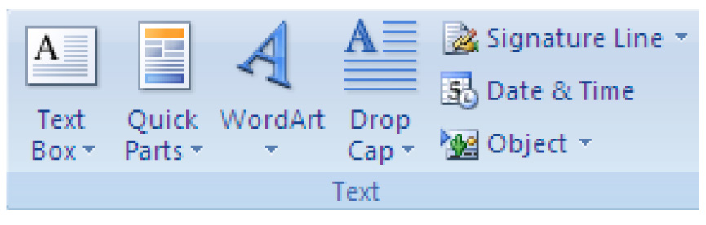 | Location – Insert tab (Text)  Drop caps, or large initial letters or words at the start of a paragraph or document, can add style and focus to your documents, for example:  Drop cap  You can use them in letters to add your own special touch. Or you can use them at the start of sections of a newsletter or report to help your readers' eyes find their way through the page.  How to:  - Click the paragraph that you want to begin with a drop cap.  - Click on Insert and click Drop Cap.  - Click Dropped.  - Click OK.

Information and “How to” table

Learning Activity 3.2

Duplicate the follow text and complete the instructions that follow. Once you have completed the activity, save the document in the location specified by your facilitator as follows (replace Name and Surname with your own name and surname):

NameSurname_Part3_Activity_3.2

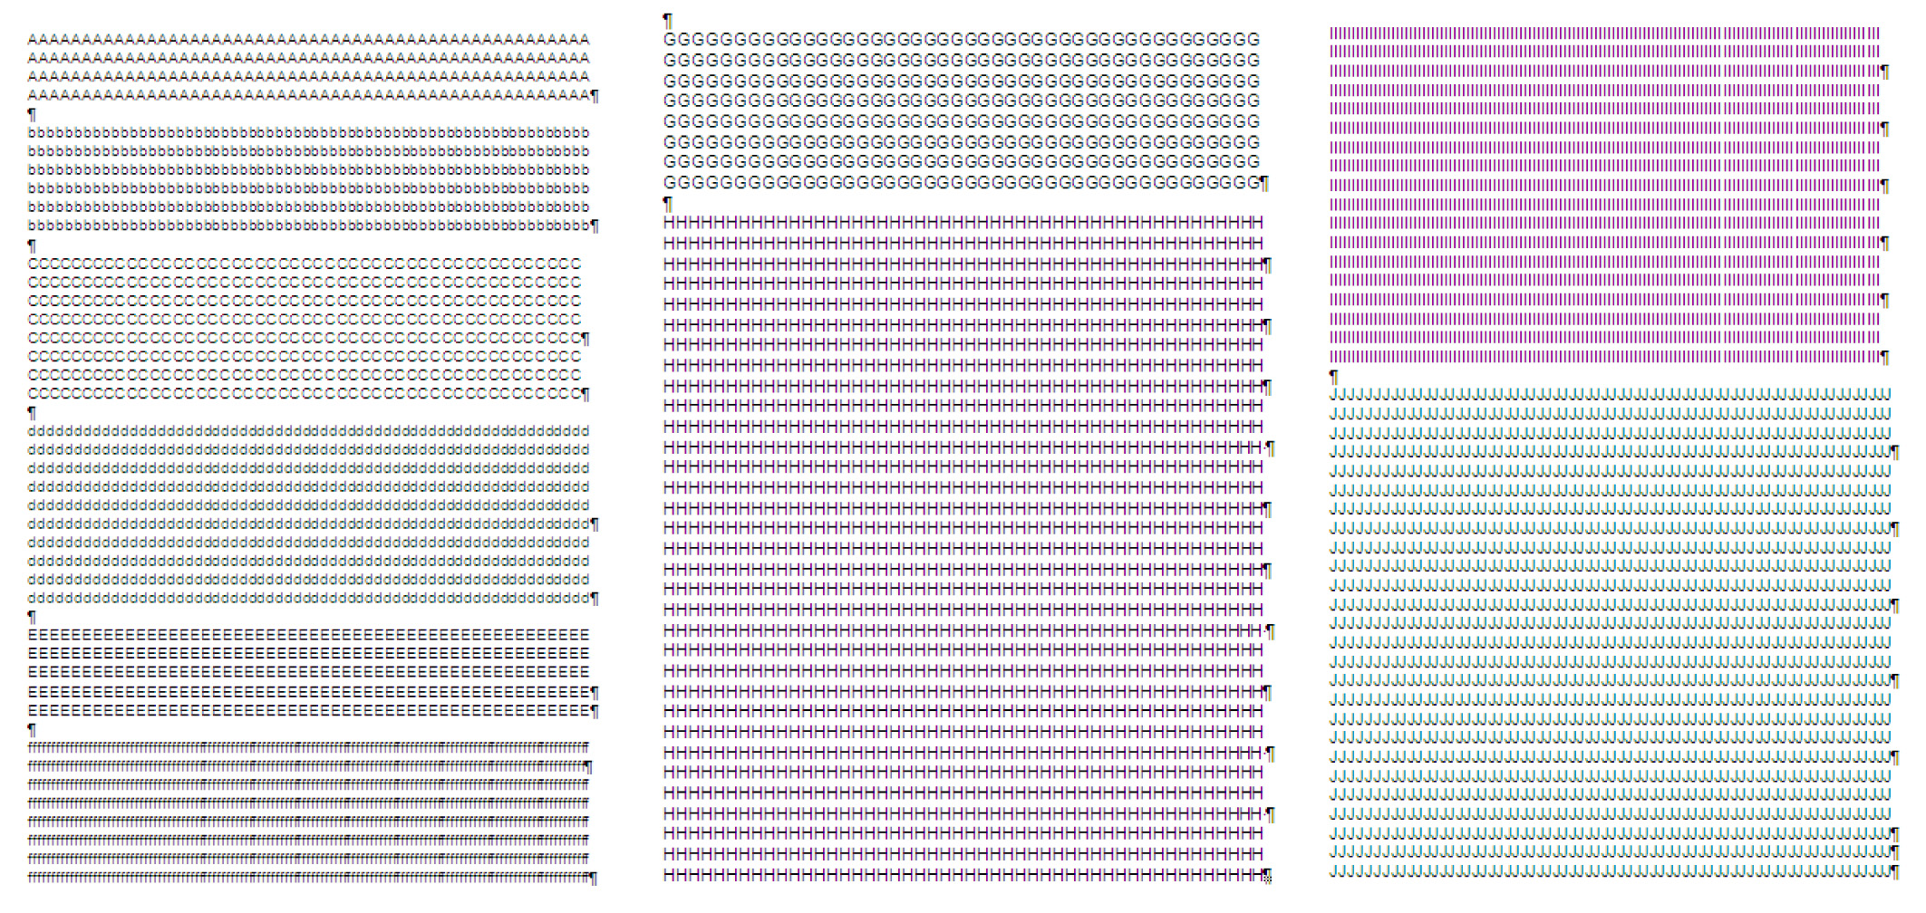

To duplicate the above text, follow the following specifications:

Use font (Arial 13); select button; leave 1 space between each paragraph

Page 1:
Paragraph 1: 4 lines of capital As
Paragraph 2: 6 lines of small ‘b’s
Paragraph 3: 8 lines of capital Cs
Paragraph 4: 10 lines of small ‘d’s
Paragraph 5: 13 lines of capital Es
Paragraph 6: 8 lines of small ‘f’s

Page 2:
leave 1 space at page top
Paragraph 7: 8 lines of capital Gs
Paragraph 8: 33 lines of capital Hs

Page 3:
Paragraph 9: 18 lines of capital Is
Paragraph 10: 26 lines of capital Js

NOTE:
To create capital letters, press the Caps Lock key on your keyboard that looks like this:

When you want to take it off, press it once again.

Now, you need to apply your newly acquired skills and do the following:

- Select the first A in paragraph 1 and insert a ‘dropped’ Drop Cap

- Select paragraph 3 and 4 (page 1) and change the Style formatting as follows:
  - Font: Jokerman, 12 point, bold, italics, colour-blue
  - Paragraph Style
- Alignment: Justify
- Indentation: Left: 1.27 cm
- Line Spacing: 1.5
- Paragraph Spacing – Before: 12 pt; After: 12 pt

- Select paragraph 5 (page 1) and change the Style formatting as follows:
  - Font: Lucida Sans Typewriter, 24 point, colour-orange
  - Character Style
- Alignment: Centre
- Line Spacing: single

- Insert a Section Break at the end of paragraph 5 (Es) and at the end of paragraph 7 (Hs)

- Change the Page Orientation of the page with paragraph 6 and 7 to Landscape

- Select paragraphs 8 and 9 and change the Page Margins as follows:
  - Top: 1 cm
  - Bottom: 2 cm
  - Left: 2.5 cm
  - Right: 2.5 cm

- Insert Page Numbers and a Header with your name, surname and date

Remember to save your document as NameSurname_Part3_Activity_4.1. Save the document as soon as you have opened it and do so regularly so that you do not lose any information.

5. Tracking my progress
You have reached the end of this section. Check whether you have achieved the learning outcomes for this section.

Learning outcomes | I feel confident | I still need practice
Select text using a variety of methods
Cut, copy and paste pieces of text
Use the undo/redo command effectively
Identify and use all the commands in the Font and Paragraph group
Use styles effectively
Insert page breaks and section breaks
Change the layout of the page
Change page margins
Insert headers, footers and page numbers

What did you like best about this section?

What did you find most difficult in this section?

What do you need to improve on? How will you do this?

Part 3: The Basics of MS Word

Section 3: Tables

1. Introduction
A table is a grid of cells consisting of rows and columns. Tables can be customized and are useful for a variety of tasks, from presenting numerical data to creating unique text layouts.

Tables can be any size and they can easily be modified. You can create a table with just one cell, with two cells, even with 100 cells or more. Table cells, rows, and columns can be added, deleted, split, and merged (joined) at any time. Once a table has been created, you can insert anything into a cell that you could in a normal document (e.g., text, images, or even another table) and then format it with any of Word's tools.

 |  | Column
 | Cell | Cell | Cell | Cell
 | Cell | Cell | Cell | Cell
Row | Cell | Cell | Cell | Cell
 | Cell | Cell | Cell | Cell
 | Cell | Cell | Cell | Cell

Learning outcomes
On completion of this lesson you will be able to...
- Insert, create or draw a table
- Add information to a table
- Add a new row or column to a table
- Delete a row or column from a table
- Merge and split cells
- Increasing and decreasing row or column size
- Format text within the cells
- Repeat headings in a table
- Add borders and shading
- Use table styles

2. Creating Tables and Adding Information

Information and “How to” table

Creating tables  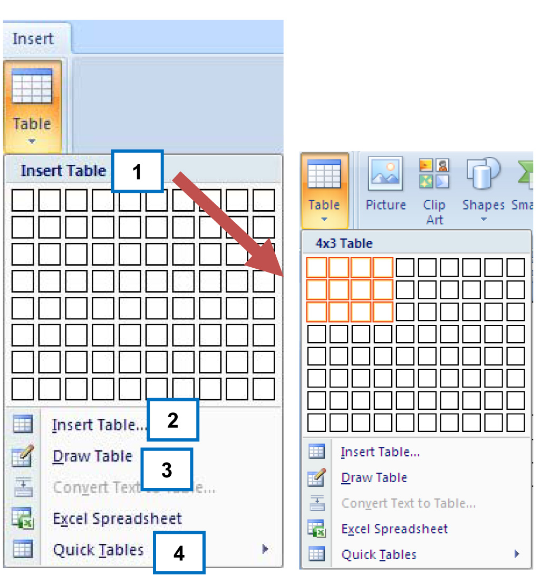 | Location – Insert tab (Tables)  When creating a table, it helps to try and spend a little time first planning how you would like your table to look. Even a simple paper sketch can reduce the amount of time needed later to make the table look exactly right. Once you know what you want the finished table to look like, you can use one of four ways to create it:  How to:  - Drag to select the number of rows and columns that you want.  - Click Insert Table and choose the table dimensions and format before you insert the table into a document.  - Click the Draw Table option and draw a complex table — for example, one that contains cells of different heights or a varying number of columns per row.  - Click Quick Tables and choose an option from a gallery of existing preformatted tables.
Adding Information  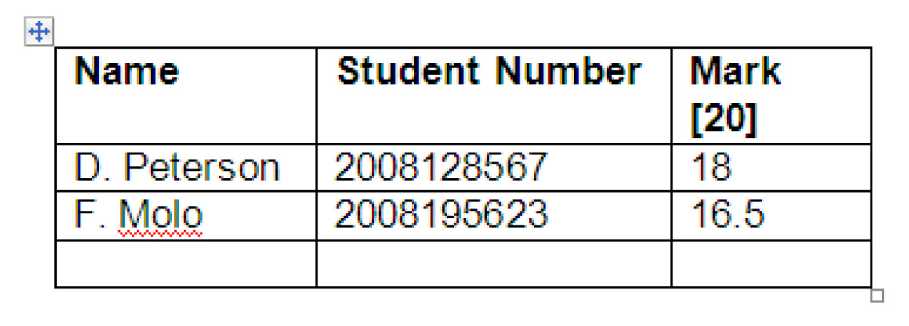 | How to:  Adding information to a table is simple. Just click inside a cell and type. You can add anything inside a table that you could outside the table. If you want to add information in separate cells, you will need to move your cursor from cell to cell in the table. You can do this by:  - Pressing [Tab]  - Pressing an arrow key.  - Using the mouse and clicking in the appropriate cell
Formatting tables | When you click on any table you have created, you will notice a new set of tabs that appear under Table Tools in the Ribbon:  1. Design Ribbon  2. Layout Ribbon
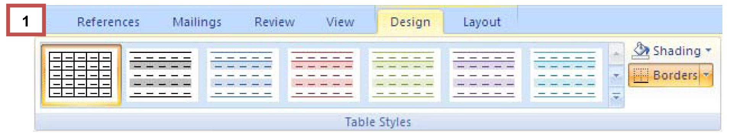
Design Ribbon  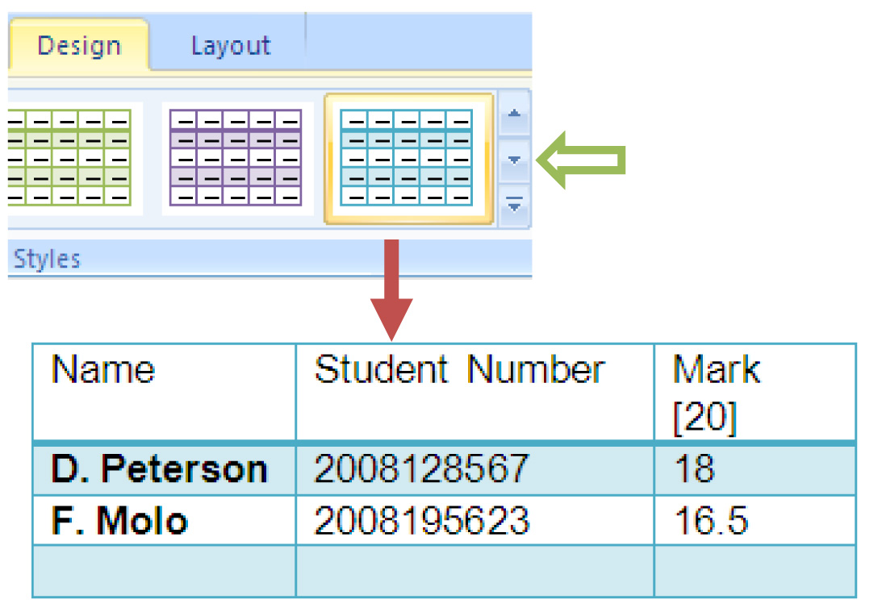 | Location – Design tab  The design ribbon offers a wide range of formatting flexibility. You can use any one of the predefined Table Styles listed on the Ribbon or you can create something that meets your exact needs. The best part is that Word 2007 allows you the ability to first preview these templates and themes before you commit to them.  It is also here on the Design Ribbon where you can set the type of line you would like to use, the width of that line, and the color. You can also set shading and place or remove border lines. These format settings can be applied to a specific cell, row, column, or to the entire table.  How to:  - Select your table and then click on Design  - Run your cursor over the Table Styles in the box. You will notice that Word gives you a preview of what your table with look like.  - Select the arrow on the right hand side of the Design Ribbon to view more Style options  - Click on the Style you like most  - You can select the Shading option on the right of the Design Ribbon if you want to colour the table in a specific colour  - The Borders option on the right of the Design Ribbon allows you to place or remove border lines.
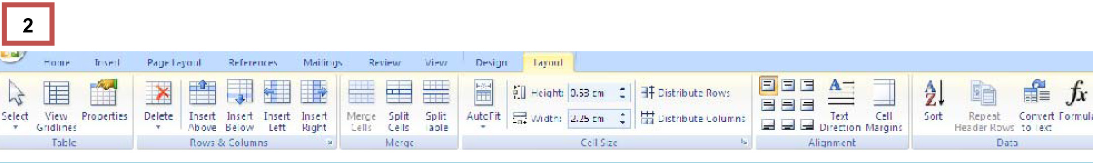
Layout Ribbon  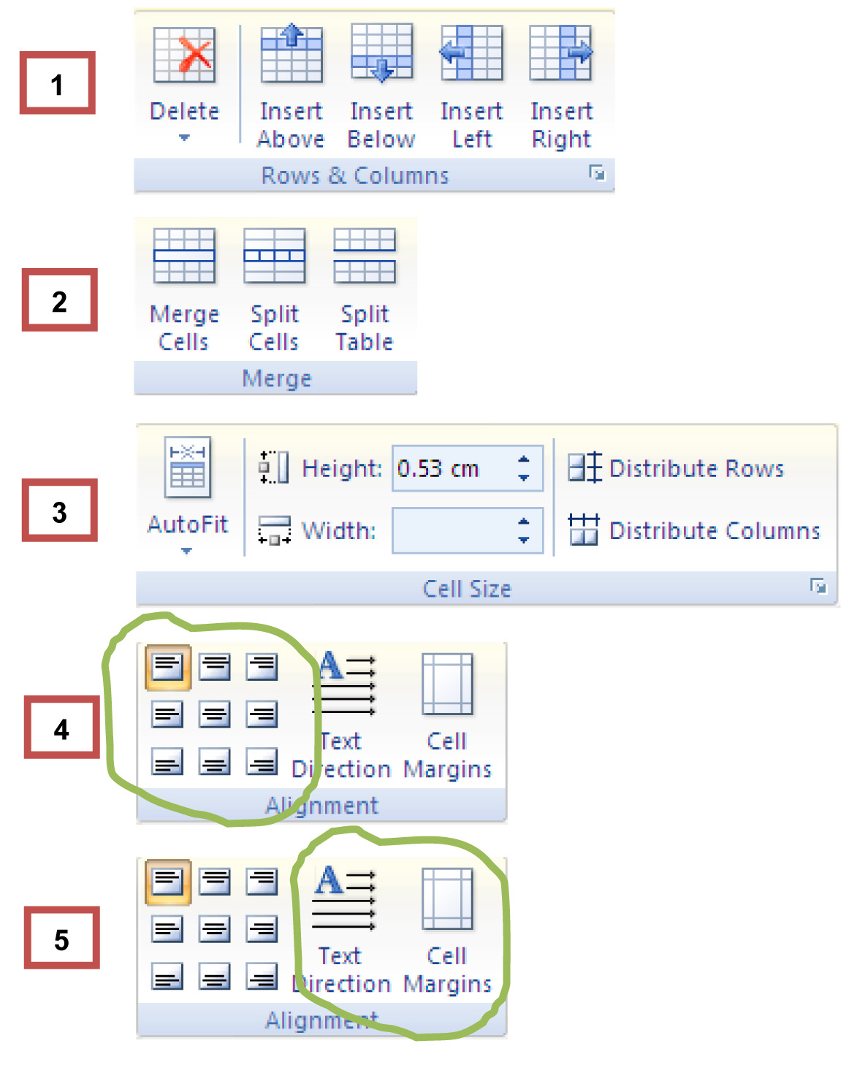 | Location – Layout tab  This Ribbon allows you to:  - insert rows and columns into your table;  - split cells into further rows and columns or merge or join several cells together to form one;  - size individual cells, rows, columns, and the entire table  - align the table and text within the table  - change text direction and cell margins  How to:  - To insert rows and columns, look at the Rows & Columns section and select either Insert Above or Insert Below to add a row; or Insert Left or Insert Right to add a column.  - You can Merge, Split Cells or Split Table by selecting the Merge option on the Layout Ribbon  - The Cell Size section allows you to align the table on the page and also make adjustment to the size of cells and the table as a whole  - The Alignment section allows you to align the whole table (right, centre or left), as well as the text in the cells.  - 5. The Alignment section also allows you to change the direction of text within your table, as well

Learning Activity 3.4

Duplicate the following table in a new document and then follow the instructions.

To duplicate the table below:

- Insert a table with 3 columns and 4 rows
- Select Table Style “Light Grid – Accent 2”
- Insert the text as seen below into the cells
- Centre the text in the cells
- Set the Cell Margins to Left: 0.6 cm and Right: 0.6 cm
- Autofit Contents
- Merge the cells of the last row

Monday | Tuesday | Wednesday
Swimming | Extra English classes | Hockey
Rugby | Learn for History test | Visit Granny

Now, do the following:

  - Insert two columns to the right of Wednesday
  - Label the columns Thursday and Friday and Centre the Text
  - Autofit Contents
  - Insert another row below row 4
  - Split the first 3 cells of the new row (row 5) into 3 columns and 1 row
  - Delete row 4
  - Shade the entire table Red, Accent 2, Lighter 60%
  - Save your document as NameSurname_Part3_Section3_Activity_2.1

5. Tracking my progress
You have reached the end of this section. Check whether you have achieved the learning outcomes for this section.

Learning outcomes | I feel confident | I still need practice
Insert, create or draw a table
Add information to a table
Add a new row or column to a table
Delete a row or column from a table
Merge and split cells
Increasing and decreasing row or column size
Format text within the cells
Add borders and shading
Use table styles

What did you like best about this section?

What did you find most difficult in this section?

What do you need to improve on? How will you do this?

Formatting refers to the layout or arrangement of text in a document. If you have cut text from one place in the document and pasted it in another, this is an example of formatting. The format painter will then copy what you did and apply it to the selected text in another part of the document.

