Part 6:

Research Skills

ICT Module, Workshop Series 2010

Part 6: Research Skills

Section 1: Finding information online

1. Introduction
In this Part, we are going to investigate ways to do research using computers and the Internet. You will be required to be able to search, find and analyse data, both for your studies, as well as in the world of work. Having access to the Internet and its vast resources makes this much easier than in the past. Previously we were bound to the information collected by institutional archivists and librarians, but now the Internet can provide access to a lot more information and also the latest information. However, you should not ignore the Resource Centre on campus or your local Library, both are still excellent sources of information and provide an environment that is conducive to learning and study.

Here we will focus on using search engines to identify specific information that will be useful to our studies and assignment-writing. We will also look at a number of strategies to determine the usefulness and authenticity of the websites identified by the search.

Learning Outcomes
On completion of this Section you will be able to:

- Conduct an advanced search using a search engine to find appropriate information on the Internet
- Be aware of the possible dangers of using online search facilities
- Have developed a preference to a particular search engine
- Critically evaluate the usefulness and authenticity of the information provided by the individual websites identified within the search results

2. Search Engines
Recently, there were over 15 billion websites on the World Wide Web. It is easy to find what you are looking for if you know the web address, but one is not always exactly sure what to search for and this is where search engines come in - they help you browse through the sea of content. Most search engines use the simple process of searching the Internet for instances of words or phrases that a user has inserted into a search field. If you click the “Search” button, millions of results are returned. However, not all search engines are the same; you need to find one that consistently returns results that suits you.

Search Engine | Description
www.google.co.za | Google is currently the most well-known and „trendy‟ search engine. People like it because it ranks sites according to popularity. It uses the number of links to a site to determine how important the site is. It places these sites high up in the returned search results. Google also has specialised searches for blogs, images, news, scholarly journals, patents and books. It is also very user-friendly.
www.yahoo.com | Yahoo is the „grandpa‟ of search engines and has built up a loyal community around it. The search facility appears at the top of the page and a portal filled with numerous services and content appears on the same page. Noteworthy features include shortcuts to dictionary, synonyms, patents, traffic, stocks, and an encyclopaedia.
www.ask.com | Ask uses a system called Subject-Specific Popularity™ ranking that allows you to suggest a broader or narrower search, thereby filtering your search results. It too has an encyclopaedia that is very useful.
www.ananzi.co.za | Ananzi is a South African-based search engine and specialises in finding local services and resources. There is also a handy map facility that shows you the street names for any district, town or city in the country.
www.za.msn.com | MSN is a popular search facility for those who use the Microsoft Network portal, MSN. In the USA, MSN search accounts for about 10% of all Internet searches. There is a local version that uses the same technology.
www.monstercrawler.com | Monster Crawler is an example of a meta-search engine that coordinates searches using all of the top 5 US search engines (Google, Yahoo, MSN, Ask and AOL). While it might make sense that more heads are better than one, there are some academics that believe that the results returned by meta-search engines are no better than those sites using one system

3. Advanced Search Strategies

Phrases and exclusion strategies

- Insert more than one word into the search field
Using more than one word to describe what you are searching for forces the search to be more focused. The search engine returns results of web pages that contain all the words you have inserted and, therefore, are more likely to be close to what you are looking for.

- Insert phrases inside inverted commas
Ensure the search engine searches for the instance of a phrase rather than a series of individual words by inserting phrases inside inverted commas like, such as “Search Engine”, “Virgin Active” and perhaps most significantly “South Africa”.

- Insert a minus sign and then the ambiguous word you want excluded
This allows you to ask the search engine to exclude or omit instances of an ambiguous meaning of a word that you are looking for, e.g. glasses – spectacles

Advanced Search screen
Most search engines offer you access to a screen that contains a host of different search strategies that allows you to customise how you search. This screen shot belongs to the Google advanced search screen. Notice that it allows you to:
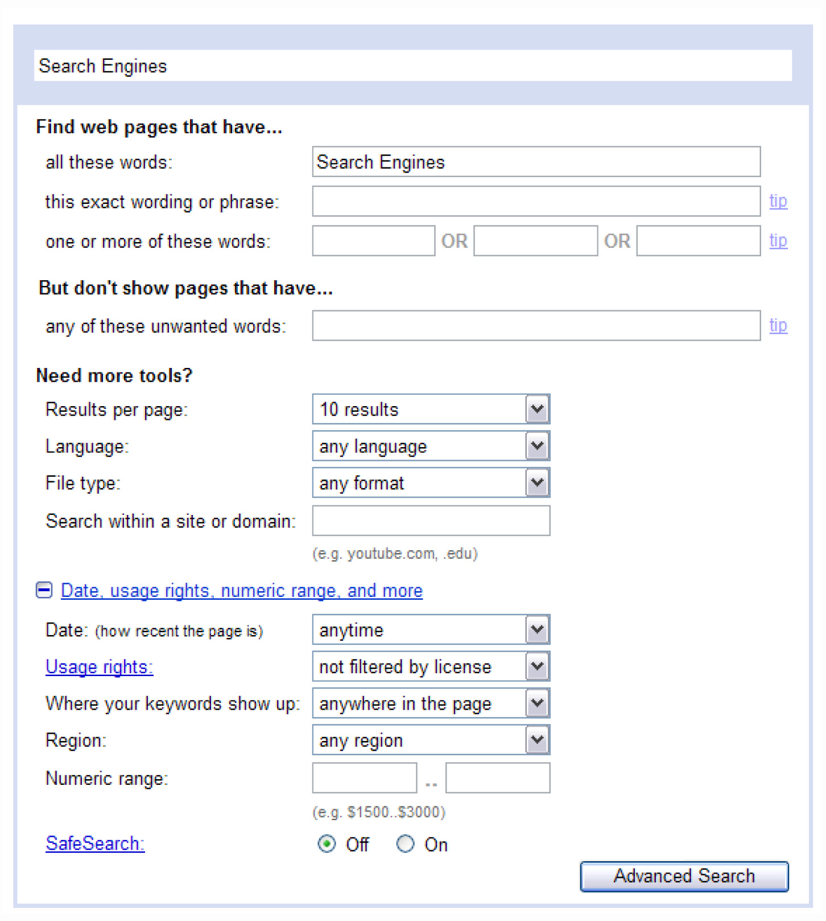
- Use exact or exclude various words
- Determine how new or old the page should be
- Identify where in the web page the key words should be found
- What geographic region or domain the page should come from
- What language the pages should be in
- If the resources you are searching for are not web pages, then you can also determine what type of file types you would prefer, e.g. PowerPoint or .ppt

4. Determining the Usefulness of the results
While there are numerous resources available on the Internet, not all of them are accurate. Therefore, it is important to be able to judge which information is trustworthy and which should be ignored. Below is an introduction to evaluating web resources:

You will need to evaluate each website according to the following five main criteria:

Accuracy
- Are the pages accurate?
- First identify who or what institution wrote the page and ask yourself if this person or organisation is known to have relevance in this field? Also try to determine what the page’s purpose is. If it’s trying to sell a product, then you need question its accuracy.
- Tip. Look to see if the author or company is contactable, if they leave an e-mail or telephone number.

Authority
- Does the site have any authority?
- Anyone can publish on the web, which means that there are many people communicating on issues where they have factually unsupported views. So look to see if the website has any authority.
- Tip: Look at the domain to determine if the organisation is academic or educational. The URL should contain, .edu or .ac for it to be one of these. Government URLs normally contain the domain, .gov.

Objectivity
- How objective is the information?
- Many people express an subjective opinions that is not always backed up by fact. You need to look for objective sites that have evidence that supports the various outlooks on a praticular subject.
- Tip: Determine if the page is really trying to promote something specific (a product, service or perspective) If so it might be biased. It’s probably a good idea to always be sceptical about a page and initially view it as an infomercial on TV.

Up-to-date
- How up-to-date is the information?
- Spend some time determining if a site is up to date, as you will usually want the latest information.
- Tip: Look for dead links. The existence of broken lines means the site has not been maintained and updated. Some sites have the date the page was updated at the bottom of the page.

Coverage
- How comprehensive is the coverage?
- Some sites look wonderful, but once you start working though the information, you might discover that the information is superficial and suggest more than they actually tell you.
- Tip: If the site wants you to use plug-ins to enhance the visual experience of the site, then ask yourself whether these are really necessary for your research.

Group Learning Activity 4.1

Access and read the following three websites on Nelson Mandela and rank each one according to the 5 criteria outlined above. A score of 1 is poor and 5 is excellent. Also write a comment about the usefulness of the site for research purposes.

Website, URL  & General Comment | Accuracy |  |  |  |  | Authority |  |  |  |  | Objective |  |  |  |  | Up-to-Date |  |  |  |  | Coverage
SA History Online | 1 | 2 | 3 | 4 | 5 | 1 | 2 | 3 | 4 | 5 | 1 | 2 | 3 | 4 | 5 | 1 | 2 | 3 | 4 | 5 | 1 | 2 | 3 | 4 | 5
http://www.sahistory.org.za/pages/people/special%20projects/mandela/bio_1.htm
General Comment:

Nelson Mandela ThinkQuest | 1 | 2 | 3 | 4 | 5 | 1 | 2 | 3 | 4 | 5 | 1 | 2 | 3 | 4 | 5 | 1 | 2 | 3 | 4 | 5 | 1 | 2 | 3 | 4 | 5
http://library.thinkquest.org/C005803F/manhome.htm
General Comment:

Mandela: An Audio History | 1 | 2 | 3 | 4 | 5 | 1 | 2 | 3 | 4 | 5 | 1 | 2 | 3 | 4 | 5 | 1 | 2 | 3 | 4 | 5 | 1 | 2 | 3 | 4 | 5
http://www.radiodiaries.org/mandela/index.html
General Comment:

5. Tracking my progress
You have reached the end of this section. Check whether you have achieved the learning outcomes for this section.

Learning outcomes | I feel confident | I still need practice
Conduct an advanced search using a search engine to find appropriate information on the Internet
Be aware of the idiosyncrasies and possible dangers of using online search facilities
Have developed a preference to a particular search engine
Critically evaluate the usefulness and authenticity of the information provided by the individual web sites identified within the search results

What did you like best about this section?

What did you find most difficult in this section?

What do you need to improve on? How will you do this?

How will you do this?

Feedback: Group Activity 4.1

Website, URL  & General Comment | Accuracy |  |  |  |  | Authority |  |  |  |  | Objective |  |  |  |  | Up-to-Date |  |  |  |  | Coverage
SA History Online | 1 | 2 | 3 | 4 | 5 | 1 | 2 | 3 | 4 | 5 | 1 | 2 | 3 | 4 | 5 | 1 | 2 | 3 | 4 | 5 | 1 | 2 | 3 | 4 | 5
http://www.sahistory.org.za/pages/people/special%20projects/mandela/bio_1.htm
General Comment:

A very good site that scores highly in all categories. When I reviewed the site, it had not been updated to include his 90th birthday, even though this had passed some months previously.

Nelson Mandela ThinkQuest | 1 | 2 | 3 | 4 | 5 | 1 | 2 | 3 | 4 | 5 | 1 | 2 | 3 | 4 | 5 | 1 | 2 | 3 | 4 | 5 | 1 | 2 | 3 | 4 | 5
http://library.thinkquest.org/C005803F/manhome.htm
General Comment:

This was in fact part of a secondary-school student’s ThinkQuest project on prominent leaders that included a page on Nelson Mandela. Its major failing is that it is not very comprehensive, so it scores poorly on ‘Coverage’, as it touches on his influence during his retirement, for example. It is, however, fairly accurate otherwise.

Mandela: An Audio History | 1 | 2 | 3 | 4 | 5 | 1 | 2 | 3 | 4 | 5 | 1 | 2 | 3 | 4 | 5 | 1 | 2 | 3 | 4 | 5 | 1 | 2 | 3 | 4 | 5
http://www.radiodiaries.org/mandela/index.html
General Comment:

An excellent site, but is limited in that it focuses exclusively on the audio history that is available on the subject. It scores high on accuracy, authority and objectivity, but because there is a lack of audio files on certain aspects of his history, there are many gaps. It scores poorly on Coverage.

Part 6: Research Skills

Section 2: encyclopedias

1. Introduction
A good place to start your research is with an encyclopaedia. These are very important source of information, both in terms of your studies at university, as well as in the world of work. Encyclopaedias offer you a concise overview of a topic or subject. They centre on what is considered established fact and try to be as objective as possible. Your research will most likely also require you to search for and read articles that focus on the latest research and findings. These views and facts would not yet have been written into any encyclopaedia article.

In this Section, we will focus on using three popular electronic encyclopaedias:

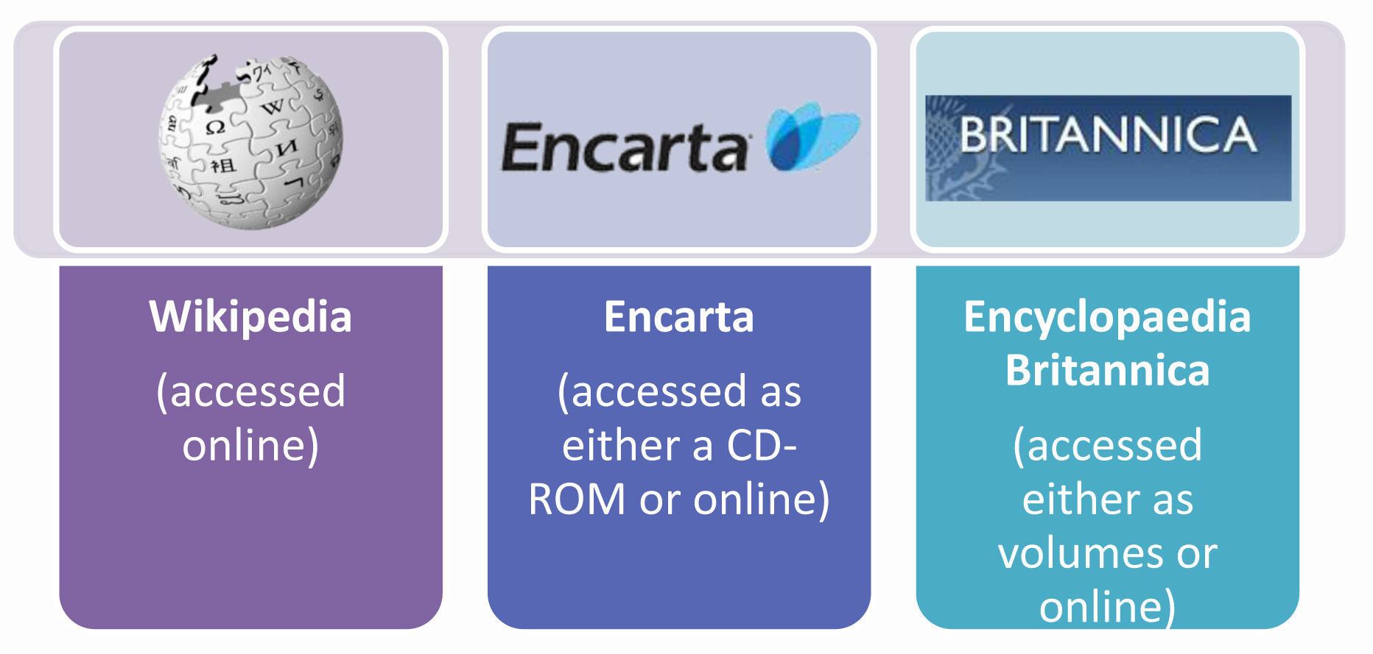

Learning Outcomes
On completion of this Section you will be:
- Be aware of the uses of Encyclopaedias
- Be able to access encyclopaedias in 3 different media: paper, DVD and online versions
- Be able to use look up articles in each medium

2. Media of Encyclopaedia

Books and Volumes

Examples of well-known sets of encyclopaedias:

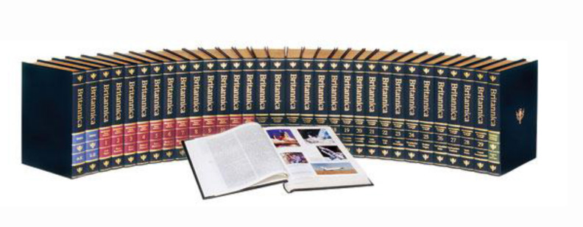
- Collier’s Encycolopedia
- Harmsworth’s Encyclopaedia
- The Children’s Encyclopedia
- World Book Encyclopedia
- Funk and Wagnalis
- Jewish Encyclopedia
- Academic American Encyclopedia

The Encyclopædia Britannica is the most famous of these paper-based references, although there are many different publishers. Another popular title is World Book. Currently the latest version of the Encyclopædia Britannica includes 32 volumes! Generally, all articles are organised alphabetically, but the set is divided into a number of sections. The first section is a quick-reference set, while the bulk of the volumes are for in-depth references. An annual yearbook is released to update an existing set.

There are many different sets of encyclopaedias available in libraries, aimed at different readers, such as young readers, scientists, religious scholars, etc.

It makes more sense these days to update an encyclopaedia online; Britannica has also moved into this medium. A subscription service allows users‟ access to their database online. This version of the encyclopaedia contains the most accurate and up-to-date information. You can access the online version at www.britannica.com, but in order to use it properly, you will need to subscribe:

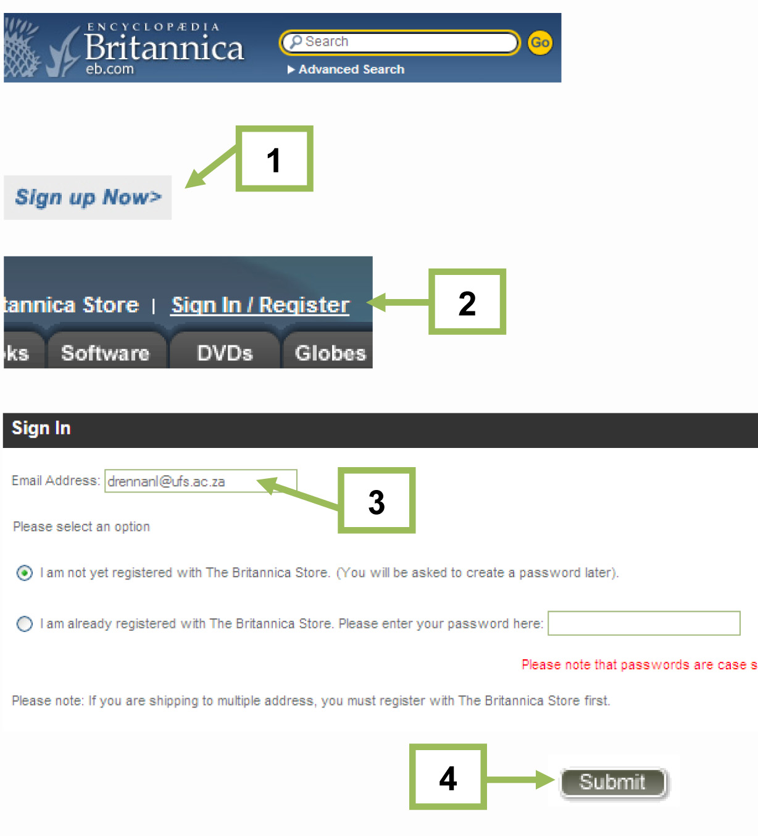 | - Click on Sign up Now  - Click on Sign In / Register  - Fill in your e-mail address and select ‘I am not yet registered with The Britannica Store’  - Click on Submit
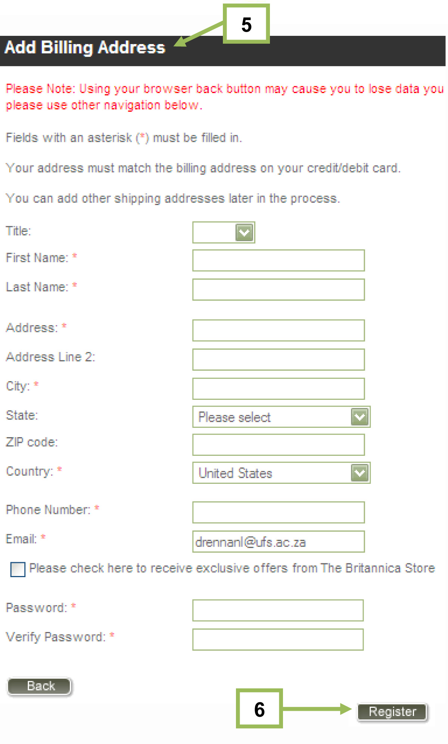 | - Fill in the information in the Add Billing Address window  - Click Register

Internet
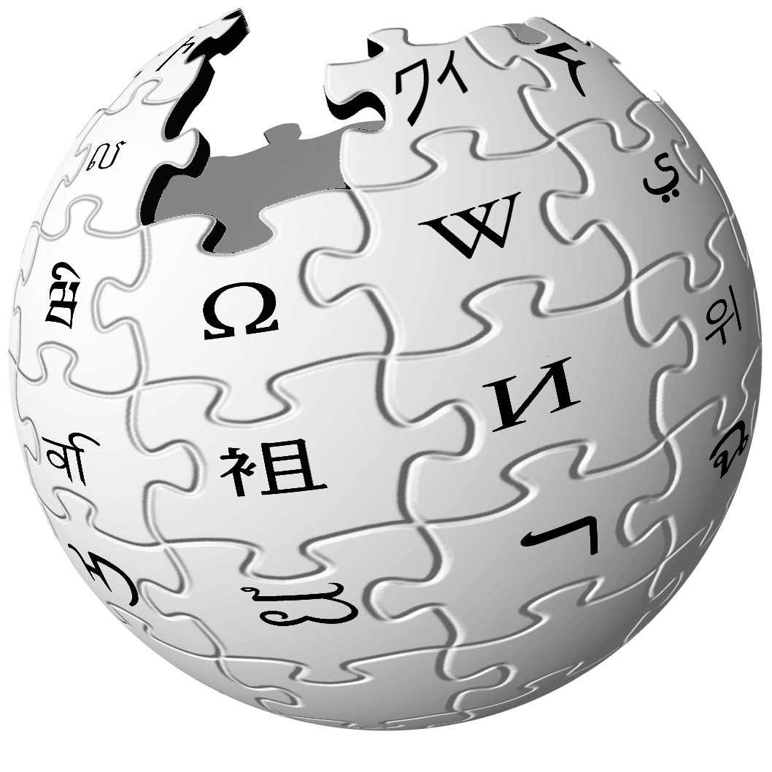
Wikipedia is a well-known, online encyclopaedia which does not require subscription. Its 10 million articles are collaboratively written by volunteers around the world, and almost all the articles can be edited by anyone who can access the Wikipedia website. Because of this, some academics are concerned that the articles might not be objective and that the information might not be reliable.

Therefore, it is important that you cross reference anything that you have located on Wikipedia before you include it in your research.

Other online encyclopaedia include:

- HighBeam Encyclopedia
www.encyclopedia.com
- Knol
http://knol.google.com/k

Compact Disk or DVD
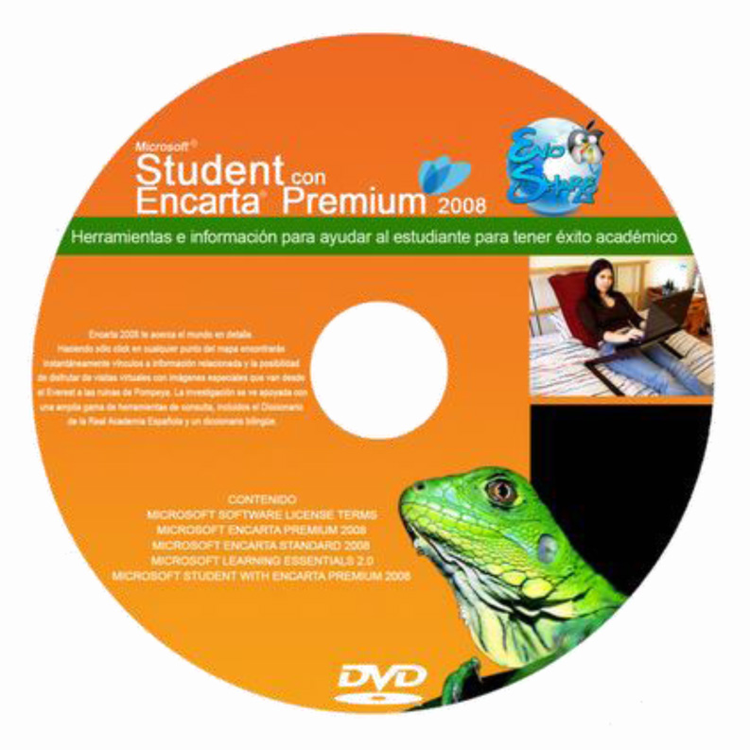
Microsoft Encarta is a popular compact disk-based reference that incorporates multimedia (audio clips, photographs, animations and video) in amongst the text. It allows one to see visual examples and hear commentary or sounds, as well as read various articles. Hyperlinks embedded in the text makes cross referencing articles easy. Encarta now has a free online version available from within the MSN portal that incorporates a dictionary and Atlas.

www.encarta.msn.com

Group Activity 2.1

Test the following free online encyclopaedias and do the same search for information on Nelson Mandela. To do this, look for the search field on each of the sites, type in the term (Nelson Mandela) you are interested in and click the „Search‟ button. The results will then appear on the screen

Also, search for Kaiser Chiefs and see how similar or different the articles are. Make a comment about your experience and the usefulness of the encyclopaedia in the box provided and, once completed, rank the online reference sites. Note which do you prefer and would use in the future.

 | HighBeam www.encyclopedia.com | Rank
 | Wikipedia www.wikipedia.org | Rank
 | Knol http://knol.google.com/k | Rank

5. Tracking my progress
You have reached the end of this section. Check whether you have achieved the learning outcomes for this section.

Learning outcomes | I feel confident | I still need practice
Be aware of the uses of Encyclopaedias
Be able to access encyclopaedias in 3 different media: paper, DVD and online versions.
Be able to use look up articles in each medium.
Be aware of the uses of Encyclopaedias

What did you like best about this section?

What did you find most difficult in this section?

What do you need to improve on? How will you do this?

How will you do this?

Feedback: Group Activity 2.1

 | HighBeam www.encyclopedia.com  This is a free, easy to use online encyclopaedia. This one supposedly has access to 200,000 articles from Britannica, Oxford University Press and Columbia Encyclopaedia. It successfully looked up the term „Nelson Mandela‟ and provided access to an accurate and accessible article on the politician. It, however, failed to find the soccer club „Kaiser Chiefs‟ but did link to a news article on the British pop band of the same name. | 2  Rank
 | Wikipedia www.wikipedia.org  This is a free, easy to use online encyclopaedia. It found the term „Nelson Mandela‟ and provided access to a good article on the leader. It also found both the football club and the British band, Kaiser Chiefs, although it defaulted to the pop group first. Both articles were well written. | 1  Rank
 | Knol http://knol.google.com/k  This is another free online encyclopaedia, organised by Google. It found the term „Nelson Mandela‟ easily and provided access to an excellent article on the leader. It failed, however, to find anything on the term „Kaiser Chiefs‟ except for a few minor mentions within other non related articles on the British pop band. | 2  Rank

See Feedback on page 8
See Feedback on page 14
See Feedback on page 14

