**1**

MODULE **1**: **Structure of Agriculture and Agricultural Policies**

LESSON 1: **Introduction to Agriculture**

TIME: **1 hour 36 minutes**

AUTHOR: **Dr. Maina Muniafu**



This lesson was made possible with the assistance of the following organisations:

[Creative Commons License](http://creativecommons.org/licenses/by/3.0/)  
  
Farmer's Agribusiness Training by [United States International University](http://www.usiu.ac.ke/) is licensed under a  
 [Creative Commons Attribution 3.0 Unported License](http://creativecommons.org/licenses/by/3.0/).  
Based on a work at [www.oerafrica.org](http://www.oerafrica.org/agshare/AgShareHome/tabid/1290/ctl/Tab/Default.aspx)

[Creative Commons License](http://creativecommons.org/licenses/by/3.0/)  
  
Farmer's Agribusiness Training by [United States International University](http://www.usiu.ac.ke/) is licensed under a  
 [Creative Commons Attribution 3.0 Unported License](http://creativecommons.org/licenses/by/3.0/).  
Based on a work at [www.oerafrica.org](http://www.oerafrica.org/agshare/AgShareHome/tabid/1290/ctl/Tab/Default.aspx)

**MODULE 1**

**Structure of Agriculture and**

**Agricultural Policies**

**1**



**Dr. Maina Muniafu**

## AUTHOR:

## TIME:

## 1 hour 36 minutes

**LESSON**

**INTRODUCTION TO AGRICULTURE**

By completion of this lesson you will:

* Appreciate the role of the country’s agricultural sector in the economy.
* Appreciate the role of farmers in the country’s agricultural sector.
* Describe the divisions of production land in the country into agro-ecosystem zones.
* Relate soil types to various production systems.

See this case study video on the course CD ROM section under *Resource Index | Module 3 | Lesson 1*

## OUTCOMES:

## :

## INTRODUCTION:

## :

Agriculture provides products that are traded at various levels of society with an exchange of money or, in rare cases nowadays, through barter trade. Such generated incomes translate into other sectors and impact on family livelihoods at one end, while on the other end governments are able to earn revenue and even foreign exchange where exports are involved. Central to all these economic activities are the individuals who are directly involved in the production. These are the farmers and this lesson will look at their role in the agricultural sector as well as what the agricultural industry means to the overall economy of the country.

Two case study videos of a farmer in Mwingi, called Simon and another in Chepsonoi called Beatrice, are presented here to illustrate various issues, as are a list of tables and maps.

**The Role of Agriculture in the Economy of Kenya**

So just how important is agriculture to the economy and which sectors within agriculture contribute the most? Complete these activities to find out!



Role of agriculture (30 minutes)

## Activity 1

Table 1: Agriculture and Kenya’s Economy

|  |  |  |
| --- | --- | --- |
| ***Gross Domestic Product, 2000*** | ***Kenya*** | ***Sub-Saharan Africa*** |
| GDP in million constant 1995 US dollars | 9,876 | 362,493 |
| Gross National Income (PPP, in million current international dollars), 2000 {a} | 30,357 | 994,240 |
| Percent of GDP earned in 2000 by: | | |
| Agriculture | 20% | 17% |
| Industry | 19% | 31% |
| Services | 61% | 53% |

***What is GDP?***

*Gross domestic product (GDP)**measures the total output of goods and services for final use occurring within the domestic territory of a given country, regardless of the allocation to domestic and foreign claims. Gross domestic product at purchaser values (market prices) is the sum of gross value added by all resident and non-resident producers in the economy, plus any taxes and minus any subsidies not included in the value of the products. The gross domestic product estimates at purchaser values (market prices) are in constant 1995 U.S. dollars and are the sum of GDP at purchaser values (value added in the agriculture, industry, and services sectors) and indirect taxes, less subsidies. It is calculated without making deductions for depreciation of fabricated assets or for depletion and degradation of natural resources. Value added is the net output of an industry after adding up all outputs and subtracting intermediate inputs. The industrial origin of value added is determined by the International Standard Industrial Classification (ISIC) revision 3.*

*(Source: extracted from Earthtrends;* [*http://earthtrends.wri.org*](http://earthtrends.wri.org) *CC: BY NC SA 2.5)*

1. From the figures presented in Table 1 below, write a short comment on the percentage contribution of agriculture to the overall economy.

Article 1

|  |  |  |  |
| --- | --- | --- | --- |
| **Rank** | **Commodity** | **Production  (Int $1000)** | **Production  (MT)** |
| 1 | Sugar cane | 106176 | 5112000 |
| 2 | Cow milk, whole, fresh | 1061100 | 3990000 |
| 3 | Maize | 259502 | 2367237 |
| 4 | Sweet potatoes | 89916 | 894781 |
| 5 | Cassava | 54114 | 750964 |
| 6 | Cabbages and other brassicas | 89505 | 609292 |
| 7 | Potatoes | 71944 | 600000 |
| 8 | Vegetables fresh | 111651 | 595000 |
| 9 | Bananas | 84561 | 593370 |
| 10 | Plantains | 131615 | 593370 |
| 11 | Tomatoes | 132604 | 559680 |
| 12 | Pineapples | 82976 | 429065 |
| 13 | Mangoes, mangosteens, guavas | 93612 | 384461 |
| 14 | Indigenous Cattle Meat | 760048 | 367478 |
| 15 | Tea | 374331 | 345800 |
| 16 | Wheat | 43462 | 288642 |
| 17 | Beans, dry | 115452 | 265006 |
| 18 | Onions, dry | 21860 | 118620 |
| 19 | Goat milk, whole, fresh | 33158 | 110000 |
| 20 | Fruit Fresh | 15153 | 95000 |

Table 2: Ranking of Kenya’s agricultural products by value

1. From the figures presented in Table 2 below, calculate the percentage contribution of the different production systems to the total agriculture earnings and list them with the high earners at the top.

**Role of Farmers in Production Systems**

It is now clear that agriculture is a crucial component of the national economy. It is also clear, however, that there are numerous farming systems and farmers face many challenges. We will investigate these systems more fully and from this information it will be possible to begin to understand the importance of policies that are beneficial to the farmers.

## icon_activity.png

## Activity 2

## icon_time.png

Production Systems (20 minutes)

|  |  |  |  |  |  |  |  |
| --- | --- | --- | --- | --- | --- | --- | --- |
| **Livestock** | **Value** |  | **Cereals Production** | **Value** |  | **Temp. Industrial Crops** | **Value** |
| Beef Cattle | KES 25 000 000 000.00 | Maize | KES 20 125 066 000.00 | Sugar cane | KES 7 053 317 600.00 |
| Dairy products | KES 23 100 000 000.00 | Wheat | KES 2 933 248 500.00 | Pyrethrum | KES 439 090 416.00 |
| Pigs | KES 1 585 466 560.00 | Barley | KES 1 275 009 554.00 | Pineapple | KES 405 000 000.00 |
| Goats | KES 6 493 518 500.00 | Rice | KES 365 925 000.00 | Tobacco | KES 129 600 000.00 |
| Sheep | KES 4 058 634 532.00 | Other | KES 23 200 000.00 | Others | KES 73 400 000.00 |
| Chicken Meat | KES 3 504 000 000.00 | Sorghum | KES 599 340 060.00 | Potatoes | KES 3 087 500 000.00 |
| Chicken Eggs | KES 4 010 000 000.00 | Millet | KES 515 271 791.00 | Pulses | KES 5 913 557 910.00 |
| Hides and Skins | KES 1 719 523 449.00 |  |  | Cotton | KES 494 000 000.00 |
| Rabbits | KES 150 000 000.00 |  |  | Oilseeds | KES 250 305 000.00 |
| Camels | KES 405 000 000.00 |  |  | Horticulture export | KES 7 057 320 506.00 |
| Honey | KES 305 000 000.00 |  |  | Horticulture domestic | KES 12 674 718 000.00 |
| Total Livestock | KES 70 331 143 041.00 | Total Cereals | KES 25 837 060 905.00 | Total Temp Indus Crops | KES 37 577 809 432.00 |
| % of Agricultural GDP | 42.34 | % of Agricultural GDP | 15.55 | % of Agricultural GDP | 22.62 |
| *Source: CBS, ASIP Support Study 0* | | | | | | | |

Table 3: Agricultural values per agricultural sector

by value

1. From Table 3 below, consider the proportion of farmers involved in the different production systems in Kenya.

***Challenges facing small scale farmers in sub-Saharan countries like Kenya***

*Seventy percent of Kenya’s population is involved in Agriculture either directly or indirectly. As in many other sub-Saharan countries, a large majority of these are small scale farmers who rely on rain-fed agriculture. This is a severe limiting factor together with other factors such as poor soils, pests, diseases and recurrent drought. According to Temu & Temu (2005) there has been a limited investment in irrigation and there is a lack of affordable technology to improve soil fertility, for pest and disease control, weed management and the introduction of drought tolerant crop varieties. On top of all this, farmers have limited access to capital and infrastructure, including roads, railways, airports and sea ports thus causing high costs of transport.*

*In Kenya specifically, agriculture currently contributes to over 60% of the country’s GDP through exports of tea, coffee and horticultural products. Traditional crop products have been cereals like maize, wheat, millet and sorghum with tea and coffee as cash crops.Over the recent past in Kenya, there has been a move towards high value agricultural products (HVAP) since they have a higher market value than traditional products. These are products with high monetary value with emerging and expanding markets worldwide and include vegetables, fruits, flowers, houseplants, foliage, condiments, spices as well as high value livestock and fisheries products such as milk, beef, poultry, eggs and fish (Temu & Temu, 2005). They are grown mainly for cash value in the domestic and export markets.*

*A unique feature of Kenya (unlike other sub-Saharan countries) is that all types of farmers including poor, rich, large scale and smallholder farmers, do participate in HVAP. Small holder farmers for example produce 60% of all exported vegetables and fruits. These products, together with the traditional ones, have had a huge impact on the country’s economy through income flow into rural economies, increased market efficiencies, strengthened domestic supply chains, provision of employment opportunities and institutional development (Xinshen, 2003). However, in the face of market liberalization in the agricultural sector, its overall performance has not been encouraging with stagnation and even a falling of agricultural incomes. Much agricultural policy research and advocacy work remains with the involvement of all stakeholders, so that everyone involved in agriculture will be better off in the liberalized environment. Kenyan agriculture will hence be able to be efficient enough to compete at world prices or at the levels of protection that the domestic consumers or the world trade organization (WTO) allow.*

*(Source Tegemeo Institute of Agricultural Policy & Development:)*

1. Read Article 1, discuss the situation with the person sitting next to you and then list the challenges faced by farmers in each of your regions. Try to include references from article 1, but justified with real examples from your own area.

Article 1

by value

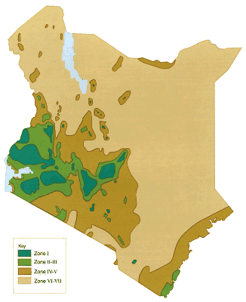

**Fig. 1 Agro-ecological zones in Kenya**

**Agro-Ecological Zones of Kenya**

|  |  |  |  |
| --- | --- | --- | --- |
| **#** | **Zone** | **Approx.  Area (km2)** | **% Total** |
| I | Agro-Alpine | 800 | 0.1 |
| II | High Potential | 53,000 | 9.3 |
| III | Medium Potential | 53,000 | 9.3 |
| IV | Semi-Arid | 48,200 | 8.5 |
| V | Arid | 300,000 | 52.9 |
| VI - VII | Very arid | 112,000 | 19.8 |
|  | Water | 15600 | 2.6 |

Kenya is divided into various agro-ecological zones. Each is distinctive depending on a number of climatic factors. Each zone is suitable for a specific range of crops. Study figure 1 below and read article 2 to learn more.

**AEZs: The Kenya System**

(Source: [www.infonet-biovision.org](http://www.infonet-biovision.org) ) CC: BY NC SA

Agro-ecological Zoning (AEZ) refers to the division of an area of land into smaller units, which have similar characteristics related to land suitability, potential production and environmental impact.

An Agro-ecological Zone is a land resource mapping unit, defined in terms of climate, landform and soils, and/or land cover, and having a specific range of potentials and constraints for land use. (FAO 1996). The essential elements in defining an agro-ecological zone are the growing period, temperature regime and soil mapping unit. There are several systems for describing Agro-ecological zones in the Tropics. In Kenya two are used:

* The FAO classification for tropics generally, and
* an older Kenya version which is only applicable in Kenya

From the above table virtually 80% of the country lies in the semi-arid to very arid Zones (ASALs), which are predominantly inhabited by the pastoralists and agro-pastoralists.   
Kenya's ASALs also support about seven million people and more than 50% of the country's livestock population. These areas, which are also classified as rangelands, are unsuitable for rain fed cultivation due to physical limitations such as aridity and poor vegetation.

**Zone I**

This zone has no direct importance in agricultural production other than being the source of rain and some rivers/streams. It is confined to mountains and immediate surrounding such as Mt. Kenya and Mt Elgon.

**Zone II**

This zone is generally restricted to the highlands of Kenya between 1980 and 2700 m and occurs as a forest or open grasslands. This zone is found in the surroundings of Mt Kenya (parts of Meru, Embu, Kirinyaga and Nyeri), isolated parts of the Rift Valley around Mau and Abadares mountains (e.g. around Kericho and Nyahururu respectively) and the surrounding of Mt Elgon (e.g. around Kitale and Webuye). The minimum rainfall is 1000mm. The main grasses are Pennisetum clandistenum (Kikuyu grass), Themeda triandra (Red oats), Andropogon chrysostachyus, Andropogon pralonsia, Exotheca abysinica, Digiteria scalaram, Eragrostis lascantha, Seteria sphacelata, Pennisetum catabasis and Sporobolus filipes. The legumes include Trifolium johnstoni, Medicago sativa (Alfalfa or Lucerne), Sesbania sesban and Leuceana leucusephala.

**Zone III**

This zone occurs mainly at elevations between 900-1800 m with a annual rainfall between 950 and 1500 mm. Trees are numerous here and are of somewhat shorter stature than in Zone II. This zone is the most significant for agricultural cultivation and several legume fodders are found here in crop-livestock systems. It is also the most resettled by humans. It occurs in the vast parts of Nyanza, Western and Central provinces, a good proportion of Central Rift-Valley,

Article 2

by value

Article 2 continued..

by value

(Nandi, Nakuru, Bomet, Eldoret, Kitale) and a small strip at the Coast province. The major grasses are Hyperenia and Cymbopogon, Themeda triandra, Panicum maximum, Seteria Sphacelata, Sporobolus pyramidalis, Bracharia brizantha (Congo signal), Bricharia siluta, Chloris gayana (Rhodes grass) and Cynodon dactylon (Star grass).

**Zone IV**

This zone occupies more or less the same elevation (900-1800 m) as the previous or may be at times lower. However, it has lower rainfall of about 500-1000 mm. This is typically represented in surroundings of Naivasha, vast parts of Laikipia and Machakos districts and vast parts of the central and southern Coast Province. It is the home of most Acacia trees and shrubs, including Acacia seyal, Acacia senegal, Acacia brevispica, Acacia drepanolobium and Acacia gerrardii. Euphorbia trees occur in some drier parts of this zone. Combretum and Terchonanthus spp. are also common here. Grasses found include Themeda triandra, Pennisetum mezianum, Pennisetum straminium, Pennisetum massaiense, Eragrostis spp., Hyperenia spp. Seteria spp., Digiteria spp., Bothriochloa insculpta, Cenchrus ciliaris. Rare grasses include Chloris spp. and Cynodon spp. Besides acacia, other important legumes include Indigoferra and Crotolaria.

**Zone V**

This zone is much drier than Zone IV and occurs at lower elevations. Annual rainfall is 300-600. This Zone is prevalent in northern Baringo, Turkana, lower Makueni and vast parts of North Eastern Province. Low trees and shrubs found here include Acacia mellifera, Acacia tortilis, Acacia horrida, Acacia reficiens, Acacia nubica, Acacia paslii, Acacia zanzibarica, Adansonia digitata, Terminalia prunioides, Dobea spp., Dioppspyros spp. and Commiphora spp. Common grasses are Eragrostis superba, Cenchrus ciliaris, Cymbopogon spp., Bothriochloa spp. and Heteropogon contortus.

**Zone VI**

This zone is considered as semi desert and is the driest part of Kenya. Annual rainfall is 200-400 mm and is quite unreliable. The zone is found in the Marsabit, Turkana, Mandera and Wajir Districts. Dominant in this zone are Acacia and Commiphora shrubs with scattered taller trees of Delonix elata, Acacia tortilis and Adansonia digitata. Balanites eagyptica, Boscia coriacea, Salvadora persica, Acacia mellifera and Acacia reficiens are important shrubs or low tree species. The very common and important dwarf shrubs are Indigofera spinosa and Sansevieria spp. Other important shrubs are Sericocomopsis, Barberia and Duosperma eromophylum. Being the most delicate zone both annual and perennial grasses are important here. Important grasses include Aristida adoensis, Stipagrostis hirtigluma are very characteristic and may occur as annuals or perennials. Other grasses also found here are Aristida mutabilis, Chrysopogon aucheri, Tetrapogon spp, Enneapogon cenchroides, Chloris roxburghiana.

**Zone VII**

This is represented by the Chalbi desert in the Marsabit district. The Chalbi is a salt desert with very sparse salt bushes as the only vegetation found. It is vast and has beautiful scenery. Pastoralists use it as a source of mineral lick for livestock, particularly during the rainy season.

(Source infonet-biovision: <http://www.infonet-biovision.org/default/ct/690/agrozones> CC: BY NC SA)



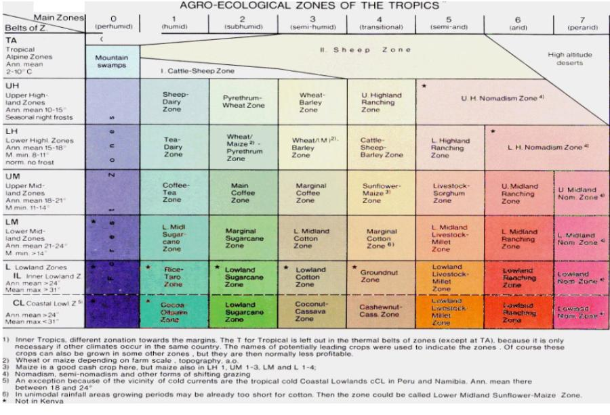

Table 4: Crop Suitability

by value

Now study Table 4 below. It identifies which crops are suited to each zone.

(Access the case study video from the CD ROM)

1. Review the case study video of Simon and Beatrice and comment on the suitability of the crops chosen by them. Also make suggestions on other crop types.
2. Consult the above resources and then fit into the slots provided in Table 5, crops that you think are suitable for the various regions indicated in the attachments.

|  |  |  |
| --- | --- | --- |
| Zone | Suitable crop(s) | Reason |
| I |  |  |
| II |  |  |
| III |  |  |
| IV |  |  |
| V |  |  |
| VI |  |  |
| VII |  |  |

Agro-Ecological Zones (20 minutes)

## Activity 3

Table 5: Activity 3.1 Answers

by value

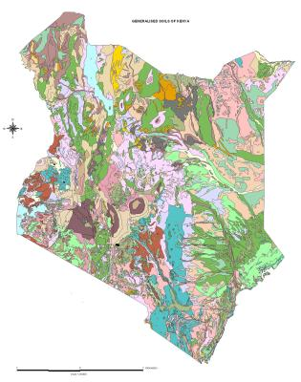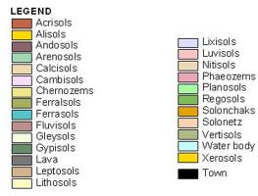

Soil types also vary from location to location. The predominance of a particular type of soil can impact on whether a chosen crop is successful or not. Soil types in Kenya are classified as indicated in Fig 3. Specific information for the different soils is also provided in Article 3.

**Figure 3: Kenyan Soil Types and Distribution**

**Soil Types and Crop Production in Kenya**

**Soil Types Information**

**Andosols (young volcanic soils)**

Andosols occur in areas with steep slopes and high-rainfall. By rainfall over 1000 mm per year, andosols are exposed to excessive leaching. Andosols are porous, have a high water-storage capacity and a low bulk density. They are also acidic (low pH) due to the high leaching of soluble bases and to the high levels of Aluminium (Al). These conditions favour P-fixation, making it no longer available to the plants. To improve agricultural production liming and the use of fertilizers is necessary. Andosols are highly susceptible to erosion as they mostly occur on steep slopes. In these areas, they are mainly used for tea, pyrethrum, temperate crops and dairy farming.

**Nitisols**

Nitisols occur in highlands and on volcanic steep slopes, for example in the central highlands of Kenya, some areas of the Ethiopian highlands and around Mts. Kenya and Kilimanjaro. They are developed from volcanic rocks and have better chemical and physical properties than other tropical soils: they have a good moisture-storage capacity and aeration; the organic matter content, the cation exchange capacity and the percentage base saturation range from low to high. Most nitisols are acidic (pH < 5.5) due to the leaching of soluble bases.   
Nitisols often have a high clay content (more than 35%). They are the best agricultural soils found in the region. They are intensely used for plantation crops and food production (e.g. banana, tea and coffee).  
For optimal agricultural production, nitosols need the use of manure and inorganic fertilizers. To protect these soils from erosion, soil conservations measures are essential.

**Acrisols, Alisols, Lixisols and Luvisols**

These kinds of soils occur in the coffee zones in the sub-humid areas, on undulating to hilly topography. They show an increase of clay content in the sub-soil (B-Horizon). The sub-soil is often not very porous, impeding root spreading. They have a relatively low water-storage capacity, compared with nitisols. Acrisols and Alisols in wet areas have a low pH (acid), Al and Mn toxicities and low levels of nutrients and nutrient reserves. These soils have poor structure and need erosion-control measures. Organic and inorganic fertilizers are needed to improve crop production. The soils respond well to fertilizers (especially N, P and K) and to the use of soil organic matter.

Article 3

by value

Article 3 continued

**Ferralsols**

Ferralsols occur on gently undulating to undulating topography. They are very old, highly weathered and leached soils, and therefore with a poor fertility, which is restricted to the top soil, as the subsoil has a low cation exchange capacity. Phosphorous (P) and Nitrogen (N) are always deficient. Ferralsols are rich in Aluminium (Al) and Iron (Fe). The nutrient reserves are easily disturbed by agricultural practices. Important management practices include the use of fertilizers (e.g. rock phosphate) and the maintenance of soil organic matter by using green manures, farmyard manures and mulching. Ferralsols have also good physical properties including an excellent capacity to hold moisture. Ferralsols are used to grow several annual and perennial crops, being particularly suited to tree crops such as oil palm, rubber and coffee.

**Planosols and Vertisols**

Planosols and Vertisols occur on very gently undulating to flat topography, mostly in rice growing areas e.g. Mwea in the Kirinyaga District and the Kano plains in Nyanza Province. They are found in semi-arid and sub-humid environments. Due to the high clay content in the subsoil (higher than in the top-soil), this layer in the B-horizon is impermeable resulting in a very slow, poor vertical and horizontal drainage and also in an extremely poor workability of the soils. These soils are dark coloured and strongly cracking.

(Source: infonet-biovision: <http://www.infonet-biovision.org/default/ct/266/soilManagement> CC: BY NC SA)



Use your journal and relate crop suitability to the different soil types and make comparisons with:

1. Your own experiences in the field;
2. Your observations on the two farmers Simon and Beatrice that appear in the video case study.

Soil Types (20 minutes)

## Activity 4



Using a series of resources we have seen the ***crucial role*** agriculture plays in the national economy. We have also seen that livestock and cereal production make up over half of the agricultural gross domestic product. Farmers, of course, are at the heart of these activities and are vital to the wellbeing of the nation.

We have also seen that an understanding of ***agro-ecological zones*** and ***soil types*** can help us make informed decisions about what crops to plant.

# Conclusion

# References

Earthtrends. *What is GDP?* Available online at <http://earthtrends.wri.org> Accessed 14/02/2011 (CC: BY NC SA 2.5)

Infonet-biovision. (2010). *Kenyan Soils*. Available online <http://www.infonet-biovision.org/default/ct/266/soilManagement> Accessed 14/02/2011 (CC: BY NC SA)

Infonet-biovision. (2010). *AEZs: The Kenya System*. Available online <http://www.infonet-biovision.org/default/ct/690/agrozones> Accessed 14/02/2011 (CC: BY NC SA)

**