**16**

MODULE4: **ICT in Support of Farming**

LESSON 1: **Introduction to Computers**

TIME: **1 hour 36 minutes**

AUTHOR: **Dalton Ndirangu**



This lesson was made possible with the assistance of the following organisations:

[Creative Commons License](http://creativecommons.org/licenses/by/3.0/)  
  
Farmer's Agribusiness Training by [United States International University](http://www.usiu.ac.ke/) is licensed under a  
 [Creative Commons Attribution 3.0 Unported License](http://creativecommons.org/licenses/by/3.0/).  
Based on a work at [www.oerafrica.org](http://www.oerafrica.org/agshare/AgShareHome/tabid/1290/ctl/Tab/Default.aspx)

**MODULE 4**

**ICT in Support of Farming**

**1**



Welcome! This sub module introduces computers and their role in agriculture. Computers have become a very important tool in our daily lives and can play a significant role in agriculture. We will learn the basics of computer hardware and software systems, the importance of using information and communication technology (ICT) in our daily operations and moreover, the importance of sharing agricultural information using modern technology. The module includes a case study drawn from a reputable farm in Nakuru County, which might provide ideas on how you might use ICTs.

By the end of this lesson participants will:

* Have an understanding of the basics of computer hardware and software systems.
* Understand different storage devices.
* Appreciate the importance of using ICT tools in their daily agricultural operations.
* Appreciate the importance of sharing farm information using modern technology as a medium of communication.

**Dalton Ndirangu**

## AUTHOR:

## TIME:

## 1 hour 36 minutes

**LESSON**

**INTRODUCTION TO COMPUTERS**

## OUTCOMES:

## :

## INTRODUCTION:

## :

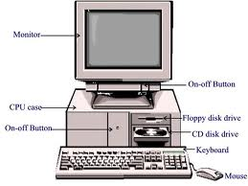

Experience (5 minutes)

**Figure1: A desktop computer or PC**

## Basic Computer Hardware and Software Systems

Many farmers shun using ICT because they believe it is complicated and overly expensive but in reality, there are many benefits to be derived from using such systems. Let us investigate.

.

What is a computer?

A computer is a tool for processing **data**. Processed data is called **information**. Thus a computer is a tool that enables us to input agricultural data such as farm records or financial records and it outputs relevant information such as yield information or profits to support us in our business and daily lives.

A computer can also be viewed as an automatic electronic device, that process and stores data. Figure 1 shows the components that make up a typical personal computer (PC) or desktop system.

.

A system is a set of interrelated functional parts working together for a common goal / purpose.

.

What is a System?

Introduce yourselves briefly by sharing the type of farm activities that you are engaged in and whether you have used a computer before.

## Activity

What is a Computer System?

**Figure 3:computer hardware devices**

**Figure 2: examples of computer equipment**

Yes, because it consists of functional parts that work together to produce vital information. In simple terms we could say that it consists of only three components, *hardware*, *software* and *org-ware.* Let us look at hardware first. Below is a diagram that shows you some of the most common hardware components.

.

## 

## 

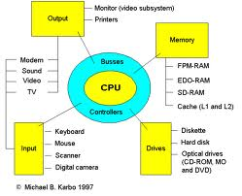

<http://video.google.com/videoplay?docid=8914665199219621055#docid=1894217510864817533>

.

Computer hardware consists of input devices, output devices and a central processing unit (CPU)

.

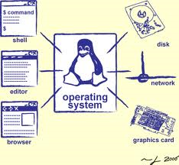

**Figure 4: Illustration of how operating systems control and coordinate other computer resources**

These are computer programs that instruct the computer how and when to perform certain functions or achieve a desired result. The Software System consists mainly of System Software and Application Software.

.

These are the programs that control and coordinate the operations of a computer. They consist of operating systems like Windows XP, Vista or Windows 7, Linux, Apple Macintosh etc. and include utility programs like an antivirus program

Software Systems

Software Systems

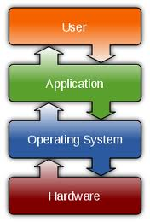

**Figure 5: Diagram showing how operating system controls hardware,  
 application programs and indirectly, users**

If you are reading this document on a computer use the blue link below to access introductory lessons on the Microsoft Windows Operating System. You will need an Internet connection: [**http://www.functionx.com/windows/index.htm**](http://www.functionx.com/windows/index.htm)

Application Software

These are programs designed to accomplish a given task. Examples include **word processors** for producing documents like letters, memos and reports, **spreadsheets** for tabulation (an automatic worksheet), and **database** programs for advanced data storage and analysis.

# Basic Computer Navigation (Windows OS)

Enough theory! Let us boot up a computer and navigate our way around the operating system for ourselves. You will need to have computer access for these tasks.

## icon_time.pngicon_activity.png

## Activity 2

Identifying parts of a computer (5 minutes)

Take 5 minutes to identify the following computer hardware parts provided and group them according to the following categories: input devices, output devices and processing devices:

1. Keyboard
2. Monitor
3. Printer
4. Mouse
5. Speakers
6. CPU tower or case

## icon_feedback1.png

Refer to the Feedback section at the end of this lesson for comments and answers



## Activity 4

## Activity 3

The course facilitator will provide you with these details if you do not already have yours

Alternatively, the course facilitator will demonstrate this procedure

Now identify the popular application software, MS Word, a word processor program**.**Follow these steps.

1. Click Start
2. Select All Program menu
3. Select Microsoft Office
4. Identify applications under Microsoft Office

All program menu (2 minutes)

Find the power button and boot up your machine. Look for this symbol on the power button.

1. Switch on your computer and wait until you can see the

Login screen

1. Type in your **username** and **password** accordingly

Booting (starting) the computer (2 minutes)



Alternatively, the course facilitator will demonstrate this procedure

Alternatively, the course facilitator will demonstrate this procedure

Using paint program (8 minutes)

Control Panel (5 minutes)

## Activity 5

## Activity 6

Now open the computer’s control panel. Follow these steps.

1. Click *Start*
2. Select *Control Panel*
3. Select *Hardware and Sound*
4. Create a list that identify devices installed in your computer

## Activity 7

1. Click the double computer Icons on the extreme bottom right of task bar
2. Identify where the connection is OK (The computer is OK if the Duration numbers are changing)

Network Connectivity (3 minutes)

Now look for the drawing software program Paint. Follow these steps.

1. Click the Start Button
2. Select All Program Menu
3. Select Accessories
4. Select Paint
5. Click on Select Icon
6. Click on Pencil Icon
7. Draw a face that has an expression that reflects how you are feeling! (Hint: Excited? Apprehensive?)

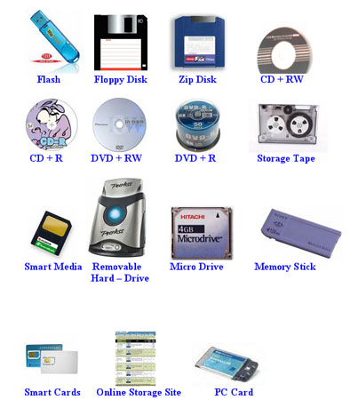

Other types of memory include the **CD ROM** and the **DVD ROM** (sometimes referred collectively as optical drives), and **flash memory** more commonly called the **USB data**

**card** amongst other types of specialist drives. The advantage of these memory devices is that they can be easily removed from a computer system.

Storage devices record data over their storage surface. The data may be stored in different ways according to the device. These include: optical optical data storage memory, magnetic media storage and mechanical storage media etc. Flash memory devices use yet another method. Storage devices are actually defined as the peripheral unit which holds data like the tape, disk, or flash memory card etc.

data storage memory, magnetic media storage and mechanical storage media etc. Flash memory devices use yet another method. Storage devices are actually defined as the peripheral unit which holds data like the tape, disk, or flash memory card etc.

**Figure 6: different types of computer storage devices**

Storage devices store data. The computer has many types of data storage devices. Some of them can be classified as the **removable data storage devices** and the others as the **non-removable data storage devices**. Data storage devices come in many sizes and shapes. The technology used for the storage of the data can be altogether different. Storage devices are some of the most important components of the computer system.

Memory comes in two variations. P**rimary memory** is **volatile** and **secondary memory** is **non-volatile**. Volatile memory is the kind of the memory that is easily erased. Typically, this happens when the electricity is turned off. Primary memory, however, is fast. Information can be retrieved quickly so it is preferred by the processor when performing its operations. Non-volatile memory is the type where the contents cannot be so easily erased but is slower in retrieving data. It is therefore used for long term storage. So when we talk about data storage *devices* it is generally assumed to be those devices that employ secondary memory. These devices include:

**Hard disk drives** – This drive is large and is located inside the computer system. It is a permanent component of the computer. It is the most common type of storage device and is found in almost all computer systems.

# Storage Devices



Computer Storage video: <http://www.youtube.com/watch?v=elvnhMOUvfM>

## Activity 8

Group Discussion (10 minutes)

Refer to the feedback section at the end of this lesson for comments and answers

**Form groups of two people and discuss the following:**

1. Discuss the difference between a hard disk and a removable disk. Name two types of removable disks.
2. Why is a flash disk a very popular storage device with many farmers?
3. What is the importance of backing up farm information stored in a computer?

Most drives that are used for the purpose of data storage are fragile and the data can be easily corrupted. The data storage devices are also used to **backup and archive data.** The data storage devices used to be costly and expensive. But these days the data storage devices are becoming cheaper day by day. Hence the data storage devices price is falling. So, we are in a position to get a storage device quite cheaply.

The data in the storage devices can be in the form of **files, data bases, digital video** and **audio** files. Non volatile storage devices can store data permanently until erased purposely. This is true in the case of the hard disk drives or the floppy disk drives.

Other kinds of storage media, for example the **CD** and the **DVD,** can be categorized into two types of storage; firstly where data once written cannot be erased. It is stored permanently. While the second type of CDs or the DVDs are called rewritable; where the data that is written can be erased completely and the same storage device can be used again for storing the different data.

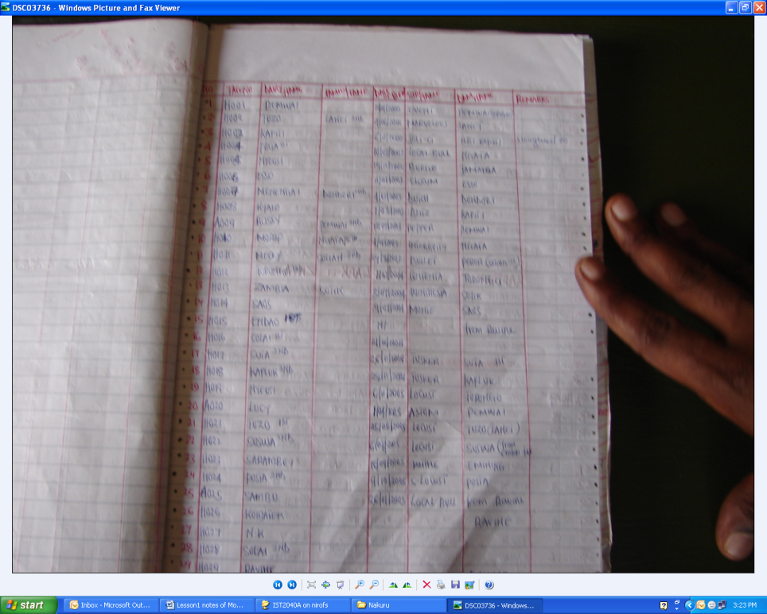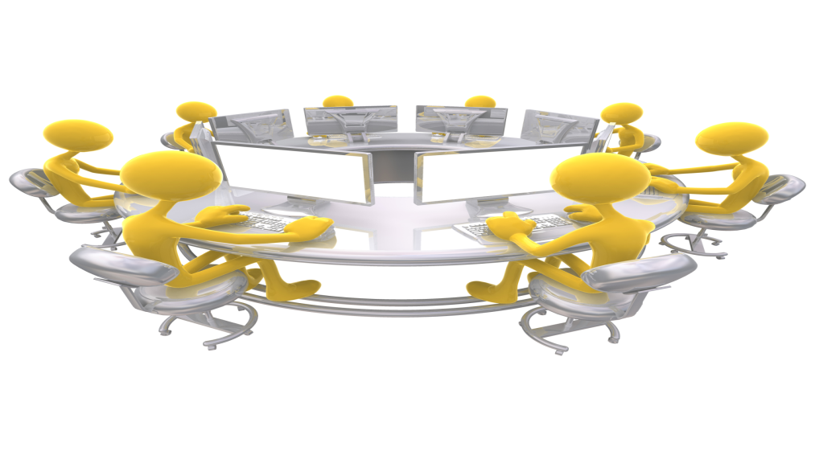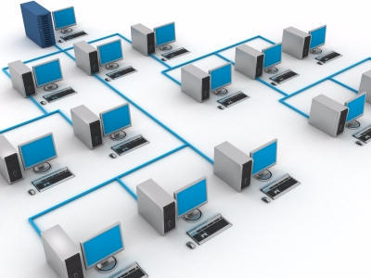

Communication

Farm Records

# ICT Usage and Application in Agriculture

**Fig 7: Manual record keeping from case in Nakuru Communication:**

Computer systems can place powerful communication tools in your hands. They can be used to communicate with individuals cheaply (e-mail, VOIP telephone services such as Skype etc.) and collect information on numerous subjects (Internet). Even outside of the internet services, those computers on the network can communicate with each other via Instant Messaging. When connected to the internet, network users can communicate with people around the world via the network.

Computers can be used to store farm records on all the activities taking place including employee’s records. The computers can also be used to perform analysis of the farm data stored in a spreadsheet or database. Computers can be used to automate some of the processes taking place in the farm. Once the computers have been networked together, resources such as files, printers, fax, scanner, etc. can easily be shared. For example fig 7 below illustrates manual record keeping which can be improved by use of computer below:

Different farmers can collaborate and share information via small simple networks. They can exchange information regarding best farming practice including how to market their products locally and abroad. Unlike the diagram below the farmers don’t have to be in the same room but could link their machines over a certain distance

Workgroup Computing

Networks allow their users to access files from computers throughout the network. This means that a user can begin work on a project on one computer and finish up on another. Multiple users can also collaborate on the same project through the networks

Flexible Access



**Form groups of 4 people and discuss the following:**

1. Discuss the importance of farmers using computers to share information.
2. If a farm has only three computers located in different offices, is it important to network the computers?
3. What benefits can farmers gain when they collaborate with each other using modern technology?
4. List the advantages of creating a website for a farm.

Refer to the feedback section at the end of this lesson for comments and answers

## Activity 9

Discussion (4 minutes)

Refer to the feedback section at the end of this lesson for comments and answers

Access the case study of Henry at Winsor Farm, Nakuru. You can access the video off the course CD ROM located at *Resource Index | Module 4 | Lesson 1 | Case Study* and then discuss with the group the following:

* List the various information sharing activities used in the above case study
* How has technology assisted the farm in the information gathering and sharing?

Group Discussion (4 minutes)

## Activity 10



We have seen from this lesson that farmers can derive benefit from using computers in their daily business. The case study demonstrated a number of possible opportunities. Also in this lesson we switched on the computer which for some of us was the first time! A simple orientation to the computer components and user interface followed. In the next lesson we will start putting the computer to use by investigating ways to use it to store farm records using a spread sheet program.

# Conclusion

In this lesson we covered these items:

Computer systems are divided into **hardware** and **software**.

Hardware includes the items you can touch (monitor, CD ROM Drive, mouse etc.) while software includes the programs that run on the system (e.g. Paint). Hardware is used either for **input** of data (e.g. keyboard), **output** of information (e.g. printer), **processing** of data (e.g. processor) or **storage** of data (e.g. hard drive).

Software includes **system** programs (e.g. operating system, such as Windows, that coordinates the computer) and **application** programs (that do specific tasks, such as Ms Word that is a word Processor).

You also learnt that an important component of the system is the various **storage devices**. (e.g. CD ROM or flash drives)

Also, don’t forget your **username** and **password** which you need to **login** as well as the brief exploration of the Windows environment. You will need these skills and knowledge in Lesson 2.

We finished off by having a look at the importance of using and sharing ICT tools in farming activities either for the keeping of records, communication or retrieving information.

# Summary



**ICT** : ICT (information and communications technology - or technologies) is an umbrella term that includes any communication device or application, encompassing: radio, television, cellular phones, computer and network hardware and software, satellite systems and so on, as well as the various services and applications associated with them, such as video conferencing and distance learning.

**Computer network**: A computer network is a system in which computers are connected to share information and resources. The connection can be done as peer-to-peer or client/server.

# Glossary

Introduction to Computers Lessons: <http://www.fayette.k12.il.us/99/Intro2Comp/introduction_to_computers.html> (Accessed on 9th December, 2010)

Microsoft International: Parts of Computers; <http://windows.microsoft.com/en-US/windows-vista/Parts-of-a-computer> (Accessed on 9th December 2010)

Microsoft International: windows tutorials; <http://www.functionx.com/windows/index.htm> (Accessed 9th December 2010)

Storage Devices; <http://www.google.com/images?hl=en&q=computer+storage+device&psj=1&um=1&ie=UTF-8&source=univ&ei=UbfXTNa-BI-RjAfH5PTbCQ&sa=X&oi=image_result_group&ct=title&resnum=3&ved=0CDQQsAQwAg&biw=1432&bih=674> (Accessed on 9th December 2010)

<http://www.youtube.com/watch?v=elvnhMOUvfM>

[David Hest](http://farmindustrynews.com/author/david-hest) and [Karen McMahon](http://farmindustrynews.com/author/karen-mcmahon); “The Wireless Farm”, [http://farmindustrynews.com/wireless-farm (Accessed](http://farmindustrynews.com/wireless-farm%20(Accessed) on 9th December 2010)

Video on Introduction to computers: <http://video.google.com/videoplay?docid=8914665199219621055#docid=1894217510864817533>( Accessed on 9th December 2010)

# Enrichment

****

1. Keyboard (input)
2. Monitor (output)
3. Printer (output)
4. Mouse (input)
5. Speakers Output)
6. CPU tower or case (Processing)
7. Hard disks are permanently fixed in the computer whereas removable disks are not permanently fixed in the computer. Two types of removable disks are flash-disk and floppy disk
8. Flash disk is a very popular storage device because it is small portable and can hold a lot of data.
9. Computers can malfunction hence the need to backup data. In the event that computers malfunction, we can use the backup data to restore the data

## Feedback Activity 8

## Feedback Activity 2

# Feedback

****

1. Use ICT to Establish agriculture related knowledge network & knowledge delivery mechanism.   
   Use ICT to foster Knowledge Sharing
2. Use ICT to enhance agricultural production
3. Use ICT to improve market access
4. Use ICT to access relevant agricultural information
5. Use ICT to access timely information in different formats
6. Use mobile to communicate with other farmers
7. Use mobile to disseminate marketing related information
8. Use mobile to monitor progress of the farming activities
9. Computers can help farmers exchange information, share ideas, speed up decision making, etc
10. No, the cost of networking outweighs the benefits that can be gained. Farmers should be encouraged to build websites and then use Broad-Band Modems to access internet and websites.

* Advantages of creating websites for a farm are
* **A website provides your company history.**
* **A website can be viewed at leisure.**
* **A website advertises 24/7, 365.**
* **A website can showcase your products.**
* **A website can cross geographical boundaries.**
* **A website can attract new suppliers.**
* **Add related help articles to your website.**

## Feedback Activity 10

## Feedback Activity 9

# Feedback