**20**

MODULE4: **ICT in Support of Farming**

LESSON 5: **e-Business**

TIME: **1 hour 36 minutes**

AUTHOR: **Walter Wanyama / Dalton Ndirangu**



This lesson was made possible with the assistance of the following organisations:

[Creative Commons License](http://creativecommons.org/licenses/by/3.0/)  
  
Farmer's Agribusiness Training by [United States International University](http://www.usiu.ac.ke/) is licensed under a  
 [Creative Commons Attribution 3.0 Unported License](http://creativecommons.org/licenses/by/3.0/).  
Based on a work at [www.oerafrica.org](http://www.oerafrica.org/agshare/AgShareHome/tabid/1290/ctl/Tab/Default.aspx)

**MODULE 4**

**ICT in Support of Farming**

**5**



On completion participants will:

1. Have had a first look at online businesses, specifically

* Value proposition,
* Dealings with suppliers,
* Operations differences,
* Customer acquisition issues.

1. Be able to determine if any of the firm’s advantages are sustainable.

## OUTCOMES:

## :

**e-Business**

**LESSON**

**Walter Wanyama / Dalton Ndirangu**

## AUTHOR:

## TIME:

## 1 hour 36 minutes



**Technology:**

Several years ago e-business was hampered by a lack of hardware, software and poor connectivity. But now African capitals have more than adequate connectivity and there is no shortage of capable ICT companies able to provide the hardware, software and hosting required. The entry level costs, however, remain high in terms of computer equipment, but not in trained and capable staff. It looks like the technical buildings blocks are in place but what is now needed are more entrepreneurs to exploit the possibilities.

**Payment:**

If you're entering the e-Commerce arena some kind of payment has to take place. If you're merely migrating existing business to the Internet, then you will most likely continue with the old payment mechanisms that you have been using offline. If, however, your business is going to rely on taking payments over the Internet, then you have some thinking to do. For the e-commerce amateur there are a variety of solutions such as PayPal or NoChex that allow for 'members' of the service to take and receive payments between each other.

**Marketing:**

Part of the expectations of e-Business is that the producers were going to be able to trade directly with customers, cutting out all the middle men and liberating huge amounts of money. So far things haven't quite turned out like that. One of the first things we have to do is to define what we mean by 'middle men'. Although they are often touted as exploiters, in fact 'middle-men' also offer valuable services such as ensuring quality or expediting sales in other locations. They are 'middle men' but they are also valuable links in the chain. We also have to face the fact that there are 'middle men' who do exploit – and who block business happening until they get their share. They're not going to give up just because of new technology so, e-Business or not, they have to be factored into the supply chains.

## INTRODUCTION:

## :

**Shipping and trade barriers:**

If you're lucky enough to be selling an electronic product, delivery is easier that physical products. If not you need to consider how you will distribute your products. For small products there are a choice of couriers – unfortunately, they're expensive, especially in relation to African economies. It is not uncommon for the shipping for an eShopAfrica order to cost more than the products and they lose orders because of this. There are also the options of air freight and sea freight but all of us who have had experience with these sectors know that they are not exactly 'click and go'. They are labour intensive and very costly time wise – and there are a lot of 'middle men'! All these things have to be factored into the price of your product.

In Kenya, individual organizations have been trying to undertake e-Business activities: m-Transactions are taking place. If we can make use of m-Payments, then why can’t we transform agriculture and make e-Farming?

Are businesses any better with the introduction of technology driven businesses? In the past, only the big players could afford to invest the time and strategic resources needed to localize their websites, and even they didn’t always invest enough to do it well. But today, more and more companies and farmer organizations are harnessing the power of the internet to globalize their businesses and tap revenue streams from across the world. The stakes have changed since the early days of e-business. In this age of global business, engaging only one nation’s consumer base is a sure way to plateau your organization’s revenue and growth.

The Agricultural producer / farmer cannot be left behind in terms of embracing technology for revenue growth. We refer to the Winsor Farm case study where the owners have opened about eleven (11) shop outlets for their products and a farm to manage using technology. Fig 1 below illustrates possible technologies for value addition in farming activities (E-Farming Activities).



An obvious example, see Diagram 1 below: How farmers are benefiting by investing time and resources in Information and Communication Technology is the ‘Farmer’s Market Online web page’ which provides vital information on how farmers can use ICT to advance the marketing activities of their products.

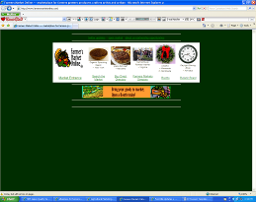

**Diagram 1: Farmer’s Market Online (http://www.farmersmarketonline.com/index.htm)**

**Fig 1: ICT forms the basis of farmer empowerment**

## What is e-Business?

What is **e-Business**? e-Business (electronic business), derived from such terms as

"e-mail" “e-commerce” and "e-marketing," is the conducting of business using technology(computers, mobile phone or the Internet (the web)), not only buying and selling, but also servicing customers, downloading information from available web sources and collaborating with business partners.

.



## 

**Figure 2: Branches of e-Business**

**Diagram 2: FreshDirect Agricultural online business operator with prices; Farmers example of Winsor Ltd have a high potential of success of placing the products online for the wider market going beyond the 11 outlet shops.**

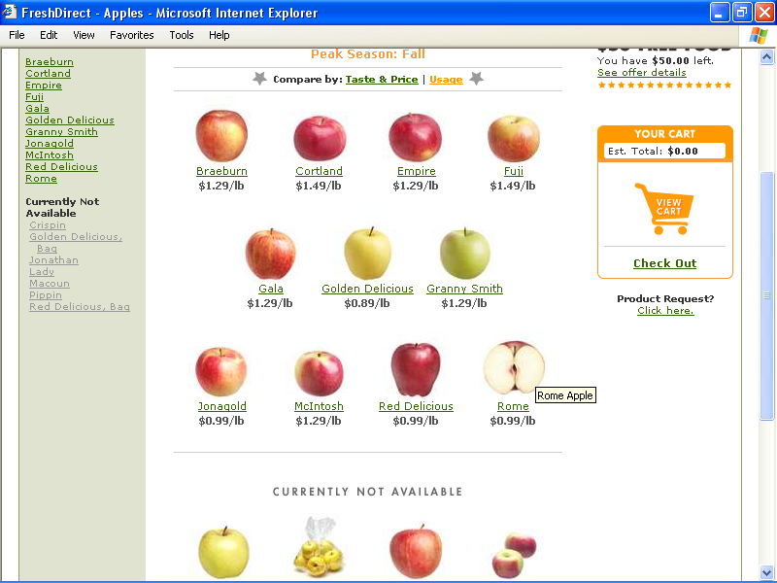

### e-Mail Marketing, Short Messaging Marketing (SMS) and Electronic Commerce

e-Mail marketing (e-Marketing) and Electronic Commerce (e-Commerce) have grown rapidly among value-added businesses focusing on marketing directly to consumers. Internet marketing offers a low cost method of reaching a wide variety of consumers. Although special care is needed for marketing perishable food products, e-Marketing and e-Commerce are something you may want to consider for your business. Study the following images and tables to see a number of different services and strategies.

.

**4: Discounting production online to attract the buyers (consumers); just like on face to face business transaction, buyers have the possibility of bargaining for the products online**

**Diagram 3: Production line, with value addition on farm produce; prices are set through the computer software to increase efficiencies on the production. This means with using technology, internal processes can be computerised.**

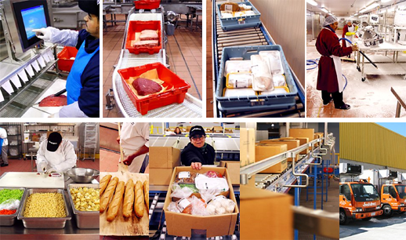

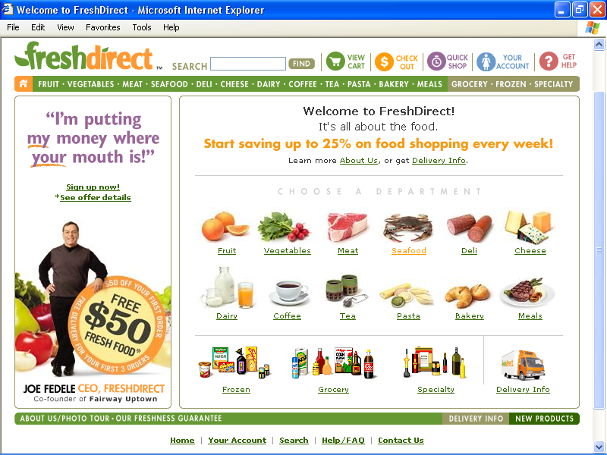

**e-Marketing Tools**

|  |  |
| --- | --- |
| [Marketing on the Internet](http://www.smallbusinessnotes.com/operating/marketing/internetmkt.html) | The most commonly used Internet marketing tools are e-mail and the World Wide Web. But mobile marketing is becoming popular. |
| [Effective On-line Marketing](http://www.smallbusinessnotes.com/operating/marketing/onlinemarketing.html) | With new sites on the World Wide Web popping up daily, it's hard to stand out in the crowd. This article on ‘Small Business Notes’ website provides some excellent tips to get you started. |
| [Email Marketing ‘Return On Investment’ Calculator](http://www.bplans.com/common/calculators/email_roi.cfm) | [www.Bplans.com](http://www.Bplans.com) - Use this calculator to determine the ROI (return on investment) for your email campaigns. Based on your marketing campaign, results and expected results, your ROI will automatically be calculated. Use this tool to test different scenarios and see results. |
| [Farmer's Market Online](http://www.farmersmarketonline.com/) | This Web site offers a place in cyberspace for producers who are marketing directly to consumers. It is a platform for marketing your products online to consumers at a small fee. |
| [Marketing without Spam](http://www.nolo.com/article.cfm/objectID/1B5A1C4B-A0A4-42DB-A69463370AA2C5AB/111/277/100/ART/) | NOLO Law for All – e-Mail marketing can be an effective marketing tool or an incredible annoyance. This resource shows you how to do it right. |
| [Articles on E-Mail Marketing](http://www.salesvantage.com/article/578/E-Newsletters-can-enhance-internal-external-image/) | [www.SalesVantage.com](http://www.SalesVantage.com) has a variety of topics on how to market with e-mail. |
| [e-Marketing](http://www.sba.gov/smallbusinessplanner/manage/marketandprice/SERV_EMARKETING.html) | e-Mail marketing is one of the most effective ways to keep in touch with customers. Use this link to US Small Business Administration’s (SBA) website to learn more about e-Marketing. |

**e-Commerce Tools**

|  |  |
| --- | --- |
| e[[-Commerce](http://www.smallbusinessnotes.com/businesses/ecommerce.html)](http://www.smallbusinessnotes.com/operating/marketing/internetmkt.html) | Should you sell your products and services on the Internet? Use this resource at Small Business Notes to assess whether your business would benefit. |
| [Doing Business on the World Wide Web](http://www.smallbusinessnotes.com/operating/marketing/wwwbusiness.html) | Many businesses want to get into online business, and, certainly, some companies are scoring big sales on the World Wide Web. |
| [Market Analysis for Your Online Business](http://articles.mplans.com/index.php/market-analysis-for-your-online-business/) | [www.bplans.com](http://www.bplans.com) - Market analysis is the foundation of the Web plan. |
| [Website Conversion Rate Calculator](http://www.bplans.com/common/calculators/conversionrate.cfm) | [www.bplans.com](http://www.bplans.com) - This calculator allows you to see the impact improving your website conversion rate has on your total online sales. Enter your visitors and total orders, and you can see what an increase in conversion can do. |
| [Adding E-business to your Agri-business](http://www1.agric.gov.ab.ca/$department/deptdocs.nsf/all/apa9574) | Agriculture, Food and Rural Development, Alberta, Canada - This document provides general information and links to sources of e-business information. |
| [E-commerce and Internet Resources](http://www.sba.gov/smallbusinessplanner/manage/technology/SERV_ECOMMERCE.html) | Should a small business get on the Web? |
| [E-commerce FAQ](http://www.business.gov/guides/online-business/) | [www.business.gov](http://www.business.gov) – Answer to questions commonly asked about E-commerce |
| [National Information Clearinghouse](http://sbdcnet.org/SBIC/e-com.php) | E-commerce guide |
| [Doing Business on the Internet FAQ](http://www.lawyers.com/legal_topics/browse_by_topic/browse_parent/browse_child/content/show_content.php?articleid=1001959) | [www.lawyers.com](http://www.lawyers.com) - What laws govern business on the Internet? What kind of lawyer do I need for a legal problem involving the Internet? What are the legal requirements for creating a Web page? |
| [E-commerce Basics](http://tools.cisco.com/cmn/jsp/index.jsp?id=22308&redir=YES&userid=%28none) | Cisco SBA Internet Business Fundamentals – Educational video. |
| [Articles on E-Commerce](http://www.salesvantage.com/article/list.php?c=9) | [www.salesvantage.com](http://www.salesvantage.com) - A variety of topics relating to e-commerce. |



Diagram 5: Start Menu

Diagram 6: Google Search engine

## Using any search engine (e.g., [www.google.com](http://www.google.com), [www.yahoo.com](http://www.yahoo.com) or [www.AltaVista.com](http://www.AltaVista.com) etc.) search the Internet for information on the following:

1. Web promotion good practice
2. Tips for designing your website for e-business
3. How to start an e-commerce website

Procedure to follow:

1. Start the computer
2. Select the ‘Start’ button on the bottom left side of the computer
3. From the Start Menu open an Internet browser programme (e.g. FireFox or Internet Explorer, see diagram 5 below)
4. Navigate to Google by typing [www.google.com](http://www.google.com) in the browser’s URL field.
5. In Google type topics listed on activity 1 (e.g. Web promotion good practice, Tips for designing your website for e-business or How to start an e-commerce website. See diagram 6)
6. Note: Exercise -- write a short paragraph on each of the topics listed on activity 1 (i., ii., and iii.,) using information from the websites you have visited.

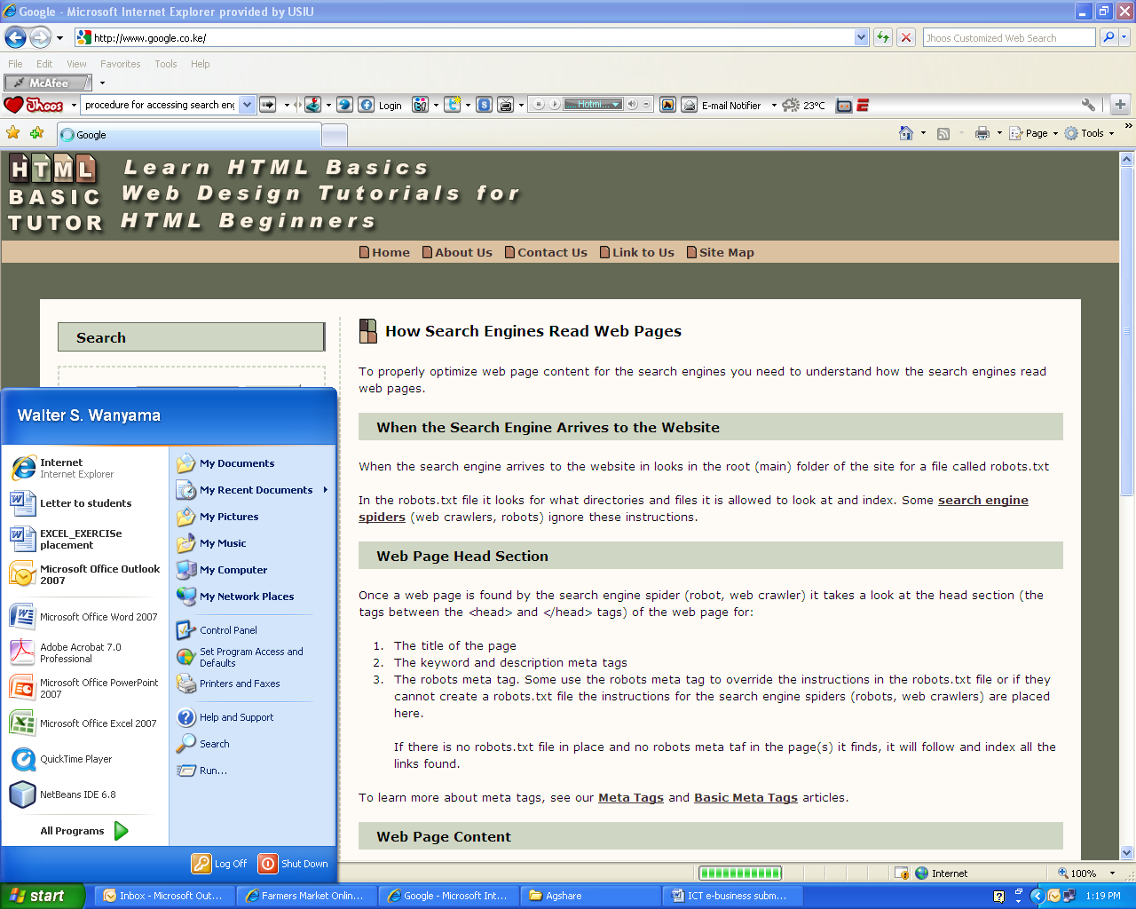

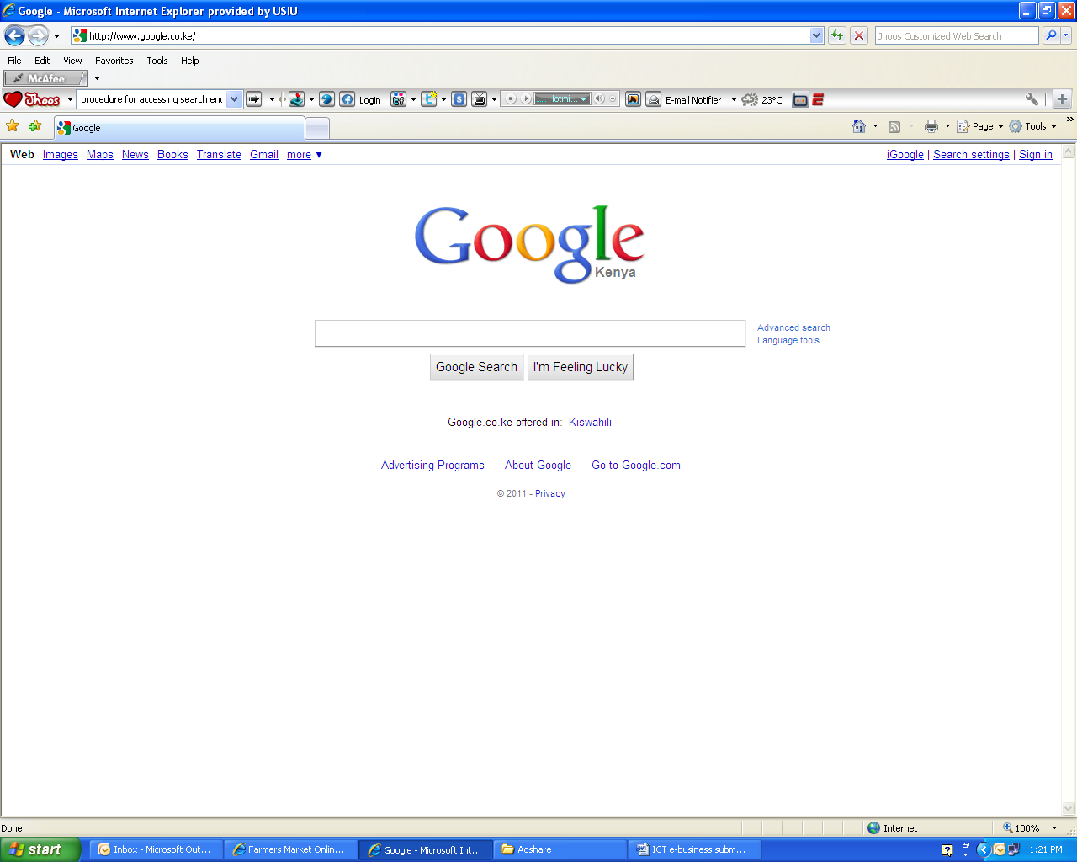

2-Business web investigation (15 Minutes)

## Activity 1



Students should perform the following mobile commerce demos (using Safaricom line)

1. **Sending money to other persons**

You can send or transfer money to any other mobile phone user, even if they are not a Safaricom subscriber. To send money you must first deposit cash into your own M-PESA account.

* To send money, go to the ‘Safaricom’ menu and select ‘M-PESA’.
* Select ‘Send Money’.
* Enter your recipient’s phone number, the amount you wish to send and your PIN.
* You will receive a screen with the information you have entered above, (e.g. Send money to 0721 108631, Ksh2000) confirm that it is correct then Press Ok.
* You and the recipient will receive an SMS confirming the transaction.

1. **Buying Airtime**

As an M-PESA customer, you will be able to purchase airtime of Ksh20 – 10,000 for your phone or another Safaricom subscriber. M-PESA value is separate from your airtime account.

* Go to ‘Buy airtime’ on your M-PESA menu.
* Enter mobile phone number of the phone you are buying airtime for.
* Enter amount of airtime you wish to buy.
* Enter your M-PESA PIN and then confirm the details. The confirmation message will read “Buy airtime 0721 108631 Ksh120”, complete transaction by pressing OK.
* You will receive a confirmation SMS from M-PESA.
* Safaricom Post Pay customers can also use M-PESA to buy airtime for prepaid phones.

1. **Enquiring about bills**

* Select "show balance".
* Enter your secret PIN.
* Wait for SMS confirmation message with your balance.

Mobile Tasks (25 Minutes)

## Activity 2

1. **Paying bills**

* You need to be an M-PESA registered customer.
* Select Pay Bill from your M-PESA menu.
* Enter ‘business number’ of the company you are paying to*.
* Enter the ‘account number’ of the bill you wish to pay*.
* Enter the amount you wish to pay (between Ksh100 – 35,000).
* Enter your M-PESA PIN.
* Confirm details are correct and press OK.

1. **Switching on the alert messages**

* Help is at hand with Get-it!!! Get-it 411 is an innovative information service that allows you to request information by sending an SMS message. The information that you request is instantly sent back to you by return SMS. All Safaricom subscribers have access to this service.
* You can access Get It 411 services through the SIM tool kit on your mobile phone.

Money transfers

Money can be transferred easily these days using web services. One way to simply send money is to use Western Union’s online services (see diagram 7). They also have a service which works using mobile technology. <http://www.westernunionmobile.com/howmobile.aspx>. A way to receive payments is to set up a PayPal account (see diagram 8) which makes it safe and easy for people to send you money. <http://www.paypal.com/ke>

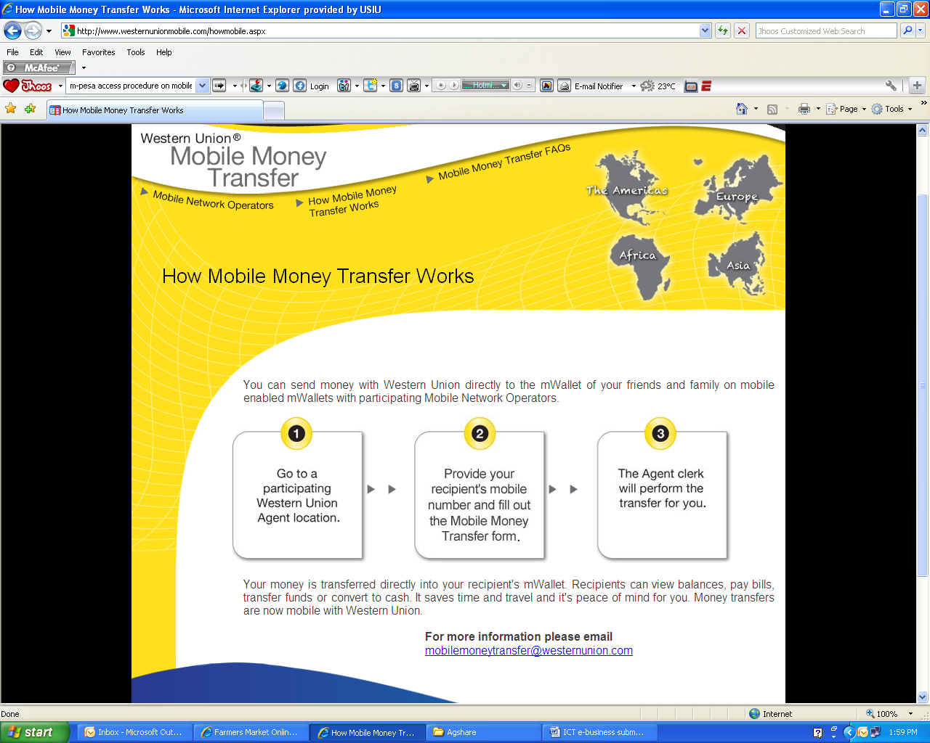

**Diagram 8: Online payment portal; in case sellers and buyers want to pay each other using known payment companies e.g. PayPal**

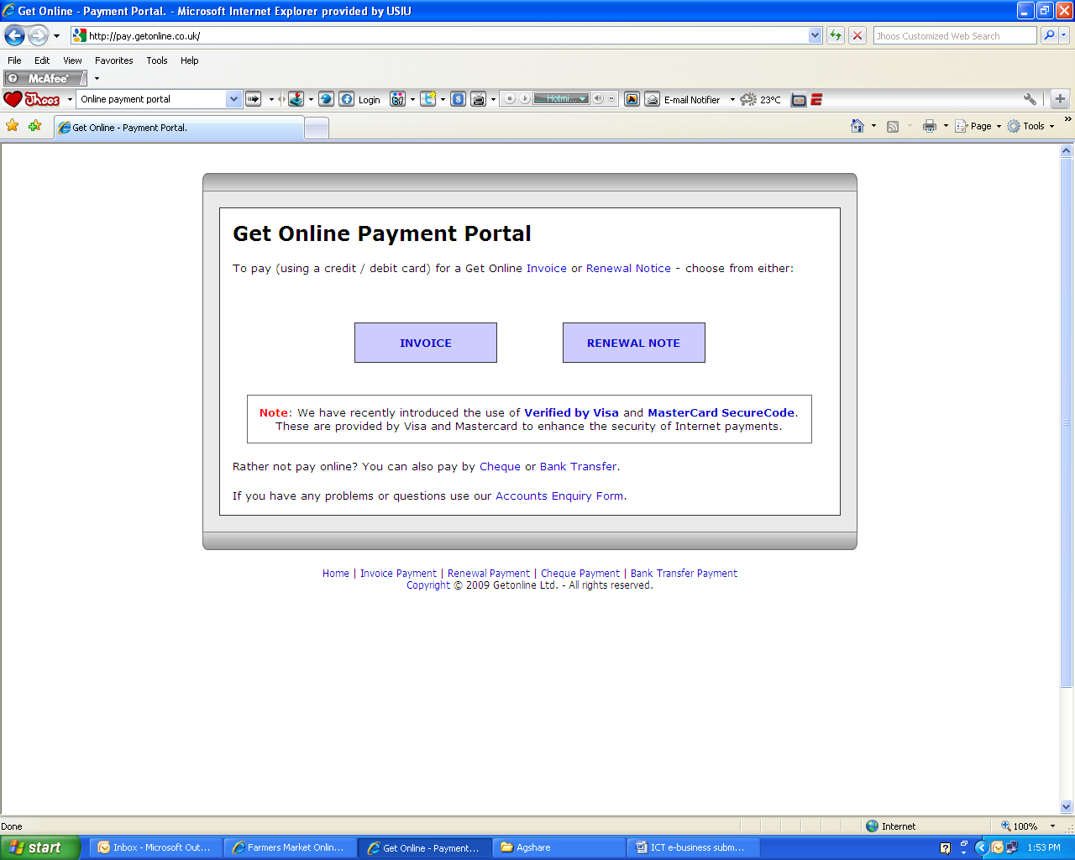

**Diagram 7: Mobile Money transfer through western union, services available with Safaricom; this demonstrates that payments can be made beyond the regions where farming takes place.**



## Activity 3

You can access the case study from the Course CD ROM:   
Course Resources | Module 4 | Lesson 4 | Case Study: Winsor Farm

Read the extract or view the video of the case study of Winsor Farm and note how they have used technology. Suggest possible ways that the company can use e-Business to enhance their farming business.

Case study (20 minutes)

**Technology Investment for information gathering**

The directors have invested in technology, mobile phones, computers hardware, telephone landlines, software, manual information storage and diary technology. Most of the communication between the farm employees is done through mobile communication with visits to the farm more frequently.

At Winsor Meat Ltd, communication and information transfer is done through the internet, e-mail, mails, catalogues etc. Storage of information is done through filling of ‘hard’ or paper copies of the business reports. The company also stores ‘soft’ copies on the computer’s storage devices. Unlike Winsor Meat Ltd, at Winsor Farm, records are still kept manually and sent to the directors through hand mail or catalogues. Therefore, the storage and retrieval of information is manual.

Even though the documents enhance decision making and tracking of the performance of the farm the directors feel that this doesn’t provide instant information for real time decision making. It also makes storage, retrieval, transmission and reconciliation of records difficult. The directors of the farm believe that investing in information gathering and disseminating tools is the way forward for the growth of both the farm and Winsor Meat Ltd to achieve efficiency.

# Extract Case Study from Winsor Ltd



The main points of this lesson are:

To build successful e-business venture, organizations must invest in technology (for example: hardware, software, internet connectivity), payments systems, marketing of the products through e-marketplaces, delivery systems such as shipping and trade barriers. This would help to revolutionize the farming activities and encourage farmers to transform to becoming e-farmers.

Activity 1 provided hints on how we can utilise available technology on the web to market products, create relationships, transact by paying and selling our products online, and create business communities to disseminate farming information/searching information.

Activity 2 looked at using the mobile devices to do payments, send money to others, receiving information and purchasing items using a mobile.

In this lesson we have been introduced to the idea that knowledge of e-Business can open wide opportunities for farmers to sell their produce beyond borders. Therefore, technology is an enabling factor for farmers to move away from being a normal entrepreneur and becoming e-famers or e-entrepreneurs. In the case of Winsor Farm, they have enhanced their venture by exploiting the e-business model

# Summary

# Conclusion



Include here any additional materials/resources that supplement the lesson.

1. AGNRC: <http://www.agmrc.org/business_development/operating_a_business/direct_marketing/email_marketing_and_electronic_commerce.cfm>
2. Farmer’s Market: <http://www.farmersmarketonline.com/>
3. NTC: <http://www.ntclimited.com/>
4. Afrigoods: <http://www.afrigoods.org/>

**Advertising on the Internet**

[Advertising and Marketing on the Internet](http://www.ftc.gov/bcp/edu/pubs/business/ecommerce/bus28.shtm) – Federal Trade Commission -- If you're thinking about advertising on the internet, remember that many of the same rules apply to electronic marketing.

[Dot Com Disclosures: Information about On-Line Advertising](http://www.ftc.gov/bcp/edu/pubs/business/ecommerce/bus41.pdf) – Federal Trade Commission -- Many of the general principles of advertising law apply to Internet ads, but new issues arise almost as fast as technology develops.

**Legal and Tax Issues**

[Tax on Internet Sales](http://www.nolo.com/lawcenter/ency/article.cfm/ObjectID/87F6DD43-E6F2-4DFE-BCDB8E2E85DFF80B/catID/806B7BA0-4CDF-4221-9230A3135E2DF07A) – NOLO Law for All -- Here's the skinny on Internet sales tax: who pays it, who doesn't and why it makes a difference to state governments and brick-and-mortar retailers.

[When is an ISP Liable for the Acts of Its Subscribers?](http://www.nolo.com/article.cfm/ObjectID/1902780E-68C9-436B-925AC37E42F4CD71/catID/806B7BA0-4CDF-4221-9230A3135E2DF07A/104/284/205/ART/) – NOLO Law for All -- In the United States, two federal laws provide a powerful shield for ISPs that follow the rules. Here's how they work.

[Cybersquatting: What It is and What Can be Done About It](http://www.nolo.com/article.cfm/objectID/60EC3491-B4B5-4A98-BB6E6632A2FA0CB2/111/228/195/ART/) – NOLO Law for All -- A 1999 law and an international arbitration procedure crack down on people looking to profit from other people's trademarks.

# Enrichment Resources

[Internet Business Method Patents](http://www.nolo.com/article.cfm/objectID/C2DBFF26-7097-4B7B-AE36DA00499851EE/111/277/167/ART/) – NOLO Law for All -- A company that develops a new way of conducting e-commerce may be able to prevent others from using it for almost two decades.

[Selling on the Internet: Prompt Delivery Rules](http://www.ftc.gov/bcp/edu/pubs/business/alerts/alt051.shtm) – Federal Trade Commission -- Ground rules for making promises about shipments, notifying customers about unexpected delays, and refunding consumers' money.

[BBB On-line Privacy Seal](http://www.bbbonline.org/privacy/index.asp) – Better Business Bureau -- For consumers shopping on the Internet, privacy is a major concern.

[Libel On-line](http://www.lawyers.com/legal_topics/browse_by_topic/browse_parent/browse_child/content/show_content.php?articleid=1001338) – Lawyers.com -- As defamation law slowly invades the Internet, more and more people are learning the hard way that expressions of free speech may not be free at all.

[Digital Signature Guidelines](http://www.abanet.org/scitech/ec/isc/dsg-tutorial.html) – American Bar Association -- In today's commercial environment, establishing a framework for the authentication of computer-based information requires a familiarity with concepts and professional skills from both the legal and computer security fields.

[Electronic Commerce: Legal Issues](http://www.usdoj.gov/criminal/cybercrime/ecommerce.html) – U.S. Department of Justice -- Overview of the legal issues related to Electronic Commerce and the Department of Justice's response to these issues.

1. [Legal Issues](http://www.entrepreneur.com/management/legalissues/index114800.html) - Entrepreneur.com -- A series of articles on legal issues.



List specialist words and provide simplified definitions.

1. **M-pesa**:

(M for mobile, pesa is Swahili for money) is the product name of a mobile-phone based money transfer service for Vodafone. Department for International Development [DFID]. (2008, May 9). *Mobile phone banking in Africa* [Video]. Retrieved 10th, April, 2011, from <http://www.youtube.com/watch?v=TNrDv4PQdCc>

1. **E-Business**

E-business (electronic business) is a term used to describe businesses run on the Internet, or utilizing Internet technologies to improve the productivity or profitability of a business.

1. **E-marketing**

e-Marketing is a subset of e-Business that utilises the electronic medium to perform marketing activities and achieve desired marketing objectives for an organisation. Internet Marketing, Interactive Marketing and Mobile Marketing for example, are all a form of e-Marketing.

1. **Search Engines**

A search engine is a set of programs which are used to search for information within a specific realm and collate that information in a database. People often use this term in reference to an Internet search engine, a search engine which is specifically designed to search the Internet, but search engines can also be devised for offline content, such as a library catalog, the contents of a personal hard drive, or a catalog of museum collections. Search engines help people to organize and display information in a way which makes it readily accessible.

1. **E-Commerce**

E-commerce (electronic commerce or EC) is the buying and selling of goods and services on the Internet, especially the World Wide Web.

1. **Portals**

A portal is a central place for making all types of information accessible to an audience of varying range.

1. **E-Marketplaces**

E-Marketplace Is an internet based trading community that includes many suppliers, manufacturers, their channels of distribution, support services that deliver finished goods and other value-added services

# Glossary