**24**

MODULE5: **Agribusiness Management for Farmer Organisations**

LESSON 4: **Decision Making Based on Loss Minimization and Present Value**

TIME: **1 hour 36 minutes**

AUTHOR: **Prof. Francis Wambalaba**



This lesson was made possible with the assistance of the following organisations:

[Creative Commons License](http://creativecommons.org/licenses/by/3.0/)  
  
Farmer's Agribusiness Training by [United States International University](http://www.usiu.ac.ke/) is licensed under a  
 [Creative Commons Attribution 3.0 Unported License](http://creativecommons.org/licenses/by/3.0/).  
Based on a work at [www.oerafrica.org](http://www.oerafrica.org/agshare/AgShareHome/tabid/1290/ctl/Tab/Default.aspx)

**MODULE 5**

**Agribusiness Management for Farmer Organisations**

**4**



By the end of this lesson you will be able to:

* Account for different types of revenues and describe the measurement of profits based on different cost parameters.
* Identify different types and situations of risks and uncertainties, especially with respect to farming and discuss respective strategies for mitigation.

This lesson continues on from lesson 3 and should be seen as a continuation. You will need to review lesson 3 and the discussion on Economic versus Accounting Costs & Relevant Cost Analysis. In lesson 4, however, we will focus on *Revenues & Measurement of Profitability* and *Risk & Uncertainty*.

**LESSON**

**DECISION MAKING BASED ON LOSS MINIMIZATION AND PRESENT VALUE**

## INTRODUCTION:

## :

**Prof. Francis Wambalaba**

## AUTHOR:

## TIME:

## 1 hour 36 minutes

## OUTCOMES:

## :

Relevant Costs in Decision Making

Based on the background covered in lesson 3, it is clear that for a farm that wishes to make decisions as a firm, a mix of economic and accounting cost skills will be handy. Relevant cost is an opportunity cost that should be used in a given decision making problem. Four illustrative devices are as follows; Depreciation cost measurement, inventory valuation, unutilized facilities and measurement of profitability.

**Depreciation**

Consider this scenario.

A farmer buys equipment worth 100,000. How much is it worth in 10 years?

Typical accounting allocates depreciation based on expected number of years. If the equipment = 100,000, and is expected to last 20 years, straight line depreciation = 100,000/20 = 5,000/year. Hence the equipment would be worthless (zero value) after 20 years.

However, from the economic or decision making perspective, the stipulated 20 years is arbitrary and may not reflect the actual economic condition. In this case, we have to ask how much the equipment is worth at this time (market value). If the equipment, after 20 years, can be sold at 14,000, then that is its value. Therefore, if a decision has to be made with regard to disposing or transacting the equipment, the market value rather than the book record should be used.

**Inventory Valuation**

In a related scenario, participants may be given the following below for discussion and decision on inventory valuation.

Closely related to the previous activity in lesson 3, suppose labour cost for constructing a fence was 60,000 and you already had acquired supplies (wires, nails, posts etc.) at 50,000. If the fencing supplies price declined to 37,500 (replacement cost), and a fencing contract is offered to you at 100,000, would you take the contract?

Typical accounting allocates costs based on acquisition. The challenge we face is whether to use acquisition cost or replacement cost. The table below presents the analysis of the two alternatives.

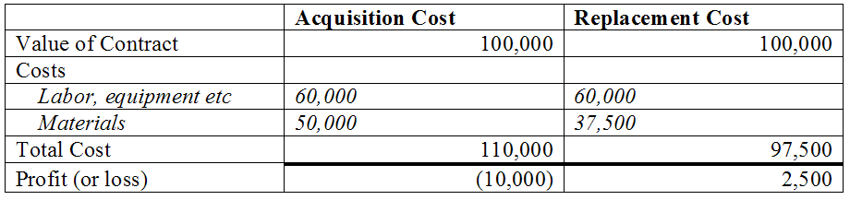

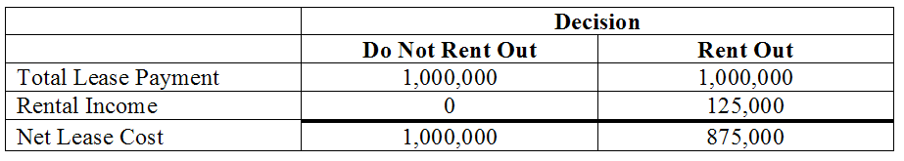

If the acquisition approach is used, there would be no contract since the net income would be perceived as (– 10,000). However, if the replacement approach is used, the net income would be perceived as 2,500 and the contract may be signed.

From the decision making perspective, given that materials have already been purchased, and there is therefore an eminent loss, one needs to now think of how to minimize “out-of-pocket” loses by considering the two analyses below.

With acquisition approach, losses are perceived to be 10,000, which may lead to a “do nothing” decision not to hire labour and construct the fence. But if nothing is done, and the supplies are resold, the actual loss would be 50,000 – 37,500 = 12,500

However, with a replacement approach, labour will be hired and the fence built generating 100,000 at a cost of 110,000 (60,000+50,000) which results in a loss of 10,000. This later loss is less than the former loss by 2,500 which would not have to be borrowed (or come from your savings or elsewhere).

The goal here is that when eminent losses are anticipated, an entrepreneur strives to minimize losses by making the decision to take on the contract.

**Unutilized Facilities**

In some cases, a farmer may have made some investments that due to unexpected circumstances leave them with some idle capacity in form of equipment, space, labour etc. We need to know what needs to be considered in the decision making process should an opportunity arise.

For example, suppose you have leased 200,000 Sq ft for which you are paying 1,000,000 (5/Sq Ft) per year. Supposing further, that this year, one of your discontinued farming activities, (such as egg production) leaves 50,000 Sq ft of space unused. If another, a potential user offers to use that space during the term of the contract when you are paying 5/Sq Ft, would you sublease the space out to her for $125,000 (or $2.50/Sq ft)?

This is a similar concept to inventory valuation above. While rent at $2.50/Sq ft is less than lease cost of $5.00/Sq ft, it minimizes the lease cost which you have to pay regardless of whether the space is subleased or not.

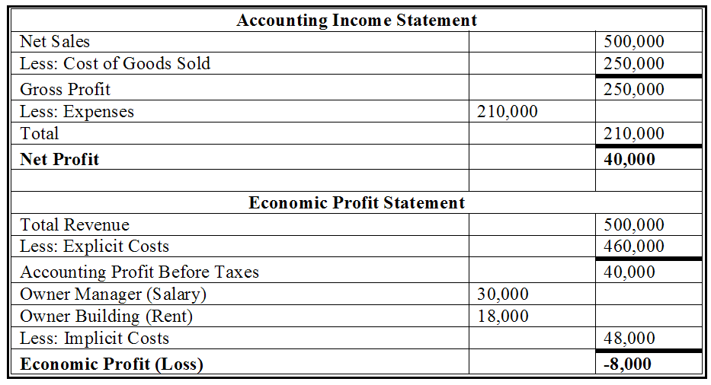

Consider this scenario:

An owner manager uses his building for business. The sales = $500,000, raw materials = $250,000, and operating expenses = $210,000. Should the owner close down this business?

Before we make this decision, we need to know how much the building is worth and how much the owner would be paid to manage a similar business.

For example, suppose the building is worth 18,000 if rented out and the owner could earn a salary of 30,000 working elsewhere, then the owner should close the business and rent out the building and work for someone else to avoid the loss of 8,000 as illustrated in the table below. Obviously, this assumes prospects for growth do not exist.

Measurement of Profitability

## 



See the feedback section at the end of this lesson to see a completed table

Work in groups of four and discuss the issues below:

1. In the depreciation case above, when would it be economical not to consider the equipment as an asset?
2. In the inventory valuation case above, when would it be economical not to take the contract?
3. In the unutilized facilities case above, when would it be economical not to sublease the space?
4. In the measurement of profitability case above, when would it be economical for the owner manager to continue operating the business?

(20 Minutes)

## Activity 1

*Risk* is a situation in which there is a possibility that actual cash flows (returns) will be less than forecasted cash flows and can be neutralized through pre-planned action. *Uncertainty* is a situation where credible probabilities to possible outcomes cannot be assigned.

Types of risks and uncertainties include but are not limited to; *Price fluctuation, Fire, Water (floods), Pests and diseases, Weather, Political/policy*, and *Theft*.

Some of the strategies for mitigation against risk and uncertainty may include insurance, planning, diversification, adoption of technologies, innovation, indigenous and religious knowledge etc.

**Measurement of NPV (Net Present Value)**

Suppose a plot of land is worth $1 million today but expected to be worth $1.2 million in a year, would you buy it? Why or why not?

For average farmers, this situation involves a long term decision making process. We first need to know the level of interest rates.

Suppose the interest rate is 9%, we can use the formula for present value to measure NPV:

PV0 = FV1 x 1/(1+i)

Where:

FV1 is future expected value of land at end of the year (year 1)

PV0 is discounted value or present equivalent of the expected future value (year 0)

i is the interest rate

NPV is the net present value (present value of investment less initial cost)

PV0=1,200,000 x 1/(1+0.09) = 1,100,917

Therefore NPV = 1,100,917-1,000,000=100,917

Since 100,917 is positive, one can invest in this land.

Risks and Uncertainty

NPV represents the contribution of that investment to the value of the firm which is the value to shareholders. The higher the NPV, the more attractive is the investment. Thus, shareholder wealth is maximized when NPV is positive or return on investment (ROI) is greater than required rate of return (RRoR).

**ROI > RRoR**

Where:

Return on investment (ROI) is revenues or payback less initial cost

Required rate of return (RRoR) is the interest rate

or the minimum expected return for typical investment

In this case, given that:

Payback = 1,200,000

Initial cost = 1,000,000

And RRoR = 9%

Therefore:

ROI = (1,200,000-1,000,000)/1,000,000

= 200,000/1,000,000 = 20%

And 20% > 9% (or 20% is greater than 9%)

Since the ROI of 20% is greater than the RRoR of 9%, this is a good investment and should be seriously considered.

Why would some investment activities have a positive NPV?

* Buyer preferences for established brand names.
* Ownership or control of distribution system.
* Patent control of product design or production technique.
* Exclusive ownership of superior natural resource deposits.
* Inability for new firms to acquire necessary factors of production.
* Superior access to financial resources at lower costs.
* Economies of large scale production & distribution due to capital-intensive production process or high initial startup costs.

**Measurement of Risk**

The problem in NPV is that it does not provide a clear means of estimating risk. For example, how sure are we that the investment will be worth 1,200,000 at the end of the year? What if it turned out to be far less than 1.2 million? Managers therefore have to evaluate investment risk and translate it into the discount rate (RRoR) to reflect adequate compensation. We therefore need to show probabilities for the return.

Suppose in the land investment example, we are not very confident on the $1.2 million? We can compensate for the perceived risk by requiring the ROI to be, say 19% instead of 9%.

Calculation using 19% will be 1.2 x 1/(1 + 0.19) = $1,008,403.

Therefore, the NPV is 1,008,403 – 1,000,000 = $8,403

Thus, high risk reduces NPV from 100,917 to 8,403.

Given the positive NPV, it will still be economical to invest in the land.



See the feedback section at the end of this lesson to see a completed table

Work in groups of four and discuss:

1. Given the land value situation above, when will it not be economical not to invest in the land?
2. What other factors need to be considered in this decision?

(20 Minutes)

## Activity 2



To turn a farm into a firm, the farmer must be on the alert in making decisions, typically considering a variety of alternatives and very often, making some calculations which, of course, require record keeping. In this case, the farmer must always consider when to use accounting valuation and when to use economic valuation. Accounting valuation tends to be useful for government reporting purposes, such as tax returns. Economic valuation tends to be useful for internal decision making purposes, such as keeping or disposing of equipment.

Similarly important are the issues of profit maximization and minimization of loss. While most entrepreneurs tend to focus too much on profit making decisions, often times, the minimization of loss is hardly considered. It is strongly advised that even when a situation is expected to result into a loss, the investment still needs to be analysed to see if there are opportunities to minimize loses.

Finally, each investment needs not only to be evaluated on the basis of a positive profit (TR-TC) but also in comparison to alternative investments. This includes calculations of present values discounted for potential interest that could be earned on the money as well as the potential risks of not earning the expected returns.

Depreciation: Reduction in value of the asset due to wear and tear.  
Inventory: Supplies and resources on hand, not yet deployed but in

storage.  
NPV: Net Present Value, i.e., present value of investment less

initial cost.  
ROI: Return on Investment, i.e., revenues or payback less

initial cost.  
RRoR: Required Rate of Return, i.e., interest rate or minimum

expected return for typical investment.

# Glossary

# Conclusion



**McGuigan, J.R., Moyer, R.C., and Harris, F.H., (1999),** *Managerial Economics, Applications, Strategy and Tactics, 8th ed.* South-Western College Publishing, Ohio.

**Maurice, S.C., and Thomas, C.R., (2002),** *Managerial Economics, 7th ed.* McGraw-Hill Irwin, New York.

**Salvatore, D., (2004)**, *Managerial Economics in a Global Economy, 5th ed.*, Thomson South-Western, Ohio.

# References

# Feedback



1. In the depreciation case above, when would it be economical not to consider the equipment as an asset?
   1. When nobody is willing to pay anything for it.
2. In the inventory valuation case above, when would it be economical not to take the contract?
   1. When the labour costs go up by 2,500 or more.
3. In the unutilized facilities case above, when would it be economical not to sublease the space?
   1. When the sublease offer is zero
   2. Also when the sublease period has to extend beyond a year.
4. In the measurement of profitability case above, when would it be economical for the owner manager to continue operating the business?
   1. When the net sales are 508,000 and above.
   2. When the expenses drop by 8,000 or more (to 202,000 or less).
   3. When the salaries for managers drop by 8,000 or more (to 22,000 or less).
   4. When potential rent for the building drops by 8,000 or more (to 10,000 or less).

## Feedback Activity 1



1. Given the land value situation above, when will it not be economical not to invest in the land?
   1. When the sale price of the land exceeds 1.2 million.
   2. When the RRoR is equal to 20% or more.
2. What other factors need to be considered in this decision?
   1. When there is a negative outcome in all or some of the conditions that make some investment activities have a positive NPV discussed earlier (such as):
      1. Buyer preferences for established brand names.
      2. Ownership or control of distribution system.
      3. Patent control of product design or production technique.
      4. Exclusive ownership of superior natural resource deposits.
      5. Inability for new firms to acquire necessary factors of production.
      6. Superior access to financial resources at lower costs.
      7. Economies of large scale production & distribution due to capital-intensive production process or high initial start-up costs.
   2. Any other reasonable arguments.

## Feedback Activity 2

# Feedback