T arou

Section 5a:

Functional Relationships

Maths Literacy, Workshop Series 2010

Section 5a:

Functional Relationships

# 1. Introduction

To be mathematically literate we also need to be able to draw and interpret simple graphs. Graphs are commonly used, on a daily basis, to express relations between different kinds of information.Their prevalence in newspapers, television and in other media makes them an essential part of modern life.

We can use graphs to analyse data, but it is only effective if you interpret it in a meaningful way.

*Answer the following question to see how well you can interpret a graph:*

Describe similarities and differences for each of the following graphs.

(1) (2)

distance

from college

time

from college

time

distance

*Check your answers at the end of the section.*

## Learning outcomes

At the end of this section you should be able to use your problem solving skills to solve problems arising from various applications that involve equations.

|  |  |
| --- | --- |
| Maths Literacy icon_2.jpg | Start up activity 5.1:  Which option will it be? |

Pair up with a class mate and complete the following activity.

You can choose between two options for a new cell phone contract:

**Option A:** R450 monthly payment for unlimited cell phone use.

**Option B:** R120 monthly payment plus R0,80 per minute for cell phone use.

1. Evaluate your monthly payment for option A if you use your cell phone for 80 minutes in a month.
2. Evaluate your monthly payment for option B if you use your cell phone for 80 minutes in a month.
3. Complete the table below.

|  |  |  |
| --- | --- | --- |
| **Number of minutes that phone is used per month** | **Monthly payment for option A** | **Monthly payment for option B** |
| 0 |  |  |
| 100 |  |  |
| 200 | 450 | 280 |
| 300 |  |  |
| 400 |  |  |
| 500 |  |  |

1. Make use of this table to compare the two options graphically, on the same set of axes, and by choosing a suitable scale. Let the x-axis denote the number of minutes that the phones are used per month, and the y-axis the monthly payments.
2. Use the graph to determine when both plans will cost the same.
3. Is one plan always better than the other? Explain.
4. When is it better to use option A? Explain.
5. When it is better to use option B? Explain.

# 2. Solving equations

## Solving Equations with Whole Numbers

Recall that an equation is a statement equating two algebraic expressions.

A variable is a symbol that represents an unknown number. Letters such as *n*, *t* , *x* and *y* are commonly used for variables.

|  |
| --- |
| **Variable:** A letter denoting the value of an unknown quantity. |

To solve an equation in one variable means to find the number or quantity represented by the variable which, when substituted for the variable, will make the equation true (i.e., the equation is *satisfied*).

To test an equation to see whether some number is a solution to this equation, we simply substitute the number for the variable in the equation. If the resulting sentence is true, the number is a solution; if not, the number is not a solution.

#### Example 5.1

Solve for *x* if .

##### Solution



 “Undo” the addition by subtracting 3 on both sides of the equation.



If you substitute  back into the equation, we get that , which is indeed true. So  is the solution we are looking for.

Remember that equations can be thought of in terms of a balance. Adding, subtracting, dividing or multiplying on both sides with the same (nonzero) quantity does not affect the balance.

#### Example 5.2

Solve for *x* if .

##### Solution



 “Undo” the subtraction by adding 2 on both sides.



If we substitute  back into the equation, we get , which is indeed true. So  is the solution we are looking for.

#### Example 5.3

Solve for *x* if .

##### Solution





 “Undo” the multiplication by dividing by 2 on both sides

If we substitute  back into the equation, we get , which is indeed the case. So  is the solution we are looking for.

|  |
| --- |
| **Strategy for solving equations:**  **Step 1:** Simplify both sides, if possible. This means (for example): remove brackets, remove fractions and add like terms. If the equation contains fractions, use the least common denominator (LCD) to simplify and clear the fractions.  (This is done by multiplying both sides of the equation by the LCD.)  **Step 2:** Use addition/subtraction to move the terms containing the variable to one side of the equation, and all the other terms to the other side. Add like terms.  **Step 3:** Use multiplication/division to clear the variable from coefficients.  **Step 4:** Check your answer. Make sure that when an answer is substituted back into the equation, and it implies division by zero, then this is invalid. |

#### Example 5.4

Solve for *x* if .

##### Solution

|  |  |
| --- | --- |
|  | **Step 2:**  “Undo” the subtraction by adding 2 on both sides. |
|  | **Step 3:**  “Undo” the multiplication by dividing by 5 on both sides. |
|  | **Step 4:**  Substitute x=3 back into original equation:  . The answer is correct. |

So *x* = 3 is the solution we are looking for.

#### Example 5.5

Solve for *x* if .

##### Solution

|  |  |
| --- | --- |
|  | **Step 2:**  “Undo” the addition by subtracting 2 on both sides. |
|  | **Step 3:**  “Undo” the multiplication by diving by 7 on both sides. |
|  | **Step 4:**  Substitute x= into original equation:  . The answer is correct. |

So *x* =  is the solution we are looking for.

#### Example 5.6

Solve for *x* if .

##### Solution

|  |  |
| --- | --- |
|  | **Step 1:**  Simplify by adding like terms. |
|  | **Step 3:**  “Undo” the multiplication by diving by 12 on both sides. |
|  | **Step 4:**  Substitute x=6 back into the original equation: . The answer is correct. |

So *x* = 6 is the solution we are looking for.

#### Example 5.7

Solve for *x* if .

##### Solution

|  |  |
| --- | --- |
|  | **Step 2:**  “Undo” the subtraction by adding 1 on both sides. |
|  | **Step 2:**  “Undo” the subtraction by adding  on both sides, and simplify by adding like terms. |
|  | **Step 3:**  “Undo” the multiplication by diving by 12 on both sides. |
|  | **Step 4:**  Substitute x=2 back into the original equation:. The answer is correct. |

So *x* = 2 is the solution we are looking for.

#### Example 5.8

Solve for  *x* if .

##### Solution

|  |  |
| --- | --- |
|  | **Step 1:**  Simplify by removing the brackets. |
|  | **Step 2:**  “Undo” the addition by subtracting 3 on both sides. |
|  | **Step 3:**  “Undo” the addition by subtracting on both sides, and simplify by adding like terms. |
|  | **Step 3:**  “Undo” the negative sign by taking the additive inverse on both sides. |
|  | **Step 4:**  Substitute x=9 back into the original equation:. The answer is correct. |

So *x* = 9 is the solution we are looking for.

|  |  |
| --- | --- |
| Maths Literacy icon_2.jpg | Learning activity 5.2 |

Solve the following equations for x:

1. 
2. 
3. 
4. 
5. 
6. 
7. 
8. 
9. 
10. 
11. 

## Solving Equations with Fractions

Recall step 1 in the strategy to solve equations: If the equation contains any fractions, use the least common denominator (LCD) to clear the fractions.  We do this by multiplying both sides of the equation by the LCD.

#### Example 5.9

Solve for *x* if .

##### Solution

|  |  |
| --- | --- |
|  | **Step 1:**  Removing fractions by multiplying both sides by the LCD of the denominators, which is 2 in this case. |
|  |  |

Substituting *x* = 16 back into the original equation shows that x=16 is indeed the correct solution.

#### Example 5.10

Solve for *x* if .

##### Solution:

|  |  |
| --- | --- |
|  | **Step 1:**  Removing fractions by multiplying both sides by the LCD of the denominators, which is 4 in this case. |
|  | **Step 2:**  “Undo” the addition by subtracting 2 from both sides. |
|  | **Step 2:**  “Undo” the addition by subtracting  from both sides. |
|  | **Step 3:**  “Undo” the multiplication by dividing both sides by . |
|  | **Step 4:**  Substitute x= back into the original equation:. The answer is correct. |

So *x* = is the solution we were looking for.

#### Example 5.11

Solve for x if .

##### Solution:

|  |  |
| --- | --- |
|  | **Step 1:**  Remove fractions by multiplying on both sides by the LCM of the denominators, which is 18 in this case. |
|  | **Step 2:**  “Undo” the subtraction by adding 72 on both sides. |
|  | **Step 2:**  Move all terms containing an x to one side of the equation. Hence subtract  from both sides. |
|  | **Step 4:**  Substitute x=72 back into the original equation:The answer is correct. |

So *x* = 72 is the solution we were looking for.

#### Example 5.12

Solve for x if .

##### Solution:

|  |  |
| --- | --- |
|  | **Step 1:**  Remove fractions by multiplying both sides by the LCM of the denominators, which is 12 in this case. |
|  | **Step 1:**  Remove brackets |
|  | **Step 1:**  Add like terms |
|  | **Step 2:**  Move terms not containing x to the right hand side of the equation. Hence subtract 324 from both sides. |
|  | **Step 3:**  Simplify the coefficient of x by dividing by -10 on both sides. |
|  | **Step 4:**  Substitute x= back into the original equation:. The answer is correct. |

So *x* =  is the solution we were looking for.

#### Example 5.13

Solve for x if 

##### Solution:

|  |  |
| --- | --- |
|  | **Step 1:**  Removing fractions by multiplying both sides by the LCM of the denominators, which isin this case. |
|  | **Step 2:**  Subtract 5 from both sides. |
|  | **Step 2:**  Subtract 3x from both sides to move all terms containing an x to the left hand side of the equation. |
|  | **Step 2:**  Add like terms |
|  | **Step 3:**  Simplify the coefficient of x by diving by  on both sides. |
|  | **Step 4:**  Substitute x=1 back into the original equation:.  The answer is correct. |

So *x* = 1 is the solution we were looking for. Remember, in step 4, if there were fractions in the problem and the substitution of *x* = a, for some number a, into the original equation requires you to divide by 0, then *x* = a must be omitted from the solution set. Note that we did not have that difficulty in the example above.

|  |  |
| --- | --- |
| Maths Literacy icon_2.jpg | Learning activity 5.3 |

Solve the following equations for x:

1. 
2. 
3. 
4. 
5. 
6. 
7. 
8. 
9. 
10. 

## Solving Problems in Engineering

We often describe one quantity in terms of another. For example, the distance travelled by a car moving at a constant speed, depends on the time travelled. Since the distance travelled depends on the time taken, the distance is called the dependent variable, and the time taken is called the independent variable.

|  |
| --- |
| **Variable:** A letter denoting the value of an unknown quantity.  **Independent Variable:** The variable that assumes the value of the input into an equation that describes the relation between the various quantities.  **Dependent Variable:** The variable that assumes the value of the output from an equation that describes the relation between the various quantities. |

The independent variables are not influenced or determined by any other information in the equation – they are independent of the constants and other variables. The dependent variables are determined by the values of the independent variables, as well as the constants that appear in the equation.

Let’s look at an example.

#### Example 5.14

A vehicle’s speed () depends on the time (t) after departure, by the relationship .

For any given value of t, one can evaluate the corresponding value of v. For example, if  then .

Whatever value of t is chosen, there will be one unique corresponding value of *v*. The variables in this example are *v* and *t*. *t* is the independent variable, and *v* is the dependent variable.

#### Example 5.15

A vehicle’s speed, *v* (in metres per second) is given by, where *t* is time (in seconds) after departure. Find the time it took to reach a speed of 30 metres per second.

##### Solution:

Substituting  gives



…subtract by 15 on both sides



…divide by 3 on both sides

 seconds

It took the vehicle 5 seconds to reach a speed of 30 metres per second.

#### Example 5.16

The resistance, *R* (in ohm ()) of a wire at  is given by, where  denotes the resistance at  and  is the temperature coefficient of the resistance of the metal in this wire. Determine, given that ,  and . The coefficient  is measured in the unit “per ”.

##### Solution:

Substituting  ,   and   into gives 

...divide by 45 on both sides

…subtract 1 from both sides

…divide by 110 on both sides

 per .

|  |
| --- |
| **Solving an equation that contains powers**  Raise both sides of the equation to the same power, namely the reciprocal of the power of the variable to solve. Then proceed with standard rules of exponents. |

#### Example 5.17

The time (*T*) , in seconds, taken for a pendulum to make a complete swing (i.e., T is the period), is given by  where *l* is the length (in metres) of the pendulum and  metres per second per second (gravitational acceleration). Determine *l* if  seconds.

##### Solution:

Substitute  and  in to the equation  gives



*…divide by  on both sides*

*…recall that *

*…raise both sides to the power 2, which is the reciprocal of *

*…exponential power rule: *

*…multiply by 9,81 on both sides*

** metres.

|  |  |
| --- | --- |
| Maths Literacy icon_1.jpg | Assessment activity 5.4 |

1. If the voltage, *V*, across a resistor, with resistance , is 15 volts, find the current *I*  (in ampere) through the resistor, given that .
2. The distance, *s*, in metres, that an object has travelled after time *t* (in seconds) is related by the equation , where *u* is the initial velocity and *a* denotes the constant acceleration of the object. Determine *a*, given that  metres,  metres per second and  seconds.
3. A gas is pumped into a cylinder. The pressure  inside the cylinder and the volume of the cylinder, are measured at two stages. During stage one, it was found that the cylinder had an initial volume of  cubic metre and a pressure of  Newton per square metre. During stage two, the pressure inside the cylinder was  Newton per square metre. What was the volume  during stage two, if it is given that ?

## Solving Problems in Economics

#### Example 5.18

Suppose that the average weekly household expenditure of food (*C*) depends on the average net household weekly income (*Y*) according to the relation .

For any given value of *Y*, one can evaluate the corresponding value of *C*. For example: if  then.

Whatever value of *Y* is chosen, there will be one unique corresponding value of *C*.

The variables in this example are *C* and *Y. Y* is the independent variable, and *C* the dependent variable.

This is easy to see, because the average weekly household expenditure on food depends on the average net household weekly income.

#### Example 5.19

The output, *Q* , in monetary units, is given by  where *L* denotes the size of the workforce. Find the *Q* if.

##### Solution:

Substitute into the equation  gives



 units

#### Example 5.20

The quantity, *Q* ,of a commodity demanded is given by , where *P* is the unit price of the commodity. Find the unit price if the quantity demanded is 30.

##### Solution:

Substituting into the equation  gives



…subtract 250 from both sides



…multiply by -2 on both sides



So the unit price is R440.

#### Example 5.21

The output *Q* (in monetary units) of a certain production process is given by  where *K* denotes the capital invested and *L* denotes the amount of labour that went into the process, in man-hours. Find *K* if  and .

##### Solution:

The production function  tells us is that the amount of output (Q) produced is dependent on the number of units of capital K invested and the number of man-hours L of labour used in the process. *K* and *L* are the independent variables.

Substituting and  into gives:



…divide by 100 on both sides



…divide by  on both sides

…raise both sides to the power 3, which is the reciprocal of

…use the exponential rule: 

 units

|  |  |
| --- | --- |
| Maths Literacy icon_1.jpg | Assessment activity 5.5 |

1. The quantity supply, *Q*, is given by, in terms of the unit price *P*. Find the quantity supply if the unit price is R18.
2. The consumption, *C*, is given by, where *Y* is the income. Find the income if the consumption is R180.
3. The average cost per item, *AC*, is given by , where *Q* denotes the number of units output. Find the output if the average cost per item is R16.
4. The number of units output, *Q*, is given by  in terms of the labour, *L*, measured in man-hours. Determine the number of man-hours labour if.
5. The output *Q* (in monetary units) of a certain production process is given by  where *K* denotes the capital invested and *L* denotes the amount of labour that went into the process, in man-hours. Find *L* if  and .

# Maths Literacy icon_11b.jpg3. Solving Exponential Equations

We cannot solve the equation  for the unknown *y* with the methods discussed up until now.

|  |
| --- |
| **To solve an exponential equation:**  Take logarithms on both sides and use the rules of logarithms. |

#### Example 5.22

Find *t* such that .

##### Solution:

Take logs on both sides;

…use the rule 

This means that .

#### Example 5.23

Solve *t* such that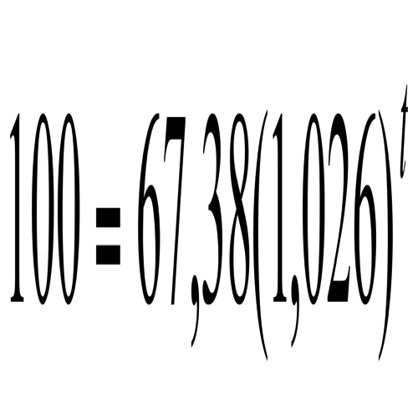.

##### Solution

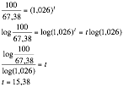

This means that .

|  |  |
| --- | --- |
| Maths Literacy icon_1.jpg | Assessment activity 5.6 |

Solve for*x.*

1. 
2. 
3. 
4. 
5. 

## Problems in Engineering

#### Example 5.24

The velocity, *v* (in metres per second), of a vehicle during the application of brakes, after time *t* (in seconds), is given by, where k is some constant. At  seconds the velocity is reduced to  metres per second. Determine the value of *k*.

##### Solution:

Substituting  and  into the equation gives



…divide both sides by 5



…apply the logarithm on both sides

…apply the rule: 

…divide by  on both sides

…divide by -25 on both sides



|  |  |
| --- | --- |
| Maths Literacy icon_1.jpg | Assessment activity 5.7 |

1. The voltage, *V*, across a capacitor is given by  after time t seconds. Find *t* if .

## Problems in Finances

#### Example 5.25

The formula for calculating the future value of an investment is given by. *A* is the future value of the investment, *P* is the present value of the investment (initial investment), *i* is the rate of interest per time period, written as a decimal, and *n* is the number of time periods over which the interest is compounded. Use this formula to solve the following problem:

Calculate how long will it take for an initial investment of R5 000 to grow to R10 000 if the nominal annual rate is , compounded yearly.

##### Solution:

Substituting ,  and  gives



…divide by 5000 on both sides



…take the logarithm on both sides

…use the rule: 

…divide by  on both sides

 years.

|  |  |
| --- | --- |
| Maths Literacy icon_1.jpg | Assessment activity 5.8 |

1. The formula for the future value  of an annuity is given by , where *R* is the instalment per time period, *n* is the total number of instalments and *i* is the interest rate per time period, written as a decimal. Use this formula to solve the following problem:

Your dad wants to save money for your sister’s college studies. He estimates that R40 000 should be adequate by the time she goes to college. If he can save R5 000 per year and earn a nominal annual interest of 13%, compounded yearly, calculate the time it will take him to have R40 000 available. [,** and ]

*Enrichment section ends*

# 4. Graphs of Linear functions

## How to Plot the graph of a linear function

In this section we will review how to plot the graphs of equations of the form ** (with *m* and *c* given real numbers)*.* This means that we plot all those points (*x,y*) (in the rectangular coordinate system) that satisfy the equation. These graphs are always straight lines. The horizontal axis (or x-axis) is usually used to indicate values of the independent variable (*x*). In the same way, the vertical axis (or y-axis) is used to indicate the values of the dependent variable (*y*).

In order to draw a straight line in the xy-plane, we plot (a minimum of) two points (*x,y*) which satisfy the equation **, and draw the straight line that passes through them. The points on that line will then represent all the points whose coordinates satisfy the equation of the line. Hence, the straight line represents the graph of the function determined by*.*

Once the graph is drawn, it is appropriate to write the equation of the line next to the line itself. This is particularly important in case more than one line is drawn on the same set of axis.

The graph of a linear equation with two variables is always a straight line.

|  |
| --- |
| **How to draw a straight line**  **Step 1:** Find the x-intercept: let y = 0 in the given equation and solve for x. Then  is the x- intercept (the point where the line intersects the x- axis).  **Step 2:** Find the y-intercept: let x = 0 in the given equation and solve for y. Then  is the y –intercept (the point where the line intersects the y- axis). |

#### Example 5.26

Sketch the graph of .

##### Solution

To find where the graph intersects the *y*-axis, put :





The *y*-intercept is .

To find where the graph intersects the *x*-axis, put:



X

Y





The *x*-intercept is .

Since we have two distinct points on the graph, we can plot the graph.

It is not always possible to use the x- and y-intercepts to draw the graph. The following example illustrates the problem.

#### Example 5.27

Sketch the graph of .

##### Solution:

To determine the *y*-intercept, put :

****



The *y*-intercept is .

To determine the *x*-intercept, put :

****

****

The *x*-intercept is .

This give the same ordered pair. Hence we still only know one point on the line. We can choose any other value for *x* or *y* to find another coordinate to plot the graph.



Say we choose:

****





This gives us the ordered pair .

Now we have two points on the line, and we can draw the graph.

|  |
| --- |
| **Horizontal line**  The graph of the linear equation, where *b* is a real number, is a horizontal line with *y*-intercept . If , the line has no *x*-intercept. |

#### Example 5.28

Draw the graph of .

##### Solution:

The *y*-coordinates of all the points on the line  are equal to 3. So for any *x*-value that we choose, the corresponding *y*-value equals 3. Two possible ordered pairs that satisfy the equation, are  and.



Draw the line trough these two points. This gives the graph of .

|  |
| --- |
| **Vertical line**  The graph of the linear equation, where *b* is a real number, is a vertical line with *x*-intercept . If the line has no *y*-intercept. |

#### Example 5.29

Plot .

##### Solution:

The x-coordinates of all the points on the line  are equal to . So for any *y*-value that we choose the corresponding *x*-value equals . Two possible ordered pairs that satisfy the equation , are  and .



Draw the line trough these two points. This gives the graph of .

|  |  |
| --- | --- |
| Maths Literacy icon_2.jpg | Learning activity 5.9 |

Draw the graphs of the following linear equations:

1. *x − y = 4*
2. *x − y = 0*
3. *x + y = 4*
4. *x + y = 0*
5. *−4x + y = 8*
6. *x = 2*
7. *y = –4*
8. 
9. 

## The slope of a Line

In this section we study the slope of a line determined by an equation of the form ** (with *m* the value of the slope and *c* the value of the *y*-intercept)*.*

By now, you would have drawn sufficiently many straight line graphs to notice that they slope in different directions. The steepness and the direction of the slope of a straight line are characteristics which can be measured.

The term *slope* is used to describe how steeply a straight line increases or decreases. Any line that is not vertical has a slope (also called a gradient). At any point of a given line, the slope is always the same.

In each of the following examples, the slope is positive:

|  |  |  |
| --- | --- | --- |
| **(a)**  X  Y | **(b)**  X  Y | **(c)**  X  Y |

In each of these diagrams, the boy walks uphill as he is progressing to the right (i.e., for increasing *x*-values). So each of the three lines has a positive slope, since for each unit in the positive *x* -direction, the corresponding

*y*-values increase. The steeper the line, the larger the numerical value of the slope. The line in (c) has the largest slope, while the line in (a) has the smallest.

In each of the following examples, the slope is negative:

|  |  |  |
| --- | --- | --- |
| **(a)**  X  Y | **(b)**  X  Y | **(c)**  X  Y |

Now the boys is walking downhill when moving to the right (i.e., for increasing *x* -values). These three lines all have negative slope, since for each unit in the positive *x* -direction, there is a corresponding decrease in *y*-values. The steeper the line, the smaller the numerical value of the slope. So the line in (c) has the smallest slope, and the line in (a) the largest. Remember that the slope is negative, so –1/2 (like in (a)) is larger than –2 (like in (c)).

|  |
| --- |
| **The slope *(m)* for various types of lines.**  *m* = 0  *m* < 0  *m* > 0  *Vertical line has no slope*    **This is a formula for the slope of a line:**  **Slope =** |

#### Example 5.30

Find the slope of the straight line below.

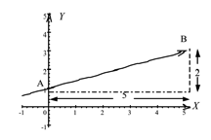

##### Solution:

The points A(0,1) and B(5,3) are on the line. Substitute the coordinates of A(0,1) and B(5,3) into the slope formula:

Slope =  =  = 0,4

The slope of a straight line is a constant. The slope will always be 0,4, whichever two points we choose on the line.

We know that the slope of a line is the ratio of the (vertical) change in *y-*values to the (horizontal) change in *x*-values. We can also say then that slope gives the average rate of change in *y*-values per unit change in *x*-values. The following example illustrates this idea.

#### Example 5.31

From the graph below it is clear that in year 1, the amount that you saved was R100. In year 5 the amount was R500. Find the average rate of change in your savings, in rand per year.



##### Solution:

First find two ordered pairs to substitute in the slope formula. For, we have and for  we have, giving the points  and  on the line.

Average rate of change =  R100

The line through the ordered pairs increases from left to right and therefore has positive slope. Thus the amount that you saved increased by R100 each year.

#### Example 5.32

The graph below shows your savings over a period of 4 years. You started with R200 million, until nothing was left after 4 years. Find the average rate of change of your savings, in million of rand, per year.



##### Solution:

First find two ordered pairs to substitute in the slope formula. For , we have  and for  we have . This gives us the points  and  on the line.

Average rate of change = 

=  million

The line descends from left to right and therefore has negative slope. Your savings is decreased by million each year.

|  |
| --- |
| **The slope of a straight line can be determined directly from its equation:**  **Step 1:** Solve the equation for *y*.  **Step 2:** The slope (gradient) of the line is given by the coefficient of *x.* |

#### Example 5.33

Find the slope of the line .

##### Solution

Solve the equation for *y*.









The slope of the line is .

|  |  |
| --- | --- |
| Maths Literacy icon_2.jpg | Learning activity 5.10 |

1. Find the slope of the straight line in the following diagram.

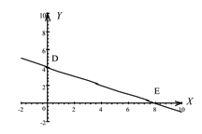

1. Find the slope of the straight line in the following diagram.

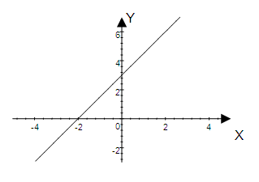

1. Find the slope of each of the following lines.
   1. 
   2. 
   3. 
   4. 
   5. 
2. Use the following table to:

|  |  |  |  |  |  |  |
| --- | --- | --- | --- | --- | --- | --- |
| *x* | -2 | -1 | 0 | 1 | 2 | 3 |
| *y* | -8 | -5 | -2 | 1 | 4 | 7 |

* 1. give a graphical representation of the data.
  2. estimate (using the graph)
     1. the *y*-value if .
     2. the *x*-value if .
  3. It is given that the equation of the line is . Now find the exact answers in 4.2.
  4. Find the slope of the line at .
  5. Is this the same as the slope of the line at? Explain.

1. The number of cell phone users from 2002 through 2007 are given in the table below.

|  |  |
| --- | --- |
| **Year** | **Number of cell phone users in millions** |
| 2002 | 17 |
| 2003 | 18 |
| 2004 | 19 |
| 2005 | 20 |
| 2006 | 21 |
| 2007 | 22 |

* 1. Find the average rate of change of cell phone users for the periods 2002 – 2003, 2004 -2005 and 2006 – 2007.
  2. What do you notice about your answers in 5.1? What does this tell you?

1. The number of cell phone users from 2002 through 2007 are given in the following table:

|  |  |
| --- | --- |
| **Year** | **Number of cell phone users** |
| 2002 | 21 100 |
| 2003 | 22 250 |
| 2004 | 23 150 |
| 2005 | 24 250 |
| 2006 | 25 140 |
| 2007 | 26 340 |

* 1. Find the average rate of change for the periods 2002 – 2003, 2003 -2004, 2004 – 2005, etc.
  2. Is the average rate of change in each case approximately the same? If the ordered pairs in the table were plotted on an *xy*-coordinate system, do they approximately lie on a straight line?

## Problems in Engineering

For some functions, there are no restrictions on the sign that the variables (independent (*x*) or dependent (*y*)) can assume. However, in engineering and economics it sometimes happen that variables can only take positive or non-negative values, and it can happen, in cases like these, that the corresponding graph intersects only one of the axes.

#### Example 5.34

The acceleration, *a*, of a particle is given by , where *t* denotes the time. Plot the graph of *a* against *t*.

##### Solution

Note that *t* can only take on non-negative values, i.e., .

To find where the graph intersects the *a*-axis, put :





The *a*-intercept is.

To find where the graph intersects the *t*-axis, put :







The *t*-intercept is.

Hence the graph:

|  |  |
| --- | --- |
| Maths Literacy icon_1.jpg | Assessment activity 5.11 |

1. Hooke’s law states that the force *F* (in Newton) exerted on a spring to extend it to length *x* (in metre), is given by . Plot the graph of *F* against *x*.

## Problems in Economics

#### Example 5.35

Sketch the graph of the function, where *C* is consumer spending and *Y* is income.

##### Solution

The values for *C* and *Y* can only assume nonnegative values.

When , , hence the graph intersects the vertical axis at the point (0,200).

When , then



The negative value of *Y* is not acceptable. Let us choose another point, e.g. when , .

*C*



Y



Note that the line does not intersect the horizontal axis.

In an equation of the form , the value of the dependent variable *y* depends on the chosen value of the independent variable *x*. For example, in microeconomics the quantity demanded of a commodity, *Q*, given by the equation , depends on the market price *P*.

Normally the independent variable (*x*) is measured along the horizontal axis and the dependent variable (*y*) along the vertical axis. There is however circumstances (in economics, for example) where the dependent variable is measured along the horizontal axis. In the few examples that follow (all of an economic flavour), we will use this point of view.

|  |
| --- |
| We say there is a **positive relationship** between variables *P* and *Q* if, as *P* increases, *Q* also increases, and, if *P* decreases, then *Q* decreases.  We say there is a **negative relationship** between variables *P* and *Q* if, as *P* increases, *Q* decreases, and, if *P* decreases, then *Q* increases. |

#### Example 5.36

Plot the graph of the demand function of a certain commodity, , where *Q* is the quantity demanded and *P* is the unit price. Describe the relationship between *P* and *Q*.

##### Solution

First, the variables *Q* and *P* can only assume non-negative values. We use the convention that the dependent variable Q is measured along the horizontal axis and the independent variable *P* along the vertical axis.

When , , so the line cuts the horizontal axis at 20.

When , then







The graph of  is the straight line segment shown here. There is a negative relationship between *P* and *Q*. If the unit price increases, the quantity demanded decreases.

Let us explain how to interpret the slope in a demand function:

Consider the function defined by .

This equation tells us that the level of demand Q is dependent on the unit price P charged. *Q* is the dependent variable and *P* the independent variable. If  then , which means that if the unit price is R66,67, no units will be sold. The minus sign (in ) tells us that there is a negative relationship between the level of demand Q and the unit price P, so if there is a price increase, there is a decrease in demand, and vice versa. The term 0,3*P* (in ) tells us that for every 1 unit increase in the unit price, demand will decrease by 0,3 units, and for every 1 unit decrease in the unit price, demand will increase by 0,3 units. The closer the coefficient of *P* is to 1 or -1, the stronger the relationship.

#### Example 5.37

Find the slope of the graph of the demand function (Q in terms of P) if it is given that. Discuss the significance of the value of the slope. Describe the relationship between *P* and *Q*.

##### Solution







The slope is the coefficient of *P*, which is –5. The significance of the value of the slope is that for every 1 unit increase in the unit price, the quantity demand decreases by 5 units. There is a negative relationship between *P* and *Q*. If price increases, the quantity demanded decreases.

|  |  |
| --- | --- |
| Maths Literacy icon_1.jpg | Assessment activity 5.12 |

1. Draw the graph of the savings function given by , where *S* denotes the savings and *Y* the income.
2. Draw the graph of the supply function given by , where *Q* denotes the number of units supply of a certain commodity and *P* the unit price.
   1. Which variable is the dependent variable?
   2. Which variable is the independent variable?
   3. Explain the significance of the value of the slope.
   4. What kind of relationship between *Q* and *P* exists? Explain your answer.

# 5. Solving two Linear Equations simultaneously

Many problems can be solved using two equations with two variables, which is then solved simultaneously. We know that the graph of a linear equation  is a straight line. The graphs of two linear equations are two straight lines in the *xy*-plane, and may be arranged in different ways:

(a) The lines intersect (b) The lines are parallel (c) The two lines coincide

For each of these cases:

1. The lines intersect. In this case, the lines have one point in common, implying that there is a unique solution to the corresponding system of equations.
2. The lines are parallel, but distinct. In this case, the lines never intersect, and hence there is no solution to the corresponding system of equations.
3. The lines coincide. In this case, there are infinitely many solutions to the corresponding system of equations. Any solution of one equation is also a solution of the other.

Let us see how we can identify these three cases by using slopes.

Recall the form of a linear equation:, where *m* represents the slope of the line, and *c* the *y*-intercept.

|  |
| --- |
| If the two lines in the system of linear equations have different slopes, the two lines will  intersect in one point, and there is one solution to the system of equations. |

#### Example 5.38

How many solutions does the system  have?

##### Solution:

Write the equations in the form  and compare:

|  |  |
| --- | --- |
| The slope is . | The slope is . |

Since the lines have different slopes, they intersect in one point. So the system of equations has one solution, namely  and , where  is the point of intersection of the two lines.

|  |
| --- |
| If the two lines in the system of linear equations have the same slope, but different *y*-intercepts,  the two lines are parallel and distinct. There is no solution to the system of equations. |

#### Example 5.39

Discuss the solutions of the system:





##### Solution:

Write the equations in the form  and compare:

|  |  |
| --- | --- |
| The slope is  and the *y*-intercept is 2. | The slope is  and the *y*-intercept is 8. |

Both lines have the same slope, but they have different *y*-intercepts. Thus the two lines are parallel and they don’t intersect anywhere. Hence there is no solution to the system.

|  |
| --- |
| If the two lines in the system of linear equations have the same slope and the  same *y-*intercept, the two lines coincide, i.e. they are exactly the same. The system has  an infinite number of solutions. |

#### Example 5.40

Describe the solutions to the system:





##### Solution

Write the equations in the form  and compare:

|  |  |
| --- | --- |
| The slope is  and the *y*-intercept is . | The slope is and the *y*-intercept is . |

Both lines have the same slope and the same *y*-intercept. Thus the two lines are the same and each point on these lines provides a solution to the system of equations.

|  |  |
| --- | --- |
| Maths Literacy icon_1.jpg | Learning activity 5.13 |

Discuss the solutions to the following systems of linear equations:

1. 



1. 



1. 



1. 



## Solving Two Linear Equations by Substitution

One way to find the solution set of a system of two linear equations is to draw the graphs of both equations on the same set of axes. An intersection point of these two lines satisfies the equations of both lines and would therefore be a solution of both equations, i.e., a solution of the system.

#### Example 5.41

Draw the graphs of and  on the same set of axes, and find their point of intersection.

##### Solution

To find the *y*-intercept of the graph of, put:







The *y*-intercept is.

To find the *x*–intercept of the graph of, put:





The *x*-intercept is.

To find the *y*-intercept of the graph of , put:





The graph goes through the origin. Let’s try another x-value: put :





So the point  is also on the line .

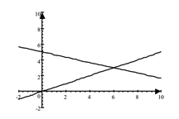

X

Y

From the graph it is evident that the two lines intersect at (6,3).

Let’s check the answer by substituting it into both equations:

 **and** 

 

Both statements are true, thus (6,3) satisfies both equations and is therefore the intersection point.

Sometimes it is hard, by just looking at the graph, to see the exact coordinates of the point of intersection of two lines, especially if the coordinates are not integers, or if the scale is too large.

There is a way of finding the exact coordinates of the intersection point. We do it algebraically, without even drawing the graphs.

|  |
| --- |
| **The substitution method:**  **Step 1:** Take any one of the two equations and solve one variable in terms of the other.  **Step 2:** Substitute the result of step 1 into the other equation.  **Step 3:** Solve the equation from step 2, which contains only one variable now, for this variable.  **Step 4:** Solve for the second variable by substitution the solution of Step 3 into any of the two equations.  **Step 5:** Check your answer. |

#### Example 5.42

Solve the following pair of linear equations by substitution.





##### Solution:

**Steps 1 and 2:** Take the equation and substitute it into: 

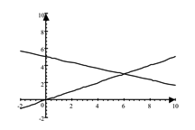

X

Y

**Step 3:** 

*…divide by 5 on both sides*

**Step 4:** Substitute  into  or :

 **or** 

 

 



**Step 5:** Note that the solution (6,3) is the same as the answer in the previous example.

Check your answer by substituting it into both equations:

 **and** 

 

So (6,3) is the correct answer.

#### Example 5.43

Solve the following pair of linear equations by substitution.





##### Solution:

**Steps 1 and 2:** Take the equation  and substitute it into .



**Step 3:** 

*…subtract 20 from both sides*

**

*…divide both sides by *



**Step 4:**

Substitute  in  or  :

 **or**  

 

 

 







(Note, in general, you do not have to do this substitution into both equations. Any one of these substitutions will suffice. We merely show here that both substitutions give the same answer.)

**Step 5:** Verify the solution .

Check your answer by substituting it in both equations:

 **and** 

 

So  is the correct answer.

(Note: Here it is important to do both substitutions, in order to make sure that both equations are indeed satisfied by the solution.)

#### Example 5.44

Solve the following pair of linear equations by substitution.





##### Solution

**Steps 1 and 2:** Take the equation  and substitute it into .



**Step 3:** 



Since this is false the result means that the equations in the system have graphs that are distinct parallel lines. This system has no solution.

#### Example 5.45

Solve the following pair of linear equations by substitution.





##### Solution

**Steps 1 and 2:** Take the equation  and substitute it into .



**Step 3:** 

*…subtract 15 from both sides*



This (true) result means that every solution of one equation is also a solution of the other, so the system has an infinite number of solutions.

|  |  |
| --- | --- |
| Maths Literacy icon_1.jpg | Learning activity 5.14 |

Solve the following pairs of linear equations by substitution.

1. 



1. 



1. 



1. 



1. 



1. 



## Solving Two Linear Equations by Elimination of a Variable

The idea here is to eliminate one of the variables. In order to do this, we need to rewrite the system so that the coefficient of the variable we want to eliminate in one equation, must be the negative of the coefficient of the same variable in the other equation.

|  |
| --- |
| **The elimination method:**  **Step 1:** Write both equation in standard form .  **Step 2:** If necessary, multiply both sides of one or both equations by a suitable number (or numbers) so that the coefficients of one of the variables are negatives of each other.  **Step 3:** Add the two equations obtained from Step 2 to obtain an equation containing only one variable (this is where we eliminate one variable).  **Step 4:** Solve the equation obtained from step 3 for the remaining variable.  **Step 5:** Substitute the solution from Step 4 into any one of the original equations, to solve for the other variable (the one that has been eliminated earlier).  **Step 6:** Check your answer. |

#### Example 5.46

Solve the following pair of linear equations by elimination.





##### Solution:

**Steps 3 and 4:** Add the two equations gives:

…A

…B

*…add A and B*

*…divide both sides by 5*



**Step 5:** To solve for *x*, substitute  into either of the two equations of the system.

 **or** 

 

 

 

 



**Step 6:** The solution is (3,4).

Check your answer by substituting it into both equations:

 **and** 

 

We can also subtract one equation from the other to eliminate a variable. In this case, the coefficients of this variable must be the same in both equations.

#### Example 5.47

Solve the following pair of linear equations by elimination.





##### Solution:

**Step 1:** …A

…B

Note that the coefficients of x in both equations are equal to 1.

**Step 2, 3 and 4:** …A

…B

*…subtract B from A*

*…divide on both sides by 5*



**Step 5:** Substitute  into A or B. Lets choose A:









**Step 6:** Note that the solution (6,3) is the same as the answer of the problem on p.39

Check your answer by substituting it into both equations:

 **and** 

 

The solution (6,3) is correct.

#### Example 5.48

Solve the following pair of linear equations by elimination.





##### Solution

**Step 2:**  …A

… B *(multiply A by 2)*

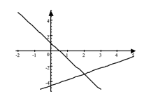

X

Y

…C

**Steps 3 & 4:** …B

 …C

* add B and C*



**Step 5:** Substitute  into B or C, say C:











**Step 6:** So the solution is .

Check the answer by substituting it into both equations:

 **and**  

 

The solution is correct.

#### Example 5.49

Solve the following pair of linear equations by elimination.





##### Solution:

**Step 2:**  …A

…B *(multiply A by 3)*

…C

…D *(multiply C by two)*

**Steps 3 & 4:** …B

…D

 *add B and D*



**Step 5:** Substitute  into B or D. Lets choose D:

*(Use your calculator skills to work out the fractions)*









**Step 6:** The solution is .

Check the answer by substituting it into both equations:

 **and**  

 

The solution is correct.

#### Example 5.50

Solve the following pair of linear equations by elimination.





##### Solution:

**Step 2:** …A

…B *(multiply A with 2)*

…C

**Steps 3 & 4:** …B

…C

…*add B and C*

The false statement  indicates that the given system has no solution.

#### Example 5.51

Solve the following pair of linear equations by elimination.





##### Solution:

**Step 2:** …A

…B *(multiply A by 2)*

…C

**Step 3 & 4:** …B

…C

…*add B and C*

This true statement occurs when the equations are equivalent, so the system has an infinite number of solutions, i.e., all the points of the line .

|  |  |
| --- | --- |
| Maths Literacy icon_1.jpg | Learning activity 5.15 |

Solve the following pairs of linear equations by elimination.

1. 



1. 



1. 



1. 



1. 



1. 



1. 



# 6. Problems in Engineering

#### Example 5.52

A crane lifts weights according to the law  where *E* is the effort force, *W* is the load and *a*, *b* are certain constants. An experiment produces the following results:

A force of  is required to lift  and a force of is required to lift , Determine the values of the constants *a* and *b*.

##### Solution:

Use substitution to solve the problem:

Substituting  and  into  gives …A

Substituting  and  into  gives …B

**Step 1:** Make *b* the subject in equation A:





**Step 2:** Substitute  into B:



**Step 3:** Solve for *a*:









**Step 4:** Solve *b*:

Substitute  into A:







**Step 5:** We obtain the solution  and .

Lets check these by substituting it into both equations A and B:

 **and** 

 .

The solution is correct.

#### Example 5.53

The length *l* of a wire made of a certain alloy varies with temperature *t* according to the law  where  is the length at temperature  and  is the coefficient of linear expansion. An experiment produces the following results: when , then  metre, and when , then  metres. Determine and .

##### Solution:

Use elimination to solve the problem:

**Step 1:** Substituting ,  into  gives:



…*divide both sides by *

…A

Substituting ,  into gives:



…*divide both sides by *

…B

**Step 2:**  …A

…*multiply A by *

**Step 3:**  …C

…B

…*add C and B*

**Step 4:** 



 metres

**Step 5:** Put  in A













**Step 6:** We obtain the solution  and .

Lets check to see if it is correct by substituting it in both equations A and B:

 **and** 

 

The solution is correct.

|  |  |
| --- | --- |
| Icon_2.png | Assessment activity 5.16 |

1. The displacement *s* of a body is given by  where *t* is the time after departure, *u* is initial velocity, and *a* is the constant acceleration of the body. In an experiment, the following observations were made: after  seconds,  metres, and after  seconds,  metres. Determine the initial velocity *u* and the acceleration *a*.
2. Let  and  denote the current in two different paths of an electrical circuit. An experiment showed (after applying Kirchoff’s law that the sum of all incoming currents to a junction equals the sum of all outgoing currents) that:





Determine  and .

# 7. Problems in Economics

## Equilibrium

Solving simultaneous linear equations in two unknowns was discussed in the previous section. Where only two equations in two variables are involved (such as in supply and demand analysis), a system of equations can easily be interpreted graphically, and solutions can mostly be obtained directly from the graph. Typically, as the price per item increases, the demand decreases, while the supply increases. This situation is portrayed by two lines, one increasing, and the other decreasing. The point at which the lines intersect determines the equilibrium supply and equilibrium demand.

For example, assume that in a competitive market the demand function is and the supply function is .

If the market is in equilibrium then the equilibrium price and quantity is where the demand and supply functions intersect. As this will correspond to a point which is on both the demand function and the supply function, the equilibrium values of *P* and *Q* are such that both the equations above hold simultaneously.

#### Example 5.54

In a competitive market, the demand and supply schedules are respectively given by  and . Use graphs to determine the equilibrium values of  and .

##### Solution:

To find the point where the graph of  intersects the *P*-axis, put :





The *P*-intercept for the graph of  is.

Find any other point on the graph of , say, where :



The gives the point .

To find the point where the graph of  intersects the *P*-axis, put :





The *P*-intercept the graph of  is.

Find any other point on the graph of , say, where :



This gives the point .



The point (Q,P)=(600,300) where the graphs intersect gives the equilibrium values  and . For these values of P and Q, the two equations  and  are simultaneously satisfied.

#### Example 5.55

In a competitive market, the demand and supply schedules are respectively  and .

Use algebraic methods to find the equilibrium values of *P* and *Q*.

##### Solution:

At the intersection point:









The value of *P* can be found by substituting  into either of the two original equations:





The equilibrium values are *P*=300 and *Q*=600.

#### Example 5.56

In a competitive market, the demand and supply schedules are respectively

 and  where P is measured in rand.

1. Find the equilibrium values of *P* and *Q*.
2. What will happen to these values if the government imposes a tax of R9 per unit on the commodity *Q*?

##### Solution:

1. At the intersection point:









Put  in 





The equilibrium values are *P*=80 and *Q* = 15.

1. If the government imposes a fixed tax of R9 per unit of the commodity, then the money that the firm actually receives from the sale of each unit, is . Replace *P* by *P*-9 in the equation .

This gives  so that .

The new equilibrium values of P and Q are where:









Set  in ****

****

****

The new equilibrium values are *P* = 80 and *Q* =15.

|  |  |
| --- | --- |
| Icon_2.png | Assessment activity 5.17 |

1. In a competitive market, the demand and supply schedules are  and  respectively. Find the equilibrium values of *P* and *Q* by making use of algebraic methods.
2. In a competitive market, the demand and supply schedules are  and  respectively. Find the equilibrium values of *P* and *Q* by making use of algebraic methods.
3. In a competitive market, the demand and supply schedules are  and  respectively where, *P* is measured in rand.
   1. Find the equilibrium values of *P* and *Q*.
   2. What will happen to these values if the government imposes a tax of R14 per unit on *Q*?
   3. What will happen to these values if the government imposes a tax of 7% per unit on *Q*?

## Break-even Point

In the manufacturing business, it is usually of interest to know how many items must be produced and sold in order to break even i.e. to find the number of items where the income gained equals the cost of manufacturing them. This process is known as break-even analysis and may be performed either by solving a pair of simultaneous equations, or with the aid of a graph.

|  |
| --- |
| The break-even point is the level of sales which will result in no profit and no loss. That is, total sales and total costs are exactly the same:  **Total sales – Variable costs – Fixed costs = 0** |

### Total Cost

Costs can be classified as either fixed or variable. Fixed costs (e.g. rent, maintenance, depreciation, salaries and telephone costs) are ones which are considered independent of the number of items produced. Variable cost, on the other hand, vary with output and include the cost of raw materials and components. Thus variable cost is dependent on the number of items produced.

Consequently: Total cost = Variable cost + Fixed cost

|  |
| --- |
| **Formula for total cost** *TC*  where:  *Q* = number of items manufactured  *v* = variable cost to manufacture each item (so *v* is a function of *Q*)  *f* = fixed cost of manufacturing the items |

### Total Income

|  |
| --- |
| **Formula for total income**  where  *s* = income made from each item  *Q* = number of items sold  **Formula for total profit**    If the value of *TP* is positive, it represents a profit. If the value is negative, it represents a loss. |

|  |  |
| --- | --- |
| Icon_3.png | Learning activity 5.18 |

1. Complete the following three graphs for sales, variable cost and fixed cost for a manufacturing business.

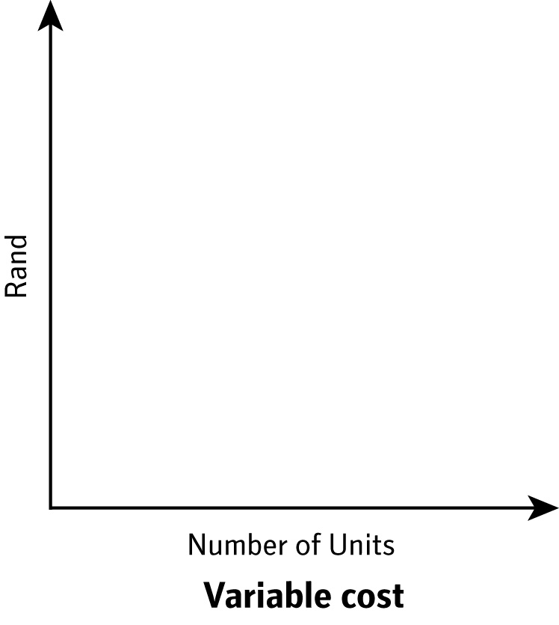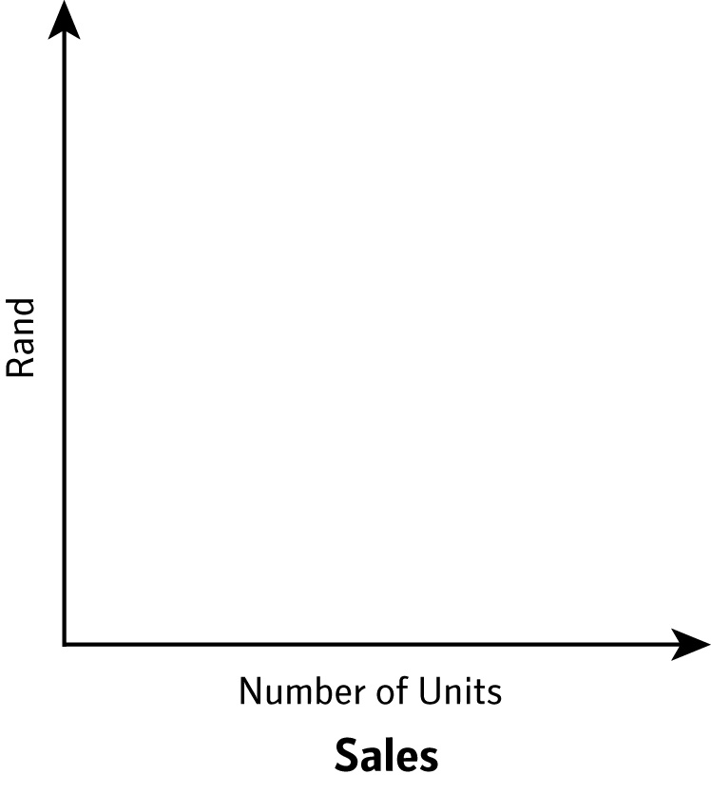

* 1. **1.2**

**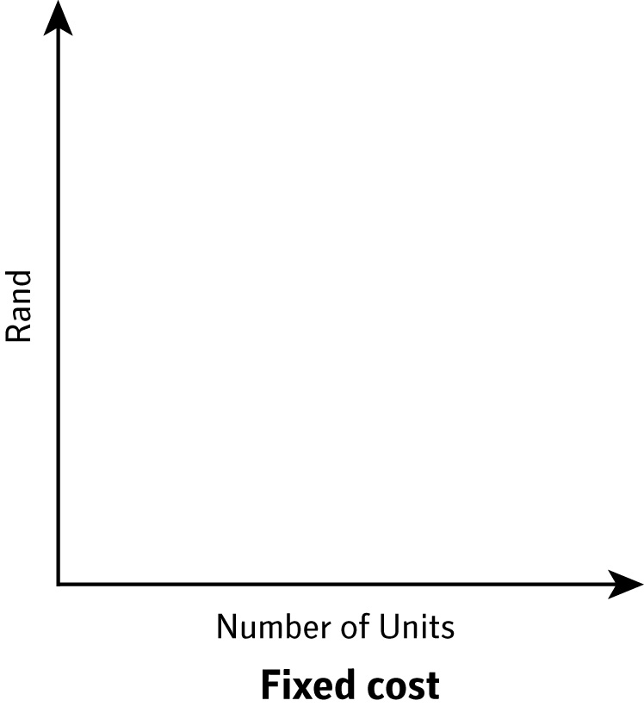 1.3**

### Evaluating the Break-even Point

We consider the graphical solution first. This method consists of drawing one line representing total costs and another line representing total income on the same set of axes, and then determine their point of intersection. This point represents the break-even point.

#### Example 5.57

A firm manufactures a scientific calculator. There is a weekly fixed cost of R500 for producing the calculators and a variable cost of R8 per calculator. The firm receives an income of R12 for each calculator that is sells.

1. Find the total cost of producing 80 calculators in a week.
2. Find the total income from selling 80 calculators.
3. Find the profit (or loss) if the firm manufactures and sells 80 calculators in a particular week.
4. Use a graph to find the point at which the total cost is equal to the total income, i.e. find the weekly sales that represent the break-even point. Interpret the meaning of this point.

##### Solution:

1. *v* = R8, *f* = R500, and *Q* = 80







Hence the total cost is R1140.

1. *s* = R12 and *Q* = 80





Hence the income is R960.

1. 



The value of *TP* is negative, so this represents a loss of R180.

1. We now determine the break-even point graphically. We have that:







From the graph we see that the point of intersection is (125,1 500). Therefore the breakeven point of sales is 125 calculators per week with the total cost and income each equalling R1 500. This means that if the firm manufactures less than 125 calculators in a week, it will make a loss; if it manufactures more than 125 calculators it will make a profit.

#### Example 5.58

Assume that a firm can sell, at R18 each, as many units of its product as it can manufacture in a month. It costs the firm R2 400 in fixed costs, plus an additional R14 for each unit produced. How many units need to be produced to break even?

##### Solution:





To find the break-even point, we must find the simultaneous solution to these two equations. This is where 



Therefore the output required to break even is 600 units per month.

|  |  |
| --- | --- |
| Icon_2.png | Assessment activity 5.19 |

1. A firm has to pay fixed costs of R4 300, plus another R45 for each unit of a certain commodity produced. How many units can it produce within its budget of R46 000?
2. A firm manufactures a certain product *Q* and can sell any number of it at R25 per unit. The firm has to pay fixed costs of R2 000 plus a variable cost of R20 for each unit produced.
   1. How many units of *Q* must be produced in order to make a profit?
   2. If the selling price is reduced to R24 per unit, what happens to the break-even output?
3. The student council is selling hotdogs as a fund raiser at a minimarket. The cost for hiring a stand at the mini market is R350. The cost to prepare the hotdogs, is R4 per hotdog. The selling price of each hotdog is R9. Determine how many hotdogs should be sold to break even. Explain what will happen in case they sell more than this number, and what will happen if they sell less than this number.

# 8. Constructing and Solving Problems using Equations

## How to Construct an Equation

When working with variables, it is useful to use a letter that reminds you of what the variable stands for. For example; let *t* be the *time* it takes to travel somewhere; let *d* be the *distance*, etc.

#### Example 5.59

Write down an equation for the income from ticket sales for a college Gala night if tickets are sold at R35 apiece? Evaluate the exact income if 138 tickets were sold.

##### Solution

Let *q* represents the number of tickets sold.

Income from ticket sales 

Income from 138 tickets sold .

If your car travels at an average speed of 100 kilometres per hour, for 2 hours, then it travels  kilometres. This is an example of the basic relationship between distance, speed and time.

|  |
| --- |
| **Relationship between distance, average speed and time**  Distance = (average speed)  time |

#### Example 5.60

A car travels on the freeway at a constant speed of 125 kilometres per hour.

1. Write an equation that gives the distance that the car has travelled after *h* hours.
2. Use the equation in (a) to find the distance travelled after 6 hours?

##### Solution:

1. Let *h* denote the time (in hours) that the car has travelled.

Distance travelled after *h* hours = 125 

1. Distance travelled after 6 hours = 125 kilometres.

|  |  |
| --- | --- |
| Icon_2.png | Assessment activity 5.20 |

1. A car salesman is paid R1 250 per week, plus a commission of R500 for every car that he sells.
   1. Write down an equation for his weekly remuneration if he sells *c* cars in a week.
   2. How much will he be paid for a week in which he sells ten cars?
2. A rectangular field has a length of  meters and a width of  meters.
   1. Write down an equation for the perimeter of the field.
   2. Write down an equation for the area of the field.
3. A car travels on the freeway for five hours.
   1. Write an equation for the distance that the car has travelled if the (constant) speed of the car is *r* kilometres per hour.
   2. Use the equation in (3.1) to find the distance travelled if the speed was 80 kilometres per hour.
4. Your firm pays you a fixed salary of R850,00 per day, plus R100,00 per hour overtime.
   1. Write down an equation for a day’s work if you work *h* hours overtime.
   2. Determine a day’s pay if you work 3 hours overtime.
   3. Write down an equation for a week’s (5 days’) pay if you work *h* hours overtime during the week.
   4. Evaluate a week’s (5 days’) pay if you work 12 hours overtime.
5. You hire a taxi to visit your parents. The price of a taxi ride consists of a fixed fare of R20, plus an additional charge of R5 for each kilometre.
   1. Write down an equation for the total cost of the journey. Choose your own symbol to represent the distance covered.
   2. What was the total cost if the distance travelled was 25 kilometres?

## Solving Problems using Equations

We now look at how equations are used to solve certain problems.

#### Example 5.61

You can work at a nursery for R800 for a 40 hour week. In addition, you can earn R35 overtime per hour. If your pay was R975 for one week, how many hours overtime did you work?

##### Solution

Let *h* represents the number of hours overtime.

Hence we have that:



…*subtract 800 on both sides*



…*divide on both sides by 35*



So you worked 5 hours overtime.

#### Example 5.62

Your monthly cellphone bill is R802, which consists of a basic monthly charge of R120 plus the cost for the metered airtime units used. If each airtime unit costs R2,20, how many airtime units were used?

Solution

Let *m* represents the number of units used.

So we have the equation:



…*subtract 120 from both sides*



…*divide on both sides by 2,20*



So 310 metered airtime units were used.

|  |  |
| --- | --- |
| Icon_2.png | Assessment activity 5.21 |

1. You hire a car to go on holiday. The car rental company charges you a fixed amount of R250 per day and a further R8 per kilometre. If you hired the car for 5 days and you paid R11 690, determine the amount of kilometres that you have driven.
2. John earns a fixed amount of R335 a day, plus R35 per hour overtime. How many hours overtime did John work if he earned R440 a day?
3. A family consisting of two adults and a number of children went to see a movie. Each adult paid R45 and each child paid R25. If the total bill was R190 how many children went?
4. You go to a foreign exchange bureau to buy US dollars. You pay R4 000 and receive $270. When you get home you discover that you have lost your receipt. Determine the exchange rate if it is known that the bureau charges a fixed amount of R50 on each transaction?
5. In a certain module that you are enrolled for, the final mark is calculated according to the ratio 30 : 70 between coursework and the examination mark. If you have scored 67% for your coursework, what examination mark is required to achieve a final mark of 50%?

The skills you develop in solving simple problems will help you to solve more realistic problems in chemistry, physics, biology, business, and other fields.

While there is not one specific method that will enable you to solve all possible kinds of problems, the following six-step method is a general rule that works in many cases.

|  |
| --- |
| **How to solve word problems**  **Step 1:** Read the problem very carefully so that you completely understand all aspects of the problem. Make sure you comprehend all the given information and that you know exactly what is asked.  **Step 2:** Represent the unknown quantities by suitable variables.  **Step 3:** If possible, sketch a diagram to “see” the situation.  **Step 4:** Form an equation that will relate known quantities (such as constants) to the unknown quantities. Use the diagram to help you to do this.  **Step 5:** Solve the equation and write down the answers to all the questions.  **Step 6:** Check your answer.  Does it make sense? |

#### Example 5.63

A rectangular field has a perimeter of 420 meter and length of 130 meter. Find the width of the field.

##### Solution

**Step 1:** Perimeter is 420 meter and length is 130 meter. Determine the width of the field.

**Step 2:** Let *w* represent the width of the field.

**Step 3:**

**Step 4:** Twice the length plus twice the width equals the perimeter:



**Step 5:** 





**Step 6:** Substitute the value in the equation: 

The answer does make sense.

The width of the field is 80 meters.

#### Example 5.64

You want to build a book-shelf, containing some shelves.  The length of each shelf must be 6 times the height of the book-shelf, and there needs to be four shelves in the book-shelf.  If you have 64 meter of wood available to build the book-shelf, what will the dimensions of the book-shelf be?

##### Solution:

**Step 1:** You have 64 meter of wood available. The length of each shelf is 6 times the height of the book-shelf. There has to be four shelves in the book-shelf. Determine the dimensions of the book-shelf. We need two vertical sides plus five horizontal parts (the shelves).

**Step 2:** Let *x* denote the height of the book-shelf. This means that the length of each shelf is 6*x*.

**Step 3:**

**Step 4:** The sum of the lengths of the vertical sides (there are two) plus the lengths of the horizontal parts (there are five) should be 64:



**Step 5:** 





**Step 6:** Substitute *x* = 2 into the equation: 

The answer does make sense.

The dimensions of the book-shelf are: width is 6(2) = 12 meters and the height is 2 meters.

#### Example 5.65

Two cyclists, A and B, are 75 kilometres apart. A is cycling at a speed of 45 kilometres per hour and B is cycling at 20 kilometres per hour, moving directly towards each other. Suppose that the two started exactly at the same time, how long does it take for the two to meet?

##### Solution:

**Step1:** The cyclists are 75 kilometres apart. A is cycles at 45 kilometres per hour and B at 20 kilometres per hour. They start to cycle at exactly the same time. Determine how longdoes it take until they meet.

**Step 2:** Let *t* represent the time that elapsed before they meet.

**Step 3:**



**Step 4:** Distance = speed  time

Distance covered by A 

Distance covered by B 

Distance that A cycled + distance that B cycled = 75 *km*



**Step 5:** 





**Step 6:** Substitute this value into the equation: 

The answer does make sense.

The time it will take for the two cyclists to meet is 1,15 hours = 1 hour and 9 minutes.

|  |
| --- |
| **Icon_6.jpgWork/rate problems**  Portion of job done in a given time = work rate  time spend |

As you can see, this formula is very similar to the formula we used fordistance, speed and time.

#### Example 5.66

Mary can paint a room in 8 hours.  Working together Anne and Mary can paint the room in 5 hours.  How long would it take Anne to paint the room by herself?

##### Solution:

**Step 1:** Mary paint a room in 8 hours.  Anne and Mary can paint the room in 5 hours. Determine how long it would take Anne to paint the room by herself.

**Step 2:** Let *t* denote the time it would have taken Anne to paint the room by herself.

**Step 4:** We need to find the work rates for each person.

Let us start with Mary:

1 job = Mary work rate  8…see the above formula

Mary work rate =  job per hour.

Now we’ll find the work rate of Anne.  Notice we don’t yet know how long it will take her to do the job by herself. We’ll have to describe her job rate in terms of *t*.

1 job = Anne work rate  *t*

Anne work rate =  job per hour.

Portion of job done by Mary plus portion of job done by Anne will be a complete job (= 1 job). So, when the work together, we have:

(work rate  time spend for Mary) + (work rate  time spend for Anne) =1



**Step 5:** 





**Step 6:** Substitute this value into the equation: 

The answer does make sense.

It would take Anne  hours (13 hours and 20 minutes) to paint the room by herself.

*Enrichment section ends*

#### Example 5.67

A movie theatre charges R35 for adults and R25 for children. Last Saturday the total earnings was R26 500 for 900 tickets sold. How many children and adult tickets respectively were sold?

##### Solution:

**Step 1:** R35 per adult and R25 per child. Total earnings was R26 500 and 900 tickets were sold. Determine how many children and adult tickets were sold.

**Step 2:** Let *x* denote the number of children tickets sold.

We know that 900 tickets in total were sold. Since the number of children tickets sold is *x*, the number of adult tickets sold is 900 – *x .*

**Step 4:** (Number of children tickets  price per children ticket) +

(Number of adult tickets  price per adult ticket) = Total earnings:



**Step 5:** 







Number of adult tickets sold = 

**Step 6:** Substitute these values into the equation:



The answer makes sense.

Therefore, 500 children and 400 adult tickets were sold.

|  |  |
| --- | --- |
| Icon_2.png | Assessment activity 5.22 |

1. The combined age of you and your brother is 24. If you are six years older than your brother, what are your respective ages?
2. A customer picked up his car after a service and received a combined bill (for parts and labour) of R1 530. If the labour costs twice as much as the parts. Determine the respective costs of parts and labour.
3. A coffee shop found that on a specific day, the number of coffees sold was four times the number of teas sold. If the total number of beverages sold was 80, how many coffees were sold?
4. The page numbers of two pages that face each other in a book adds up to 621. Find the two page numbers. [Hint: two such page numbers are always consecutive, such as 41 and 42.]
5. A bookstore purchased 250 copies of a book, some in soft-cover and some in hard-cover. The soft-cover sold for R87 each and the hard-cover for R110 apiece. When all the books were sold, the total amount that the store received from the sale was R23 590. How many of each of the soft-cover and hard-cover versions were sold?
6. Two cars leave the college at the same time and travel in the same direction. Car A travels at a constant speed of 65 kilometres per hour and car B travels at a constant speed of 55 kilometres per hour. In how many hours will the distance between them be 15 kilometres?

*Enrichment – questions 7,8 &9*

1. John can paint a fence in 4 hours, and Jim can paint the same fence in 6 hours. How long would it take to paint the fence if they worked together?
2. Three pieces of wood are required for a woodwork project. The longest piece must be twice the length of the middle-sized piece, and the shortest piece must be 85 centimetres shorter than the middle-sized piece. If the total length of the pieces is 315 centimetres, determine how long each piece is.
3. Three pieces of wood are required for a woodwork project. The longest piece must be twice the length of the middle-sized piece, and the shortest piece must be 85 centimetres shorter than the middle-sized piece. If the total length of the pieces is 200 centimetres, determine how long each piece is.

Many problems involve more than one unknown quantity. Some problems with two unknown can be solved using just one variable. To solve a problem with two unknowns, we sometimes have to write down two equations that relate the unknown quantities. This system formed by the pair of equations can then be solved using the methods described in part 5.

The following steps give a basic strategy for solving problems using more than one variable.

|  |
| --- |
| **Icon_6.jpg Solving problems with systems of equations**  **Step 1:** Read the problem very carefully so that you completely understand all aspects of the problem.  Identify all the given information and make sure you know exactly what is asked.  **Step 2:** Assign variables to represent the unknown values and use diagrams or tables, if applicable.  **Step 3:** Write a system of equations that relates the unknowns.  **Step 4:** Solve the system of equations.  **Step 5:** Check your answer.  Does it make sense? |

#### Example 5.68

The college cafeteria sold a total of 68 pizzas and hamburgers on one day. The income from the sale of these two items was R1 930. Determine how many of each type were sold if pizzas sold for R35 each and hamburgers for R25 each.

##### Solution:

**Step 1:** Find the number of pizzas and hamburgers sold.

**Step 2:** Let *p* represent the number of pizzas sold and *h* the number of hamburgers sold.

**Step 3:** A total of 68 pizzas and hamburgers sold gives the equation:



Pizzas sold for R35 each and hamburgers for R25 each. The total amount of income was R1 930. This gives the equation:



Therefore the system of equations is:

…A

…B

**Step 4:** Multiply A by :

…C

…B

…*add C and B*



To find the value of *p*, substitute  into equation A (or in B)



…*subtract 45 from both sides*

**Step 5:** We obtained the solution: 23 pizzas and 45 hamburgers were sold.

Check the answer by substituting this into both equations:

 **and**  

 .

The answer is correct.

#### Example 5.69

During the rugby season two national tickets and one international ticket sells at an average price of R690. One national and two international tickets would have cost R1 020. What was the average price for each type of ticket?

##### Solution:

**Step 1:** Find the average price for both the national and the international tickets.

**Step 2:** Let *n* represent the price of a national ticket and let *I* denote the price of an international ticket.

**Step 3:** Two national tickets and one international ticket sold at an average price of R690. This gives the equation: 

One national and two international tickets sold for an average price of R1 020. This gives the equation: 

Therefore the system is:

 …A

…B

**Step 4:** Multiply B by :

 …C

…A

…*add C and A*



To find the value of *n*, substituteinto equation A (or in C)



…*subtract 450 from both sides*

…*divide on both sides by 2*

**Step 5:** The average ticket price for a national ticket is R120 and R450 for an international ticket.

Check the answer by substituting it into both equations:

 **and** 

 

The answer is correct.

#### Example 5.70

A company produces chairs and sofas. A chair requires 2 hours of assembly time and 2 hours of finishing. A sofa requires 1 hour of assembly time and 3 hours of finishing. In each week, there are 57 hours available for assembly, and 107 hours for finishing. How many chairs and sofas should be produced each week if all available time must be used?

##### Solution

**Step 1:** Find the number of chairs and sofas produced each week if all available time must be used.

**Step 2:** Let *C* represent the number of chairs produced per week and *S* the number of sofas produced per week.

Organize the information in a table.

|  |  |  |  |
| --- | --- | --- | --- |
|  | **Each Chair** *C* | **Each Sofa** *S* | **Totals** |
| Hours of assembly time | 2 | 1 | 57 |
| Hours of finishing | 2 | 3 | 107 |

**Step 3:** The chairs require  hours of assembly and the sofas require  hours of assembly. Since 57 hours are available for the assembly process, the equation becomes: 

The chairs require  hours of finishing and the sofas require  hours of finishing. Since 107 hours are available for the finishing process, the equation in this case is: 

Therefore the system is:

…A

…B

**Step 4:** …A

…B

…*subtract A from B*

…*divide both sides by 2*

To find the value of *C*, substitute into equation A (or B)



…*subtract 25 from both sides*

…*divide on both sides by 2*

**Step 5:** The number of chairs produced each week is 16 and the number of sofas produced each week is 25 if all available time is used.

Check the answer by substituting it into both equations:

 **and**  

 .

The answer is correct.



|  |
| --- |
| **Relationship between distance, speed and time**  Distance = speed  time |

#### Example 5.71

A car travels a distance of 150 kilometres in the same time that it takes a train to travel a distance of 100 kilometres. If the speed of the car is 6 kilometres per hour faster than the speed of the train, find both speeds.

##### Solution:

**Step 1:** We need to find the speed of the car and the speed of the train.

**Step 2:** Let *C* represent the speed of the car and let *T* represent the speed of the train.

Organize the information in a table.

|  |  |  |  |
| --- | --- | --- | --- |
|  | **Distance** | **Speed** | **Time** |
| Car | 150 | *C* |  |
| Train | 100 | *T* |  |

The table says nothing about the time. To get an expression for time, use the formula: Distance = speed  time or 

Therefore: .

We can know complete the table:

|  |  |  |  |
| --- | --- | --- | --- |
|  | **Distance** | **Speed** | **Time** |
| Car | 150 | *C* |  |
| Train | 100 | *T* |  |

**Step 3:** The speed of the car is 6 kilometres per hour faster than the speed of the train, so we have that: 

Both the car and the train travel for the same time, which gives the equation:



This not a linear equation. Cross multiplication gives, which is linear.

Therefore the system is:

…A

…B

**Step 4:** Multiply A by :

…C

…B

…*add C and B*



To find the value of *T*, substitute  into equation B (or C)





…*divide on both sides by 150*

**Step 5:** The car’s speed is 18 kilometres per hour and the train’s speed is 12 kilometres per hour.

Check your answer by substituting it into both equations:

 **and** 

 .

The answer is correct.

*Enrichment section ends here*

|  |  |
| --- | --- |
| Icon_2.png | Assessment activity 5.23 |

1. Paris and Moscow are two of the most expensive cities in the world. Using average costs per day, two days in Paris and one day in Moscow cost R3 750. Three days in Paris and four days in Moscow cost R9 500. What is the average cost per day for each city?
2. You were selling tickets for a concert at your college. The cost of a ticket for a child was R45 and R65 for an adult. Your total income after the concert was R51 800 and a total of 920 tickets were sold. Report back to your ticket manager, outlining the respective incomes with respect to children and adults.
3. At a business meeting at your local coffee shop, the bill for three cappuccinos and two teas was R65,35. The next day the bill for two cappuccinos and one tea was R40,80. How much did each type of beverage cost?



1. A truck travels 150 kilometres in the same time that it takes a car to travel 220 kilometres. If the speed of the truck is 7 kilometres per hour slower than the speed of the car, find both speeds.
2. You have to consider two job offers:

Job A: pays a straight commission of 9% on all sales.

Job B: pays a monthly salary of R4 300 plus a 2% commission on all sales.

Explain when it is better to choose Job A and when it is better to choose Job B.

|  |  |
| --- | --- |
| Icon_5.png | Group activity 5.24 |

To do the following group activity, visit the web site:

<http://sixthsense.osfc.ac.uk/maths/sim_equations/unit7_5/maths@work_p6_10.asp>

*(24-03-2009)*

###### Optimising Production of Products from Crude Oil

A refinery takes crude oil extracted from wells bored into the earth. Crude oil is a natural product formed over thousands of years by a transformation of plant life and organic materials which have been buried and exposed to high temperatures and pressures. At Fawley Refinery we take crude from all over the world including wells in the North Sea and Saudi Arabia.

The composition of crude oil is not fixed or constant, it is not a scientific compound, but a mixture of many components that we separate in our processes and refine into useful products. Some examples of these many components are petrol, aviation fuel, liquefied petroleum gas and naphtha that are sold for various industrial and commercial uses.

Each component has different properties and we separate those using distillation columns, which split the components according to their boiling point. Essentially, we heat up the crude oil and the light products, such as LPG, come off the top of the distillation column, streams such as petrol are taken out of the middle of the column and heavier products, such as the components used in motor oils or bitumen, come off the bottom of the tower.

**It is important for us to be able to calculate the proportion of these various components in our feed crude oil as each product is worth a different amount of money to the refinery and has an effect on the way we run our equipment.**

Chemical models of the various crudes are used to predict the overall refinery production and matched with the markets or demands for the various products. Below is a simple example of the type of calculation we use to determine what types of crude we use and in what amounts.

**Worked Example**

We have two crude oil feed streams that are blended to make up a single feed to a distillation column. For simplicity we will assume that the crude oil is being split into 3 components: Liquefied Petroleum Gas, Light Virgin Naphtha and Petrol. One crude comes from the North Sea oilrigs and one crude comes from Saudi Arabia. Each crude is composed of a different percentage of each product.

We need to be able to calculate the percentage of LPG, LVN and petrol in each of the two feed crudes.

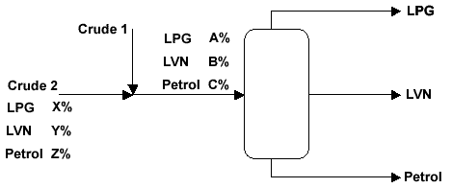

The table below shows the input flow rates of crude 1 and 2 and the resulting amounts of LPG, LVN and Petrol that come out of the distillation column.

|  |  |  |  |  |  |  |  |
| --- | --- | --- | --- | --- | --- | --- | --- |
|  | **Crude Oil**  **(m3/hr)** | | **Total**  **in** |  | **Outputs**  **(m3/hr)** |  | **Total**  **out** |
|  | Stream 1 | Stream 2 |  | LPG | LVN | Petrol |  |
| **Case 1** | 100 | 100 | 200 | 25 | 45 | 130 | 200 |
| **Case 2** | 130 | 150 | 280 | 34.5 | 62.5 | 183 | 280 |

This information can be shown diagrammatically:

**CASE 1**

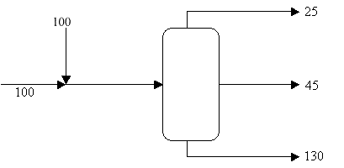

**CASE 2**

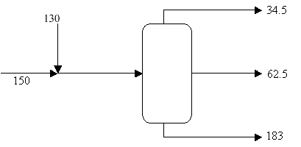

All amounts are in m3/hr

So in case 1, 100 m3/hr of crude 1 is mixed with 100 m3/hr of crude 2 and 25, 45, 130 m3/hr respectively of LPG, LVN and Petrol are produced. Similarly for case 2.

What are the percentages of each component in each crude?

**ANSWERS**

From the two cases above we can produce two simultaneous equations for each product.

|  |  |
| --- | --- |
|  |  |
|  |  |
| **Consider LPG** | 100A + 100X = 25 |
|  | 130A + 150X = 34.5 |
|  |  |
|  | Solving this gives A = 15 %, X = 10 % |
|  |  |
| **Consider LVN** | 100B + 100Y = 45 |
|  | 130B + 150Y = 62.5 |
|  |  |
|  | Solving this gives B = 25 %, Y = 20% |
|  |  |
| **Consider Petrol** | 100C + 100Z = 130 |
|  | 130C + 150Z = 183 |
|  |  |
|  | Solving this gives C = 60%, Z = 70% |

So we have been able to determine the composition of the two feed streams of crude oil.

In summary

|  |  |  |  |  |
| --- | --- | --- | --- | --- |
|  | **LPG %** | **LVN %** | **Petrol %** | **Total %** |
| Crude 1 | 15 | 25 | 60 | 100 |
| Crude 2 | 10 | 20 | 70 | 100 |

Altering the flow rate of each crude will alter the mix of products. This in turn will have profit implications. We will consider these now.

**Financial Implications**

|  |  |  |
| --- | --- | --- |
| If the products are worth |  | LPG $10 /m3 |
|  |  | LVN $20 /m3 |
|  |  | Petrol $30 /m3 |
| Crude 1 costs | $15 /m3 |  |
| Crude 2 costs | $25 /m3 |  |

How much per day will we make in each case?

Let us look at what we calculated the amounts of each of the three products to be in case 1

|  |  |  |  |  |
| --- | --- | --- | --- | --- |
|  | **LPG** | **LVN** | **Petrol** | **Total m3 /hr** |
| Crude 1 | 15 | 25 | 60 | 100 |
| Crude 2 | 10 | 20 | 70 | 100 |
| **Total** | **25** | **45** | **130** | **200** |

From these figures we can calculate the money made and the costs

(In each case we multiply by 24 to calculate for a day rather than an hour)

**Money Made**

|  |  |  |
| --- | --- | --- |
| For LPG | 25 x 10 x 24 = | $ 6 000 |
| For LVN | 45 x 20 x 24 = | $ 21 600 |
| For Petrol | 130 x 30 x 24 = | $ 93 600 |
|  |  | Total $121 200 |

**Costs of Crude**

|  |  |  |
| --- | --- | --- |
| Crude 1 | 100 x 15 x 24 = | $ 36 000 |
| Crude 2 | 100 x 25 x 24 = | $ 60 000 |
|  |  | Total $ 96 000 |

|  |  |  |
| --- | --- | --- |
| **PROFIT (assuming no other costs)** | **$ 25 200** | **per 24 hours** |

**ANSWER THE FOLLOWING QUESTIONS**

****

As you can see from the diagram, two feed streams of crude oil 1 and 2 are flowing into the distillation column. By heating the mixture the distillation column will separate the streams into three components, LPG, LVN and Petrol.

Crude oils vary enormously and we do not know the percentage of each of the three components in each input stream, but we can measure how much of each component comes out of the distillation column.

We need to work out the input percentages A, B, C and X, Y, Z so that we can ensure that the correct mix of crude1: crude2 is being fed into the column.

We can alter the rate at which each of the crude oils flow into the column.

We then measure how much of LPG, LVN and Petrol comes out for that particular case.

The information below shows two cases. The first case has crude 1 and 2 both flowing in at 100 m³/hr and the second has crude 1 at 200 m³/hr and crude 2 at 150 m³/hr.

1. Using the information below produce three sets of simultaneous equations and hence calculates the percentages A, B, C, X, Y and Z.

|  |  |  |  |  |
| --- | --- | --- | --- | --- |
|  | Crude Oil  (m3/hr) | Total in |  | Outputs |
|  | Stream 1 | Stream 2 |  | LPG |
| Case 1 | 100 | 100 | 200 | 15 |
| Case 2 | 170 | 150 | 320 | 25 |

CASE 1

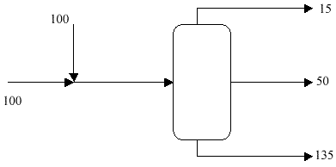

CASE 2

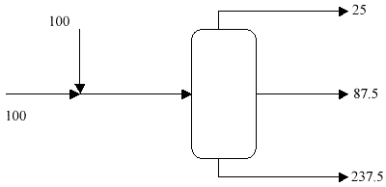

220

25

80

170

1. Look at the financial implications for running the distillation case 1.

The values and costs remain the same

|  |  |  |
| --- | --- | --- |
| If the products are worth |  | LPG $10 /m3 |
|  |  | LVN $20 /m3 |
|  |  | Petrol $30 /m3 |
| Crude 1 costs | $15 /m3 |  |
| Crude 2 costs | $25 /m3 |  |

How much profit will you make?

# End of section comments

This was one of the most important sections for the semester. We will make use of the content in all the sections for the second semester. Make sure that you understand and can confidently work with everything that was addressed in this section.

# Feedback

To see how well you can interpret a graph:

Graph (1) start at the college walking away from it, say to your home, where you stayed for some time. Graph (2) start away from the college, say at home, and walking to the college and staying there for some time. We can also say that the speed that we are walking from the college in (1) is slower than the speed we are walking to the college in (2). However, the distances that we walk in (1) and (2) are the same, and also the times we stayed at the college and at home in (2) and (1) are the same.

##### Answers to start-up activity 5.1

1. R450
2. R184

|  |  |  |
| --- | --- | --- |
| **Number of minutes talk per month** | **Monthly payment for option A** | **Monthly payment for option B** |
| 0 | 450 | 120 |
| 100 | 450 | 200 |
| 200 | 450 | 280 |
| 300 | 450 | 360 |
| 400 | 450 | 440 |
| 500 | 450 | 520 |



1.  minutes
2. No, it depends on the number of minutes you talk.
3. If you talk more than 412 minutes.
4. If you talk less than 412 minutes.

##### Answers to learning activity 5.2

1. 
2. 
3. 
4. 
5. 
6. 
7. 
8. 
9. 
10. 
11. 

##### Answers to learning activity 5.3

1. 
2. 
3. 
4. 
5. 
6. 
7. 
8. 
9. 

##### Answers to assessment activity 5.4

1. 
2.  meter per second per second
3.  cubic metres

##### Answers to assessment activity 5.5

1.  units
2. 
3.  units
4.  units
5.  units

##### Answers to assessment activity 5.6

1. 
2. 
3. 
4. 
5. 

##### Answers to assessment activity 5.7

1. 

##### Answers to learning activity 5.8

1.  years

##### Answers to learning activity 5.9

1. Cuts the *x*-axis at: 4 Cuts the *y*-axis at: 
2. Goes through the origin
3. Cuts the *x*-axis at: 4 Cuts the *y*-axis at: 4
4. Goes through the origin
5. Cuts the *x*-axis at:  Cuts the *y*-axis at: 8
6. Vertical line : 
7. Horizontal line : 
8. Cuts the *x*-axis at:  Cuts the *y*-axis at: 
9. Cuts the *x*-axis at: 3 Cuts the *y*-axis at: 

##### Answers to learning activity 5.10

1. 
2. 
3. 1. 
   2. 
   3. 
   4. 
   5. Not defined



* + 1. 
    2. 
  1.  and 
  2. 
  3. Yes the slope of a straight line is the same at each of its points.

|  |  |
| --- | --- |
| **Year** | **Rate** |
| 2002 – 2003 | 1 |
| 2004 – 2005 | 1 |
| 2006 – 2007 | 1 |

* 1. The average rate stays the same for every year. The graph is a straight line.

|  |  |
| --- | --- |
| **Year** | **Rate** |
| 2002 – 2003 | 1150 |
| 2003 – 2004 | 900 |
| 2004 – 2005 | 1100 |
| 2005 – 2006 | 890 |
| 2006 – 2007 | 1200 |

* 1. Yes, and yes, a straight line fits approximately to the given data.

##### Answers to assessment activity 5.11



##### Answers to learning activity 5.12





* 1. Q
  2. P
  3. For every 1 unit increase in price, the quantity supply will increase by 2 units.
  4. Positive relationship: If price increases, the quantity supply also increases.

##### Answers to learning activity 5.13

1. One solution
2. One solution
3. No solution
4. Infinitely many solutions

##### Answers to learning activity 5.14

1.  and 
2.  and 
3.  and 
4.  and 
5. Parallel lines
6. Infinitely many solutions

##### Answers to learning activity 5.15

1.  and 
2.  and 
3.  and 
4.  and 
5.  and 
6. No solution
7. Infinitely many solutions

##### Answers to assessment activity 5.16

1.  meter per second and  meter per second per second
2.  and 

##### Answers to assessment activity 5.17

1.  and 
2.  and 
   1.  and 
   2.  and 
   3.  and 

##### Answers to learning activity 5.18

* 1. **1.2**

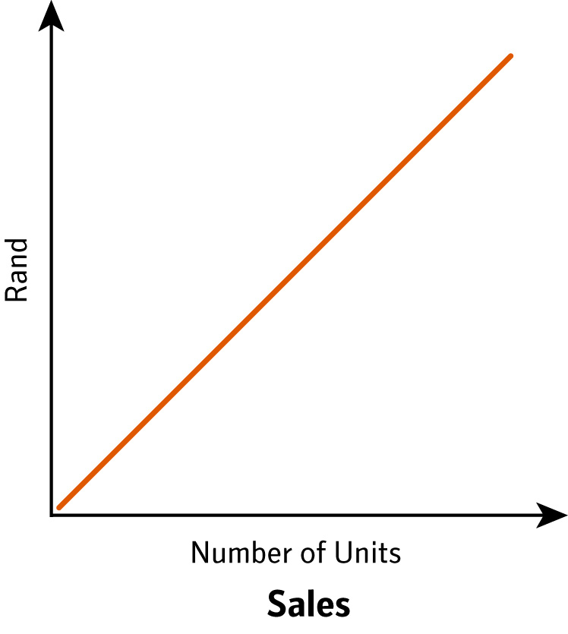 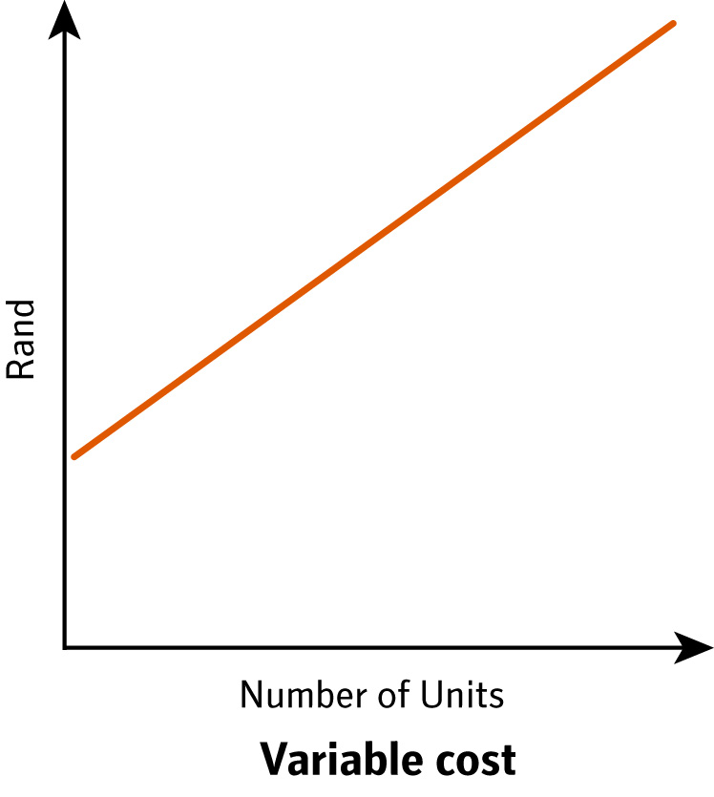

**1.3**

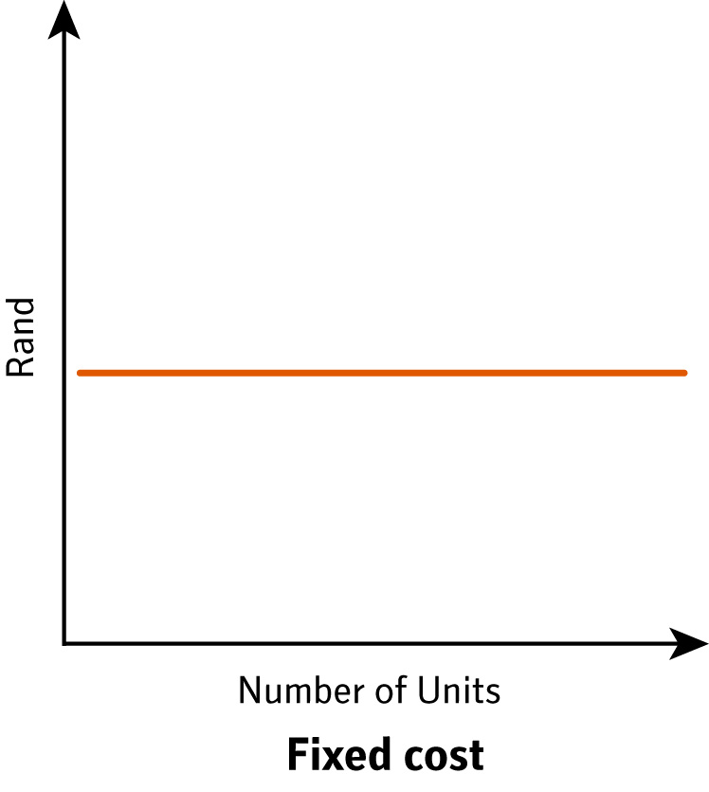

##### Answers to assessment activity 5.19

1. 
   1. The number of units must be more than 400.
   2. More than 500 must be produced to break even.
2. 70 hotdogs should be sold to break even. If more than 70 are sold, a profit will be made. Less than 70 sold results in a loss.

##### Answers to assessment activity 5.20

* 1. 
  2. 6250
  3. 
  4. 
  5. 
  6. 400
  7. 
  8. 1150
  9. 
  10. 5450
  11. 
  12. 145

##### Answers to assessment activity 5.21

1. 1305 kilometre
2. 3 hours
3. 4 children
4. R14,63
5. 42,7%

##### Answers to assessment activity 5.22

1. I am 15 years old and my brother is 9 years.
2. Amount for parts = R510 Amount for labour = R1 020
3. Coffee = 64 Tea = 16
4. Numbers of pages are 310 and 311
5. Hard- cover = 80 copies; Soft-cover = 170 copies
6. It will take 1,5 hours
7. It will take them 2 hours and 24 minutes
8. The middle piece = 100 centimetre

The longest piece = 200 centimetre

The shortest piece = 15 centimetre

1. No solution exists

##### Answers to assessment activity 5.23

1. Paris  and Moscow 
2. Number of children tickets  Number of adult tickets 

Amount for children tickets = R18 000

Amount for adult tickets = R33 800

1. Tea costs R8,30 Cappuccino costs R16,25
2. Truck speed = 15 kilometres per hour

Car speed = 22 kilometres per hour

1. If the sales are more than R61 428 you will choose Job A, and if the sales are less than R61 428 you will choose Job B.

##### Answers to group activity 5.24

1. A = 2,5% X = 12,5% B = 25% Y = 25% C = 47,5% Z = 87,5%
2. Profit is R28 800

# Tracking my progress

You have reached the end of this section. Check whether you have achieved the learning outcomes for this section.

|  |  |  |
| --- | --- | --- |
| **Learning outcomes** | **✓ I feel confident** | **✓ I don’t feel confident** |
| Solve equations with Whole numbers |  |  |
| Solve equations with fractions |  |  |
| Use equations to solve problems involving one unknown variable |  |  |
| Solve exponential equations by taking logs on both sides |  |  |
| Use exponential equations to solve problems involving one unknown variable |  |  |
| Plot a line by finding the intercept(s) with the axes |  |  |
| Plot a vertical line |  |  |
| Plot a horizontal line |  |  |
| Calculate the slope of a line using the formula: Slope = |  |  |
| Find the slope of a line directly from its linear equation |  |  |
| Use tables to find the average rate of change of processes over time |  |  |
| Identify the independent variable in an equation |  |  |
| Identify a positive relationship between two variables |  |  |
| Identify a negative relationship between two variables |  |  |
| Explain the significance of the value of the slope for a demand or supply  function |  |  |
| Determine when a system of equations has one solution |  |  |
| Determine when a system of equations does not have a solution |  |  |
| Determine when a system of equations has infinitely many solutions |  |  |
| Solve a system of two simultaneous linear equations in two unknowns  using substitution |  |  |
| Solve a system of two simultaneous linear equations in two unknowns  using elimination |  |  |
| Solve a system of two simultaneous linear equations in two unknowns  to solve problems |  |  |
| Find the equilibrium values for a simultaneous demand and supply graph |  |  |
| Find changes to equilibrium values if government imposes taxes on units sold |  |  |
| Distinguish between variable and fixed cost |  |  |
| Write the equation for total cost from a given word problem |  |  |
| Write the equation for total income from a given word problem |  |  |
| Write the equation for total profit from a given word problem |  |  |
| Apply the principle of simultaneous equations to break-even analysis |  |  |
| Write and solve mathematical equations from a given word problem |  |  |
| Apply the six steps for problem solving |  |  |
| Write and solve simultaneous equations from a given word problem |  |  |

Now answer the following questions honestly:

1. What did you like best about this section?

|  |
| --- |
|  |
|  |
|  |

1. What did you find most difficult in this section?

|  |
| --- |
|  |
|  |
|  |

1. What do you need to improve on?

|  |
| --- |
|  |
|  |
|  |

1. How will you do this?

|  |
| --- |
|  |
|  |
|  |