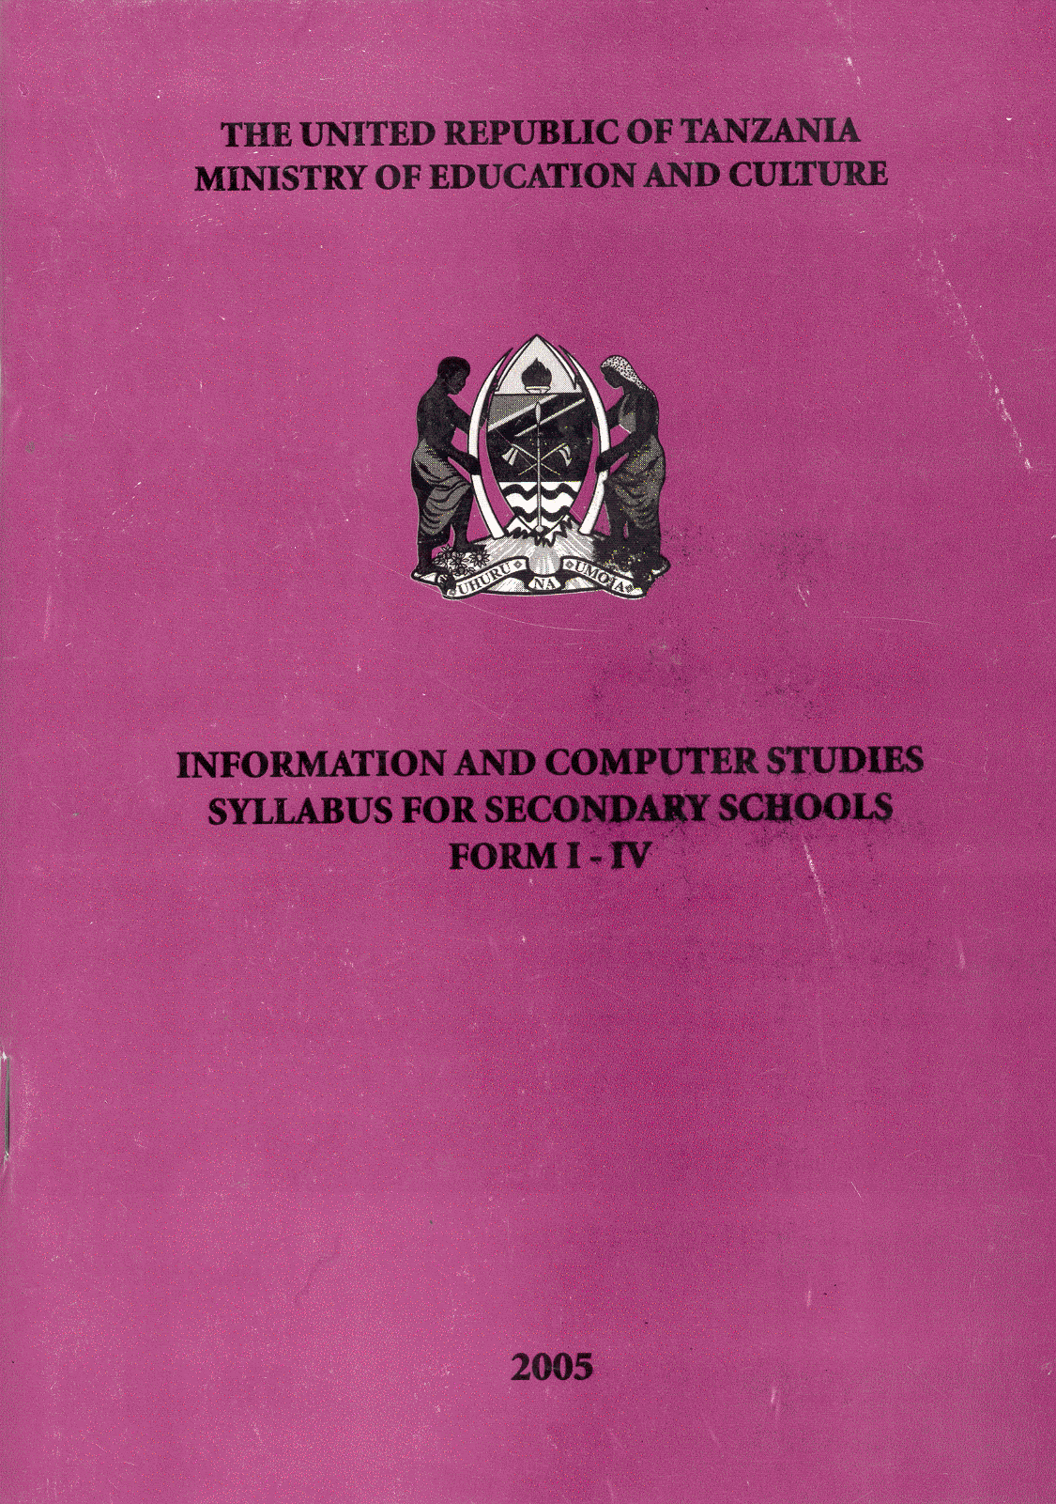

THE UNITED REPUBLIC OF TANZANIA MINISTRY OF EDUCATION AND CULTURE
INFORMATION AND COMPUTER STUDIES
SYLLABUS FOR SECONDARY SCHOOLS
FORM I - IV
2005
© Ministry of Education and Culture, 2005
All rights reserved. No part of this publication may be reproduced, reported, stored in retrieval system, or transmitted in any form or by any means electronic, mechanical, photocopying, recording or otherwise without thepennission of the copyright owner.
Designed and prepared by:
Tanzania Institute of Education Dar es Salaam Tanzania.

TABLE OF CONTENTS
1 INTRODUCTION ii
2 OBJECTIVES OF EDUCATION IN TANZANIA ii
3 OBJECTIVES OF SECONDARY EDUCATION ii
4 GENERAL COMPETENCIES iii
5 GENERAL OBJECTIVES iii
6 STRUCTURE AND ORGANIZATION OF THE SYLLABUS iii
FORM ONE 1
FORM TWO 16
FORM THREE 29
FORM FOUR 42

- INTRODUCTION
This new INFORMATION AND COMPUTER STUDIES Syllabus for Form One to Form Four is a revised version, which has been prepared to replace that of 2002. The four years.
The revision process has observed a change in paradigm from content based to a competence based curriculum. The teaching and learning process using this reviewed syllabus should be student centred and activity oriented. Students are expected to be engaged in a variety of activities which culminated in learning. Moreover, the revision has also taken into consideration the requirements of the Secondary Education Development Plan (SEDP).

- OBJECTIVES OF EDUCATION IN TANZANIA
The general aims and objectives of education in Tanzania are:
(a) to guide and promote the development and improvement of the personalities of the
citizen of Tanzania, their human resources an4 effective utilization of those resources in bringing about individual and national development.
(b) to promote the acquisition and appreciation of the culture, customs and traditions of the people of Tanzania.
(c). to promote the acquisition and appropriate use of literacy, social, scientific, vocational, technological, professional and other forms of knowledge, skills and attitudes for the development and improvement of the condition of man and society.
(d) to develop and promote self-confidence and an inquiring mind, and understanding and respect for human dignity and human rights and readiness to work hard for self advancement and national development.
(e) to promote and expand the scope of acquisition, improvement and upgrading of mental, practical, productive and other skills needed to meet the changing needs of industry and the economy;
(f) to enable every citizen to understand and uphold the fundamentals of the National Constitution as well as the enshrined human and civic rights, obligations and its
responsibilities.
(g) to promote love for work, self and wage employment and improved performance in the production and service sectors.
- OBJECTIVES OF SECONDARY EDUCATION
In Tanzania, secondary education refers to post primary formal education offered to the learners who successfully complete seven years of primary education and have met the requisite entry qualifications.
The aims and objectives of secondary education are to:
(a) consolidate and broaden the scope of basic ideas, knowledge, skills and attitudes acquired and developed at the primary educational level.
(b) enhance the development and appreciation of national unity, identity and ethic, personal integrity, respect for human rights, cultural and moral values, customs traditions and civic responsibilities and obligations.
(c) promote linguistic ability and effective use of communication skills in Kiswahili and English.
(d) provide opportunities for the acquisition of knowledge, skills, attitudes and understanding in prescribed or selected fields of study.
(e) prepare students for tertiary and higher education, vocational, technical and professional training.
(f) inculcate a sense and ability for self-study, self-confidence and self-advancement in new frontiers of science and technology, academic and occupational knowledge and 7;' skills.
(g) prepare the students to become able members of the society.
- GENERAL COMPETENCIES
By the end of the four years course, the student should have the ability to:
1. interpret organize and present information in a variety of forms.
2, use Information and Communication Technologies in data and information processing;
3. apply principles, knowledge and skills of information technology in daily life;
4, solve problems, using computers;
5. demonstrate willingness to keep abreast with current developments and issues related to everyday use of computers.

- GENERAL OBJECTIVES
By the end of the four years course, the student should be able to:
1. demonstrate skills of data processing and interpretation of information.
2. appreciate the role of information technology in socio-economic and cultural development of the society.
3, develop awareness of the place of Information Technology in the society.
4. apply Information Technology knowledge and skills in daily life.
5. develop practical skills in the use of computers.
6. outline types of network~ ,nd security issu~s in a networked environment.
- STRUCTURE AND ORGANIZATION OF THE SYLLABUS
This ICS syllabus has a slightly different structure compared to that of 2002. The following changes were added for improvement:
- General competences for the whole course.
- Competences for each level, i.e. Form One to Form Four.
- Suggested areas for assessment.
- Number of periods per sub-topic.
Also an extra column for subtopics has been added to the table of the syllabus content.
  - Class Level Competencies
Competences are skills, knowledge and attitudes attained by the learner after the learning
process. Competences have been stated for each class/level of ICS course. The class level objectives are derived from the class level competences.
  - Class Level Objectives
For each competence intended to be achieved, one or more objectives have been stated in order to achieve it. The general objectives for Form One to Form Four are stated in general terms to indicate the scope of content to be covered within each level.
  - Topics
Some topics in the 2002 ICS syllabus have been retained. Also some content from Cross-Cuning Issues (CCI), have been integrated. The topics have been derived from the class level competences and objectives.
- . Emphasis has been put on the logical arrangement of the topics, i.e from simple to most difficult.
- . A spiral arrangement has been adopted.
- . Spiral and clock arrangement have been adopted bearing in mind logical flow of the content.
- . Topics have been arranged to attain a logical order starting from the simple to the most difficult one. Both spiral and block arrangements of topics have been adopted.
  - Sub - Topic
Topics ~ave been divided into sub -topics. The sub-topics have been arranged to attain a logical order.
  - Specific Objectives
Each sub-topic has one or more specific objectives. These specific objectives are the expected outcomes in classroom instructions. They also reflect the process to attain competences within the cognitive, affective and psychomotor domains.
  - Teaching and Learning Strategies
The column of teaching and learning strategies indicates what the teacher and students
are expected to be doing in the process of teaching and learning. Students are encouraged to work in small groups for maximum participatory and cooperative learning. The
teacher shall assume the role of a facilitator to promote, guide and help students' learning activities. The whole teaching and learning process should be participatory and interactive, where the student learns by doing a series of logical activities.
These suggested teaching and .learning (T/L) strategies are not binding. The teacher and students may use any other learner - centred T/L strategy which suit the T/L strategy.
  - Teaching and Learning Resource
In the teaching of ICS a great variety of teaching- learning resources will be needed in quality and quantity. In case the commercial varieties of T/L resources are not available, the teacher should work with students to collect or improvise alternative resources available in the environment.
  - Assessment
For every specific instructional objective, there is/are some suggested questions or areas for assessment. Formative and summative assessments should be geared towards mastering attaining the competences developed within the course. .
  - Number of Periods
The column of number of periods is a proposal of duration to be used to teach a given sub-topic. The number of periods have been taken into account the time needed to adequately cover the sub-topic some topics need more time than others.
  - Instructional Time
This syllabus is to be covered in 40 weeks having approximately 194 instructional days per year including two weeks reserved for mid term and annual examinations. The number of periods for teaching this syllabus is 2 periods per week of fourty minutes each.
The teacher is advised to make maximum use of time for classroom instruction. Lost instructional time should always be compensated.

Ricky A. Mpama
Chief Education Officer
Ministry of Education and Culture

- FORM ONE
- CLASS COMPETENCES
By the end of Form One course, the student should have ability to:
1. use information and communication media
2. use computer to process data and information
3. demonstrate skills of computer handling
4. use operating system to manage files and folders
5. use the knowledge of historical development of computers for advancement of the
technology
- CLASS OBJECTIVES
By the end of Form One, the student should be able to:
I. develop skills of using information and communication media.
2. apply skills of using different accessories of the computer to process data and information.
3. develop skills of computer handling..
4. develop skills of using operating systems.
5. analyse stages of computer evolution.

TOPIC | SUB-TOPIC | SPECIFIC OBJECTIVES | TEACHING/LEARNING STRATEGIES | TEACHING/LEARNING RESOURCES | ASSESSMENT | NUMBER OF PERIODS
- INFORMATION | - Concept of Information | The student should be able to:  - Define data | - Students to brainstorm about data.  - The teacher to summarize and conclude.  - Student to use summary to define data. | - Magazines, newspapers  - Radio  - Journal, TV | Can the student define data ? | 5
 |  | - Relate data and information | - The teacher to lead students to discuss data and information  - Students to develop the relationship between data and information. | - Meetings  - Public speeches  - Press releases  - Newspapers | Is the student able to associate information and data ?
 |  | - Identify sources of information | - Students in groups to discuss sources of information.  - Students to present their findings.  - The teacher to clarify and conclude.  - Students to use the summary to identify sources of information | - Radio  - Magazine  - Journals  - TV  - Newspapers  - Computer | Is the student able to identify the sources of information ?
 |  | - State the importance of information | - The teacher to prepare case studies.  - Student to discuss case studies.  - The teacher to summarize and highlight the importance of information  - Students to use summary to state the importance of information. | - TV  - Radio  - Journal  - Poster  - Magazines  - Newspaper  - Banners | Is the student able to explain the importance of information ?
 | - Information dissemination | The student should be able to:  - List the traditional ways of disseminating information | - The teacher to assign students to collect information from elders on traditional means of disseminating information such as songs, stories and poems.  - Students to present their findings to the class pleminary.  - The teacher to summarize and conclude.  - Studnets to use the summary to list the traditional ways of disseminating information. | - Horns  - Whistle  - Historical sites  - Resource persons  - Real objects | Is the student able to explain traditional ways of disseminating information ?  Can the student list traditional ways of disseminating information ? | 5
 |  | - List the modern ways of disseminating information. | - Students to brainstorm on modern ways of disseminating information  - The teacher to summarize and conclude.  - Student to use the summary to list the modern ways of disseminating information | - TV  - Radio  - Newspaper  - Journal  - Magazines  - Books | Is the student able to explain modern ways of disseminating information ?  Can student list modern ways of disseminating information ?

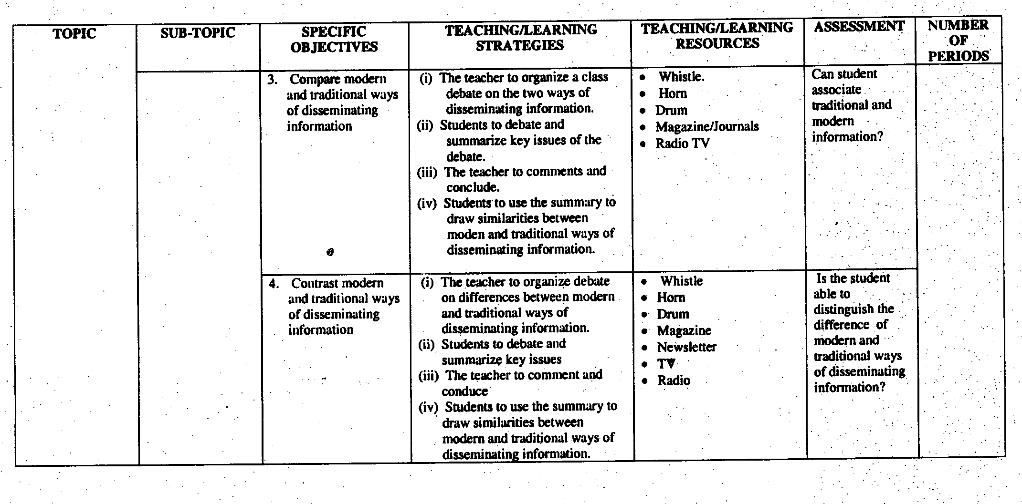
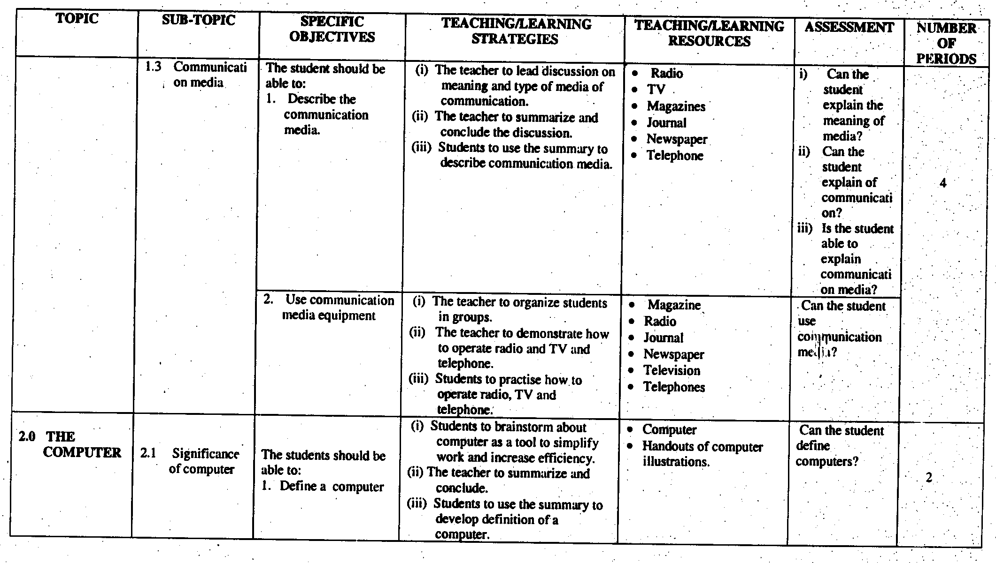
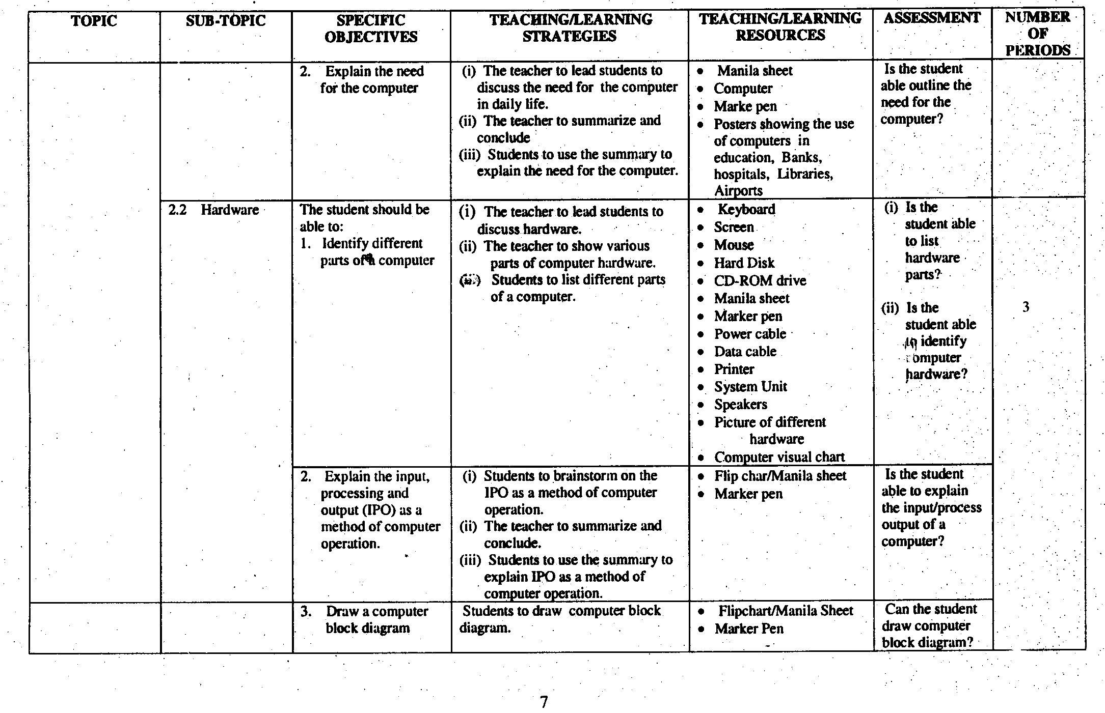
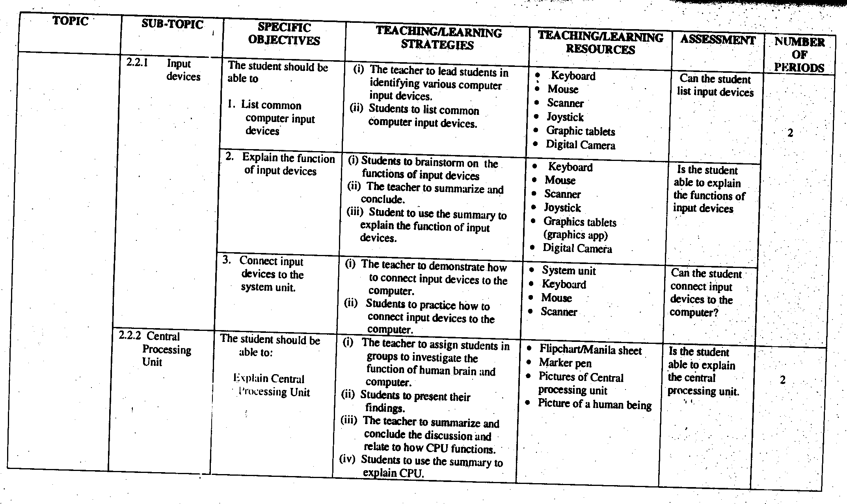
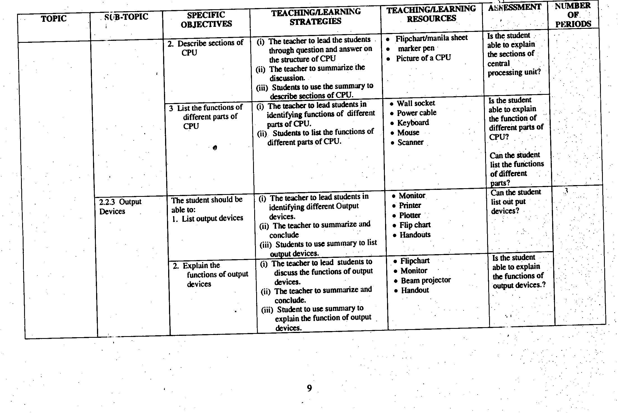
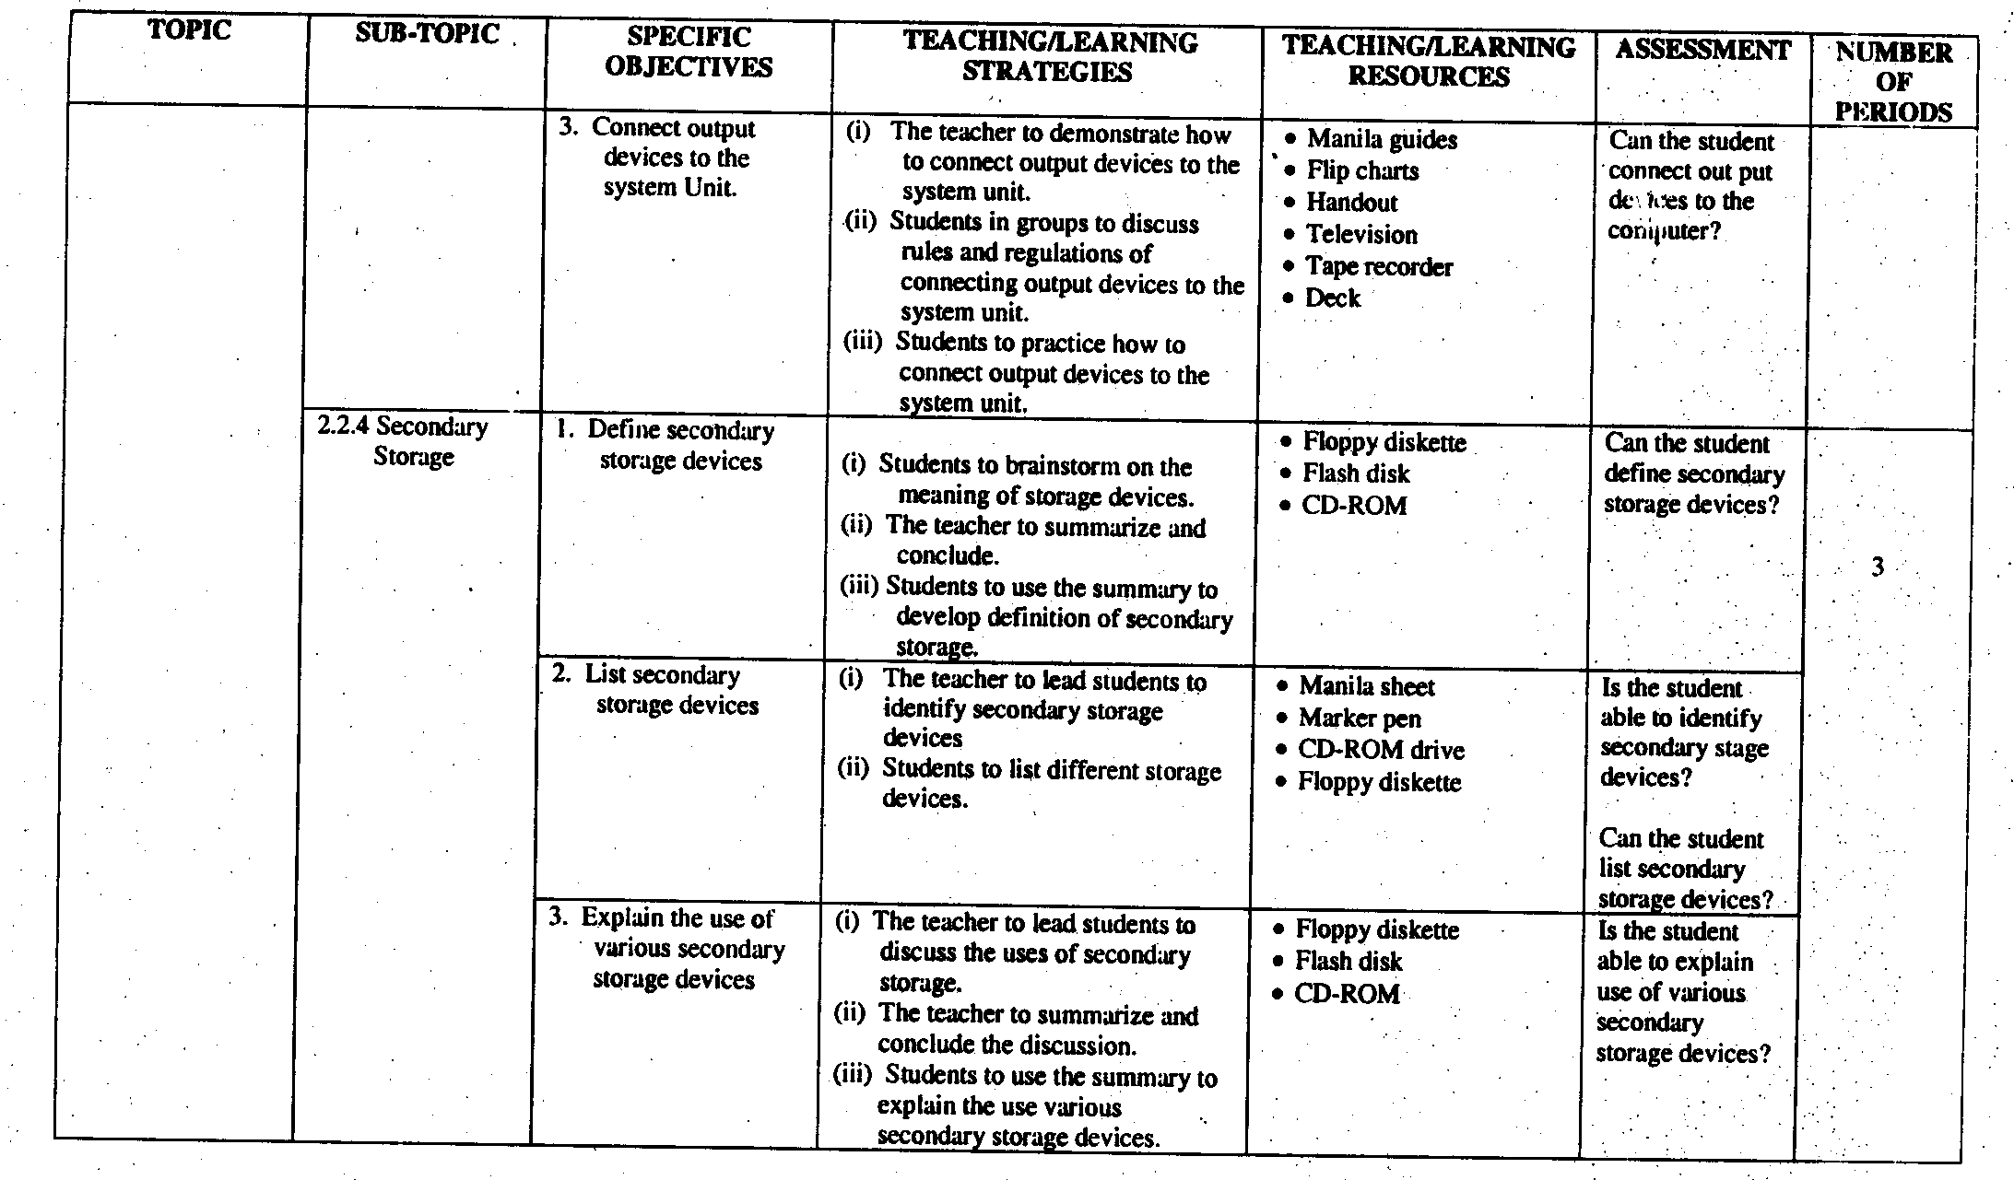
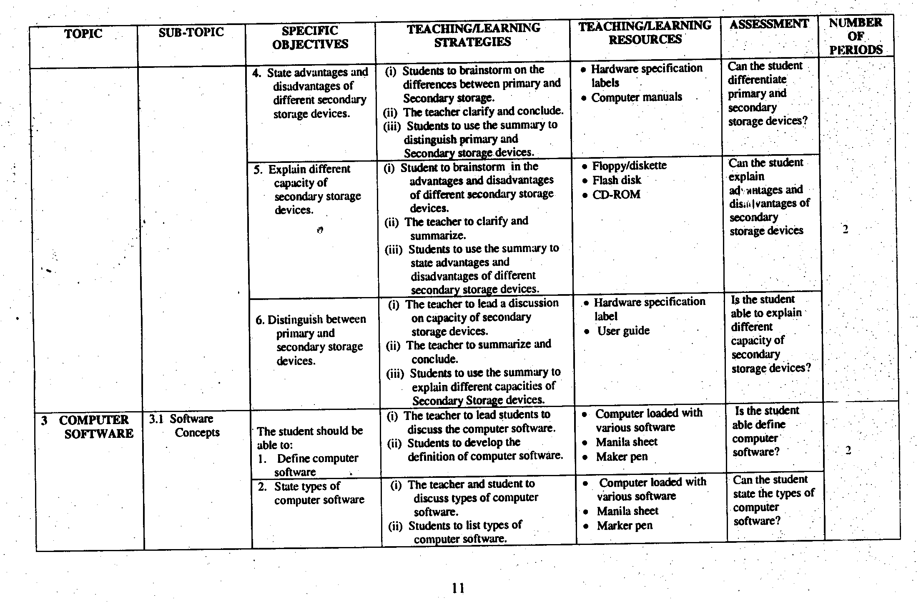
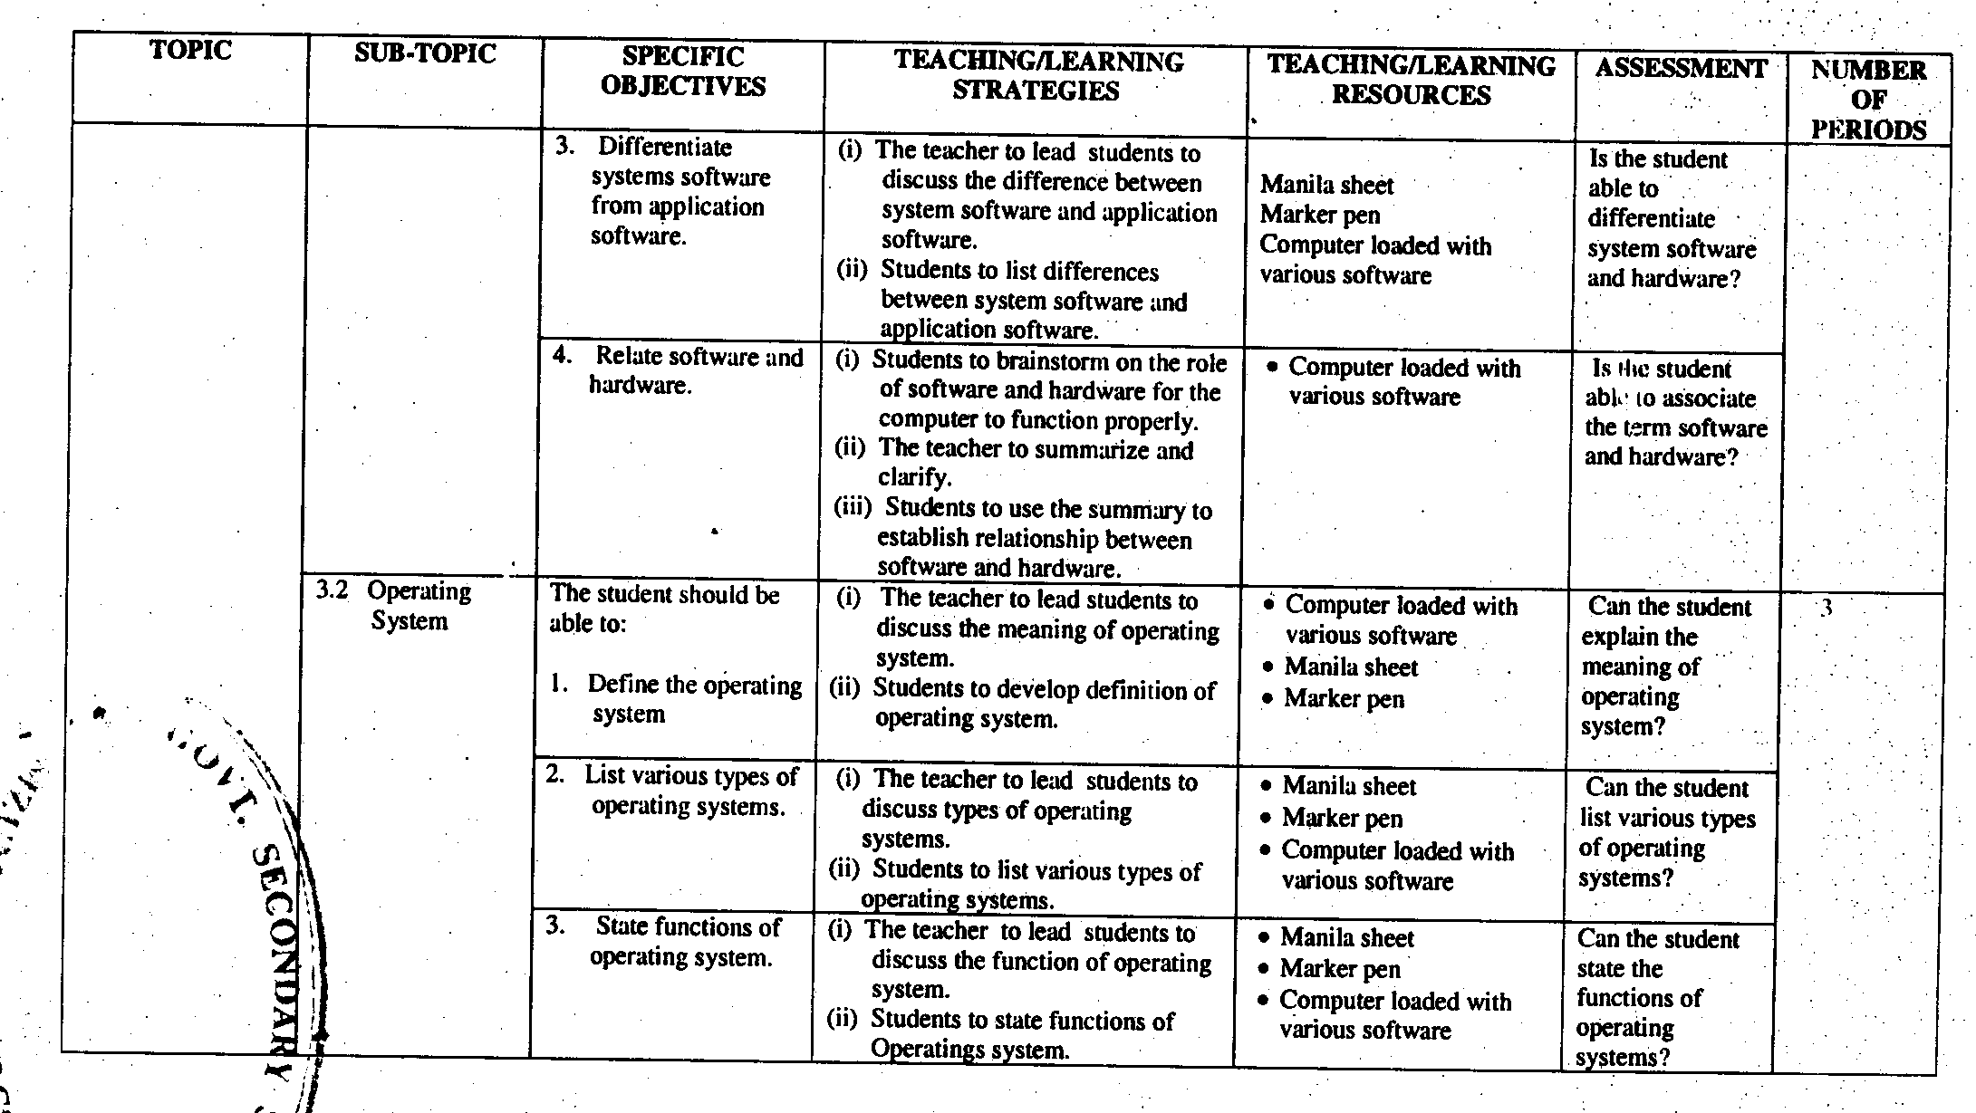
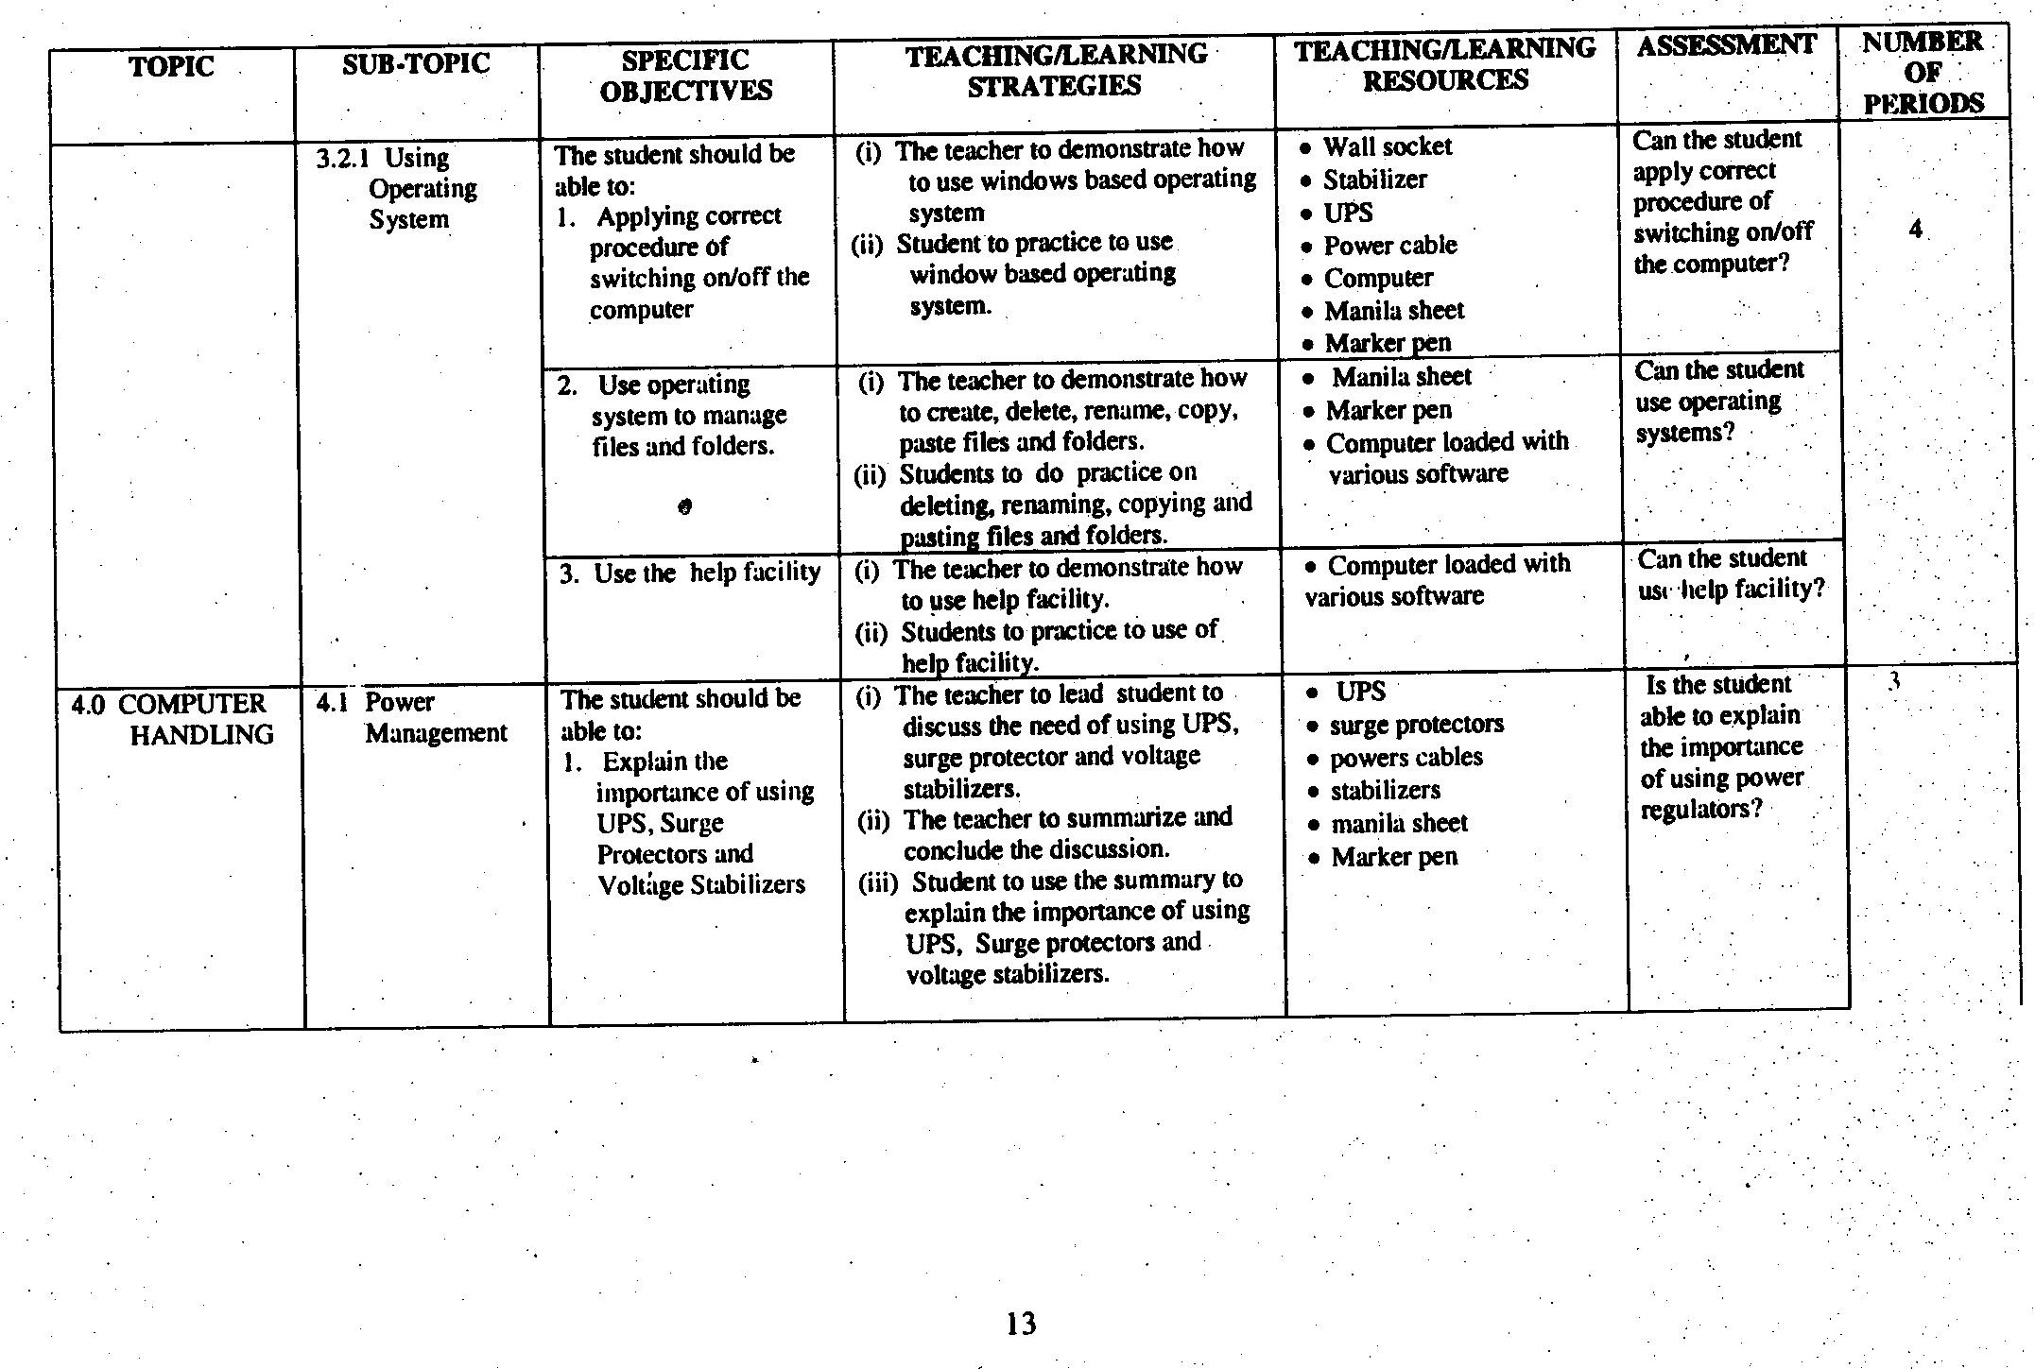
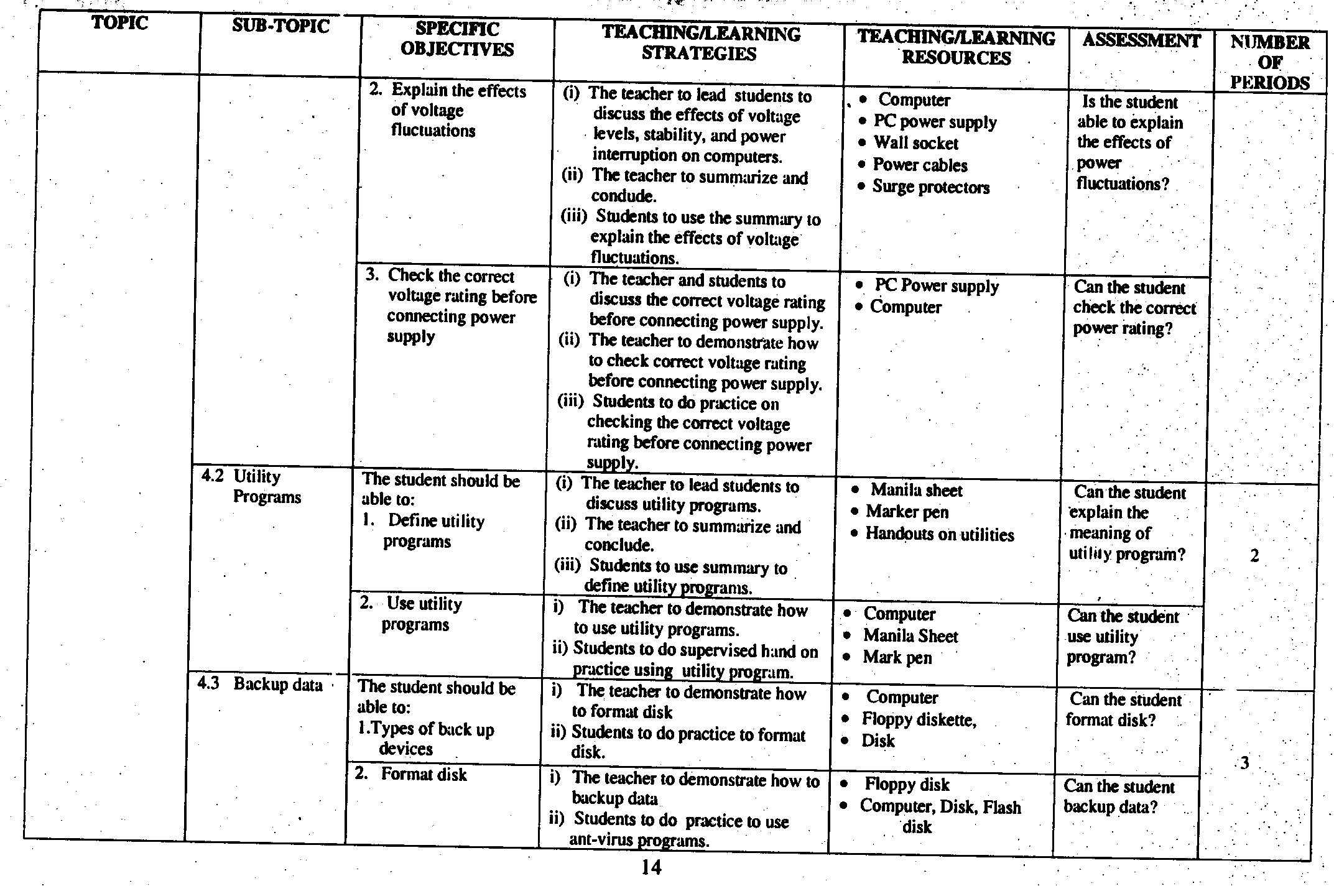
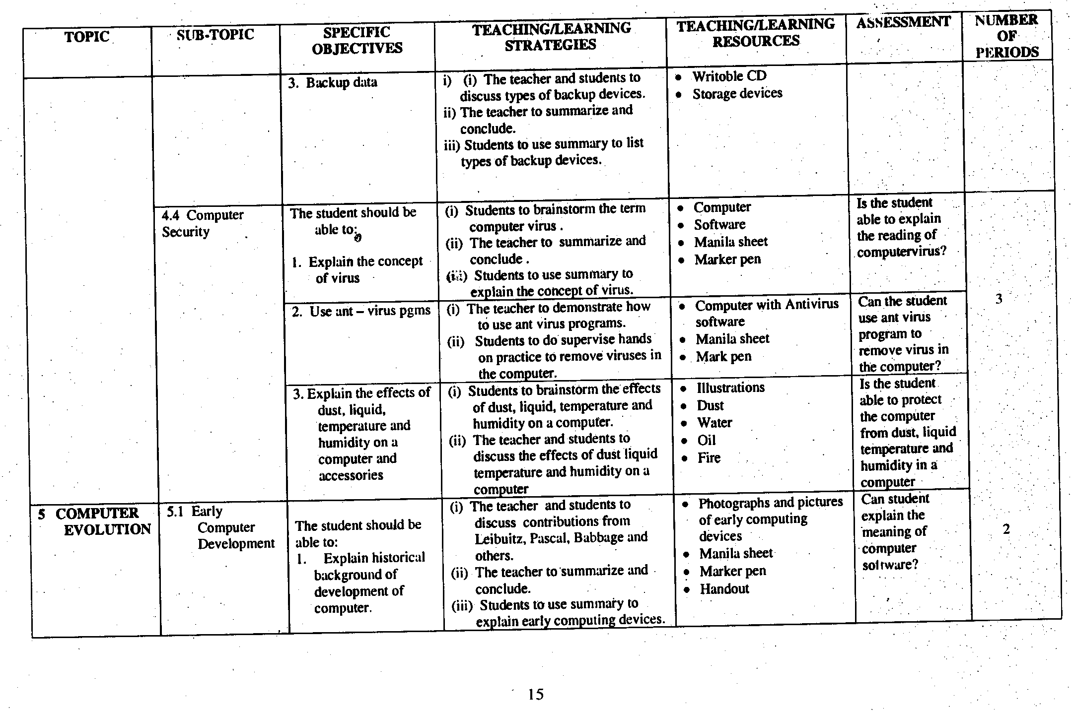
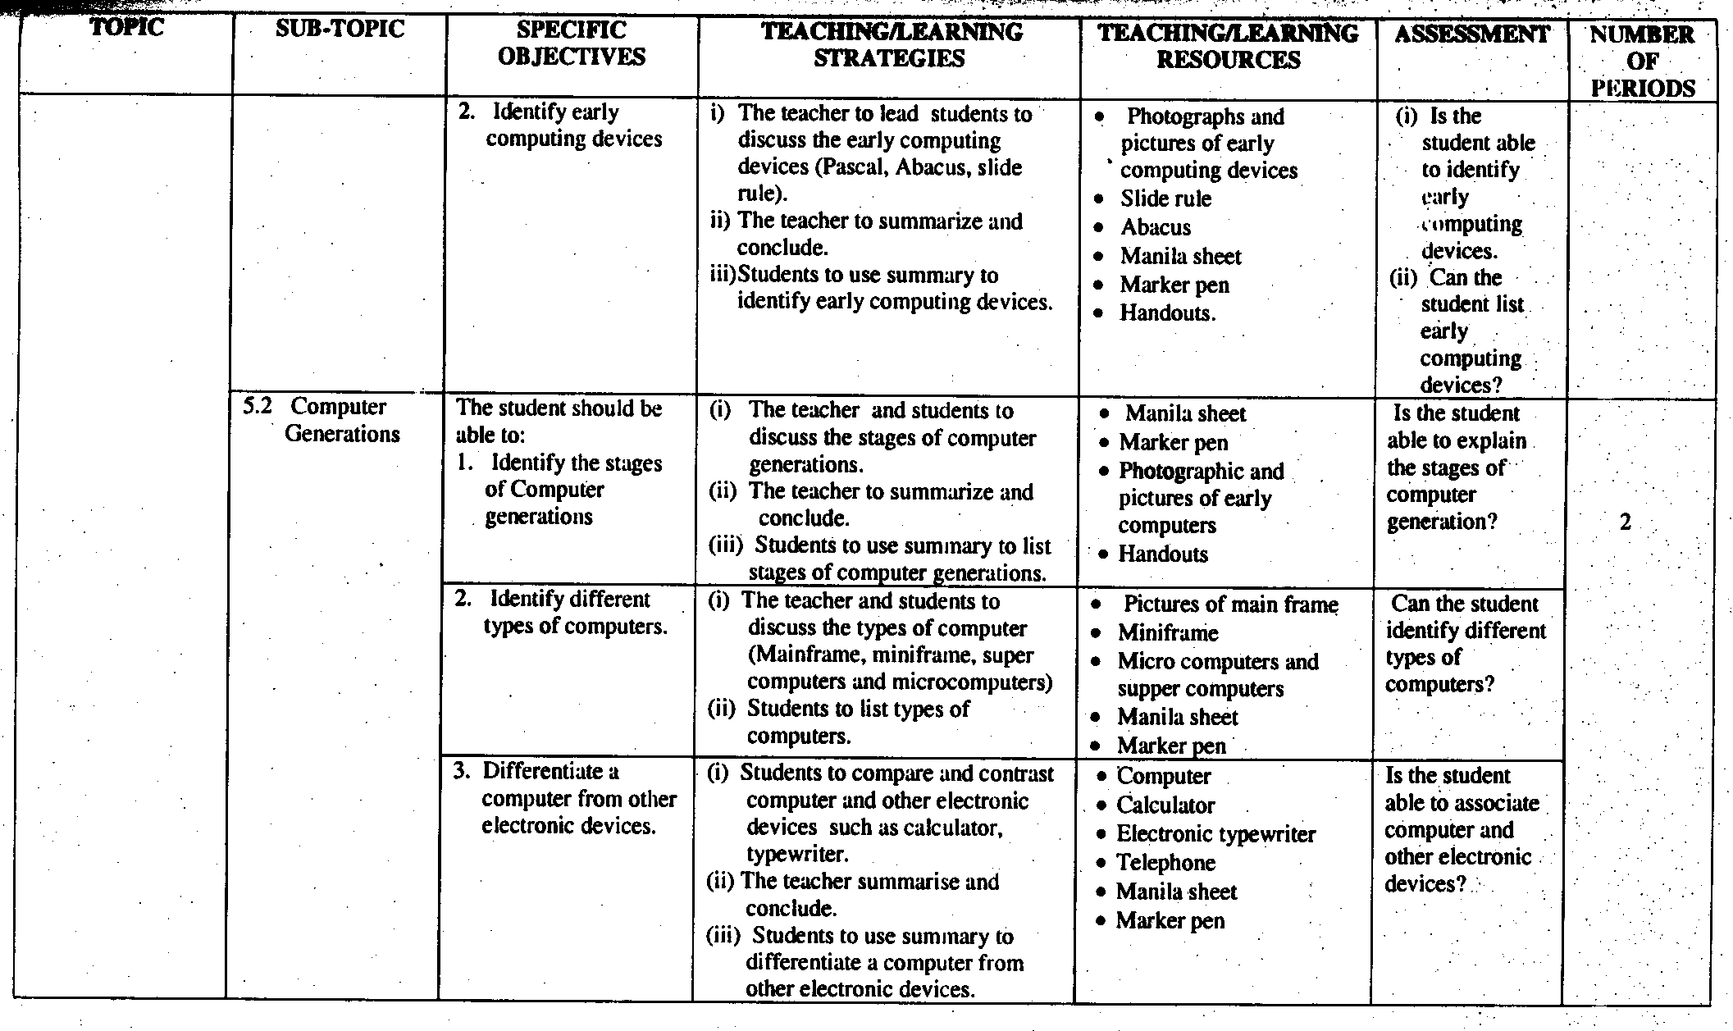

- FORM TWO
- CLASS COMPETENCES
By the end of Form Two, the student should have ability to:
1. create a word document.
2. use computer spreadsheet to process data.
3. use different types of networks to access information.
4. use Internet to access data and information.
- CLASS OBJECTIVES
By the end of Form Two course, the student should be able to:
1. apply word processing skills for data and information processing.
2. analyse data and information using spreadsheet
3. apply knowledge of computer networks to access information.
4. develop skills of using internet and its application

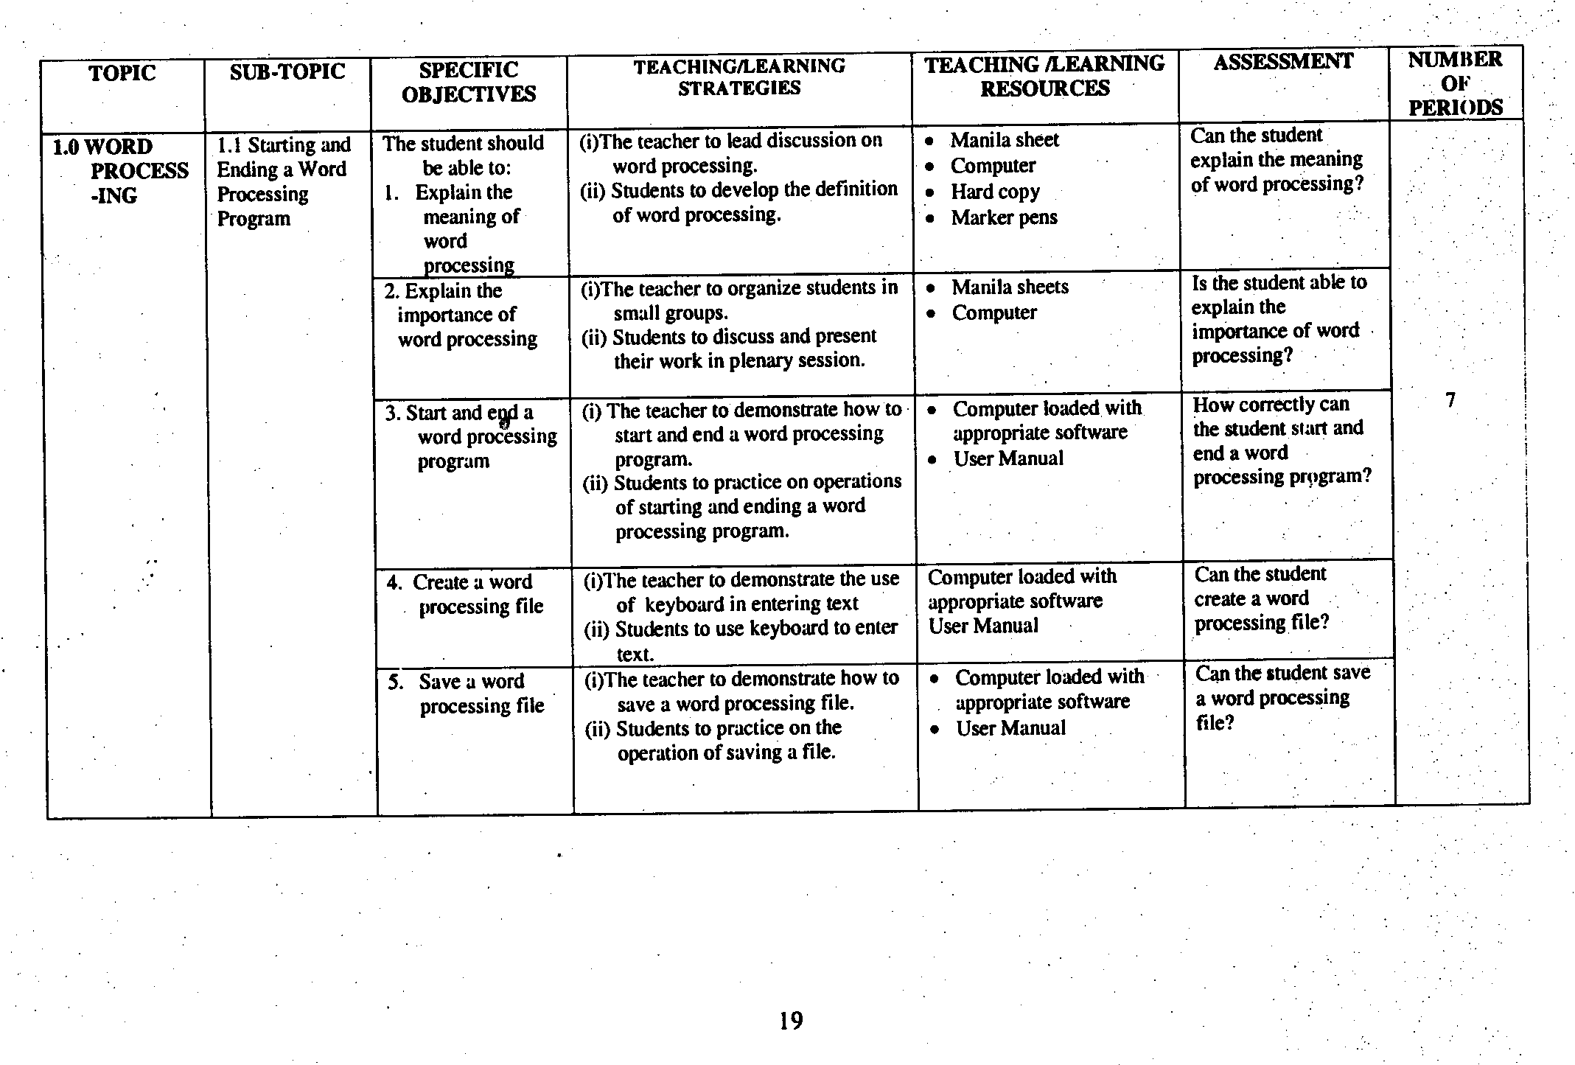
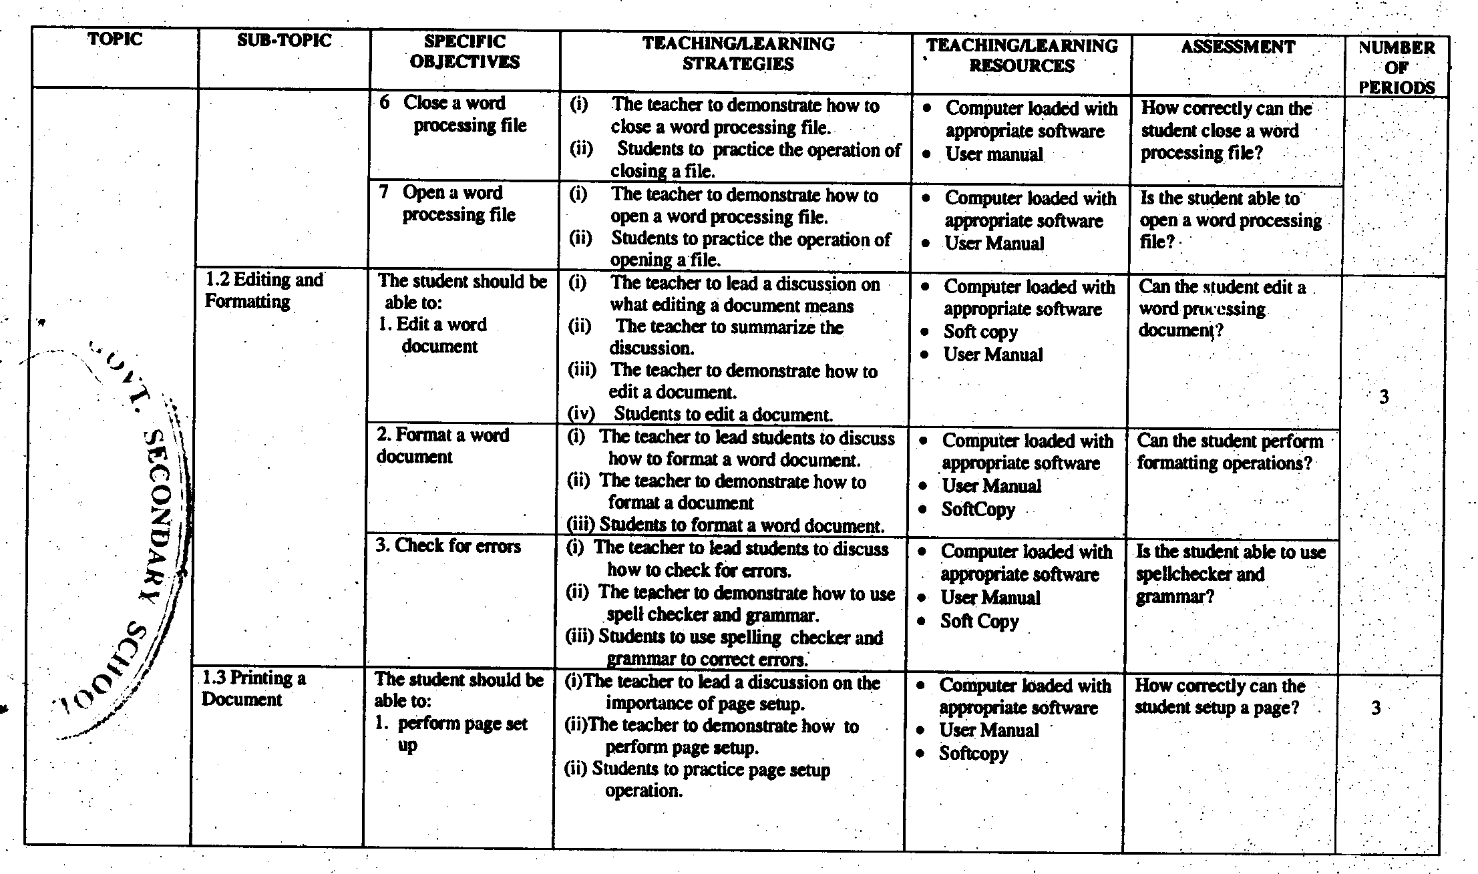
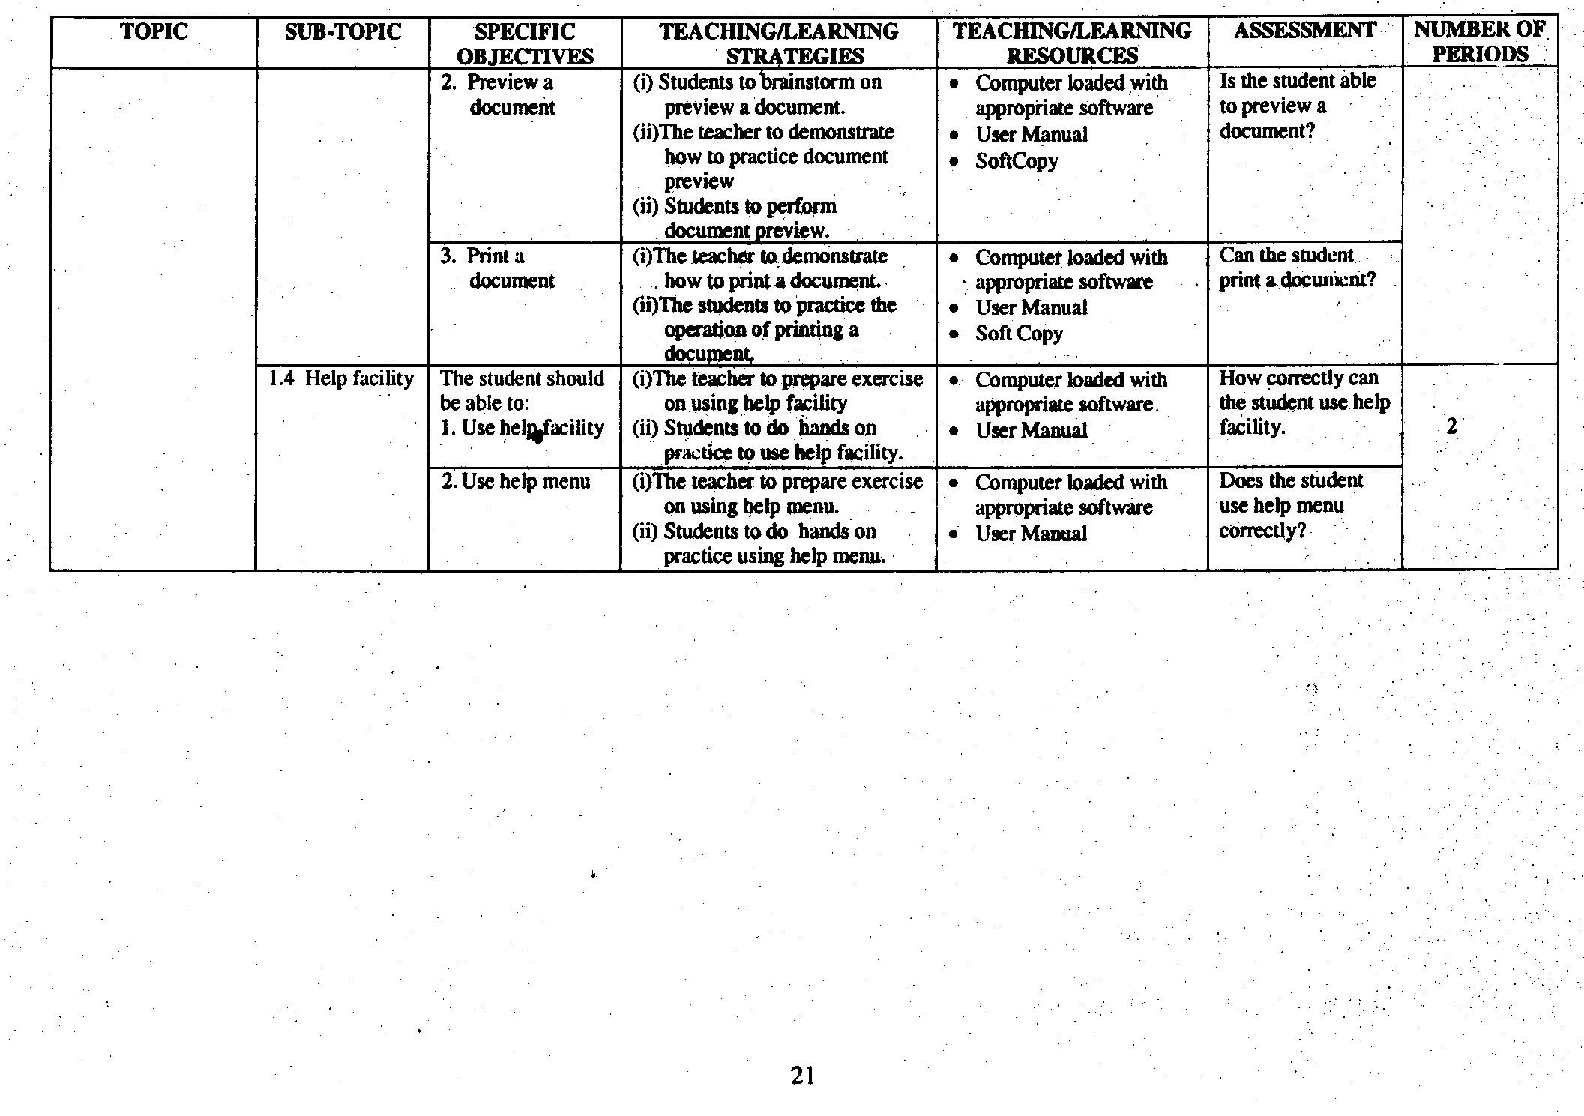
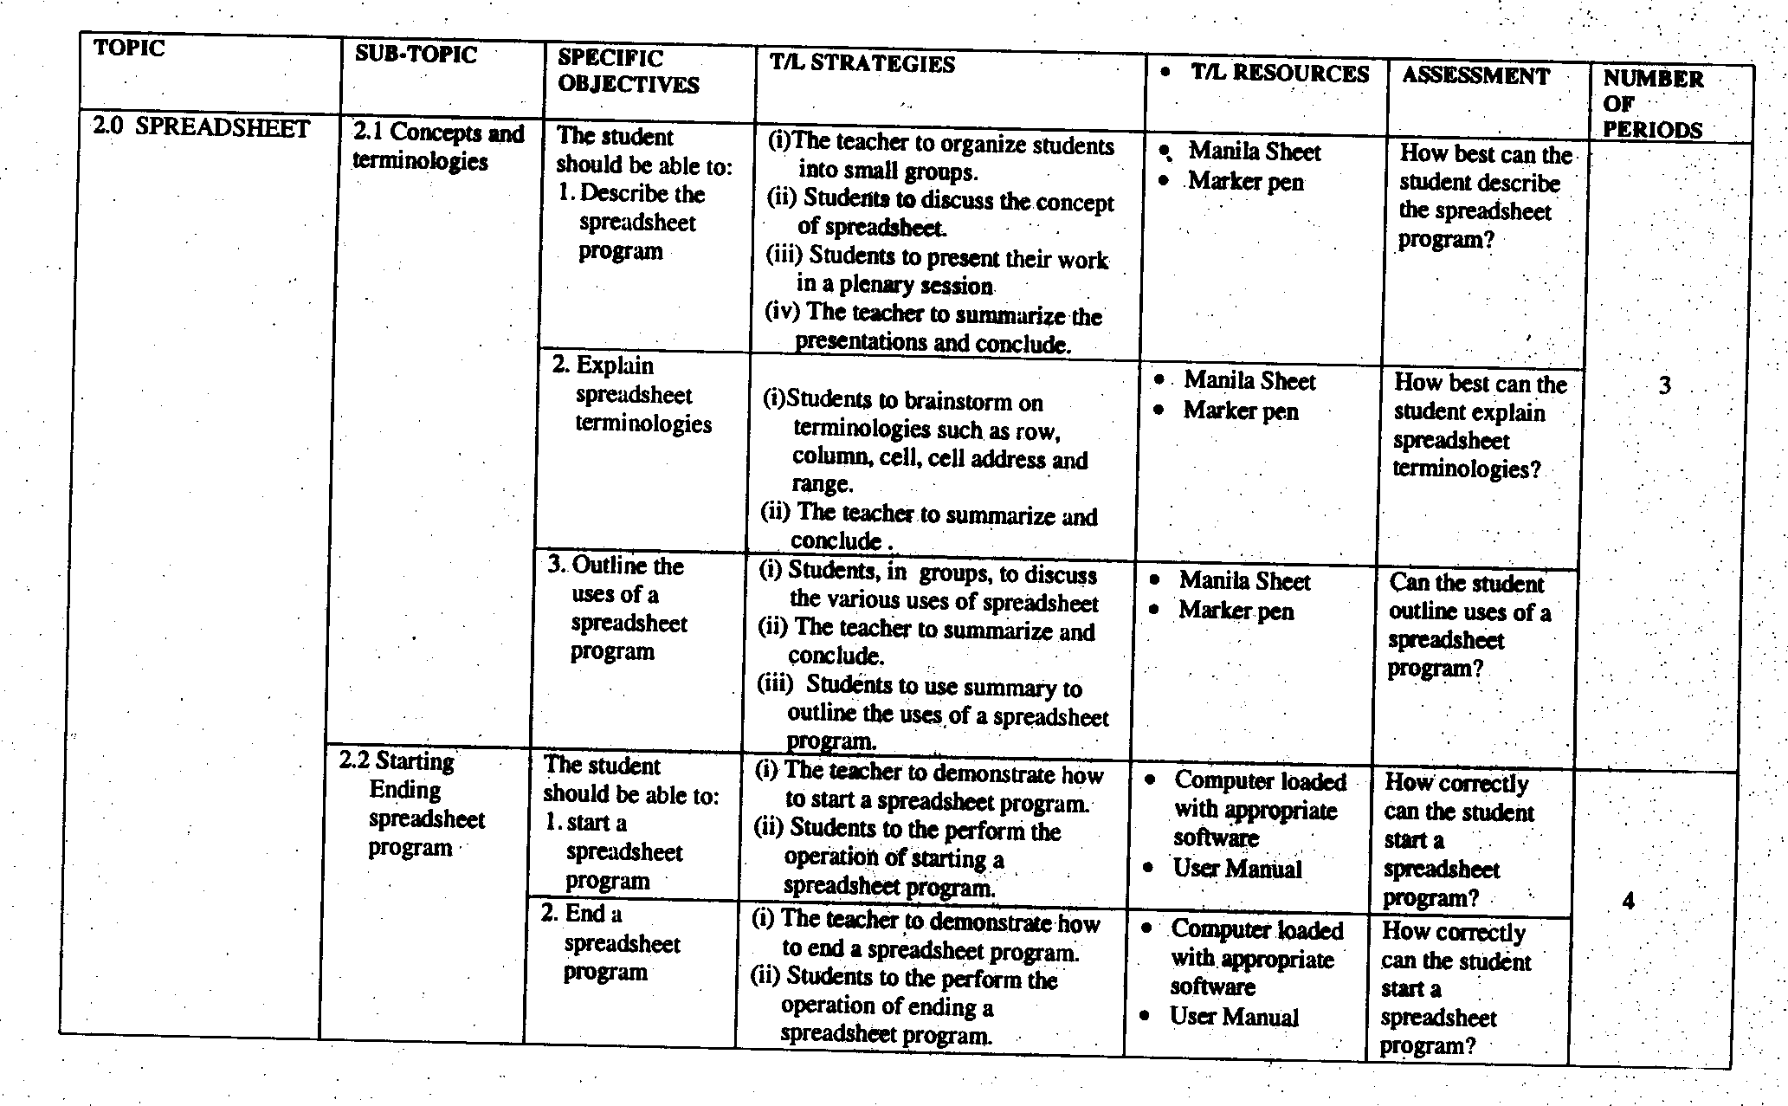
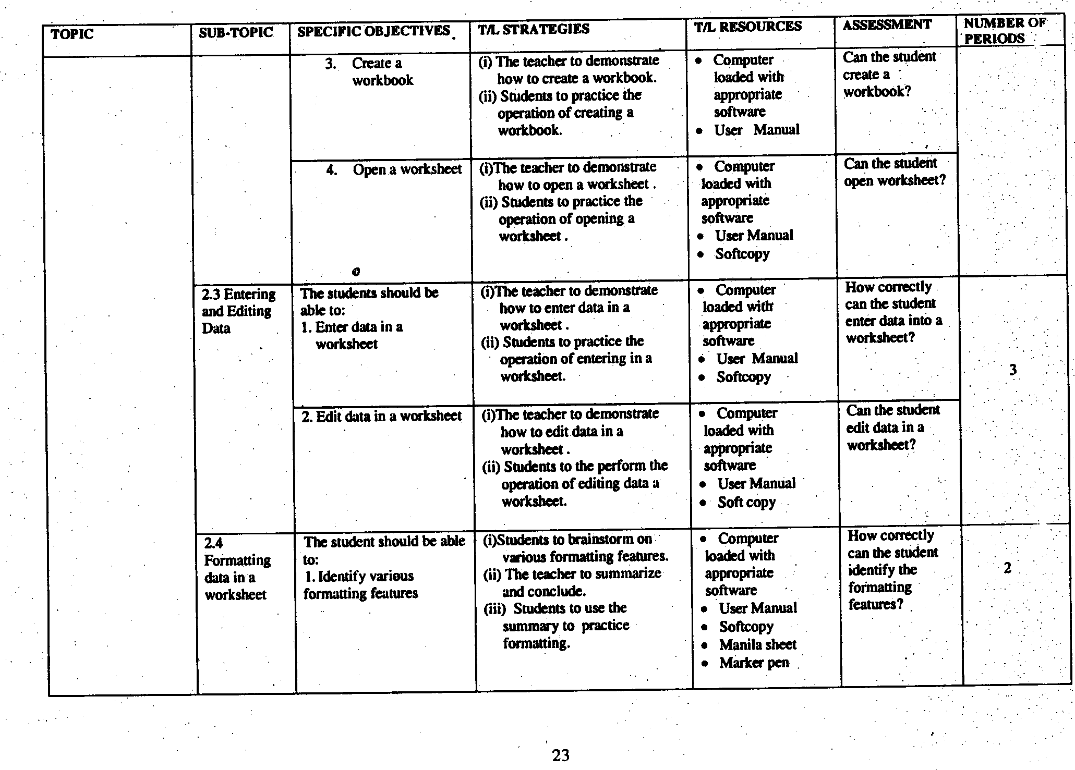
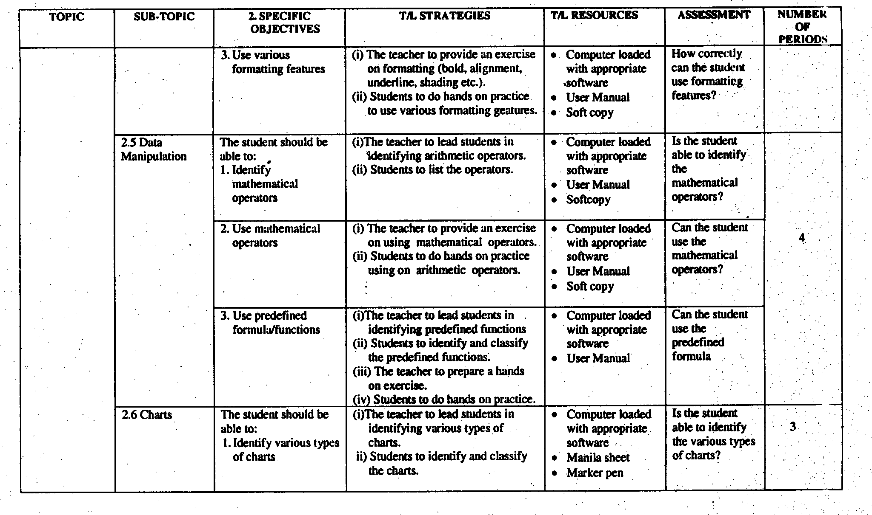
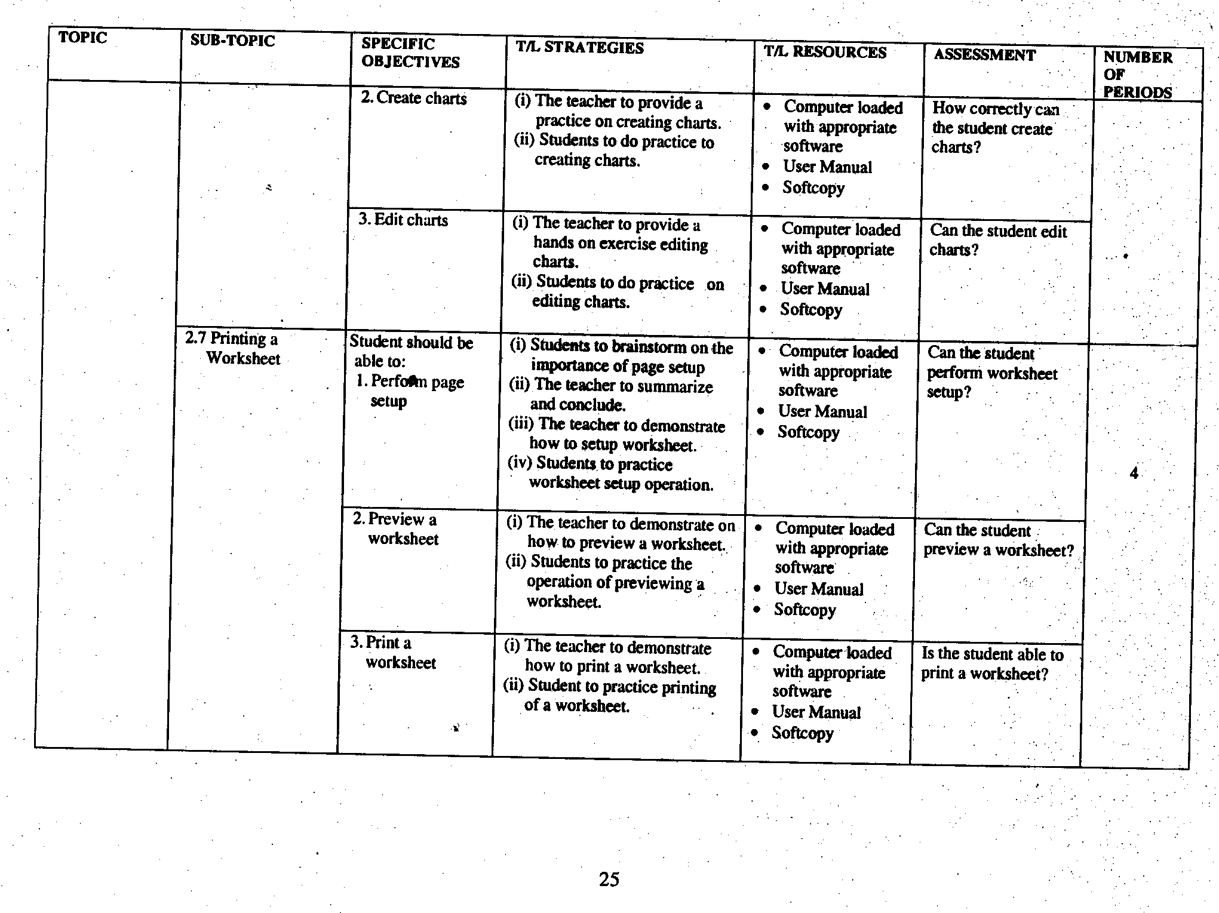
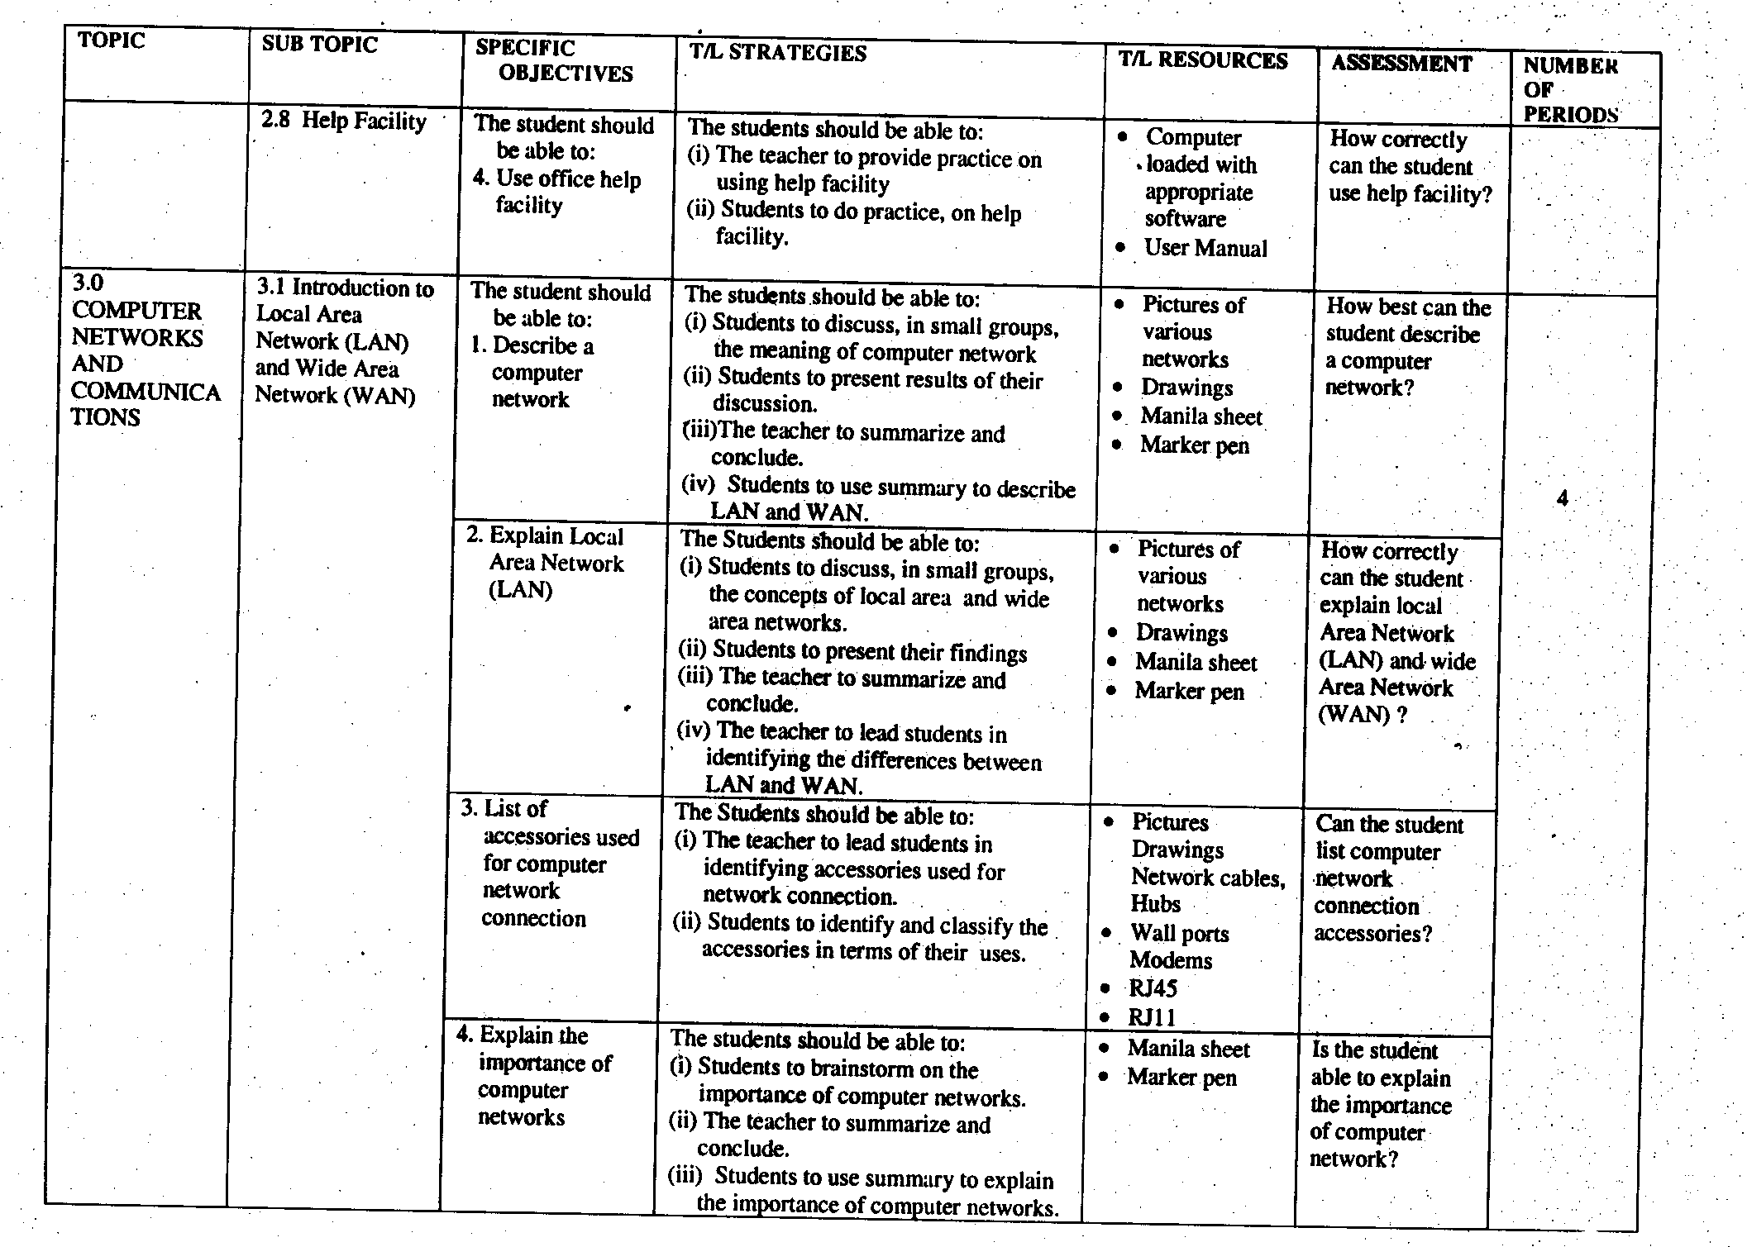
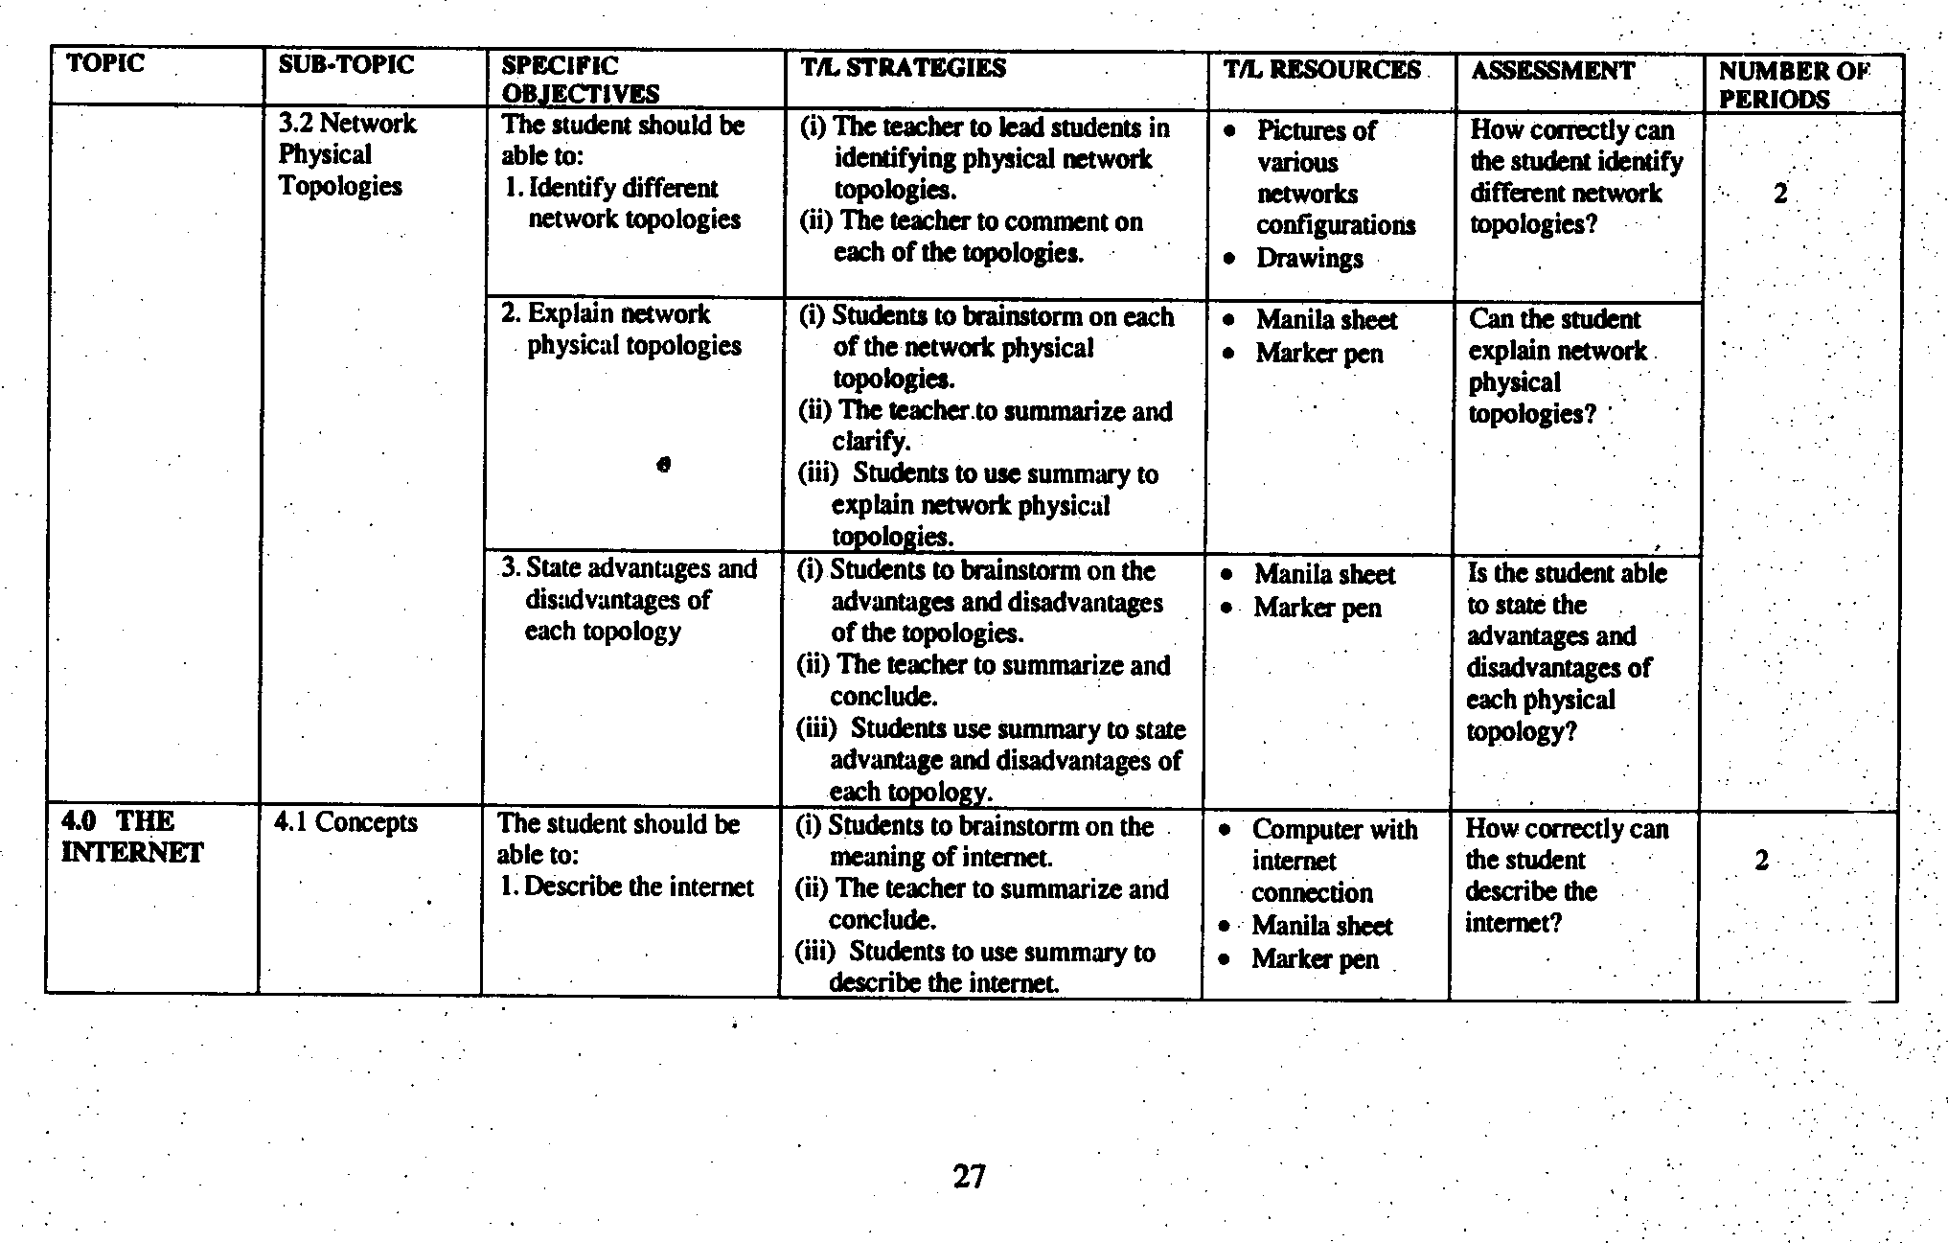
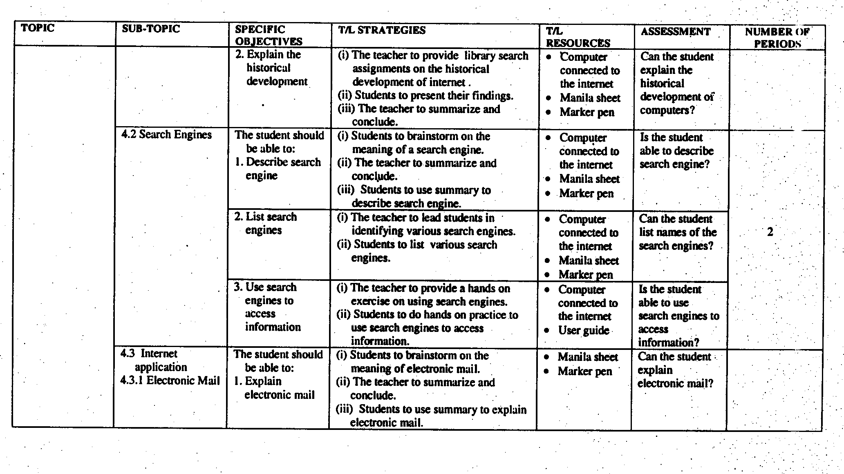
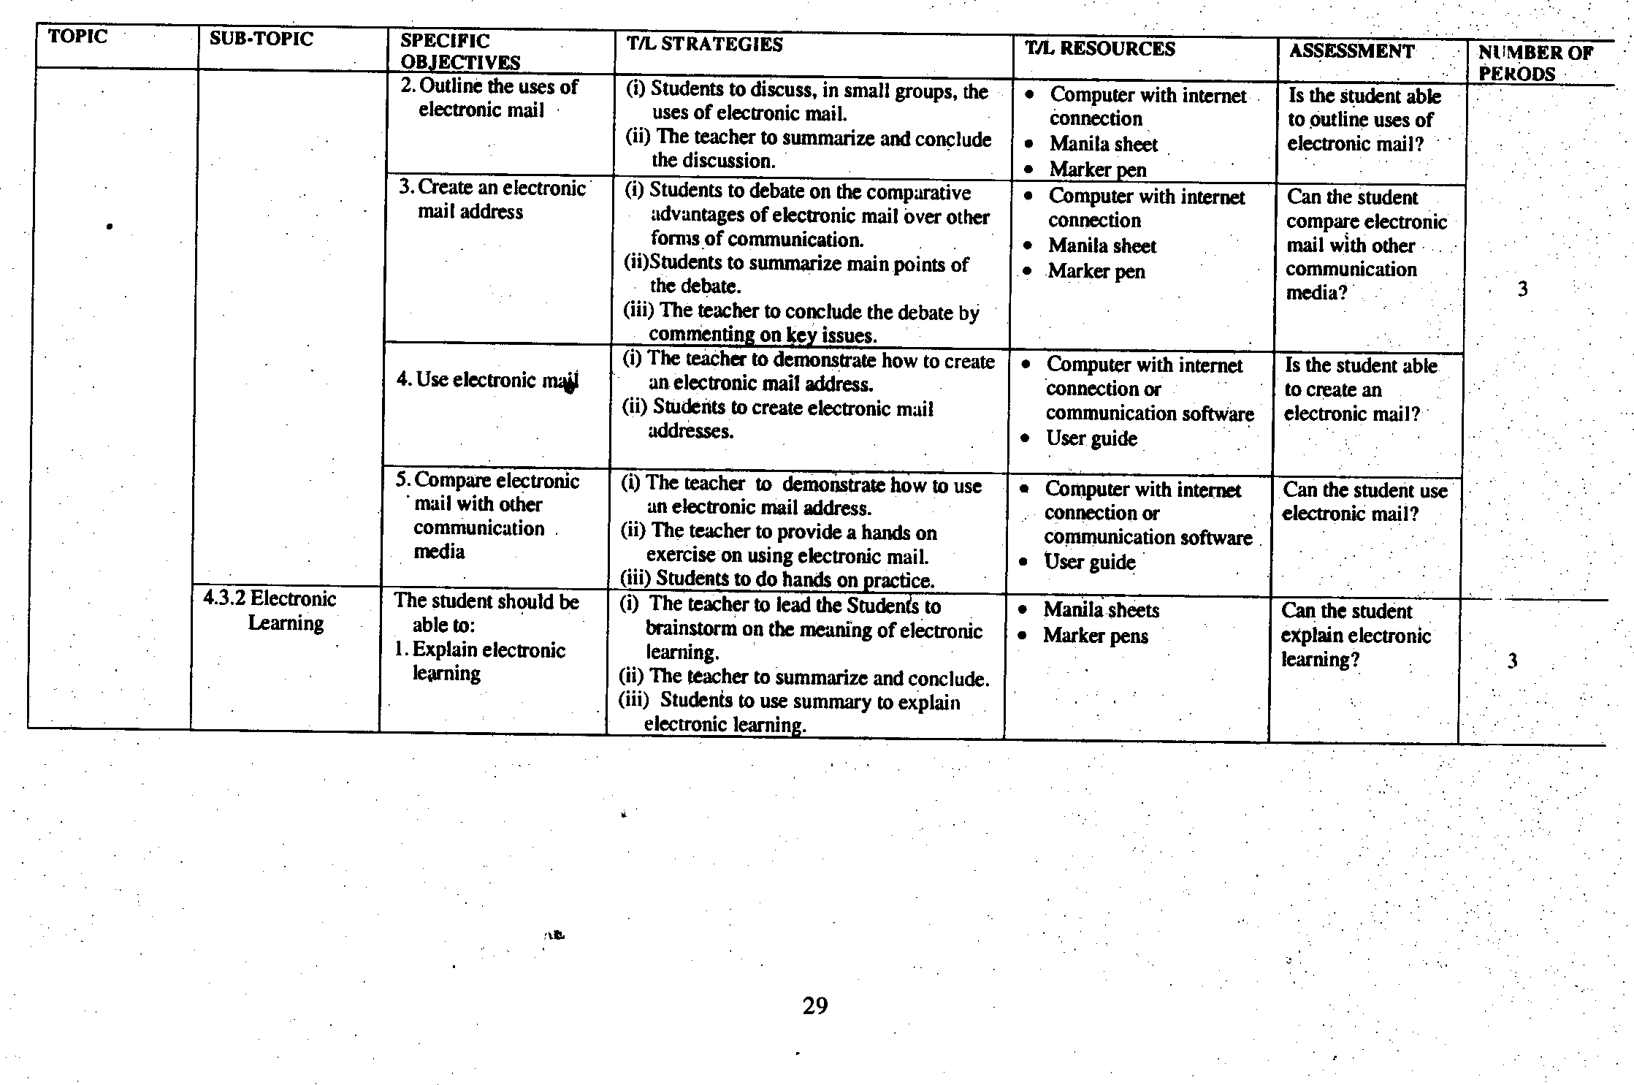
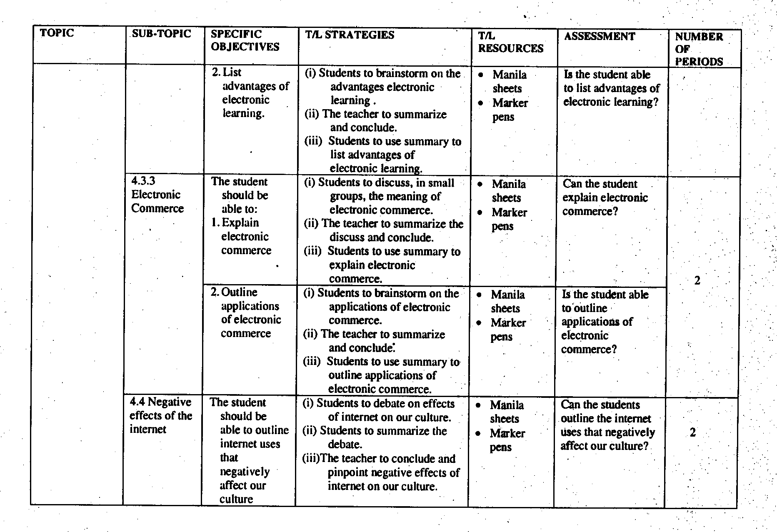

- FORM THREE
- CLASS COMPETENCES
By the end of Form Three, the student should have ability to:
1. user computers in daily life appropriately.
2. investigate the role of Information Technology in bringing about changes in organization and society.
3. create and use websites to access and process information.
4. create and use databases to organize, store and retrieve information.
- CLASS OBJECTIVES
By the end of Form Three course, the student should be able to:
1. analyse the importance of computers in the society.
2. explain the impact of Information and Communication Technology (ICT) on the society.
3. demonstrate skills of developing website.
4. develop skills of using database for organizing information.

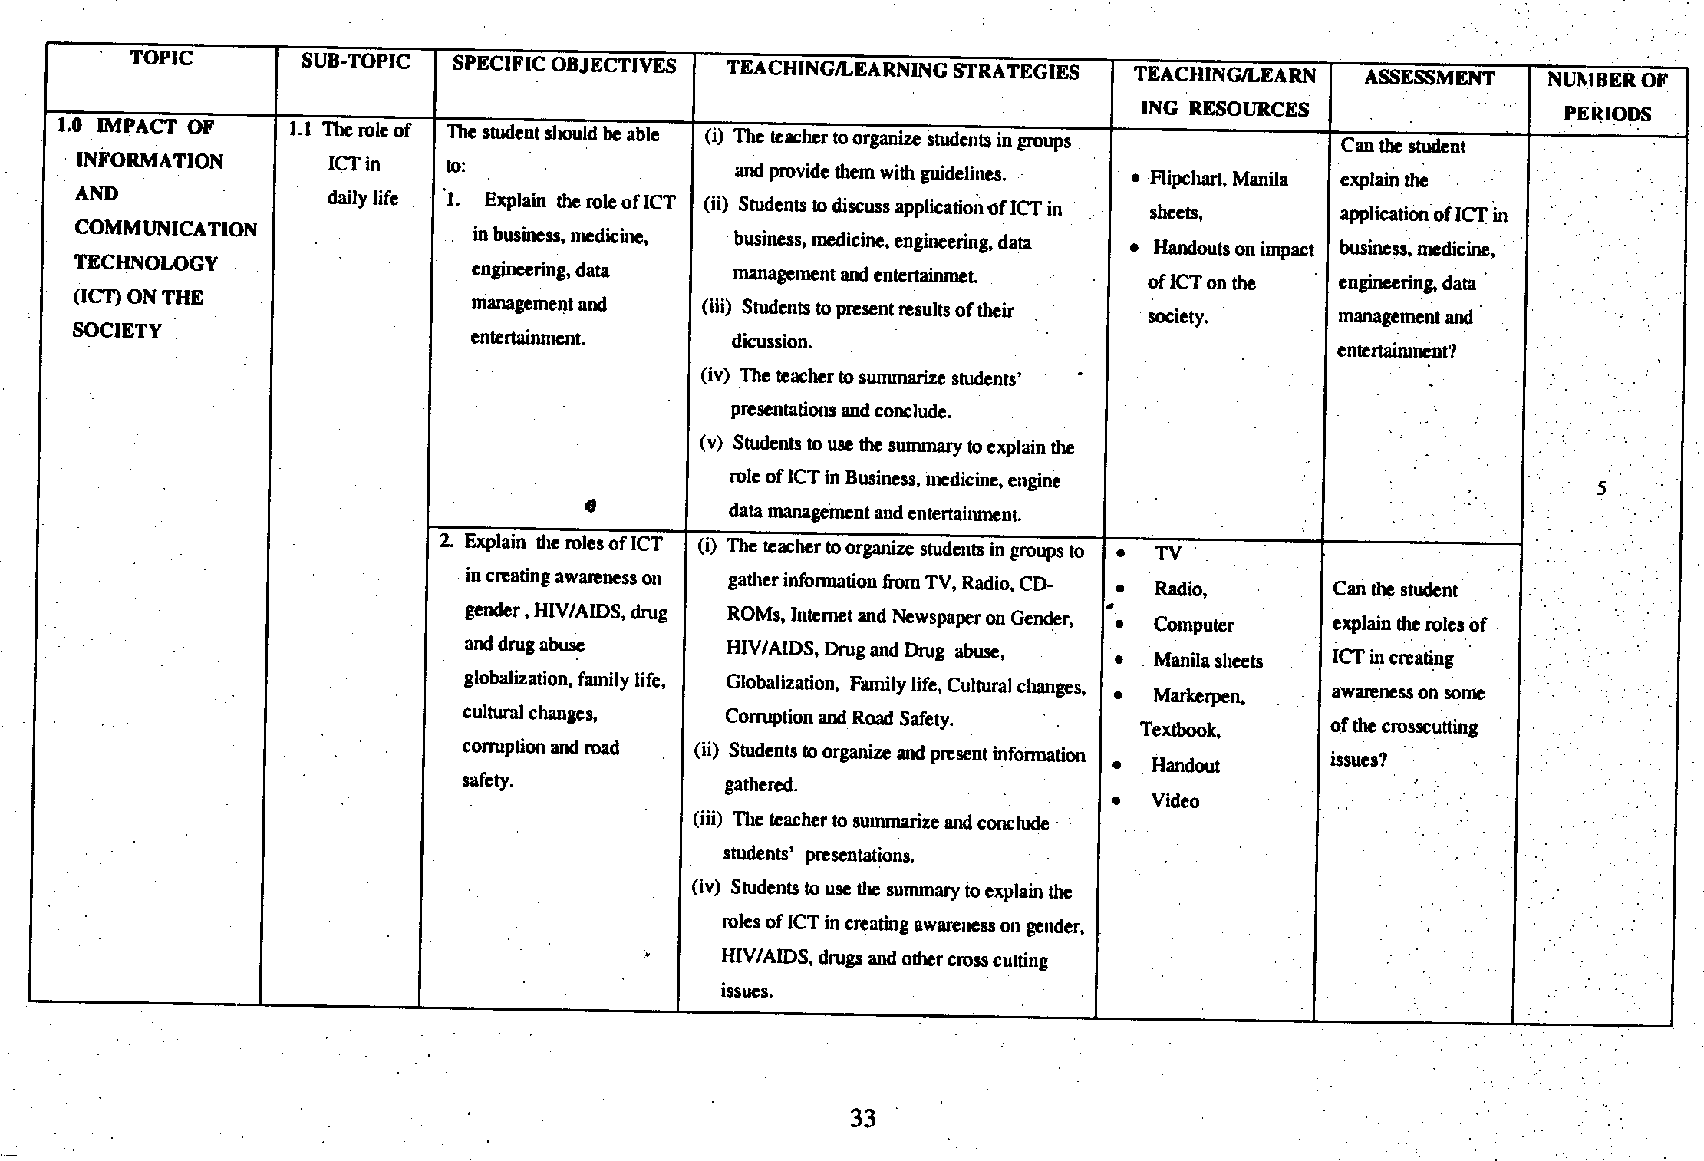
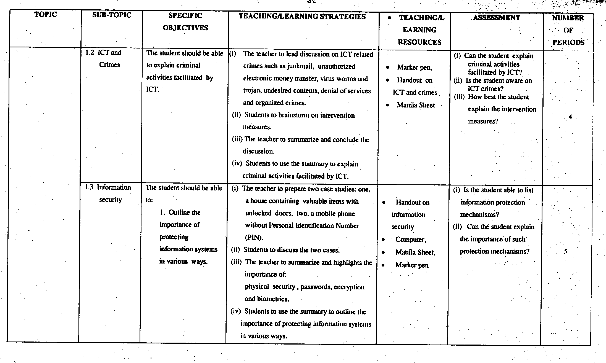
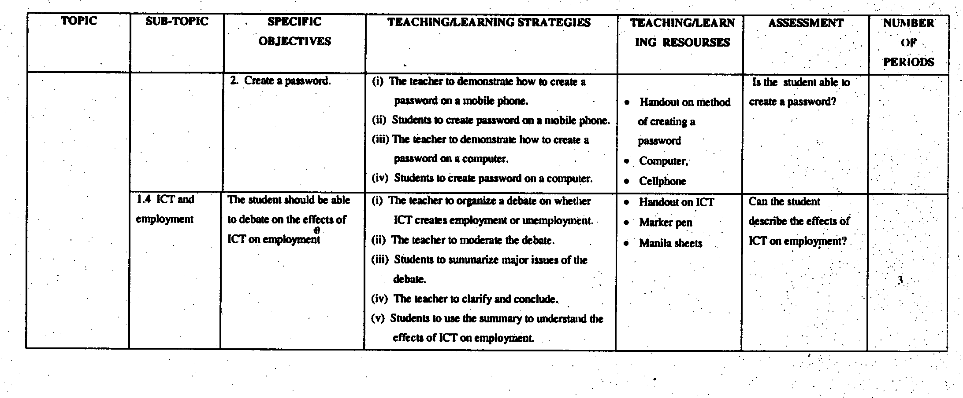
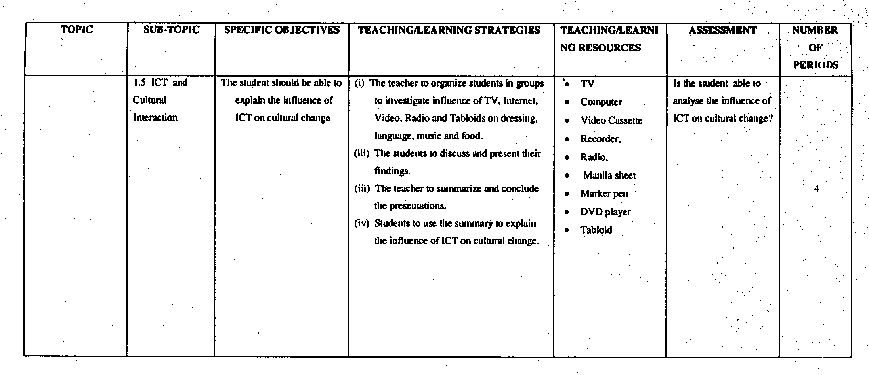
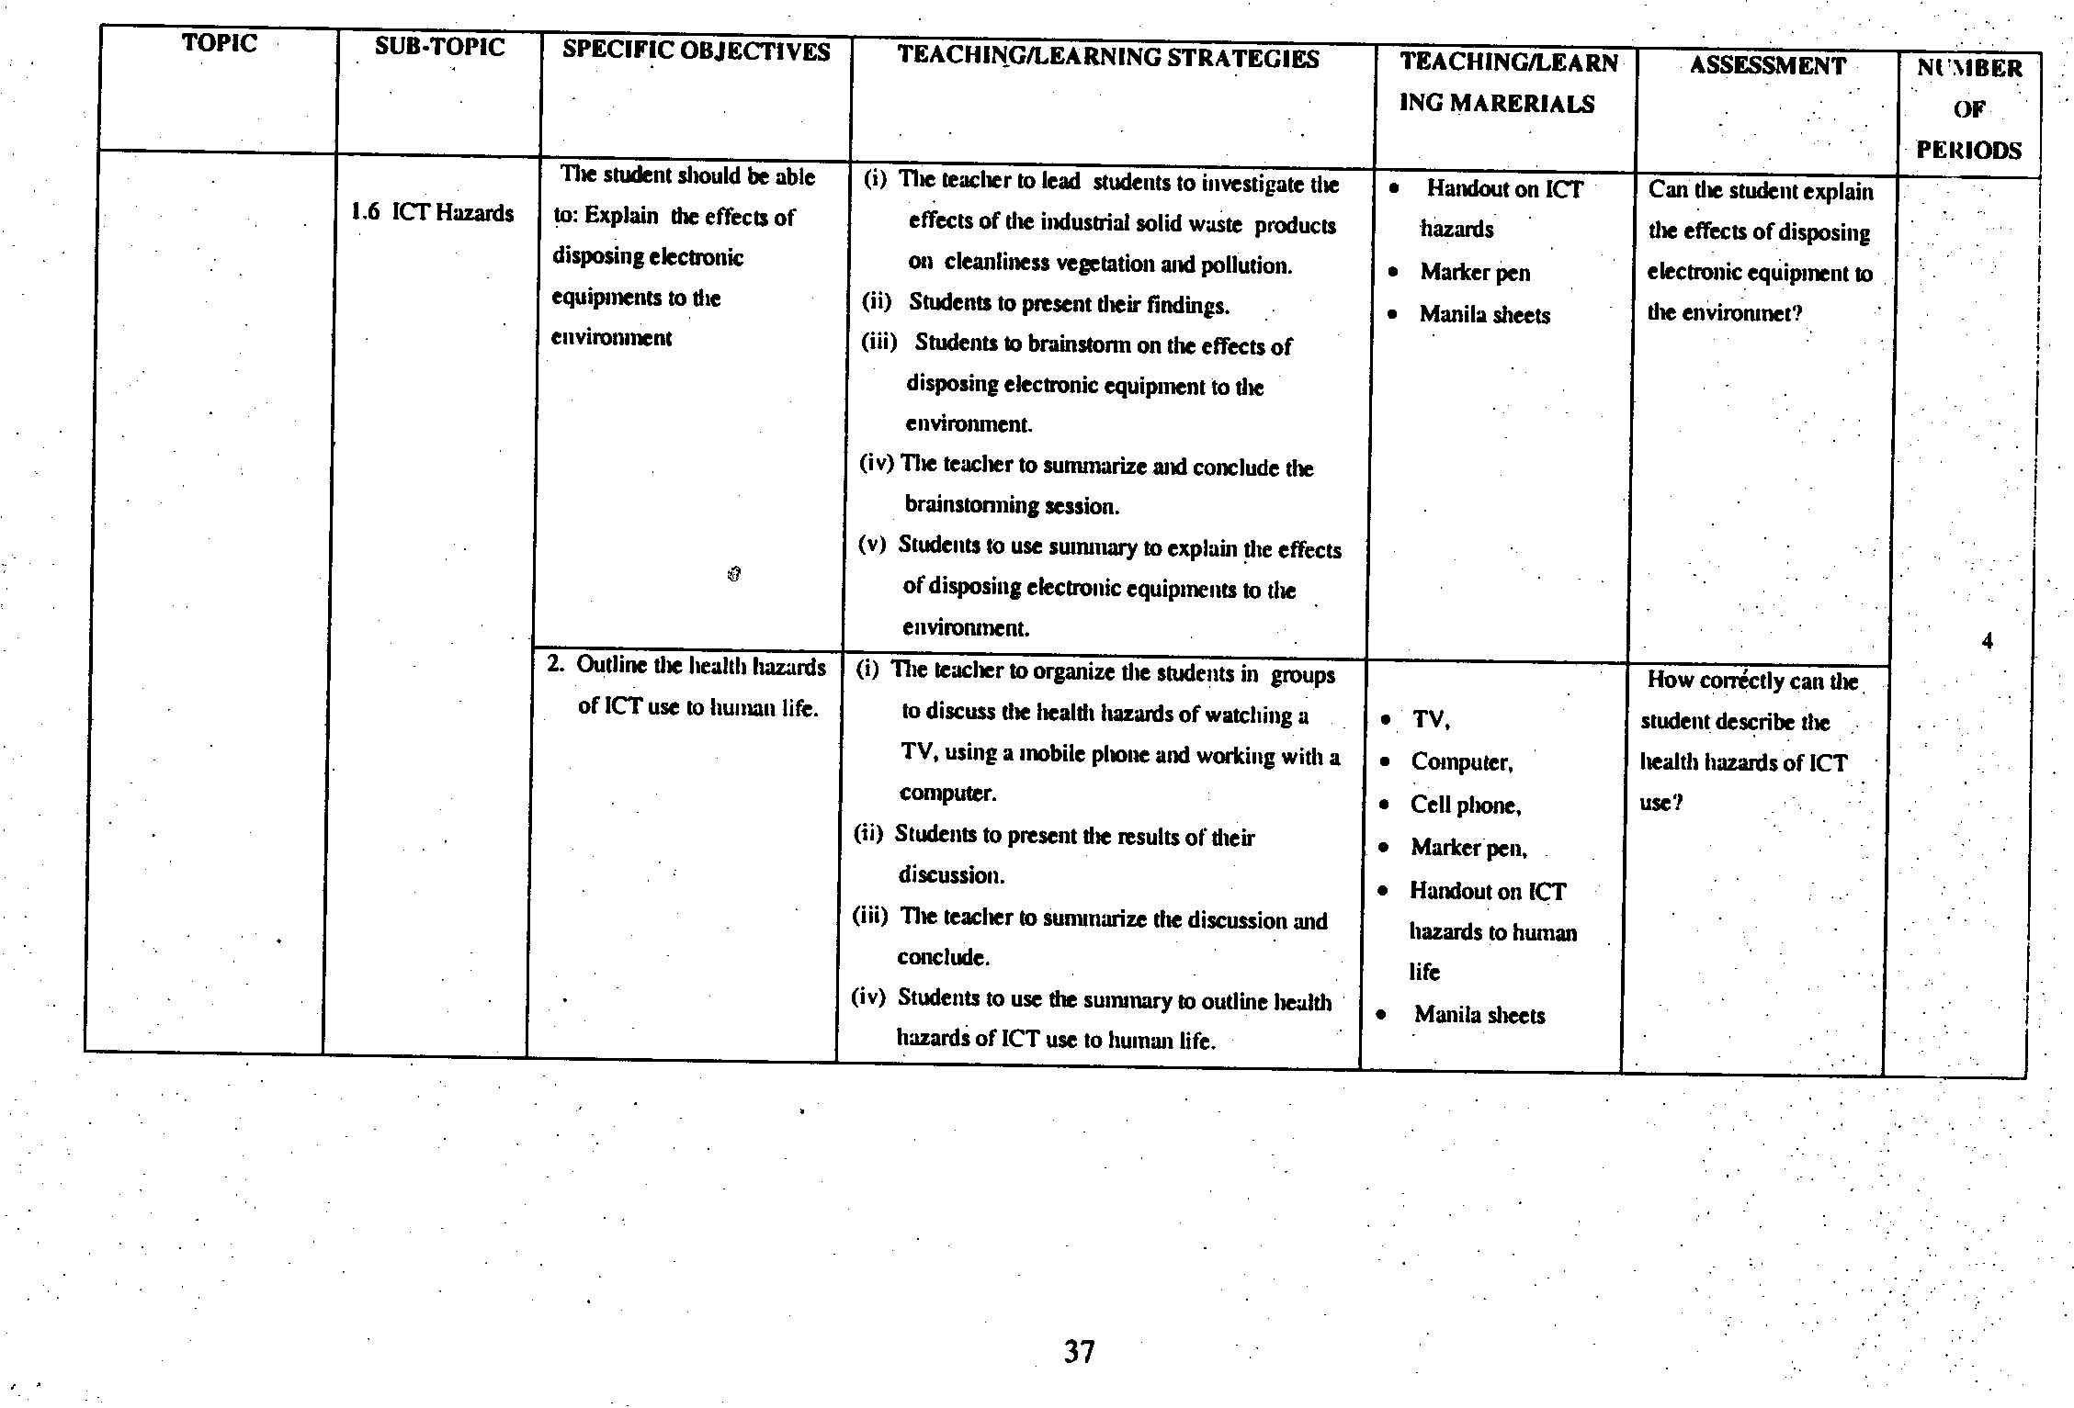
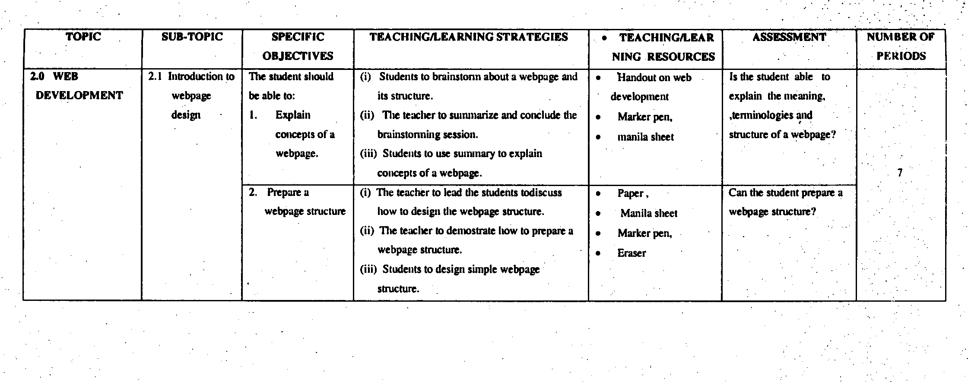
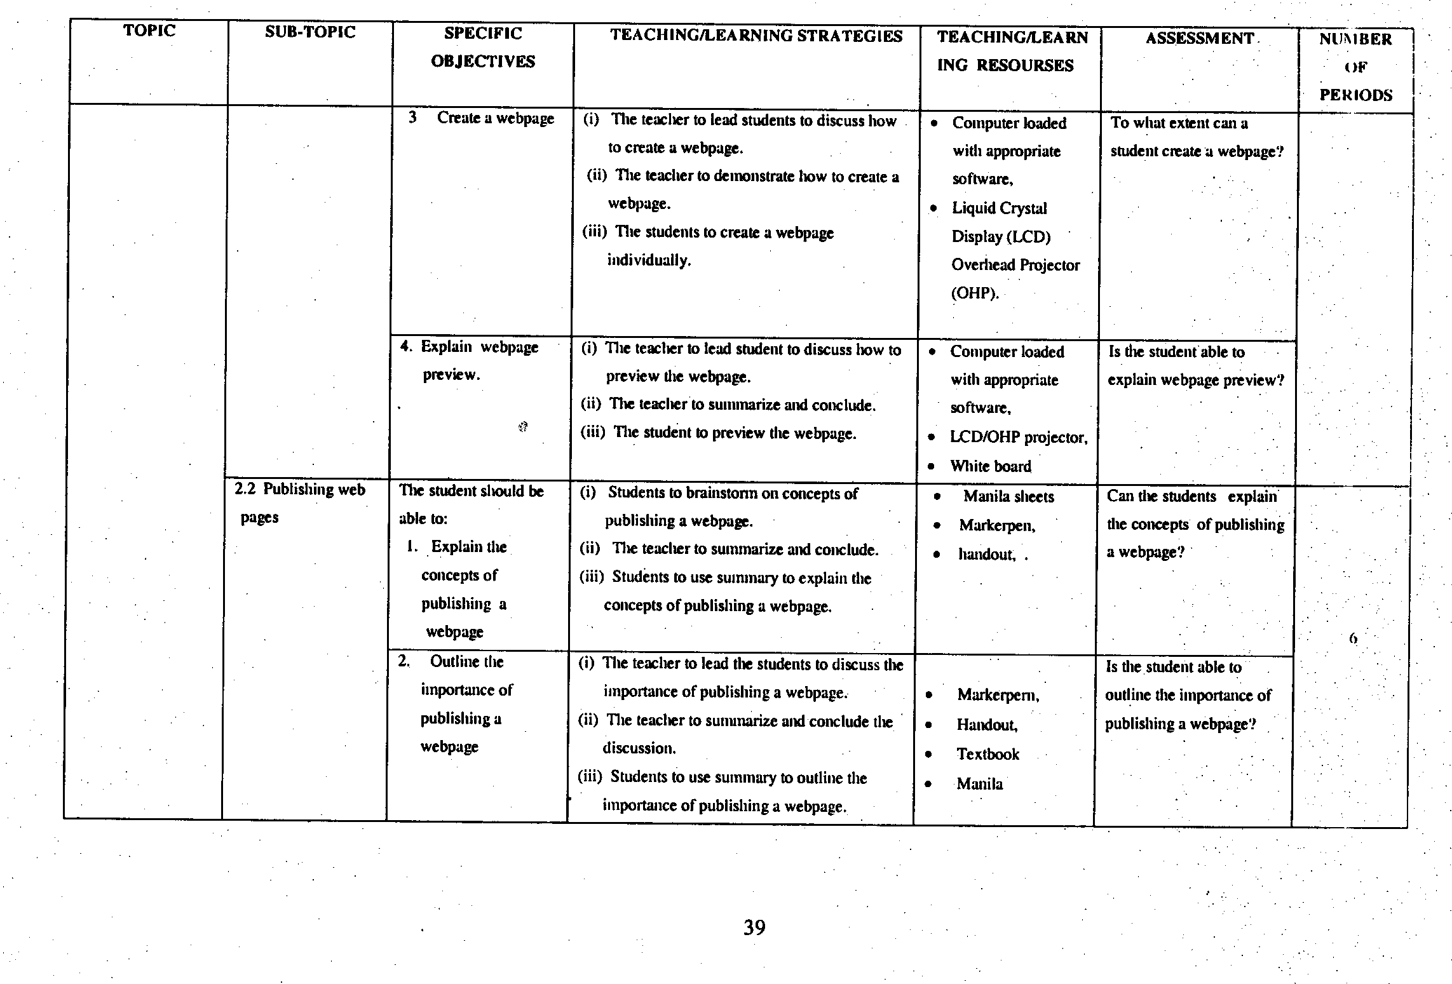
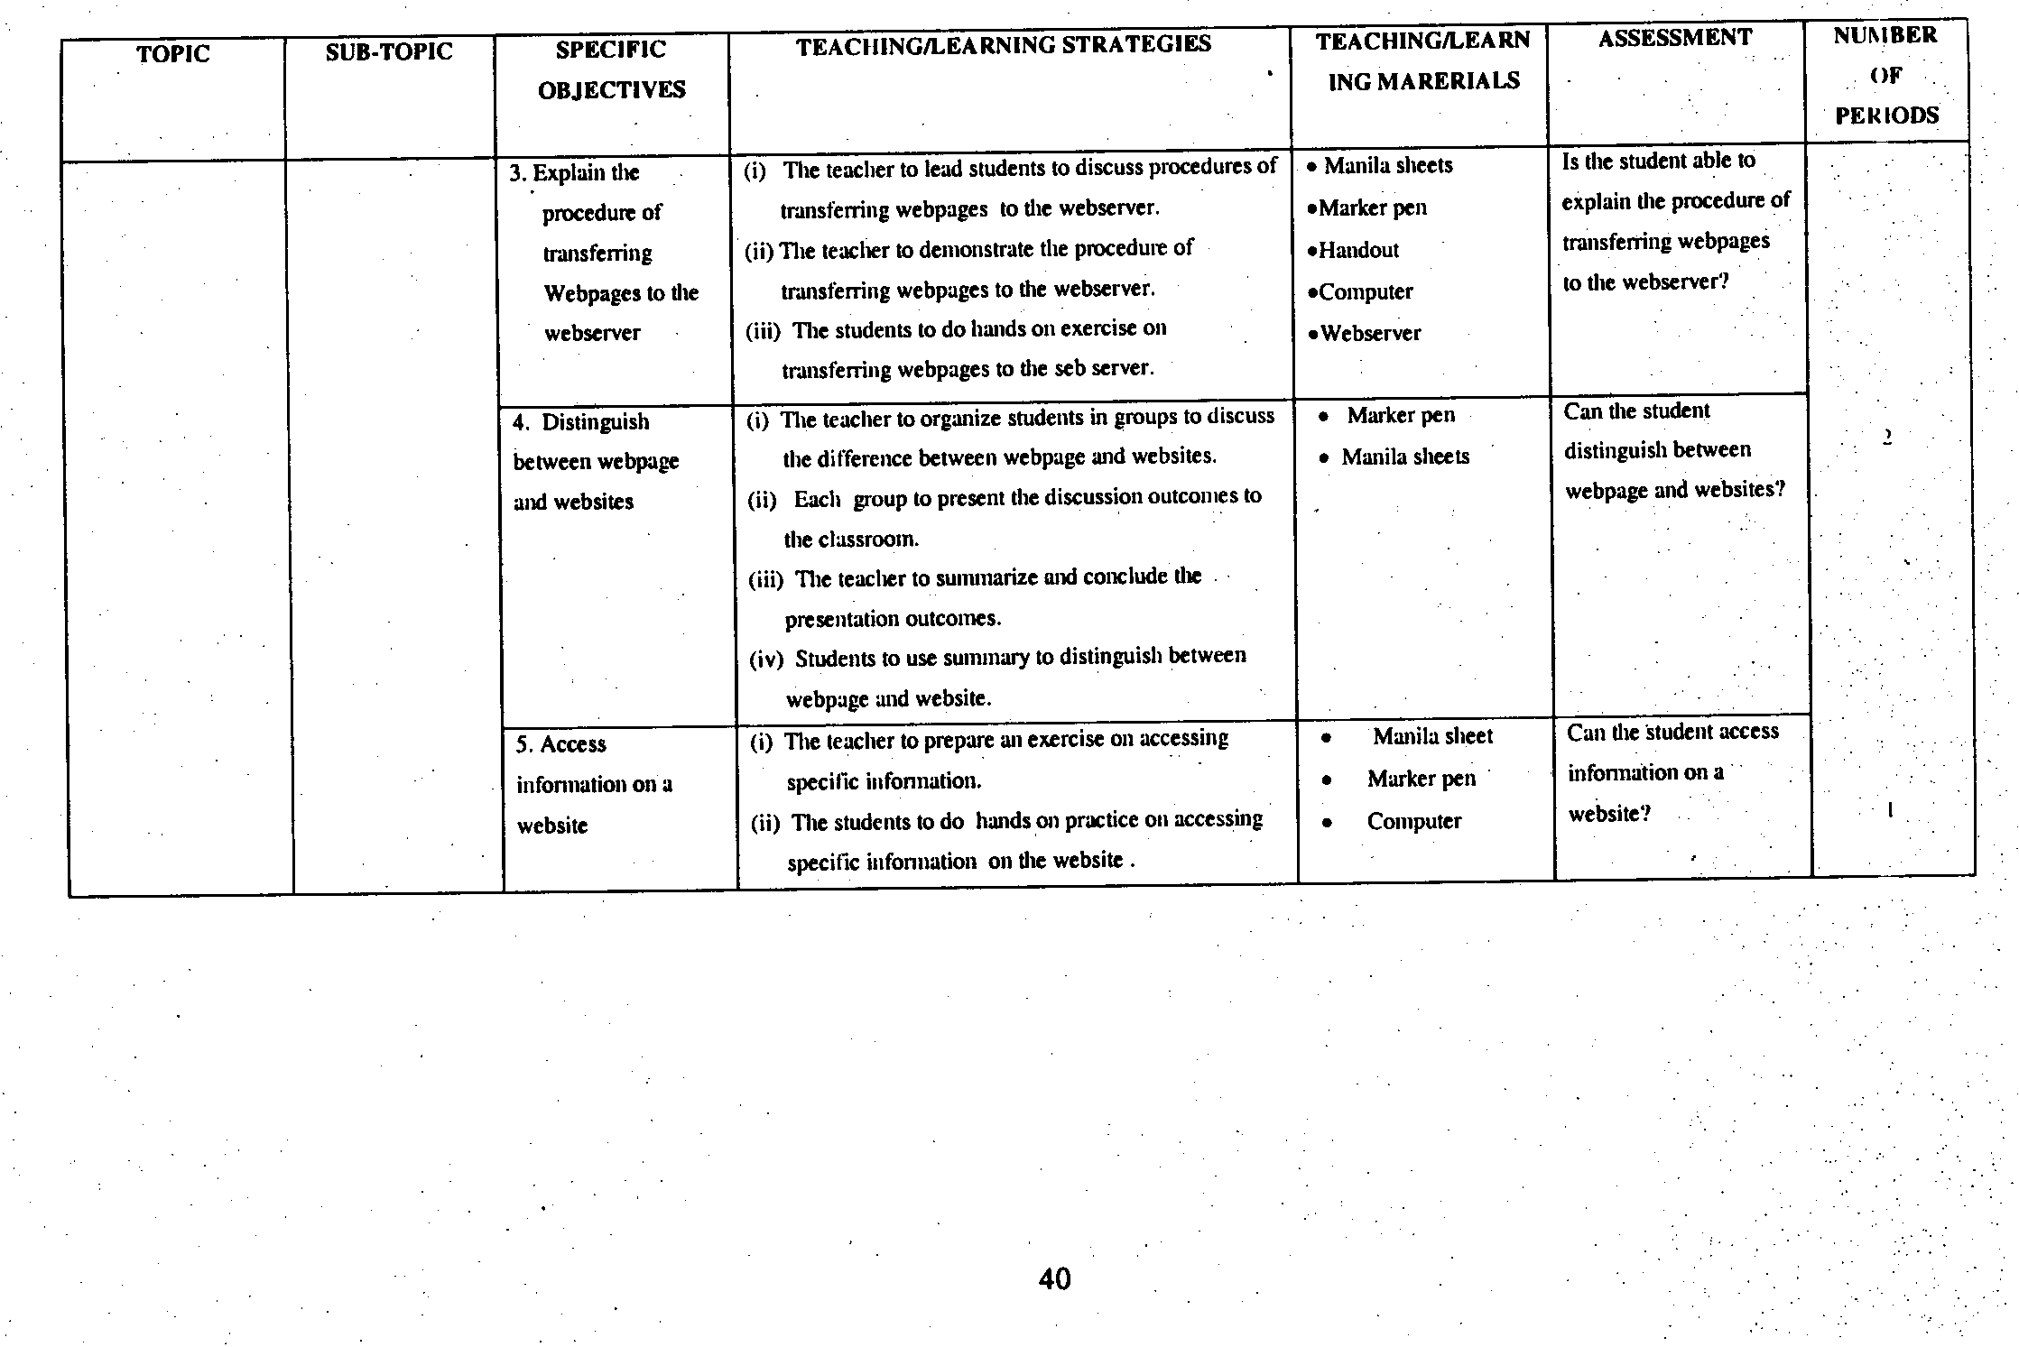
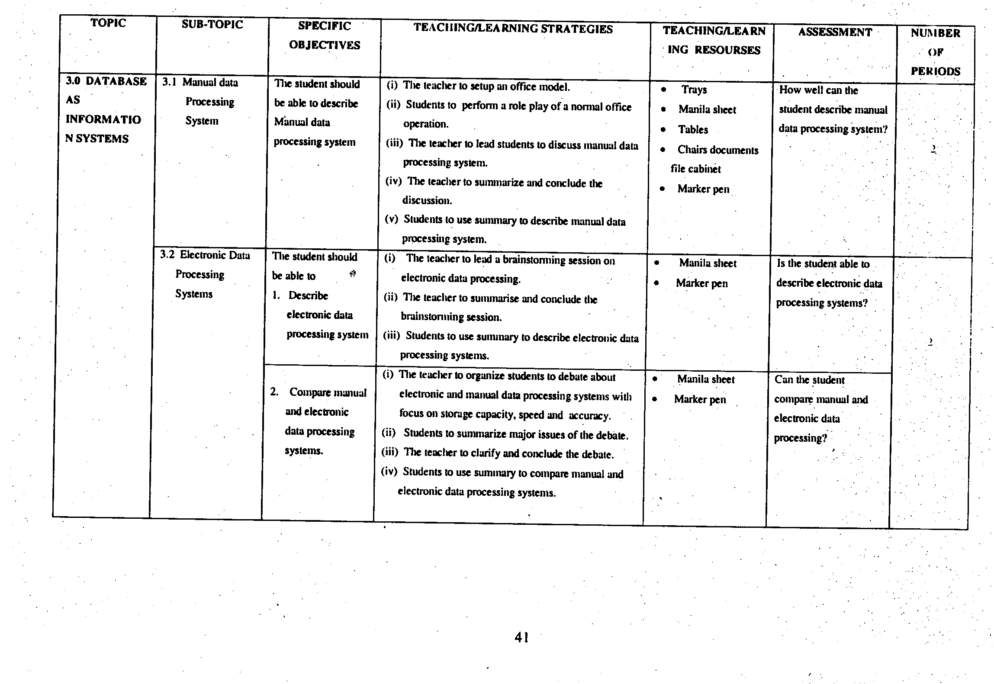
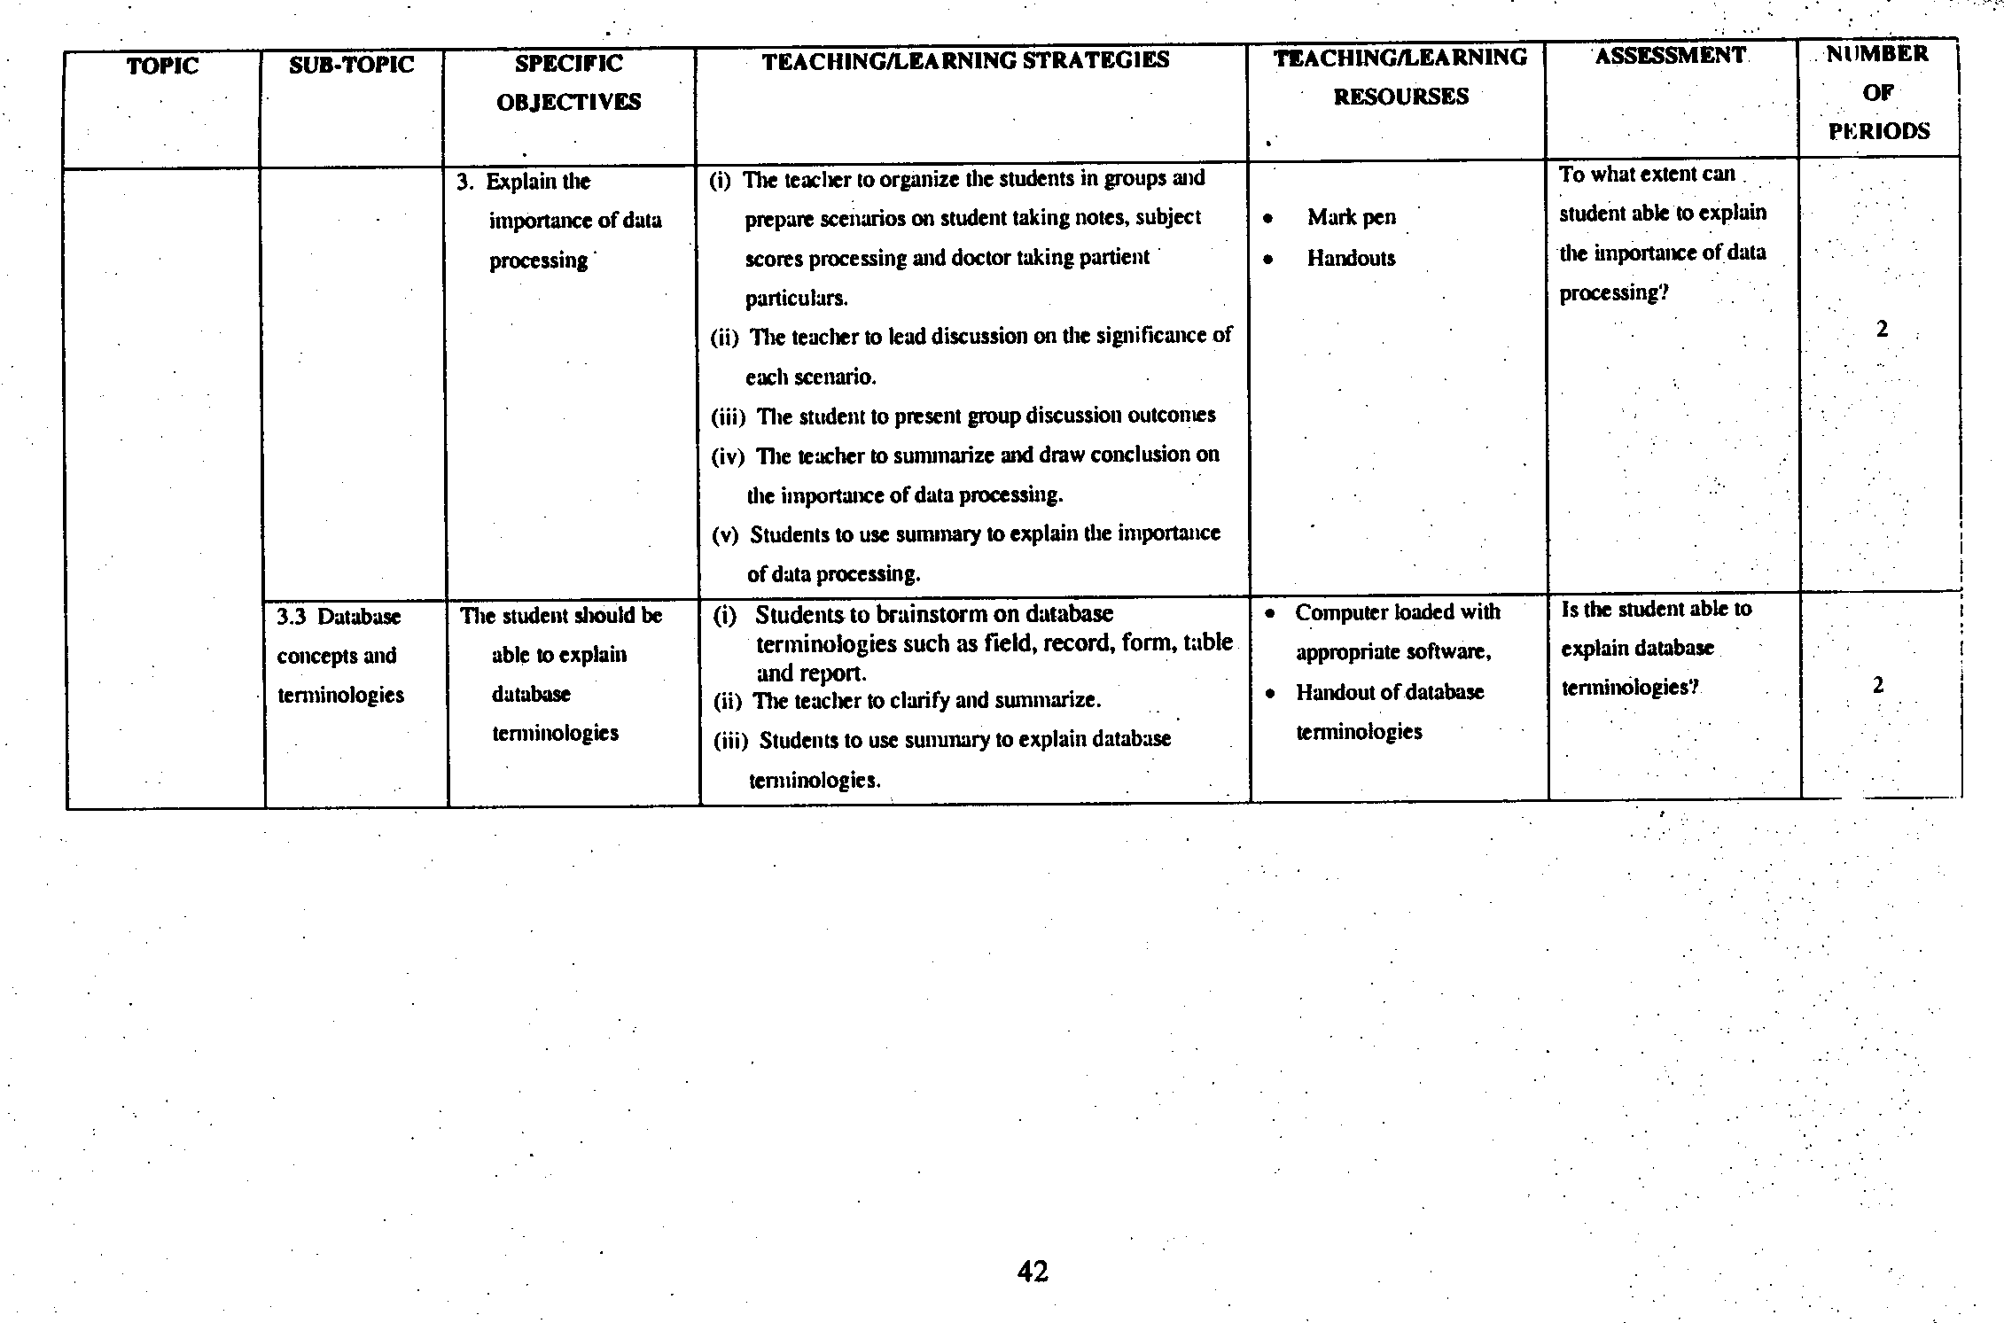
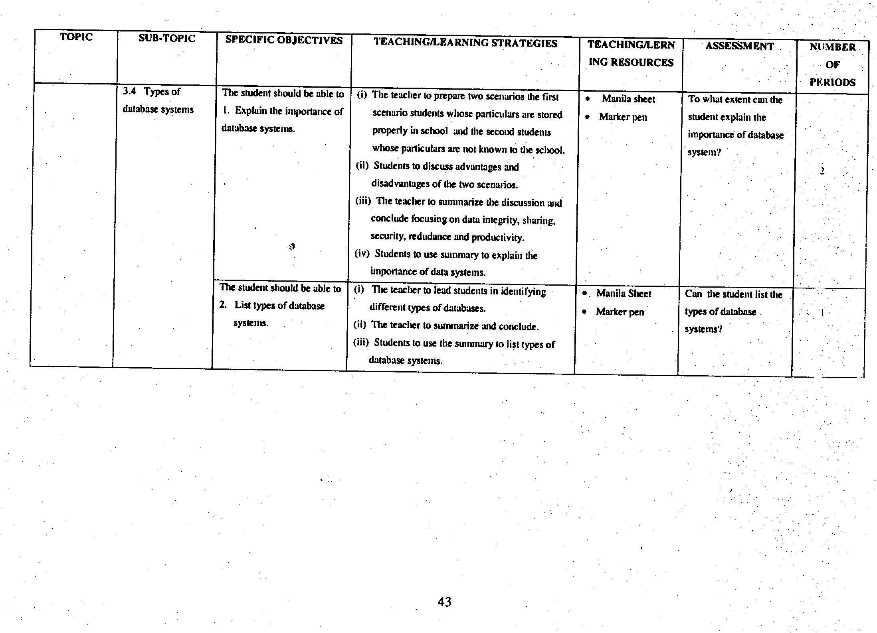
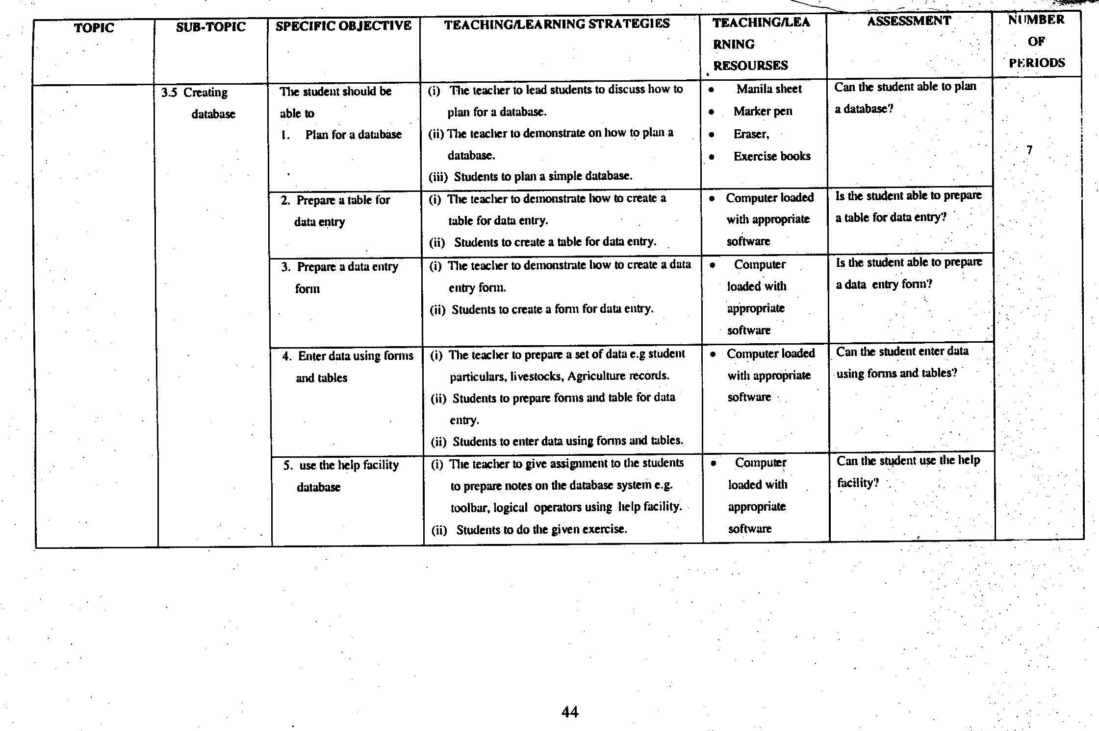

- FORM FOUR
- CLASS COMPETENCES
By the end of Form Four, the student should have ability to:
1. manage database systems.
2. create and make presentations.
3. produce desktop publications.
4. create Multimedia Publications.
- CLASS OBJECTIVES
By the end of Form Four course, the student should be able to:
1. develop skills of managing database.
2. use presentation application packages.
3. apply skills of presentation.
4. develop skills for desktop publishing.
5. demonstrate appropriate use of multimedia technology

