Unit Five:

Solving Problems

YGPS (Your Global Positioning System), Workshop Series 2010

Unit 5: Solving Problems

1. Introduction
We are all faced with problems on a daily basis. Some of the problems we face have only a minor effect on us whereas others can feel overwhelming. I would like you to reflect on the following quotations:
“We can't solve problems by using the same kind of thinking we used when
we created them.”
- Albert Einstein
“The best years of your life are the ones in which you decide your problems are
your own. You do not blame them on your mother, the ecology, or the president.
You realize that you control your own destiny.”
- Albert Ellis
In this module we hope that you will learn to apply the skills that will help you to have the best years of your life.

Learning outcomes
By the end of this module, you should be able to:

- Understand and apply the problem-solving process
- Identify the essential elements of a problem
- Collect reliable information
- Generate solutions from multiple perspectives
- Selecting possible solutions
- Evaluating solutions

Start up Activity 5.1:
Is your mind being deceived?

At the start of this programme you prepared a profile of who you are, including your strengths and your weaknesses (refer back to pg.17).Have a look at the weaknesses you noted, and then identify what skills you need to improve in order to overcome these weaknesses. For example, these skills might be your reading speed, note taking ability, stress management, public speaking etc.

Use the space below to identify the skills you would like to improve. You will use this list as the basis of exploring how to solve problems, so this unit is an important part of your own skills development.

2. The problem solving process
There is a vast amount of literature on solving problems. If you look on the internet you will see that you can find approaches to problems in maths, engineering, your finances, your love life, etc. The problem solving process illustrated below provides an approach that has the common elements found in most problem solving approaches.

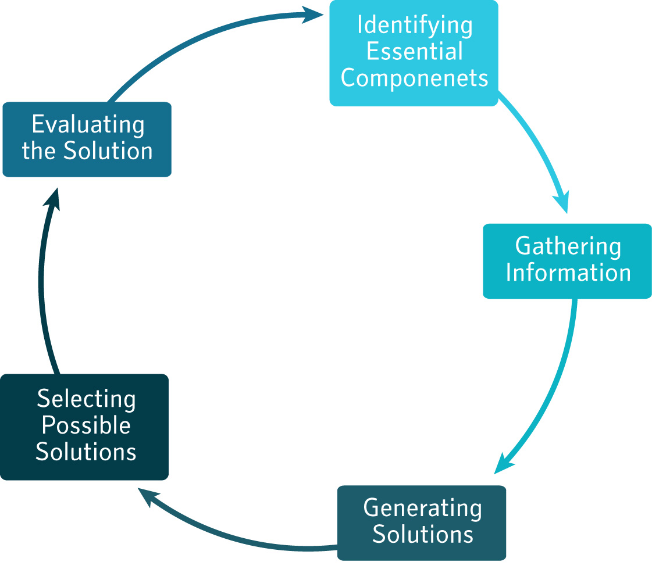

The problem solving process starts with thinking carefully about a problem and what its components (parts) are. After identifying the components you can then gather information that will enable you to generate solutions. Finding the best solution for the specific problem is then followed by an evaluation of the solution after it has been implemented (Drew & Bingham, 2001).

In the following sections you will apply this problem solving process to the “problem” or skills you want to improve that you identified in Activity 5.1.

3. What is the problem?
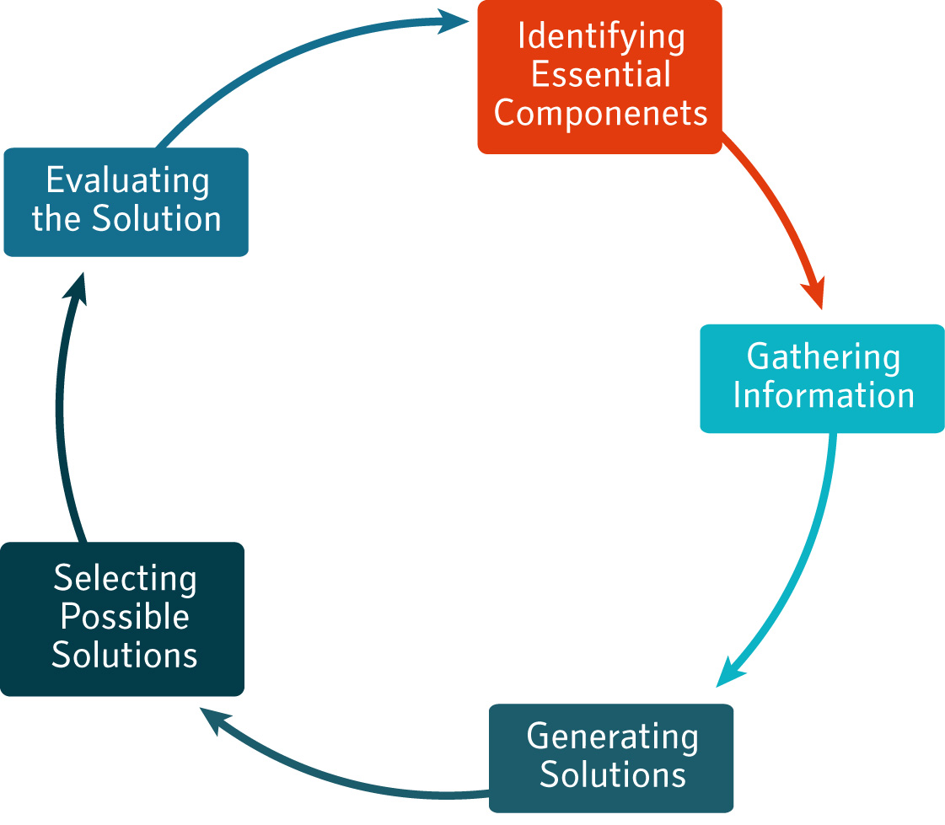
Identifying the components of a problem can sometimes be easy and other times more difficult. For example a simple problem might be that you are tired
and the solution is to rest. Other problems like global warming or pollution for example are much more complex to understand.

In the learning activities an example of improving reading speed will be used as an illustrative case.

Learning Activity 5.2:
Identifying the components

Turn back to activity 5.1 and choose one skill that you want to improve. To help you identify the components of the problem of improving you skills answer the questions below.

Hint: We have included an example, the problem of needing to improve reading speed as an illustrative case to show you how you might respond to each question.

What do you want to do/ solve?
Example: I would like to improve my reading speed

Why?
Example: I would like to be able to study faster

What are the things (factors) that cause (contribute to) the problem?
Example: Bad lighting where I study, I do not know how to read fast, It is noisy where I read.

By when would you like to have this problem solved?
Example: I would like improve my reading speed by the end of the term

There are also many other questions that you can ask yourself to help clarify a problem such as:
- Will other parties be involved in solving the problem?
- What are the criteria against which a solution will be measured?
- How will we know the problem is solved?
- For whom are we solving the problem?
(Drew & Bingham, 2001)

3. Gathering information
There are many different sources of information but finding the best information is the key to success, as Albert Einstein says:
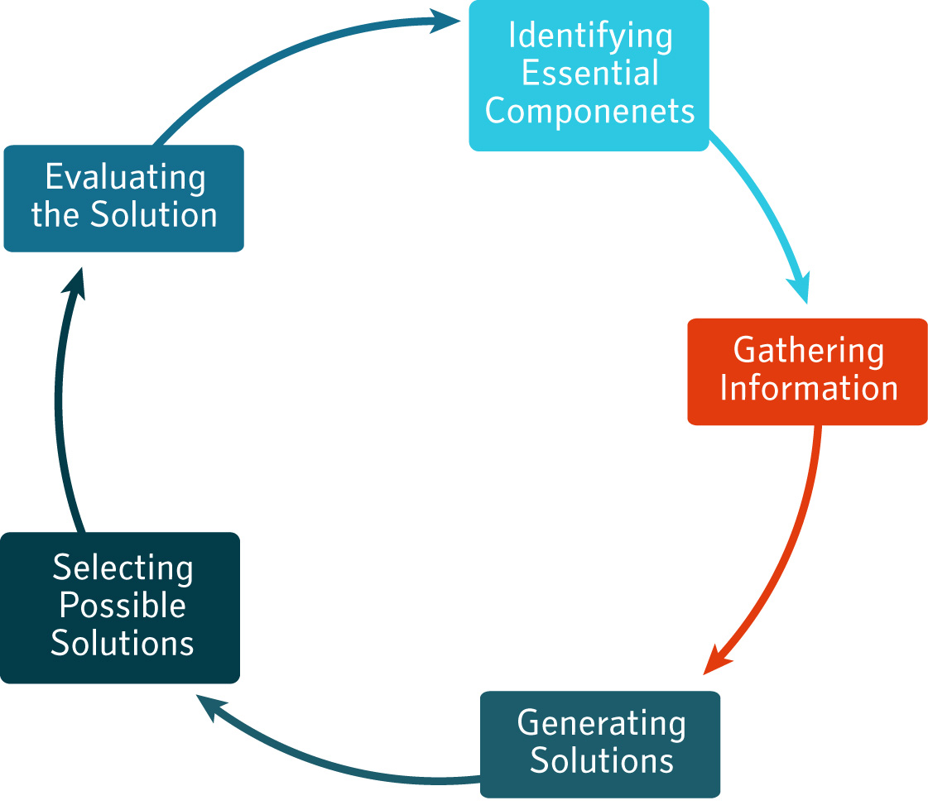
“Know where to find the information and how to use it - that's the secret of success”
As a learner or a student you will be required to find information from different sources such as: books, journals, newspapers, interviews with participants in a study to name but a few.

Computers and the internet have become key tools in finding information today. Therefore in this section you will look for ways to improve your identified skill using internet resources.

Learning Activity 5.3:
Internet search strategy

Answer the following questions about your search:

What information do you want to find?
Example: I would like information on how to read faster/ or improve my reading speed

Which search engine are you going to use?
Example: Google

Which key words/ phrases will help you to get the information?
Example: Speed reading, Improving reading speed etc,.

Is the information applicable?
Example: I will evaluate if the sources are credible and objective

Is the information reliable?
There are about 182 million website on the internet that range from personal blogs to company and library websites (Agarwal, 2009). To ensure that you are getting reliable information via the internet, instead of just someone’s personal opinions you can use the Ten C’s developed by Betsy Richmond from the library at University of Wisconsin at Eau Claire.

Ten C's For Evaluating Internet Sources Guide

The "Ten C's" provide criteria to consider in evaluating Internet resources. Sections of this document include:

1. Content
What is the intent of the content? Are the title and author identified? Is the content "juried?" Is the content "popular" or "scholarly", satiric or serious? What is the date of the document or article? Is the "edition" current? Do you have the latest version? (Is this important?) How do you know?

2. Credibility
Is the author identifiable and reliable? Is the content credible? Authoritative? Should it be? What is the purpose of the information, that is, is it serious, satiric, humorous? Is the URL extension .edu, .com, .gov or .org? What does this tell you about the "publisher"?

3. Critical Thinking
How can you apply critical thinking skills, including previous knowledge and experience, to evaluate Internet resources? Can you identify the author, publisher, edition, etc. as you would with a "traditionally" published resource? What criteria do you use to evaluate Internet resources?

4. Copyright
Even if the copyright notice does not appear prominently, someone wrote, or is responsible for, the creation of a document, graphic, sound or image, and the material falls under the copyright conventions. "Fair use" applies to short, cited excerpts, usually as an example for commentary or research. Materials are in the "public domain" if this is explicitly stated. Internet users, as users of print media, must respect copyright.

5. Citation
Internet resources should be cited to identify sources used, both to give credit to the author and to provide the reader with avenues for further research. Standard style manuals (print and online) provide some examples of how to cite Internet documents, although these standards are not uniform.

6. Continuity
Will the Internet site be maintained and updated? Is it now and will it continue to be free? Can you rely on this source over time to provide up-to-date information? Some good .edu sites have moved to .com, with possible cost implications. Other sites offer partial use for free, and charge fees for continued or in-depth use.

7. Censorship
Is your discussion list "moderated"? What does this mean? Does your search engine or index look for all words or are some words excluded? Is this censorship? Does your institution, based on its mission, parent organization or space limitations, apply some restrictions to Internet use? Consider censorship and privacy issues when using the Internet.

8. Connectivity
If more than one user will need to access a site, consider each users' access and "functionality." How do users connect to the Internet and what kind of connection does the assigned resource require? Does access to the resource require a graphical user interface? If it is a popular (busy) resource, will it be accessible in the time frame needed? Is it accessible by more than one Internet tool? Do users have access to the same Internet tools and applications? Are users familiar with the tools and applications? Is the site "viewable" by all Web browsers?

9. Comparability
Does the Internet resource have an identified comparable print or CD ROM data set or source? Does the Internet site contain comparable and complete information? (For example, some newspapers have partial but not full text information on the Internet.) Do you need to compare data or statistics over time? Can you identify sources for comparable earlier or later data? Comparability of data may or may not be important, depending on your project.

10. Context
What is the context for your research? Can you find "anything" on your topic, that is, commentary, opinion, narrative, statistics and your quest will be satisfied? Are you looking for current or historical information? Definitions? Research studies or articles? How does Internet information fit in the overall information context of your subject? Before you start searching, define the research context and research needs and decide what sources might be best to use to successfully fill information needs without data overload.
(Richmond, 2003)

Learning Activity 5.4:
Internet search strategy

Open the internet and find 3 websites or downloads (articles, books, etc) that will help you improve your specific skill.

For each source, make a note of the author, date, title, and url (website address), followed by a summary of the 3 most relevant points for your specific problem.

Source One:
Author:
Date:
Title:
URL:
Summary of 3 most relevant points for my specific problem:

Source Two:
Author:
Date:
Title:
URL:
Summary of 3 most relevant points for my specific problem:

Source Three:
Author:
Date:
Title:
URL:
Summary of 3 most relevant points for my specific problem:

Resource file:
Go on SAFARI

This section has given you a good introduction to searching for information on the web. If you would like more advanced information gathering skills we can recommend that you go to the following site: http://www.open.ac.uk/safari/

This excellent site will take you on an expedition through the information world which will help you to become a professional at gathering information in cyberspace (“Welcome to SAFARI,” 2009).

4. Generating solutions
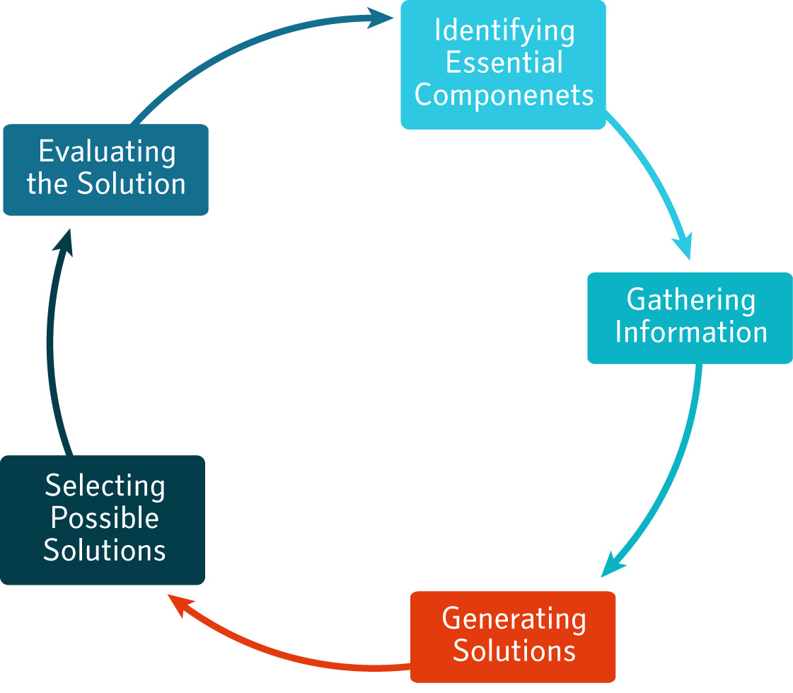
Various approaches exist for generating solutions to problems. The most well known method of generating solutions is Brain Storming.

Brain storming is however often done incorrectly. In this
section you will use brain storming to generate ideas on how to improve you your skills. Read the following extract about how to brainstorm.

Brainstorming
This works well with a group but you can do it alone. If you are in a group, get one person to write down whatever is said on a board or flip chart where all can see it. It can help to set a time limit (eg 10 minutes).
‘Rules’ are as follows:
  - write down any ideas however unusual, impractical or rude
  - do not discuss or make judgements about the ideas. This stops the flow of ideas and your aim at this stage is to generate ideas creatively.
  - ‘piggy backing’ is encouraged (adding ideas to other people’s ideas, even if they may at this stage seem away from the point).

When you have finished generating ideas:
  - if in a group, check what people meant
  - whether in a group or alone, sort ideas into ones which appear similar
  - discuss the ideas
  - judge which ones look suitable and which ones don’t.
(Drew & Bingham, 2001)

Group Activity 5.5

Form a group of 5 students. As a group select a group leader and a scribe (a person that will note down all the solutions generated). Pick a skill that someone in the group wanted to improve or perhaps a skill that more than one person would like to improve on and brain storm possible solutions, using the guidelines above. Use the space below to make notes

Brain storming notes

Another way to generate solutions could be to use De Bono’s 6 hats technique that we practiced in Unit 4 to look at a problem from different perspectives and in that way to stimulate ideas during brain storming.

5. Selecting a solution
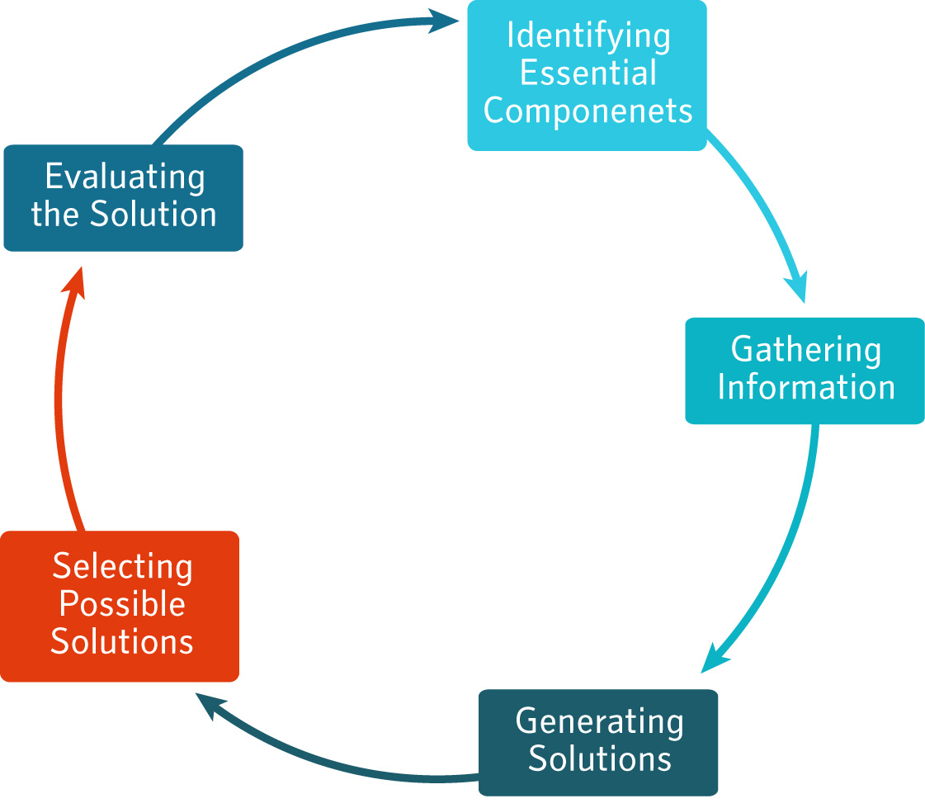
This is a step in the problem solving process that is often overlooked. Especially, if people are under pressure to find quick solutions to problems they often do not look carefully at whether they have the best solution for the specific problem.

In other words, you need to ask yourself: “how will I know that I have selected the best solution to my problem?”

A table such as the following is a useful way of checking which possible solutions are likely to be best in your specific context. NOTE: Different people will often select different solutions, as it will depend on your unique situation.

Possible Solutions | Positive consequences of implementing the solution | Negative consequences of implementing the solution | Justification for final choice
Example: Go for a speed reading course | Learn speed reading skills | Cost | Reading faster will make it possible to read more and get through work more thoroughly and this is worth the money spent.

6. Evaluating the solution
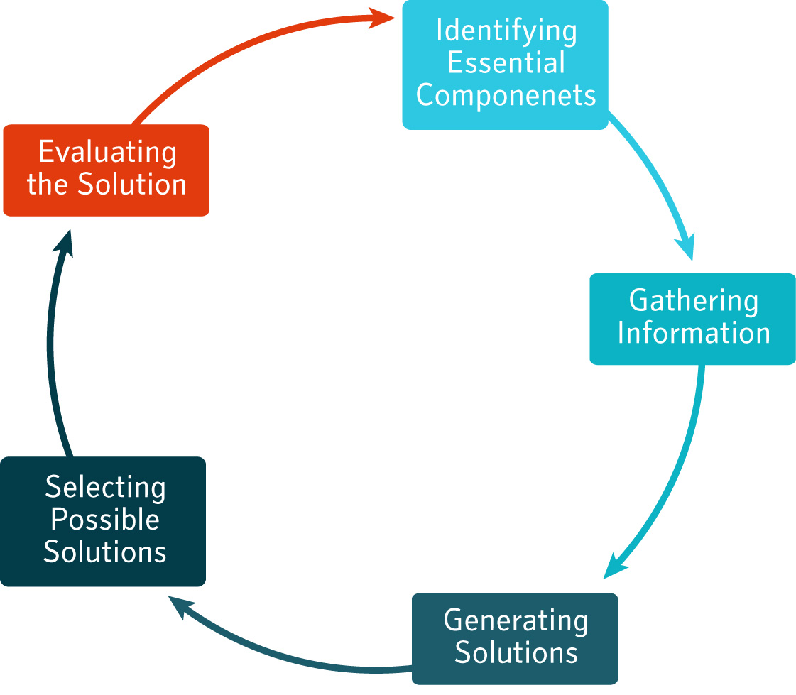
The evaluation of a solution after it was implemented is critical to improving individual and organisational performance. This is again a step that individuals, group and organisation under pressure can neglect due to pressure and it is where the most learning takes place.

Learning Activity 5.6

To ensure that you can apply the knowledge and skills you developed in this section, for this activity you need to think of a specific problem you have experienced in the past month and then write a 1-page reflection that will cover the following aspects:
- What was your problem?
- What solution did you practically implement to solve this problem?
- How effective was your solution to this problem?
- What could/should you have done differently now that you understand the problem solving process?

Tracking my progress
You have reached the end of this section. Check whether you have achieved the learning outcomes for this section.

Learning outcomes | I feel confident | I still need practice
I understand and can apply the problem-solving process
I can identify the essential elements of a problem
I can collect reliable information
I can generate solutions from multiple perspectives
I understand how to select a solution
I am able to evaluate solutions

What did you like best about this section?

What did you find most difficult in this section?

What do you need to improve on? How will you do this?

References
Agarwal, A. (2009). How Many Websites are there on the Internet? Retrieved February 28, 2009, from http://www.labnol.org/internet/total-websites-on-internet-worldwide/5206/.
Drew, S., & Bingham, R. (2001). Solving Problems Starter. In The Student Skills Guide (2nd ed., pp. 126-139). Burlington: Gower.
Richmond, B. (2003). Ten C's For Evaluating Internet Sources. Retrieved February 28, 2009, from http://www.montgomerycollege.edu/departments/writegt/htmlhandouts/Ten%20C%20internet%20sources.htm.
Welcome to SAFARI. (2009). . Retrieved February 28, 2009, from http://www.open.ac.uk/safari/.

