Unit Nine:

Developing Professional Competencies

YGPS (Your Global Positioning System), Workshop Series 2010

Unit 9: Developing professional competencies
“The journey of 1000 miles begins with the first step”

1. Stepping stones to success
Activity 9.1:
Watch the short video on Success

The short video ends with the following slide summarising what leads to success. In the section that follows we will reflect on many of these ‘stepping stones’ to success.
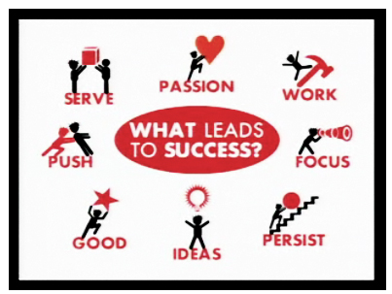

But first, let us briefly explore a little bit more about what we mean by ‘stepping stones’ since this concept forms the backdrop to this unit.

A young boy stands at the edge of a wide, gushing river. On the opposite bank of the river a group of his friends are playing soccer. With all his heart he longs to be a part of their game. He sits down, despondent; he knows that he will never be able to cross the river without being swept downstream. Whilst he is sitting on a rock wishing he were on the other side, one of the older children whistles to him and tells him, “Try upstream!” and points furiously in an upward direction. Not understanding the advice, but having no other options, the young boy decides to walk alongside the riverbank. After walking for about 5 minutes he sees a series of stepping stones that create a pathway for him to cross from one side of the river to the other. Immediately he begins to make his way to the other side of the river, one stone at a time, proceeding carefully so as not to slip. His heart is racing as he takes the last step onto the river bank to join in the game of soccer!

The river in this story is symbolic of our professional lives. We find ourselves on one side of the river, looking ahead to our dreams and ideals in the future, but often we have no idea how to get to the other side. Similar to the stepping stones in the story above, professional competencies can be considered the stepping stones to success in your career, taking you across waters you would otherwise not be able to cross. In this module we are going to take a look at a number of stepping stones to success that can help you on your journey towards your personal goals.

Learning outcomes
- Understand what professional competencies are and why they are important.
- Conduct research on a prospective study and career path;
- Identify skills areas you will need to develop;
- Know how to compile a professional CV and cover letter;
- Practice the skills needed for a successful interview;
- Understand the value of becoming a life-long learner.

2. Stepping Stone: Professional Competencies
Competencies are groups of skills, behaviours and knowledge that are required for you to be able to do a particular job.

In the world of work you will need both knowledge and behavioural skills in order to be successful – it is not enough just to have content knowledge (facts you learnt from a book), you must be able to “do” what the job requires of you. (NC Department of Health and Human Services, 2008).

There are many ways to acquire the knowledge and skills you need – you can learn in a formal educational environment such as school or university, use the internet and books to teach yourself informally or learn how to do things by trial and error (i.e. experience). You will find as you grow in your career that it is necessary to use formal, informal and experiential opportunities to develop as a person and reach your goals.

The only thing that we can be certain of in today’s work environment is that things are constantly changing. As a worker in the 21st century you will have to make sure that you continue to develop new skills that enable you to achieve in this type of environment. The Skills for a Changing World is just one stepping stone of many that you will take throughout your career! You will learn many new skills and gain knowledge but it is important that you see this programme as the beginning of a journey, not as the end. Decide today that you are going to commit to continually development your own personal competencies throughout your career!

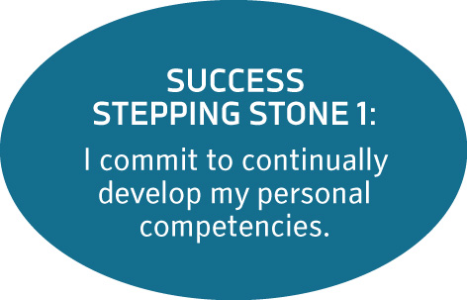

3. Stepping Stone: Researching your future
Each different career path requires you to have a unique set of competencies. In order to be as successful as possible, you must be able to identify which competencies you have to develop. This section is going to help you focus on investigating the necessary competencies for your envisaged career path.

There are two broad types of competencies you will need to develop in order to grow in your career:
- Specialized skills: content/job specific knowledge that enables you to successfully complete a job. For example you will need to know how to do financial statements before you can become an accountant.
- Transferable skills: more general skills that can be used in a wide variety of jobs. For example, the skill of being able to communicate effectively or to work in a team, to solve problems or to deal with conflict.

First we are going to focus on identifying which specialised skills you will need.

Learning Activity 9.2:
Identifying specialised skills

In order to complete this activity you will need to go back to the Managing your Life module and refer to Activity 2.2 (pg. 24). This was the activity where you had to list your goals in the four different areas. Take a look now at the work related goals you listed. Write these down in the space provided below.

E.g. I want to work for a South African magazine as a journalist.

Which of these goals did you indicate were your most important priority? On the list you created above indicate your most important career goal by placing a star next to it.

Now you need to ask yourself what SPECIALISED skills will I need in order to achieve this goal?

On your own, list at least 2 specialised skills that you might need.
E.g. I need a diploma/degree in journalism

Now, find a partner in your class whose career goal is very different from yours. Together help each other brainstorm about other specialist skills each of you may need to attain your chosen career goals.
E.g. I need to learn how to interview people from all walks of life

Finally, it is time for you to do some research on your specific career.

Log onto the internet, and use various websites and search engines to find additional information on your intended career. Use your research to answer the following questions:

- Do you need a formal qualification? Yes or No

If yes, list at least two institutions where you can obtain this qualification. Also write down what the name of the qualification is and how long the full course of study is.

Institution 1:

Institution 2:

- List 3 companies/organisations where you will be able to work once you have this qualification.

- Based on the research you did, write a brief paragraph that describes the type of work you will be doing in your career direction.
You have now identified the specialised skills that you have to obtain. However, to be a successful person takes more than just the knowledge or a qualification. Each career has certain transferrable skills (sometimes called soft skills) that will be required of you. For example to be a journalist, you would not only have to be able to write, you would also need to have excellent communication skills to help you in interviewing for stories, as well as the ability to deal with stress, pressure and deadlines.

The YGPS programme has already incorporated many of these types of skills. For example, managing your time, learning to solve problems and working with diverse groups of people are all transferrable skills that will be of use to you no matter which career path you have chosen.

The activity below is going to highlight some of the transferrable skills that are most valued by employers in all career directions.

Learning Activity 9.3:
Identifying transferrable skills

The table below is adapted from the Macmillan open learning course (www.materials.ac.uk) and lists a number of the transferrable skills that employers find very valuable.

Read each statement in the table below carefully. Think about how you would rate yourself for each statement. Does this statement describe something you are good at, or something you need to improve on? Try to be as realistic as possible when you rate yourself on the scale below. Be willing to indicate both your strengths and weaknesses.

Mark with a cross in the most appropriate column. The last 4 rows are empty. Use this space to write down 2 skills (that are not on the list) that you already have that are an advantage to you in the world of work and 2 skills (that are not on the list) that you still need to develop before you enter the world of work.

Skills | I need to  put effort into improving this skill | I am OK at this, but not great | I am really  good at this
How I work with people:
I am comfortable interacting with diverse groups of people.
I am comfortable when I have to speak in front of a group of people and give a presentation.
I am comfortable with conflict situations in groups and know how to deal with them.
I can work as a member of a team, and make a meaningful contribution.
How I talk and listen to people:
I can listen carefully when others are speaking to me without losing concentration.
I can express myself in such a way that others understand what I am trying to communicate with them.
I can write clearly.
When I read information, I find it easy to identify the main message and I can summarise the information I read easily.
I allow others the opportunity to express their opinions when working in a group/team.
I know how to find information and how to use it effectively
I can use a library to search relevant information.
I can use the internet to find relevant information.
I have had experience in planning a project, thinking logically and making a step-by-step plan.
I can be creative, coming up with new ideas and ways of doing things.
I can look at a situation from many different perspectives and think critically about it.
I am comfortable handling finances
I can draw up a budget for a project.
I can stick to a planned budget.
Additional skills
I am willing to stretch beyond my comfort zone and to do what needs to be done, simply because the situation requires it.
I am willing to give extra effort and time in my work even if I do not get paid for it.

You have now identified specialised and transferrable skills that you need to develop and from here on the responsibility lies with you to find ways in which to attain these skills in an informal or formal manner.

Speak to your facilitator, a teacher or someone in your chosen career field about what steps you can take to set your plan in action.

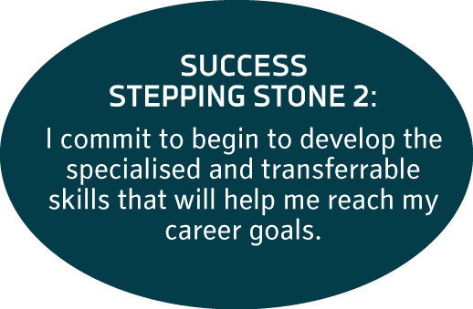

4. Stepping Stone: Compiling your CV
A curriculum vitae (CV) is Latin for “the story of your life” and it is used by companies to decide whether or not they will invite you for an interview. (Department for Employment, 2009).

Try to imagine your CV (sometimes called a “resume”) as your brochure that markets your skills and abilities to a prospective employer, and reflects who you are and what you have achieved to date.

You are going to follow a step-by-step guide and compile your very own CV, but first take a look at exactly what you should include in your CV (Red Kite Learning, 2008):
- Personal details (your name, address, and contact details etc.)
- Personal profile
- Educational qualifications
- Work experience
- Achievements and awards
- References

Before you begin to write a CV, take note of the following guidelines from the professionals as to how to compile the best possible CV (Department for Employment, 2009):
- Be concise and to the point;
- Make an effort to type your CV, this will create a good impression and set you apart from other candidates who are applying;
- Check your spelling and make sure that there are NO grammatical errors – it is highly unprofessional to submit a CV with errors and it creates the impression that you are sloppy or careless with your work.

Successful professionals ensure that they always have an up to date CV prepared, you never know when opportunity will knock on your door! Each time you acquire a new skill, get additional work experience or achieve something noteworthy, add it to your CV immediately. The activity below is a step-by-step guide to compiling your CV.

Learning Activity 9.4:
Creating your first CV
(This activity is based on http://www.rkl.org.uk/CVWizard/, www.jobsearch.about.com)

You might like to take a look at some of the examples of CVs included on your resource CD.

STEP 1: Complete your personal details.
On the template there is space provided for you to complete all your personal and contact details. This provides your prospective employer with all the necessary information about you as a person. It is extremely important that this information is correct otherwise employers will not be able to contact you in the event that you are selected for an interview.

STEP 2: Complete your personal profile
You should write a short statement about yourself, describing your skills and experience. This should grab the attention of the employer and make them want to know more about you and your capabilities.

Before you complete your personal profile on the CV template, read through the examples below to get an idea of how a personal profile should look.
Example 1:
An enthusiastic, ambitious individual, with the ability to motivate others. Performs well individually or as part of a team. Thrives under pressure.
Example 2:
I am a recent graduate who is computer literate. I have good communication skills, am reliable, a good timekeeper and quick to learn. I am currently seeking a position within the voluntary sector.

Example 3:
I am a flexible, trustworthy and responsible graduate. I am extremely self-motivated and enjoy working on my own initiative. I have excellent problem-solving, planning and presentation skills.

STEP 3: Add your work experience
This part of the CV is an opportunity for you to showcase what you are able to do in a work environment. Always start with your most recent job and work backwards. You should always indicate the dates your worked in the company, what your position was and where the company is located. Also give a brief description of your main duties, using phrases rather than full sentences. The examples below indicate how to describe your duties using phrases.
Example 1: Undertook telephone answering duties
Example 2: Undertook internet based research

Example 3: Responsible for front office administration

Because you are still busy with your basic education, you will not have had extensive work experience, thus in this section you can add volunteer work you have done or part time jobs you have had. If you have had no experience you can delete this section from your CV. In this case it would be a good idea for you to try to gain some experience by volunteering in your community, at a company you might like to work for, at your church and so on.

STEP 4: Add your educational history
This part of your CV will capture all your formal qualifications. Here you can include the details of your schooling and certificates obtained. You can also add degrees/diplomas you have obtained, and even include short courses you have attended. Always include the name of the qualification, the name of the institution, the dates you studied there and the date when you obtained the qualification. Underneath the qualification you can indicate any achievements or awards you received during your studies.

STEP 5: Complete your interests
When you add your interests/hobbies to a CV, they serve the purpose of showing your prospective employer that you are a well-balanced person.

Try and include things that will enhance your CV, such as any positions of responsibility or activities that you are involved in organising. Potential employers often ask questions at interviews about interests, so make sure you can talk about what you claim to have an interested in!

STEP 6: Your references
Your prospective employer will want to contact people you have worked with previously as references. On your CV you should include the names and contact details of at least 2-3 references. This should include your last employer or teachers who know you well. Remember to let these people know that you are job hunting and ask them if you can add them as references.
Well done! You have now compiled a complete, professional CV. Next check it thoroughly for spelling or grammar errors and then print it out.

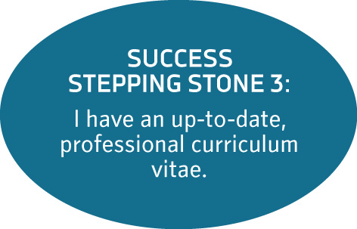

4.1 Stepping Stone: Your cover letter
Each time you submit a CV to a prospective employer, you must include a cover letter. A covering letter is your opportunity to introduce yourself, highlight the most important or relevant aspects of your CV, convey your enthusiasm for the job and persuade the reader to examine your application in more detail. Your letter must be clear concise and no longer than 1 page (Red Kite Learning, 2009).

When applying for a job a cover letter should be sent or posted with your resume. Your cover letter should be specific to the position you are applying for, relating your skills and experience to those noted in the job posting. Your cover letter is your first (and best) chance to make a good impression!

As part of your assessment portfolio complete the activity below.

Learning Activity 9.5:
Your CV cover letter
(The following activity is based on the following websites www.jobsearch.about.com,www.rkl.uk/CVwizard)

Imagine your life in 8-10 years time. You have by this time acquired the necessary specialised and transferable skills to apply for your dream job. Now it is time to take action and APPLY for a job!

Step 1:
Identify a position you would like to apply for that is related to the career goal you stated earlier in this module.

When you are looking for available positions, you can make use of either the internet or newspapers. Most newspapers have career sections where posts are advertised on a weekly basis. Take some time to browse through newspapers you have access to, if you find a position you would be interested in, cut it out. Alternatively, the e-papers (newspapers on the internet) also have career sections where you can search online for jobs. Use Google to find the homepage of a newspaper and look for their careers section. You can copy the information of the position, paste it into a Word document and then print out the details. Alternatively, there are websites dedicated to career related issues. Browse these sites for job listings:

www.bestjobs.co.za
www.careers24.com
www.netads.24.com
www.careerclassifieds.co.za
www.careerjunction.co.za

Using any of the methods described above, find at least 3 positions you would be interested in applying for. You must include copies of all 3 advertisements in your assessment portfolio.

Step 2:
Select one of the jobs you identified in Step 1. You are now going to write a cover letter for your CV as if you were applying for this specific job. Remember you are imagining yourself a couple of years from now when you have all the necessary skills necessary to apply.

Use the template in your resource file entitled Cover Letter to complete this activity. The summary below outlines each of the sections that should be included in your letter and gives you guidelines as well as examples of what to write.

- Address and Date
A formal letter must include your address, the address of the person to whom you are sending it and the date on which the letter was written

- Opening paragraph: Why you are writing
Indicate what post you are applying for and where you found out about it. Here are a few examples to help you write your opening paragraph.
Example 1:
I am writing with reference to the vacancy for ____________, which was advertised in the ____________ on ____________
Example 2:
I am writing to apply for the position of ____________ advertised in ____________ on ____________
Example 3:
Please find enclosed my CV in application for the position of ____________ as advertised in ____________

- Second paragraph: Highlight your skills and experience
When you are describing your skills and experience, try to use key words and phrases from the advertisement or job description to emphasise how you fit in with their requirements. This is the section where you get to market yourself and give the employer an incentive as to why they should contact you.

Here are a few examples to help you write the section on your skills and experience
Example 1:
As you will see from my enclosed CV I have extensive experience in ____________ .
Example 2:
My CV shows that I have a strong background in____________ .

- Third paragraph: Highlight your attributes and personal qualities
Once you have mentioned your work experience, use the third paragraph to highlight what else you can offer the employer in terms of your attributes and personal qualities.
Example 1:
I am self-motivated and conscientious and enjoy working as part of a team.
Example 2:
I have excellent communication skills, both written and verbal, and am highly motivated and ambitious.
Example 3:
I am computer literate, enthusiastic and an excellent team player.
Example 4:
I work well on my own and within a team. I have a track record of working efficiently and perform well under pressure.
- Final Paragraph
Always end your letter on a positive note and thank the employer for considering you.
Example 1:
I look forward to discussing my application in more detail. I am available for interview at any time.
Example 2:
I look forward to hearing from you shortly.
Example 3:
Thank you for taking the time to consider my application, I look forward to hearing from you soon.
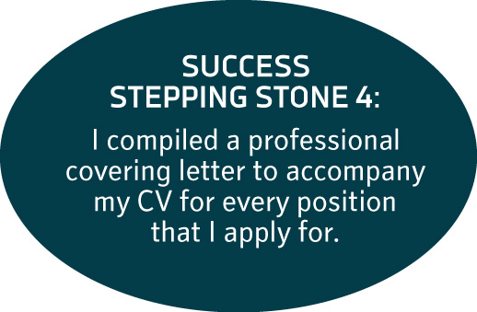

5. Stepping Stone: Preparing for interviews
After you have submitted your CV, interested employers can contact you for an interview. Your CV is only the first step in impressing your potential employers, the interview is an opportunity to market yourself in person! You must remember that you only get one chance to make a first impression when a prospective employer meets you, so make the most of it. In this section of the module we are going to look at a couple of guidelines on how to handle an interview effectively.

The best strategy is to go to an interview as prepared as you possibly can be.
Rodger Darlington (2008), a well renowned human resource specialist, believes that good preparation is the key to a successful interview. He advises prospective employees to use the internet and telephone to research the industry or company where you want to work.

Learning Activity 9.6:
Preparing for an interview

For this activity you will now imagine that you have been invited to an interview for the position you applied for in the cover letter activity. Based on the advert you used to write the letter, complete the following activity.

Write down the name of the company where you are applying for a job.

Use the internet to locate the webpage. Write their homepage address down in the space provided.

Use their website to obtain the following information:
Name of the CEO or Head at the office where you are applying for the position.

Office location where you are applying for the position.

Mission/Vision of the company.

Write down three interesting facts about the company, its history or its traditions.

You can now use this information to help prepare for your interview. If you know the goals of your company you can prepare for questions such as “Why do you want to work for this company? Also, demonstrating to employers that you took time to research their company indicates your enthusiasm and will count in your favour.

Preparing interview questions
Once you have learnt as much as possible about the company where you may be working, it is time to prepare yourself for the type of questions you may be asked during the interview. Read the insert below to see some of the most frequently asked interview questions. Underneath each question are some guidelines on how to answer them (University of the Free State, 2008).

Frequently asked interview questions

1. “Tell us about yourself.”
Answer: Give a short history of your education and background. Keep it focused. The employer wants to know about your suitability for the job, not what your extended relatives eat for Christmas dinner.

2. “What attracts you to this company?”
Answer: Talk about the opportunities the job offers and how you can use your strengths to take advantage of those opportunities. Show off your knowledge about the company that you gathered from your pre-interview research.

3. “Tell us about a difficult problem you have encountered and how you solved it.”
Answer: Have a story about a particular experience ready. Show how you used your skills, education or experience to come up with a creative, workable solution.

4. “What are your weaknesses?”
Answer: Don’t say you don’t have any – everyone does. Find a way to turn your weaknesses into strengths. Don’t exaggerate, but show how you have learned and developed as you dealt with those weaknesses.

5. “Where do you see yourself in five year’s time?”
Answer: You don’t want the company to think it can’t live up to your lofty goals, but you still want to appear ambitious. Say that you want to pursue opportunities as they arise.

6. “Why should we hire you?”
Answer: Here is the place to sum up your strengths. Create a list of five reasons that show why you are right for the job, with supporting evidence of each.

Simply reading interview questions will not be adequate preparation, you need to practice your answers out aloud – either in front of a mirror or with a friend.

Presenting yourself during interviews
There are a number of technical aspects that you should pay attention to when you arrive at the interview. Here are a couple of hints (Best.Job.Interview, 2007):

- Pay attention to what you wear. Always be neat, tidy and professional. Find out what the dress code is for the specific company where you are going to be interviewed – it is a good idea to match the company culture.

- Visit the following website to learn more about what to wear to an interview: http://www.best-job-interview.com/dress-for-an-interview.html

- Your body language is also important. Being on the spot can feel uncomfortable, forcing you into a defensive posture. Make sure you sit up straight with your shoulders backwards and your chin up, making eye contact. It does not matter how nervous you are; you need to look at the people interviewing you!

Visit the following website to learn more about body language in an interview: http://www.best-job-interview.com/interview-body-language.html

- Speak clearly and articulately. Remember, no matter how good your answer is, if no one can hear what you are saying they will not be able to identify your strengths and hear how well prepared you are.

For the following group activity you are going to practice writing and answering interview questions.

Group Activity 9.7

Divide into groups of 3 members. Group members must swap their job advertisements (used in Portfolio activity 4.2 to construct the cover letter).
Each group member must now take 5 minutes to write 3 potential interview questions for the advert they have.

Next, group members must take turns to interview each other. One group member will be the potential employee who will be interviewed. The group member who prepared the questions based on this person’s advert will be the interviewer. The third group member must observe the interview carefully and answer the following questions. You should note your answers on the sheets that your facilitator will hand out so that you can give your feedback to the person being interviewed.

- What questions were answered well?
- What questions were not answered well?
- Comments on the interviewee’s body language, posture, clarity of voice and confidence
- How could the interviewee improve in future interviews?

As a group, make a list of the lessons you learnt about interviews based on your experiences in this activity. You can record your notes below.

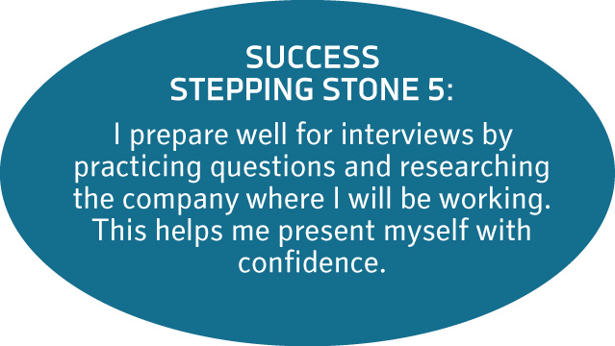

6. Conclusion: Being a life-long learner
By completing this module you have learnt very valuable skills that will help you to be a success in the world of work. However, the most important lesson to be learnt is that successful people never stop learning. You should make an effort to constantly improve your specialised and transferrable skills so that you can keep up to the pace of change in the world. Each time you learn a new skill you make yourself more valuable to your future employer – and remember to keep your CV up to date.

We started out this unit by watching an amusing video about what it takes to be successful. To remind yourself of the key points, and also the importance of life long learning in being successful, you might like to refer to the figure on the next page from time to time. You might even find it helpful to put a copy up where you study to remind you of where you are going.
May you enjoy your journey of life-long learning!

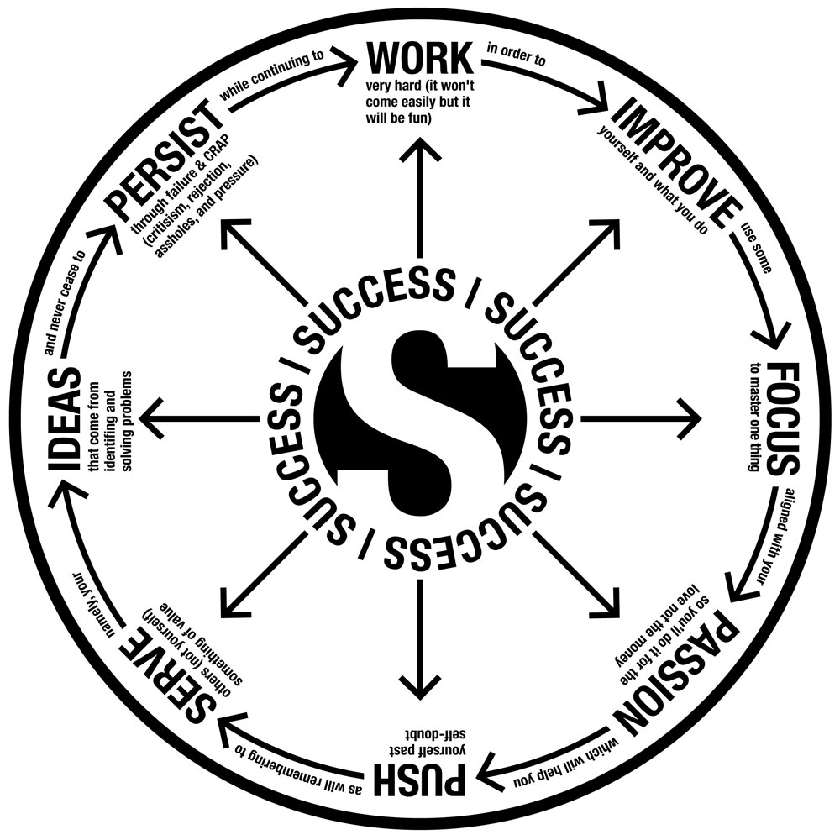

Source: Kurtz, J (online). www.jameskurtz.com

Tracking my progress
You have reached the end of this unit. Check whether you have achieved the learning outcomes for this section.

Learning outcomes | I feel confident | I still need practice
I understand the value of developing professional competencies
I have researched possible study and career directions
I have identified specialised skills I would like to acquire
I have identified transferrable skills that I need to acquire
I can compile a CV and a cover letter
I know how to prepare for a job interview
I understand the value of becoming a life-long learner

What did you like best about this section?

What did you find most difficult in this section?

What do you need to improve on? How will you do this?

References
Best.Job.Interview. (2007). Interview body language that sends the right message. Retrieved from http://www.best-job-interview.com/interview-body-language.html on 27 February 2009.
Darlington, Roger. (2008). How to have a good job interview. Retrieved from http://www.rogerdarlington.co.uk/interview/html. on 19 September 2008.
Department for Employment and Learning. (2009). Compile a CV. Retrieved from http://www.careersserviceni.com/Cultures/en-GB/FindAJob/Advice/Compile+a+CV.htm on 25 February 2009.
Doyle, A. (2009). Resume, CV, Cover Letter, and Job Letter Samples. Retrieved from http://jobsearch.about.com/od/sampleresumes/a/sampleresumes.htm on 28 February 2009.
Kurtz, J (2008). The secrets of success in graphic form. Online: http://www.jameskurtz.com/2008/03/14/the-secrets-of-success-in-graphic-form/
NC Department of Health and Human Services. (2008). Managing employee workplans: Definition of competencies. Retrieved from http://www.dhhs.state.nc.us/humanresources/workplan/competencies_definition.html on 25 February 2009.
Red Kite Learning. (2008). About CV’s. Retrieved from http://www.rkl.org.uk/CVWizard/ on 24 February 2009.
Singh, K (2008). 12 things your CV should not have. Retrieved from http://www.rediff.com/getahead/2008/feb/08cv.htm on 24 February 2009.
The University of the Free State. (2008). Six most common interview questions. Retrieved from www.ufs.ac.za on 1 December 2008.

