# AfLIA conference, May 2023

## Title of paper

The case for openness: why academic librarians should embrace open education

Dr. Tony Lelliott, *Saide*, South Africa

[tonyl@saide.org.za](mailto:tonyl@saide.org.za)

## Sub-theme that the presentation addresses

5. The Open ecosystem, libraries and the future of learning in Africa

## Abstract

This presentation makes the following case: that the world has changed over the past two decades, and while traditional tools of librarianship may have sufficed in the past, there is an urgent need for librarians to embrace open licences, open education resources, open access publications, open data, and open science. Each of these five major parts of the open ecosystem will be discussed, with a focus on how African librarians can learn about and adopt open practices for their own use and that of their clients.

The paper emphasises the need for professional development of librarians, and demonstrate ways in which individuals, groups and institutions can access free online open resources to empower themselves. The current collaboration between OER Africa and AfLIA includes reference to a continuous professional development (CPD) framework for academic librarians. Such a framework is an innovative planning guide for CPD that supports the career development of librarians, as an alternative to unplanned ad hoc development. The presentation will conclude with the draft professional development framework for academic librarians offered for comment.

## Introduction

Open education refers to a movement that encompasses a number of “open” concepts such as access, co-creation, collaboration and integration. There is no one definition of open education; instead it can be seen as an evolving concept that is based on the “common good” to provide practical opportunities for learners, and make research more accessible to all. With its roots in higher education in the 1960s and 1970s, open education has flourished with the rise of the Internet and digital technologies. The [Cape Town Open Education Declaration](https://www.capetowndeclaration.org/read/), resulting from a 2007 conference, stressed the need for educators, learners, publishers, institutions and governments to prioritise open education concepts, policies, open licences, open access and open educational resources (OER). For the purpose of this article, we shall include the concepts of five components of an open education “ecosystem” that we consider relevant to librarians in Africa, namely:

* Open Licensing;
* Open education resources;
* Open access publications;
* Open data; and
* Open science

We will show that, in the 21st century, it is imperative that librarians embrace such open practices. In turn, we shall attempt to demonstrate the importance of each element, and show how librarians can learn about and adopt them for their own use and that of their clients. Such learning will involve capacity-building or professional development, and is relevant to the current collaboration between OER Africa and AfLIA. The partnership includes discussion of a continuous professional development (CPD) framework for academic librarians. Such a framework is an innovative planning guide for CPD that supports the career development of librarians, as an alternative to unplanned ad hoc development. The presentation will conclude with a draft professional development framework for academic librarians offered for comment.

## Five components of openness

We have chosen the following elements that we consider crucial for librarians to be familiar with. In this section we briefly explain what each element involves.

### Open Licensing

Copyright is a law adopted differently by countries around the world that gives the owner of a work (for example, an article, book or website) the right to say how other people can use it. Traditionally, copyright is “All Rights Reserved” which means that another person cannot reproduce, distribute and/or adapt any part of the work without the permission of the copyright holder. An open licence is a flexible form of copyright that specifies how the work can be used **without** requiring the permission of the copyright holder. Openly licensing a resource does not give away its copyright, so a resource can be copyright **and** be openly licensed.

While a number of groups have developed open licences, the most widespread is the Creative Commons non-profit organisation. Creative Commons (CC) have developed a number of licences of differing degrees of openness to reflect the wishes of the copyright holder, shown in figure 1

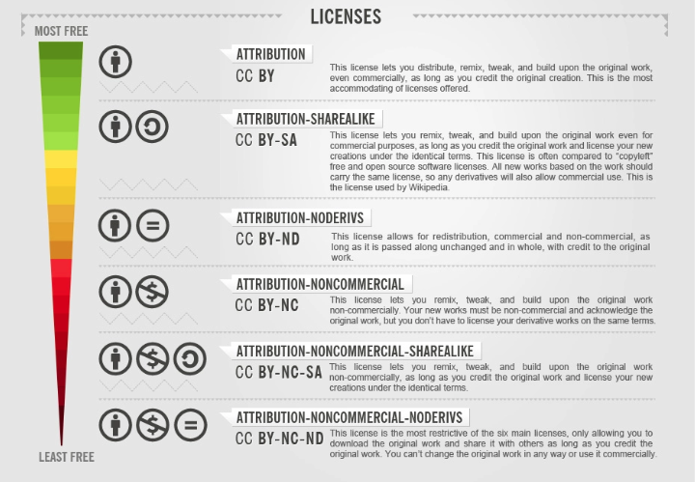

Figure 1: Types of CC license, Foter.com, CC BY-SA

All of the licences require the user of the resource to, at the very least, attribute (“BY”) the author of the work. The licences can be more restricted by not allowing commercial use (“NC”), not allowing changes to the resource (“ND”) or requiring an adaptation of the resource to be relicensed with the same licence (“SA”). For more detail on licensing, go the [Creative Commons website](https://creativecommons.org/licenses/), or visit the [OER Africa tutorial](https://www.oerafrica.org/communication/find-open-content/index.html#/lessons/G3JH5e_GnfxiSvQ0SXpyX7nLDpUYGGNB) on the subject. Given the increasing importance of open licensing over the past two decades, it is vital that librarians become familiar with the licences themselves and the process of licensing.

### Open Educational Resources

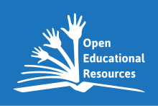

Figure 2: UNESCO global OER logo.

Open Educational Resources are teaching, learning, and research resources that reside in the public domain or have been released under an intellectual property licence that **permits their free use** and**repurposing by others**. Note the emphasis in the definition is ours, as we feel strongly that OER should:

* be free
* not require permission to use
* allow new users to adapt and find new ways to use resources

OER include full courses, course materials, modules, textbooks, streaming videos, tests, software, and any other tools, materials, or techniques used to support access to knowledge. (Hewlett Foundation, [OER Defined](http://www.hewlett.org/strategy/open-educational-resources/)). Many academic libraries in Africa have LibGuides (e.g. [UNISA](https://libguides.unisa.ac.za/c.php?g=355663&p=2399098)) that explain how the institution views and works with OER. It is important that such information is extended to all libraries.

### Open Access

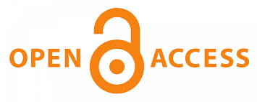

Figure 3: Open access logo, originally designed by Public Library of Science.

Open access (OA) is a publishing model for scholarly communication that makes research information available to readers at no cost, as opposed to the traditional subscription model in which readers get access to scholarly information by paying a subscription, usually via libraries. ([open access.nl](https://www.openaccess.nl/en/what-is-open-access)) There are various routes for a journal article to be published open access, including full open access journals, hybrid journals and repositories. The [Directory of Open Access Journals](https://doaj.org/) (DOAJ) is the best source for finding journals worldwide. Books and reports can also be published openly to enable greater access to researchers and the public. Openly licensed research normally uses Creative Commons licences. [African Journals Online](https://www.ajol.info/index.php/ajol) hosts 670 journals, including 371 open access journals. It is imperative that librarians can provide advice to academics who wish to publish in open access journals, as then the results of research produced in Africa can be more easily accessible to all.

### Open Data

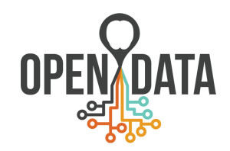

Figure 4: Open Data logo. Source: JulieBeck

Open data are data that can be freely used, re-used and redistributed by anyone. To be classified as *open*, data should conform to the following:

* **Availability and Access:** the data must be available as a whole and at no more than a reasonable reproduction cost, preferably by downloading over the internet. The data must also be available in a convenient and modifiable form.
* **Re-use and Redistribution:** the data must be provided under terms that permit re-use and redistribution including the intermixing with other datasets.
* **Universal Participation:** everyone must be able to use, re-use and redistribute - there should be no discrimination against fields of endeavour or against persons or groups, i.e. restrictions such as *non-commercial* are not allowed.

([Open Data Handbook](https://opendatahandbook.org/guide/en/what-is-open-data/))

The [Fordham University LibGuide](https://fordham.libguides.com/OpenDataSets) on open data shows how a range of academic disciplines use open datasets, such as Science & Technology, Business & Economics, and Education. If African scholars wish to be at the forefront of global research, then their librarians need to be able to provide them with guidance in this arena.

### Open Science

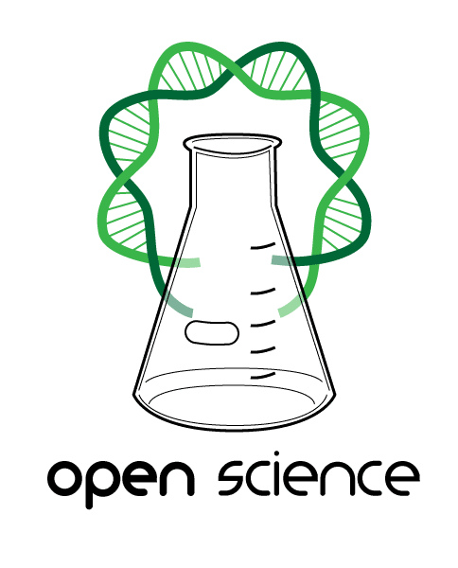

Figure 5: Open Science logo. Source: G.emmerich CC BY SA

Open Science (OS) is the movement to make scientific research, data and their dissemination available to any member of an inquiring society, from professionals to citizens. It encourages practices such as publishing open research and campaigning for open access, with the ultimate aim of making it easier to publish and communicate scientific knowledge.

([Orion Open Science](https://www.orion-openscience.eu/resources/open-science))

Put more simply, UNESCO’S [explanation](https://www.unesco.org/en/open-science) of open science is as follows:

“The idea behind Open Science is to allow scientific information, data and outputs to be more widely accessible (Open Access) and more reliably harnessed (Open Data) with the active engagement of all the stakeholders (Open to Society).”

The [University of Free State LibGuide](https://ufs.libguides.com/openscience) on open science is a valuable resource for librarians to understand what the open science movement entails, and can be used as a basis for training in their own institutions.

## The relevance of openness for librarians

So, in what ways is openness relevant for librarians? Well, most people would agree that access to knowledge is a public good. For example, in the recent Covid-19 pandemic, research was shared rapidly around the world, which enabled many countries to use the findings effectively in public health policies. The rapid sharing of knowledge could not have been possible without publications being made open – either public domain or open access. Similarly, other crucial issues such as innovative climate change and agricultural practices are distributed most effectively when the research is provided in an open manner. Academic librarians can play their part in encouraging academic researchers in their institutions to share their research openly. Librarians need to be familiar with initiatives such as the [African Open Science Platform](https://aosp.org.za/), that encourages partnerships, provides resources and hosts various initiatives.

Similarly, librarians need to be familiar with OA publishing so that they can advise their clients of the various options available, such as [Gold, Green and Hybrid open access](https://www.oerafrica.org/communication/publish-open-access/#/lessons/byyrkXaJEX6nq2np715QLl7Gb2pwEUId). The various models will suit different individuals in different institutions. Similarly, librarians need to be able to offer advice to researchers on how their data may be published openly so that it is accessible to others. [The Open Data for Africa Portal](https://dataportal.opendataforafrica.org/) has been developed by the African Development Bank (AfDB) in response to the increasing demand for statistical data and indicators relating to Africa. The Portal provides various customised tools to gather indicators, analyse them, and export them into multiple formats. Users can search by region or country and by topic.

In addition to the research arena, all countries are coming under increased pressure to encourage universities and other educational institutions to release resources they produce as OER. [UNESCO’s OER recommendation is gaining momentum](https://www.oerafrica.org/content/unesco-oer-recommendation-implementation-gathers-pace), and with the next few years governments will need to report to the UN on how they are implementing OER policies and practices in their countries. Again, librarians need to be at the cutting edge of OER practices, so that they can advise their academic colleagues how to find, adapt and licence OER, as well as inform students how to download, evaluate and use OER for learning.

All of the above open initiatives are underpinned by open licences. In order to be able to advise academic staff on how to release their offerings under an open licence, librarians need to have a working knowledge of how such licences work. Similarly, librarians should be able to advise institutional administrations on possible open policies they should promulgate.

## Professional Development for Academic Librarians

We have tried to show above that librarians in the 2020s and 2030s need a different skillset from those who worked in the previous century. In order to acquire such skills, professional development is required. From 2023 to 2025, OER Africa is collaborating with AfLIA to work on a Continuous Professional Development framework for academic librarians, to provide some guidance on what sorts of knowledge and skills can be expected at different levels of competence. We believe that a CPD framework is valuable for the following reasons:

* Higher education is increasingly becoming massified and marketized.
* Digital skills are becoming a crucial part of all librarians’ toolkits.
* There is a move towards active learning and ‘critical skills’ (e.g. 21st Century skills) for higher education students.
* CPD needs to be accounted for within existing workload models for librarians and other academic staff.
* Although CPD can be carried out in an ad hoc and informal manner, it is likely to be more effective if it is planned.

The CPD frameworks being created by OER Africa are based on frameworks developed by the [British Council](https://www.teachingenglish.org.uk/publications/resource-books/british-council-cpd-framework) for teachers and teacher educators. Each has a set of domains that cover areas of capacity building that we believe are valuable for university professionals. For each domain, there are three levels of competence: foundation, established and advanced. Figure 6 shows a draft framework in development for university academics (lecturers), with a total of 11 domains. OER Africa intends to support universities in up to four domains, such as those shown highlighted.

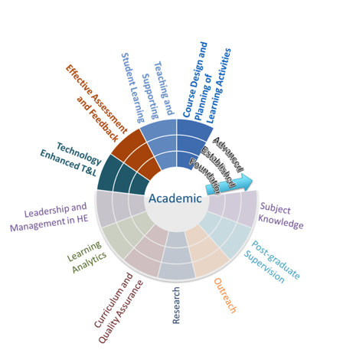

Figure 6: Draft CPD framework for academics.

The framework can be used by institutions or by individuals; Each domain is elaborated upon with a capability descriptor and indicators of attainment (Table 1) and is supported by a set of CPD OER to assist in development, either by self-study or facilitated. An example of a short openly licensed self-study tutorial on open access can be found at <https://www.oerafrica.org/communication/publish-open-access/#/>. A complete book for librarians, that would likely need to be facilitated over a period of time is [OER: A field guide for academic librarians](https://boisestate.pressbooks.pub/oer-field-guide/).

Table 1: Example of a capability descriptor and indicators of attainment for one of the domains of the CPD framework for academics

|  |  |  |
| --- | --- | --- |
| Capability Descriptor | Level of Progress | Indicators of attainment |
| Innovation in the design of teaching, including the use of learning technologies.  Effective preparation and management of tutors and teaching teams. | Foundation | * Planned learning activities designed to develop students learning * Peer review of unit materials by unit/course coordinator |
| Established | * Innovation in the design of teaching, including the use of learning technologies. * Effective preparation and management of tutors and teaching teams. |
| Advanced | * Leadership role and impact in curriculum design and review, planning and/or development at an (inter) national level * Leadership role in mentoring and supporting colleagues in planning and designing learning activities and curriculum |

An initial CPD framework for librarians is being drafted during 2023. The current version (Figure 7) has only got five preliminary domains: open licensing, OER, OA, Communicating Research Findings, and teaching strategies for Information Literacy.



Figure 7: Draft CPD framework for academic librarians.

One of the purposes of this paper is to request feedback on the framework for academic librarians; for example, we would like to answer the following questions:

1. What should the full set of domains comprise?
2. Which domains are key, and should be prioritised for capacity building by AfLIA and OER Africa from 2023 to 2025?
3. What capability descriptors and indicators of attainment should be attached to each domain?
4. Are there any existing CPD OER that could be used to assist with capacity development?

## Conclusion

This paper has discussed segments of the Open Knowledge space that have developed over the past two decades, and the need for librarians to engage with them. First, in the 2020s and beyond, it is essential that librarians become familiar with open licensing in order to explain to their clients what open licences mean and how they can be used. Secondly, librarians working with students and academic staff need to fully understand the affordances and limitations of OER, so that quality resources can be accessed in the sorts of numbers needed for learning. Thirdly, librarians to be knowledgeable about open access, open data and open science to be able to encourage researchers to engage with such areas of the open ecosystem. As the century progresses, African scholars can take advantage of openness in research to push forward a “public good” agenda in numerous fields relevant to developing countries on the continent.

In order for librarians to become capacitated in the open sphere, a systematic process of CPD needs to be effected at the institutions in which they work. This paper presents initial ideas towards a CPD framework for academic librarians, and calls for feedback from professional librarians and managers so that the framework can be fully populated and made available for institutions to work with.

## Acknowledgements

With thanks to Dr. Nkem Osuigwe (AfLIA), and the various posts from [OER Africa](https://www.oerafrica.org/whats_new), especially those written by Liz Levey, that we have drawn extensively on, and that expand on the five areas of openness discussed in this paper.

Bibliography

[African Open Science Platform](https://aosp.org.za/)

[Fordham University LibGuide](https://fordham.libguides.com/OpenDataSets) on open data

[OER Africa communication posts](https://www.oerafrica.org/whats_new)

OER Africa [Open Knowledge Primer](https://www.oerafrica.org/system/files/12591/oa-publishing-african-universities06052019.pdf?file=1&type=node&id=12591)

[Open Data for Africa Portal](https://dataportal.opendataforafrica.org/)

[University of Free State LibGuide](https://ufs.libguides.com/openscience) on open science