**21**

MODULE5: **Agribusiness Management for Farmer Organisations**

LESSON 1: **Introduction to Economics of the Firm**

TIME: **1 hour 15 minutes**

AUTHOR: **Prof. Francis Wambalaba**



This lesson was made possible with the assistance of the following organisations:

[Creative Commons License](http://creativecommons.org/licenses/by/3.0/)  
  
Farmer's Agribusiness Training by [United States International University](http://www.usiu.ac.ke/) is licensed under a  
 [Creative Commons Attribution 3.0 Unported License](http://creativecommons.org/licenses/by/3.0/).  
Based on a work at [www.oerafrica.org](http://www.oerafrica.org/agshare/AgShareHome/tabid/1290/ctl/Tab/Default.aspx)

**MODULE 5**

**Agribusiness Management for Farmer Organisations**

**1**



## INTRODUCTION:

## :

By the end of this sub-module, you will be able to:

* Explain the meaning of economics and the basis for allocation of resources.
* Contrast the role of farming as a social livelihood from that of farming as a business enterprise from your own experience.
* Identify and explain the meaning of a market structure and how each can improve profits and strategize to manage farming as an enterprise.

**LESSON**

The study of economics is all about the allocation of scarce resources among the unlimited wants in society. It requires constant interrogation, experimentation, intervention and diversification of practices. However, for the majority of small scale farmers, farming is a way of life that is unchanging and has often never been interrogated deeply enough. More so, it tends to be tradition bound and therefore does not allow frequent experimentation with other types of farming. Unfortunately, over time, as the land has become more and more scarce, this traditional approach to farming has continued to result in less and less productivity.

The goal of this module is therefore to transform the traditional farmer’s mind set from that of a *farm* owner to that of a *firm* manager. To do so, several pertinent economic fundamentals of a firm will be covered in the context of farming and in contrast to traditional approaches, so as to demonstrate the need for a paradigm shift.

This sub-module defines the concept of economics, provides an overview of the concept of a firm and explores the centrality of profit in its models.

**Prof. Francis Wambalaba**

## AUTHOR:

## TIME:

## 1 hour 15 minutes

**Introduction to**

**Economics of the Firm**

## OUTCOMES:

## :

DEFINITION OF ECONOMICS AND OPPORTUNITY COST (50 Minutes)



## Activity 1

Discussion (5 minutes)

Work in groups of five. Discuss if everyone believes they have enough resources (i.e. land, workers and equipment) to sufficiently provide for all they ***want*** in life. Keep in mind these are ***wants*** as opposed to ***needs*** (*wants* are for meeting a desired life style while *needs* are for meeting basic survival). Next, consider if access to resources was doubled, would things be different?

## icon_cd-resources.png

See the feedback section at the end of this lesson to see a model answer or comments about this activity

## 

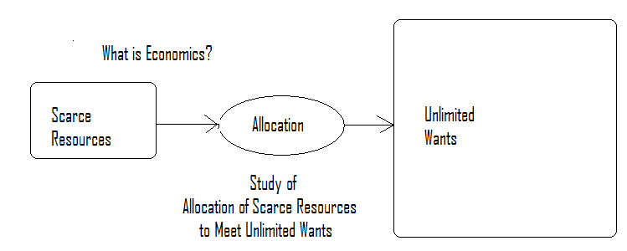

**What is Economics**

What is economics?

No matter how many resources we gain, they will always remain insufficient to meet our wants which will forever remain unlimited. *Scarcity* is defined as a situation when wants are more than the resources available. Hence, the study of economics is about how one goes about allocating these limited (scarce) resources to unlimited wants.

However, to do so, choices have to be made to allocate resources towards certain alternative wants and not others. Since before the choice was made, all alternatives were available opportunities, the alternatives that were not selected (or forgone) are opportunities lost. This situation is called opportunity cost.

Economics is the study of how societies allocate scarce resources (*which are?*) in an attempt to meet the virtually limitless wants/needs of consumers (Figure 1.1).



See the feedback section at the end of this lesson to see a model answer or comments about this activity

* If you were given 50,000 shillings in the situation of chapatti flour and Jembes above, but now the price of Jembes is 500 shillings each while Unga is still 200 shillings. How would you allocate the 50,000 towards Jembes or Unga or a combination of both if you MUST spend all the 50 000 shillings?
* In your discussions, ensure that *all* the money is spent. Try to ascertain how many combinations are possible.

Group Work – Opportunity Cost (10 minutes)

So to sum up consider these four points.

* First is that two fundamental facts emerge, i.e.:
  + A society’s economic wants (for individuals and firms) are unlimited and insatiable (cannot be completely satisfied).
  + These wants cannot be met by the limited resources (the means for producing goods and services are scarce).
* Secondly, scarcity imposes choices on individuals or society
* Thirdly, choices result in sacrifices or opportunity cost.
* And finally, opportunity cost is the next best forgone alternative (*not all forgone alternatives*)

Discussion by examples (5 minutes)

1. Consider this scenario. If you had 200 shillings and chapatti flour (Unga) was 200 shillings while a hoe (Jembe) was also 200 shillings, you would only buy Unga or a Jembe but not both. To buy Unga, you have to give up a Jembe. Your opportunity cost is the Jembe you gave up to buy Unga.
2. Can you think of similar examples of opportunity cost that affect your business?

## Activity 2

Opportunity Cost

## Activity 3

Production Possibility Curve (PPC)

Opportunity cost can be represented by a production possibility curve (PPC) as shown in Figure 1.2 below with Unga represented by Consumer Goods and Jembes by Capital Goods.

## 

**Fig. 1.2: Production Possibility Curve (PPC).**

A PPC joins all different combinations of goods and services that can be purchased (consumed or produced) using all available resources and efficient techniques.

In your opinion, is it possible to purchase a combination at point B on the graph?   
Notice that this is not possible because resources are scarce.

However, the amounts of resources do change. Sometimes they increase, while at other times they decline. We experience economic decline when resources decrease and an economic growth when resources increase. A decrease in resources shifts the PPC curve inwards (to the left). An increase shifts outward (to the right).

We can also buy less of each item when resources decline and more of each when resources increase as shown in figure 1.3 below (see points C - H)

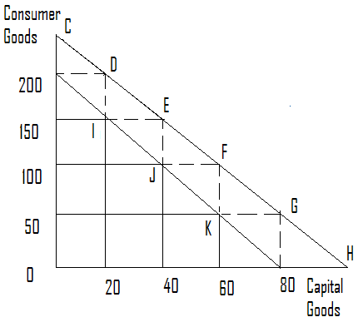

**Fig. 1.3: Shifts in Production Possibility Curve**

**.**

The PPC shifts with changes in resources. For examples an economic decline (40,000) leads to shift inwards (I, J, K etc.)

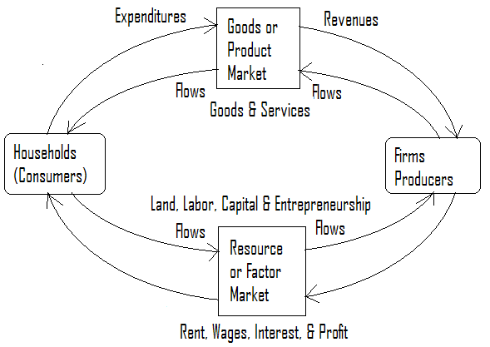

**Fig. 1.4: The Firm’s Goods and Factor Markets.**

In general, firms participate in two distinct markets. One from which they buy their inputs called a **resource market** or **factor market**. The other is in which they sell their produce called the **product market** or **goods market**.

Environment of the Firm

A **farm** is land set aside for the production of crops, livestock, birds and other food and cash generating products. A **firm** is an organized combination of production resources of land, labour and capital by an entrepreneur to produce a product or a combination of products.

Some farms are informally organized for the purpose of simply sustaining life at subsistence levels. These practices constitute “**farming as a social livelihood**”. Other farms are formally organized for the purpose of producing surplus products for sale, value addition and growth. These practices constitute “**farming as a business**” (or they transform a farm into a firm).

Other key characteristics of a firm may include;

1. Consideration of production as an investment,
2. Specialization in the production process,
3. Return on every factor of production including the entrepreneur, and ultimately,
4. Profit making as the key objective for production.

# TRANSFORMATION OF FARMS INTO FIRMS

# (10 minutes)

Farms and Firms

Farmer firms go to the factor markets to buy inputs such as land, labour and capital with which they combine to produce products. They then take their products to sell in the goods market. The primary goal of farmer firms is to maximize their revenues called **profits**. This means earning revenues enough to pay for the land, labour, capital and themselves as entrepreneurs, and possibly a surplus for future expansion.

On the other end of the equation are households who supply resources to the factor market and buy products from the goods market. The primary goal for consumers is to maximize their satisfaction called **utility**.

Therefore, a farm that desires to transform itself into a firm must, at the minimum, focus on customer satisfaction and profit making. To do so, the farmer must understand the market environment around them, especially the competition.

Features of Market Structure (10 minutes)

The competitive relationship among firms in the marketplace constitutes a market structure. The four main relationships include;

1. Competitive market,
2. Monopoly market,
3. Monopolistic competition market, and
4. Oligopoly market.

The key differentiating factors are the number and relative size of firms in the industry, the degree of product differentiation, the degree of interdependency or independence in decision making, and conditions for entry and exit. Let us investigate further.

1. Competitive Market

The key characteristics of a competitive market include the following:

* This is a market structure comprising many buyers & sellers, each selling small proportions and therefore not able to influence the market price. Each firm is a price taker
* All firms produce a homogeneous product and therefore there is no product differentiation.
* There is complete knowledge of all relevant market information.
* There is free entry and exit since there are minimal barriers to enter and exit.

1. Monopoly Market

* In a monopoly situation, there is only one firm producing a specific product in a specific market, there are no close substitutes (no cross elasticity), and no interdependence with other competitors in the relevant market.
* The demand curve for the firm is the demand curve for the industry, since the firm is the industry.
* Typically, there are substantial barriers to entry, including absolute cost advantage of the established firms due to large capital requirements as well as scale economies. The product is differentiated for loyalty purposes, and in some cases, there is a legal exclusion of potential competitors through patented technology, trade secrets and natural monopolies

# THE MARKET STRUCTURE (30 minutes)

c) Monopolistic Competition

This concept was coined by Chamberlin and Robinson to describe industries with few dominant firms but with a large number of competitive fringe firms. Secondly, they exhibit highly differentiated products (real, perceived or imagined). Thirdly, they face independent decision making process unlike oligopolies that tend to be dependent. On one hand, they have monopoly characteristics such as engaging in product differentiation, while on the other hand they exhibit competitive characteristics of many firms in the industry.

The other characteristics include independent decision making and ease of entry and exit but with substantial barriers by leading brands.

d) Oligopolistic Competition

Finally, the oligopolistic market is characterized by having a few closely related firms with a high degree of interdependence. Hence, actions of one to change price, output, product style, quality, terms of sale etc., have perceptible impact on sales of other firms. In some cases, they may be homogeneous such as cash products producers of sugar cane, coffee, tea, timber, animal hides etc., while in other cases, they may produce differentiated products such as small scale consumer product producers of vegetables, fruits, milk etc.



In this lesson we have been introduced to the idea that the study of economics and management can help us better understand the environment farming businesses are required to operate in. We will take this further in the next lesson.

# Summary

At a very simplistic level we can see individuals and their businesses responding to **needs**, **wants**, and the **allocation of scare resources**. Any allocation of resources will, however, invoke **opportunity cost** because there are insufficient resources. We have seen that we can in some ways anticipate the impact of shifts in the availability of resources by using a **production possibility curve** (PPC) to map opportunity cost.

Farmers and their businesses operate in two markets. Inputs are bought from the **resource** (**factor**) **market** while their outputs are sold in the **product** (**goods**) **market**. In order to be successful and generate a profit, farmers need to understand the market to be **competitive**.

Markets can, however, have different characteristics. There are at least four variations: **competitive, monopoly, monopolistic** or **oligopolistic**. Each market type dictates how profits can be generated.

# Conclusion



# Glossary

**Profit**

In economics, the term ***profit*** has two related but distinct meanings. **Normal profit** represents the total opportunity costs (both explicit and implicit) of a venture to an entrepreneur or investor. Whilst **economic profit** (is, the difference between a firm's total revenue and all costs, including normal profit (Perkin,1997) and <http://en.wikipedia.org/wiki/Profit_(economics)>

**Market**A **market** is any one of a variety of systems, institutions, procedures, social relations and infrastructures whereby businesses sell their goods, services and labour to people in exchange for money. (Perkin,1997) and <http://en.wikipedia.org/wiki/Market>

**Opportunity Cost**Opportunity cost is the cost related to the next-best choice available to someone who has picked among several mutually exclusive choices. It is a key concept in **economics**. It has been described as expressing "the basic relationship between **scarcity** and **choice**." The notion of opportunity cost plays a crucial part in ensuring that scarce resources are used efficiently. Thus, opportunity costs are not restricted to monetary or financial costs: the real cost of output forgone, lost time, pleasure or any other benefit that provides utility should also be considered opportunity costs (Perkin, 1997) and <http://en.wikipedia.org/wiki/Opportunity_cost>

**Production Possibility Curve (PPC)**In economics … a **production-possibility curve** or product transformation curve, is a graph that shows the different rates of production of two goods and/or services that an economy or individual can produce *efficiently* during a specified period of time with a *limited quantity of productive resources*, or factors of production. The PPC shows the maximum amount of one commodity that can be obtained for any specified production level of the other commodity (or composite of all other commodities), given the society's technology and the number of factors of production available (Perkin, 1997) and <http://en.wikipedia.org/wiki/Production_Possibility_Curve>

****

Above are the possible combinations but each point contains opportunity costs.

## Feedback Activity 3

|  |  |  |  |  |  |  |  |
| --- | --- | --- | --- | --- | --- | --- | --- |
| **Combinations** | **C** | **D** | **E** | **F** | **G** | **H** | **B** |
| Chapati Flour | 250 | 200 | 150 | 100 | 50 | 0 | 150 |
| Jembes | 0 | 20 | 40 | 60 | 80 | 100 | 80 |

Production Possibility Table

## Feedback Activity 1

Sadly it is human nature that even if we had better access to resources we would still not be satisfied. Basically, there are insufficient resources in the world! There would never be enough to satisfy everyone’s wants.

# Feedback