**23**

MODULE5: **Agribusiness Management for Farmer Organisations**

LESSON 3: **Decision Making – Explicit and Implicit Costs**

TIME: **1 hour 36 minutes**

AUTHOR: **Prof. Francis Wambalaba**



This lesson was made possible with the assistance of the following organisations:

[Creative Commons License](http://creativecommons.org/licenses/by/3.0/)  
  
Farmer's Agribusiness Training by [United States International University](http://www.usiu.ac.ke/) is licensed under a  
 [Creative Commons Attribution 3.0 Unported License](http://creativecommons.org/licenses/by/3.0/).  
Based on a work at [www.oerafrica.org](http://www.oerafrica.org/agshare/AgShareHome/tabid/1290/ctl/Tab/Default.aspx)

**MODULE 5**

**Agribusiness Management for Farmer Organisations**

**3**



By the end of this lesson you will be able to:

* Differentiate between economic costs and accounting costs.
* Make decisions based on the economic logic and explain the rationale for each decision.

This lesson will focus on building skills and economic rationales for decision making under given farming scenarios that may have multiple options. We will spend some time looking specifically at Economic versus Accounting Costs & Relevant Cost Analysis.

**LESSON**

**DECISION MAKING –**

**EXPLICIT AND IMPLICIT COSTS**

## INTRODUCTION:

## :

**Prof. Francis Wambalaba**

## AUTHOR:

## TIME:

## 1 hour 36 minutes

## OUTCOMES:

## :

Economic vs. Accounting Costs

While in many cases, economists talk the same vernacular of numbers that lend to measurement of profit, in a few cases, the two appear to speak about the same numbers in foreign languages. Some of these incidences are covered here.

## icon_activity.png

Class Discussion (5 minutes)

## Activity 1

## icon_time.png

**Economic Profit = TR - TC**

Where:

TR = Total Revenue (Sales receipts - or price x quantity)

TC = Total Cost (Opportunity cost of resources land, labour, capital and entrepreneurs)

Work in groups of four and discuss: “What, do you think, are the objectives of a farmer?”

While the various objectives identified by each member are valid, notice the centrality of the concept of profit in each viewpoint, especially those that desire their farm to be a firm. For example, firms need market share so we can eventually earn profits; they need to satisfy employees or customers so that they can stay in business to make a profit. In other words, unless they are a charity or government receiving revenues from other sources, they will go out of business eventually if their revenues remain below costs.

The profit model’s objective is to maximize economic profits:

**Accounting Profit (AP) = TR – Explicit Costs**

**Economic Profit (EP) = TR – (Explicit + Implicit Costs)**

*Accounting Profit* is the difference between total revenue and explicit costs. Explicit costs constitute every expense that is referred to as a direct cost. A direct cost can be accounted for with receipts from a market transaction such as leased land, purchased fertilizer, hired labour, purchased equipment etc. In fact, an explicit cost is the opportunity cost of using resources owned by others and thus, money is exchanged and is typically used in accounting cost.

*Economic Profit* is the difference between total revenue and economic costs. Economic costs include both direct and indirect (implicit) costs. An indirect or implicit cost is an expense that might not be accounted for with a receipt from a market transaction (such as using your own time, plot, house, children etc.). In fact, an implicit cost is the opportunity cost of using resources owned by the entrepreneur (or the firm) and thus, no money is exchanged.

Normal Profit is usually equal to zero but includes implicit cost of owner supplied resources.

Abnormal profit occurs when total explicit and implicit costs are less than total revenue.

Economic loss occurs when total explicit and implicit costs are more than total revenue.



See the feedback section at the end of this lesson to see a completed table

Suppose a contract is offered at KES 10 per egg to supply 10,000 eggs to a restaurant, the employee you hire will cost you 20,000 per year and chicken feed costs 50,000 per year. Suppose also that your son, who can work equally as well as your employee is also helping with the chicken work for half of his working time. Also, you have informed your employer to cut your salary from 40,000 to 20,000 so you can work half time and spend the other half on your chicken business, would you take the contract?

Work in groups of four and discuss your decision by calculating the revenues below

1. What would the annual total revenue for this business be?
2. What would the annual total supplies or materials cost for this business be?
3. What would the annual total labour cost for this business be?
4. What would the annual total managerial cost for this business be?
5. What would the annual total cost for this business be?
6. What would the annual accounting profit for this business be?
7. What would the annual economic profit for this business be?
8. What would the annual normal profit for this business be?

(20 minutes)

## Activity 1

As alluded to above, a firm’s objectives would typically include business growth, quality product, job satisfaction, market share etc. But the firm’s underlying objective is **profit maximization**.

What constraints limit profit maximization?   
These would typically be markets and technology.

*Market constraints* are conditions under which a firm buys input and sells output. On the input side, limited supply of resources means higher prices for additional units. On the output side, limited demand for goods & services means lower prices for additional units.

*Technology constraints* are limits to the quantity of output that can be produced using given quantities of inputs.

Therefore, to maximize profits, a firm must be technologically efficient, i.e., not using more inputs than necessary to produce a given output and economically efficient, i.e., producing a given output at the lowest possible cost.

**The Production Side of the Analysis Process**

Production is the creation of goods or services with economic value to consumers or other producers. This includes physical processing or manufacturing of material goods or production of services such as transportation, legal, teaching, etc. The goal is how to produce the desired output by combining input efficiently, given existing constraints (budget, technology etc.)

There are typically two types of variables in the production process. Variable inputs vary with output while fixed inputs are those that do not change with output (at least in the short run). A **short run** is a period of time when the quantities of some inputs are fixed (typically capital) while the quantities of others are variable (typically labour & raw materials). A **long run** is a period of time when all input quantities may be varied, such as an increase in plant size. In the long run, all inputs are variable (need to change plant size) as illustrated in Table 3.1 and Figure 3.1 below.

Cost & Revenue Analysis



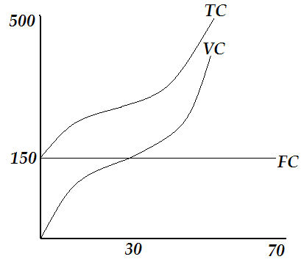

Note that:

FC is constant

VC is inverted S curve from the origin

TC is same as VC but starts at 150

The gap between TC & VC = FC = 150.

Why?

**Table 3.1**

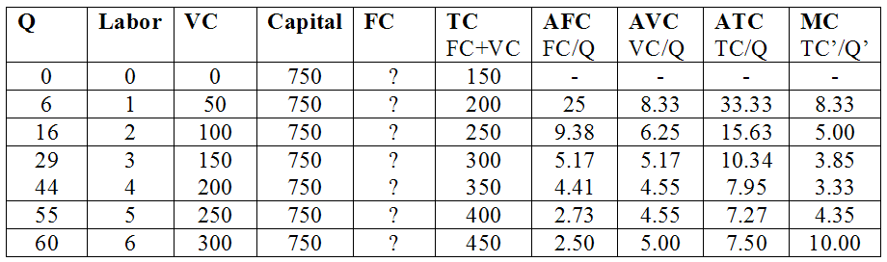

## Activity 2

Class Discussion

Revenues are earnings generated from the sale of a product or service and a measurement of Profitability. Supposing in a competitive market, Price P=10 and Quantity Q varies from 1 to 10.

1. What would be the total revenue (TR), the Average Revenue (AR), and Marginal Revenue (MR)? Note that marginal revenue is one additional revenue from one additional unit of a product or service sold.

**Fig 3.2: Revenue Types Relationships**

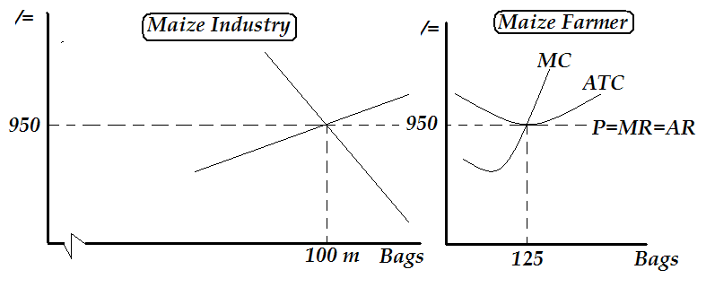

Please note that while the price P remained constant at 950, total revenues TR kept increasing at a constant rate of 950 per additional unit sold. In other words, marginal revenue MR remained constant at 950. Similarly, average revenue AR remained at 950 since on average, each additional unit sold contributed 950.

**Implications of the Curves**

Referring to figure 3.2 below, please note that price P is set at 950 in the maize industry’s supply and demand forces (such as in the figure on the left). Therefore, no one firm (such as in the figure on the right), can influence the price P which is represented by the line P=MR=AR and just tangent at the intersection of MC and ATC.

**Table 3.2: Revenue Types Relationships**

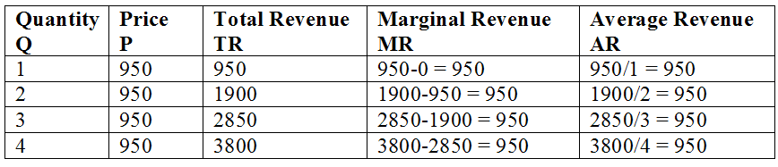

In this section, use PowerPoint or draw the table and figures on board to illustrate the relationships among the revenue types shown below.

It is evident from the table that profits are maximized when 3.74 units are produced with approximately TR=3550 and TC = 2850 and therefore economic profit TR-TC = 700. Note that this is an abnormal profit since it is above total explicit and implicit costs.

|  |  |  |  |  |
| --- | --- | --- | --- | --- |
| **Quantity**  **Q** | **Price**  **P** | **Total Revenue**  **TR** | **Total Cost**  **TC** | **Economic Profit**  **TR-TC** |
| 1 | 950 | 950 | 1450 | -500 |
| 2 | 950 | 1900 | 1900 | 0 |
| 3 | 950 | 2850 | 2450 | 400 |
| 3.74 | 950 | 3550 | 2850 | 700 |
| 4 | 950 | 3800 | 3800 | 0 |
| 5 | 950 | 4750 | 5250 | -500 |

**Profit Maximization**

In the market place, profit is maximized where the difference between TR and TC is widest.

Supposing the price P is 950 as discussed above and the total costs TC (explicit + implicit) are given as in table 3.3 below, we can determine the profit maximization level by increasing quantity from one unit onwards to see where the difference between TR and TC (or TR-TC) is widest.

**Table 3.3: Revenue Maximisation**

**Fig 3.3**

Please note that the yellow areas are the profit range while the red areas are the loss range. Profit is maximized where the yellow range is widest. Also note that at point sets where the red and yellow ranges meet, profit is zero and is referred to as a break-even point. A break-even is a situation where total revenue (TR) is equal to total cost TC.

Also note that the curve on the bottom part of figure 3.3 represents total revenues. The TR increases from negative to positive, reaching the highest point where profit is maximized and then declining back to negative.

This information can be represented graphically as shown in Figure 3.3 below derived from Table 3.3 above.

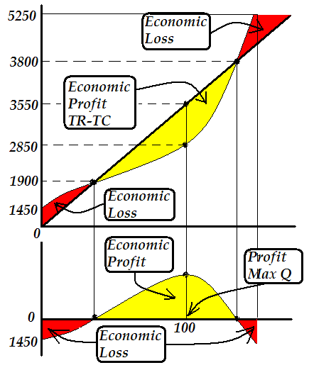



See the feedback section at the end of this lesson to see a completed table

Work in groups of four and discuss what will happen if:

1. Price per unit was 850.
2. Price per unit was 762.

(20 Minutes)

## Activity 2



Overall, it has been clear that each farmer who plans to transform their farm into a firm must account for all costs, both explicit and implicit. Implicit costs include resources owned by the farmer (including his or her own time and his or her own children’s time at market price) for which they would earn money if they sold to someone else. When all of these costs are accounted for, a farmer can make abnormal profits if the total revenues exceed total costs, normal profits if total revenues equal total costs and economic loss if total revenues are less than total costs.

For a competitive market, since the price per unit is set by the market (the farmer cannot affect it), the role of the farmer would be to strive to reduce the costs if they wanted to increase their profits.

1. **Lipsey, R.G. (1983),** *Introduction to Positive Economics*, English Language Book Society, Weidenfeld.
2. **McConnel, R.C., and Brue, S.L.**, *Economics: Principles, Problems and Policies*, McGraw-Hill, Toronto.
3. **Parkin, Michael, (1997),** *Microeconomics, 4th Ed.,* Addison-Wesley, New York

# References

# Conclusion

# Feedback

****

1. What would the annual total revenue for this business be?

TR= Q x P or 10 x 10,000 = 100,000

1. What would the annual total supplies or materials cost for this business be?

Your supplies or materials is the chicken feed which is = 50,000

1. What would the annual total labour cost for this business be?

Hired employee cost is 20,000

Value of your son’s labour is worth 20,000, like your employee.

Since he works only half time his labour cost is 10,000

Total labour cost of employee and son is therefore 30,000.

1. What would the annual total managerial cost for this business be?

Value of your work is the salary you gave up from your employer.

Therefore annual managerial cost is 20,000.

1. What would the annual total cost for this business be?

TC = hired cost + sons cost + managerial cost = 50,000

1. What would the annual accounting profit for this business be?

Accounting Profit is TR – Explicit Costs (hired labour and purchased supplies)

Therefore Accounting Profit = 100,000 – 70,000 (20,000 +50,000) = 30,000

1. What would the annual economic profit for this business be?

Economic Profit is TR – (Explicit Costs + Implicit Costs)

In this case, implicit cost is the sons labour cost and your managerial cost.

Therefore Economic Profit = 100,000 – 100,000 (70,000 + 30,000) = 0

1. What would the annual normal profit for this business be?

Normal profit is zero as above.

Should supplies have been 40,000, then abnormal profit would have been 10,000.

Should supplies have been 60,000, then economic profit would have been - 10,000.

## Feedback Activity 1

****

|  |  |  |  |  |
| --- | --- | --- | --- | --- |
| **Quantity**  **Q** | **Price**  **P** | **Total Revenue**  **TR** | **Total Cost**  **TC** | **Economic Profit**  **TR-TC** |
| 1 | 850 | 850 | 1450 | -600 |
| 2 | 850 | 1700 | 1900 | -200 |
| 3 | 850 | 2550 | 2450 | 100 |
| 3.74 | 850 | 3180 | 2850 | 330 |
| 4 | 850 | 3400 | 3800 | -400 |
| 5 | 850 | 4250 | 5250 | -1000 |

The table below represents the price of 950.

Notice that when the price declines to 850, while total costs stay the same, total revenues decline leading to decline in profits. Maximum profits (total abnormal profits) are now 330.

The table below represents the price of 762

Also notice that when the price declines to 762, while total costs stay the same, total revenues decline leading to decline in profits. Maximum profits (total normal profits) are now 0. This means the business can still continue to operate since the owner is able to pay off all explicit costs and also pay off implicit costs. In other words, the owner is able to pay him or herself exactly the same amount they would be paid if they worked for someone else.

|  |  |  |  |  |
| --- | --- | --- | --- | --- |
| **Quantity**  **Q** | **Price**  **P** | **Total Revenue**  **TR** | **Total Cost**  **TC** | **Economic Profit**  **TR-TC** |
| 1 | 762 | 762 | 1450 | -688 |
| 2 | 762 | 1524 | 1900 | -376 |
| 3 | 762 | 2286 | 2450 | -164 |
| 3.74 | 762 | 2850 | 2850 | 0 |
| 4 | 762 | 3048 | 3800 | -752 |
| 5 | 762 | 3810 | 5250 | -1440 |

## Feedback Activity 2

# Feedback