Unit 4: Fractions

Unit 4: Fractions 3
Introduction 3
Fractions and wholes: introductory concepts and activities 4
Further activities in the teaching of fractions 12
Equivalent fractions and comparison of fractions 22
Categories of the whole – a review of concepts and apparatus 30
Apparatus 33
Rational numbers 41
Unit summary 50
Assessment 51

© Saide, with the Wits School of Education, University of the Witwatersrand

Permission is granted under a Creative Commons Attribution licence to replicate, copy, distribute, transmit, or adapt this work freely provided that attribution is provided as illustrated in the citation below. To view a copy of this licence visit http://creativecommons.org/licences/by/3.0/ or send a letter to Creative Commons, 559 Nathan Abbott Way, Stanford, California, 94305, USA.

Citation
Sapire, I. (2010). Mathematics for Primary School Teachers. Saide and the Wits School of Education, University of the Witwatersrand, Johannesburg.
ISBN: 978-0-9869837-5-7

Saide
Fax: +27 11 4032813
E-mail: info@saide.org.za
Website: www.saide.org.za
P O Box 31822
Braamfontein
2017 Johannesburg
South Africa

Unit 4: Fractions

Introduction
Fraction concept is a part of number concept, since fractions are the numerals (symbols) for a group of numbers. But a fraction is no simple group of numbers.
Fractions can be used to express all rational numbers. This was discussed in Unit 2 of this course. Rational number concept involves an understanding of fractions which involves more than just the finding of parts of a whole. Learners need to be exposed to a range of activities and conceptual teaching on fractions as parts of wholes, ratios, decimals and percentages in order to develop fully their understanding of multiplicative reasoning and rational numbers.
Fraction numerals are written as a numerator over a denominator. In your numeration course we discussed the difference between a number and a numeral.

Reflection | Do you remember the difference between a number and a numeral?  How does this difference start to speak to you about the difference between knowing how to write a fraction numeral and knowing the numeric value of that numeral?

Upon completion of this unit you will be able to:
Outcomes | - Differentiate between continuous and discontinuous wholes.  - Demonstrate and explain the use of concrete wholes in the establishment of fraction concept in young learners.  - Illustrate and use language patterns in conjunction with concrete activities to extend the fraction concept of learners from that of  $\frac{1}{n}$ to $\frac{m}{n}$  - Identify improper fractions and be able to convert from proper to improper fractions and vice versa.  - Determine the rules for calculating equivalent fractions which are based on the equivalence of certain rational numbers.  - Compare different fractions to demonstrate an understanding of the relative sizes of different rational numbers.  - Describe the differences between the different forms that rational numbers can take on.

Fractions and wholes: introductory concepts and activities
Fractions can be used to represent numbers which are not whole numbers. As such, they are slightly more difficult to come to terms with than whole numbers.
The first two sections of this unit will look in a detailed manner at sound methods for the teaching of fractions to young learners. You should be able to follow these ideas and ensure that all of this information given is part of your own knowledge.
It is vital that all teachers of mathematics have a good concept of fractions themselves.
We need to ensure that the learners are given adequate exposure to a great enough variety of examples of fractions in concrete demonstrations, so that they are able to form their own abstract concept of what number the fraction numeral represents. So we will begin by looking at fractions as parts of concrete wholes and progress from there to more abstract working with fractions.
The first important thing we should stress is that we can find fractions of continuous and discontinuous wholes. These two types of wholes are not always given equal representation. We should not emphasise one more than the other or we risk giving an unbalanced idea of concrete wholes.
A continuous whole is a single item which is cut/folded/broken/divided up into parts of equal size in one way or another in order to find its fraction parts.
Examples of continuous wholes are: an orange, a piece of paper, a slab of chocolate, a circular disc, a loaf of bread etc.

Reflection | List five more of your own examples of continuous wholes.

A discontinuous whole is a group of items that together make up the whole. To find a fraction part of such a whole, we can divide it up into groups, each with the same number of items. We call such groups "equal-sized groups" or "groups of equal size". It is important that we always mention that the groups are equal in size to emphasise this aspect of the fraction parts of a whole.
Examples of discontinuous wholes are: 15 oranges, 6 biscuits, 27 counters, 4 new pencils, etc.

Reflection | List five more of your own examples of discontinuous wholes.

To assist the learners establish their fraction concept, we must use good language patterns consistently. It is thought that our language is linked to our thought, and so by talking about what they see, we help the learners to transfer what they see in the concrete demonstrations into their abstract thought. The language patterns that we are talking about are recorded below.
 | 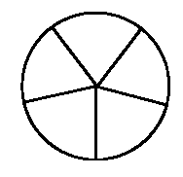 | 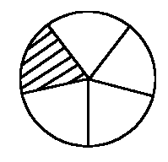
Whole | Whole divided up into  5 parts of equal size | $\frac{1}{5}$ of the whole shaded

Language patterns for a continuous whole
To find $\frac{1}{5}$ of my circular disc, I first divide the whole circular disc into 5 parts of equal size. Each part is $\frac{1}{5}$ of the whole, and if I shade one of these parts, I have shaded $\frac{1}{5}$ of the whole.
Example | Find $\frac{1}{8}$ of 32 counters  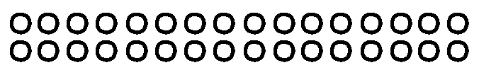  32 counters (shown above) represent the whole  I put my counters into 8 groups of equal size. There are four counters in each group.  One of the groups of equal size is $\frac{1}{8}$ of the whole.
Language patterns for a discontinuous whole
To find $\frac{1}{8}$ of 32 counters, I first divide the counters into 8 groups of equal size. I find eight groups with four counters in each group. Each group is $\frac{1}{8}$ of the whole, and so 4 counters is $\frac{1}{8}$ of 32 counters.

When you introduce fractions to learners, you will begin by finding unit fractions (as we have done above). A unit fraction is a fraction of the form $\frac{1}{n}$ – the numerator is one and the denominator can be any number. You must allow the learners to experiment with finding unit fractions of a broad variety of wholes. At the beginning you will restrict your discontinuous wholes according to the denominator.
For example, if the denominator is 6, you will only ask the learners to find fraction parts of 6 counters, or 12, 18, 24, etc. counters (multiples of 6). You must also remember to set them tasks involving unit wholes as well as discontinuous wholes.
Vary your apparatus as widely as you can. Use pieces of paper, string, sand, water, beads, counters, strips of paper, bottle tops – whatever is easily available.

Activity | Activity 4.1  Illustrate and record your solutions to the following questions:  - Find $\frac{1}{7}$ of the rectangle given below:  Record your language pattern.  - Find $\frac{1}{9}$ of 27 beads, as given below.  Record your language pattern.  - Now try these additional exercises (illustrate and give the language pattern each time):  - Find $\frac{1}{3}$ of 30 biscuits.  - Shade $\frac{1}{10}$ of a 15 cm-long strip of paper.  - Illustrate and explain how to find $\frac{1}{6}$ of a circular cake.  - Find $\frac{1}{4}$ of 20 beads.

You could turn some of your fraction finding into games or activities. In this way, you could keep the learners busy for slightly longer periods of time, while they are learning and discovering ideas in an interesting and enjoyable way.
Example | "Full House"  In this example, learners are given 20 counters. They must then try to find all the possible fraction parts that they can, of 20 counters. They could work in groups of two to four members (not more, as they would not have enough of a chance to express themselves). The discussion of the different fraction parts, could go on in the whole group. Once the group thinks that they have found all the possible fraction parts they can put up their hands and say "Full House!", to call you to come and check up on them. As a follow up, ask each learner to record in full and good language one of the fraction parts which they found. Try this activity out yourself!

Reflection | Look around for other ideas of games and activities, or make them up yourself and share them with your colleagues.  Record your ideas so that you don't forget them!

Once you are satisfied that your learners have established the general result:
$\frac{1}{n}$ of = ÷ , you can move on to finding non-unit fractions. We will discuss these in the next section.

Activity | Activity 4.2  What does $\frac{1}{n}$ of = ÷ mean to you? Give 2 examples, one of a continuous whole and one of a discontinuous whole. Illustrate each of your examples.

You should now be able to do all of the exercises in the activities that follow.

Activity |  | Activity 4.3  How many equal sized parts have the wholes below been divided into?
 | A |  |  |  |  | F | 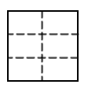 | I | 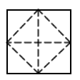
 | B |  |  |  |  | G | 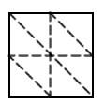 | J | 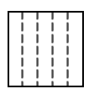
 | C
 | D |  |  |  |  | H | 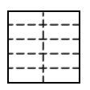 | K | 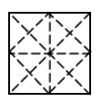
 | E

Activity |  | Activity 4.4  Identify what part of the whole has been shaded in each case.
 | A |  | F
 |  |  | G
 |  |  | H | 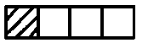
 | B |  | I
 |  |  | J
 |  |  | K
 | C |  | L
 |  |  | M
 | D
 | E | 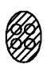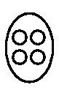

Activity |  | Activity 4.5  Shade the fraction part requested in each case.
 | A | $\frac{1}{8}$ | F | 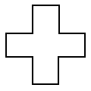$\frac{1}{2}$ | I | $\frac{3}{4}$
 | B | $\frac{1}{4}$ | G | 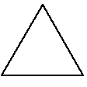$\frac{2}{3}$ | K | $\frac{1}{2}$ | N | $\frac{3}{4}$
 | C | $\frac{1}{2}$ | H | $\frac{1}{4}$ | L | $\frac{2}{3}$ | O | $\frac{5}{9}$
 | D | $\frac{1}{6}$ | I | 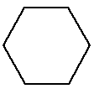$\frac{1}{2}$ | M | $\frac{2}{3}$ | P | $\frac{5}{6}$
 | E | 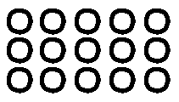$\frac{1}{5}$

Activity |  | Activity 4.6  Which of the following illustrations correctly give the fraction parts as indicated?
 |  | Halves?
 | A
 |  | Thirds? |  |  |  | Thirds?
 | C |  |  |  | B
 |  | Quarters? |  |  |  |  |  | Quarters?
 | E |  |  |  |  |  | D | 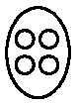
 |  | Halves? |  | Halves? |  |  |  | Halves? |  | Halves?
 | F | 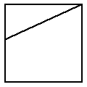 | G | 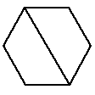 |  |  | H |  | I | 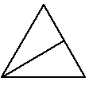
 |  | Thirds? |  | Thirds? |  |  |  | Thirds? |  | Thirds?
 | J | 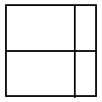 | K | 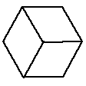 |  |  | L | 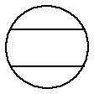 | M | 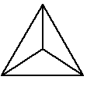
 |  | Quarters? |  | Quarters? |  |  |  | Quarters? |  | Quarters?
 | N | 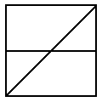 | O | 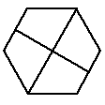 |  |  | P | 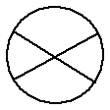 | Q | 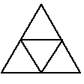

Further activities in the teaching of fractions
The activities described in the first topic would cover fractions work in the foundation phase. At the beginning of the intermediate phase, you would even spend time revising the idea of finding unit fractions of a variety of wholes. You could then move on to finding other fractions of the form where $n≠0$, that is, fractions where the numerator can be any number , and the denominator can be any number , except zero ($n≠0$).
At this point, let us establish that you are sure which of the numerals is the numerator and which is the denominator. We have already used these terms, but this is where you would introduce your learners to them.

Reflection | 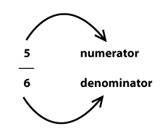  You must learn these names if you do not already know them. This is important terminology in the section of fractions. You could set exercises where the learners use the terminology repeatedly, to help them build the words into their regular speech. You could ask questions such as (try these yourselves):  Which numeral is missing in each fraction below? Fill it in and name it.  In the fractions below, double each denominator and add 5 to the numerator. Do you create a fraction that has the same value as the one you started off with?  - $\frac{2}{4}$  - $\frac{7}{3}$  - $\frac{15}{30}$  - $\frac{6}{7}$

You will now set tasks for your learners to find fraction parts of wholes, where the fraction is of the type $\frac{m}{n}$ where $n≠0$. This is purely an extension of the previous activities, where you found $\frac{1}{n}$ of a whole. The learners should not experience too many difficulties here if unit fractions have been grasped well. Study the examples below.

Example |  | Discontinuous whole: Find $\frac{3}{4}$ of 36 beads
 |  | The whole
 |  | The whole divided into quarters
 |  | 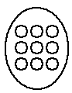
 |  | Three of the four groups (representing $\frac{3}{4}$ of 36) have been shaded
 |  | 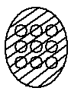
Language pattern
The whole is 36 beads. I divide the whole up into four groups of equal size in order to find quarters. There are 9 beads in each group. One group of 9 is $\frac{1}{4}$ of 36, and so 3 groups of 9 are $\frac{3}{4}$ of 36, i.e. 27 is $\frac{3}{4}$ of 36.

Example |  | Find $\frac{5}{6}$ of the square sheet of paper below.
 |  | The whole | The whole divided up into 6 parts of equal size |  | 5 of the 6 parts of equal size have been shaded. i.e. $\frac{5}{6}$ of the whole has been shaded
 |  |  | 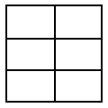 |  | 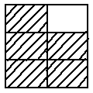
Language pattern
The whole is a square sheet of paper. I fold the whole up into six parts of equal size in order to find sixths. Each part is $\frac{1}{6}$of the whole, so 5 of the six equal sized parts is $\frac{5}{6}$ of the whole.

Activity | Activity 4.7  Try these examples on your own. Write out the full language pattern you would use in each case, so that you can check your own ability to talk fluently about the fraction parts you are finding.  - Illustrate $\frac{2}{3}$ of a pizza.  - Show how you find $\frac{2}{5}$ of 25 bricks.  - Shade $\frac{7}{12}$ of a rectangular sheet of paper.  - What is $\frac{8}{9}$ of 27 liquorice strips?

Until now we have only found fraction parts where the denominators relate to the number of units in the discontinuous wholes.
Now we look at a slightly more complex form of discontinuous wholes. Examine the following examples. Notice that the first examples relate to unit fractions, while the later examples relate to non-unit fractions.
Example | What is $\frac{1}{5}$ of 3 Tex bars?  The whole is 3 Tex bars: We cannot just hand out Tex bars because there are only 3 bars and we want to find fifths. What we do is the following:  Cut each Tex bar into 5 pieces of equal size. If you take $\frac{1}{5}$ from each of the 3 bars, you have found $\frac{1}{5}$ of each of the 3 bars. But what you have in your hand is actually $\frac{3}{5}$ of one Tex bar. So $\frac{1}{5}$ of 3 = $\frac{3}{5}$ of 1.  3 Tex Bars 1 Tex Bar
Example | Find $\frac{1}{7}$ of 2 Cokes.  The whole is 2 Cokes. We cannot just pour out the cokes because there are only 2 cokes and we want to find sevenths. What we do is the following:  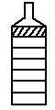  Pour $\frac{1}{7}$ from each Coke into a glass.  Each glass receives $\frac{1}{7}$ of a Coke from 2 Coke bottles, and so in total each glass receives $\frac{2}{7}$ of a Coke.  So $\frac{1}{7}$ of 2 = $\frac{2}{7}$ of 1.

Activity | Activity 4.8  - Find $\frac{3}{8}$ of 5, using the grid below to assist you.  Record your language pattern.  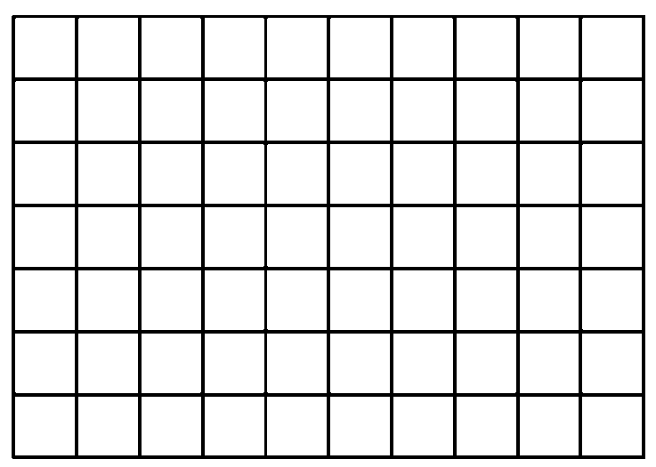  - Find $\frac{3}{4}$ of 9 cupcakes.  Record your language pattern.  (Each circle below represents one cupcake)  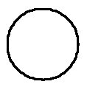  - Find $\frac{2}{5}$ of 8 strips of paper.  Use the grid paper below to assist you.  Record your language pattern.  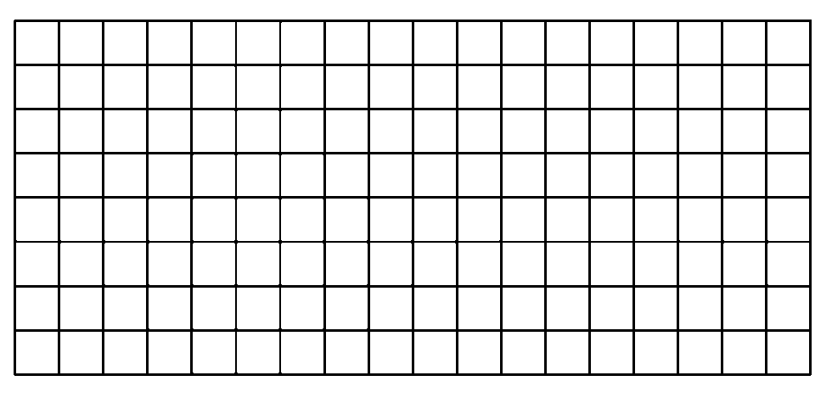  - Find $\frac{6}{7}$ of 2.  Use the grid paper below to assist you.  Record your language pattern alongside.  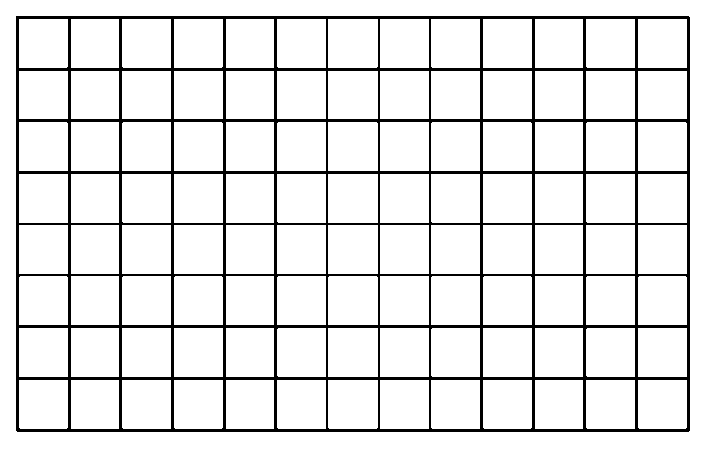

Activity | Activity 4.9  Make your own drawings or grids to illustrate your solutions.  - What is $\frac{2}{3}$ of 5 pizzas?  - Find $\frac{4}{5}$ of 3 chocolate slabs.  - Use grid paper to illustrate how to find $\frac{5}{6}$ of 8.  - Use grid paper to illustrate how to find $\frac{2}{9}$ of 4.  - Use grid paper to illustrate how to find $\frac{7}{10}$ of 12.  - Use grid paper to illustrate how to find $\frac{3}{5}$ of 4.
You must allow your learners ample chance to come to terms with the type of examples we have done above. They often find it quite tricky. Be sure that you feel completely comfortable with illustrating and explaining the solution to questions like those above. In general terms, the idea that we have established is stated as $\frac{1}{n}$ of m = $\frac{m}{n}$ of 1.
Give your own numeric contextualised example of a question involving the idea that
$\frac{1}{n}$ of m = $\frac{m}{n}$ of 1.
At this stage we have covered the finding of fractions of many different wholes. We will begin to hope that our learners are starting to think of fractions also as numerals for numbers, and have started to recognise certain fractions which look different but which actually represent the same number (such as $\frac{1}{2}$and $\frac{2}{4}$). The last thing we need to cover in this introductory section is a little more terminology, relating to types of fractions.
We call fractions which have the same denominators like fractions.
For example $\frac{3}{7}$, $\frac{6}{7}$, $\frac{7}{12}$ have 7 as their denominator.

Activity | Activity 4.10  Give 5 other fractions which are like to the given fraction  - $\frac{ 4}{15}$  - $\frac{13}{23}$

Example | $\frac{4}{7}$, $\frac{15}{18}$, $\frac{2}{9}$, $\frac{3}{8}$ are proper fractions

Reflection | Give your own 6 examples of proper fractions.

When the numerator of a fraction is bigger than the denominator of a fraction, the fraction is called an improper fraction.

Example | $\frac{14}{7}$, $\frac{15}{8}$, $\frac{22}{9}$, $\frac{3}{2}$ are improper fractions

Activity | Activity 4.11  - Give your own 6 examples of improper fractions.  - Can you change a proper fraction into an improper fraction, and if so, how do you do this?  - Are like fractions equal in number?  - Are the fractions such as $\frac{2}{2}$, $\frac{4}{4}$, $\frac{5}{5}$ and $\frac{18}{18}$ proper or improper fractions?

Equivalent fractions and comparison of fractions

Equivalent fractions
Your learners will already have begun to notice certain equivalent fractions before you consciously introduce the topic in class. They might have begun to say things to you like "but $\frac{2}{4}$ is the same as $\frac{1}{2}$". You should encourage this early observation. You could possibly even comment that they have noticed an important quality that you will examine later in more detail.
Let us now look at equivalent fractions using concrete wholes. (As usual, we first use concrete wholes before we work with purely numeric examples.)

Equivalence of fractions using a continuous whole
Try the following activity yourself as you read through the instructions and follow the illustrations.

Activity |  | Activity 4.12  - Take 5 pieces of paper that are the same size. Fold each of them into thirds, as illustrated below:
 |  | 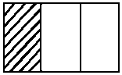
 |  | A | B | C | D | E
 |  | - Shade in the first third on each piece of paper. Now fold pieces B, C, D and E as indicated below:
 |  |  | 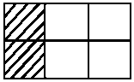 | 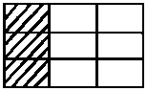 | 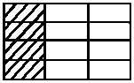 | 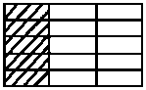
 |  | A | B | C | D | E
 |  | - What fraction of each piece of paper has been shaded?

Discussion | The fraction represented by the shaded part on each piece of paper is the following:  A $\frac{1}{3}$ is shaded  B $\frac{2}{6}$ is shaded  C $\frac{3}{9}$ is shaded  D $\frac{4}{12}$ is shaded  E $\frac{5}{15}$ is shaded  All of these fractions have the same value ( $\frac{1}{3}$ ) although they are written in different ways with different fraction numerals.

Reflection | You know that the shaded part of each piece of paper in Activity 4.12 is the same size. You can verify this for yourself by putting all of the pieces of paper on top of each other. So although we name each shaded part differently, these names (the fraction numeral) represent the SAME AMOUNT. We call these fractions equivalent fractions. (They are different numerals which represent the same number.) We can equate these equivalent fractions and discover a numeric rule to find other such equivalent fractions.  $\frac{1}{3}$ = $\frac{2}{6}$ = $\frac{3}{9}$ = $\frac{4}{12}$ = $\frac{5}{15}$

Examine the numerators and denominators of the fractions above, to see if you can identify a rule for the relationship between equivalent fractions.
You' should notice something similar between the relationships indicated below.
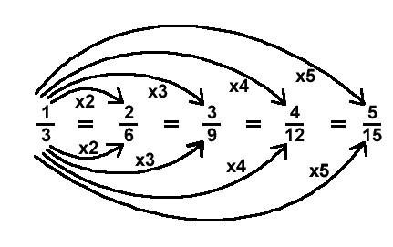
From this we can see that if you multiply the numerator by a number, and then multiply the denominator by the same number, you will generate an equivalent fraction.

Equivalence of fractions using a discontinuous whole
Once again you should try this activity out for yourself, as you read through the instructions and follow the illustrations.

Activity | Activity 4.13  - Take 24 counters. This is the whole. Each single counter represents $\frac{1}{24}$ of the whole.  - Now put the counters into pairs. You should get 12 pairs.  Each pair of counters represents $\frac{1}{12}$ of the whole.  - Now put the counters into threes. You should get 8 threes. Each group of three counters represents $\frac{1}{8}$ of the whole.  - Now, regroup the counters into fours. You should get 6 fours. Each group of four counters represents $\frac{1}{6}$ of the whole.  - Similarly, group the counters into sixes, eights and twelves.  - How many groups of six do you find?  - Each group of six is therefore what fraction of the whole?  - How many groups of eight do you find?  - Each group of eight is therefore what fraction of the whole?  - How many groups of twelve do you find?  - Each group of twelve is therefore what fraction of the whole?

Reflection | So we have found that:  12 counters out of 24 counters is $\frac{1}{2}$ of the whole  12 counters out of 24 counters is also $\frac{2}{4}$ of the whole  12 counters out of 24 counters is also $\frac{3}{6}$ of the whole  12 counters out of 24 counters is also $\frac{4}{8}$ of the whole  12 counters out of 24 counters is also $\frac{6}{12}$ of the whole  12 counters out of 24 counters is also $\frac{12}{24}$ of the whole  In this way we have found some more equivalent fractions. We can equate them as follows, since they all represent the same number:  $\frac{12}{24} = \frac{6}{12} = \frac{4}{8} = \frac{3}{6} = \frac{2}{4} = \frac{1}{2}$

Once again we can examine the numerators and the denominators in the above fractions to look for a relationship between them.
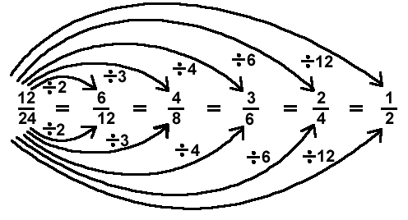
This gives us the other general rule for finding equivalent fractions, which is that if you divide the numerator by one number, you divide the denominator by the same number in order to find an equivalent fraction.

Reflection | What is wrong with the rule that many people state for finding equivalent fractions? They state that to find equivalent fractions "what you do to the top, you do to the bottom".  Rephrase this general rule differently, in a more mathematically correct way.

You should now be able to recognise, name and work with equivalent fractions.
Equivalent fractions come in particularly handy when we add and subtract fractions, as you will see later. Try the following exercises (look for more in school textbooks):

Activity | Activity 4.14  - Give four fractions which are equivalent to $\frac{3}{8}$ .  - Give four fractions which are equivalent to $\frac{54}{60}$.  - Complete the following by filling in the missing numbers:  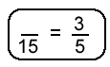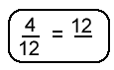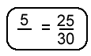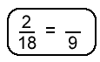  - There is one further term that comes up in this context: What do we mean by a fraction that is in "lowest terms"? In the list of fractions below, identify the ones that are in lowest terms:  $\frac{4}{16}$ $\frac{3}{7}$ $\frac{2}{6}$ $\frac{5}{15}$ $\frac{8}{21}$ $\frac{1}{2}$ $\frac{35}{20}$  - What made you choose the ones that you chose?

A fraction is in lowest terms when there is no common factor other than the number 1 for the numerator and the denominator.

Comparing Fractions
It is natural to compare whether or not certain numbers represent more or less than other numbers. When we do so for fractions, this process is sometimes fairly involved. We can start by comparing fractions using concrete wholes, and then move onto the purely numeric examples.
When we compare fractions, we often ask or need to find out "which one is greater and by how much?" The solution to this is not always as clearly evident as it is in whole number questions.
Example | Here is an example of the comparison of $\frac{2}{3}$ and $\frac{3}{4}$, using a concrete whole. Let 12 counters be our whole (so we are using a discontinuous whole):  The whole  $\frac{2}{3}$ of 12 is 8  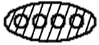  $\frac{3}{4}$ of 12 is 9  So $\frac{3}{4}$ is greater than $\frac{2}{3}$ by one counter.  But what is the value of one counter? If there are 12 counters in the whole, then one counter is $\frac{1}{12}$ of the whole. We can thus say that $\frac{3}{4}$ is greater than $\frac{2}{3}$ by $\frac{1}{12}$.

Let us now compare $\frac{1}{3}$ and $\frac{1}{2}$, using a continuous whole.
Let the circular disk below be the whole:

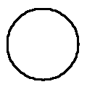 | 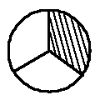 | 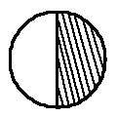
Whole | Thirds  $\frac{1}{3}$ is shaded | Halves  $\frac{1}{2}$ is shaded

Reflection | Which one is greater?  By how much?

To answer the "by how much" question properly, we need to cut the whole up into smaller parts. Examine the drawings below:

 | 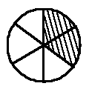 | 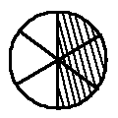
Whole | Thirds  $\frac{1}{3}$ is shaded  $\frac{2}{6}$ is shaded | Halves  $\frac{1}{2}$ is shaded  $\frac{3}{6}$ is shaded

From this illustration is becomes clear that $\frac{1}{2}$ is greater than $\frac{1}{3}$ by $\frac{1}{6}$.
Find out which is greater, $\frac{2}{3}$ or $\frac{3}{5}$ and by how much, using a concrete whole.

Comparing fractions using equivalent fractions
If you look closely at the numerals involved in the comparisons above, you will see that our concrete working simply leads us to finding equivalent fractions when we want to say how much bigger the one fraction is than the other. Once we are familiar with equivalent fractions, we can do simple numeric conversions to compare fractions. You should be able to answer questions like the ones below on your own by now.

Activity | Activity 4.15  Compare the following pairs of fractions, stating which one is greater and by how much.  The first one has been done for you:  - $\frac{4}{7}$ and $\frac{3}{4}$  $\frac{4}{7} × \frac{4}{4} = \frac{16}{28}$ $\frac{3}{4} × \frac{7}{7} = \frac{21}{28}$ $∴ \frac{3}{4} > \frac{4}{7} by \frac{5}{28}$  - $\frac{5}{30}$ and $\frac{2}{3}$  - $\frac{6}{25}$ and $\frac{2}{10}$

Once the topic of decimals has been covered, you can also convert to the decimal form of the fraction in order to find relative values of different given numbers. To do so, you could use equivalent fractions (convert to decimal fractions) or you could simply use a calculator. We can use a calculator when the conversion to decimal form is too complicated for us to waste time on it manually. Here are some examples (you should make up some other examples like these for yourself once you have completed these two):

Activity | Activity 4.16  - Compare $\frac{23}{25}$ and $\frac{47}{50}$ using decimal fractions and hence decimals:  $\frac{23}{25} × \frac{4}{4} = \frac{92}{100}=0,92$  $\frac{47}{50} = \frac{94}{100} = 0,94$  $∴ \frac{23}{25} < \frac{47}{50} by 0,02$  - Compare $\frac{34}{37}$and $\frac{39}{43}$ using a calculator  $\frac{34}{37} ≈ 0,919$  $\frac{39}{43} ≈ 0,907$  $∴ \frac{34}{37} > \frac{39}{43}$ by approximately 0,12  ($≈$ means approximately equal to)  - Compare using decimals:  - $\frac{13}{17} and \frac{21}{25}$.  - $\frac{3}{10} and \frac{24}{50}.$  - $\frac{5}{7} and \frac{3}{4}$  - $\frac{19}{25} and \frac{17}{20}$

Categories of the whole – a review of concepts and apparatus
In the first three sections of this unit we looked at finding fractions of different wholes and there we found equivalent fractions and compared different fractions using both concrete wholes and numeric algorithms. As we progressed through this unit, we used different types of wholes, though we just referred to them as different types of continuous and discontinuous wholes. We can name these different types of wholes according to several categories. You need to know these categories and be sure to expose your learners to all of them, in a logical sequence of ever-increasing difficulty.
The categories are listed in order of complexity. The examples are all left for you to solve, as a revision of work we have already done.

Category 1: Continuous
The unit whole. All wholes which consist of a single item fall into this category. To find a fraction part of a unit whole, we have to cut/fold/break, etc. because the whole is a single thing.

Reflection | Find $\frac{4}{7}$ of an apple pie. Illustrate and explain your solution.  Whole

Category 2: Discontinuous (made of more than one item)
The whole consists of more than one unit, but the number of units is limited to the same number as the denominator. It is thus made up of more that one item and is a discontinuous whole.

Reflection | Find $\frac{5}{8}$ of 8 Crunchie bars. Illustrate and explain your solution.

Category 3: Discontinuous (made of more than one item)
The whole consists of more that one unit, but the whole is always a multiple of the denominator. This is also made up of more than one unit and so it is a discontinuous whole.

Reflection | Find $\frac{1}{6}$ of 24 Cadbury's Chocolate Eclair sweets. Illustrate and explain your solution.

Category 4: Discontinuous (made of more than one item)
The whole consists of more than one unit, but less than the number of units in the denominator.
This is also a multiple unit whole, and so it is a discontinuous whole.

Reflection | Find $\frac{3}{4}$ of 3 slabs of chocolate. Illustrate and explain your solution.

Category 5: Discontinuous (made of more than one item)
The whole consists of more than one unit, and more than the number in the denominator. This is another discontinuous whole.

Reflection | Find $\frac{2}{3}$ of 10 pieces of bread. Illustrate and explain your solution.

Apparatus
When we draw examples and imagine using apparatus, it is often very useful to refer to food items to make up our wholes. Where we want to use actual concrete apparatus, it is not such a good idea to use food. We now discuss other concrete apparatus that you can use in your class.
For discontinuous wholes we use counters of whichever type are readily available, such as bottle tops, beans (which can be spray-painted in different colours), discs, etc. Depending on how many counters you need in the whole, you use them in various numbers. You have seen several examples of working done with counters in the various categories of the whole.
Scrap paper can very successfully be used for unit wholes, as it can be folded, cut and coloured according to instructions relating to different fraction activities – but if you want to make something more durable, you can make a "fraction kit", as described below.
Fraction kit
To make this kit you need 7 squares of cardboard, 24 cm x 24 cm.
You need to mark and cut the parts very accurately as indicated, so that your apparatus is useful in the teaching of fractions as like parts of a whole. Measure, label and cut the 7 pieces of cardboard as follows: If you have different colours of cardboard, this makes an even nicer apparatus, but this is not essential. (Paint or colour them if you want to.) Don't use cardboard that is too soft, as it will bend and be torn easily.

Whole  24 cm x 24 cm | $\frac{1}{12}$ each  2 cm wide strips | $\frac{1}{8}$ each  3 cm wide strips | $\frac{1}{6}$ each  4 cm wide strips
$\frac{1}{4}$ each  6 cm wide strips | $\frac{1}{3}$ each  8 cm wide strips | $\frac{1}{2}$ each  12 cm wide strips

You will cut the strips as indicated, so that you can use them to demonstrate different fractions fitting into each other (equivalent fractions). You can also allow the learners to manipulate the apparatus. Make sure that you always pack the whole kit safely into a box or bag so that no pieces get lost, and keep them flat so that they don't get bent. Here are some examples of activities you could work on using your kit.

Reflection | Find out which fractions in your kit can make equivalent fractions for a half.  How many twelfths are there in $\frac{1}{4}$ ? Lay out the necessary pieces from the fraction kit to demonstrate the answer. Illustrate this.

Fraction wall
This is less flexible than a fraction kit because you draw a fraction wall on a chart and don't cut it up. But fraction walls are very useful in work on fraction parts and equivalent fractions. It is easy to make several fraction walls of related groups of fractions, because you do not need so much cardboard for each wall. They can also be used to demonstrate more than one fraction kit is able to do. The fraction walls illustrated below would be useful as aids in a classroom. You could put them up as charts on the wall (for permanent display) and refer to them when necessary. Or you could bring them out when you work on equivalent fractions and the operations with fractions. These charts have been drawn so that you could photocopy them and use them, if you have the facilities and would like to do so.
$$\frac{1}{10}$$ | $$\frac{1}{10}$$ | $$\frac{1}{10}$$ | $$\frac{1}{10}$$ | $$\frac{1}{10}$$ | $$\frac{1}{10}$$ | $$\frac{1}{10}$$ | $$\frac{1}{10}$$ | $$\frac{1}{10}$$ | $$\frac{1}{10}$$
$$\frac{1}{5}$$ |  | $$\frac{1}{5}$$ |  | $$\frac{1}{5}$$ |  | $$\frac{1}{5}$$ |  | $$\frac{1}{5}$$
$$\frac{1}{2}$$ |  |  |  |  | $$\frac{1}{2}$$
Whole

$$\frac{1}{24}$$ | $$\frac{1}{24}$$ | $$\frac{1}{24}$$ | $$\frac{1}{24}$$ | $$\frac{1}{24}$$ | $$\frac{1}{24}$$ | $$\frac{1}{24}$$ | $$\frac{1}{24}$$ | $$\frac{1}{24}$$ | $$\frac{1}{24}$$ | $$\frac{1}{24}$$ | $$\frac{1}{24}$$ | $$\frac{1}{24}$$ | $$\frac{1}{24}$$ | $$\frac{1}{24}$$ | $$\frac{1}{24}$$ | $$\frac{1}{24}$$ | $$\frac{1}{24}$$ | $$\frac{1}{24}$$ | $$\frac{1}{24}$$ | $$\frac{1}{24}$$ | $$\frac{1}{24}$$ | $$\frac{1}{24}$$ | $$\frac{1}{24}$$
$$\frac{1}{12}$$ |  | $$\frac{1}{12}$$ |  | $$\frac{1}{12}$$ |  | $$\frac{1}{12}$$ |  | $$\frac{1}{12}$$ |  | $$\frac{1}{12}$$ |  | $$\frac{1}{12}$$ |  | $$\frac{1}{12}$$ |  | $$\frac{1}{12}$$ |  | $$\frac{1}{12}$$ |  | $$\frac{1}{12}$$ |  | $$\frac{1}{12}$$
$$\frac{1}{8}$$ |  |  | $$\frac{1}{8}$$ |  |  | $$\frac{1}{8}$$ |  |  | $$\frac{1}{8}$$ |  |  | $$\frac{1}{8}$$ |  |  | $$\frac{1}{8}$$ |  |  | $$\frac{1}{8}$$ |  |  | $$\frac{1}{8}$$
$$\frac{1}{6}$$ |  |  |  | $$\frac{1}{6}$$ |  |  |  | $$\frac{1}{6}$$ |  |  |  | $$\frac{1}{6}$$ |  |  |  | $$\frac{1}{6}$$ |  |  |  | $$\frac{1}{6}$$
$$\frac{1}{4}$$ |  |  |  |  |  | $$\frac{1}{4}$$ |  |  |  |  |  | $$\frac{1}{4}$$ |  |  |  |  |  | $$\frac{1}{4}$$
$$\frac{1}{3}$$ |  |  |  |  |  |  |  | $$\frac{1}{3}$$ |  |  |  |  |  |  |  | $$\frac{1}{3}$$
$$\frac{1}{2}$$ |  |  |  |  |  |  |  |  |  |  |  | $$\frac{1}{2}$$
Whole

$$\frac{1}{18}$$ | $$\frac{1}{18}$$ | $$\frac{1}{18}$$ | $$\frac{1}{18}$$ | $$\frac{1}{18}$$ | $$\frac{1}{18}$$ | $$\frac{1}{18}$$ | $$\frac{1}{18}$$ | $$\frac{1}{18}$$ | $$\frac{1}{18}$$ | $$\frac{1}{18}$$ | $$\frac{1}{18}$$ | $$\frac{1}{18}$$ | $$\frac{1}{18}$$ | $$\frac{1}{18}$$ | $$\frac{1}{18}$$ | $$\frac{1}{18}$$ | $$\frac{1}{18}$$
$$\frac{1}{9}$$ |  | $$\frac{1}{9}$$ |  | $$\frac{1}{9}$$ |  | $$\frac{1}{9}$$ |  | $$\frac{1}{9}$$ |  | $$\frac{1}{9}$$ |  | $$\frac{1}{9}$$ |  | $$\frac{1}{9}$$ |  | $$\frac{1}{9}$$
$$\frac{1}{6}$$ |  |  | $$\frac{1}{6}$$ |  |  | $$\frac{1}{6}$$ |  |  | $$\frac{1}{6}$$ |  |  | $$\frac{1}{6}$$ |  |  | $$\frac{1}{6}$$
$$\frac{1}{3}$$ |  |  |  |  |  | $$\frac{1}{3}$$ |  |  |  |  |  | $$\frac{1}{3}$$
Whole

Quad paper or grid paper
This is an area marked into squares of equal size.

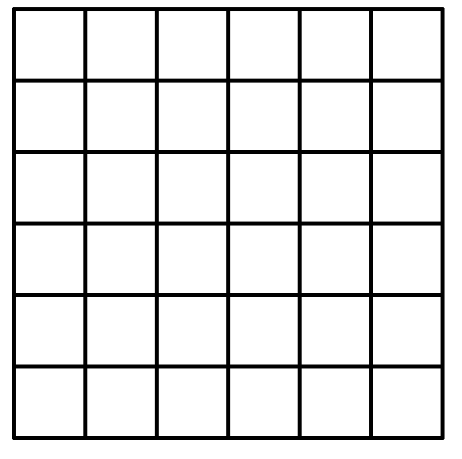

The squares can readily be used to draw up unit wholes of different convenient sizes, depending on the fractions you are working on. Your learners will become very good at choosing a useful unit size if you do a lot of work using quad paper. Here are some examples of solutions using quad paper, followed by some examples for you to try:

Illustrate the finding of $\frac{8}{3}$ using quad paper:
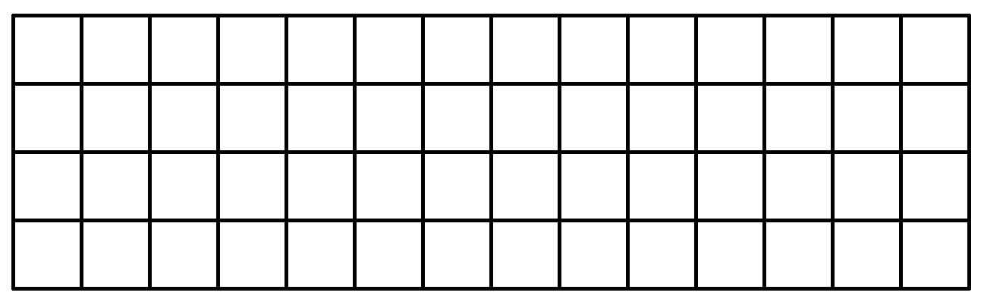

Choose a whole that is 3 blocks long so that it is easy to find thirds.

Draw a table that shows that $\frac{5}{10}=\frac{1}{2}$ using quad paper: Choose a whole that is 10 blocks long so that you can divide it into tenths and halves.

Activity | Activity 4.17  - Illustrate and explain how to find the following fractions using quad paper:  - $\frac{1}{8}$  - $\frac{3}{5}$  - $\frac{2}{9}$  - $\frac{1}{2}$  - $\frac{7}{10}$  - Find $\frac{1}{4}$ of 7 using quad paper.  - Find $\frac{2}{7}$ of 3 using quad paper.  - Illustrate the equivalence of $\frac{2}{3}$, $\frac{4}{6}$ and $\frac{8}{12}$ using quad paper.

Number lines
Number lines are not concrete apparatus in the sense that the apparatus discussed above is. They are more abstract and assist us to check that the learners are beginning to grasp the number concept involved in the fraction work which we have done. Number lines can be drawn and reproduced very easily and are a must in your teaching of fractions. You need to be sure that you (and your learners) are able to plot any fractions on a number line. You need to know how to choose the correct scale for number lines which are not already marked for you.
Consider the following examples:
Example | Plot $\frac{1}{2}$, $\frac{3}{8}$, $\frac{3}{4}$ and $\frac{9}{8}$ on the same number line.  We look at the denominators to assist us in choosing a good scale. They are 2, 4 and 8, and so we will choose 8cm to represent one unit. Then  1cm = $\frac{1}{8}$ and 2cm = $\frac{1}{4}$, etc. Look at the number line below.  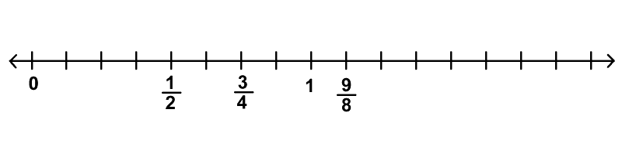

Example | Plot $\frac{2}{7}$, $\frac{5}{14}$, 1, $\frac{13}{14}$, $\frac{15}{14}$, $\frac{14}{14}$, $\frac{5}{7}$ and $\frac{8}{7}$ on the same number line.  The denominators are 7 and 14, so we choose 14cm to represent one unit. Then 1cm = $\frac{1}{14}$, etc.  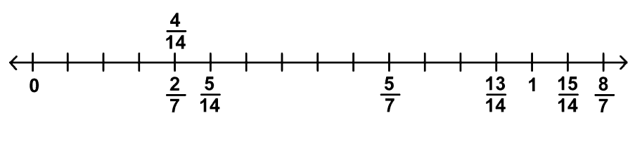

Activity | Activity 4.18  Now try the following on your own. Think carefully about your choice of scale before you begin:  - Plot $\frac{2}{6}$, $\frac{2}{3}$, $\frac{3}{3}$, $\frac{5}{6}$, $\frac{7}{6}$, $\frac{4}{3}$ on the same number line.  - Plot $\frac{1}{2}$, $\frac{2}{5}$, $\frac{7}{10}$, $\frac{11}{10}$, $\frac{6}{5}$, $\frac{3}{10}$, $\frac{4}{5}$ on the same number line.  - Plot $\frac{2}{3}$, $\frac{2}{3}$, $\frac{5}{6}$, $\frac{6}{5}$, $\frac{5}{3}$, $\frac{1}{6}$ on the same number line.

Here is a grid for you to print and copy to use when necessary

Rational numbers
We have spoken about fractions as the numerals for numbers several times in this module. In this unit, we name those numbers: They are the RATIONAL NUMBERS. The symbol for rational numbers is Q. When we studied numeration, there was a unit on the number systems. If you look back at that unit, you will see where the rational numbers fit into our numeration system. In this unit we will look more closely at the rational numbers, and our work with those numbers.
You might recall that we were unable to list the set of rational numbers in the way in which we were able to list, for example, the natural numbers and the integers. We had to use set notation, and described the set like this
Q = {/ a Z and b Z; b 0}
This tells us that rational numbers are represented by numerals of the fraction form $\frac{a}{b}$ where the numerator a Z and denominator b Z; b 0. (i.e. a and b are both integers (positive or negative whole numbers), but b, the denominator is not allowed to be equal to zero (b 0).

Reflection | 0?

Rational numbers give the solution to the question a ÷ b, since, as we have seen in this unit,
$\frac{a}{b}$ = a ÷ b
In unit 3 we studied equivalent fractions. Here we saw that several different fraction numerals can represent exactly the same number.

Example | For example $\frac{15}{20}$, $\frac{60}{80}$, $\frac{24}{32}$ are all different ways of writing $\frac{3}{4}$.
Because of this possibility in the field of fractions, we say that a rational number has many names.
Reflection | What does it mean to say "a rational number has many names"? Give an example to illustrate what you say.

Activity | Activity 4.19  In the table below, several fraction numerals represent the same rational number.  $$÷$$ 0 1 2 3 4 5 6 7 8 9 10  0 0 $$\frac{0}{1}$$ $$\frac{0}{2}$$ $$\frac{0}{3}$$ $$\frac{0}{4}$$ $$\frac{0}{5}$$ $$\frac{0}{6}$$ $$\frac{0}{7}$$ $$\frac{0}{8}$$ $$\frac{0}{9}$$ $$\frac{0}{10}$$  1 $$\frac{1}{0}$$ $$\frac{1}{1}$$ $$\frac{1}{2}$$ $$\frac{1}{3}$$ $$\frac{1}{4}$$ $$\frac{1}{5}$$ $$\frac{1}{6}$$ $$\frac{1}{7}$$ $$\frac{1}{8}$$ $$\frac{1}{9}$$ $$\frac{1}{10}$$  2 $$\frac{2}{0}$$ $$\frac{2}{1}$$ $$\frac{2}{2}$$ $$\frac{2}{3}$$ $$\frac{2}{4}$$ $$\frac{2}{5}$$ $$\frac{2}{6}$$ $$\frac{2}{7}$$ $$\frac{2}{8}$$ $$\frac{2}{9}$$ $$\frac{2}{10}$$  3 $$\frac{3}{0}$$ $$\frac{3}{1}$$ $$\frac{3}{2}$$ $$\frac{3}{3}$$ $$\frac{3}{4}$$ $$\frac{3}{5}$$ $$\frac{3}{6}$$ $$\frac{3}{7}$$ $$\frac{3}{8}$$ $$\frac{3}{9}$$ $$\frac{3}{10}$$  4 $$\frac{4}{0}$$ $$\frac{4}{1}$$ $$\frac{4}{2}$$ $$\frac{4}{3}$$ $$\frac{4}{4}$$ $$\frac{4}{5}$$ $$\frac{4}{6}$$ $$\frac{4}{7}$$ $$\frac{4}{8}$$ $$\frac{4}{9}$$ $$\frac{4}{10}$$  5 $$\frac{5}{0}$$ $$5$$ $$\frac{5}{2}$$ $$\frac{5}{3}$$ $$\frac{5}{4}$$ $$\frac{5}{5}$$ $$\frac{5}{6}$$ $$\frac{5}{7}$$ $$\frac{5}{8}$$ $$\frac{5}{9}$$ $$\frac{5}{10}$$  6 $$\frac{6}{0}$$ $$\frac{6}{1}$$ $$\frac{6}{2}$$ $$\frac{6}{3}$$ $$\frac{6}{4}$$ $$\frac{6}{5}$$ $$\frac{6}{6}$$ $$\frac{6}{7}$$ $$\frac{6}{8}$$ $$\frac{6}{9}$$ $$\frac{6}{10}$$  7 $$\frac{7}{0}$$ $$\frac{7}{1}$$ $$\frac{7}{2}$$ $$\frac{7}{3}$$ $$\frac{7}{4}$$ $$\frac{7}{5}$$ $$\frac{7}{6}$$ $$\frac{7}{7}$$ $$\frac{7}{8}$$ $$\frac{7}{9}$$ $$\frac{7}{10}$$  8 $$\frac{8}{0}$$ $$\frac{8}{1}$$ $$\frac{8}{2}$$ $$\frac{8}{3}$$ $$\frac{8}{4}$$ $$\frac{8}{5}$$ $$\frac{8}{6}$$ $$\frac{8}{7}$$ $$\frac{8}{8}$$ $$\frac{8}{9}$$ $$\frac{8}{10}$$  9 $$\frac{9}{0}$$ $$\frac{9}{1}$$ $$\frac{9}{2}$$ $$\frac{9}{3}$$ $$\frac{9}{4}$$ $$\frac{9}{5}$$ $$\frac{9}{6}$$ $$\frac{9}{7}$$ $$\frac{9}{8}$$ $$\frac{9}{9}$$ $$\frac{9}{10}$$  10 $$\frac{10}{0}$$ $$\frac{10}{1}$$ $$\frac{10}{2}$$ $$\frac{10}{3}$$ $$\frac{10}{4}$$ $$\frac{10}{5}$$ $$\frac{10}{6}$$ $$\frac{10}{7}$$ $$\frac{10}{8}$$ $$\frac{10}{9}$$ $$\frac{10}{10}$$  How many different rational numbers are recorded in the table?  Find out by eliminating all the equivalent fractions and all numbers that are not rational. The table is a grid of division facts.  How many different rational numbers are there on the table?
When you do exercises with equivalent fractions, you are working with rational numbers which are the same but have different names.
We have often emphasised the importance of using number lines in our teaching. In our fraction work, we can get the learners to plot different fractions onto number lines. This can be very revealing in terms of the learners' actual understanding of the relative size (or amount) that each fraction represents. If you (or your learners) are unable to plot numbers on number lines, you need to spend more time thinking about how to do it and practise doing it.

Reflection | When you plot fractions on the number line, you might have found that you need to name the same point on the number line more than once. When did this need arise?

We say that each rational number has a single point at which it can be found on a number line. This means that if we are asked to plot equivalent fractions, because these fractions represent the same number, they will all be plotted at the same point. So some points may have just one name, while others have several names.
Let us plot 1, $\frac{2}{3}$, $\frac{4}{3}$, $\frac{4}{6}$, $\frac{3}{3}$, $\frac{5}{6}$, $\frac{6}{6}$ and $\frac{2}{6}$ on a number line.
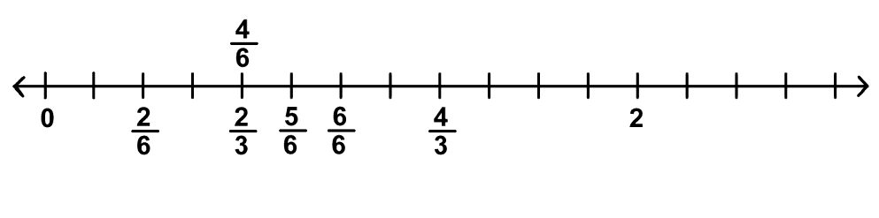

Reflection | How many different rational numbers did we plot on the number line above?

Many people experience difficulty in plotting fractions on number lines. Here are two more examples for you to try. Choose a good scale before you label the number line. This is vital if you are to plot the points correctly.

Activity | Activity 4.20  - Plot $\frac{1}{4}$, $\frac{6}{8}$, $\frac{9}{8}$, 1, $\frac{3}{4}$, $\frac{4}{4}$, $\frac{2}{8}$, $\frac{3}{8}$ on the number line below.  - Plot $\frac{1}{10}$, $\frac{2}{5}$, $\frac{11}{10}$, $\frac{8}{10}$, $\frac{12}{10}$, $\frac{5}{5}$ on the number line below.

Reciprocals
The reciprocal of a fraction is what you find if you invert (turn over) the fraction. The numerator becomes the denominator and the denominator becomes the numerator.
The reciprocal of $\frac{3}{7}$ is $\frac{7}{3}$. They are called a reciprocal pair, because of the special relationship between their numerators and denominators. They are not equal in value!
We discuss reciprocal values here under the topic of rational numbers because the possibility of finding reciprocals is a special property of rational numbers. There are times when you will need to find reciprocals and so you have to know what this term means. The most common instance when you will need to find reciprocals is when you are dividing fractions. This will be dealt with in more detail in your module on operations with fractions.

Activity | Activity 4.21  - Give the reciprocals of the fractions below:  - $\frac{5}{4}$ b. $\frac{11}{12}$ c. $\frac{4}{9}$ d. $\frac{23}{5}$  - In a pair of reciprocal fractions, what type of fractions (proper or improper) do you find?  Plot $\frac{2}{3}$ and $\frac{3}{2}$ on the number line below to check before you answer this question. Let the chosen scale guide you when you plot the points.  - What do you notice about the distance from 1 on the number line of the two points that you plotted above?

Decimals
We will not deal with decimals in any detail here because there will be another module on decimals in the second part of this course. We take a little time here to look at conversions from fraction form to decimal form and vice versa. Decimals are also numerals for rational numbers, but not all decimals are rational numbers. (If you look back to your notes on the number systems, you will see that some decimals are irrational numbers.)
Conversion from fraction form to decimal form
To convert a fraction to a decimal, we use division. We use the property that $\frac{m}{n}$ = $m÷n$, and calculate $m÷n$ using long division. Study the examples below. These three examples are all examples of terminating decimals:

Example | - $\frac{2}{5}=\underline{0,4 }$  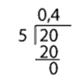  - $\frac{7}{16}=\underline{0,4375 }$  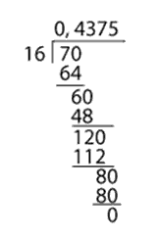  - $\frac{25}{100}=\underline{0,25}$  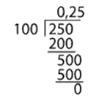
Here are some examples of non-terminating, recurring decimals that we sometimes encounter when we convert fractions to decimals. These are also rational numbers:
Example | - $\frac{2}{3}=0,666666…$  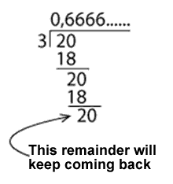  - $\frac{4}{7}=0,571428$  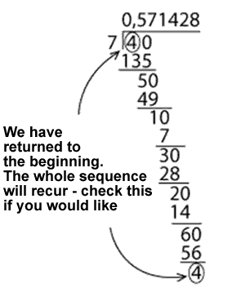  - $\frac{7}{11}=\underline{0,63 }$  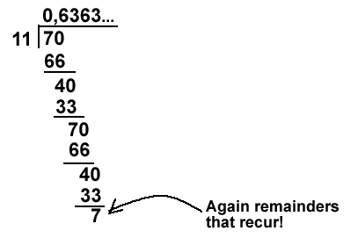

Note | We use two alternative forms of notation for recurring decimals: You should know and be able to use this notation.  Single digit pattern  Place a dot above the digit that recurs. Write the recurring digit only once. If you record the decimal as a repeating string, put three dots after the last numeral you record.  $0,\dot{6}=0,66666666…$  Double digit pattern  Place a dot above each digit that recurs. Write the recurring digits only once. Another possibility is to draw a single line that stretches above the two recurring digits. Do not let this line go over the decimal comma or beyond the two recurring digits. If you record the decimal as a repeating string, put three dots after the last pair of digits you record.  $0,\dot{6}\dot{3}=0,6363636363636363…$  A string of digits that recur  Place a dot above the first and the last of the digits in the sequence that recurs. Write the recurring sequence of digits only once. Another possibility is to draw a single line that stretches above the whole recurring sequence from the first digit to the last digit in the sequence. Do not let this line go over the decimal comma or beyond the last recurring digit of the sequence. If you record the decimal as a repeating string, put three dots after the last digit of the sequence that you record.  $0,\dot{6}3\dot{8}=0,638638638…$  Or  $0,571428571428571428…=0,\dot{5}7142\dot{8}=0,\overline{571428}$

Activity | Activity 4.22  Try the following conversions: Convert from fraction form to decimal form using long division (some will not recur and some will recur).  - $\frac{7}{8}$  - $\frac{5}{12}$  - $\frac{33}{100}$  - $\frac{2}{9}$  - $\frac{3}{7}$  - $\frac{12}{33}$

Conversion from decimal form to fraction form
We will look only at conversions from terminating decimals to fractions. This is a simple procedure where we put the numerals occurring after the decimal comma over a denominator of 10, 100, 1000 or whatever is necessary. Look at the worked examples and then try the activity for yourself. Notice that some of the fractions can simplify, in which case we simplify them, but others cannot, and we leave them as they are.

Example | - $0,15=\frac{15}{100}=\frac{3}{20}$  - $0,8=\frac{8}{10}=\frac{4}{5}$  - $0,417=\frac{417}{1000}$

Activity | Activity 4.23  Convert into fraction form:  - 0,67  - 0,55  - 0,4  - 0,75

Unit summary
In this unit you learned how to:
- Differentiate between continuous and discontinuous wholes.
- Demonstrate and explain the use of concrete wholes in the establishment of fraction concept in young learners.
- Illustrate and use language patterns in conjunction with concrete activities to extend the fraction concept of learners from that of $\frac{1}{n}$ to $\frac{m}{n}$.
- Identify improper fractions and be able to convert from proper to improper fractions and vice versa.
- Determine the rules for calculating equivalent fractions which are based on the equivalence of certain rational numbers.
- Compare different fractions to demonstrate an understanding of the relative sizes of different rational numbers.
- Describe the differences between the different forms that rational numbers can take on.

Assessment
Fractions
- Make a fraction kit as described in your notes on fractions.
- Illustrate and describe in full how you would find $\frac{2}{5}$ of 15 marbles.
- Which is greater, $\frac{1}{3}$ or $\frac{1}{2}$, and by how much? You must illustrate your solution using a continuous whole of your choice.

- Use equivalent fractions to compare:

- $\frac{6}{7}$ and $\frac{7}{8}$

- $\frac{25}{30}$ and $\frac{10}{15}$

- Use decimals to compare:
- $\frac{2}{5}$ and $\frac{7}{50}$

- $\frac{13}{17}$ and $\frac{34}{53}$

- Convert from fraction form to decimal form using long division:
$\frac{3}{5}$, $\frac{5}{9}$, $\frac{12}{25}$, $\frac{12}{23}$
- Convert from decimal form to fraction form:
0,37 and 0,4
- Plot the following numbers on a number line:
$\frac{3}{4}$, $\frac{5}{8}$, 1, $\frac{5}{4}$, $\frac{9}{8}$
- What do we mean when we say that a rational number has many names?

