# cover

Addressing Diarrhea Through

Public Health Action:

The Case of an Informal Settlement

in Sub-Saharan Africa

School of Public Health (SOPH), University of the Western Cape (UWC), South Africa

**Open Education Resource Description**

**Abstract:** The case concerns an informal settlement with a high prevalence of diarrheal disease in sub-Saharan Africa, and the factors that feed into this situation. The learning aim is to apply a model for intervention – the Public Health Action Cycle, which is based on UNICEF’s Triple A Cycle for nutrition improvement.

**Keywords:** Informal settlement, water, sanitation, faeces, Sub-Saharan Africa, poverty, Public Health Action cycle

**Learning object type:** Public Health case

**Background:** Developed from the experiences of a medical doctor who was then an MPH student, and from visiting the settlement with her as well as an interview with a community developer. It was developed for teaching purposes in the SOPH, UWC Postgraduate Programme.

**Target audience:** Individuals leading and/or participating in Public Health education

**Auxiliary materials:** References to online articles; Advocacy document in Addendum 1: Reynolds, L. & Sanders, D. on behalf of the People’s Health Movement (PHM). (2008). *Submission to the SA Human Rights Commission.* Cape Town, RSA: PHM.

**Version:** 1.0

**Copyright holder:** University of the Western Cape (UWC), School of Public Health

**License:** Except where otherwise noted, this work is licensed under a Creative Commons Attribution - ShareAlike 3.0 Unported (CC BY-SA 3.0) [**http://creativecommons.org/licenses/by-sa/3.0/**](http://creativecommons.org/licenses/by-sa/3.0/)

**Copyright:** © 2012 SOPH School of Public Health, UWC.

**Date content created:** March 2012

# Acknowledgements

This case study resource was developed by the School of Public Health (SOPH), University of the Western Cape (UWC) for use in our teaching. The case is based on the experience of a medical doctor and student at the School of Public Health, University of the Western Cape, who was at the time working at a hospital in sub-Saharan Africa which served this informal settlement. The medical doctor wishes to remain anonymous to preserve the anonymity of those living in this settlement. Her contribution is gratefully acknowledged.

**Institution where the case study was developed:** University of the Western Cape (UWC), School of Public Health (SOPH).

**Content submitted by:** Lucy Alexander, Senior Academic Programme Co-ordinator, SOPH, UWC.

**Author/s:** Content was developed by a SOPH MPH student and written into the case study by Lucy Alexander, SOPH with suggestions from the content reviewer.

**Content reviewer:** Dr Ruth Stern, BSc (Physio) (Wits), Dip Health Promotion (Lond), MA (Lond), DrPH (Lond)., OPH, UWC

**Editor:** Lucy Alexander, Senior Academic Programme Co-ordinator, SOPH, UWC.

**Links to related Postgraduate Programme modules:** Relevant to *Introducing Public Health: Its Basis and Scope,* and most other Postgraduate Diploma in Public Health and Masters in Public Health modules which address programmatic interventions.

**Financial support provided by:** Hewlett Foundation Education Program and facilitated by the African Health OER Project, University of Michigan and OER Africa. This acknowledgement in no way indicates endorsement of this work.

|  |  |
| --- | --- |
| Contents SECTION 1 - Topic Rationale ……..…………………………...................................…..…SECTION 2 - Learning Input ……..……………………………...................................…...2.1 Setting and Population ……..…………………….............................………….... 2.2 Learning Objectives .……..………………………..….............................……….... 2.3 Learning Activity 1 – Understanding Diarrhea….....................……….....2.4 Learning Activity 2 – Considering the causes of Diarrhea inKavu Mahali …….................…………..................................................................... SECTION 3 - Case Context ...…..……………………...........................................................  3.1 The environment ……..…………………................................................................  3.2 A significant health problem …………..………………………………..……...... SECTION 4 – Planning Public Health Action …..….........………................................4.1 A Public Health Action Implementation Cycle ....………….......................4.2 Learning Activity 3 – Following a Public Health Action approach and planning an intervention for Kavu ..…………..……….........................Reference List and Additional Readings .……………..…….......................…….....… Addendum 1: Submission to the South African Human Rights Commission: An Example of Advocacy …..……………………................................... | 7  9  9  9  9  10  13  13  14  17  17  19  21  23 |

# SECTION 1 - Topic Rationale

*”Diarrheal diseases account for nearly 1.3 million deaths a year among children under-five years of age, making them the second most common cause of child deaths worldwide. Over half of the deaths occur in just five countries: India, Nigeria, Afghanistan, Pakistan and Ethiopia.*

*Oral rehydration salts (ORS) and oral rehydration therapy (ORT), adopted by UNICEF and WHO in the late 1970s, have been successful in helping manage diarrhea among children. It is estimated that in the 1990s, more than 1 million deaths related to diarrhea may have been prevented each year, largely attributable to the promotion and use of these therapies. Today, however, there are indications that in some countries knowledge and use of appropriate home therapies to successfully manage diarrhea, including ORT, may be declining.* [UNICEF. *Acute Diarrhea Still a Major Cause of Child Death “* [Online], Available: [*http://www.unicef.org/health/index\_43834.html*](http://www.unicef.org/health/index_43834.html) Downloaded: 20.6.12].

Furthermore the world is not yet on track to achieve the Millennium Development Goal target of a two-thirds reduction in the rate of child mortality by 2015.

Millennium Development Target 4A: [Reduce by two thirds, between 1990 and 2015, the under-five mortality rate](http://www.un.org/millenniumgoals/pdf/MDG%20Report%202010%20En%20r15%20-low%20res%2020100615%20-.pdf#page=28)

* Child deaths are falling, but not quickly enough to reach the target
* Revitalizing efforts against pneumonia and diarrhea, while bolstering nutrition, could save millions of children
* Recent success in controlling measles may be short-lived if funding gaps are not bridged

Read the Fact Sheet on MDG 4 which is part of [United Nations. (2010). *The Millennium Development Goals Report, 2010.* [Online], Available: <http://www.un.org/millenniumgoals/pdf/MDG_FS_4_EN.pdf> Downloaded: 20.1.12].

*“In some developing countries, the toll is so harsh that more than one in five children die before they reach their fifth birthday. Many of those who do survive are unable to grow and develop to their full potential. Most deaths result from five causes, or a combination of them: acute respiratory infections (ARI), diarrhea, measles, malaria and malnutrition. Poverty and the failure to ensure universal access to basic social services are to blame. …. The inequalities in child survival between poor and better-off children are stark, not only between countries but within them. For countries with available data, children in the poorest 20% of households are far more likely to die before their fifth birthday than children living in the richest quintile*”[UNICEF. *The Big Picture* [Online], Available: <http://www.unicef.org/health/index_bigpicture.html>.

Downloaded: 20.6.12].

UNICEF reports that there was a significant proportional increase in under five children receiving Oral Rehydration Therapy, “from 24% in 1995 to 43% in 2005”. They note also that a range of strategies is important in reducing diarrheal disease.

*“Measures to prevent childhood diarrheal episodes include promoting exclusive breastfeeding, raising vitamin A supplementation rates, improving hygiene, increasing the source of improved sources of drinking water and sanitation facilities, promoting zinc intake and immunization against rotavirus”* [UNICEF. *Acute Diarrhea Still a Major Cause of Child Death.* [Online], Available: [*http://www.unicef.org/health/index\_43834.html*](http://www.unicef.org/health/index_43834.html) Downloaded: 20.6.12].

In spite of an important milestone having been reached in child survival by 2007, with an estimated 27% decline in the under-five mortality rate, “… the continued loss of 9.2 million young lives each year is unacceptable, especially when many of these deaths are preventable” [UNICEF. *The Big Picture* [Online], Available: http://www.unicef.org/health/index\_bigpicture.html. Downloaded: 20.6.12].

# SECTION 2 - Learning Input

## 2.1 Setting and Population

For this case, the town has been called Tarkavale and the informal settlement - Kavu Mahali (Dry Place). The population is that of an informal settlement in sub-Saharan Africa.

2.2 Learning Objectives

* To explore diarrhea as a Public Health issue.
* To analyse the factors that contribute to diarrheal disease in an informal settlement.
* To use a model of Public Health Action to plan a Public Health intervention to address diarrhea in Kavu.

|  |  |  |  |
| --- | --- | --- | --- |
| **UWC SOPH Malnutrition_LB_Activity**   |  | | --- | | ReferencePages 151-160 of this publication provide a full description of diarrhea: Werner, D. with Carol Thuman and Jane Maxwell (2010). *Where There is No Doctor: A Village Health Care Handbook.* Rev. ed. [Online], Available: <http://weblife.org/pdf/>where\_there\_is\_no\_doctor.pdfHard copy: Macmillan/TALC. Available: TALC. This can be ordered from TALC: <http://www.talcuk.org/books/where-there-is-no-doctor-african-edition.htm> [Downloaded: 20.7.12]. | | **2.3 Learning Activity 1 – Understanding diarrhea**  Use your own knowledge, the internet or medical reference books to prepare responses to these questions:   1. What is diarrhea\*? What is meant by orofaecal transmission? 2. What are the most likely causes of death in a child with diarrhea? Consider social, economic and cultural factors too. 3. What is the under five mortality rate from diarrhea in your country? 4. What factors exacerbate diarrheal disease? 5. What are the recommended home-care strategies for dealing with children with diarrhea? What strategies are used if the child is admitted to hospital? 6. What are some of the controversial issues surrounding Oral Rehydration Therapy (ORT)?  |  | | --- | | References for Activity 1 There is a list of possible references after Section 4 which you may wish to use. a) \*Also spelt diarrhoea; a definition has been included at the end of Section 3, taken from one of the References.(f) For this question, you will find this reading interesting: Werner, D. & Sanders, D. (1997). *Questioning the Solution: The Politics of Primary Health Care and Child Survival.* Palo Alto, CA: HealthWrights: Chapters 6-10 pp32-72. It can be downloaded from the HealthWrights Workgroup for People’s Health and Rights at <http://www.healthwrights.org/hw/books/208-ques-solu> [Downloaded 17.07.12]. | |

|  |  |  |
| --- | --- | --- |
| **UWC SOPH Malnutrition_LB_Activity**   |  | | --- | | ReferenceWerner, D. with Carol Thuman and Jane Maxwell (2010). *Where There is No Doctor: A Village Health Care Handbook.* Rev. ed. [Online], Available: http://weblife.org/pdf/where\_there\_is\_no\_doctor.pdf Hard copy: Macmillan/TALC. Available: TALC. This can be ordered from TALC: <http://www.talcuk.org/books/where-there-is-no-doctor-african-edition.htm> [Downloaded: 20.7.12]. | | **2.4 Learning Activity 2 – Considering the causes of diarrhea in Kavu Mahali**   1. Now that you have considered the clinical reasons for children dying from diarrhea, we turn to the causes of diarrhea. The most immediate causes are illustrated through the well-known F diagram developed by Wagner and Laniox (1958) below, which shows the transmission chain of diarrhea. Read through the Case Context (parts 3.1 and 3.2) and identify which of these F factors are likely to affect under-5 children in Kavu, explaining why you say so. 2. Then take each of the relevant factors, e.g. “fingers”, and ask the question *But why* is this so? This technique comes from David Werner’s seminal book *Where there is no Doctor,* 2010. It should enable you to think beyond the direct causes to the underlying and deep systemic causes, which may be economic, social and political in nature. Some may suggest the same underlying factors. Jot down your answers in each column; in this way you are starting to develop an understanding of the most important conditions and factors which you would have to address to break the transmission chain as a Public Health worker. You will use this brainstorm in the next activity. |

*”The F-diagram which follows shows the different routes that the microbes of diarrhoea take from faeces, through the environment, to a new person. For example; microbes in faeces on the ground by a well can get into the water (fluids) and be drunk by a child, hands that have not been washed after going to the toilet can carry microbes onto foods, which are then eaten, infecting another child, who gets diarrhea and spreads more microbes ... “*

[UNICEF. (1999). *Water, Environment and Sanitation Technical Guidelines Series No. 6: A Manual on Hygiene Promotion*. *Document No. UNICEF/PD/WES/99-02.* New York: UNICEF. [Online], Available: <http://www.unicef.org/wash/files/com_e.pdf> [Downloaded: 27.7.12].

#### 

The F diagram could also be a useful teaching tool in communities where there is a poor understanding of the transmission routes of diarrhea. Language would need to be modified.

Figure 1: The F diagram developed by Wagner and Laniox (1958) [UNICEF, 1999: 34]

|  |  |  |  |  |  |  |
| --- | --- | --- | --- | --- | --- | --- |
| **Why do these factors prevail at Kavu?** | **Faeces** | **Fluids, e.g. faeces, sputum, vomit, etc** | **Fields** | **Flies** | **Fingers** | **Foods** |
| But why? | Lack of toilets or hygienic disposal mechanisms for nappies |  |  |  |  |  |
| **But why?** | Lack of services |  |  |  |  |  |
| **But why?** | Lack of infrastructure and no rates tax base |  |  |  |  |  |
| **But why?** | Recent development (poor infrastructure) and population very poor (No rates base) |  |  |  |  |  |
| **But why?** | Population very poor |  |  |  |  |  |
| **But why?** | Urban drift, lack of education, lack of economic activity |  |  |  |  |  |
| **But why?** | Historical discriminatory political factors; poor social development policies |  |  |  |  |  |

Keep your table, as you will be able to use it as the basis of more learning activities in Section 4. In the diagram below, two actions for preventing the F factors are proposed, but these do not necessarily address the deeper level socio-economic and political issues.

Another way to understand the causes, in particular those at a deeper level (socio-economic or political) is to analyse the causes of diarrhea using the UNICEF Conceptual Framework [UNICEF. (1990). *Strategy for Improved Nutrition of Children and Women in Developing Countries.* [Online], Available: <http://www.ceecis.org/iodine/01_global/01_pl/01_01_other_1992_unicef.pdf> Downloaded: 20.7.12].

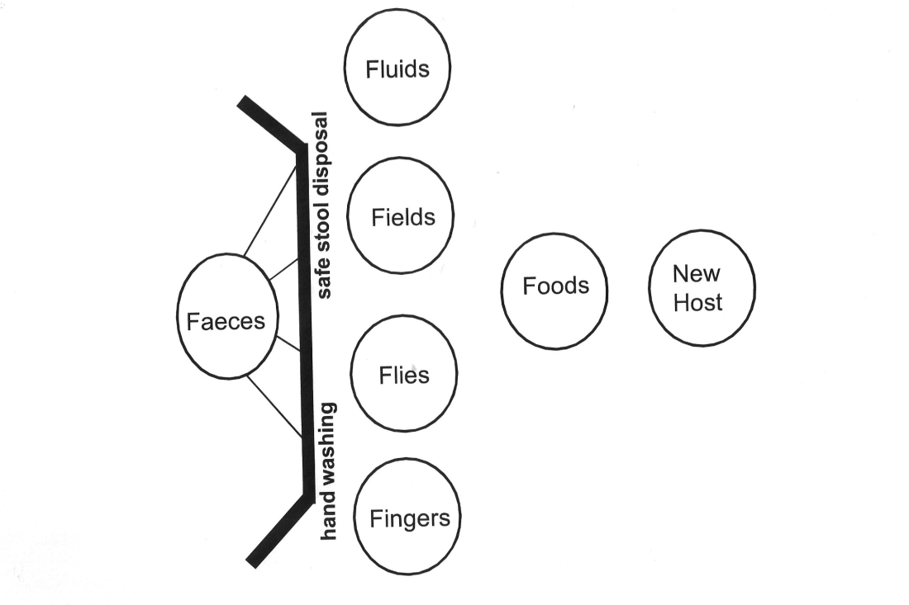

Figure 2: Addressing the F factors [UNICEF, 1999:35]

**SECTION 3 - Case Context**

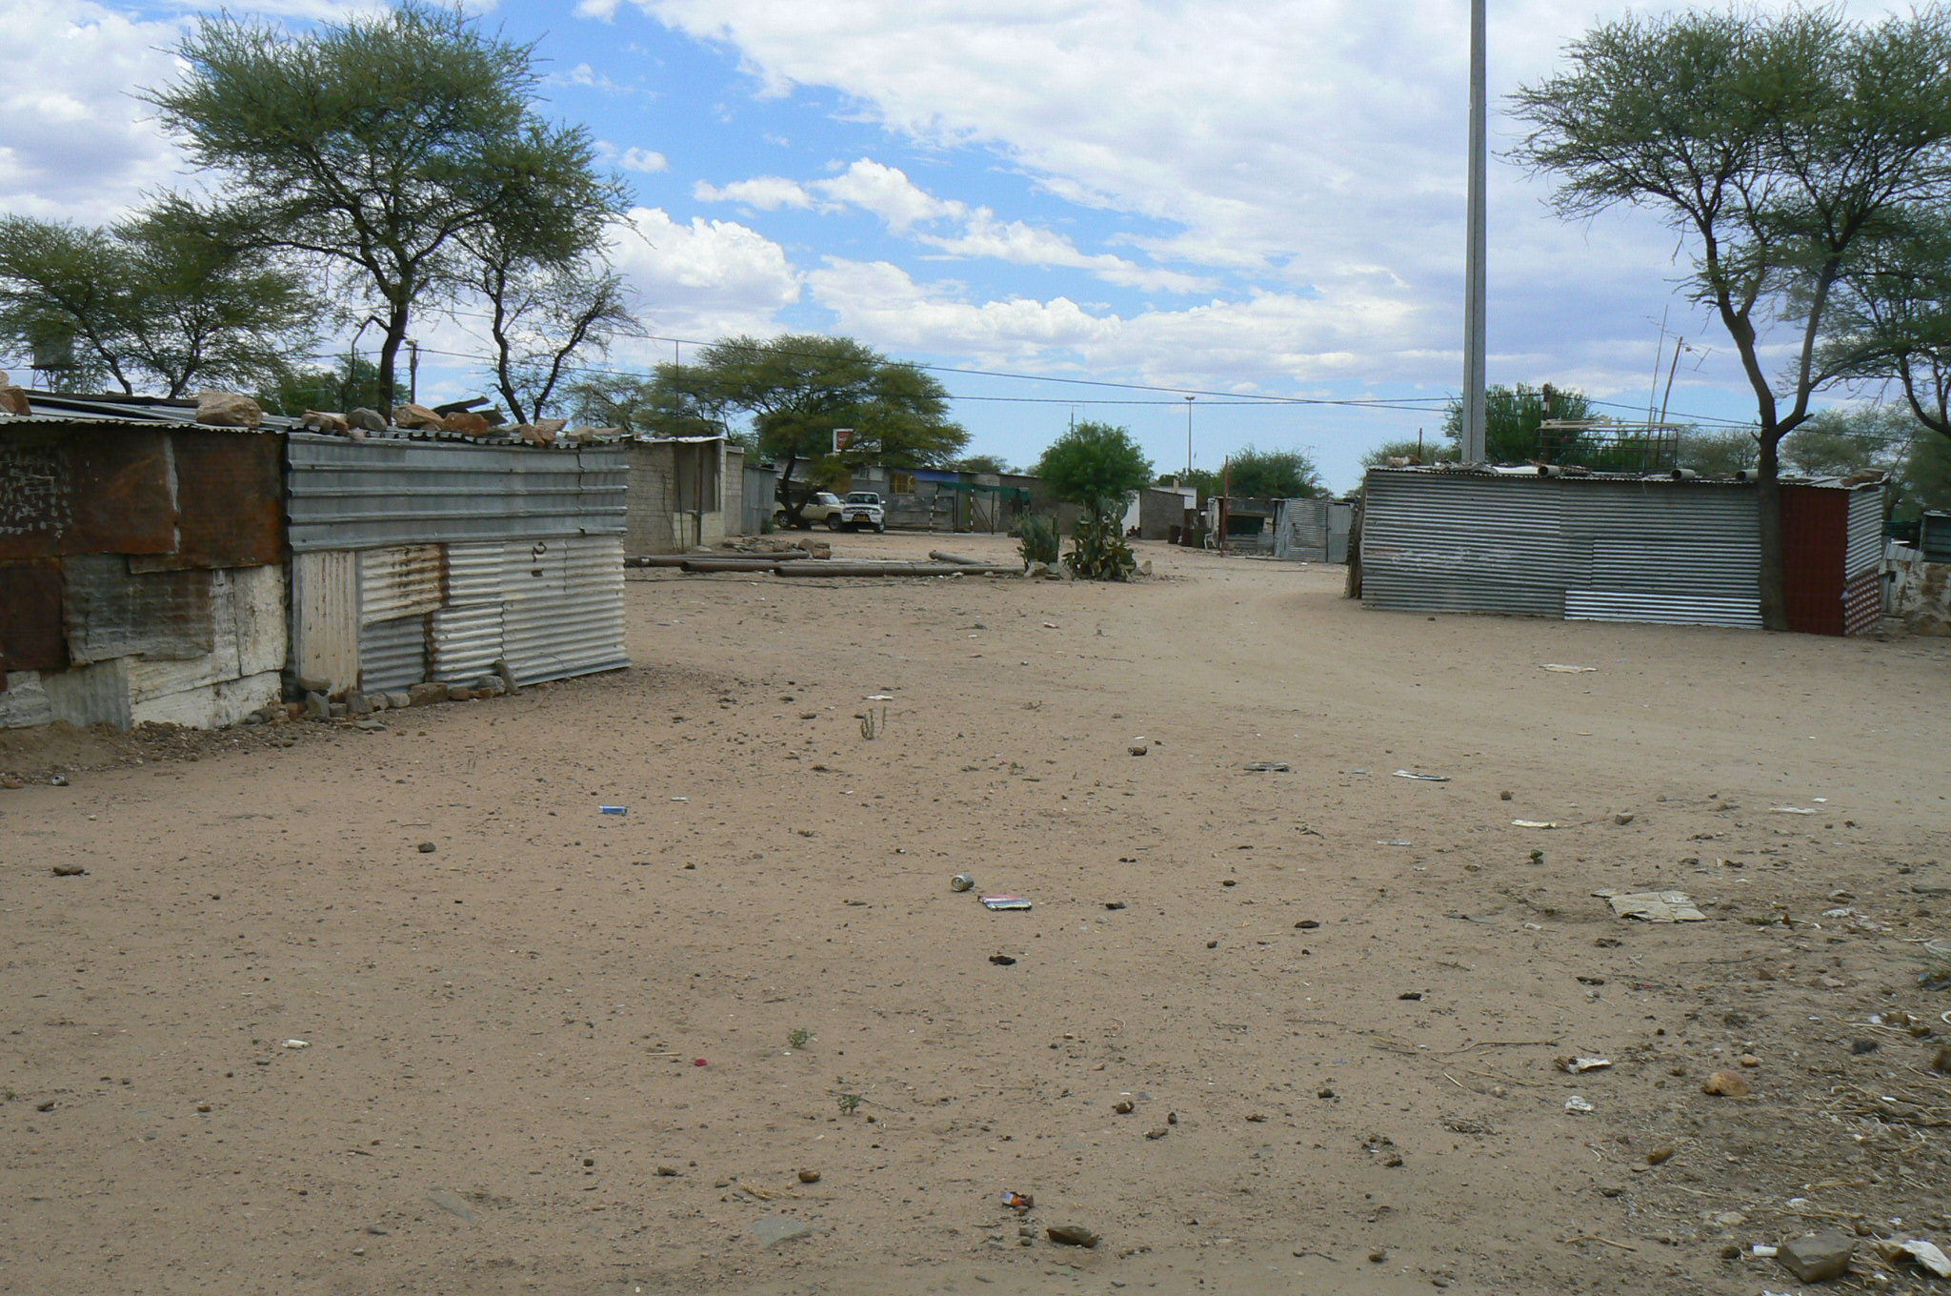

Photo 1: The Kavu Mahali informal settlement [SOPH, UWC]

**3.1 The environment**

This is the informal settlement of Kavu Mahali (*Dry Place*) which is situated outside Tarkavale, 60km north of the capital in a country in sub-Saharan Africa. Tarkavale is just off the main highway which serves as a passage to the coastal and northern areas of the country. The majority of the population lives in the town, which is surrounded by commercial and communal farms. Its economy is based on serving the needs of the surrounding farming population, and the army which has a training station in Tarkavale.

The informal settlement known as *Kavu* by the residents has developed since 2005 and now has a population of about 3 200 which is still growing as people migrate from farms in search of work or a better life. Settlement took place here because around 2005, a farmer allowed settlement on a strip of his land at the cost of a small deposit. The land area was therefore privately owned until 2007, and only recently formally serviced by the municipality. In the past few years, the municipality has provided broad coverage electric street lights, and scattered communal water pumps.

The district has one hospital situated on the far side of Tarkavale, a walk of 5 kilometres. These facilities cater for a population of 31 706 of which 5 323 are under the age of five years (Census Statistics). Though 97% of the district population have safe (but communal) water sources, 79% have no sanitary facilities (Census Statistics). Kavu has no toilets and the dry river bed alongside the settlement is generally used for defecation.

Although the residents of the informal settlement have very few sources of income in their environment, there are a number of taverns, mainly used by men of the area, scattered through the residences.

Whenever there is a health problem or outbreak of any illness in the area, the urban residents of Tarkavale blame Kavu as the source of the problem. This has led to stigma being attached to living in Kavu, which further affect residents’ attempts to find work in Tarkavale.

Within the urban and surrounding areas, there are several informal settlements like Kavu served by minimal numbers of communal taps which are metred and can only be used by purchasing and inserting tokens into the metre (seen in Photo 2). Residents then transport the container of water back to their dwellings. There are no sanitation services, and the community is obliged to use the areas surrounding the settlement where children also play. This places a significant number of children at risk of diarrhea since they have little access to sanitation (see Learning Activity 2 in Section 2 – But why?).

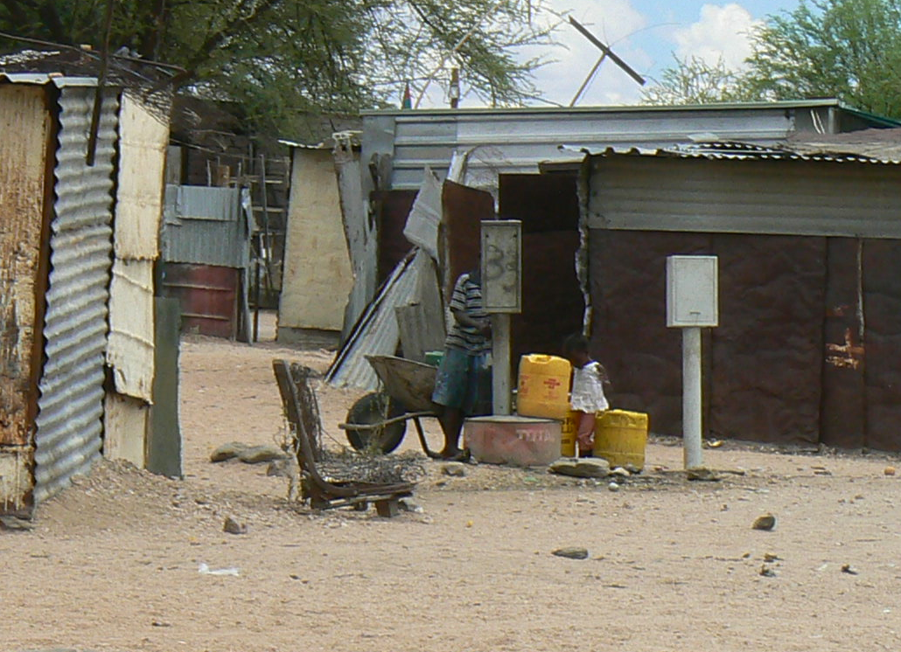

Photo 2: A child drawing water at a communal water tap in an informal settlement in Kavu: water is metred and only accessible only with purchased tokens, 2009 [SOPH, UWC]

**3.2 A significant health problem**

Diarrhea or Gastroenteritis (GE) or is the leading cause of death in children under-5 years of age at Tarkavale Hospital and is an avoidable cause of death. Diarrhea was ranked second in the causes for hospital outpatient department visits in 2008 in the same age group.

#### A clinical perspective

We interviewed a medical practitioner at the Tarkavale Hospital who explained:

*“Gastro-enteritus can be caused by a variety of infectious and non-infectious factors. The common infectious causes of gastroenteritis are viruses especially bacteria such as E. Coli, Salmonella, Shigella, Campylobacter and Versinia and Rota viruses; in addition, parasites such as Entamoeba, Cryptosporidia, Giardiasis and Cyclospora. The mode of transmission is orofaecal. Correct and adequate treatment, given early, could avoid these deaths.*

*Diarrhea may present as a mild self-limiting episode, acute rapid dehydration with electrolyte imbalance or persistent diarrhea with nutritional deficiencies and electrolyte and fluid imbalances. It has been observed that children often present to the health facilities with severe dehydration. These children have a higher risk of deranged electrolytes and fluid imbalances which make adequate resuscitation difficult resulting in death of some of these children, while some of the children are brought in already dead.*

In addition, Tarkavale Hospital has no laboratory facilities. This makes it difficult to diagnose electrolyte imbalances with the urgency needed. For the above reasons, early presentation to health facilities is necessary to prevent the complications of diarrhea.

These complications which can result in death are overwhelming septicaemia, fluid and electrolyte derangements and hypovolemia (depleted blood volume) due to rapid or chronic fluid loss. Early presentation to the health facility allows the children to be attended to before they develop these complications. This also makes it important to understand the issues surrounding why caregivers often bring their children to the health facilities when it is too late to save them. Caregivers’ reasons for delayed seeking of medical attention for their children are complex and varied and may be linked with culture, beliefs and values.

*Diarrhea incidence and mortality has been aggravated by malnutrition and the Human Immunodeficiency Virus (HIV), both of which increase the risk of contracting diarrhea and also increase the potential of mortality from it.*

*Prevention of diarrhea could be achieved through good hygienic practices – especially handwashing, provision of adequate sanitation and a sufficient available clean water supply.”*

|  |
| --- |
| To widen your perspective on how this problem could be handled, search for readings addressing the issue of diarrhea, and read this 2008 editorial from the *Bulletin of the World Health Organization*, questioning the potential loss of opportunities by losing sight of the issue of clean safe water in preventing disease. Bartram, J. (Jan 2008). Flowing Away: Water and Public Health Opportunities. *Bulletin of the World Health Organization*, 86(1): 2. [Online], Available: <http://www.who.int/bulletin/volumes/86/1/07-049619/en/> [Downloaded: 27.7.12]. |

There are a number of ways that the diarrhea problem in Kavu could be addressed – some are more clinical, as suggested by the medical doctor, while others relate to cultural practices (as is also suggested); others could address the social factors underlying the problem. What do you think? In the next section, you are presented with a model for planning an intervention to address a problem like this.

|  |
| --- |
| **A Definition of Diarrhea**  “*Diarrhea” is an alteration in a normal bowel movement characterized by an increase in the water content, volume, or frequency of stools. A decrease in consistency (i.e., soft or liquid) and an increase in frequency of bowel movements to >3 stools per day have often been used as a definition for epidemiological investigations. “Infectious diarrhea” is diarrhea due to an infectious etiology, often accompanied by symptoms of nausea, vomiting, or abdominal cramps. “Acute diarrhea” is an episode of diarrhea of <14 days in duration. “Persistent diarrhea” is diarrhea of 114 days in duration. Although we will not categorize persistent diarrhea further here, some experts refer to diarrhea that lasts 130 days as “chronic”* [Guerrant et al, 2001]. |

# SECTION 4 – Planning Public Health Action

#### 4.1 A Public Health Action Implementation Cycle

In this section we introduce an Implementation Cycle for Public Health Action which was developed by Professor Mickey Chopra and Emeritus Professor David Sanders of the SOPH, UWC. It is based on UNICEF’s Triple A (Assessment, Analysis, Action) Cycle illustrated below.

**The Triple A Cycle**

The Triple A Cycle was designed as a tool for nutrition programme managers when planning nutrition interventions and is used in conjunction with the UNICEF Conceptual Framework [Pelletier, 2002].

*“After an initial assessment of the situation, the analysis of the causative*

*processes follows. The determinants of malnutrition are very complex, as some*

*are general while others are more context-specific. If the analysis is performed by a combination of people who live with or very close to the situation under review, it is more likely that the whole exercise will be more successful. The presence of individuals who are trained and experienced in such analysis will also improve the outcome. Based on the analysis of causative processes and an assessment of available or potential resources, actions are designed and implemented. Most situations do not necessarily improve with the first set of actions. The actions may, however, contribute to the creation of a new situation that is more conducive to actions that were not feasible before.*

*After the situation has been assessed and analysed and actions have been implemented, it is necessary to reassess the impact of the actions, and then to reanalyze it again. For this purpose, nutrition information systems must be in place”.*

You can read more about it at: UNICEF. (1990). *Strategy for Improved Nutrition*

*of Children and Women in Developing Countries.* [Online], Available: <http://www.ceecis.org/iodine/01_global/01_pl/01_01_other_1992_unicef.pdf> [Downloaded: 20.7.12].

Figure 3: The Triple A Cycle

You will find information more about the Triple A Cycle and the UNICEF Conceptual Framework in Pelletier, D. L. (2002). Toward a Common Understanding of Malnutrition: Assessing the Contributions of the UNICEF Framework. World Bank/UNICEF. [Online], Available: http://www.tulane.edu/~internut/publications/WB\_Bckgrd\_Pprs/Narrative/  
NarrativeonePelletierfinal.doc [Downloaded 20.1010]

The Public Health Action model (see Fig 1 below) involves a number of phases, which revolve around the hub of capacity development. At the heart of Public Health action, Sanders and Chopra argue (c.2005), is ongoing capacity development because the cycle cannot be undertaken unless sufficient capacity is developed amongst the various players in the field.

Assessment is essentially a fact-finding process (and would include the development of a situational or community profile) (Chopra & McCoy, 2000); analysis is undertaken using epidemiological tools and qualitative methods: after this, actions are prioritised. In the course of analysis, we identify a range of causes of a particular problem, interrogate the levels of causation and their risk factors including the social determinants that may underpin the problem.

Public Health Action follows, which in Chopra and Sanders’s elaboration includes planning to intervene. This leads to a Public Health intervention which addresses prevention and Health Promotion, and seeks to address social, economic and environmental determinants, as well as its implementation and management. This leads to Public Health intervention, its implementation and management. Once the intervention has been implemented and managed for some time, one would evaluate its effectiveness and potentially modify existing policy to consolidate changes in the health system. However monitoring tools would need to be designed when planning the intervention. Finally, if such policy is to be accepted and successfully implemented, advocacy and team building would be necessary in order that the intervention is successfully achieved. Sanders and Chopra note that sometimes team building occurs early on, so that different aspects of assessment and analysis can be undertaken by different individuals who may have different skills. All these actions must be supported by training, mentoring and capacity development in line with changing knowledge, technologies, contextual understandings and the need for increased and re-orientated capacity. This process of capacity development is central to successful implementation.

If you were a Public Health Officer in Kavu, starting from scratch, you would be involved in assessment or conducting a situational assessment, in order to understand the particular context, the population, their socio-economic circumstances, their environmental resources and constraints, and of course the health problems they experience.

Figure 4: A Model for Public Health Action [Chopra, M. & Sanders, D., c.2005]

This implementation cycle below has been used as a metaphor and a template for the University of the Western Cape School of Public Health’s Postgraduate Programme curricula.



|  |  |
| --- | --- |
| **UWC SOPH Malnutrition_LB_Activity** | * 1. **Learning Activity 3 – Following a Public Health Action approach and planning an intervention for Kavu**   Take the role of the newly appointed Environmental Health/Public Health Officer in the Tarkavale Municipality.  Go back to your “But why?” table. Using three different colours, highlight the factors you identified according to those which could be addressed in the short, medium and longer term. This has to do with the level of control of the Public Health officer (which you will have to decide for yourself). Circle those conditions over which the residents have primary control.  Using the Public Health Action Cycle introduced above, develop a short to medium term, and separately a long term Public Health strategy or plan which would address the prevalence of diarrhea in Kavu. You could produce this as a table, a diagram, or on a large sheet of paper with a set of stickers or cards so that you can move items around while you work.  **A few guidelines:**   * Your starting point should be prevention of diarrhea. Explore any articles you find on strategies for preventing it, e.g. Scott, B. (2006). * Be sure to consider working with all the relevant stakeholders. * Be aware of the Advocacy stage which is a very important part of Public Health Action. We have included an example of Advocacy at a national level as Addendum 1, after the References. It is a submission from the Peoples’ Health Movement to the South African Human Rights Commission (2009). * Remember to include the core of the process - capacity building strategies at all stages of your planning. |

If you undertake this process with your students or as a student, we would like to see the results, which could be added to the case study as an Addendum. Please send feedback to:

[soph-comm@uwc.ac.za](mailto:soph-comm@uwc.ac.za) marked Open Education Resources.

There are many ways to use cases: if you redevelop or repurpose this case, we would also like to see the results. Please send feedback to: [soph-comm@uwc.ac.za](mailto:soph-comm@uwc.ac.za) marked Open Education Resources.

# 

# Reference List and Additional Readings

Bartram, J. (Jan 2008). Flowing Away: Water and Public Health Opportunities. *Bulletin of the World Health Organization*, 86(1): 2. [Online], Available: <http://www.who.int/bulletin/volumes/86/1/07-049619/en/> [Downloaded: 27.7.12].

# Bradley, H., Zarowsky, C. & Alexander, L. & Mathole, T. (2010). *Introducing Public Health: Its Basis and Scope.* Module Guide for the Postgraduate Diploma in Public Health. Cape Town: School of Public Health, University of the Western Cape.

Cairncross, S. & Valdmanis, J. (2006). Water Supply, Sanitation and Hygiene Promotion. In D. T. Jamison , J. G. Breman, A. R. Measham, G. Alleyne, M. Claeson, D. B. Evans, P. Jha, A. Mills & P. Musgrove (Eds).  *Disease Control Priorities in Developing Countries, Second Edition,* Oxford University Press and The World Bank. [Online], Available: <http://www.dcp2.org/pubs/DCP> [Downloaded 31.7.12].

Chopra, M. & McCoy, D. (2000). *How to Conduct a Rapid Nutrition Situation Assessment, A Guide for Health Districts and Sub-districts in South Africa.* Durban: Health Systems Trust. [Online], Available: <http://www.hst.org.za/publications/396> [Downloaded: 20.10.10].

Chopra, M. & Sanders, D. (2005). *Unpublished Model of the Public Health Implementation Cycle.* Cape Town: School of Public Health, University of the Western Cape.

Fewtrell, L. & Colford, J. M. (2005). Water, Sanitation and Hygiene in Developing Countries: Interventions and Diarrhoea – a Review. *Water Sci Technology,* 52(8):133-142.

Guerrant, R. L., Van Gilder, T., Steiner, T. S., Thielman, N. M., Slutsker, L., Tauxe, R. V. Hennessy, T., Griffin, P. M., DuPont, H., Sack, R. B., Tarr, P., Neill, M., Nachamkin, I. L., Reller, B., Osterholm, M. T., Bennish, M. L. and Pickering, L. K. (2001). *Practice Guidelines for the Management of Infectious Diarrhea.* *IDSA Guidelines*, 32. [Online],

Available: <http://www.uphs.upenn.edu/bugdrug/antibiotic_manual/idsadiarrhea.pdf> [Downloaded: 27.7.12].

Humphrey, J. H. (2009). Child Undernutrition, Tropical Enteropathy, Toilets and

Handwashing. *Lancet,* 374: 1032–1035.

Jonsson, U. *et al.* (1992). *The UNICEF Nutrition Strategy.* UNICEF. 5-33.

Overseas Development Institute. (2006). *Sanitation and Hygiene: Knocking on new doors, Briefing Paper no. 13.*{Online], Available: <http://www.odi.org.uk/resources/details.asp?id=48&title=sanitation-hygiene-knocking-doors>. [Downloaded: 31.7.12].

PATH. (July 2011). *Fact Sheet: An Integrated Approach to Confronting Diarrheal Disease.*

Washington: PATH: A Catalyst for Global Health. [Online], Available:

<http://www.path.org/publications/files/VAC_dd_approach_fs.pdf> [Downloaded: 30. 07.12].

Pelletier, D. L. (2002). Toward a Common Understanding of Malnutrition: Assessing the

Contributions of the UNICEF Framework. *World Bank/UNICEF*. [Online], Available: [http://www.tulane.edu/~internut/publications/WB\_Bckgrd\_Pprs/Narrative/NarrativeonePelletierfinal.doc](http://www.tulane.edu/%7Einternut/publications/WB_Bckgrd_Pprs/Narrative/NarrativeonePelletierfinal.doc)[Downloaded 20.1010].

Reynolds, L. & Sanders, D. on behalf of the PHM. (2008). *Submission to the SA Human Rights Commission.* Cape Town, RSA: PHM.

Sanders, D., Reynolds, L., Westwood, T., Eley, B., Kroon, M., Zar, H. & Davies, M.

with Nongena, P. & van Heerden, T*.* (2007). *Decreasing the Burden of Childhood*

*Disease Final Report.* DoH Western Cape: Western Cape Childhood Diseases Workgroup.

[Online], Available: <http://www.capegateway.gov.za/Text/2007/6/cd_volume_7_childhood_diseases_overview.pdf> [Downloaded: 20.10.10].

Scott, B. (2006). Health Impacts of Improved Household Sanitation. Well Factsheet. [Online], Available: <http://www.lboro.ac.uk/well/resources/fact-sheets/fact-sheets-htm/Household%20Sanitation.htm> [Downloaded: 20.7.12].

Scott, B., Curtis, V., Rabie, T. & Garbrah-Aidoo, N. (2007). Health in our hands, but not in our heads: Understanding Hygiene Motivation in Ghana. *Health Policy and Planning,* 22: 225–233.

UNICEF. (1990). *Strategy for Improved Nutrition of Children and Women in Developing Countries.* [Online], Available: <http://www.ceecis.org/iodine/01_global/01_pl/01_01_other_1992_unicef.pdf> [Downloaded: 20.7.12].

UNICEF. *Acute Diarrhea Still a Major Cause of Child Death.* [Online], Available: [*http://www.unicef.org/health/index\_43834.html*](http://www.unicef.org/health/index_43834.html) Downloaded: 20.6.12].

UNICEF. *The Big Picture* [Online], Available: http://www.unicef.org/health/index\_bigpicture.html. Downloaded: 20.6.12].

UNICEF. (1999). *Water, Environment and Sanitation Technical Guidelines Series No. 6: A Manual on Hygiene Promotion*. *Document No. UNICEF/PD/WES/99-02.* New York: UNICEF. [Online], Available: <http://www.unicef.org/wash/files/com_e.pdf> [Downloaded: 27.7.12].

UNICEF/WHO. (2009). *Diarrhoea: Why Children Are Still Dying And What Can Be Done.* New York: UNICEF/World Health Organization (WHO). [Online], Available: whqlibdoc.who.int/publications/2009/9789241598415\_eng.pdf [Downloaded: 27.7.12].

United Nations. (2010). *The Millennium Development Goals Report, 2010.* [Online], Available: <http://www.un.org/millenniumgoals/pdf/MDG_FS_4_EN.pdf> Downloaded: 20.6.12].

# Varley, R. C., Tarvid, J. & Chao, D. N. (1998). A Reassessment of the Cost-effectiveness of Water and Sanitation Interventions in Programmes for Controlling Childhood Diarrhoea. *Bulletin of the World Health Organisation,* 76(6): 617-31.

Werner, D & Sanders, D. (1997). Questioning the Solution: The Politics of Primary Health

Care and Child Survival. Palo Alto, CA: HealthWrights. [Online], Available: <http://www.healthwrights.org/hw/books/208-ques-solu> [Downloaded 17.07.12].

# Werner, D. with Thuman , C. and Maxwell, J. (2010). *Where There is No Doctor: A Village Health Care Handbook.* Revised ed. [Online], Available: <http://weblife.org/pdf/>

# where\_there\_is\_no\_doctor.pdf

Hard copy: Macmillan/TALC. Available: TALC. This can be ordered from TALC: <http://www.talcuk.org/books/where-there-is-no-doctor-african-edition.htm> [Downloaded: 20.7.12].

WHO. (2000). Management of the Child with a Serious Infection or Severe Malnutrition:

Guidelines for Care at the First-Referral Level in Developing Countries. Geneva: World Health Organization: 80-91. [Online], Available: [http://www.who.int/child-adolescent-health/publications/referral\_care/homepage.html](http://www.who.int/child-adolescent-health/publications/referral_care/homepage.html%20) [Accessed 12.8.09].

WHO. (2008a). *The Social Determinants of Health.* [Online], Available: <http://www.who.int/social_determinants/en/> [Downloaded 17.12.09].

WHO. (2008b). The Commission on Social Determinants of Health. [Online], Available: <http://www.who.int/mediacentre/news/releases/2008/pr29/en/index.html> [Downloaded: 17.12.09].

**Addendum 1: Submission to the South African Human Rights Commission: An Example of Advocacy**

Here is an example of advocacy undertaken at a national level in South Africa in 2009 which was presented at a hearing of the Human Rights Commission in South Africa. The submission was compiled by members of the People’s Health Movement . Note that evidence serves as the basis of the submission.

**Submission to the SA Human Rights Commission**

Reference: Reynolds, L. & Sanders, D. on behalf of the People’s Health Movement (PHM). (2008). *Submission to the SA Human Rights Commission. Cape Town, RSA: PHM.*

The People’s Health Movement (PHM) has its roots deep in the grassroots people's movement and owes its genesis to many health networks and activists who have been concerned by the growing inequities in health over the last 25 years. The PHM calls for a revitalisation of the principles of the Alma-Ata Declaration which promised Health for All by the year 2000 and complete revision of international and domestic policy that has shown to impact negatively on health status and systems.

Visit their website at: http://www.phmovement.org/

Conditions in health facilities often give us a good idea of what goes on in the areas and communities that the patients come from. They also provide good insight into prevailing standards of health care, both within the facility and elsewhere.

The Red Cross War Memorial Children's Hospital (RCCH) provides a teaching platform for the Health Sciences Faculty of the University of Cape Town. It provides training for various categories of health professionals including nurses and future doctors and specialists.

It is a relatively well-resourced institution in comparison with other public sector health facilities, and it is located in the province with the lowest under-5 mortality[[1]](#footnote-1) rate in the country.

This short document describes conditions in the outpatient ward at the RCCH as an indicator of progress in implementing children's constitutional rights.

**Trends in admission to the Ward S11 (A8 – General, A9 – Rehydration) at Red Cross War Memorial Children’s Hospital**

The Short Stay Ward, S11, at the Red Cross War Memorial Children's Hospital (RCCH) is the main ward for sick children from Klipfontein, Khayelitsha and Mitchell’s Plain sub-districts in Cape Town. About 18% of patients come from beyond those areas.

Since S11 only admits children who are too ill to be treated at home, the spectrum of disease in the ward reflects the pattern of severe childhood illness in the communities from which they come.

Children stay in S11 with their caregivers [usually their mothers] until they are well enough to go home to continue treatment, or – if they need more prolonged hospital treatment – until an in-patient bed can be found for them at RCCH or another hospital. In theory their stay in S11 should not be more than 24 hours, but in practice it can be as long as 4 – 5 days because of a general shortage of paediatric beds in the public sector. The ward is often overcrowded with more than 100% bed occupancy.

The ward has 2 sections, A8 and A9. A8 is used mainly as a rehydration facility for dehydrated children with diarrhoea due to gastroenteritis.[[2]](#footnote-2) A9 provides short-term care for children with other diseases who are too ill to be treated at home.

The table shows how many patients were admitted to S11 between 2001 & 2008.



**Table 1:** admission statistics for ward S11

Over the 7 years between 2001 and 2008 overall admissions increased by 58%, or by 8.2% per year on average. Admissions for gastroenteritis increased by 37% (5,3% per year), while admissions for other diseases increased by 57% (8.2% per year).

Between 2003 and 2005 the rate of admissions remained static, but in the 3 years since 2005 there has been a more rapid rise in the annual rate of admissions than before 2003. Overall admissions increased by 36% between 2005 and 2008 – an average increase of 12% per year. Admissions for gastroenteritis are up by 22 % (7.2% per year), while admissions for other diseases are up by almost 40% (13.2% per year).

**What the figures show**

* Both diarrhoea and non-diarrhoea admissions are increasing.
* The rates of increase of both have been greater since 2005 than they were before 2003.
* Non-diarrhoea admissions are increasing faster than diarrhoea admissions.

A concerted attempt over the past 4 years by the Health Department to mitigate the cases of diarrhoea that require admission through earlier and more aggressive treatment at primary level may account for the relatively lower rate of increase in diarrhoea admissions.

However, even these sterling efforts have not stemmed the tide of severe diarrhoea in young children. At the same time admissions from other diseases continue to increase at an alarming rate. This indicates that the underlying determinants of childhood illness, including diarrhoea, are not improving or that they are getting worse. Global experience indicates that these determinants include, but are not limited to, poor water and sanitation, poor food hygiene (no home refrigeration), poor nutrition – leading to reduced immunity to infection, overcrowding in households, and smoky and poorly ventilated homes.

**Why is there an increase in admissions of very ill children?**

The most likely explanations for the growing numbers of admissions for severe childhood illness in the City of Cape Town are (1) an increase in the population, and (2) deteriorating child health, within the drainage area.

1. **An increasing child population.**

The 2007 Community Survey Analysis for Cape Town found that the population of Cape Town grew by 20.9% since Census 2001 and 36.4% since Census 1996. While the South African population increased by 8.2% between 2001 and 2007, the Western Cape was the province with the largest increase (16.7%) with 80.2% of the population increase occuring in Cape Town. [[3]](#footnote-3)

The accelerated growth in Cape Town's population has been overwhelmingly among the black African group (Figure 1), and in the informal periurban settlements such as Khayelitsha. These areas are the source of the overwhelming majority of Ward S11 admissions.



**Figure 1**: inward migration to Cape Town by population group

Inward migration, particularly from the Eastern Cape and from outside South Africa accounts for a large proportion of the population increase. About 27% of the immigrants are children under the age of 14, with 14.4% being under 5 years old. In addition to inward migration there has been a 10 to15% per year increase in the the numbers of births in the Cape Town Metropolitan area over the past 3 years.

1. **Deteriorating child health, resulting in more childhood disease.**

Most of the children come from Khayelitsha and other informal settlements areas where poverty and lack of adequate clean water and sanitation, as well as inadequately ventilated and overcrowded housing, create conditions that make children highly vulnerable to severe illness, including diarrhoea, pneumonia and tuberculosis.

***Water:***

The Community Survey analysis found that by 2007 over 99% of households in all race groups had access to piped water. Piped water was available in the dwelling in 80.5%, in the yard in 10.6% and outside the yard in 8.4%.

Among Black African households, however, only 52.6% had piped water in the dwelling by 2007. In some areas up 90 to 100 households, or 300 to 400 people share a single standpipe. Research done in several parts of the world indicate that, where a water source is distant or shared amongst many, water usage declines.

Having access to sufficient volumes of water for personal and food hygiene reduces the risk of water-related diseases such as diarrhoea and skin infections and increases quality of life.[[4]](#footnote-4) [[5]](#footnote-5)

***Sanitation:***

Households without adequate toilet facilities are more vulnerable to diseases and epidemics.[[6]](#footnote-6) [[7]](#footnote-7)Pollution of waterways and wetlands increases and this puts a large percentage of the population at risk of contracting water born diseases. These increase the need for additional health care facilities.

In 2007 6.9% of Black African household used bucket toilets, while 9.1% had no toilet facilities.

It is therefore highly likely that the population of small children in the Cape Town Metropolitan Area who are highly vulnerable to severe illness is growing rapidly. In addition, the determinants of child health in specific areas of the metropolitan area are not improving fast enough, and conditions that make children sick persist.

As a result, Cape Town's children are getting sicker, and the load on the health system is growing.

**What do these trends tell us about the implementation of the rights in the Bill of Rights?**

Not only are Cape Town's children getting sicker, but the impact of the increasing admissions is also putting severe stress on the hospital staff and affecting the quality of their care. This has implications for the following rights in the Bill of Rights:

1. *Section 28 (1) Every child has the right … (c) to basic nutrition, shelter, basic health care services and social services.*

Though the RCCH is seen by some as a tertiary referral hospital, the majority of patients in Ward S11 are receiving the kind of acute care that should be available within the community: oxygen, antibiotics, and correction of dehydration. This is basic health care.

Furthermore, if 'basic health care' includes safety in the clinical setting, then there is an additional argument supporting the idea that children in S11 are not enjoying the right to basic health care. They are at risk of hospital-acquired infection, as will be shown below.

1. *Section 28 (2): A child’s best interests are of paramount importance in every matter concerning the child.*

The intention here is the same as that contained in Article 3 of the UN Convention on the Rights of the Child.

In giving meaning to the 'best interests' principle, Article 3 of the UNCRC states that

*States Parties shall ensure that the institutions, services and facilities responsible for the care or protection of children shall conform with the standards established by competent authorities, particularly in the areas of safety, health, in the number and suitability of their staff, as well as competent supervision.*

It has become impossible to maintain adequate safety measures and standards of care. Facilities are crowded with patients too close to each other to prevent infections from spreading from patient to patient and even to staff members.

Despite clear evidence of progressive increases in the clinical load at the RCCH (as well as other health care facilities) there has been a steady attrition in the staff numbers, including nurses, physiotherapists, social workers and others. The reasons include poor working conditions, poor pay, job dissatisfaction, falling morale, increasing levels of stress, and frozen posts.

1. *Section 24 (a): Everyone has the right (a) to an environment that is not harmful to their health or well-being.* As a result of overcrowding and understaffing, children in Ward S11 find themselves in an extremely dangerous environment. The following paragraphs illustrate this.

Between February and May 2009, 10 children in Ward S11 were found to have become infected with a highly antibiotic-resistant organism, ESBL Klebsiella. Two of these children died as a result of the infection. A senior paediatrician at the hospital says

*'Overcrowding has reached intolerable limits in S11 – 2 children have died as a direct result of this infection and many others suffer unreported injustices. … This is surely enough to convince management that too many patients, too few staff, not enough space is a time bomb that has already gone off.'*

**Conclusions[[8]](#footnote-8)**

Progress in implementing the social and economic rights in the Bill of Rights is disappointing. In the South African constitution the rights of children to basic nutrition, shelter, basic health care services and social services are not conditional on the availability of resources [in my understanding as a non-lawyer at least] and there should be no delay in implementing them.

Children's socio-economic rights should at least never be retrogressive. The failure to respond adequately to the challenges posed by demographic trends means that some children will experience retrogression of their rights. This applies to the right to social services (where social worker posts are frozen or moved), and to basic health care (when the need for care outstrips availability and access, and where safety standards cannot be maintained).

It is clear that very little cognisance is given to the principle of 'the best interests of the child' in the way that safety standards and quality of care have become compromised as a result of declining staff numbers having to deal with growing numbers of very ill children in inadequate facilities.

It is likely that inward migration to the Western Cape indicates that there is an even greater lack of implementation in other provinces, particularly the Eastern Cape.

The global economic crisis with its trail of rising unemployment and increasing poverty will exacerbate the difficulties in meeting socio-economic rights by both increasing the material needs and decreasing the availability of resources to state and non-state actors.

**Acknowledgements**

We thank Karen Small and Janet Gie of the City of Cape Town for making information available to us, and Professor Tony Westwood for his input and for the statistics relating to Ward S11. We are also indebted to other colleagues for speaking openly to us about their experiences in caring for children with hospital acquired infections. However, we take full responsibility for the contents of this document. We write on behalf of the People's Health Movement, South Africa.

|  |  |
| --- | --- |
| Associate Professor Louis Reynolds Department of Paediatrics & Child Health University of Cape Town People's Health Movement, South Africa | Professor David Sanders School of Public Health University of the Western Cape People's Health Movement, South Africa |

**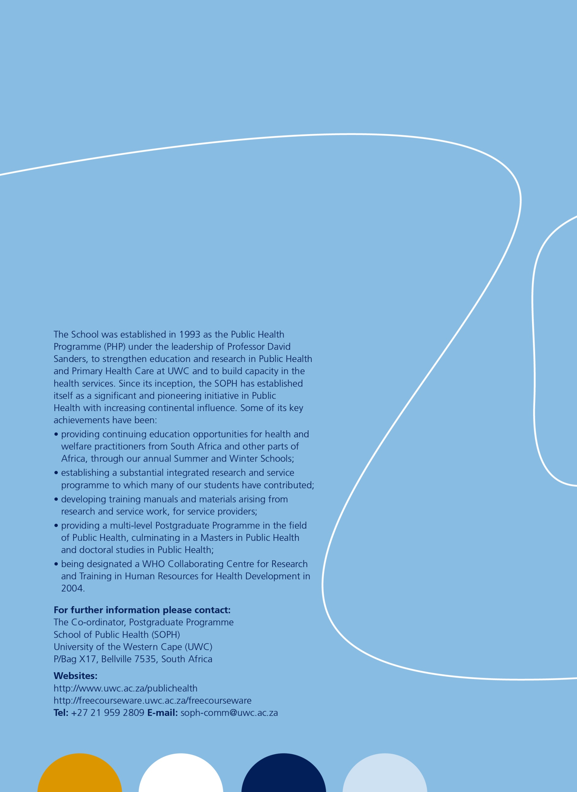**

1. Under-5 mortality refers to the probability that a child will die before her or his 5th birthday, expressed per 1000 live births. The U-5MR is an important indicator of a country's state of development. [↑](#footnote-ref-1)
2. Diarrhoea due to gastroenteritis is a major cause of death in children under 5 years old globally. It kills when the child becomes severely dehydrated due to the loss of water and salts from the body. Children with gastroenteritis are admitted to A9 only if they are dehydrated or at risk of dehydration. [↑](#footnote-ref-2)
3. Karen Small. *2007 Community Survey Analysis.* Strategic Development Information and GIS Department, Strategic Information Branch, Cape Town. October 2008 [↑](#footnote-ref-3)
4. Esrey S., Potash J., Roberts L., Schiff C. 1991. Effects of improved water supply and sanitation on ascariasis, diarrhoea, drancunculiasis, hookworm infection, schistosomiasis and trachoma. *Bulletin of the World Health Organization* 60:609-621. [↑](#footnote-ref-4)
5. Huttly S., Morris S.and Pisani V. 1997. Prevention of diarrhoea in young children in developing countries. *Bulletin of the World health Organisation* 75(2): 163-174. [↑](#footnote-ref-5)
6. Billig P., Bendahmane D., Swindale A. 1991. Water and Sanitation Indicators Measurement Guide. *Food and Nutrition Technical Assistance Project,* Washington D.C. [↑](#footnote-ref-6)
7. Esrey S., Potash J., Roberts L., Schiff C. 1991. Effects of improved water supply and sanitation on ascariasis, diarrhoea, drancunculiasis, hookworm infection, schistosomiasis and trachoma. *Bulletin of the World Health Organization* 60:609-621. [↑](#footnote-ref-7)
8. I, LR, write this as a non lawyer; it is based on my somewhat limited understanding of these matters. [↑](#footnote-ref-8)